Transformational Government Framework Primer Version 1.0
  - Committee Note Draft 01
  - 17 March 2011
Work Product URIs:
This Version:
http://docs.oasis-open.org/tgf/TGF-Primer/v1.0/cnd01/TGF-Primer-v1.0-cnd01.docx (Authoritative)
http://docs.oasis-open.org/tgf/TGF-Primer/v1.0/cnd01/TGF-Primer-v1.0-cnd01.pdf
http://docs.oasis-open.org/tgf/TGF-Primer/v1.0/cnd01/TGF-Primer-v1.0-cnd01.html
Previous Version:
N/A
Latest Version:
http://docs.oasis-open.org/tgf/TGF-Primer/v1.0/TGF-Primer-v1.0.docx (Authoritative)
http://docs.oasis-open.org/tgf/TGF-Primer/v1.0/TGF-Primer-v1.0.pdf
http://docs.oasis-open.org/tgf/TGF-Primer/v1.0/TGF-Primer-v1.0.html
Technical Committee:
  - OASIS Transformational Government Framework TC
Chair(s):
John Borras, Individual
Editor(s):
Peter F Brown, Individual
Chris Parker, CS Transform Limited
Abstract:
This Primer is intended to serve as an introduction to and detailed overview of the “Transformational Government Framework” (TGF) - a practical “how to” standard for the design and implementation of an effective program of technology-enabled change at national, state or local government level.
It also covers the Framework’s rationale, purpose, scope, and intended use.
The Framework is a managed process of ICT-enabled change in the public sector, which puts the needs of citizens and businesses at the heart of that process and which achieves significant and transformational impacts on the efficiency and effectiveness of government.
The Primer is in three main parts:
- Part I, including an Introduction and Overview, sets out the context in which the TGF has been produced, its purpose, and the principal users at whom the Framework is aimed.
- Part II describes the Transformational Government Framework itself, including the conformance criteria by which users of the Framework may determine if they are conformant.
Part III provides a set of Guidance Notes providing further information to users of the TGF on how they can implement it in practice.
Status:
This document was last revised or approved by the OASIS Transformational Government Framework TC on the above date. The level of approval is also listed above. Check the “Latest Version” location noted above for possible later revisions of this document.
Technical Committee members should send comments on this document to the Technical Committee‘s email list. Others should send comments to the Technical Committee by using the “Send A Comment” button on the Technical Committee‘s web page at http://www.oasis-open.org/committees/tgf/.

Citation Format:
When referencing this specification the following citation format should be used:
[TGF-PRIMER-V1.0]
Transformational Government Framework Primer Version 1.0. 17 March 2011. OASIS Committee Note Draft 01. http://docs.oasis-open.org/tgf/TGF-Primer/v1.0/cnd01/TGF-Primer-v1.0-cnd01.docx.

Notices
Copyright © OASIS Open 2011. All Rights Reserved.
All capitalized terms in the following text have the meanings assigned to them in the OASIS Intellectual Property Rights Policy (the "OASIS IPR Policy"). The full Policy may be found at the OASIS website.
This document and translations of it may be copied and furnished to others, and derivative works that comment on or otherwise explain it or assist in its implementation may be prepared, copied, published, and distributed, in whole or in part, without restriction of any kind, provided that the above copyright notice and this section are included on all such copies and derivative works. However, this document itself may not be modified in any way, including by removing the copyright notice or references to OASIS, except as needed for the purpose of developing any document or deliverable produced by an OASIS Technical Committee (in which case the rules applicable to copyrights, as set forth in the OASIS IPR Policy, must be followed) or as required to translate it into languages other than English.
The limited permissions granted above are perpetual and will not be revoked by OASIS or its successors or assigns.
This document and the information contained herein is provided on an "AS IS" basis and OASIS DISCLAIMS ALL WARRANTIES, EXPRESS OR IMPLIED, INCLUDING BUT NOT LIMITED TO ANY WARRANTY THAT THE USE OF THE INFORMATION HEREIN WILL NOT INFRINGE ANY OWNERSHIP RIGHTS OR ANY IMPLIED WARRANTIES OF MERCHANTABILITY OR FITNESS FOR A PARTICULAR PURPOSE.
The name "OASIS" is a trademark of OASIS, the owner and developer of this specification, and should be used only to refer to the organization and its official outputs. OASIS welcomes reference to, and implementation and use of, specifications, while reserving the right to enforce its marks against misleading uses. Please see http://www.oasis-open.org/who/trademark.php for above guidance.

Table of Contents
Table of Contents 4
Disclaimer 6
Part I: Introduction to the Framework 7
Context 7
Purpose of the Transformational Government Framework 10
Target audience for the Transformational Government Framework 10
Overview of the Transformational Government Framework 11
Component 1: Guiding Principles for Transformation 11
Component 2: Critical Success Factors 11
Component 3: Service Delivery Processes 11
Component 4: Benefit Realisation Framework 12
Part II: The Transformational Government Framework 13
Component 1: Guiding Principles 14
Develop a detailed and segmented understanding of your citizen and business customers 14
Build services around customer needs, not organisational structure 14
Citizen Service transformation is done with citizens, not to them 14
Grow the market 14
Manage and measure these nine critical success factors: 15
Component 2: Critical Success Factors 15
Strategic Clarity 15
Leadership 15
User focus 16
Stakeholder engagement 16
Skills 16
Supplier Partnership 16
Future-proofing 16
Achievable Delivery 17
Benefit Realization 17
Component 3: Delivery Processes 17
Business Management Framework 19
Customer Management Framework 21
Channel Management Framework 22
Technology Management Framework 23
Component 4: Benefit Realisation Strategy 26
Terminology and Reference Model 27
Core Terminology 27
Conformance Criteria 30
Part III: Guidance Notes 32
Part III (a): Guidance on the TGF Business Management Framework 33
Introduction 33
Context 33
Overview of key components in the TGF Business Management Framework 33
Transformational Government Leadership 34
Collaborative Stakeholder Governance Model 35
Common Terminology and Reference Model 39
Transformation Business Model 40
Policy Product Management 44
Transformation Roadmap 45
Part III (b): Guidance on the TGF Customer Management Framework 48
Introduction 48
Context 48
Overview of key components in the TGF Customer Management Framework 48
Brand and Marketing Strategy 49
Identity Management 51
Citizen Empowerment Framework 53
Part III (c): Guidance on the TGF Channel Management Framework 55
Introduction 55
Context 55
Overview of key components in the TGF Channel Management Framework 55
Channel Mapping 56
Channel Transformation Strategy 57
Part III (d): Guidance on the TGF Technology Management Framework 60
Context 60
Overview of key components in the TGF Technology Management Framework 60
Resources Management 61
Eco-system Participation 61
SOA-based system realisation and governance 62
Acknowledgements 63
Revision History 64

Disclaimer
The Committee will be developing OASIS ‘Standards Track’ deliverables in parallel to the current document and some material that is currently included here will in time and once work has stabilised be included in those deliverables and thence be removed from this work.
This is a preliminary draft of what is intended to be produced as an OASIS ‘Committee Note’. At this early stage, and given the volume of initial contributions to the Committee’s work, this draft captures a complete overview of the work to develop the Transformational Government Framework. As such it currently contains sections and content that will not be appropriate to the Committee Note once approved.

Part I: Introduction to the Framework
Part I covers:
- The context and historical background for Transformational Government;
- The definition of Transformational Government in this context;
- The purpose of the Transformational Government Framework (TGF);
- The audience, intended primary and secondary users, of the Framework;
An overview with top-level description of the key components of the TGF with context on why each is important.

Context
All around the world, governments at national, state, and local levels face huge pressure to do “more with less”. Whether their desire is: to raise educational standards to meet the needs of a global knowledge economy; to help our economies adjust to financial upheaval; to lift the world out of poverty when more than a billion people still live on less than a dollar a day; to facilitate the transition to a sustainable, inclusive, low-carbon society; to reduce taxation; or to cut back on public administration; every government faces the challenge of achieving their policy goals in a climate of increasing public expenditure restrictions.
Responding effectively to these challenges will mean that governments need to deliver change which is transformational rather than incremental.
During much of the last two decades, technology was heralded as providing the key to deliver these transformations. Now that virtually every government is an "e-Government" - with websites, e-services and e-Government strategies proliferating around the world, even in the least economically developed countries - it is now clear that Information and Communication Technologies (ICT) are no “silver bullet”. The reality of many countries' experience of e-Government has instead been duplication of ICT expenditure, wasted resources, no critical mass of users for online services, and limited impact on core public policy objectives.
An increasing number of governments and institutions are now starting to address the much broader and more complex set of cultural and organizational changes which are needed if ICT is to deliver significant benefits in the public sector. Countries such as the UK, Canada and Australia have all recently published strategies which shift decisively away from "e-Government" towards a much more radical focus on transforming the whole relationship between the public sector and users of public services. In the same vein, the European Commission has updated and published its ‘European Interoperability Framework’ (EIF) and several US agencies are looking to update and consolidate the ‘Federal Enterprise Architecture’ (FEA) into a new ‘Unified Government Enterprise Architecture Framework’ (UGEAF).
We call this process: Transformational Government
Defining Transformational Government
The definition of Transformational Government used here and in the Framework is
Transformational Government
A managed process of ICT-enabled change in the public sector, which puts the needs of citizens and businesses at the heart of that process and which achieves significant and transformational impacts on the efficiency and effectiveness of government.
This definition deliberately avoids describing some perfect “end-state” for government. That is not the intent of the Transformational Government Framework. All governments are different: the historical, cultural, political, economic, social and demographic context within which each government operates is different, as is the legacy of business processes and technology implementation from which it starts. So the Transformational Government Framework is not a “one-size-fits-all” prescription for what a government should look like in future.
Rather, the focus is on the process of transformation: how a government can build a new way of working which enables it rapidly and efficiently to adapt to changing citizen needs and emerging political and market priorities. In the words of one of the earliest governments to commit to a transformational approach: “…. the vision is not just about transforming government through technology. It is also about making government transformational through the use of technology”,
A full understanding of this definition of Transformational Government can also be assisted by focusing on the four major ways in which Transformational Government programs differ from traditional e-Government programs:
- They take a whole-of-government view of the relationship between the public sector and the citizen or business user
- They include initiatives to e-enable the frontline of public services: that is, staff involved in direct personal delivery of services such as education and healthcare - rather than just looking at transactional services which can be e-enabled on an end-to-end basis
- They take a whole-of-government view of the most efficient way of managing the cost base of government
They focus on the "citizen" not the "customer". That is, they seek to engage with citizens as owners of and participants in the creation of public services, not as passive recipients of services.
Each of these defining aspects of Transformational Government is explored in more detail below.

Transforming services around the citizen and business user
Most governments are structured around a set of vertically-integrated silos or stovepipes - agencies, departments, ministries. By and large, it is these silos which the Governments of developed countries have spent billions of dollars "e-enabling" since the 1990s. However, this is an ICT investment strategy which is fundamentally not citizen-focused, because the needs of citizens, businesses and others cut across the organisational structures and hierarchies of government. It has inevitably resulted in low levels of take-up for e-services. Governments in developed countries are now grappling with the legacy of thousands of fragmented, silo-focused websites: more than 270,000 in the US public sector, 9,000 in Germany, and 3,000 in the UK. An increasing number of governments are now seeking to make a fundamental strategic shift, towards a holistic, citizen-centred approach, driven at the whole-of-government level.
This shift includes, in leading countries, a move to a “one-stop” citizen-centric service delivered over multiple channels.

e-Enabling the frontline
Traditional e-Government has focused on e-enabling transactional services and providing online content. The great majority of public sector staff and expenditure is not however involved in such services, but rather in "front line" delivery: teachers, healthcare workers, police, court officials, emergency response teams, etc. Leading governments are beginning to understand how the work of such front line staff can be transformed through the use of real-time knowledge management and mobile workflow applications.

Empowering the citizen
Citizens' experience of new technologies is shaped by the best that the private sector has to offer globally and - increasingly - through the ability to co-create content and services as individuals or in peer-to-peer networks. They will demand ever greater interactivity and ownership in their relationship with public services. Transformational Government programs embrace this. Where traditional e-Government programs focused on the user as "the customer", Transformational Government enhances the relationship between government and the citizen on a richer, more reciprocated, and more empowering basis.

Cross-government efficiency
The silo-based approach to ICT investment typical of much e-Government has not only resulted in "un-citizen-centric" services (as discussed above), but also in duplication and inefficiency. Governments have "reinvented the wheel" in ICT terms - over and over again - with different agencies each:
- maintaining their own databases, even for universal data sets such as citizen identity, addresses and so forth;
- building bespoke applications for e-service functions common to all or many agencies (such as payments in and out, eligibility, notification, and authentication), as well as for common business processes such as HR and Financial Management; and
doing so in ways which not only duplicate expenditure, but which also will not inter-operate with other agencies - making it more difficult and expensive to move towards inter-agency collaboration in future.
A key focus of Transformational Government is therefore to move towards a service-oriented and building-block approach to ICT and back-office service architecture across all parts of government - reaping efficiency gains while at the same time enabling better, more citizen-focused service delivery. As “cloud computing” gains traction and momentum, this approach opens up even greater scope to achieve large-scale efficiency savings while simultaneously improving organizational agility.

Purpose of the Transformational Government Framework
Delivering this degree of change is not straight-forward for government. Indeed, government faces unique challenges in delivering transformational change, notably:
- the unparalleled breadth and depth of its service offering;
- the fact that it provides a universal service, engaging with the whole population rather than picking and choosing its customers;
structures, governance, funding & culture which are all organized around specific business functions, not around meeting citizen needs in a holistic way.
The time is now right to set out a clear standardized framework within which governments can overcome these challenges to deliver genuinely transformational ICT-enabled change in the public sector. Against the background, the purpose of the Transformational Government Framework is
Transformational Government Framework: purpose
In the increasingly common situation of governments being expected to deliver better and more services for less cost whilst maintaining high-level oversight and governance, the Transformational Government Framework provides a framework for designing and delivering an effective program of technology-enabled change at all levels of government.

Target audience for the Transformational Government Framework
The Transformational Government Framework (TGF) is intended primarily to meet the needs of:
- Political and administrative leaders responsible for shaping public sector reform and e-Government strategies and policies (at national, state/regional and city/local levels);
Senior executives in industry who wish to partner with and assist governments in the transformation of public services and to ensure that the technologies and services which the private sector provides can have optimum impact in terms of meeting public policy objectives
Service and technology solution providers to the public sector.
Secondary audiences for the Transformational Government Framework include:
- Leaders of international organisations working to improve public sector delivery, whether at a global level (e.g. World Bank, United Nations) or a regional one (e.g. European Commission, ASEAN, IADB)
- Professional bodies that support industry sectors by the development and maintenance of common practices, protocols, processes and standards to facilitate the production and operation of services and systems within the sector, where the sector needs to interact with government processes and systems.
Academic and other researchers working in the field of public sector reform.
Civil society institutions engaged in debate on how technology can better enable service transformation.

Overview of the Transformational Government Framework
There are four main components to the Framework:
- Guiding Principles
- Critical Success Factors
- Delivery Frameworks and
- A Benefit Realisation Framework

Component 1: Guiding Principles for Transformation
As discussed above, a “one-size-fits-all” approach to public sector reform does not work. Nevertheless, there are some guiding principles which 10-15 years of experience with e-enabled government around the world suggests are universal. They are based on the experience of many OASIS member organizations working with governments of all kinds, all around the world, and they form the heart of the Framework.
In the Transformational Government Framework, we use the term “principle” to mean an enduring statement of values which can used on a consistent basis to steer business decision making over the long term.
The principles used in the TGF are detailed in Part II below.

Component 2: Critical Success Factors
Programs and projects which seek to deliver Transformational Government face significant risks to successful delivery. Typically, these risks are not related to the technology itself – which is largely mature and proven – but rather to business and cultural changes. Such changes are needed within government to deliver the business management, customer management and channel management transformations described in Component 3 of the TGF.
However, there is now an increasing body of research which seeks to understand why some ICT-enabled transformation programs succeed and why others fail. The TGF therefore includes nine Critical Success Factors that reflect and respond to the findings of such research, validated with OASIS members around the world. These Critical Success Factors need to be taken on board by any government seeking to develop and deliver an effective Transformational Government program.

Component 3: Service Delivery Processes
The TGF includes four major delivery processes within government, all of which need refocusing in a citizen-centric way in order to deliver genuinely transformational impact:
- business management,
- customer management,
- channel management, and
technology management based on the principles of service-oriented architecture.
Part II of the Primer below describes frameworks for each of these areas, and Part III gives further guidance on how to implement them.

Component 4: Benefit Realisation Framework
The Benefit Realisation Framework is needed to ensure that the Transformation Government program ultimately delivers all of its intended benefits and impacts in practice. Logically, the design and delivery of a Benefit Realisation Strategy is a part of the Business Management task, and is a core responsibility for the Transformational Government Leadership and the collaborative stakeholder governance model described in the TGF Business Management Framework. It is of such vital importance however that it is highlighted as a distinct component of the overall Framework.
ICT projects in government (and indeed in the private sector) do not automatically deliver benefits. Governments historically have fallen into two pitfalls which have hindered full benefit realisation:
- Failure to pro-actively manage the downstream benefits after an individual ICT project has been completed. Often, ICT projects are seen as “completed” once the technical implementation is initially operational. In order to reap the full projected benefits (efficiency savings, customer service improvements etc.), on-going management is essential, often involving significant organizational and cultural changes. A study for the European Commission calculated that, as a rule of thumb, organizational change accounts for 55% of the full costs of e-Government projects in Europe, while ICT only accounts for 45%. Yet these organisational change costs are often not fully factored in or delivered, resulting in a failure to maximize the potential benefits of the ICT investments.
Failure at a whole-of-Government level to undertake the restructuring of the public labour market to take advantage of new efficiencies. Effective delivery of e-Government services – both externally in service delivery to citizens and businesses and internally in modernising the operations of government – opens up the potential to reduce significantly the cost of government. As the cost of delivering government services falls, so governments need to plan and implement the necessary restructuring of the public sector labour market to realize efficiency benefits in the traditional paper-based channels. These efficiency savings can then either be returned to the tax payer in the form of lower taxes, or recycled into priority front-line public services such as health and education. A study by the OECD in 2006 showed that this “whole-of-government” approach to efficiency savings had until that point been a feature of only a few countries, notably Canada, the UK and Finland. Increasingly though, financial pressures are forcing governments to focus on this issue.
The Transformational Government Framework does not seek to specify in detail what benefits and impacts a Transformational Government program should seek to achieve – that is a matter for each individual government. However, the TGF does set out a best practice approach to benefit realisation.

Part II: The Transformational Government Framework
In the increasingly common situation of governments being expected to deliver better and more services for less cost whilst maintaining high-level oversight and governance, the Transformational Government Framework provides a framework for designing and delivering an effective program of technology-enabled change at all levels of government.
The Transformational Government Framework can be seen schematically below, made up of four high-level components:
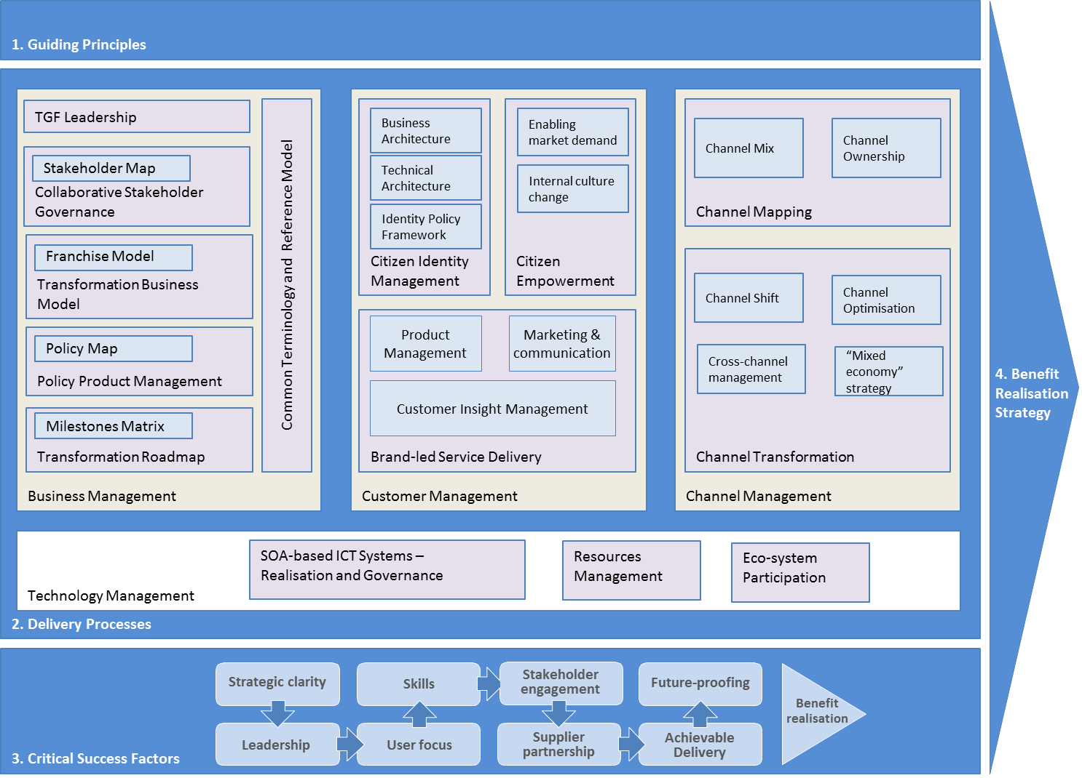
Figure 1: The overall framework
Each of these components is described in more detail below.

Component 1: Guiding Principles
The TGF Guiding Principles are set out below, and must be used by any Transformational Government program conforming to the TGF.

Develop a detailed and segmented understanding of your citizen and business customers
- Own the customer at the whole-of-government level
- Don't assume you know what users of your services think - research, research, research
Invest in developing a real-time, event-level understanding of citizen and business interactions with government

Build services around customer needs, not organisational structure
- Provide people with one place to access government, built around their needs (such as accessibility)
- Don't try to restructure-Government to do this - build "customer franchises" which sit within the existing structure of government and act as change agents
- Deliver services across multiple channels - but use Service-Oriented Architecture (SOA) principles to join it all up, reduce infrastructure duplication, and to encourage customers into lower cost channels where possible
- Don't spend money on technology before addressing organisational and business change
Don't reinvent wheels - build a cross-government strategy for common citizen data sets (e.g. name, address) and common citizen applications (e.g. authentication, payments, notifications)

Citizen Service transformation is done with citizens, not to them
- Engage citizens directly in service design and delivery
- Give citizens the technology tools that enable them to create public value themselves
Give citizens ownership and control of their personal data - and make all non-personal government data freely open for reuse and innovation by citizens and third parties

Grow the market
- Ensure that your service transformation plans are integrated with an effective digital inclusion strategy to build access to and demand for e-services across society
Recognise that other market players (in the private, voluntary and community sectors) will have a significant influence on citizen attitudes and behaviour - so build partnerships which enable the market and others to work with you to deliver jointly-owned objectives.

Manage and measure these nine critical success factors:
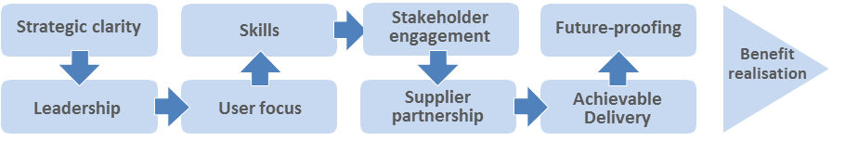
Figure 2: The nine Critical Success Factors
These nine factors are covered in Component 2 of the TGF.

Component 2: Critical Success Factors
Conformant Transformational Government programs manage and measure these Critical Success Factors throughout the life of the program.

Strategic Clarity
- All-of-Government view: Transformational government cannot be pursued on a project-by-project or agency-specific basis but requires a whole-of-government view, connecting up relevant activities in different agencies at different levels of government within and between countries.
- Clear vision: all program stakeholders have a common, agreed and comprehensive view of what the program is seeking to achieve. In particular, we do not spend money on technology before identifying the key organizational and business changes needed to deliver our vision.
- Strong business case: we know what outcomes we want to achieve, have base-lined where we are now, and know how we will measure success.
- Focus on results: although we have a vision of where we want to go, and a set of principles by which we will move forwards, we do not over-plan. Instead, our strategy focuses on taking concrete, practical steps in the short to medium term, rather than continually describing the long-term vision.

Leadership
- Sustained support: political leaders and senior management are committed to the program for the long term. This is particularly relevant given the realities of changing political leadership and underlines the need for continuity across those changes.
- Leadership skills: our program leaders have the skills needed to drive ICT-enabled business transformation, and have access to external support
- Collaborative governance: leaders from all parts of our and other organizations involved in the program are motivated for it to succeed, and are engaged in clear and collaborative governance mechanisms to manage any risks and issues.

User focus
- A holistic view of the customer: we understand who the customers for our services are - not just for individual services - but across the Government as a whole. We know our customers, both internal and external, are different - and understand their needs on a segmented basis.
- Citizen-centric delivery: citizens can access all our services through a "one-stop" service. This is available over multiple channels and that respond to different needs, but we use web-based services to join it all up and reduce infrastructure duplication, and we encourage customers into lower cost channels where possible and compatible with citizen needs (such as accessibility).
- Citizen empowerment: we engage citizens directly in service design and delivery, and provide them with technology tools that enable them to create public value themselves.

Stakeholder engagement
- Stakeholder communication: all our stakeholders - users, suppliers, delivery partners elsewhere in the public, private and voluntary sector, politicians, the media, etc. - have a clear understanding of our program and how they can engage with it.
- Cross-sectoral partnership: other market players (in the private, voluntary and community sectors) often have much greater influence on citizen attitudes and behaviour than government - so our strategy aims to build partnerships which enable the market to deliver our objectives.

Skills
- Skills mapping: we know that the mix of business change, product and marketing management, program management, and technology skills needed to deliver transformational change does not already exist in our organisation. We have mapped out the skills we need, and have a clear strategy for acquiring and maintaining them.
- Skills integration: we have effective mechanisms in place to maximize value from the skills available in all parts of our delivery team, bringing together internal and external skills into an integrated team.

Supplier Partnership
- Smart supplier selection: we select suppliers based on long-term value for money rather than price, and in particular based on our degree of confidence that the chosen suppliers will secure delivery of the expected business benefits.
- Supplier integration: we will manage the relationship with strategic suppliers at top management level, and ensure effective client/supplier integration into an effective program delivery team with shared management information systems.

Future-proofing
- Interoperability: Wherever possible we will use interoperable, open standards which are well supported in the market-place.
- Web-centric delivery: we will use SOA principles in order to support all of our customer interactions, from face-to-face interactions by frontline staff to online self-service interactions
- Agility: we will deploy technology using common building blocks which can be re-used to enable flexible and adaptive use of technology to react quickly to changing customer needs and demands.
- Shared services: key building blocks will be managed as government-wide resources - in particular common data sets (e.g. name, address); common citizen applications (e.g. authentication, payments, notifications); and core ICT infrastructure.

Achievable Delivery
- Phased implementation: we will avoid a "big bang" approach to implementation, reliant on significant levels of simultaneous technological and organizational change. Instead, we will develop a phased delivery roadmap which:
- works with citizens and businesses to identify a set of services which will bring quick user value, in order to start building a user base
- prioritise those services which can be delivered quickly, at low cost, and low risk using standard (rather than bespoke) solutions
- works first with early adopters within the Government organisation to create exemplars and internal champions for change
- learns from experience, and then drives forward longer term transformations.
- Continuous improvement: we expect not to get everything right first time, but have systems which enable us to understand the current position, plan, move quickly, and learn from experience
- Risk management: we need clarity and insight into the consequences of transformation and mechanisms to assess risk and handle monitoring, recovery and roll-back

Benefit Realization
- Benefit realisation strategy: we have a clear strategy to ensure that all the intended benefits from our Transformation Program are delivered in practice, built around the three pillars of benefit mapping, benefit tracking and benefit delivery.

Component 3: Delivery Processes
Delivering the principles outlined in Component 1, in line with the Critical Success Factors detailed in Component 2, involves re-inventing every stage of the service delivery process. The Transformational Government Framework identifies four main delivery processes, each of which must be managed in a government-wide and citizen-centric way in order to deliver effective transformation:
- Business Management
- Customer Management
- Channel Management
Technology Management
A high-level map of these delivery processes and how their constituent elements interact is illustrated in summary below. The following sections then look in more detail at each of the four delivery processes, setting out the best practices which should be followed in order to ensure conformance with the Transformational Government Framework.
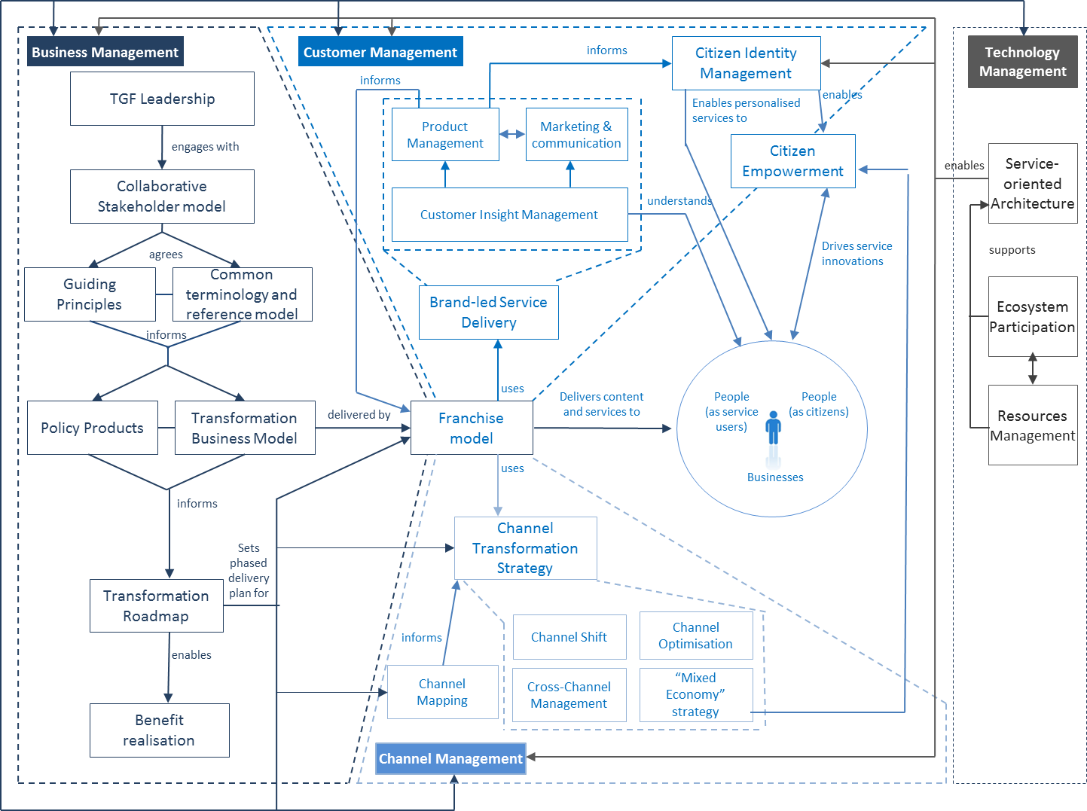
Figure 3: Relationships between the four Delivery Processes for Transformational Government

Business Management Framework
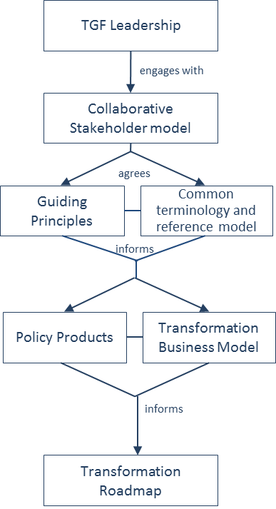
The Transformational Government Framework identifies six key aspects of business management which must be tackled at the whole-of-government level:

Figure 4: Overview of the Business Management Framework
- Transformational Government leadership: the key people and governance structures needed to develop and implement a Transformational Government program;
- A collaborative Stakeholder Governance Model: the process by which all key stakeholders are identified, engaged and buy-in to the transformation program;
- A common terminology and Reference Model: ensuring that all stakeholders have a clear, consistent and common understanding of the key concepts involved in Transformational Government; how these concepts relate to each other; how they can be formally modelled; and how such models can be leveraged and integrated into new and existing information architectures;
- A Transformation Business Model: a new virtual business layer within government, focused round the needs of citizens and businesses (the “Franchise Marketplace”), which enables the existing silo-based structure of government to collaborate effectively in understanding and meeting user needs;
- The development and management of Policy Products: these documents formally define government-wide goals for achieving government transformation and thus constitute the documented commitment of any conformant agency to the transformational process;
A Transformation Delivery Roadmap: giving a four to five year view of how the program will be delivered, with explicit recognition of priorities and trade-offs between different elements of the program.
Any conformant implementation of the TGF Business Management Framework:
MUST have Leadership which involves:
- Clear accountability at both the political and administrative levels
- Deployment of formal program management disciplines
- A clearly identified mix of leadership skills
- Engagement of a broad-based leadership team across the wider government.
MUST have a Collaborative Stakeholder Governance Model
MUST have an agreed and shared terminology and reference model
MUST have a Transformation Business Model
SHOULD use the Franchise Marketplace Model
MUST use the Policy Product Map to identify all necessary Policy Products
MUST have a phased Transformation Roadmap
Further guidance on how to implement this process is given in Part III (a) of the Primer.

Customer Management Framework
There are three key parts to the TGF Customer Management Framework:
- Brand-led Service Delivery: a user-focused framework for ensuring that:
- Detailed insight is gathered into citizen and business needs
- This insight informs a brand-led product management process covering all stages of government service design and delivery
- The brand values for Transformational Government then drive all aspects of marketing and communications for government services;
- Identity Management: the business architecture, technical architecture, and citizen-centric identity model needed to enable secure and joined-up services which citizens and businesses will trust and engage with; and
Citizen Empowerment: the internal cultural changes and external market-enabling actions which enable governments to engage with citizens and businesses as active co-creators of public services, rather than their passive recipients.
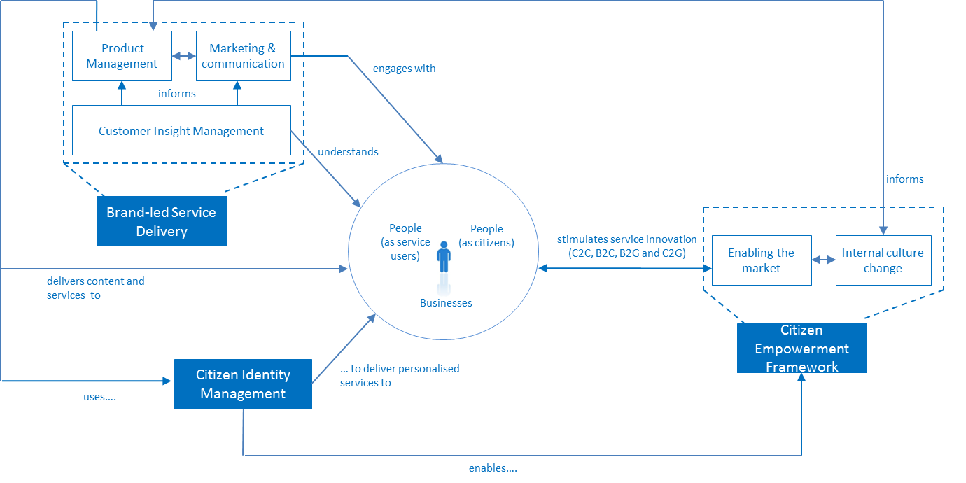
Figure 5: Overview of the Customer Management Framework
Any conformant implementation of the TGF Customer Management Framework:
MUST have a Brand-led Service Delivery Strategy, which is agreed and managed at a whole-of-government level and which addresses:
- Customer Insight;
- Product Management;
- Marketing and communication;
MUST have a Citizen Identity Management Framework, which:
- uses a federated business model;
- uses a service-oriented IT architecture;
- is citizen-centric, giving citizens control, choice and transparency over personal data;
MUST have a Citizen Empowerment Framework, which encourages and enables service innovation in the Citizen-to-Citizen, Business-to-Citizen, and Citizen-to-Government sectors.
Further guidance on how to implement this process is given in Part III (b) of this TGF Primer.

Channel Management Framework
The two key parts of the Channel Management Framework are:
- Channel Mapping: a clear audit of what channels are currently used to deliver government services. The TGF Channel Mapping approach includes an analysis of these channels across two key dimensions: which delivery channels are being used (‘channel mix’) and who owns them (‘channel ownership’).
- Channel Transformation Strategy: building a new channel management approach centred around the needs and behaviour of citizens and businesses. The key concerns of such an approach include:
- Channel Optimization;
- Channel Shift;
- Cross-Channel Management; and
- development of a “Mixed Economy” in service provision through private and voluntary sector intermediaries.
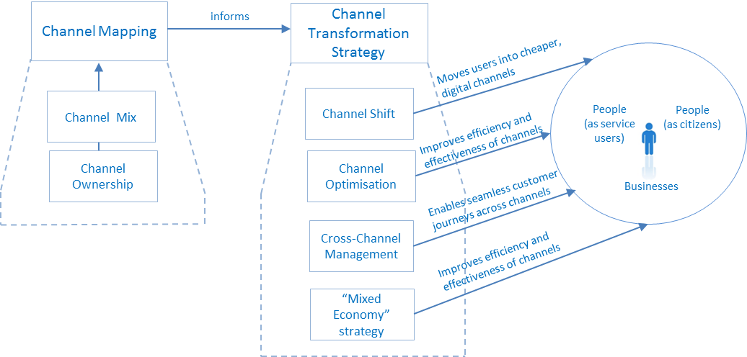
Figure 6: Overview of the Channel Management Framework
Any conformant implementation of the Channel Management Framework:
MUST have a clear mapping of existing channels, and their cost structures
MUST have a Channel Transformation Strategy which addresses the following elements:
- Shifting service users into lower cost, digital channels;
- Optimising the cost and performance of each channel, including through use of benchmarking;
- Improving cross-channel management, with the aim of providing a seamless user experience across different channels;
- Developing a thriving mixed economy in the delivery of government services by private and voluntary sector intermediaries.
Further guidance on how to implement this process is given in Part III (c) of this TGF Primer.

Technology Management Framework
The elements of the TGF Technology Management Framework are as follows:
- Resources Management: the explicit identification and management of all information and technology resources;
- Ecosystem Participation: a clear model and understanding of the stakeholders, actors and systems that comprise the overall service ecosystem and their relationships to each other;
Realisation and governance of ICT systems based on SOA principles
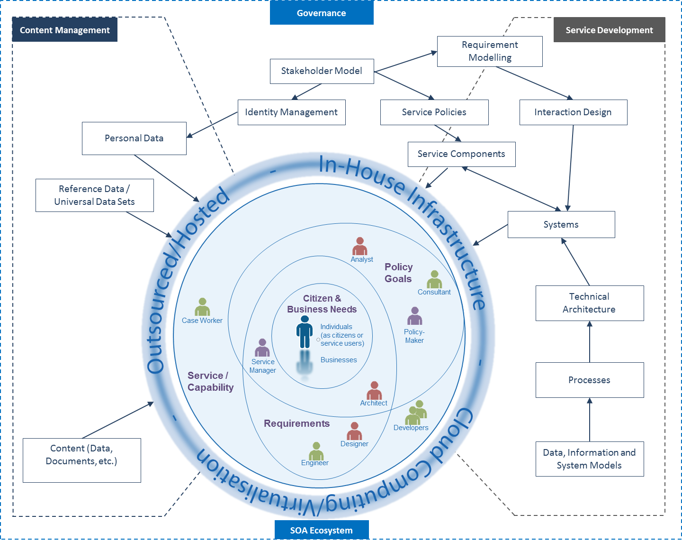
Figure 7: Overview of the Technology Management Framework
Any conformant implementation of the Technology Management Framework:
MUST manage information and ICT system resources as distinct, valued assets including issues related to the Identification, ownership, stewardship and usage policies for each asset type;
MUST explicitly model the stakeholders, actors and systems that comprise the overall service ecosystem and their relationships to each other
SHOULD maintain and update the stakeholder model on a regular basis
MUST use the OASIS ‘Reference Model for SOA’ as the primary source for core concepts and definitions of the SOA paradigm, including
- A clear understanding of the goals, motivations and requirements that any SOA-based system is intended to address;
- Identifiable boundaries of ownership of all components (and identity of the components themselves) in any SOA ecosystem;
- Discrete service realisation and re-use that provides a capability to perform some work on behalf of another party;
- The specification of any capability that is offered for use by another party with clear service descriptions and contracts
SHOULD consider the OASIS ‘SOA Reference Architecture Framework’ when designing specific SOA-based systems
Further guidance on how to implement this process is given in Part III (d) of this TGF Primer.

Component 4: Benefit Realisation Strategy
The three parts of the TGF Benefit Realisation Strategy are:
- Benefit Mapping: which sets out all the intended outcomes from the transformation program and gives visibility of how the outputs from specific activities and investments in the program flow through to deliver those outcomes;
- Benefit Tracking: which takes this a step further by baselining current performance against the target output and outcomes, defining “smart” success criteria for future performance, and tracking progress against planned delivery trajectories aimed at achieving these success criteria; and
Benefit Delivery: which ensures that governance arrangements are in place to ensure continued benefits after the initial transformation program is implemented.
The relationship between these parts and conformance criteria for this element of the TGF are shown below.
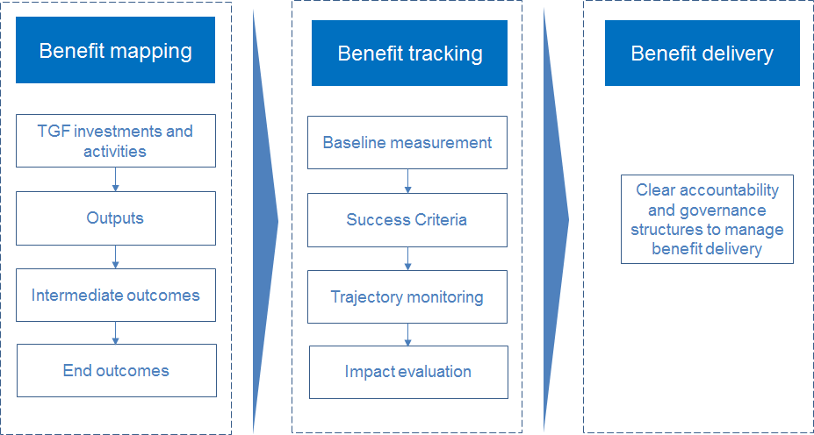
Figure 8: Overview of the Benefit Realisation Strategy
Any conformant implementation of the Benefit Realisation Strategy:
MUST clearly identify and quantify the impacts and outcomes that implementation of the TGF aims to achieve
SHOULD ensure clear line-of-sight between every investment and activity in the programme, the immediate outputs these produce, and the final targeted outcomes
MUST establish clear and quantified baselines for the current performance of target outputs and outcomes
MUST set measurable success criteria
SHOULD track progress against planned delivery trajectories for each of the targeted outputs and outcomes
MUST establish clear accountability and governance structures to manage benefit delivery

Terminology and Reference Model
The Business Management Framework of the TGF includes formal terminology and a reference model in order to ensure that all stakeholders have a clear, consistent and common understanding of the key concepts involved in Transformational Government; how these concepts relate to each other; how they can be formally modelled; and how such models can be leveraged and integrated into new and existing information architectures.
This enables any conformant agency to use a common terminology without ambiguity and be sure that these terms are used consistently throughout all work.
Some key concepts are already introduced below. Further guidance on how the terminology is composed and how a reference model may be used is given in Part III (a) of this Primer.

Core Terminology

TGF Leadership, Stakeholders, Administrations and Agencies
Leadership
Key people and governance structures needed to develop and implement a Transformational Government program
Stakeholder
Any claimant inside or outside an organisation who have a vested interest in any problem and/or its solution
Stakeholder Governance Model
Model and process in which key stakeholders are identified, engaged and buy-in to the transformation program

Transformation Business Model
Delivery Roadmap
A detailed multi-year plan for the delivery of an overall cross-government vision for service transformation
Transformational Government
A managed, citizen-centred, process of ICT-enabled change in the public sector

Policy formulation and Policy Products
Goal
A broadly stated, unmeasured but desired outcome. Not to be confused with an Objective
Need
A general statement expressed by a stakeholder of something that is required. Not to be confused with a Requirement
Objective
A specific, measurable and achievable outcome that a participant seeks to achieve
Policy Product
A document that has been formally adopted on a government-wide basis and aimed at helping achieve one or other goal of citizen service transformation
Requirement
A formal statement of a desired result that, if achieved, will satisfy a need

Service delivery and the Franchise Marketplace Model
Accessibility
A policy prescription that aims at ensuring that people with disabilities and the elderly can use public services with the same service levels as all other citizens.
Channel
A particular means and/or path of delivery of a service to a customer
Customer Franchise
A collaborative organisation created by the government with the purpose of: understanding the needs of a specific customer segment for government services (such as, for example, parents, motorists, disabled people, land and property); championing the needs of that segment within government; aggregating content and transactions for that segment from across government and beyond; and delivering that content and services as part of the wider Franchise Marketplace.
Franchise Marketplace
The virtual business infrastructure within which Customer Franchises collaborate with each other and other stakeholders to deliver user-centric, trusted and interoperable content and transactions to citizens and businesses. The Franchise Marketplace is the business model recommended by the TGF for best delivering the TGF Guiding Principle of “Build services around customer needs, not organisational structure”.
Delegate
Some person or agent acting with authority on behalf of another person.
Inclusion
A policy prescription that aims at allowing everyone to take full advantage of the opportunities offered by new technologies to overcome social and economic disadvantages and exclusion.

SOA and Technology Infrastructure
Ecosystem
A set of ICT systems and stakeholders together with the environment and context within which they all operate
Interoperability
The ability of disparate and diverse organisations to interact towards mutually beneficial and agreed common goals, involving the sharing of information and knowledge between the organisations, through the business processes they support, by means of the exchange of data between their respective ICT systems.
Security
The set of mechanisms for ensuring and enhancing trust and confidence in a system.
Service-Orientation, Service-Oriented
A paradigm for organizing and utilizing distributed capabilities that may be under the control of different ownership domains.
System
A collection of components organized to accomplish a specific function or set of functions

Conformance Criteria
A consolidated view of the conformance criteria described in the TGF is given below. Any conformant implementation of this Framework:
- MUST use the Guiding Principles set out in Component 1 of the TGF
- MUST have delivery processes for business management, customer management, channel management and technology management which address the best practices described in Component 2 of the TGF. Specifically, this means:
- A Business Management Framework which:
- MUST have Leadership which involves:
Clear accountability at both the political and administrative levels;
- Deployment of formal program management disciplines;
- A clearly identified mix of leadership skills;
- Engagement of a broad-based leadership team across the wider government.
- MUST have a Collaborative Stakeholder Governance Model
- MUST have an agreed and common terminology and reference model
- MUST have a Transformation Business Model
- SHOULD use the Franchise Marketplace Model
- MUST use the Policy Product Map as a tool to help identify Policy Products needed within the relevant government
MUST have a phased Transformation Roadmap
- A Customer Management Framework which:
- MUST have a Brand-led Service Delivery Strategy, which is agreed and managed at a whole-of-government level and which addresses:
Customer Insight
Product Management
- Marketing and communication
- MUST have a Citizen Identity Management Framework, which:
Uses a federated business model
Uses a service-oriented architecture (as part of the wider SOA described in the TGF Technology Management Framework)
- Is citizen-centric, giving citizens control, choice and transparency over personal data
MUST have a Citizen Empowerment Framework, which encourages and enables service innovation in the Citizen-to-Citizen, Business-to-Citizen, Citizen-to-Government, and Business-to-Government sectors
- A Channel Management Framework which:
- MUST have a clear mapping of existing channels, and their cost structures
- MUST have a Channel Transformation Strategy which addresses the following elements:
Shifting service users into lower cost, digital channels
Optimising the cost and performance of each channel, including through use of benchmarking
Improving cross-channel management, with the aim of providing a seamless user experience across different channels
- Developing a thriving mixed economy in the delivery of government services by private and voluntary sector intermediaries.
- A Technology Management Framework which:
- MUST manage information and ICT system resources as distinct, valued assets including issues related to the Identification, ownership, stewardship and usage policies for each asset type;
- MUST explicitly model the stakeholders, actors and systems that comprise the overall service ecosystem and their relationships to each other
- SHOULD maintain and update the stakeholder model on a regular basis
- MUST use the OASIS ‘Reference Model for SOA’ as the primary source for core concepts and definitions of the SOA paradigm, including
- A clear understanding of the goals, motivations and requirements that any SOA-based system is intended to address;
- Identifiable boundaries of ownership of all components (and identity of the components themselves) in any SOA ecosystem;
- Discrete service realisation and re-use that provides a capability to perform some work on behalf of another party;
- The specification of any capability that is offered for use by another party with clear service descriptions and contracts
- MUST measure and manage the Critical Success Factors outlined in Component 3 of the TGF
- SHOULD seek regular, independent review of performance against these Critical Success Factors
- MUST have a Benefit Realisation Strategy which addresses the areas of benefit mapping, benefit tracking and benefit delivery as described in Component 4 of the TGF
In terms of the primary users identified for the TGF in Part I:
- A conformant government will be able to demonstrate and document that it is engaged in a Transformation Program which complies with all these criteria.
- A conformant private-sector organisation will be able to demonstrate and document that it provides products and services which help governments to comply with all these criteria.

Part III: Guidance Notes
This part of the TGF Primer sets out some initial guidance to help TGF users understand and implement the TGF, focusing in particular on:
- The TGF Business Management Framework
- The TGF Customer Management Framework
- The TGF Channel Management Framework
- The TGF Technology Management Framework
TGF Terminology.
We envisage issuing further guidance over time, but this initial set of guidance notes is intended to give a deeper view of the context for these major elements of the TGF, and to highlight best practice approaches to its implementation.

Part III (a): Guidance on the TGF Business Management Framework

Introduction
The TGF Business Management Framework is in four main sections:
- Context
- Overview of key components in the TGF Business Management Framework
Detailed description of and guidance on the key components

Context
For largely historical reasons, governments are generally organised around individually accountable vertical silos (for example, tax, health, transport) with clear demarcations between central, regional, and local government. Even within a particular tier of government, several organisations can have responsibility for different aspects of the same person, same asset or same process. Yet citizen and business needs cut across these demarcations. In moving to a customer-centric approach, it is vital to redress this fragmented approach to business management, and to put in place business management processes which operate at the whole-of-government level.

Overview of key components in the TGF Business Management Framework
The Transformational Government Framework identifies six key aspects of business management which need to be tackled in this way:
- Transformational Government leadership: the key people and governance structures needed to develop and implement a Transformational Government program
- A collaborative Stakeholder Governance Model: the process by which all key stakeholders are identified, engaged and buy-in to the transformation program, including to the Guiding Principles described in Component 1 of the TGF
- A common terminology and reference architecture: ensuring that all stakeholders have a clear, consistent and common understanding of the key concepts involved in Transformational Government and how these inter-relate
- A Transformation Business Model: a new virtual business layer within government, focused round the needs of citizens and businesses, which enables the existing silo-based structure of government to collaborate effectively in understanding and meeting user needs
- The development and management of Policy Products that constitute the documented commitment to the transformational process of any conformant agency
A Transformation Delivery Roadmap: giving a four to five year view of how the program will be delivered, with explicit recognition of priorities and trade-offs between different elements of the program.
A high level view of the logical relationships between these components is illustrated below.
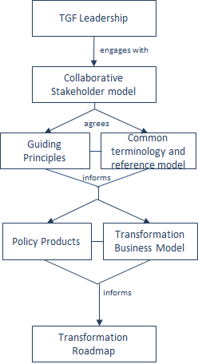
Figure 9: Key components of the Business Management Framework

Transformational Government Leadership
Transformation programs require sustained leadership over a period of years.
There is no “ideal” leadership structure for a transformation program: the optimal positioning of the leadership team will depend on the context of each specific government. However, global experience suggests the following factors are vital to address in whichever way is most appropriate for the specific context:
- A clear focus of accountability: at both the political and administrative levels there should be an explicit functional responsibility for the Transformation Program. These functions should be occupied by individuals with sufficient authority to command the resources and mobilise the support necessary to fulfil this mission.
- Deployment of formal program management disciplines: to deliver effective-Government-wide transformation, it is vital to use a formalised program management approach, such as PRINCE 2.
Ensuring the right skills mix in the leadership team. Effective leadership of a Transformation Program requires the senior accountable leaders to have access to a mix of key skills in the leadership team which they build around them, including: strategy development skills, stakeholder engagement skills, marketing skills, commercial skills and technology management skills. Deployment of a formal competency framework such as SFIA can be helpful in identifying and building the right skill sets.
Building a broad-based leadership team across the wider government. It is not essential that all Ministers and senior management are committed to the transformation program from the outset. Indeed, a key feature of an effective roadmap for transformation is that it nurtures and grows support for the strategy through the implementation process. However, it is important that the program is seen not simply as a centralised or top-down initiative. Sharing leadership roles with senior colleagues across the Government organisation is therefore important. Further detail on this is set out in the section below on a collaborative stakeholder model.

Collaborative Stakeholder Governance Model
Development and delivery of an effective Transformational Government program requires engagement with a very wide range of stakeholders, not only across the whole of government but also with the private sector, voluntary and community sectors as well as with business and citizen users of public services. A significant effort is needed to include all stakeholders in the governance of the Transformational Government program at an appropriate and effective level.
Key elements are set out below that a conformant TGF program will need to address in developing its Collaborative Stakeholder Governance Model, if it is to engage successfully with stakeholders and align them effectively behind shared objectives. Each of these elements is then discussed in more detail.
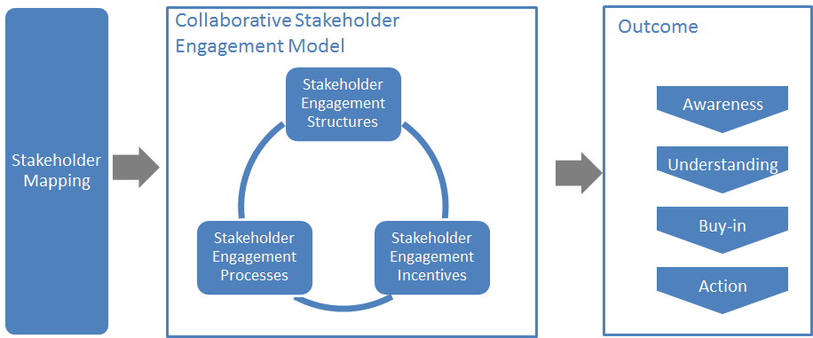
Figure 10: Overview of Collaborative Stakeholder Governance

Stakeholder Mapping
It is vital to describe and map the complete landscape of relevant stakeholders. The Transformational Government Framework puts the individual – whether as a citizen or as someone acting within a business or other role – at the centre:
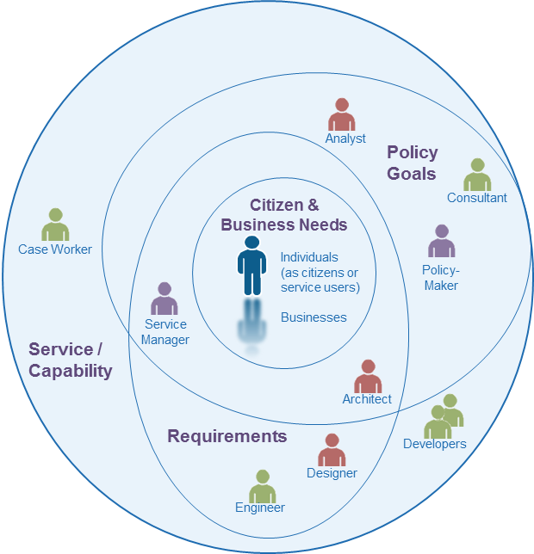
Figure 11: Landscape of some key stakeholders
This view deliberately and completely avoids the rather generic concept of ‘User’ that is dominant in traditional IT stakeholder engagement models, preferring rather to identify the different interests and concerns that are at stake (the mauve labels) and the key groups of stakeholders (the different people icons) in the development of any service.
The figure is by no means complete nor the only ‘valid’ view. It seeks instead to illustrate that the process of transformation requires reappraisal of the current set-up and assessment of what needs to change.
By clearly separating out key stakeholder groups and starting to understand and articulate their specific concerns as stakeholders (any individual’s role may vary according to context: in one situation, a person is a parent; in another, a policy-maker; or another, a service provider), we can start to understand how stakeholders relate (in different roles): to each other; to various administrations and services involved; to policy drivers and constraints; and how these all come together in a coherent ecosystem supported by a Transformational Government Framework. In this view,
- A service (or ICT capability made available as a service) is understood as responding to a set of requirements and policy goals (some of which overlap) – stakeholders concerned at this level include, for example, case workers in a public administration or developers who have worked with them in delivering a specific service;
- Requirements encapsulate and formalise vaguely stated goals and needs of citizens and businesses and take on board the policy goals of the political sponsor or champion – stakeholders at this level include, for example, managers of public service who can articulate the needs of their respective services, the information and systems architects who capture those needs as formal requirements that engineers can work with to develop services;
- Policy Goals capture the high-level concerns and priorities of the political authorities and continually assess how these goals reflect key citizen and business concerns – stakeholders include policy makers and senior management as well as consultants and analysts involved in helping identify technology and administrative trends that can be used to leverage those goals; and finally;
- Citizen and Business Needs that, ultimately, can only be fully understood by the people concerned themselves – nonetheless stakeholders at this level can also include citizen or business associations, consumer and other interest groups who engage with policy makers to advance the interests of certain groups with distinct needs and are able to articulate those needs in ways that can be used by analysts and consultants.
The various ellipses in the diagram above are deliberately not concentric circles. This is to underline that the process of establishing a service or capability is not a linear one going from needs, goals and requirements. In reality stages are often inter-related.
The mapping of stakeholders and their principal concerns at a generic level is used as a key input to the TGF reference model outlined in the next section and that needs to be validated within any TGF program. It is valuable as a tool for encouraging collaborative governance as it renders explicit many of the relationships and concerns that are often left implicit but nonetheless impact on an organisation’s ability to reflect stakeholders’ concerns.

The Stakeholder Engagement Model
However, it is not enough simply to map and understand stakeholder relationships and concerns. An effective TGF program will also address the three other dimensions of the model illustrated above:
- Stakeholder Engagement Structures: the organisational arrangements put in place to lead the transformation programme, e.g.:
central unit(s)
governance boards
- industry partnership board
- Stakeholder Engagement Processes: the processes and work flows through which the TGF Leadership and the different TGF Stakeholders interact, e.g.:
reporting and accountability processes
risk management processes
issue escalation processes
consultation processes
- collaborative product development processes.
- Stakeholder Incentives: the set of levers available to drive change through these governance structures and processes. These will vary by government, but typical levers being deployed include:
central mandates
political leadership
administrative championship
personal performance incentives for government officials
- alignment between public policy objectives and the commercial objectives of private sector partners.
There is no one right model for doing this successfully, but any conformant TGF program needs to make sure that it has used the framework above to define its own Collaborative Stakeholder Engagement Model which explicitly articulates all of these elements: a comprehensive stakeholder map, coupled with the structures, processes and incentives needed to deliver full understanding and buy-in to the program, plus effective stakeholder action in support of it.

Collaboration between TGF Programs
The model clearly focuses attention within any specific TGF program. However (and increasingly) collaboration is required also between governments and, by implication, between TGF programs.
In the figure below, we see that collaboration between TGF programs is favoured at the political, legal and organisational levels and only later, if and when necessary, at the more ‘tightly-coupled’ semantic and technical levels.
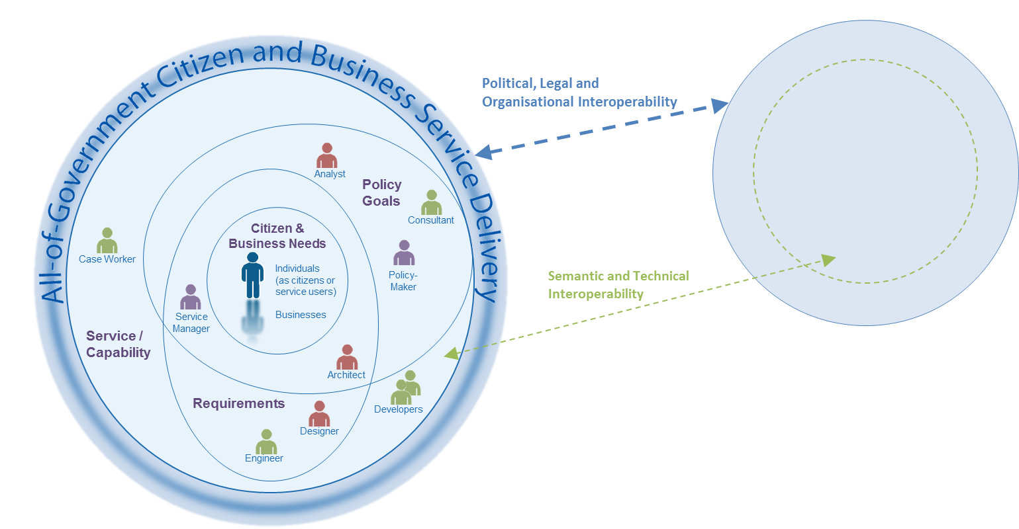
Figure 12: Collaboration between TGF programs through different levels of Interoperability
This approach is also consistent with the SOA paradigm for service development – not only are requirements defined and services offered independently of any underlying technology or infrastructure but also one TGF program can be seen (and may need to be seen) as a ‘service provider’ to another TGF program’s ‘service request’. For example, a business wishing to establish itself in a second country may need to provide authenticated information and credentials managed by government or business in the first country.
A further advantage of this approach is that it becomes easier to identify and manage high level government requirements for services: whether in the choice of ICT standards that may need to be used to address a particular technology issue or determining the criteria for awarding public procurement contracts, this approach allows a ‘loose-coupling’ at the level of clearly defined high-level policy needs rather than the more tightly-coupled and often brittle approach of specifying particular technologies, software or systems.

Common Terminology and Reference Model
In any change program of this breadth and complexity, it is vital that all stakeholders have a common understanding of the key concepts involved and how they interrelate, and have a common language to describe these in.
We therefore recommend that a TGF-conformant transformation program should seek to agree with stakeholders a common Terminology and Transformation Reference Model.

Why have a terminology and reference model?
In everyday life, we use terms – ‘citizen’, ‘need’, ‘service’ – as common, often implicitly accepted labels for concepts. The concept is the abstract mental idea (which should be universal and language independent) to which the term gives a material expression in a specific language. Particularly in an international environment such as global standardization initiatives, the distinction is important as it is common concepts that we wish to work with, not common terms.
This distinction also helps avoid common modelling pitfalls. Terms that may seem similar or the same across two or more languages may actually refer to different concepts; or a single term in one language could be understood to refer to more than one concept which another language expresses with discrete terms: For example, the English term ‘service’ can refer to different concepts - an organisational unit (such as ‘Passport Service’) or something that is performed by one for another (such as ‘a dry cleaning service’), whereas discrete terms are used for the discrete concepts in German (‘Dienst’ or ‘Dienstleistung’). As the TGF is intended for use anywhere in the world, it is important to ensure that (ideally) global concepts can be transposed and translated and thus understood in other languages: we therefore need to associate an explicit definition with each concept as we do in a dictionary. The TGF uses the structure and methodology of an existing international standard to create its terminology
Concepts do not exist in isolation, however. It is the broader understanding of the relationships between concepts that give those concepts fuller meaning and allow us to model our world, our business activities, our stakeholders, etc. in a way that increases the chance that our digital systems are an accurate reflection of our work. In information science, an ontology is a formal representation of knowledge as a set of concepts within a domain, and the relationships between those concepts. It can be used to describe the domain (the coverage should be sufficiently comprehensive to include all concepts relevant to the domain) and to reason about the domain.
The TGF does not include a formal ontology but is sufficiently clear in its concepts, definitions and relationships between concepts that the Framework will use consistently as an internally coherent set. It does include however a “reference model” that is clear enough that subsequent ontology development is possible if so desired.
The TGF Primer already includes formal definitions of key concepts used throughout the Framework and a complete terminology and reference model – that formalizes the concepts and the relationships between them – is prepared as a separate deliverable.

Transformation Business Model

Weaknesses of current models
A central task of the TGF leadership and collaborative stakeholder model is to develop a new and effective business model which enables the machinery of government to deliver citizen-centric services in practice.
It is failure to address this requirement for a new business model which, arguably, has been the greatest weakness of most traditional e-Government programmes. For the most part, the transition to e-Government has involved overlaying technology onto the existing business model of government: a business model based around unconnected silos - in which policy-making, budgets, accountability, decision-making and service delivery are all embedded within a vertically-integrated delivery chain based around specific government functions. The experience of governments around the world over the last two decades is that this simply does not work.
So what is the new business model which is required to deliver citizen service transformation? Many attempts have been made by governments to introduce greater cross-government coordination, but largely these have been "bolted on" to the underlying business model, and hence experience only limited success.

The Franchise Marketplace Model
This Framework recommends implementation of a business model which permits the joining-up of services from all parts of government and external stakeholders in a way that makes sense to citizens and businesses, yet without attempting to restructure the participating parts of government. Conceptually, this leads to a model where the existing structure of government continues to act as a supplier of services, but intermediated by a "virtual" business infrastructure based around customer needs. A top-level view of such a virtual, market-based approach to citizen service transformation is set out in the figure below:
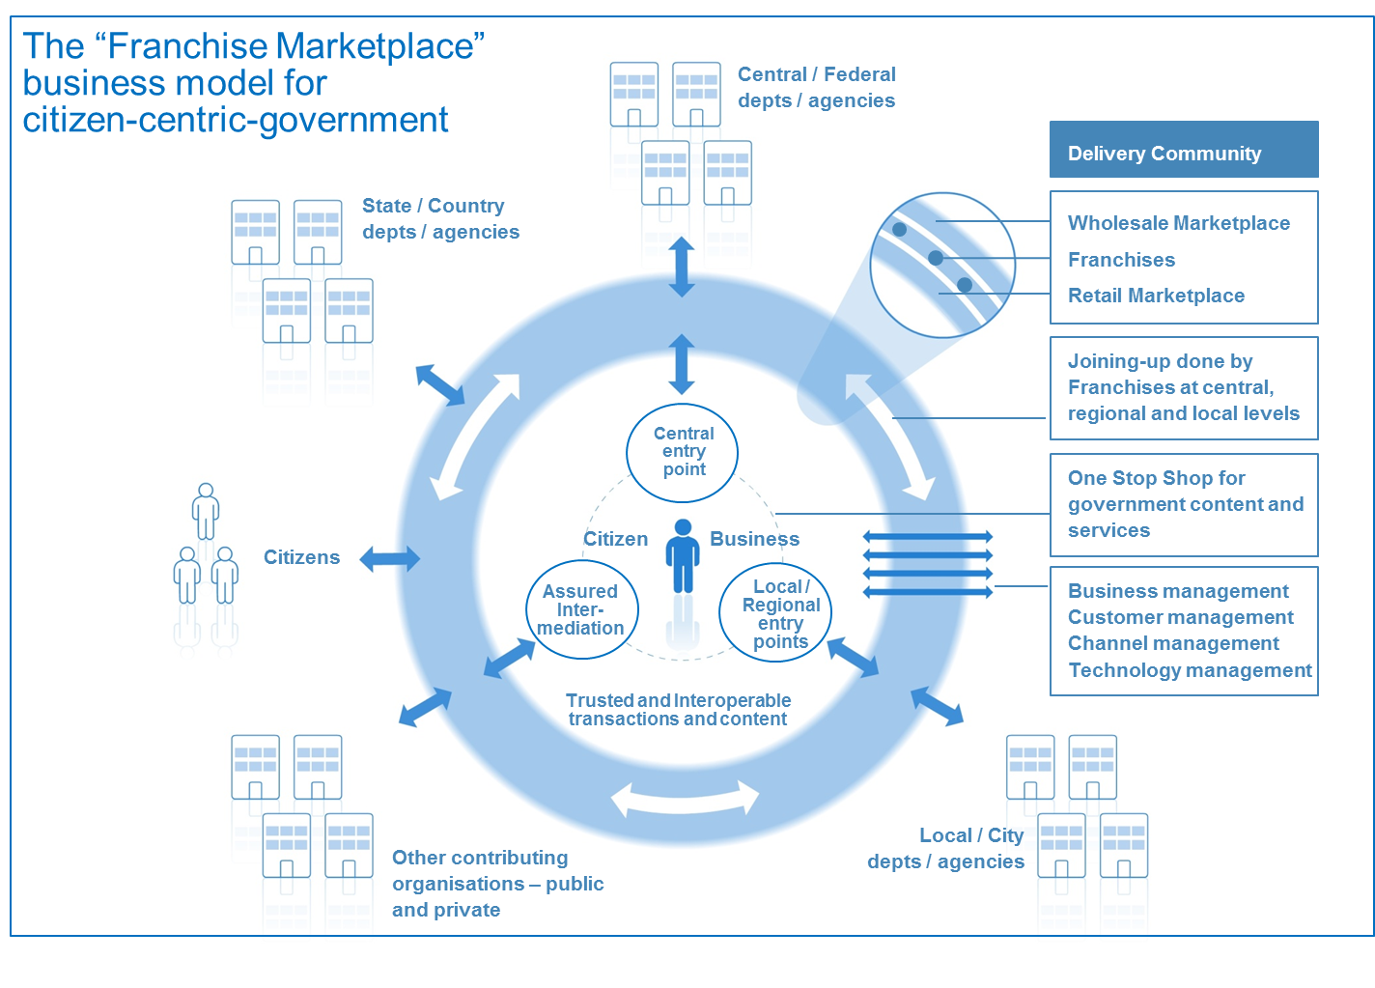
Figure 13: Overview of the Franchise Marketplace
Key features of this business model are:
- The model puts into place a number of agile cross-government virtual "franchise businesses" based around customer segments (such as, for example, parents, motorists, disabled people). These franchises are responsible for gaining full understanding of their customers' needs so that they can deliver quickly and adapt to changing requirements over time in order to deliver more customer centric services - which in turn, is proven to drive higher service take-up and greater customer satisfaction.
- Franchises provide a risk-averse operational structure that enables functionally-organised government agencies at national, regional and local to work together in a customer-focused "Delivery Community". They do this by :
- Enabling government to create a "virtual" delivery structure focused on customer needs
- Operating across the existing structure of Government (because they are led by one of the existing "silos") and resourced by organisations that have close links with the relevant customer segment including, possibly, some outside of government
- Dividing the task into manageable chunks
- Removing a single point of failure
- Working to a new and precisely-defined operating model so as to ensure consistency
- Working across and beyond government to manage the key risks to citizen-centric service delivery
- Acting as change agents inside-Government departments / agencies.
- The model enables a "mixed economy" of service provision:
- firstly, by providing a clear market framework within which private and voluntary sector service providers can repackage public sector content and services; and
- secondly by deploying ‘Web 2.0’ type approaches across government that promote re-use and ‘mash-ups’ of existing content and services, to make this simpler and cheaper at a technical level.
The whole model is capable of being delivered using Cloud Computing
This Franchise model represents an important break-through in the shift from a traditional e-Government approach towards citizen service transformation. Certainly, the model as a whole or key elements of it has been adopted successfully in governments as diverse as the UK, Hong Kong, Croatia, Abu Dhabi and Australia (where it has been adopted by both the South Australia and Queensland governments).
It is clearly possible that alternate models may develop in future. But however the Transformational Government agenda develops, every government will need to find some sort of new business model along these lines, rather than continue simply to overlay technology onto an old silo-based business model built for an un-networked world.

Enabling the Franchise Marketplace Model
A number of relationships need to be managed by a franchise to enable it to develop, maintain and deliver transformational citizen-centric services. These represent different viewpoints that can be broadly classified as:
- Customers: Those citizens and businesses to whom the franchise delivers content and services, plus those internal stakeholders to whom the franchise provides a service within the government.
- Partners: Those who are actors in the normal operation and delivery of the service, both internally and externally to the government.
- Influencers: those who have a political, business or altruistic interest in the service and the part that it plays in broader government, business and social scenarios.
Internal Customers: Those who work with the franchise to develop and maintain the service.
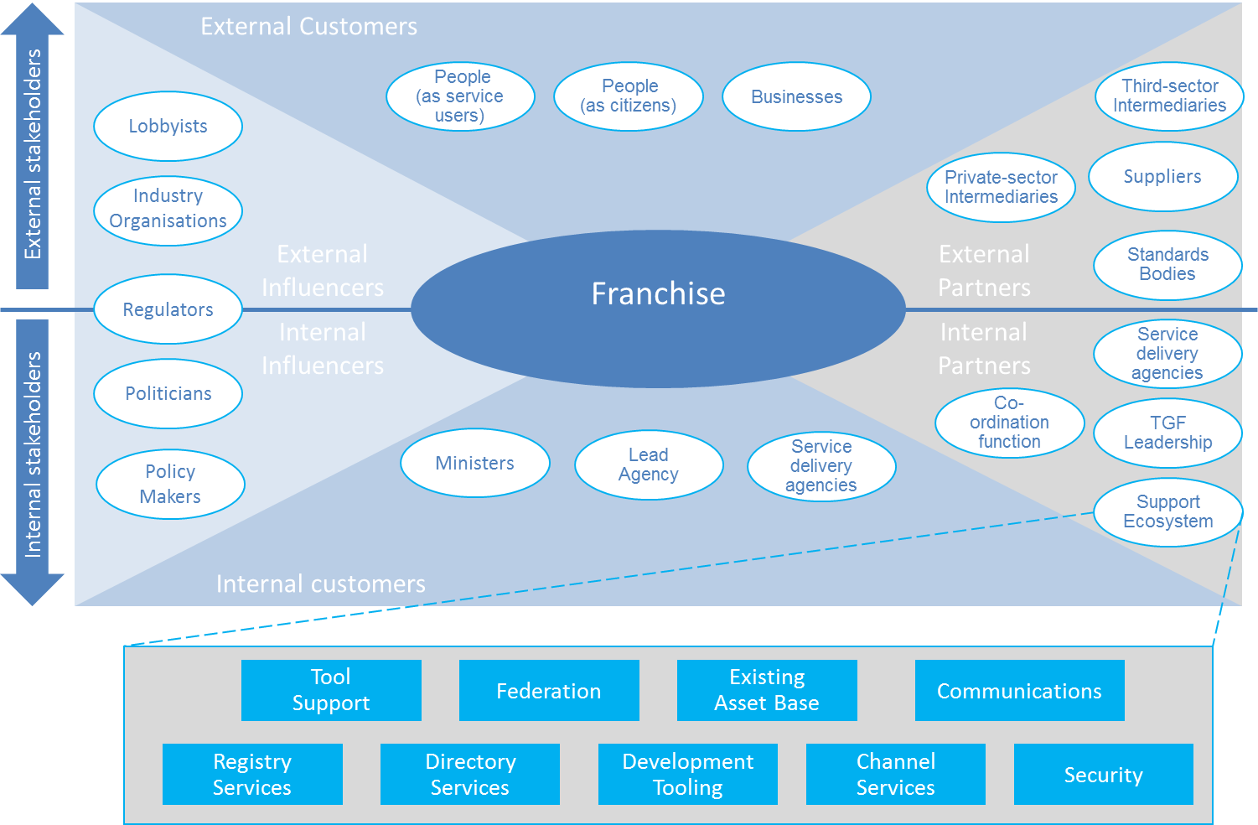
Figure 14: Relationships in the Franchise Marketplace

The Franchise
The franchise is based around a customer segment. It may contain bodies drawn from central, regional, and state government and others that contribute to serving that segment.
It MUST have a lead organisation that ensures its interests are represented to other franchises and bodies. It MUST also have sponsoring organisations that with a responsibility for the full range of service perspectives across the segment.
The franchise is responsible for ensuring that all relationships with external bodies are managed and for the provision of supporting assets necessary to allow organisations within the franchise and working with it to discharge their responsibilities in an open, consultative and transparent manner.
Despite the importance of the franchise concept, it is not intended to add unnecessary bureaucracy – rather, it is intended to provide a lightweight framework within which participants can work naturally and cooperatively.

Customers
Customers are the most important actors in operational services as the services MUST address their needs and those of the people that they represent.
Thus, as well as being users, it is essential that they are consulted during the proposal stage for all services. Once operational, this group SHOULD to be involved in customer satisfaction exercises and the development of any service enhancements to ensure that their needs continue to be met.
It is vital that Franchises identify their internal government customers and apply similar customer research and customer satisfaction measurement to these internal customer relationships as well as to external ones.

Partners
Many partners will be involved in helping the Franchise effectively to deliver the requirements of its customer segment. The partnership may involve:
- working with the franchise to develop and maintain the service
providing the supporting assets which give a technical underpinning for this and other services.
The supporting assets provide the technical underpinning for project delivery. Where they are publically owned, it is intended that they will provide light-touch governance and facilities (primarily technical) to support franchises and inter-working between them and with standards bodies.
It is essential that they ensure the provision and availability of assets that are universal (i.e. fundamental items that are required by all public sector organisations) or common (i.e. assets used across multiple franchises).
Tooling SHOULD to be provided with the aim of supporting all stakeholders and facilitating their collaboration.

Influencers
The influencers are those who identify, and possibly mandate, the need for a service. Accordingly, it is vital that they are able to steer developments within and across franchises. They also have a responsibility to ensure that all stakeholders are aligned and are organisationally capable of discharging their responsibilities.

Policy Product Management
We define a "Policy Product" as: any document which has been formally adopted on a government-wide basis in order to help achieve the goals of citizen service transformation. These documents vary in nature (from statutory documents with legal force, through mandated policies, to informal guidance and best practice) and in length (some may be very lengthy documents; others just a few paragraphs of text). Policy Products are important drivers of change within government: first because the process of producing them, if managed effectively, can help ensure strategic clarity and stakeholder buy-in; and second because they then become vital communication and management tools.
Over recent years, several governments have published a wide range of Policy Products as part of their work on Interoperability Frameworks and Enterprise Architectures, and other governments are therefore able to draw on these as reference models when developing their own Policy Products. However, we believe that the set of Policy Products required to ensure that a holistic, government -wide vision for transformation can be delivered is much broader than is currently being addressed in most Interoperability Frameworks and Enterprise Architectures.
A TGF-conformant transformation program will use the matrix shown below to create a map of the Policy Products that are needed to deliver the program effectively. This matrix maps the four delivery processes described in Component 2 of the TGF (Business Management, Customer Management, Channel Management and service-oriented Technology Management) against the five interoperability domains identified in what is currently the broadest of Interoperability Frameworks - the European Interoperability Framework (EIF): technical, semantic, organisational, legal and policy interoperability. While the EIF framework is conceptually complete, by mapping it against these core delivery processes, a much clearer sense can be gained of the actions which are needed.
The TGF Policy Product Map | Political Interoperability | Legal Interoperability | Organisational Interoperability | Semantic Interoperability | Technical Interoperability
Business Management | Strategic Business Case for overall Programme | Legal vires for inter-agency collaboration | Benefits Realisation Plan | Business Process Model | Technology roadmap
Customer Management | Identity Management Strategy | Privacy, data protection and data security legislation | Federated trust model for cross-agency identity management | Common data standards | Single sign-on architecture
Channel Management | Intermediaries Policy | Pro-competitive regulatory framework for the telecoms sector | Channel Management guidelines | Web accessibility guidelines | Presentation architecture
Technology Management | Information Security policy | Procurement legislation | Service level agreements | Physical data model | Interoperability Framework
Figure 15: A Policy Product Map completed with examples of individual policy products. Each cell in the matrix may contain one or more policy products depending on the outcome of relevant analysis
A full analysis of the Policy Products which we recommend are typically needed to deliver an effective and holistic transformation program will be included in a separate Committee Note “Tools and Models for the Business Management Framework”. Although the detailed Policy Products in that note are advisory and not all of them may be needed, any conformant transformation program MUST use the overall framework and matrix of the Policy Product Map in order to conduct at minimum a gap analysis aimed at identifying the key Policy Products needed for that government, taking the Committee Note into account as guidance.

Transformation Roadmap
Finally, it is essential that the vision, strategy, business model and policies for citizen service transformation are translated into an effective Transformation Roadmap.
Since everything can clearly not be done at once, it is vital to map out which elements of the transformation programme need to be started immediately, which can be done later, and in what order. There is no one-size-fits all strategy which governments can use, since strategy needs to be tailored to the unique circumstances of each government's situation.
However, all governments face the same strategic trade-offs: needing to ensure clear line-of-sight between all aspects of programme activity and the end outcomes which the Government is seeking to achieve, and to balance quick wins with the key steps needed to drive longer term transformation.
In the early days of the Transformational Government program, we recommend that the major strategic focus should be on safe delivery - that is, prioritising high benefit actions which help to accelerate belief and confidence across the Government and the wider stakeholder community that ICT-enabled change is possible and beneficial - but which can be delivered with very low levels of risk. As the programme develops, and an increasing number of services become available, the strategic focus can move towards building take-up: that is, building demand for online services and creating a critical mass of users. Once that critical mass starts to appear, the strategic focus can start to shift towards fuller transformation: in other words, to start driving out some of the more significant transformational benefits that high levels of service take-up enables, for example in terms of reducing the cost of government service delivery.
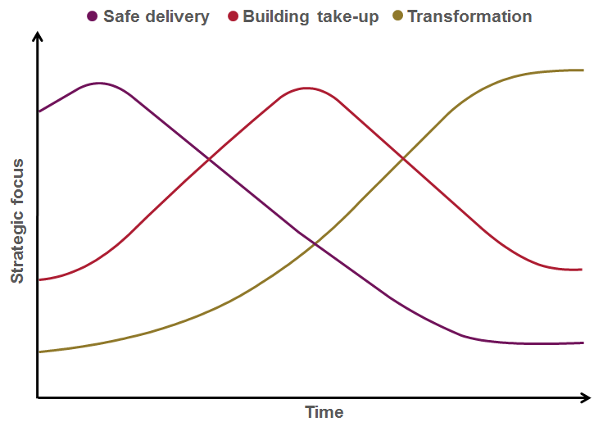
As the diagram below makes clear, these strategic foci are not mutually exclusive, but overlap. Crucially, in the Safe Delivery phase there will also be some vital steps needed in order to pave the way for longer term transformation, particularly in respect of establishing the business case for transformation, and embedding the strategy in effective governance processes. But the diagram shows how the strategic weight between each consideration should shift over time.
Figure 16: Roadmap priorities over time
Guided by the strategic trade-off framework described above, experience shows that a phased approach is the most successful. Typically, an effective Delivery Roadmap will cover five main phases.

Plan
The preparation and planning needed to develop a tailored Delivery Roadmap for the Government, to ensure that the business case for transformation is fully articulated, and that all key stakeholders are on-board. Key outputs from this phase should include:
- Transformation vision: a high level document setting out the agreed future model for transformation of our client organisation and its re-engineered business processes
- Strategic business case: the key costs and benefits associated with the transformation programme
- Delivery roadmap: a multi-year transformation plan, covering, among other things:
- A change management plan (including communication and training plans)
- Central capability building and governance processes
- A sourcing strategy
- A strategy for moving towards a service oriented ICT architecture
- A risk management strategy
- A high level benefit realisation plan, setting out the actions needed to ensure full downstream delivery of the intended benefits from the transformation programme.

Initiate
In this first phase of delivery, the focus is on building the maximum of momentum behind the Roadmap for the minimum of delivery risk. This means focusing in particular on three things:
- some early quick wins to demonstrate progress and early benefits, for a minimum of delivery risk and using little or no technology expenditure
- embedding the Roadmap in governance structures and processes which will be needed to inform all future investments, notably the frameworks of enterprise architecture, customer service standards and issue/risk management that will be required
selecting effective delivery partners.

Deliver
In this phase, some of the more significant investments start coming on stream - for example, the first version of the major "one-stop" citizen-facing delivery platforms, and the first wave of transformation projects from "champion" or "early adopter" agencies within the Government

Consolidate
In this phase, the focus shifts towards driving take-up of the initial services, expanding the initial one-stop service over more channels, learning from user feedback, and using that feedback to specify changes to the business and technology architectures being developed as longer term, strategic solutions

Transform
Finally, the program looks to build out the broader range of e-transformation projects, drive forward the migration of all major citizen-facing services towards the new one-stop channels, and complete the transition to the full strategic IT platform needed to guarantee future agility as business and customer priorities change.

Part III (b): Guidance on the TGF Customer Management Framework

Introduction
The TGF Customer Management Framework is in three main sections:
- Context
- Overview of key components in the TGF Customer Management Framework
Detailed description of and guidance on the key components

Context
The first of the Guiding Principles identified in Component 1 of the TGF is:
“Develop a detailed and segmented understanding of your citizen and business customers:
- Own the customer at the whole-of-government level;
- Don't assume you know what users of your services think - research, research, research;
- Invest in developing a real-time, event-level understanding of citizen and business interactions with government”
Putting these principles into practice involves taking a holistic, market-driven approach to every step of the service design and delivery process. This in turn often requires new skills and management practices to be brought into government. The TGF Customer Management Framework draws together best practice on how to do this.

Overview of key components in the TGF Customer Management Framework
There are three key components of the TGF Customer Management Framework:
- Brand-led Service Delivery
- Identity Management
Citizen Empowerment
A high level view of the logical relationships between these components is illustrated below.
Figure 17: Overview of the Customer Management Framework

Brand and Marketing Strategy
Marketing is critical to effective citizen service transformation, yet is something at which government traditionally does not excel. Often, marketing is fundamentally misunderstood within government - as being equivalent to advertising or perhaps, more broadly, as being equivalent to communication.
Properly understood, however, marketing is the process of:
- Understanding the target market for government services in all its breadth and complexity
- Learning what is needed in order to meet citizen needs
- Developing an offer for citizens and businesses that they will engage with
- Establishing a clear set of brand values for that offer - a set of underpinning statements that adequately describe what the product or service will deliver and how
- Delivering that offer though appropriate channels, in a way which fully delivers on the brand values
- Generating awareness about the offer
- Creating desire/demand for the offer
- Reminding people
Changing the offer in the light of experience
This is the process that a brand-led consumer product company such as Proctor and Gamble or Virgin would go through when developing a new product. However, it is not typically how governments manage their own service development, and governments generally lack the skills to do it. Moreover, the challenge faced by governments is significantly more complex than any private sector company, given the greater range and complexity of services and governments need to provide a universal service rather than pick and choose its customers. Yet if governments are to succeed in the ambition of shifting service delivery decisively away from traditional channels to lower-cost digital channels, then these marketing challenges have to be met.
And given the fact that a) citizen needs cut across organisational boundaries in government and b) the skills for delivering an effective brand-led marketing approach to service transformation will inevitably be in short supply, it is important that these challenges are addressed at a government-wide level.
A TGF-conformant Transformation Program will establish government-wide processes for managing the three core elements of the TGF Brand-led Service Delivery Framework illustrated below:
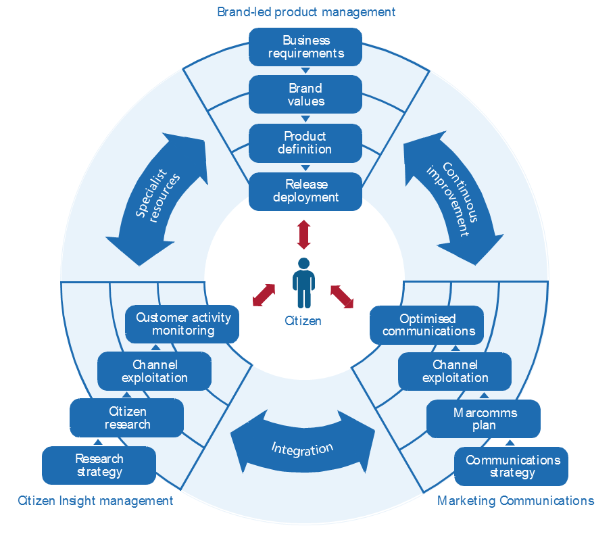
Figure 18: Brand-led Service Delivery Framework
- Citizen insight
- Brand-led product management
Marketing communications
Citizen insight must inform all aspects of the process, and involves a comprehensive programme of qualitative and quantitative research to understand and segment the customer base for government services. The learnings from this need to be fed into a brand-led product management process - not as a one-off input of initial research, but through a continuous process of iterative design and customer testing. A key output from this will be a set of brand values for the service, which then need to drive all aspects of service delivery, and marketing communications for the service.
This is an iterative process of continuous improvement, not a linear one. Continuous citizen insight research is needed to ensure that both the service delivery experience and the marcoms activity remain aligned with the brand values, through successive phases of release deployment. As the service is implemented, across a range of channels, best practice management information systems can be deployed to ensure that the Government now has real-time, event-level management information about the experience of all customers - which in turn provides a powerful feedback loop into further innovation in the service design.
Often, this will require the Government to bring in specialist resources, because typically it may face significant gaps in terms of the people and skills needed to manage brand-led product development and marketing cycles of this nature.

Identity Management
Identity management is a key enabler, yet something with which most governments struggle. At the heart of that struggle is often a failure to put the citizen at the centre of government's thinking about identity.
A wide range of agencies, standards bodies and advocacy groups are deeply involved in many aspects of this work, from technical models for privacy management (such as the OASIS PMRM technical committee) through to the business, legal and social issues around online identity assurance (such as promoted by Open Identity Exchange, OIX). It is not the purpose of the Transformational Government Framework to address the details of identity management or recommend specific policies or approaches but rather to give high-level guidance on the main issues that a conformant program should seek to address.
Identity is a complex, and by definition deeply personal, concept. As the following figure illustrates, a single citizen in fact has multiple, overlapping "identities".
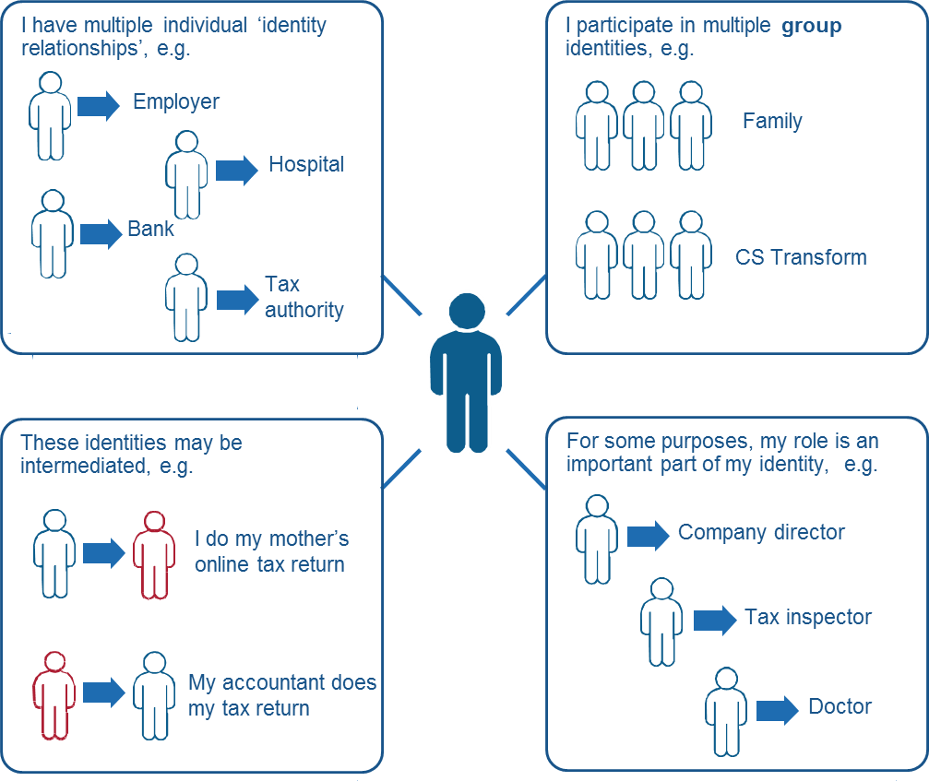
Figure 19: Complexity of identities
Each identity may be associated with different rights and permissions, even different addresses. These identities overlap, but in some cases the citizen may want to keep them separate in order to protect his or her privacy. At other times, the citizen may want them to be joined up, and be frustrated at constantly having to furnish government with the same information over and over again.
Governments have often struggled to manage this complexity. Typically, identity is defined separately in relation to each silo-based government service. Even countries which have traditionally had the simplicity of a single citizen identifier (such as Finland, where there has been a single population register since 1634), have tended to build up separate and inconsistent business processes for identity verification. Although the advent of e-Government held out the promise of significant simplification of identity management - bringing service improvement gains for the citizen and efficiency savings for the Government - significant barriers remain. These include legal barriers that have grown up over centuries of piecemeal approaches taken by public administrations (as well as, more recently, also by the private sector) and put in place often to protect individuals from the effects of equally piecemeal processes. As such the impact of any changes must be considered very carefully.
Many of the tools which governments have put in place to guarantee security in the online world (passwords, PINs, digital signatures etc), have in practice acted as barriers to take-up of online services. And attempts to join up databases to enable cross-government efficiencies and service improvements have often been met with mistrust and suspicion by citizens.
Increasingly, however, a set of best practices is emerging around the world which we believe represents a way forward for citizen service transformation, which is broadly applicable across a very wide range of governments.
Key aspects of this are:

Business Architecture
Firstly, a business architecture for identity management which is based on federation between a wide range of trusted organisations (the Government, banks, employers etc), and a clear model for cross-trust between these organisations.

Technical Architecture
Secondly, a technology architecture to support this which does not rely on monolithic and potentially vulnerable large databases, but which, in line with the SOA paradigm, uses Internet-based gateway services to act as a broker between the different databases and IT systems of participants in the federated trust model.

Citizen-centric Identity Model
Thirdly - and perhaps most importantly - a citizen service model for identity management which places citizens themselves directly in control of their own data, able to manage their own relationship with government – whether on their own behalf as citizens or in another identity relationship or intermediated role – and with clearly visible controls to reassure them that this is the case. This citizen-centric approach to identity management is illustrated in the figure below.
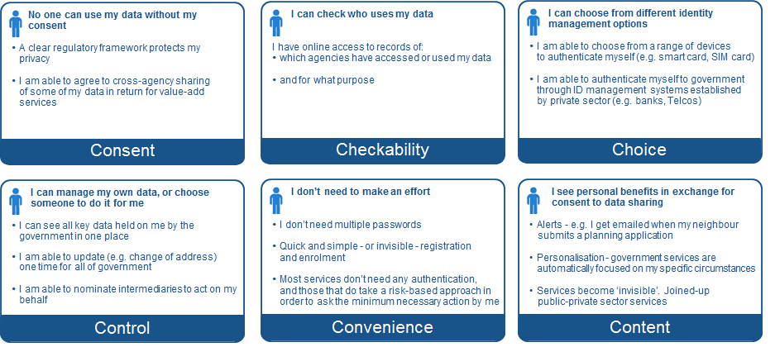
Figure 20: Overview of Citizen-Centric Identity Model
No one-Government has implemented all features of this approach, but all are being successfully deployed around the world, and together they represent our view of the approach to identity management which will best help deliver Transformational Government.

Citizen Empowerment Framework
We argued in Part I of the TGF that a defining feature of Transformational Government programs is that they focus on the "citizen" not the "customer" - that is, they seek to engage with citizens and businesses as owners of and participants in the creation of public services, not as passive recipients of services.
What does this mean in practice?
Citizen empowerment involves a set of changes which are much more fundamental than the online consultations and "e-participation" initiatives which characterised the first wave of e-Government programmes. It is also more fundamental than the application of the latest generation of technologies to government - although such technologies do have a role to play.
The key shift is to think of service delivery not as something which is done by government to citizens and businesses but as something in which they are active co-creators of services - or even where public services are delivered directly citizen-to-citizen with no or minimal government involvement. Innovators in government who are making that shift are starting to develop a wide range of new ways to create public value and enhance services, as illustrated:
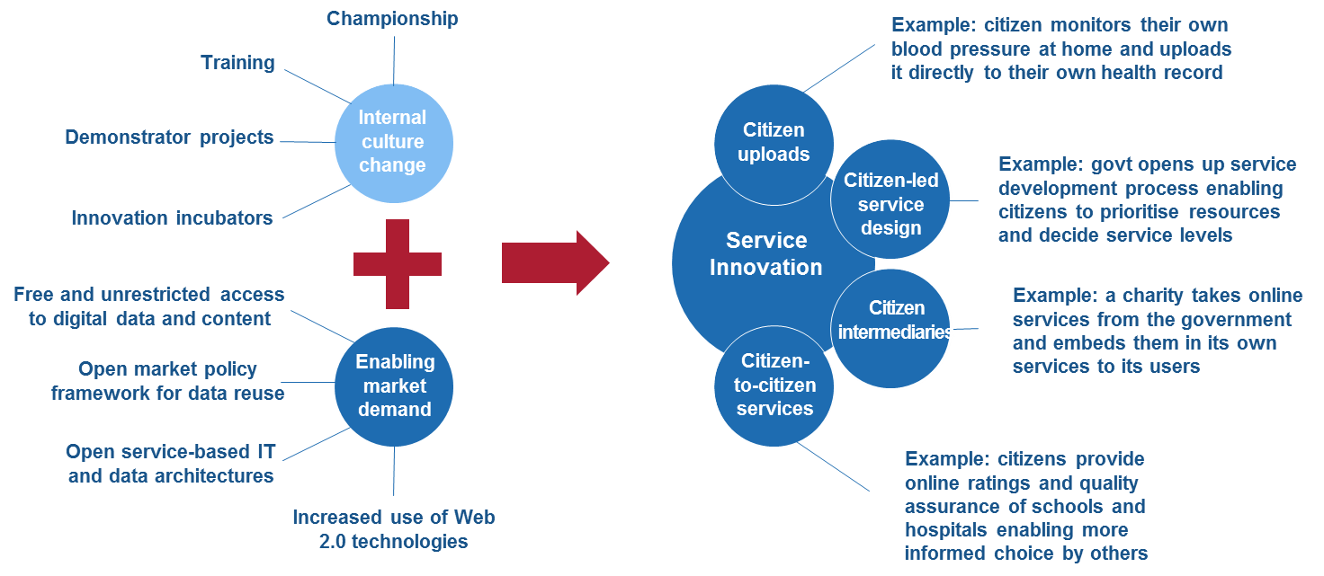
Figure 21: Overview of Citizen Empowerment Framework
This figure also highlights two important enablers of this innovation, which we believe are important to address as part of a Transformational Government program:
- Action on the supply side within government, to help create a culture of open innovation within the public sector. Such a culture change - which reflects an increasing trend in the private sector to see external ideas and collaborations as being the key to successful innovation - is particularly challenging in the public sector given the strong tradition of internal control over decision-making and policy development. So pro-active change management is essential.
- Action to enable demand-side pull by citizens and third party organisations outside-Government. Particularly important here is the principle that all non-personal data held by government should be open, public, easily reusable, and available at marginal cost - which for digital information means free. By opening up government data, content and services for reuse and repurposing by others, government can enable a level of service innovation and market reach that it could not hope to achieve on its own. Most governments also find that simply making data and content available in theory is not sufficient: in practice they also need to facilitate market-based public service delivery by:
- building a business model of rules and processes which enable a level-playing field for new market entrants (see the “Wholesale Intermediary Market” component of Part III (b))
- establishing a service-oriented technology architecture based around open standards and technologies which makes it easier in practical terms for third parties to re-purpose and repackage-Government content (see Part III (d)).

Part III (c): Guidance on the TGF Channel Management Framework

Introduction
The TGF Channel Management Framework is in two main sections:
- Context
- Overview of key components in the TGF Channel Management Framework
Detailed description of and guidance on the key components

Context
Channel management is often a weak spot in government service delivery, with widespread duplication, inefficiency and lack of user-focus. Experience has shown the common pitfalls to include:
- Managing new, digital channels as "bolt-ons", with business and technical architectures which are entirely separate from traditional face-to-face or paper-based channels
- No common view of citizen service across multiple channels
- Operational practices, unit costs and service standards for many channels which fall well below standards set for those channels in the private sector
- A reliance on government-owned channels, with insufficient understanding of how to partner with private and voluntary sector organisations who have existing trusted channels to government customers
Unproductive and costly competition among service delivery channels
Transformational Government programs seek to avoid these pitfalls, by building a channel management approach centred around the needs and behaviour of citizens and businesses.

Overview of key components in the TGF Channel Management Framework
The two key elements of the approach recommended in the Transformational Government Framework are:
- Channel Mapping: a clear audit of what existing channels are currently used to deliver government services. The TGF Channel Mapping approach includes an analysis of these channels across two key dimensions: which delivery channels are being used (‘channel mix’) and who owns them (‘channel ownership’).
- Channel Transformation Strategy: the TGF helps build a new channel management approach centred around the needs and behaviour of citizens and businesses. The key components of such an approach include:
- Channel Optimization
- Channel Shift
- Cross-Channel Management
- Development of a “mixed economy” in service provision through private and voluntary sector intermediaries.
A high level view of the logical relationships between these components is illustrated below.
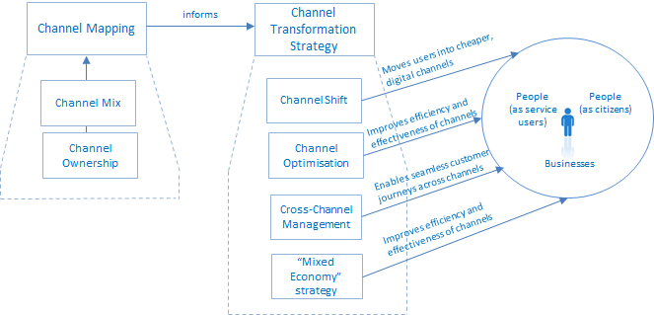
Figure 22: Overview of Channel Management Framework

Channel Mapping
A vital first step in developing a citizen-centric channel management strategy is to carry out a mapping of existing delivery channels across government, and to put a cost to each transaction delivered through these channels based on standard industry assumptions. This will highlight duplication across government (for example, having multiple high-street locations in the same town serving different government departments or agencies), and the savings that can be achieved by joining government services together and using the most efficient delivery channel in each case.
A common finding in channel audits of this type is that much customer contact between governments and citizens is unnecessary, hidden and uncosted. For example, many governments have literally thousands of public service telephone contact numbers.
Much of the contact that results between citizen or business users and the Government is therefore:
- unnecessary - because the user is struggling to find the right place to get the service they need, resulting in multiple contacts before their need is finally resolved
hidden and uncosted - because only some of these customer contacts are caught by existing management information systems. The rest are just lost within the broader operational structure and budget of government.
A clear map of customer interactions by channel, and the true costs of these, therefore provides essential data in building the business case for service transformation.
In undertaking this mapping, we recommend that a holistic approach is taken to understanding the range of channels through which government services are and could be delivered. Government services can be delivered through a wide range of different channels. It can be helpful to think of that range as varying across two key dimensions, as illustrated below:
- Channel mix: that is, the physical type of channel being used. Traditionally, channels for government service delivery have included the face-to-face channel (through high-street and other locations), traditional mail and the traditional telephone. More recently, interactive voice recognition (IVR) and the Internet have become important channels. A key distinction is the extent to which the channel is based around self-service by the citizen, or requires some form of intermediation - either in person (e.g. the citizen visiting a government office or an official visiting the citizens in the community) or remotely (e.g. by telephone or email).
Channel ownership: it is important to understand, too, the variety of "channel ownership" options which are available. Traditionally, channels for government services have been branded as belonging to a specific government agency. Increasingly, governments looking to develop a citizen-centric approach have also started to badge these on a government-wide basis: either covering a single channel (such as a national government portal), or multiple channels (such as Service Canada, which spans walk-in offices, contact centres, and the web).
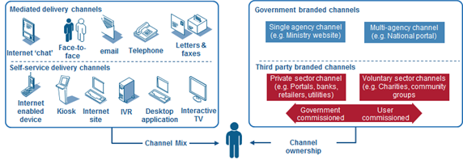
Figure 23: Overview of Channel Mapping

Channel Transformation Strategy
Once a full Channel Mapping has captured the current channel mix and cost base, it is important to map out a strategy for the future desired channel mix, and the future customer experience over different channels.
The key elements of this Channel Transformation Strategy are discussed below.

Channel Shift
Successful private-sector businesses are more effective at this than government. They understand that each channel opens up different ways to create value for customers, so they differentiate services across channels. They also take a hard-nosed approach to channel management, with customers being incentivised to use the channels that are most efficient from a business point of view. And they realise that channel shift is a complicated process, which needs planning over a multi-year period.
Transformational Government programs adopt a similar approach, setting out clear strategies for channel shift⁷. Typically though they recognise two distinct differences between the public and private sector:
- First, government has an obligation to provide services on a universal basis, so is not able to pick and choose which customers it will engage with through different channels. "Directed choice" towards cheaper channels is therefore the strategy selected for most citizen-facing services (although a number of governments are increasingly looking to make Internet-only services the norm for businesses).
Second, in terms of the online channel, government is in a unique position compared with any other online service provider. Whereas an online bank or retailer is limited by the size of the online population in the market, a government can take action significantly to increase that online population. "Digital inclusion" policies, aimed at increasing the proportion of citizens who have access to and confidence in using online channels, are therefore an important part of government channel strategies which would not normally be seen in their private-sector counterparts.

Channel optimisation
As well as seeking to shift future service delivery to an optimal channel mix, Transformational Government programs seek to optimise the performance of each individual channel. In the UK for example, a government-wide review of customer contact found that contact centre performance lagged significantly behind private sector benchmarks, and that on average operational savings of 25% could be achieved in public centre contact centres over a 3 year period by adopting best practices.

Cross-Channel Service Management
However, it is vital not to think about channel optimisation solely on a channel-by-channel basis. There are two imperatives for taking a cross-channel approach to service delivery:
- First, to improve service to citizens. Citizens do not want simply want services to be available through a choice of channels. Rather they want services to be delivered in an integrated way across channels. Transformational Government programs therefore focus on achieving an integrated view of customer interactions across all channels.
Second, to reduce costs. A shared service approach to channel management can deliver significant efficiency savings. By building channel support services around a common, web-based infrastructure, governments can both reduce costs while also facilitating joined-up services.

Development of a Mixed Economy in Service Provision
Finally, it is essential to recognise that a citizen-centric approach involves delivering services where citizens want to receive them - and this may often mean that it is important to deliver services through private or voluntary sector intermediaries.
This is particularly important as services become digitised, potentially reducing the marginal costs of delivery to near zero and hence making it easier for third party organisations to bundle public sector services with their own service offerings. This can be challenging for governments, however, since for the first time it means that they are "competing" for customers with other organisations. Establishing clear ground rules for how this sort of mixed economy of service provision should work, on a basis that will encourage private and voluntary sector organisations to become actively involved, is therefore an important task for government in creating the policy framework for Transformational Government and SHOULD be addressed using the Franchise Marketplace Model outlined above.

Part III (d): Guidance on the TGF Technology Management Framework
The TGF Technology Management Framework is in three main sections:
- Context
- Overview of key components in the TGF Technology Management Framework
Detailed description of and guidance on the key components

Context
The transformations to business, customer and channel management described above require a new approach to technology and in particular a commitment to the paradigm and principles of Service Oriented Architecture (SOA) and SOA-based infrastructure, as defined in the OASIS ‘Reference Model for Service-Oriented Architecture [SOA-RM].
Transformational Government demands a single view of the citizen or business, delivered inside an integrated business and channels architecture. In terms of ICT, all of this requires governments to learn from private-sector best practice. Industry is moving towards a model of company-wide, service-orientated enterprise architecture, where common building blocks using open standards can be re-used to enable flexible and adaptive use of technology to react quickly to changing customer needs and demands. Increasingly, companies are gaining even greater efficiency benefits by managing these building blocks as a service, provided not only from within their own ICT architecture but also from within "the Cloud" - the dynamically-scalable set of private and public computing resources now being offered as a service over the Internet.
Governments are increasingly taking this 'building block' approach to technology development. Key building blocks such as ICT infrastructure, common data sets, and identity verification need to be co-ordinated effectively. While much can be learned from the private sector, simply importing industry practices will not solve this coordination problem within government.
Governments are taking different approaches to the co-ordination function: some build central infrastructure for use by all departments and agencies; others identify lead departments to build and implement common solutions; others have a more decentralised approach, allowing departments to develop their own solutions according to a common architecture and standard set. However, finding an effective approach which works within a specific government is vital, since without this sort of technology flexibility, then Transformational Government becomes impossible - or possible only at great expense and with significant wasteful and duplicated ICT expenditure.

Overview of key components in the TGF Technology Management Framework
The Technology Management Framework is modelled as one of the four TGF delivery processes, but it is concerned with more than “just” the delivery of services using ICT. Its focus on the SOA paradigm is key to an approach that puts citizens and businesses as customers at the centre of a service ecosystem with many stakeholders, roles and systems involved.
The three key elements of the approach recommended in the Transformational Government Framework are:
- Resources Management which underpins ecosystem governance
- Ecosystem Participation
Realisation and governance of SOA-based ICT systems
A high level view of the logical relationships between these components is illustrated below.
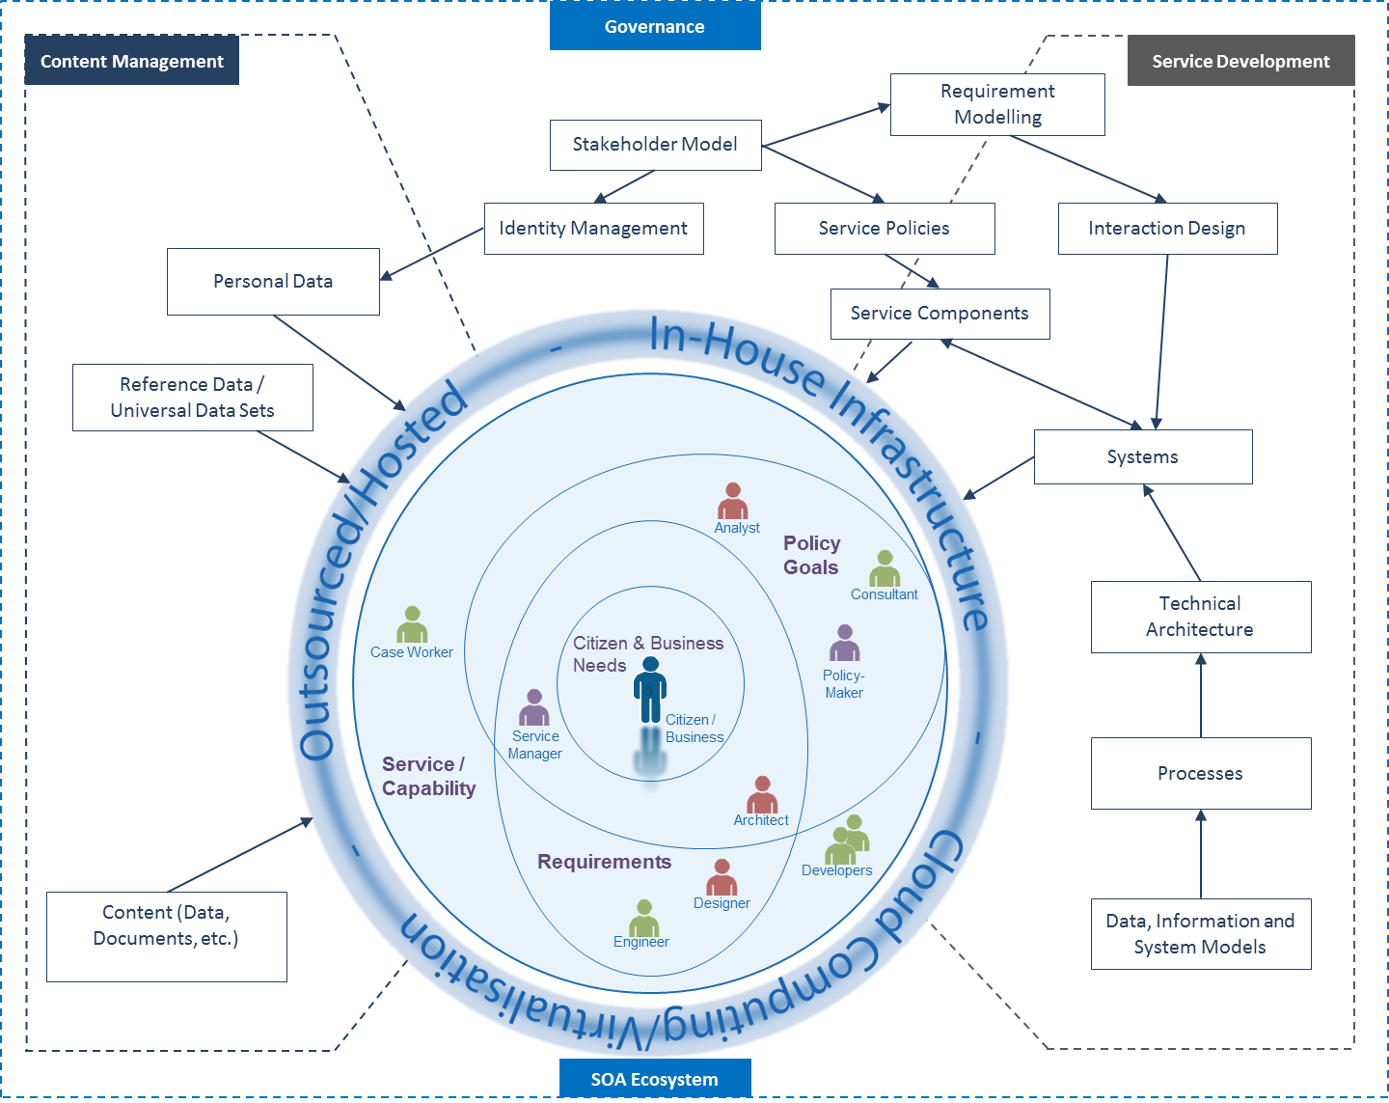
Figure 24: Overview of Technology Management Framework

Resources Management
This entails the explicit identification and management of resources as valued assets, whether information resources (data sets, documents, models, processes, etc.) and technology ‘soft products’ (systems, applications and services.

Eco-system Participation
Best practice technology management requires a clear model and understanding of the stakeholders, actors and systems that comprise the overall service ecosystem and their relationships to each other. The model must be maintained and updated as stakeholders change over time and over the course of any development effort thus ensuring that requirements are continually evaluated and revised.

Citizens and businesses, as potential customers, must be understood as stakeholders in the ecosystem with ‘needs’ (often imprecisely formulated) that they seek to satisfy through use of a service; but citizens and businesspeople are also human actors interacting with pieces of technology in precisely-defined interactions. These system-focussed interactions are a result of accurately modelling the processes required of both system and user in order to deliver a particular service capability conforming to explicit ‘requirements’. Requirements in turn are revised and updated to reflect changes in stakeholder composition and concerns.
Stakeholders are clearly distinguished and modelled – including the fact that they play different roles in different contexts (and which therefore has implications for role-based authentication). Stakeholder composition is also a good predictor of project risk – understand and modelling stakeholder types helps identify and mitigate risk. Stakeholder modelling underlines that every participant in an ICT development project is implicitly an intermediary representing diverse stakeholder interests in the deployed service.

SOA-based system realisation and governance
Service-Oriented Architecture (SOA) must be understood in its broadest sense – as a paradigm for organising and using capabilities distributed and managed across different ownership domains. In this sense, SOA is technology and platform agnostic and thus provides an appropriate foundation for the technology management framework.
Disparate systems are weaved together as part of a coherent ecosystem while specific ‘services’, broken down into functional components, are identifiable as distinct from the underlying technologies that deliver them. This encourages ecosystem agility, allowing services to be mixed and matched, composed and re-used – it remains agile and flexible without being brittle, as with many systems where service functionality is tailored and tightly-coupled to addressing a specific problem. Ownership and governance – of information resources as well as ICT products – is federated across ownership boundaries and explicit service descriptions and contracts ensure that everyone knows the ‘rules of engagement and use’ when using any service.
Key concerns of such an approach include:
- SOA technical architecture and component service (“building block”) realisation and re-use;
- Service policies;
- Identity Management;
- Cloud Computing (Service and Infrastructure Virtualisation);
- Interaction Design, based on end-user needs

Acknowledgements
The following individuals have participated in the creation of this specification and are gratefully acknowledged:
Participants:
Hans Aanesen, Individual Member
Oliver Bell, Microsoft Corporation
John Borras, Individual Member
Peter F Brown, Individual Member
Bill Edwards, CS Transform Ltd
Chet Ensign, Individual Member
Nig Greenaway, Fujitsu Ltd
Ted Haas, GS1
Andy Hopkirk, Individual Member
Gershon Janssen, Individual Member
Arnaud Martens, Belgian SPF Finances
Steve Mutkoski, Microsoft Corporation
Monica Palmirani, University of Bologna
Chris Parker, CS Transform Ltd
John Ross, Individual Member
Pothiraj Selvaraj, GCE
Trond Arne Undheim, Oracle Corporation
Colin Wallis, New Zealand Government
David Webber, Oracle Corporation
Joe Wheeler, MTG Management Consultants, LLC
Takao Yamasaki, Nomura Research Institute

Revision History
17-03-2011: (compared to Working Draft 02) Finalised remaining edits agreed by TC at adoption; Update of ToC; Numbering of Figures

European Interoperability Framework (EIF) for European public services, see http://ec.europa.eu/isa/strategy/doc/annex_ii_eif_en.pdf
Federal Enterprise Architecture, see http://www.whitehouse.gov/omb/e-gov/fea/
See the UK Government’s white paper “Transformational Government – enabled by technology”, Cabinet Office, 2005
The Association of Southeast Asian Nations
The Inter-American Development Bank
Source: e-Government Economics Project
IT Outlook 2006, OECD
‘Identity Management’ is correctly termed ‘Identity Information Management’ as identity itself is not technically managed but intrinsic to us as humans. It is often shortened to Identity Management, which will be used throughout.
PRINCE2 is a process-based approach for project management, providing an easily tailored and scalable project management methodology for the management of all types of projects. The method is the de-facto standard for project management in the UK and is practiced worldwide. It is in the public domain, offering non-proprietorial best practice guidance on project management. PRINCE2 is a registered trademark of the UK government’s Office of Government Commerce.
The Skills Framework for the Information Age (SFIA) provides a common reference model for the identification of the skills needed to develop effective Information Systems (IS) making use of ICT, enabling employers of ICT professionals to carry out a range of HR activities against a common framework of reference - including skill audit, planning future skill requirements, development programmes, standardisation of job titles and functions, and resource allocation. The Skills Framework for the Information Age is owned by The SFIA Foundation: www.SFIA.org.uk.
This is central to all multi-lingual thesauri, for example, where the core item of organisation is the concept, not the term.
“Terminology work – Vocabulary – Part 1: Theory and application” [ISO 1087-1:2000]
See http://www.oasis-open.org/committees/tc_home.php?wg_abbrev=pmrm
See http://openidentityexchange.org/
Service Transformation: A better service for citizens and businesses, a better deal for taxpayers, see http://webarchive.nationalarchives.gov.uk/+/http://www.hm-treasury.gov.uk/media/4/F/pbr06_varney_review.pdf

