
OASIS Committee Note

PKCS #11 Cryptographic Token Interface Usage Guide Version 3.2
Committee Note 01
15 April 2025
This stage:
https://docs.oasis-open.org/pkcs11/pkcs11-ug/v3.2/cn01/pkcs11-ug-v3.2-cn01.docx (Authoritative)
https://docs.oasis-open.org/pkcs11/pkcs11-ug/v3.2/cn01/pkcs11-ug-v3.2-cn01.html
https://docs.oasis-open.org/pkcs11/pkcs11-ug/v3.2/cn01/pkcs11-ug-v3.2-cn01.pdf
Previous stage:
N/A
Latest stage:
https://docs.oasis-open.org/pkcs11/pkcs11-ug/v3.2/pkcs11-ug-v3.2.docx (Authoritative)
https://docs.oasis-open.org/pkcs11/pkcs11-ug/v3.2/pkcs11-ug-v3.2.html
https://docs.oasis-open.org/pkcs11/pkcs11-ug/v3.2/pkcs11-ug-v3.2.pdf
Technical Committee:
OASIS PKCS 11 TC
Chairs:
Valerie Fenwick (vfenwick@apple.com), Apple,Inc
Robert Relyea (rrelyea@redhat.com). RedHat
Editor:
Dieter Bong (Dieter.Bong@utimaco.com), Utimaco
Additional artifacts:
- none
Related work:
This document replaces or supersedes:
- PKCS #11 Usage Guide Version 2.40. Edited by Robert Griffin and Valerie Fenwick. OASIS Standard. Latest stage: https://docs.oasis-open.org/pkcs11/pkcs11-ug/v2.40/pkcs11-ug-v2.40.html
This document is related to:
- PKCS #11 Specification Version 3.2. Edited by Dieter Bong and Greg Scott. OASIS Standard. Latest stage: https://docs.oasis-open.org/pkcs11/pkcs11-spec/v3.2/pkcs11-spec-v3.2.html
- PKCS #11 Profiles Version 3.2. Edited by Tim Hudson. Latest stage: https://docs.oasis-open.org/pkcs11/pkcs11-profiles/v3.2/pkcs11-profiles-v3.2.html
Abstract:
This document provides guidance on using PKCS #11 Version 3.20.
Status:
This is a Non-Standards Track Work Product. The patent provisions of the OASIS IPR Policy do not apply.
This document was last revised or approved by the OASIS PKCS 11 TC on the above date. The level of approval is also listed above. Check the "Latest stage" location noted above for possible later revisions of this document. Any other numbered Versions and other technical work produced by the Technical Committee (TC) are listed at https://groups.oasis-open.org/communities/tc-community-home2?CommunityKey=922ef643-1e10-4d65-a5ea-018dc7d3f0a4
TC members should send comments on this document to the TC's email list. Others should send comments to the TC's public comment list, after subscribing to it by following the instructions at: https://groups.oasis-open.org/communities/community-home?CommunityKey=05ce61d8-21dd-4bd1-bf18-018f5aa80127
Citation format:
When referencing this document, the following citation format should be used:
[PKCS11-UG-v3.2]
PKCS #11 Cryptographic Token Interface Usage Guide Version 3.2. Edited by Dieter Bong. 15 April 2025. OASIS Committee Note 01. https://docs.oasis-open.org/pkcs11/pkcs11-ug/v3.2/cn01/pkcs11-ug-v3.2-cn01.html Latest stage: https://docs.oasis-open.org/pkcs11/pkcs11-ug/v3.2/pkcs11-ug-v3.2.html.
Notices:
Copyright © OASIS Open 2025. All Rights Reserved.
Distributed under the terms of the OASIS IPR Policy, [https://www.oasis-open.org/policies-guidelines/ipr/]. For complete copyright information please see the Notices section in the Appendix.
Table of Contents
1 Introduction 4
1.1 Changes from earlier Versions 4
1.2 Glossary 4
2 General overview 5
2.1 Introduction 5
2.2 General model 5
2.3 Logical view of a token 6
2.4 Users 7
2.5 Applications and their use of Cryptoki 7
2.5.1 General Guidance 7
2.5.2 Applications and processes 7
2.5.3 Applications and threads 8
2.6 Sessions 8
2.6.1 General Guidance 8
2.6.2 Read-only session states 9
2.6.3 Read/write session states 9
2.6.4 Permitted object accesses by sessions 10
2.6.5 Session events 11
2.6.6 Session handles and object handles 11
2.6.7 Capabilities of sessions 12
2.6.8 Example of use of sessions 12
3 Security considerations 14
3.1 General Guidance 14
3.2 Padding Oracle Attacks 14
4 Cryptoki tips and reminders 15
4.1 Operations, sessions, and threads 15
4.2 Multiple application access behavior 15
4.3 Objects, attributes, and templates 15
4.4 Signing with recovery 16
Appendix A. Informative References 17
Appendix B. Acknowledgments 18
B.1 Special Thanks 18
B.2 Participants 18
Appendix C. Revision History 19
Appendix D. Notices 20

Introduction
This document complements [PKCS11-Spec-v3.2], [PKCS11-Hist-v3.0] and [PKCS11-Prof-v3.2] by providing guidance on how to implement the PKCS #11 interface most effectively. In particular, it includes the following guidance:
- General overview information and clarification of assumptions and requirements that drive or influence the design of PKCS #11 and the implementation of PKCS #11-compliant solutions.
- Specific recommendations for implementation of selected PKCS #11 functionality.
Guidance regarding conformant PKCS #11 implementations is provided in [PKCS11-Prof-v3.2].

Changes from earlier Versions
This version of the PKCS #11 Usage Guide is a resumption of the Usage Guide version 2.40, now based on current PKCS #11 specification and profiles version 3.2. It omits outdated information about comparison of Cryptoki and other APIs, and deprecated PKCS #11 functionality though.

Glossary
For a list of terms, acronyms, abbreviations and conventions, refer to [PKCS11-Spec-v3.2].

General overview

Introduction
Portable computing devices such as smart cards, USB token and Hardware Security Modules are ideal tools for implementing public-key cryptography, as they provide a way to store the private-key component of a public-key/private-key pair securely, under the control of a single user. With such a device, a cryptographic application, rather than performing cryptographic operations itself, utilizes the device to perform the operations, with sensitive information such as private keys never being revealed. As more applications are developed for public-key cryptography, a standard programming interface for these devices becomes increasingly valuable. This standard addresses this and other needs.

General model
Cryptoki's general model is illustrated in the following figure. The model begins with one or more applications that need to perform certain cryptographic operations, and ends with one or more cryptographic devices, on which some or all the operations are actually performed. A user may or may not be associated with an application.
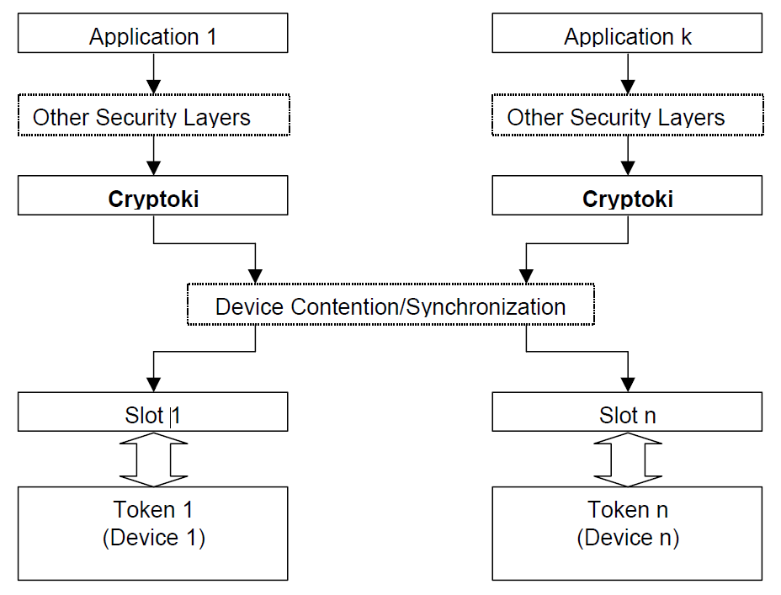
Figure 1, General Cryptoki model
Cryptoki provides an interface to one or more cryptographic devices that are active in the system through a number of “slots”. Each slot, which corresponds to a physical reader or other device interface, may contain a token. A token is typically “present in the slot” when a cryptographic device is present in the reader. Of course, since Cryptoki provides a logical view of slots and tokens, there may be other physical interpretations. It is possible that multiple slots may share the same physical reader. The point is that a system has some number of slots, and applications can connect to tokens in any or all those slots.
A cryptographic device can perform some cryptographic operations, following a certain command set; these commands are typically passed through standard device drivers, for instance PCI Express card services or socket services. Cryptoki makes each cryptographic device look logically like every other device, regardless of the implementation technology. Thus, the application need not interface directly to the device drivers (or even know which ones are involved); Cryptoki hides these details. Indeed, the underlying “device” may be implemented entirely in software (for instance, as a process running on a server)—no special hardware is necessary.
Cryptoki is likely to be implemented as a library supporting the functions in the interface, and applications will be linked to the library. An application may be linked to Cryptoki directly; alternatively, Cryptoki can be a so-called “shared” library (or dynamic link library), in which case the application would link the library dynamically. Shared libraries are fairly straightforward to produce in operating systems such as Microsoft Windows, and can be achieved without too much difficulty in UNIX and Linux systems.
The dynamic approach certainly has advantages as new libraries are made available, but from a security perspective, there are some drawbacks. In particular, if a library is easily replaced, then there is the possibility that an attacker can substitute a rogue library that intercepts a user’s PIN. From a security perspective, therefore, direct linking is generally preferable, although code-signing techniques can prevent many of the security risks of dynamic linking. In any case, whether the linking is direct or dynamic, the programming interface between the application and a Cryptoki library remains the same.
The kinds of devices and capabilities supported will depend on the particular Cryptoki library. This standard specifies only the interface to the library, not its features. In particular, not all libraries will support all the mechanisms (algorithms) defined in this interface (since not all tokens are expected to support all the mechanisms), and libraries will likely support only a subset of all the kinds of cryptographic devices that are available. (The more kinds, the better, of course, and it is anticipated that libraries will be developed supporting multiple kinds of token, rather than just those from a single vendor.) It is expected that as applications are developed that interface to Cryptoki, standard library and token “profiles” will emerge.

Logical view of a token
Cryptoki’s logical view of a token is a device that stores objects and can perform cryptographic functions. Cryptoki defines three classes of object: data, certificates, and keys. A data object is defined by an application. A certificate object stores a certificate. A key object stores a cryptographic key. The key may be a public key, a private key, or a secret key; each of these types of keys has subtypes for use in specific mechanisms. This view is illustrated in the following figure:
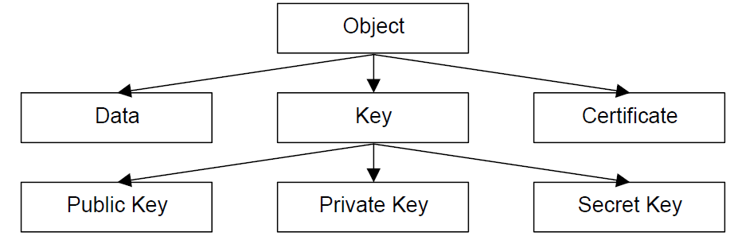
Figure 2, Object Hierarchy
Objects are also classified according to their lifetime and visibility. “Token objects” are visible to all applications connected to the token that have sufficient permission, and remain on the token even after the “sessions” (connections between an application and the token) are closed and the token is removed from its slot. “Session objects” are more temporary: whenever a session is closed by any means, all session objects created by that session are automatically destroyed. In addition, session objects are only visible to the application which created them.
Further classification defines access requirements. Applications are not required to log into the token to view “public objects”; however, to view “private objects”, a user must be authenticated to the token by a PIN or some other token-dependent method (for example, a biometric device). A token can create and destroy objects, manipulate them, and search for them. It can also perform cryptographic functions with objects. A token may have an internal random number generator.
It is important to distinguish between the logical view of a token and the actual implementation, because not all cryptographic devices will have this concept of “objects,” or be able to perform every kind of cryptographic function. Many devices will simply have fixed storage places for keys of a fixed algorithm and be able to do a limited set of operations. Cryptoki's role is to translate this into the logical view, mapping attributes to fixed storage elements and so on. Not all Cryptoki libraries and tokens need to support every object type. It is expected that standard “profiles” will be developed, specifying sets of algorithms to be supported.
“Attributes” are characteristics that distinguish an instance of an object. In Cryptoki, there are general attributes, such as whether the object is private or public. There are also attributes that are specific to a particular type of object, such as a modulus or exponent for RSA keys.

Users
This version of Cryptoki recognizes two token user types. One type is a Security Officer (SO). The other type is the normal user. Only the normal user is allowed access to private objects on the token, and that access is granted only after the normal user has been authenticated. Some tokens may also require that a user be authenticated before any cryptographic function can be performed on the token, whether or not it involves private objects. The role of the SO is to initialize a token and to set the normal user’s PIN (or otherwise define, by some method outside the scope of this version of Cryptoki, how the normal user may be authenticated), and possibly to manipulate some public objects. The normal user cannot log in until the SO has set the normal user’s PIN.
Other than the support for two types of users, Cryptoki does not address the relationship between the SO and a community of users. In particular, the SO and the normal user may be the same person or may be different, but such matters are outside the scope of this standard.
With respect to PINs that are entered through an application, Cryptoki assumes only that they are variable-length strings of characters from the set in [PKCS11-Spec-v3.2] Table 3. Any translation to the device’s requirements is left to the Cryptoki library. The following issues are beyond the scope of Cryptoki:
- Any padding of PINs.
- How the PINs are generated (by the user, by the application, or by some other means).
PINs that are supplied by some means other than through an application (e.g., PINs entered via a PIN pad on the token) are even more abstract. Cryptoki knows how to wait (if need be) for such a PIN to be supplied and used, and little more.

Applications and their use of Cryptoki

General Guidance
To Cryptoki, an application consists of a single address space and all the threads of control running in it. An application becomes a “Cryptoki application” by calling the Cryptoki function C_Initialize from one of its threads; after this call is made, the application can call other Cryptoki functions. When the application has finished using Cryptoki, it calls the Cryptoki function C_Finalize and ceases to be a Cryptoki application.

Applications and processes
In general, on most platforms, the previous paragraph means that an application consists of a single process.
Consider a UNIX process P which becomes a Cryptoki application by calling C_Initialize, and then uses the fork() system call to create a child process C. Since P and C have separate address spaces (or will when one of them performs a write operation, if the operating system follows the copy-on-write paradigm), they are not part of the same application. Therefore, if C needs to use Cryptoki, it needs to perform its own C_Initialize call. Furthermore, if C needs to be logged into the token(s) that it will access via Cryptoki, it needs to log into them even if P is already logged in, since P and C are separate applications.
In this particular case (when C is the child of a process which is a Cryptoki application), the behavior of Cryptoki is undefined if C tries to use it without its own C_Initialize call. Ideally, such an attempt would return the value CKR_CRYPTOKI_NOT_INITIALIZED; however, because of the way fork() works, insisting on this return value might have a bad impact on the performance of libraries. Therefore, the behavior of Cryptoki in this situation is left undefined. Applications should definitely not attempt to take advantage of any potential “shortcuts” which might (or might not!) be available because of this.
In the scenario specified above, C should actually call C_Initialize whether or not it needs to use Cryptoki; if it has no need to use Cryptoki, it should then call C_Finalize immediately thereafter. This (having the child immediately call C_Initialize and then call C_Finalize if the parent is using Cryptoki) is considered to be good Cryptoki programming practice, since it can prevent the existence of dangling duplicate resources that were created at the time of the fork() call; however, it is not required by Cryptoki.

Applications and threads
Some applications will access a Cryptoki library in a multi-threaded fashion. Cryptoki enables applications to provide information to libraries so that they can give appropriate support for multi-threading. In particular, when an application initializes a Cryptoki library with a call to C_Initialize, it can specify one of four possible multi-threading behaviors for the library:
- The application can specify that it will not be accessing the library concurrently from multiple threads, and so the library need not worry about performing any type of locking for the sake of thread-safety.
- The application can specify that it will be accessing the library concurrently from multiple threads, and the library must be able to use native operation system synchronization primitives to ensure proper thread-safe behavior.
- The application can specify that it will be accessing the library concurrently from multiple threads, and the library must use a set of application-supplied synchronization primitives to ensure proper thread-safe behavior.
- The application can specify that it will be accessing the library concurrently from multiple threads, and the library must use either the native operating system synchronization primitives or a set of application-supplied synchronization primitives to ensure proper thread-safe behavior.
The 3rd and 4th types of behavior listed above are appropriate for multi-threaded applications that are not using the native operating system thread model. The application-supplied synchronization primitives consist of four functions for handling mutex (mutual exclusion) objects in the application’s threading model. Mutex objects are simple objects that can be in either of two states at any given time: unlocked or locked. If a call is made by a thread to lock a mutex that is already locked, that thread blocks (waits) until the mutex is unlocked; then it locks it and the call returns. If more than one thread is blocking on a particular mutex, and that mutex becomes unlocked, then exactly one of those threads will get the lock on the mutex and return control to the caller (the other blocking threads will continue to block and wait for their turn).
See [PKCS11-Spec-v3.2] section 5.1.5 for more information on Cryptoki’s view of mutex objects.
In addition to providing the above thread-handling information to a Cryptoki library at initialization time, an application can also specify whether or not application threads executing library calls may use native operating system calls to spawn new threads.

Sessions

General Guidance
Cryptoki requires that an application open one or more sessions with a token to gain access to the token’s objects and functions. A session provides a logical connection between the application and the token. A session can be a read/write (R/W) session or a read-only (R/O) session. Read/write and read-only refer to the access to token objects, not to session objects. In both session types, an application can create, read, write and destroy session objects, and read token objects. However, only in a read/write session can an application create, modify, and destroy token objects.
After it opens a session, an application has access to the token’s public objects. All threads of a given application have access to exactly the same sessions and the same session objects. To gain access to the token’s private objects, the normal user must log in and be authenticated.
When a session is closed, any session objects which were created in that session are destroyed. This holds even for session objects that are “being used” by other sessions. That is, if a single application has multiple sessions open with a token, and it uses one of them to create a session object, then that session object is visible through any of that application’s sessions. However, as soon as the session that was used to create the object is closed, that object is destroyed.
Cryptoki supports multiple sessions on multiple tokens. An application may have one or more sessions with one or more tokens. In general, a token may have multiple sessions with one or more applications. A particular token may allow an application to have only a limited number of sessions—or only a limited number of read/write sessions-- however.
An open session can be in one of several states. The session state determines allowable access to objects and functions that can be performed on them. The session states are described in section 2.6.2 and section 2.6.3.

Read-only session states
A read-only session can be in one of two states, as illustrated in the following figure. When the session is initially opened, it is in either the “R/O Public Session” state (if the application has no previously open sessions that are logged in) or the “R/O User Functions” state (if the application already has an open session that is logged in). Note that read-only SO sessions do not exist. Read-only sessions that are open while the SO is logged in behave identically to the "R/O Public Session" state.
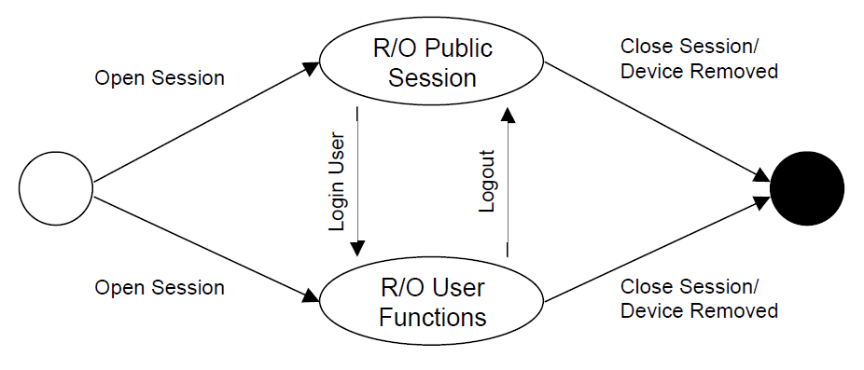
Figure 3, Read-Only session states
The following table describes the session states:
Table 1, Read-Only Session States
State | Description
R/O Public Session | The application has opened a read-only session. The application has read-only access to public token objects and read/write access to public session objects.
R/O User Functions | The normal user has been authenticated to the token. The application has read-only access to all token objects (public or private) and read/write access to all session objects (public or private).

Read/write session states
A read/write session can be in one of three states, as illustrated in the following figure. When the session is opened, it is in either the “R/W Public Session” state (if the application has no previously open sessions that are logged in), the “R/W User Functions” state (if the application already has an open session that the normal user is logged into), or the “R/W SO Functions” state (if the application already has an open session that the SO is logged into).
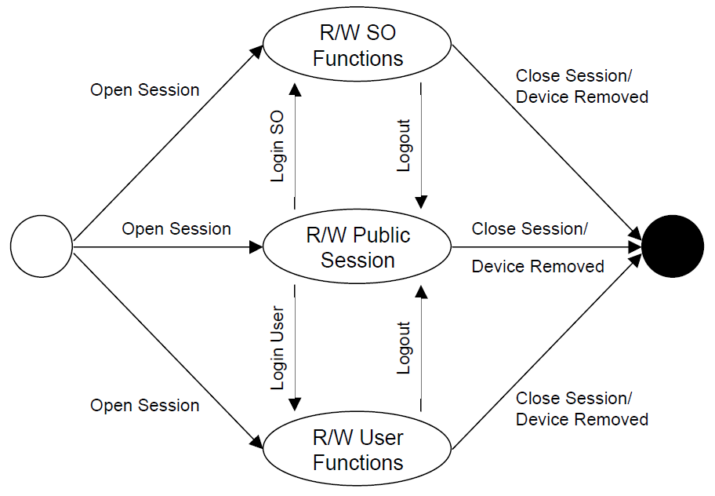
Figure 4, Read-Write session states
The following table describes the session states:
Table 2, Read-Write Session States
State | Description
R/W Public Session | The application has opened a read/write session. The application has read/write access to all public objects.
R/W SO Functions | The Security Officer has been authenticated to the token. The application has read/write access only to public objects on the token, not to private objects. The SO can set the normal user’s PIN.
R/W User Functions | The normal user has been authenticated to the token. The application has read/write access to all objects.

Permitted object accesses by sessions
The following table summarizes the kind of access each type of session has to each type of object. A given type of session has either read-only access, read/write access, or no access whatsoever to a given type of object.
Note that creating or deleting an object requires read/write access to it, e.g., a “R/O User Functions” session cannot create or delete a token object.
Table 3, Access to different types of objects by different types of sessions
Type of object | Type of session
 | R/O Public | R/W Public | R/O User | R/W User | R/W SO
Public session object | R/W | R/W | R/W | R/W | R/W
Private session object |  |  | R/W | R/W
Public token object | R/O | R/W | R/O | R/W | R/W
Private token object |  |  | R/O | R/W
As previously indicated, the access to a given session object which is shown in Table 3 is limited to sessions belonging to the application which owns that object (i.e., which created that object).

Session events
Session events cause the session state to change. The following table describes the events:
Table 4, Session events
Event | Occurs when...
Log In SO | the SO is authenticated to the token.
Log In User | the normal user is authenticated to the token.
Log Out | the application logs out the current user (SO or normal user).
Close Session | the application closes the session or closes all sessions.
Device Removed | the device underlying the token has been removed from its slot.
When the device is removed, all sessions of all applications are automatically logged out. Furthermore, all sessions any applications have with the device are closed (this latter behavior was not present in Version 1.0 of Cryptoki) - an application cannot have a session with a token that is not present. Realistically, Cryptoki may not be constantly monitoring whether or not the token is present, and so the token’s absence could conceivably not be noticed until a Cryptoki function is executed. If the token is re-inserted into the slot before that, Cryptoki might never know that it was missing.
In Cryptoki, all sessions that an application has with a token must have the same login/logout status (i.e., for a given application and token, one of the following holds: all sessions are public sessions; all sessions are SO sessions; or all sessions are user sessions). When an application’s session logs into a token, all that application’s sessions with that token become logged in, and when an application’s session logs out of a token, all of that application’s sessions with that token become logged out. Similarly, for example, if an application already has a R/O user session open with a token, and then opens a R/W session with that token, the R/W session is automatically logged in.
This implies that a given application may not simultaneously have SO sessions and user sessions open with a given token.

Session handles and object handles
A session handle is a Cryptoki-assigned value that identifies a session. It is in many ways akin to a file handle, and is specified to functions to indicate which session the function should act on. All threads of an application have equal access to all session handles. That is, anything that can be accomplished with a given file handle by one thread can also be accomplished with that file handle by any other thread of the same application.
Cryptoki also has object handles, which are identifiers used to manipulate Cryptoki objects. Object handles are similar to session handles in the sense that visibility of a given object through an object handle is the same among all threads of a given application. R/O sessions, of course, only have read-only access to token objects, whereas R/W sessions have read/write access to token objects.
Valid session handles and object handles in Cryptoki always have nonzero values. For developers’ convenience, Cryptoki defines the following symbolic value:
CK_INVALID_HANDLE

Capabilities of sessions
Very roughly speaking, there are three broad types of operations an open session can be used to perform: administrative operations (such as logging in); object management operations (such as creating or destroying an object on the token); and cryptographic operations (such as computing a message digest). Cryptographic operations sometimes require more than one function call to the Cryptoki API to complete. In general, a single session can perform only one operation at a time; for this reason, it may be desirable for a single application to open multiple sessions with a single token. For efficiency’s sake, however, a single session on some tokens can perform the following pairs of operation types simultaneously: message digesting and encryption; decryption and message digesting; signature or MACing and encryption; and decryption and verifying signatures or MACs. Details on performing simultaneous cryptographic operations in one session are provided in [PKCS11-Spec-v3.2] section 5.20.
A consequence of the fact that a single session can, in general, perform only one operation at a time is that an application should never make multiple simultaneous function calls to Cryptoki which use a common session. If multiple threads of an application attempt to use a common session concurrently in this fashion, Cryptoki does not define what happens. This means that if multiple threads of an application all need to use Cryptoki to access a particular token, it might be appropriate for each thread to have its own session with the token, unless the application can ensure by some other means (e.g., by some locking mechanism) that no sessions are ever used by multiple threads simultaneously. This is true regardless of whether or not the Cryptoki library was initialized in a fashion which permits safe multi-threaded access to it. Even if it is safe to access the library from multiple threads simultaneously, it is still not necessarily safe to use a particular session from multiple threads simultaneously.

Example of use of sessions
We give here a detailed and lengthy example of how multiple applications can make use of sessions in a Cryptoki library. Despite the somewhat painful level of detail, we highly recommend reading through this example carefully to understand session handles and object handles.
We caution that our example is decidedly not meant to indicate how multiple applications should use Cryptoki simultaneously; rather, it is meant to clarify what uses of Cryptoki’s sessions and objects and handles are permissible. In other words, instead of demonstrating good technique here, we demonstrate “pushing the envelope”.
For our example, we suppose that two applications, A and B, are using a Cryptoki library to access a single token T. Each application has two threads running: A has threads A1 and A2, and B has threads B1 and B2. We assume in what follows that there are no instances where multiple threads of a single application simultaneously use the same session, and that the events of our example occur in the order specified, without overlapping each other in time.
- A1 and B1 each initialize the Cryptoki library by calling C_Initialize (see [PKCS11-Spec-v3.2] for explanation of the specifics of Cryptoki functions). Note that exactly one call to C_Initialize should be made for each application (as opposed to one call for every thread, for example).
- A1 opens a R/W session and receives the session handle 7 for the session. Since this is the first session to be opened for A, it is a public session.
- A2 opens a R/O session and receives the session handle 4. Since all of A’s existing sessions are public sessions, session 4 is also a public session.
- A1 attempts to log the SO into session 7. The attempt fails, because read-only sessions cannot be used to log in the SO.
- A2 logs the normal user into session 7. This turns session 7 into a R/W user session and turns session 4 into a R/O user session. Note that because A1 and A2 belong to the same application, they have equal access to all sessions, and therefore, A2 is able to perform this action.
- A2 opens a R/W session and receives the session handle 9. Since all of A’s existing sessions are user sessions, session 9 is also a user session.
- A1 closes session 9.
- B1 attempts to log out session 4. The attempt fails, because A and B have no access rights to each other’s sessions or objects. B1 receives an error message which indicates that there is no such session handle (CKR_SESSION_HANDLE_INVALID).
- B2 attempts to close session 4. The attempt fails in precisely the same way as B1’s attempt to log out session 4 failed (i.e., B2 receives a CKR_SESSION_HANDLE_INVALID error code).
- B1 opens a R/W session and receives the session handle 7. Note that, as far as B is concerned, this is the first occurrence of session handle 7. A’s session 7 and B’s session 7 are completely different sessions.
- B1 logs the SO into [B’s] session 7. This turns B’s session 7 into a R/W SO session and has no effect on either of A’s sessions.
- A1 uses [A’s] session 7 to create a session object O1 of some sort and receives the object handle 7. Note that a Cryptoki implementation may or may not support separate spaces of handles for sessions and objects.
- B1 uses [B’s] session 7 to create a token object O2 of some sort and receives the object handle 7. As with session handles, different applications have no access rights to each other’s object handles, and so B’s object handle 7 is entirely different from A’s object handle 7. Of course, since B1 is an SO session, it cannot create private objects, and so O2 must be a public object (if B1 attempted to create a private object, the attempt would fail with error code CKR_USER_NOT_LOGGED_IN or CKR_TEMPLATE_INCONSISTENT).
- B2 uses [B’s] session 7 to perform some operation to modify the object associated with [B’s] object handle 7. This modifies O2.
- A1 uses [A’s] session 4 to perform an object search operation to get a handle for O2. The search returns object handle 1. Note that A’s object handle 1 and B’s object handle 7 now point to the same object.
- A1 attempts to use [A’s] session 4 to modify the object associated with [A’s] object handle 1. The attempt fails, because A’s session 4 is a R/O session, and is therefore incapable of modifying O2, which is a token object. A1 receives an error message indicating that the session is a R/O session (CKR_SESSION_READ_ONLY).
- A1 uses [A’s] session 7 to modify the object associated with [A’s] object handle 1. This time, since A’s session 7 is a R/W session, the attempt succeeds in modifying O2.
- B1 uses [B’s] session 7 to perform an object search operation to find O1. Since O1 is a session object belonging to A, however, the search does not succeed.
- A2 uses [A’s] session 4 to perform some operation to modify the object associated with [A’s] object handle 7. This operation modifies O1.
- A2 uses [A’s] session 7 to destroy the object associated with [A’s] object handle 1. This destroys O2.
- B1 attempts to perform some operation with the object associated with [B’s] object handle 7. The attempt fails, since there is no longer any such object. B1 receives an error message indicating that its object handle is invalid (CKR_OBJECT_HANDLE_INVALID).
- A1 logs out [A’s] session 4. This turns A’s session 4 into a R/O public session and turns A’s session 7 into a R/W public session.
- A1 closes [A’s] session 7. This destroys the session object O1, which was created by A’s session 7.
- A2 attempts to use [A’s] session 4 to perform some operation with the object associated with [A’s] object handle 7. The attempt fails, since there is no longer any such object. It returns a CKR_OBJECT_HANDLE_INVALID.
- A2 executes a call to C_CloseAllSessions. This closes [A’s] session 4. At this point, if A were to open a new session, the session would not be logged in (i.e., it would be a public session).
- B2 closes [B’s] session 7. At this point, if B were to open a new session, the session would not be logged in.
- A and B each call C_Finalize to indicate that they are done with the Cryptoki library.
Modules implementing previous versions of PKCS #11 may return the CKR_SESSION_READ_ONLY_EXISTS and CKR_SESSION_READ_WRITE_SO_EXISTS error codes.

Security considerations

General Guidance
As an interface to cryptographic devices, Cryptoki provides a basis for security in a computer or communications system. Two of the features of the interface that facilitate such security are the following:
- Access to private objects on the token, and possibly to cryptographic functions and/or certificates on the token as well, requires a PIN. Thus, possessing the cryptographic device that implements the token may not be sufficient to use it; the PIN may also be needed.
- Additional protection can be given to private keys and secret keys by marking them as “sensitive” or “unextractable”. Sensitive keys cannot be revealed in plaintext off the token, and unextractable keys cannot be revealed off the token even when encrypted (though they can still be used as keys).
It is expected that access to private, sensitive, or unextractable objects by means other than Cryptoki (e.g., other programming interfaces, or reverse engineering of the device) would be difficult.
If a device does not have a tamper-proof environment or protected memory in which to store private and sensitive objects, the device may encrypt the objects with a master key which is perhaps derived from the user’s PIN. The particular mechanism for protecting private objects is left to the device implementation, however.
Based on these features it should be possible to design applications in such a way that the token can provide adequate security for the objects the applications manage.
Of course, cryptography is only one element of security, and the token is only one component in a system. While the token itself may be secure, one must also consider the security of the operating system by which the application interfaces to it, especially since the PIN may be passed through the operating system. This can make it easy for a rogue application on the operating system to obtain the PIN; it is also possible that other devices monitoring communication lines to the cryptographic device can obtain the PIN. Rogue applications and devices may also change the commands sent to the cryptographic device to obtain services other than what the application requested.
It is important to be sure that the system is secure against such attack. Cryptoki may well play a role here; for instance, a token may be involved in the “booting up” of the system.
We note that none of the attacks just described can compromise keys marked “sensitive,” since a key that is sensitive will always remain sensitive. Similarly, a key that is unextractable cannot be modified to be extractable.
An application may also want to be sure that the token is “legitimate” in some sense (for a variety of reasons, including export restrictions and basic security). This is outside the scope of the present standard, but it can be achieved by distributing the token with a built-in, certified public/private-key pair, by which the token can prove its identity. The certificate would be signed by an authority (presumably the one indicating that the token is “legitimate”) whose public key is known to the application. The application would verify the certificate and challenge the token to prove its identity by signing a time-varying message with its built-in private key.
Once a normal user has been authenticated to the token, Cryptoki does not restrict which cryptographic operations the user may perform; the user may perform any operation supported by the token. Some tokens may not even require any type of authentication to make use of its cryptographic functions.

Padding Oracle Attacks
To protect against chosen ciphertext attacks, like the Bleichenbacher attack, use PKCS #1 Version 2, with OAEP, and disable support for PKCS #1, Version 1.5.
Furthermore, more specifically to smart card implementations, the requirement of the PIN and a long open connection to the device is required to execute the attack. For smartcard implementations, execution of these attacks requires private key operations and a sufficiently long open connection. It is strongly recommended that any applets exposing private key operations are protected using an encrypted PIN (a PIN not submitted in the clear), and the session is closed when not in use.

Cryptoki tips and reminders

Operations, sessions, and threads
In Cryptoki, there are several different types of operations which can be “active” in a session. An active operation is essentially one which takes more than one Cryptoki function call to perform. The types of active operations are object searching; encryption; decryption; message-digesting; signature with appendix; signature with recovery; verification with appendix; and verification with recovery.
A given session can have 0, 1, or 2 operations active at a time. It can only have 2 operations active simultaneously if the token supports this; moreover, those two operations must be one of the four following pairs of operations: digesting and encryption; decryption and digesting; signing and encryption; decryption and verification.
If an application attempts to initialize an operation (make it active) in a session, but this cannot be accomplished because of some other active operation(s), the application receives the error value CKR_OPERATION_ACTIVE. This error value can also be received if a session has an active operation and the application attempts to use that session to perform any of various operations which do not become “active”, but which require cryptographic processing, such as using the token’s random number generator, or generating/wrapping/unwrapping/deriving a key.
To abandon an active operation an application may have to complete the operation and discard the result. Closing the session will also have this effect. Alternatively, the library may allow active operations to be abandoned by the application, simply by allowing initialization for some other operation. In this case CKR_OPERATION_ACTIVE will not be returned but the previous active operation will be unusable.
Different threads of an application should never share sessions, unless they are extremely careful not to make function calls at the same time. This is true even if the Cryptoki library was initialized with locking enabled for thread-safety.

Multiple application access behavior
When multiple applications, or multiple threads within an application, are accessing a set of common objects the issue of object protection becomes important. This is especially the case when application A activates an operation using object O, and application B attempts to delete O before application A has finished the operation. Unfortunately, variation in device capabilities makes an absolute behavior specification impractical. General guidelines are presented here for object protection behavior.
Whenever possible, deleting an object in one application should not cause that object to become unavailable to another application or thread that is using the object in an active operation until that operation is complete. For instance, application A has begun a signature operation with private key P and application B attempts to delete P while the signature is in progress. In this case, one of two things should happen. The object is deleted from the device, but the operation is allowed to complete because the operation uses a temporary copy of the object, or the delete operation blocks until the signature operation has completed. If neither of these actions can be supported by an implementation, then the error code CKR_OBJECT_HANDLE_INVALID may be returned to application A to indicate that the key being used to perform its active operation has been deleted.
Whenever possible, changing the value of an object attribute should impact the behavior of active operations in other applications or threads. If this cannot be supported by an implementation, then the appropriate error code indicating the reason for the failure should be returned to the application with the active operation.

Objects, attributes, and templates
In general, a Cryptoki function which requires a template for an object needs the template to specify - either explicitly or implicitly - any attributes that are not specified elsewhere. If a template specifies a particular attribute more than once, the function can return CKR_TEMPLATE_INVALID or it can choose a particular value of the attribute from among those specified and use that value. In any event, object attributes are always single-valued.

Signing with recovery
Signing with recovery is a general alternative to ordinary digital signatures (“signing with appendix”) which is supported by certain mechanisms. Recall that for ordinary digital signatures, a signature of a message is computed as some function of the message and the signer’s private key; this signature can then be used (together with the message and the signer’s public key) as input to the verification process, which yields a simple “signature valid/signature invalid” decision.
Signing with recovery also creates a signature from a message and the signer’s private key. However, to verify this signature, no message is required as input. Only the signature and the signer’s public key are input to the verification process, and the verification process outputs either “signature invalid” or - if the signature is valid - the original message.
Consider a simple example with the CKM_RSA_X_509 mechanism. Here, a message is a byte string which we will consider to be a number modulo n (the signer’s RSA modulus). When this mechanism is used for ordinary digital signatures (signatures with appendix), a signature is computed by raising the message to the signer’s private exponent modulo n. To verify this signature, a verifier raises the signature to the signer’s public exponent modulo n, and accepts the signature as valid if and only if the result matches the original message.
If CKM_RSA_X_509 is used to create signatures with recovery, the signatures are produced in exactly the same fashion. For this particular mechanism, any number modulo n is a valid signature. To recover the message from a signature, the signature is raised to the signer’s public exponent modulo n.
- Informative References
This appendix contains the references that are used in this document.
While any hyperlinks included in this appendix were valid at the time of publication, OASIS cannot guarantee their long-term validity.

[PKCS11-Hist-v3.0]
PKCS #11 Cryptographic Token Interface Historical Mechanisms Specification Version 3.0. Edited by Chris Zimman and Dieter Bong. Latest stage. https://docs.oasis-open.org/pkcs11/pkcs11-hist/v3.0/pkcs11-hist-v3.0.html
[PKCS11-Prof-v3.2]
PKCS #11 Profiles Version 3.2. Edited by Tim Hudson. Latest stage: https://docs.oasis-open.org/pkcs11/pkcs11-profiles/v3.2/pkcs11-profiles-v3.2.html
[PKCS11-Spec-v3.2]
PKCS #11 Specification Version 3.2. Edited by Dieter Bong and Greg Scott. OASIS Standard. Latest stage: https://docs.oasis-open.org/pkcs11/pkcs11-spec/v3.2/pkcs11-spec-v3.2.html

- Acknowledgments
- Special Thanks
Substantial contributions to this document from the following individuals are gratefully acknowledged:

Ms. Dina Kurktchi-Nimeh, Oracle
- Participants
The following individuals were members of this Technical Committee during the creation of this document and their contributions are gratefully acknowledged:

Dr. Warren Armstrong, QuintessenceLabs Pty Ltd.
Anthony Berglas, Cryptsoft Pty Ltd.
Mr. Dieter Bong, Utimaco IS GmbH
Hamish Cameron, nCipher
Kenli Chong, QuintessenceLabs Pty Ltd.
Mr. Justin Corlett, Cryptsoft Pty Ltd.
Mr. Tony Cox, TC Logic/Tony Cox
Ms. Valerie Bubb Fenwick, Apple
Ms. Susan Gleeson, Oracle
Tim Hudson, Cryptsoft Pty Ltd. | OpenSSL Software Services Inc.
Mr. Gershon Janssen, Reideate
Mr. Jakup Jelen, Red Hat
Mr. Darren Johnson, THALES
Sun-Ho Lee, MDS Intelligence Inc
John Leiseboer, QuintessenceLabs Pty Ltd.
Mr. John Leser, Oracle
Scott Leubner, THALES
Scott Marshall, Cryptsoft Pty Ltd.
Dr. Michael Markowitz, Information Security Corporation
Mr. Darren Moffat, Oracle
Mr. Tim Ober, THALES
Dr. Florian Poppa, QuintessenceLabs Pty Ltd.
Mr. Robert Relyea, Red Hat
Mr. Jonathan Schulze-Hewett, Information Security Corporation
Mr. Greg Scott, Cryptsoft Pty Ltd.
Mr. Martin Shannon, QuintessenceLabs Pty Ltd.
Mr. Oscar So, Individual
Simo Sorce, Red Hat
Mr. Manish Upasani, Utimaco IS GmbH
Ms. Magda Zdunkiewicz, Cryptsoft Pty Ltd.
- Revision History

Revision | Date | Editor | Changes Made
WD01 | 06 Aug 2024 | Dieter Bong | Import of PKCS #11 V2.40 Usage Guide into Version 3.20 -Working Draft 01:  - Import of sections 1 to 4, omitting outdated sections 5 and 6  - Moving some text to align with updated template formats  - Replace old technology (PCMCIA, smart diskette) by current technology like (USB, PCI Express)
WD02 | 15 Apr 2025 | Dieter Bong / Valerie Fenwick | Updated Appendix B Acknowledgments

- Notices
Copyright © OASIS Open 2025. All Rights Reserved.
All capitalized terms in the following text have the meanings assigned to them in the OASIS Intellectual Property Rights Policy (the "OASIS IPR Policy"). The full Policy may be found at the OASIS website: [https://www.oasis-open.org/policies-guidelines/ipr/].
This document and translations of it may be copied and furnished to others, and derivative works that comment on or otherwise explain it or assist in its implementation may be prepared, copied, published, and distributed, in whole or in part, without restriction of any kind, provided that the above copyright notice and this section are included on all such copies and derivative works. However, this document itself may not be modified in any way, including by removing the copyright notice or references to OASIS, except as needed for the purpose of developing any document or deliverable produced by an OASIS Technical Committee (in which case the rules applicable to copyrights, as set forth in the OASIS IPR Policy, must be followed) or as required to translate it into languages other than English.
The limited permissions granted above are perpetual and will not be revoked by OASIS or its successors or assigns.
This document and the information contained herein is provided on an "AS IS" basis and OASIS DISCLAIMS ALL WARRANTIES, EXPRESS OR IMPLIED, INCLUDING BUT NOT LIMITED TO ANY WARRANTY THAT THE USE OF THE INFORMATION HEREIN WILL NOT INFRINGE ANY OWNERSHIP RIGHTS OR ANY IMPLIED WARRANTIES OF MERCHANTABILITY OR FITNESS FOR A PARTICULAR PURPOSE. OASIS AND ITS MEMBERS WILL NOT BE LIABLE FOR ANY DIRECT, INDIRECT, SPECIAL OR CONSEQUENTIAL DAMAGES ARISING OUT OF ANY USE OF THIS DOCUMENT OR ANY PART THEREOF.
The name "OASIS" is a trademark of OASIS, the owner and developer of this document, and should be used only to refer to the organization and its official outputs. OASIS welcomes reference to, and implementation and use of, documents, while reserving the right to enforce its marks against misleading uses. Please see https://www.oasis-open.org/policies-guidelines/trademark/ for above guidance.

