
Integrated Collaboration Object Model (ICOM) for Interoperable Collaboration Services Version 1.0
Committee Specification Draft 01 /
Public Review Draft 01
16 March 2011
Specification URIs:
This Version:
http://docs.oasis-open.org/icom/icom-ics/v1.0/csprd01/icom-ics-v1.0-csprd01.doc (Authoritative)
http://docs.oasis-open.org/icom/icom-ics/v1.0/csprd01/icom-ics-v1.0-csprd01.html
http://docs.oasis-open.org/icom/icom-ics/v1.0/csprd01/icom-ics-v1.0-csprd01.pdf
Previous Version:
N/A
Latest Version:
http://docs.oasis-open.org/icom/icom-ics/v1.0/icom-ics-v1.0.doc (Authoritative)
http://docs.oasis-open.org/icom/icom-ics/v1.0/icom-ics-v1.0.html
http://docs.oasis-open.org/icom/icom-ics/v1.0/icom-ics-v1.0.pdf
Technical Committee:
OASIS Integrated Collaboration Object Model for Interoperable Collaboration Services
(ICOM) TC
Chair(s):
Eric S. Chan, Oracle
Editor(s):
Eric S. Chan, Oracle
Patrick Durusau, Individual
Related work:
N/A
Declared XML Namespace(s):
http://docs.oasis-open.org/ns/icom/core/201008
http://docs.oasis-open.org/ns/icom/accesscontrol/201008
http://docs.oasis-open.org/ns/icom/metadata/201008
http://docs.oasis-open.org/ns/icom/content/201008
http://docs.oasis-open.org/ns/icom/document/201008
http://docs.oasis-open.org/ns/icom/message/201008
http://docs.oasis-open.org/ns/icom/presence/201008
http://docs.oasis-open.org/ns/icom/addressbook/201008
http://docs.oasis-open.org/ns/icom/calendar/201008
http://docs.oasis-open.org/ns/icom/forum/201008
http://docs.oasis-open.org/ns/icom/conference/201008
Abstract:
The Integrated Collaboration Object Model (ICOM) for Interoperable Collaboration Services standard defines a framework for integrating a broad range of domain models for collaboration activities in an integrated and interoperable collaboration environment.
The framework is not intended to prescribe how applications or services conforming to its model implement, store, or transport the objects. It is intended as a basis for integrating a broad range of collaboration objects to enable seamless transitions across collaboration activities. This enables applications to aggregate discussion threads across multiple collaboration activities. For example, applications can aggregate conversation threads in email with other conversations on the same topic in instant message, over the phone or via real-time conferencing, by discussion threads in community forum, weblog or micro blog, and activity stream of participants from all channels.
The model integrates a broad range of collaboration activities, by encompassing and improving on a range of models which are part of existing standards and technologies. The model is modular to allow extensibility. The core concepts, metadata concepts, and their relations are included in the Core, while the specific concepts and relations for each area of collaboration activities are defined in separate extension modules.
Status:
This document was last revised or approved by the OASIS Integrated Collaboration Object Model for Interoperable Collaboration Services (ICOM) TC on the above date. The level of approval is also listed above. Check the “Latest Version” location noted above for possible later revisions of this document.
Technical Committee members should send comments on this specification to the Technical Committee’s email list. Others should send comments to the Technical Committee by using the “Send A Comment” button on the Technical Committee’s web page at http://www.oasis-open.org/committees/icom/.
For information on whether any patents have been disclosed that may be essential to implementing this specification, and any offers of patent licensing terms, please refer to the Intellectual Property Rights section of the Technical Committee web page (http://www.oasis-open.org/committees/icom/ipr.php).

Citation Format:
When referencing this specification the following citation format should be used:
[ICOM-ics-v1.0]
Integrated Collaboration Object Model (ICOM) for Interoperable Collaboration Services Version 1.0. 16 March 2011. OASIS Committee Specification Draft 01 / Public Review Draft 01. http://docs.oasis-open.org/icom/icom-ics/v1.0/csprd01/icom-ics-v1.0-csprd01.doc.

Notices
Copyright © OASIS Open 2011. All Rights Reserved.
All capitalized terms in the following text have the meanings assigned to them in the OASIS Intellectual Property Rights Policy (the "OASIS IPR Policy"). The full Policy may be found at the OASIS website.
This document and translations of it may be copied and furnished to others, and derivative works that comment on or otherwise explain it or assist in its implementation may be prepared, copied, published, and distributed, in whole or in part, without restriction of any kind, provided that the above copyright notice and this section are included on all such copies and derivative works. However, this document itself may not be modified in any way, including by removing the copyright notice or references to OASIS, except as needed for the purpose of developing any document or deliverable produced by an OASIS Technical Committee (in which case the rules applicable to copyrights, as set forth in the OASIS IPR Policy, must be followed) or as required to translate it into languages other than English.
The limited permissions granted above are perpetual and will not be revoked by OASIS or its successors or assigns.
This document and the information contained herein is provided on an "AS IS" basis and OASIS DISCLAIMS ALL WARRANTIES, EXPRESS OR IMPLIED, INCLUDING BUT NOT LIMITED TO ANY WARRANTY THAT THE USE OF THE INFORMATION HEREIN WILL NOT INFRINGE ANY OWNERSHIP RIGHTS OR ANY IMPLIED WARRANTIES OF MERCHANTABILITY OR FITNESS FOR A PARTICULAR PURPOSE.
OASIS requests that any OASIS Party or any other party that believes it has patent claims that would necessarily be infringed by implementations of this OASIS Committee Specification or OASIS Standard, to notify OASIS TC Administrator and provide an indication of its willingness to grant patent licenses to such patent claims in a manner consistent with the IPR Mode of the OASIS Technical Committee that produced this specification.
OASIS invites any party to contact the OASIS TC Administrator if it is aware of a claim of ownership of any patent claims that would necessarily be infringed by implementations of this specification by a patent holder that is not willing to provide a license to such patent claims in a manner consistent with the IPR Mode of the OASIS Technical Committee that produced this specification. OASIS may include such claims on its website, but disclaims any obligation to do so.
OASIS takes no position regarding the validity or scope of any intellectual property or other rights that might be claimed to pertain to the implementation or use of the technology described in this document or the extent to which any license under such rights might or might not be available; neither does it represent that it has made any effort to identify any such rights. Information on OASIS' procedures with respect to rights in any document or deliverable produced by an OASIS Technical Committee can be found on the OASIS website. Copies of claims of rights made available for publication and any assurances of licenses to be made available, or the result of an attempt made to obtain a general license or permission for the use of such proprietary rights by implementers or users of this OASIS Committee Specification or OASIS Standard, can be obtained from the OASIS TC Administrator. OASIS makes no representation that any information or list of intellectual property rights will at any time be complete, or that any claims in such list are, in fact, Essential Claims.
The names "OASIS" and “ICOM” are trademarks of OASIS, the owner and developer of this specification, and should be used only to refer to the organization and its official outputs. OASIS welcomes reference to, and implementation and use of, specifications, while reserving the right to enforce its marks against misleading uses. Please see http://www.oasis-open.org/who/trademark.php for above guidance.

Table of Contents
1 Introduction 8
1.1 Terminology 8
1.2 Normative References 8
1.3 Non-Normative References 9
2 Modeling Language 10
2.1 Introduction 10
2.2 Class Definition Grammar 10
2.3 Property Definition Grammar 12
2.4 Namespaces 14
3 Core Model 16
3.1 Main Branch 16
3.1.1 UML Diagram of Entity and Top-Level Subclasses 16
3.1.2 Identifiable 16
3.1.3 Parental 17
3.1.4 Extent 18
3.1.5 Entity 19
3.1.6 EntityDefinition 23
3.2 Scope Branch 24
3.2.1 UML Diagram of Scope and Top-Level Subclasses 24
3.2.2 Scope 24
3.2.3 Community 27
3.2.4 Space 29
3.3 Subject Branch 31
3.3.1 UML Diagram of Subject and Top-Level Subclasses 31
3.3.2 Subject 31
3.3.3 Group 33
3.3.4 Actor 35
3.3.5 User 37
3.3.6 ResourceActor 39
3.3.7 ResourceType 42
3.3.8 ResourceBookingRule 43
3.4 Artifact Branch 44
3.4.1 UML Diagram of Artifact and Top-Level Subclasses 44
3.4.2 Item 44
3.4.3 SpaceItem 46
3.4.4 Container 46
3.4.5 FolderContainer 47
3.4.6 Artifact 48
3.4.7 Folder 50
3.4.8 HeterogeneousFolder 51
3.5 Access Control Model 53
3.5.1 Accessor 53
3.5.2 Owner 54
3.5.3 RoleDefinition 55
3.5.4 Role 56
3.5.5 Privilege 57
3.5.6 PrivilegeEnum 58
3.5.7 AccessControlList 59
3.5.8 AccessControlEntry 60
3.5.9 AccessType 61
3.5.10 AccessTypeEnum 62
3.6 Metadata Model 64
3.6.1 PropertyDefinition 64
3.6.2 Property 66
3.6.3 PropertyChoiceType 68
3.6.4 PropertyType 69
3.6.5 PropertyTypeEnum 70
3.6.6 Cardinality 71
3.6.7 UML Diagram of Marker and Subclasses 72
3.6.8 Marker 72
3.6.9 Category 73
3.6.10 CategoryApplication 75
3.6.11 Tag 76
3.6.12 TagApplication 78
3.6.13 RelationshipBondable 79
3.6.14 RelationshipDefinition 80
3.6.15 Relationship 81
3.7 Common Concepts 83
3.7.1 Participant 83
3.7.2 Priority 85
3.7.3 DateTimeResolution 86
3.7.4 Location 86
3.7.5 GeoCoordinates 88
4 Extension Modules 90
4.1 Content Module 90
4.1.1 Content 90
4.1.2 MultiContent 92
4.1.3 SimpleContent 93
4.1.4 OnlineContent 95
4.1.5 ContentDispositionType 96
4.1.6 Attachment 97
4.2 Document Module 98
4.2.1 Versionable 98
4.2.2 VersionControlMetadata 100
4.2.3 VersionSeries 101
4.2.4 Version 103
4.2.5 VersionType 105
4.2.6 Document 106
4.2.7 WikiPage 108
4.3 Message Module 110
4.3.1 MimeConvertible 110
4.3.2 Message 111
4.3.3 UnifiedMessage 112
4.3.4 UnifiedMessageFlag 116
4.3.5 UnifiedMessageDeliveryStatusNotificationRequest 117
4.3.6 UnifiedMessageChannel 118
4.3.7 UnifiedMessageEditMode 119
4.3.8 InstantMessage 120
4.3.9 InstantMessageType 123
4.3.10 InstantMessageChatStatus 124
4.3.11 InstantMessageFeed 125
4.3.12 InstantMessageConnection 127
4.4 Presence Module 129
4.4.1 Presence 129
4.4.2 PresenceEditMode 131
4.4.3 ContactMethod 132
4.4.4 ContactReachabilityStatus 134
4.4.5 Activity 136
4.4.6 ActivityType 138
4.5 Address Book Module 139
4.5.1 Addressable 139
4.5.2 Person 140
4.5.3 AddressBook 143
4.5.4 Contact 145
4.6 Calendar Module 149
4.6.1 Calendar 149
4.6.2 OccurrenceSeries 151
4.6.3 Occurrence 156
4.6.4 OccurrenceStatus 161
4.6.5 OccurrenceType 162
4.6.6 OccurrenceEditMode 163
4.6.7 ParticipantTransparency 164
4.6.8 OccurrenceParticipant 164
4.6.9 OccurrenceParticipantStatus 165
4.7 FreeBusy Module 166
4.7.1 FreeBusy 166
4.7.2 FreeBusyInterval 168
4.7.3 FreeBusyType 170
4.8 TaskList Module 171
4.8.1 TaskList 171
4.8.2 Task 172
4.8.3 TaskStatus 177
4.8.4 TaskEditMode 177
4.8.5 TaskParticipantStatus 178
4.9 Forum Module 179
4.9.1 Discussion 179
4.9.2 DiscussionContainer 180
4.9.3 DiscussionMessage 181
4.9.4 Forum 183
4.9.5 Topic 185
4.9.6 Announcement 186
4.9.7 AnnouncementStatus 187
4.10 Conference Module 188
4.10.1 Conference 188
4.10.2 ConferenceType 191
4.10.3 ConferenceState 192
4.10.4 ConferenceSession 193
4.10.5 ConferenceSessionEndingReason 195
4.10.6 ConferenceSetting 196
4.10.7 ConferenceParticipantRole 197
5 Conformance 199
A. Acknowledgements 200
B. Non-Normative Text 201
C. Revision History 202

Introduction
The Integrated Collaboration Object Model (ICOM) for Interoperable Collaboration Services standard defines a framework for a broad range of domain models for collaboration activities in an integrated and interoperable collaboration environment. The framework is intended as a basis for integrating a broad range of collaboration objects to enable seamless transitions across collaboration activities. This enables applications to support continuity of conversations across multiple collaboration activities.
ICOM encompasses and integrates a range of models which are part of existing standards and technologies, several of which are referenced in Section 1.3 Non-Normative References. The model is defined in modular and extensible way, with core concepts, metadata concepts, and their relations included in the Core, while the specific concepts and relations for each area of collaboration activities defined in separate extension modules. ICOM core model encompasses LDAP Directory Information Models [RFC4512]. The extension modules integrate models from Content Management Interoperability Services [CMIS], Java Content Repository API [JCR 2.0], Web Distributed Authoring and Versioning (WebDAV) [RFC4918], Internet Message Access Protocol (IMAP) [RFC2119], Simple Mail Transfer Protocol (SMTP) [RFC5321], Extensible Messaging and Presence Protocol (XMPP) [RFC3920], XMPP Instant Messaging and Presence [RFC3921], vCard MIME Directory Profile [RFC2426], Internet Calendaring and Scheduling Core Object Specification (iCalendar) [RFC5545], and Calendaring Extensions to WebDAV (CalDAV) [RFC4791]. ICOM is open for extensions with additional domain models: for example in process integration domain which includes Web Services Business Process Execution Language [WS-BPEL], WS-BPEL Extension for People [BPEL4People], and Web Services for Human Task [WS-HumanTask]; in social networking domain, which includes Friend of a Friend [FOAF], Semantically-Interlinked Online Communities [SIOC], Open Social [OpenSocial], and Facebook Platform Open Graph [OpenGraph]. The OASIS ICOM TC Wiki [ICOM Wiki] provides Non-Normative supplemental information, including overview, primer, extensions, use cases, and mappings to various standard and proprietary data models.
The integrated model can be the foundation for defining the application programming interfaces (API) for application developers to develop integrated collaboration applications to interoperate with collaboration services. A service provider interface (SPI) can be specified to support interchangeable and interoperable services that conform to the ICOM application framework. ICOM does not prescribe how applications or services conforming to its model implement, store, or transport the objects.

Terminology
The key words “MUST”, “MUST NOT”, “REQUIRED”, “SHALL”, “SHALL NOT”, “SHOULD”, “SHOULD NOT”, “RECOMMENDED”, “MAY”, and “OPTIONAL” in this document are to be interpreted as described in [RFC2119].

Normative References
[CMIS] OASIS Standard, Content Management Interoperability Services (CMIS) Version 1.0, May 2010. (http://docs.oasis-open.org/cmis/CMIS/v1.0/os/cmis-spec-v1.0.doc)
[RFC2119] Bradner, S., "Key words for use in RFCs to Indicate Requirement Levels", BCP 14, RFC 2119, March 1997. (http://www.ietf.org/rfc/rfc2119.txt)
[RFC3986] Berners-Lee, T., Fielding, R., and Masinter, L., "Uniform Resource Identifier (URI): Generic Syntax", STD 66, RFC 3986, January 2005. (http://www.ietf.org/rfc/rfc3986.txt)
[RFC3987] Duerst, M. and Suignard, M., "Internationalized Resource Identifiers (IRIs)", RFC 3987, January 2005. (http://www.ietf.org/rfc/rfc3987.txt)
[XML SCHEMA] Biron, P.V. and Malhotra. A., "XML Schema Part 2: Datatypes Second Edition", W3C Recommendation, 28 October 2004. (http://www.w3.org/TR/xmlschema-2/)

Non-Normative References
[BPEL4People] OASIS Committee Specification, WS-BPEL Extension for People (BPEL4People) Specification Version 1.1, August 2010. http://docs.oasis-open.org/bpel4people/bpel4people-1.1.html
[FOAF] Brickley, D. and Miller, L., “FOAF Vocabulary Specification”, August 2009. (http://xmlns.com/foaf/spec/)
[ICOM Wiki] OASIS ICOM TC Wiki, (http://wiki.oasis-open.org/icom)
[JCR 2.0] Java Specification Request (JSR) 283, Content Repository for Java™ Technology API 2.0 Specification, August 2009. (http://jcp.org/en/jsr/detail?id=283)
[OpenGraph] Facebook Platform Open Graph Core Concepts, (http://developers.facebook.com/docs/coreconcepts/)
[OpenSocial] OpenSocial and Gadgets Specification Group, “Social Data Specification”, November 2010. (http://opensocial-resources.googlecode.com/svn/spec/2.0/Social-Data.xml)
[RFC2119] Crispin, M., "Internet Message Access Protocol – Version 4rev1", RFC 2060, December 1996. (http://tools.ietf.org/html/rfc2060)
[RFC2426] Dawson, F. and Howes, T., "vCard MIME Directory Profile", RFC 2426, September 1998. (http://tools.ietf.org/html/rfc2426)
[RFC3920] Saint-Andre, P., "Extensible Messaging and Presence Protocol (XMPP): Core", RFC 3920, October 2004. (http://tools.ietf.org/html/rfc3920)
[RFC3921] Saint-Andre, P., " Extensible Messaging and Presence Protocol (XMPP): Instant Messaging and Presence", RFC 3921, October 2004. (http://tools.ietf.org/html/rfc3921)
[RFC4512] Zeilenga, K., "Lightweight Directory Access Protocol (LDAP): Directory Information Models", RFC 4512, June 2006. (http://tools.ietf.org/html/rfc4512)
[RFC4791] Daboo, C. and Desruisseaux, B., "Calendaring Extensions to WebDAV (CalDAV)", RFC 4791, March 2007. (http://tools.ietf.org/html/rfc4791)
[RFC4918] Dusseault, L., "HTTP Extensions for Web Distributed Authoring and Versioning (WebDAV)", RFC 4918, June 2007. (http://tools.ietf.org/html/rfc4918)
[RFC5321] Klensin, J., "Simple Mail Transfer Protocol, Draft Standard” RFC 5321, October 2008. (http://tools.ietf.org/html/rfc5321)
[RFC5545] Desruisseaux, B., "Internet Calendaring and Scheduling Core Object Specification (iCalendar)", RFC 5545, September 2009. (http://tools.ietf.org/html/rfc5545)
[SIOC] W3C Member Submission, “SIOC Core Ontology Specification”, June 2007. (http://www.w3.org/Submission/2007/SUBM-sioc-spec-20070612/)
[WS-BPEL] OASIS Standard, Web Services Business Process Execution Language Version 2.0, April 2007. http://docs.oasis-open.org/wsbpel/2.0/wsbpel-v2.0.html
[WS-HumanTask] OASIS Committee Specification, Web Services – Human Task (WS-HumanTask) Specification Version 1.1, CS-01, August 2010. http://docs.oasis-open.org/bpel4people/ws-humantask-1.1-spec-cs-01.html

Modeling Language

Introduction
ICOM specifies a schema of objects in a collaboration environment, in terms of classes and property definitions of the classes. Objects comprise the information structures in a common application framework. An ICOM information structure MAY be composed of information from multiple repositories or collaboration services.
The framework includes a core model and a set of extension models. All objects in the framework must be instances of at least one class.
Each class is defined by a namespace attribute, a localName attribute, a description attribute, an extendsFrom attribute representing a set of zero or more super classes, a stereotype attribute indicating whether a class is primary or mixin, an isAbstract attribute indicating whether a primary class is abstract, an isEnumeration attribute indicating whether instances of a primary class are enumerated, and a propertyDefinition attribute representing a set of zero or more property definitions.
A fully expanded class name, namespace/localName, MUST be unique within a domain.
Note: A namespace IRI reference qualifies a local name by associating the local name with the IRI reference to derive an expanded name.

Class Definition Grammar
A class-definition MUST contain the following attributes:
namespace String
The namespace attribute specifies an IRI.

localName String
The localName attribute specifies a local name portion of an expanded name or qualified name.

description String (optional)
The description attribute describes the nature and intended use of a class.

extendsFrom IRI (multi-valued)
The extendsFrom attribute specifies a set of zero or more super classes.

stereotype Enum
The stereotype attribute specifies whether a class is a primary or mixin class.
The values of stereotype attribute are:
- Primary: A primary class is part of a single inheritance class hierarchy;
- Mixin: A mixin class is part of multiple inheritance class hierarchy.
A particular class is either a primary class or a mixin class, i.e. it cannot be both.
Inheritance is constrained by:
- a primary class MUST extend from one and only one primary class;
- a primary or mixin class MAY extend from zero or more mixin classes;
- a mixin class MUST NOT extend from a primary class.
An object MUST be an instance of one and only one primary class.
Note: When there is more than one super class in a class definition, at most one of the super classes is a primary class and the rest of the super classes are mixin classes. For example, Scope extends from Entity, RelationshipBondable, and Extent. Scope is a primary class. Among its super classes, only Entity is a primary class while RelationshipBondable and Extent are mixin classes.

isAbstract Boolean
The isAbstract attribute specifies whether a primary class is an abstract class. It is applicable only when the value of stereotype attribute is Primary.
The values of isAbstract attribute are:
- TRUE if the primary class is an abstract class;
- FALSE if the primary class is not an abstract class.
The default value is FALSE.
Note: An abstract class typically does not provide a complete declaration and cannot be instantiated. An abstract class is intended to be extended by other primary classes.
An abstract primary class MUST NOT extend from any non-abstract primary class.

isEnumeration Boolean
The isEnumeration attribute specifies whether instances of a primary class are enumerated in a class definition. It is applicable only when the value of stereotype attribute is Primary.
The values of isEnumeration attribute are:
- TRUE if the instances of a primary class are enumerated in a class definition;
- FALSE if the instances of a primary class are not enumerated in a class definition.
The default value is FALSE.
Note: A primary class which is an enumeration of instances is also known as an enum class.

instances
The instances attribute enumerates instances of an enum class. It is applicable only when the value of stereotype attribute is Primary and the value of isEnumerated attribute is TRUE.

propertyDefinition property-definition (multi-valued)
The propertyDefinition attribute defines a set of zero or more property definitions for a class.
Property definitions of a class are a union of inherited property definitions from super classes and property definitions explicitly defined on a class.
The order of property definitions within a class is not significant.
Property definitions MUST be uniquely named to avoid conflicts from multiple inheritances.
Note: It is possible for the same property definition to be inherited through different paths in a super class hierarchy. Duplicate property definitions are eliminated from the set of property definitions of a class.

Property Definition Grammar
A property-definition MUST contain the following attributes:
namespace String
The namespace attribute specifies an IRI.

localName String
The localName attribute specifies the local name portion of an expanded name or qualified name.

description String (optional)
The description attribute specifies a description of a property

propertyType Enum
The propertyType attribute specifies a property-type for property values.
The value of propertyType attribute is one of the property-type names. The property-type names include names for the following data type defined by XML Schema Part 2 [XML SCHEMA]:
- string (xsd:string)
- boolean (xsd:boolean)
- decimal (xsd:decimal)
- integer (xsd:integer)
- datetime (xsd:dateTime)
- uri (xsd:anyURI)
In addition, the following data type names are also specified by ICOM:
- id (an opaque string representing an object id of an identifiable object)
- html (a document or fragment of Hypertext Markup Language)

cardinality Enum
The cardinality attribute specifies a cardinality of property values.
The values of cardinality attribute are:
- Single: Property can have zero or one value (if property is not required), or exactly one value (if property is required)
- Multi: Property can have zero or more values (if property is not required), or one or more values (if property is required).

updatability Enum
The updatability attribute specifies under what circumstances the value of this property MAY be updated.
The values of updatability attribute are:
- ReadOnly: The value of this property MUST NOT be set directly by application. It is a property that is either maintained or computed by a service provider.
- WriteOnly: The value of this property can be set by application. It is a property whose value MAY be propagated into another ReadOnly property by a service provider.
- ReadWrite: The property value can be modified.
- OnCreate: The property value MUST only be update-able during the creation (a create operation) of an object.

inherited Boolean
The inherited attribute specifies whether a property definition is inherited from a super class.
The values of inherited attribute are:
- TRUE if a property definition is inherited from a super class;
- FALSE if a property definition is explicitly defined for a class.

required Boolean
The required attribute is only applicable to read-write and on-create properties, i.e. properties whose value is provided by application.
The values of required attribute are:
- TRUE if the value of a property MUST never be set to the “not set” state when an object of this type is created or updated. If a value is not provided during a create or update operation, a service provider MUST provide a value for the property. If a value is not provided, then a default value defined for the property MUST be set. If no default value is defined, a service provider MUST throw an exception.
- FALSE if the value of a property MAY be set to the “not set” state when an object of this type is created or updated.
This attribute is not applicable when the value updatability attribute is ReadOnly. In that case, required attribute SHOULD be set to FALSE.
Note: The value of a read-only property (such as icom:objectId, icom:createdBy) is set by a service provider. Hence, the value of the required attribute SHOULD be FALSE because it is read only for applications.

choices property-choice-type (multi-valued)
The choices attribute specifies an explicit ordered set of single values allowed for this property.
Each value of choices attribute is an instance of property-choice-type that specifies a display name and a value to be stored in a property when selected.
If the value of cardinatity attribute is Single and the value of openChoice attribute is FALSE, then a property value MUST be at most one of the values listed in choices attribute.
If the value of cardinatity attribute is Single and the value of openChoice attribute is TRUE, then a property value MAY be one of the values listed in choices attribute.
If the value of cardinatity attribute is Multi and the value of openChoice attribute is FALSE, then a property value MUST be zero, one, or more than one of the values listed in choices attribute.
If the value of cardinatity attribute is Multi and the value of openChoice attribute is TRUE, then a property value MAY be zero, one, or more than one of the values listed in choices attribute.
If choices attribute is “not set”, then a property value MAY be an instance of the property-type specified by the propertyType attribute of a property definition.

openChoice Boolean
The openChoice attribute specifies whether the value of a property must be listed in choices attribute. It is applicable only when choices attribute is set.
The values of openChoice attribute are:
- TRUE if a value of a property MAY be other than those listed in choices attribute;
- FALSE if a value of a property MUST be among those listed in choices attribute.

defaultValue property-type
The defaultValue attribute specifies a value that a service provider MUST set for a property if a value is not provided by application when an object is created.
If no default value is specified and application creates an object of this class without setting a value for a property of this property definition, a service provider MUST attempt to store a “not set” state for the property value. If this occurs for a property that is defined to be required, then a service provider MUST throw an exception.
The value of the defaultValue attribute is an instance of the property-type specified by the propertyType attribute of a property definition.

minValue Integer | Decimal
The minimum value allowed for a property. It is applicable only when the propertyType attribute of a property definition specifies the property types Integer or Decimal.

maxValue Integer | Decimal
The maximum value allowed for a property. It is applicable only when the propertyType attribute of a property definition specifies the property types Integer or Decimal.

A property-choice-type MUST contain the following attributes:
displayName String
The displayName attribute specifies a string for presentation by application.

value property-type
The value attribute specifies a value compatible with the property-type specified by the propertyType attribute of a property definition.

Namespaces
Qualified names are subject to namespace interpretation depending on the namespace prefixes.
The class definition includes the two attributes: namespace and localName. The namespace specifies one of the namespace prefixes in Table 1. The localName specifies an unprefixed name of a class. Syntactically, the namespace qualifies the local name.

Table 1 Namespace prefixes and IRI references.
icom = http://docs.oasis-open.org/ns/icom/core/201008
icom_ac = http://docs.oasis-open.org/ns/icom/accesscontrol/201008
icom_mata = http://docs.oasis-open.org/ns/icom/metadata/201008
icom_content = http://docs.oasis-open.org/ns/icom/content/201008
icom_doc = http://docs.oasis-open.org/ns/icom/document/201008
icom_msg = http://docs.oasis-open.org/ns/icom/message/201008
icom_card = http://docs.oasis-open.org/ns/icom/addressbook/201008
icom_presence = http://docs.oasis-open.org/ns/icom/presence/201008
icom_cal = http://docs.oasis-open.org/ns/icom/calendar/201008
icom_forum = http://docs.oasis-open.org/ns/icom/forum/201008
icom_conf = http://docs.oasis-open.org/ns/icom/conference/201008

Note: The namespace prefix icom represents the IRI reference http://docs.oasis-open.org/ns/icom/core/201008 for ICOM core namespace. Both the unprefixed name Entity and prefixed name icom:Entity are qualified names that SHALL be interpreted by the expanded name http://docs.oasis-open.org/ns/icom/core/201008#Entity.

Core Model

Main Branch

UML Diagram of Entity and Top-Level Subclasses
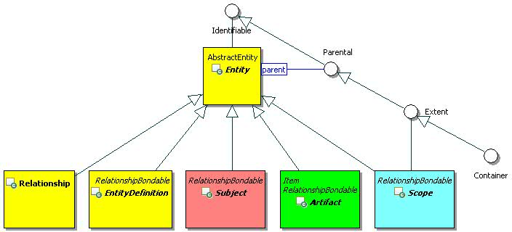
Figure 1 Entity and Top-Level Subclasses

Identifiable

Description
An identifiable object has objectId and changeToken properties. The assignment of an objectId is implementation-dependent. The objectId is read only (immutable) once it is assigned.

Class Definition
The Identifiable class is a mixin class which defines the characteristics of entities and non-entities that can be uniquely identified.
The Identifiable class is defined by the attribute values:

localNamespace
Value: icom

localName
Value: Identifiable

extendsFrom
Value:

stereotype
Value: mixin

description
Value: Identifiable is a mixin class which defines the characteristics of all entities and some non-entities that can be uniquely identified.

propertyDefinitions
The values for this attribute are defined in Section 3.1.2.3.

Property Definitions
The Identifiable class MUST have the property definitions:

icom:objectId
Description: A persistent identifier of an object.
Required: False
Inherited: False
Property Type: ID
Cardinality: Single
Updatability: Read Only

icom:changeToken
Description: An opaque token used for optimistic locking & concurrency checking.
Required: False
Inherited: False
Property Type: String
Cardinality: Single
Updatability: Read Only

The Identifiable class MAY include additional property definitions which are implementation-defined.

Parental

Description
A parental object may be a parent of other objects.

Class Definition
The Parental class is a mixin class which defines the characteristics of entities that may be parents of other entities or identifiable objects.
The Parental class is defined by the attribute values:

localNamespace
Value: icom

localName
Value: Parental

extendsFrom
Value: icom:Identifiable

stereotype
Value: mixin

description
Value: Parental is a mixin class which defines the characteristics of the entities that can be parents of other entities or identifiable objects.

propertyDefinitions
The values for this attribute are defined in Section 3.1.3.3.

Property Definitions
The Parental class inherits property definitions from super classes.
The Parental class MAY include additional property definitions which are implementation-defined.

Extent

Description
An extent object is a parental object which may contain other entities.

Class Definition
The Extent class is a mixin class which defines characteristics of entities that may contain other entities.
The Extent class is defined by the attribute values:

localNamespace
Value: icom

localName
Value: Extent

extendsFrom
Value: icom:Parental

stereotype
Value: mixin

description
Value: Extent is a mixin class which defines the characteristics of entities that may contain other entities.

propertyDefinitions
The values for this attribute are defined in Section 3.1.4.3.

Property Definitions
The Extent class inherits property definitions from super classes.
The Extent class MUST have the property definitions:

icom:parent
Description: Parent of an extent.
Required: False
Inherited: False
Property Type: icom:Extent
Cardinality: Single
Updatability: Read Only

The Extent class MAY include additional property definitions which are implementation-defined.

Entity

Description
An entity is an identifiable object that can be persisted and that has an access control list.
Each entity is assigned an internationalized resource identifier (IRI) composed from its objectId. The form of the IRI is implementation-dependent.

Class Definition
The Entity class is defined by the attribute values:

localNamespace
Value: icom

localName
Value: Entity

extendsFrom
Value: icom:Identifiable

stereotype
Value: primary

isAbstract
Value: TRUE

description
Value: An entity is an object that has an immutable id and can be individually access controlled.

propertyDefinitions
The values for this attribute are defined in Section 3.1.5.3.

Property Definitions
The Entity class inherits property definitions from super classes.
The Entity class MUST have the property definitions:

icom:name
Description: Name of an entity.
Required: False
Inherited: False
Property Type: String
Cardinality: Single
Updatability: Read Write

icom:createdBy
Description: An actor who creates an entity.
Required: False
Inherited: False
Property Type: icom:Actor
Cardinality: Single
Updatability: Read Only

icom:creationDate
Description: Date and time when an entity is created. It is immutable.
Required: False
Inherited: False
Property Type: DateTime
Cardinality: Single
Updatability: Read Only

icom:lastModifiedBy
Description: An actor who last modified an entity.
Required: False
Inherited: False
Property Type: icom:Actor
Cardinality: Single
Updatability: Read Only

icom:lastModificationDate
Description: Date and time when an entity is last modified.
Required: False
Inherited: False
Property Type: DateTime
Cardinality: Single
Updatability: Read Only

icom_ac:owner
Description: A subject who owns an entity.
Required: True
Inherited: False
Property Type: icom_ac:Owner
Cardinality: Single
Updatability: Read Write

icom:parent
Description: A parental entity which contains an entity.
Required: False
Inherited: False
Property Type: icom:Parental
Cardinality: Single
Updatability: Read Only

icom_meta:attachedMarker
Description: Zero or more markers applied on an entity.
Required: False
Inherited: False
Property Type: icom_meta:Marker
Cardinality: Multi
Updatability: Read Only

icom_meta:categoryApplication
Description: Zero or more category applications on an entity.
Required: False
Inherited: False
Property Type: icom_meta:CategoryApplication
Cardinality: Multi
Updatability: Read Only

icom_meta:tagApplication
Description: Zero or more tag applications on an entity.
Required: False
Inherited: False
Property Type: icom_meta:TagApplication
Cardinality: Multi
Updatability: Read Only

icom_ac:accessControlList
Description: Access control list on an entity.
Required: False
Inherited: False
Property Type: icom_ac:AccessControlList
Cardinality: Single
Updatability: Read Write

The Entity class MAY include additional property definitions which are implementation-defined.

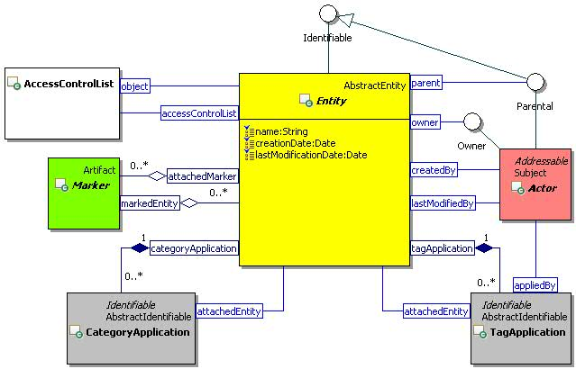
Figure 2 Entity Class Diagram

EntityDefinition

Description
An entity definition is an entity that defines a type of entities.

Class Definition
The EntityDefinition class is defined by the attribute values:

localNamespace
Value: icom

localName
Value: EntityDefinition

extendsFrom
Value: icom:Entity, icom_meta:RelationshipBondable

stereotype
Value: primary

isAbstract
Value: TRUE

description
Value: An entity definition defines a type of entities.

propertyDefinitions
The values for this attribute are defined in Section 3.1.6.3.

Property Definitions
The EntityDefinition class inherits property definitions from super classes.
The EntityDefinition class MUST have the property definitions:

icom:description
Description: A description of an entity definition.
Required: False
Inherited: False
Property Type: String
Cardinality: Single
Updatability: Read Write

The EntityDefinition class MAY include additional property definitions which are implementation-defined.

Scope Branch

UML Diagram of Scope and Top-Level Subclasses
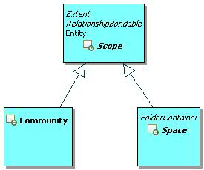
Figure 3 Scope Branch

Scope

Description
A scope is an extent of an administrative realm.

Class Definition
The Scope class is defined by the attribute values:

localNamespace
Value: icom

localName
Value: Scope

extendsFrom
Value: icom:Entity, icom:Extent, icom_meta:RelationshipBondable

stereotype
Value: primary

isAbstract
Value: TRUE

description
Value: A scope is an extent of an administrative realm.

propertyDefinitions
The values for this attribute are defined in Section 3.2.2.3.

Property Definitions
The Scope class inherits property definitions from super classes.
The Scope class MUST have the property definitions:

icom:description
Description: A description of a scope.
Required: False
Inherited: False
Property Type: String
Cardinality: Single
Updatability: Read Write

icom:parent
Description: A community which contains a scope.
Required: False
Inherited: True
Property Type: icom:Community
Cardinality: Single
Updatability: Read Only

icom:roleDefinition
Description: Zero or more role definitions defined in a scope.
Required: False
Inherited: False
Property Type: icom_ac:RoleDefinition
Cardinality: Multi
Updatability: Read Only

icom:role
Description: Zero or more roles defined in a scope.
Required: False
Inherited: False
Property Type: icom_ac:Role
Cardinality: Multi
Updatability: Read Only

icom:group
Description: Zero or more groups defined in a scope.
Required: False
Inherited: False
Property Type: icom:Group
Cardinality: Multi
Updatability: Read Only

icom:memberGroup
Description: Member groups of a scope, i.e. groups whose assigned scopes include this scope.
Required: False
Inherited: False
Property Type: icom:Group
Cardinality: Multi
Updatability: Read Only

icom_meta:relationship
Description: Zero or more relationships associated with a scope.
Required: False
Inherited: False
Property Type: icom_meta:Relationship
Cardinality: Multi
Updatability: Read Only

The Scope class MAY include additional property definitions which are implementation-defined.

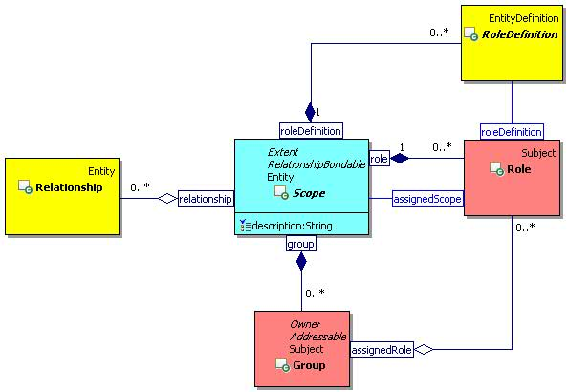
Figure 4 Scope Class Diagram

Community

Description
A community is a scope that has a set of actors as members who can participate in a set of spaces.
It is implementation-dependent whether or not a space in a community can include participating actors who are not members of a parent community or ancestor communities.

Class Definition
The Community class is defined by the attribute values:

localNamespace
Value: icom

localName
Value: Community

extendsFrom
Value: icom:Scope

stereotype
Value: primary

description
Value: A community is a scope that has a set of actors as members who can participate in a set of spaces.

propertyDefinitions
The values for this attribute are defined in Section 3.2.3.3.

Property Definitions
The Community class inherits property definitions from super classes.
The Community class MUST have the property definitions:

icom:community
Description: Sub-communities of a community.
Required: False
Inherited: False
Property Type: icom:Community
Cardinality: Multi
Updatability: Read Only

icom:space
Description: Spaces of a community.
Required: False
Inherited: False
Property Type: icom:Space
Cardinality: Multi
Updatability: Read Only

icom:actor
Description: Managed actors of a community, i.e. actors whose parent community is this community.
Required: False
Inherited: False
Property Type: icom:Actor
Cardinality: Multi
Updatability: Read Only

icom:memberActor
Description: Member actors of a community, i.e. actors whose assigned communities include this community.
Required: False
Inherited: False
Property Type: icom:Actor
Cardinality: Multi
Updatability: Read Only

The Community class MAY include additional property definitions which are implementation-defined.

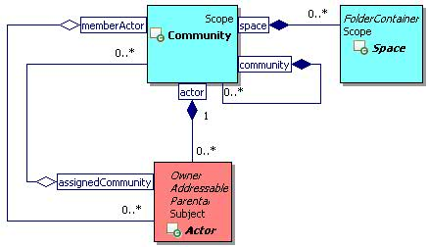
Figure 5 Community Class Diagram

Space

Description
A space is a scope that defines a durable context and place for actors to work or collaborate.

Class Definition
The Space class is defined by the attribute values:

localNamespace
Value: icom

localName
Value: Space

extendsFrom
Value: icom:Scope, icom:FolderContainer

stereotype
Value: primary

description
Value: A space is a scope that defines a durable context and place for actors to work or collaborate.

propertyDefinitions
The values for this attribute are defined in Section 3.2.4.3.

Property Definitions
The Space class inherits property definitions from super classes.
The Space class MUST have the property definitions:

icom:element
Description: Elements of a space.
Required: False
Inherited: False
Property Type: icom:SpaceItem
Cardinality: Multi
Updatability: Read Only

The Space class MAY include additional property definitions which are implementation-defined.

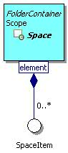
Figure 6 Space Class Diagram

Subject Branch

UML Diagram of Subject and Top-Level Subclasses
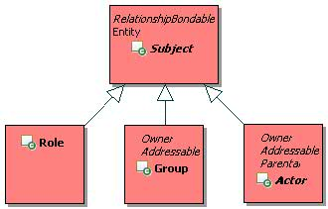
Figure 7 Subject Branch

Subject

Description
A subject is an entity that can have rights to perform actions.

Class Definition
The Subject class is defined by the attribute values:

localNamespace
Value: icom

localName
Value: Subject

extendsFrom
Value: icom:Entity, icom_meta:RelationshipBondable

stereotype
Value: primary

isAbstract
Value: TRUE

description
Value: A subject is an entity that can have rights to perform actions.

propertyDefinitions
The values for this attribute are defined in Section 3.3.2.3.

Property Definitions
The Subject class inherits property definitions from super classes.
The Subject class MUST have the property definitions:

icom:description
Description: A description of a subject.
Required: False
Inherited: False
Property Type: String
Cardinality: Single
Updatability: Read Write

icom:parent
Description: A scope which contains a subject.
Required: False
Inherited: True
Property Type: icom:Scope
Cardinality: Single
Updatability: Read Only

icom_meta:relationship
Description: Zero or more relationships associated with a subject.
Required: False
Inherited: False
Property Type: icom_meta:Relationship
Cardinality: Multi
Updatability: Read Only

icom_meta:property
Description: Zero or more extended properties of a subject.
Required: False
Inherited: False
Property Type: icom_meta:Property
Cardinality: Multi
Updatability: Read Write

The Subject class MAY include additional property definitions which are implementation-defined.

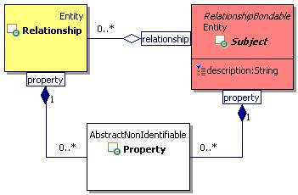
Figure 8 Subject Class Diagram

Group

Description
A group is a subject representing a set of actors and sub-groups.
A group can be part of one or more super-groups.
It can be an owner of one or more entities.

Class Definition
The Group class is defined by the attribute values:

localNamespace
Value: icom

localName
Value: Group

extendsFrom
Value: icom:Subject, icom_card:Addressable, icom_ac:Accessor
Optional Value: icom_ac:Owner

stereotype
Value: primary

description
Value: A group is a subject representing a set of actors and sub-groups. A group can be part of one or more super-groups. It can be an owner of one or more entities.

propertyDefinitions
The values for this attribute are defined in Section 3.3.3.3.

Property Definitions
The Group class inherits property definitions from super classes.
The Group class MUST have the property definitions:

icom:assignedRole
Description: Roles to which a group is assigned.
Required: False
Inherited: False
Property Type: icom:Role
Cardinality: Multi
Updatability: Read Write

icom:assignedGroup
Description: Super-groups to which a group is assigned.
Required: False
Inherited: False
Property Type: icom:Group
Cardinality: Multi
Updatability: Read Write

icom:assignedScope
Description: Scopes to which a group is assigned.
Required: False
Inherited: False
Property Type: icom:Scope
Cardinality: Multi
Updatability: Read Write

icom:memberGroup
Description: Sub-groups assigned to a group.
Required: False
Inherited: False
Property Type: icom:Group
Cardinality: Multi
Updatability: Read Only

icom:memberActor
Description: Actors assigned to a group.
Required: False
Inherited: False
Property Type: icom:Actor
Cardinality: Multi
Updatability: Read Only

The Group class MAY include additional property definitions which are implementation-defined.

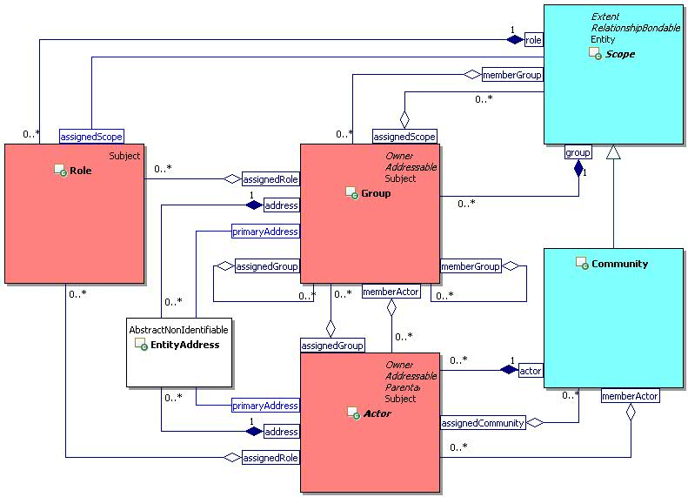
Figure 9 Group and Actor Class Diagram

Actor

Description
An actor is a subject that can perform actions on objects.
It can be an owner of entities.

Class Definition
The Actor class is defined by the attribute values:

localNamespace
Value: icom

localName
Value: Actor

extendsFrom
Value: icom:Subject, icom_card:Addressable, icom_ac:Owner

stereotype
Value: primary

isAbstract
Value: TRUE

description
Value: An actor is a subject that can perform actions on objects.

propertyDefinitions
The values for this attribute are defined in Section 3.3.4.3.

Property Definitions
The Actor class inherits property definitions from super classes.
The Actor class MUST have the property definitions:

icom:parent
Description: A community which contains an actor.
Required: False
Inherited: True
Property Type: icom:Community
Cardinality: Single
Updatability: Read Only

icom:assignedRole
Description: Roles to which an actor is assigned.
Required: False
Inherited: False
Property Type: icom:Role
Cardinality: Multi
Updatability: Read Write

icom:assignedGroup
Description: Groups to which an actor is assigned.
Required: False
Inherited: False
Property Type: icom:Group
Cardinality: Multi
Updatability: Read Write

icom:assignedCommunity
Description: Communities to which an actor is assigned.
Required: False
Inherited: False
Property Type: icom:Community
Cardinality: Multi
Updatability: Read Write

The Actor class MAY include additional property definitions which are implementation-defined.

User

Description
A user is an actor who is also a person.
A user has a personal space.

Class Definition
The User class is defined by the attribute values:

localNamespace
Value: icom

localName
Value: User

extendsFrom
Value: icom:Actor, icom_card:Person

stereotype
Value: primary

description
Value: A user is an actor who is also a person.

propertyDefinitions
The values for this attribute are defined in Section 3.3.5.3.

Property Definitions
The User class inherits property definitions from super classes.
The User class MUST have the property definitions:

icom:personalSpace
Description: Personal space of a person.
Required: False
Inherited: False
Property Type: icom:Space
Cardinality: Single
Updatability: Read Only

icom_presence:presence
Description: Presence of a person.
Required: False
Inherited: False
Property Type: icom_presence:Presence
Cardinality: Single
Updatability: Read Only

icom_msg:instantMessageFeed
Description: Instant message feed for a person.
Required: False
Inherited: False
Property Type: icom_msg:InstantMessageFeed
Cardinality: Single
Updatability: Read Only

The User class MAY include additional property definitions which are implementation-defined.

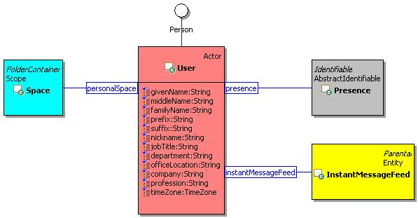
Figure 10 User Class Diagram.

ResourceActor

Description
A resource actor is an actor representing a bookable resource, such as a conference room, equipment, or on-line conference.
A resource actor is associated with a resource space that contains a resource scheduling calendar and on-line conference.

Class Definition
The ResourceActor class is defined by the attribute values:

localNamespace
Value: icom

localName
Value: ResourceActor

extendsFrom
Value: icom:Actor

stereotype
Value: primary

description
Value: A resource actor is an actor representing a bookable resource, such as a conference room, equipment, or on-line conference.

propertyDefinitions
The values for this attribute are defined in Section 3.3.6.3..

Property Definitions
The ResourceActor class inherits property definitions from super classes.
The ResourceActor class MUST have the property definitions:

icom:resourceSpace
Description: Administrative space of a resource actor.
Required: False
Inherited: False
Property Type: icom:Space
Cardinality: Single
Updatability: Read Only

icom:description
Description: Description of a resource.
Required: False
Inherited: False
Property Type: String
Cardinality: Single
Updatability: Read Write

icom:location
Description: Location of a resource.
Required: False
Inherited: False
Property Type: icom:Location
Cardinality: Single
Updatability: Read Write

icom:capacity
Description: Capacity of a resource.
Required: False
Inherited: False
Property Type: Integer
Cardinality: Single
Updatability: Read Write

icom:resourceType
Description: Type of a resource.
Required: False
Inherited: False
Property Type: icom:ResourceType
Cardinality: Single
Updatability: Read Write

icom:bookingRule
Description: Resource booking rule.
Required: False
Inherited: False
Property Type: icom:ResourceBookingRule
Cardinality: Single
Updatability: Read Write

icom:bookingApprover
Description: One or more users who approve the booking of a resource.
Required: False
Inherited: False
Property Type: icom:User
Cardinality: Single
Updatability: Read Write

The ResourceActor class MAY include additional property definitions which are implementation-defined.

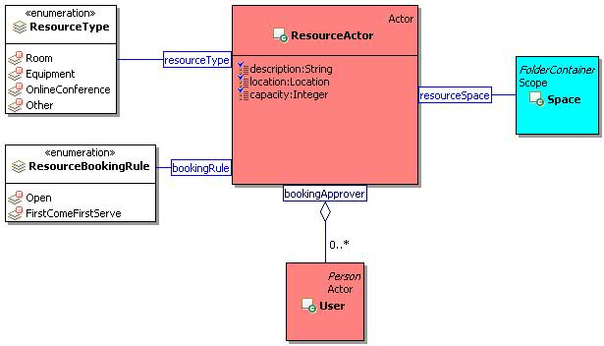
Figure 11 ResourceActor Class Diagram.

ResourceType
The ResourceType class is an enum class that enumerates the instances each of which expresses a type of a resource.
The ResourceType class is defined by the attribute values:

localNamespace
Value: icom

localName
Value: ResourceType

extendsFrom
Value:

stereotype
Value: primary

isEnumeration
Value: TRUE

description
Value: An enumeration of instances each of which expresses a type of a resource.

instances
Value: <icom:Room, icom:Equipment, icom:OnlineConference, icom:Other>

The following resource types are defined by ICOM:
- icom:Room to express that a resource represents a room.
- icom:Equipment to express that a resource represents an equipment.
- icom:OnlineConference to express that a resource represents an online conference.
- icom:Other to express that a resource represents other things.

ResourceBookingRule
The ResourceBookingRule class is an enum class that enumerates the instances each of which expresses a booking rule.
The ResourceBookingRule class is defined by the attribute values:

localNamespace
Value: icom

localName
Value: ResourceBookingRule

extendsFrom
Value:

stereotype
Value: primary

isEnumeration
Value: TRUE

description
Value: An enumeration of instances each of which expresses a booking rule.

instances
Value: <icom:Open, icom:FirstComeFirstServe>

The following resource booking rules are defined by ICOM:
- icom:Open to express that a resource is open for booking.
- icom:FirstComeFirstServe to express that a resource is first come first serve.

Artifact Branch

UML Diagram of Artifact and Top-Level Subclasses
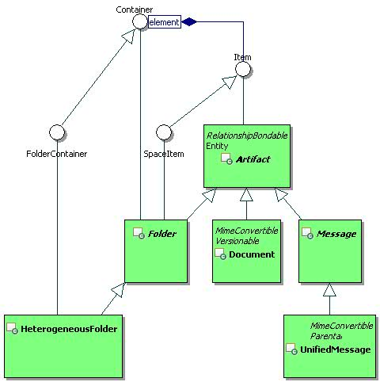
Figure 12 Artifact Branch

Item

Description
An item is an element of a container.
The parent of an item MUST be a container.

Class Definition
The Item class is a mixin class which defines the characteristics of entities that can be elements of a Container.
The Item class is defined by the attribute values:

localNamespace
Value: icom

localName
Value: Item

extendsFrom
Value: icom:Identifiable

stereotype
Value: mixin

description
Value: Item is a mixin class which defines the characteristics of entities that can be placed in a Container.

propertyDefinitions
The values for this attribute are defined in Section 3.4.2.3.

Property Definitions
The Item class inherits property definitions from super classes.
The Item class MUST have the property definition:

icom:parent
Description: A parent container of an item.
Required: False
Inherited: True
Property Type: icom:Container
Cardinality: Single
Updatability: Read Only

The Item class MAY have the optional property definition:

icom:container
Description: Zero, one, or more containers of an item.
Required: False
Inherited: False
Property Type: icom:Container
Cardinality: Multi
Updatability: Read Write

The Item class MAY include additional property definitions which are implementation-defined.

SpaceItem

Description
A space item is an element of a space.

Class Definition
The SpaceItem class is a mixin class which defines the characteristics of entities that can be elements of a Space.
The SpaceItem class is defined by the attribute values:

localNamespace
Value: icom

localName
Value: SpaceItem

extendsFrom
Value: icom:Item

stereotype
Value: mixin

description
Value: SpaceItem is a mixin class which defines the characteristics of entities that can be elements of a Space.

propertyDefinitions
The values for this attribute are defined in Section 3.4.3.3.

Property Definitions
The SpaceItem class inherits property definitions from super classes.
The SpaceItem class MAY include additional property definitions which are implementation-defined.

Container

Description
A container is an extent that contains items.

Class Definition
The Container class is mixin class which defines the characteristics of extents that contain items.
The Container class is defined by the attribute values:

localNamespace
Value: icom

localName
Value: Container

extendsFrom
Value: icom:Extent

stereotype
Value: mixin

description
Value: A container is an extent that contains items.

propertyDefinitions
The values for this attribute are defined in Section 3.4.4.3.

Property Definitions
The Container class inherits property definitions from super classes.
The Container class MUST have the property definitions:

icom:element
Description: Elements of a container, i.e. items whose parent container is the container or whose containers include the container.
Required: False
Inherited: False
Property Type: icom:Item
Cardinality: Multi
Updatability: Read Only

The Container class MAY include additional property definitions which are implementation-defined.

FolderContainer

Description
A folder container is a container which may contain folders. Space and heterogeneous folder are folder containers.

Class Definition
The FolderContainer class is a mixin class that defines the characteristics of containers that may contain folders.
The FolderContainer class is defined by the attribute values:

localNamespace
Value: icom

localName
Value: FolderContainer

extendsFrom
Value: icom:Container

stereotype
Value: mixin

description
Value: A folder container is a container which may contain folders.

propertyDefinitions
The values for this attribute are defined in Section 3.4.5.3.

Property Definitions
The FolderContainer class inherits property definitions from super classes.
The FolderContainer class MAY include additional property definitions which are implementation-defined.

Artifact

Description
An artifact is a result of a communication, cooperation, content creation, or collaboration activity.
Note: Document versioning is an example of content creation activity resulting in an artifact (a version of document).

Class Definition
The Artifact class is defined by the attribute values:

localNamespace
Value: icom

localName
Value: Artifact

extendsFrom
Value: icom:Entity, icom:Item, icom_meta:RelationshipBondable
Optional Value: icom:SpaceItem

stereotype
Value: primary

isAbstract
Value: TRUE

description
Value: An artifact is a result of a communication, cooperation, content creation, or collaboration activity.

propertyDefinitions
The values for this attribute are defined in Section 3.4.6.3.

Property Definitions
The Artifact class inherits property definitions from super classes.
The Artifact class MUST have the property definitions:

icom:description
Description: A description of an artifact.
Required: False
Inherited: False
Property Type: String
Cardinality: Single
Updatability: Read Write

icom:userCreationDate
Description: Date and time when an artifact is created. This field can be set by application.
Required: False
Inherited: False
Property Type: DateTime
Cardinality: Single
Updatability: Read Write

icom:userLastModificationDate
Description: Date and time when an artifact is last modified. This field can be set by application.
Required: False
Inherited: False
Property Type: DateTime
Cardinality: Single
Updatability: Read Write

icom_meta:property
Description: Zero or more extended properties of an artifact.
Required: False
Inherited: False
Property Type: icom_meta:Property
Cardinality: Multi
Updatability: Read Write

icom_meta:relationship
Description: Zero or more relationships associated with an artifact.
Required: False
Inherited: False
Property Type: icom_meta:Relationship
Cardinality: Multi
Updatability: Read Only

The Artifact class MAY include additional property definitions which are implementation-defined.

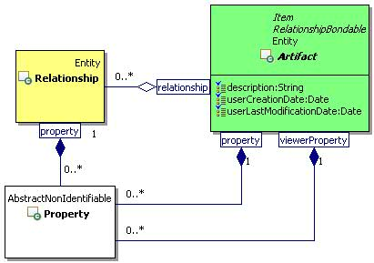
Figure 13 Artifact Class Diagram

Folder

Description
A folder is an artifact that may contain other artifacts.
Note: Every folder except root folders has at least one parent folder. The parent of a root folder is a space. Subclasses of Folder class should enforce their own semantics on elements.

Class Definition
The Folder class is defined by the attribute values:

localNamespace
Value: icom

localName
Value: Folder

extendsFrom
Value: icom:Artifact, icom:Container, icom:SpaceItem

stereotype
Value: primary

isAbstract
Value: TRUE

description
Value: A folder is an artifact that may contain other artifacts.

propertyDefinitions
The values for this attribute are defined in Section 3.4.7.3.

Property Definitions
The Folder class inherits property definitions from super classes.
The Folder class MUST have the property definitions:

icom:parent
Description: A parent container of a folder.
Required: False
Inherited: True
Property Type: icom:FolderContainer
Cardinality: Single
Updatability: Read Only

The Folder class MAY include additional property definitions which are implementation-defined.

HeterogeneousFolder

Description
A heterogeneous folder is an unconstrained folder to contain any type of artifacts. It is typically used for document folders, inbox, and trash folder of a space.

Class Definition
The HeterogeneousFolder class is defined by the attribute values:

localNamespace
Value: icom

localName
Value: HeterogeneousFolder

extendsFrom
Value: icom:Folder, icom:FolderContainer

stereotype
Value: primary

description
Value: A heterogeneous folder is an unconstrained folder to contain any type of artifacts.

propertyDefinitions
The values for this attribute are defined in Section 3.4.8.3.

Property Definitions
The HeterogeneousFolder class inherits property definitions from super classes.
The HeterogeneousFolder class MUST have the property definitions:

icom:element
Description: Elements of a heterogeneous folder.
Required: False
Inherited: True
Property Type: icom:Artifact
Cardinality: Multi
Updatability: Read Only

The HeterogeneousFolder class MAY include additional property definitions which are implementation-defined.

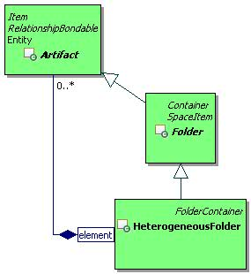
Figure 14 Heterogeneous Folder Class Diagram

Access Control Model

Accessor

Description
An accessor can be granted or denied access rights to access objects.

Class Definition
The Accessor class is a mixin class which defines the characteristics of subjects such as groups and actors that can be granted or denied access types in access control lists and privileges in role assignments.
The Accessor class is defined by the attribute values:

localNamespace
Value: icom_ac

localName
Value: Accessor

extendsFrom
Value: icom:Identifiable

stereotype
Value: mixin

description
Value: Accessor is a mixin class which defines the characteristics of subjects such as groups and actors that can be granted or denied access types in access control lists and granted privileges in role assignments.

propertyDefinitions
The values for this attribute are defined in Section 3.5.1.3.

Property Definitions
The Accessor class inherits property definitions from super classes.
The Accessor class MAY include additional property definitions which are implementation-defined.

Owner

Description
An owner is a subject that can be the owner of entities.
An owner of an entity MAY always have rights to update the access control list for the entity.

Class Definition
The Owner class is a mixin class which defines the characteristics of subjects such as groups and actors that can own entities.
The Owner class is defined by the attribute values:

localNamespace
Value: icom_ac

localName
Value: Owner

extendsFrom
Value: icom_ac:Accessor

stereotype
Value: mixin

description
Value: Owner is a mixin class which defines the characteristics of subjects such as groups and actors that can own entities.

propertyDefinitions
The values for this attribute are defined in Section 3.5.2.3.

Property Definitions
The Owner class inherits property definitions from super classes.
The Owner class MAY include additional property definitions which are implementation-defined.

RoleDefinition

Description
A role definition is a named set of privileges.

Class Definition
The RoleDefinition class is defined by the attribute values:

localNamespace
Value: icom_ac

localName
Value: RoleDefinition

extendsFrom
Value: icom:EntityDefinition

stereotype
Value: primary

description
Value: A role definition is a named set of privileges.

propertyDefinitions
The values for this attribute are defined in Section 3.5.3.3.

Property Definitions
The RoleDefinition class inherits property definitions from super classes.
The RoleDefinition class MUST have the property definitions:

icom_ac:privilege
Description: A set of privileges.
Required: True
Inherited: False
Property Type: icom_ac:Privilege
Cardinality: Multi
Updatability: Read Write

The RoleDefinition class MAY include additional property definitions which are implementation-defined.

Role

Description
A role assigns a named set of privileges to a set of accessors for operations within an assigned scope.

Class Definition
The Role class is defined by the attribute values:

localNamespace
Value: icom_ac

localName
Value: Role

extendsFrom
Value: icom:Subject

stereotype
Value: primary

description
Value: A role assigns a named set of rights to a set of accessors for operations within an assigned scope.

propertyDefinitions
The values for this attribute are defined in Section 3.5.4.3.

Property Definitions
The Role class inherits property definitions from super classes.
The Role class MUST have the property definitions:

icom_ac:roleDefinition
Description: A role definition containing a set of privileges.
Required: True
Inherited: False
Property Type: icom_ac:RoleDefinition
Cardinality: Single
Updatability: On Create

icom_ac:assignedScope
Description: A scope in which a role is assigned.
Required: True
Inherited: False
Property Type: icom:Scope
Cardinality: Single
Updatability: Read Write

icom_ac:memberAccessor
Description: Accessors (actors and groups) assigned to a role.
Required: False
Inherited: False
Property Type: icom_ac:Accessor
Cardinality: Multi
Updatability: Read Write

The Role class MAY include additional property definitions which are implementation-defined.

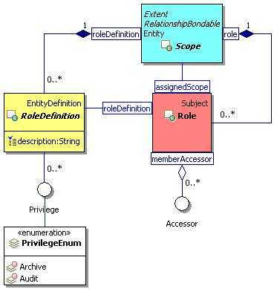
Figure 15 Role Definition and Role Class Diagram

Privilege

Description
A privilege is an access right granted through roles.

Class Definition
The Privilege class is a mixin class which defines access rights that can be included in role definitions.
The Privilege class is defined by the attribute values:

localNamespace
Value: icom_ac

localName
Value: Privilege

extendsFrom
Value:

stereotype
Value: mixin

description
Value: Privilege is a mixin class which defines access rights that can be included in role definitions.

propertyDefinitions
The values for this attribute are defined in Section 3.5.5.3.

Property Definitions
The Privilege class MAY include additional property definitions which are implementation-defined.

PrivilegeEnum
The PrivilegeEnum class is an enum class that enumerates the instances each of which expresses a privilege that can be assigned to a role.
The PrivilegeEnum class is defined by the attribute values:

localNamespace
Value: icom_ac

localName
Value: PrivilegeEnum

extendsFrom
Value: icom_ac:Privilege

stereotype
Value: primary

isEnumeration
Value: TRUE

description
Value: An enumeration of instances each of which expresses a privilege that can be assigned to a role.

instances
Value: <icom_ac:Archive, icom_ac:Audit>

The following privileges are defined by ICOM:
- icom_ac:Archive to express a right to archive contents in a scope.
- icom_ac:Audit to express a right to audit activities in a scope.

AccessControlList

Description
An access control list (ACL) is an object attached to an entity to specify a list of permissions to access the entity.

Class Definition
The AccessControlList class is defined by the attribute values:

localNamespace
Value: icom_ac

localName
Value: AccessControlList

extendsFrom
Value:

stereotype
Value: primary

description
Value: An access control list (ACL) is an object attached to an entity to specify a list of permissions to access the entity.

propertyDefinitions
The values for this attribute are defined in Section 3.5.7.3.

Property Definitions
The AccessControlList class MUST have the property definitions:

icom_ac:object
Description: Associated object.
Required: True
Inherited: False
Property Type: icom:Entity
Cardinality: Single
Updatability: On Create

icom_ac:accessControlEntry
Description: One or more access control entries.
Required: True
Inherited: False
Property Type: icom_ac:AccessControlEntry
Cardinality: Multi
Updatability: Read Write

AccessControlList class MAY include additional property definitions which are implementation-defined.

AccessControlEntry

Description
An access control entry specifies access types granted to or denied for an accessor.

Class Definition
The AccessControlEntry class is defined by the attribute values:

localNamespace
Value: icom_ac

localName
Value: AccessControlEntry

extendsFrom
Value:

stereotype
Value: primary

description
Value: An access control entry is associated with an accessor and contains a list of access types (permissions) granted to or denied from the accessor.

propertyDefinitions
The values for this attribute are defined in Section 3.5.8.3.

Property Definitions
The AccessControlEntry class MUST have the property definitions:

icom_ac:subject
Description: Associated subject.
Required: True
Inherited: False
Property Type: icom_ac:Accessor
Cardinality: Single
Updatability: On Create

icom_ac:grant
Description: One or more access types granted to a subject.
Required: False
Inherited: False
Property Type: icom_ac:AccessType
Cardinality: Multi
Updatability: Read Write

icom_ac:deny
Description: One or more access type denied for a subject.
Required: False
Inherited: False
Property Type: icom_ac:AccessType
Cardinality: Multi
Updatability: Read Write

The AccessControlEntry class MAY include additional property definitions which are implementation-defined.

AccessType
An AccessType is an access right granted through an access control entry.

Class Definition
The AccessType class is a mixin class which defines access rights that can be granted or denied in an access control entry.
The AccessType class is defined by the attribute values:

localNamespace
Value: icom_ac

localName
Value: AccessType

extendsFrom
Value:

stereotype
Value: mixin

description
Value: AccessType is a mixin class which defines access rights that can be granted or denied in an access control entry.

propertyDefinitions
The values for this attribute are defined in Section 3.5.9.2.

Property Definitions
The AccessType class inherits property definitions from super classes.
The AccessType class MAY include additional property definitions which are implementation-defined.

AccessTypeEnum
The AccessTypeEnum class is an enum class that enumerates the instances each of which expresses an access type that can be granted or denied in an access control entry.
The AccessTypeEnum class is defined by the attribute values:

localNamespace
Value: icom_ac

localName
Value: AccessTypeEnum

extendsFrom
Value: icom_ac:AccessType

stereotype
Value: primary

isEnumeration
Value: TRUE

description
Value: An enumeration of instances each of which expresses an access type that can be granted or denied in an access control entry.

instances
Value: <icom_ac:Read, icom_ac:Write, icom_ac:Delete>

The following access types are defined by ICOM:
- icom_ac:Read to express a right to retrieve an entity.
- icom_ac:Write to express a right to update an entity.
- icom_ac:Delete to express a right to delete an entity.

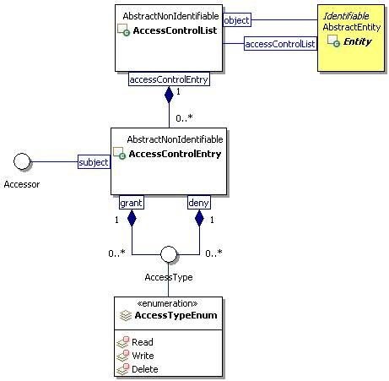
Figure 16 Access Control List Class Diagram

Metadata Model

PropertyDefinition

Description
A property definition specifies the name, type, choice, and cardinality of values for properties. A property type includes string, boolean, decimal, integer, datetime, etc.

Class Definition
The PropertyDefinition class is defined by the attribute values:

localNamespace
Value: icom_meta

localName
Value: PropertyDefinition

extendsFrom
Value: icom:Identifiable

stereotype
Value: primary

description
Value: A property definition specifies the name, type, choice, and cardinality of values for properties.

propertyDefinitions
The values for this attribute are defined in Section 3.6.1.3.

Property Definitions
The PropertyDefinition class inherits property definitions from super classes.
The PropertyDefinition class MUST have the property definitions:

icom:name
Description: Name for a property.
Required: True
Inherited: False
Property Type: String
Cardinality: Single
Updatability: Read Write

icom:description
Description: A description of a property definition.
Required: False
Inherited: False
Property Type: String
Cardinality: Single
Updatability: Read Write

icom_meta:propertyType
Description: Type of a property.
Required: True
Inherited: False
Property Type: icom_meta:PropertyType
Cardinality: Single
Updatability: On Create
Choices: PropertyChoiceType
Open Choice: False

icom_meta:defaultValue
Description: A default value for a property.
Required: False
Inherited: False
Property Type: property-type
Cardinality: Single
Updatability: Read Write

icom_meta:choices
Description: An explicit ordered set of single values allowed for a property.
Required: False
Inherited: False
Property Type: List< icom_meta:PropertyChoiceType>
Cardinality: Single
Updatability: Read Write

icom_meta:cardinality
Description: Cardinality of a property specifying whether the property can have “zero or one” or “zero or more” values.
Required: True
Inherited: False
Property Type: icom_meta:Cardinaility
Cardinality: Single
Updatability: On Create

icom_meta:minValue
Description: Minimum value for an integer or decimal property.
Required: False
Inherited: False
Property Type: Integer | Decimal
Cardinality: Single
Updatability: Read Write

icom_meta:maxValue
Description: Maximum value for an integer or decimal property.
Required: False
Inherited: False
Property Type: Integer | Decimal
Cardinality: Single
Updatability: Read Write

The PropertyDefinition class MAY include additional property definitions which are implementation-defined.

Property

Description
The property holds a property value.

Class Definition
The Property class is defined by the attribute values:

localNamespace
Value: icom_meta

localName
Value: Property

extendsFrom
Value:

stereotype
Value: primary

description
Value: A property value.

propertyDefinitions
The values for this attribute are defined in Section 3.6.2.3.

Property Definitions
The Property class MUST have the property definitions:

icom_meta:propertyDefinition
Description: A property definition that specifies the name, type, and cardinality of a property.
Required: True
Inherited: False
Property Type: icom_meta:PropertyDefinition
Cardinality: Single
Updatability: On Create

icom_meta:value
Description: A value of a property.
Required: True
Inherited: False
Property Type: property-type
Cardinality: Single
Updatability: Read Write

The Property class MAY include additional property definitions which are implementation-defined.

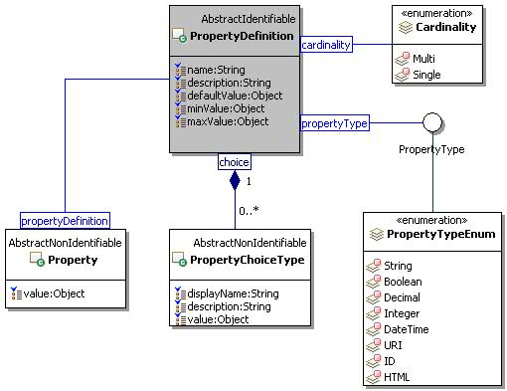
Figure 17 Property Definition and Property Class Diagram

PropertyChoiceType

Description
The property choice type represents a value choice for a property. Each choice includes a display name to be used for presentation purpose and a value to be stored in a property when a choice is selected.

Class Definition
The PropertyChoiceType class is defined by the attribute values:
localNamespace
Value: icom_meta

localName
Value: PropertyChoiceType

extendsFrom
Value:

stereotype
Value: primary

description
Value: A choice for a property value.

propertyDefinitions
The values for this attribute are defined Section 3.6.3.3.

Property Definitions
The PropertyChoiceType class MUST have the property definitions:

icom_meta:displayName
Description: Display name of a property choice.
Required: True
Inherited: False
Property Type: String
Cardinality: Single
Updatability: Read Write

icom:description
Description: A description of a property choice.
Required: False
Inherited: False
Property Type: String
Cardinality: Single
Updatability: Read Write

icom_meta:value
Description: A value of a property choice.
Required: True
Inherited: False
Property Type: property-type
Cardinality: Single
Updatability: Read Write

The PropertyChoiceType class MAY include additional property definitions which are implementation-defined.

PropertyType
A PropertyType expresses a name of a property-type.

Class Definition
The PropertyType class is a mixin class which expresses a name of a property-type.
The PropertyType class is defined by the attribute values:

localNamespace
Value: icom_meta

localName
Value: PropertyType

extendsFrom
Value:

stereotype
Value: mixin

description
Value: PropertyType is a mixin class which expresses a name of a property-type.

propertyDefinitions
The values for this attribute are defined in Section 3.6.4.2.

Property Definitions
The PropertyType class MAY include additional property definitions which are implementation-defined.

PropertyTypeEnum
The PropertyTypeEnum class is an enum class that enumerates the instances each of which expresses the name of a property-type.

localNamespace
Value: icom_meta

localName
Value: PropertyTypeEnum

extendsFrom
Value: PropertyType

stereotype
Value: primary

isEnumeration
Value: TRUE

description
Value: An enumeration of instances each of which expresses the name of a basic data type.

instances
Value: <icom_meta:String, icom_meta:Boolean, icom_meta:Decimal, icom_meta:Integer, icom_meta:Datetime, icom_meta:URI, icom_meta:ID, icom_meta:HTML>

The following names of data types are defined by ICOM:
- icom_meta:String to express xsd:string.
- icom_meta:Boolean to express xsd:boolean.
- icom_meta:Decimal to express xsd:decimal.
- icom_meta:Integer to express xsd:integer.
- icom_meta:Datetime to express xsd:dateTime.
- icom_meta:URI to express xsd:anyURI.
- icom_meta:ID to express opaque object identifiers.
- icom_meta:HTML to express documents or fragments of Hypertext Markup Language (HTML) content

Note: ICOM uses several basic data types defined by “XML Schema Part 2: Datatypes Second Edition” (W3C Recommendation, 28 October 2004, http://www.w3.org/TR/xmlschema-2/).

Cardinality
The Cardinality class is an enum class that enumerates instances each of which expresses the cardinality of a property.
The Cardinality is defined by the attribute values:

localNamespace
Value: icom_meta

localName
Value: Cardinality

extendsFrom
Value:

stereotype
Value: primary

isEnumeration
Value: TRUE

description
Value: An enumeration of instances each of which expresses the cardinality of a property.

instances
Value: <icom_meta:Single, icom_meta:Multi>

The following cardinality types are defined by ICOM:
- icom_meta:Single to express that a property can have zero or one value (if property is not required), or exactly one value (if property is required).
- icom_meta:Multi to express that a property can have zero or more values (if property is not required), or one or more values (if property is required).

UML Diagram of Marker and Subclasses
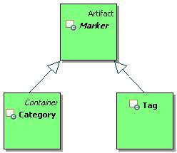
Figure 18 Marker Branch

Marker

Description
A marker is an artifact that groups together entities by a criterion. Markers can be flat or hierarchical. Flat markers are modeled by tag and hierarchical markers are modeled by category.
Note: In some cases when a user applies a marker to an entity, the marker application should be private such that only the user who applies the marker can browse or locate the entity through the marker. This is especially the case when markers are created by a user and visible only to the user who created them.

Class Definition
The Marker class is defined by the attribute values:

localNamespace
Value: icom-meta

localName
Value: Marker

extendsFrom
Value: icom:Artifact

stereotype
Value: primary

isAbstract
Value: TRUE

description
Value: A marker is an artifact that groups together entities by a criterion.

propertyDefinitions
The values for this attribute are defined in Section 3.6.8.3.

Property Definitions
The Marker class inherits property definitions from super classes.
The Marker class MUST have the property definitions:

icom_meta:markedEntity
Description: A marked entity.
Required: False
Inherited: False
Property Type: icom:Entity
Cardinality: Multi
Updatability: Read Only

The Marker class MAY include additional property definitions which are implementation-defined.

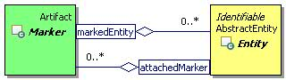
Figure 19 Marker Class Diagram

Category

Description
A category is a marker that classifies entities by taxonomy.

Class Definition
The Category class is defined by the attribute values:

localNamespace
Value: icom_meta

localName
Value: Category

extendsFrom
Value: icom_meta:Marker

stereotype
Value: primary

description
Value: A category is a marker that classifies entities by taxonomy.

propertyDefinitions
The values for this attribute are defined in Section 3.6.9.3.

Property Definitions
The Category class inherits property definitions from super classes.
The Category class MUST have the property definitions:

icom_meta:superCategory
Description: A super category.
Required: False
Inherited: False
Property Type: icom_meta:Category
Cardinality: Single
Updatability: Read Only

icom_meta:subcategory
Description: Zero or more sub categories.
Required: False
Inherited: False
Property Type: icom_meta:Category
Cardinality: Multi
Updatability: Read Only

icom_meta:isAbstract
Description: Indicates whether a category is abstract or concrete.
Required: False
Inherited: False
Property Type: Boolean
Cardinality: Single
Updatability: Read Write

icom_meta:propertyDefinition
Description: Optional or mandatory properties for a category application.
Required: False
Inherited: False
Property Type: icom_meta:PropertyDefinition
Cardinality: Multi
Updatability: Read Write

The Category class MAY include additional property definitions which are implementation-defined.

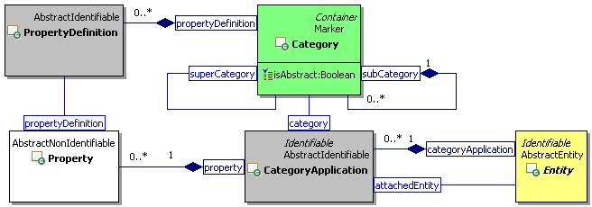
Figure 20 Category and Category Application Class Diagram

CategoryApplication

Description
A category application is an instance of association between a category and a specific entity.

Class Definition
The CategoryApplication class is defined by the attribute values:

localNamespace
Value: icom_meta

localName
Value: CategoryApplication

extendsFrom
Value: icom:Identifiable

stereotype
Value: primary

description
Value: A category application is an instance of association between a category and a specific entity.

propertyDefinitions
The values for this attribute are defined in Section 3.6.10.3.

Property Definitions
The CategoryApplication class inherits property definitions from super classes.
The CategoryApplication class MUST have the property definitions:

icom_meta:attachedEntity
Description: An entity on which a category is applied.
Required: True
Inherited: False
Property Type: icom:Entity
Cardinality: Single
Updatability: On Create

icom_meta:category
Description: A category which is applied on an entity.
Required: True
Inherited: False
Property Type: icom_meta:Category
Cardinality: Single
Updatability: On Create

icom_meta:property
Description: Zero or more properties.
Required: False
Inherited: False
Property Type: icom_meta:Property
Cardinality: Multi
Updatability: Read Write

The CategoryApplication class MAY include additional property definitions which are implementation-defined.

Tag

Description
A tag is a marker that labels entities by a keyword.

Class Definition
The Tag class is defined by the attribute values:

localNamespace
Value: icom_meta

localName
Value: Tag

extendsFrom
Value: icom_meta:Marker

stereotype
Value: primary

description
Value: A tag is a marker that labels entities by a keyword.

propertyDefinitions
The values for this attribute are defined in Section 3.6.11.3.

Property Definitions
The Tag class inherits property definitions from super classes.
The Tag class MUST have the property definitions:

icom_meta:applicationCount
Description: The number of times a tag is applied on entities.
Required: False
Inherited: False
Property Type: Integer
Cardinality: Single
Updatability: Read Only

The Tag class MAY include additional property definitions which are implementation-defined.

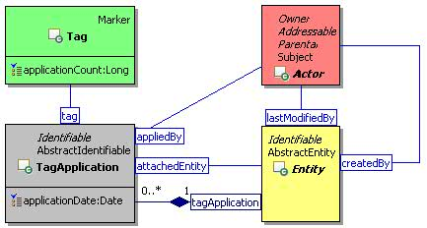
Figure 21 Tag and Tag Application Class Diagram

TagApplication

Description
A tag application is an instance of association between a tag and a specific entity.

Class Definition
The TagApplication class is defined by the attribute values:

localNamespace
Value: icom_meta

localName
Value: TagApplication

extendsFrom
Value: icom:Identifiable

stereotype
Value: primary

description
Value: A tag application is an instance of association between a tag and a specific entity.

propertyDefinitions
The values for this attribute are defined in Section 3.6.12.3.

Property Definitions
The TagApplication class inherits property definitions from super classes.
The TagApplication class MUST have the property definitions:

icom_meta:attachedEntity
Description: An entity on which a tag is applied.
Required: True
Inherited: False
Property Type: icom:Entity
Cardinality: Single
Updatability: On Create

icom_meta:tag
Description: A tag which is applied on an entity.
Required: True
Inherited: False
Property Type: icom_meta:Tag
Cardinality: Single
Updatability: On Create

icom_meta:appliedBy
Description: A user who applies a tag on an entity.
Required: False
Inherited: False
Property Type: icom:Actor
Cardinality: Single
Updatability: Read Only

icom_meta:applicationDate
Description: A date and time when a tag is applied on an entity.
Required: False
Inherited: False
Property Type: DateTime
Cardinality: Single
Updatability: Read Write

The TagApplication class MAY include additional property definitions which are implementation-defined.

RelationshipBondable

Description
A relationship bondable entity is an entity which may be relationship bonded.
Note: a relationship cannot be relationship bonded by other relationships, i.e. relationships are entities that are not relationship bondable.

Class Definition
The RelationshipBondable class is a mixin class which defines the characteristics of entities that may be relationship bonded. It includes almost every subclass of Entity except Relationship.
The RelationshipBondable class is defined by the attribute values:

localNamespace
Value: icom_meta

localName
Value: RelationshipBondable

extendsFrom
Value: icom:Identifiable

stereotype
Value: mixin

description
Value: RelationshipBondable is a mixin class which defines the characteristics of entities that can be relationship bonded.

propertyDefinitions
The values for this attribute are defined in Section 3.6.13.3.

Property Definitions
The RelationshipBondable class inherits property definitions from super classes.
The RelationshipBondable class MAY include additional property definitions which are implementation-defined.

RelationshipDefinition

Description
A relationship definition is an entity that defines a type of relationship, including a name and a description of the relationship type, types of source entity and target entities of a relationship, and definition of properties in a relationship.

Class Definition
The RelationshipDefinition class is defined by the attribute values:

localNamespace
Value: icom_meta

localName
Value: RelationshipDefinition

extendsFrom
Value: icom:EntityDefinition

stereotype
Value: primary

description
Value: A relationship definition is an entity that defines a type of relationship.

propertyDefinitions
The values for this attribute are defined in Section 3.6.14.3.

Property Definitions
The RelationshipDefinition class inherits property definitions from super classes.
The RelationshipDefinition class MUST have the property definitions:

icom_meta:propertyDefinition
Description: Optional or mandatory properties for a relationship.
Required: False
Inherited: False
Property Type: icom_meta:PropertyDefinition
Cardinality: Multi
Updatability: Read Write

icom_meta:allowedSourceType
Description: A list of expanded names of relationship bondable classes, indicating that the source entity of a relationship MUST be an instance of a class in the list.
Required: False
Inherited: False
Property Type: IRI
Cardinality: Multi
Updatability: Read Write

icom_meta:allowedTargetType
Description: A list of expanded names of relationship bondable classes, indicating that the target entity of a relationship MUST be an instance of a class in the list.
Required: False
Inherited: False
Property Type: IRI
Cardinality: Multi
Updatability: Read Write

The RelationshipDefinition class MAY include additional property definitions which are implementation-defined.

Relationship

Description
A relationship is an entity that relates a set of entities by a predicate.

Class Definition
The Relationship class is defined by the attribute values:

localNamespace
Value: icom_meta

localName
Value: Relationship

extendsFrom
Value: icom:Entity

stereotype
Value: primary

description
Value: A relationship is an entity that relates a set of entities by a predicate.

propertyDefinitions
The values for this attribute are defined in Section 3.6.15.3.

Property Definitions
The Relationship class inherits property definitions from super classes.
The Relationship class MUST have the property definitions:

icom_meta:relationshipDefinition
Description: A definition of relationships.
Required: True
Inherited: False
Property Type: icom_meta:RelationshipDefinition
Cardinality: Single
Updatability: On Create

icom_meta:sourceEntity
Description: A source entity of a relationship.
Required: True
Inherited: False
Property Type: icom_meta:RelationshipBondable
Cardinality: Single
Updatability: On Create

icom_meta:targetEntity
Description: One or more target entities of a relationship.
Required: True
Inherited: False
Property Type: icom_meta:RelationshipBondable
Cardinality: Multi
Updatability: Read Write

icom_meta:property
Description: Zero or more properties.
Required: False
Inherited: False
Property Type: icom_meta:Property
Cardinality: Multi
Updatability: Read Write

The Relationship class MAY include additional property definitions which are implementation-defined.

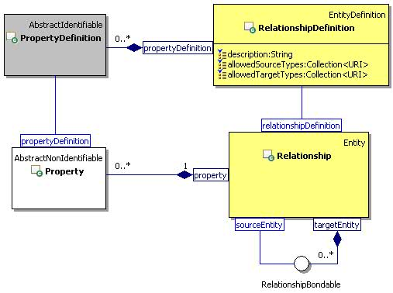
Figure 22 Relationship Class Diagram

Common Concepts

Participant

Description
A participant object represents the participation of any addressable entity in a collaboration activity such as an occurrence, task, conference, discussion, and message.
If an addressable entity is not specified, an address must be specified.

Class Definition
The Participant class is defined by the attribute values:

localNamespace
Value: icom

localName
Value: Participant

extendsFrom
Value:

stereotype
Value: primary

description
Value: A participant object represents the participation of any addressable entity in a collaboration activity such as an occurrence, task, conference, discussion, and message.

propertyDefinitions
The values for this attribute are defined in Section 3.7.1.3.

Property Definitions
The Participant class inherits property definitions from super classes.
The Participant class MUST have the property definitions:

icom:participant
Description: An addressable entity to participate in a collaboration activity.
Required: False
Inherited: False
Property Type: icom_card:Addressable
Cardinality: Single
Updatability: On Create

icom:address
Description: An address of a participant in a collaboration activity.
Required: False
Inherited: False
Property Type: URI
Cardinality: Single
Updatability: On Create

icom:name
Description: Name of a participant in a collaboration activity.
Required: False
Inherited: False
Property Type: String
Cardinality: Single
Updatability: On Create

The Participant class MAY include additional property definitions which are implementation-defined.

Priority
The Priority class is an enum class that enumerates the instances each of which expresses a precedence ordering.
The Priority is defined by the attribute values:

localNamespace
Value: icom

localName
Value: Priority

extendsFrom
Value:

stereotype
Value: primary

isEnumeration
Value: TRUE

description
Value: An enumeration of the instances each of expresses a precedence ordering.

instances
Value: <icom:None, icom:Low, icom:Medium, icom:High>

The following priorities are defined by ICOM:
- icom:None to express a normal priority.
- icom:Low to express a low priority.
- icom:Medium to express a medium priority.
- icom:High to express a high priority.

DateTimeResolution
The DateTimeResolution class is an enum class that enumerates the instances each of which expresses a resolution of a date time value.
The DateTimeResolution is defined by the attribute values:

localNamespace
Value: icom

localName
Value: DateTimeResolution

extendsFrom
Value:

stereotype
Value: primary

isEnumeration
Value: TRUE

description
Value: An enumeration of instances each of which expresses a resolution of a date time value.

instances
Value: <icom:Year, icom:Date, icom:Time>

The following three date time resolutions are defined by ICOM:
- icom:Year to express date time resolution is in years.
- icom:Date to express date time resolution is in years and days.
- icom:Time to express date time resolution is in years, days, and time of day.

Location

Description
A location object represents a physical location which is defined by name, description, and geo coordinates.
Note: The name of a location may remain unchanged while a physical location may be changing. For example, a location name might be “On an airplane” while a physical location might be the geo coordinates of a flight path or current coordinates of a plane.

Class Definition
The Location class is defined by the attribute values:

localNamespace
Value: icom

localName
Value: Location

extendsFrom
Value:

stereotype
Value: primary

description
Value: A location object represents a physical location which is defined by name, description, or geo coordinates.

propertyDefinitions
The values for this attribute are defined in Section 3.7.4.3.

Property Definitions
The Location class inherits property definitions from super classes.
The Location class MUST have the property definitions:

icom:name
Description: Name of a location.
Required: False
Inherited: False
Property Type: String
Cardinality: Single
Updatability: Read Write

icom:description
Description: A description of a location.
Required: False
Inherited: False
Property Type: String
Cardinality: Single
Updatability: Read Write

icom:timeZone
Description: Time zone of a location.
Required: False
Inherited: False
Property Type: TimeZone
Cardinality: Single
Updatability: Read Write

icom:locationMark
Description: A list of geo coordinates marking a point, path, or area of a physical location.
Required: False
Inherited: False
Property Type: icom:GeoCoordinates
Cardinality: Multi
Updatability: Read Write

The Location class MAY include additional property definitions which are implementation-defined.

GeoCoordinates

Description
A geo coordinates object specifies the latitude, longitude, and altitude of a physical location.

Class Definition
The GeoCoordinates class is defined by the attribute values:

localNamespace
Value: icom

localName
Value: GeoCoordinates

extendsFrom
Value:

stereotype
Value: primary

description
Value: A geo coordinates object specifies the latitude, longitude, and altitude of a physical location.

propertyDefinitions
The values for this attribute are defined in Section 3.7.5.3.

Property Definitions
The GeoCoordinates class MUST have the property definitions:

icom:latitude
Description: Latitude of coordinates.
Required: False
Inherited: False
Property Type: Float
Cardinality: Single
Updatability: Read Write

icom:longitude
Description: Longitude of coordinates.
Required: False
Inherited: False
Property Type: Float
Cardinality: Single
Updatability: Read Write

icom:altitude
Description: Altitude of coordinates.
Required: False
Inherited: False
Property Type: Float
Cardinality: Single
Updatability: Read Write

The GeoCoordinates class MAY include additional property definitions which are implementation-defined.

Extension Modules

Content Module

Content

Description
A content object represents a piece of data in a document or message. Content, multi-content, simple content, and online content form a composite design pattern.

Class Definition
The Content class is defined by the attribute values:

localNamespace
Value: icom_content

localName
Value: Content

extendsFrom
Value: icom:Identifiable, icom_msg:MimeConvertible

stereotype
Value: primary

isAbstract
Value: TRUE

description
Value: Content represents a piece of data in a document or message.

propertyDefinitions
The values for this attribute are defined in Section 4.1.1.3.

Property Definitions
The Content class inherits property definitions from super classes.
The Content class MUST have the property definitions:

icom_content:contentId
Description: A content id is a unique identifier for a part of content in multi-part contents.
Required: False
Inherited: False
Property Type: String
Cardinality: Single
Updatability: Read Write

icom_ content:mediaType
Description: Media type is a two-part identifier for Internet file formats as defined in RFC 2046 and additional RFCs including RFC 3236, RFC 1847, etc.
Required: False
Inherited: False
Property Type: String
Cardinality: Single
Updatability: Read Write

icom_ content:contentDisposition
Description: Content disposition is defined in RFC 2183 to specify a presentation style.
Required: False
Inherited: False
Property Type: ContentDispositionType
Cardinality: Single
Updatability: Read Write

The Content class MAY include additional property definitions which are implementation-defined.

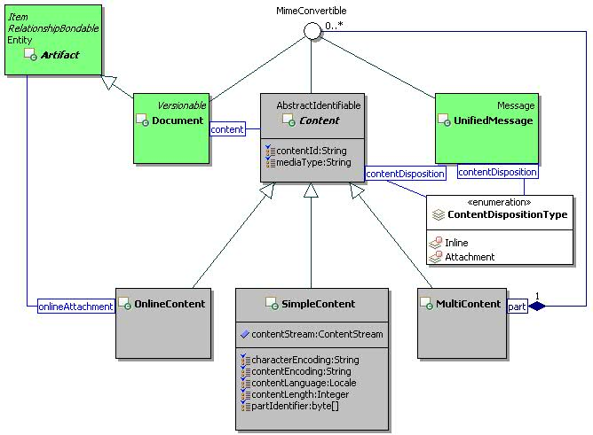
Figure 23 Composite Content Class Diagram

MultiContent

Description
A multi-content object represents multiple parts of a message or document. It is a composite content that can contain a list of simple or composite contents.
Note: A media type is an official RFC 2046 type.

Class Definition
The MultiContent class is defined by the attribute values:

localNamespace
Value: icom_content

localName
Value: MultiContent

extendsFrom
Value: icom_content:Content

stereotype
Value: primary

description
Value: A multi-content object represents the multiple parts of a message or document.

propertyDefinitions
The values for this attribute are defined in Section 4.1.2.3.

Property Definitions
The MultiContent class inherits property definitions from super classes.
The MultiContent class MUST have the property definitions:

icom_content:part
Description: Zero or more parts of a hierarchical composite content.
Required: False
Inherited: False
Property Type: icom_msg:MimeConvertible
Cardinality: Multi
Updatability: Read Write

The MultiContent class MAY include additional property definitions which are implementation-defined.

SimpleContent

Description
A simple content holds a single piece of data.
Note: A media type is an official RFC 2046 type. Content encoding specifies RFC 2616 content encoding applied to a content. Character encoding specifies RFC 2616 character set of a content (a missing value means that a content should be treated as binary or raw). Content language specifies RFC 2616 content language for a content (a missing value means non-natural language content).

Class Definition
The SimpleContent class is defined by the attribute values:

localNamespace
Value: icom_content

localName
Value: SimpleContent

extendsFrom
Value: icom_content:Content

stereotype
Value: primary

description
Value: A simple content holds a single piece of data.

propertyDefinitions
The values for this attribute are defined in Section 4.1.3.3.

Property Definitions
The SimpleContent class inherits property definitions from super classes.
The SimpleContent class MUST have the property definitions:

icom_content:characterEncoding
Description: Character encoding specifies RFC 2616 character set of a content (a missing value means that a content should be treated as binary or raw).
Required: False
Inherited: False
Property Type: String
Cardinality: Single
Updatability: Read Write

icom_content:contentEncoding
Description: Content encoding specifies RFC 2616 content encoding applied to a content.
Required: False
Inherited: False
Property Type: String
Cardinality: Single
Updatability: Read Write

icom_content:contentLangauge
Description: Content language specifies RFC 2616 content language for a content (a missing value means non-natural language content).
Required: False
Inherited: False
Property Type: Locale
Cardinality: Single
Updatability: Read Write

icom_content:contentLength
Description: Length of a content.
Required: False
Inherited: False
Property Type: Integer
Cardinality: Single
Updatability: Read Write

The SimpleContent class MAY include additional property definitions which are implementation-defined.

OnlineContent

Description
An online content holds an online artifact attached to a document, message, or invitation.
Note: An online artifact must be rendered as a URL when a message or invitation is delivered to external recipients.

Class Definition
The OnlineContent class is defined by the attribute values:

localNamespace
Value: icom_content

localName
Value: OnlineContent

extendsFrom
Value: icom_content:Content

stereotype
Value: primary

description
Value: An online content holds an online artifact attached to a message or invitation.

propertyDefinitions
The values for this attribute are defined in Section 4.1.4.3.

Property Definitions
The OnlineContent class inherits property definitions from super classes.
The OnlineContent class MUST have the property definitions:

icom_content:onlineAttachment
Description: An online artifact attached to a message.
Required: True
Inherited: False
Property Type: Artifact
Cardinality: Single
Updatability: Read Write

The OnlineContent class MAY include additional property definitions which are implementation-defined.

ContentDispositionType
The ContentDispositionType class is an enum class that enumerates the instances each of which expresses a presentation style of content.
Note: The enumerated instances for this class are content disposition types defined in RFC 2183.
The ContentDispositionType class is defined by the attribute values:

localNamespace
Value: icom_content

localName
Value: ContentDispositionType

extendsFrom
Value:

stereotype
Value: primary

isEnumeration
Value: TRUE

description
Value: An enumeration of instances each of which expresses a presentation style of content defined in RFC 2183.

instances
Value: <icom_content:Inline, icom_content:Attachment>

There are two content disposition types defined by ICOM:
- icom_content:Inline to express that content is to be displayed automatically upon display of the main body of an artifact.
- icom_content:Attachment to express that content is separate from the main body of an artifact, and that its display should not be automatic, but contingent upon some further action of a user.

Attachment

Description
An attachment holds a simple content for an occurrence, task, and contact artifact.

Class Definition
The Attachment class is defined by the attribute values:

localNamespace
Value: icom_content

localName
Value: Attachment

extendsFrom
Value:

stereotype
Value: primary

description
Value: An attachment holds a simple content for an occurrence, task, and contact artifact.

propertyDefinitions
The values for this attribute are defined in Section 4.1.6.3.

Property Definitions
The Attachment class MUST have the property definitions:

icom:name
Description: Name of a simple content attachment.
Required: True
Inherited: False
Property Type: String
Cardinality: Single
Updatability: Read Write

icom_content:content
Description: A simple content attached to an occurrence, task, or contact artifact.
Required: True
Inherited: False
Property Type: SimpleContent
Cardinality: Single
Updatability: Read Write

The Attachment class MAY include additional property definitions which are implementation-defined.

Document Module

Versionable

Description
A versionable artifact is
- a representative copy,
- a specific versioned copy, or
- a private working copy
of an artifact version series.
When a versionable artifact is not under version control, a representative copy of a versionable artifact is the only version of a version series and represents the versionable artifact itself, i.e. there is only one objectId so far.
When a versionable artifact is under version control:
- a representative copy of a versionable artifact is a versionable artifact which has its own object identifier that is different from the object identifier of any versioned copy or private working copy of the versionable artifact. It retains the object identifier it has when the artifact is created. Its version type changes from RepresentativeCopy to ViewOnlyRepresentativeCopy.
- a representative copy of a versionable artifact provides a view of a version series, depending on the check out state of the version series and the user loading the artifact. If the current user loading a representative copy is the same user who checks out from a version series, the representative copy is a copy of the content and state of a private working copy. Otherwise, the representative copy is a copy of the content and state of the latest versioned copy in a version series.
A specific versioned copy of a versionable artifact is an explicit ”deep” copy of the content and state of a versionable artifact, preserving its content and state at a certain point in time. Each versioned copy of a versionable artifact is itself a versionable artifact, i.e. it has its own objectId. A versioned copy has a version number, label, and check in comment.
A private working copy of a versionable artifact is a versionable artifact created by an explicit checkout operation on a versionable artifact under version control. The properties for a private working copy SHOULD be identical to the properties of a versioned copy of a versionable artifact on which a checkout operation was performed. Certain properties such as objectId and creationDate SHALL be different from a versioned copy. The content of a private working copy MAY be identical to the content of a versioned copy. Its object identifier must be different from that of the representative copy or any versioned copy. A private working copy can be saved to the version series for sharing and co-editing, however, it needs not be visible to users who may only have permissions to view other versioned copies in a version series. Until it is checked in using an explicit checkin operation, a private working copy MUST NOT be considered the LatestMajorVersion in a version series.
Note: A container of a versionable artifact can contain a representative copy of a version series so that it provides an artifact view of the latest state of the version series. Starting from a representative copy in a container, an actor can traverse a version series to retrieve any versioned copy or private working copy.
ICOM version control model is based on the CMIS version control model specified in Section 2.1.9 of Content Management Interoperability Services Version 1.0 [CMIS].

Class Definition
The Versionable class is a mixin class that defines the characteristics of artifacts that can be versioned.
The Versionable class is defined by the attribute values:

localNamespace
Value: icom_doc

localName
Value: Versionable

extendsFrom
Value: icom:Identifiable

stereotype
Value: mixin

description
Value: Versionable class is a mixin class that defines the characteristics of artifacts that can be versioned.

propertyDefinitions
The values for this attribute are defined in Section 4.2.1.3.

Property Definitions
The Versionable class inherits property definitions from super classes.
The Versionable class MUST have the property definitions:

icom_doc:versionControlMetadata
Description: A version control metadata object attached to a versionable artifact.
Required: False
Inherited: False
Property Type: icom_doc:VersionControlMetadata
Cardinality: Single
Updatability: Read Only

icom_doc:versionType
Description: A type of version controlled copy of a versionable artifact.
Required: False
Inherited: False
Property Type: icom_doc:VersionType
Cardinality: Single
Updatability: Read Only

The Versionable class MAY include additional property definitions which are implementation-defined.

VersionControlMetadata

Description
A version control metadata is an object that contains version control information.
There are two classes of version control metadata: version series and version. A version control metadata of a versionable artifact is either a version series or a version depending on the version type.
- If the version type is icom_doc:RepresentativeCopy or icom_doc:ViewOnlyRepresentativeCopy, then metadata MUST be a version series object.
- If the version type is icom_doc:VersionedCopy or icom_doc:PrivateWorkingCopy, then metadata MUST be a version object.

Class Definition
The VersionControlMetadata class is a mixin class that defines the characteristics of entities that serve as metadata for version control.
The VersionControlMetadata class is defined by the attribute values:

localNamespace
Value: icom_doc

localName
Value: VersionControlMetadata

extendsFrom
Value: icom:Identifiable

stereotype
Value: mixin

description
Value: VersionControlMetadata is a mixin class that defines the characteristics of entities that serve as metadata for version control.

propertyDefinitions
The values for this attribute are defined in Section 4.2.2.3.

Property Definitions
The VersionControlMetadata class inherits property definitions from super classes.
The VersionControlMetadata class MUST have the property definitions:

icom_doc:representativeCopy
Description: A representative copy of a versionable artifact.
Required: False
Inherited: False
Property Type: icom_doc:Versionable
Cardinality: Single
Updatability: Read Only

The VersionControlMetadata class MAY include additional property definitions which are implementation-defined.

VersionSeries

Description
A version series is a version control metadata that contains a version history and check in/out states of a versionable artifact.
A version series object is a version control metadata of a representative copy of a versionable artifact.

Class Definition
The VersionSeries class is defined by the attribute values:

localNamespace
Value: icom_doc

localName
Value: VersionSeries

extendsFrom
Value: icom:Entity, icom_doc:VersionControlMetadata, icom_meta:RelationshipBondable

stereotype
Value: primary

description
Value: A version series is a version control metadata that contains a version history and check in/out states of a versionable artifact.

propertyDefinitions
The values for this attribute are defined in Section 4.2.3.3.

Property Definitions
The VersionSeries class inherits property definitions from super classes.
The VersionSeries class MUST have the property definitions:

icom_doc:versionHistory
Description: A history of version nodes of a versionable artifact.
Required: False
Inherited: False
Property Type: icom_doc:Version
Cardinality: Multi
Updatability: Read Only

icom_doc:versionableHistory
Description: A history of the versioned copies of a versionable artifact.
Required: False
Inherited: False
Property Type: icom_doc:Versionable
Cardinality: Multi
Updatability: Read Only

icom_doc:latestVersionedCopy
Description: Latest versioned copy of a versionable artifact.
Required: False
Inherited: False
Property Type: icom_doc:Versionable
Cardinality: Single
Updatability: Read Only

icom_doc:privateWorkingCopy
Description: A private working copy of a versionable artifact.
Required: False
Inherited: False
Property Type: icom_doc:Versionable
Cardinality: Single
Updatability: Read Only

icom_doc:versionSeriesCheckedOut
Description: Indicates whether a version series is checked out.
Required: False
Inherited: False
Property Type: Boolean
Cardinality: Single
Updatability: Read Only

icom_doc:versionSeriesCheckedOutBy
Description: An actor who checks out a version series.
Required: False
Inherited: False
Property Type: icom:Actor
Cardinality: Single
Updatability: Read Only

icom_doc:versionSeriesCheckedOutOn
Description: The time when a version series is checked out.
Required: False
Inherited: False
Property Type: DateTime
Cardinality: Single
Updatability: Read Only

icom_doc:versionSeriesCheckoutComment
Description: A checked out comment of a version series.
Required: False
Inherited: False
Property Type: String
Cardinality: Single
Updatability: Read Only

icom_doc:totalSize
Description: Total size of all versioned copies of a versionable artifact in a version series.
Required: False
Inherited: False
Property Type: Integer
Cardinality: Single
Updatability: Read Only

The VersionSeries class MAY include additional property definitions which are implementation-defined.

Version

Description
A version is a version control metadata that contains a version number, label, and description.
A version object is a version control metadata of a versioned copy or a private working copy of a versionable artifact.

Class Definition
The Version class is defined by the attribute values:

localNamespace
Value: icom_doc

localName
Value: Version

extendsFrom
Value: icom:Entity, icom_doc:VersionControlMetadata, icom_meta:RelationshipBondable

stereotype
Value: primary

description
Value: A version is a version control metadata that contains a version number, label, and description.

propertyDefinitions
The values for this attribute are defined in Section 4.2.4.3.

Property Definitions
The Version class inherits property definitions from super classes.
The Version class MUST have the property definitions;

icom_doc:checkinComment
Description: A check in comment of a versioned copy.
Required: False
Inherited: False
Property Type: String
Cardinality: Single
Updatability: Read Write

icom_doc:versionNumber
Description: A version number of a versioned copy.
Required: True
Inherited: False
Property Type: Integer
Cardinality: Single
Updatability: Read Write

icom_doc:versionLabel
Description: A version label of a versioned copy.
Required: True
Inherited: False
Property Type: String
Cardinality: Single
Updatability: Read Write

icom_doc:majorVersion
Description: Indicates whether a versioned copy is a major version.
Required: True
Inherited: False
Property Type: Boolean
Cardinality: Single
Updatability: Read Write

icom_doc:versionedOrPrivateWorkingCopy
Description: A versioned copy or private working copy corresponding to a version of a versionable artifact.
Required: False
Inherited: False
Property Type: icom_doc:Versionable
Cardinality: Multi
Updatability: Read Only

The Version class MAY include additional property definitions which are implementation-defined.

VersionType
The VersionType class is an enum class that enumerates the instances each of which expresses a version type.
The VersionType class is defined by the attribute values:

localNamespace
Value: icom_doc

localName
Value: VersionType

extendsFrom
Value:

stereotype
Value: primary

isEnumeration
Value: TRUE

description
Value: An enumeration of the instances each of which expresses a version type.

instances
Value: <icom_doc:RepresentativeCopy, icom_doc:ViewOnlyRepresentativeCopy, icom_doc:VersionedCopy, icom_doc:PrivateWorkingCopy>

There are four version types defined by ICOM:
- icom_doc:RepresentativeCopy to express that a versionable artifact is a representative copy of an artifact.
- icom_doc:ViewOnlyRepresentativeCopy to express that a versionable artifact is a view only representative copy of an artifact version series.
- icom_doc:VersionedCopy to express that a versionable artifact is a versioned copy of an artifact version series.
- icom_doc:PrivateWorkingCopy to express that a versionable artifact is a private working copy of an artifact version series.

Document

Description
A document is a versionable artifact that can contain a single content of a media type or composite contents of any assortment of media types.

Class Definition
The Document class is defined by the attribute values:

localNamespace
Value: icom_doc

localName
Value: Document

extendsFrom
Value: icom:Artifact, icom_doc:Versionable, icom_content:MimeConvertible

stereotype
Value: primary

description
Value: A document is a versionable artifact that can contain a single content of a media type or composite contents of any assortment of media types.

propertyDefinitions
The values for this attribute are defined in Section 4.2.6.3.

Property Definitions
The Document class inherits property definitions from super classes.
The Document class MUST have the property definitions:

icom_content:content
Description: Content of a document.
Required: False
Inherited: False
Property Type: icom_content:Content
Cardinality: Single
Updatability: Read Write

icom_doc:size
Description: The size of a copy of a document.
Required: False
Inherited: False
Property Type: Integer
Cardinality: Single
Updatability: Read Only

The Document class MAY include additional property definitions which are implementation-defined.

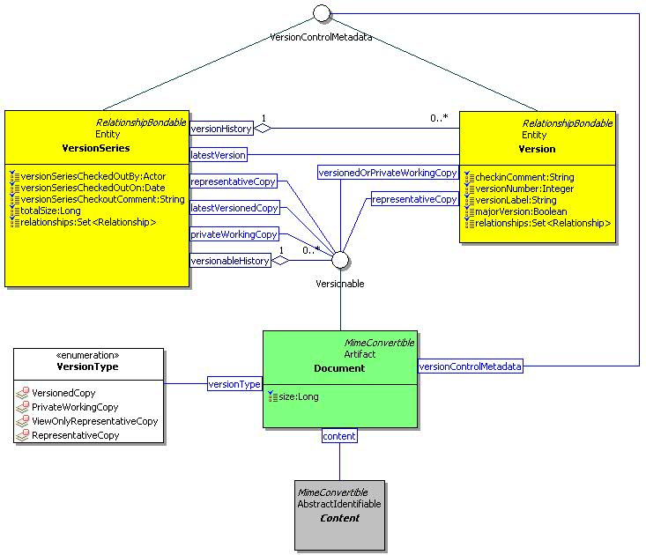
Figure 24 Document, Version Series, and Version Class Diagram

WikiPage

Description
A wiki page is a document that contains a rendered page and a rendered content.

Class Definition
The WikiPage class is defined by the attribute values:

localNamespace
Value: icom_doc

localName
Value: WikiPage

extendsFrom
Value: icom_doc:Document

stereotype
Value: primary

description
Value: A wiki page is a document that contains a rendered page and a rendered content.

propertyDefinitions
The values for this attribute are defined in Section 4.2.7.3.

Property Definitions
The WikiPage class inherits property definitions from super classes.
The WikiPage class MUST have the property definitions:

icom_doc:renderedPage
Description: A page rendered from wiki page content.
Required: False
Inherited: False
Property Type: String
Cardinality: Single
Updatability: Read Only

icom_doc:renderedContent
Description: An object rendered from wiki page content.
Required: False
Inherited: False
Property Type: Object
Cardinality: Single
Updatability: Read Only

The WikiPage class MAY include additional property definitions which are implementation-defined.

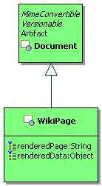
Figure 25 WikiPage Class Diagram.

Message Module

MimeConvertible

Description
A MimeConvertible object represents an object that has Multipurpose Internet Mail Extensions (MIME) characteristics such as headers, content transfer encoding, and possible hierarchy of sub-contents.
Note: MIME is specified by RFC memoranda: RFC 2045, RFC 2046, RFC 2047, RFC 4288, RFC 4289 and RFC 2049.

Class Definition
The MimeConvertible class is a mixin class that defines the characteristics of objects that can be represented in MIME format.
The MimeConvertible class is defined by the attribute values:

localNamespace
Value: icom_msg

localName
Value: MimeConvertible

extendsFrom
Value: icom:Identifiable

stereotype
Value: mixin

description
Value: MimeConvertible class is a mixin class that defines the characteristics of objects that can be represented in MIME format.

propertyDefinitions
The values for this attribute are defined in Section 4.3.1.3.

Property Definitions
The MimeConvertible class inherits property definitions from super classes.
The MimeConvertible class MAY include additional property definitions which are implementation-defined.

Message

Description
A message is a unit of conversation. It holds a simple content or multipart message contents in a content property. It has a single sender.
Note: The delivered time is the time when a message is delivered to a given recipient. The sent time of a message is represented by a user creation date and time of the message. The name property holds the subject of a message.

Class Definition
The Message class is defined by the attribute values:

localNamespace
Value: icom_msg

localName
Value: Message

extendsFrom
Value: icom:Artifact

stereotype
Value: primary

isAbstract
Value: TRUE

description
Value: A message is a unit of conversation.

propertyDefinitions
The values for this attribute are defined in Section 4.3.2.3.

Property Definitions
The Message class inherits property definitions from super classes.
The Message class MUST have the property definitions:

icom_msg:sender
Description: Sender of a message.
Required: False
Inherited: False
Property Type: icom:Participant
Cardinality: Single
Updatability: Read Write

icom_msg:deliveredTime
Description: The time when a message is delivered to a given recipient.
Required: False
Inherited: False
Property Type: DateTime
Cardinality: Single
Updatability: Read Only

icom_content:content
Description: Content of a message
Required: False
Inherited: False
Property Type: icom_content:Content
Cardinality: Single
Updatability: Read Write

The Message class MAY include additional property definitions which are implementation-defined.

UnifiedMessage

Description
A unified message is a special type of message delivered electronically over a computer, voice, fax, and other networks.
A unified message can be one of these types:
- Email is a type of message that is delivered electronically over a computer network.
- Voice is a type of message that contains a voice or audio stream.
- Fax is a type of message that contains an image transmitted via phone lines using the fax protocol.
- Notification is a type of message sent by applications.

Class Definition
The UnifiedMessage class is defined by the attribute values:

localNamespace
Value: icom_msg

localName
Value: UnifiedMessage

extendsFrom
Value: icom_msg:Message, icom_msg:MimeConvertible

stereotype
Value: primary

description
Value: A unified message is a special type of message delivered electronically over a computer, voice, fax, and other networks.

propertyDefinitions
The values for this attribute are defined in Section 4.3.3.3.

Property Definitions
The UnifiedMessage class inherits property definitions from super classes.
The UnifiedMessage class MUST have the property definitions:

icom_msg:envelopSender
Description: An envelop sender (sometimes called return path) of a message.
Required: False
Inherited: False
Property Type: icom:Participant
Cardinality: Single
Updatability: Read Write

icom_msg:toReceivers
Description: A list of participants to whom a message is sent or to be sent.
Required: False
Inherited: False
Property Type: icom:Participant
Cardinality: Multi
Updatability: Read Write

icom_msg:ccReceivers
Description: A list of participants to whom a message is carbon-copied or to be carbon-copied.
Required: False
Inherited: False
Property Type: icom:Participant
Cardinality: Multi
Updatability: Read Write

icom_msg:bccReceivers
Description: A list of participants to whom a message is blind-carbon-copied or to be blind-carbon-copied.
Required: False
Inherited: False
Property Type: icom:Participant
Cardinality: Multi
Updatability: Read Write

icom_msg:replyTo
Description: A list of participants to whom reply messages should be sent.
Required: False
Inherited: False
Property Type: icom:Participant
Cardinality: Multi
Updatability: Read Write

icom_ content:contentId
Description: Content id is a unique identifier for a message part in multi-part messages.
Required: False
Inherited: False
Property Type: String
Cardinality: Single
Updatability: Read Write

icom_ content:mediaType
Description: Media type is a two-part identifier for Internet file formats as defined in RFC 2046 and additional RFCs including RFC 3236, RFC 1847, etc.
Required: False
Inherited: False
Property Type: String
Cardinality: Single
Updatability: Read Write

icom_ content:contentDisposition
Description: Content disposition is defined in RFC 2183 to specify a presentation style.
Required: False
Inherited: False
Property Type: icom_content:ContentDispositionType
Cardinality: Single
Updatability: Read Write

icom:priority
Description: The priority of a message.
Required: False
Inherited: False
Property Type: icom:Priority
Cardinality: Single
Updatability: Read Write

icom_msg:flag
Description: Zero or more flags on a message.
Required: False
Inherited: False
Property Type: icom_msg:UnifiedMessageFlag
Cardinality: Multi
Updatability: Read Write

icom_msg:messageDispositionNotificationRequested
Description: A message disposition notification (RFC 2298) is requested for a message.
Required: False
Inherited: False
Property Type: Boolean
Cardinality: Single
Updatability: Read Write

icom_msg:messageDeliveryStatusNotificationRequest
Description: Indicates the types of delivery status notifications (RFC 1891) requested for a message. Default is icom_msg:Failure.
Required: False
Inherited: False
Property Type: UnifiedMessageDeliveryStatusNotificationRequest
Cardinality: Multi
Updatability: Read Write

icom_msg:channel
Description: Indicates the delivery channel of a message.
Required: False
Inherited: False
Property Type: icom_msg:UnifiedMessageChannel
Cardinality: Single
Updatability: Read Write

icom_msg:mode
Description: Indicates an editable mode (new, draft, or delivered) of a message.
Required: False
Inherited: False
Property Type: icom_msg:UnifiedMessageEditMode
Cardinality: Single
Updatability: Read Only

icom_msg:mimeHeader
Description: A list of headers including those defined in RFC 822 and other custom headers. Each header is represented by a multi-valued property. The name of a property is a printable header name. The value of a property is a collection of ascii or non-ascii strings.
Required: False
Inherited: False
Property Type: icom_meta:Property
Cardinality: Multi
Updatability: Read Write

The UnifiedMessage class MAY include additional property definitions which are implementation-defined.

UnifiedMessageFlag
The UnifiedMessageFlag class is an enum class that enumerates the instances each of which expresses a type of flag.
The UnifiedMessageFlag class is defined by the attribute values:

localNamespace
Value: icom_msg

localName
Value: UnifiedMessageFlag

extendsFrom
Value:

stereotype
Value: primary

isEnumeration
Value: TRUE

description
Value: An enumeration of the instances each of which expresses a type of flag.

instances
Value: <icom_msg:Answered, icom_msg:Forwarded, icom_msg:Redirected, icom_msg:Hidden, icom_msg:MarkedForDelete, icom_msg:MarkedForFollowUp, icom_msg:MarkedForDraft, icom_msg:MessageDispositionNotificationProcessed>

There are eight flags defined by ICOM:
- icom_msg:Answered to express that a message is answered.
- icom_msg:Forwarded to express that a message is forwarded.
- icom_msg:Redirected to express that a message is redirected.
- icom_msg:Hidden to express that a message is hidden.
- icom_msg:MarkedForDelete to express that a message is marked for delete.
- icom_msg:MarkedForFollowUp to express that a message is marked for follow up.
- icom_msg:MarkedForDraft to express that a message is marked for draft.
- icom_msg:MessageDispositionNotificationProcessed to express that a message disposition notification (RFC 2298) is processed.

UnifiedMessageDeliveryStatusNotificationRequest
The UnifiedMessageDeliveryStatusNotificationRequest class is an enum class that enumerates the instances each of which expresses a request for one of several types of delivery status notification defined in RFC 1891.
The UnifiedMessageDeliveryStatusNotificationRequest class is defined by the attribute values:

localNamespace
Value: icom_msg

localName
Value: UnifiedMessageDeliveryStatusNotificationRequest

extendsFrom
Value:

stereotype
Value: primary

isEnumeration
Value: TRUE

description
Value: An enumeration of the instances each of which expresses a request for one of several types of delivery status notification.

instances
Value: <icom_msg:Never, icom_msg:Success, icom_msg:Failure, icom_msg:Delay>

There are four delivery status notification requests defined by ICOM:
- icom_msg:Never to express that a sender requests status notification not be returned to the sender under any condition.
- icom_msg:Success to express that a sender requests a status notification for successful delivery of a message.
- icom_msg:Failure to express that a sender requests a status notification for delivery failure of a message.
- icom_msg:Delay to express that a sender requests a status notification when delivery of a message has been delayed for an unusual length of time.

UnifiedMessageChannel
The UnifiedMessageChannel class is an enum class that enumerates the instances each of which expresses a type of delivery channel.
The UnifiedMessageChannel class is defined by the attribute values:

localNamespace
Value: icom_msg

localName
Value: UnifiedMessageChannel

extendsFrom
Value:

stereotype
Value: primary

isEnumeration
Value: TRUE

description
Value: An enumeration of the instances each of which expresses a requested receipt type.

instances
Value: <icom_msg:Email, icom_msg:Voice, icom_msg:Fax, icom_msg:Notification>

There are four channel types defined by ICOM:
- icom_msg:Email to express that delivery channel is email.
- icom_msg:Voice to express that delivery channel is voice.
- icom_msg:Fax to express that delivery channel is fax.
- icom_msg:Notification to express that delivery channel is notification.

UnifiedMessageEditMode
The UnifiedMessageEditMode class is an enum class that enumerates the instances each of which expresses whether a message is a draft copy, delivered copy, or other.
The UnifiedMessageEditMode class is defined by the attribute values:

localNamespace
Value: icom_msg

localName
Value: UnifiedMessageEditMode

extendsFrom
Value:

stereotype
Value: primary

isEnumeration
Value: TRUE

description
Value: An enumeration of the instances each of which expresses whether a message is a draft copy, delivered copy, or other.

instances
Value: <icom_msg:DraftCopy, icom_msg:DeliveredCopy, icom_msg:Other>

There are three modes defined by ICOM:
- icom_msg:DraftCopy to express that a message is saved as a draft.
- icom_msg:DeliveredCopy to express that a message is a sent or received message.
- icom_msg:Other to express that a message is other than draft or delivered.

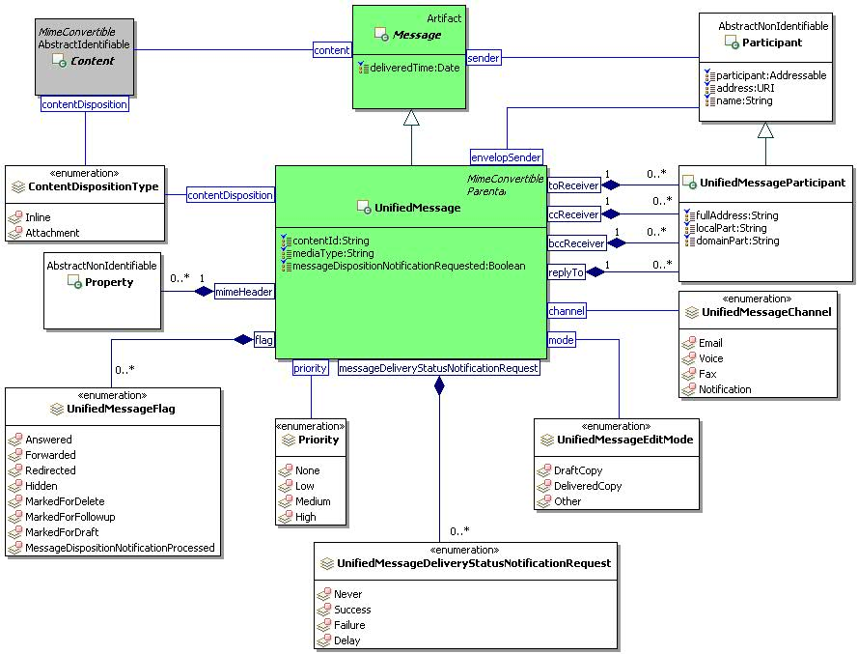
Figure 26 Unified Message Class Diagram

InstantMessage

Description
An instant message is a special type of message for one-on-one, synchronous, usually text based, conversation.

Class Definition
The InstantMessage class is defined by the attribute values:

localNamespace
Value: icom_msg

localName
Value: InstantMessage

extendsFrom
Value: icom_msg:Message

stereotype
Value: primary

isAbstract
Value: TRUE

description
Value: An instant message is a special type of message for one-on-one, synchronous, usually text based, conversation.

propertyDefinitions
The values for this attribute are defined in Section 4.3.8.3.

Property Definitions
The InstantMessage class inherits property definitions from super classes.
The InstantMessage class MUST have the property definitions:

icom_msg:toReceivers
Description: A list of participants to whom a message is sent or to be sent.
Required: False
Inherited: False
Property Type: icom:Participant
Cardinality: Multi
Updatability: Read Write

icom_msg:conversationId
Description: An identifier of a conversation involving one or more instant messages.
Required: False
Inherited: False
Property Type: Integer
Cardinality: Single
Updatability: Read Write

icom_msg:clientSideId
Description: An identifier of a client.
Required: False
Inherited: False
Property Type: String
Cardinality: Single
Updatability: Read Write

icom_msg:formatingStyle
Description: A formatting style of rich text message in xhtml.
Required: False
Inherited: False
Property Type: String
Cardinality: Single
Updatability: Read Write

icom_msg:instantMessageType
Description: A type of instant message.
Required: False
Inherited: False
Property Type: icom_msg:InstantMessageType
Cardinality: Single
Updatability: Read Write

icom_msg:chatStatus
Description: A chat status of a user.
Required: False
Inherited: False
Property Type: icom_msg:InstantMessageChatStatus
Cardinality: Single
Updatability: Read Write

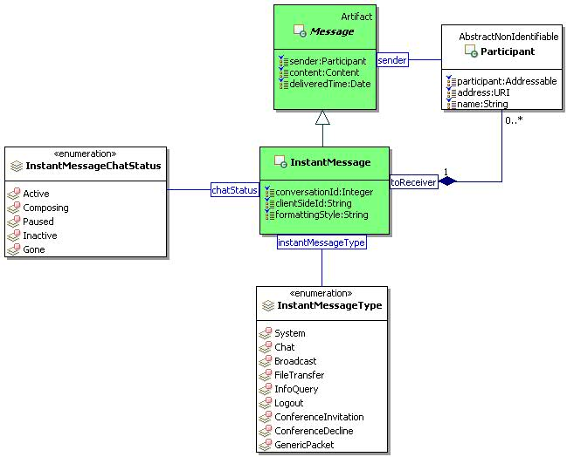
Figure 27 InstantMessage Class Diagram.

InstantMessageType
The InstantMessageType class is an enum class that enumerates the instances each of which expresses a type of instant message.
The InstantMessageType class is defined by the attribute values:

localNamespace
Value: icom_msg

localName
Value: InstantMessageType

extendsFrom
Value:

stereotype
Value: primary

isEnumeration
Value: TRUE

description
Value: An enumeration of the instances each of which expresses a type of instant message.

instances
Value: <icom_msg:System, icom_ msg:Chat, icom_ msg:Broadcast, icom_msg:FileTransfer, icom_ msg:InfoQuery, icom_ msg:Logout, icom_ msg:ConferenceInvitation, icom_ msg:ConferenceDecline, icom_ msg:GenericPacket>

There are nine instant message types defined by ICOM:
- icom_msg:System to express that an instant message is a system message.
- icom_msg:Chat to express that an instant message is a chat message.
- icom_msg:Broadcast to express that an instant message is a broadcast message.
- icom_msg:FileTransfer: to express that an instant message is a file transfer message.
- icom_msg:InfoQuery to express that an instant message is a info query message.
- icom_msg:Logout to express that an instant message is a logout message.
- icom_msg:ConferenceInvitation to express that an instant message is a conference invitation message.
- icom_msg:ConferenceDecline to express that an instant message is a decline message to a conference invitation.
- icom_msg:GenericGone to express that an instant message is a generic message indicating that a user is gone.

InstantMessageChatStatus
The InstantMessageChatStatus class is an enum class that enumerates the instances each of which expresses a chat status of a user.
The InstantMessageChatStatus class is defined by the attribute values:

localNamespace
Value: icom_msg

localName
Value: InstantMessageChatStatus

extendsFrom
Value:

stereotype
Value: primary

isEnumeration
Value: TRUE

description
Value: An enumeration of the instances each of which expresses a chat status of a user.

instances
Value: <icom_msg:Active, icom_ msg:Composing, icom_ msg:Paused, icom_msg:Inactive, icom_ msg:Gone>

There are five chat status defined by ICOM:
- icom_msg:Active to express that a user is active.
- icom_msg:Composing to express that a user is composing a message.
- icom_msg:Paused to express that a user has paused.
- icom_msg:Inactive: to express that a user is inactive.
- icom_msg:Gone to express that a user is gone.

InstantMessageFeed

Description
An instant message feed contains a set of instant message connections.

Class Definition
The InstantMessageFeed class is defined by the attribute values:

localNamespace
Value: icom_msg

localName
Value: InstantMessageFeed

extendsFrom
Value: icom:Entity

stereotype
Value: primary

description
Value: An instant message feed contains a set of instant message connections.

propertyDefinitions
The values for this attribute are defined in Section 4.3.11.3.

Property Definitions
The InstantMessageFeed class inherits property definitions from super classes.
The InstantMessageFeed class MUST have the property definitions:

icom_msg:connection
Description: One or more instant messaging connections.
Required: False
Inherited: False
Property Type: icom_msg:InstantMessageConnection
Cardinality: Multi
Updatability: Read Only

icom_msg:outboundInstantMessage
Description: A queue for outbound instant messages.
Required: False
Inherited: False
Property Type: icom_msg:InstantMessage
Cardinality: Multi
Updatability: Write Only

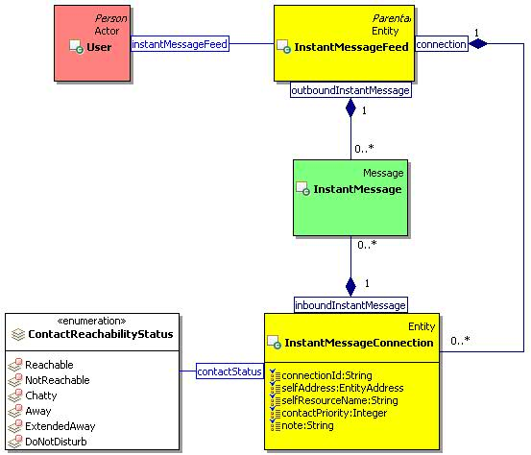
Figure 28 Instant Message Feed and Connection Class Diagram.

InstantMessageConnection

Description
An instant message connection contains the queues for inbound and outbound instant messages.
A presentity can update the contact status, contact priority, and note for a contact method associated with a connection.

Class Definition
The InstantMessageConnection class is defined by the attribute values:

localNamespace
Value: icom_msg

localName
Value: InstantMessageConnection

extendsFrom
Value: icom:Entity

stereotype
Value: primary

description
Value: An instant message connection contains the queues for inbound and outbound instant messages.

propertyDefinitions
The values for this attribute are defined in Section 4.3.12.3.

Property Definitions
The InstantMessageConnection class inherits property definitions from super classes.
The InstantMessageConnection class MUST have the property definitions:

icom_msg:connectionId
Description: An identifier of a connection.
Required: False
Inherited: False
Property Type: String
Cardinality: Single
Updatability: Read Only

icom_msg:selfAddress
Description: Address of a presentity who opens a connection.
Required: True
Inherited: False
Property Type: URI
Cardinality: Single
Updatability: On Create

icom_msg:selfResourceName
Description: Resource name associated with a connection.
Required: True
Inherited: False
Property Type: String
Cardinality: Single
Updatability: On Create

icom_presence:contactStatus
Description: Reachability status to be propagated to an associated contact method.
Required: False
Inherited: False
Property Type: icom_presence:ContactReachabilityStatus
Cardinality: Single
Updatability: Write Only

icom_presence:contactPriority
Description: Priority to be propagated to an associated contact method.
Required: False
Inherited: False
Property Type: Integer
Cardinality: Single
Updatability: Write Only

icom_presence:note
Description: Note to be propagated to an associated contact method.
Required: False
Inherited: False
Property Type: String
Cardinality: Single
Updatability: Write Only

icom_msg:inboundInstantMessage
Description: A queue for inbound instant messages.
Required: False
Inherited: False
Property Type: icom_msg:InstantMessage
Cardinality: Multi
Updatability: Read Only

Presence Module

Presence

Description
A presence describes the contact methods and activities of a presentity.
It provides a list of contact methods describing how to contact a presentity. A viewer may choose any one of the contact methods based on circumstances.
It includes a list of activities describing what a presentity is doing.

Class Definition
The Presence class is defined by the attribute values:

localNamespace
Value: icom_presence

localName
Value: Presence

extendsFrom
Value: icom:Identifiable

stereotype
Value: primary

description
Value: A presence describes the contact methods and activities of a presentity.

propertyDefinitions
The values for this attribute are defined in Section 4.4.1.3.

Property Definitions
The Presence class inherits property definitions from super classes.
The Presence class MUST have the property definitions:

icom:lastModificationDate
Description: Last modification date and time of information in a presence.
Required: False
Inherited: False
Property Type: DateTime
Cardinality: Single
Updatability: Read Only

icom_presence:mode
Description: Editable mode of a presence.
Required: False
Inherited: False
Property Type: icom_presence:PresenceEditMode
Cardinality: Single
Updatability: Read Only

icom_presence:contactMethod
Description: A collection of contact methods describing how to contact a presentity. A viewer may choose any one of the contact methods based on circumstances.
Required: False
Inherited: False
Property Type: icom_presence:ContactMethod
Cardinality: Multi
Updatability: Read Only

icom_presence:activity
Description: A collection of activities describing what a presentity is doing.
Required: False
Inherited: False
Property Type: icom_presence:Activity
Cardinality: Multi
Updatability: Read Only

The Presence class MAY include additional property definitions which are implementation-defined.

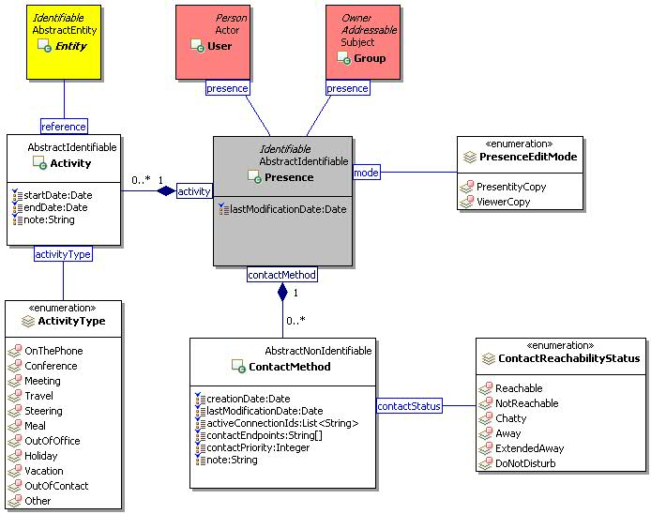
Figure 29 Presence Class Diagram.

PresenceEditMode
The PresenceEditMode class is an enum class that enumerates the instances each of which expresses an editable mode of a presence.
The PresenceEditMode class is defined by the attribute values:

localNamespace
Value: icom_presence

localName
Value: PresenceEditMode

extendsFrom
Value:

stereotype
Value: primary

isEnumeration
Value: TRUE

description
Value: An enumeration of the instances each of which expresses an editable mode of a presence.

instances
Value: <icom_presence:PresentityCopy, icom_presence:ViewerCopy>

There are two presence editable modes defined by ICOM:
- icom_presence:PresentityCopy to express that a presence is a copy belonging to a presentity who may update the properties such activities.
- icom_presence:ViewerCopy to express that a presence is a copy visible to a subscriber who may not update the properties.

ContactMethod

Description
A contact method object describes reachability circumstances of a presentity.

Class Definition
The ContactMethod class is defined by the attribute values:

localNamespace
Value: icom_presence

localName
Value: ContactMethod

extendsFrom
Value:

stereotype
Value: primary

description
Value: A contact method object describes reachability circumstances of a presentity.

propertyDefinitions
The values for this attribute are defined in Section 4.4.3.3

Property Definitions
The ContactMethod class MUST have the property definitions:

icom:creationDate
Description: Creation date and time of information in a contact method.
Required: False
Inherited: False
Property Type: DateTime
Cardinality: Single
Updatability: Read Only

icom:lastModificationDate
Description: Last modification date and time of information in a contact method.
Required: False
Inherited: False
Property Type: DateTime
Cardinality: Single
Updatability: Read Only

icom_presence:activeConnectionId
Description: A list of active connection ids of a presentity.
Required: False
Inherited: False
Property Type: String
Cardinality: Multi
Updatability: Read Only

icom_presence:contactEndpoint
Description: A list of endpoints or URIs for contacting a presentity.
Required: False
Inherited: False
Property Type: String
Cardinality: Multi
Updatability: Read Only

icom_presence:contactPriority
Description: Priority of a contact method relative to other contact methods in a presence.
Required: False
Inherited: False
Property Type: Integer
Cardinality: Single
Updatability: Read Only

icom_presence:contactStatus
Description: Status of a contact method in a presence.
Required: False
Inherited: False
Property Type: icom_presence:ContactReachabilityStatus
Cardinality: Single
Updatability: Read Only

icom_presence:note
Description: A note about a contact method in a presence.
Required: False
Inherited: False
Property Type: String
Cardinality: Single
Updatability: Read Only

ContactReachabilityStatus
The ContactReachabilityStatus class is an enum class that enumerates the instances each of which expresses a reachability status of a contact method.
The ContactReachabilityStatus class is defined by the attribute values:

localNamespace
Value: icom_presence

localName
Value: ContactReachabilityStatus

extendsFrom
Value:

stereotype
Value: primary

isEnumeration
Value: TRUE

description
Value: An enumeration of the instances each of which expresses a reachability status of a contact method.

instances
Value: <icom_presence:Reachable, icom_ presence:NotReachable, icom_ presence:Chatty, icom_presence:Away, icom_ presence:ExtendedAway, icom_ presence:DoNotDisturb>

There are six reachability status defined by ICOM:
- icom_presence:Reachable to express that a presentity is reachable through a contact method.
- icom_presence:NotReachable to express that a presentity is not reachable through a contact method.
- icom_presence:Chatty to express that a presentity is chatty.
- icom_presence:Away to express that a presentity is away.
- icom_presence:ExtendedAway to express that a presentity is away for an extended period.
- icom_presence:DoNotDisturb to express that a presentity prefers not to be disturbed.

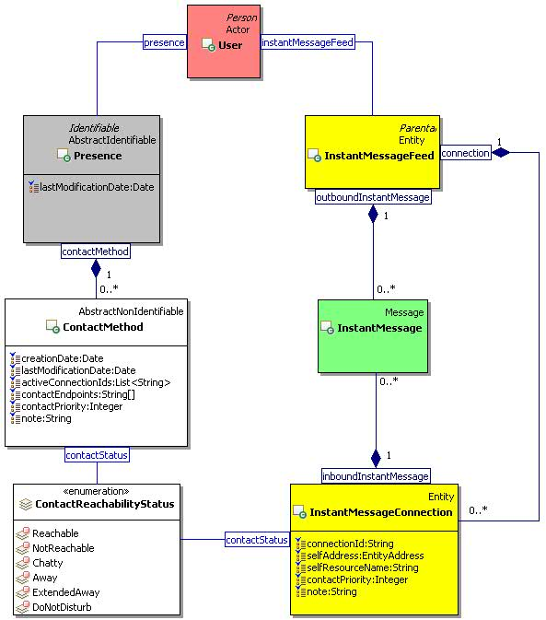
Figure 30 Presence Contact Method and Instant Message Connection Class Diagram.

Activity

Description
An activity object describes what a presentity is currently doing.

Class Definition
The Activity class is defined by the attribute values:

localNamespace
Value: icom_presence

localName
Value: Activity

extendsFrom
Value:

stereotype
Value: primary

description
Value: An activity object describes what a presentity is currently doing.

propertyDefinitions
The values for this attribute are defined in Section 4.4.5.3.

Property Definitions
The Activity class MUST have the property definitions:

icom:startDate
Description: Start date and time of an activity.
Required: True
Inherited: False
Property Type: DateTime
Cardinality: Single
Updatability: Read Write

icom:endDate
Description: End date and time of an activity.
Required: True
Inherited: False
Property Type: DateTime
Cardinality: Single
Updatability: Read Write

icom_presence:activityType
Description: Type of an activity.
Required: true
Inherited: False
Property Type: icom_presence:ActivityType
Cardinality: Single
Updatability: Read Write

icom_presence:note
Description: A note describing an activity.
Required: False
Inherited: False
Property Type: String
Cardinality: Single
Updatability: Read Write

icom_presence:reference
Description: An entity, such as occurrence, task, conference, etc., which is the source of or reference for an activity.
Required: False
Inherited: False
Property Type: icom:Entity
Cardinality: Single
Updatability: Read Write

ActivityType
The ActivityType class is an enum class that enumerates the instances each of which expresses a type of activity.
The ActivityType class is defined by the attribute values:

localNamespace
Value: icom_presence

localName
Value: ActivityType

extendsFrom
Value:

stereotype
Value: primary

isEnumeration
Value: TRUE

description
Value: An enumeration of the instances each of which expresses a type of activity.

instances
Value: <icom_presence:OnThePhone, icom_ presence:Conference, icom_ presence:Meeting, icom_presence:Travel, icom_ presence:Steering, icom_ presence:Meal, icom_presence:OutOfOffice, icom_ presence:Holiday, icom_ presence:Vacation, icom_ presence:OutOfContact, icom_ presence:Other>

There are eleven activity types defined by ICOM:
- icom_presence:OnThePhone to express that a presentity is on the phone.
- icom_presence:Conference to express that a presentity is in a conference.
- icom_presence:Meeting to express that a presentity is in a meeting.
- icom_presence:Travel to express that a presentity is traveling.
- icom_presence:Steering to express that a presentity is steering a vehicle.
- icom_presence:Meal to express that a presentity is having a meal.
- icom_presence:OutOfOffice to express that a presentity is out of office.
- icom_presence:Holiday to express that a presentity is on holiday.
- icom_presence:Vacation to express that a presentity is on vacation.
- icom_presence:OutOfContact to express that a presentity is out of contact.
- icom_presence:Other to express that a presentity is involved in an unspecified activity.

Address Book Module

Addressable

Description
An addressable object is an identifiable object which has email and other addresses.

Class Definition
The Addressable class is a mixin class which defines the characteristics of entities that has email and other addresses.
The Addressable class is defined by the attribute values:

localNamespace
Value: icom_card

localName
Value: Addressable

extendsFrom
Value: icom:Identifiable

stereotype
Value: mixin

description
Value: Addressable is a mixin class which defines the characteristics of entities that has email and other addresses.

propertyDefinitions
The values for this attribute are defined in 4.5.1.3.

Property Definitions
The Addressable class inherits property definitions from super classes.
The Addressable class MUST have the property definitions:

icom_card:address
Description: Zero or more addresses of an addressable object.
Required: False
Inherited: False
Property Type: icom_card:EntityAddress
Cardinality: Multi
Updatability: Read Write

icom_card:primaryAddress
Description: The primary address of an addressable object.
Required: False
Inherited: False
Property Type: icom_card:EntityAddress
Cardinality: Single
Updatability: Read Write

The Addressable class MAY include additional property definitions which are implementation-defined.

Person

Description
A person object is an addressable object which has a given name, middle name, family name, nickname, etc.

Class Definition
The Person class is a mixin class which defines the characteristics of persons.
The Person class is defined by the attribute values:

localNamespace
Value: icom_card

localName
Value: Person

extendsFrom
Value: icom_card:Person

stereotype
Value: mixin

description
Value: A person object is an addressable object which has a given name, middle name, family name, nickname, etc.

propertyDefinitions
The values for this attribute are defined in Section 4.5.2.3.

Property Definitions
The Person class inherits property definitions from super classes.
The Person class MUST have the property definitions:

icom_card:givenName
Description: Given name of a person.
Required: False
Inherited: False
Property Type: String
Cardinality: Single
Updatability: Read Write

icom_card:middleName
Description: Middle name of a person.
Required: False
Inherited: False
Property Type: String
Cardinality: Single
Updatability: Read Write

icom_card:familyName
Description: Family name of a person.
Required: False
Inherited: False
Property Type: String
Cardinality: Single
Updatability: Read Write

icom_card:prefix
Description: Prefix of a person’s name.
Required: False
Inherited: False
Property Type: String
Cardinality: Single
Updatability: Read Write

icom_card:suffix
Description: Suffix of a person’s name.
Required: False
Inherited: False
Property Type: String
Cardinality: Single
Updatability: Read Write

icom_card:nickname
Description: Nickname of a person.
Required: False
Inherited: False
Property Type: String
Cardinality: Single
Updatability: Read Write

icom_card:jobTitle
Description: Job title of a person.
Required: False
Inherited: False
Property Type: String
Cardinality: Single
Updatability: Read Write

icom_card:department
Description: A person’s affiliated department.
Required: False
Inherited: False
Property Type: String
Cardinality: Single
Updatability: Read Write

icom_card:officeLocation
Description: Location of a person’s department.
Required: False
Inherited: False
Property Type: String
Cardinality: Single
Updatability: Read Write

icom_card:company
Description: A person’s affiliated company.
Required: False
Inherited: False
Property Type: String
Cardinality: Single
Updatability: Read Write

icom_card:profession
Description: A person’s profession.
Required: False
Inherited: False
Property Type: String
Cardinality: Single
Updatability: Read Write

The Person class MAY include additional property definitions which are implementation-defined.

AddressBook

Description
An address book is a folder that contains addressable contacts.

Class Definition
The AddressBook class is defined by the attribute values:

localNamespace
Value: icom_card

localName
Value: AddressBook

extendsFrom
Value: icom:Folder

stereotype
Value: primary

description
Value: An address book is a folder that contains addressable contacts.

propertyDefinitions
The values for this attribute are defined in Section 4.5.3.3.

Property Definitions
The AddressBook class inherits property definitions from super classes.
The AddressBook class MUST have the property definitions:

icom_card:addressBook
Description: Sub-address books in an address book.
Required: False
Inherited: False
Property Type: icom_card:AddressBook
Cardinality: Multi
Updatability: Read Only

icom_card:contact
Description: Contacts in an address book.
Required: False
Inherited: False
Property Type: icom_card:Contact
Cardinality: Multi
Updatability: Read Only

The AddressBook class MAY include additional property definitions which are implementation-defined.

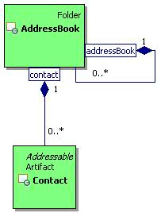
Figure 31 AddressBook Class Diagram.

Contact

Description
A contact is an artifact that contains address information about a person.

Class Definition
The Contact class is defined by the attribute values:

localNamespace
Value: icom_card

localName
Value: Contact

extendsFrom
Value: icom:Artifact, icom_card:Addressable

stereotype
Value: primary

description
Value: A contact is an artifact that contains address information about a person.

propertyDefinitions
The values for this attribute are defined in Section 4.5.4.3.

Property Definitions
The Contact class inherits property definitions from super classes.
The Contact class MUST have the property definitions:

icom_card:bookmark
Description: A person which is bookmarked by a contact.
Required: False
Inherited: False
Property Type: icom_card:Person
Cardinality: Single
Updatability: On Create

icom_card:timeZone
Description: Time zone of a person.
Required: False
Inherited: False
Property Type: TimeZone
Cardinality: Multi
Updatability: Read Write

icom_content:attachment
Description: One or more simple content attachments in a contact.
Required: False
Inherited: False
Property Type: icom_content:Attachment
Cardinality: Multi
Updatability: Read Write

icom_card:givenName
Description: Given name of a person.
Required: False
Inherited: False
Property Type: String
Cardinality: Single
Updatability: Read Write

icom_card:middleName
Description: Middle name of a person.
Required: False
Inherited: False
Property Type: String
Cardinality: Single
Updatability: Read Write

icom_card:familyName
Description: Family name of a person.
Required: False
Inherited: False
Property Type: String
Cardinality: Single
Updatability: Read Write

icom_card:prefix
Description: Prefix of a person’s name.
Required: False
Inherited: False
Property Type: String
Cardinality: Single
Updatability: Read Write

icom_card:suffix
Description: Suffix of a person’s name.
Required: False
Inherited: False
Property Type: String
Cardinality: Single
Updatability: Read Write

icom_card:nickname
Description: Nickname of a person.
Required: False
Inherited: False
Property Type: String
Cardinality: Single
Updatability: Read Write

icom_card:jobTitle
Description: Job title of a person.
Required: False
Inherited: False
Property Type: String
Cardinality: Single
Updatability: Read Write

icom_card:department
Description: A person’s affiliated department.
Required: False
Inherited: False
Property Type: String
Cardinality: Single
Updatability: Read Write

icom_card:officeLocation
Description: Location of a person’s department.
Required: False
Inherited: False
Property Type: String
Cardinality: Single
Updatability: Read Write

icom_card:company
Description: A person’s affiliated company.
Required: False
Inherited: False
Property Type: String
Cardinality: Single
Updatability: Read Write

icom_card:profession
Description: A person’s profession.
Required: False
Inherited: False
Property Type: String
Cardinality: Single
Updatability: Read Write

The Contact class MAY include additional property definitions which are implementation-defined.

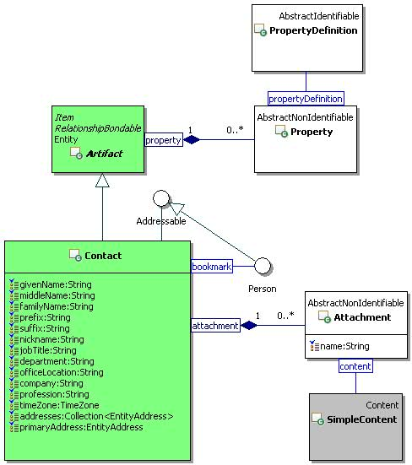
Figure 32 Contact Class Diagram.

Calendar Module

Calendar

Description
A calendar is a folder that contains time management artifacts such as occurrences and occurrence series.

Class Definition
The Calendar class is defined by the attribute values:

localNamespace
Value: icom_cal

localName
Value: Calendar

extendsFrom
Value: icom:Folder

stereotype
Value: primary

description
Value: A forum is a folder that contains time management artifacts such as occurrences and occurrence series.

propertyDefinitions
The values for this attribute are defined in 4.6.1.3.

Property Definitions
The Calendar class inherits property definitions from super classes.
The Calendar class MUST have the property definitions:

icom_cal:timeZone
Description: Time zone of a calendar.
Required: True
Inherited: False
Property Type: TimeZone
Cardinality: Single
Updatability: Read Write

icom:element
Description: Elements of a calendar.
Required: False
Inherited: True
Property Type: icom_cal:Occurrence
Cardinality: Multi
Updatability: Read Only

icom_cal:recurrence
Description: Recurrence elements of a calendar.
Required: False
Inherited: True
Property Type: icom_cal:OccurrenceSeries
Cardinality: Multi
Updatability: Read Only

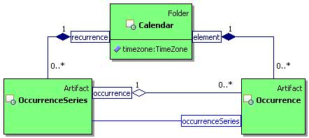
Figure 33 Calendar Class Diagram.

OccurrenceSeries

Description
An occurrence series is an artifact that represents a series of occurrences associated with the same calendar event.

Class Definition
The OccurrenceSeries class is defined by the attribute values:

localNamespace
Value: icom_cal

localName
Value: OccurrenceSeries

extendsFrom
Value: icom:Artifact

stereotype
Value: primary

description
Value: An occurrence series is an artifact that represents a series of occurrences associated with the same calendar event.

propertyDefinitions
The values for this attribute are defined in 4.6.2.3.

Property Definitions
The OccurrenceSeries class inherits property definitions from super classes.
The OccurrenceSeries class MUST have the property definitions:

icom_cal:recurrenceStartDate
Description: Start date and time of an occurrence series.
Required: True
Inherited: False
Property Type: DateTime
Cardinality: Single
Updatability: On Create

icom_cal:recurrenceStartDateResolution
Description: Resolution of start date and time of an occurrence series.
Required: True
Inherited: False
Property Type: icom:DateTimeResolution
Cardinality: Single
Updatability: On Create

icom_cal:duration
Description: Duration of each occurrence in an occurrence series.
Required: True
Inherited: False
Property Type: Duration
Cardinality: Single
Updatability: On Create

icom_cal:recurrenceRule
Description: A recurrence rule of an occurrence series.
Required: True
Inherited: False
Property Type: String
Cardinality: Single
Updatability: On Create

icom:location
Description: Location of an occurrence series.
Required: False
Inherited: False
Property Type: icom:Location
Cardinality: Single
Updatability: Read Write

icom:organizer
Description: Organizer of an occurrence series.
Required: True
Inherited: False
Property Type: icom:Participant
Cardinality: Single
Updatability: On Create

icom:participant
Description: Participants of an occurrence series.
Required: False
Inherited: False
Property Type: icom_cal:OccurrenceParticipant
Cardinality: Multi
Updatability: Read Write

icom_cal:occurrenceStatus
Description: Status of an occurrence series.
Required: True
Inherited: False
Property Type: icom_cal:OccurrenceStatus
Cardinality: Single
Updatability: Read Write

icom_cal:occurrenceType
Description: Type of an occurrence series.
Required: True
Inherited: False
Property Type: icom_cal:OccurrenceType
Cardinality: Single
Updatability: Read Write

icom_cal:mode
Description: Mutability mode of an occurrence series.
Required: False
Inherited: False
Property Type: icom_cal:OccurrenceEditMode
Cardinality: Single
Updatability: Read Only

icom_cal:occurrence
Description: Occurrences in an occurrence series.
Required: False
Inherited: False
Property Type: icom_cal:Occurrence
Cardinality: Multi
Updatability: Read Only

icom_content:attachment
Description: One or more simple content attachments in an occurrence series.
Required: False
Inherited: False
Property Type: icom_content:Attachment
Cardinality: Multi
Updatability: Read Write

icom_cal:attendee
Description: An attendee of an occurrence series.
Required: False
Inherited: False
Property Type: icom:Participant
Cardinality: Single
Updatability: Read Only

icom_cal:attendeePriority
Description: Priority for an attendee of an occurrence series.
Required: False
Inherited: False
Property Type: icom:Priority
Cardinality: Single
Updatability: Read Write

icom_cal:attendeeParticipantStatus
Description: Participation status for an attendee of an occurrence series.
Required: False
Inherited: False
Property Type: icom_cal:OccurrenceParticipantStatus
Cardinality: Single
Updatability: Read Write

icom_cal:attendeeTransparency
Description: Participant transparency for an attendee of an occurrence series.
Required: False
Inherited: False
Property Type: icom_cal:ParticipantTransparency
Cardinality: Single
Updatability: Read Write

icom_cal:attendeeProperty
Description: Extensible properties for an attendee of an occurrence series.
Required: False
Inherited: False
Property Type: icom:Property
Cardinality: Multi
Updatability: Read Write

icom_cal:conference
Description: One or more conferences for an occurrence series.
Required: False
Inherited: False
Property Type: icom_conf:Conference
Cardinality: Multi
Updatability: Read Write

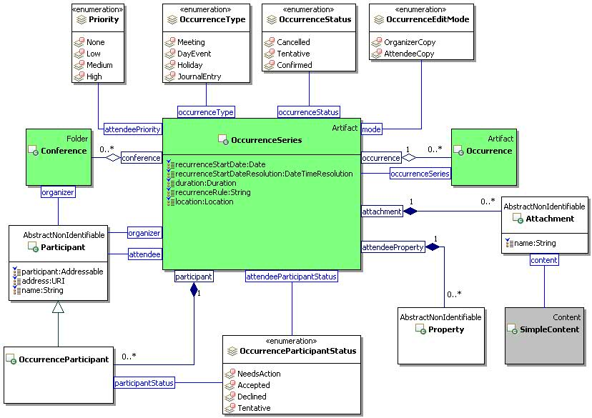
Figure 34 OccurrenceSeries Class Diagram.

Occurrence

Description
An occurrence is an artifact that represents an event in a calendar.

Class Definition
The Occurrence class is defined by the attribute values:

localNamespace
Value: icom_cal

localName
Value: Occurrence

extendsFrom
Value: icom:Artifact

stereotype
Value: primary

description
Value: An occurrence is an artifact that represents an event in a calendar.

propertyDefinitions
The values for this attribute are defined in 4.6.3.3.

Property Definitions
The Occurrence class inherits property definitions from super classes.
The Occurrence class MUST have the property definitions:

icom_cal:startDate
Description: Start date and time of an occurrence.
Required: True
Inherited: False
Property Type: DateTime
Cardinality: Single
Updatability: On Create

icom_cal:startDateResolution
Description: Resolution of start date and time of an occurrence.
Required: True
Inherited: False
Property Type: icom:DateTimeResolution
Cardinality: Single
Updatability: On Create

icom_cal:endDate
Description: End date and time of an occurrence.
Required: True
Inherited: False
Property Type: DateTime
Cardinality: Single
Updatability: On Create

icom_cal:endDateResolution
Description: Resolution of end date and time of an occurrence.
Required: True
Inherited: False
Property Type: icom:DateTimeResolution
Cardinality: Single
Updatability: On Create

icom:location
Description: Location of an occurrence.
Required: False
Inherited: False
Property Type: icom:Location
Cardinality: Single
Updatability: Read Write

icom_cal:occurrenceSeries
Description: An occurrence series that includes an occurrence.
Required: False
Inherited: False
Property Type: icom_cal:OccurrenceSeries
Cardinality: Single
Updatability: Read Only

icom_cal:fromRecurringOccurrenceSeries
Description: Occurrence is part of a recurring occurrence series.
Required: False
Inherited: False
Property Type: Boolean
Cardinality: Single
Updatability: Read Only

icom_cal:exceptionToOccurrenceSeries
Description: Occurrence is an exception to an occurrence series.
Required: False
Inherited: False
Property Type: Boolean
Cardinality: Single
Updatability: Read Only

icom:organizer
Description: Organizer of an occurrence.
Required: True
Inherited: False
Property Type: icom:Participant
Cardinality: Single
Updatability: On Create

icom:participant
Description: Participants of an occurrence.
Required: False
Inherited: False
Property Type: icom_cal:OccurrenceParticipant
Cardinality: Multi
Updatability: Read Write

icom_cal:occurrenceStatus
Description: Status of an occurrence.
Required: True
Inherited: False
Property Type: icom_cal:OccurrenceStatus
Cardinality: Single
Updatability: Read Write

icom_cal:occurrenceType
Description: Type of an occurrence.
Required: True
Inherited: False
Property Type: icom_cal:OccurrenceType
Cardinality: Single
Updatability: Read Write

icom_cal:mode
Description: Mutability mode of an occurrence.
Required: False
Inherited: False
Property Type: icom_cal:OccurrenceEditMode
Cardinality: Single
Updatability: Read Only

icom_content:attachment
Description: One or more simple content attachments in an occurrence.
Required: False
Inherited: False
Property Type: icom_content:Attachment
Cardinality: Multi
Updatability: Read Write

icom_cal:attendee
Description: An attendee of an occurrence.
Required: False
Inherited: False
Property Type: icom:Participant
Cardinality: Single
Updatability: Read Only

icom_cal:attendeePriority
Description: Priority for an attendee of an occurrence.
Required: False
Inherited: False
Property Type: icom:Priority
Cardinality: Single
Updatability: Read Write

icom_cal:attendeeParticipantStatus
Description: Participation status for an attendee of an occurrence.
Required: False
Inherited: False
Property Type: icom_cal:OccurrenceParticipantStatus
Cardinality: Single
Updatability: Read Write

icom_cal:attendeeTransparency
Description: Participant transparency for an attendee of an occurrence.
Required: False
Inherited: False
Property Type: icom_cal:ParticipantTransparency
Cardinality: Single
Updatability: Read Write

icom_cal:attendeeProperty
Description: Extensible properties for an attendee of an occurrence.
Required: False
Inherited: False
Property Type: icom:Property
Cardinality: Multi
Updatability: Read Write

icom_cal:conference
Description: One or more conferences for an occurrence.
Required: False
Inherited: False
Property Type: icom_conf:Conference
Cardinality: Multi
Updatability: Read Write

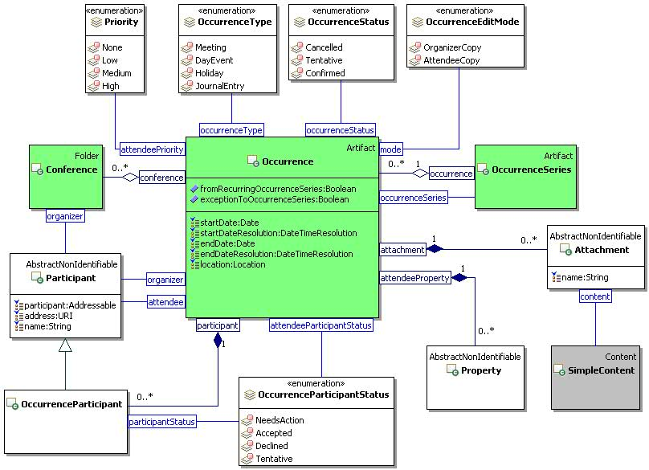
Figure 35 Occurrence Class Diagram.

OccurrenceStatus
The OccurrenceStatus class is an enum class that enumerates the instances each of which expresses a status of an occurrence or occurrence series.
The OccurrenceStatus class is defined by the attribute values:

localNamespace
Value: icom_cal

localName
Value: OccurrenceStatus

extendsFrom
Value:

stereotype
Value: primary

isEnumeration
Value: TRUE

description
Value: An enumeration of the instances each of which expresses a status of an occurrence or occurrence series.

instances
Value: <icom_cal:Cancelled, icom_cal:Tentative, icom_cal:Confirmed>

There are three occurrence status defined by ICOM:
- icom_cal:Cancelled to express that an occurrence or occurrence series is cancelled.
- icom_cal:Tentative to express that an occurrence or occurrence series is tentative.
- icom_cal:Confirmed to express that an occurrence or occurrence series is confirmed.

OccurrenceType
The OccurrenceType class is an enum class that enumerates the instances each of which expresses a type of an occurrence or occurrence series.
The OccurrenceType class is defined by the attribute values:

localNamespace
Value: icom_cal

localName
Value: OccurrenceType

extendsFrom
Value:

stereotype
Value: primary

isEnumeration
Value: TRUE

description
Value: An enumeration of the instances each of which expresses a type of an occurrence or occurrence series.

instances
Value: <icom_cal:Meeting, icom_cal:DayEvent, icom_cal:Holiday, icom_cal:JournalEntry>

There are four occurrence types defined by ICOM:
- icom_cal:Meeting to express that an occurrence or occurrence series is a meeting.
- icom_cal:DayEvent to express that an occurrence or occurrence series is a day event.
- icom_cal:Holiday to express that an occurrence or occurrence series is a holiday.
- icom_cal:JournalEntry to express that an occurrence or occurrence series is a journal entry.

OccurrenceEditMode
The OccurrenceEditMode class is an enum class that enumerates the instances each of which expresses an editable mode of an occurrence or occurrence series.
The OccurrenceEditMode class is defined by the attribute values:

localNamespace
Value: icom_cal

localName
Value: OccurrenceEditMode

extendsFrom
Value:

stereotype
Value: primary

isEnumeration
Value: TRUE

description
Value: An enumeration of the instances each of which expresses an editable mode of an occurrence or occurrence series.

instances
Value: <icom_cal:OrganizerCopy, icom_cal:AttendeeCopy>

There are two occurrence editable modes defined by ICOM:
- icom_cal:OrganizerCopy to express that an occurrence or occurrence series is a copy created by an organizer who may update the properties such as occurrence type, occurrence status, etc.
- icom_cal:AttendeeCopy to express that an occurrence or occurrence series is a copy delivered to an attendee who may only update the attendee properties such as attendee priority, attendee transparency, etc .

ParticipantTransparency
The ParticipantTransparency class is an enum class that enumerates the instances each of which expresses an occurrence or occurrence series transparency in a participant’s calendar or free busy.
The ParticipantTransparency class is defined by the attribute values:

localNamespace
Value: icom_cal

localName
Value: ParticipantTransparency

extendsFrom
Value:

stereotype
Value: primary

isEnumeration
Value: TRUE

description
Value: An enumeration of the instances each of which expresses an occurrence or occurrence series transparency in a participant’s calendar or free busy.

instances
Value: <icom_cal:Opaque, icom_cal:Transparent, icom_cal:Tentative, icom_cal:OutOfOffice, icom_cal:DefaultTransparency >

There are five participant transparencies defined by ICOM:
- icom_cal:Opaque to express that an occurrence or occurrence series is opaque in a participant’s calendar or free busy.
- icom_cal:Transparent to express that an occurrence or occurrence series is transparent in a participant’s calendar or free busy.
- icom_cal:Tentative to express that an occurrence or occurrence series has a tentative transparency in a participant’s calendar or free busy.
- icom_cal:OutOfOffice to express that an occurrence or occurrence series has out of office transparency in a participant’s calendar or free busy.
- icom_cal:DefaultTransparency to express that an occurrence or occurrence series has default transparency in a participant’s calendar or free busy.

OccurrenceParticipant

Description
An occurrence participant object is a participant object that contains an occurrence participant status.

Class Definition
The OccurrenceParticipant class is defined by the attribute values:

localNamespace
Value: icom_cal

localName
Value: OccurrenceParticipant

extendsFrom
Value: icom:Participant

stereotype
Value: primary

description
Value: An occurrence participant object is a participant object that contains an occurrence participant status.

propertyDefinitions
The values for this attribute are defined in Section 4.6.8.3.

Property Definitions
The OccurrenceParticipant class inherits property definitions from super classes.
The OccurrenceParticipant class MUST have the property definitions:

icom_cal:participantStatus
Description: Status of an occurrence participant.
Required: False
Inherited: False
Property Type: icom_cal:OccurrenceParticipantStatus
Cardinality: Single
Updatability: Read Write

OccurrenceParticipantStatus
The OccurrenceParticipantStatus class is an enum class that enumerates the instances each of which expresses a participant’s response status for an occurrence or occurrence series.
The OccurrenceParticipantStatus class is defined by the attribute values:

localNamespace
Value: icom_cal

localName
Value: OccurrenceParticipantStatus

extendsFrom
Value:

stereotype
Value: primary

isEnumeration
Value: TRUE

description
Value: An enumeration of the instances each of which expresses a participant’s response status for an occurrence or occurrence series.

instances
Value: <icom_cal:NeedsAction, icom_cal:Accepted, icom_cal:Declined, icom_cal:Tentative>

There are four occurrence participant’s status defined by ICOM:
- icom_cal:NeedsAction to express that an attendee needs to act on an occurrence or occurrence series.
- icom_cal:Accepted to express that an attendee accepted an occurrence or occurrence series.
- icom_cal:Declined to express that an attendee declined an occurrence or occurrence series.
- icom_cal:Tentative to express that an attendee is tentative about attending an occurrence or occurrence series.

FreeBusy Module

FreeBusy

Description
A free busy object specifies the free time and busy time intervals of one or more participants.

Class Definition
The FreeBusy class is defined by the attribute values:

localNamespace
Value: icom_cal

localName
Value: FreeBusy

extendsFrom
Value:

stereotype
Value: primary

description
Value: A free busy object specifies the free time and busy time intervals of one or more participants.

propertyDefinitions
The values for this attribute are defined in Section 4.7.1.3.

Property Definitions
The FreeBusy class MUST have the property definitions:

icom_cal:creationDate
Description: Creation date and time of a free busy object.
Required: False
Inherited: False
Property Type: DateTime
Cardinality: Single
Updatability: Read Only

icom_cal:startDate
Description: Start date and time of a list of free busy intervals.
Required: False
Inherited: False
Property Type: DateTime
Cardinality: Single
Updatability: Read Only

icom_cal:endDate
Description: End date and time of a list of free busy intervals.
Required: False
Inherited: False
Property Type: DateTime
Cardinality: Single
Updatability: Read Only

icom_cal:interval
Description: A list of free busy intervals.
Required: False
Inherited: False
Property Type: icom_cal:FreeBusyInterval
Cardinality: Multi
Updatability: Read Only

icom_cal:participant
Description: A list of participants whose free busy intervals are merged.
Required: False
Inherited: False
Property Type: icom:Participant
Cardinality: Multi
Updatability: Read Only

FreeBusyInterval

Description
A free busy interval object specifies an interval of free or busy time.
If a free busy type is icom_cal:Free, then a time interval is free for scheduling.
If a free busy type is icom_cal:Busy, then a time interval is busy because one or more events have been scheduled for the interval.

Class Definition
The FreeBusyInterval class is defined by the attribute values:

localNamespace
Value: icom_cal

localName
Value: FreeBusy

extendsFrom
Value:

stereotype
Value: primary

description
Value: A free busy interval object specifies an interval of free or busy time.

propertyDefinitions
The values for this attribute are defined in Section 4.7.2.3

Property Definitions
The FreeBusyInterval class MUST have the property definitions:

icom_cal:startDate
Description: Start date and time of a free busy interval.
Required: False
Inherited: False
Property Type: DateTime
Cardinality: Single
Updatability: Read Only

icom_cal:endDate
Description: End date and time of a free busy interval.
Required: False
Inherited: False
Property Type: DateTime
Cardinality: Single
Updatability: Read Only

icom_cal:freeBusyType
Description: A type of free busy interval.
Required: False
Inherited: False
Property Type: icom_cal:FreeBusyType
Cardinality: Single
Updatability: Read Only

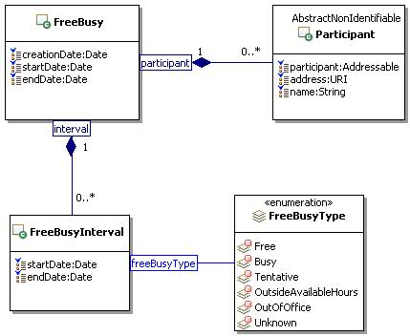
Figure 36 FreeBusy Class Diagram.

FreeBusyType
The FreeBusyType class is an enum class that enumerates the instances each of which expresses a type of free busy interval.
The FreeBusyType class is defined by the attribute values:

localNamespace
Value: icom_cal

localName
Value: FreeBusyType

extendsFrom
Value:

stereotype
Value: primary

isEnumeration
Value: TRUE

description
Value: An enumeration of the instances each of which expresses a type of free busy interval.

instances
Value: <icom_cal:Free, icom_cal:Busy, icom_cal:Tentative, icom_cal:OutsideAvailableHours, icom_cal:OutOfOffice, icom_cal:Unknown>

There are six free busy types defined by ICOM:
- icom_cal:Free to express that a free busy interval is free.
- icom_cal:Busy to express that a free busy interval is busy.
- icom_cal:Tentative to express that a free busy interval is tentative.
- icom_cal:OutsideAvailableHours to express that a free busy interval is outside available hours.
- icom_cal:OutOfOffice to express that a free busy interval is coincides with out of office hours.
- icom_cal:Unknown to express that a free busy interval is unknown.

TaskList Module

TaskList

Description
A task list is a folder that contains task management artifacts.

Class Definition
The TaskList class is defined by the attribute values:

localNamespace
Value: icom_cal

localName
Value: TaskList

extendsFrom
Value: icom:Folder

stereotype
Value: primary

description
Value: A task list is a folder that contains task management artifacts.

propertyDefinitions
The values for this attribute are defined in 4.8.1.3.

Property Definitions
The TaskList class inherits property definitions from super classes.
The TaskList class MUST have the property definitions:

icom_cal:timeZone
Description: Time zone of a task list.
Required: True
Inherited: False
Property Type: TimeZone
Cardinality: Single
Updatability: Read Write

icom:element
Description: Elements of a task list.
Required: False
Inherited: True
Property Type: icom_cal:Task
Cardinality: Multi
Updatability: Read Only

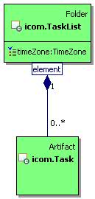
Figure 37 TaskList Class Diagram.

Task

Description
A task is an artifact that represents a task to do or a task assignment in a task list.

Class Definition
The Task class is defined by the attribute values:

localNamespace
Value: icom_cal

localName
Value: Task

extendsFrom
Value: icom:Artifact

stereotype
Value: primary

description
Value: A task is an artifact that represents a task to do or a task assignment in a task list.

propertyDefinitions
The values for this attribute are defined in 4.8.2.3.

Property Definitions
The Task class inherits property definitions from super classes.
The Task class MUST have the property definitions:

icom_cal:startDate
Description: Start date and time of a task.
Required: True
Inherited: False
Property Type: DateTime
Cardinality: Single
Updatability: On Create

icom_cal:startDateResolution
Description: Resolution of start date and time of a task.
Required: True
Inherited: False
Property Type: icom:DateTimeResolution
Cardinality: Single
Updatability: On Create

icom_cal:dueDate
Description: Due date and time of a task.
Required: True
Inherited: False
Property Type: DateTime
Cardinality: Single
Updatability: On Create

icom_cal:dueDateResolution
Description: Resolution of due date and time of a task.
Required: True
Inherited: False
Property Type: icom:DateTimeResolution
Cardinality: Single
Updatability: On Create

icom:location
Description: Location of a task.
Required: False
Inherited: False
Property Type: icom:Location
Cardinality: Single
Updatability: Read Write

icom:organizer
Description: Organizer of a task.
Required: True
Inherited: False
Property Type: icom:Participant
Cardinality: Single
Updatability: On Create

icom_cal:taskStatus
Description: Status of a task.
Required: True
Inherited: False
Property Type: icom_cal:TaskStatus
Cardinality: Single
Updatability: Read Write

icom_cal:mode
Description: Mutability mode of a task.
Required: False
Inherited: False
Property Type: icom_cal:TaskEditMode
Cardinality: Single
Updatability: Read Only

icom_content:attachment
Description: One or more simple content attachments in a task.
Required: False
Inherited: False
Property Type: icom_content:Attachment
Cardinality: Multi
Updatability: Read Write

icom_cal:assignee
Description: An assignee of a task.
Required: False
Inherited: False
Property Type: icom:Participant
Cardinality: Single
Updatability: Read Only

icom_cal:assigneePriority
Description: Priority for an assignee of a task.
Required: False
Inherited: False
Property Type: icom:Priority
Cardinality: Single
Updatability: Read Write

icom_cal:assigneeParticipantStatus
Description: Participation status for an assignee of a task.
Required: False
Inherited: False
Property Type: icom_cal:TaskParticipantStatus
Cardinality: Single
Updatability: Read Write

icom_cal:assigneeCompletionDate
Description: Completion date and time of a task.
Required: False
Inherited: False
Property Type: DateTime
Cardinality: Single
Updatability: Read Write

icom_cal:assigneeCompletionDateResolution
Description: Resolution of completion date and time of a task.
Required: False
Inherited: False
Property Type: icom:DateTimeResolution
Cardinality: Single
Updatability: Read Write

icom_cal:assigneePercentComplete
Description: Percentage of task completed.
Required: False
Inherited: False
Property Type: Integer
Cardinality: Single
Updatability: Read Write

icom_cal:assigneeProperty
Description: Extensible properties for an assignee of a task.
Required: False
Inherited: False
Property Type: icom:Property
Cardinality: Multi
Updatability: Read Write

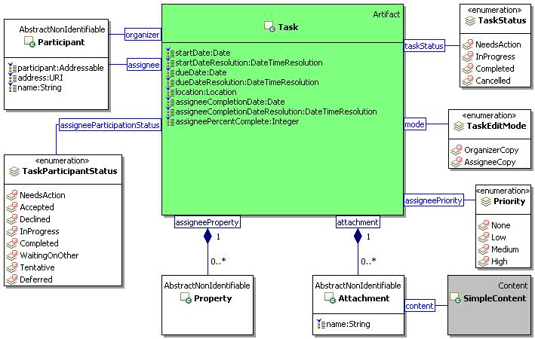
Figure 38 Task Class Diagram.

TaskStatus
The TaskStatus class is an enum class that enumerates the instances each of which expresses a status of task.
The TaskStatus class is defined by the attribute values:

localNamespace
Value: icom_cal

localName
Value: TaskStatus

extendsFrom
Value:

stereotype
Value: primary

isEnumeration
Value: TRUE

description
Value: An enumeration of the instances each of which expresses a status of a task.

instances
Value: <icom_cal:NeedsAction, icom_cal:InProgress, icom_cal:Completed, icom_cal:Cancelled>

There are four task status defined by ICOM:
- icom_cal:NeedsAction to express that a task needs action.
- icom_cal:InProgress to express that a task is in progress.
- icom_cal:Completed to express that a task is completed.
- icom_cal:Cancelled to express that a task is cancelled.

TaskEditMode
The TaskEditMode class is an enum class that enumerates the instances each of which expresses an editable mode of a task.
The TaskEditMode class is defined by the attribute values:

localNamespace
Value: icom_cal

localName
Value: TaskEditMode

extendsFrom
Value:

stereotype
Value: primary

isEnumeration
Value: TRUE

description
Value: An enumeration of the instances each of which expresses an editable mode of a task.

instances
Value: <icom_cal:OrganizerCopy, icom_cal:AssigneeCopy>

There are two task editable modes defined by ICOM:
- icom_cal:OrganizerCopy: to express that a task is a copy created by an organizer who may update the properties such as start time, due time, etc.
- icom_cal:AssigneeCopy: to express that task is a copy delivered to an assignee who may only update the assignee properties such as assignee completion time, assignee participant status, assignee percent completed, etc .

TaskParticipantStatus
The TaskParticipantStatus class is an enum class that enumerates the instances each of which expresses a participant’s response status for a task.
The TaskParticipantStatus class is defined by the attribute values:

localNamespace
Value: icom_cal

localName
Value: TaskParticipantStatus

extendsFrom
Value:

stereotype
Value: primary

isEnumeration
Value: TRUE

description
Value: An enumeration of the instances each of which expresses a participant’s response status for a task.

instances
Value: <icom_cal:NeedsAction, icom_cal:Accepted, icom_cal:Declined, icom_cal:InProgress, icom_cal:Completed, icom_cal:WaitingOnOther, icom_cal:Tentative, icom_cal:Deferred>

There are eight task participant’s status defined by ICOM:
- icom_cal:NeedsAction to express that an assignee needs to act on a task.
- icom_cal:Accepted to express that an assignee accepted a task.
- icom_cal:Declined to express that an assignee declined a task.
- icom_cal:InProgress to express that a task is in progress.
- icom_cal:Completed to express that a task is completed.
- icom_cal:WaitingOnOther to express that an assignee is waiting on other.
- icom_cal: Tentative to express that an assignee is tentative about a task status.
- icom_cal:Deferred to express that an assignee deferred a task.

Forum Module

Discussion

Description
A discussion is an item in a discussion container.

Class Definition
The Discussion class is a mixin class which defines the characteristics of entities that can be elements of a DiscussionContainer.
The Discussion class is defined by the attribute values:

localNamespace
Value: icom_forum

localName
Value: Discussion

extendsFrom
Value: icom:Item

stereotype
Value: mixin

description
Value: Discussion is a mixin class which defines the characteristics of entities that can be placed in a DiscussionContainer.

propertyDefinitions
The values for this attribute are defined in Section 4.9.1.3.

Property Definitions
The Discussion class inherits property definitions from super classes.
The Discussion class MUST have the property definitions:

icom_forum:inReplyTo
Description: Another discussion object that a discussion object is replying to.
Required: False
Inherited: False
Property Type: icom_forum:Discussion
Cardinality: Single
Updatability: Read Write

The Discussion class MAY include additional property definitions which are implementation-defined.

DiscussionContainer

Description
A discussion container is a container of discussions.

Class Definition
The DiscussionContainer class is a mixin class which defines the characteristics of entities that contain Discussion items.
The DiscussionContainer class is defined by the attribute values:

localNamespace
Value: icom_forum

localName
Value: DiscussionContainer

extendsFrom
Value: icom:Container

stereotype
Value: mixin

description
Value: DiscussionContainer is a mixin class which defines the characteristics of entities that contain Discussion items.

propertyDefinitions
The values for this attribute are defined in Section 4.9.2.3.

Property Definitions
The DiscussionContainer class inherits property definitions from super classes.
The DiscussionContainer class MUST have the property definitions:

icom_forum:element
Description: Elements of a discussion container.
Required: False
Inherited: True
Property Type: icom_forum:Discussion
Cardinality: Multi
Updatability: Read Only

The DiscussionContainer class MAY include additional property definitions which are implementation-defined.

DiscussionMessage

Description
A discussion message is a message in a forum discussion thread.

Class Definition
The DiscussionMessage class is defined by the attribute values:

localNamespace
Value: icom_forum

localName
Value: DiscussionMessage

extendsFrom
Value: icom_msg:Message, icom_forum:Discussion

stereotype
Value: primary

description
Value: Discussion message is a message in a forum discussion thread.

propertyDefinitions
The values for this attribute are defined in Section 4.9.3.3.

Property Definitions
The DiscussionMessage class inherits property definitions from super classes.
The DiscussionMessage class MUST have the property definitions:

icom_forum:inReplyTo
Description: Another discussion message that a discussion message is replying to.
Required: False
Inherited: True
Property Type: icom_forum:DiscussionMessage
Cardinality: Single
Updatability: Read Write

The DiscussionMessage class MAY include additional property definitions which are implementation-defined.

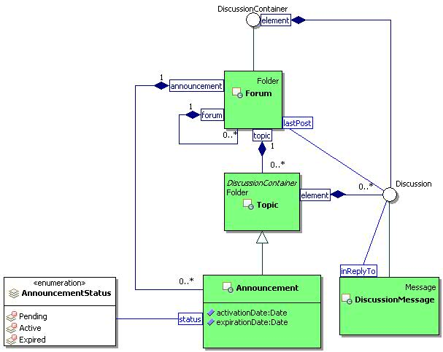
Figure 39 Forum Class Diagram

Forum

Description
A forum is a folder that contains sub-forums, topics, and announcements.

Class Definition
The Forum class is defined by the attribute values:

localNamespace
Value: icom_forum

localName
Value: Forum

extendsFrom
Value: icom:Folder

stereotype
Value: primary

description
Value: A forum is a folder that contains sub-forums, topics, and announcements.

propertyDefinitions
The values for this attribute are defined in Section 4.9.4.3.

Property Definitions
The Forum class inherits property definitions from super classes.
The Forum class MUST have the property definitions:

icom_forum:lastPost
Description: The last posted discussion in a forum.
Required: False
Inherited: False
Property Type: icom_forum:Discussion
Cardinality: Single
Updatability: Read Only

icom_forum:forum
Description: Sub-forums of a forum.
Required: False
Inherited: False
Property Type: icom_forum:Forum
Cardinality: Multi
Updatability: Read Only

icom_forum:topic
Description: Topics of a forum.
Required: False
Inherited: False
Property Type: icom_forum:Topic
Cardinality: Multi
Updatability: Read Only

icom_forum:announcement
Description: Announcements of a forum.
Required: False
Inherited: False
Property Type: icom_forum:Announcement
Cardinality: Multi
Updatability: Read Only

The Forum class MAY include additional property definitions which are implementation-defined.

Topic

Description
A topic is a folder that contains a conversation among forum participants. The discussions in a topic may be sorted in chronological order or threaded by reply.

Class Definition
The Topic class is defined by the attribute values:

localNamespace
Value: icom_forum

localName
Value: Topic

extendsFrom
Value: icom:Folder, icom_forum:DiscussionContainer

stereotype
Value: primary

description
Value: A topic is a folder that contains discussion threads.

propertyDefinitions
The values for this attribute are defined in Section 4.9.5.3.

Property Definitions
The Topic class inherits property definitions from super classes.
The Topic class MUST have the property definitions:

icom:element
Description: Elements of a topic.
Required: False
Inherited: True
Property Type: icom_forum:Discussion
Cardinality: Multi
Updatability: Read Only

icom_forum:firstPost
Description: The first posted discussion in a topic.
Required: False
Inherited: False
Property Type: icom_forum:Discussion
Cardinality: Single
Updatability: Read Only

icom_forum:lastPost
Description: The last posted discussion in a topic.
Required: False
Inherited: False
Property Type: icom_forum:Discussion
Cardinality: Single
Updatability: Read Only

The Topic class MAY include additional property definitions which are implementation-defined.

Announcement

Description
An announcement is a special topic for time-sensitive discussion posts that are valid for a specified period of time, depending on activation and expiration times.

Class Definition
The Announcement class is defined by the attribute values:

localNamespace
Value: icom_forum

localName
Value: Announcement

extendsFrom
Value: icom_forum:Topic

stereotype
Value: primary

description
Value: An announcement is a special topic for discussions that are valid for a specified period of time.

propertyDefinitions
The values for this attribute are defined in Section 4.9.6.3.

Property Definitions
The Announcement class inherits property definitions from super classes.
The Announcement class MUST have the property definitions:

icom_forum:activationDate
Description: Date and time when an announcement becomes active.
Required: False
Inherited: False
Property Type: DateTime
Cardinality: Single
Updatability: Read Write

icom_forum:expirationDate
Description: Date and time when an announcement expires.
Required: False
Inherited: False
Property Type: DateTime
Cardinality: Single
Updatability: Read Write

icom_forum:announcementStatus
Description: Status of an announcement.
Required: True
Inherited: False
Property Type: icom_forum:AnnouncementStatus
Cardinality: Single
Updatability: Read Write

The Announcement class MAY include additional property definitions which are implementation-defined.

AnnouncementStatus
The AnnouncementStatus class is an enum class that enumerates the instances each of which expresses a status of announcement.
The AnnouncementStatus class is defined by the attribute values:

localNamespace
Value: icom_forum

localName
Value: AnnouncementStatus

extendsFrom
Value:

stereotype
Value: primary

isEnumeration
Value: TRUE

description
Value: An enumeration of the instances each of which expresses a status of announcement.

instances
Value: <icom_forum:Pending, icom_forum:Active, icom_forum:Expired>

There are three announcement status defined by ICOM:
- icom_forum:Pending to express that an announcement is pending.
- icom_forum:Active to express that an announcement is active.
- icom_forum:Expired to express that an announcement is expired.

Conference Module

Conference

Description
A conference is a folder that represents a durable context for conference sessions.
It contains conference metadata, settings, and transcripts.

Class Definition
The Conference class is defined by the attribute values:

localNamespace
Value: icom_conf

localName
Value: Conference

extendsFrom
Value: icom:Folder

stereotype
Value: primary

description
Value: A conference is a folder that represents a durable context for online conference sessions.

propertyDefinitions
The values for this attribute are defined in Section 4.10.1.3.

Property Definitions
The Conference class inherits property definitions from super classes.
The Conference class MUST have the property definitions:

icom_conf:organizer
Description: Organizer of a conference.
Required: False
Inherited: False
Property Type: icom_cond:Participant
Cardinality: Single
Updatability: On Create

icom_conf:conferenceType
Description: Type of a conference.
Required: False
Inherited: False
Property Type: icom_conf:ConferenceType
Cardinality: Single
Updatability: Read Write

icom_conf:conferenceState
Description: Session state of a conference.
Required: False
Inherited: False
Property Type: icom_conf:ConferenceState
Cardinality: Single
Updatability: Read Only

icom_conf:runningSession
Description: Current session of a conference.
Required: False
Inherited: False
Property Type: icom_conf:ConferenceSession
Cardinality: Single
Updatability: Read Only

icom_conf:conferenceSetting
Description: Configurable settings of a conference.
Required: False
Inherited: False
Property Type: icom_conf:ConferenceSetting
Cardinality: Single
Updatability: Read Only

icom_conf:transcript
Description: Transcripts from ended sessions of a conference.
Required: False
Inherited: False
Property Type: icom_doc:Document
Cardinality: Multi
Updatability: Read Write

icom_conf:scheduledStartTime
Description: Scheduled start time of the current or next session of a conference.
Required: False
Inherited: False
Property Type: Date
Cardinality: Single
Updatability: Read Write

icom_conf:scheduledEndTime
Description: Scheduled end time of the current or next session of a conference.
Required: False
Inherited: False
Property Type: Date
Cardinality: Single
Updatability: Read Write

The Conference class MAY include additional property definitions which are implementation-defined.

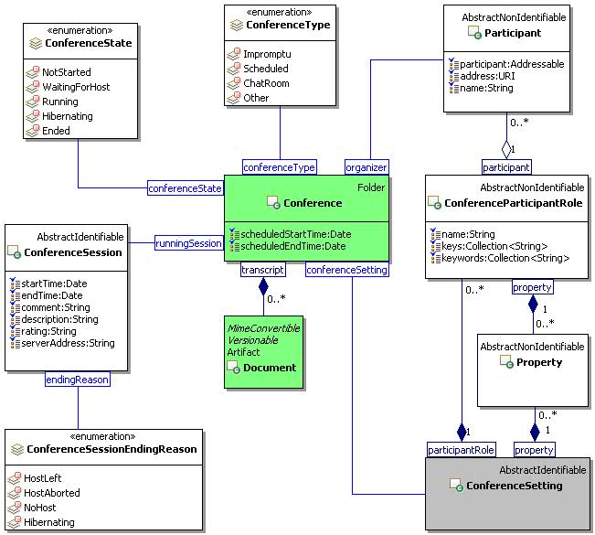
Figure 40 Conference Class Diagram.

ConferenceType
The ConferenceType class is an enum class that enumerates the instances each of which expresses a type of a conference.
The ConferenceType class is defined by the attribute values:

localNamespace
Value: icom_conf

localName
Value: ConferenceType

extendsFrom
Value:

stereotype
Value: primary

isEnumeration
Value: TRUE

description
Value: An enumeration of the instances each of which expresses a type of a conference.

instances
Value: <icom_conf:Impromptu, icom_conf:Scheduled, icom_conf:ChatRoom, icom_conf:Other>

There are four conference types defined by ICOM:
- icom_conf:Impromptu to express that a conference session is started impromptu .
- icom_conf:Scheduled to express that a conference session is scheduled.
- icom_conf:ChatRoom to express that a conference is used for a chat room.
- icom_conf:Other to express that a conference is of other type.

ConferenceState
The ConferenceState class is an enum class that enumerates the instances each of which expresses a session state of a conference.
The ConferenceState class is defined by the attribute values:

localNamespace
Value: icom_conf

localName
Value: ConferenceState

extendsFrom
Value:

stereotype
Value: primary

isEnumeration
Value: TRUE

description
Value: An enumeration of the instances each of which expresses a session state of a conference.

instances
Value: <icom_conf:NotStarted, icom_conf:WaitingForHost, icom_conf:Running, icom_conf:Hibernatimg, icom_conf:Ended>

There are five conference session states defined by ICOM:
- icom_conf:NotStarted to express that a conference session is not started .
- icom_conf:WaitingForHost to express that a conference session is waiting for a host.
- icom_conf:Running to express that a conference session is running.
- icom_conf:Hibernating to express that a conference session is hibernating.
- icom_conf:Ended to express that a conference session is ended.

ConferenceSession

Description
A conference session represents the metadata for a runtime session of a conference.

Class Definition
The ConferenceSession class is defined by the attribute values:

localNamespace
Value: icom_conf

localName
Value: ConferenceSession

extendsFrom
Value: icom:Identifiable

stereotype
Value: primary

description
Value: A conference session represents the metadata for a runtime session of a conference.

propertyDefinitions
The values for this attribute are defined in Section 4.10.4.3.

Property Definitions
The ConferenceSession class inherits property definitions from super classes.
The ConferenceSession class MUST have the property definitions:

icom_conf:startTime
Description: Start time of a conference session.
Required: False
Inherited: False
Property Type: Date
Cardinality: Single
Updatability: Read Only

icom_conf:endTime
Description: End time of a conference session.
Required: False
Inherited: False
Property Type: Date
Cardinality: Single
Updatability: Read Only

icom_conf:comment
Description: Comment on a conference session.
Required: False
Inherited: False
Property Type: String
Cardinality: Single
Updatability: Read Write

icom_conf:description
Description: Description of a conference session.
Required: False
Inherited: False
Property Type: String
Cardinality: Single
Updatability: Read Write

icom_conf:rating
Description: Rating of a conference session.
Required: False
Inherited: False
Property Type: String
Cardinality: Single
Updatability: Read Write

icom_conf:serverAddress
Description: Address of a server that hosts a conference session.
Required: False
Inherited: False
Property Type: String
Cardinality: Single
Updatability: Read Only

icom_conf:endingReason
Description: Reason for ending a conference session.
Required: False
Inherited: False
Property Type: icom_conf:ConferenceSessionEndingReason
Cardinality: Single
Updatability: Read Only

The ConferenceSession class MAY include additional property definitions which are implementation-defined.

ConferenceSessionEndingReason
The ConferenceSessionEndingReason class is an enum class that enumerates the instances each of which expresses a reason for ending a conference session.
The ConferenceSessionEndingReason class is defined by the attribute values:

localNamespace
Value: icom_conf

localName
Value: ConferenceSessionEndingReason

extendsFrom
Value:

stereotype
Value: primary

isEnumeration
Value: TRUE

description
Value: An enumeration of the instances each of which expresses a reason for ending a conference session.

instances
Value: <icom_conf:HostLeft, icom_conf:HostAborted, icom_conf:NoHost, icom_conf:Hibernating>

There are four conference session states defined by ICOM:
- icom_conf:HostLeft to express that a conference session ended after the host left.
- icom_conf:HostAborted to express that a conference session ended after the host aborted it.
- icom_conf:NoHost to express that a conference session ended due to no one hosting.
- icom_conf:Hibernating to express that a conference session is hibernating.

ConferenceSetting

Description
A conference setting represents configuration settings for sessions of a conference.

Class Definition
The ConferenceSetting class is defined by the attribute values:

localNamespace
Value: icom_conf

localName
Value: ConferenceSetting

extendsFrom
Value:

stereotype
Value: primary

description
Value: A conference setting represents configuration settings for sessions of a conference.

propertyDefinitions
The values for this attribute are defined in Section 4.10.6.3.

Property Definitions
The ConferenceSetting class inherits property definitions from super classes.
The ConferenceSetting class MUST have the property definitions:

icom_conf:participantRole
Description: Role settings for conference participants.
Required: False
Inherited: False
Property Type: icom_conf:ConferenceParticipantRole
Cardinality: Multi
Updatability: Read Write

icom_conf:property
Description: Configurable properties for a conference.
Required: False
Inherited: False
Property Type: icom:property
Cardinality: Multi
Updatability: Read Write

The ConferenceSetting class MAY include additional property definitions which are implementation-defined.

ConferenceParticipantRole

Description
A conference participant role contains roles settings for a conference.

Class Definition
The ConferenceParticipantRole class is defined by the attribute values:

localNamespace
Value: icom_conf

localName
Value: ConferenceParticipantRole

extendsFrom
Value:

stereotype
Value: primary

description
Value: A conference participant role contains roles settings for a conference.

propertyDefinitions
The values for this attribute are defined in Section 4.10.7.3.

Property Definitions
The ConferenceParticipantRole class MUST have the property definitions:

icom_conf:name
Description: Name of a role setting in a conference.
Required: False
Inherited: False
Property Type: String
Cardinality: Single
Updatability: Read Write

icom_conf:key
Description: One or more sign on keys to activate a role setting.
Required: False
Inherited: False
Property Type: String
Cardinality: Multi
Updatability: Read Write

icom_conf:keyword
Description: One or more key words to activate a role setting.
Required: False
Inherited: False
Property Type: String
Cardinality: Multi
Updatability: Read Write

icom_conf:participant
Description: One or more participants in a role setting.
Required: False
Inherited: False
Property Type: icom:Participant
Cardinality: Multi
Updatability: Read Write

icom_conf:property
Description: Configurable properties for a role setting.
Required: False
Inherited: False
Property Type: icom:Property
Cardinality: Multi
Updatability: Read Write

The ConferenceParticipantRole class MAY include additional property definitions which are implementation-defined.

5 Conformance
The ICOM specification does not presume a particular software architecture or arrangement for use of the ICOM model.

Conformance to the ICOM model is defined by the roles played in any software architecture or arrangement; however a particular implementation chooses to allocate these roles and accompanying responsibilities.
Conformance to the ICOM model is defined as:

- Service provider role: An ICOM service provider shall conform to all mandatory and optional statements of the core ICOM model as defined in Section 3 of this standard.
- Service provider role: An ICOM service provider shall conform to all mandatory and optional statements for one or more extension models as defined in Section 4 of this standard, but no application fulfilling the service provider role is required to conform to any particular extension model.

Note: Implementations may choose one or more extension modules to support in an ICOM application.

- ICOM producer role: An ICOM producer, which is an application that produces artifacts to be managed by an ICOM service provider, shall produce artifacts that conform to both mandatory and optional statements in Section 3 and 4 of this standard, for any artifact produced.

Note: Implementations in the ICOM producer role are not required to produce any particular ICOM artifacts, but any which are produced to be managed by an ICOM service provider, must conform to this standard.

- ICOM consumer role: An ICOM consumer, which is an application that consumes artifacts managed by an ICOM service provider, shall accept ICOM artifacts that conform to both mandatory and optional statement in Section 3 and 4 of this standard.
- Acknowledgements
The following individuals have participated in the creation of this specification and are gratefully acknowledged:
Participants:
Rafiul Ahad, Oracle Corporation
Eric S. Chan, Oracle Corporation
Martin Chapman, Oracle Corporation
Scott Conroy, Individual
Stefan Decker, Digital Enterprise Research Institute (DERI)
Laura Dragan, Digital Enterprise Research Institute (DERI)
Patrick Durusau, Individual
Siegfried Handschuh, Digital Enterprise Research Institute (DERI)
Deirdre Lee, Digital Enterprise Research Institute (DERI)
Marc Pallot, Individual
Chancellor Pascale, Johns Hopkins University Applied Physics Laboratory
Vassilios Peristeras, Digital Enterprise Research Institute (DERI)
Peter Saint-Andre, Cisco Systems, Inc.
Peter Yim, CIM Engineering Inc. (CIM3)
Ramesh Vasudevan, Oracle Corporation
- Non-Normative Text
- Revision History

Revision | Date | Editor | Changes Made
cd01 | Aug 23, 2010 | Eric S. Chan | Created
cd01a | Nov 1, 2010 | Eric, Patrick | Co-edited for TC Meeting Review
cd01b | Nov 9, 2010 | Eric, Patrick | Co-edited
cd01c | Nov 22, 2010 | Eric | Added UML diagrams
cd01d | Feb 9. 2011 | Eric | Added Presence, Calendar, Task, FreeBusy
cd01e | Feb 15, 2011 | Eric | Added AddressBook and Contact
cd01f | Feb 18, 2011 | Eric | Added User, ResourceActor, InstantMessage, WikiPage, Conference
cd01g | Feb 22, 2011 | Eric | Changed Conference accessor to participant
cd01h | Mar 6, 2011 | Eric | Moved Instant Message Feed from Presence Module to Message Module.  Change Occurrence-Conference relations from “many-to-one” to “many-to-many” relationship.  Add references in the introduction to other standards and technologies that ICOM reuses.  First pass typo corrections across the document.
CD1 | March 09, 2011 | Eric S. Chan  Patrick Durusau | Candidate for Committee Specification Draft:  added conformance clauses

