

Energy Interoperation Common Transactive Services (CTS) Version 1.0

Committee Specification

2 September 2025

This stage:

<https://docs.oasis-open.org/energyinterop/ei-cts/v1.0/cs01/ei-cts-v1.0-cs01.pdf> (Authoritative)

<https://docs.oasis-open.org/energyinterop/ei-cts/v1.0/cs01/ei-cts-v1.0-cs01.html>

<https://docs.oasis-open.org/energyinterop/ei-cts/v1.0/cs01/ei-cts-v1.0-cs01.docx>

Previous stage:

<https://docs.oasis-open.org/energyinterop/ei-cts/v1.0/csd06/ei-cts-v1.0-csd06.pdf> (Authoritative)

<https://docs.oasis-open.org/energyinterop/ei-cts/v1.0/csd06/ei-cts-v1.0-csd06.html>

<https://docs.oasis-open.org/energyinterop/ei-cts/v1.0/csd06/ei-cts-v1.0-csd06.docx>

Latest stage:

<https://docs.oasis-open.org/energyinterop/ei-cts/v1.0/ei-cts-v1.0.pdf> (Authoritative)

<https://docs.oasis-open.org/energyinterop/ei-cts/v1.0/ei-cts-v1.0.html>

<https://docs.oasis-open.org/energyinterop/ei-cts/v1.0/ei-cts-v1.0.docx>

Technical Committee:

[OASIS Energy Interoperation TC](https://groups.oasis-open.org/higherlogic/ws/public/workgroup?wg_id=d3a22f3f-887d-465e-bb0f-018dc7d3f405)

Chairs:

William T. Cox ([wtcox@coxsoftwarearchitects.com](mailto:wtcox@coxsoftwarearchitects.com)), Individual

David Holmberg ([david.holmberg@nist.gov](mailto:david.holmberg@nist.gov)), [NIST](http://www.nist.gov)

Editor:

Toby Considine ([toby.considine@unc.edu](mailto:toby.considine@unc.edu)), [University of North Carolina at Chapel Hill](http://www.unc.edu/)

Related work:

This document replaces or supersedes:

* Common Transactive Services 1.0. The Energy Mashup Lab Specification. Edited by William T. Cox, Toby Considine 30 November 2020. <https://www.theenergymashuplab.org/s/cts-1-0-draft-20201130.pdf>.

This document is related to:

* *Energy Interoperation Version 1.0*. Edited by Toby Considine, 11 June 2014. OASIS Standard. <http://docs.oasis-open.org/energyinterop/ei/v1.0/os/energyinterop-v1.0-os.html>. Latest version: <http://docs.oasis-open.org/energyinterop/ei/v1.0/energyinterop-v1.0.html>. and its TeMIX Profile
* *Energy Market Information Exchange (EMIX) Version 1.0.* Edited by Toby Considine. Latest version: <http://docs.oasis-open.org/emix/emix/v1.0/emix-v1.0.html>.
* *WS-Calendar Platform Independent Model (PIM) Version 1.0*. Edited by William Cox and Toby Considine. Latest version: <http://docs.oasis-open.org/ws-calendar/ws-calendar-pim/v1.0/ws-calendar-pim-v1.0.html>.
* *Schedule Signals and Streams Version 1.0.* Edited by Toby Considine and William T. Cox. Latest version: <http://docs.oasis-open.org/ws-calendar/streams/v1.0/streams-v1.0.html>.

Abstract:

Common Transactive Services (CTS) permits energy consumers and producers to interact through energy markets by simplifying actor interaction with any market. CTS is a streamlined and simplified profile of the OASIS Energy Interoperation (EI) specification, which describes an information and communication model to coordinate the exchange of energy between any two Parties that consume or supply energy, such as energy suppliers and customers, markets and service providers.

Status

This document was last revised or approved by the OASIS Energy Interoperation TC on the above date. The level of approval is also listed above. Check the "Latest stage" location noted above for possible later revisions of this document. Any other numbered Versions and other technical work produced by the Technical Committee (TC) are listed at <https://groups.oasis-open.org/communities/tc-community-home2?CommunityKey=d3a22f3f-887d-465e-bb0f-018dc7d3f405#technical>.

Comments from TC members should be sent directly to the TC's mailing list. Comments may be submitted to the project by any other person through the use of the project’s Comment Facility: <https://groups.oasis-open.org/communities/community-home?communitykey=70a647c6-d0e6-434c-8b30-018dce25fd35>

This document is provided under the [RF on Limited Terms](https://www.oasis-open.org/policies-guidelines/ipr/#RF-on-Limited-Mode) Mode of the [OASIS IPR Policy](https://www.oasis-open.org/policies-guidelines/ipr/), the mode chosen when the Technical Committee was established. For information on whether any patents have been disclosed that may be essential to implementing this document, and any offers of patent licensing terms, please refer to the Intellectual Property Rights section of the TC's web page (<https://www.oasis-open.org/committees/energyinterop/ipr.php>).

Note that any machine-readable content ([Computer Language Definitions](https://www.oasis-open.org/policies-guidelines/tc-process-2017-05-26/#wpComponentsCompLang)) declared Normative for this Work Product is provided in separate plain text files. In the event of a discrepancy between any such plain text file and display content in the Work Product's prose narrative document(s), the content in the separate plain text file prevails.

Key words:

The key words "MUST", "MUST NOT", "REQUIRED", "SHALL", "SHALL NOT", "SHOULD", "SHOULD NOT", "RECOMMENDED", "NOT RECOMMENDED", "MAY", and "OPTIONAL" in this document are to be interpreted as described in BCP 14 [RFC2119] and [RFC8174] when, and only when, they appear in all capitals, as shown here.

Citation format:

When referencing this document, use the following citation format:

[Energyinterop-CTS-v1.0]

*Energy Interoperation Common Transactive Services (CTS) Version 1.0*. Edited by Toby Considine. 09 September 2024. OASIS Committee Specification 01. <https://docs.oasis-open.org/energyinterop/ei-cts/v1.0/cs01/ei-cts-v1.0-cs01.html><.> Latest stage: <https://docs.oasis-open.org/energyinterop/ei-cts/v1.0/ei-cts-v1.0.html>

Notices:

Copyright © OASIS Open 2025. All Rights Reserved.

Distributed under the terms of the OASIS IPR Policy, [<https://www.oasis-open.org/policies-guidelines/ipr/>]. For complete copyright information please see the Notices section in the Appendix.

Table of Contents

1 Introduction 11

1.1 Application of the Common Transactive Services 12

1.2 Support for Developers 12

1.3 Naming Conventions 13

1.4 Editing Conventions 13

1.5 FIX and the Language of Trading 14

1.6 Use of terms Actors and Facets in this specification 14

1.7 Security and Privacy 15

1.7.1 Security Considerations 15

1.7.2 Privacy Considerations 15

1.8 Semantic Composition 15

1.9 Applicability to Microgrids (Informative) 16

1.10 Specific scope statements 16

1.11 Naming of Messages and Operations 17

2 Overview of Common Transactive Services 18

2.1 Parties 18

2.2 Trading semantics from FIX Protocol 18

2.2.1 Parties and Orders 19

2.2.2 Instruments 19

2.2.3 Market Crossing 19

2.2.4 Markets and Market Segments 19

2.3 Common Transactive Services Roles 20

2.3.1 Parties as Market Participants 20

2.3.2 Party and Counterparty and Transactions 20

2.3.3 Facets in the CTS Specification 20

2.4 Time in CTS 22

2.5 Integration between FIX and CTS Implementations—Informative 22

2.6 Responses 22

2.7 Identities 25

3 Market Semantics: Resource, Product, Instrument, and Streams 26

3.1 Resource, Product, & Instrument 26

3.1.1 Defining Resource 27

3.1.2 Defining Product 28

3.1.3 Defining Instrument 29

3.1.4 Summary of Instrument Specification 30

3.2 CTS Streams: Expressing Time Series 31

3.3 The Bounding Interval Pattern in CTS 33

4 Party Registration Facet 34

5 The Tender Facet (Order Messages) 35

5.1 Messages for the Tender Facet 35

5.1.1 Illustrative Narrative on Tenders [Non-Normative] 35

5.2 Interaction Patterns for the Tender Facet 35

5.3 Information Model for the Tender Facet 36

5.3.1 Interval Tenders and Stream Tenders 41

5.3.2 Execution Instructions 42

5.3.3 Use of Warrants in Tenders 43

5.4 Contingent Tenders 44

5.4.1 Illustrative Narrative on Contingent Tenders [Non-Normative] 44

5.5 Rejecting a Tender and Tender Responses 44

5.6 Message Payloads for the Tender Facet 45

6 The Transaction Facet (Execution) 52

6.1 Messages for the Transaction Facet 52

6.2 Interaction Pattern for the Transaction Facet 52

6.3 Information Model for the Transaction Facet 53

6.4 Payloads for the Transaction Facet 55

6.5 Comparison of Tender and Transaction Payloads 57

6.6 Off-Market Transactions 58

7 The Position Facet 60

7.1 Introduction 60

7.2 Information Model for the Position Facet 61

7.3 Payloads for the Position Facet 61

8 The Delivery Facet 65

8.1 Interaction Pattern for the Delivery Facet 65

8.2 Information Model for the Delivery Facet 66

8.3 Payloads for the Delivery Facet 66

9 The Negotiation Facet 70

9.1 Negotiation Vocabulary 70

9.2 Narrative on Negotiation (non-normative) 71

9.3 Messages for the Negotiation Facet 72

9.4 Interaction Pattern for the Negotiation Facet 73

9.4.1 Interaction Patterns for RFQ and Quote 74

9.4.2 Creating Transactions from Quotes 75

9.4.3 Interaction Pattern for Market-Facilitated Negotiation 75

9.4.4 Interaction Patterns Restricted by Market Mechanism 76

9.4.4.1 Quote-Driven Markets 77

9.4.4.2 Request for Quotations Market 78

9.5 Information Model for the Negotiation Facet 78

9.5.1 A Note on MultiLeg Stream Quotes ,Tenders, and RFQs 78

9.5.2 The Request for Quotation 79

9.5.3 Quotes 81

9.6 Messages for the Negotiation Facet 83

9.6.1 RFQ Messages 83

9.6.2 Quote Messages 87

9.6.2.1 Cancelling a Quote 91

9.6.2.2 Accepting a Quote 92

9.6.2.3 Rejecting a Quote 93

10 Subscription Facet 95

10.1 Messages for the Subscription Facet 95

10.2 Interaction Pattern for the Subscription Facet 96

10.3 Information Model for Subscription Requests 96

11 Tickers 99

11.1 Messages for Tickers 100

11.2 Interaction Pattern for Tickers 100

11.3 Exceptions to Ticker Subscription Interactions 100

11.4 Interaction Patterns for Ticker Data 100

11.5 Information Model for Ticker Payloads 101

11.5.1 Tender Tickers 102

11.5.2 Quote Tickers 103

11.5.3 RFQ Tickers 103

11.5.4 Transaction Tickers 103

11.6 Message Payloads for Managing Ticker Subscriptions 103

12 Instrument Data Subscriptions 105

12.1 Messages for Instrument Data Subscriptions 105

12.2 Interaction Pattern for Instrument Data Subscriptions 105

12.3 Information Model for Manage Instrument Data Subscription Payloads 106

12.4 The Instrument Session Reports 107

12.4.1 Information Model for the Instrument Session Report Type 107

12.4.2 The Instrument Summary Types 109

12.4.2.1 The Instrument Session Summary 110

12.4.2.2 The Instrument Book Summary 111

13 Market Structure Reference Data: Market, Segment, and Session Subscriptions 113

13.1 Market Mechanisms 113

13.2 Delivery Reconciliation and the CTS Spot Market Mechanism 115

13.2.1 Delivery Reconciliation and Imputed Transactions 116

13.2.2 CTS Spot Market Mechanism Requirements 116

13.3 Price Distribution 117

13.4 Market Reference Data 117

13.4.1 Messages for Market Structure Reference Data 117

13.4.2 Interaction Pattern for Market Reference Data 117

13.4.3 Information Model for Market Reference Data 119

13.4.4 Payloads for Market Reference Data 121

13.5 Segment Reference Data 122

13.5.1 Messages for Segment Reference Data 123

13.5.2 Interaction Pattern for Segment Reference Data 123

13.5.3 Information Model for Segment Reference Data 123

13.5.4 Payloads for Segment Reference Data 129

13.6 Trading Session Data 130

13.6.1 Messages for Trading Session Data 130

13.6.2 Interaction Pattern for Trading Session Data 130

13.6.3 Information Model for Trading Session Data 131

13.6.4 Payloads for Trading Session Data 132

14 Conformance 134

14.1 Introduction to Conformance 134

14.2 Claiming Conformance to Common Transactive Services 134

14.3 FIX Conformance 135

14.4 Warrants in Tenders 135

Appendix A. References 136

A.1 Normative References 136

A.2 Informative References 137

Appendix B. Building Markets using CTS 139

B.1 Central Limit Order Book: Simple Bids & Offers 139

B.2 Periodic Auctions 139

B.3 Quote-Driven Segments 140

B.4 Request for Quote Markets—Negotiating 140

B.5 Market Mechanisms Refined from or Not Defined in the FIX MMT 142

B.5.1 Off-Book segment 142

B.5.2 Price Distribution Segments 142

B.5.3 Spot Markets 142

B.6 Regulatory Reporting 143

Appendix C. Security and Privacy Considerations 144

C.1 CTS and Security Considerations 144

C.2 CTS and Privacy Considerations 144

Appendix D. Semantic Composition from Energy Interoperation, EMIX, and WS-Calendar 147

D.1 Conformance with Energy Interoperation 147

D.2 Conformance with EMIX 147

D.3 Conformance with WS-Calendar Streams 148

D.4 CTS and WS-Calendar Streams 148

Appendix E. Glossary of Terms and Abbreviations Used in this document 150

Appendix F. Acknowledgments 151

F.1 Participants 151

F.2 Special Thanks 151

Appendix G. Revision History 152

Notices 155

Table of Tables

Table ‎2‑1: Facets Defined in CTS 21

Table ‎2‑2: Attributes of EiResponseType 23

Table ‎2‑3 Enumeration Response Detail Type 24

Table ‎3‑1: Defining the Resource 27

Table ‎3‑2: Defining the Product 28

Table ‎3‑3: Specifying the Instrument 30

Table ‎3‑4:CTS Stream (including Stream Interval) 32

Table ‎5‑1: Tender Facet Payloads 35

Table ‎5‑2: EiTender Attributes 38

Table ‎5‑3 Tender Base Attributes 39

Table ‎5‑4: Execution Instructions 43

Table ‎5‑5 EiCreateTenderPayload Attributes 47

Table ‎5‑6 EICreatedTenderPayload Attributes 49

Table ‎5‑7 EiCancelTender Payload Attributes 50

Table ‎5‑8 EiCanceledTenderPayload Attributes 50

Table ‎5‑9 EiCanceledResponseType Attributes 51

Table ‎6‑1: Transaction Facet 52

Table ‎6‑2: EiTransaction Attributes 55

Table ‎6‑3 EiCreateTransactionPayload Attributes 56

Table ‎6‑4 EiCreatedTransactionPayload Attributes 57

Table ‎7‑1: Position Facet 60

Table ‎7‑2: Attributes of EiRequestPosition Payload 62

Table ‎7‑3 Attributes of EiReplyPosition Payload 63

Table ‎8‑1: Delivery Facet 65

Table ‎8‑2: Attributes of EiRequestDelivery Payload 67

Table ‎8‑3 Attributes of EiReplyDelivery Payload 68

Table ‎9‑1: Negotiation Terminology 70

Table ‎9‑2 Messages for the Negotiation Facet 73

Table ‎9‑3 Attributes of EiRfqType 81

Table ‎9‑4 Attributes of EiQuoteType 82

Table ‎9‑5: EiCreateRFQ Payload Attributes 85

Table ‎9‑6 EiCreatedRFQ Payload Attributes 86

Table ‎9‑7 EiCancelRfq Payload Attributes 86

Table ‎9‑8 EiCanceledRfq Payload Attributes 87

Table ‎9‑9 EiCreateQuotePayload 88

Table ‎9‑10 EiCreatedQuotePayload 90

Table ‎9‑11 EiCancelQuote Payload Attributes 91

Table ‎9‑12 EiCanceledQuote Payload Attributes 91

Table ‎9‑13 EiAcceptQuotePayload Attributes 92

Table ‎9‑14 EiAcceptedQuotePayload Attributes 93

Table ‎9‑15 EiReject and EiRejected Quote Payload Attributes 94

Table ‎10‑1 Messages for the Subscription Facet 96

Table ‎10‑2 EiSubscriptionRequest Attributes 97

Table ‎10‑3 EiSubscriptionResponse Attributes 98

Table ‎11‑1: Types of Tickers in CTS Facet 99

Table ‎11‑2 Ticker Facet Messages 100

Table ‎11‑3 Attributes for the Ticker Payload Base and Ticker Types 101

Table ‎11‑4 Attributes for the EiManage and EiManagedTickerSubscription Payloadfs 104

Table ‎12‑1 Messages for Instrument Data 105

Table ‎12‑2: Attributes for Manage Instrument Data Payload 107

Table ‎12‑3: Attributes for the Instrument Session Report Type 108

Table ‎12‑4: Instrument Session Summary Type attributes 110

Table ‎12‑5: Instrument Book Summary Attributes Including those Inherited from Instrument Summary Type 111

Table ‎12‑6 Book Entry Attributes 111

Table ‎13‑1 Market Mechanism Types in CTS 114

Table ‎13‑2 Messages for Market Reference Data 117

Table ‎13‑3 Attributes for Market Reference Data 119

Table ‎13‑4 Messages for Segment Reference Data 123

Table ‎13‑5 Segment Reference Data 124

Table ‎13‑6 Messages for Trading Session Data 130

Table ‎13‑7 Session Data 131

Table C‑‑‎14‑1 Abbreviations and Terms used throughout this document 150

Table of Figures

Figure ‎2‑1 UML Class Diagram of EiResponseType 23

Figure ‎2‑2 UML Class Diagram of ID Types in CTS 25

Figure ‎3‑1 Informal sketch showing relationship between Resource, Product, and Instrument 26

Figure ‎3‑2 UML Class Diagram for Resource, Product, and Instrument 27

Figure ‎3‑3 UML Class Diagram for Product showing Inheritance from Resource 28

Figure ‎3‑4 UML Class Diagram for Instrument showing Inheritance from Resource & Product 31

Figure ‎3‑5: UML Class Model for CtsStream and the Stream Intervals 32

Figure ‎5‑1: UML Sequence Diagram for the Tender Facet 36

Figure ‎5‑2 UML Class Diagram Showing Commonality between Tender, Quote, and RFQ 37

Figure ‎5‑3 UML Class Diagram of EiTenderType showing inherited attributes 38

Figure ‎5‑4 UML Class Diagram for Tender Facet Payloads 46

Figure ‎6‑1: UML Sequence Diagram for the EiTransaction Facet 53

Figure ‎6‑2: UML Class Diagram of EiTransactionType 54

Figure ‎6‑3: UML Class Diagram of EiTransaction Facet Payloads 55

Figure ‎6‑4: UML Diagram comparing Tender and Transaction Facet Payloads 58

Figure ‎7‑1: UML Sequence Diagram for the Position Facet 61

Figure ‎7‑2: UML Class Diagram of Payloads for the Position Facet 62

Figure ‎8‑1: UML Sequence Diagram for the Delivery Facet 66

Figure ‎8‑2: UML Class Diagram of Payloads for the Delivery Facet 67

Figure ‎9‑1 UML Sequence Diagram for Negotiation Facet RFQ (Request for Quote) 74

Figure ‎9‑2 UML Sequence Diagram for Negotiation Facet Quote 75

Figure ‎9‑3 Market Mediated Quote and Responses Sequence Diagram 76

Figure ‎9‑4 Quote-Driven Market (MMT_QUOTE_DRIVEN) Responses to EiCreateQuote. 77

Figure ‎9‑5 Request for Quotations Market (RQ) MMT_RFQ Responses to EiCreateQuote are EiAcceptQuote and EiRejectQuote 78

Figure ‎9‑6 UML Class Diagram for EiRfqType 80

Figure ‎9‑7 UML Class Diagram of EiQuoteType showing inherited attributes. 82

Figure ‎9‑8 UML Class Diagram Showing Negotiation Facet RFQ Payloads 84

Figure ‎9‑9 Negotiation Facet Quote Payloads 88

Figure ‎9‑10 Negotiation Facet Accept and Accepted Quote Payloads 92

Figure ‎9‑11 EiReject and EiRejectedQuote Payloads 94

Figure ‎10‑1 UML Class Diagram for Subscription Request and Response Types 96

Figure ‎11‑1 TickerType Enumeration 99

Figure ‎11‑2: UML Sequence Diagram for the Ticker Facet 100

Figure ‎11‑3 Ticker Payloads and Ticker Type showing inheritance 101

Figure ‎11‑4 Ticker Manage Subscription Payloads showing inherited attributes 104

Figure ‎12‑1 ‎Manage Instrument Data Subscription 106

Figure ‎12‑2 UML Class Diagram for Manage Instrument Data Messages 106

Figure ‎12‑3 UML Class Diagram for Instrument Session Report Type 108

Figure ‎12‑4 Instrument Summary Type UML Class Diagram 110

Figure ‎13‑1 Market Mechanism Type Enumeration 114

Figure ‎13‑2: UML Sequence Diagram for Market Reference Data 118

Figure ‎13‑3: UML Class Diagram for Market Reference Data 119

Figure ‎13‑4 UML Class Diagram for Market Reference Data Subscription Payloads 122

Figure ‎13‑5 UML Sequence Diagram for Segment Reference Data 123

Figure ‎13‑6 UML Class Diagram for Segment Reference Data 124

Figure ‎13‑7 UML Class Diagram of Payloads for Segment Reference Data Subscriptions 130

Figure ‎13‑8: UML Sequence Diagram for Manage Trading Session Data 131

Figure ‎13‑9 UML Class Diagram for [Trading] Session Data 131

Figure ‎13‑10 UML Class Diagram of the Payloads for Manage Session Data 133

Figure D‑‎14‑1: CtsStream Definition (Repeated from Figure ‎3‑5) 149

# Introduction

Transactive energy names the collaboration techniques to balance energy supply and energy demand at every moment even as power generation becomes decentralized and as the ownership of energy assets becomes more diverse. The OASIS Energy Interoperation 1.0 ([EI]) specification defined the interactions and communication required for transactive energy.

The Common Transactive Services (CTS) is an application profile of [EI] with most optionality and complexity stripped away. CTS is strongly influenced by both the TEMIX profile of [EI] and by the philosophy behind TEMIX. CTS defines the messages for transactive energy, leaving communication details unspecified. CTS extends the TEMIX approach using lessons learned in the world’s largest financial markets. CTS is both a simplification and extension of [EI] and not part of EI.

The purpose of CTS is to enable broad semantic interoperation between systems in transactive energy-based markets, or in any markets whose products are commodities distinguished chiefly by time of delivery. These time-volatile commodities are termed resources, and the interactions defined in CTS are common to any market used to manage resources over time.

To encourage broad adoption, CTS uses terms from financial markets in preference to the relatively obscure terms used in specialized energy markets. The Technical Committee has collaborated through a liaison with the FIX Trading Community[1], whose specifications are supported by essentially all global financial markets.

Among these is the use of the term instrument for a tradeable asset, or a negotiable item. In CTS, the term instrument encompasses a quantity of a Resource delivered at a particular time for a particular duration. A transaction is created when a buyer and seller agree on the price for an instrument.

Transactive resource markets coordinate resource supply and resource use through markets that trade instruments. The initial research into transactive resource markets used a market to allocate heat from a single furnace within a commercial building. Transactive resource markets balance supply and demand over time using automated voluntary transactions between market participants.

Examples of transactable resources include, but are not limited to, electrical energy, electrical power, natural gas, and thermal energy such as steam, hot water, or chilled water. The capability to transmit such time-dependent resources is also a transactable resource, as instruments can be defined for transmission rights as well as for the services that maintain grid frequency or voltage.

When we apply transactive resource markets to the distribution of power or energy, we refer to it as transactive energy. A significant driver of transactive energy is the desire to smooth supply and demand variability, or alternatively, to match demand to variable supply. We anticipate this variability to increase as additional variable and distributed generation sources are connected to the power grid. The reader can find an extended discussion of Transactive Energy (TE) in the EI specification [EI]

A goal of CTS is to enable systems and devices developed today or in the future to address the challenges of increasing distributed energy resources. CTS enables distributed actors to participate in markets deployed today or in the future.

CTS defines interactions between actors in energy markets. We do not identify whether an actor is a single integrated system, or a distributed collection of systems and devices working together. See Section 1.6 for a discussion of the term Actor in this specification. Autonomous market actors must be able to recognize patterns and make choices to best support their own needs.

CTS assumes the perspective of a *trader*, that is of a market participant. [EI] was developed with significant input form Economists and energy market regulators, and it relies on language from economics and regulation. The Committee deliberately chose to seek guidance from financial traders and to use their language. Many data elements and message types have been renamed to align with FIX-based financial markets.

CTS messages are simple and strongly typed and make no assumptions about the systems or technologies behind the actors. Rather, CTS defines a technology-agnostic minimal set of messages to enable interoperation through markets of participants irrespective of internal technology. In a similar manner, CTS does not specify the internal organization of a market, but rather a common set of messages that can be used to communicate with any transactive energy market.

The Common Transactive Services, strictly speaking, are a definition of the payloads and exchange patterns necessary for a full-service environment for interaction with markets. In other words, CTS describes the message payloads to be exchanged, defining the semantic content and ordering of messages. Any message exchange mechanism may be used, including but not limited to message queues and Service-Oriented mechanisms.

In a Service-Oriented Architecture [SOA] environment, the semantic payloads are those sent and returned by the *services* described. CTS enables any SOA or other framework to exchange equivalent semantic information without presuming the specific messaging system(s) or architecture used, thus allowing straightforward semantic interoperation.[2] See Section 2.3.

## Application of the Common Transactive Services

The purpose of this specification is to codify the common interactions and messages required for energy markets. Any system able to use CTS should be able to interoperate with any CTS-conforming market with minimal or no change to system logic. The full protocol stack and cybersecurity requirements for message exchange between systems using CTS are out of scope.

Systems that can be represented by CTS actors include but are not limited to:

* Smart Buildings/Homes/Industrial Facilities
* Building systems/devices
* Business Enterprises
* Electric Vehicles
* Microgrids
* Collections of IoT (Internet of Things) devices

TE demonstrations and deployments have seldom been interoperable—each uses its own message model and its own market dynamics. Systems built to participate in these demonstrations and deployments are not able to interoperate with other implementations. The intent of this specification is to enable systems and markets developed for future deployments to interoperate even as the software and markets continue to evolve.

CTS does not presume a Market with a single seller (e.g., a utility). CTS recognizes two parties to a transaction, and the role of any Party can switch from buyer to seller from one transaction to the next. Each Resource Offer (Tender) has a Side attribute (Buy or Sell). When each transaction is committed (once the product has been purchased), it is owned by the purchaser, and it can be re-sold as desired or needed.

A CTS micromarket may balance power over time in a traditional distribution system attached to a larger power grid or it may bind to and operate a stand-alone autonomous microgrid **[SmartGridBusiness].**

## Support for Developers

Specific coding, message, and protocol recommendations are beyond the scope of this specification which specifies information content and interactions between systems. The Common Transactive Services payloads are described using the Universal Modelling Language [UML]. Many software development tools can accept artifacts in UML or in XSD to enforce proper message formation.

The Committee plans to release artifacts defining the commonly used XML and JSON schemas.

The FIX Simple Binary Encoding [SBE] is used in financial markets and for high-performance messaging—SBE is designed to encode and decode messages using fewer CPU instructions than standard encodings and without forcing memory management delays. SBE-based messaging is used when very high rates of message throughput are required. The TC plans to release an SBE schema as well.

All bindings including schemas will be published separately after this specification is complete.

## Naming Conventions

This specification follows naming conventions for artifacts defined by the specification, as follows:

Names of attributes in the UML models follow the lowerCamelCase convention, with all names starting with a lower-case letter. For example,

inResponseTo

For the names of types within UML and XSD files, the names follow the UpperCamelCase convention with all names starting with an upper-case letter and generally with a “Type“ suffix. For example in the UML model

EiResponseType

For clarity in UML models, diagrams, and tables the suffix “type” is not always used.

UML Primitve Types are Integer, Real, String, and Boolean as shown in the UML Class Diagrams; other types are defined elsewhere in the UML model and specification.

For the names of intents and for attributes in the UML models, names follow the lowerCamelCase convention, with all names starting with a lower-case letter, EXCEPT for cases where the intent represents an established acronym, in which case the entire name is in upper case. In certain cases where there are existing standard names we include a prefix in all capital letters followed by an underscore.

JSON and SBE names follow the same conventions.

Where there is a FIX tag for a particular field name the tag is shown in parenthese after the FIX field name; occasionally for readbility there may be a space.

One particular issue is with FIX PartyID which is one word with a tag number following; in the tables where a CTS attribute is listed as *Party ID* the model and generated code and profiles use the identifier *PartyId* with no spaces. There are no spaces in class or attribute names, but for readability there may be spaces between parts of a name in the tables.

## Editing Conventions

For readability, attribute names in tables appear as separate words. Actual names are lowerCamelCase, as specified above, and as they appear in the UML models and in XML and JSON schemas.

**All attributes in the tables not marked as “optional” are mandatory**. This is the opposite of the convention used in the specification of FIX Protocol.

**Attribute multiplicity (sometimes called cardinality)** is shown in the UML Class Diagrams.

Information in the **FIX Field** column is non-normative and includes in parentheses zero or more FIX Tags that are related to the field. This provides guidance for those integrating CTS markets to interoperate with markets supporting the FIX Protocol.

Information in the **Meaning** column of the tables is normative. Information appearing in the **Notes** column is explanatory and non-normative.[3]

Examples and Appendices are non-normative. In particular, architectural and functional examples are presented only to support narrative description. The specific processes, structures, and algorithms are out of scope.

## FIX and the Language of Trading

As noted above, this specification strives to apply the language of financial trading to resource markets. FIX is the language of trading.

We thank members of the FIX Trading Community (<https://www.fixtrading.org/>) for their extensive input and close reading. FIX was formed in 1991 to connect the global ecosystem of venues, asset managers, banks/brokers, vendors and regulators by standardizing the communication among participants. FIX relies on 4 key principles:

* Creating and maintaining robust open standards across the across the trade life-cycle with its pre-trade, trade, and post-trade environments.
* Providing advice and counsel to regulatory bodies in a transparent and unbiased way.
* Seeking ways to improve the trading process front to back for the global financial services industry.
* Providing FIX members with a neutral, collaborative environment to come together through member-driven committees, working groups and conferences to promote, support and educate.

This specification relied strongly on their assistance.

## Use of terms Actors and Facets in this specification

This specification defines message content and interaction patterns.

The EI 1.0 specification in 2011 presumed web services for interactions. That specification described a Service-Oriented Architecture (SOA) approach. Service orientation complements loose integration and organizes distributed capabilities that may be in different ownership domains by focusing solely on requested results rather than on mechanisms. [EI] uses the language of web services to describe all interactions.

There is a growing use of the descriptive term “cloud-native computing” for extending the architecture and technologies developed for use in clouds not only in data centers but to edge computing, where IoT devices reside. A discussion of the rapidly evolving topics of cloud-native computing and edge computing is beyond the scope of this specification.

At the time of this specification, typical architectures decompose applications into smaller, independent building blocks that are easier to develop, deploy and maintain. A single market participant in energy may be embodied as several of these independent blocks (actors).

For the Internet of Things (IoT), the term Actor begins and ends at the interfaces to things. The “actor model” makes no assumptions of the mechanisms or even motives internal to an Actor. An Actor is simply a thing that acts. The Actor may be instantiated by software in a traditional computer, a cloud node, by a human behind a user interface, or by a device on the Internet of things.

In transactive energy, the actor model supports the diversity of IoT and of markets. An energy seller may be a generator or a solar panel or a virtual power plant or a demand responsive facility or a financial entity. An energy buyer or seller may be a home or commercial facility or an embedded device or a microgrid or an energy district. A Market acts to match Tenders. An Actor may take a market-maker role, buying and/or selling power for itself. An energy storage system may act as a buyer or as a seller at any time.

We use the term “Facet” to name a cohesive set of messages that an Actor may use to communicate with other Actors. An Actor submits tenders to buy or to sell. An Actor may operate a Market. If the Architecture includes a telemetry Actor, measuring Resource flow (metering), then that Actor MAY represent the Market or the market participant or even a third party. This specification makes no requirement as to how to distribute or make use of these facets.

While this specification discusses messages between Actors, it establishes no requirement or expectation of specific implementation. While this specification uses the language of Actor and Facet, there is no architectural expectation linked to this language. One could apply the terms Actor and Facet throughout the [EI] specification. A traditional [EI] application consisting of several unitary systems each presenting all facets as web services described by WSDL can be conformant so long as it uses a compatible set of information payloads.

## Security and Privacy

Service requests and responses are generally considered public actions of each interoperating system, with limitations to address privacy and security considerations (see Appendix C). Service actions are independent from private actions behind the interface (i.e., device control actions). A Facet is used without needing to know all the details of its implementation. Consumers of services generally pay for results, not for effort.

### Security Considerations

Size of transactions, costs of failure to perform, confidentiality agreements, information stewardship, and even changing regulatory requirements can require that similar transactions be expressed within quite different security contexts. Loose integration using the service-oriented architecture (SOA) style assumes careful definition of security requirements between partners. It is a feature of the SOA approach that security is composed in order to meet the specific and evolving needs of different markets and transactions. Security implementation is free to evolve over time and to support different needs. The Common Transactive Services allow for this composition, without prescribing any particular security implementation.

The best practice in cloud-native computing is to use Zero Trust security **[ZeroTrust]**. Zero Trust security requires authentication and authorization of every device, person, and application. The best practice is to encrypt all messages, even those between the separate components of an application within the cloud.

This specification makes no attempt to describe methods or technologies to enable Zero Trust interactions between Actors.

### Privacy Considerations

Detailed knowledge of offers to buy or sell or knowledge of energy inputs and outputs for an Actor may reveal information on actions and operations. For example, transactions or tenders may indicate whether a production line is starting or stopping, or anticipated energy needs, or who has been buying or selling power. Making such information public may be damaging to actors. Similarly, an adverse party may be able to determine the likelihood that a dwelling is presently occupied.

The essence of any transaction is the agreement of a Party to sell, and of another Party to buy. The identity of the buyer and the identity of the seller are each part of the transaction. Some transaction notifications may hide the identity of the buyer from the seller. Some transaction notifications may hide the identity of the seller from the buyer. Some transactions, such as those arising from what the energy world calls a double auction[4], may be between the market participants as a whole, and not with any particular counterparty. Where required, the Market itself may be designated as the counterparty in a notification.

Both security and privacy considerations are addressed in Appendix C.

## Semantic Composition

The semantics and interactions of CTS are selected from and derived from OASIS Energy Interoperation [EI]. EI references two other standards, [EMIX] and [WS-Calendar], and uses an earlier Streams definition. We adapt, update, and simplify the use of the referenced standards, while maintaining conformance.

* Appendix D Semantic Composition from Energy Interoperation, EMIX, and WS-Calendar describes price and product for electricity markets. WS-Calendar communicates schedules and sequences of operations.
* EI uses the vocabulary and information models defined by those specifications to describe the services that it provides. The payload for each EI service references a product defined using [EMIX]. EMIX schedules and sequences are defined using [WS-Calendar]. Any additional schedule-related information required by [EI] is expressed using [WS-Calendar].
* Since OASIS published [EI], a semantically equivalent but simpler [Streams] specification was developed in the OASIS WS-Calendar Technical Committee. CTS uses that simpler [Streams] specification.

See Appendix D, Semantic Composition from Energy Interoperation, EMIX, and WS-Calendar.

In [EI], the fundamental resource definition was the [EMIX] Item, composed of a resource name, a unit of measure, a scale factor, and a quantity. For example, a specific EMIX Item may define a Market denominated in 25 MWh bids. In CTS, we group and name these elements as a Resource, Product, and Instrument. These terms are defined in Section 2.2.4, “Markets and Market Segments”

Note that the informational elements in a fully defined tender or transaction are identical to those described in EMIX. The conceptual regrouping enables common behaviors including Market discovery and interoperation between Actors built on different code bases.

## Applicability to Microgrids (Informative)

As an extended example, using the Common Transactive Services terminology, a microgrid is comprised of interacting nodes each represented by an actor (interacting as CTS parties). Those actors interact in a micromarket co-extensive in scope with the microgrid. No actor reveals any internal mechanisms, but only its interest in buying and selling power.

An actor can represent a microgrid within a larger micromarket; the actor would in effect aggregate the resources in the microgrid. As above, such an actor would not reveal any internal mechanisms, but only its interest in buying and selling power. There is no explicit bound on repeating this interoperation pattern.

An actor representing a microgrid may interoperate with markets in a regional grid, which may or may not be using CTS. In addition, infrastructure capacity may limit delivery to the microgrid. The Actor representing a microgrid must translate and enforce constraints and share information with the other nodes in the microgrid solely by means of CTS. Any translations or calculations performed are out of scope.

See informative references [StructuredEnergy] and [SmartGridBusiness] for a discussion. [Fractal Microgrids] is an early reference that describes hierarchies of microgrids. [Transactive Microgrids] describes transactive energy in microgrids.

## Specific scope statements

This specification interprets Energy Interoperation from the perspective of a Trader interacting with a Market. CTS defines Pre-Trade, Trade, and Post-Trade information exchanges. Trading refers to the specific interactions that buy or sell a resource. A Trader uses pre-trade information to discern the operation of the Market and the actions of the other Traders. Post-Trade information informs the participants of the Trade, tracks whether the resource is delivered, and any resulting changes to the Trader’s ability to participate in the Market.

Interaction patterns and facet definitions to support the following are in scope for Common Transactive Services:

* Interaction patterns to support transactive energy, including tenders, transactions, and supporting information.
* Information models for price and Product communication.
* Information models for Market and Market Segment characteristics.
* Payload definitions for Common Transactive Services.

The following are out of scope for Common Transactive Services:

* Requirements specifying the type of agreement, contract, Product definition, or tariff used by a particular market.
* Computations or agreements that describe how power is sold into or sold out of a market.
* Communication protocols, although semantic interaction patterns are in scope.

This specification describes standard messages, the set of which may be extended.

## Naming of Messages and Operations

The naming of messages and operations and message payloads follows the pattern defined in [EI]. Services are named starting with the letters ***Ei*** following the Upper Camel Case convention. Operations in each service use one or more of the following patterns. The first listed is a fragment of the name of the initial service operation; the second is a fragment of the name of the response message which acknowledges receipt, describes errors, and may pass information back to the invoker of the first operation.

*Create—Created* An object is created and sent to the other Party.

*Cancel—Canceled* A previously created request is canceled.

For example, to construct an operation name for the Tender Facet, "Ei" is concatenated with the name fragment (verb) as listed. An operation to cancel an outstanding Tender is called *EiCancelTender*.[5]

*Facets* describe what would be called services in a full Service-Oriented Architecture implementation, as we do not define SOA services, but only imply and follow a service structure from [EI].

# Overview of Common Transactive Services

CTS provides for the exchange of resources among actors, in the role of parties, which represent any provider or consumer of energy.Systems use CTS to interoperate in transactive resource markets. A transactive resource market balances the supply of a resource over time and the demand for that resource by using a market specifying the time of delivery.

Although the Common Transactive Services are a profile and extension of Energy Interoperation, the CTS focus is markets and trading. The language used in the Energy Interoperation specification was developed with extensive input from economists, regulators, and participants in highly regulated markets.

CTS strives to use the language of financial markets and traders.

This specification supports agreements and transactional obligations, while offering flexibility of implementation to support specific approaches and goals of the various participants.

## Parties

This CTS specification defines defines interactions between participants in a resource market. This Resource Market is a means to make collaborative decisions that allocate power or other resources over time. We follow [EI] and financial markets by calling market participants “Parties”.

When the market recognizes tenders that match each other, however decided, the market generates a transaction that represents a contract (“Trade”) between the buyer and the seller. This transaction includes a party and a counterparty.

## Trading semantics from FIX Protocol

The FIX Protocol divides messages into Pre-Trade, Trade, and Post-Trade Messages.

Pre-Trade messages convey information that traders need to discover how to use the market and to develop a strategy to buy and sell successfully. Pre-Trade messages include market data (“Tickers”) of bids, offers and contracts in the market(“Orders” and “Quotes”). Other Pre-Trade messages provide reference data, describing how the market itself works and what a Party can expect when interacting with the market.

Trade messages include submitting and cancelling orders (“Tenders”) to the market and executing contracts (“Transactions”) when orders to sell match (however defined) orders to buy.

Post-trade messages in FIX include allocation, confirmation, settlement, position and collateral management. CTS does not include allocation or collateral management.

For narrative purposes, this specification begins with the Trade facets: Tenders and Transactions. It then discusses the post-trade facets of Delivery and Position. This covers all the functions in some transactive resource markets. This specification then describes Negotiation, an optional Pre-Trade facet. It next describes the Pre-Trade market data (“Tickers”) that inform an Actor about the activities of other participants. The Pre-Trade Instrument Market Data facet provides summary information about Tenders currently held in the market. Finally, the Pre-Trade Market Structure facet conveys how a Trader may interact with the market, which includes how to find each facet and which messages this market supports.

An Actor interacting with the market would first discover the market structure, subscribe to Tickers relevant to its interest, and then use the facets and messages that are permitted in this market to Trade. A Party MAY not understand Negotiation, or MAY skip subscribing to Tickers, but any party MUST be able to Trade.

When available, this specification references matching field names, tag numbers, and values from the FIX Protocol. FIX Protocol field names are upper camel case and we follow their convention that the field name is followed by the tag number in parentheses, as in FieldName(0).

### Parties and Orders

In Energy Interop as in FIX, a trade is executed between two parties. While Energy Interoperation acknowledges only a Party and a Counterparty, FIX is more semantically rich.

What Energy Interoperation (and this specification) terms Tenders, FIX terms orders. An order that is on the book in the market is a Resting or Passive order. An order that enters the market to match a Resting order is the Initiating or Aggressive order. Passive orders increase market liquidity. Aggressive orders decrease market liquidity when they match to existing orders. Regulators of financial markets are often interested in liquidity and in the ratios of Aggressive to Passive orders.

When it makes the discussion clearer, this specification uses the terms Resting, Passive, Initiating, and Aggressive as they are used in financial markets.

### Instruments

Financial Markets trade financial instruments. CTS borrows this language from FIX. See Section 3, Market Semantics: Resource, Product, Instrument, for a discussion.

### Market Crossing

Market Crossing refers to either the opening or to the closing of a market or market segment. A traditional exchange opens in the morning and closes in the afternoon. Tenders are not matched prior to market opening or after the market close.

In many markets, parties wishing to trade pay close attention to prices and volumes in the period around closing. Many traders prefer not to trade close to a crossing because it is a period of high price volatility on a market. Many markets announce an indicative “closing price” and an indicative “opening price”, even though no transaction may occur at either of those prices. The actual opening or closing price is determined as first step of the uncrossing of a market, which ends the crossing phase.

As transactive resource markets are in essence markets in time of delivery, individual instruments can be considered to open and close as well. In a continuously open market segment, a rule might prevent trading more than 24 hours in advance. In that same market, an instrument for delivery of a resource between 10:00 AM and 11:00 AM may no longer be traded at noon in the previous day.

Transactive resource markets may have regulatory time limits on trading. Some electricity markets have banned transactions more than a day prior to delivery. CTS traders must be able to understand the local rules and adjust their trading tactics without human intervention. A Market MAY accept Tenders prior to the opening of the Market Segment or Instrument. Transactive market researchers have used tenders submitted prior to opening to generate opening prices in black-start scenarios. Others have used trade residue, which is the tenders left in the market after closing to seed real-time prices for unplanned energy use.

### Markets and Market Segments

Actors use the Common Transactive Services to interoperate in transactive resource markets. A transactive resource market balances the supply of a resource over time and the demand for that resource by using a market and instruments specifying the time of delivery.

A Market is composed of one or more [market] segments wherein different products are traded, perhaps with different rules. The Market and all its segments trade a single Resource. Following the FIX Protocol, we term these Market Segments, and we use the FIX Market Model Typology ([MMT][6]) to name the market activities (Market Mechanism and Trading Mode) of each Segment. A Market may have one or many Market Segments.

Segment persist a relatively long time; [Trading] Sessions within a segment are more transitory.

## Common Transactive Services Roles

Actors interact through messages submitted to Facets. The specification makes no assertions about the behaviors, processes, or motives within each Actor. A particular Actor may use all Facets, a subset of Facets, or even a single Facet. This specification groups similar messages by Facet messages and interactions.

### Parties as Market Participants

The Common Transactive Services (CTS) defines interactions in a Resource Market. This Resource Market is a means to make collaborative decisions that allocate power or other Resource over time. We follow [EI] and financial markets by calling market participants “Parties”.

A Party can take one of two Sides in Transaction:

* Buy, or
* Sell

A Party selling an Instrument takes the Sell Side of the Transaction. A Party buying an Instrument takes the Buy Side of the Transaction. The initiating Party is called the Party in a Transaction; the other Party is called the Counterparty.

From the perspective of the Market, there is no distinction between a Party selling additional power and Party selling from its previously acquired position. An Actor representing a generator would generally take the Sell side of a transaction. An Actor representing a consumer generally takes the Buy side of a transaction. However, a generator may take the Buy Side of a Transaction to reduce its own generation, in response either to changes in physical or market conditions or to reflect other commitments made by the Actor. A consumer may choose to sell from its current position if its plans change, or if it receives an attractive price. A power storage system actor may choose to buy or sell from Interval to Interval, consistent with its operating and financial goals.

This specification does not specify how to manage delivery of the Resource.

### Party and Counterparty and Transactions

The party in a tender is offering to buy or sell. The Party ID in a Tender should always reference the Party that is tendering.

When the Market recognizes tenders that *match* each other (however defined), the market generates a Transaction that represents an agreement between the buyer and the seller. This Transaction includes sending a EiTransaction message to both the Party and a Counterparty. If the match was composed from multiple Tenders, each party receives an EiTransaction for each Tender matched.

### Facets in the CTS Specification

This specification refers to a cohesive set of interactions, that is, closely related requests and responses, as Facets. A Party sends and receives defined messages through one or more Facets. A Party may be composed of one or more Actors, each with one or more Facets. A Party may communicate with its composite Actors through the same Facets or through other Facets not defined in this specification.

Actors use Facets to interact with other Actors that expose a complementary Facet. An Actor in a CTS-based system of systems may expose all Facets, a single Facet, or any collection of Facets. A particular Market may use some or all named Facets. A participant in a Market must include Actors supporting each Facet required in that Market; there is no requirement that each Actor supports all these Facets.

Detailed descriptions of each facet begin in Section 4.

Table 2‑1: Facets Defined in CTS

| Facet | Description |
| --- | --- |
| Registration | A Party must Register with a Market to participate in the Market Segments in that Market.  See Section 4, “Party Registration Facet”. |
| Tender | Tenders are actionable offers to buy or to sell an Instrument at a given price. Tenders may be sent to a specific counterparty or sent to the whole Market Segment, published via a Ticker to all Parties in the Market Segment.  See Section 5, “The Tender Facet”. |
| Transaction | A Transaction records the trade when a Tender to buy and a Tender to sell are matched. Each Party is notified of the creation of the Transaction. Note: a Tender for one side MAY match more than one Tender on the other side, and could generate multiple Transactions, potentially at different prices.  See Section 6, “The Transaction Facet”. |
| Position | At any moment, a Party has a position which represents the cumulative quantity for each of the Instruments that the Party has previously transacted for within a bounding time interval across all Segments in the Market. A Position for an Instrument reflects the algebraic sum of all quantities previously bought or sold.  Note that parties that can store or generate power or that can buy from another market MAY be able to sell more than their market position.  See Section 7, “The Position Facet”. |
| Delivery | It is simplest to think of Delivery as a meter reading, although that meter may be virtual or computed. Some implementations may compare what was purchased or sold with what was delivered. What a system does after this comparison is out of scope.  See Section 8, “The Delivery Facet”. |
| Negotiation | Negotiation uses messages that may lead to a Tender that will be accepted. Negotiation includes Requests for Quotes (RFQs), Quotes, and Quote Responses.  See Section 9, “The Negotiation Facet”. |
| Tickers | A Ticker is a continuous live view of market interactions—consider the historical ticker tape. A Ticker is one form of Market Subscriptions as defined by FIX.  See Section 11, “Tickers” |
| Market Instrument Summaries | A Market Instrument Summary is a compressed or summarized variant of Market Data as defined by FIX. See Section 12 “Instrument Data Subscriptions” |
| Market Reference and Dynamic Data | The Reference Data Facet communicates Market Reference Data that describes the Market and each Market Segment; Session data is more dynamic.  An Actor may query the Market to discover the Resource and Products traded in a Market. While a Market trades a single Resource, it may consist of multiple Market Segments trading multiple Products.  See Section 13 “Market Structure Reference Data: Market, Segment, and Session Subscriptions” |

Each of these facets includes multiple messages which are described starting in Section 0 below. Sometimes the use of one facet precedes the use of another facet, as Tenders may initiate messages that result in messages for the Transaction Facet.

## Time in CTS

CTS applies [CAL-PIM] and uses WS-Calendar PIM *Instant Type, Duration Type*, and *Interval Type*. These types are designed to use text strings conformed to [ISO 8601] and [iCalendar].

Programming languages frequently have their own view of time—instants or timestamps, duration, and possibly intervals. Differences in expression may be reflected in native language payload generation.

An efficient implementation MAY therefore use native types for time stamps and duration (CTS *Instant Type* and *Duration Type*, both of which are used in *Interval Type*). if so, the details MUST be described in Section 14 Conformance to allow integration across different implementations.

## Integration between FIX and CTS Implementations—Informative

CTS is expressed in [UML] including tables that describe model attributes. An implementation must be bound to one or more specific programming languages.

FIX Field names and numbers are provided as semantic references and a guide to integrating interoperable systems between CTS and FIX Trading conformance systems.

## Responses

This section re-iterates terms, simplifies, and extends models from [EI]. The form of the Response is common across all Facets.

Figure 2‑1 shows the UML class diagram for responses and the Response Detail enumeration.

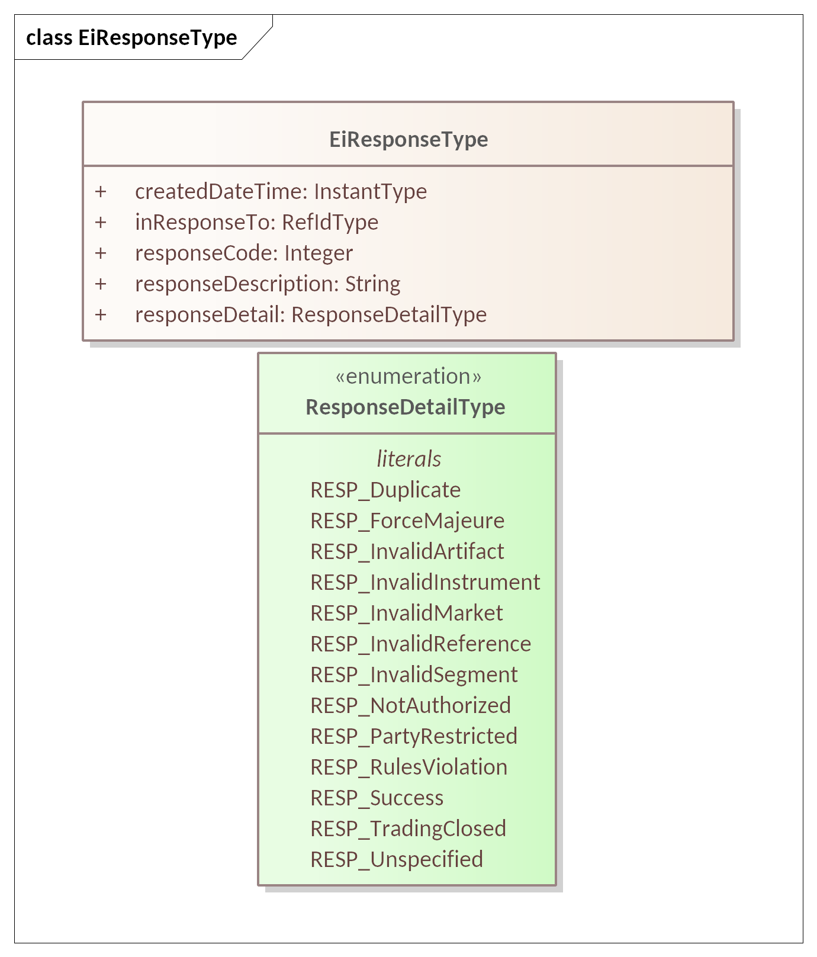

Figure 2‑1 UML Class Diagram of EiResponseType

Attributes for responses are shown in Table 2‑2. The various attribute types are not in FIX.

Table 2‑2: Attributes of EiResponseType

| Attribute | Type | Meaning |
| --- | --- | --- |
| Created DateTime | Instant Type | Timestamp for creation of this response |
| In Response To | Ref ID Type | A reference ID which identifies the artifact or message element to which this is a response. The Request ID uniquely identifies this request and can serve as a messaging correlation ID[7]. |
| Response Code | Integer | The Response Code indicates success or failure of the operation requested. The Response Description is unconstrained text, perhaps for use in a user interface.  The code ranges are those used for HTTP response codes,[8] specifically:  1xx: Informational - Request received, continuing process.  2xx: Success - The action was successfully received, understood, and accepted  3xx: Pending - Further action must be taken in order to complete the request  4xx: Requester Error - The request contains bad syntax or cannot be fulfilled  5xx: Responder Error - The responder failed to fulfill an apparently valid request  Response codes for the. Facets are described in the respective sections. For the Tender Facet see Section 5.5. |
| Response Description | String | A string describing the response, e.g. “Duration doesn’t match Segment configured Duration” |
| Response Detail | Response Detail Type | An enumeration that gives more detail on the response reason. See table below. |

Many messages elicit a response. Information-only messages, as in Tickers, do not. The enumeration literals for Response Detail are shown in Table 2‑3.

Table 2‑3 Enumeration Response Detail Type

| Literal | Meaning |
| --- | --- |
| RESP_Duplicate | The operation submitted a duplicate artifact. |
| RESP_ForceMajeure | The trading venue of its own accord rejected the operation. A similar situation arises when a market cancels a tender to maintain market integrity or liquidity. |
| RESP_InvalidArtifact | The artifact (Tender, Transaction, Quote, RFQ) included is not valid. |
| RESP_InvalidInstrument | The instrument specified is invalid or is otherwise not tradeable. Reasons include (a) the instrument is outside the Segment’s Tradeable Interval, (b) the Duration does not match that for the product traded in the target segment, and (c) Parties are not resolvable. |
| RESP_InvalidMarket | The MarketID is not valid |
| RESP_InvalidReference | A referenced object (e.g. Referenced Quote ID in an EiAcceptQuote Payload) |
| RESP_Invalid Segment | The Segment ID is not valid in the Market specified |
| RESP_Not Authorized | The party invoking the operation is not authorized |
| RESP_Party Restricted | One of the parties is not presently permitted to trade. |
| RESP_Rules Violation | Attributes from Segment, Market, or Session data are violated. For example, lot size, maximum order size, and the like. |
| RESP_Success | The action was successfully received, understood, and accepted |
| RESP_Trading Closed | The targeted segment was not open for trading when the request was received. Hours are in the respective data. |
| RESP_Unspecified | An unspecified error occurred. |

## Identities

In general, CTS uses specific types that inherit from UID Type, with a string as the inherited attribute. This allows representation of unique identifiers variously called UIDs, GUIDs, and other names, while maintaining type safety.

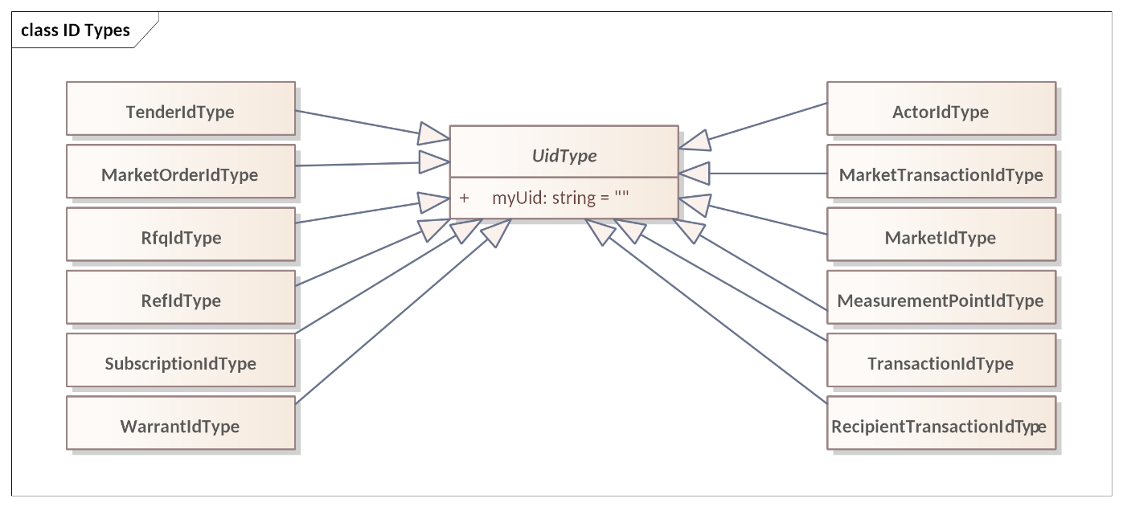

Figure 2‑2 UML Class Diagram of ID Types in CTS

# Market Semantics: Resource, Product, Instrument, and Streams

The messages of CTS use a few common elements. These elements derive from and are compatible with definitions in [WS-Calendar], [EMIX], and in [EI].

Every CTS-based market offers the exchange of a specific resource. Each CTS market segment is a venue for trading a single product, which is a resource packaged for sale. All tenders and transactions are for instruments, which are products scheduled for delivery at a specific time.

## Resource, Product, & Instrument

We define a Resource as a commodity whose value depends on time of delivery. A Party subscribes (see Section 10) to a Market to discover the Resource that is traded in the market, and the Products available in different Market Segments. (See Section 13 “Market Structure Reference Data: Market, Segment, and Session Subscriptions”) A Party can then trade Instruments, a Product at a specific time, in a Market Segment. This specification leaves Market Definition until the end of the specification, as the meaning and import of the terms used to define each Segment are first described in the trading process.

Figure 3‑1 illustrates the relationship between Resource, Product and Instrument. This is expressed formally as UML in Figure 3‑2*.* The relationship is illustrated twice, with an informal sketch and with formal UML below.

Understanding these three terms is essential to understanding CTS.

Figure 3‑1 Informal sketch showing relationship between Resource, Product, and Instrument

The Product incorporates the Resource, defining how the Resource is “packaged” for market. Adding a start date-time to a Product defines an Instrument.

A Market Segment trades Instruments, as a financial market trades financial instruments. CTS trades Instruments to deliver Product at a specific time.

A Market trades a single Resource; a Market Segment trades a single Product.

The UML in Figure 3‑2 shows the relationship between Resource, Product, and Instrument.

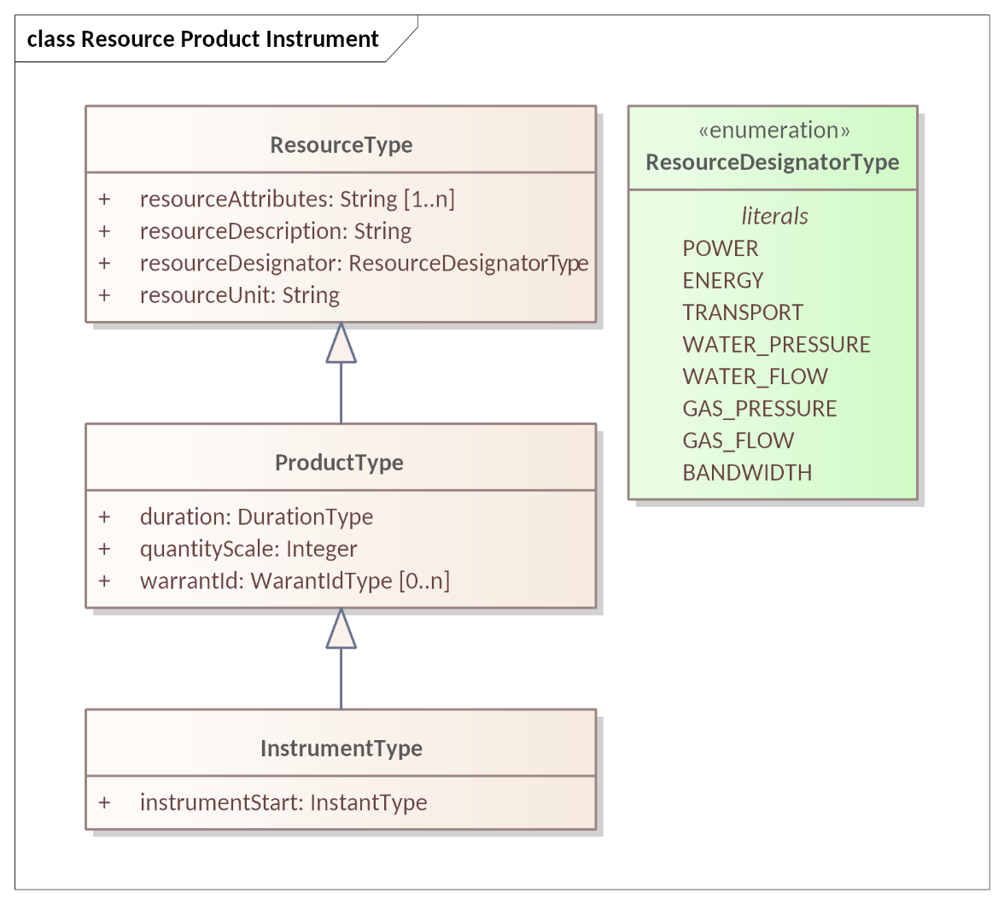

Figure 3‑2 UML Class Diagram for Resource, Product, and Instrument

### Defining Resource

We define a Resource as a commodity whose value depends on time of delivery. A developer may extend the Resource enumeration using standard UML techniques (subclassing); however, CTS 1.0 uses only the limited list in the Resource Designator Type (Figure 3‑3).

A Market typically includes some information that further specifies the Resource, for example voltage and frequency for Power.

Table 3‑1: Defining the Resource

| Attribute | Type | FIX Field | Meaning | Notes |
| --- | --- | --- | --- | --- |
| Resource Attributes | String | Not in FIX | Optional elements that further describe the Resource | e.g. Hertz and Voltage. Different Commodities will require different attributes to be specific. Not defined in this specification. |
| Resource Description | String | Not in FIX | Text description of the Resource |  |
| Resource Designator | String | Not in FIX | POWER ENERGY TRANSPORT WATER_PRESSURE WATER_FLOW GAS_PRESSURE GAS_FLOW BANDWIDTH | The Resource Designator serves a purpose similar to that of the FIX AssetSubClass(1939) with AssetClass(1938)=5 (Commodity)  The list is extensible |
| Resource Unit | String | Not in FIX | The unit of measure for the Resource | Item Unit in [EMIX] The Resource Unit serves a purpose similar to that of the FIX UnitOfMeasure (996) |

The Resource is named in the Market. Each Market deals in a single Resource. Segments of a Market restrict trading into profiles of the Resource. Position and Delivery (see Sections 7, 8 below) itemize Resource quantities.

### Defining Product

The Product is a Resource packaged for Market. The size and duration of the Product define what is, in effect, the “package size” for the commodity. A Market may offer multiple Products for the same Resource in different Market Segments.

Note that the Product is derived from the [EMIX] ItemBase.

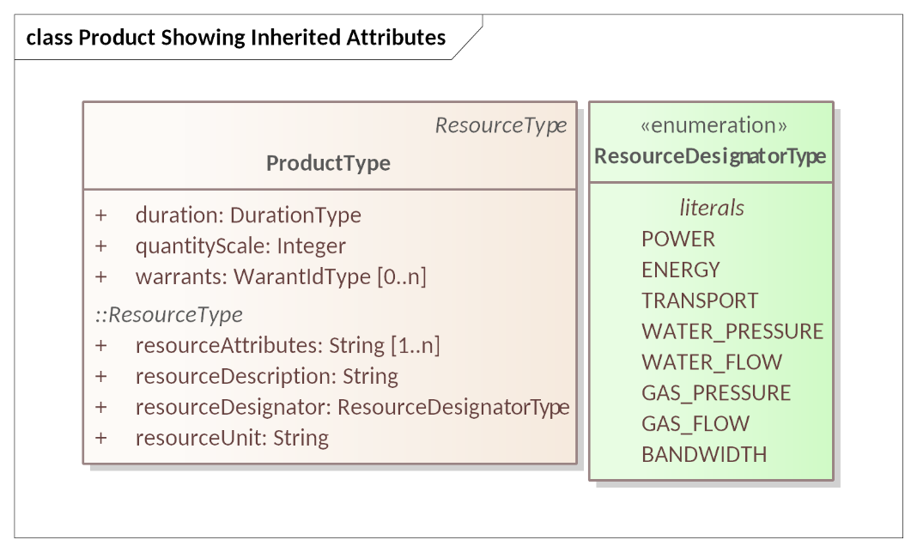

Figure 3‑3 UML Class Diagram for Product showing Inheritance from Resource

Table 3‑2, below, defines each of the fields in the Product.

Table 3‑2: Defining the Product

| Attribute | Type | FIX Field | Meaning | Notes |
| --- | --- | --- | --- | --- |
| Duration | Duration Type | Not in FIX | The interval Duration for the specific Product definition. | As defined in **[WS-Calendar]**. See Section 2.4 Time in CTS. |
| Quantity Scale | Integer | UnitOfMeasure(996) and UnitOfMeasureQty(1147) | A scale factor for Resource Units; the number of resource units in a trade of quantity one of an instrument. | Example 1: A Product measured in kilowatts where the resource unit is Watts has a Quantity Scale of 1000.  Example 2: In a Segment with a Quantity Scale of 1000, a trade of one unit is a trade of one thousand of the Resource Unit—if the resource unit is Watt-hours and Quantity Scale 1000, a trade of quantity 1 is a trade of one kWatt hour. (kWh)  FIX can express this with UnitOfMeasure equal to “kWh” and UnitOfMeasureQty equal to 1. |
| Warrants (Optional) | Warrant ID Type | Not in FIX | Optional further specificity of Product. | Warrants that MAY be available are itemized in the Market. This specification does not define Warrants. |
| Other attributes are inherited from Resource Type (Table 3‑1) | | | | |

Products with differing Warrants are different Products and therefore traded in different Market Segments. A Merket Segment’s reference data (See Section 13.5 Segment Reference Data)

As non-normative examples, if a Party wishes to buy energy with a *Green Warrant* (however defined) then the Party, not the Market, is responsible for defining its trading strategies if the warranted Product is not available. Similarly, a Party that wishes to buy or sell Neighborhood Solar Power is responsible for submitting Tenders that expire in time to make alternate arrangements, or in time to cancel Tenders before fulfillment. This specification establishes no expectation that the Market engine will address these issues automatically.

Warrants are defined in [EMIX], and CTS permits Warrants to support this complexity if desired, but warrants are out of scope and not described in this specification. A Market MAY define a list of Warrants. Warrants were defined in [EI] as additional non-essential characteristics of a Resource such as how it was produced, or an attribute of regulatory interest. Warrants are defined at the Market but are offered per Segment.

### Defining Instrument

At a high level, an instrument is that which is tradeable.

A Market Segment trades Instruments for a single Product. In CTS, an Instrument is a Product delivered for a specific duration beginning at a certain time. CTS includes Duration explicitly in both the Tender and the Quote. The Instrument follows the pattern defined in WS-Calendar—a Resource bound to a Duration (forming a Product) and the Product bound to a Starting DateTime. See Section 2.4 Time in CTS.

The Instrument Start time added to a Product creates an Instrument. See Figure 3‑2.

Table 3‑3: Specifying the Instrument

| Attribute | Type | FIX Field | Meaning | Notes |
| --- | --- | --- | --- | --- |
| Instrument Start | Instrument Type | EventType (865), EventDate (866), EventTime (1145) | Starting Date & Time | A start time completes the specification of Product into a tradeable Instrument The Start Time serves a purpose similar to that of the FIX repeating group EvntGrp with EventType(865)=21 (Delivery start time).  See Section 2.4 Time in CTS. |
| *Other attributes are inherited from Product Type, Table 3‑2* | | | | |

Every Tender, Transaction, and Quote is to buy or sell a quantity of an Instrument.

Within a Segment, the Start Date and Time uniquely identifies an Instrument. Because an off-market Segment, sometimes known as an Over The Counter (OTC) Segment can transact products of any Duration, Tenders, Quotes, and Transactions all use the Segment identifier, the Start Time, and the Duration to identify the Instrument and Product.

### Summary of Instrument Specification

A UML class diagram for Instrument showing inheritance is in Figure 3‑4 below:

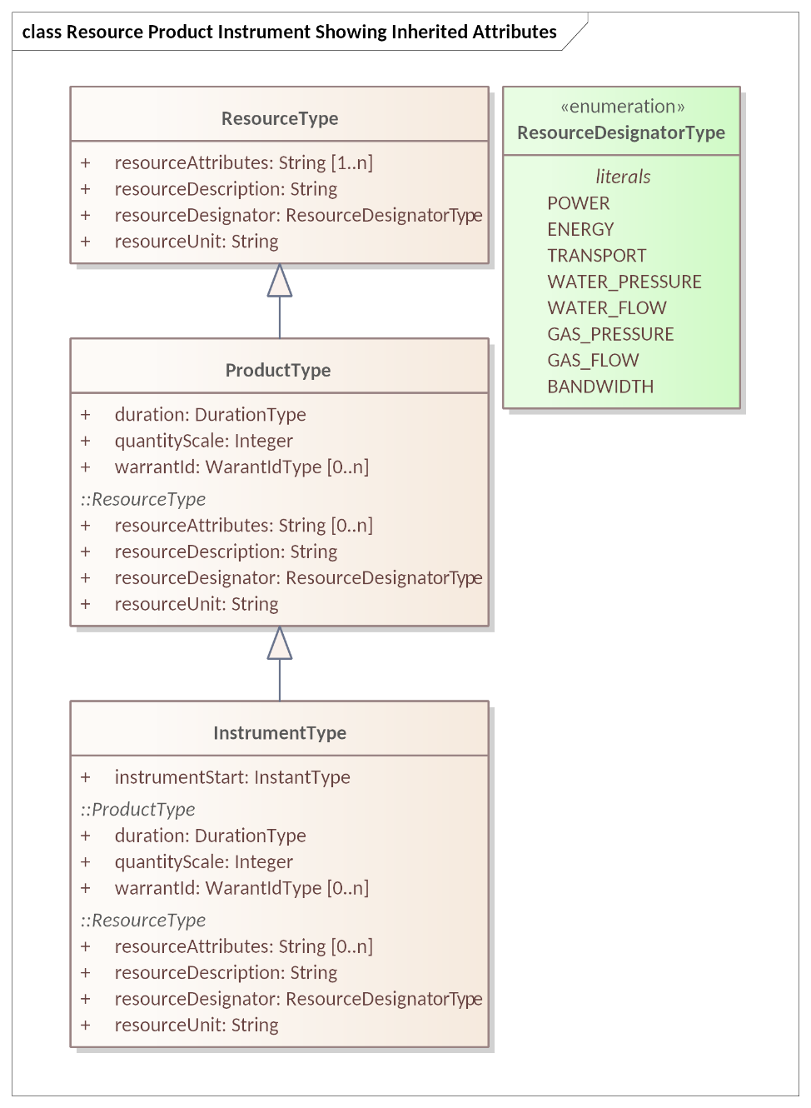

Figure 3‑4 UML Class Diagram for Instrument showing Inheritance from Resource & Product

## CTS Streams: Expressing Time Series

Resource Markets are based on time-of-delivery. It is often useful to convey requests and information about consecutive durations. This specification uses the simplified pattern described in WS-Calendar [Streams], that is, common information followed by a repeating set of information for each consecutive Interval. Each Interval uses a common Duration. All Intervals in a Stream are consecutive.

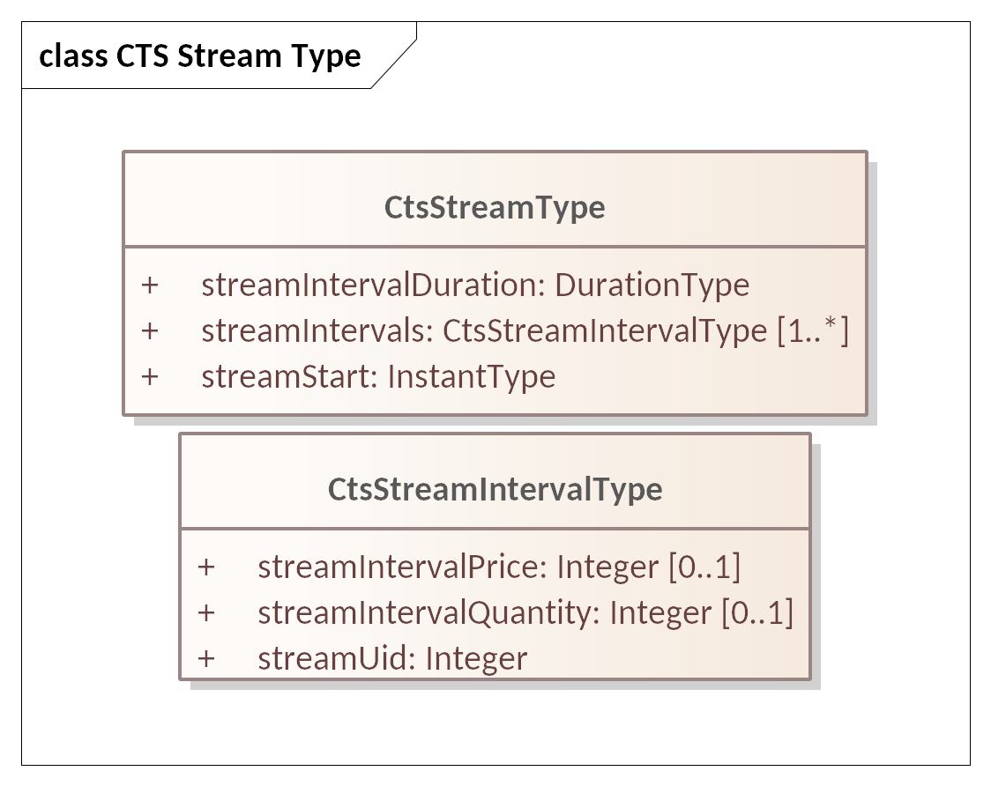

Figure 3‑5: UML Class Model for CtsStream and the Stream Intervals

The response to a request for a stream includes a stream.

For example, the common information in a TenderStream, derived from the CTS Stream, is the Product and the Start DateTime for the first element of the Stream. The Product specifies Resource and Duration. The consecutive intervals in the CtsStream begin with the Start DateTime for the specified Duration. The second Interval has an implied start of the end of the first Interval. The third Interval has an implied start of the end of the second Interval…and so on.

Each interval carries what can be considered a *local UID*.[9]

Several Facets request a CtsStream in the response. They are:

* Position Facet
* Delivery Facet

Certain payloads may include a CtsStream, including:

* Tender Facet *(*see *“Interval Tenders and Stream Tenders”,* Section 5.3.1)
* Quote and Negotiation Facet *(see Stream Quote)*

Table 3‑4:CTS Stream (including Stream Interval)

| Attribute | Type | FIX Field | Meaning | Notes |
| --- | --- | --- | --- | --- |
| Stream Interval Duration | Duration Type | *Not in FIX* | The interval Duration for each Stream element. | As defined in **[WS-Calendar]** Om WS-Calendar MAY be Optional if inherited from message containing Stream.  Mandatory in CTS. |
| Stream Start | Instant Type | *Not in FIX* | Starting Date & Time for the first in the series of Intervals. | After the first Interval, each Interval starts when the preceding Interval finishes |
| Stream Interval Price Value | Integer | Price(44) | Price per Unit during Interval  Optional. At least one of Stream Interval Price Value and Stream Interval Quantity Value MUST be present. | Optional depending upon purpose of message including Stream. |
| Stream Interval Quantity Value | Integer | OrderQty (38) | The Quantity of the Product during the Interval  Optional. At least one of Stream Interval Price Value and Stream Interval Quantity Value MUST be present. | Optional depending upon purpose of message including Stream. |
| StreamUID | Integer | *Not in FIX* | Unique identifier for each interval; local to the Stream instance. | Certain deserializations do not guarantee order -- the UID enables reconstructing the order.  An integer suffices as a sortable UID for streams. |

## The Bounding Interval Pattern in CTS

The CTS requests may include a Bounding Interval. The response is typically all Intervals (CTS Stream Intervals, or Instruments) that are contained within the Bounding Interval including those which align with the ends of the Bounding Interval.

More formally, given a request including a Bounding Interval the request will return information on all Instruments or Stream Intervals within the Bounding Interval whose start is at or later than the Bounding Interval start and whose end point is at or before the end of the Bounding Interval.

One common pattern (see e.g. Figure 7‑2 and Figure 8‑2) is to request information for a Bounding Interval where the response is a CtsStream.

The information within each Interval varies per message type. For example, a StreamQuote will put the Price and Quantity in each interval. A Delivery (metering) payload will put only the Quantity in each Interval.

# Party Registration Facet

A valid Party ID is required to interact with a Market and is included in most payloads.

Party Registration is described in EI. This facet describes the messages necessary for an actor to register and obtain a Party ID to participate in a Market.

EiCreateParty associates an actor with a Party ID and informs the Market of that ID. CTS makes no representation on whether that ID is an immutable characteristic, such as a MAC address, a stable network address, such as an IP, or assigned during registration.

EiRegisterParty names the exchange of information about an actor that enables full participation in a CTS Market. It may exchange information needed for financial transfers including, perhaps, reference to an existing customer or vendor ID, or proof of financial bond for large participants, or issuance of crypto-tokens, or any other local market requirements. A Registered Party is ready to be a full participant in the local Market.

Cancel Party Registration removes a Party from the Market. It may include final settlement, cancellation of outstanding Tenders, backing out of future contracts, or other activities as defined in a particular CTS Market.

Aside from the business services as described, Party Registration may have additional low-level requirements tied to the protocol itself used in a particular implementation based on CTS.

This specification does not attempt to standardize these interactions and messages beyond naming the Register Party facet. A more complete discussion can be found in the [EI] specification.

Some Markets MAY wish to associate one or more measurement points with a Party. Such measurement points could be used to audit Transaction completion, to assess charges for using uncontracted-for-energy, etc. Measurement points are referenced in *Section 8 “The Delivery Facet”*, Markets that require this functionality may want to include an enumeration of Measurement Points in Party Registration.

An implementation is not required to use the Party Registration Facet. For example, if uniqueness and universality are satisfied, any assignment of Party IDs should work.

# The Tender Facet (Order Messages)

A party wishing to buy or sell submits an order (“Tender”) using the Tender Facet. The Service descriptions and payloads in [EI] are simplified and updated in CTS. The FIX Protocol classifies Tenders as Orders. Simple Tenders are handled as what the FIX Protocol would describe as Single Leg Orders with related messages as defined in the FIX category SingleGeneralOrderHandling.

## Messages for the Tender Facet

Parties exchange Order messages to find or create a Transaction. The Tender Facet payloads are shown in Table 5‑1.

Tenders and transactions are artifacts based on **[EMIX]** artifacts, suitably flattened and simplified, and which contain schedules and prices in varying degrees of specificity or concreteness.

Table 5‑1: Tender Facet Payloads

|  |  |  |  |
| --- | --- | --- | --- |
| Facet | CTS Initial Message | CTS Response Message | Meaning |
| EiTender | EiCreateTender | EiCreatedTender | A Party sends a CreateTender message containing one or more Tenders to requesting that the [Market][10] create a Tender. The [Market] either returns the CreatedTender acknowledgement or returns errors. The CreatedTender message returns the Market-assigned ID for the submitted Tender |
| EiTender | EiCancelTender | EiCanceledTender | Cancel one or more Tenders |

In the FIX Protocol, an Order is “completed” when it is fully filled, when it is cancelled, or when it expires. FIX also supports the replacement of orders to change some of its attributes. CTS does not permit replacing tenders, instead requiring that a Party cancel a tender and submit a new one. If a Tender is already partially filled, cancellation cancels only the unfilled portion.[11]

### Illustrative Narrative on Tenders [Non-Normative]

For example, Party A submits a Tender 1 to buy 100 kWh over an hour. A Tender from Party B for 45 kWh matches Party A’s Tender and the Market creates a Transaction (see Section **6**, *“The Transaction Facet”* for a discussion of Transactions). A Tender from Party C for 35 kWh matches Party A’s Tender and the Market creates a Transaction. Party A’s Tender 1 remains on the market with 20 kWh remaining. If Party A wishes to increase the price offered to get the 20 kWh for a critical operation, Party A must cancel Tender 1, with 20 kWh remaining, and submit a Tender 2 offering a new price. Cancelling Tender 1 does not invalidate either of the two completed Transactions.

## Interaction Patterns for the Tender Facet

Figure 5‑1 presents the UML sequence diagram for the EiTender Facet. Note that while [EI] defines a message EIDistributeTender, CTS uses the Negotiation Facet (Section 9, *“The Negotiation Facet”*) and Ticker Subscriptions (Section 11, *“Tickers”*) to accomplish similar purposes.

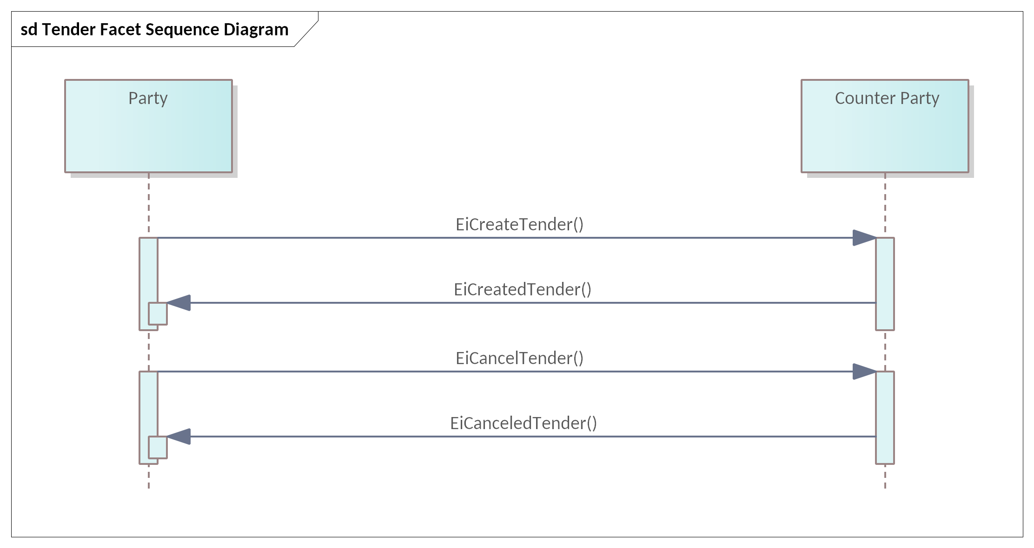

Figure 5‑1: UML Sequence Diagram for the Tender Facet

## Information Model for the Tender Facet

The information model for the Tender Facet artifacts follows that of [EMIX] but flattened and with Product definition implied by the implementation. See Section 5.6 Message Payloads for the Tender Facet below.

The Tender and Quote and RFQ classes share most attributes in common. Accordingly, a superclass *Tender Base* holds those common attributes as shown in Figure 5‑2.

*TenderBase* is an abstract class, so no object can be of that class.

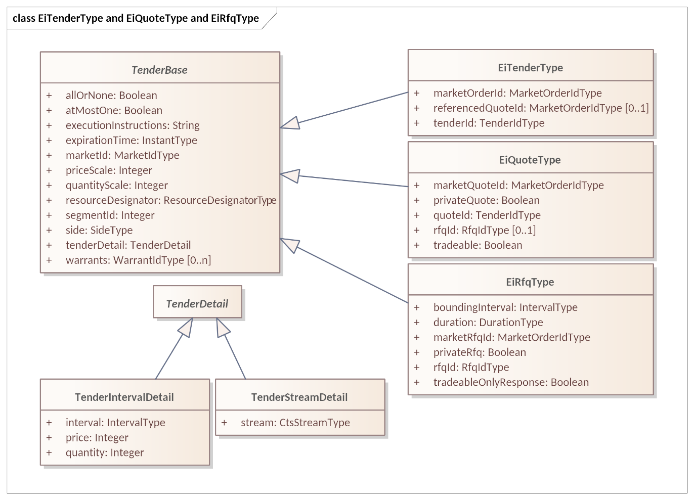

Figure 5‑2 UML Class Diagram Showing Commonality between Tender, Quote, and RFQ

Figure 5‑3 shows all attributes for EiTenderType and their sources.

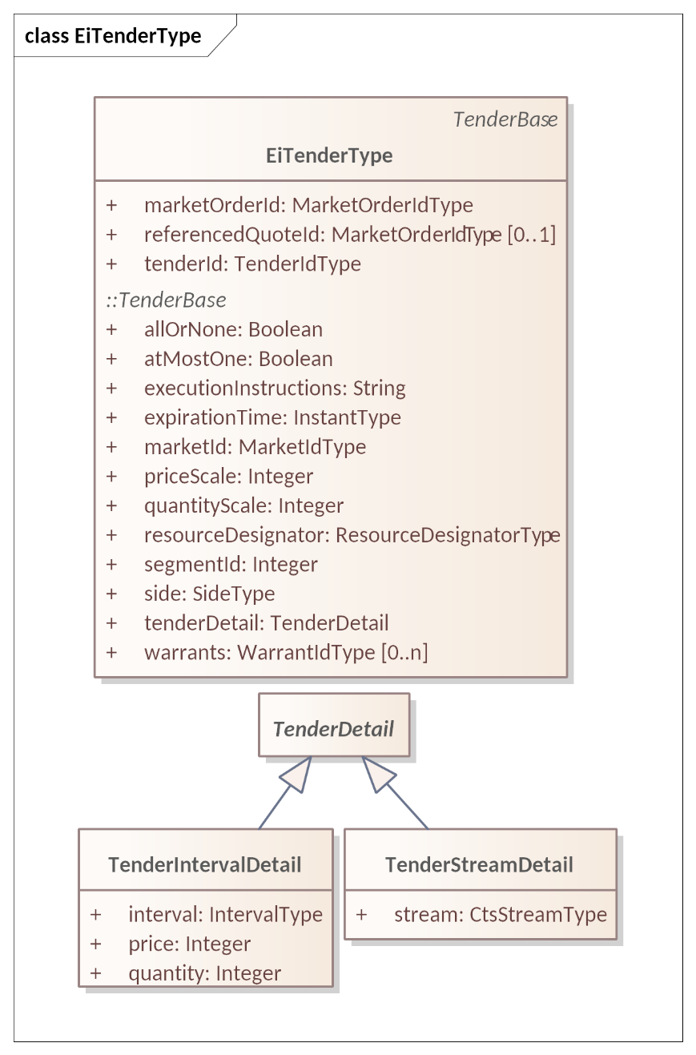

Figure 5‑3 UML Class Diagram of EiTenderType showing inherited attributes

EiTenderType inherits from TenderBase, which holds the common attributes between Tender, Quote, and RFQ.

Attributes used in Tenders and TenderBase are shown in Table 5‑2 and Table 5‑3.

Of the attributes in Table 5‑2, Tender ID and Referenced Quote ID (Referenced Quote Id) are unique to EiTenderType; the others are inherited from Tender Base and shared with EiQuoteType and EiRfqType. See Section 9, “*The Negotiation Facet”*, for a discussion of Quotes and Requests For Quotes.

Table 5‑2: EiTender Attributes

| Attribute | Type | FIX Field | Meaning | Notes |
| --- | --- | --- | --- | --- |
| Market Order ID | Market Order ID Type | OrderID(37) | A market-assigned unique identifier for an Order (Tender in CTS) |  |
| Referenced Quote ID | Market Order ID Type | QuoteMsgID (1166); OrderID (37) | ID of the Tradeable Quote to which this is a response. | Optional. If Quote ID (represented in CTS as a Market Order ID Type) is not known to the Market Segment, or if the referenced Quote has expired, then the Tender is rejected.  See Section 2.6 Responses. |
| Tender ID | Tender ID Type | ClOrdID(11) | An ID for this Tender generated by the submitting Party |  |
| *Other attributes are inherited from TenderBase—See Table 5‑3* | | | | |

The complete description of the Interval for a Tender is in TenderDetail—either an Interval with a price and quantity, or a CtsStream with price and quantity for each Stream Interval.

While a Market Segment typically only accepts Tenders and Quotes of a single configured duration[12] as defined in the Segment’s product, the complete description is required to ensure validity and for off-market interactions.

Table 5‑3 Tender Base Attributes

| Attribute | Type | FIX Field | Meaning | Notes |
| --- | --- | --- | --- | --- |
| All or None | Boolean | ExecInst(18)  In FIX, this is one among many Execution Instructions | All or none of the quantity must be traded or accepted.  Applies to the interval or all stream intervals within the enclosing object. | See Section 5.3.2 Execution Instructions.  A separate Boolean to avoid string parsing.  See also MultiLeg in EiCreateTender and EiCreateQuote. |
| At Most One | Boolean | ContingencyType (1385) | Used to indicate alternatives, only one of which is to be effective | See Section 5.3.2 Execution Instructions.  First match cancels other same level artifacts. |
| Execution Instructions | String | ExecInst(18) | FIX Supports many instructions for how to execute an order. | See Table 5‑4 below. Modeled as a String in CTS.  FIX uses ExecInstValue (1308) to determine which are valid the present Market Segment. |
| Expiration Time | Instant Type | ExpireTime (126) | The Tender or Quote expires at the specific time. | Always expressed in UTC |
| Market ID | Market ID Type | MarketID (1301) | Identifies the Market | Note that in FIX, this is generally a formal identifier (e.g., “NYSE”), using ISO 10383 (MIC). If the market is a house, there is no place to look this up. There is always a UID for a Market. |
| Price Scale | Integer | Not in FIX | A multiplier for the Price | Note that Price Scale is specific to this instance of Tender Base, and not necessarily to Markets or Segments in which the Tender Base may be used. |
| Quantity Scale | Integer | UnitOfMeasure (996)  UnitOfMeasure Quantity (1147) | A scale factor on the Resource unit for this Market | See Table 3‑2: Defining the Product. Note that the Tender Quantity Scale is specific to this Tender Base. |
| Resource Designator | Resource Designator | Not in FIX | Identifier of the Resource being offered (Optional in many markets) | While a Market only accepts Tenders and Quotes for a single Resource, the complete description is required to ensure validity and for off-market interactions. |
| Segment ID | Integer | MarketSegmentID(1300) | Identifies the Segment processing the Tender, Transaction, or Quote | This should be a unique combination paired with the Market ID. |
| Side | Side Type | Side(54) | Whether the Tender is to buy or to sell the Product | Buy or Sell side |
| Tender Detail | Tender Detail | Not in FIX | Unit price and quantity for this tender | Exactly one. May be Interval or Stream as permitted by the intended trading venue. |
| Tender ID | Tender ID Type | ClOrdId(11) | ID managed by submitter to Market | Identifies Tender on the initiator side, Market Order ID is assigned by Market.  See Market Order ID above. |
| Tender Interval Detail | Tender Interval Detail | Not in FIX | Interval, price and quantity for this tender | Used in Interval Tender |
| Tender Stream Detail | Tender Stream Detail | Not in FIX | Stream of consecutive Intervals with Prices and Quantities and a MultiLeg flag | Sometime referred to as a Load Curve in Power Markets.  If MultiLeg is True, all stream interval values must be accepted or none. |
| Warrants (Optional) | Warrant ID Type | Not in FIX | Optional reference to Warrants as defined in the Market | If used, see Warrants in Tenders, Section 5.3.3. |
| *The following attributes are in Tender Interval Detail or Tender Stream Detail—See* Figure 5‑3 | | | | |
| Interval | Interval Type | Not in FIX | Start Instant for Product delivery together with Duration of delivery. Part of Instrument | While a Market Segment only accepts Tenders and Quotes of a single configured duration, the complete description is required to ensure validity and for off-market interactions. |
| Price | Long | Price(44) | The unit price for the Product being Tendered | Amount is the product of Price and Quantity. Note that Price is subject to the Price Scale for this Tender Base. |
| Quantity | Long | OrderQty(38) | The quantity of the Product being Tendered | Note that Quantity is subject to the Quantity Scale for this Tender Base.  Quantity must meet the Quantity Scale and Round Lot requirements of the Segment in which the containing Tender, Quote, or RFQ is to be traded . (see Table 13‑5) |
| Stream | CTS Stream Type | Not in FIX | A CTS Stream with Price and quantity for each Stream Interval | Attribute of TenderStreamDetail—see Figure 5‑3 and 3.2 CTS Streams: Expressing Time Series. |

### Interval Tenders and Stream Tenders

The most common Tender is the simple Interval Tender, that is, an offer for a Product in a single interval beginning at a specific date and time.

In financial markets, a *multi-leg order* is submitted for securities that are made up of multiple securities, known as legs. The legs are not traded individually. This specification describes a specialized type of multi-leg order for use in in some Market Segments which we term a Stream Tender. A Stream Tender defines a consecutive series of Intervals of identical Duration. The price and quantity tendered must be specified for each Interval.

For example, an industrial customer in a power market may intend to buy power to support a long running process. In power markets, such a sequence of power use is sometimes referred to as a *load curve*.

Such multi-leg orders are expressed using a CtsStream (see 0, “

CTS Streams: Expressing Time Series”). While the information contained in a Stream Tender can be mapped precisely to a group of Interval Tenders, multi-leg semantics and processing of the related tenders leads to a Stream Tender.

Not all Market Segments permit Stream Tenders; some may require them. A Party submits a Stream Tender, when permitted or required, just as a Party submits an Interval Tender. A Market responds to the submission of a Stream Tender, when permitted or required, just as it responds to an Interval Tender.

Partys may submit Stream Tenders only to Market Segments that specifically permit or require them. See Section 13, “Market Structure Reference Data: Market, Segment, and Session Subscriptions”.

Market Segments that support Stream Tenders SHALL also support Stream Quotes (if they support Quotes) and Stream Transactions. See Section 9, “The Negotiation Facet”, for a discussion of Quotes.

### Execution Instructions

FIX supports multiple Execution Instructions for the same order. CTS supports multiple Execution Instructions from a reduced set, keeping in mind that a Segment may further restrict acceptable Execution Instructions.

For example, the the following instructions could all be on the same order:

* Cross is forbidden.
* Reinstate on system failure.
* Cancel on trading halt.

Future versions of CTS may permit additional Execution Instructions.[13]

Table 5‑4 presents the subset of the FIX Execution Instructions permitted for use in CTS. See FIX Field ExecInst(18) for the definitions. FIX Field ExecInstValue(1308) describes Execution Instructions valid in a particular Segment. See Table 13‑4.

In Stream Tenders (as in Stream Quotes) if All or None is true each stream interval quantity must be accepted in full or not at all.

In the case of Quote Tickers (See Section 11.5.2 Quote Tickers) for price notification a stream quote SHOULD NOT set the All or None attribute as all recipients cannot lift the quote.

This MAY also be used for delivery reconciliation in a SPOT segment.

Table 5‑4: Execution Instructions

| Instruction | FIX Code | Notes |
| --- | --- | --- |
| No cross | A | Tender is cancelled after any market transition (See 13.6, “Trading Session Data”) |
| OK to cross | B | Cross is Permitted. (See 13.6, “Trading Session Data”) |
| All or none – AON | G | Ignored if present. The All or none attribute in Tender Base applies instead. See Table 5‑3.  For consistency in integration, if All or None is True in Tender Base this Execution Instruction SHOULD also be present.  Note that All or None applies to the quantity ordered or quoted. |
| Reinstate on system failure | H | Mutually exclusive with Q and l (lower case L). |
| Reinstate on trading halt | J | Mutually exclusive with K and m. |
| Cancel on trading halt | K | Mutually exclusive with J and m. |
| Cancel on system failure | Q | Mutually exclusive with H and l (lower case L). |
| Cancel if not best | Z | Cancel if order is not immediately matchable |
| Ignore price validity checks | c | Do not reject order due to price outside of reasonable range |
| Suspend on system failure | l | Mutually exclusive with H and Q. |
| Suspend on trading halt | m | Mutually exclusive with J and K. |

Similar semantics are applied to Quotes, Tenders, and RFQs:

* A Quote, Tender, or RFQ has a Boolean attribute AllOrNone in the shared Tender Base. The All or none instruction is applied to all intervals within the enclosing Quote or Tender.
* The use of All or None should not be confused with MutliLeg semantics. EiCreateQuote and EiCreateTender Payloads have a Boolean attribute MultiLeg that indicates that all of the included legs (Quotes or Tenders) must be accepted In effect, this is across the enclosed artifacts.

A similar rule applies for At Most One, which is FIX Field ContingencyType(1385), not an execution instruction.

### Use of Warrants in Tenders

Warrants increase the specificity of Product (and Instrument). A Buyer who does not specify a Warrant will be satisfied by Delivery of a Product whether or not it has a Warrant. A Buyer who requests Product with a Warrant will only be satisfied by Delivery of a Product that has that Warrant.

Note that warrants, their definition and behavior are out of scope. A Warrant ID is in Tender Base (See Figure 5‑2).

Consider a buyer who wishes to buy a package of coffee beans and a buyer who wishes to buy a package of organic coffee beans. The word “Organic” on the label serves as a Warrant. The first buyer will buy solely on price, and is indifferent to seeing the word “Organic” on the label. The second buyer will choose only from among those packages with the warrant “Organic” on the label.

When a Tender on the Buy side specifies a Warrant, it must be rejected by any Market Segment that does not include that Warrant. A Tender on the Sell side that specifies a Warrant may be accepted by any Segment where the same Resource and Duration are traded. Conversely, a Tender on the Sell side without a Warrant must be rejected by any Segment that specifies a Warrant.

## Contingent Tenders

FIX permits multiple Orders submitted in a single message. The FIX NewOrderList(35=E) message bundles multiple Orders with a common instruction that influences how fulfilling each Order affects the other Orders. A CTS Market Segment either forbids or requires the use of Contingent Tenders. Tender Contingency Types in CTS are based on the values of the FIX field ContingencyType(1385).

### Illustrative Narrative on Contingent Tenders [Non-Normative]

The Contingency Type describes how the other Tenders in the List are affected by the acceptance of any one Tender. A Party submitting a List with atMostOne = True is willing to accept whatever Tender matches the Transaction that created by the Market. In CTS Version 1, the FIX-defined Contingency OCO or “One Cancels the Other” is expressed as a Boolean *At Most One.*

Stream Tenders support a special case. Stream Tenders (Load Curves) can support business needs such as acquiring power for a long-running industrial process. The Party may intend to acuire the amounts in all of the sub-Tenders that compose the Stream Tender or none of them. The Party indicates this by setting the MultiLeg flag to True. If the MultiLeg is False, then each sub-Tender is handled AS IF a separate Tender. The submitter may still set the AllOrNone flag to indicate that each of the sub-Tenders is to be fulfilled in whole or not at all. See Section 5.3.2 Execution Instructions.

A Party MAY wish to probe the market to make a more nuanced decision. This may include choosing one of several options. A decision to schedule a long-running process may depend upon being able to acquire a specific load curve over the entire schedule. A party that requires such complex contingent behavior should use the Negotiation Facet (section 9) to obtain Tradeable Quotes, and then make its own choices based on those Quotes.

## Rejecting a Tender and Tender Responses

A Market may reject a Tender that violates market rules or which, if transacted, would violate the market’s integrity and other constraints (e.g. liquidity goals). There are many reasons a Segment may reject a Tender. A Segment rejects a Tender as described in EiResponse (Table 2-2) which includes Response Detail (Table 2-3) and Response Description.

As informative examples, the reasons include, but are not limited to:

* Tender exceeds price limits on the potential transaction.
* Tender exceeds total value limits on the potential transaction.
* Tender violates total quantity limits for this Market Segment.
* Party is not in good standing with the Market.
* Tender violates lot size requirements of the Market Segment.
* Tender violates starting time requirements for instruments in the Market Segment.
* Market Segment is not open.
* Instrument is prior to temporal trading limits for this Market Segment.
* Instrument is past temporal trading limits for this Market Segment.
* Tender is incomplete or corrupt.
* Referenced Quote not found.
* Referenced Quote has expired.

Details for rejection MAY be included in the response included in the EiCreatedTenderPayload; the details apply to other Create payloads as well. See Section 2.6 Responses.

The optional Response Description string is for implementation-defined additional information. The EiResponse is used similarly for other response payloads.

## Message Payloads for the Tender Facet

Figure 5‑4 is a **[UML]** class diagram for the payloads for the Tender Facet operations. Note that each operation supports one or more Tenders, each of which may be an Interval or a Stream Tender.

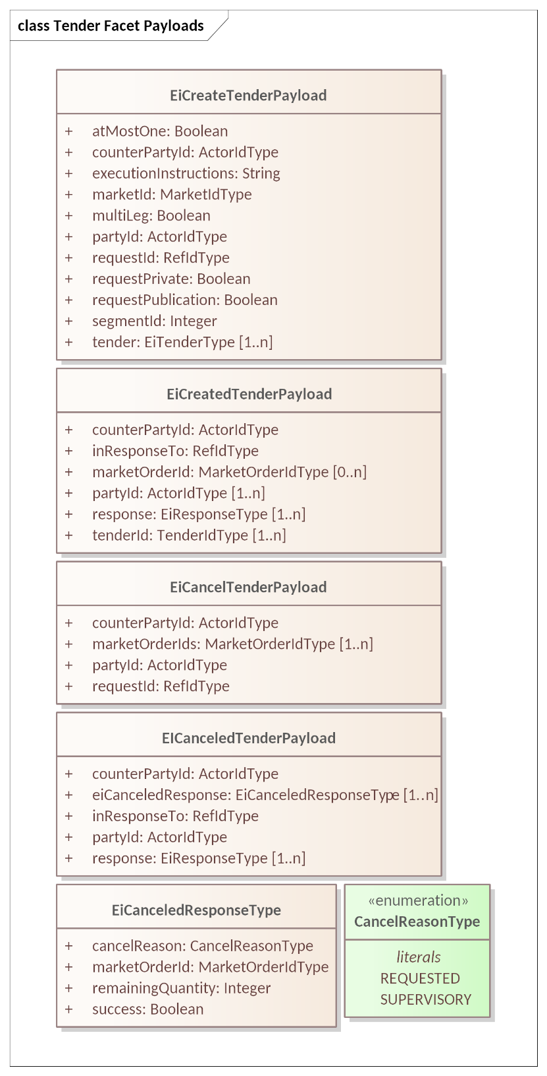

Figure 5‑4 UML Class Diagram for Tender Facet Payloads

The Market Order ID is assigned by the Market on receipt of a Tender[14]. The Market makes no assumption that the Tender ID (FIX field ClOrdID(11)) submitted as part of the Tender is unique across all Parties in the Market; however it is presumed that a Tender ID is unique at least across a single trading day.

The Market responds with an EiCreatedTender payload with a Market Order ID for each Tender ID submitted successfully. The submitting Party should record this Market Order ID, as it will be used in any Transactions created by the Market, and is required to cancel any Tender.

The TenderId in EiTenderType is the creator’s ID; as in FIX, the IDs must be guaranteed unique within a trading day.

Specific Market Segments may limit all Tender submissions to either Interval Tenders or Stream Tenders or may accept both. Specific Market Segments may restrict each Tender submission to all Interval Tenders or all Stream Tenders. See Section 13 for details.

The following tables describe the attributes for the Tender Facet Payloads.

Table 5‑5 EiCreateTenderPayload Attributes

| Attribute | Type | FIX Field | Meaning | Notes |
| --- | --- | --- | --- | --- |
| At Most One | Boolean | ContingencyType (1385) | When multiple Tenders are submitted at once, then at most one Tender can be matched. | See Section 5.3.2 Execution Instructions, however this is not an Execuion Instructions. See ContingencyType 1 *One Cancels the Other*.  First match cancels others. |
| Counter Party ID | Actor ID | PartyID (448) | The Actor ID for the Counterparty for which the Tender is created. | In CTS, generally the Party ID for the Market. To indicate a bilateral exchange, i.e., a Tender between two specific parties, the Party ID of a specific counterparty is used. |
| Execution Instructions | String | ExecInst (18) and ExecInstValue (1308) | Execution Instruction. | Execution instructions for each included Tender are in that Tender.  Note that All or None does not apply at the Create level. |
| Market ID | Market ID Type | MarketID (1301) | Identifies the Market | Note that in FIX, this is generally a formal identifier (e.g., “NYSE”), using ISO 10383 (MIC).  For example, if the market is a house, there is no place to look this up.  There is always a UID for a Market. |
| MultiLeg | Boolean | See FIX message NewOrderMultileg[15] | Each of the enclosed Tenders must be accepted or none of them are. | See Section 5.3.2 Execution Instructions. |
| Party ID | Actor ID | PartyID (448) | The Actor ID for the Party on whose behalf this Tender is made. | Indicates which Actor proposes the buy or sell side EiCreateTender. |
| Request ID | Ref ID Type | ClOrdID (11) | An identifier for this Create Tender Payload |  |
| Request Private | Boolean | Not in FIX. See PrivateQuote (1171) | The sender requests that Tender(s) be Private (available) only to specified Counter Party or Parties.  This is for symmetry with EiCreate Transaction, RFQ, and Quote where it means that the ability to engage is to the named counterparty only. | FIX has Public as an antonym of Private; due to privacy related market rules, CTS separates the concepts and clarifies that it is a request.  This is a request and may not take place. Note that the Market or Segment may be the publisher of a Tender Ticker, so this may not affect behavior. |
| Request Publication | Boolean | PreTradeAnonymity (1091) (inverted) | Publication of the Tender(s) are requested. | The sender of an EiCreateTender Payload requests publication on the Tender Ticker if available.  This is a request and may not take place. Note that the Market or Segment may be the publisher of a Transaction Ticker, so this may not affect behavior.  See also Request Private. |
| Segment ID | Integer | MarketSegmentID (1300) | Identifies the Segment processing the Tender, Transaction, or Quote | This should be a unique combination paired with the Market Order ID |
| Tender | EiTender Type |  | Tenders requested to be created | One or more Tenders per Table 5‑2: EiTender Attributes.  Sometimes informally called *a bag of tenders*. |

Table 5‑6 EICreatedTenderPayload Attributes

| Attribute | Type | FIX Field | Meaning | Notes |
| --- | --- | --- | --- | --- |
| Counter Party ID | Actor ID | PartyID (448) | The Actor ID for the CounterParty for which the Tender is created. | In CTS, generally the Party ID for the Market. To indicate a bilateral exchange, i.e., a Tender between two specific parties, the Party ID of a specific counterparty is used. |
| In Response To | Ref ID Type | ClOrdID (11) | An identifier for EiCreateTender to which this is a response |  |
| Market Order ID (Optional) | Market Order ID | OrderID (37) | Zero or more Market Order IDs assigned by the Segment or Market.  Optional if all requested Create Tender operations fail. | Used in acknowledgment and in all future market messages.  May not be present if no tender was successfully created. |
| Party ID | Actor ID | PartyID (448) | The Actor ID for the Party on whose behalf this Tender is made. | Indicates which Actor proposes the buy or sell side EiCreateTender. |
| Response | EiResponse Type | OrdRejReason(103) | Specific error responses | See Section 2.6 |
| Tender ID | Tender ID Type | OrderID (37) | The Tender ID(s) that were used in the EiCreateTender payload to which this is a response | While UIDs should be truly unique, with a mix of technologies and possible faulty implementations in low-end devices, CTS follows the FIX Protocol in assuming that Customer Order is only unique for this Customer for the current business day.  Always present in the same multiplicity as in the EICreateTender payload; there may be no Market Order IDs created if all requestedTenders fail to be created. |

Table 5‑7 EiCancelTender Payload Attributes

| Attribute | Type | FIX Field | Meaning | Notes |
| --- | --- | --- | --- | --- |
| Counter Party ID | Actor ID | PartyID (448) | The Actor ID for the CounterParty for which the Tender is created. | In CTS, generally the Party ID for the Market. To indicate a bilateral exchange, i.e., a Tender between two specific parties, the Party ID of a specific counterparty is used. |
| Market Order ID | Market Order ID | OrderID (37) | ID assigned by the Segment or Market. | One or more Market Order IDs to cancel. |
| Party ID | Actor ID | PartyID (448) | Actor ID for the Party that created the Tender |  |
| Request ID | Ref ID Type | ClOrdID (11) | An identifier for this Cancel Tender Payload |  |

Table 5‑8 EiCanceledTenderPayload Attributes

| Attribute | Type | FIX Field | Meaning | Notes |
| --- | --- | --- | --- | --- |
| Counter Party ID | Actor ID | PartyID (448) | The Actor ID for the CounterParty for which the Tender is created. | In CTS, generally the Party ID for the Market |
| EiCanceled Response | EiCanceled Response Type | Not in FIX | Detailed response for each Market Order ID for which canelation was requested in the EiCancelTender Payload | See Section 5.5 and Table 5‑9 below. |
| In Response To | Ref ID Type | ClOrdID (11) | An identifier for the Cancel Tender Payload to which this is a response |  |
| Party ID | Actor ID | PartyID (448) | The Actor ID for the Party on whose behalf this Tender was made. | Indicates which Actor proposes the buy or sell side EiCreateTender. |
| Response | EiResponse Type | CxlRejReason(102) | Specific error responses | See Section 2.6 Responses. |

Table 5‑9 EiCanceledResponseType Attributes

| Attribute | Type | FIX Field | Meaning | Notes |
| --- | --- | --- | --- | --- |
| Cancel Reason | Cancel Reason Type |  | The source of the cancelation request. An enumeration with values REQUESTED—by a Party or SUPERVISORY—by the market operator or other actor. |  |
| Market Order ID | Market Order ID | OrderID (37) | ID assigned by the Segment or Market. | The Market Order IDs on which cancelation was requested. |
| Remaining Quantity | Integer | OrderQty (38) | The Quantity of the Product remaining from previous partial matches of the tender. | Purpose is to inform the requestor what has already been matched. |
| Success | Boolean | Not in FIX | The cancel succeeded for the included Market Order ID. | If Success is false, Remaining Quantity may not be correct. |

# The Transaction Facet (Execution)

This section presents the Transaction Facet, used by the Market to notify of the creation of Transactions. FIX terms the matching of a Buyer and a Seller as a “Trade” or “Execution”. CTS follows EI (and the term transactive energy) in naming it a Transaction.

In the general case, the Market notifies each Party of the creation of a Transaction when two Tenders match as discovered by the Market’s internal matching engine. To protect participant privacy, the market MAY use the MarketID as the counterparty to each Party receiving the Notification.

Unlike in financial markets, the market operator must cooperate with relevant system operators to enforce flow limits imposed by physical infrastructure limits. For example, a substation or distribution cable will have physical limits for power transferred during a given Interval. The reasons and mechanisms for such an enforcement are out of scope for CTS.

See Section 9, *“The Negotiation Facet”* for a discussion of Transactions based upon a Tradeable Quote.

All Transactions are committed, that is, they cannot be cancelled or modified under normal market operations. Transactions in aggregate make up the Position. (See Section 7, *“The Position Facet”* for a discussion of Position.) A Party may thereafter choose to sell any or all of its Position in any instrument. Moreover, market and/or segment rules (out of scope for CTS) may limit attempts to sell more than the Party’s current position; in FIX such check may include a pre-trade risk limit or credit limit check.

## Messages for the Transaction Facet

A Transaction is created by a Market or Segment (See Section 13) based on some Mechanism internal to the Market.[16] (See Section 13.1 for what a Party can know of the Mechanism). When a Market recognizes a potential Transaction, it creates a Transaction ID, and notifies the participating Parties.

Table 6‑1: Transaction Facet

| Facet | CTS Initial Message | CTS Response Message | Meaning |
| --- | --- | --- | --- |
| Transaction | EiCreateTransaction | EiCreatedTransaction | Create and acknowledge creation of a Transaction; typically initiated by the matching engine of the Market Segment. |

## Interaction Pattern for the Transaction Facet

Figure 6‑1 shows the UML sequence diagram for the EiTransaction Facet.

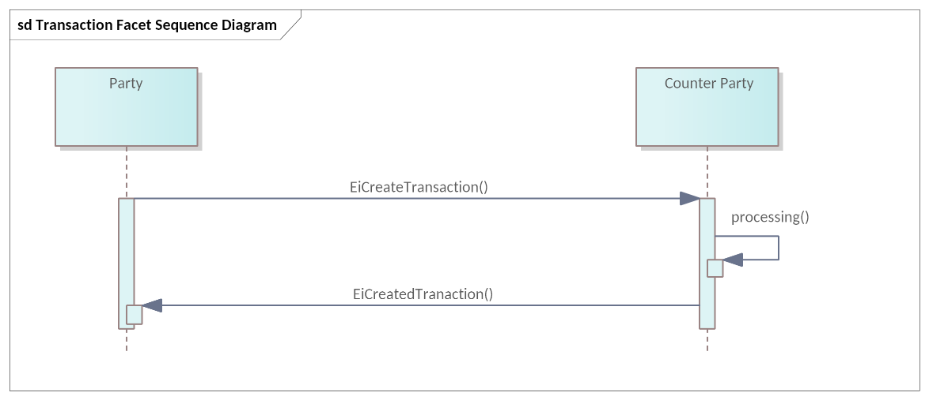

Figure 6‑1: UML Sequence Diagram for the EiTransaction Facet

Most Transactions are mediated by a market. The Market matches Tenders, creates a Transaction, and notifies the submitting Parties.

In Off-Market and quote-based Segments (See Section 13), the Parties match Quote and Tender, and inform the Market to create the Transaction. Even in Off-Market and quotation-based Segments, the market operator must still enforce physical or other limitations. Interaction patterns for such Segments are defined in Section 9, *“The Negotiation Facet”*.

## Information Model for the Transaction Facet

The EiTransaction object includes the information in the original EiTender, possibly updated to reflect the actual price and quantity rather than the requested price and quantity.

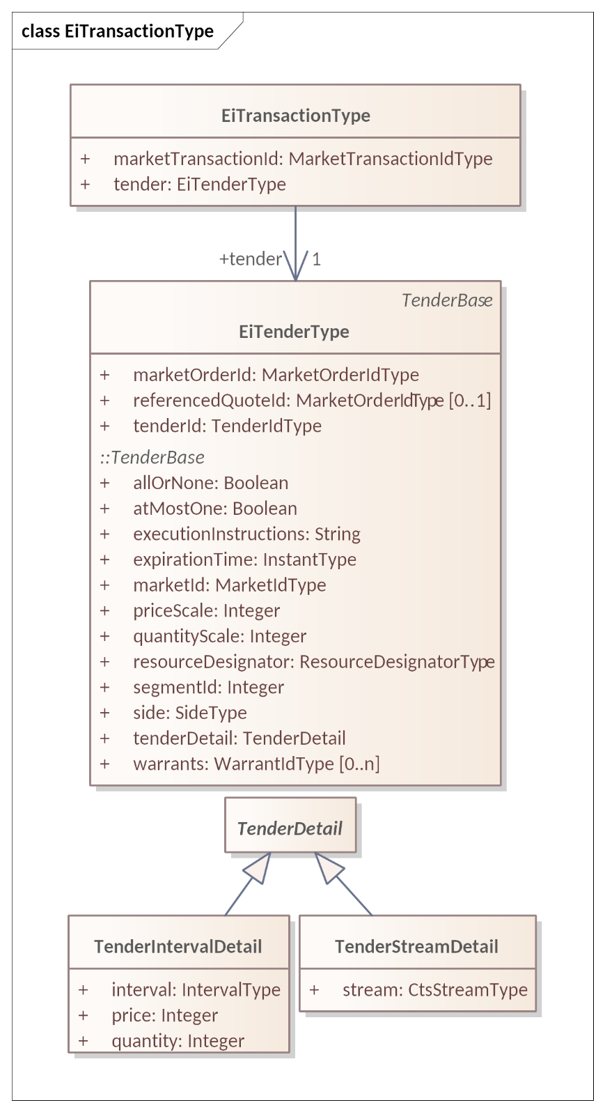

Figure 6‑2: UML Class Diagram of EiTransactionType

The attributes of EiTransactionType are shown in Table 6‑2.

Table 6‑2: EiTransaction Attributes

| Attribute | Type | FIX Field | Meaning | Notes |
| --- | --- | --- | --- | --- |
| Market Transaction ID | Market Transaction ID Type | TradeID (1003) | ID Assigned this Transaction (Trade) by the Market (Segment) | This is assigned by the actor that performed the match, typically a market segment.  It is explicitly returned in the EICreatedTransaction Payload. |
| Other attributes are defined in EiTenderType and Tenderbase. See Figure 5‑3 and following tables | | | | |

## Payloads for the Transaction Facet

The **[UML]** class diagram in Figure 6‑3 describes the payloads for the EiTransaction facet operations.

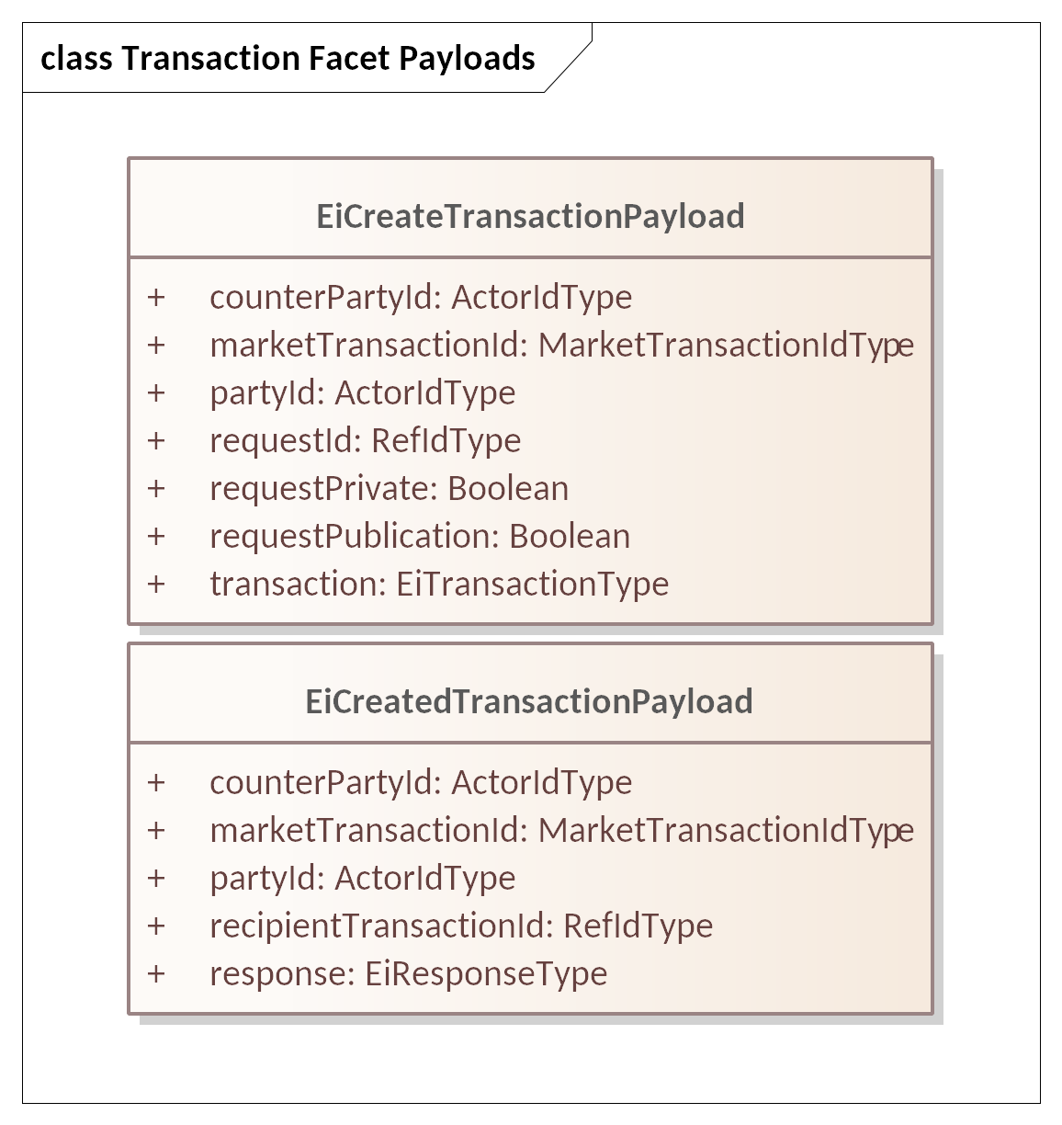

Figure 6‑3: UML Class Diagram of EiTransaction Facet Payloads

The following tables list the attributes of the Transaction Facet Payloads.

Transactions are produced by a market or actor that performs matches; the resulting Transaction information is sent to the Parties whose Tender(s) are matched. Note that there is not a one-to-one relationship of Tender to Tender, or Tender to Contract. A Tender to buy one hundred might match multiple Tenders to sell ten; this results in multiple Transactions for one Tender. Each Transaction is created by an interaction between a Tender to buy and a Tender to Sell. The Transaction payloads “echo” each Tender to the Party that submitted it to become part of the Transaction.

The Tender included as part of a Transaction payload indicates buy side or sell side. When the Transaction indicates “buy”, then the Party ID is that of the Buyer. When the Transaction indicates “sell”, then the Party ID is that of the Seller. The Counterparty ID is the other participant in the Transaction.

Financial markets often designate a “clearing” or “central” counterparty. Privacy concerns, particularly for transactions involving homes, are one reason for using the Party ID of the central counterparty. Some rules may require revealing the identity of certain Parties. For example, the Party ID of a dominant participant such as a distribution system operator MAY be deemed public information; transactions involving such a designated participant would use the participant’s Party ID in the payload.

When use of a Party ID for the clearing counterparty is required, CTS uses the Party ID of the Market.

Table 6‑3 EiCreateTransactionPayload Attributes

|  |  |  |  |  |
| --- | --- | --- | --- | --- |
| Attribute | Type | FIX Field | Meaning | Notes |
| Counter Party ID | Actor ID | PartyID (448) | Party ID of the Party on the other “side” from the Tender in the payload. | May be the Party ID of the clearing counterparty. |
| Market Transaction ID | Market Transaction ID Type | TradeID (1003) | ID assigned by the Market when generating a Trade (or one of the Parties if not Market-Facilitated).  Mandatory. | Assigned by the Market or the Creating Party.  Typically a Match in a Segment is the proximate cause of an EiCreateTransaction message. |
| Party ID | Actor ID Type | PartyID (448) | Party ID of the Party on the same “side” of the Tender in the Payload. | Side of the included transaction determines the Party. |
| Request ID | Ref ID Type | ClOrdID (11) | An identifier for this EiCreateTransaction payload | FIX Field is for Order ID. |
| Request Private | Boolean | Not in Fix. See PrivateQuote (1171) | The sender requests that Transaction to be Private only to specified Counter Party or Parties.  May not be meaningful; this is for symmetry with EiCreateTender, RFQ, and Quote where it means that the ability to engage is to the named counterparty only. | FIX has Public as an antonym of Private; due to privacy related market rules, CTS separates the concepts and clarifies that it is a request.  This is a request and may not take place. Note that the Market or Segment may be the publisher of a Transaction Ticker, so this may not affect behavior. |
| Request Publication | Boolean | PreTradeAnonymity (1091) (inverted) | Publication of the Transaction is requested. Note that in FIX this does not apply to Transactions/Trades. | The sender of an EiCreateTransaction Payload requests publication on the Transaction Ticker if available.  This is a request and may not take place. Note that the Market or Segment may be the publisher of a Transaction Ticker, so this may not affect behavior.  See also Request Private. |
| Transaction | EiTrancaction Type | Not in FIX | Price and Quantity for each interval are found in the Transaction |  |

Table 6‑4 EiCreatedTransactionPayload Attributes

| Attribute | Type | FIX Field | Meaning | Notes |
| --- | --- | --- | --- | --- |
| Counter Party ID | Actor ID Type | PartyID (448) | Party ID of the Party on the other “side” from the Tender in the payload. | May be the Party ID of the clearing counterparty. |
| Market Transaction ID | Market Transaction ID Type | TradeID (1003) | ID assigned by the Market when generating a Trade | Assigned by the Market or the Creating Party.  Typically a Match in a Segment is the proximate cause of an EiCreateTransaction message.  Sent in the EiCreateTransaction Payload to which this responds. |
| Party ID | Actor ID Type | PartyID (448) | Party ID of the Party on the same “side” of the Tender in the Payload. | Side of the included transaction determines the Party. |
| Recipient Transaction ID | Ref ID Type | ExecID (17) | The ID assigned to the received Transaction by the recipient of the associated EiCreateTransaction | FIX uses the message ID as the ExecID(17) for Recipient Transaction ID |
| Response | EiResponse Type |  | Specific error responses | See Section 2.6 Responses. |

## Comparison of Tender and Transaction Payloads

In this section we show the payloads for the Tender and Transactive Facets

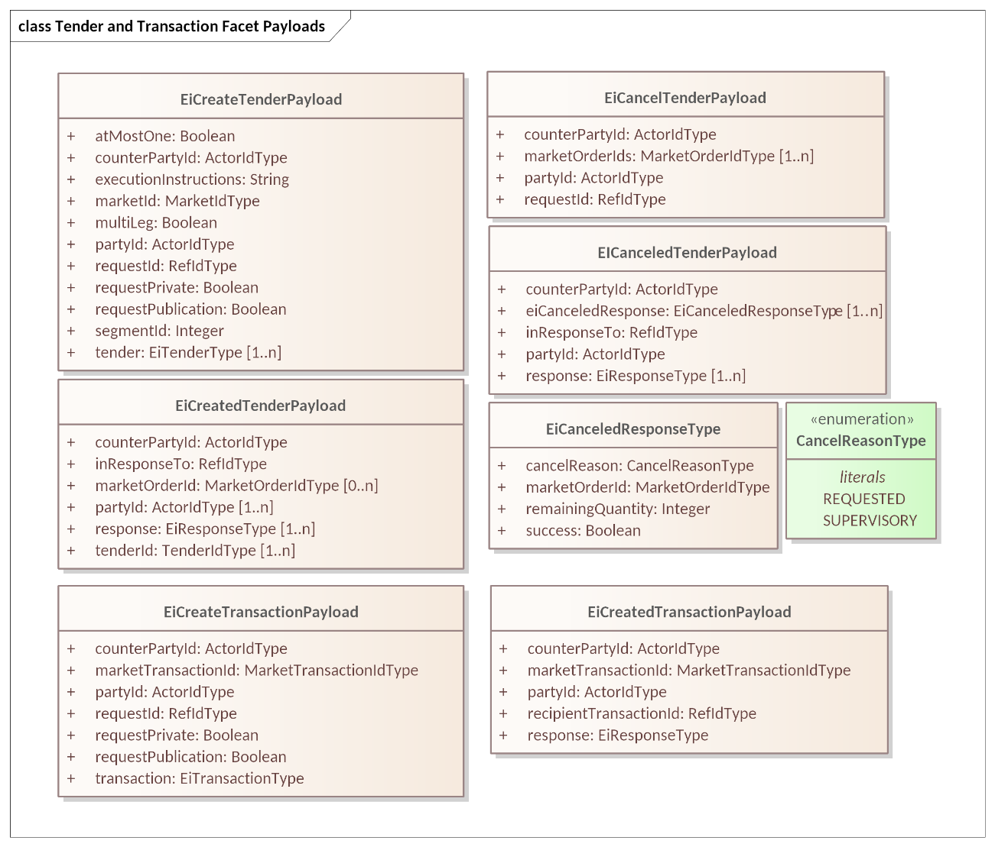

Figure 6‑4: UML Diagram comparing Tender and Transaction Facet Payloads

## Off-Market Transactions

While most transactions originate as Tenders submitted to the Market, which some mechanism inside the Market matches, and result in a Transaction created by the Market, there are use cases for bilateral actions that generate a Transaction that did not come through the market.

For example, two parties within a market may choose to transact directly. A party may opt to buy directly from his neighbor’s solar power. Another market may permit charity, that is, a donation to the Position of a neighbor. In either case, the Market must register the Transaction so that is can maintain each Party’s Position, and so that the Buyer does not get double billed. These transactions may also be referred to as over-the-counter (OTC) agreements.

Off-Market agreements require both parties to report to the Market. The originating Party sends a Tradeable Quote to the Market, including the ID of the counterparty. The simplest means is for one Party to send a targeted Quote (see Section 9, *“The Negotiation Facet”,* below) naming the Counterparty in the Quote. The Counterparty then accepts the Quote by submitting a message referencing the Quote Id and including a Tender matching the Tender in the Quote.

Some Markets will have specific Market Segments for Off-Market Transactions with specific message patterns. An OTC Market is notable for permitting violations of the Lot Size constraint and of the start time and duration constraints of other market segments. For example, in a Market with a Market Segment with a product of Lot Size 20 kWh and a Duration of one hour, an Off-Market execution could register a transaction of 23 kWh delivered over 27 minutes beginning at 2:48.

See Sections 13.1*“*Market Mechanisms”.

# The Position Facet

The Position Facet provides the sum of a Resource transacted for by a Party, positive and negative, for each interval within a possibly larger bounding Interval. Position is typically requested by a settlement agent (See Section 8 The Delivery Facet) or by a Party to get information about its own position.

A Party may buy and sell from several Market Segments, perhaps with different Durations. A Party may also transact with specific counterparties in an Over-The-Counter (OTC) market. All of these are part of the Party’s position.

In most Resource markets, a Party may also take delivery (see Section 8, The Delivery Facet) which is measured by a meter. But what is the Quantity for this “self-executed” Transaction? This amount is calculated by the difference between Position and Delivery and thereby creates Transactions for the used-but-never-bought Resource; the frequency and nature of such actions are out of scope for CTS.

There may be other reasons to track Position. A market rule may require a Party designated as a Market Maker to maintain a Position of a certain quantity. A Party representing a Storage System may have specific rules for Position before a weather event. This specification does not catalog all the uses for Position that a Market or Party may require.

## Introduction

The purpose of the Position Facet is to allow access to the accumulated position for actors supporting specific Roles. A Party’s ***Position*** for a time period is the algebraic sum of committed supply or sales for instruments overlapping that time period. A Party’s position for an Instrument is computed from trades for that Instrument. In CTS, purchasing a Resource increases the Position, and Selling a Resource reduces the Position.

An Actor may, with appropriate authorization, request positions for other parties. This permits the specification and implementation of an auditor Actor. Roles using the Position Facet include:

* The Actor whose position is being requested—the *position Party.*
* An Actor who is authorized to request position information for other actors—including but not limited to an auditor—the *requestor.*

Position Interactions follow the Streams pattern. A request for position includes a bounding interval. The response reports, at least, the Position for each Interval included within the bounded Interval of the Request.

Table 7‑1: Position Facet

| Facet | Request Payload | Response Payload | Notes |
| --- | --- | --- | --- |
| Position | EiRequestPosition | EiReplyPosition | Request an Actor’s Position(s) for a specific time interval and reply with those Position(s) if access is authorized. |

This is the UML sequence diagram for the Position Facet:

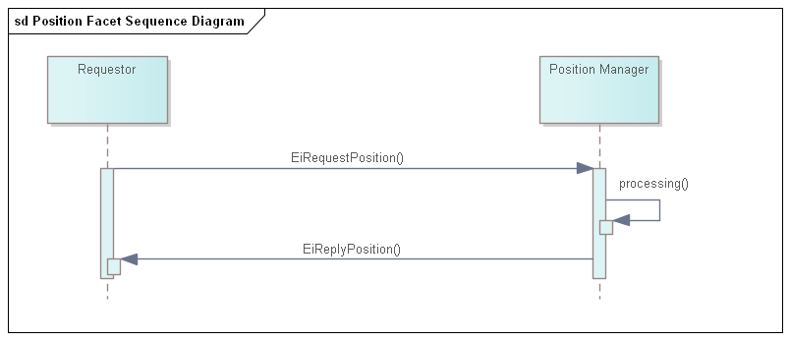

Figure 7‑1: UML Sequence Diagram for the Position Facet

## Information Model for the Position Facet

This Facet applies Section 3.3 *“The Bounding Interval Pattern in CTS”.*

For Position, a bounding interval is specified and the position in each interval contained in the closed bounding interval is returned. A Request for Position specifies a Resource.

When the Position Request is for a Resource, then the Position is assembled from all Transactions for that Resource

A Position is concerned with the total amount under contract, not the prices. If an Actor has positions in more than one Product, say, in a one-hour Product and in a one-minute Product, then the returned Position SHALL use the shorter Duration to denote the total amount.

The attributes are shown in the following section.

## Payloads for the Position Facet

The Reply Position payload contains one or more CTS Streams, with only a Quantity in the Interval Payload. The Position is the sum of Transactions in all Segments.

The [UML] class diagram describes the payloads for the Position facet. The payload attributes are described in the following two tables.

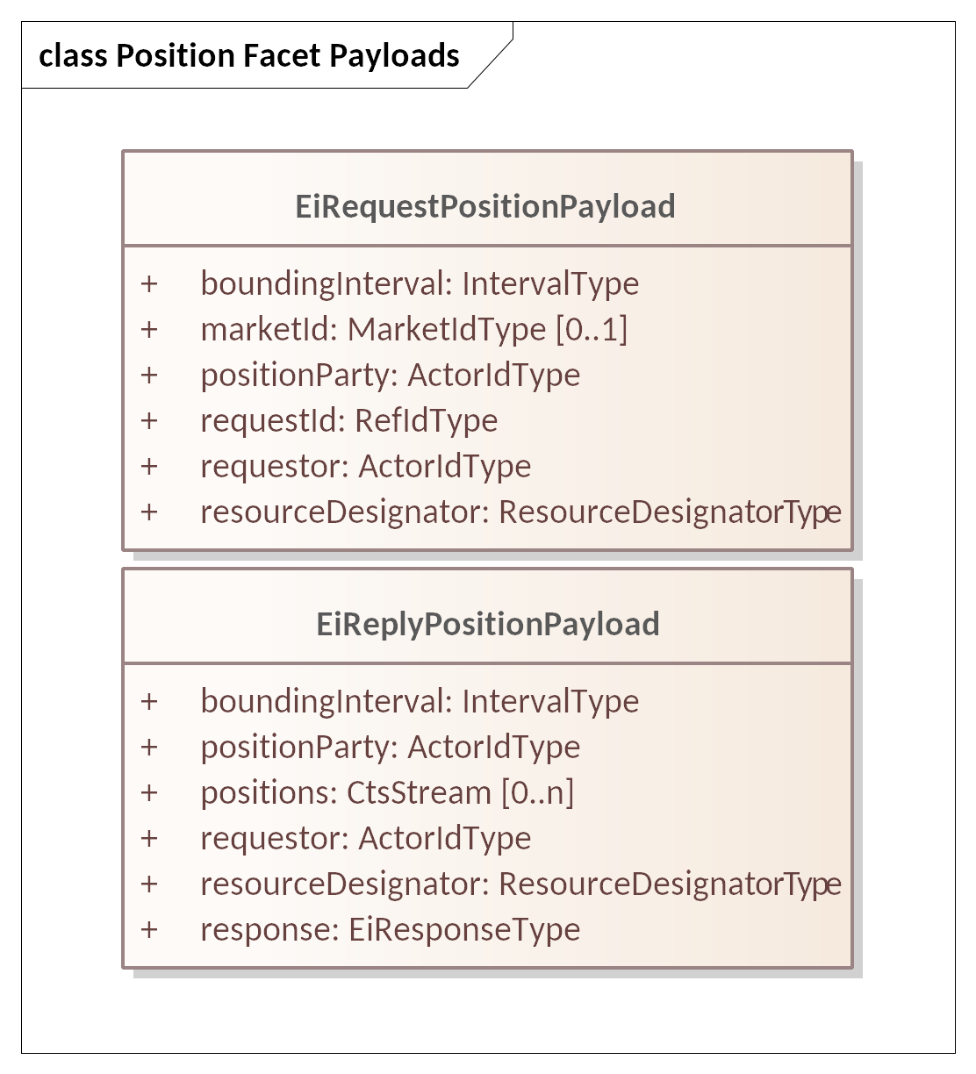

Figure 7‑2: UML Class Diagram of Payloads for the Position Facet

Table 7‑2: Attributes of EiRequestPosition Payload

| Attribute | Attribute Type | FIX Field | Meaning |
| --- | --- | --- | --- |
| Bounding Interval | Interval Type | Not in FIX | The [closed] time interval for which position information is requested. The first Positions Stream Interval starts at or after the start of the Bounding Interval. The last Stream Interval ends at or before the end of the Bounding Interval.  See Section.3.3 “The Bounding Interval Pattern in CTS” |
| Market ID (Optional) | Market ID Type | MarketID(1301) | Identifier of the market of interest. An actor MAY be able to participate in more than one Market See Section 13.  If Market ID is not present, the position reflects purchases and sales in any Segments known to the Position Manager. |
| Position Party | Actor ID Type | PartyID(448) | The Party whose position is being requested.  Allows a request for another Party’s position, with appropriate privacy and security constraints (out of scope). |
| Request ID | Ref ID Type | PosReqID(710) | A reference to this payload. May be used as a correlation ID |
| Requestor | Actor ID Type | PartyID(448) | The Actor requesting the position. A failure indication will be returned if the Requestor is not authorized to access position information for Position Party. |
| Resource Designator | Resource Designator Type | Not in FIX | The Resource for which Position is being requested. Should match the identified Market’s Resource Designator. |

Table 7‑3 Attributes of EiReplyPosition Payload

| Attribute | Attribute Type | FIX Field | Meaning |
| --- | --- | --- | --- |
| Bounding Interval | Interval Type | Not in FIX | The [closed] time interval for which position information is requested. The first Positions Stream Interval starts at or after the start of the Bounding Interval. The last Stream Interval ends at or before the end of the Bounding Interval.  See Section.3.3 “The Bounding Interval Pattern in CTS” |
| Market ID | Market ID Type | MarketID(1301) | Identifier of the market of interest.  An actor MAY be able to participate in more than one Market. See Section 13. |
| Position Party | Actor ID | PartyID(448) | The Party whose position was requested.  Allows a request for another Party’s position, with appropriate privacy and security constraints |
| Positions (Optional) | Cts Stream Type | Related to FIX PositionReport and AdjustedPositionReport messages[17] | Zero (if failed) or one or more CTS Streams containing the positions for Position Party for the requested Resource.[18] Positions are signed and may be zero.  Price is not included in the CtsStream Intervals.  In CTS, purchasing a Resource increases the Position, and Selling a Resource reduces the Position.  Each CtsStream interval that is contained within the Bounding Interval will have a value associated (signed integer).  Note that a CtsStream contains a Resource Designator and a |
| Requestor | Actor ID | PartyID(448) | The Party requesting the position. |
| Resource Designator | Resource Designator Type | Not in FIX | The Resource for which Position is being requested. Should match the identified Market’s Resource Designator.  The Resource Designator is also included in the Positions CTS stream if present. |
| Response | EIResponse Type | Not in FIX | An EiResponse will indicate failure if Requestor is not authorized to access position information for Position Party for any of the requested intervals.  See Section 2.6 Responses. |

The purposes for requesting Position are system-specific and out of scope for this specification. Potential uses include:

* An Actor may request its own position(s) to recover from failure.
* A supplier of last resort may compare Positions to Delivery to impute transactions for unpurchased power delivered. (See Section 8  *The Delivery Facet”).*

# The Delivery Facet

The CTS Delivery Facet can be considered as the meter telemetry facet. We name it “Delivery” to align with the market focus of this specification, that is, a building takes delivery of power, or a distributed energy Resource (DER) delivers power. A CTS Delivery payload contains a CtsStream that conveys the measured or computed flow of a specific Resource through a particular point on the Resource’s delivery network during a specific Interval.

This Facet applies Section 3.3 “The Bounding Interval Pattern in CTS”.

CTS Delivery is typically derived from reading one or more meters, but it may be computed, implied or derived from some other method. Every Transaction is between a Party that promises to buy and a Party that promises to sell. Consider an actor that performs temporal arbitrage, i.e., buys one-hour Products and sells one-minute Products during the same hour. The Actor MAY report that it took delivery in each minute of that Interval, and the sales to other Actors MAY be visible only as reductions as recorded in Delivery.

In most cases, a node that takes delivery of more power or other Resource during an Interval than contracted for must eventually pay for that delivery. For example, An *auditor* (however defined) could sum all positions (See section 7, *The Position* Facet) and compare the result to total Delivery. The Auditor can then impute a transaction for the over-delivery. This may not be a simple “spot price”; if multiple Actors are taking over-delivery, then the last transaction is likely underpriced. Systems that track “actor reputation” may lower the reputation score. These examples explain the potential use of the information delivered by this facet and are not meant to suggest or dictate any particular business process or system model.

A CTS Delivery payload reports on the flow of a Resource and the durations of that report stream may not match the temporal granularity of any particular Product. The payload may (e.g.) include the sum of a one-hour market and of a one-minute market for the same Resource.

A CTS Market MAY assess penalties for Delivery outside certain bounds from the Position—as do many of today’s tariffed markets. Such bounds and penalties are out of scope for CTS. Computation and notification of Penalties is outside of scope.

A Market MAY define a CTS_SPOT market mechanism segment, which generates imputed transactions to reconcile delivery and position. This reconciliation requires publication of prices for buying and selling to reconcile position and delivery. See Section 13.2.

A request for delivery specifies a Resource, unit of measure, bounding interval (Section 3.3), and a temporal granularity [Duration]. While the unit of measure and temporal granularity need to be within the capabilities of the telemetry node, they need not match any particular Product.

## Interaction Pattern for the Delivery Facet

Table 8‑1: Delivery Facet

| Facet | Request Payload | Response Payload | Notes |
| --- | --- | --- | --- |
| Delivery | EiRequestDelivery | EiReplyDelivery | Request Delivery through a specific Measurement Point |

Figure 8‑1 is the UML sequence diagram for the Delivery Facet.

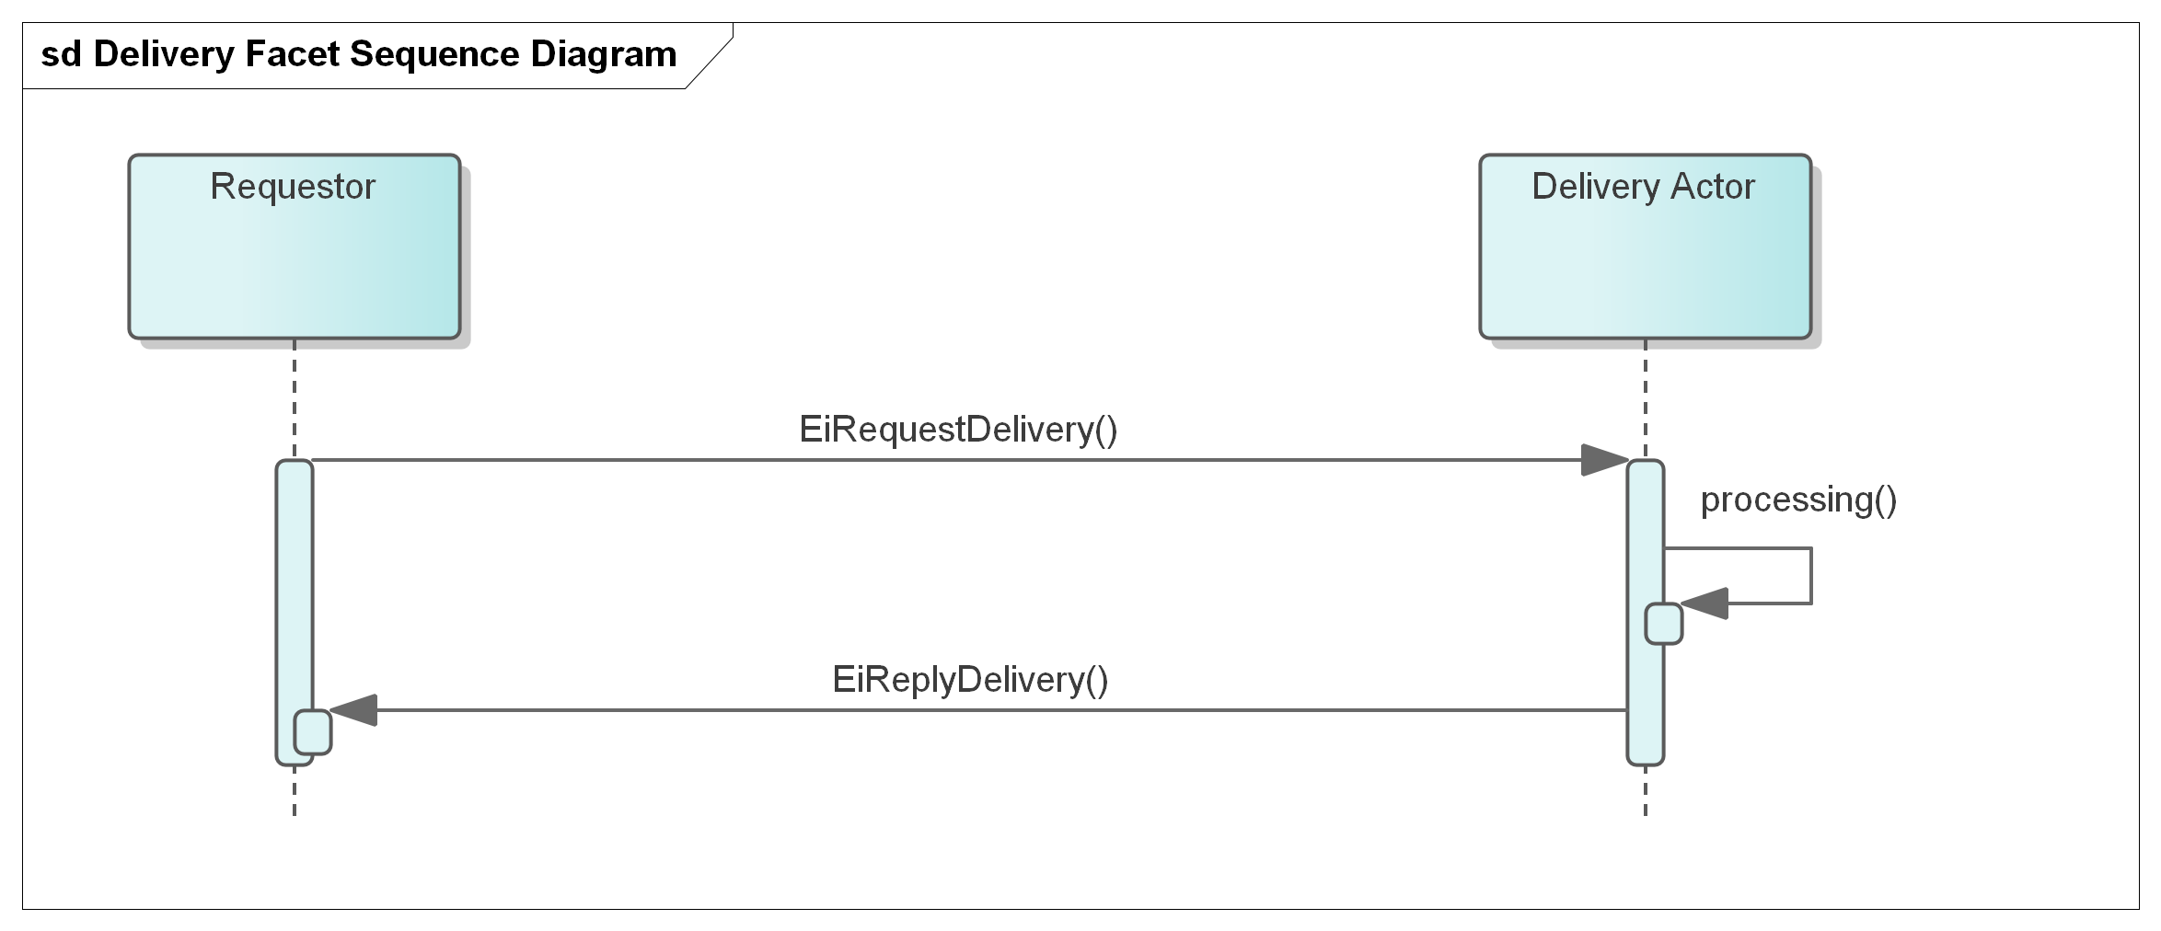

Figure 8‑1: UML Sequence Diagram for the Delivery Facet

## Information Model for the Delivery Facet

A Delivery response returns a single CtsStream of intervals of the requested Duration, with a quantity in each.

As with the Position Facet a bounding interval is specified and the delivery in each interval contained in the closed bounding interval is returned. The temporal granularity as requested may not be available, or the Delivery Actor may convert and combine—for example a request for one hour delivery intervals could be responded to using information from 1 minute or 5-minute measurement cycles.

The attributes are shown in the following section.

## Payloads for the Delivery Facet

The **[UML]** class diagram describes the payloads for the Delivery facet. The attributes follow in Table 8‑2 and Table 8‑3.

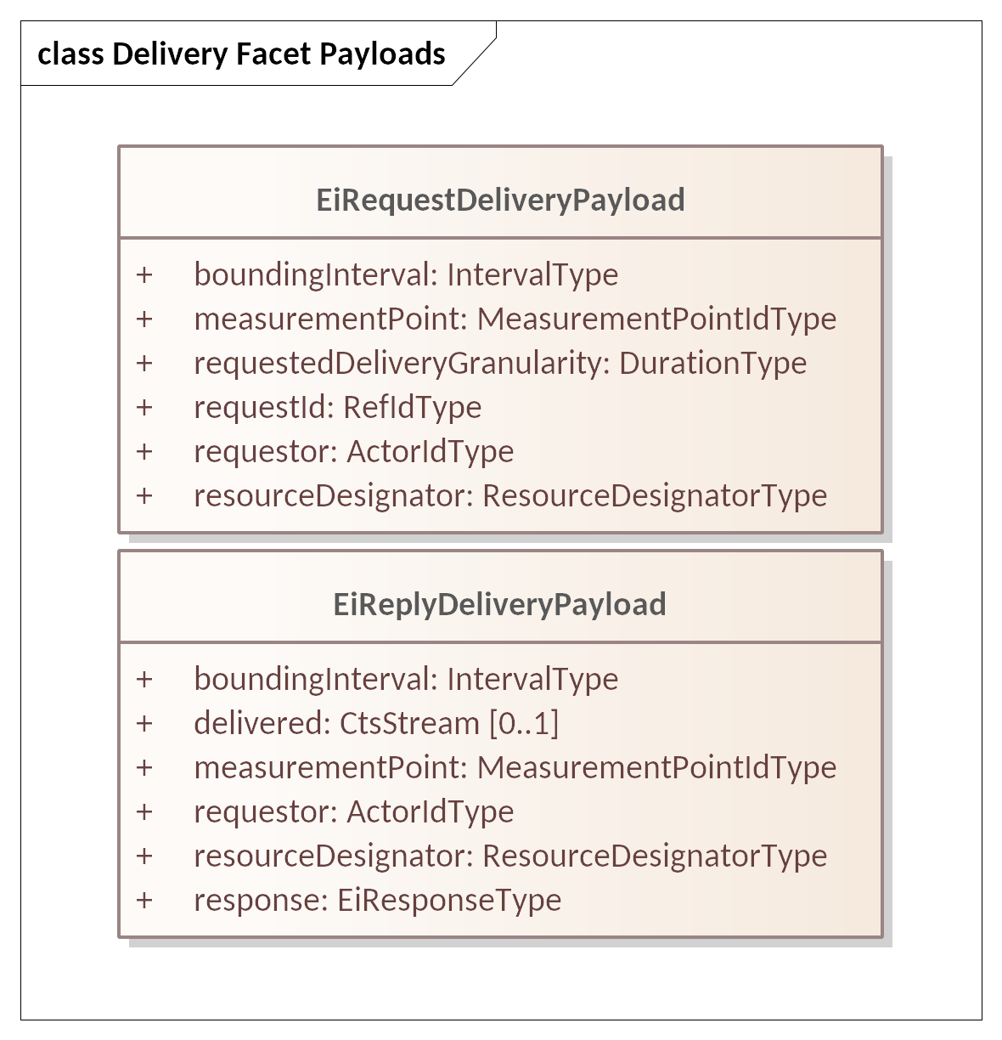

Figure 8‑2: UML Class Diagram of Payloads for the Delivery Facet

Table 8‑2: Attributes of EiRequestDelivery Payload

| Attribute | Type | FIX Field | Meaning | Notes |
| --- | --- | --- | --- | --- |
| Bounding Interval | Interval Type | Not in FIX | The closed time interval for which delivery information is requested.  The first Delivery Stream Interval starts at or after the start of the Bounding Interval. The last Stream Interval ends at or before the end of the Bounding Interval. | See Section.3.3 “The Bounding Interval Pattern in CTS” |
| Measurement Point | Measurement Point ID Type | Not in FIX | An identification of the Point where the flow of the Resource is measured. | Information should be secure in conformance with appropriate privacy and security constraints.  See Section 2.7 Identities  Note that correlation of physical measurement locations and Party identification is out of scope. |
| Requested Delivery Granularity | Duration Type | Not in FIX | The granularity requested for delivery information | Requested temporal granularity for the response.  Response granularity is in the header of the returned CTS stream if present. |
| Request ID | Ref ID Type | Not in FIX | A reference to this payload | May be used as a correlation ID |
| Requestor | Actor ID | PartyID (448) | The Party requesting the delivery information. | Requestor must be authorized to access delivery information for this point. |
| Resource Designator | Resource Designator Type | Not in FIX | The Resource delivered | The Resource for which Position is being requested. Should match the identified Market’s Resource Designator. |

Table 8‑3 Attributes of EiReplyDelivery Payload

| Attribute | Type | FIX Field | Meaning | Notes |
| --- | --- | --- | --- | --- |
| Bounding Interval | Interval Type | Not in FIX | The closed time interval for which delivery information was requested.  The first Delivery Stream Interval starts at or after the start of the Bounding Interval. The last Stream Interval ends at or before the end of the Bounding Interval. | See Section.3.3 “The Bounding Interval Pattern in CTS” |
| Delivered (Optional) | Cts Stream | Not in FIX | An optional CtsStream containing the Quantity delivered in each Interval. | Zero (if failed) or one or more CTS Streams containing the positions for Measurement Point for the requested Resource.[19] Deliver yquantities are signed and may be zero.  Price should not be present in the stream intervals.  Response granularity is in the header of the optional returned CTS stream. |
| Measurement Point | Measurement Point ID Type | Not in FIX | An identification of the Point where the flow of the Resource is measured. | Information should be secure in conformance with appropriate privacy and security constraints.  See Section 2.7 Identities |
| Requestor | Actor ID |  | The Party requesting the position. | Requestor must be authorized to access delivery information for this point. May be Party, auditor or other. |
| Resource Designator | Resource Designator Type | Not in FIX | The Resource delivered | The Resource for which Position is being requested. Should match the identified Market’s Resource Designator.  The Resource Designator is also included in the Delivered CTS stream if present. |
| Response | EiResponse Type |  | An EiResponse. Will indicate failure if Requestor is not authorized to access information, | If the Requested Delivery Granularity cannot be used, the Response MAY indicate what granularit(ies) can be used.  See Section 2.6 Responses. |

# The Negotiation Facet

So far, this specification has described an order book market of simple Tender, Transaction and Delivery. This section discusses more advanced interactions. A Segment-based matching engine, however defined, matches Tenders to Buy and Tenders to Sell and creates Transactions.

With this Section, we introduce the messages used in Segments wherein the Buyer and the Seller jointly create matching Tenders. Negotiations rely on what FIX terms Pre-Trade Information. This section describes how Parties come to an agreement to create a Transaction through direct communication. The Parties conduct this conversation using requests for quotes, quotes, and quote responses. The Market facilitates the quote process but does not intervene—it acts as a neutral party.

In essence, a Quote contains a Tender. The message accepting the Quote contains a matching Transaction and MUST reference the accepted Quote. The Parties must inform the Segment of the agreement, and the Segment processes the logical Transaction memorializing that agreement. The Market may still reject the agreement because of credit limits, or because a third Party has already lifted the quote (in case of public quotes), or because the Transaction would exceed operating limits of the system, or for some other reason.

The messages and interactions are determined by the mechanism used in the market Segment. See Section 13 for a discussion of Market Mechanisms and how to select a Segment to trade in. Note: not all Markets must support all Market Mechanisms.

Requests for Quotes and Indicative Quotes (see below for definitions) may be public and if they are, they appear in a Quotes Ticker.

Financial markets assume that the same party, called the Quote Issuer, initiates all quotes in a specific negotiation. The recipient of a quote can accept the quote, if it is tradeable and the terms are agreeable, or reject the quote, i.e., end the negotiation. When a Party accepts (“hits” or “lifts”) a tradeable quote, the Market executes the Transaction—the issuer of the quote cannot back out. A recipient MAY abandon the negotiation, choosing to initiate a new negotiation with a new Quote.

CTS negotiations differ from financial practice in that in financial negotiations, the instrument never changes. Over the course of a CTS negotiation, the time of delivery may change, which is a change of Instrument.

Negotiation may be used to enable large buyers to plan significant Resource use over time, for example, scheduling a long running industrial process which may also require off-market mechanisms such as labor planning. Such a buyer could submit multiple Requests for Quotes with different schedules, and then select from among the Quotes received in response.

This specification does not require that a Market include any of the scenarios described above. We include them to illustrate how the essential components of Negotiation might fit together in a specific market.

## Negotiation Vocabulary

Negotiations use information elements defined above in TenderBase (5.3), also used in Tenders and Transactions. Note that the term Quote by itself includes both indicative and tradeable Quotes.

Table 9‑1: Negotiation Terminology

| Term | Purpose | Comment |
| --- | --- | --- |
| Request for Quote (RFQ) | A Party submits a Request for Quote to try to find a market in an Instrument or Instruments.  A Request for a Quote may be for a time range of Instruments. | May be used pre-opening to elicit tenders, both buy and sell, to determine market opening prices. |
| Quote | Indicates the price and quantity at which an instrument can be bought or sold. A Quote may be issued in response to an RFQ or it may initiate a negotiation. | The CTS Quote may be either a Bid Quote (buy side) or an Ask Quote (sell side).  The initiator may choose to advertise any Quote to attract potential counterparties by requesting Publication*.* |
| Indicative Quote | A Quote that cannot be used to create a commitment leading to a Transaction. | As part of a Negotiation, a Party may submit a counter Quote to ask for a better Quote. Indicative quote(s) may also be issued in response to an RFQ.  Also described as *not tradeable* and represented by Tradeable = False. |
| Interval Quote | A Quote provided for only a Specific Interval. | Some Segments MAY limit negotiations to Intervals (in TenderBase) only by disallowing Streams. See Section 13.5, “Segment Reference Data” |
| Stream Quote | Prices and Quantities for a Product in a series of consecutive Instruments submitted as a single Quote. | In energy markets, a stream quote is often referred to as a “Load Curve.” |
| Tradeable Quote | An offer to buy or sell up to a specific quantity of an Instrument for a specific price. | A Tradeable Quote is registered by the Segment and can be referenced (“lifted”) to initiate a Trade as if it were a Tender. |
| Quote Response | A response to a an RFQ or Quote, The response may accept the Quote, or counter with another Quote or announce an end to a Negotiation. | Only a Tradeable Quote can be accepted to create a Transaction. |
| Private Quote Private RFQ | A quote or RFQ sent only to selected Counterparties during a Negotiation. | An implementation may use the Segment to distribute Quotes to Counterparties or it may expect Parties to message Counterparties directly. |
| Public Quote  Public RFQ | A Quote or RFQ published to all subscribers to a Segment’s Quotes Ticker. (See Section 11.5.2) | RFQs, Indicative Quotes, and Tradeable Quotes may be Published. |
| Issuer | The Issuer is the Party that originates a Quote, whether in response to an RFQ, or unsolicited. | The Issuer must accept a Transaction created in response to a Tradeable Quote in case of a positive Quote Response. |

## Narrative on Negotiation (non-normative)

An extended discussion of use cases and negotiation in markets is in Appendix B.

The Negotiation process is inherently flexible. A Transaction may come after many rounds of negotiation, or directly from a response to the first tradeable quote. This section describes some potential interactions to clarify the concepts before defining message types in the following sections.

A Party that wants to transact some quantity of a Resource may start a Negotiation by sending a Request for Quotation (RFQ) or an indicative Quote; a Tender simplifies the interaction

Message semantics and sequencing are in this section in the relevant diagrams and tables.

This Facet applies Section 3.3 “The Bounding Interval Pattern in CTS”.

An RFQ uses an optional Bounding Interval to focus on what an acceptable response might be. The possible situations are.

(1) A Bounding Interval is included.[20]. This indicates that a Stream Quote that matches the Bounding Interval is likely to be acceptable. The responder has the option rejecting the quote and starting a new negotiation by submitting a counter-quote, that is, initiating a new Quote/Response interaction, perhaps with a different Bounding Interval proposing a different Interval l[21].

(2) A Bounding Interval is not included in the Quote or RFQ—any response must match the included interval or stream.[22]

RFQs and Quotes may be addressed directly to one or more potential counterparties or published to the entire Segment by means of a Ticker. The Market does not need to know about or register the RFQ or Indicative Quote because it cannot lead directly to a trade or Transaction. The recipient may issue a Quote Response to counter or reject the Quote. The recipient may also drop the Negotiation and start a new one by issuing a Quote or RFQ. See Section 13.1 “Market *Mechanisms*”, as well as Appendix B for a discussion of interaction patterns in different markets.

When the Party that has received a Tradeable Quote decides that there is an essential meeting of requirements, a recipient accepts (“lifts”) the Quote; in CTS, the recipient must inform the Market to create the Transaction using an EiAcceptQuote payload which in turn generates an EiAcceptQuote payload to each party.

Note that if multiple actors accept a quote, market serialization determines which accept is processed first.

Negotiations may include Interval Quotes or Stream Quotes, a pattern that matches that of Tenders (See Section 5.3.1, *“Interval Tenders and Stream Tenders.”*) The stream in an RFQ need not fill the Bounding Interval; an overnight bounding interval of fifteen hours may be seeking any proposed three-hour stream during that interval.

## Messages for the Negotiation Facet

A Request for Quotes (RFQ) is a message describing what is to be quoted, and may be sent to a Segment or to one or more intended counterparties.

A Quote is either unsolicited or in response to an RFQ. A recipient (CounterParty) of a Tradeable Quote may respond with a Quote response to accept it.

Table 9‑2 Messages for the Negotiation Facet

| Request Payload | Response Payload | Notes |
| --- | --- | --- |
| EiCreateRfq | EiCreatedRfq | Create and send an RFQ. The RFQ is directed to intended Partys or published to the Segment.  The sender of EiCreateRfq may request Publication , but has no guarantee that Publication occurs. |
| EiCancelRfq | EiCanceledRfq | Indicates that the RFQ Issuer no longer wishes to receive Quotes. |
| EiCreateQuote | EiCreatedQuote | Create and send a Quote. If the Quote is to be published, the Counterparty is the ID of the Market. Otherwise, it goes to the intended Counterparty.  The sender of EiCreateQuote may request publication, but has no guarantee that the Market publishes the Quote. |
| EiAcceptQuote | EiAcceptedQuote | EiAcceptQuote is a specialization of EiCreateTransaction. EiAcceptedQuote is a specialization of EiCreatedTransaction. Errors may be returned in an EiResponseType in EiAcceptedQuote as well as in the superclass EiCreatedTransactionPayload.  As with EiCreatedTransaction, the EiAcceptedQuote payload must be sent to Party and CounterParty.  See note on Market Transaction ID in Section 9.6.2.2. |
| EiCancelQuote | EiCanceledQuote | Cancel a Quote. This may be rejected if the Quote was tradeable and had already been lifted by the Counterparty. |
| EiRejectQuote | EiRejectedQuote | Recipient explicitly rejects referenced Quote. |

## Interaction Pattern for the Negotiation Facet

These are the UML sequence diagrams for the Negotiation Facet. Different Market Mechanism Types ([MMT]) may have shortened Interaction patterns. Due to the complexity of the Quote diagram, we show the RFQ and Quote aspects in separate diagrams.

We have not shown the full Market-mediated interaction pattern in which the Market initially passes messages through but needs to take action when agreement has been reached, by sending an EiAcceptQuote to both parties. See Section 9.4.3.

Where the Market mediates the interactions, in general the payloads are passed on. One exception is where the Market might add (e.g.) a Market Order ID to a payload. Other possible actions include posting a ticker payload.

### Interaction Patterns for RFQ and Quote

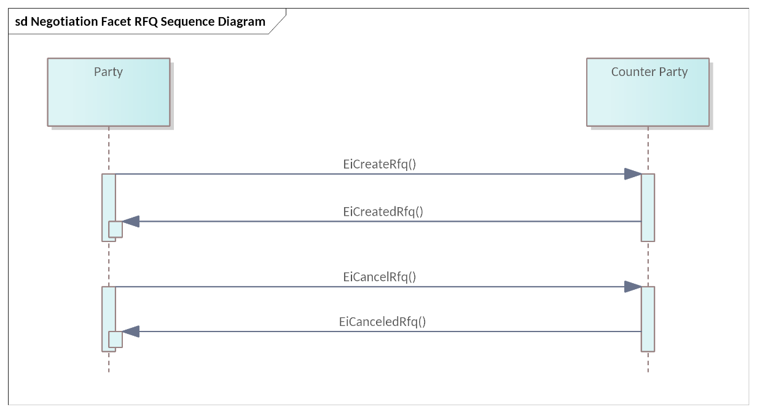

Figure 9‑1 UML Sequence Diagram for Negotiation Facet RFQ (Request for Quote)

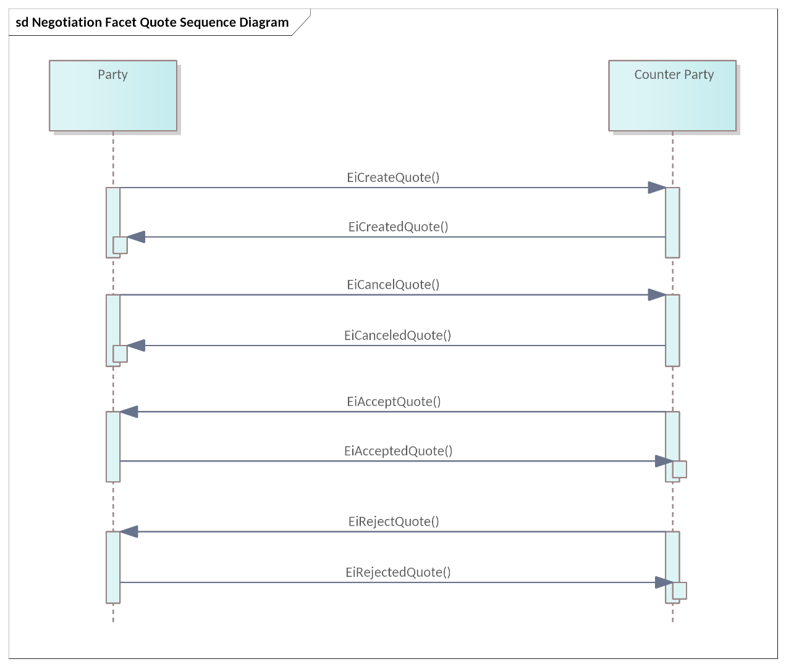

Figure 9‑2 UML Sequence Diagram for Negotiation Facet Quote

### Creating Transactions from Quotes

A Party receiving a Tradeable Quote MAY respond by submitting an AcceptQuote that references that Quote. The Market registers a Tradeable Quote it receives AS IF it were a Tender,[23] and retains this information at least until it expires or is cancelled.

EiAcceptQuotePayload is a subclass[24] of an EiCreateTenderPayload that references the ID of the Tradeable Quote being accepted; see Section 6.4 for attributes. Figure 9‑10 shows this relationship.

### Interaction Pattern for Market-Facilitated Negotiation

Certain Quotes and RFQs may have attributes which require Market Segment knowledge. These include Private Quotes, Published Quotes, and Tradeable Quotes

As a partial example of this agency of a Market or Segment see Figure 9‑3 “Market Mediated Quote and Responses Sequence Diagram”. Similar interaction patterns take place for other market-mediated interactions, e.g., for Tradeable Quotes.

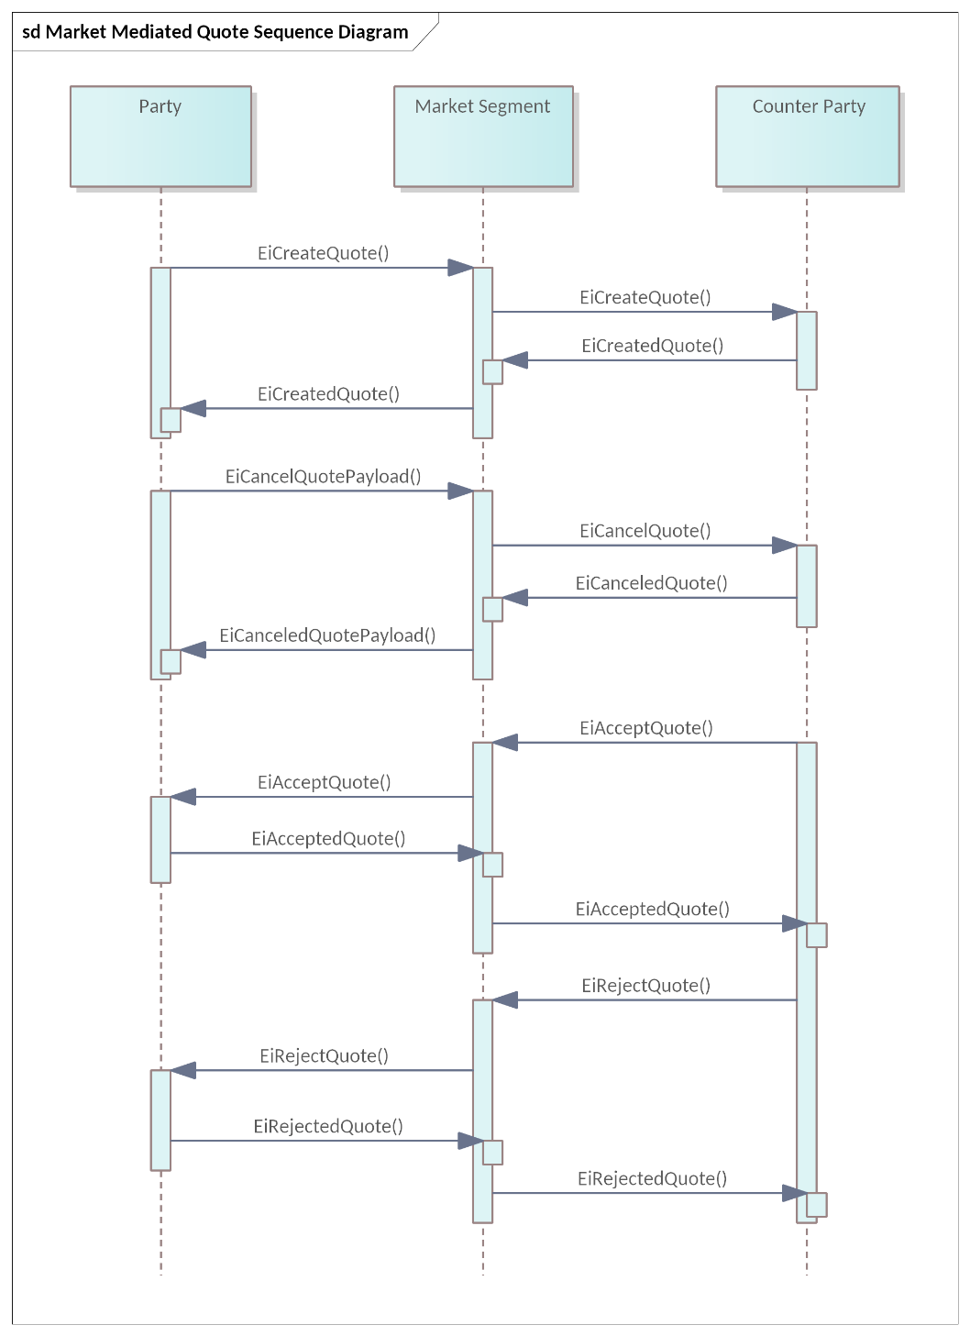

Figure 9‑3 Market Mediated Quote and Responses Sequence Diagram

### Interaction Patterns Restricted by Market Mechanism

Certain Market Mechanisms (See Section 13.1 *”Market Mechanisms”)* restrict possible responses to an EiCreateQuote payload.

#### Quote-Driven Markets

Quote-Driven markets are typified by one or more dominant players who provide Quotes and Parties can lift some or all of each Quote. In a Quote-Driven Market Mechanism (MMT_QUOTE_DRIVEN) after receiving and responding to an EiCreateQuote the allowable responses after EiAcceptQuote are shown in the Sequence Diagram in Figure 9‑4.

Figure 9‑4 Quote-Driven Market (MMT_QUOTE_DRIVEN) Responses to EiCreateQuote.

#### Request for Quotations Market

In a Request for Quotations Market (RQ) (MMT_RFQ) after receiving an EiCreateQuote and responding with EiCreatedQuote, the allowable responses are below and include EiCreateRfq as shown in the Sequence Diagram in Figure 9‑5 “Request for Quotations Market (RQ) MMT_RFQ Responses to EiCreateQuote”.

* EIAcceptQuote
* EiRejectQuote

The following messages start a new negotiation and are not show in the figure:

* EiCreateQuote
* EiCreateRfq

Note that either EiCreateQuote or EiCreateRFQ initiates a new negotiation. A failure response stops the negotiation in progress.

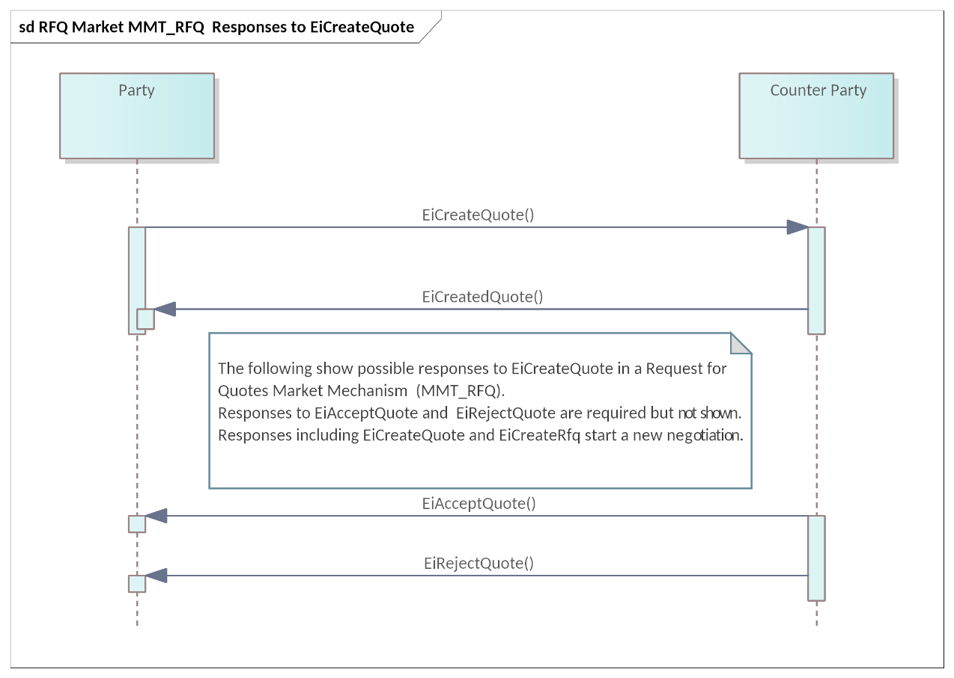

Figure 9‑5 Request for Quotations Market (RQ) MMT_RFQ Responses to EiCreateQuote are EiAcceptQuote and EiRejectQuote

## Information Model for the Negotiation Facet

The RFQ can be considered as preliminary to a Quote, and so has more optionality.

### A Note on MultiLeg Stream Quotes ,Tenders, and RFQs

Some Segments may permit or require Stream Quotes, Tenders, or RFQs— a single Quote for multiple consecutive Instruments—indicated by Stream Trading OK set to True in the Segment Reference Data.

A Stream Quote, Tender, or RFQ is MultiLeg if the MultiLeg flag in Tender Stream Detail is set. For example a Party that wishes to lift a Stream Quote must lift ALL of the Stream Quote if that flag is set. In Power markets, Stream Quotes, Tenders, and RFQ are used to buy or to sell load curves, that is, Power in each Interval over a longer time.[25]. See Section 13.1 *“Market Mechanisms”* and Appendix B for discussions of Market Mechanisms.

There is a subtle distinction between MultiLeg in the stream and MultLeg in the Create payload for Tenders, Quotes, and RFQs. The Create MultiLeg applies to the *bag of tenders* in the payload—all must be accepted or none.

### The Request for Quotation

The RFQ can be considered as preliminary to a Quote, and so has more optionality. An RFQ could solicit a quote for 15 minutes of power sometime in an 8-hour window. It could be precise, as in a request for a specific amount of power for a specific duration at a specific time.

The UML Class Diagram for the EiRfqType is shown in Figure 9‑6.

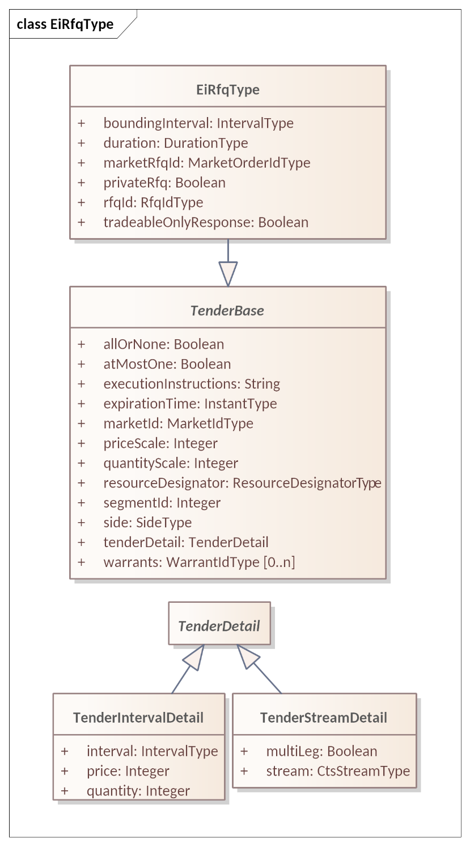

Figure 9‑6 UML Class Diagram for EiRfqType

Attributes of EiRfqType are shown in Table 9‑3. Attributes inherited from TenderBase are defined in Table 5‑3.

For example, consider a Party requesting a Quote for three hours of Power this evening between 4 PM and midnight. The RFQ would have a Bounding Interval 4 PM to 12M and a Duration of 3 hours of the amounts specified in the TenderBase. If the TenderBase references a Segment of 0, the Request goes to all Segments.

Table 9‑3 Attributes of EiRfqType

| Attribute | Type | FIX Field | Meaning | Notes |
| --- | --- | --- | --- | --- |
| Bounding Interval | Interval Type | Not in FIX | The [closed] time interval for which information is requested. | A Quote outside the Interval is permitted. In the example above, this is the “4pm to Midnight”. See Section 3.3 “The Bounding Interval Pattern in CTS” |
| Duration | Duration Type | Not in FIX | The desired duration in the responding responsive Quote. | This is the “3 hours” in the example above. Zero means not specified. |
| Market RFQ ID | Market Order Id Type | Not in FIX | ID assigned by the Segment or Market. | Used in acknowledgment and in all future market messages In FIX the Market does not issue its own IDs when it merely supports the negotiation between the parties with its infrastructure.  In contrast, CTS requires a Market-assigned ID, which requires the Market to create and attach those IDs. |
| Private RFQ | Boolean | PrivateQuote ( 1171) | The RFQ is specific to a single Party. |  |
| RFQ ID | RFQ ID Type | QuoteReqID(131) | ID assigned by originating Party. |  |
| Tradeable -Only Response | Boolean | QuoteType(537) | Indicates whether the initiator wants only Tradeable Quotes in response. |  |
| *Attributes for TenderBase are defined in* Table 5‑3 *Tender Base Attributes* | | | | |

### Quotes

As described in Section 5.3 *“Information Model for the Tender Facet”* and in this Section, EiRfq and EiQuote are subclasses of and inherit from abstract class TenderBase. In Table 9‑4, only the first five attributes are part of EiQuoteType; the rest are inherited as shown.

Figure 9‑7 is a UML Class Diagram of EiQuoteType showing inherited and included attributes.

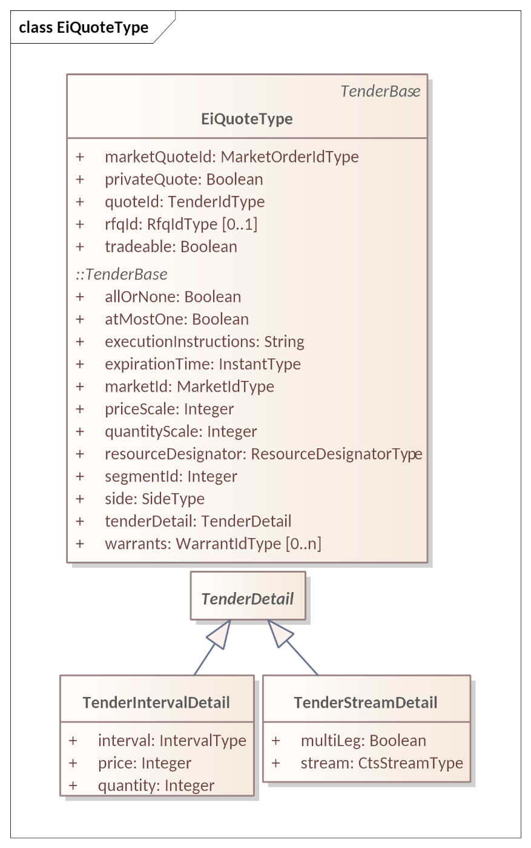

Figure 9‑7 UML Class Diagram of EiQuoteType showing inherited attributes.

Table 9‑4 Attributes of EiQuoteType

| Attribute | Type | FIX Field | Meaning | Notes |
| --- | --- | --- | --- | --- |
| Market Quote ID | Market Order ID Type | Secondary QuoteID(1751); OrderID(37) | ID assigned by the Segment or Market. | Used in acknowledgment and in all future market messages.  CTS overloads Market Order ID Type for Market-assigned Quote and RFQ and Tender IDs. |
| Private Quote | Boolean | Private Quote (1171) | Quote is available specified counterparty only. | Quote is not available to the Segment. Only the stated counterparty may lift this quote.  Implies Publication Request = False. |
| Quote ID | Tender ID Type | QuoteID(117) | ID as submitted by Quote originator/issuer | Used in off-market negotiation |
| RFQ ID (Optional) | RFQ ID Type | QuoteReqID (131) is related | Market-assigned ID of the RFQ to which this quote responds | Referenced by a Quote responding to RFQ. Optional.  In EiRfqType both a requester and market-assigned IDs are present. |
| Tradeable | Boolean | QuoteType (537) | Indicates whether the Quote is tradeable or not | If true, the quote is tradeable. If false the quote is not tradeable, which is by definition an Indicative Quote, consistent with FIX terminology. |
| *Attributes for TenderBase are defined in* Table 5‑3 *Tender Base Attributes* | | | | |

The Quote, RFQ, and Tender share common information using TenderBase. See Figure 5‑2 *“UML Class Diagram Showing Commonality between Tender, Quote, and RFQ”.*

## Messages for the Negotiation Facet

### RFQ Messages

The UML Class Diagram for the RFQ payloads is shown in Figure 9‑8 below.

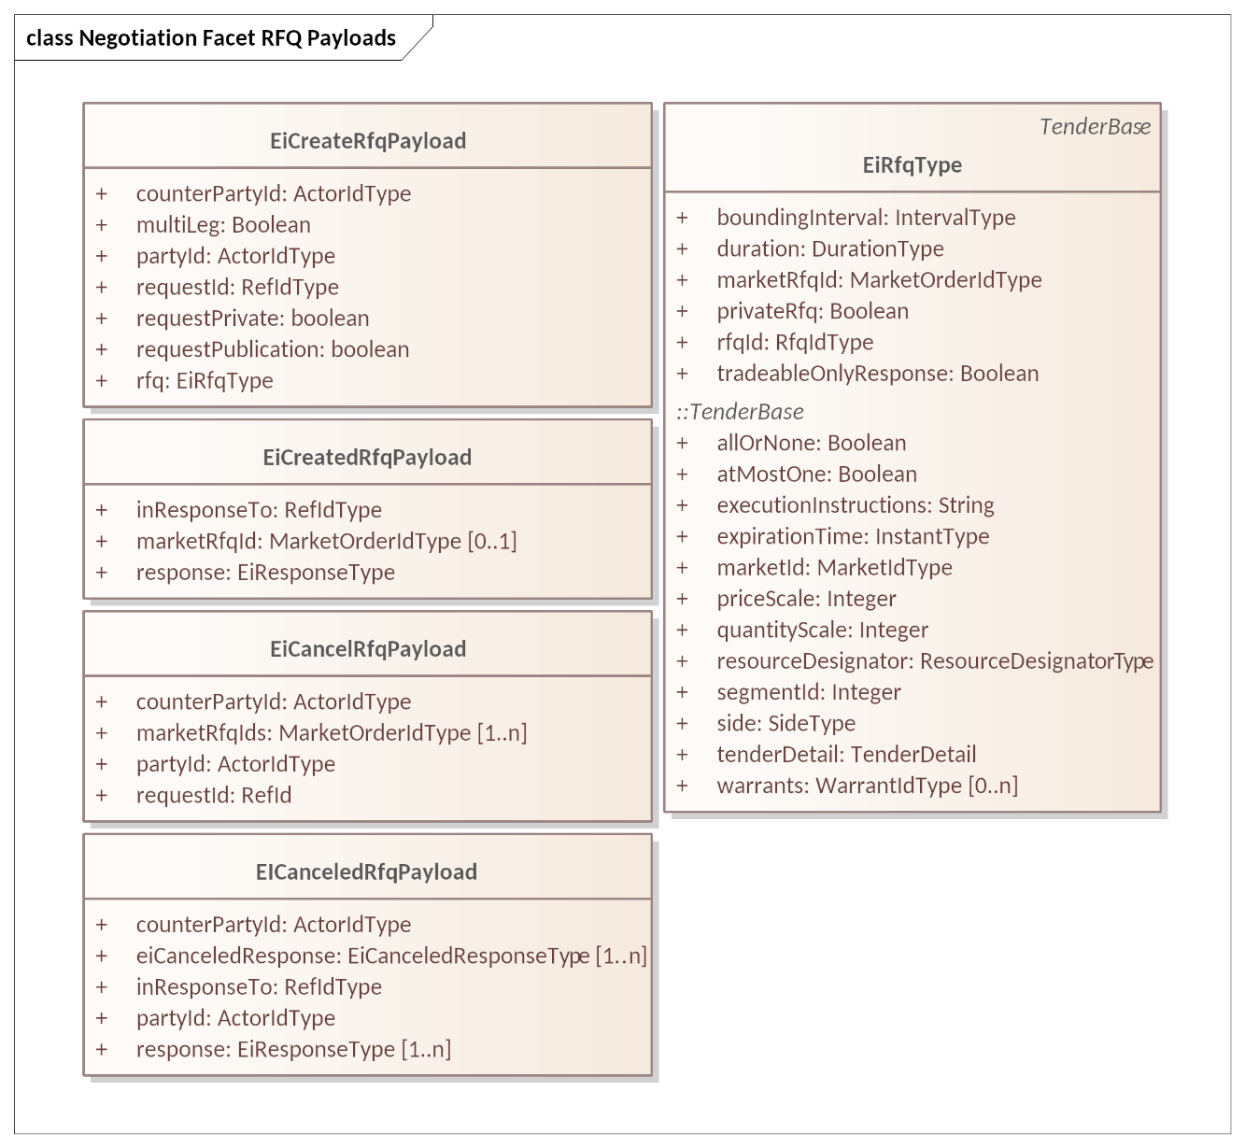

Figure 9‑8 UML Class Diagram Showing Negotiation Facet RFQ Payloads

The attributes of the EiCreateRFQ payload is in Table 9‑5.

Table 9‑5: EiCreateRFQ Payload Attributes

| Attribute | Type | FIX Field | Meaning | Notes |
| --- | --- | --- | --- | --- |
| Counter Party ID | Actor ID Type | PartyID (448) | The Party IDs for the CounterParties for which the RFQ is created. | In CTS, generally the Party ID for the Market. To indicate a bilateral exchange, i.e., a Tender between two specific parties, the Party ID of a specific counter-party is used. |
| MultiLeg | Boolean | See FIX message NewOrderMultileg[26] | Each of the enclosed Quotes must be accepted or none of them are. | See Section 5.3.2 Execution Instructions. |
| Party ID | Actor ID Type | PartyID (448) | The Actor ID for the Party requesting the Quote. | Indicates which Actor proposes the buy or sell side. |
| Request ID | RefIDType | Not in FIX | Reference to this message payload |  |
| Request Private | Boolean | PrivateQuote (1171) | The sender requests that RFQ to be Private only to specified Counter Party. | FIX has Public as an antonym of Private; due to privacy related market rules, CTS separates the concepts and clarifies that it is a request. |
| Request Publication | Boolean | PreTradeAnonymity(1091) (inverted) | Publication of the RFQ is requested. | The sender of an EiCreateRfq Payload requests publication on the Quotes Ticker if available.  This is a request and may not take place.  See also Request Private. |
| RFQ | EiRfqType |  | The RFQ transmitted. | An RFQ may use a Stream to indicate what sort of Stream Quote it is looking for or even multiple Streams to indicate an interest in transactions over time.  Fields of EIRfqType are shown in Figure 9‑6 and Table 9‑3 |

The attributes for ECreatedRfq Payload are in Table 9‑6.

Table 9‑6 EiCreatedRFQ Payload Attributes

| Attribute | Type | FIX Field | Meaning | Notes |
| --- | --- | --- | --- | --- |
| In Response To | Ref ID Type | RFQReqID(644) | An identifier for the Create Quote payload to which this is a response |  |
| Market RFQ ID (Optional) | Market Order ID Type | OrderID (37); RFQReqID(644) | ID for this RFQ assigned by the Segment or Market. Not present if Create failed—see Response | Used in acknowledgement and in future market messages.  CTS overloads OrderID(17) to express Market Quote, Tender, and RFQ IDs. |
| Response | EiResponse Type | QuoteAckStatus(1865)  QuoteReject Reason(300) | Specific error responses | See Section 2.6 Responses. |

The attributes for EiCancelRfq and EiCanceledRfq are in Table 9‑7 and Table 9‑8 below.

Table 9‑7 EiCancelRfq Payload Attributes

| Attribute | Type | FIX Field | Meaning | Notes |
| --- | --- | --- | --- | --- |
| Counter Party ID | Actor ID | PartyID (448) | The Actor ID for the Counterparty for which the Tender is created. | Unlike Tenders, Negotiations are typically directed to a specific Party. If the Quote or RFQ is published, the Counterparty is the Segment’s Party ID. |
| Market RFQ IDs | Market Order Id Type | OrderID (37); RFQReqID(644) | One or more IDs assigned by the Segment or Market for the Request for Quote | Market Assigned in parallel with Tenders.  One or more Market RFQ [Order] IDs to request cancelation.  CTS overloads OrderID(17) to express Market Quote, Tender, and RFQ IDs. |
| Party ID | Actor ID | PartyID (448) | The Actor ID for the Party on whose behalf this RFQ is made. | Indicates which Actor proposed the buy or sell side RFQ. |
| Request ID | RefIDType | Not in FIX | Reference to this message payload |  |

Table 9‑8 EiCanceledRfq Payload Attributes

| Attribute | Type | FIX Field | Meaning | Notes |
| --- | --- | --- | --- | --- |
| Counter Party ID | Actor ID | PartyID (448) | The Actor ID for the Counterparty for which the Tender is created. | Unlike Tenders, Negotiations are typically directed to a specific Party.  If the Quote or RFQ is published, the Counterparty is the Segment’s Party ID. |
| EiCanceled Response | EiCanceled Response Type | Not in FIX | Detailed response for each Market RFQ ID (Market Order ID) for which cancelation was requested in the EiCancelRfq Payload | One or more in parallel with RFQ(s) requested to be canceled. |
| In Response To | RefIdType |  | An identifier for the EiCancelRfq Payload to which this is a response |  |
| Party ID | Actor ID | PartyID (448) | The Actor ID for the Party on whose behalf the original Create RFQ was made. | Indicates which Actor proposes the RFQ being canceled |
| Response | EiResponse Type | CxlRejReason(102) | Specific error responses | See Section 2.6 Responses.  One or more in parallel with RFQ(s) requested to be canceled. |

### Quote Messages

The UML Class Diagram for the Quote payloads is shown below. Attributes are in tables starting with Table 9‑9.

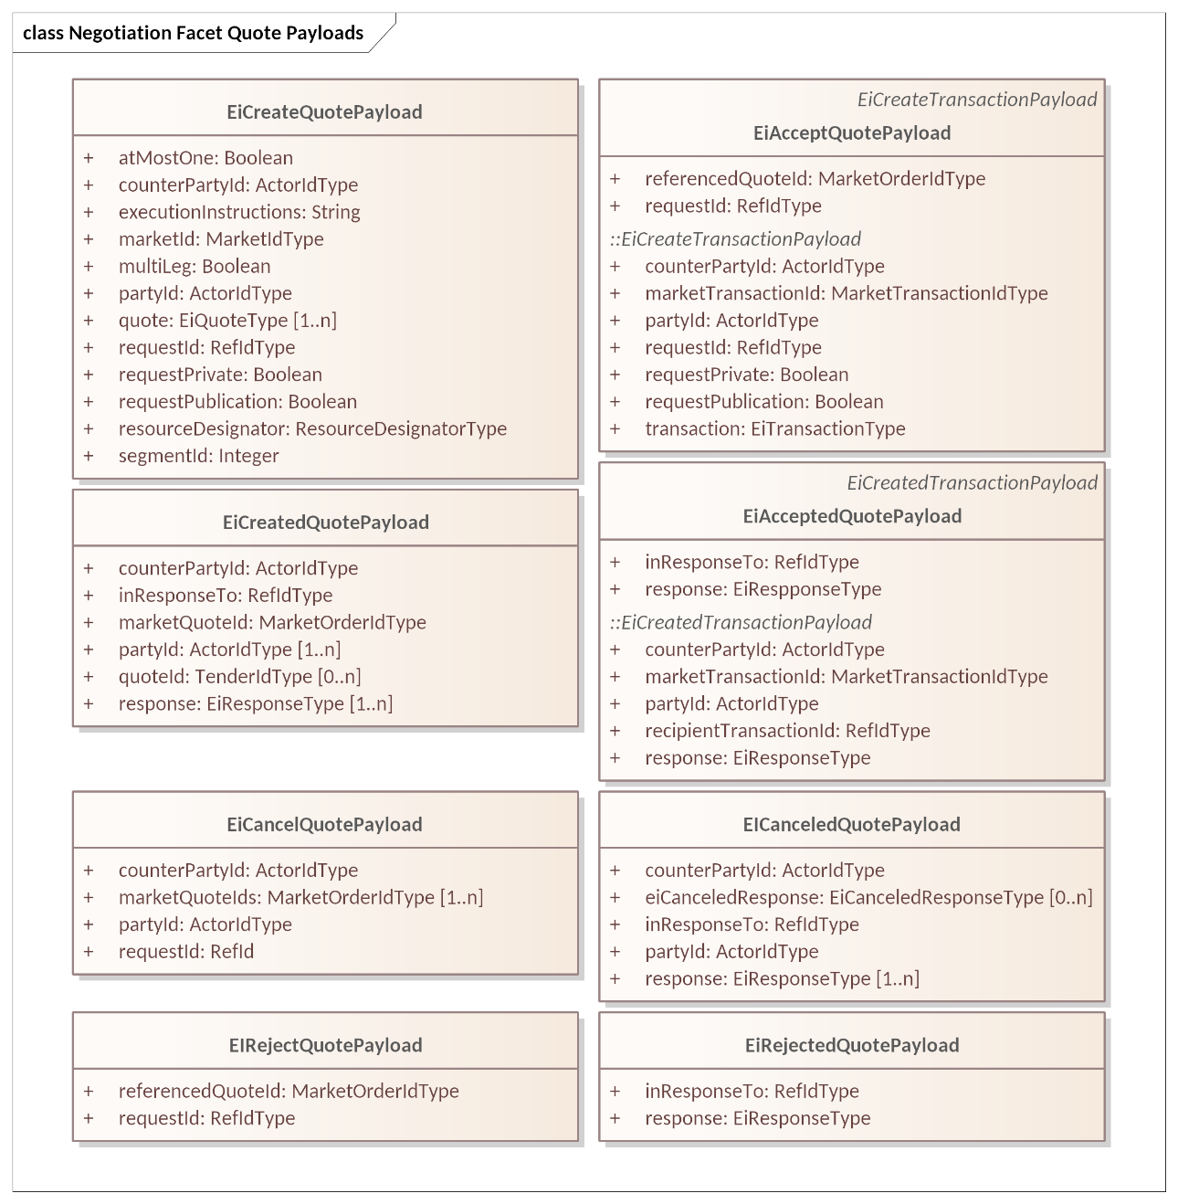

Figure 9‑9 Negotiation Facet Quote Payloads

The following tables show attributes for the Quote Payloads.

Table 9‑9 EiCreateQuotePayload

| Attribute | Type | FIX Field | Meaning | Notes |
| --- | --- | --- | --- | --- |
| At Most One | Boolean | ContingencyType (1385) | When multiple Quotes are submitted at once, then at most one Quote can be used. | See Section 5.3.2 Execution Instructions.  First match cancels others. |
| Counter Party ID | Actor ID | PartyID (448) | The Actor ID for the CounterParty for which the Quote is created. | In CTS, generally the Party ID for the Market. To indicate a bilateral exchange, i.e., a Tender between two specific parties, the Party ID of a specific counterparty is used. |
| Execution Instructions | String | ExecInst(18) and ExecInstValue (1308) | Execution Instruction. | Used only for multi-leg, and applies to all tenders in multi-leg.  Execution instructions apply to the EiCreateQuote Payload |
| Market ID | Market ID Type | MarketID(1301) | Market ID | Identifier of the market of interest. An actor MAY be able to participate in more than one Market See Section 13 |
| MultiLeg | Boolean | See FIX message NewOrderMultileg[27] | Each of the enclosed Quotes must be accepted or none of them are. | See Section 5.3.2 Execution Instructions. |
| Party ID | Actor ID | PartyID (448) | The Actor ID for the Party requesting the Quote. | Indicates which Actor proposes the buy or sell side |
| Quote | EiQuote Type |  | The quote transmitted by this message payload | One or more quotes |
| Request ID | RefIDType | QuoteMsgID (1166) | Reference to this message payload |  |
| Request Private | Boolean | PrivateQuote (1171) | The sender requests that Quote(s) be Private only to thespecified Counter Party .  This is for symmetry with EiCreateTender, Transaction, and RFQ, where it means that the ability to engage is to the named counterparty only. | FIX has Public as an antonym of Private; due to privacy related market rules, CTS separates the concepts and clarifies that it is a request.  This is a request and may not take place. |
| Request Publication | Boolean | PreTradeAnonymity(1091) (inverted) | Publication of the Quote is requested. | The sender of an EiCreateQuote Payload requests publication on the Quote Ticker if available.  This is a request and may not take place.  See also Request Private. |
| Resource Designator | Resource Designator Type |  |  |  |
| Segment ID | Integer | MarketSegmentID (1300) | Identifies the Segment processing the Tender, Transaction, or Quote | This should be a unique combination paired with the Market Order ID |

Table 9‑10 EiCreatedQuotePayload

| Attribute | Type | FIX Field | Meaning | Notes |
| --- | --- | --- | --- | --- |
| Counter Party ID | Actor ID | PartyID (448) | The Actor ID for the CounterParty for which the Quote is created. | In CTS, generally the Party ID for the Market. To indicate a bilateral exchange, i.e., a Tender between two specific parties, the Party ID of a specific counter-party is used. |
| In Response To | Ref ID Type | QuoteMsgID (1166) | An identifier for the Create Quote payload to which this is a response |  |
| Market Quote ID | Market Order ID Type | Secondary QuoteID(1751) | ID for this quote assigned by the Segment or Market | Used in acknowledgement and in future market messages. CTS overloads OrderID(17) to express Market Quote, Tender, and RFQ IDs. |
| Party ID | Actor ID | PartyID (448) | The Actor ID for the Party requesting the Quote. | Indicates which Actor proposes the buy or sell side |
| Quote ID | Tender ID Type | QuoteID(117) | The quote transmitted by the EICreateQuote message payload | Zero or more quotes |
| Response | EiResponse Type | QuoteAckStatus(1865) QuoteReject Reason(300) | Specific error responses | See Section 2.6 Responses. |

The Segment normally does not publish a Quote that is private or directed to a specific Party or Parties. If the Quote Issuer requests Publication, then the Segment MAY do so following its anonymization and publication practices. A Segment Publishes a Quote by distributing it using the Quotes Ticker. See Section 11.5.2, *“Quote Ticker”*

While the Quote Issuer can request Publication, the decision to Publish a Quote is made by the Segment. A Segment MAY be required to Publish Quotes from Parties identified as significant in the Market. A Segment may decline to publish, or anonymize, any or selected Quotes to comply with privacy regulations.

#### Cancelling a Quote

A Party May cancel a Quote at any time so long as it has not previously been lifted by a Counterparty. The attributes of the Ei Cancel Quote payloads are in Table 9‑11 and Table 9‑12.

Table 9‑11 EiCancelQuote Payload Attributes

|  |  |  |  |  |
| --- | --- | --- | --- | --- |
| Attribute | Type | FIX Field | Meaning | Notes |
| Counter Party ID | Actor ID | PartyID (448) | The Actor ID for the CounterParty for which the Tender is created. | In CTS, generally the Party ID for the Market. To indicate a bilateral exchange, i.e., a Tender between two specific parties, the Party ID of a specific counterparty is used. |
| Market Quote IDs | Market Order ID Type | SecondaryQuoteID(1751); OrderID(37) | ID assigned by the Segment or Market. | One or more Market Quote IDs (of Market Order ID Type) for which cancelation is requested.  CTS overloads OrderID(17) for Market assigned Order, Quote, and RFQ IDs. |
| Party ID | Actor ID | PartyID (448) | Actor ID for the Party that created the Tender |  |
| Request ID | Ref ID Type | QuoteReqID(131) | An identifier for this Cancel Tender Payload |  |

Table 9‑12 EiCanceledQuote Payload Attributes

| Attribute | Type | FIX Field | Meaning | Notes |
| --- | --- | --- | --- | --- |
| Counter Party ID | Actor ID | PartyID (448) | The Actor ID for the CounterParty for which the Tender is created. | In CTS, generally the Party ID for the Market |
| Ei Canceled Response | Canceled Response Type | Not in FIX | Detailed response for each quote that was included in the EiCancelQuote Payload | One or more depending on quotes for which cancelation is requested. |
| Response | EiResponse Type | QuoteAckStatus(1865) QuoteReject Reason(300) | Specific error responses | See Section 2.6 Responses. |
| In Response To | Ref ID Type | QuoteMsgID(1166) | An identifier for the Cancel Quote Payload to which this is a response |  |
| Party ID | Actor ID | PartyID (448) | The Actor ID for the Party on whose behalf this Tender was made. | Indicates which Actor proposes the buy or sell side Quote |

#### Accepting a Quote

To accept a Tradeable Quote, whether on first notice or after negotiation, a Party submits an EiAcceptQuote Payload matching the Price and Quantity of the Quote and referencing the Market Quote ID (FIX Secondary QuoteID(1751). FIX and financial markets call this *lifting a quote*.

The EiAcceptQuote payload is exactly an EiCreateTransaction payload with the addition of a reference to the quote accepted because the match has been performed by the Quote/Accept cycles.

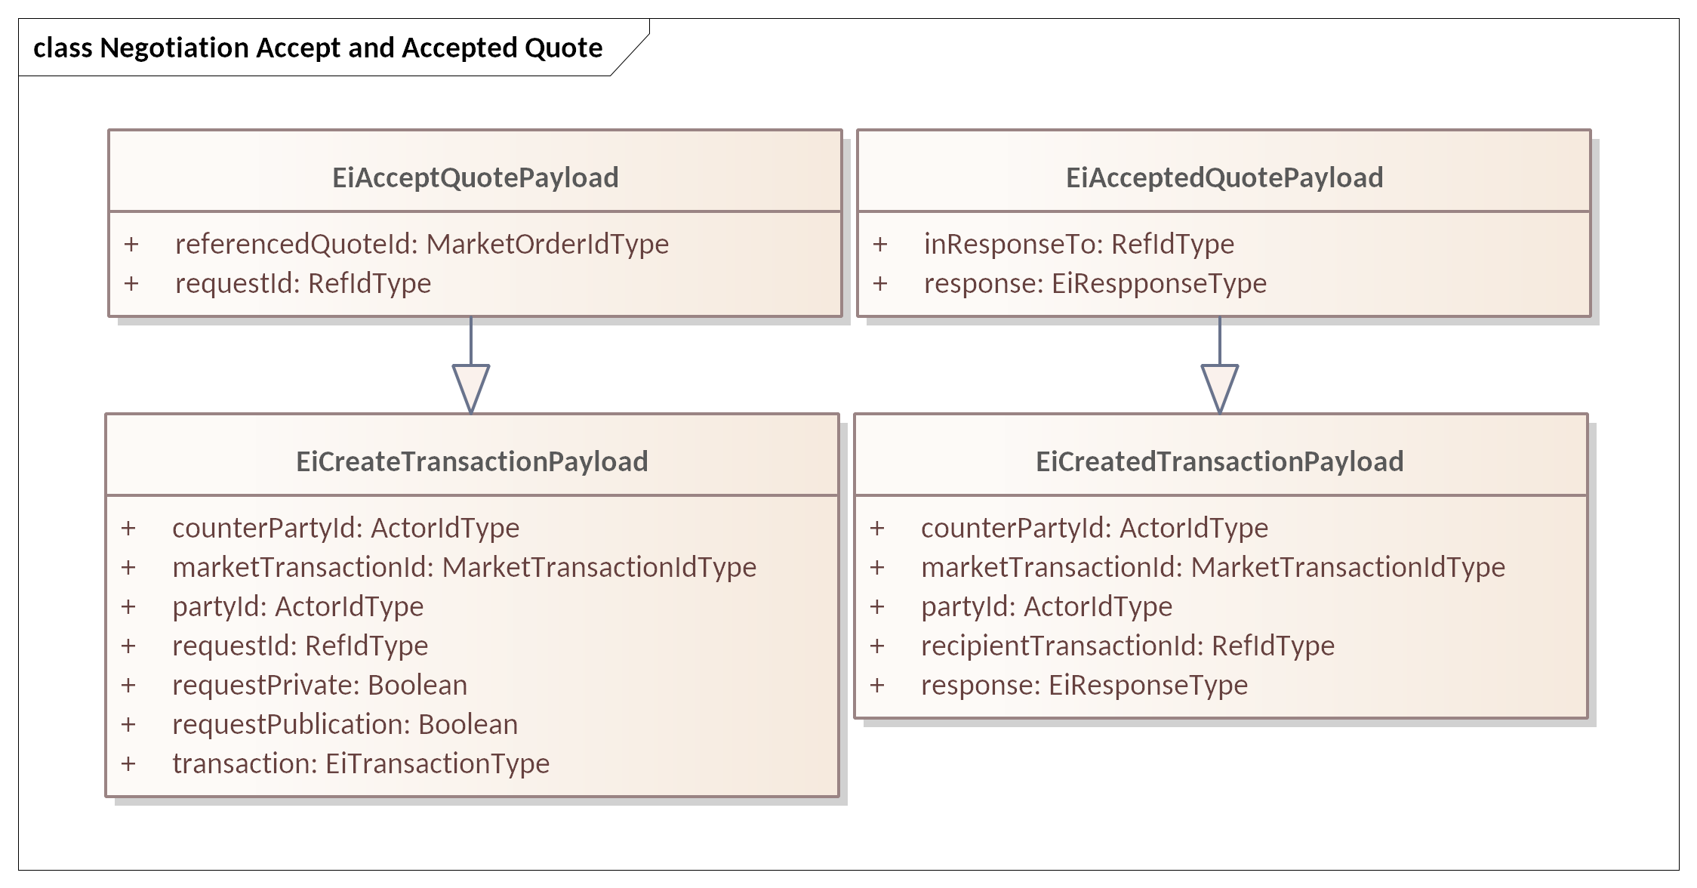

Figure 9‑10 Negotiation Facet Accept and Accepted Quote Payloads

The following Table 9‑13 and Table 9‑14 show the attributes for EiAcceptQuote and EiAcceptedQuote Payloads; the inherited attributes for the payloads are those in Table 6‑3 and Table 6‑4.

Table 9‑13 EiAcceptQuotePayload Attributes

| Attribute | Type | FIX Field | Meaning | Notes |
| --- | --- | --- | --- | --- |
| Referenced Quote ID | Market Order ID Type | QuoteID (117) | The Market-assigned ID for the quote being rejected. | CTS overloads OrderID(17) to express Market Quote, Tender, and RFQ IDs. |
| Request ID | Ref ID Type | QuoteMsgID (1166) | A reference to this message payload | May be used as a correlation ID |

Table 9‑14 EiAcceptedQuotePayload Attributes

| Attribute | Type | FIX Field | Meaning | Notes |
| --- | --- | --- | --- | --- |
| In Response To | Ref ID Type | QuoteMsgID (1166) | An identifier for the Accept Quote payload to which this is a response | In EiAcceptedQuote Payload |
| Response | EiResponse Type | QuoteAckStatus (1865)  QuoteReject Reason(300) | Specific error responses | See Section 2.6 Responses. |

The Market will then validate the accepted Quote and update the EiCreateTrransaction included in the EiAcceptQuote payload.

Note that the Market Transaction ID may not have been assigned, in which case that attribute should be set to a null ID Type; the AcceptedQuote from the market will have a valid Market Transaction ID unless the Accept failed. In addition, EiAcceptedQuote Payload has two responses, one to the Accepted Quote and one to the included EiCreateTransaction payload.

The TenderBase in the EiAcceptQuote must match Instrument, Price, and Quantity in the Quote, except in a Quote-Driven Market, wherein EiAcceptQuote can lift a part of the Quote. Quotes in Segments with Market Mechanisms other than Quote Driven must have an execution instruction of All-or-None. The Segment typically maintains the balance remaining in a Quote.

Notwithstanding any negotiation, the Market may reject the Accept Quote if accepting it would interfere with resource operations or violate financial requirements on participants.

If a Tradeable Quote is open when the Instrument closes, it is the responsibility of the Party that submitted the Quote to cancel it, and/or to have an appropriate expiration for the Quote. If the issuer still wishes to accept an instrument scheduled for 11:00 at 11:30, that is up to the Parties; how that is accomplished is out of scope of CTS. The Market will enforce its own rules for accepting the Transaction.

#### Rejecting a Quote

When a Party wants to end further negotiation, it replies with a Reject Quote message. Reject Quote is in the choreography for an RFQ Market (MMT_RFQ) but not in a Quote-Driven Market.

The UML class diagram for EiRejectQuote and EiRejectedQuote is in Figure 9‑11 Attributes are described in Table 9‑15.

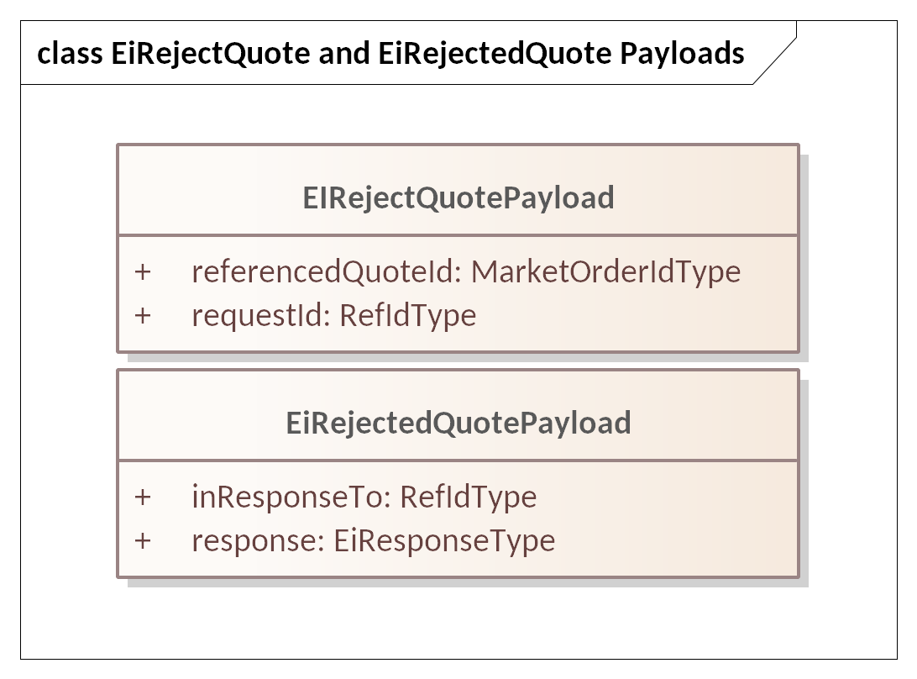

Figure 9‑11 EiReject and EiRejectedQuote Payloads

Table 9‑15 EiReject and EiRejected Quote Payload Attributes

| Attribute | Type | FIX Field | Meaning | Notes |
| --- | --- | --- | --- | --- |
| Referenced Quote ID | Market Order ID Type | QuoteID (117) | The Market-assigned ID for the quote being rejected. | CTS overloads OrderID(17) to express Market Quote, Tender, and RFQ IDs. |
| Request ID | RefIDType | QuoteMsgID (1166) | Reference to this message payload |  |
| In Response To | Ref ID Type | QuoteMsgID (1166) | An identifier for the Reject Quote Payload to which this is a response |  |
| Response | EiResponse Type | Not in FIX | Specific error responses | See Section 2.6 Responses. |

# Subscription Facet

A Party wishing to trade in a market naturally wants to be kept apprised of changing information about the market. This can be roughly divided into granular information about what other Parties are doing in the Market, and information about the Market, Segment, Trading Session, or instruments (high price, low price, quantity sold, etc.).

In this section we describe the common aspects of subscriptions, including starting and stopping, or a one-time information message.

The FIX Protocol specification describes these as Market Data, that is, granular or aggregate information about activities in a Market, and Market Structure Reference Data, that is, information about how each Market Segment is operating.

FIX distinguishes between

* *Reference Data* which changes very slowly if at all—think the name of a market, or that a market segment trades one hour energy, and
* *Dynamic Data* which changes more frequently—think orders to buy or sell an instrument, session trading status, session intraday unscheduled auctions, and the like.

In the FIX Protocol, a Party gets this information either by means of Subscriptions or request messages resulting in a single response message. A Party subscribes to the information it needs and thereafter receives periodic updates relating to that subscription. The FIX interaction model defines a *subscription* as how an Actor requests one or more market reports.

A Market consists of multiple Market Segments, each trading a single Product based on the Resource traded in that market. Multiple Market Segments in a Market MAY trade the same Product, perhaps with different trading rules, or different schedules of operation. The Segments in a Market may support different Market Structure Reference Data reports. Information about a Market and its Segments is conveyed in the Market Structure Reference Data Subscriptions.

Subscriptions are how a Party requests specific Pre-Trade information. Not all Markets and Segments will support all Subscription types. The Subscriptions supported by each Segment are described in Section 13, *“Market Structure Reference* Data: Market, Segment, and Session Subscriptions*”.*

The following sections each use the Subscription pattern:

* Section 11, *“*Tickers”—Tenders, Quotes, RFQs, and Transactions
* Section 12, “Instrument Data Subscriptions”—outstanding tenders to buy or sell, high and low prices
* Section 13, “Market Structure Reference Data: Market, Segment, and Session Subscriptions*”*—slowly or unchanging reference data

Some markets or segments may not support fine-grained subscriptions. In such cases, the Managed Subscription payload and/or Market Structure Data Report MAY indicate a multi-cast point or other source to which an actor may choose to listen.

In CTS, the message transport is layered and out of scope.

## Messages for the Subscription Facet

All subscriptions follow a common pattern for creation, management, and cancelation. This facet includes messages for Tickers, Instrument Data, and Market, Segment, and Session Data, as described in the following sections. Those messages inherit from the core subscription messages, which are of abstract type as no actual messages use only this base.

Table 10‑1 Messages for the Subscription Facet

| Facet | Request Payload | Response Payload | Notes |
| --- | --- | --- | --- |
| Subscription | EiManageSubscription | EiManagedSubscription | Create, manage, and cancel subscriptions |

## Interaction Pattern for the Subscription Facet

There is no UML sequence diagram for the Subscription Facet because the payload is abstract. The manage interactions are defined in Sections 11, 12, and 13. Specific subscriptions inherit from this pattern.

## Information Model for Subscription Requests

The UML Class Diagram for the Subscription Request and Response is shown in Figure 10‑1. Specific requests for tickers, instrument, and market information are defined in the following sections.

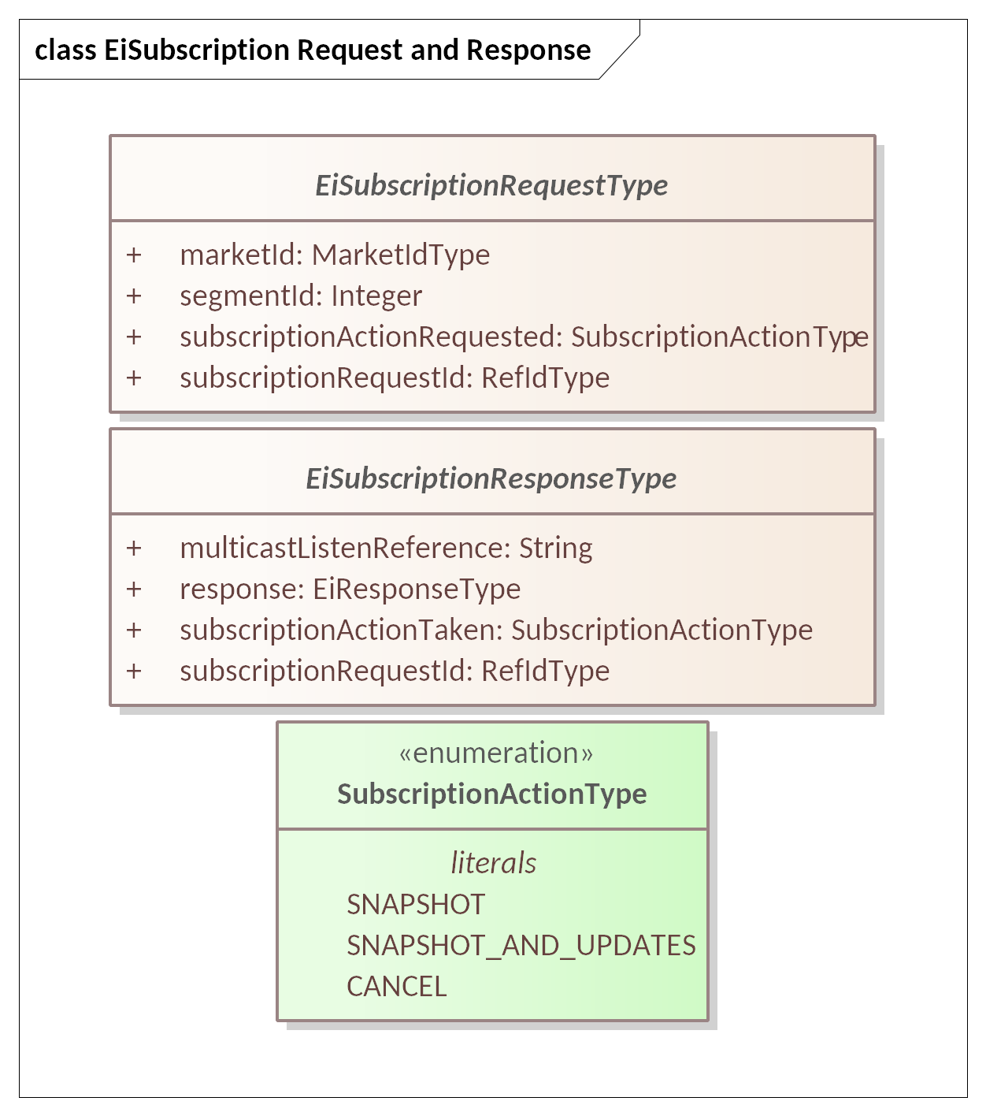

Figure 10‑1 UML Class Diagram for Subscription Request and Response Types

Attributes for the Subscription Request are shown in Table 10‑2. We follow FIX’s approach in using the message ID (RefID) as the subscription identifier.

Table 10‑2 EiSubscriptionRequest Attributes

| Attribute | Attribute Type | FIX Field | Meaning |
| --- | --- | --- | --- |
| Market ID | Market ID Type | MarketID(1301) | Identifier of the market of interest. An actor MAY be able to participate in more than one Market. See Section 13 “Market Structure Reference Data: Market, Segment, and Session Subscriptions” |
| Segment ID | Integer | MarketSegmentID(1300) | The FIX MarketSegmentID is a UID represented by a string; CTS uses an integer for Segment ID.  If Segment ID is non-zero, the request is limited to reporting on the indicated single Segment. If zero, the subscription requests reporting on all Segments of the Market. |
| Subscription Action Requested | Subscription Action Type (enumeration) | SubscriptionRequestType (263) | The Subscription response type requested. CTS uses an enumeration that matches the pattern of FIX numeric codes:  0 – **SNAPSHOT**  1 – **SNAPSHOT_AND_UPDATES**  2 – **CANCEL**  See the discussion following this Table. |
| Subscription Request ID | Ref ID Type | MDReqID(262) | Used to identify this request for managing a subscription. The Ref ID for this payload is used as an identifier for the subscription and must be used to cancel or change.  This follows the FIX MarketDataRequest (35=DR). |

Attributes for EiSubscriptionResponse are shown in Table 10‑3.

Subscriptions are inherently asynchronous. A Snapshot subscription request asks for a full report when the provider responds. A Snapshot and Updates subscription returns a full report and will return regular updates at some future times. A Cancel subscription stops all future Updates and ends the Subscription.

There is no expectation that each market participant can or should be able to get perfect knowledge about the trading behavior of all other participants; and creating a capability of doing so would likely prevent the development of the emergent knowledge which is the purpose of transactive resource markets.

Table 10‑3 EiSubscriptionResponse Attributes

| Attribute | Attribute Type | FIX Field | Meaning |
| --- | --- | --- | --- |
| MultiCast Listen Reference | String | PrimaryServiceLocationID(2567) | If non-NULL the Subscription Manager provisions the subscription by sending a message to (e.g.) a multicast in lieu of response messages.  If non-NULL the subscription payloads are sent via a mechanism that does not use individual responses. |
| Response | EiResponse Type | Not in FIX | A standard CTS response type.  See Section 2.6 Responses. |
| Subscription Action Taken | Subscription Action Type (enumeration) | SubscriptionRequestType (263) | The action taken on the referenced or newly created Subscription. |
| Subscription Request ID | Ref ID Type | MDReqID(262) | A UID indicating the newly created, modified, or canceled subscription. |

# Tickers

This section applies the subscription pattern of Section 10, and describes mechanisms to access continuous Market Data on the activities of market participants. CTS calls these *Tickers*. Tickers update continuously, on a schedule determined by the provider, as Parties interact with a Segment.

A Party wishing to trade in a market naturally wants to be kept apprised of changing information about the market. The FIX Protocol divides this information into three categories: Orders, Trades, and Bids/Offers. CTS defines Tickers for Tenders [Orders], Transactions [Trades], Quotes [Bids/Offers], and Requests for Quotation [RFQs].

The four types of Tickers are represented as an enumeration. See Table 11‑1 and Figure 11‑1 below.

Table 11‑1: Types of Tickers in CTS Facet

| Ticker Type | Request Payload |
| --- | --- |
| Quotes | Published Indicative (non-Tradeable) Quotes |
| RFQs | Published RFQs |
| Tenders | Anonymized Tenders offering to Buy or to Sell |
| Transactions | Anonymized Trades, whether from market matches or from Negotiation |

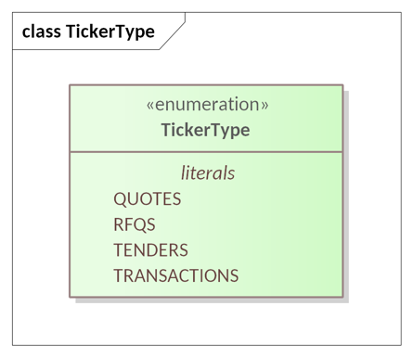

Figure 11‑1 TickerType Enumeration

Not all Markets or Market Segments support Ticker subscriptions or all Ticker types. Actors can discover what Tickers a Segment supports and how to interact with them through the Market Reports as discussed in Section 13, *“Market Structure Reference* Data: Market, Segment, and Session Subscriptions*”*.

Private Quotes do not appear in Tickers.

It is common that, following market or segment rules, most parties in tickers are anonymized, that is, the identity of the party is not disclosed. In such situations, the Market Party ID is used as the Party ID and/or Counterparty ID in the Ticker.

In Resource markets as in financial markets, Parties with specific and/or influential roles are not anonymized. For example, a Market may choose not to anonymize the Party ID of the distribution system operator (DSO).

This specification makes no statement about what anonymization rules a resource market must use. This specification offers general guidance that most participants be anonymized to preserve privacy, but that Ticker messages for significant participants may be distributed under their own identity.

## Messages for Tickers

An Actor subscribes to a Ticker based on the subscription model (Section 10, “Subscription Facet”). An Actor can subscribe to a single Market Segment or any or all Market Segments in a Market. Each Ticker Type, if available, requires a separate Subscription.

Table 11‑2 Ticker Facet Messages

| Facet | Request Payload | Response Payload | Notes |
| --- | --- | --- | --- |
| Ticker | EiManage Ticker Subscription Payload | EiManaged Ticker Subscription Payload | As multiple Markets may use same Ticker service, must allow multiple subscriptions. |

## Interaction Pattern for Tickers

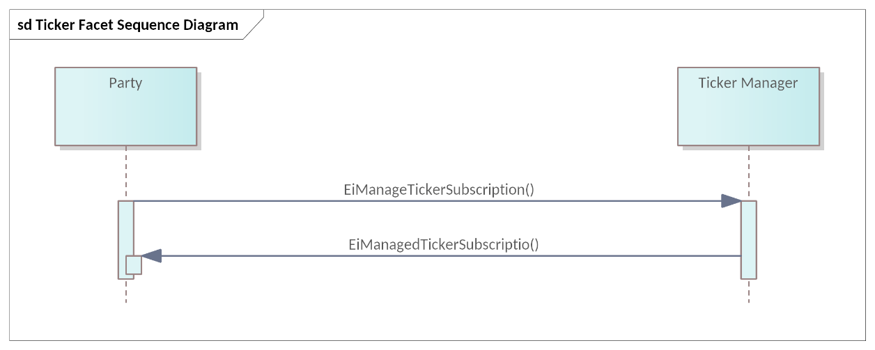

Figure 11‑2: UML Sequence Diagram for the Ticker Facet

## Exceptions to Ticker Subscription Interactions

A given Segment may provide a single Ticker data stream combining any or all Ticker Payloads. An Actor that subscribes to any Ticker implicitly subscribes to all the Types included with that Ticker.

In larger markets, there may be a broadcast or multicast channel for a Ticker. In such markets, there is no subscription; the Actor simply listens to that broadcast channel. The Subscription Id is not part of the multicast and an Actor unsubscribes as per the transport used.

## Interaction Patterns for Ticker Data

The various types of tickers share a common approach:

* A subscription is created using EiManageTickerSubscription, passing the requested change and which ticker is being managed.
* The ticker payloads contain the subscription ID and the relevant object for the ticker type:
  + TenderTickerType is EiTenderType for Bid and Offer tickers.
  + TransactionTickerType is EiTransactionType
  + QuoteTickerType is EiQuoteType (not tradeable)
  + RfqTickerType is EiRfqType.
* The Ticker Payloads are described below in Figure 11‑3. Delivery of Ticker Payloads is out of scope,
  + Large or complex markets might use a multicast for delivery using the relevant ticker payloads (out of scope)
  + Small or less complex markets might use a market-defined delivery mechanism (out of scope)

## Information Model for Ticker Payloads

Ticker payloads are sent asynchronously when subscribed. The UML Class Diagrams for Ticker Payloads and Ticker Type are in Figure 11‑3.

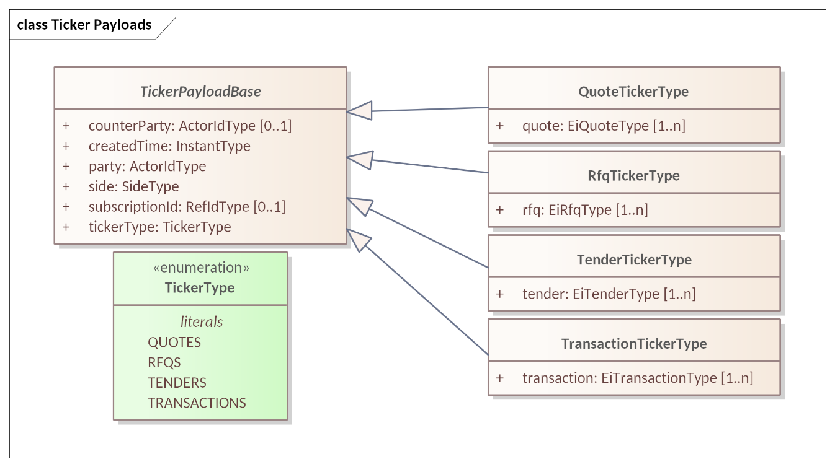

Figure 11‑3 Ticker Payloads and Ticker Type showing inheritance

The attributes for the Ticker Payloads are shown in Table 11‑3. Ticker Payloads will be delivered pursuant to ticker subscriptions on a Segment.[28]

Table 11‑3 Attributes for the Ticker Payload Base and Ticker Types

| Attribute | Attribute Type | FIX Field | Meaning |
| --- | --- | --- | --- |
| Counter Party | Actor ID Type | PartyID(448) | The counterparty in the ticker payload by type; may be anonymized per market rules.  Optional.  CounterParty for Ticker Payload Base may be anonymized for Transaction, and may be included for market-facilitated Tender and RFQ tickers. |
| Created Time | Instant Type | Not in FIX | Time stamp indicating when the Ticker Payload object was created. |
| Party | Actor ID Type | PartyID(448) | The party in the referenced ticker; may be anonymized per market rules. |
| Side | Side Type | Side(54) | The side for the referenced ticker; note that an EiTender, etc., have side in the inherited TenderBase. The Side in the Ticker Payload Base MUST match that in any referenced object. |
| Subscription ID (Optional) | Ref ID Type | MDReqID(262) | An optional ID indicating the related subscription.  Present only for individual subscriptions but MAY be absent even then.  NOTE that if delivered via (e.g.) multicast or broadcast, customization of Subscription IDs cannot be done, so this attribute MAY be absent.  Cancelation of a multicast Snapshot-and-Updates subscriptions is accomplished by sending an EiManageTicker Payload with the original Subscription Request ID. |
| Ticker Type | Ticker Type enumeration | Not in FIX | See Figure 11‑3 for class diagram. The values are QUOTES, RFQS, TENDERS, and TRANSACTIONS |
| Quote | EiQuoteType |  | One or more.  For QuoteTickerType; the Side attribute in TenderBase MUST be the same as Side in Ticker Payload Base. |
| RFQ | EiRfqType |  | One or more.  For RfqTickerType; the Side attribute in TenderBase MUST be the same as Side in Ticker Payload Base. |
| Tender | EiTenderType |  | One or more.  For TenderTickerType; the Side attribute in TenderBase MUST be the same as Side in Ticker Payload Base. |
| Transaction | EiTransactionType |  | One or more.  For TransactionTickerType; the Side attribute in TenderBase MUST be the same as Side in Ticker Payload Base. |

### Tender Tickers

Bids and Offers are simply Buy or Sell side Tenders. When a Tender is submitted, the Segment announces the Tender on the Ticker subject to the Segment rules and requests for publication and privacy.

Tenders are submitted to the entire Market Segment; there is no guarantee that a Tender will still be available when a Party submits a matching Tender.

The Market and/or Segment may publish Quotes subject to Issuer’s request for publication, subordinate to Market and/or Segment rules.

The payload for Tender Tickers includes one or more EiTenderType objects with attributes anonymized following market or segment rules. Attributes are shown in Table 5‑2: EiTender Attributes.

A Party that wishes to receive Tenders from a Segment must subscribe to that Segment’s Tender Ticker.

### Quote Tickers

If a Segment and its Market Mechanism supports Negotiations, then it supports a Quote Ticker. There is more diversity in Quotes than in Tenders.

The Quote attribute of the Quotes Ticker Type is defined in Section 9 “Negotiations.” Because the purpose of a public offer (“publishing a Quote”) is to initiate a Negotiation between Parties, the Quotes Ticker is not anonymized.

A price distribution Ticker should use Indicative (not-Tradeable) Quotes.

As an example, a quote ticker might state prices for each hour of the next day with specific quantities. The Boolean All or None in the quote should not be set so that purchases can use less than the quoted quantity. The quoted quantity might reflect a total available. (See Section 5.3.2 Execution Instructions.). (See Section 113.2.1 Delivery Reconciliation and Imputed Transactions13.2.1

### RFQ Tickers

While the type and semantics of RFQs and Quotes are closely related, the separation simplifies the data model. There may be reasons for a Negotiation market to not support an RFQ Ticker.

### Transaction Tickers

The Transactions Ticker is the continuous advertisement of Trades executed in a Market Segment. Both Parties are listed on a Transaction, although either or both may be anonymized as specified in market rules.

In some Market Mechanisms (see 13.1, *“Market Mechanisms”*) the contract may be negotiated privately. Note: even a Transaction that was negotiated privately may be published in the Transaction ticker based on market rules.

## Message Payloads for Managing Ticker Subscriptions

The messages for adding, changing, or deleting a Ticker subscription contain only the ticker type and a subscription request or response as defined in Table 10‑2 and Table 10‑3. The UML Class Diagrams for the message payloads are shown in Figure 11‑4.

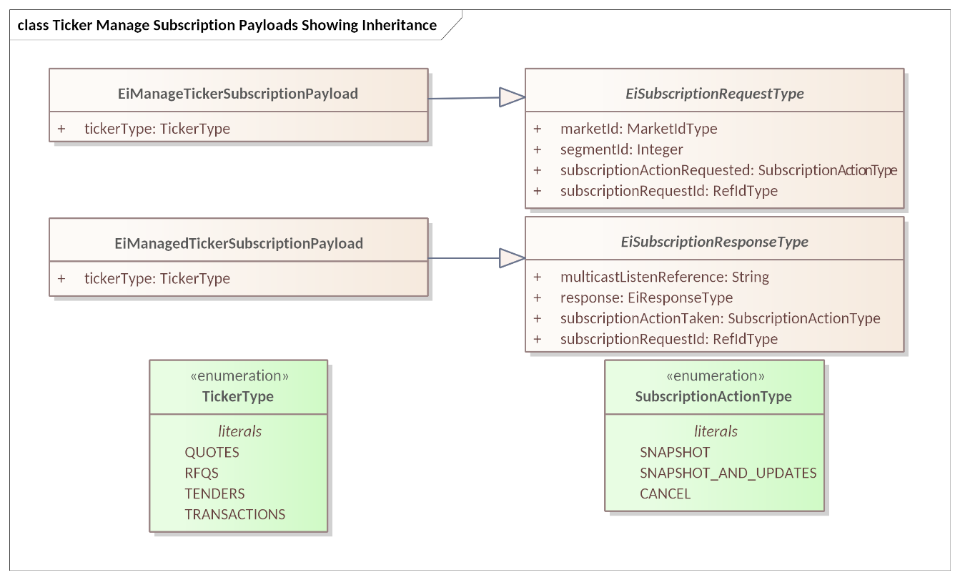

Figure 11‑4 Ticker Manage Subscription Payloads showing inherited attributes

Table 11‑4 shows the attributes for the EiManage and EiManaged Ticker Subscription Payloads.

Table 11‑4 Attributes for the EiManage and EiManagedTickerSubscription Payloadfs

| Attribute | Attribute Type | FIX Field | Meaning |
| --- | --- | --- | --- |
| Ticker Type | Ticker Type enumeration |  | The Type of Ticker for subscription. |
| All other attributes are as in EiSubscriptionRequest and EiSubscriptionResponse in Table 10‑2 and Table 10‑3 | | | |

# Instrument Data Subscriptions

Instrument Summaries are obtained by Subscription (described in Section 10) and provide dynamic data about specific Instruments traded in the Segment. Like other Subscriptions, Instrument Summary Subscriptions provide an aspect of what FIX calls Pre-Trade Data.

The information in the Instrument data may be considered a blend of Reference and Dynamic—the Reference Data includes all the attributes of Instrument Session Report Type except for the Instrument Summary; the Reference data in effect describes the market, segment, resource, and similar reference data. The combination is dynamic, with static identifying information.

As resource market instruments are time-based, the tradeable set of instruments may change over time as old instruments expire and become irrelevant (perhaps post-reconciliation) and new instruments become available. Hence instrument data is always dynamic.

The request for a subscription includes the usual requests for snapshot, snapshot and updates, and unsubscribe (see Section 10) with the addition for Instrument data of how to update.

The Subscription Manager may restrict the frequency and the content. Certain requests, e.g., multiple levels of the order book, or many instruments, involve a lot of data. Some restrictions are described in Section 13.5.3 “Information Model for Segment Reference Data” (Max Summary Instruments and Market Depth.

## Messages for Instrument Data Subscriptions

Subscription requests need additional information beyond the EiManageSubscription payloads:

* The Bounding Interval for instruments requested
* A limit on how many instruments to supply data for
* How to update the requested data if the subscription requests updates—incremental or a full update

Table 12‑1 Messages for Instrument Data

| Facet | Request Payload | Response Payload | Notes |
| --- | --- | --- | --- |
| Subscription – Instrument Data | EiManage Instrument Data | EiManaged Instrument Data | Create, manage, and cancel subscriptions |

## Interaction Pattern for Instrument Data Subscriptions

An Instrument Data Subscription requests data on contiguous temporal range of Instruments.

Within a Market Segment, trading is for a single Product, and Instruments are distinguished by the resource delivery Interval. The Subscription returns data for all Instruments whose interval falls within the Bounding Interval of the Subscription request.

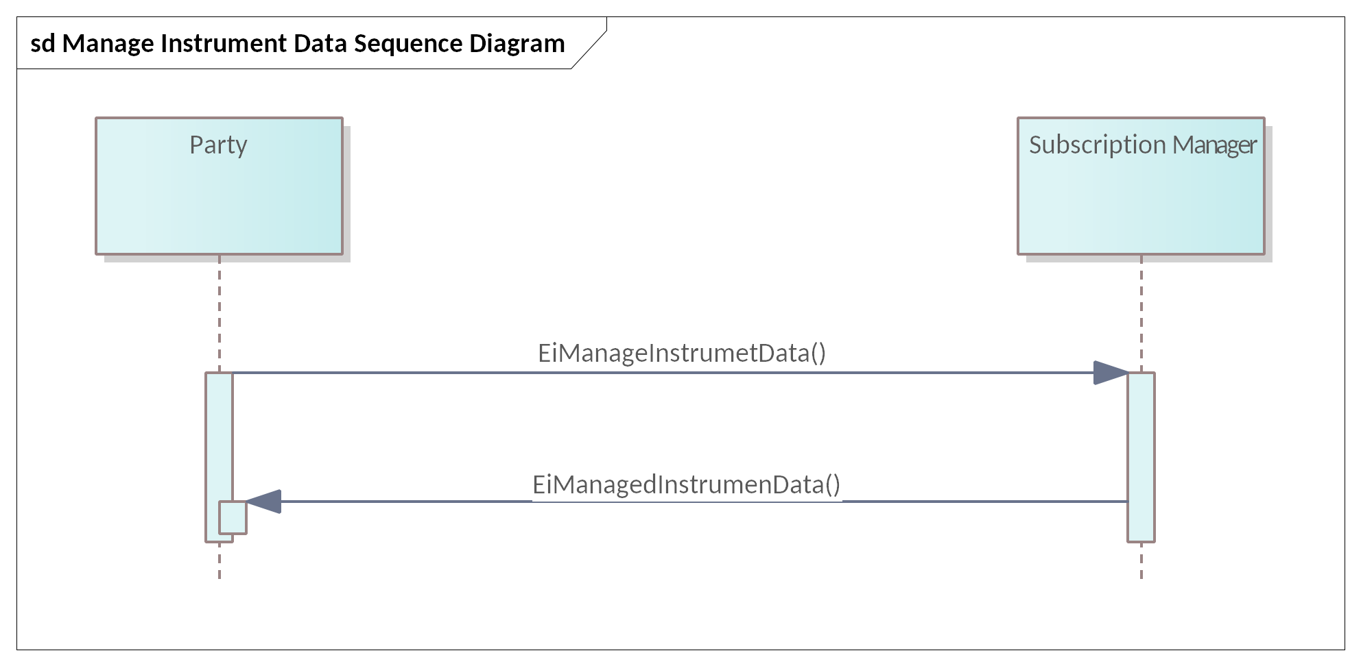

Figure 12‑1 ‎Manage Instrument Data Subscription

## Information Model for Manage Instrument Data Subscription Payloads

The UML class diagram for the Manage Instrument Data messages is in Figure 12‑2.

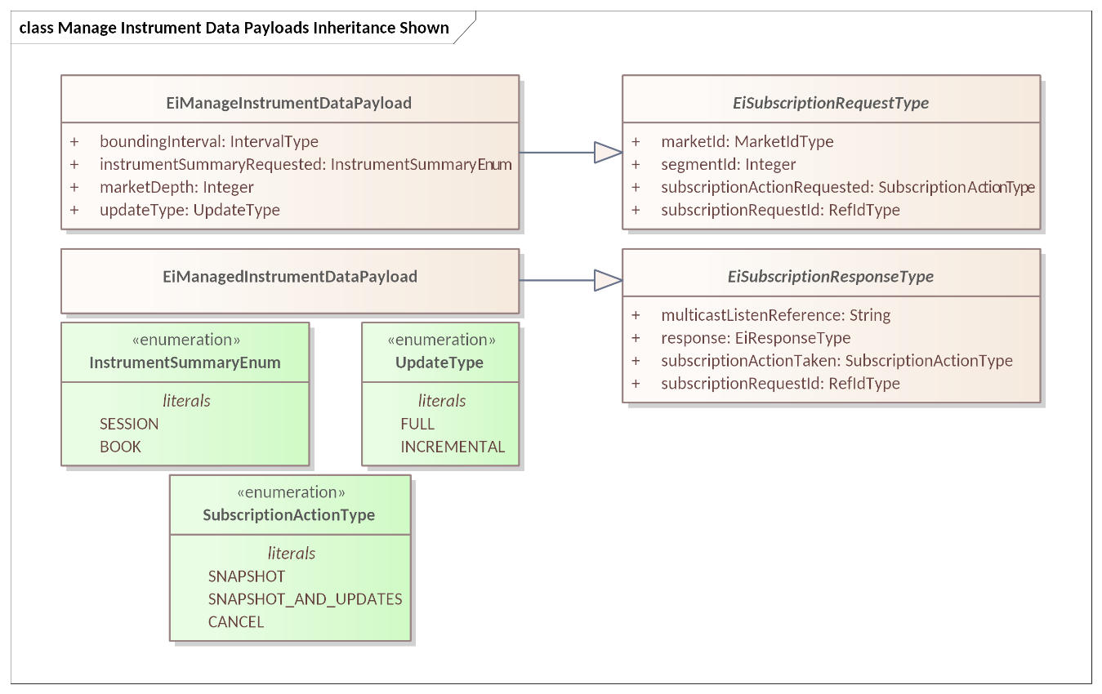

Figure 12‑2 UML Class Diagram for Manage Instrument Data Messages

The Manage Instrument Data payload specifies the type of summary and instruments requested. Its attributes are in Table 12‑2.

Table 12‑2: Attributes for Manage Instrument Data Payload

| Attribute | Attribute Type | FIX Field | Notes |
| --- | --- | --- | --- |
| Bounding Interval | Interval Type | Not in FIX | Subscription request is for all Instruments within the Bounding Interval. What is returned is at the discretion of the Segment.  The request will return information on all instruments within the [closed] time interval whose start is at or later than the Bounding Interval start and whose end point is at or before the end of the Bounding Interval.  See Section 3.3 “The Bounding Interval Pattern in CTS” |
| Instrument Summary Type | Instrument Summary Type Enumeration | Related to FIX Subscription RequestType(263) | Supported values are:  0 = Session Summary (CTS: **SESSION**)  1 = Book (see Market Depth attribute) (CTS: **BOOK**) |
| Market Depth | Integer | MarketDepth (264) | Depth of market requested for Book Snapshot and/or Incremental updates 0 = full book depth 1 = top of book 2 or greater = book depth (number of levels).  The Segment may limit the response to the depth indicated by Market Depth attribute of Segment Reference Data. |
| Update Type | Update Type Enumeration | MDUpdateType (265) | Enumeration. FIX values are  0 = **FULL**  1 = **INCREMENTAL**  The nature and frequency of Incremental Updates is at the discretion of the Subscription Manager. |
| The remaining attributes are inherited from EiSubscriptionRequestType (Table 10‑2) | | | |

The attributes for the *Managed Instrument Data Payload* are all inherited from EiSubscriptionResponseType (Table 10‑3).

## The Instrument Session Reports

As with Tickers (See Section 11 “Tickers”) the actual requested information may be delivered by various means, including but not limited to multicast, point-to-point delivery, and publication to be downloaded by the actor, some of which may not support subscription request identifiers.

The Instrument Session Reports provide summary information about one or more instruments. Common information about the report is presented in class Instrument Report

In CTS, the messages are modeled by Instrument Session Report Type which has zero or more Instrument Summary Type instances.

### Information Model for the Instrument Session Report Type

The UML class model for Instrument Session Report Type is shown in Figure 12‑2.

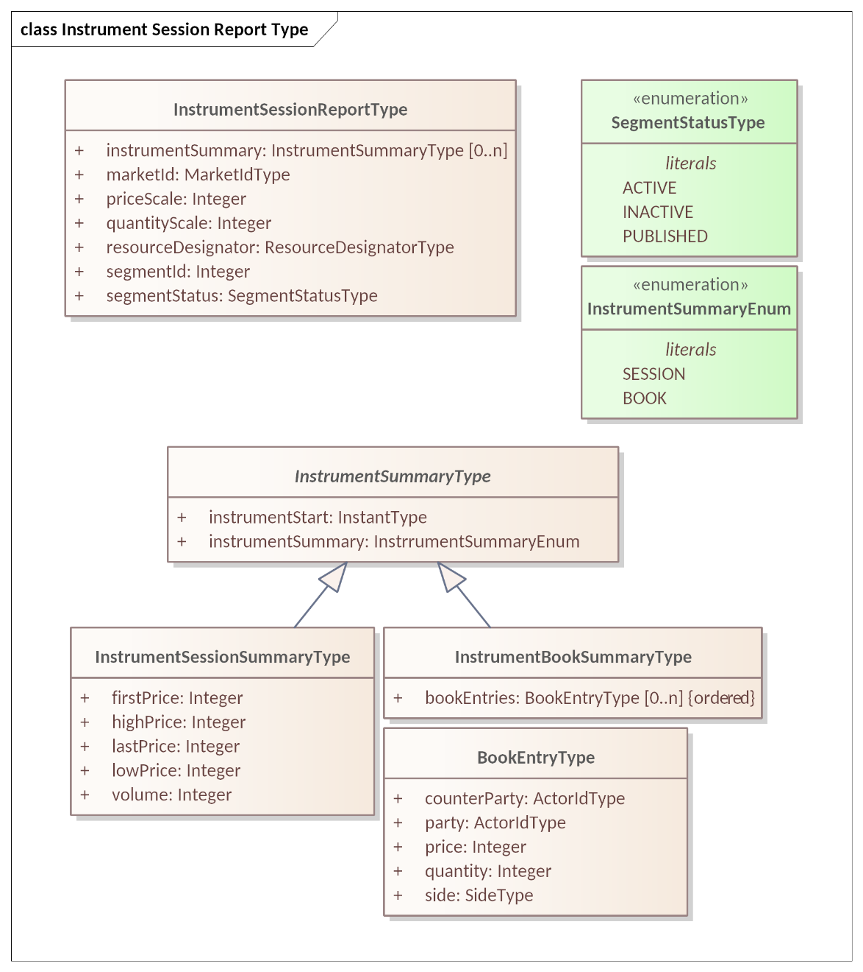

Figure 12‑3 UML Class Diagram for Instrument Session Report Type

The attributes for the classes in Figure 12‑3 are shown below.

Table 12‑3: Attributes for the Instrument Session Report Type

| Attribute | Attribute Type | FIX Field | Meaning | Notes |
| --- | --- | --- | --- | --- |
| Instrument Summary | Instrument Summary Type | Related to FIX MarketDataRequest message | A repeating series for each Instrument in the Report. The information varies by the Summary Type requested. | Zero or more Instrument Summaries; type is in response to that requested in the Instrument Summary Type included in the Manage Instrument Reference Data payload, |
| Market ID | Market Id Type | MarketID (1301) | Identifies the Market | Identifier of the market of interest. An actor MAY be able to participate in more than one Market See Section 13. |
| Price Scale | Integer | Not in FIX | A multiplier for the Price used in this segment | A market segment might be denominated in e.g. dollars or 10ths of a cent. |
| Quantity Scale | Integer | UnitOfMeasure (996)  UnitOfMeasureQuantity (1147) | A scale factor for the Resource unit for the Segment being reported on. | A scale factor for Resource Units; the number of resource units in a trade of quantity one of an instrument.. See Table 3‑2: Defining the Product. |
| Resource Designator | Resource Designator Enumeration | FIX Instrument Component | Identifier of the Resource being offered | While a Market only accepts Tenders and Quotes for a single Resource, the complete description is required to ensure validity and for off-market interactions. |
| Segment ID | Integer | MarketSegmentID (1300) | Unique Identifier for Segment | FIX Segment is a string to allow a UID. CTS Segment is an integer intended to be used with a MarketID UID. |
| Segment Status | Segment Status Type Enumeration | MarketSegmentStatus (2542) | Segment status as of time of report | 1 = Active (CTS: **ACTIVE**): Market segment is active, i.e. trading is possible. 2 = Inactive (CTS: **INACTIVE**): Market segment has previously been active and is now inactive. 3 = Published (CTS: **PUBLISHED**): Market segment information is provided prior to its first activation. |

### The Instrument Summary Types

The Instrument Summary is the information in an Instrument Summary Report that is repeated for each Instrument in the range.

The information conveyed varies with the Instrument Subscription Type. The UML class model for Instrument Summary Type is shown in Figure 12‑4. The attributes are shown in Table 12‑4, Table 12‑5, and Table 12‑6.

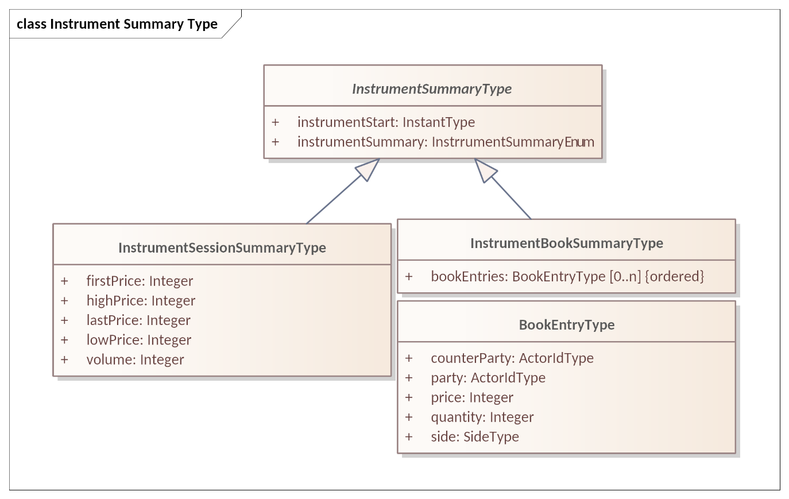

Figure 12‑4 Instrument Summary Type UML Class Diagram

#### The Instrument Session Summary

A common change reported in a Session Summary shows after a Session changes its state. In transactive resources, each Instrument closes on its own schedule. A Segment might not permit trading in an Instrument more than forty-eight hours in the future. A Segment might not permit trading an Instrument with a Start DateTime in the past. We term the union of Segment schedule and Instrument tradability the Instrument Session.

Instrument Session summaries include opening prices, closing prices, and volume traded. Note that all prices are scaled using Price Scale in the Session Report. Volume is not scaled.

The UML class diagram is in Figure 12‑4

Table 12‑4: Instrument Session Summary Type attributes

| Attribute | Attribute Type | FIX Field | Meaning |
| --- | --- | --- | --- |
| Instrument Start | Instant Type | Not in FIX | Start time that identifies this instrument and thereby this Instrument Session Summary Detail |
| Instrument Summary | Instrument Summary Enum | Not in FIX | An anumeration indicating whether a book (order book) or session summary is provided. The information is the same as expressed in the type system. |
| First Price | Integer | FirstPx (1025) | Indicates the first price of a Session; can be a bid, offer, or trade price. |
| High Price | Integer | HighPx (332) | The high end of the price range prior to the open or reopen |
| Last Price | Integer | LastPx (31) | Indicates the last price of a Session; can be a bid, offer, or trade price. |
| Low Price | Integer | LowPx (333) | The low end of the price range prior to the open or reopen |
| Volume | Integer | TotalVolumeTraded(387) | Total volume traded of an instrument, including negotiated and market trades. |

#### The Instrument Book Summary

The Book is the set of all Tenders, including Tradeable Quotes, in the Market Segment. In an active market, unless there are restrictions on matching, all Tenders to sell are priced higher than all Tenders to buy; if there were an overlap, they would already have generated Transactions and the Tenders would be removed.

The depth of the Book is a list of the volume bid or offered at each price. The Book sorts Bids by descending price. The Book sorts Offers by ascending price. A Top of the Book request, subscription depth of 1, provides just the top entry in each list, anonymized. A subscription depth of 0 provides both entire sorted lists, anonymized. Any other subscription level (n) provides the first (n) entries in each level.

The UML class diagram is in Figure 12‑4.

Table 12‑5: Instrument Book Summary Attributes Including those Inherited from Instrument Summary Type

| Attribute | Attribute Type | FIX Field | Meaning |
| --- | --- | --- | --- |
| Instrument Start | Instant Type | Not in FIX | Time stamp (inherited from Instrument Summary Type) |
| Instrument Summary | Instrument Summary Enum | Not in FIX | An enumeration indicating whether a book (order book) or session summary is provided. The information is the same as expressed in the type system. |
| Book Entries | Book Entry Type | MDIncGrp | An ordered repeating element for each side and level of the Book |

The Book Entry is the repeating information for each Side in the Book. The Book Entry is the same message format as a Quote, anonymized as required by market rules. Book Entry attributes are in Table 12‑6. The UML class diagram is in Figure 12‑4.

Table 12‑6 Book Entry Attributes

| Attribute | Attribute Type | FIX Field | Meaning |
| --- | --- | --- | --- |
| CounterParty | Actor ID Type | PartyID(448) | CounterParty for the specific Side Type. MAY be anonymized following Market Rules. |
| Party | Actor ID Type | PartyID(448) | Party for the specific Side Type. MAY be anonymized following Market Rules. |
| Price | Integer | MDEntryPx(270) | Price in the book. Subject to Price Scale. |
| Quantity | Integer | MDEntrySize(271) | Quantity in the book. Subject to Quantity Scale. |
| Side | Side Type | MDEntryType(269) | On which side is the Entry |

# Market Structure Reference Data: Market, Segment, and Session Subscriptions

For any Market, there are standing terms and expectations about Product offerings. If these standing terms and expectations are not known, a Party may have to use many interactions to discover where to trade for the Products that meet that Party’s needs.

For the Trader, the questions include

* “What products are traded in this Market, and where are they traded?” (Market Structure)
* “How and when can I trade in each Segment in this market? (Segment description)
* “What instruments can I trade now (Session information)

CTS uses the standard mechanism of the CTS Subscription to query the Market structure including enumerating the Segments, to describe each Segment, and the status of the current trading session in each Segment. A Trading Session is a period for trading in a Segment between the opening and the closing of the Segment.

In CTS Markets, the Instruments tradeable in a Trading Session may change regularly as Instruments enter or exit the trading window of the Market.

A Party must interact with a specific Segment to trade a specific Product. A Market MAY contain two or more Market Segments trading the same Product; such segments may differ in the Market Mechanism, or in trading window. For example, a regulated provider may offer a day-ahead hourly market based on an Auction between 9:00 AM and 3:00 PM. The same actor may trade the same Product by order book in another Segment. The Auction and the Order Book are different mechanisms for matching buyer and seller.

A Party chooses to trade in the Segment that it anticipates will be to its greatest advantage. The Party will make this choice based on anticipated price, or on block size, or even on Table 8‑3. Because Transactions are committed when created, a Party may buy on one Segment, and thereafter sell part of it on another. Segments may be available for trading on different schedules, and the Instruments available in each Segment change over time. The Segment Structure provides detailed information to guide trading, negotiation, and settlement. The Segment Structure defines when Sessions open and when Sessions close.

All trades occur within a Trading Session. Trading Session Data provides information on trading in a Session, including times for session changes (open, close, and more) and tradeable instruments . Trading Session Status informs whether a Session is available for trading, and when that status will change. A Trading Session’s Tradeable Instrument Trading Range permints a Party to compute whether an Instrument is currently tradeable.

Information on instruments is described in Section 12.4.

A Party discovers a Market, including changes over time, by subscribing to Market Structure Reference Data. Market Structure Reference Data includes a description of all Segments in the Market. A Party discovers and monitors a Segment by subscribing to the Segment Reference Data. A Party monitors the changing constraints on a Segment by subscribing to Trading Session Data.

This Section describes the interactions to subscribe to Market Reference Data, to Segment Reference Data, and to Trading Session Data.

## **Market Mechanisms**

One of the most important distinctions between Segments is the Market Mechanism. The FIX Trading Community defines a standard called Market Model Typology **[MMT]**. MMT classifies the mechanisms and general algorithms that operate a Market.

A Party participating in trading may change its behavior based on the mechanism the Segment uses to execute trades. The optimum trading strategy for a Party will change between an order book and an auction. If there is only a single seller, the Buyer will want to attend closely to the quotes from that seller.

CTS characterizes each Segment in part by its mechanism. FIX MMT defines some mechanisms that are not included by CTS. CTS also supports mechanisms not included in FIX, such as a self-executing mechanism to settle the difference between consumption as measured at the Meter (Delivery) and the Position as known (see Section 7. “The Position Facet” and Section 8 “The Delivery Facet”).

Figure 13‑1 shows the UML Class Diagram for the Market Mechanism Enumeration. Detailed description is in Table 13‑1 showing the Market Mechanism Types supported by CTS and the FIX MMT information.

A Market Mechanism is an attribute of a Segment; Sessions related to each Segment share the ordinary trading mode from the Segment MMT, but a Session MAY have a different trading mode, e.g. “scheduled opening auction” or “unscheduled auction”, which is described in Section 13.6 “Trading Session Data”.

This differs from the FIX MMT semantics; FIX MMT is strictly post-trade information used to show how prices were determined for regulators and auditors; CTS uses market mechanism to give information about expect trading behavior, and is therefore pre-trade reference information.[29]

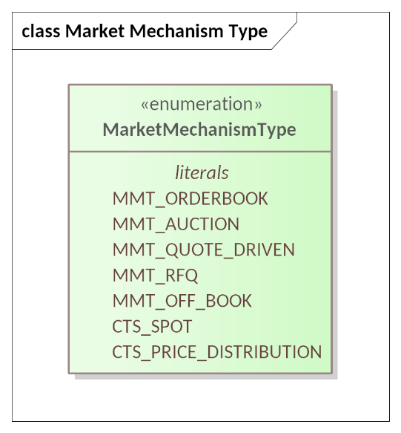

Figure 13‑1 Market Mechanism Type Enumeration

Table 13‑1 Market Mechanism Types in CTS

| Mechanism Name | CTS Enumeration Literal | Meaning |
| --- | --- | --- |
| Centralized Limit Order Book | MMT_ORDERBOOK | Participants submit their buy and sell orders, which are matched based on specific rules and executed accordingly. |
| Periodic Auction | MMT_AUCTION | An Auction Driven Market matches Tenders only in scheduled auctions wherein all participants clear at the same price. In existing power markets, also referred to as a “Double Auction”, that is, an auction in which both sellers and buyers submit bids. |
| Quote Driven Market | MMT_QUOTE_DRIVEN | Quote Driven Markets are used for Markets with one or more dominant suppliers. Parties are notified of the Quoted price for each Instrument and submit Tenders in Quote Responses. |
| Request for Quotes | MMT_RFQ | A Request for Quotes Market is used for bilateral negotiations around price. Sellers may advertise round lots that they would like to buy or to sell, and to indicate an interest in buying or selling. Trades in a Request for Quotes Market may be for odd lots, for custom durations, and span the temporal boundaries of Products |
| Off Book | MMT_OFF_BOOK | CTS reserves Off Book mechanisms for direct allocations of Resources from one Party to another. The Segment notifies the Parties executing the Transaction.  CTS restricts MMT Off Book. See also Section B.5 |
| Spot Market (CTS-specific) | CTS_SPOT | EACH Market that enables delivery reconciliation MUST have ONE Spot Segment which MUST have a Quote Ticker if imputed transactions are to be generated.  Imputed Transactions are issued by the Spot Segment.  The Spot segment MAY issue RFQs and trade those.  See Section B.5 below. |
| Price Distribution (CTS-specific) | CTS_PRICE_DISTRIBUTION | EACH Market that enables price distribution MUST have ONE Price Distribution Segment which MUST have a Quote Ticker.  See Section B.5 below |

A non-normative discussion about trading in Segments with each mechanism can be found in Appendix B Building Markets using CTS.

## Delivery Reconciliation and the CTS Spot Market Mechanism

An important function in resource markets and resource distribution systems is reconciliation of what was purchased with what was delivered.

There are two roles to consider, that of a *Resource Distribution Operator* or *Distribution Operator*, and that of a *Market Operator*.

The Distribution Operator needs to ensure that physical constraints are met, for example, not delivering power beyond a line or transformer rating.

The Market Operator manages the market and its segments, addressing issues connecting committed purchased positions across all segments, and ensuring that delivery and position are reconciled after delivery has taken place.

Note that the problem of so-called *shoulders*, where a resource supply or consumption changes, is a complex problem, which Resource markets may address by implementing a Spot Segment. RFQ may be issued to address changing and projected shortage or surplus.

### Delivery Reconciliation and Imputed Transactions

In typical present-day resource markets, the actual consumption of a resource is measured by metering of some sort. Where electrical energy is the resource, one or more meters measure consumption. There is a decoupling between actual and committed consumption, as well as out of scope distribution functions to accommodate decoupling—in electrical energy distribution these include regulation, acquisition of additional supplies where a shortfall is projected, and so forth.

In addition, the decoupling between what is bought and what is consumed is necessary to allow balancing of resource grids.

Since a party’s position (see Section 7 The Position Facet) may include transactions from multiple sources, *Delivery Reconciliation* compares what was previously purchased with what was used, and creates *Imputed Transactions* to align purchases with consumption. These imputed transactions may have varying products including some not traded in typical market segments.

In the next section we define a special purpose market mechanism type to address these issues—the CTS Spot Market Mechanism.

### CTS Spot Market Mechanism Requirements

A CTS Spot Market Segment is a CTS-specific market mechanism, There MAY be at most one Market Segment with Attribute *Market Mechanism* set to CTS_SPOT. That Segment MUST meet the following requirements:

1. The segment requirement that all quotes and trades are for an identical product is relaxed; since a Market trades a single resource, a SPOT Segment must trade the same resource as the containing Market.
2. The Segment has a Quote Ticker (See Section 11 Tickers) to deliver Quotes. That Ticker indicates the price that the Segment will use for “instant” purchases or sales, e.g., due to a transient or emergency situation related to the resource. Note that quotes delivered for other Segments are processed by those Segments.[30]
   1. If there is an active SELL side quote for the instrument being addressed, an Imputed SELL transaction is generted.
   2. If there is an active BUY side quote for the instrument being addressed, an imputed BUY transaction is generated.
   3. The applicable quote must be active, that is, not expired.
   4. The reconciliation process SHOULD ignore the Tradeable flag in the applicable quote.
   5. A single imputed transaction may not exceed the quantity in the applicable quote, if present.
3. Market Reference Data *Delivery Reconciliation* is True—this is a Delivery Reconciliation segment.
4. Requests for Quotes (RFQs) MAY be issued by the Distribution Operator through the Spot Segment—the operator knows when a shortfall or surplus may occur, and requests quotes to accommodate those shortfalls or surpluses.[31]
5. Quotes received in response to a Spot Segment RFQ are transacted in the SPOT segment. In effect, the SPOT segment MAY issue EiAcceptQuote payloads and participate in necessary interactions.
6. The Market will use the most recent applicable Quote for the SPOT Segment to impute Transactions for the difference between Position and Delivery. (See Section 8 The Delivery Facet) If there is no active quote then the Market CANNOT issue imputed transactions. The Created Time attribute of the Quote Ticker defines order of creation.

A CTS Market MAY assess penalties for Delivery outside certain bounds from the Position—as do many of today’s tariffed markets. Such bounds and penalties are out of scope for CTS. Computation and notification of Penalties is outside of scope.

In CTS he recourse for over or under consumption is simply imputed transactions with the requirements met for applicable quotes.

See also Section B.5.2 for an informative discussion.

## Price Distribution

The Market Mechanism Type CTS_PRICE_DISTRIBUTION provides a means for delivering prices to actors. The mechanism is a simplified version of the CTS_SPOT mechanism.

A CTS Price Distribution Market Segment is a CTS-specific market mechanism. There MAY be at most one Market Segment with Attribute *Market Mechanism* set to CTS_PRICE_DISTRIBUTION. That Segment MUST meet the following requirements:

1. The segment requirement that all quotes and trades are for an identical product is relaxed; since a Market trades a single resource, a SPOT Segment must trade the same resource as the containing Market.
2. The Segment has a Quote Ticker (See Section 11 Tickers) to deliver Quotes. The behavior and application of quotes from a price distribution segment is out of scope.
3. Quotes sent via that Quote Ticker MUST be non-tradeable.
4. The Created Time attribute of the Quote Ticker defines order of creation.

## Market Reference Data

### Messages for Market Structure Reference Data

The payloads for Market Reference Data are shown below.

Table 13‑2 Messages for Market Reference Data

|  |  |  |  |
| --- | --- | --- | --- |
| Facet | CTS Initial Message | CTS Response Message | Meaning |
| Market Reference Data | EiManage Market Reference Data | EiManaged Market Reference Data | Request reference data for a Market. |

### Interaction Pattern for Market Reference Data

The Market Reference Data subscription enables an Actor to request the details of a Market and its Segments. The initial request returns the Market and all Segments. Update reports occur when there is a change to a Segment or to Market Reference Data, and include the Market Reference Data plus only the changed Market Segment(s). A request to cancel the Subscription suspends all further updates.

See Section 10 *“Subscription Facet.”*

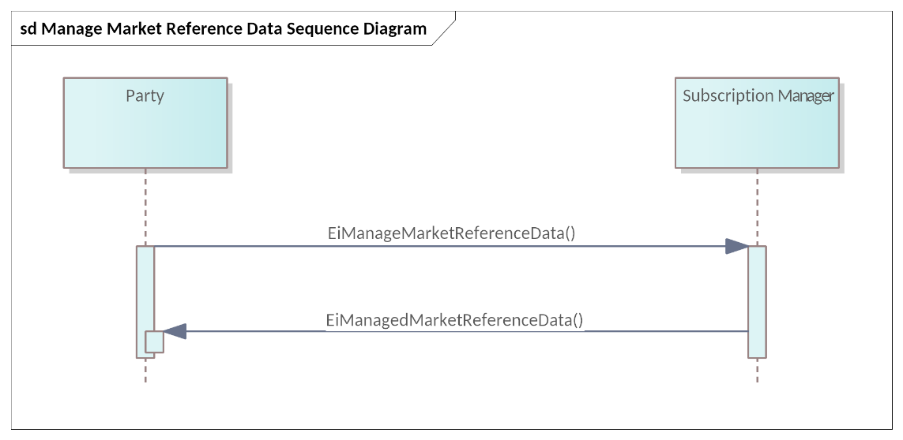

Figure 13‑2: UML Sequence Diagram for Market Reference Data

A Party may watch changes to a single Segment by naming that Segment in the subscription request. This will return only that Segment and updates to that Segment.

### Information Model for Market Reference Data

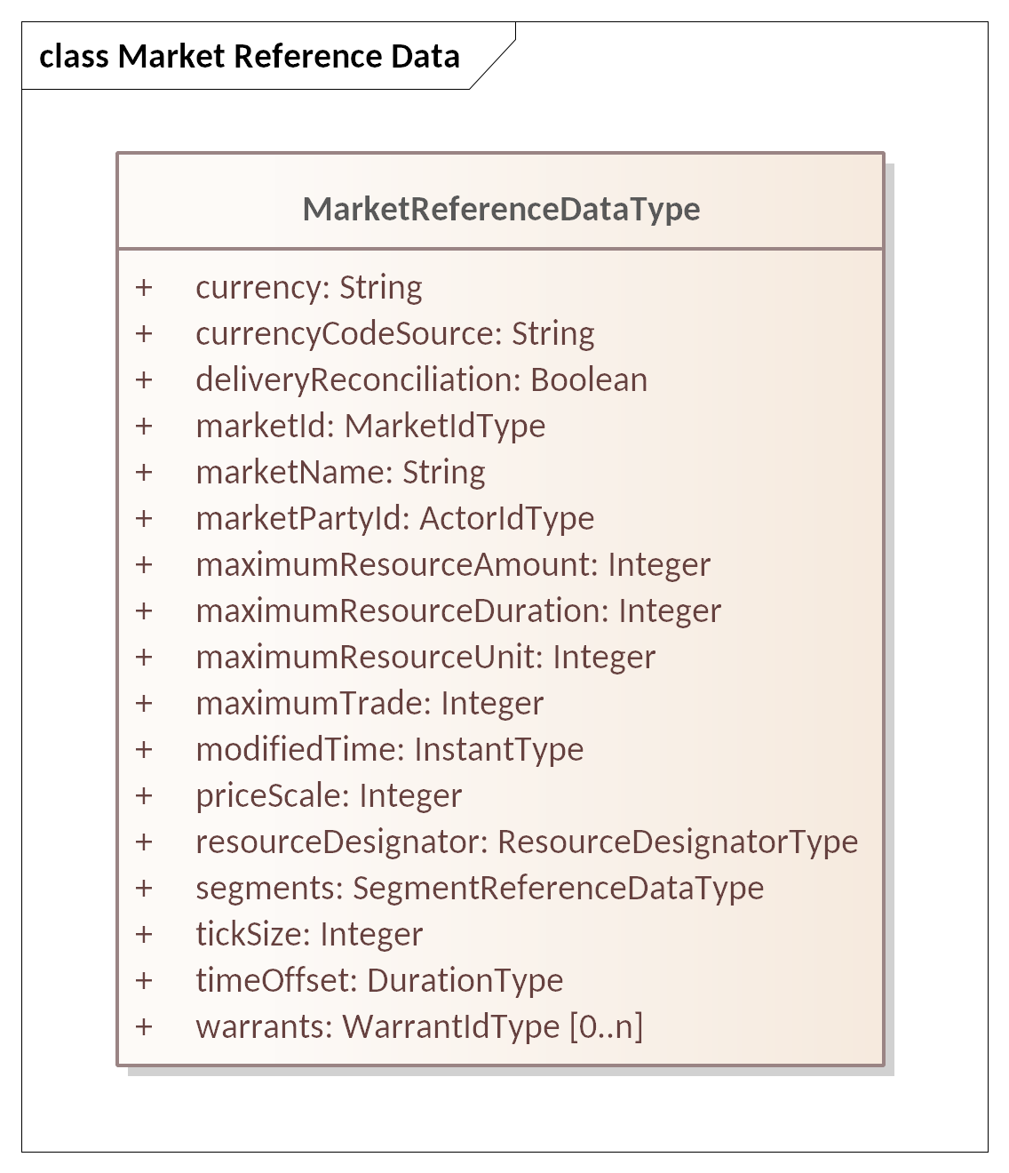

Figure 13‑3: UML Class Diagram for Market Reference Data

Attributes for Market Reference Data are described in Table 13‑3

Table 13‑3 Attributes for Market Reference Data

| Attribute | Attribute Type | FIX Field | Meaning | Comments |
| --- | --- | --- | --- | --- |
| Currency | String | Currency(15) | String indicating how value is denominated in a market. |  |
| Currency Co[de Source](https://fiximate.fixtrading.org/en/FIX.Latest/tag2897.html) | String | CurrencyCo[de Source](https://fiximate.fixtrading.org/en/FIX.Latest/tag2897.html)(2897) | ISO – Fiat Currency per ISO 4217 DTI – Digital Token Identifier  LOC – Locally defined Currency |  |
| Delivery Reconciliation | Boolean | Not in FIX | The Market supports delivery reconciliation of position and delivery. If True, there is a CTS_SPOT segment.  See Section 13.2 Delivery Reconciliation and the CTS Spot Market |  |
| Market ID | Market ID Type | MarketID(1301) | Note that in FIX, this is generally a formal identifier (e.g., “NYSE”), using ISO 10383 (MIC). If the market is a house, there is no place to look this up. There is always a UID for a Market. |  |
| Market Name | String | Not in FIX | Text providing a descriptive name for a Market. While the Name MAY be displayed in a user interface; it is not meaningful to the Actors. |  |
| Market Party ID | Actor ID Type | PartyID(448) | The Party ID used in Tenders to the Market and in Transactions with the Market. May also be used for anonymization of Parties. |  |
| Maximum Resource Amount | Integer |  | Maximum Quantity of Resource Units per Maximum Resource Duration that the Market will permit. |  |
| Maximum Resource Duration | Duration |  | Duration for Maximum Resource Quantity |  |
| Maximum Resource Unit | Integer |  | Units for Maximum Resource Flow per Duration. |  |
| Maximum Trade | Integer |  | The value of the largest trade that the Market permits. |  |
| Modified Time | Instant Type | Not in FIX | The time stamp for when this Market Reference Data was last modified | In Warrence Data, Segment Reference Data, and Session Data. |
| Price Scale | Integer | Not in FIX | A multiplier for the Prices used in this Market.  A Market has a Price Scale; Contained segments also have a Price Scale applicable to that segment. |  |
| Resource Designator | Resource Designator Type |  | The Resource traded in this Market and Segment |  |
| Segments | Segment Reference Data Type | Market Segment | A list of one or more Market Segment descriptions for each Market Segment contained in the Market. See Section 13.5 “Segment Reference Data” |  |
| Tick Size | Integer | Tick Increment (1208) | Specifies the valid price increments at which a Party may quote or trade an Instrument.[32]. Use if a common Tick Increment required for all Market Segments. Tick Increments can increase market liquidity.  Tick Size is a price and is scaled using PriceScale. |  |
| Time Offset | Duration Type |  | A Duration that some Markets MAY use to describe trading where a first interval is not on an “natural” boundary.[33] For example, a market in one hour Power MAY start at 7 minutes after the hour. |  |
| Warrants (Optional) | Warrant ID Type |  | (Optional) Zero or more Warrant IDs that MAY be supported in one or more segments of this market as described in the conformance statement.  Each segment’s reference data indicates which warrants are used. This specification does not define warrants. |  |

### Payloads for Market Reference Data

The following Figure 13‑4 shows the UML Class Diagram for the Market Reference Data [Subscription] payloads.

The attributes are inherited from Subscription Request and Response (Figure 10‑1 and Table 10‑2 and Table 10‑3) so are not repeated here.

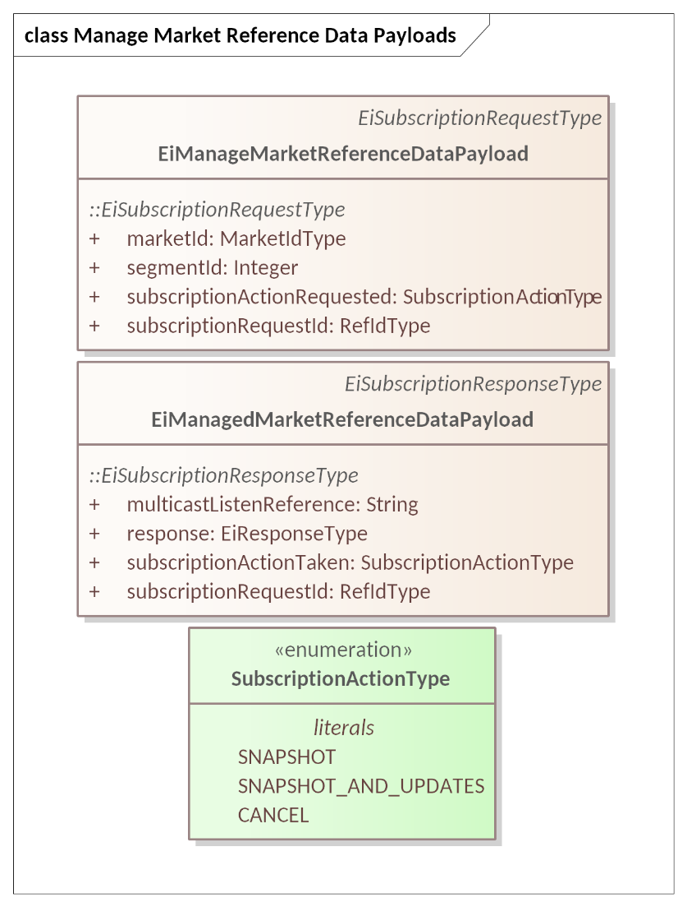

Figure 13‑4 UML Class Diagram for Market Reference Data Subscription Payloads

## Segment Reference Data

A Party must interact with a specific Trading Session to trade a specific Product. A Market MAY contain two or more Segments trading the same Product; such segments may differ in Market Mechanism, or in schedule.

A Party chooses the Segment that it anticipates will be to its greatest advantage. The Party will make this choice based on anticipated price, or on block size, or even on Warrant. Because Transactions are committed when created, a Party may buy on one Market Segment, and thereafter sell part of it on another.

A Party discovers Market Structure, including changes over time, by subscribing to that Market and/or its Segments. Even without market activity, the information provided by a Subscription may change. For example, a Segment may open or close and the biddable Instruments change regularly.

### Messages for Segment Reference Data

Table 13‑4 Messages for Segment Reference Data

| Facet | Request Payload | Response Payload | Notes |
| --- | --- | --- | --- |
| Reference Data | EiManage Segment Reference Data Payload | EiManaged Segment Reference Data Payload | Messages are subclasses of the Subscription Management Messages |

### Interaction Pattern for Segment Reference Data

Figure 13‑5 shows the UML Sequence Diagram for Segment Reference Data.

See Section 10 *“Subscription Facet.”*

Figure 13‑5 UML Sequence Diagram for Segment Reference Data

### Information Model for Segment Reference Data

Segment Reference Data is relatively static, as Segments in typical use are long-lived.

The UML Class Diagram for Segment Reference Data is in Figure 13‑6; the attribute definitions follow in Table 13‑5.

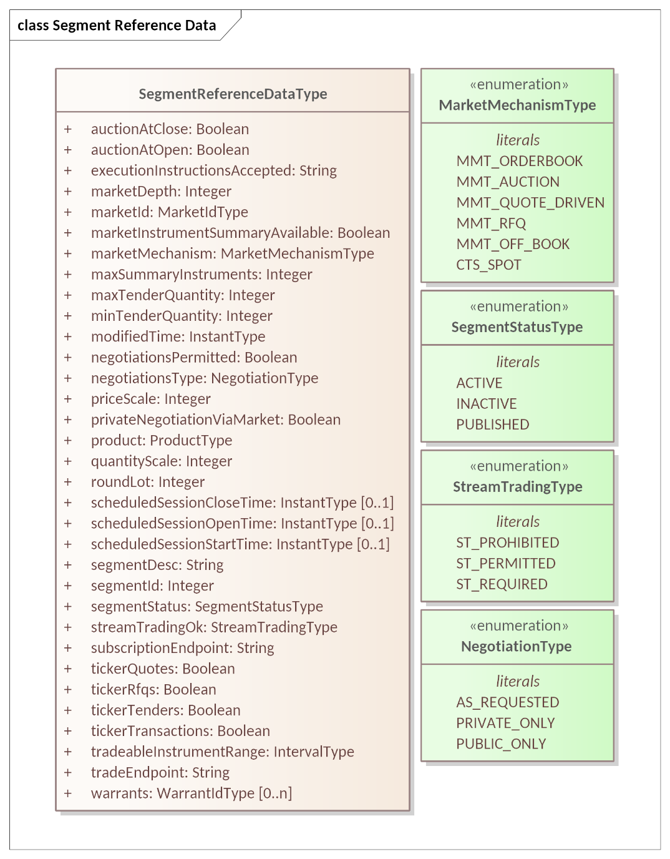

Figure 13‑6 UML Class Diagram for Segment Reference Data

The following table lists the attributes in the Segment Reference Data class shown above; certain attributes are present in both the Segment Reference Data and in the Session Data (See Section 13.6 “Trading Session Data” below.

Table 13‑5 Segment Reference Data

| Attribute | Attribute Type | FIX Field | Meaning | Comments |
| --- | --- | --- | --- | --- |
| Auction at Close | Boolean | [MMT] | Scheduled behavior for related Sessions. | Related to Session Trading Mode Type.  Current session mode is in Session Data. |
| Auction at Open | Boolean |  | Scheduled behavior for related Sessions. | Related to Session Trading Mode Type.  Current session mode is in Session Data. |
| Execution Instructions Accepted | String | ExecInst(18) and ExecInstValue(1308) | A list of Execution Instructions that are accepted in this Segment (see Table 5‑4). | All or None needs to be included in the accepted set if available. |
| Market Depth | Integer | Market Depth (264) | Levels of Book that can be requested | 0 – Unlimited 1-N – 0 – Unlimited 1-N – Up to N |
| Market ID | Market ID Type | MarketID(1301) | Identifies the containing market |  |
| Market Instrument Summary Available | Boolean |  | If FALSE, no Market Instrument Summary is available | Optional |
| Market Mechanism | Market Mechanism Type Enumeration | See [MMT] | Description of mechanism used to match and execute trades. | This is the default Mechanism Type during a Session for this Segment (for (continuous) trading).  Sessions may use different Trading Modes (see Section 13.1) from time to time. [34]  See Section 13.1 “Market Mechanisms” and Section 13.6 “Trading Session Data”. |
| Max Summary Instruments | Integer |  | 0 – U Unlimited Instruments 1-N – Maximum Instruments in a Subscription | If Market Instrument Summary Available is False, this value is ignored. |
| Max Tender Quantity | Integer | MaxTradeVol (1140) | The maximum order quantity in units of Instruments that can be submitted. | FIX TradeVolType (1786) allows round lots or units n (of an instrument). The default is Units; CTS uses units of the instrument.  This is the maximum quantity that can be tendered or a quote lifted. Some Segments MAY set different limits for different Parties. |
| Min Tender Quantity | Integer | MinTradeVol(562) | The minimum number of units that can be ordered. | This is the minimum quantity that can be tendered or a quote lifted. |
| Modified Time | InstantType | Not in FIX | The time stamp for when this Segment Reference Data was last modified | In Market Reference Data, Segment Reference Data, and Session Data. |
| Negotiations Permitted | Boolean | Not in FIX | Segment supports Negotiation | Must be TRUE for MMT “RQ”) |
| Negotiations Type | Negotiation Type Enumeration | Not in FIX | Segment supports the indicated style of negotiation | Private Quotes Only (CTS: PRIVATE_ONLY) Public Quotes Only (CTS: PUBLIC_ONLY) As Requested (CTS: AS_REQUESTED) |
| Price Scale | Integer | Not in FIX | A multiplier for the Price used in this segment | A market segment might be denominated in e.g. dollars or cents[35] based on Market Reference Data Currency.  The Market Price Scale may be the same as the Segment’s Price Scale. |
| Private Negotiation via Market | Boolean | Not in FIX | Private Quotes are sent to the Segment which then forwards them to Counterparties | False – Prohibited – Private Quotes not forwarded by Segment True – Permitted – Segment forwards Private Quotes to listed CounterParties  (FIX uses 0 to represent False, 1 to represent True) |
| Product | Product Type | Not in FIX | Product transactable this Segment. See Defining Product (Section 3.1.2) for details. | Each Product shares a Resource with the Market |
| Quantity Scale | Integer | UnitOfMeasure(996)  UnitOfMeasureQty (1147) | A scale factor for the Resource Unit for this Segment | A factor to convert from market quantity units to the base unit size. See Table 3‑2: Defining the Product. |
| Round Lot | Integer | RoundLot(561) | The trading lot size for an instrument. Chunking quantity for which a Tender may be submitted | For example, for Round Lot of 10, Tenders of 10 and 20 are accepted, and Tenders of 17 are rejected. This is an attribute of the Segment. |
| Scheduled Session Close Time[36] (Optional) | Instant Type | TradSesCloseTime (344) | Closing Time of the trading session.  Date and Time current Session next Closes (or when last session Closed) | Session times may vary for different Market Mechanisms (See Section 13.1)  FIX uses UTC Time Stamps; CTS Instant Type is consistent with ISO 8601  Session Data includes the Session’s actual Start, Open, and Close Times; if present, these are the default or typical session times; if session data is available the session data controls. |
| Scheduled Session Open Time (Optional) | Instant Type | TradSesOpenTime (342) | Opening Time of the trading session.  Date and Time current Session next opens (or when current or last session Opened) | Session Data includes the Session’s typical Start, Open, and Close Times; if present these are the default or typical session times. |
| Scheduled Session Start Time (Optional) | Instant Type | TradSesStartTime (341) | Starting Time of the trading session.  Date and Time when Tenders may first be submitted for the current or next Session | Session Data includes the Session’s typical Start, Open, and Close Times; if present these are the default or typical session times. |
| Segment Desc | String | MarketSegmentDesc (1396) | Text providing a description for the Market Segment. MAY be the null string. | While the Name MAY be displayed in a user interface; it is not meaningful to the Actors. |
| Segment ID | Integer | MarketSegmentID (1300) | Unique Identifier for Segment | Enables market unique ID when combined with the Market ID. |
| Segment Status | Segment Status Type Enumeration | MarketSegmentStatus (2542) | Current trading status of the Market Segment. | 1 = Active: (CTS: ACTIVE) Market segment is active, i.e. trading is possible. 2 = Inactive: (CTS: INACTIVE) Market segment has previously been active and is not currently Open. 3 = Published: (CTS: PUBLISHED) Market segment information is provided prior to its first activation. |
| Stream Trading OK | Stream Trading OK Enumeration | Stream Trading is analogous to what FIX terms multi-leg orders, in which all instruments are [bought] or none. | Applies to both Tenders and Quotes | 0 – Prohibited (default if missing) (CTS: ST_PROHIBITED) 1 – Permitted (CTS: ST_PERMITTED) 2 – Required (CTS: ST_REQUIRED) |
| Subscription Endpoint | String |  | Endpoint for subscriptions to Segment | May be the same as the Trade Endpoint, Segment-specific, the same across a Market, or specific to an Actor. |
| Ticker Quotes | Boolean |  | A Ticker is available for Quotes in this Segment | True – Available for this segment |
| Ticker RFQs | Boolean |  | A Ticker is available for RFQs in this Segment. | True – Available for this segment |
| Ticker Tenders | Boolean |  | A Ticker is available for Tenders in this Segment. | True – Available for this segment |
| Ticker Transactions | Boolean |  | A Ticker is available for Transactions in this Segment. | True – Available for this segment. Transactions Ticker shows Matched Tenders and completed Negotiations in this Segment. |
| Tradeable Instrument Range | Interval Type | Not in FIX | Instruments whose Interval is contained in the Tradeable Instrument Range may be traded. | Uses the Bounding Interval pattern (See Section 3.3 “The Bounding Interval Pattern in CTS”)  Sessions have their own Tradeable Instrument Range which may be more dynamic. |
| Trade Endpoint | String |  | Endpoint to access trade facets of the Segment. | May be Segment-specific, the same across a Market, or specific to an Actor. |
| Warrants (Optional) | Warrant ID Type | Not in FIX | Zero or more Warrant IDs, provided that Warrants are supported by the implementation.  Optional further specificity of Product. Not defined in this specification. | Warrants that MAY be available in one or more Segments are listed in the Market Reference Data.  Warrants available in a particular Segment are listed in the Segment Reference Data..  This specification does not define Warrants. |

### Payloads for Segment Reference Data

The payloads for managing Segment Reference Data are subclasses of the Subscription Management Messages. See Figure 13‑7.

The attributes are inherited from Subscription Request and Response (Figure 10‑1 and Table 10‑2 and Table 10‑3) so are not repeated here.

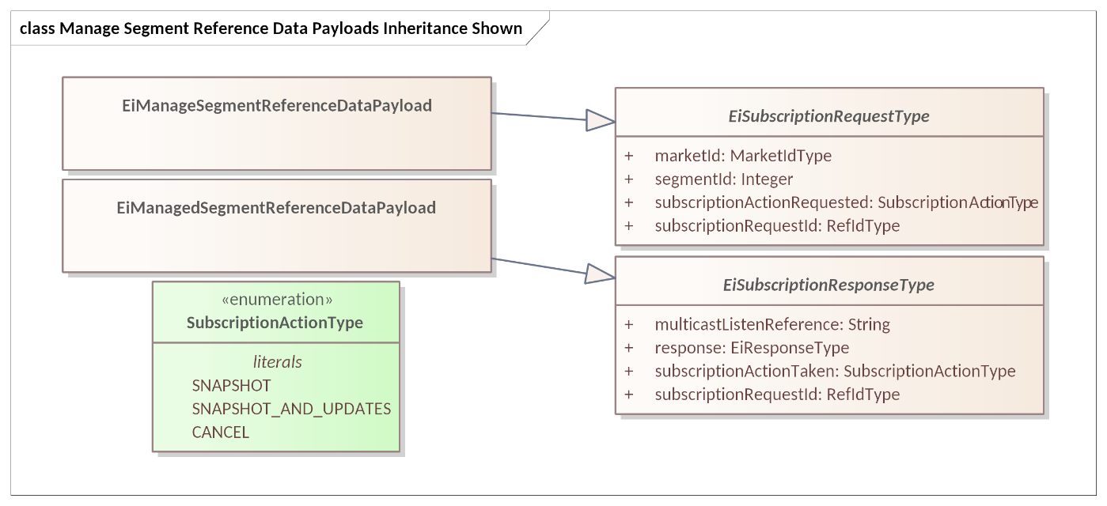

Figure 13‑7 UML Class Diagram of Payloads for Segment Reference Data Subscriptions

The subscription payloads for delivery of Session Reference Data is a single Segment Reference Data Type object (Figure 13‑6 and Table 13‑5 Segment Reference Data).

## Trading Session Data

The Market Structure Report tells the Party how to trade. Following the classification used by FIX, Market Structure Reference Data is just one part of Pre-Trade Information.

Segment Reference Data includes information on Opening and Closing Auctions, as well as information for specific Instruments. It also includes detailed information to guide trading, negotiation, execution, settlement (not in scope for CTS) and audit (supported by CTS, wherein the difference between market Position and measured Delivery is automatically executed).

### Messages for Trading Session Data

Table 13‑6 Messages for Trading Session Data

| Facet | Request Payload | Response Payload | Notes |
| --- | --- | --- | --- |
| Reference Data | EiManage Session Data Payload | EiManaged Session Data Payload | Messages are subclasses of the Subscription Management Messages |

### Interaction Pattern for Trading Session Data

Trading Session Data is very dynamic, and includes (e.g.) information on planned and unplanned closures, auctions, and more. It follows the Subscription pattern—see Section 10 *“Subscription Facet.”*

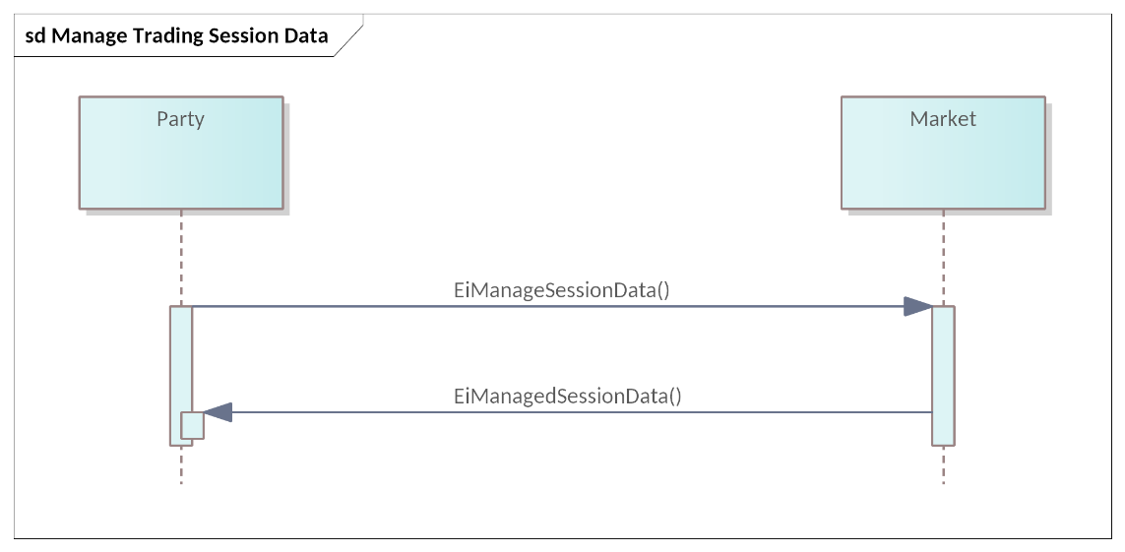

Figure 13‑8: UML Sequence Diagram for Manage Trading Session Data

A Party may watch changes to a single Session by naming that Session in the subscription request. This will return only that Session and updates to that Session.

### Information Model for Trading Session Data

Figure 13‑9 shows the UML Class Diagram for Session Data and the enumerations used.

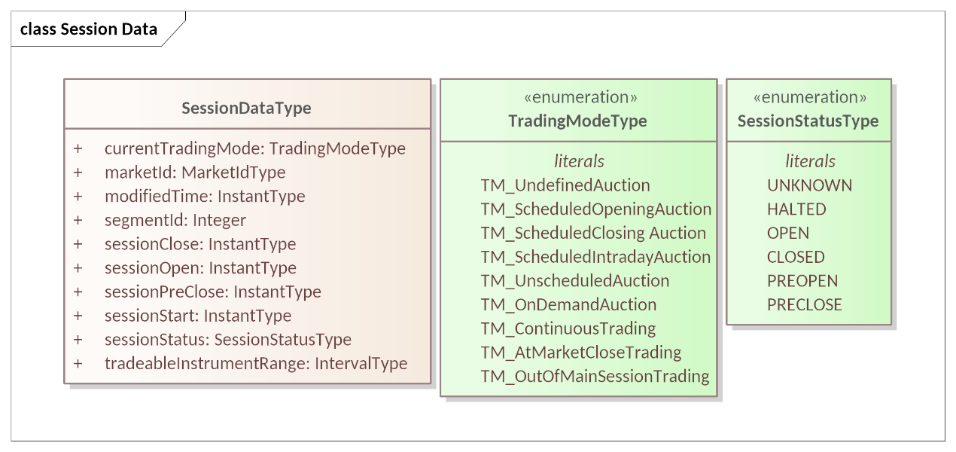

Figure 13‑9 UML Class Diagram for [Trading] Session Data

The attributes for Session Data are in Table 13‑7.

Table 13‑7 Session Data

| Attribute | Attribute Type | FIX Field | Meaning | Comments |
| --- | --- | --- | --- | --- |
| Current Trading Mode | Trading Mode Type | From [MMT] Trading Mode | Active trading mode for the session. From [MMT] | The values used in CTS are restricted from the full Trading Mode list in [MMT] |
| Market ID | Market ID Type | MarketID (1301) | Identifies the containing market |  |
| Modified Time | InstantType | Not in FIX | The time stamp for when this Session Data was last modified | In Market Reference Data, Segment Reference Data, and Session Data. |
| Segment ID | Integer | MarketSegmentID (1300) | Identifies the containing Segment | This is unique when paired with the Market ID |
| Session Close | Instant Type | TradSesCloseTime (344) | Closing time of the trading session | Session times may vary for different Market Mechanisms (Section 0) |
| Session Open | Instant Type | TradSesOpenTime (342) | Time of the opening of the trading session | Follow FIX semantics. |
| Session PreClose | Instant Type | TradSesPreCloseTime (343) | Time of the pre-close of the trading session | Follow FIX semantics. |
| Session Start | Instant Type | TradSesStartTime (341) | Starting time of the trading session | Follow FIX semantics. |
| Session Status | Session Status Type Enumeration | TradSesStatus (340) | The status of this session | Values are   * Unknown * Halted * Open * Closed * PreOpen * PreClose |
| Tradeable Instrument Range | Interval Type | Not in FIX | Instruments whose Interval is contained in the Tradeable Instrument Range may be traded. | See Section 3.3 “The Bounding Interval Pattern in CTS”  Segments have their own Tradeable Instrument Range which may be less dynamic. |

### Payloads for Trading Session Data

The payloads for Session Data are those of the Subscription Management Messages. See Figure 13‑10.

The attributes are inherited from Subscription Request and Response (Figure 10‑1 and Table 10‑2 and Table 10‑3) so are not repeated here.

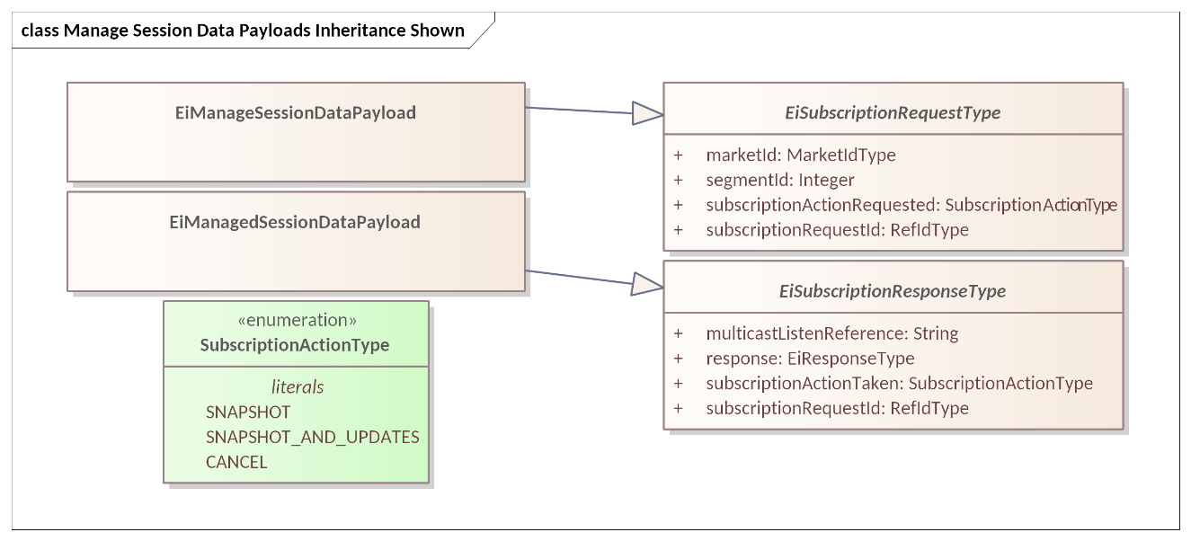

Figure 13‑10 UML Class Diagram of the Payloads for Manage Session Data

# Conformance

## Introduction to Conformance

By design, CTS is a simplified and restricted subset profile of TeMIX with extension for financial market semantics. See Appendix D.

Portions of CTS conform to, and use updated and simplified versions of the specifications consumed by EI, specifically:

* OASIS WS-Calendar **[WS-Calendar]**
* A definition of Streams contained in **[EI]**

We normatively reference and apply the evolution of these specifications, in particular:

* OASIS WS-Calendar Schedule Streams and signals **[Streams]**, simplified as CTS Streams.
* The WS-Calendar **[CAL-MIN]** Interval is used directly (as IntervalType).

This specification simplifies WS-Calendar Schedule Streams and Signals [Streams] as CTS Streams (see Section 0) and refactors the TEMIX profile of **[EI].**

## Claiming Conformance to Common Transactive Services

Implementations claim conformance to Common Transactive Services 1.0 by asserting conformance statements on the numbered items below.

For an implementation to conform

1. The conformance statement MUST list all Facets which it supports in full or and in part. The list MUST include the Tender and Transaction Facets and also Sections 2.4 and 2.5.
2. Stream Tenders and Quotes need not be supported, but whether the implementation supports them MUST be described along with any limitations on their use.
3. The conformance statement MUST describe all extensions to payloads described in this specification.
4. The conformance statement MUST describe the serialization Binding(s) which the conforming implementation uses along with bindings for any extensions to CTS. Note that at present there are no standardized bindings in this specification.[37]
5. The conformance statement MUST describe how each payload definition conforms to the UML and/or profiled definitions for each payload unless it uses only standard Bindings planned for a future Technical Committee document.
6. The conformance statement MUST indicate multiplicity for message payload attributes where there is flexibility in this specification.
7. The conformance statement MUST describe any facets it defines to extend this specification.
8. The conformance statement MUST describe how and to what extent the implementation supports the Subscription Facet (Section 10) and MUST include a list of supported Tickers (Section 11).
9. The conformance statement MUST describe how and to what extent Session, Instrument, Market, Segment, and Instrument Data and subscriptions are produced and delivered (Sections 12 and 13).
10. The conformance statement MUST describe what Market Mechanisms are presented to users of the implementation from the list in Section 13.1 Market Mechanisms and Appendix B.
11. The conformance statement MUST describe how DurationType, InstantType, and IntervalType are implemented.[38]
12. The conformance statement MUST state whether warrants are supported by the implementation.
13. If supported, the conformance statement MUST provide specific and complete descriptions of those warrants upported, including meaning and comparison of warrants and Warrant IDs, and details of how the optional Warrants attributes may be used.[39]

## FIX Conformance

Wherever possible this specification uses concepts and terminology defined by the FIX Trading Community (<https://www.fixtrading.org/>) as expressed in their online standards support tool **[FIXimate**].

All words and terms in the tables that reference a FIX Field are as defined by FIX Trading Community standards and referenced through FIXimate. All have the meaning and effect in interactions as specified by the FIX Trading Community.

CTS and the broad range of FIX specifications have different goals—CTS is a simplified standardized means of interacting with markets, and typically does not express the full richness of complex markets—so CTS has things that are not in FIX and *vice versa*.

There are some differences in naming for operations; FIX naming convention for messages and operations uses the term “Request” in the message name to invoke an operation. A field inside the request message contains the desired operation, e.g. “Cancel”.CTS instead uses simple strongly typed messages that are less complex (and less expressive of market complexities).

## Warrants in Tenders

Warrants are out of scope, but a means of expressing Warrant IDs is in CTS to support possible extensions..

Warrants increase the specificity of Product (and Instrument). A Buyer who does not specify a Warrant will be satisfied by Delivery of a Product whether or not it has a Warrant. A Buyer who requests Product with a Warrant will only be satisfied by Delivery of a Product that has that Warrant.

Consider a buyer who wishes to buy a package of coffee beans and a buyer who wishes to buy a package of organic coffee beans. The word “Organic” on the label serves as a Warrant. The first buyer will buy solely on price, and is indifferent to seeing the word “Organic” on the label. The second buyer will choose only from among those packages with the warrant “Organic” on the label.

When a Tender on the Buy side specifies a Warrant, it must be rejected by any Market Segment that does not support that Warrant. A Tender on the Sell side that specifies a Warrant may be accepted by any Segment where the same Resource and Duration are traded. Conversely, a Tender on the Sell side without a Warrant must be rejected by any Segment that specifies a Warrant.

Note that warrants are identified by Warrant ID (see Sectioni 2.7). Comparison methods MUST be described ini the conformance statement. It suffices to compare the WarrantIDs, which are subclassed UIDs.

1. References

This appendix contains the normative and informative references that are used in this document. Normative references are specific (identified by date of publication and/or edition number or Version number) and Informative references may be either specific or non-specific.

While any hyperlinks included in this appendix were valid at the time of publication, OASIS cannot guarantee their long-term validity.

* 1. Normative References

The following documents are referenced in such a way that some or all of their content constitutes requirements of this document.

[CAL-MIN]  
*WS-Calendar Minimal PIM-Conformant Schema* Version 1.0. Edited by William Cox and Toby Considine. 26 August 2016. OASIS Committee Specification. <http://docs.oasis-open.org/ws-calendar/ws-calendar-min/v1.0/ws-calendar-min-v1.0.html>

**[CAL-PIM]**   
OASIS WS-Calendar Platform-Independent Model version 1.0, Committee Specification 02 Edited by William T. Cox and Toby Considine, 21 August 2015. <http://docs.oasis-open.org/ws-calendar/ws-calendar-pim/v1.0/cs02/ws-calendar-pim-v1.0-cs02.html> Latest version: http://docs.oasis-open.org/ws-calendar/ws-calendar-pim/v1.0/ws-calendar-pim-v1.0.html

**[EI]**  
*Energy Interoperation Version 1.0*. Edited by Toby Considine, 11 June 2014. OASIS Standard. <http://docs.oasis-open.org/energyinterop/ei/v1.0/os/energyinterop-v1.0-os.html> Latest version: <http://docs.oasis-open.org/energyinterop/ei/v1.0/energyinterop-v1.0.html>. and its TeMIX Profile

**[EMIX]**   
OASIS Energy Market Information Exchange (EMIX) Version 1.0 Committee Specification 02 Edited by Toby Considine, 11 January 2012. <http://docs.oasis-open.org/emix/emix/v1.0/cs02/emix-v1.0-cs02.html> Latest version: <http://docs.oasis-open.org/emix/emix/v1.0/emix-v1.0.html>

[JSON]

JavaScript Object Notation and JSON Schema. <https://cswr.github.io/JsonSchema/>

[**MMT]**  
FIX Trading Community Market Model Typology v4.2, June 18, 2024, retrieved July 2, 2024, <https://www.fixtrading.org/mmt/>. Table is in linked spreadsheet at <https://www.fixtrading.org/packages/mmt_v4-2_18-jun-2024a/>

[RFC8174]  
Leiba, B., "Ambiguity of Uppercase vs Lowercase in RFC 2119 Key Words", BCP 14, RFC 8174, DOI 10.17487/RFC8174, May 2017, <<http://www.rfc-editor.org/info/rfc8174>>.

[RFC2119]  
Bradner, S., "Key words for use in RFCs to Indicate Requirement Levels", BCP 14, RFC 2119, DOI 10.17487/RFC2119, March 1997, <<http://www.rfc-editor.org/info/rfc2119>>.

**[RFC2246]**T. Dierks, C. Allen *Transport Layer Security (TLS) Protocol Version 1.0*, <http://www.ietf.org/rfc/rfc2246.txt>, IETF RFC 2246, January 1999.

**[SBE]**Simple Binary Encoding Technical Specification 1.0. FIX Trading Community, June 16, 2016. <https://www.fixtrading.org/standards/sbe/> Also ISO/IEC 25390:2025, April 2025.

[Streams]  
*Schedule Signals and Streams Version 1.0.* Edited by Toby Considine and William T. Cox. 18 September 2016. OASIS Committee Specification. <http://docs.oasis-open.org/ws-calendar/streams/v1.0/streams-v1.0.html>.

* 1. Informative References

The following referenced documents are not required for the application of this document but may assist the reader with regard to a particular subject area.

**[Actor Model]**C. Hewitt, "Actor Model of Computation: Scalable Robust Information Systems," arxiv.org, 2010.

**[Fractal Microgrids]**Art Villanueva et al, *Camp Pendleton Fractal Microgrid Demonstration,* California Energy Commission Report CEC-500-2016-013,j available at <http://400.sydneyplus.com/CaliforniaEnergy_SydneyEnterprise/Download.aspx?template=Books&field=PublicURL&record=57483797-a40e-49e7-b675-2858a3ad0d91&showSave=False&repeat=d4e63b56-27d1-4476-9300-7ede86a533ca>

**[Framework]**National Institute of Standards and Technology, *NIST Framework and Roadmap for Smart Grid Interoperability Standards, Release 1.0*, January 2010, <http://nist.gov/public_affairs/releases/upload/smartgrid_interoperability_final.pdf>

**[CTS2016]**W.T. Cox, E. Cazalet, E., A Krstulovic, W Miller, & W.Wijbrandi *Common Transactive Services*. TESC 2016. Available at <http://coxsoftwarearchitects.com/Resources/TransactiveSystemsConf2016/Common%20Transactive%20Services%20Paper%2020160516.pdf>

**[EML-CTS]**Energy Mashup Lab Common Transactive Services (open-source software) <https://github.com/EnergyMashupLab/eml-cts>)

**[FIXimate]**FIXimatesm FIX Interactive Message And Tag Explorer  
[https://FIXimate.fixtrading.org/](https://fiximate.fixtrading.org/)

**[FSGIM]***Facility smart grid information model*. ISO 17800. <https://www.iso.org/standard/71547.html> 2017

**[iCalendar]**B. Desruisseaux*, Internet Calendaring and Scheduling Core Object Specification (iCalendar)*, <https://tools.ietf.org/html/rfc5545>. 2009,   
See also  
C. Daboo & M. Douglas. *Calendar Availability*, <https://tools.ietf.org/html/rfc7953>, 2016

**[GridFaultResilience]**W.T. Cox & T. Considine. *Grid Fault Recovery and Resilience: Applying Structured Energy and Microgrids*. IEEE Innovative Smart Grid Technologies 2014. Available at <http://coxsoftwarearchitects.com/Resources/ISGT_2014/ISGT2014_GridFaultRecoveryResilienceStructuredMicrogrids_Paper.pdf>

[**IEC62746-10-3]** International Standard.   
Systems interface between customer energy management system and the power management system - Part 10-3: Open automated demand response - Adapting smart grid user interfaces to the IEC common information model, <https://webstore.iec.ch/publication/59771> 2018.

[Micromarkets]  
W.T. Cox & T. Considine, *Energy, Micromarkets, and Microgrids.*   
GridInterop 2011, <https://www.gridwiseac.org/pdfs/forum_papers11/cox_considine_paper_gi11.pdf>

[RFC3552]  
E Rescorla & B. Korver, "Guidelines for Writing RFC Text on Security Considerations", BCP 72, RFC 3552, DOI 10.17487/RFC3552, July 2003, <https://www.rfc-editor.org/info/rfc3552>.

**[SmartGridBusiness**]  
T. Considine & W.T. Cox, *Smart Loads and Smart Grids—Creating the Smart Grid Business Case*. Grid-Interop 2009. Available at <http://coxsoftwarearchitects.com/Resources/Grid-Interop2009/Smart%20Loads%20and%20Smart%20Grids.pdf>

**[StructuredEnergy]***Structured Energy: Microgrids and Autonomous Transactive Operation*, <http://coxsoftwarearchitects.com/Resources/ISGT_2013/ISGT-Cox_StructuredEnergyPaper518.pdf>. Innovative Smart Grid Technologies 2013 (IEEE).

**[TPB-EI]**   
Transport Protocol Bindings for OASIS Energy Interoperation 1.0 Version 1.0. 01 October 2012. OASIS Committee Specification 01.  
<https://docs.oasis-open.org/energyinterop/tpb-ei/v1.0/tpb-ei-v1.0.pdf> .

**[TeMIX]**TeMIX Transactive Energy Market Information Exchange [TeMIX] an approved Note of the EMIX TC. Ed Cazalet et al., 23 May 2010. <http://www.oasis-open.org/committees/download.php/37954/TeMIX-20100523.pdf>

**[TransactiveMicrogrids]**Jennifer M. Worrall, Edward G. Cazalet, PhD, William T. Cox, PhD, Narayanan Rajagopal, Thomas  
R. Nudell, PhD, and Paul D. Heitman, *Energy Management in Microgrid Systems,*TESC 2016. Available at <http://coxsoftwarearchitects.com/Resources/TransactiveSystemsConf2016/tes2016_microgrids_paper_Final.pdf>

**[TRM] (Transactive Resource Management)**B. Huberman and S. H. Clearwater, *Thermal markets for controlling building environments*, Energy Engineering*,* vol. 91, no. 3, pp. 26- 56, January 1994.

**[UML]**Object Management Group, *Unified Modeling Language (UML), V2.5.1*, December 2017. <https://www.omg.org/spec/UML/2.5.1/>

[XSD]  
*W3C XML Schema Definition Language (XSD) 1.1*. Part 1: Structures, S Gao, C. M. Sperberg-McQueen, H Thompson, N Mendelsohn, D Beech, M Maloney <http://www.w3.org/TR/xmlschema11-1/>, April 2012, Part 2: Datatypes, D Peterson, S Gao, A Malhotra, C. M. Sperberg-McQueen, H Thompson, P Biron, <http://www.w3.org/TR/xmlschema11-2/> April 2012

**[ZeroTrust]**Zero Trust Architecture, S Rose, O Borcher, S Mitchell, S Connelly. NIST Special Publication 800-207, <https://doi.org/10.6028/NIST.SP.800-20> August 2020

1. Building Markets using CTS

The semantics of the FIX Trading Community support every major financial market and can support almost any trading interaction. Markets based on the FIX protocol are international in scope or sized for the smallest securities dealer.

Resource markets are based around the physical delivery of the Resource. A corollary of this is that local Markets will be best suited to balance local supply and demand. Distributed energy, for example, may create a local surplus that distribution systems cannot deliver in real time to a remote customer. In a similar way, resource storage systems enable a Party to perform arbitrage in the local market. A Resource Market may rely primarily on distant supply even as it accommodates local suppliers. This diversity of sources may dictate different Market Segments in the same Market, perhaps with different trading horizons and different rules.

Resource Markets today have typically used their own market semantics. CTS aligns the resource markets semantically with financial markets in part to reduce impedance when a trader backs a Resource Instrument with a Financial Instrument. This unavoidably introduces new language to Resource Markets.

The authors of CTS cannot specify which market mechanism to use in every situation. This non-normative section discusses some ways to build Resource Markets using the example of Electrical Power and based on the semantics of CTS and the FIX Trading Community.

See Section 13.1 “*Market Mechanisms*” for the normative description of market mechanisms.

* 1. Central Limit Order Book: Simple Bids & Offers

The central limit order book, also known colloquially simply as an order book, is the market many see when investing. Would-be buyers submit bids which the market immediately executes or writes in the order book. Would-be sellers submit offers which the market writes in the order book. The order book represents the collective actions of buyers and sellers who place orders to buy or sell an asset at a specific price.

The order book continuously updates as new orders are added, as the market matches existing orders, and as orders are cancelled. The Market Segment creates Transactions by matching compatible buy orders and sell orders. Matches are made based on price-time priority, where orders are filled based on the highest bid and the lowest ask, and when these prices overlap, the order that was placed first gets priority.

When a Segment matches a submitted order against one or more orders on the book, the Segment executes a trade creating a transaction, and the order book is updated to reflect the new supply and demand levels.

In summary, the order book market matching process is a continuous cycle of order formation, order matching, and price discovery, driven by the interactions of buyers and sellers in the marketplace. Customers can trade directly with dealers, dealers can trade with other dealers, and importantly, customers can trade directly with other customers anonymously.

* 1. Periodic Auctions

Participants in periodic auctions submit bids and offers up until a published deadline. After the deadline, all tenders are evaluated and a common price is determined, e.g. at which the greatest volume can be executed. All bids (tenders to buy) above that common price are accepted, and all offers (tenders to sell) below that price are accepted. All transactions clear at the common price. Any remaining Tenders are referred to as the Residual.

The North American bulk power markets are run largely through periodic auctions (e.g., with transactions in day-ahead markets announced the day before) to enable large generators to schedule their operations.

Periodic auctions are also referred to as “Double Auctions”, that is, auctions in which both sellers and buyers submit bids.

Some financial markets conduct an auction when the market opens or closes to set the opening price as well as to remove accumulated orders from the order book. Pre-opening auctions have been discussed to support smooth recovery of power grids following a blackout.

* 1. Quote-Driven Segments

Quote-driven markets typify markets with dominant suppliers or market makers providing additional liquidity by offering to buy and/or sell at any time. The price of the resource is determined and announced by the dominant suppliers. The dominant suppliers MAY represent many third parties, i.e., a distribution system operator (DSO) acting as an intermediary to a bulk power market.

Quote-Driven Markets permit partial lifting, that is a Party may issue a Tender for 7kWh in response to a Quote for 150 kWh. Quote Driven Markets do not normally process Rejections or accept counter-Quotes as a Quote Response; Quotes are issued on a take-it-or-leave-it basis.

In typical FIX Protocol-based markets, quotes are non-negotiable and are valid for a short time, perhaps three seconds. In existing power markets using quotes for day-ahead markets, they may be available for hours. In either case, if buyers take all the quantity in a quote, a dominant supplier has the option of submitting a new quote, potentially at a different price.

A common example of a quote-driven market is one in which an electric utility announces 24 hourly prices for the next day. These are good until a certain time and indicate the maximum quantity that the issuer is willing to sell at that price. In CTS, these will be tradeable quotes. A buyer or seller submits a Quote Response containing a Tender which can automatically match against a tradeable quote.

This pattern is useful because at the limit, all resource markets are limited by the maximum potential rate of resource delivery. Once that limit is reached, the market maker may avoid all further transactions by not entering additional quotes.

In some regulated electricity markets, the price received for selling power is less than the price paid for buying power, establishing a spread. A market maker may opt to publish a range of quotes to buy as well and benefit from the spread by buying and selling a resource at different times as the prices fluctuate.

Quote-driven CTS markets are typically highly regulated markets.

* 1. Request for Quote Markets—Negotiating

Request for quote markets support bilateral negotiations around price and quantity. Interactions begin with a request for quote (RFQ), which may be vague as to prices, quantities, or even the price schedule of the Instruments. The recipient of an RFQ may reply with one or more indicative or tradeable quotes, perhaps for different delivery times or quantities. When an acceptable tradeable Quote is received, the party wishing to lift that Quote responds with a Quote Response that notifies the Market of the acceptance. The Market then generates a Transaction.

The Negotiation process is inherently flexible. A Transaction may come after many rounds of negotiation, or directly from a response to the first tradeable quote. This section describes some potential interactions to clarify the concepts.

An RFQ Market can permit large buyers to plan significant resource use over time, for example, scheduling a long running industrial process which also requires labor planning. Such a buyer could submit multiple Requests for Quotes with different schedules, and then select from among the Quotes received in response.

An RFQ uses a Bounded Interval to indicate what an acceptable Quote would be.

* Consider Party A that wishes to buy 15 kW of power over a two-hour period, sometime within an 8-hour window. This would take the form of submitting an RFQ to Party B with an eight-hour Bounding Interval with a specific start time, but with a Stream of two Intervals with a Duration of 1 hour but with no starting time specified.

Consider instead that Party A further wishes to buy 10 kW of energy over an hour at $0.05/kWh sometime during the workday. Party A can issue an RFQ, with a bounding duration of the workday, containing a single unscheduled Interval of one hour containing the Price and the Quantity.

Party A and B can send these RFQs directly to one or more potential counterparties or published to the entire market. Because it is not tradeable, a RFQ does not need to be submitted to the Market and the Segment does not need to register the RFQ. The response is a quote, either indicative or tradeable.

Party A may receive one or more offers in response. These become more specific, perhaps two Quotes issued by the same counterparty with different prices at different times. A quote issuer may make a counteroffer by sending a quote proposing different quantities and/or prices. Perhaps the responding Party considers that it will turn on a generator, but only if it can operate the generator at an economic rate for an economic duration. A quote MAY be for only one of the two hours indicated in the original RFQ, leaving the requesting Party to find an acceptable match from among all the offers (quotes) it receives. The prices may be higher or lower than requested in the original RFQ. Until one party issues a tradeable Quote, all responses are RFQs or indicative Quotes, issued to continue the negotiation.

When either Party thinks that there is an essential meeting of requirements, that Party submits a tradeable Quote, that is a quote that a matching Tender will turn into a Transaction. For a CTS quote to be tradeable, the Party informs the Segment, even if it is a private quote and not published.

To accept a tradeable Quote, a Party submits a Tender to the Segment, referencing the Quote ID, and matching the details of the quote. The market mechanism compares the Tender to the quote, and, if they match, it executes the Transaction. All tradeable quotes are treated as if they are marked All-or-None (AON).

The issuer normally accepts a Tender received in response to a tradeable Quote, with exceptions for expiration or for another Tender having gotten to the Segment first.

The issuer MUST accept a Tender received in response to a tradeable Quote.

Negotiations may include Interval Quotes or Stream Quotes, a pattern that matches that of Tenders (See Section 5.3.1, *“Interval Tenders and Stream Tenders.”*) A Stream Quote must be matched to a Stream Tender in the Quote Response to create a Transaction. A requester that wishes to acquire a power curve indicates this with a Stream Quote back indicates it in the RFQ or indicative Quote Note: the response does not need to match the request; the Indicative or Tradeable Quote received in response may propose a different Stream.

Below are three non-normative scenarios for negotiation to illustrate the flexibility of Negotiation: (1) Single-provider, (2) over the counter, and (3) system recovery.

1. Parties may choose to use a negotiated trade because they wish to bypass certain market restrictions. For example, consider a Party wishing to buy 87 kWh of Power for a period over 1 hour and 5 minutes beginning 15 minutes after the hour. Parties negotiate as above, come to terms, as above, and the Segment records the Transaction.
2. Order Book Segments impose restrictions on Round Lots and Intervals to improve Market Liquidity, that is, the likelihood of a match between a Tender to Buy and a Tender to Sell. If Parties already have made an agreement, then there is no need to improve liquidity. This makes the Durations and Round-Lots in negotiated markets indicative rather than prescriptive. 87 kWh is a rough match for Off-Market Segment with a 20 kWh round lot—a GWh is not. In a comparable way, the quote’s Duration is a rough match for Segment with an Hour Duration while 3 minutes is not.
3. Markets commonly project opening prices for Instruments before they open. If a system recovery requires a market re-start, there may be no good information to set opening prices. Prior to a re-start, a Segment may publish RFQs to buy and to sell. The Operator may use a Segment to probe the potential market in this way several times, perhaps with different prices and quantities, to discover an indicative opening price at which the Resource will be in rough balance. (This rough balancing MAY be by an implied auction.) When the market has enough information, then the market opens a Segment for trading, announcing the indicative opening prices for each Instrument.

This specification does not require that a Market segment include any of the scenarios described above. We include them to illustrate how the essential components of Negotiation might fit together in a specific system.

* 1. Market Mechanisms Refined from or Not Defined in the FIX MMT

As traditional regulated and centrally managed resource markets migrate to TE, CTS supports one mechanism not defined in the FIX Market Model Typology [MMT] and re-defines the use of the Off Book MMT.

* + 1. Off-Book segment

Off-Book Segments process Tenders made directly between Parties. There is no presumption as to how the Tenders are aligned or created. The Market must validate still validate the interaction and create the Transaction; two parties may not create a Transaction that would interfere with Market operation.

A transactive resource market may be used to balance resource flows within a microgrid or other local distribution system. Markets solve the knowledge problem of balancing supply and demand over time even when all parties or systems have a common owner.

CTS considers a special case of Off Book transactions wherein a Resource or Position is transferred between two Parties under common ownership. i.e., the direct allocation of Resource from one Party to another by a process external to the Market. Parties are notified through the receipt of trade notices (Transactions).

A common scenario, say on a campus or base, is to handle scarce resources through direct assignment to one of the parties. Consider a campus of 10 buildings and a hospital. The owner may wish to create a Transaction in which each commercial building transfers 10 kWh to the hospital which receives 100 kWh into its position. The donor buildings must then trade within their own accounts to rebalance supply and demand, or re-balance operations to stay within their new position.

On military bases, this may be described as power following command intent. The Party gaining or losing power is responsible for adjusting operations to align with its new Position.

* + 1. Price Distribution Segments

Price Distribution Markets are essentially minimal Quote-Driven Markets with one-way interaction. A Quotes Ticker distributes prices for each time of delivery. All Quotes are indicative only; the Buyer cannot submit a bid to lift the quote and create a Transaction.

A Price Distribution Segment may quote different prices to buy and to sell for the same delivery period. The Segment MAY continually update the quoted prices, as, for example, a heat wave pushes up the price of electricity beyond that in an earlier Quote.

The Market generates all transactions after-the-fact, by reading the meter (See Delivery). The Transaction Price assessed by the Market for this imputed Transaction is that of the last Quote published for each measured period.

* + 1. Spot Markets

See Section 13.2 *“Delivery Reconciliation and the CTS Spot Market Mechanism”*, for a normative description of Spot Markets.

A Quote Ticker in a spot market indicates the “instant” price in the Segment indicating the Price for purchases or sales. A spot market Segment may limit active trading to a small window of time.

A spot market segment MAY accept Tenders to sell as the market maker tries to pull a resource back into the market to address a looming shortfall.

A spot market may support an asymmetry of self-execution, perhaps creating transactions for unplanned consumption but not for unplanned sales from existing Position. A Spot Market would indicate this by issuing Quotes to Sell but no Quotes to Buy. Whether accompanied by RFQ negotiations or not, a Spot Market is different than a Price Distribution Segment in that customers may have a Market Position from prior trading, and that the Market considers Position when computing the imputed Transactions if any.

* 1. Regulatory Reporting

The semantics of the FIX Trading Community are commonly used for regulatory reporting. The categories of market mechanism came in part from a desire by regulators to understand how different customers paid different prices for similar transactions.

We anticipate that any wide-spread use of Transactive Resource Markets will require preparing reports for regulators. Those designing Market software should plan to make note of the market mechanism used to generate the price in each transaction.

This specification makes no statements about the information in or format of possible regulatory reports on transactive resource markets.

1. Security and Privacy Considerations

This specification defines message payloads only. Security must be composed in. Privacy considerations must be decided when implementing specific systems for specific purposes.

* 1. CTS and Security Considerations

Procuring energy for local use and selling energy for remote use are each at the cusp of finance and operations.

* A price that is falsely low may cause the buyer to operate a system when there is inadequate power, potentially harming systems within a facility, or harming other facilities on the same circuit.
* A price that is falsely low may cause the seller to leave the market.
* A price that is falsely high may cause the buyer to shut down operation of systems or equipment.
* A price that is falsely high may cause the seller to increase operations when there is neither a ready consumer nor perhaps even grid capacity to take delivery.

For these reasons, it is important that each system guard the integrity of each message, assure the identities of the sender and of the receiver, and prove whether a message was received or not.

Messages should be encrypted to prevent eavesdropping. Any node should be able to detect replay, message insertion, deletion, and modification. A system must guard against and detect man-in-the-middle” attacks wherein an intermediary node passes of messages as originating from a known and trusted source.

The Technical Committee generally recommends that production implementations use Zero-Trust security **[ZeroTrust]**, especially because of the wide distribution and potentially diverse ownership of TRM Actors. Zero Trust security requires authentication and authorization of every device, person, and application. The best practice is to encrypt all messages, even those between the separate components of an application within the cloud.

This specification makes no attempt to describe methods or technologies to enable Zero Trust interactions between Actors.

* 1. CTS and Privacy Considerations

The United Nations has defined privacy as “the presumption that individuals should have an area of autonomous development, interaction and liberty, a ‘private sphere’ with or without interaction with others, free from state intervention and excessive unsolicited intervention by other uninvited individuals. The right to privacy is also the ability of individuals to determine who holds information about them and how that information is used” (UN General Assembly 2013:15).

Electrical usage data inherently creates a privacy risk. Published work has demonstrated that simple usage data can be used to reveal the inner operations and decisions in a home. Other research has demonstrated that anonymous electrical usage data can be “de-anonymized” to identify an individual electricity user. The more fine-grained the data, the more intimate the details that can be garnered from meter telemetry.

In an amicus brief in a case on smart metering, the Electronic Freedom Foundation testified that that aggregate smart meter data collected from someone’s home in 15-minute intervals could be used to infer, for example, whether they tend to cook meals in the microwave or on the stove; whether they make breakfast; whether and how often they use exercise equipment, such as a treadmill; whether they have an in-home alarm system; when they typically take a shower; if they have a washer and dryer, and how often they use them; and whether they switch on the lights at odd hours, such as in the middle of the night. And these inferences, in turn, can permit intimate deductions about a person's lifestyle, including their occupation, health, religion, sexuality, and financial circumstances. These privacy concerns are linked to increased security risks criminals may be able to access the data and use the information to enable inferences about what people are doing in their home or if they are away from home.

This specification describes how to share communications beyond mere electrical usage telemetry. Communications reveal what the user would like to buy, how much they would be willing to spend, and future intents and plans.

System developers using this specification should consider legal requirements under the Fair Practice Principles and the European Union's General Data Protection Regulation. These include:

1. The Collection Limitation Principle. There should be limits to the collection of personal data and any such data should be obtained by lawful and fair means and, where appropriate, with the knowledge or consent of the data subject.
2. The Data Quality Principle. Personal data should be relevant to the purposes for which they are to be used and, to the extent necessary for those purposes, should be accurate, complete and kept up to date.
3. The Purpose Specification Principle. The purposes for which personal data are collected should be specified not later than at the time of data collection and the subsequent use limited to the fulfillment of those purposes or such others as are not incompatible with those purposes and as are specified on each occasion of change of purpose.
4. The Use Limitation Principle. Personal data should not be disclosed, made available or otherwise used for purposes other than those specified, except a) with the consent of the data subject, or b) by the authority of law.
5. The Security Safeguards Principle. Personal data should be protected by reasonable security safeguards against such risks as loss or unauthorized access, destruction, use, modification or disclosure of data.
6. The Openness Principle. There should be a general policy of openness about developments, practices and policies with respect to personal data. Means should be readily available of establishing the existence and nature of personal data and the main purposes of their use, as well as the identity and usual residence of the data controller.
7. The Individual Participation Principle. An individual should have the right:

* to obtain from a data controller, or otherwise, confirmation of whether or not the data controller has data relating to him.
* to have data relating to him communicated to him, within a reasonable time, at a charge, if any, that is not excessive; in a reasonable manner, and in a form that is readily intelligible to him.
* to be given reasons if a request made under subparagraphs (a) and (b) is denied and to be able to challenge such denial; and
* to challenge data relating to him and, if the challenge is successful, to have the data erased, rectified, completed or amended.

1. The Accountability Principle. A data controller should be accountable for complying with measures which give effect to the principles stated above.

In developing this specification, the Technical Committee has kept in mind the need to support a developer wishing to support privacy. Actors representing an up-stream electrical serving entity, say a distribution system operator or traditional utility, use the tame messages as anyone else—no actor is inherently privileged. Messages to provide market information or “tickertape” functions do not include Party IDs. General advertising of Tenders, while necessary to draw matching Tenders quickly to market, may be anonymous.

In some messages and some markets, it is necessary to use a proxy ID to protect privacy or to simply conveyance of a transaction from a complex matching mechanism. To protect privacy, a market may transmit such a proxy ID in place of a Party Id in Quotes, Tenders, Transactions, and Tickers. Markets that use cumulative matching algorithms such as double auction cannot identify a specific Counter Party to a transaction.

The system developer should keep the privacy principals in mind when making specific technology choices. For example, messages between an actor and the market MAY be encrypted to protect the privacy of people represented by individual actors. While the transactive energy market must know both buyers and sellers to support transactions and settlements, the developer should take steps to guard that information. A developer may opt that each notice of contract sent to an actor always has a counterparty of the market, so as to protect the sources and uses of electricity.

It is beyond the scope of this specification to specify security practices and privacy design for markets built using this specification.

1. Semantic Composition from Energy Interoperation, EMIX, and WS-Calendar

This Common Transactve Services specification draws on semantics previously defined by this and related Technical Committees. The history presented in this informative Appendix may be of interest to readers.

The predecessor standard, Energy Interoperation [EI] of which the TEMIX profile is part, applies other standards including [EMIX] and [WS-Calendar], and uses an earlier Streams definition. We have adapted, updated, and simplified the use of the referenced standards, while maintaining semantic conformance in a broad sense.[40]

We note that

* EMIX described price and product for electricity markets.
* WS-Calendar communicates schedules and sequences of operations. CTS uses the [Streams] optimization, which is a standalone specification, rather than part of EI 1.0.
* EI uses the vocabulary and information models defined by those specifications to describe the services that it provides. The payload for each EI service references a product defined using **[EMIX]**. EMIX schedules and sequences are defined using [WS-Calendar]. Any additional schedule-related information required by [EI] is expressed using [WS-Calendar].
* Since [EI] was published, a semantically equivalent but simpler [Streams] specification was developed in the OASIS WS-Calendar Technical Committee. CTS uses that simpler [Streams] specification.

All terms used in this specification are as defined in their respective specifications.

In [EI], the fundamental resource definition was the [EMIX] Item, composed of: a resource name, a unit of measure, a scale factor, and a quantity. For example, a specific EMIX Item may define a Market denominated in 25 MWh bids. [EI] defined how to buy and sell items during specific intervals defined by a duration and a start time. The Quotes, Tenders, and Transactions that are the subject of [EI] added specific prices and quantities to the item and interval. EMIX optionally included a location, i.e., a point of delivery for each [EI] service.

In CTS, we group and name these elements as a Resource, Product, and Instrument. These terms are defined in Section 2.2.4, “Markets and Market Segments”

Note that the informational elements in a fully defined tender or transaction are identical to those described in EMIX. The conceptual regrouping enables common behaviors including Market discovery and interoperation between Actors built on different code bases.

* 1. Conformance with Energy Interoperation

EI defines an end-to-end interaction model for transactive services and for demand response. CTS uses the EI transactive services and draws definitions of parties and transactive interactions primarily from the [EI] TEMIX profile.

This specification can be viewed as a minimal transactive profile of [EI].

* 1. Conformance with EMIX

This specification uses a simplified profile of the models and artifacts defined in OASIS Energy Market Information Exchange **[EMIX]** to communicate Product definitions, quantities, and prices. EMIX provides a succinct way to indicate how prices, quantities, or both vary over time.

The EMIX Product definition is the Transactive Resource in CTS 1.0.

EMIX defines Market Context, a URI used as the identifier of the Market. EMIX further defines Standard Terms as retrievable information about the Market that an actor can use to configure itself for interoperation with a given Market. We extend and clarify those terms, provide an extension mechanism, and discuss the relationship of markets, market segments, and products.

* 1. Conformance with WS-Calendar Streams

WS-Calendar expresses events and sequences to support machine-to-machine (M2M) negotiation of schedules while being semantically compatible with human schedules as standardized in [**iCalendar**]. Schemas in **[WS-Calendar]** support messages that are nearly identical to those used in human schedules. We use a conformant but simpler and more abstract Platform Independent Model **[CAL-PIM]** and the [**Streams**] compact expression[41], to support telemetry (Delivery Facet) and series of Tenders while not extending the semantics of [**Streams**].[42]

WS-Calendar conveys domain specific information in a per-event payload within a schedule-centric message; in CTS, the domain is the price, product, and quantity. An essential concept of WS-Calendar is inheritance, by which a starting time can be applied to an existing message, or by which all events in a sequence share common information such as duration. Inheritance is used to “complete” a partial message during negotiation. CTS makes use of this to apply a common product across a sequence, or to convey a specific starting time to a market product.

* 1. CTS and WS-Calendar Streams

The **[Streams]** specification describes how to handle repeating time series of similar data, applying repeating information to a series of schedulable intervals, expressing common information once for the series, overriding the common information only if needed within a specific interval, and potentially scheduling (“binding”) the entire series by adding a starting date and time to one of the Intervals.

For CTS, this means that a Product is fully described in the header, and only the elements that vary, such as the Price or the Quantity, are expressed in the intervals.

CTS Streams use this same format even when the Intervals contain only a single Interval.

In addition, CTS Streams include energy-market elements that are outside the Streams standard but follow the pattern of referrals as defined in [Steams] conformance.

CTS Streams have neither interaction patterns nor payloads, as they are a common abstract information model used to define the messages used in Facet messages.

The CtsStream follows this pattern. The elements from **[Streams]** have been flattened into the CTS Stream, and the Stream Interval and payload flattened into a streamPayloadValue and the internal local UID for the stream element. See Section 3.2 CTS Streams: Expressing Time Series.



Figure D‑14‑1: CtsStream Definition (Repeated from Figure 3‑5)

As with **[Streams]**, CtsStreamIntervals are ordered, that is the sequence of intervals is essential. Some serialization specifications, notably XML, do not require that order be preserved when deserializing a list. The Stream UID enables proper ordering of the Stream Intervals in case order is not preserved. Since conformant CTS implementations need not be owned by the same implementer, and may pass through multiple translations, the UID property is required.

1. Glossary of Terms and Abbreviations Used in this document

Throughout this document, abbreviations are used to improve clarity and brevity, especially to reference specifications with long titles.

Table C‑‑14‑1 Abbreviations and Terms used throughout this document

| Attribute | Meaning |
| --- | --- |
| CTS | Common Transactive Services |
| EI | Energy Interoperation, an OASIS specification as per the normative references, CTS is a conforming profile of EI. |
| EMIX | Energy Market Information Exchange, an OASIS specification used to describe Products and markets for resources, particularly those traded in power grids. |
| FIX | The Financial Information Exchange Protocol is a vendor-neutral electronic communications protocol for the international real-time exchange of securities transaction information. The FIX Protocol language is comprised of a series of messaging specifications used in trade communications. FIX is maintained by the FIX Trading Community. |

1. Acknowledgments

This work is derived from the specification Common Transactive Services 1.0 , contributed by The Energy Mashup Lab, written by William T. Cox and Toby Considine.

Portions of models and text are derived from The Energy Mashup Lab open-source project EML-CTS and is used with explicit permission under the terms of the Apache 2.0 License for that project.[43]

* 1. Participants

The following individuals were members of this Technical Committee during the creation of this document and their contributions are gratefully acknowledged:

Rolf Bienert, OpenADR Alliance  
Toby Considine, University of North Carolina at Chapel Hill  
William T. Cox, Individual Member  
Pim van der Eijk, Sonnenglanz Consulting  
David Holmberg, National Institute for Standards & Technology (NIST)  
Elysa Jones, Individual Member  
Chuck Thomas, Electric Power Research Institute (EPRI)

Hanno Klein and members of the FIX Trading Community Transactive Resource Working Group

* 1. Special Thanks

The Technical Committee extends a special thanks to Hanno Klein, FIX Technical Director. Hanno’s patient explanations of trading semantics and suggestions for approaches that would increase the commonality of financial markets and CTS markets were invaluable. His knowledge of global, open and free standards for trading is unparalleled. Where we missed our mark, it is where we misunderstood his advice.

1. Revision History

| Revision | Date | Editor | Changes Made |
| --- | --- | --- | --- |
| WD01 | 2/15/2021 | Toby Considine | Initial reformatting and conversion of the specification contributed by The Energy Mashup Lab to create a document for committee work. |
| WD02 | 3/3/2021 | Toby Considine | Added prose definitions of Resource, Product, and Instrument |
| WD03 | 4/5/2021 | Toby Considine | Simplified introductory material, raised message type to earlier in document. Removed some repetitive material. Revised UML required. |
| WD04 | 5/7/2021 | Toby Considine David Holmberg William T Cox | Reordered intro material to reduce repetition, Reference Actor Model more consistently, Revise and re-factor Resource/Product/Instrument Add Section 3 to elevate common semantic elements |
| WD05 | 5/25/2021 | Toby Considine David Holmberg William T Cox | Continues clean-up and condensation of sections 1, 2 |
| WD06 | 6/7/2021 | Toby Considine | Refines Item language into Resource and Products. Explains Message Groups as a conforming descendant of EI Services. |
| WD07 | 6/21/2021 | Toby Considine  William T Cox | Clarified terminology and relationship to implied Service-Oriented Architecture. Structured CTS facets for clearer explanation |
| WD08 | 8/5/2021 | Toby Considine  William T Cox  David Holmberg | Clarify and simplify actor facets descriptions, including Tender, Transaction, and Configuration. Reduce redundant and less relevant content. |
| WD09 | 9/14/2021 | William T Cox  Toby Considine  David Holmberg | Added Facet descriptions for Position, Market Characteristics, CTS Streams, and drafts of Privacy Consideration, Delivery and Party Registration Facets. Numerous edits for clarity and conciseness. |
| WD10 | 10/4/2021 | Toby Considine  William T Cox  David Holmberg | Extended Market Facets. Defined Position and Delivery facets. Made references more consistent. Updated UML model and diagrams. |
| WD11 | 10/22/2021 | David Holmberg William T Cox Toby Considine | Corrections for clarity. Improved UML diagrams. Flagged requests for comments in Public Review |
| CSD01 | 10/29/2021 | OASIS TC Administration | Content as in WD11, formatted to include OASIS metadata and references to the published specification |
| WD12 | 1/10/2022 | William T Cox Toby Considine | Simpler edits in response to comments from PR |
| WD13 |  | William T Cox Toby Considine | Clarification of Resource/Product/Instrument Removal of references to “Architecture” Responses to “Clarity” tagged issues |
| WD14 | 2/22/2022 | William T Cox Toby Considine | Clarification of front material Section 1/-2 compared to eliminate duplicative definitions Numerous issues resolutions applied as per Jira |
| WD15 | 3/20/2020 | William T Cox Toby Considine | Clarity, responses to issues from Review |
| WD16 | 4/12/2022 | William T Cox Toby Considine | Marketplace and Market characteristics responses to issues Expanded Quotes and Tickers Focus on capitalization |
| WD17 | 4/25/2022 | William T Cox Toby Considine | Updated UML Market Information added OTC Transactions Edits for Clarity |
| WD18 | 9/19/2023 | Toby Considine | First response to FIX meetings Changed to Market/Market Segment language Reference FIX Tags when known Closings and Crossings added First pass at FIX-conformant Market Data Reports |
| WD19 | 10/2024 | Toby Considine | Response to Second PR  Preparations to work with |
| WD20-22 |  | Toby Considine | Re-writes while discussing with FIX.  Added Negotiations, Tickers, Instrument Data, Market Structure |
| WD23 | 6/23/2024 | Toby Considine | Post PR03, showing all comments received |
| WD24 | 7/7/2024 | Toby Considine William T. Cox | Working through public review comments  Simplification of Tickers and Market Structure  Re-work and simplification of Negotiations |
| WD25 | 7/7/2024 | Toby Considine | Accepted simpler comments to focus attention to larger issues |
| WD26 | 7/17/2024 | Toby Considine | Moved material on selecting a Market Mechanism and on non-normative illustrations of business interactions to an appendix |
| WD27 | 8/12/2024 | William T. Cox Toby Considine | Rework of models and exposition for all negotiations & subscriptions (9-12) |
| WD28 | 8/27/2024 | William T Cox | UML updates and revisions for the entire technical content of the specification. |
| WD29 |  | William T Cox Toby Considine David Holmberg | Subscriptions, and more consistent delineations of Structure (non-volatile) and Session (volatile) data throughout.  Many smaller edits to align earlier parts of document with the specification as it has emerged in later details. |
| WD30 | 11/23/2024 | Toby Considine | All “simple” FIX comments addressed (wrong variable name, etc.) All other review comments incoporated into document |
| WD31 | 1/17/2015 | William T Cox Toby Considine David Holmberg | PR Comments processed and applied misc Editorial comments, clarity addressed misc formatting errors |
| WD32 | 2/17/202 | William T Cox Toby Considine | Detailed analysis of UML model, tables, and sequence diagrams, which drove minor technical and editoral corrections. |
| WD33 | 6/8/2025 | William T Cox Toby Considine David Holmberg | Incorporate review comments from Public Review 05 CSD06. Clarify Spot market and other descriptions. Perform audit of UML diagrams and synchronize with associated tables. Editoral review to clarify text. |
| WD34 | 6/23/2025 | William T Cox Toby Considine | Audit UML Diagrams and synchronize with text. Normalize reference IDs. Allign MMT with current understanding. Update Appendix B non-normative discussion of applying CTS. |
| WD35 | 6/23/2025 | William T. Cox | Minor clarifications based on FIX Trading suggestions. Approved as CS01 |

Notices

Copyright © OASIS Open 2025. All Rights Reserved.

All capitalized terms in the following text have the meanings assigned to them in the OASIS Intellectual Property Rights Policy (the "OASIS IPR Policy"). The full [Policy](https://www.oasis-open.org/policies-guidelines/ipr/) may be found at the OASIS website: [<https://www.oasis-open.org/policies-guidelines/ipr/>].

This document and translations of it may be copied and furnished to others, and derivative works that comment on or otherwise explain it or assist in its implementation may be prepared, copied, published, and distributed, in whole or in part, without restriction of any kind, provided that the above copyright notice and this section are included on all such copies and derivative works. However, this document itself may not be modified in any way, including by removing the copyright notice or references to OASIS, except as needed for the purpose of developing any document or deliverable produced by an OASIS Technical Committee (in which case the rules applicable to copyrights, as set forth in the OASIS IPR Policy, must be followed) or as required to translate it into languages other than English.

The limited permissions granted above are perpetual and will not be revoked by OASIS or its successors or assigns.

This document and the information contained herein is provided on an "AS IS" basis and OASIS DISCLAIMS ALL WARRANTIES, EXPRESS OR IMPLIED, INCLUDING BUT NOT LIMITED TO ANY WARRANTY THAT THE USE OF THE INFORMATION HEREIN WILL NOT INFRINGE ANY OWNERSHIP RIGHTS OR ANY IMPLIED WARRANTIES OF MERCHANTABILITY OR FITNESS FOR A PARTICULAR PURPOSE. OASIS AND ITS MEMBERS WILL NOT BE LIABLE FOR ANY DIRECT, INDIRECT, SPECIAL OR CONSEQUENTIAL DAMAGES ARISING OUT OF ANY USE OF THIS DOCUMENT OR ANY PART THEREOF.

As stated in the OASIS IPR Policy, the following three paragraphs in brackets apply to OASIS Standards Final Deliverable documents (Committee Specifications, OASIS Standards, or Approved Errata).

[OASIS requests that any OASIS Party or any other party that believes it has patent claims that would necessarily be infringed by implementations of this OASIS Standards Final Deliverable, to notify OASIS TC Administrator and provide an indication of its willingness to grant patent licenses to such patent claims in a manner consistent with the IPR Mode of the OASIS Technical Committee that produced this deliverable.]

[OASIS invites any party to contact the OASIS TC Administrator if it is aware of a claim of ownership of any patent claims that would necessarily be infringed by implementations of this OASIS Standards Final Deliverable by a patent holder that is not willing to provide a license to such patent claims in a manner consistent with the IPR Mode of the OASIS Technical Committee that produced this OASIS Standards Final Deliverable. OASIS may include such claims on its website, but disclaims any obligation to do so.]

[OASIS takes no position regarding the validity or scope of any intellectual property or other rights that might be claimed to pertain to the implementation or use of the technology described in this OASIS Standards Final Deliverable or the extent to which any license under such rights might or might not be available; neither does it represent that it has made any effort to identify any such rights. Information on OASIS' procedures with respect to rights in any document or deliverable produced by an OASIS Technical Committee can be found on the OASIS website. Copies of claims of rights made available for publication and any assurances of licenses to be made available, or the result of an attempt made to obtain a general license or permission for the use of such proprietary rights by implementers or users of this OASIS Standards Final Deliverable, can be obtained from the OASIS TC Administrator. OASIS makes no representation that any information or list of intellectual property rights will at any time be complete, or that any claims in such list are, in fact, Essential Claims.]

The name "OASIS" is a trademark of [OASIS](https://www.oasis-open.org/), the owner and developer of this document, and should be used only to refer to the organization and its official outputs. OASIS welcomes reference to, and implementation and use of, documents, while reserving the right to enforce its marks against misleading uses. Please see <https://www.oasis-open.org/policies-guidelines/trademark/> for above guidance.

1. <https://www.fixtrading.org/>
2. SOA is occasionally mis-described as a *client-server* approach. In distinction, services are requested by an Actor and fulfilled by another Actor. In SOA the services offered are key, and the actors take different roles in different interactions.
3. In ISO and IEC standards, portions that are not normative are *informative*. OASIS uses the term *non-normative*.
4. In a double auction, there are tenders to buy and tenders to sell, and all participants clear at the same price. FIX simply uses the term “Auction”.
5. This pattern was developed and is used by IEC Technical Committee 57 (Power Systems).
6. The [MMT] standard originated from an initiative of the Federation of European Securities Exchanges aiming at improving the consistency and comparability of data from different data sources. To encourage wider adoption and recognition, the MMT standard has been placed under the FIX Protocol Limited Trust.
7. As an example of the *Correlation Pattern* for messages
8. See e.g. <https://en.wikipedia.org/wiki/List_of_HTTP_status_codes>
9. Certain serializations for payloads do not guarantee order, so a small integer serves as a unique identifier for each interval.
10. See Section ‎9 *“The Negotiation Facet”* and Section ‎13.1, *“Market Mechanisms*” for discussions where the message target may not be the Market.
11. This avoids a potential race condition in variable latency distributed systems.
12. A CTS_SPOT segment MAY accept (transact) quotes in response to RFQs issued by that segment. The RFQs may solicit quotes for instruments of any duration.
13. Segment Reference Data includes which Execution Instructions are supported.
14. CTS overloads MarketOrderIdType (FIX OrderID(17)) for RFQ IDs and for Quote IDs.
15. FIX uses MultiLeg for an order with multiple securities—each is a *Leg Instrument*—. This should be distinguished from a Stream Tender where all or no legs must be accepted.
16. Some aspects of the market’s mechanism(s) are visible to actors who are trading, generally where the mechanism affects rational bidding strategies. For example, bidding very low in an auction market is reasonable (as you get the clearing price), but bidding very low in an order book market is not (as you may get something like what you offered). See Section ‎13 and Market Mechanisms.
17. Attribute "Positions" is a list of positions for the given Party and the resources it has. FIX has position report messages, but the FIX messages convey multiple positions in a specific instrument, not for a specific party (the owning party is also part of the message) in multiple instruments.
18. Note that a Market trades one resource. A position is with respect to the given Market.
19. Note that a Market trades one resource. A position is with respect to the given Market.
20. This is the same pattern used in Sections ‎3.3 “The Bounding Interval Pattern in CTS”, ‎7 (Position Facet) and ‎8. (Delivery Facet)
21. Consider a Buyer seeking a Seller willing to run a generator for three hours. The Seller, for economic or operational reasons is unwilling to run the generator for less than 6 hours and returns a stream quote indicating this longer Interval.
22. A CTS Stream may be considered to implicitly includes a bounding Interval.
23. Including assigning a Market Order ID.
24. In UML formal terminology, EiAcceptQuote Payload and EiAcceptedQuote Payload are generalizations respectively of EiCreateTransaction Payload and EiCreatedTransation Payload. Informally, one would say “An EiAcceptQuote Payload *is an* EiCreateTransaction Payload with a few other attributes.” All attributes are inherited from the respective base class. See Figure ‎9‑10 Negotiation Facet Accept and Accepted Quote Payloads.
25. For example, a large generator may have a ramp up period to reach full power followed by a ramp down period. A long-running industrial process may issue RFQs to find the best time to run a process, and then lift a Quotation to select an operating schedule.
26. FIX uses Multileg for an order with multiple securities; we apply the term to a Create RFQ with multiple included RFQs. This should be distinguished from a Stream RFQ where all or no legs must be responded to.
27. FIX uses Multileg for an order with multiple securities; we apply the term to a CreateQuote with multiple included Quotes. This should be distinguished from a Stream Quote where all or no legs must be accepted.
28. Just as for message payloads, how these are delivered is out of scope. Some Markets and Segments may use multicast or delivery as response message(s).
29. For example, in a CTS MMT_AUCTION segment, bidding a negative price means that the bidder will get the clearing price, which may be positive or negative, consistent with bult power markets today. A negative tender in an MMT_ORDERBOOK segment may clear at that price.
30. Consider the case of a quote ticker delivering tradeable quotes. Those quotes may be lifted in the Segment in the quote, which should be a Quote-Driven Market (MMT Code QB, CTS MMT_QUOTE_DRIVEN).

    A quote ticker for a SPOT Segment giving buy or sell side quotes for delivery reconciliation must reference the SPOT Segment.
31. RFQs should request Tradeable quotes to avoid multiple negotiation round trips.
32. Integer operations are typically much more efficient than fixed or floating point, so it is likely to be much faster to apply decimal shift on input and output rather than for more frequent comparison operations in the Execution Engine implementation.
33. A power distribution entity may experience disruption if there is a big price change on the hour. For example, a distribution system operator (DSO) that operates multiple CTS Markets could opt to set a different offset on each Market Segment operated out of a given substation. In this model, a Market could use an offset duration of 3 minutes to indicate that all tenders are based on three minutes after the hour.
34. For example, a Session might pre-open with an Auction, followed by Order Book for the bulk of the session, and end with a closing Auction.
35. In a Segment with Price Scale of 100, a trade price of one is one one-hundredth of the intrinsic currency from Market Reference Data—price tendered is in cents if the currency is USD.
36. Note that session data may not be available; the session close, open, and start times should match session data times if available.
37. Formal bindings are planned by the Technical Committee in a forthcoming Technical Report *Bindings for Common Transactive Services (CTS) Version 1.0.*
38. Careful specification, e.g. of how these types are represented perhaps with native programming language types, will simplify interoperation and integration of CTS implementations.
39. Note that there are Warrants attributes in many definitions in this specification, with multiplicity 0..n.
40. Conformance of the CTS evolved specification to these previous specifications can be shown with the techniques of informative [**IEC62746-10-3]** .
41. Simplified as CTS Streams in this specification.
42. Some specifications (e.g. [FSGIM]) have extended the basic [Streams] capabilities, but this brings additional complexity which does not benefit our use cases.
43. https://github.com/EnergyMashupLab/eml-cts