
Cloud Application Management for Platforms Version 1.1
Committee Specification Draft 03 /
Public Review Draft 01
31 July 2013
Specification URIs
This version:
http://docs.oasis-open.org/camp/camp-spec/v1.1/csprd01/camp-spec-v1.1-csprd01.pdf (Authoritative)
http://docs.oasis-open.org/camp/camp-spec/v1.1/csprd01/camp-spec-v1.1-csprd01.html
http://docs.oasis-open.org/camp/camp-spec/v1.1/csprd01/camp-spec-v1.1-csprd01.doc
Previous version:
http://docs.oasis-open.org/camp/camp-spec/v1.1/csd02/camp-spec-v1.1-csd02.pdf Authoritative)
http://docs.oasis-open.org/camp/camp-spec/v1.1/csd02/camp-spec-v1.1-csd02.html
http://docs.oasis-open.org/camp/camp-spec/v1.1/csd02/camp-spec-v1.1-csd02.doc
Latest version:
http://docs.oasis-open.org/camp/camp-spec/v1.1/camp-spec-v1.1.pdf (Authoritative)
http://docs.oasis-open.org/camp/camp-spec/v1.1/camp-spec-v1.1.html
http://docs.oasis-open.org/camp/camp-spec/v1.1/camp-spec-v1.1.doc
Technical Committee:
OASIS Cloud Application Management for Platforms (CAMP) TC
Chair:
Martin Chapman (martin.chapman@oracle.com), Oracle
Editors:
Jacques Durand (jdurand@us.fujitsu.com), Fujitsu Limited
Adrian Otto (adrian.otto@rackspace.com), Rackspace Hosting, Inc.
Gilbert Pilz (gilbert.pilz@oracle.com), Oracle
Tom Rutt (trutt@us.fujitsu.com), Fujitsu Limited
Abstract:
This document defines the artifacts and APIs that need to be offered by a Platform as a Service (PaaS) cloud to manage the building, running, administration, monitoring and patching of applications in the cloud. Its purpose is to enable interoperability among self-service interfaces to PaaS clouds by defining artifacts and formats that can be used with any conforming cloud and enable independent vendors to create tools and services that interact with any conforming cloud using the defined interfaces. Cloud vendors can use these interfaces to develop new PaaS offerings that will interact with independently developed tools and components.
Status:
This document was last revised or approved by the OASIS Cloud Application Management for Platforms (CAMP) TC on the above date. The level of approval is also listed above. Check the “Latest version” location noted above for possible later revisions of this document.
Technical Committee members should send comments on this specification to the Technical Committee’s email list. Others should send comments to the Technical Committee by using the “Send A Comment” button on the Technical Committee’s web page at http://www.oasis-open.org/committees/camp/.
For information on whether any patents have been disclosed that may be essential to implementing this specification, and any offers of patent licensing terms, please refer to the Intellectual Property Rights section of the Technical Committee web page (http://www.oasis-open.org/committees/camp/ipr.php).
Citation format:
When referencing this specification the following citation format should be used:
[CAMP-v1.1]
Cloud Application Management for Platforms Version 1.1. 31 July 2013. OASIS Committee Specification Draft 03 / Public Review Draft 01. http://docs.oasis-open.org/camp/camp-spec/v1.1/csprd01/camp-spec-v1.1-csprd01.html.

Notices
Copyright © OASIS Open 2013. All Rights Reserved.
All capitalized terms in the following text have the meanings assigned to them in the OASIS Intellectual Property Rights Policy (the "OASIS IPR Policy"). The full Policy may be found at the OASIS website.
This document and translations of it may be copied and furnished to others, and derivative works that comment on or otherwise explain it or assist in its implementation may be prepared, copied, published, and distributed, in whole or in part, without restriction of any kind, provided that the above copyright notice and this section are included on all such copies and derivative works. However, this document itself may not be modified in any way, including by removing the copyright notice or references to OASIS, except as needed for the purpose of developing any document or deliverable produced by an OASIS Technical Committee (in which case the rules applicable to copyrights, as set forth in the OASIS IPR Policy, must be followed) or as required to translate it into languages other than English.
The limited permissions granted above are perpetual and will not be revoked by OASIS or its successors or assigns.
This document and the information contained herein is provided on an "AS IS" basis and OASIS DISCLAIMS ALL WARRANTIES, EXPRESS OR IMPLIED, INCLUDING BUT NOT LIMITED TO ANY WARRANTY THAT THE USE OF THE INFORMATION HEREIN WILL NOT INFRINGE ANY OWNERSHIP RIGHTS OR ANY IMPLIED WARRANTIES OF MERCHANTABILITY OR FITNESS FOR A PARTICULAR PURPOSE.
OASIS requests that any OASIS Party or any other party that believes it has patent claims that would necessarily be infringed by implementations of this OASIS Committee Specification or OASIS Standard, to notify OASIS TC Administrator and provide an indication of its willingness to grant patent licenses to such patent claims in a manner consistent with the IPR Mode of the OASIS Technical Committee that produced this specification.
OASIS invites any party to contact the OASIS TC Administrator if it is aware of a claim of ownership of any patent claims that would necessarily be infringed by implementations of this specification by a patent holder that is not willing to provide a license to such patent claims in a manner consistent with the IPR Mode of the OASIS Technical Committee that produced this specification. OASIS may include such claims on its website, but disclaims any obligation to do so.
OASIS takes no position regarding the validity or scope of any intellectual property or other rights that might be claimed to pertain to the implementation or use of the technology described in this document or the extent to which any license under such rights might or might not be available; neither does it represent that it has made any effort to identify any such rights. Information on OASIS' procedures with respect to rights in any document or deliverable produced by an OASIS Technical Committee can be found on the OASIS website. Copies of claims of rights made available for publication and any assurances of licenses to be made available, or the result of an attempt made to obtain a general license or permission for the use of such proprietary rights by implementers or users of this OASIS Committee Specification or OASIS Standard, can be obtained from the OASIS TC Administrator. OASIS makes no representation that any information or list of intellectual property rights will at any time be complete, or that any claims in such list are, in fact, Essential Claims.
The name "OASIS" is a trademark of OASIS, the owner and developer of this specification, and should be used only to refer to the organization and its official outputs. OASIS welcomes reference to, and implementation and use of, specifications, while reserving the right to enforce its marks against misleading uses. Please see http://www.oasis-open.org/policies-guidelines/trademark for above guidance.

Table of Contents
1 Introduction 10
1.1 Overview 10
1.2 Purpose 10
1.3 Example (non-normative) 11
1.4 Non-Goals 12
1.5 PaaS Roles 12
1.6 Terminology 12
1.7 Specification Version 13
1.7.1 Backwards Compatibility 13
1.8 Normative References 13
1.9 Non-Normative References 14
2 Concepts and Types 15
2.1 Application Assemblies 16
2.1.1 Platform 16
2.1.2 Assemblies 17
2.1.3 Components 17
2.1.4 Capabilities and Requirements 17
2.1.5 Operations and Sensors 18
2.1.6 Resource Relationships 20
2.2 Deployment 21
2.3 Versions and Extensions 22
2.4 Parameters 24
2.5 CAMP Common Types 25
2.6 Representation Skew 26
3 Application Management Lifecycle 27
3.1 Initial Platform Resources 27
3.2 Creating an Assembly Template from a PDP 27
3.3 Creating and Managing an Application Assembly 28
3.4 Removing Assemblies and Assembly Templates 29
4 Platform Deployment Package 30
4.1 PDP Package Structure 30
4.1.1 Supported Archive Formats 30
4.1.2 Validating Integrity 30
4.2 Deployment Plan Overview 30
4.2.1 Types 31
4.2.2 Service Specifications 31
4.2.3 Names, Description, and Tags 34
4.3 Deployment Plan Schema 35
4.3.1 General Attributes 35
4.3.2 DeploymentPlan 35
4.3.3 ArtifactSpecification 36
4.3.4 ServiceSpecification 37
4.3.5 ContentSpecification 37
4.3.6 RequirementSpecification 38
4.3.7 CharacteristicSpecification 39
5 Resources 40
5.1 Common Types 40
5.1.1 Boolean 40
5.1.2 String 40
5.1.3 URI 40
5.1.4 Timestamp 40
5.1.5 Link 40
5.1.6 RequirementTemplateLinks 40
5.2 Attribute Constraints 41
5.2.1 Required 41
5.2.2 Mutable 41
5.2.3 Consumer-mutable 41
5.3 Common Resource Attributes 41
5.3.1 uri 41
5.3.2 name 42
5.3.3 description 42
5.3.4 tags 42
5.3.5 type 42
5.3.6 representationSkew 42
5.4 Error Response Message Resource 43
5.5 HTTP Method Support 45
5.6 PlatformEndpoints Resource 45
5.6.1 platformEndpointLinks 45
5.7 PlatformEndpoint Resource 46
5.7.1 specificationVersion 46
5.7.2 backwardCompatibleSpecificationVersions 46
5.7.3 implementationVersion 47
5.7.4 backwardCompatibleImplementationVersions 47
5.7.5 platformUri 47
5.8 Platform Resource 47
5.8.1 supportedFormatsUri 48
5.8.2 extensionsURI 48
5.8.3 typeDefinitionsURI 48
5.8.4 platformEndpointsURI 48
5.8.5 specificationVersion 49
5.8.6 implementationVersion 49
5.8.7 assemblyTemplates 49
5.8.8 assemblies 49
5.8.9 platformComponentTemplates 49
5.8.10 platformComponentCapabilities 50
5.8.11 platformComponents 50
5.8.12 parameterDefinitionsUri 50
5.9 AssemblyTemplate Resource 50
5.9.1 applicationComponentTemplates 51
5.9.2 parameterDefinitionsUri 51
5.9.3 pdpUri 51
5.9.4 dpUri 51
5.10 ApplicationComponentTemplate Resource 52
5.10.1 assemblyTemplate 52
5.10.2 applicationComponentDependencies 52
5.10.3 platformComponentDependencies 52
5.11 ApplicationComponentRequirement Resource 53
5.12 ApplicationComponentCapability Resource 53
5.13 PlatformComponentTemplate Resource 53
5.13.1 parameterDefinitionsUri 54
5.14 PlatformComponentRequirement Resource 54
5.15 PlatformComponentCapability Resource 54
5.16 Assembly Resource 54
5.16.1 applicationComponents 55
5.16.2 assemblyTemplate 55
5.16.3 operationsUri 55
5.16.4 sensorsUri 55
5.17 ApplicationComponent Resource 56
5.17.1 assembly 56
5.17.2 applicationComponents 56
5.17.3 platformComponents 56
5.17.4 operationsUri 56
5.17.5 sensorsUri 57
5.18 PlatformComponent Resource 57
5.18.1 externalManagementResource 57
5.18.2 operationsUri 57
5.18.3 sensorsUri 58
5.19 Formats Resource 58
5.19.1 formatLinks 58
5.20 Format Resource 58
5.20.1 mimeType 58
5.20.2 version 59
5.20.3 documentation 59
5.20.4 Required JSON Format Resource 59
5.21 TypeDefinitions Resource 59
5.21.1 typeDefinitionLinks 59
5.22 TypeDefinition Resource 60
5.22.1 documentation 60
5.22.2 attributeDefinitionLinks 60
5.23 AttributeDefinition Resource 60
5.23.1 documentation 61
5.23.2 attributeType 61
5.23.3 required 61
5.23.4 mutable 61
5.23.5 consumerMutable 61
5.24 ParameterDefinitions Resource 62
5.24.1 parameterDefinitionLinks 62
5.25 ParameterDefinition Resource 62
5.25.1 parameterType 62
5.25.2 required 62
5.25.3 defaultValue 63
5.25.4 parameterExtensionUri 63
5.26 Operations Resource 63
5.26.1 targetResource 63
5.26.2 operationLinks 63
5.27 Operation Resource 63
5.27.1 name 64
5.27.2 documentation 64
5.27.3 targetResource 64
5.28 Sensors Resource 64
5.28.1 targetResource 65
5.28.2 sensorLinks 65
5.29 Sensor Resource 65
5.29.1 documentation 65
5.29.2 targetResource 66
5.29.3 sensorType 66
5.29.4 value 66
5.29.5 timestamp 66
5.29.6 operationsUri 66
6 Protocol 67
6.1 Transfer Protocol 67
6.2 URI Space 67
6.3 Media Types 67
6.3.1 Required Formats 67
6.3.2 Supported Formats 67
6.4 Request Headers 67
6.5 Request Parameters 68
6.6 POST Body Parameters 68
6.6.1 Parameter Handling 68
6.7 Response Headers 69
6.8 HTTP Status Codes 69
6.9 Mutability of Resource Attributes 69
6.10 Updating Resources 69
6.10.1 Updating with PUT 69
6.10.2 Updating with JSON Patch 69
6.11 Registering an Application 69
6.11.1 Registering an Application by Reference 70
6.11.2 Registering an Application by Value 70
6.12 Instantiating an Application 71
6.13 Suspending and Resuming an Application 71
6.14 Deleting an Application Instance and a Deployed Application 72
7 Extensions 73
7.1 Unique Name Requirement 73
7.2 Extensions Resource 74
7.2.1 extensionLinks 74
7.3 Extension Resource 75
7.3.1 version 75
7.3.2 documentation 75
7.4 Extending Existing Resources 75
8 Conformance 77
8.1 CAMP Provider 77
8.2 CAMP Consumer 77
8.3 Platform Deployment Package 77
Appendix A. Acknowledgments 78
Appendix B. Glossary 79
Appendix C. Normative Statements 81
C.1 Mandatory Statements 81
C.2 Non-Mandatory Statements 86
Appendix D. Example Database Platform Component (Non-Normative) 90
D.1 Model 90
D.2 DatabaseCapability 90
D.2.1 clusterTypes 91
D.2.2 maxNumberNodes 91
D.2.3 maxCores 91
D.2.4 maxMemSize 91
D.2.5 maxDiskSize 92
D.2.6 backupAvailable 92
D.2.7 synchronousCopyAvailable 92
D.2.8 partitionAvailable 92
D.2.9 compressionAvailable 92
D.2.10 retentionAvailable 92
D.2.11 tunings 93
D.2.12 cachingAvailable 93
D.3 DatabaseRequirement 93
D.3.1 clusterTypes 93
D.3.2 numberNodesRange 94
D.3.3 coreRange 94
D.3.4 memSizeRange 94
D.3.5 diskSizeRange 94
D.3.6 backupEnabled 94
D.3.7 synchronousCopyEnabled 94
D.3.8 partitionEnabled 95
D.3.9 compressionEnabled 95
D.3.10 retentionEnabled 95
D.3.11 tunings 95
D.3.12 cachingEnabled 95
D.4 DatabaseTemplate 95
D.4.1 clusterType 96
D.4.2 numberNodes 96
D.4.3 cores 96
D.4.4 memSize 96
D.4.5 diskSize 97
D.4.6 backupEnabled 97
D.4.7 synchronousCopyEnabled 97
D.4.8 partitionEnabled 97
D.4.9 compressionEnabled 97
D.4.10 retentionEnabled 97
D.4.11 tuning 98
D.4.12 cachingEnabled 98
D.5 Database 98
D.5.1 externalManagementResource 98
D.5.2 clusterType 99
D.5.3 numberNodes 99
D.5.4 cores 99
D.5.5 memSize 99
D.5.6 diskSize 99
D.5.7 backupEnabled 99
D.5.8 synchronousCopyEnabled 99
D.5.9 partitionEnabled 100
D.5.10 compressionEnabled 100
D.5.11 retentionEnabled 100
D.5.12 tuning 100
D.5.13 cachingEnabled 100
D.5.14 operationsThroughput 100
D.5.15 operationsBandwidth 100
Appendix E. Revision History 101

Introduction

Overview
Platform as a Service (PaaS) is a term that refers to a type of cloud computing in which the service provider offers customers/consumers access to one or more instances of a running application computing platform or application service stack. NIST defines PaaS [SP800-145] as a “service model” with the following characteristics:
The capability provided to the consumer is to deploy onto the cloud infrastructure consumer-created or acquired applications created using programming languages and tools supported by the provider. The consumer does not manage or control the underlying cloud infrastructure including network, servers, operating systems, or storage, but has control over the deployed applications and possibly application hosting environment configurations.
There are multiple commercial PaaS offerings in existence using languages such as Java, Python and Ruby and frameworks such as Spring and Rails. Although these offerings differ in such aspects as programming languages, application frameworks, etc., there are inherent similarities in the way they manage the lifecycle of the applications that are targeted for, and deployed upon them. The core proposition of this specification is that these similarities can be leveraged to produce a generic application and platform management API that is language, framework, and platform neutral.
For PaaS consumers this management API would have the following benefits:
- “Portability between clouds” is emerging as one of the primary concerns of cloud computing. By standardizing the management API for the use cases around deploying, stopping, starting, and updating applications, this specification increases consumers’ ability to port their applications between PaaS offerings.
- It is likely that implementations of this specification will appear as plugins for application development environments (ADEs) and application management systems. Past experience has shown that, over time, such generic implementations are likely to receive more attention and be of higher quality than the implementations written for solitary, proprietary application management interfaces.
For PaaS providers this management API would have the following benefits:
- Because the strength and features of a PaaS offering’s application management API are unlikely to be perceived as key differentiators from other PaaS offerings, the existence of a consensus management API allows providers to leverage the experience and insight of the specification’s contributors and invest their design resources in other, more valuable areas.
- By increasing the portability of applications between PaaS offerings, this management API helps “grow the pie” of the PaaS marketplace by addressing one of the key pain points for PaaS consumers.

Purpose
This document defines the artifacts and APIs that need to be offered by a Platform as a Service (PaaS) cloud to manage the building, running, administration, monitoring and patching of applications in the cloud. Its purpose is to enable interoperability among self-service interfaces to PaaS clouds by defining artifacts and formats that can be used with any conforming cloud and enable independent vendors to create tools and services that interact with any conforming cloud using the defined interfaces. Cloud vendors can use these interfaces to develop new PaaS offerings that will interact with independently developed tools and components.
The following is a non-exhaustive list of the use cases which are supported by this specification.
- Building and packaging an application in a local Application Development Environment (ADE)
- Building an application in an ADE running in the cloud
- Importing a Platform Deployment Package into the cloud
- Uploading application artifacts into the cloud
- Run, stop, suspend, snapshot, and patch an application

Example (non-normative)
This example illustrates a scenario in which the application administrator wants to run and monitor an application. It assumes that the application package was previously made available to the platform, either because it was uploaded to the platform or developed directly on the platform.
The administrator starts by deploying the application package to the platform. This is done by sending an HTTP POST request to the platform entry point URL as shown below, where "/myPaaS" is the entry point and "/myPaas/pkgs/1" is the location of the application package.
POST /myPaaS HTTP/1.1
Host: example.org
Content-Type: application/json
Content-Length: ...
{
"pdpUri": "/myPaaS/pkgs/1"
}
On receiving such a request the platform deploys the application package and creates a new resource "/myPaas/templates/1" that represents the deployed application. The response from the platform is show below.
HTTP/1.1 201 Created
Location: http://example.org/myPaaS/templates/1
Content-Type: ...
Content-Length: ...
...
Once the application is deployed, the administrator starts the application by sending an HTTP POST request to the resource that represents the deployed application, which was obtained in the previous step ("/myPaaS/templates/1").
POST /myPaaS/templates/1 HTTP/1.1
Host: example.org
On successful start the platform creates a new resource representing the running application and provides the URL of that resource "/myPaaS/apps/1" in the response as shown below.
HTTP/1.1 201 Created
Location: http://example.org/myPaaS/apps/1
Content-Type: ...
Content-Length: ...
...
The administrator can now monitor the running application by sending an HTTP GET request to the resource that represents the running application, which was obtained in the previous step ("/myPaas/apps/1").
GET /myPaaS/apps/1 HTTP/1.1
Host: example.org
The response contains the JSON representation of the running application as shown below.
HTTP/1.1 200 OK
Content-Type: application/json
Content-Length: ...
{
"uri": "http://example.org/myPaaS/apps/1",
"name": "Hello Cloud App",
"type": "assembly",
"description": "Hello Cloud Application Running in a PaaS Env",
"applicationComponents": [
{
"href": "/myPaaS/apps/1/acs/1", "targetName": "appComp1"
},
{
"href": "myPaaS/apps/1/acs/2", "targetName:: "appComp2"
}
],
"platformComponents": [
{
"href": "/myPaaS/pcs/1", "targetName": "dbPlatComp"
},
{
"href": "myPaaS/pcs/2", "targetName": "msgBusPlatComp"
}
],
"assemblyTemplate": "/myPaaS/templates/1",
}

Non-Goals
The specification of functional interfaces specific to services provided by individual components (see Application Components and Platform Components, below) is out of scope for this document. This is because such interfaces may be quite diverse and differ significantly from platform to platform.

PaaS Roles
There are many roles that can be defined for a PaaS environment. For the purposes of this specification we identify the following roles:
Application Developer: The person that builds and tests an application and presents the developed artifacts for deployment.
Application Administrator: The person that deploys applications and manages the application throughout its life-cycle.
Together these two roles make up the consumers of the management API described in this specification. This specification is intended mainly for Application Administrators, though it does constraint the artifacts that an Application Developer presents for deployment.
Platform Administrator: The person that manages the platform. This specification describes some of the functions of a Platform Administrator, though most of the functions of this role are outside its scope.
Application End-User: A user of an application deployed on the platform. The interactions of the Application end-user and the application are outside the scope of this specification.
Extension Developer: The person who creates new Extensions for Platforms.

Terminology
The key words “MUST”, “MUST NOT”, “REQUIRED”, “SHALL”, “SHALL NOT”, “SHOULD”, “SHOULD NOT”, “RECOMMENDED”, “MAY”, and “OPTIONAL” in this document are to be interpreted as described in RFC 2119 [RFC2119].
Upper case versions of the RFC 2119 keywords are used in this document for emphasis. All text except examples, unless otherwise labeled, is normative. All examples are non-normative.
Three conformance targets are defined in this specification:
- A CAMP Provider, or “Provider” for short, is an implementation of the server aspects of this specification.
- A CAMP Consumer, or “Consumer” for short, is an implementation of the client aspects of this specification.
- Platform Deployment Package (PDP) defines the format of a deployment plan of an application and associated artifacts and meta-data.
See Section 8, “Conformance”, for details on Conformance to this specification.

Specification Version
Each version of a CAMP specification is identified by a unique string termed the “Specification Version String”. The Specification Version String for this specification is “CAMP 1.1”.

Backwards Compatibility
This version of the CAMP specification is not backwards compatible with any previous version of the CAMP specification.

Normative References
[RFC2119] Bradner, S., “Key words for use in RFCs to Indicate Requirement Levels”, BCP 14, RFC 2119, March 1997. http://www.ietf.org/rfc/rfc2119.txt.
[RFC2616] R. Fielding et al, “Hypertext Transfer Protcol – HTTP/1.1”, IETF RFC 2616, June 1999. http://www.w3.org/Protocols/rfc2616/rfc2616.txt
[RFC2617] J. Franks et al, “HTTP Authentication: Basic and Digest Access Authentication”, IETF RFC 2617, June 1999. http://www.ietf.org/rfc/rfc2617.txt
[RFC 3986] T.Berners-Lee et al, “Uniform Resource Identifiers (URI): Generic Syntax”, IETF RFC 3986, August 1998. http://www.ietf.org/rfc/rfc3986.txt
[RFC4346] T. Dierks, E. Rescorla, “The Transport Layer Security (TLS) Protocol Version 1.2”, IETF RFC 4346, April 2006. http://www.ietf.org/rfc/rfc4346.txt
[RFC4627] D. Crockford, “The application/json Media Type for JavaScript Object Notation (JSON)”, IETF RFC 4627, July 2006. http://www.ietf.org/rfc/rfc4627.txt
[RFC5246] T. Dierks, E. Rescorla, “The Transport Layer Security (TLS) Protocol Version 1.2”, IETF RFC 5246, August 2008. http://www.ietf.org/rfc/rfc5246.txt
[RFC5789] L. Dusseault, Linden Lab, J. Snell, “PATCH Method for HTTP”, IETF RFC 5789, March 2010. http://www.ietf.org/rfc/rfc5789.txt
[JSON Patch] P. Bryan, M. Nottingham, “JSON Patch”, IETF Draft, January 2013. http://tools.ietf.org/html/draft-ietf-appsawg-json-patch-10
[ISO 8601:2004] International Organization for Standardization, Geneva, Switzerland, “Data elements and interchange formats -- Information interchange - - Representation of dates and times”, March 2008. http://www.iso.org/iso/iso_catalogue/ catalogue_tc/catalogue_detail.htm?csnumber=40874
[YAML 1.1] Oren Ben-Kiki, Clark Evans, Brian Ingerson, “YAML Ain’t Markup Language (YAML) Version 1.1”, January 2005. http://yaml.org/spec/1.1/
[OVF] Distributed Management Task Force, “Open Virtualization Format Specification”, DSP0243, 13 December 2012. http://www.dmtf.org/sites/default/files/standards/documents/DSP0243_2.0.0.pdf
[TAR] "IEEE Std 1003.1-2001, IEEE Standard for Information Technology - Portable Operating System Interface (POSIX)"
[GZIP] RFC-1952 "GZIP file format specification version 4.3," http://tools.ietf.org/html/rfc1952
[ZIP] ZIP File Format Specification, http://www.pkware.com/documents/APPNOTE/APPNOTE-6.3.0.TXT
[SHA256] FIPS PUB 180-4, Federal Information Processing Standards Publication, “Secure Hash Standard (SHS),” http://csrc.nist.gov/publications/fips/fips180-4/fips-180-4.pdf

Non-Normative References
[SP800-145] Peter Mell, Timothy Grance, “The NIST Definition of Cloud Computing”, Special Publication 800-145, September 2011. http://csrc.nist.gov/publications/nistpubs/800-145/SP800-145.pdf
[Git] The Software Freedom Conservancy, “Git, the fast version control system”, March 2012. http://git-scm.com/

Concepts and Types
This document specifies the self-service management API that a Platform as a Service offering presents to the consumer of the platform. The API is typically the interface into a platform implementation layer that controls the deployment of applications and their use of the platform.
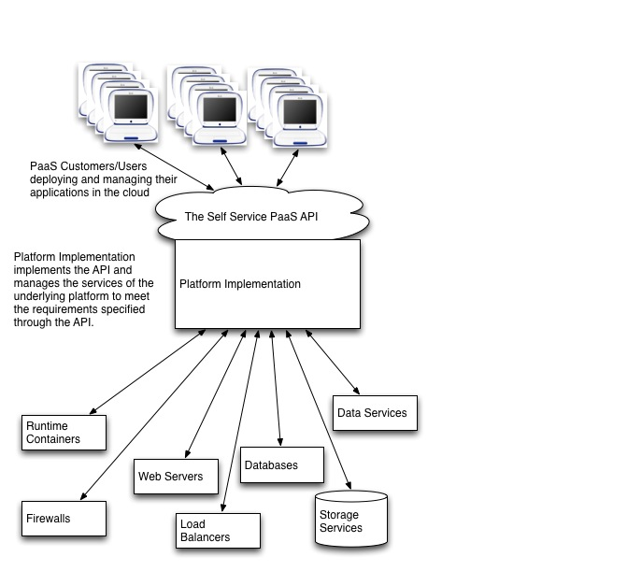
Figure 2-1: Typical PaaS Architecture
The figure above shows a typical architecture of a Platform as a Service cloud. The platform implementation is a management client of the underlying resources that transforms (through policies) the application requirements expressed by the Application Administrator into provisioning and other operations on those resources. The Platform Administrator manages the underlying hardware, storage, networks, and software services that make up the platform through existing administrative interfaces. Thus the Application Administrator is able to concentrate on their application and its deployment environment rather than having to be a systems administrator, database administrator and middleware administrator as well (as is the case with IaaS).
The goal of the management interface is to provide the PaaS consumer with a model that is as simple as possible, and yet still provides the essential elements that give them control over the deployment, execution, administration and metering of their application and its deployment environment.

Application Assemblies
The model of resources manipulated through the interface, in combination with the protocol used to remotely accomplish this, constitutes the self-service PaaS management API. The model contains resource types corresponding to the artifacts discussed earlier.
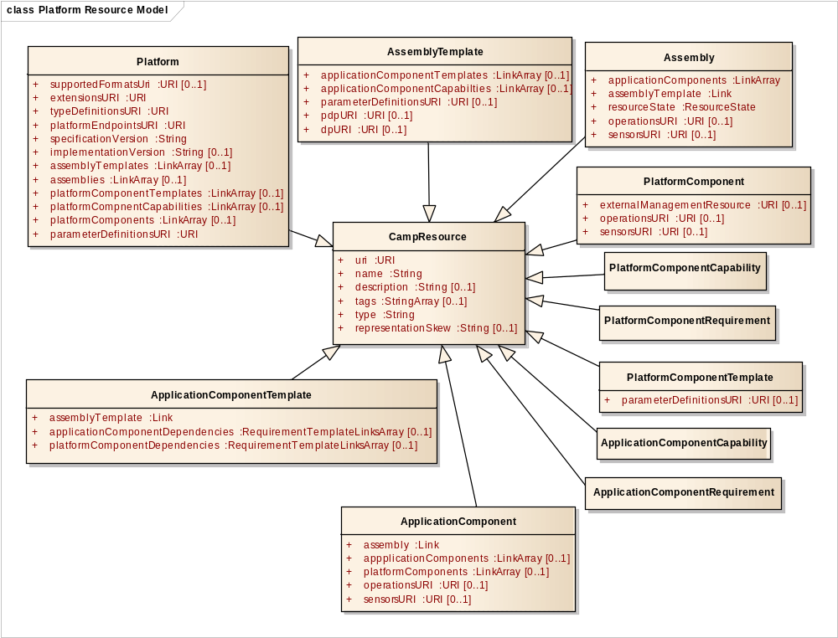
Figure 2-2: CAMP Resources as UML Classes
Figure 2-2 is a UML Class Diagram showing the CAMP resources as UML classes. All CAMP resources share a set of common attributes shown here as a CampResource parent class.
Each attribute shown in these UML class diagrams has a CAMP common type. The ‘+’ symbol before each attribute name in the boxes indicates that the attribute access is public (i.e. available thru the API). Non-mandatory resource attributes are indicated using the [0..1] UML multiplicity tag.

Platform
The Platform resource is the primary view of the platform and what is running on it. The Platform references templates for creating applications (as Assembly Templates) as well as running applications (as Assemblies) and enables discovery of the PaaS offering in terms of Platform Components and their capabilities. The Platform also determines the scope of access for sharing amongst multiple applications.

Assemblies
Assembly resources represent running applications. Operations on an Assembly resource affect the components and elements of that application. Assembly Template resources are templates for the creation of Assemblies.

Components
There are two kinds of components, application components and platform components, each of which can exist in either template or instantiated forms.
The Application Component Template resource represents a discrete configuration of a part of an Assembly Template supplied by the Application Administrator. The attributes of this resource represent the configuration values that will be applied to the component upon instantiation.
The Application Component resource represents an instantiated instance of an Application Component Template, such as a deployed WAR file.
The Platform Component Template resource represents a discrete configuration of a part of an Assembly Template supplied by the Platform. The attributes of this resource represent the configuration values that will be applied to the component upon instantiation.
The Platform Component resource represents an instantiated instance of a Platform Component Template in use by an application.

Capabilities and Requirements
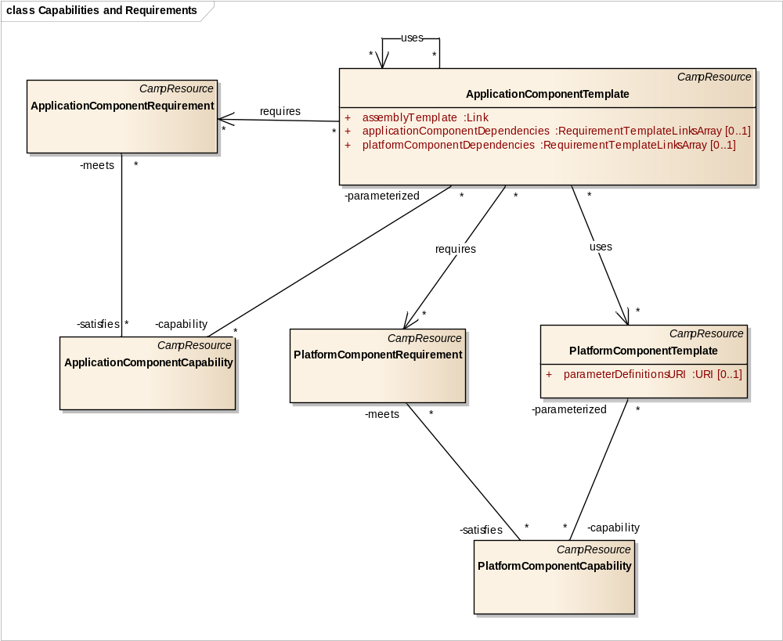
Figure 2-3: Capabilities, Requirements, and Template Relationships
Figure 2-3 shows the relationships between capabilities, requirements, and template resources. Associations which are visible thru pointer attributes in resources (i.e. URI, Link, or LinksArray attribute types) are show using UML named associations with navigation arrows. Associations which model implementation specific relationships, not visible thru the API, are represented using the UML association end notation, without navigation arrows. The association end names were chosen to represent the role that resource plays in the relationship. The ‘–‘ symbol before the association end names expresses that they have private access (i.e. navigation across resource links is not available thru the API).
Like Templates, Capability resources represent the configuration of instantiable Components (Application Components or Platform Components). Unlike Templates, which delineate discrete configurations, Capabilities specify ranges of configuration values.
Requirement resources are created by the Application Developer or Application Administrator to express an application’s dependency on a component that is capable of satisfying a certain set of requirements. For example, an application component might depend upon a messaging service that supports a certain version of an AMQP API, can accept messages of up to 2MB in size, and which provides a persistent message store.
The process of matching Requirements with Capabilities is referred to as “requirement resolution”.

Operations and Sensors
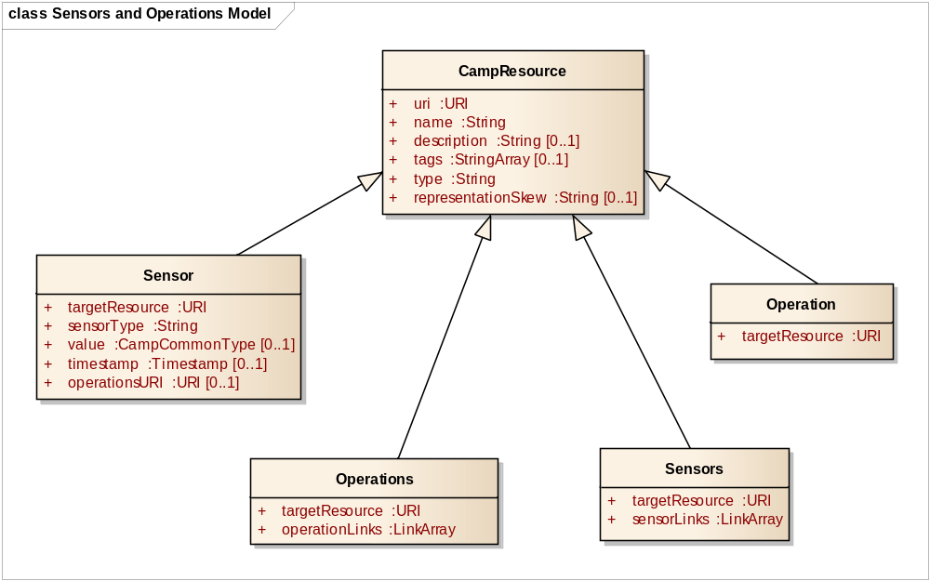
Figure 2-4: Operations and Sensors
Figure 2-4 is a UML class diagram showing the attributes of the Operations and Sensors resources.
Operations and Sensors provide a way of interacting with an application through the CAMP API. Operation resources represent actions that can be taken on a resource, and Sensor resources represent dynamic data about resources, such as metrics or state. Sensor resources are useful for exposing data that changes rapidly, or that might need to be fetched from a secondary system. Sensor Resources can also offer Operations to allow resetting metrics, or adjusting frequency collection settings.
Operation and Sensor resources are exposed on Assembly resources, Application Component resources and Platform Component resources. Operations are also known as effectors. The combination of sensors and operations enables ongoing management. This can include automation techniques such as using policies, event-condition-action paradigms, or autonomic control. A Consumer can use the REST API to perform such management. A Provider can also use them. For example, a Platform Component could be offered that allows for “autoscaling” capacity based on the volume of work an application performs.
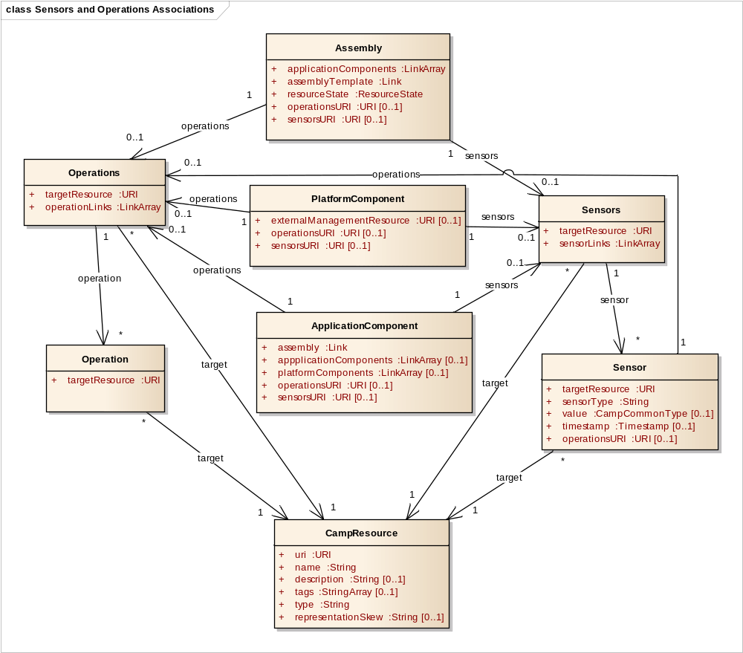
Figure 2-5: Operations and Sensors Associations
Figure 2-5 is a UML class diagram showing Operations and Sensors resources, and the CAMP resources that they are associated with.

Resource Relationships
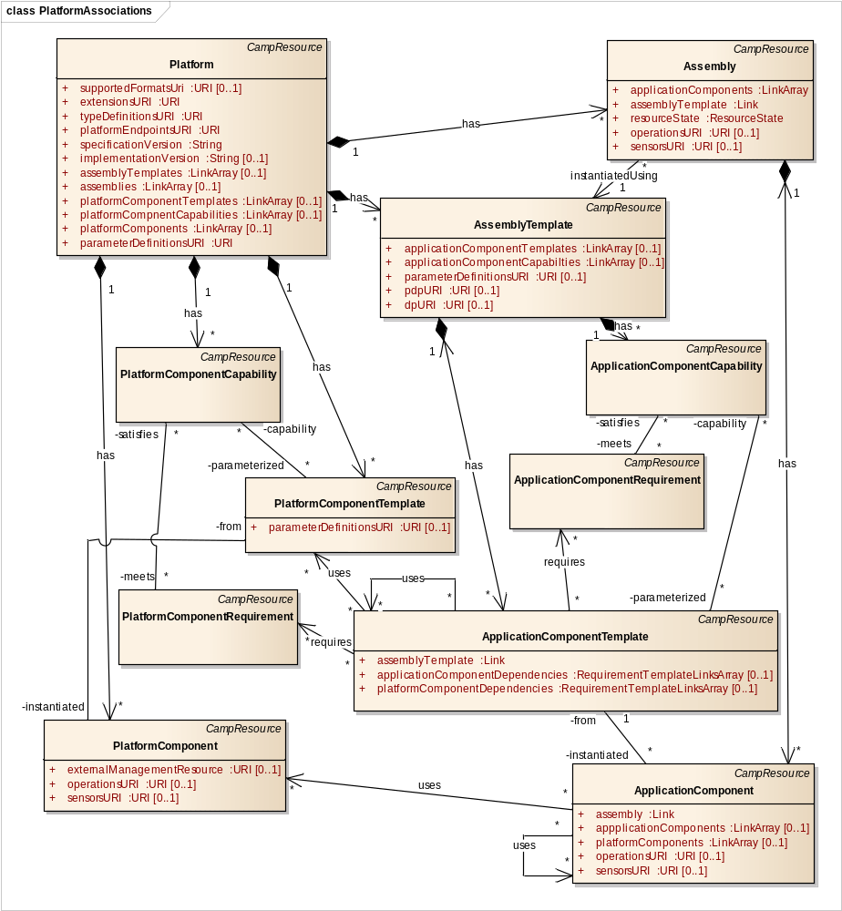
Figure 2-6: Platform Resource Relationships
Figure 2-6 shows the relationships between Platform Resources using a UML class diagram.
Associations which are visible thru pointer attributes in resources (i.e. URI, Link, or LinkArray attribute types) are shown using UML named associations with navigation arrows.
Associations which model implementation specific relationships, not visible thru the API, are represented using the UML association end notation, without navigation arrows. The ‘–‘ symbol on these association ends expresses that access is private (i.e. navigation using resource links is not available thru the API).
Strict aggregation (i.e. “has” relationship) is indicated using a solid diamond on the association end attached to the owning resource. This implies that the owned resource cannot exist independent of its owner.
A Platform provides a set of Platform Components that can be used by the invoking applications. Examples of Platform Components include servlet containers, web servers, LDAP stores, and database instances. Platforms can also provide higher-level business components such as a business rules manager to gain competitive advantage and developer loyalty. The Platform Administrator manages and operates the implementation of Platform Components.
An application is composed of a set of Application Components that depend on one or more Platform Components. Examples of Application Components include Ruby gems, Java libraries, and PHP modules. Application Components can also include non-code artifacts such as datasets and collections of identity information.
Application Components can also interact with other Application Components. Thus, an Application Component has two different sets of dependencies. It depends on the Components provided by the platform, and depends on services provided by other Application Components. Such Application Components can be on the same platform or can reside at some other location. The Assembly resource is used to aggregate the management of these components as shown in Figure 2-6.
Platform Components have a set of Platform Component Capabilities that an application can choose from to meet its requirements. Applications can tailor Platform Component Requirements (a refinement or narrowing of the configuration ranges in the Capabilities) to meet their needs based on the range of parameters expressed in the Platform Component Capability.
The relationships of an Assembly Template to Application Component Templates and Platform Component Templates, or their Requirements are shown in Figure 2-6.
An Application Component can express the exact configuration of its dependency on other Components using one of the Component Template resources (either an Application Component Template or Platform Component Template). Alternatively, it can express a range of configuration values that are acceptable for that dependency by using one of the Component Requirement resources (either an Application Component Requirement or Platform Component Requirement). This might be done, for example, in an ADE when the existing Component Templates are not known. During the deployment, these Requirements are matched with Capabilities that have attribute values that fall within the ranges specified by the Requirements.
An Application Component Template cannot be instantiated unless all of its dependencies are satisfied. An Application Component Template SHALL be referenced by a single Assembly Template. [CO-01] An Assembly Template SHALL NOT be instantiated until all of its Application Component Templates are successfully instantiated. [CO-02]

Deployment
A Deployment Plan (DP) is packaging management meta-data that provides a description of the artifacts that make up an application, the services that are required to execute or utilize those artifacts, and the relationship of the artifacts to those services.
A Platform Deployment Package (PDP) is an archive containing the DP together with application content files such as web archives, database schemas, scripts, source code, localization bundles, and icons; and metadata files such as manifests, checksums, signatures, and certificates. It can be used to move an Application and its Components from Platform to Platform, or between an Application Development Environment and a Platform.
A CAMP Consumer can create a new Assembly Template by uploading either a PDP or a DP to the Platform resource URI using an HTTP POST request. Assembly resources are created from the Assembly Templates. An Assembly resource represents a running instance of an application. An Assembly resource can be created using an HTTP POST request to the URI of an Assembly Template resource.
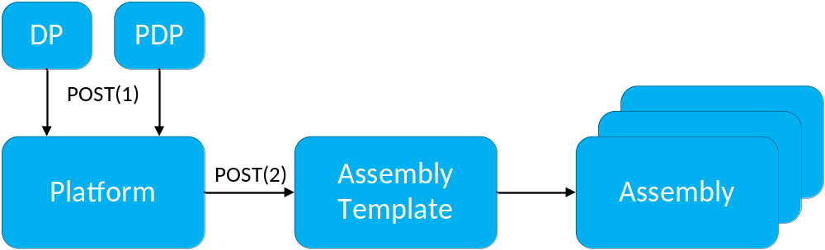
Figure 2-7: Creation of an Assembly resource
In Figure 2-7 the POST(1) request creates an Assembly Template resource by uploading either a PDP or a DP to the Platform resource’s URI. The POST(2) request on the Assembly Template’s URI creates an Assembly resource. Multiple Assembly resources can be created from an Assembly Template by submitting multiple HTTP POST requests.

Versions and Extensions
This specification supports multiple endpoints and versions, and extensions. All of these are represented in the resource model so they can be discovered by CAMP Consumers. The resources enabling discovery are shown in Figure 2-8, and their relationships are shown in Figure 2-9.
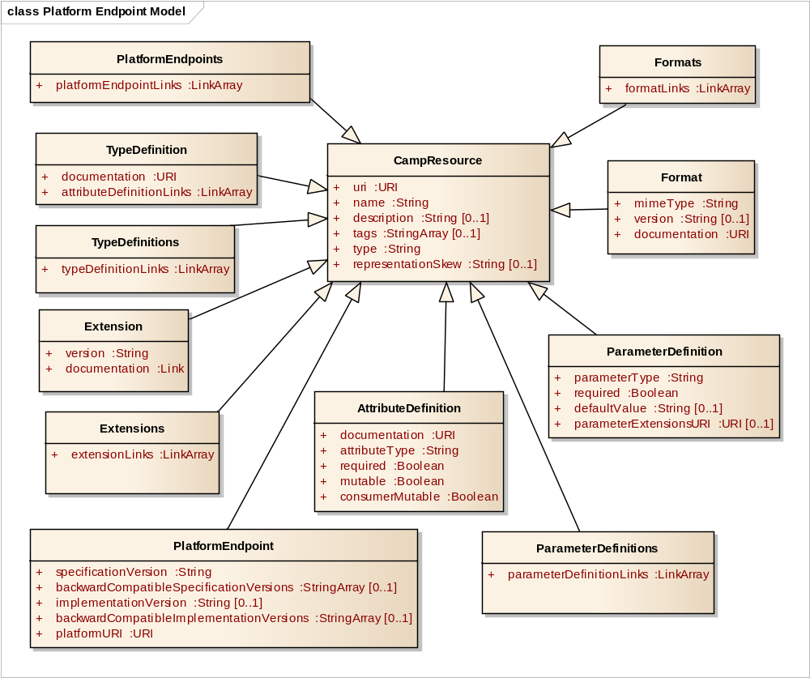
Figure 2-8: Platform Endpoint and Meta Data Resources
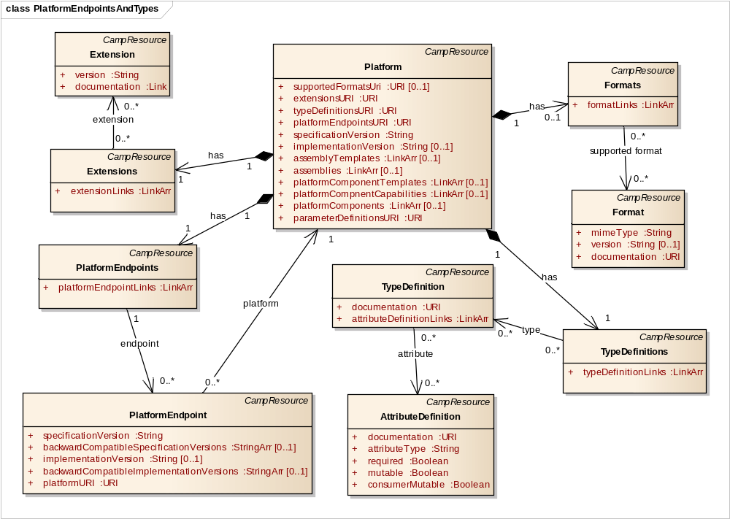
Figure 2-9: Platform Endpoint and Extension Resource Relationships

Parameters
Parameters can be defined on the Platform, Assembly Template, and Platform Component Template resources. Parameters affect the resources that are instantiated from these resources. Figure 2-10 illustrates the relationships between these resources and the resources used to represent Parameters.
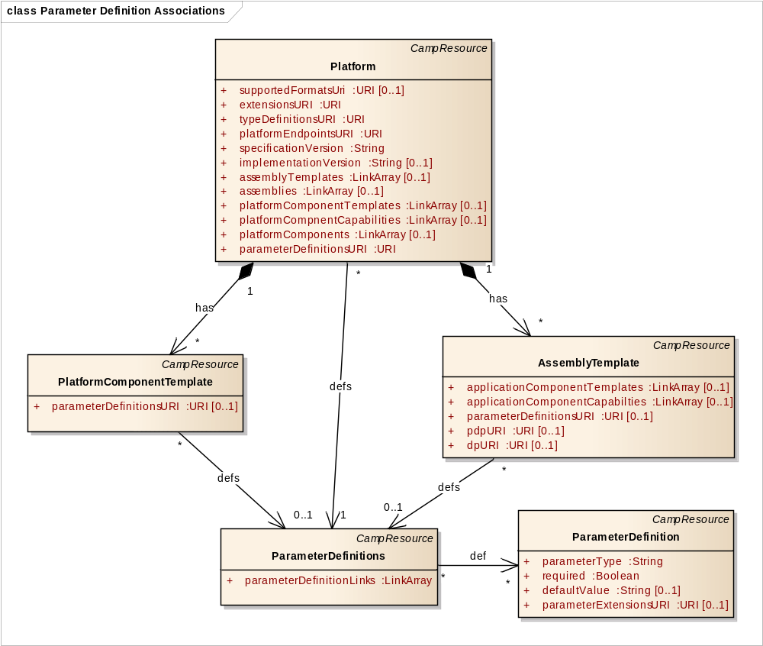
Figure 2-10: Parameter Definition Relationships

CAMP Common Types
Many of the attributes in the UML class diagrams have one of the CAMP common types, specified in Section 5.1, “Common Types”. Figure 2-11 is a UML diagram showing the common data types as UML Data Types, which are used for the Types of these Resource Attribute definitions.
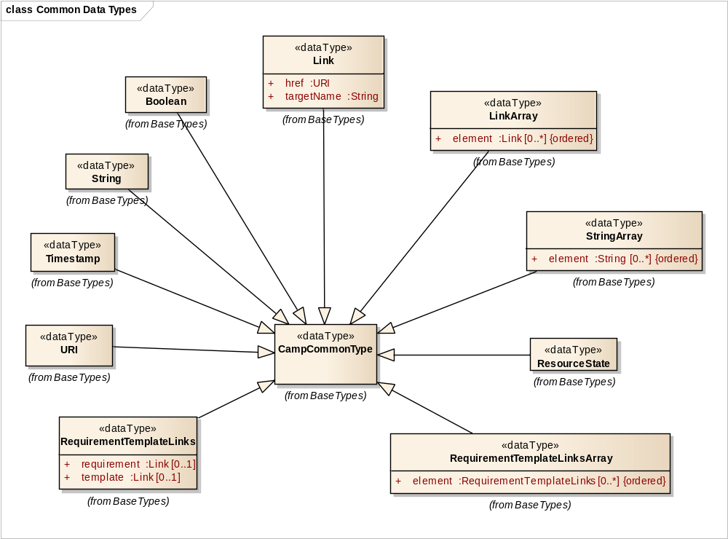
Figure 2-11: CAMP Common Base Types for Resource Attribute Definitions
Multi-valued member attributes are used to model the elements of the LinkArray, StringArray, and RequirementTemplateLinksArray types. This is for modeling purposes; the attribute name "element" does not appear in the JSON serialization for these common types.
The three array types have their elements tagged as ordered.

Representation Skew
There can be situations in which the information in the resources provided by the CAMP API is not a complete or accurate representation of the state of the underlying platform implementation. For example, while instantiating a new instance of an application, a CAMP server might be asked to provide a representation of an Application Component that corresponds to a dataset that is in the process of being loaded onto a database service. While the CAMP server might not be able to provide all of the information about this Application Component, it would be inaccurate to say that Application Component does not exist; it exists but it an intermediate state. It is expected that these sorts of situations will be the exception and that, during the majority of its existence, a CAMP resource will be in synch with the state of its underlying platform implementation.
The significance of this skew is the manner in which it affects the client’s interactions with, and expectations about, the resource. In the above example, while the client cannot reasonably expect to make any changes to the Application Component until it has reached a steady state, the client can expect that the resource will reach this state in the near future. There are other situations in which, through some sort of error or breakdown, the CAMP API cannot tell when or if the information in the resource will ever be synchronized with the underlying implementation.
Details on how this skew is exposed in the CAMP API are provided in Section 5.3.6, “representationSkew”.

Application Management Lifecycle
The figures in this section are UML object instance diagrams, which represent related Resource instances at various stages of Platform Resource instantiation. For simplification, attributes for these resources are not shown. For a comprehensive list of attributes for resources see Section 5, “Resources”.
Instances in these diagrams are indicated by boxes, with an underlined “object-name: Class” label. Relationships visible thru the API are shown using associations with navigation arrows. Implementation specific relationships are indicated using the association end notation, without navigation arrows.

Initial Platform Resources
The CAMP model includes the resources below when no Assemblies have been created.
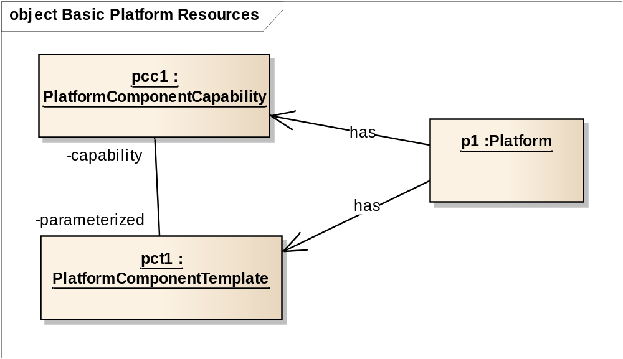
Figure 3-12: Initial Platform Resources
When the Application Administrator first accesses a new account a Platform will have a number of resources visible through the API. The Platform resource is used to find the other resources in this diagram. The various Platform Component Capabilities allow for discovery of all the platform services that are available along with value ranges for each service’s attributes. The various Platform Component Templates may represent pools of previously configured platform resources and represent this configuration as specific values for each of the attributes. These values are chosen from the range of values in the corresponding Platform Component Capability.

Creating an Assembly Template from a PDP
A CAMP Consumer can create a new Assembly Template by uploading either a PDP or a DP to the Platform resource URI using an HTTP POST request (see Section 2.2, “Deployment”). When the Assembly Template is created other resources such as Application Component Templates or Platform Component Requirements might also be created by the CAMP Provider to facilitate the future creation of an Assembly resource. The model might then appear as follows:
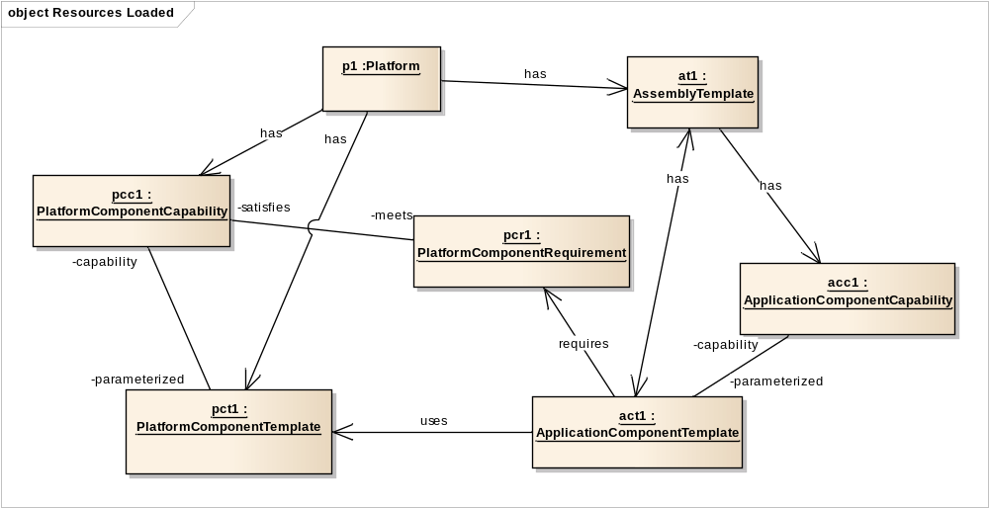
Figure 3-13: Loaded Resources
An Assembly Template is now present with one or more Application Component Templates, Application Component Requirements and Platform Component Requirements. The Application Component Template resources represent code and/or associated resources that were loaded with the PDP. The Application Component Requirement resources were used to find Application Component Templates (pre-existing software libraries for example) that were not part of the PDP but are required for the application. The Application Component Capability resources show the range of configurable attributes that the loaded Application Components can take on, when reused by future Application Components.
The Platform Component Requirement resources were used to find Platform Component Templates (pre-configured platform resources) that were part of the platform and required by the loaded Application Components, but perhaps unknown at the time the PDP was created (in an ADE for example).
If any of its requirements are not resolved, an Assembly Template could require modification before it can be used to create Assembly resources.

Creating and Managing an Application Assembly
To start an application an Assembly is created from the Assembly Template using a POST request (see Section 2.2, “Deployment”). This also creates Application Components and Platform Components corresponding to their respective templates, and the model would look as follows:
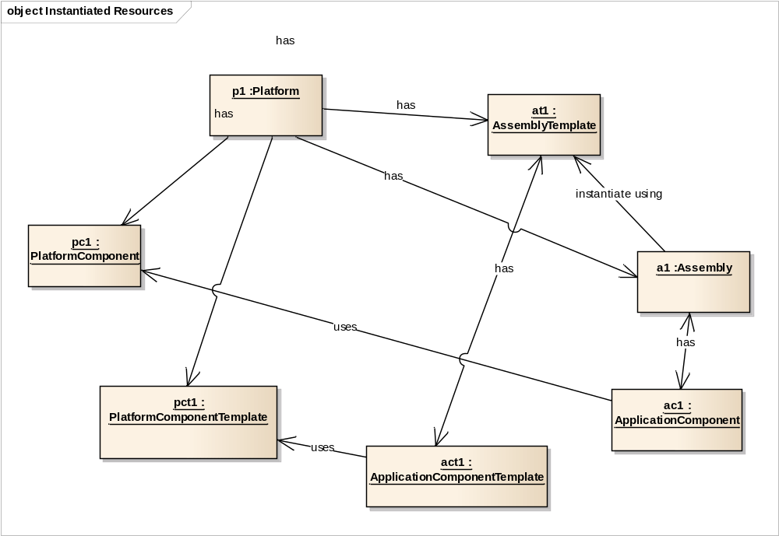
Figure 3-14: Instantiated Resources
To manage the operation of the application, the Application Administrator interacts with the Assembly resource and the related Application Component and Platform Component resources.
The traversal of the resources in the model can be accomplished by following the navigation arrows on the associations in these object instance diagrams, from each resource to the other resources it depends on.
The Application Administrator can observe real-time operational metrics through Sensor resources on Assembly and Component resources. In response to these metrics, the Application Administrator — or an automated process such as a management system — can affect changes to those resources through the Operation resources linked from those same resources.

Removing Assemblies and Assembly Templates
When finished working with an application, an Application Administrator can delete an Assembly using a DELETE request. The CAMP platform will typically soon thereafter remove the Assembly resource and all associated resources which are dedicated to that Assembly, such as Application Components. Where such a resource is not removed immediately, for example, when it is in the process of shutting down, it ought to present a representation skew of DESTROYING in the interim.
When the original Assembly Template is no longer needed, an Application Administrator can, again, delete it using a DELETE request. Again, the CAMP platform will typically delete the Assembly Template and all associated resources which are dedicated to that Assembly Template. Where this deletion is accepted but not immediate, such as because an Assembly is in use that references the Assembly Template, again the CAMP platform ought to present a representation skew of DESTROYING for the resources being deleted.
Following a lifecycle where an Assembly Template is created, then an Assembly is created, then the Assembly is deleted, then the Assembly Template is deleted, the model of Resources in the CAMP Provider will typically look similar to the initial model shown in Figure 3-12.

Platform Deployment Package
The Platform Deployment Package (PDP) ensures portability across platforms. It can be created by a platform to export to another platform, which then imports it. It can also be created by an Application Development Environment running locally or deployed as Software as a Service in the cloud. The PDP (and the Deployment Plan (DP), see Section 4.1.1, “Deployment Plan Overview”) defines the formats for onboarding new applications into a CAMP-enabled Provider. A Consumer can create a new Assembly Template resource in the Platform by submitting a valid PDP or DP to a Platform URI using a POST request (see Section 6.11, “Registering a PDP”).

PDP Package Structure
A PDP is an archive which contains a Deployment Plan (DP) file named camp.yaml at the root of the archive (see Section 4.1.1, “Deployment Plan Overview”). A PDP archive MAY include other files related to the application including, but not limited to, language-specific bundles, resource files, application content files such as web archives, database schemas, scripts, source code, localization bundles, and icons; and metadata files such as manifests, checksums, signatures, and certificates. [PDP-01]

Supported Archive Formats
A Provider SHALL support the following archive formats for a PDP:
- A PDP as a ZIP archive [ZIP] [PDP-02]
- A PDP as a TAR archive [TAR] [PDP-03]
- A PDP as a GZIP [GZIP] compressed TAR archive [PDP-04]
Providers MAY support additional archive formats for the PDP. [PDP-05]

Validating Integrity
A PDP MAY contain a manifest file, named camp.mf, at the root of the archive. [PDP-06] This file contains SHA256 [SHA256] digests of some or all files in the package. A Provider SHOULD reject a PDP if any digest listed in the manifest does not match the computed digest for that file in the package. [PDP-07]
A PDP MAY contain a certificate, named camp.cert, at the root of the archive. [PDP-08] This file contains a signed SHA256 digest for the manifest file and the corresponding X.509 certificate. A Provider SHOULD reject any PDP for which the signature verification fails. [PDP-09]
The format of the manifest file and the certificate file SHALL be as defined by the OVF specification [OVF]. [PDP-10]

Deployment Plan Overview
The Deployment Plan (DP) provides a description of the artifacts that make up an application, the services that are required to execute or utilize those artifacts, and the relationship of the artifacts to those services.
Example 1: Minimal DP describing an application consisting of a single RPM file.
00 campVersion: CAMP 1.1
01 artifacts:
02 -
03 artifactType: org.rpm:RPM
04 content: { href: my-app.rpm }
The above example describes an application that consists of a single RPM package, named “my-app.rpm”, which exists at the root of the PDP archive. The services required to install/run this package and the relationship of this package to those services are not specified.

Types
Deployment Plans can contain descriptions of artifacts, services and their relationships. However, it is outside the scope of this specification to provide detailed definitions of these entities. Instead Deployment Plans use ‘type’ nodes to identify these things. ‘Type’ nodes are Strings that describe entities that are managed by CAMP, but whose value and semantics are defined outside the CAMP specification. For example, a group of PaaS providers could agree to use the artifact type “org.rpm:RPM” to identify RPM packages. Line 03 in Example 1, above, is an example of the use of such a type.
To promote portability, both providers and consumers of the CAMP API are encouraged to namespace-qualify the types that they use. For example, if a PaaS provider supports a requirement type that expresses the relationship “deploy on a Spring container”, the value “com.paas-r-us.spring.DeployOn” is preferable to the value “DeployOn”, as the latter is likely to collide with similar types.
In addition to defining the labels for artifacts, services, and their relationships it is expected that those individuals and organizations that define such labels will also define additional attributes that qualify and constrain the entity that is referenced.
Example 2: Expanded DP describing details of how to install the RPM
00 campVersion: CAMP 1.1
01 artifacts:
02 -
03 artifactType: org.rpm:RPM
04 content: { my-app.rpm }
05 requirements:
06 -
07 requirementType: org.rpm:Install
08 org.rpm.installopts.excludedocs: true
The above example is an expansion of Example 1 that uses a Requirement Specification (lines 07-08) to describe the relationship of the RPM artifact to some (unspecified) service. This relationship is labeled on line 07 with a value of “org.rpm:Install”. It is assumed that this semantics associated with this label are documented, and that this documentation also describes the value space and semantics of the “org.rpm.installopts.excludedocs” node used on line 08.

Service Specifications
In addition to artifacts and their relationships to the platform, Deployment Plans can also contain descriptions of the services that can be used by those artifacts. These descriptions take the form of Service Specifications.
Example 3: Expanded DP that includes a Service Specification
00 campVersion: CAMP 1.1
01 artifacts:
02 -
03 artifactType: org.rpm:RPM
04 content: { my-app.rpm }
05 requirements:
06 -
07 requirementType: org.rpm:Install
08 org.rpm.installopts.excludedocs: true
09 fulfillment:
10 characteristics:
11 -
12 characteristicType: com.example:Linux
13 com.example.linux.kernelVersion: 3.9.6
14 org.iaas.bitsize: 64
The above example is an expansion of Example 2 that uses a Service Specification to outline the parameters of the service on which the RPM is to be installed. Lines 10-14 in the above example make up the Service Specification which, in this case, consists of a single Characteristic Specification (lines 12-14). Line 12 indicates that the target service for the RPM is a Linux instance. Line 13 indicates that this target has to run kernel version 3.9.6 and line 14 indicates that it has to be a 64-bit system.

Shared Services
There are situations in which an application can have two or more artifacts that need to share the same runtime instance of a service.
Example 4: DP with shared Service Specification
00 campVersion: CAMP 1.1
01 artifacts:
02 -
03 artifactType: com.java:WAR
04 content: { href: vitaminder.war }
05 requirements:
06 -
07 requirementType: com.java:HostOn
08 com.java.servlet.contextName: "/vitaM"
09 fulfillment:
10 …
11 -
12 requirementType: com.java.jdbc:ConnectTo
13 fulfillment:
14 id: db
15 characteristics:
16 -
17 characteristicType: org.storage.db:RDBM
18 …
19 -
20 characteristicType: org.storage.db:Replication
21 …
22 -
23 characteristicType: org.iso.sql:SQL
24 …
25 -
26 artifactType: org.sql:SqlScript
27 content: { href: vitaminder.sql }
28 requirements:
29 -
30 requirementType: org.sql:ExecuteAt
31 fulfillment: id:db
The above example describes an application with two components, a WAR file and an SQL script. In the case of this particular application, the SQL script is used to initialize the database that will be used by the WAR file. The two artifacts need to share a common database instance or the application will not work. Lines 14-24 describe the target database service. Line 14 is an ‘id’ node with the value ‘db’. This node is used as the target for the ‘fulfillment’ node on line 31. The use of the “id:db” reference on line 31 indicates that the database instance that will be used to fulfill the “org.sql:ExecuteAt” relationship on line 30 is the same instance that will be used to fulfill the “com.java.jdbc:ConnectTo” relationship on line 12.
The Deployment Plan in Example 4 can also be expressed in the following manner:
Example 5: DP with ‘services’ section
00 campVersion: CAMP 1.1
01 artifacts:
02 -
03 artifactType: com.java:WAR
04 content: { href: vitaminder.war }
05 requirements:
06 -
07 requirementType: com.java:HostOn
08 com.java.servlet.contextName: "/vitaM"
09 fulfillment:
10 …
11 -
12 requirementType: com.java.jdbc:ConnectTo
13 fulfillment: id:db
14 -
15 artifactType: org.sql:SqlScript
16 content: { href: vitaminder.sql }
17 requirements:
18 -
19 requirementType: org.sql:ExecuteAt
20 fulfillment: id:db
21 services:
22 -
23 id: db
24 characteristics:
25 -
26 characteristicType: org.storage.db:RDBM
27 …
28 -
29 characteristicType: org.storage.db:Replication
30 …
31 -
32 characteristicType: org.iso.sql:SQL
33 …
This example is equivalent to Example 4, but places the specification of the shared database service in the ‘services’ section that begins on line 21. In this case, both the WAR file and SQL script artifacts use references (lines 13 and 20, respectively) to indicate the service that will be used to fulfill their particular relationships.

Service Frameworks
There are situations in which the artifacts of an application are dynamically added (e.g. via a git [Git] push operation) after the creation of a “service framework” on which these artifacts can be deployed. Such a framework can be specified via a Deployment Plan that contains Service Specifications but no Artifact Specifications.
Example 6: DP with only Services Specifications
campVersion: CAMP 1.1
services:
-
name: Rails Runtime
characteristics:
-
characteristicType: org.ruby-lang:Ruby
…
-
characteristicType: org.rubyonrails:Rails
…
-
name: Database
characteristics:
-
characteristicType: org.storage.db:RDBM
…
-
name: Git Repo
characteristics:
-
characteristicType: com.git-scm:GIT
…
The above example specifies a set of services onto which the user can deploy Rails components by pushing them to the git repository that will be created as a result of registering this DP and instantiating the resulting Assembly Template.

Names, Description, and Tags
Deployment Plans, artifacts and services can be decorated with names, descriptions, and tags. CAMP platform implementations can use this information when creating the resources that correspond to these entities. For example, the following Deployment Plan:
Example 7: DP with names, descriptions, and tags
name: Mike’s Drupal Instance
description: Drupal 6.28
tags: [ PHP, Drupal6, mikez ]
campVersion: CAMP 1.1
artifacts:
-
artifactType: net.php:Module
content:
href: ftp://ftp.drupal.org/files/projects/drupal-6.28.tar.gz
…
when successfully registered, could result in the creation of, among other resources, the following Assembly Template resource:
{
"type": "assemblyTemplate",
"uri: "http://uswest.paas-r-us.com/camp/AssemblyTemplate/101",
"name": "Mike’s Drupal Instance",
"description": "Drupal 6.28",
"tags": [ "PHP", "Drupal6", "mikez" ],
…
}

Deployment Plan Schema
A Platform Deployment Package (PDP) SHALL contain a single Deployment Plan. [PDP-11] The Deployment Plan SHALL be located at the root of the PDP archive. [PDP-12] The Deployment Plan file SHALL be named “camp.yaml” and SHALL consist of a well-formed YAML 1.1 [YAML 1.1] file that conforms to the description provided in this section. [PDP-13] Note the description of the structures and information in this section utilizes YAML’s nomenclature.

General Attributes
The following nodes may appear as elements of the Deployment Plan, Artifact Specifications, or Service Specifications.

name
Type: String
Required: false
This node expresses the human-readable name of the Plan or Specification. Providers MAY reflect the value of this attribute in the names of any resources that are created in the processing the Deployment Plan. [PDP-14]

description
Type: String
Required: false
This node expresses the human-readable description of the Plan or Specification. Providers MAY reflect the value of this attribute in the descriptions of the resources that are in the processing the Deployment Plan. [PDP-15]

tags
Type: String[]
Required: false
This node expresses an array of human-readable tags for the Plan or Specification. Providers MAY reflect the values of this attribute in the tags of the resources that are created in the processing of the Deployment Plan. [PDP-16]

DeploymentPlan
This type defines the structure of the Deployment Plan. A Deployment Plan SHALL contain a single instance of a DeploymentPlan node. [PDP-17] This node has the following, general representation:
name: String ?
description: String ?
tags: ?
- String +
campVersion: String
origin: String ?
artifacts: ?
-
ArtifactSpecification +
services: ?
-
ServiceSpecification +
In addition to the general attributes, the DeploymentPlan node contains the following attributes:

campVersion
Type: String
Required: true
The value of this node expresses the version of the CAMP specification to which the Deployment Plan conforms. This value SHALL be the Specification Version String of the CAMP specification to which this Deployment Plan conforms. [PDP-18]
For Deployment Plans that conform to this document, the value of this node SHALL be “CAMP 1.1” as defined in Section Error: Reference source not found “Specification Version”. [PDP-19]

origin
Type: String
Required: false
The value of this node specifies the origin of the Deployment Plan. For example, when exporting an Assembly Template into a PDP, a platform instance might use the URL of its Platform resource for this value. Alternatively, an Application Development Environment could use its name and version.

artifacts
Type: ArtifactSpecification[]
Required: false
This node describes the artifacts that, together with the Deployment Plan itself, make up the PDP. Providers SHALL NOT regard the order of the ArtifactSpecifications within this array as semantically significant. [PDP-20]

services
Type: ServiceSpecification[]
Required: false
This node describes the services that the application in the PDP requires in order to function. Providers SHALL NOT treat the order of ServiceSpecifications within this array as semantically significant. [PDP-21]

ArtifactSpecification
This type describes an artifact of the application. The artifact MAY be contained within the PDP or MAY exist in some other location. [PDP-22] This type has the following, general representation:
name: String ?
description: String ?
tags: ?
- String +
artifactType: String
content: ContentSpecification
requirements: ?
-
RequirementSpecification +
In addition to the general attributes, the ArtifactSpecification type contains the following attributes:

artifactType
Type: String
Required: true
This node defines the type of the artifact described by this Artifact Specification. See Section 4.2.1, “Types”, for a general description of the definition and treatment of these values.

content
Type: ContentSpecification
Required: true
This node defines the content of the artifact described by this Artifact Specification. See Section 4.3.5, “ContentSpecification”, for a description of this node’s type.

requirements
Type: RequirementSpecification[]
Required: false
This array specifies the ways in which the artifact described by this Artifact Specification engages with the services provided by the platform. See Section 4.3.6, “RequirementSpecification”, for a description of the RequirementSpecification type. Providers SHALL NOT treat the order of RequirementSpecifications within this array as semantically significant. [PDP-23]

ServiceSpecification
A ServiceSpecification outlines a service that the application contained within the PDP requires in order to function. This outline is not intended to be a complete description of the service but, instead, delineate those characteristics that are significant to the application. This type has the following, general representation:
name: String ?
description: String ?
tags: ?
- String +
id: String ?
characteristics: ?
-
CharacteristicSpecification +
In addition to the general attributes, the ServiceSpecification type contains the following attributes:

id
Type: String
Required: false
The value of this node serves as an anchor for intra-Deployment Plan references. See Section 4.3.6.2, “fulfillment”, for information on how this anchor is used.

characteristics
Type: CharacteristicSpecification[]
Required: true
This array provides the characteristics of the service described by this Service Specification. See Section 4.3.7, “CharacteristicSpecification”, for a description of the CharacteristicSpecification type. Providers SHALL NOT treat the order of CharacteristicSpecifications within this array as semantically significant. [PDP-24]

ContentSpecification
This type defines the content of a component. Content Specifications SHALL declare either a String attribute “href” that references the content or a String attribute “data” whose value is the data or, but not both. [PDP-25] It has the following, general representation:
href: URI
or
data: String
When “href” is used in a Content Specification its value is interpreted as follows:
- For IANA-assigned URI schemes (e.g. “http”, “https”, “ftp”, etc.) the Provider SHALL engage the protocol as per the relevant spec. [PDP-26] Providers SHALL support the “http” and “https” URI schemes. [PDP-27] A Provider MAY support additional URI schemes. [PDP-28]
- URL’s with the special scheme “pdp:” are interpreted as files contained in the PDP.
  - If the path segment (after the “pdp:”) begins with a “/” it is an absolute path.
  - If the path segment is “!” (i.e. the URL is “pdp:!”), the reference is to the PDP archive itself. This is useful in making an existing deployment package (such as a WAR) function as a PDP.
  - For any other path segment, the path is relative to the location of the file which contains the Content Specification, subject to the guidelines below.
  - Where the path segment contains the special character “!”, it is treated as a delimiter to look for the path to the right of “!” inside the archive at the path to the left of the “!". Providers SHALL understand this delimiter and SHALL NOT resolve any content if the archive format is unsupported. [PDP-29] For example “pdp:/certs.zip!/id_rsa.pub” refers to a file “id_rsa.pub” contained at the root of a “certs.zip” file located at the root of the PDP, and is valid only on platforms which support the ZIP format in conjunction with “!”. On other platforms the link will not be resolved.
- Where the value is not a URI, it is interpreted as a “pdp:” protocol link, as though it were preceded by “pdp:/”.
Example 7: A DP describing an application consisting of the contents of the PDP
00 artifacts:
01 -
02 type: org.oasis-open.tosca:CSAR
03 content: { href: pdp:! }
04 requirements:
05 -
06 type: com.oasis-open.tosca:DeployOn
07 …
The above example illustrates the use of the “pdp:!” construct wherein the content being referenced (on line 03) is the PDP itself. In this case the PDP is also an OASIS TOSCA v1 Cloud Service Archive.

RequirementSpecification
A RequirementSpecification describes the relationship between an artifact and a service. It has the following, general representation:
requirementType: String
fulfillment: [String | ServiceSpecification] ?
… ?

requirementType
The value of this node defines the relationship of the artifact that contains this RequirementSpecification to a service. For example, “com.java:HostOn”. See Section 4.2.1, “Types”, for a general description of the definition and treatment of these values.
It is expected that RequirementSpecifications will contain extension nodes that modify or provide additional information about the relationship that they describe. The value space and semantics of these extensions ought to be part of the definition of the value used in the “type” node. For example, the definition of the “com.java:HostOn” relationship might define a “com.java:contextPath” node whose value specifies the desired context path for the artifact when it is deployed on its selected service.

fulfillment
The value of this node either describes, or references a description of, the other party in the relationship (i.e. the service) defined by this RequirementSpecification. In the case where this node references a description, the value is a String that corresponds to the “id” node of a ServiceSpecification (e.g. “id:db”). In the case where this node contains the description, the value is a ServiceSpecification. See Section 4.3.4, “ServiceSpecification”, for a description of this type.

CharacteristicSpecification
A CharacteristicSpecification describes a desired characteristic or capability of a service. It has the following, general representation.
characteristicType: String
… ?
The inclusion of a CharacteristicSpecification in a ServiceSpecification indicates that the characteristic being described is significant to the application, but the degree of this significance (e.g. “absolutely necessary” versus “would be nice to have”) is not indicated.

characteristicType
The value of this node defines the characteristic being described by this CharacteristicSpecification. For example, “com.java:ServletContainer”. See Section 4.2.1, “Types”, for a general description of the definition and treatment of these values.
It is expected that CharacteristicSpecifications will contain extension nodes that modify or provide additional information about the characteristic that they describe. The value space and semantics of these extensions ought to be part of the definition of the value used in the “characteristicType” node. For example, the definition of the “org.rubyonrails:Rails” characteristic might define a “org.rubyonrails:version” node whose value specifies the version of Rails provided by the service.

Resources
The following sub-sections describe the resources defined by this specification.

Common Types
Resource attributes are defined using the following types:

Boolean
As defined by JSON [RFC4627], a token having a literal value of either true or false.

String
A UNICODE string as defined by JSON [RFC4627].

URI
A String (see above) that conforms to the syntax defined in RFC 3986 [RFC3986].

Timestamp
A String (see above) that conforms to the syntax defined in ISO 8601 [ISO 8601:2004]. Consumers and Providers SHALL express Timestamps in UTC (Coordinated Universal Time), with the special UTC designator ("Z"). [RE-65]

Link
The management model defined in this specification involves resource entity attribute values that link to other resource entities. For example, one of the Platform resource entity attribute values points to Assembly Templates. The “Link” type defined here is used for such attribute values.
{
"href": URI
"targetName": String
…
}
The following attributes SHALL be present in a Link. [RE-01] Other attributes, not defined in this specification, MAY also be present. [RE-02]

href
This attribute is the URI [RFC 3986] of the resource referenced by this Link. The value of this attribute MAY be changed by the Provider. [RE-03] Consumers SHALL NOT change the value of this attribute. [RE-04]

targetName
This attribute echoes the value of the “name” attribute of the resource referenced by this Link. The value of this attribute may be changed by the Platform. Consumers SHALL NOT change the value of this attribute. [RE-31]

RequirementTemplateLinks
Requirement resources and Template resources are inherently related. The unsatisfied dependencies represented by Requirements are resolved by links to Templates that define services and capabilities that satisfy those dependencies. This relationship is surfaced in the CAMP resource model through the “RequirementTemplateLinks” type. By grouping together a link to a Requirement and a link to a Template this type supports the expression the concept that “this Template satisfies this Requirement”.
{
"requirement": Link ?,
"template": Link ?
…
}
Though both attributes of this type are optional, a valid RequirementTemplateLinks type SHALL have at least one of the following attributes: [RE-05]

requirement
This optional attribute is a Link type that references either a Platform Component Requirement or an Application Component Requirement resource. The absence of this attribute indicates that the enclosing attribute (i.e. the attribute that is of type ‘RequirementTemplateLinks’) is expressing a link to a Template with no corresponding Requirement.

template
This optional attribute is a Link type that references either a Platform Component Template or an Application Component Template resource. The absence of this attribute indicates that the enclosing attribute (i.e. the attribute that is of type ‘RequirementTemplateLinks’) is expressing an unsatisfied Requirement.

Attribute Constraints
Resource attributes are constrained along a number of axes. These are:

Required
If the Required boolean constraint for an attribute of a resource type has a value of "true", then an instance of that resource type SHALL have the attribute present. [RE-06] If the value is "false" then the instance is valid with or without the attribute present.

Mutable
This boolean indicates the mutability of the attribute’s value(s). “false” indicates that the value of the attribute, once set, SHALL NOT change for the lifetime of the resource. [RE-07] “true” indicates that the value of the attribute MAY change due to the actions or activity of either the provider or the consumer. [RE-08]

Consumer-mutable
This boolean indicates the ability of a consumer to set the value of the attribute. It is only relevant for mutable attributes. “false” indicates that the value(s) of the attribute SHALL NOT be changed by the Consumers. [RE-09] A value of “true” indicates that consumers MAY change the value of the attribute. [RE-10] Note that a value of 'true' does not preclude the Provider from changing the value of the attribute.

Common Resource Attributes
All the resources in this specification contain the following common attributes:

uri
Type: URI
Required: true
Mutable: false
This attribute expresses the URI of the resource.

name
Type: String
Required: true
Mutable: true
Consumer-mutable: true
This attribute expresses the human-readable name of the resource.

description
Type: String
Required: false
Mutable: true
Consumer-mutable: true
This attribute expresses the human-readable description of the resource.

tags
Type: String[]
Required: false
Mutable: true
Consumer-mutable: true
This attribute is an array of String values that may be assigned by the provider or the user. These values can be used for keywording and terms-of-interest.

type
Type: String
Required: true
Mutable: false
Consumer-mutable: false
This attribute expresses the CAMP resource type. Every CAMP resource type defined in this specification specifies the required value for this attribute.

representationSkew
Type: String
Required: false
Mutable: true
Consumer-mutable: false
The representationSkew attribute expresses the relationship between the information presented in the resource and the status of the platform implementation artifacts that are represented by that resource (see Section 2.6, “Representation Skew”). It is an optional, enumerated String. If present, representationSkew SHALL have one of the following values: [RE-11]
- “CREATING” – describes a resource that is in the process of being created. The client can expect that the resource will have a skew of “NONE” once this process has completed.
- “NONE” – is an assertion by the CAMP server that the information in the resource is an accurate representation of the underlying platform implementation. Absent some action by the client or some other event (e.g. platform shutdown), a resource with a skew of NONE can be expected to remain in synch with the platform implementation.
- “UNKNOWN” – indicates that the CAMP server cannot accurately depict the aspect of the platform implementation represented by this resource. Users can attempt to address the underlying issues(s) by manipulating this and/or other resources as specified by the API.
- “DESTROYING” – describes a resource that is in the process of being destroyed. The client can expect that the resource will cease to exist once this process has completed.
The absence of the reprsentationSkew attribute is semantically equivalent to the “NONE” value.
The value of the representationSkew attribute affects the availability of the HTTP methods for that resource. For example, resources with a representationSkew value of CREATING might support the GET, HEAD and DELETE methods, but no other HTTP methods. The following table lists the methods that SHALL be supported for each representationSkew value. [RE-12]
representationSkew value | Methods Available
CREATING | GET, DELETE
NONE | All supported methods for that resource.
UNKNOWN | All supported methods for that resource.
DESTROYING | GET
Table 5-1: representationSkew Available Methods
For each representationSkew value, CAMP Providers MAY support HTTP methods in addition to those listed in the corresponding row of Table 5-1. [RE-13]

Error Response Message Resource
Successful requests will generally return an HTTP status code of 200 (OK), 201 (Created), 202 (Accepted), or 204 (No Content), to indicate that the requested action has been successfully performed or submitted. In addition, they might include a response message body containing a representation of the requested information. However, it is possible for a number of things to go wrong. The various underlying causes are described (as discussed in the previous section) by various HTTP status codes in the range 400-499 (for client side errors) or 500-599 (for server side problems).
If a response is returned with an error status code (400-499 or 500-599), where appropriate, the server is encouraged to include a response message body containing an ErrorMessage object (as defined below). The text values of such messages might be used, for example, to communicate with a human user of the client side application.
The list of messages included in a single error response is encapsulated in the ErrorMessage data model.
Field | Type | Occurs | Description
message | Message | 0..n | Zero or more message data for each individual message.
Table 5-2: ErrorMessage Data Model
An individual message contains the following fields:
Field | Type | Occurs | Description
code | String | 0..1 | Symbolic error code identifying the type of error reported by this message
field | String | 0..1 | Name of the field from the request data model that this message is associated with
hint | String | 0..1 | Localized text further describing the nature of the problem, possibly including potential workarounds that the client could try
text | String | 1 | Localized text describing the nature of the problem reported by this message
severity | String | 0..1 | Label indicating the severity of the error condition represented by this message  Vendor shall publish the enumerators that are associated with this field and their semantics
stackTrace | String | 0..1 | Vendor specific stack trace associated with this message
source | String | 0..1 | Symbolic identifier of the implementation component that triggered this message
message-id | String | 0..1 | A unique string that identifies this particular message
profile | URI | 0..1 | A reference to the standard URI to indicate the meaning of this message
Table 5-3: Message Data Model
The profile attribute indicates the semantic meaning of the message which clients may handle automatically. Messages with the same profile shall adhere to the semantic requirements of that profile, but the payload (hint, text, severity, stackTrace) may be different. In other words, given a profile, clients processing the message should be able to subsequently interact with the providers in a consistent manner across.
Each provider may extend the profile to include specific scenarios and use cases.
The information captured in the message data element should be complementary to the HTTP status code, and could provide more detailed information. However, it SHALL NOT contradict the HTTP status code that is returned with the request. [RE-14]
The following table outlines the common profiles that would accompany this specification.
Profile | Description
/msg/unknown | Unknown error and information given is descriptive in nature
/msg/security | Security issues
/msg/security/authentication | An authentication error
/msg/access | Access violation error
/msg/allocation | Allocation related issues
/msg/allocation/insufficient | Insufficient resource to satisfy the request
/msg/infrastructure | Infrastructure related issues
/msg/infrastructure/maintenance | The request cannot be immediately responded due to the infrastructure being in maintenance status
Table 5-4: Common Message Profiles

HTTP Method Support
As described in Section 6.1, “Transfer Protocol”, Consumers use HTTP [RFC2616] to interact with CAMP-defined resources. To foster interoperability it is necessary to define the HTTP methods supported by each resource. Note that a requirement on the Provider to support a particular HTTP method on a resource does not ensure that all requests to that resource using that method will succeed; it simply guarantees that the Provider will not fail such requests with a 405 (Method Not Allowed) error.
Providers SHALL support the HTTP GET, PUT, and PATCH methods on all of the resources defined in this section. [RE-53] Requirements for the support of additional HTTP methods are outlined in the descriptions of each resource below. Providers MAY elect to support additional HTTP methods in addition to those described here. [RE-54]

PlatformEndpoints Resource
A Provider MAY concurrently offer multiple instances of the CAMP API. [RE-15] The primary example of why a provider might do this is to simultaneously support two or more incompatible versions/implementations of the CAMP API, but there are many reasons for a provider to offer multiple instances of the CAMP API.
Concurrent instances are supported through the use of multiple instances of the Platform resource. The PlatformEndpoints resource allows Consumers to discover all the instances of the CAMP API that are currently available. It contains an array of Links to PlatformEndpoint resources (that each reference Platform resources), and has the following general representation:
{
"uri": URI,
"name": String,
"type": "platformEndpoints",
"description": String ?,
"representationSkew": String ?,
"tags": String[] ?,
"platformEndpointLinks": Link[]
}
Because of the unique function of this resource, future versions of the CAMP specification SHALL NOT make non-backwards compatible changes to this resource. [RE-16]
NOTE: A Provider MAY expose the PlatformEndpoints and corresponding PlatformEndpoint resources in a way that allows for version discovery before the client has authenticated. [RE-17]
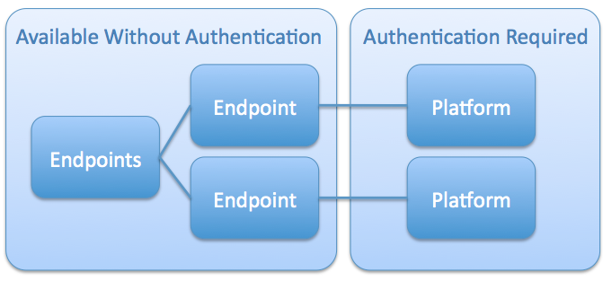
Figure 5-15: Example Implementation
The PlatformEndpoints resource contains the following attributes:

platformEndpointLinks
Type: Link []
Required: true
Mutable: false
This attribute is an array of Links to PlatformEndpoint Resources. This array SHALL contain at least one PlatformEndpoint Resource. [RE-18] References between the resources (PlatformEndpoints, PlatformEndpoint, and Platform) SHALL be self-consistent. [RE-19]

PlatformEndpoint Resource
Each PlatformEndpoint Resource SHALL refer to exactly one Platform Resource, and indicate the versions supported by the Platform. [RE-20] This specification is deliberately silent about any relationship between resources within different Platform trees. Each PlatformEndpoint Resource could represent a different CAMP API “view” of the same applications and services. On the other hand, each Endpoint could represent a completely independent system.
A PlatformEndpoint Resource has the following general representation:
{
"uri": URI,
"name": String,
"type": "platformEndpoint",
"description": String ?,
"representationSkew": String ?,
"tags": String[], ?
"platformUri": URI,
"specificationVersion": String,
"backwardCompatibleSpecificationVersions": String[] ?,
"implementationVersion": String,
"backwardCompatibleImplementationVersions": String[] ?
}
Because of the unique function of this resource, future versions of the CAMP specification SHALL NOT make non-backwards compatible changes to this resource. [RE-21]
Instances of the PlatformEndpoint resource contain the following attributes:

specificationVersion
Type: String
Required: true
Mutable: false
Each instance of a Platform resource is the root of a tree of resources, the syntax and semantics of which conform to one or more versions of the CAMP specification. The value of this attribute is the Specification Version String of the CAMP specification that is supported by the resources rooted in the Platform referenced by the platformUri attribute of this resource.
For Platforms that implement this version of the CAMP specification, the value of this attribute SHALL be “CAMP 1.1” as defined in section 1.7. [RE-22]

backwardCompatibleSpecificationVersions
Type: String[]
Required: false
Mutable: false
The values in this array identify each version of the CAMP specification that is backwards compatible with the current specificationVersion of the Platform (referenced in the platformUri attribute of this resource). The values in this array SHALL be the Specification Version Strings of previous CAMP specification versions. [RE-23]
If this attribute is not present, the version of the CAMP specification implemented by the Platform (referenced in the platformUri attribute of this resource) is not backwards compatible with any previous version of the CAMP specification.
PlatformEndpoint resources that reference Specification Version “CAMP 1.1” Platform Resources SHALL NOT include this attribute because no previous versions are compatible. [RE-24]

implementationVersion
Type: String
Required: false
Mutable: false
Multiple implementations of the same CAMP specification MAY be offered concurrently. [RE-25] For example, a Provider could offer an initial beta version of “CAMP 1.1” and, later, a production version; allowing a period of overlap for their customers to migrate from the beta to the production version. The value of this attribute is an arbitrary String that expresses the Provider-specific implementation version supported by the resources rooted in the Platform (referenced in the platformUri attribute of this resource).

backwardCompatibleImplementationVersions
Type: String[]
Required: false
Mutable: false
The values in this array list the provider-specific implementation versions that are backwards compatible with the implementation version of the Platform (referenced in the platformUri attribute of this resource). The values in this array are arbitrary Strings that correspond to previous implementationVersion Strings.
If this attribute is not present, the implementation version offered by the Platform (referenced in the PlatformURI attribute of this resource) is not backwards compatible with any previous implementation versions.

platformUri
Type: URI
Required: true
Mutable: false
This attribute is the URI of the Platform Resource that this PlatformEndpoint Resource represents.

Platform Resource
A Platform represents the Consumer’s initial view of the accessible resources and deployed entities. This resource has the following, general representation:
{
"uri": URI,
"name": String,
"type": "platform",
"description": String ?,
"representationSkew": String ?,
"tags": String[] ?,
"supportedFormatsUri": URI,
"extensionsUri": URI,
"typeDefinitionsUri": URI,
"platformEndpointsURI": URI,
"specificationVersion": String,
"implementationVersion": String ?,
"assemblyTemplates": Link[] ?,
"assemblies": Link[] ?,
"platformComponentTemplates": Link[] ?,
"platformComponentCapabilities": Link[] ?,
"platformComponents": Link[] ?,
"parameterDefinitionsUri": URI
}
In addition to the methods defined in Section , “HTTP Method Support”, Providers SHALL support the HTTP POST method on the Platform resource as described in Section 6.11, “Registering an Application”. [RE-55]
The Platform resource contains the following attributes:

supportedFormatsUri
Type: URI
Required: false
Mutable: false
This attribute is a URI reference to the Formats resource for the purpose of identifying all Supported Formats for this Platform. See Section 5.19, “Formats Resource”, for details.

extensionsURI
Type: URI
Required: true
Mutable: false
This attribute provides a link to the Extensions this Platform supports. See Section 7.2, “Extensions Resource”, for details.

typeDefinitionsURI
Type: URI
Required: true
Mutable: false
This attribute provides a link to the TypeDefinitions resource that provides information on the resource types that the Platform supports. See Section 5.21, “TypeDefinitions Resource”, for details.

platformEndpointsURI
Type: URI
Requried: true
Mutable: false
This attribute provides a link to a PlatformEndpoints resource. The PlatformEndpoints resource enumerates the currently available CAMP implementations. See Section 5.6, “PlatformEndpoints Resource“, for details.

specificationVersion
Type: String
Required: true
Mutable: false
Each instance of a Platform resource is the root of a tree of resources, the syntax and semantics of which conform to one or more versions of the CAMP specification. The value of this attribute is the Specification Version String of the CAMP specification that is supported by the resources rooted in this Platform.
For Platforms that implement this version of the CAMP specification, the value of this attribute SHALL be “CAMP 1.1” as defined in Section 1.7, “Specification Version”. [RE-26]
The value of this attribute SHALL exactly match the value of the specificationVersion attribute of any PlatformEndpoint resource that references this Platform Resource. [RE-27]

implementationVersion
Type: String
Required: false
Mutable: false
A Provider MAY choose to offer multiple implementations of the same CAMP specification. [RE-28] For example, a Provider could offer an initial beta version of “CAMP 1.1” and, later, a production version; allowing a period of overlap for their customers to migrate from the beta to the production version. The value of this attribute is an arbitrary String that expresses the Provider-specific implementation version supported by the resources rooted in this Platform.
The value of this attribute SHALL exactly match the value of the implementationVersion attribute of any PlatformEndpoint resource that references this Platform resource. [RE-29]

assemblyTemplates
Type: Link[]
Required: false
Mutable: true
Consumer-mutable: false
This attribute is an array of Links to the AssemblyTemplates that are accessible to the Consumer.

assemblies
Type: Link[]
Required: false
Mutable: true
Consumer-mutable: false
This attribute is an array of Links to the Assembly resources that are accessible to the Consumer.

platformComponentTemplates
Type: Link[]
Required: false
Mutable: true
Consumer-mutable: false
This attribute is an array of Links to the PlatformComponentRequirement resources that are accessible to the Consumer.

platformComponentCapabilities
Type: Link[]
Required: false
Mutable: true
Consumer-mutable: false
This attribute is an array of Links to the PlatformComponentCapability resources that are accessible to the Consumer.

platformComponents
Type: Link[]
Required: false
Mutable: true
Consumer-mutable: false
This attribute is an array of Links to the PlatformComponent resources that are accessible to the Consumer.

parameterDefinitionsUri
Type: URI
Required: true
Mutable: true
Consumer-mutable: false
parameterDefinitionsURI points to a resource that contains links to parameterDefinitions that describe the parameters accepted by this resource on an HTTP POST method. Each of the parameterDefinitions provide metadata for a parameter as described in Section Error: Reference source not found, “ParemeterDefinitions Resource”. The Platform resource accepts the pdpUri parameter to create new AssemblyTemplate resources upon a POST. The Platform resource SHALL indirectly reference a parameterDefinition resource that describes the pdpUri parameter. [RE-30]

AssemblyTemplate Resource
An Assembly Template is the template for the creation of Assemblies. This resource has the following, general representation:
{
"uri": URI,
"name": String,
"type": "assemblyTemplate",
"description": String ?,
"representationSkew": String ?,
"tags": String[] ?,
"applicationComponentTemplates": Link[] ?,
"parameterDefinitionsUri": URI ?,
"pdpUri": URI ?,
"dpUri": URI ?
}
In addition to the methods defined in Section , “HTTP Method Support”, Providers SHALL support the HTTP POST and DELETE methods on instances of the AssemblyTemplate resource. [RE-56] As described in Section 6.12, “Instantiating an Application”, a successful POST request results in the instantiation of a new Assembly resource. As described in Section 6.14, “Deleting an Application Instance and a Deployed Application”, a successful DELETE request removes the AssemblyTemplate from the system along with any ApplicationComponentTemplates referenced by the AssemblyTemplate and any PlatformComponentRequirements or ApplicationComponentRequirements referenced by those ApplicationComponentTemplates (i.e. the tree of resources that was created when the application was registered). A successful DELETE also removes the reference to the AssemblyTemplate from the Platform resource’s assemblyTemplates array.
Instances of the AssemblyTemplate resource contain the following attributes:

applicationComponentTemplates
Type: Link[]
Required: false
Mutable: true
Consumer-mutable: false
This attribute is an array of Links to the ApplicationComponentTemplate resources that are part of this AssemblyTemplate. An AssemblyTemplate MAY have zero references to ApplicationComponentTemplate resources, [RE-32] but Providers SHALL NOT instantiate an Assembly using an AssemblyTemplate that does not reference at least one ApplicationComponentTemplate. [RE-33]

parameterDefinitionsUri
Type: URI
Required: false
Mutable: false
Consumer-mutable: false
This attribute references the URI of the ParameterDefinitions resource that defines parameters that may be passed to this resource. The ParameterDefinitions resource referenced by this attribute SHALL define parameters to allow setting the ‘name’, ‘description’, and ‘tags’ attributes of any new resource created in the course of interacting with this resource. [RE-34]

pdpUri
Type: URI
Required: false
Mutable: true
Consumer-mutable: false
This attribute specifies the URI of the PDP from which the Assembly Template resource was created. If present, it allows one to register another Assembly Template from the same PDP using the method defined in Section 6.11.1, “Registering a PDP by reference”.

dpUri
Type: URI
Required: false
Mutable: true
Consumer-mutable: false
This attribute specifies the URI of the Deployment Plan from which the Assembly Template resource was created. If present, it allows one to register another Assembly Template from the same DP using the method defined in Section 6.11.1, “Registering a PDP by reference”.

ApplicationComponentTemplate Resource
An Application Component Template represents the definition of the deployable Component. This resource has the following, general representation:
{
"uri": URI,
"name": String,
"type": "applicationComponentTemplate",
"description": String ?,
"representationSkew": String ?,
"tags": String[] ?,
"assemblyTemplate": Link,
"applicationComponentDependencies": RequirementTemplateLinks[] ?,
"platformComponentDependencies": RequirementTemplateLinks[] ?
}
In addition to the methods defined in Section , “HTTP Method Support”, Providers SHALL support the HTTP DELETE method on instances of the ApplicationComponentTemplate resource. [RE-57] A successful DELETE request removes the ApplicationComponentTemplate from the system along with any PlatformComponentRequirements or ApplicationComponentRequirements referenced by that ApplicationComponentTemplates (i.e. the tree of resources rooted in the ApplicationComponentTemplate). A successful DELETE also removes the reference to the ApplicationComponentTemplate from the applicationComponentTemplates array of its containing AssemblyTemplate.
Instances of the ApplicationComponentTemplate resource contain the following attributes:

assemblyTemplate
Type: Link
Required: true
Mutable: true
Consumer-mutable: true
The attribute contains the link to the AssemblyTemplate that contains this resource. This attribute SHALL be present. [RE-35]

applicationComponentDependencies
Type: RequirementTemplateLinks[]
Required: false
Mutable: true
Consumer-mutable: true
This attribute is an array of RequirementTemplateLinks that reference related pairs of ApplicationComponentRequirement and ApplicationComponentTemplate resources.
If one of the elements in this array has a ‘requirement’ attribute with no matching ‘template’ attribute that indicates that this ApplicationComponentTemplate has an unsatisfied requirement and that the ApplicationComponent described by this template cannot be instantiated.

platformComponentDependencies
Type: RequirementTemplateLinks[]
Required: false
Mutable: true
Consumer-mutable: true
This attribute is an array of RequirementTemplateLinks that reference related pairs of PlatfromComponentRequirement and PlatformComponentTemplate resources.
If one of the elements in this array has a ‘requirement’ attribute with no match ‘template’ attribute that indicates that this ApplicationComponentTemplate has an unsatisfied requirement and that the ApplicationComponent described by this template cannot be instantiated.

ApplicationComponentRequirement Resource
An Application Component Requirement represents an Application Component’s requirement on another Application Component and its required range of component capabilities. Each Application Component Requirement implements this class and adds its’ own Attribute Ranges to the list below. This resource has the following, general representation:
{
"uri": URI,
"name": String,
"type": "applicationComponentRequirement",
"description": String ?,
"representationSkew": String ?,
"tags": String[] ?
}
In addition to the methods defined in Section , “HTTP Method Support”, Providers SHALL support the HTTP DELETE method on instances of the ApplicationComponentRequirement resource. [RE-58] A successful DELETE request removes the ApplicationComponentRequirement from the system as well as removing its reference from the applicationComponentDependencies array of any ApplicationComponentTemplates that refer to it.

ApplicationComponentCapability Resource
An Application Component Capability represents the definition of an Applicaton Component’s range of component capabilities. This resource has the following, general representation:
{
"uri": URI,
"name": String,
"type": "applicationComponentCapability",
"description": String ?,
"representationSkew": String ?,
"tags": String[] ?
}
In addition to the methods defined in Section , “HTTP Method Support”, Providers SHALL support the HTTP DELETE method on instances of the ApplicationComponentCapability resource. [RE-59]

PlatformComponentTemplate Resource
A Platform Component Template represents the desired configuration of a Platform Component with specific values for the component capabilities. The specified value for each component attribute SHALL be in the range defined in the corresponding Platform Component Capability. [RE-36] This resource has the following, general representation:
{
"uri": URI,
"name": String,
"type": "platformComponentTemplate",
"description": String ?,
"representationSkew": String ?,
"tags": String[] ?,
"parameterDefinitionsUri": URI ?
}
Instances of the PlatformComponentTemplate resource contain the following attributes:

parameterDefinitionsUri
Type: URI
Required: false
Mutable: false
Consumer-mutable: false
This attribute references the URI of the ParameterDefinitions resource that defines parameters that may be passed to this resource. The ParameterDefinitions resource referenced by this attribute SHALL define parameters to allow setting the ‘name’, ‘description’, and ‘tags’ attributes of any new resource created in the course of interacting with this resource. [RE-37]
If this attribute is present in an instance of this resource, Providers SHALL support the POST method on that instance in addition to the methods defined in Section , “HTTP Method Support”. [RE-38]

PlatformComponentRequirement Resource
A Platform Component Requirement represents an Application Component’s requirement on a Platform Component and its required range of component capabilities. This resource has the following, general representation:
{
"uri": URI,
"name": String,
"type": "platformComponentRequirement",
"description": String ?,
"representationSkew": String ?,
"tags": String[] ?
}
In addition to the methods defined in Section , “HTTP Method Support”, Providers SHALL support the HTTP DELETE method on instances of the PlatformComponentRequirement resource. [RE-60] A successful DELETE request removes the PlatformComponentRequirement from the system as well as removing its reference from the platformComponentDependencies array of any ApplicationComponentTemplates that refer to it.

PlatformComponentCapability Resource
A Platform Component Capability represents the definition of Platform Component and its range of component capabilities. This resource has the following, general representation:
{
"uri": URI,
"name": String,
"type": "platformComponentCapability",
"description": String ?,
"representationSkew": String ?,
"tags": String[] ?
}

Assembly Resource
An Assembly represents an instantiated Application at runtime. This resource has the following, general representation:
{
"uri": URI,
"name": String,
"type": "assembly",
"description": String ?,
"representationSkew": String ?,
"tags": String[] ?,
"applicationComponents": Link[] ?,
"assemblyTemplate": Link
"operationsUri": URI ?,
"sensorsUri": URI ?
}
In addition to the methods defined in Section , “HTTP Method Support”, Providers SHALL support the HTTP DELETE methods on instances of the Assembly resource as described in Section 6.14, “Deleting an Application Instance and a Deployed Application”. [RE-61] A successful DELETE request removes the Assembly resource from the system along with any ApplicationComponents and PlatformComponents referenced by that Assembly. (i.e. the tree of resources that was created when the application was instantiated). A successful DELETE also removes the reference to the Assembly resource from the Platform resource’s assemblies array.
Instances of the Assembly resource contain the following attributes:

applicationComponents
Type: Link[]
Required: true..*
Mutable: false
This attribute is an array of Links to the ApplicationComponent resources that are part of this Assembly. An Assembly resource SHALL have at least one reference to an ApplicationComponent resource. [RE-39]

assemblyTemplate
Type: Link
Required: true
Mutable: false
This attribute is a Link to the AssemblyTemplate resource from which this Assembly was created.

operationsUri
Type: URI
Required: false
Mutable: false
Consumer-mutable: false
This attribute contains a URI of the Operations resource listing the Operation resources available on this resource.

sensorsUri
Type: URI
Required: false
Mutable: false
Consumer-mutable: false
This attribute contains a URI of the Sensors resource listing the Sensor resources available on this resource.

ApplicationComponent Resource
An Application Component represents an instantiated Component at runtime. This resource has the following, general representation:
{
"uri": URI,
"name": String,
"type": "applicationComponent",
"description": String ?,
"representationSkew": String ?,
"tags": String[] ?,
"assembly": Link,
"applicationComponents": Link[] ?,
"platformComponents": Link[] ?,
"operationsUri": URI ?,
"sensorsUri": URI ?
}
In addition to the methods defined in Section , “HTTP Method Support”, Providers SHALL support the HTTP DELETE method on instances of the ApplicationComponent resource. [RE-62] A successful DELETE request stops the underlying component, removes the ApplicationComponent resource from the system, and removes its reference from the applicationComponents array of its containing Assembly.
Instances of the ApplicationComponent resource contain the following attributes:

assembly
Type: Link
Required: true
Mutable: false
This attribute is a Link to the Assembly resource of which this ApplicationComponent is a member.

applicationComponents
Type: Link[]
Required: false
Mutable: false
This attribute is an array of Links to the ApplicationComponent resources that this ApplicationComponent depends on.

platformComponents
Type: Link[]
Required: false
Mutable: false
This attribute is an array of Links to the PlatformComponent resources that this ApplicationComponent depends on.

operationsUri
Type: URI
Required: false
Mutable: false
Consumer-mutable: false
This attribute contains a URI of the Operations resource listing the Operation resources available on this resource.

sensorsUri
Type: URI
Required: false
Mutable: false
Consumer-mutable: false
This attribute contains a URI of the Sensors resource listing the Sensor resources available on this resource.

PlatformComponent Resource
A Platform Component represents the runtime instance of a platform component and its configuration of component attributes as well as metrics associated with those attributes. This resource has the following, general representation:
{
"uri": URI,
"name": String,
"type": "platformComponent",
"description": String ?,
"representationSkew": String ?,
"tags": String[] ?,
"externalManagementResource": URI ?
"operationsUri": URI ?,
"sensorsUri": URI ?
}
In addition to the methods defined in Section , “HTTP Method Support”, Providers SHALL support the HTTP DELETE method on instances of the PlatformComponent resource. [RE-63] A successful DELETE request stops the underlying component, removes the PlatformComponent resource from the system, and removes its reference from the Platform resource’s platformComponents array.
Instances of the Platform Component resource contain the following attributes:

externalManagementResource
Type: URI
Required: false
Mutable: false
A URI to an external management interface to manage this platform component (such as an IaaS API to manage the virtual machines that support this component). This is platform dependent and requires external documentation to understand its meaning.

operationsUri
Type: URI
Required: false
Mutable: false
Consumer-mutable: false
This attribute contains a URI of the Operations resource listing the Operation resources available on this resource.

sensorsUri
Type: URI
Required: false
Mutable: false
Consumer-mutable: false
This attribute contains a URI of the Sensors resource listing the Sensor resources available on this resource.

Formats Resource
The Formats resource contains an array of Links to Format resources. It allows the identification of Supported Formats. This resource has the following, general representation:
{
"uri": URI,
"name": String,
"type": "formats",
"description": String ?,
"representationSkew": String ?,
"tags": String[] ?,
"formatLinks": Link[]
}
The Formats resource contains the following attribute:

formatLinks
Type: Link[]
Required: true
Mutable: false
This attribute contains Links to Format resources that contain information about data serialization formats supported by the Platform. For every format that the Platform supports, there SHALL be a Format resource Link that represents such a format. [RE-40] The Required JSON Format Resource SHALL be listed first in the formatLinks array. [RE-41]

Format Resource
A Format resource represents exactly one supported data serialization format. This resource has the following, general representation:
{
"uri": URI,
"name": String,
"type": "format",
"description": String ?,
"representationSkew": String ?,
"tags": String[] ?,
"mimeType": String,
"version": String,
"documentation": URI
}
Instances of the Format resource contain the following attributes:

mimeType
Type: String
Required: true
Mutable: false
This attribute contains the mime-type to be used by the Platform in HTTP [RFC2616] compliant content negotiation for this Format. For example: “application/json”.

version
Type: String
Required: false
Mutable: false
This attribute contains the version identifier of the data serialization format used.

documentation
Type: URI
Required: true
Mutable: false

Required JSON Format Resource
The Required JSON Format Resource is defined as:
{
"uri": URI,
"name": "JSON",
"type": "format",
"description": "JavaScript Object Notation",
"tags": [ String, + ], ?
"mimeType": "application/json",
"version": "RFC4627",
"documentation": "http://www.ietf.org/rfc/rfc4627.txt",
"representationSkew": String ?
}
The name, mimeType, version, and documentation attribute values for the JSON Format Resource SHALL reflect the above values. [RE-42]

TypeDefinitions Resource
This resource contains an array of Links to all TypeDefinition resources. The Platform resource SHALL provide a Link to the TypeDefinitions resource in the required attribute named typeDefinitionsUri. [RE-43] This resource has the following, general representation:
{
"uri": URI,
"name": String,
"type": "typeDefinitions",
"description": String ?,
"representationSkew": String ?,
"tags": String[] ?,
"typeDefinitionLinks": Link[]
}
The TypeDefinitionss resource contains the following attribute:

typeDefinitionLinks
Type: Link[]
Required: true
Mutable: false
This attribute contains Links to TypeDefinition resources that contain information about resource types supported by the Platform. If the Platform does not extend this specification to add new resource types then the array can be empty. If the array is non-empty, for every resource type that the Platform supports, there SHALL be a TypeDefinition resource Link that represents such a resource type. [RE-44]

TypeDefinition Resource
A TypeDefinition resource represents exactly one resource type supported by the Platform. This resource has the following, general representation:
{
"uri": URI,
"name": String,
"type": "typeDefinition",
"description": String ?,
"representationSkew": String ?,
"tags": String[] ?,
"documentation": URI,
"attributeDefinitionLinks": Link[]
}
Instances of the TypeDefinition resource contain the following attributes:

documentation
Type: URI
Required: true
Mutable: false
This attribute contains a URI that points to the documentation for the resource type. For resource types that are defined in this Specification, the URI can point to this Specification.

attributeDefinitionLinks
Type: Link[]
Required: true
Mutable: false
This attribute contains an array of Links. Each Link in this array points to an AttributeDefinition resource. Each of these AttributeDefinition resources represents an attribute of the type represented by the Type resource. For every attribute of the type, there SHALL be an AttributeDefinition resource Link that represents the attribute. [RE-45] For more information on the AttributeDefinition resource see the next Section.

AttributeDefinition Resource
An AttributeDefinition resource represents exactly one supported attribute of one or more resource types. This resource has the following, general representation:
{
"uri": URI,
"name": String,
"type": "attributeDefinition",
"description": String ?,
"representationSkew": String ?,
"tags": String[] ?,
"documentation": URI,
"attributeType": String,
"required": Boolean,
"mutable": Boolean,
"consumerMutable": Boolean
}
Instances of the AttributeDefinition resource contain the following attributes:

documentation
Type: URI
Required: true
Mutable: false
This attribute contains a URI that points to the documentation for the attribute that this resource represents. For attributes that are defined in this Specification, the URI can point to this Specification.

attributeType
Type: String
Required: true
Mutable: false
This attribute specifies the type of the attribute that this resource represents. For example, "String", "Timestamp".

required
Type: Boolean
Required: true
Mutable: false
This attribute specifies if the attribute that this resource represents is required.

mutable
Type: Boolean
Required: true
Mutable: false
This attribute specifies the mutability of the attribute that this resource represents.

consumerMutable
Type: Boolean
Required: true
Mutable: false
This attribute specifies if the attribute this resource represents is writable by a CAMP client.

ParameterDefinitions Resource
A ParameterDefinitions resource represents a collection of supported parameters for a particular resource. Multiple resources MAY reference the same ParameterDefinitions Resource. [RE-46] This resource has the following, general representation:
{
"uri": URI,
"name": String,
"type": "parameterDefinitions",
"description": String ?,
"tags": String[] ?,
"representationSkew": String ?,
"parameterDefinitionLinks": Link[]
}
Instances of the ParameterDefinitions resource contain the following attributes:

parameterDefinitionLinks
Type: Link[]
Required: true
Mutable: true
This attribute is an array of Links to ParameterDefinition resources. Each Link in this array refers to one ParameterDefinition resource.

ParameterDefinition Resource
A ParameterDefinition resource represents exactly one supported parameter of one or more resource type. This resource has the following, general representation:
{
"uri": URI,
"name": String,
"type": "parameterDefinition",
"description": String ?,
"tags": String[] ?,
"representationSkew": String ?,
"parameterType": String,
"required": Boolean,
"defaultValue": String,
"parameterExtensionUri": String ?
}
Instances of the ParameterDefinition resource contain the following attributes:

parameterType
Type: String
Required: true
Mutable: false
This attribute specifies the type of the attribute that this resource represents. For example, "String", "Timestamp".

required
Type: Boolean
Required: true
Mutable: false
This attribute specifies if the parameter that this resource represents is required.

defaultValue
Type: String
Required: false
Mutable: false
This attribute specifies the default value for this parameter, when present.

parameterExtensionUri
Type: URI
Required: false
Mutable: false
If this parameter is handled by an extension, this attribute refers to the Extension Resource that represents that extension and documents how the parameter is handled.

Operations Resource
An Operations resource represents a collection of Operation resources available on a target resource. This resource has the following, general representation:
{
"uri": URI,
"name": String,
"type": "operations",
"description": String ?,
"tags": String[] ?,
"representationSkew": String ?,
"targetResource": URI,
"operationLinks": Link[]
}
Instances of the Operations resource contain the following attributes:

targetResource
Type: URI
Required: true
Mutable: false
This attribute indicates the CAMP resource on which the linked operations are invoked. Linked operations are those referred to by the operationLinks attribute. We use the term “target resource” to identify the resource referred to by this attribute.

operationLinks
Type: Link[]
Required: true
Mutable: false
This attribute contains Links to the Operation resources available on the target resource.

Operation Resource
An Operation resource represents exactly one operation or action available on a target resource. This resource has the following, general representation:
{
"uri": URI,
"name": String,
"type": "operation",
"description": String ?,
"tags": String[] ?,
"representationSkew": String ?,
"documentation": URI,
"targetResource": URI
}
In addition to the methods defined in Section , “HTTP Method Support”, Providers SHALL support the HTTP POST method on instances of the Operation resource. [RE-64]
A POST request on the Operation resource invokes the operation on the target resource. The Operation MAY require content in the body of the POST, such as parameters. [RE-47] The response to a POST request on an Operation resource SHOULD indicate what changes were made on the target resource. [RE-48] For asynchronous operations, the response SHOULD indicate how to track the progress of the request operation. [RE-49]
NOTE: For asynchronous operations, a Provider can accept a webhook URL from the Consumer as a parameter to the Operation POST request, and notify the client at that URL upon completion of the operation. It can also allow for polling of the resource to indicate completion.
Instances of the Operation resource contain the following attributes:

name
Type: String
Required: true
Mutable: false
This attribute contains the name of the operation that this resource represents. For example, “deploy” or “resize”.

documentation
Type: URI
Required: true
Mutable: false
This attribute contains a URI of documentation for the operation this resource represents. The documentation SHOULD describe the behavior of the operation, the form of the body expected in POST requests, and the semantics and form of the response to such requests. [RE-50]

targetResource
Type: URI
Required: true
Mutable: false
This attribute indicates the CAMP resource on which the linked operation is invoked.

Sensors Resource
A Sensors resource represents a collection of Sensor resources available on a target resource. This resource has the following, general representation:
{
"uri": URI,
"name": String,
"type": "sensors",
"description": String ?,
"tags": String[] ?,
"representationSkew": String ?,
"targetResource": URI,
"sensorLinks": Link[]
}
Instances of the Sensors resource contain the following attributes:

targetResource
Type: URI
Required: true
Mutable: false
This attribute indicates the CAMP resource for which the linked sensors supply runtime data. Linked sensors are those referred to by the sensorLinks attribute. We use the term “target resource” to identify the resource referred to by this attribute.

sensorLinks
Type: Link[]
Required: true
Mutable: false
This attribute contains Links to the Sensor resources available on the target resource.

Sensor Resource
A Sensor resource represents exactly one supported sensor on one or more resources. Sensor resources represent dynamic data about resources, such as metrics or state. Sensor resources are useful for exposing data that changes rapidly, or that may need to be fetched from a secondary system. This resource has the following, general representation:
{
"uri": URI,
"name": String,
"type": "sensor",
"description": String ?,
"tags": String[] ?,
"representationSkew": String ?,
"documentation": URI,
"targetResource": URI,
"sensorType": String,
"value": <sensorType> ?,
"timestamp": Timestamp ?,
"operationsURI": URI ?
}
Instances of the Sensor resource contain the following attributes:

documentation
Type: URI
Required: true
Mutable: false
This attribute contains a URI that points to the documentation for the sensor this resource represents.

targetResource
Type: URI
Required: true
Mutable: false
This attribute indicates the CAMP resource for which this Sensor resource supplies runtime data.

sensorType
Type: String
Required: true
Mutable: false
This attribute specifies the type of the data that this Sensor resource collects. For example, "String", "Timestamp". Common Types are defined in Section 5.1, “Common Types”. TypeDefinitions may also be used to specify types. See Section 5.21, “TypeDefinitions Resource”.

value
Type: As defined in sensorType
Required: false
Mutable: false
This attribute contains the current or most recent available value for this sensor. It can be omitted, for example, to indicate that no current value is available; either because no data has been collected or the collected data is stale.

timestamp
Type: Timestamp
Required: false
Mutable: false
This attribute contains the timestamp of the last collection or relevant activity of the sensor. When a “value” attribute is supplied, any timestamp provided in this attribute SHOULD correspond to when that value was observed. [RE-51]

operationsUri
Type: URI
Required: false
Mutable: false
This attribute contains URI of the Operations resource listing the Operation resources available for this resource.
Extensions MAY be defined to govern common sensor management operations, such as enabling, disabling, adjusting collection frequency, specifying the history of values which should be remembered, or collecting immediately. [RE-52]

Protocol

Transfer Protocol
The CAMP API is based on the Hypertext Transfer Protocol, version 1.1 [RFC2616]. Each request will be authenticated using HTTP Basic Authentication [RFC2617] unless otherwise noted. Therefore, requests sent from Consumers across unsecured networks SHOULD use the HTTPS protocol. [PR-40] TLS 1.1 [RFC4346] SHALL be implemented by the Provider. [PR-41] TLS 1.2 [RFC5246] is RECOMMENDED. [PR-42] When TLS is implemented, the following cipher suites are RECOMMENDED to ensure a minimum level of security and interoperability between implementations:
- TLS_RSA_WITH_AES_128_CBC_SHA (mandatory for TLS 1.1/1.2) [PR-43]
- TLS_RSA_WITH_AES_256_CBC_SHA256 (addresses 112-bit security strength requirements) [PR-44]

URI Space
The resources in the system are identified by URIs. Dereferencing the URI will yield a representation of the resource containing resource attributes and links to associated resources.
Consumers SHALL NOT make assumptions about the layout of the URIs or the structure of the URIs of the resources. [PR-45]

Media Types

Required Formats
In this specification, resource representations, request bodies, and error response messages are encoded in JSON, as specified in [RFC4627]. The media-type associated with CAMP JSON resource and error response message representations is "application/json".
Providers SHALL provide representations of all available resources in JSON. [PR-01]

Duplicate Keys in JSON Objects
Duplicate keys in JSON objects are allowed by [RFC4627]. This specification prohibits duplicate keys for interoperability reasons. Both Consumers and Providers SHALL NOT transmit JSON objects that contain duplicate keys. [PR-02] If a Consumer sends a Provider a request containing duplicate keys in a JSON object, the Provider SHOULD reject the request by sending back a ‘400 Bad Request’ status code. [PR-03] If a Provider sends a Consumer a response containing duplicate keys in a JSON object, the Consumer SHOULD raise an error to the user indicating the response from the server was malformed. [PR-04]

Supported Formats
If Supported Formats besides JSON are referenced in the supportedFormatsUri attribute of the Platform resource then resource representations, request bodies, and error response messages are allowed in the Supported Formats.
Supported Formats SHALL be applied uniformly for all resources defined by this specification. [PR-05]
A client can request any Supported Format using HTTP content negotiation.

Request Headers
This API does not impose any requirements on clients’ use of HTTP headers. All PUT requests that update a resource SHOULD contain the If-Match header field with a single entity tag value. [PR-06] If the If-Match header field value in the request does not match the one on the server-side, the Provider SHALL send back a '412 Precondition Failed' status code. [PR-07]

Request Parameters
To retrieve a subset of the attributes in a resource, the Consumer MAY use the ‘SelectAttr’ request parameter in conjunction with the HTTP GET method. [PR-08]
Format | Description | Example
?SelectAttr=attr1,attr2,… | Comma (“,”) separated attribute names of the resource to return.  If an attribute is not part of the resource, an HTTP 4XX status code SHALL be returned. [PR-09] | Assembly132?SelectAttr =name,description,tags  Would access only “name”, “description”, “tags” attributes of Assembly132.
Table 6-5: Request Parameters
The “SelectAttr” query parameter MAY appear more than once (separated by an “&”). [PR-10] The Consumer SHALL URL encode the request parameters. [PR-11]
When one or more request parameters are specified for a PUT request, a Consumer SHALL NOT include attributes in the request entity body that are not specified in the request parameter. [PR-12] Upon receiving such a request the Provider SHALL respond with a 400 status code. [PR-13]

POST Body Parameters
Parameters MAY be included when performing a POST request on any resource with a parameterDefinitionsUri attribute defined. [PR-14] Supported parameters are defined by the parameterDefinitions resource referenced by the parameterDefinitionsUri attribute of the resource handling the POST request.
Example of a POST Parameter:
POST /<assembly-template-resource-url> HTTP/1.1
Host: example.org
Content-Type: application/json
Content-Length: ...
{ "EXAMPLE:someParameter": "bar" }
HTTP/1.1 201 Created
Location: http://example.org/paas/assembly/1
Content-Type: ...
Content-Length: ...

Parameter Handling
Parameters allow customizing Resources upon creation. Parameters MAY have the same name as an Attribute on the Resource. [PR-15] In such cases the Provider SHOULD set the Attribute to take the value of the Parameter OR clearly document alternate behavior. [PR-16] The parameterExtensionUri MAY be used to reference the Extension which documents how the parameter is handled. [PR-17]
If a POST request body does not contain a value for a required parameter, a “400 Bad Request” response SHALL be returned with an Error Response Message Resource. [PR-18]
If a POST request body does not contain an acceptable value for a parameter, a “400 Bad Request” response SHALL be returned with an Error Response Message Resource. [PR-19]

Response Headers
Responses returned by the Provider make standard use of HTTP headers. All HTTP responses that return representation of a resource SHOULD use strong Etag response header field indicating the current value of the entity tag for the resource. [PR-20]

HTTP Status Codes
The API returns standard HTTP response codes.

Mutability of Resource Attributes
Consumers SHALL NOT send a request that changes the value of a resource attribute that is declared with a constraint of 'Mutable=false' or 'Consumer-mutable=false'. [PR-21] On receiving such a request the Provider SHALL generate an HTTP response with 403 HTTP status code. [PR-22]

Updating Resources
Attributes of the resources defined with “consumerMutable: true” can be modified by Consumers in two ways. Consumers MAY use the HTTP PUT method to replace the representation of a resource, in its entirety, with a new representation that adds, omits or replaces the values for some of the attributes. [PR-23] Alternatively, Consumers MAY use the [HTTP PATCH] method and the “application/json-patch” media type [JSON Patch] to add, delete, or replace specific attributes. [PR-24]

Updating with PUT
HTTP PUT requests are requests for complete replacement of the resource identified by the request URL. If a resource attribute is present on a resource and if an HTTP PUT request omits that attribute, it SHOULD be treated by the Provider as a request to delete the attribute. [PR-25]

Updating with JSON Patch
JSON Patch [JSON Patch] defines a JSON document structure for expressing a sequence of operations to apply to a JSON document, suitable for use with the HTTP PATCH method. The "application/json-patch" media type is used to identify such patch documents.
Providers SHALL support the HTTP PATCH method in conjunction with the “application/json-patch” media type with the following, additional provisions with respect to the operations defined in section 4 of the JSON Patch specification [JSON Patch]: [PR-26]
- Providers SHALL support the ‘add’, ‘remove’, and ‘replace’ operations. [PR-27]
- Providers MAY support the ‘move’, ‘copy, and ‘test’ operations. [PR-28]

Registering an Application
As indicated in Section 3.2,”Creating an Assembly Template from a PDP”, registering an application moves it to the deployed state. There are two ways to register a PDP: by POSTing the entire PDP to the Platform resource (by value) or by POSTing the URI of the PDP to the Platform resource (by reference). Similarly, there are two ways to register an application using a DP: by POSTing the entire DP to the Platform resource (by value) or by POSTing the URI of the DP to the Platform resource (by reference). All of these methods are described below. A Provider supports registering a PDP using the ZIP [ZIP], TAR [TAR], and GZIP [GZIP] compressed TAR format. The media types associated with the various formats SHALL be as follows:
- ZIP: "application/x-zip" [PR-29]
- TAR: "application/x-tar" [PR-30]
- GZIP compressed TAR: "application/x-tgz" [PR-31]
Since the DP is a YAML file, when registering an application using a DP the associated media type SHALL be "application/x-yaml". [PR-32]

Registering an Application by Reference
To register an application by reference, a Consumer sends a POST HTTP request to the Platform URL. The entity body of the request contains the URI that identifies the PDP or the DP that is being registered. If the URI that identifies the PDP or the DP is a relative URI, its base URI is the Platform URI. When registering a PDP the JSON serialization of the HTTP request entity body is:
{"pdpUri" : "<uri-of-the-pdp>"}
When registering a DP the JSON serialization of the HTTP request entity body is:
{"dpUri" : "<uri-of-the-dp>"}
Where, the value of pdpUri is the URI of the PDP to be registered and the value of dpUri is the URI of the DP to be registered. The JSON object MAY contain additional name-value pairs that are not defined in this specification. [PR-33] On successful registration of the application, the Provider creates an AssemblyTemplate resource and sends a 201 Created HTTP status code with the Location header in the HTTP response. The Location header points to the newly created AssemblyTemplate resource. The Provider also updates the assemblyTemplates attribute of the Platform resource to include a reference to the newly created AssemblyTemplate. When a PDP is used to register the application, the Provider SHALL include the pdpUri attribute, which identifies the PDP from which the template was created, in the newly created AssemblyTemplate resource. [PR-34] When a DP is used to register the application, the Provider SHALL include the dpUri attribute, which identifies the DP from which the template was created, in the newly created AssemblyTemplate resource. [PR-35]
An example HTTP request-response is as follows:
POST /<platform-url> HTTP/1.1
Host: example.org
Content-Type: application/json
Content-Length: ...
{"pdpUri": "/paas/pdp/1"}
HTTP/1.1 201 Created
Location: http://example.org/paas/asm_template/1
Content-Type: ...
Content-Length: ...
...

Registering an Application by Value
To register an application by value, a Consumer sends a POST HTTP request to the Platform URL. The entity body of the request contains the PDP or the DP that is being registered. On successful registration of the PDP, the Provider creates an AssemblyTemplate resource and sends a 201 Created HTTP status code with the Location header in the HTTP response. The Location header points to the newly created AssemblyTemplate resource. The Provider also updates the assemblyTemplates attribute of the Platform resource to include a reference to the newly created AssemblyTemplate. When a PDP is used to register the application, the Provider SHALL include the pdpUri attribute, which identifies the PDP from which the template was created, in the newly created AssemblyTemplate resource. [PR-36] When a DP is used to register the application, the Provider SHALL include the dpUri attribute, which identifies the DP from which the template was created, in the newly created AssemblyTemplate resource. [PR-37]
For example, the pdpUri can point to an entry in the repository used by the Platform to manage its deployment artifacts.
An example HTTP request-response is as follows:
POST /<platform-url> HTTP/1.1
Host: example.org
Content-Type: application/x-zip
Transfer-Encoding: chunked
Content-Transfer-Encoding: binary
...
... binary PDP ZIP octets ...
HTTP/1.1 201 Created
Location: http://example.org/paas/asm_template/12
Content-Type: application/json
...
For large PDPs, the Consumer can use existing HTTP facilities like chunked transfer encoding. Please note that, unlike registration by reference, it is not possible to include additional parameters when registering by value.

Instantiating an Application
Once the application is in the deployed state, a Consumer can instantiate the application by sending a POST HTTP request to the corresponding AssemblyTemplate URL. The entity body of the request can be empty. Interpretation of a non-empty entity body of the request is implementation-dependent. On success the server creates an Assembly resource and sends a 201 Created HTTP status code with the Location header in the HTTP response. The Location header points to the newly created Assembly resource. The server also updates the AssemblyInstances attribute of the Platform resource to include a reference to the newly created assembly.
An example HTTP request-response is as follows:
POST /paas/asm_template/1 HTTP/1.1
Host: example.org
HTTP/1.1 201 Created
Location: .org/paas/assembly/1
Content-Type: ...
Content-Length: ...
...

Suspending and Resuming an Application
To suspend, or resume an application, a client sends a POST HTTP request to the assembly resource URL. The entity body of the request contains the value of the new state for the application. The JSON serialization of the HTTP request entity body is:
{"new_state" : "<new-state-value>"}
Where, new_state specifies the new desired value for the application state. This specification defines two such values: "suspend", and "resume," whose semantics are as defined in Section . A Provider MAY have additional state values that it allows. [PR-38] The JSON object MAY contain additional name-value pairs that are not defined in this specification. [PR-39] An implementation can define additional state values or name-value pairs, to allow clients to specify the scale at which the application is suspended and resumed.
An example HTTP request-response is as follows:
POST /<assembly-resource-url> HTTP/1.1
Host: example.org
Content-Type: application/json
Content-Length: ...
{"new_state": "suspend"}
HTTP/1.1 200 OK

Deleting an Application Instance and a Deployed Application
To delete an application instance (an Assembly), a client sends a DELETE HTTP request to the Assembly resource URL. Similarly, to delete a deployed application, a client sends a DELETE HTTP request to the Assembly template URL.

Extensions
Features provided by this specification can be extended to provide additional information and functionality. Using Requirements and Capabilities is RECOMMENDED instead of Extensions, if possible. [EX-01] Extensions MAY be added by registering the new functionality in the Extensions resource. [EX-02] Extensions SHALL NOT change or remove any features or functionality of this specification. [EX-03] Each Extension SHALL satisfy all criteria in the Conformance section and SHALL NOT contradict any normative statements in this document. [EX-04] The following extensions are allowed:
Category | Functionality | Description
API Extension | New HTTP Request Verbs | Support for additional HTTP Request Verbs that are not used by this specification, such as HEAD.
API Extension | HTTP Header Handlers | Processing of specific HTTP headers provided by clients. For example, an API Extension may require an authentication token header.
API Extension | New Resources | Addition of new resources that MAY handle HTTP requests such as POST or PUT to create instantiations of a new resource type.
API Extension | New Resource Methods | Allow the creation of new methods or actions that may cause different sequences of state changes than happen by default.
PDP Extension | New Metadata in the PDP | Additional metadata provided in the PDP to allow for more sophisticated handling of the bundled data.
Resource Extension | New Resource Types | Addition of new resource types.
Resource Extension | New Resource Attributes | Addition of new attributes to existing resources.
Resource Extension | New States in any Application Lifecycle | Addition of new application states, such as an intermediate state between the states defined by the specification.
Table 7-6: Extension Categories and Functionality

Unique Name Requirement
Entities
- Resources
- Attributes
- Methods
- PDP Metadata Keys
Table 7-7: Entities
Entities are enumerated in Table 7-7. The Extension Developer SHALL use a unique name for new Entities within an existing namespace. [EX-05] Entities added by an Extension SHALL NOT interfere with names of existing entities, including any added by another Extension. [EX-06]
NOTE: Each resource has its own namespace. It is acceptable to create a resource named example.org:Foo, and another resource named example.org:Bar, where both resources have an attribute named fooBar.
The use of your registered ICAAN Internet domain name followed by a colon (“:”) character as a prefix to all your entity names is RECOMMENDED to comply with these requirements. [EX-07]
Example: New Attribute “foo” added by Example Organization
example.org:foo
Example: New Attribute “foo” added by Example Inc.
EXAMPLE-INC:foo
Extension Category | New Entity | Exception
API Extension | Adding HTTP Request Verbs | Unique name not required for HTTP verbs
API Extension | Adding HTTP Header Handlers | Unique name not required for HTTP headers
Table 7-8: Unique Name Exceptions
A unique name is not required for entities listed in Table 7-3.
NOTE: RFC-3986 identifies Unreserved Characters that may be used in a URI without any encoding. Percent-Encoding allows any character to be represented in a URI. Special characters such as “:” and “.” have specific meanings in scripting languages such as JavaScript. Special characters must be properly escaped in order to use them as part of a name string. Your data serialization format may not escape all problematic characters, so you may need to add logic to your clients to escape special characters to enable interaction with an Extension.

Extensions Resource
The Extensions resource contains an array of Links to Extension resources. It allows the identification of Extensions. The Extensions resource is represented as:
{
"uri": URI,
"name": String,
"type": "types",
"description": String, ?
"tags": String[], ?
"representationSkew": String ?,
"extensionLinks": Link[]
}
Instances of the Extensions contain the following attribute:

extensionLinks
Type: Link[]
Required: true
Mutable: false
This attribute contains Links to Extension resources that contain information about Extensions available on the Platform. For every Extension available, there SHALL be an Extension resource Link that represents the Extension. [EX-08] The Platform resource SHALL provide a Link to the Extensions resource in the required attribute named extensionsUri. [EX-09]
Example of an extensionLinks value:
[
{
"targetName" : "EXAMPLE:Auth",
"href": "http://example.org/paas1/extension/1"
},
{
"targetName" : "EXAMPLE:PDPforFooLang",
"href" : "http://example.org/paas1/extension/2"
}
…
]

Extension Resource
An Extension resource represents new functionality added to the Platform. This resource has the following, general representation:
{
"uri": URI,
"name": String,
"type": "extension",
"description": String,
"version": String,
"documentation": URI ?
}
The Extension resource contains the following attributes:

version
Type: String
Required: true
Mutable: false
This attribute contains a string identifier of the version of this Extension.

documentation
Type: Link
Required: false
Mutable: false
This attribute is a Link to a human readable document that describes the Extension in depth.

Extending Existing Resources
New attributes MAY be added to an existing resource using an Extension if the Unique Name Requirement in is met. [EX-10] A new resource type is not required in order to add new attributes.
Example of an Extended Extension Resource:
{
"uri": URI,
"name": String,
"type": "extension",
"description": String,
"version": String,
"documentation": URI ?,
"acme.com:foo": String ?
}
Note that in the above example, the new attribute “acme.com:foo” was added, and the type attribute remained set to the original value “extension”.

Conformance
There are three conformance targets defined in this specification:
- CAMP Provider
- CAMP Consumer
- Platform Deployment Package

CAMP Provider
An implementation claiming to conform to the requirements of a CAMP Provider defined in this specification SHALL comply with all of the mandatory statements listed in Appendix C.1, “Mandatory Statements”, related to CAMP Provider or Provider.

CAMP Consumer
An implementation claiming to conform to the requirements of a CAMP Consumer defined in this specification SHALL comply with all of the mandatory statements listed in Appendix C.1, “Mandatory Statements”, related to CAMP Consumer or Consumer.

Platform Deployment Package
For a document to be a valid PDP, it SHALL comply with all mandatory statements listed in Appendix C.1, “Mandatory Statements”, related to the PDP.
- Acknowledgments
The following individuals have participated in the creation of this specification and are gratefully acknowledged:
Participants:
Roshan Agrawal Rackspace Hosting, Inc.
Michael Behrens US Department of Defense (DoD)
Bhaskar Reddy Byreddy Software AG, Inc.
Mark Carlson Oracle
Martin Chapman Oracle
Francesco D'Andria Cloud4SOA
Jacques Durand Fujitsu Limited
Panagiotis Gouvas Cloud4SOA
Keith Grange JumpSoft
Alex Heneveld Cloudsoft Corporation Limited
Gershon Janssen Individual Member
David Jilk Standing Cloud, Inc.
Duncan Johnston-Watt Cloudsoft Corporation Limited
Anish Karmarkar Oracle
Tobias Kunze Red Hat
Eugene Luster US Department of Defense (DoD)
Ashok Malhotra Oracle
Rich Miller Cloudsoft Corporation Limited
Jeff Mischkinsky Oracle
Adrian Otto Rackspace Hosting, Inc.
Derek Palma Vnomic
Gilbert Pilz Oracle
Krishna Raman Red Hat
Tom Rutt Fujitsu Limited
Zhexuan Song Huawei Technologies Co., Ltd.
Charles Tupitza JumpSoft
Jeffrey West Oracle
Prasad Yendluri Software AG, Inc.
- Glossary
Application – a set of components that act together to provide useful functions and are typically exposed as a service to Application end-users. An application is represented by different resources (e.g. Assembly Template, Assembly) throughout its lifecycle.
Application Component – a collection of code and/or, resources (optionally accompanied by metadata) that either provides a set of related services or functionality or contains a set of related information. Code examples include Ruby gems, Java libraries, and PHP modules. Examples of resources include data sets, identity sets (i.e. collections of user account and attribute information), and collections of graphical images.
Application Component Capability – a management resource that represents an Application Component’s capabilities.
Application Component Requirement – a management resource that represents a requirement on an Application Component, expressed with attributes that may have value ranges.
Application Component Template - a management resource that represents an unrealized Application Component and includes a reference to the executable code as well as metadata for configuring the Application Component and referencing its platform and other components.
Application Development Environment (ADE) – a developer tool used to create an application (can be an offline tool installed locally or part of the platform offering itself).
Assembly – a management resource that represents a running application.
Assembly Template - a management resource that represents an unrealized Assembly and includes a reference to the Application Component Templates used within the Application as well as metadata for configuring the Application Component and referencing its platform and other components.
Deploy – the step of creating one or more management resources on the platform. Deployment can be done through the API for individual management resources (i.e via a POST to a URI), or can be done as part of the import of a Platform Deployment Package.
Deployment Plan - packaging management meta-data that provides a description of the artifacts that make up an application, the services that are required to execute or utilize those artifacts, and the relationship of the artifacts to those services.. Deployment Plans are an essential a required part of a Platform Deployment Package.
Extension - a systematic representation of additional features and functionality added by an Extension Developer.
Platform – The collection of management resources that constitute the consumer visible view of the Platform as a Service offering. The Platform management resource is an aggregation and discovery point for all the Applications and their dependencies currently deployed and running.
Platform as a Service (PaaS) - A type of cloud computing in which the service provider offers customers/consumers access to one or more instances of a running application computing platform or application service stack.
Platform Component – a management resource that represents an application’s use of a realized and running Platform Component.
Platform Component Capability – a management resource that represents a Platform Component’s capabilities.
Platform Component Requirement – a management resource that represents a requirement on a Platform Component, expressed with attributes that may have value ranges.
Platform Component Template - a management resource that represents an unrealized Platform Component and includes references to metadata for configuring an instance of that Platform Component.
Platform Deployment Package (PDP) - an archive of executable images, dependency descriptions and metadata (Management Resources serialized into a Deployment Plan) that can be used to move an Application and its Components from Platform to Platform, or between an Application Development Environment and a Platform (e.g. a storefront application with component binaries, database images and all the configurations needed to install and run).
Supported Formats - one or more data serialization format for data representation. JSON format is required, but other data serialization formats are also allowed. The Platform resource identifies all Supported Formats in the optional supportedFormatsUri attribute. If the supportedFormatsUri attribute is absent from the Platform resource, then only JSON is supported.
- Normative Statements
  - Mandatory Statements
Tag | Statement
[CO-01] | An Application Component Template SHALL be referenced by a single Assembly Template.
[CO-02] | An Assembly Template SHALL NOT be instantiated until all of its Application Component Templates are successfully instantiated.
[PDP-02] | A Provider SHALL support the following archive formats for a PDP:  - A PDP as a ZIP archive [ZIP]
[PDP-03] | A Provider SHALL support the following archive formats for a PDP:  - A PDP as a TAR archive [TAR]
[PDP-04] | A Provider SHALL support the following archive formats for a PDP:  - A PDP as a GZIP [GZIP] compressed TAR archive
[PDP-10] | The format of the manifest file and the certificate file SHALL be as defined by the OVF specification [OVF].
[PDP-11] | A Platform Deployment Package (PDP) SHALL contain a single Deployment Plan.
[PDP-12] | The Deployment Plan SHALL be located at the root of the PDP archive.
[PDP-13] | The Deployment Plan file SHALL be named “camp.yaml” and SHALL consist of a well-formed YAML 1.1 [YAML 1.1] file that conforms to the description provided in this section.
[PDP-17] | A Deployment Plan SHALL contain a single instance of a DeploymentPlan node.
[PDP-18] | This value SHALL be the Specification Version String of the CAMP specification to which this Deployment Plan conforms.
[PDP-19] | For Deployment Plans that conform to this document, the value of this node SHALL be “CAMP 1.1” as defined in Section Error: Reference source not found “Specification Version”.
[PDP-20] | Providers SHALL NOT regard the order of the ArtifactSpecifications within this array as semantically significant.
[PDP-21] | Providers SHALL NOT treat the order of ServiceSpecifications within this array as semantically significant.
[PDP-23] | Providers SHALL NOT treat the order of RequirementSpecifications within this array as semantically significant.
[PDP-24] | Providers SHALL NOT treat the order of CharacteristicSpecifications within this array as semantically significant.
[PDP-25] | Content Specifications SHALL declare either a String attribute “href” that references the content or a String attribute “data” whose value is the data or, but not both.
[PDP-26] | For IANA-assigned URI schemes (e.g. “http”, “https”, “ftp”, etc.) the Provider SHALL engage the protocol as per the relevant spec.
[PDP-27] | Providers SHALL support the “http” and “https” URI schemes.
[PDP-29] | Providers SHALL understand this delimiter and SHALL NOT resolve any content if the archive format is unsupported.
[RE-01] | The following attributes SHALL be present in a Link.
[RE-04] | Consumers SHALL NOT change the value of this attribute.
[RE-05] | Though both attributes of this type are optional, a valid RequirementTemplateLinks type SHALL have at least one of the following attributes:
[RE-06] | If the Required boolean constraint for an attribute of a resource type has a value of "true", then an instance of that resource type SHALL have the attribute present.
[RE-07] | This boolean indicates the mutability of the attribute’s value(s). “false” indicates that the value of the attribute, once set, SHALL NOT change for the lifetime of the resource.
[RE-09] | “false” indicates that the value(s) of the attribute SHALL NOT be changed by the Consumers.
[RE-11] | If present, representationSkew SHALL have one of the following values:  - “CREATING” – describes a resource that is in the process of being created. The client can expect that the resource will have a skew of “NONE” once this process has completed.  - “NONE” – is an assertion by the CAMP server that the information in the resource is an accurate representation of the underlying platform implementation. Absent some action by the client or some other event (e.g. platform shutdown), a resource with a skew of NONE can be expected to remain in synch with the platform implementation.  - “UNKNOWN” – indicates that the CAMP server cannot accurately depict the aspect of the platform implementation represented by this resource. Users can attempt to address the underlying issues(s) by manipulating this and/or other resources as specified by the API.  - “DESTROYING” – describes a resource that is in the process of being destroyed. The client can expect that the resource will cease to exist once this process has completed.
[RE-12] | The following table lists the methods that SHALL be supported for each representationSkew value.
  representationSkew value | Methods Available
  CREATING | GET, DELETE
  NONE | All supported methods for that resource.
  UNKNOWN | All supported methods for that resource.
  DESTROYING | GET
[RE-14] | However, it SHALL NOT contradict the HTTP status code that is returned with the request.
[RE-16] | Because of the unique function of this resource, future versions of the CAMP specification SHALL NOT make non-backwards compatible changes to this resource.
[RE-18] | This array SHALL contain at least one PlatformEndpoint Resource.
[RE-19] | References between the resources (PlatformEndpoints, PlatformEndpoint, and Platform) SHALL be self-consistent.
[RE-20] | Each PlatformEndpoint Resource SHALL refer to exactly one Platform Resource, and indicate the versions supported by the Platform.
[RE-21] | Because of the unique function of this resource, future versions of the CAMP specification SHALL NOT make non-backwards compatible changes to this resource.
[RE-22] | For Platforms that implement this version of the CAMP specification, the value of this attribute SHALL be “CAMP 1.1” as defined in section 1.7.
[RE-23] | The values in this array SHALL be the Specification Version Strings of previous CAMP specification versions.
[RE-24] | PlatformEndpoint resources that reference Specification Version “CAMP 1.1” Platform Resources SHALL NOT include this attribute because no previous versions are compatible.
, “Specification Version”. [RE-26] | For Platforms that implement this version of the CAMP specification, the value of this attribute SHALL be “CAMP 1.1” as defined in Section 1.7, “Specification Version”.
[RE-27] | The value of this attribute SHALL exactly match the value of the specificationVersion attribute of any PlatformEndpoint resource that references this Platform Resource.
[RE-29] | The value of this attribute SHALL exactly match the value of the implementationVersion attribute of any PlatformEndpoint resource that references this Platform Resource.
[RE-30] | The Platform resource SHALL indirectly reference a parameterDefinition resource that describes the pdpUri parameter.
[RE-31] | Consumers SHALL NOT change the value of this attribute.
[RE-33] | but Providers SHALL NOT instantiate an Assembly using an AssemblyTemplate that does not reference at least one ApplicationComponentTemplate.
[RE-34] | The ParameterDefinitions resource referenced by this attribute SHALL define parameters to allow setting the ‘name’, ‘description’, and ‘tags’ attributes of any new resource created in the course of interacting with this resource.
[RE-35] | This attribute SHALL be present.
[RE-36] | The specified value for each component attribute SHALL be in the range defined in the corresponding Platform Component Capability.
[RE-37] | The ParameterDefinitions resource referenced by this attribute SHALL define parameters to allow setting the ‘name’, ‘description’, and ‘tags’ attributes of any new resource created in the course of interacting with this resource.
[RE-38] | If this attribute is present in an instance of this resource, Providers SHALL support the POST method on that instance in addition to the methods defined in Section , “HTTP Method Support”.
[RE-39] | An Assembly resource SHALL have at least one reference to an ApplicationComponent resource.
[RE-40] | For every format that the Platform supports, there SHALL be a Format resource Link that represents such a format.
[RE-41] | The Required JSON Format Resource SHALL be listed first in the formatLinks array.
[RE-42] | The name, mimeType, version, and documentation attribute values for the JSON Format Resource SHALL reflect the above values.
[RE-43] | The Platform resource SHALL provide a Link to the TypeDefinitions resource in the required attribute named typeDefinitionsUri.
[RE-44] | If the array is non-empty, for every resource type that the Platform supports, there SHALL be a TypeDefinition resource Link that represents such a resource type.
[RE-45] | For every attribute of the type, there SHALL be an AttributeDefinition resource Link that represents the attribute.
[RE-53] | Providers SHALL support the HTTP GET, PUT, and PATCH methods on all of the resources defined in this section.
[RE-55] | In addition to the methods defined in Section , “HTTP Method Support”, Providers SHALL support the HTTP POST method on the Platform resource as described in Section 6.11, “Registering an Application”.
[RE-56] | In addition to the methods defined in Section , “HTTP Method Support”, Providers SHALL support the HTTP POST and DELETE methods on instances of the AssemblyTemplate resource.
[RE-57] | In addition to the methods defined in Section , “HTTP Method Support”, Providers SHALL support the HTTP DELETE method on instances of the ApplicationComponentTemplate resource.
[RE-58] | In addition to the methods defined in Section , “HTTP Method Support”, Providers SHALL support the HTTP DELETE method on instances of the ApplicationComponentRequirement resource.
[RE-59] | In addition to the methods defined in Section , “HTTP Method Support”, Providers SHALL support the HTTP DELETE method on instances of the ApplicationComponentCapability resource.
[RE-60] | In addition to the methods defined in Section , “HTTP Method Support”, Providers SHALL support the HTTP DELETE method on instances of the PlatformComponentRequirement resource.
[RE-61] | In addition to the methods defined in Section , “HTTP Method Support”, Providers SHALL support the HTTP DELETE methods on instances of the Assembly resource as described in Section 6.14, “Deleting an Application Instance and a Deployed Application”.
[RE-62] | In addition to the methods defined in Section , “HTTP Method Support”, Providers SHALL support the HTTP DELETE method on instances of the ApplicationComponent resource.
[RE-63] | In addition to the methods defined in Section , “HTTP Method Support”, Providers SHALL support the HTTP DELETE method on instances of the PlatformComponent resource.
[RE-64] | In addition to the methods defined in Section , “HTTP Method Support”, Providers SHALL support the HTTP POST method on instances of the Operation resource.
[RE-65] | Consumers and Providers SHALL express Timestamps in UTC (Coordinated Universal Time), with the special UTC designator ("Z").
[PR-01] | Providers SHALL provide representations of all available resources in JSON.
[PR-02] | Both Consumers and Providers SHALL NOT transmit JSON objects that contain duplicate keys.
[PR-05] | Supported Formats SHALL be applied uniformly for all resources defined by this specification.
[PR-07] | If the If-Match header field value in the request does not match the one on the server-side, the Provider SHALL send back a '412 Precondition Failed' status code.
[PR-09] | If an attribute is not part of the resource, an HTTP 4XX status code SHALL be returned.
[PR-11] | The Consumer SHALL URL encode the request parameters.
[PR-12] | When one or more request parameters are specified for a PUT request, a Consumer SHALL NOT include attributes in the request entity body that are not specified in the request parameter.
[PR-13] | Upon receiving such a request the Provider SHALL respond with a 400 status code.
[PR-18] | If a POST request body does not contain a value for a required parameter, a “400 Bad Request” response SHALL be returned with an Error Response Message Resource.
[PR-19] | If a POST request body does not contain an acceptable value for a parameter, a “400 Bad Request” response SHALL be returned with an Error Response Message Resource.
[PR-21] | Consumers SHALL NOT send a request that changes the value of a resource attribute that is declared with a constraint of 'Mutable=false' or 'Consumer-mutable=false'.
[PR-22] | On receiving such a request the Provider SHALL generate an HTTP response with 403 HTTP status code.
[PR-26] | Providers SHALL support the HTTP PATCH method in conjunction with the “application/json-patch” media type with the following, additional provisions with respect to the operations defined in section 4 of the JSON Patch specification [JSON Patch]:
[PR-27] | Providers SHALL support the ‘add’, ‘remove’, and ‘replace’ operations.
[PR-29] | The media types associated with the various formats SHALL be as follows:  - ZIP: "application/x-zip"
[PR-30] | The media types associated with the various formats SHALL be as follows:  - TAR: "application/x-tar"
[PR-31] | The media types associated with the various formats SHALL be as follows:  - GZIP compressed TAR: "application/x-tgz"
[PR-32] | Since the DP is a YAML file, when registering an application using a DP the associated media type SHALL be "application/x-yaml".
[PR-34] | When a PDP is used to register the application, the Provider SHALL include the pdpUri attribute, which identifies the PDP from which the template was created, in the newly created AssemblyTemplate resource.
[PR-35] | When a DP is used to register the application, the Provider SHALL include the dpUri attribute, which identifies the DP from which the template was created, in the newly created AssemblyTemplate resource.
[PR-36] | When a PDP is used to register the application, the Provider SHALL include the pdpUri attribute, which identifies the PDP from which the template was created, in the newly created AssemblyTemplate resource.
[PR-37] | When a DP is used to register the application, the Provider SHALL include the dpUri attribute, which identifies the DP from which the template was created, in the newly created AssemblyTemplate resource.
[PR-41] | TLS 1.1 [RFC4346] SHALL be implemented by the Provider.
[PR-45] | Consumers SHALL NOT make assumptions about the layout of the URIs or the structure of the URIs of the resources.
[EX-03] | Extensions SHALL NOT change or remove any features or functionality of this specification.
[EX-04] | Each Extension SHALL satisfy all criteria in the Conformance section and SHALL NOT contradict any normative statements in this document.
[EX-05] | The Extension Developer SHALL use a unique name for new Entities within an existing namespace.
[EX-06] | Entities added by an Extension SHALL NOT interfere with names of existing entities, including any added by another Extension.
Error: Reference source not found | For every Extension available, there SHALL be an Extension resource Link that represents the Extension.
Error: Reference source not found | The Platform resource SHALL provide a Link to the Extensions resource in the required attribute named extensionsUri.

  - Non-Mandatory Statements
Tag | Statement
[PDP-01] | A PDP archive MAY include other files related to the application including, but not limited to, language-specific bundles, resource files, application content files such as web archives, database schemas, scripts, source code, localization bundles, and icons; and metadata files such as manifests, checksums, signatures, and certificates.
[PDP-05] | Providers MAY support additional archive formats for the PDP.
[PDP-06] | A PDP MAY contain a manifest file, named camp.mf, at the root of the archive.
[PDP-07] | A Provider SHOULD reject a PDP if any digest listed in the manifest does not match the computed digest for that file in the package.
[PDP-08] | A PDP MAY contain a certificate, named camp.cert, at the root of the archive.
[PDP-09] | A Provider SHOULD reject any PDP for which the signature verification fails.
[PDP-14] | Providers MAY reflect the value of this attribute in the names of any resources that are created in the processing the Deployment Plan.
[PDP-15] | Providers MAY reflect the value of this attribute in the descriptions of the resources that are in the processing the Deployment Plan.
[PDP-16] | Providers MAY reflect the values of this attribute in the tags of the resources that are created in the processing of the Deployment Plan.
[PDP-22] | The artifact MAY be contained within the PDP or MAY exist in some other location.
[PDP-28] | A Provider MAY support additional URI schemes.
[RE-02] | Other attributes, not defined in this specification, MAY also be present.
[RE-03] | The value of this attribute MAY be changed by the Provider.
[RE-08] | “true” indicates that the value of the attribute MAY change due to the actions or activity of either the provider or the consumer.
[RE-10] | A value of “true” indicates that consumers MAY change the value of the attribute.
[RE-13] | For each representationSkew value, CAMP Providers MAY support HTTP methods in addition to those listed in the corresponding row of Table 5-1.
[RE-15] | A Provider MAY concurrently offer multiple instances of the CAMP API.
[RE-17] | A Provider MAY expose the PlatformEndpoints and corresponding PlatformEndpoint resources in a way that allows for version discovery before the client has authenticated.
[RE-25] | Multiple implementations of the same CAMP specification MAY be offered concurrently.
[RE-28] | A Provider MAY choose to offer multiple implementations of the same CAMP specification.
[RE-32] | An AssemblyTemplate MAY have zero references to ApplicationComponentTemplate resources
Error: Reference source not found | Multiple resources MAY reference the same ParameterDefinitions Resource.
[RE-47] | The Operation MAY require content in the body of the POST, such as parameters.
[RE-48] | The response to a POST request on an Operation resource SHOULD indicate what changes were made on the target resource.
[RE-49] | For asynchronous operations, the response SHOULD indicate how to track the progress of the request operation.
[RE-50] | The documentation SHOULD describe the behavior of the operation, the form of the body expected in POST requests, and the semantics and form of the response to such requests.
[RE-51] | When a “value” attribute is supplied, any timestamp provided in this attribute SHOULD correspond to when that value was observed.
[RE-52] | Extensions MAY be defined to govern common sensor management operations, such as enabling, disabling, adjusting collection frequency, specifying the history of values which should be remembered, or collecting immediately.
[RE-54] | Providers MAY elect to support additional HTTP methods in addition to those described here.
[PR-03] | If a Consumer sends a Provider a request containing duplicate keys in a JSON object, the Provider SHOULD reject the request by sending back a ‘400 Bad Request’ status code.
[PR-04] | If a Provider sends a Consumer a response containing duplicate keys in a JSON object, the Consumer SHOULD raise an error to the user indicating the response from the server was malformed.
[PR-06] | All PUT requests that update a resource SHOULD contain the If-Match header field with a single entity tag value.
[PR-08] | To retrieve a subset of the attributes in a resource, the Consumer MAY use the ‘SelectAttr’ request parameter in conjunction with the HTTP GET method.
[PR-10] | The “SelectAttr” query parameter MAY appear more than once (separated by an “&”).
[PR-14] | Parameters MAY be included when performing a POST request on any resource with a parameterDefinitionsUri attribute defined.
[PR-15] | Parameters MAY have the same name as an Attribute on the Resource.
[PR-16] | In such cases the Provider SHOULD set the Attribute to take the value of the Parameter OR clearly document alternate behavior.
[PR-17] | The parameterExtensionUri MAY be used to reference the Extension which documents how the parameter is handled.
[PR-20] | All HTTP responses that return representation of a resource SHOULD use strong Etag response header field indicating the current value of the entity tag for the resource.
[PR-23] | Consumers MAY use the HTTP PUT method to replace the representation of a resource, in its entirety, with a new representation that adds, omits or replaces the values for some of the attributes.
[PR-24] | Alternatively, Consumers MAY use the [HTTP PATCH] method and the “application/json-patch” media type [JSON Patch] to add, delete, or replace specific attributes.
[PR-25] | If a resource attribute is present on a resource and if an HTTP PUT request omits that attribute, it SHOULD be treated by the Provider as a request to delete the attribute.
[PR-28] | Providers MAY support the ‘move’, ‘copy, and ‘test’ operations.
[PR-33] | The JSON object MAY contain additional name-value pairs that are not defined in this specification.
[PR-38] | A Provider MAY have additional state values that it allows.
[PR-39] | The JSON object MAY contain additional name-value pairs that are not defined in this specification.
[PR-40] | Therefore, requests sent from Consumers across unsecured networks SHOULD use the HTTPS protocol.
[PR-42] | TLS 1.2 [RFC5246] is RECOMMENDED.
[PR-43] | When TLS is implemented, the following cipher suites are RECOMMENDED to ensure a minimum level of security and interoperability between implementations:  - TLS_RSA_WITH_AES_128_CBC_SHA (mandatory for TLS 1.1/1.2)
[PR-44] | When TLS is implemented, the following cipher suites are RECOMMENDED to ensure a minimum level of security and interoperability between implementations:  - TLS_RSA_WITH_AES_256_CBC_SHA256 (addresses 112-bit security strength requirements)
[EX-01] | Using Requirements and Capabilities is RECOMMENDED instead of Extensions, if possible.
[EX-02] | Extensions MAY be added by registering the new functionality in the Extensions resource.
[EX-07] | The use of your registered ICAAN Internet domain name followed by a colon (“:”) character as a prefix to all your entity names is RECOMMENDED to comply with these requirements.
[EX-10] | New attributes MAY be added to an existing resource using an Extension if the Unique Name Requirement in is met.

- Example Database Platform Component (Non-Normative)
One important Platform Component that can be provided by many platforms is a database. The following sections illustrate how database components could be provided by extending the model defined in this specification. The material in these sections is non-normative.
  - Model
A Database Platform Component provides four sub-classed resources as shown in the below diagram:
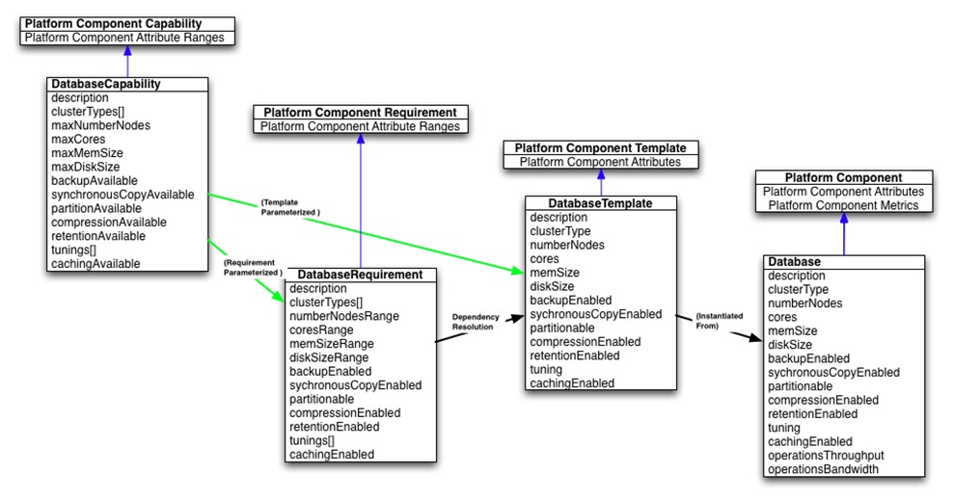
Figure D-: Database Platform Component Model
  - DatabaseCapability
For an Application Administrator, a Database Capability represents the definition of a database platform component and its range of capabilities. This resource has the following, general representation:
{
"uri": URI,
"name": String,
"type": "databaseCapability",
"description": String,
"representationSkew": String, ?
"tags": [ String, + ], ?
"clusterTypes": [
String, +
],
"maxNumberNodes": String,
"maxCores": String,
"maxMemSize": String,
"maxDiskSize": String,
"backupAvailable": Boolean,
"synchronousCopyAvailable": Boolean,
"partitionAvailable": Boolean,
"compressionAvailable": Boolean,
"retentionAvailable": Boolean,
"tunings": [
String, +
],
"cachingAvailable": Boolean,
}
Each type of DatabasePlatformComponent implements this class and populates the attributes in the list below.
    - clusterTypes
Type: String[]
Required: true
Mutable: true
Consumer-mutable: false
An array of supported cluster types. Values include: “active” and “passive”.
    - maxNumberNodes
Type: String
Required: true
Mutable: true
Consumer-mutable: false
Expresses the maximum number of supported nodes for scaling purposes.
    - maxCores
Type: String
Required: true
Mutable: true
Consumer-mutable: false
Expresses the maximum number of supported cores for scaling purposes.
    - maxMemSize
Type: String
Required: true
Mutable: true
Consumer-mutable: false
Expresses the maximum size of supported memory for an instance.
    - maxDiskSize
Type: String
Required: true
Mutable: true
Consumer-mutable: false
Expresses the limit to the size of a disk for an instance.
    - backupAvailable
Type: Boolean
Required: true
Mutable: true
Consumer-mutable: false
true if backup can be enabled.
    - synchronousCopyAvailable
Type: Boolean
Required: true
Mutable: true
Consumer-mutable: false
true if synchronous copy can be enabled
    - partitionAvailable
Type: Boolean
Required: true
Mutable: true
Consumer-mutable: false
true if partitioning can be enabled
    - compressionAvailable
Type: Boolean
Required: true
Mutable: true
Consumer-mutable: false
true if compression can be enabled
    - retentionAvailable
Type: Boolean
Required: true
Mutable: true
Consumer-mutable: false
true if retention can be enabled
    - tunings
Type: String[]
Required: true
Mutable: true
Consumer-mutable: false
An array of supported tuning types. Values include: “OLAP”, “DataMining”, and “Spatial”
    - cachingAvailable
Type: Boolean
Required: true
Mutable: true
Consumer-mutable: false
true if caching can be enabled
  - DatabaseRequirement
For an Application Administrator, a Database Requirement represents an Application Component’s requirements on a database platform component and its required range of capabilities. This resource has the following, general representation:
{
"uri": URI,
"name": String,
"type": "databaseRequirement",
"description": String,
"representationSkew": String, ?
"tags": [ String, + ], ?
"clusterTypes": [ String, + ],
"numberNodesRange": String,
"coreRange": String,
"memSizeRange": String,
"diskSizeRange": String,
"backupEnabled": Boolean,
"synchronousCopyEnabled": Boolean,
"partitionEnabled": Boolean,
"compressionEnabled": Boolean,
"retentionEnabled": Boolean,
"tunings": [ String, + ],
"cachingEnabled": Boolean
}
Each type of DatabaseRequirement implements this class and populates the attributes in the list below.
    - clusterTypes
Type: String[]
Required: true
Mutable: true
Consumer-mutable: true
An array of required cluster types. Values include: “active” and “passive”.
    - numberNodesRange
Type: String
Required: true
Mutable: true
Consumer-mutable: true
Expresses the range of the number of nodes for scaling purposes
    - coreRange
Type: String
Required: true
Mutable: true
Consumer-mutable: true
Expresses the required range of number of cores.
    - memSizeRange
Type: String
Required: true
Mutable: true
Consumer-mutable: true
Expresses the range of required memory sizes.
    - diskSizeRange
Type: String
Required: true
Mutable: true
Consumer-mutable: true
Expresses the range if disk sizes required.
    - backupEnabled
Type: Boolean
Required: true
Mutable: true
Consumer-mutable: true
true if backup is required.
    - synchronousCopyEnabled
Type: Boolean
Required: true
Mutable: true
Consumer-mutable: false
true if synchronous copy is required.
    - partitionEnabled
Type: Boolean
Required: true
Mutable: true
Consumer-mutable: true
true if partitioning is required.
    - compressionEnabled
Type: Boolean
Required: true
Mutable: true
Consumer-mutable: true
true if compression is required.
    - retentionEnabled
Type: Boolean
Required: true
Mutable: true
Consumer-mutable: true
true if retention is required.
    - tunings
Type: String[]
Required: true
Mutable: true
Consumer-mutable: true
An array of required tuning types. Values include: “OLAP”, “DataMining” and “Spatial”.
    - cachingEnabled
Type: Boolean
Required: true
Mutable: true
Consumer-mutable: true
true if caching is required.
  - DatabaseTemplate
A Database Template represents the desired configuration of a Database Platform Component with specific values for the component capabilities. The specified value for each component attribute shall be in the range defined in the corresponding Database Capability. Some PaaS offerings might only offer a fixed number of Database Template instances that cannot be modified (read-only, no new instances) indicating pre-tuned and configured pools of database resources from which these draw. Other PaaS offerings may allow newly created Database Template instances with values in any combination. This resource has the following, general representation:
{
"uri": URI,
"name": String,
"type": "databaseTemplate",
"description": String,
"representationSkew": String, ?
"tags": [ String, + ], ?
"clusterType": String,
"numberNodes": String,
"cores": String,
"memSize": String,
"diskSize": String,
"backupEnabled": Boolean,
"synchronousCopyEnabled": Boolean,
"partitionEnabled": Boolean,
"compressionEnabled": Boolean,
"retentionEnabled": Boolean,
"tuning": String,
"cachingEnabled": Boolean
}
Each type of DatabaseTemplate implements this class and populates the attributes in the list below.
    - clusterType
Type: String
Required: true
Mutable: true
Consumer-mutable: false
The desired cluster type. Values include: “active” and “passive”
    - numberNodes
Type: String
Required: true
Mutable: true
Consumer-mutable: false
The desired number of nodes for an instance
    - cores
Type: String
Required: true
Mutable: true
Consumer-mutable: false
The desired number of cores for an instance
    - memSize
Type: String
Required: true
Mutable: true
Consumer-mutable: false
The desired size of memory for an instance
    - diskSize
Type: String
Required: true
Mutable: true
Consumer-mutable: false
The desired size of a disk for an instance.
    - backupEnabled
Type: Boolean
Required: true
Mutable: true
Consumer-mutable: false
true if backup is desired for an instance.
    - synchronousCopyEnabled
Type: Boolean
Required: true
Mutable: true
Consumer-mutable: false
true if synchronous copy is desired for an instance.
    - partitionEnabled
Type: Boolean
Required: true
Mutable: true
Consumer-mutable: false
true if partitioning is desired for an instance
    - compressionEnabled
Type: Boolean
Required: true
Mutable: true
Consumer-mutable: false
true if compression is desired for an instance
    - retentionEnabled
Type: Boolean
Required: true
Mutable: true
Consumer-mutable: false
true if retention is desired for an instance
    - tuning
Type: String
Required: true
Mutable: true
Consumer-mutable: false
The desired tuning types. Values include: “OLAP”, “DataMining” and “Spatial”
    - cachingEnabled
Type: Boolean
Required: true
Mutable: true
Consumer-mutable: false
true if caching is desired for an instance
  - Database
A Database represents the runtime instance of a Database Template and its configuration of component attributes as well as metrics associated with those attributes. Each Application’s use of a Database is represented by an instance of this resource. This resource has the following, general representation:
{
"uri": URI,
"name": String,
"type": "database",
"description": String,
"representationSkew": String, ?
"tags": [ String, + ], ?
"externalManagementResource": String,
"clusterType": String,
"numberNodes": String,
"cores": String,
"memSize": String,
"diskSize": String,
"backupEnabled": Boolean,
"synchronousCopyEnabled": Boolean,
"partitionEnabled": Boolean,
"compressionEnabled": Boolean,
"retentionEnabled": Boolean,
"tuning": String,
"cachingEnabled": Boolean,
"operationsThroughput": String,
"operationsBandwidth": String
}
Each type of Database implements this class and populates the attributes in the list below.
    - externalManagementResource
Type: URI
Required: false
Mutable: false
A URI to an external management interface to manage this platform component (such as an IaaS API to manage the virtual machines that make up this database). This is platform dependent and requires external documentation to understand its meaning.
    - clusterType
Type: String
Required: true
Mutable: false
The actual cluster type. Values include: “active” and “passive”
    - numberNodes
Type: String
Required: true
Mutable: false
The actual number of nodes for an instance.
    - cores
Type: String
Required: true
Mutable: false
The actual number of cores for an instance.
    - memSize
Type: String
Required: true
Mutable: false
The actual size of memory for an instance.
    - diskSize
Type: String
Required: true
Mutable: false
The actual size of a disk for an instance.
    - backupEnabled
Type: Boolean
Required: true
Mutable: false
true if backup is enabled for this instance.
    - synchronousCopyEnabled
Type: Boolean
Required: true
Mutable: false
true if synchronous copy is enabled for this instance.
    - partitionEnabled
Type: Boolean
Required: true
Mutable: false
true if partitioning is enabled for this instance.
    - compressionEnabled
Type: Boolean
Required: true
Mutable: false
true if compression is enabled for this instance.
    - retentionEnabled
Type: Boolean
Required: true
Mutable: false
true if retention is enabled for this instance.
    - tuning
Type: String
Required: true
Mutable: false
The actual tuning type of the database instance. Values include: “OLAP”, “DataMining” and “Spatial”
    - cachingEnabled
Type: Boolean
Required: true
Mutable: false
true if caching is enabled for this instance.
    - operationsThroughput
Type: String
Required: true
Mutable: true
Consumer-mutable: false
The billable operations per second.
    - operationsBandwidth
Type: String
Required: true
Mutable: true
Consumer-mutable: false
The billable MegaBytes per second.
- Revision History
Revision | Date | Editor | Changes Made
1 | 2012-12-04 | Anish Karmarkar | Applied OASIS template to version 1.0
2 | 2012-12-18 | Anish Karmarkar | Included resolutions for issues 7, 12, 13, 15, 24, 33.
3 | 2013-02-05 | Anish Karmarkar | Included resolutions for issues 2, 6, 10, 14, 25, 35
4 | 2013-02-12 | Adrian Otto | Included resolutions for 19, 38
5 | 2013-02-13 | Adrian Otto | Included resolutions for 1, 49
6 | 2013-02-27 | Adrian Otto | Included resolutions for 36, 48, 53
7 | 2013-02-27 | Adrian Otto | Included resolutions for 34, 52
8 | 2013-03-13 | Adrian Otto | Included resolution for 40
9 | 2013-04-29 | Anish Karmarkar | Included resolutions for 50, 57
10 | 2013-05-01 | Adrian Otto | Included resolution for 30
11 | 2013-06-05 | Adrian Otto | Included resolution for 58
12 | 2013-06-13 | Gilbert Pilz, Tom Rutt | Included resolutions for issues 17, 67 and 68
13 | 2013-06-27 | Gilbert Pilz | Included resolution for 3.
14 | 2013-07-01 | Tom Rutt | Updated Figures for 3, kept revision marks from 12
15 | 2013-07-08 | Gilbert Pilz | Included resolution for 4.
16 | 2013-07-10 | Gilbert Pilz, Tom Rutt | Included resolution for 9. Miscellaneous, non-material changes and cleanups.
17 | 2013-07-11 | Gilbert Pilz, Tom Rutt | Included resolution for 65. Miscellaneous, non-material changes and cleanups.
18 | 2013-07-19 | Gilbert Pilz, Tom Rutt | Includes resolution for 55. Miscellaneous, non-material changes and cleanups.
19 | 2013-07-25 | Gilbert Pilz | Included resolutions for 45, 56, 61, 75, 76, and 78. Miscellaneous, non-material changes and cleanups.
20 | 2013-07-26 | Gilbert Pilz | Added names to Appendix A, “Acknowledgements”. Tagged normative statements that were missed in WD19. Homogenized captions for figures and tables. Homogenized and corrected cross-references. Miscellaneous editorial cleanups.

