
XACML MAP Authorization Profile Version 1.0
Committee Specification Draft 01
14 November 2013
Specification URIs
This version:
http://docs.oasis-open.org/xacml/xacml-map-authz/v1.0/csd01/xacml-map-authz-v1.0-csd01.doc (Authoritative)
http://docs.oasis-open.org/xacml/xacml-map-authz/v1.0/csd01/xacml-map-authz-v1.0-csd01.html
http://docs.oasis-open.org/xacml/xacml-map-authz/v1.0/csd01/xacml-map-authz-v1.0-csd01.pdf
Previous version:
N/A
Latest version:
http://docs.oasis-open.org/xacml/xacml-map-authz/v1.0/xacml-map-authz-v1.0.doc (Authoritative)
http://docs.oasis-open.org/xacml/xacml-map-authz/v1.0/xacml-map-authz-v1.0.html
http://docs.oasis-open.org/xacml/xacml-map-authz/v1.0/xacml-map-authz-v1.0.pdf
Technical Committee:
OASIS eXtensible Access Control Markup Language (XACML) TC
Chairs:
Bill Parducci (bill@parducci.net), Individual
Hal Lockhart (hal.lockhart@oracle.com), Oracle
Editors:
Richard Hill (richard.c.hill@boeing.com), The Boeing Company
John Tolbert (john.w.tolbert@boeing.com), The Boeing Company
Steve Legg (steven.legg@viewds.com), ViewDS
Related work:
This specification is related to:
- eXtensible Access Control Markup Language (XACML) Version 3.0. Latest version.
http://docs.oasis-open.org/xacml/3.0/xacml-3.0-core-spec-en.html.
- TNC MAP Content Authorization http://www.trustedcomputinggroup.org/resources/tnc_map_content_authorization
Abstract:
This specification defines a profile for the use of XACML in expressing policies for TCG TNC Metadata Access Points (MAP). It defines standard attribute identifiers useful in such policies, in which a MAP utilizes an XACML PDP to make MAP content authorization decisions.
Status:
This document was last revised or approved by the OASIS eXtensible Access Control Markup Language (XACML) TC on the above date. The level of approval is also listed above. Check the “Latest version” location noted above for possible later revisions of this document.
Technical Committee members should send comments on this specification to the Technical Committee’s email list. Others should send comments to the Technical Committee by using the “Send A Comment” button on the Technical Committee’s web page at http://www.oasis-open.org/committees/xacml/.
For information on whether any patents have been disclosed that may be essential to implementing this specification, and any offers of patent licensing terms, please refer to the Intellectual Property Rights section of the Technical Committee web page (http://www.oasis-open.org/committees/xacml/ipr.php).
Citation format:
When referencing this specification the following citation format should be used:
[xacml-map-authz-v1.0]
XACML MAP Authorization Profile Version 1.0. 14 November 2013. OASIS Committee Specification Draft 01. http://docs.oasis-open.org/xacml/xacml-map-authz/v1.0/csd01/xacml-map-authz-v1.0-csd01.html.

Notices
Copyright © OASIS Open 2013. All Rights Reserved.
All capitalized terms in the following text have the meanings assigned to them in the OASIS Intellectual Property Rights Policy (the "OASIS IPR Policy"). The full Policy may be found at the OASIS website.
This document and translations of it may be copied and furnished to others, and derivative works that comment on or otherwise explain it or assist in its implementation may be prepared, copied, published, and distributed, in whole or in part, without restriction of any kind, provided that the above copyright notice and this section are included on all such copies and derivative works. However, this document itself may not be modified in any way, including by removing the copyright notice or references to OASIS, except as needed for the purpose of developing any document or deliverable produced by an OASIS Technical Committee (in which case the rules applicable to copyrights, as set forth in the OASIS IPR Policy, must be followed) or as required to translate it into languages other than English.
The limited permissions granted above are perpetual and will not be revoked by OASIS or its successors or assigns.
This document and the information contained herein is provided on an "AS IS" basis and OASIS DISCLAIMS ALL WARRANTIES, EXPRESS OR IMPLIED, INCLUDING BUT NOT LIMITED TO ANY WARRANTY THAT THE USE OF THE INFORMATION HEREIN WILL NOT INFRINGE ANY OWNERSHIP RIGHTS OR ANY IMPLIED WARRANTIES OF MERCHANTABILITY OR FITNESS FOR A PARTICULAR PURPOSE.
OASIS requests that any OASIS Party or any other party that believes it has patent claims that would necessarily be infringed by implementations of this OASIS Committee Specification or OASIS Standard, to notify OASIS TC Administrator and provide an indication of its willingness to grant patent licenses to such patent claims in a manner consistent with the IPR Mode of the OASIS Technical Committee that produced this specification.
OASIS invites any party to contact the OASIS TC Administrator if it is aware of a claim of ownership of any patent claims that would necessarily be infringed by implementations of this specification by a patent holder that is not willing to provide a license to such patent claims in a manner consistent with the IPR Mode of the OASIS Technical Committee that produced this specification. OASIS may include such claims on its website, but disclaims any obligation to do so.
OASIS takes no position regarding the validity or scope of any intellectual property or other rights that might be claimed to pertain to the implementation or use of the technology described in this document or the extent to which any license under such rights might or might not be available; neither does it represent that it has made any effort to identify any such rights. Information on OASIS' procedures with respect to rights in any document or deliverable produced by an OASIS Technical Committee can be found on the OASIS website. Copies of claims of rights made available for publication and any assurances of licenses to be made available, or the result of an attempt made to obtain a general license or permission for the use of such proprietary rights by implementers or users of this OASIS Committee Specification or OASIS Standard, can be obtained from the OASIS TC Administrator. OASIS makes no representation that any information or list of intellectual property rights will at any time be complete, or that any claims in such list are, in fact, Essential Claims.
The name "OASIS" is a trademark of OASIS, the owner and developer of this specification, and should be used only to refer to the organization and its official outputs. OASIS welcomes reference to, and implementation and use of, specifications, while reserving the right to enforce its marks against misleading uses. Please see http://www.oasis-open.org/policies-guidelines/trademark for above guidance.

Table of Contents
1 Introduction 5
1.1 Glossary 6
1.2 Terminology 7
1.3 Normative References 8
1.4 Non-Normative References 8
2 Profile 9
2.1 Subject Attributes 9
2.1.1 Role 9
2.1.2 Task 9
2.2 Resource Attributes 9
2.2.1 Metadata-Type 10
2.2.2 Identifier-Type 10
2.2.3 Is-Map-Client-Identifier 11
2.2.4 Is-Self-Identifier 11
2.2.5 On-Link 12
2.2.6 Metadata-Attribute 12
2.2.7 Identifier Attribute 13
2.3 Action Attributes 15
2.3.1 Action-Id 15
2.3.2 Request-Type 15
2.3.3 Purge-Own-Metadata 15
2.3.4 Publish-Request-Subtype 16
2.4 Environment Attributes 16
2.4.1 Dry-Run 16
2.5 Obligation Caching 17
2.5.1 Maximum-Policy-Lag 17
3 Identifiers 18
3.1 Profile Identifier 18
4 Conformance 19
4.1 Attribute Identifiers 19
4.2 Attribute Values 20
Appendix A. Acknowledgements 21
Appendix B. Revision History 24

Introduction
{Non-normative}
The Trusted Computing Group (TCG) provides vendor-neutral standards through the Trusted Network Connect (TNC) Working Group for Network Access Controls (NAC). TNC defines an open architecture and interfaces for NAC, in which the IF-MAP interface is most relevant to the context of this profile. The IF-MAP protocol allows devices to publish, subscribe and search data events through a Metadata Access Point (MAP) server (see figure 1). The MAP server stores state information about devices, users, and flows in a network (see figure 2) and automatically aggregates, correlates, and distributes data to and from IF-MAP enabled devices on a network. TNC also provides an authorization model for the MAP that provides access control to metadata and constrains which operations an IF-MAP client can perform [TNC-MAP-Authz]. The TNC MAP authorization model defines the use of an XACML Policy Decision Point (PDP) when making MAP access control decisions. This profile describes attributes for such decisions between the MAP server and the XACML PDP and is based on, and aligned with [TNC-MAP-Authz].

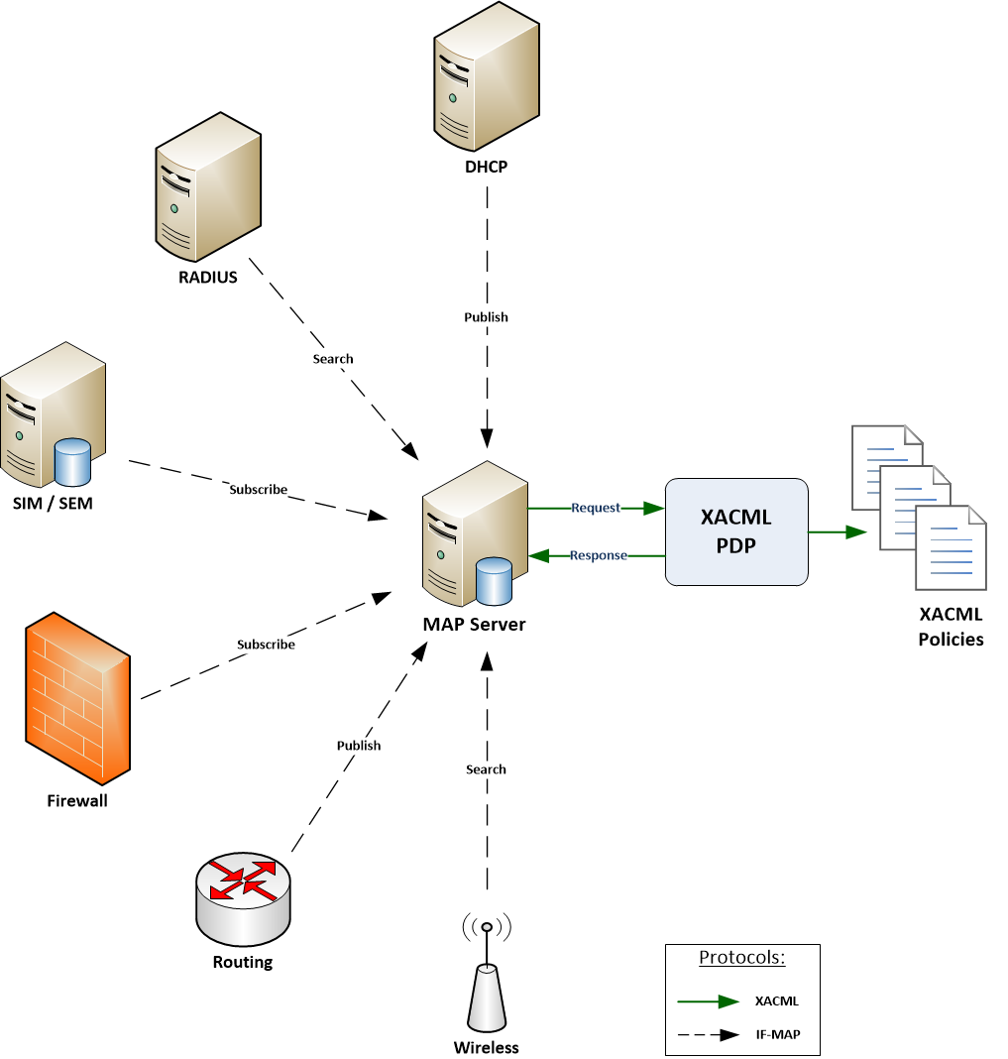
Figure 1: Example MAP – XACML scenario
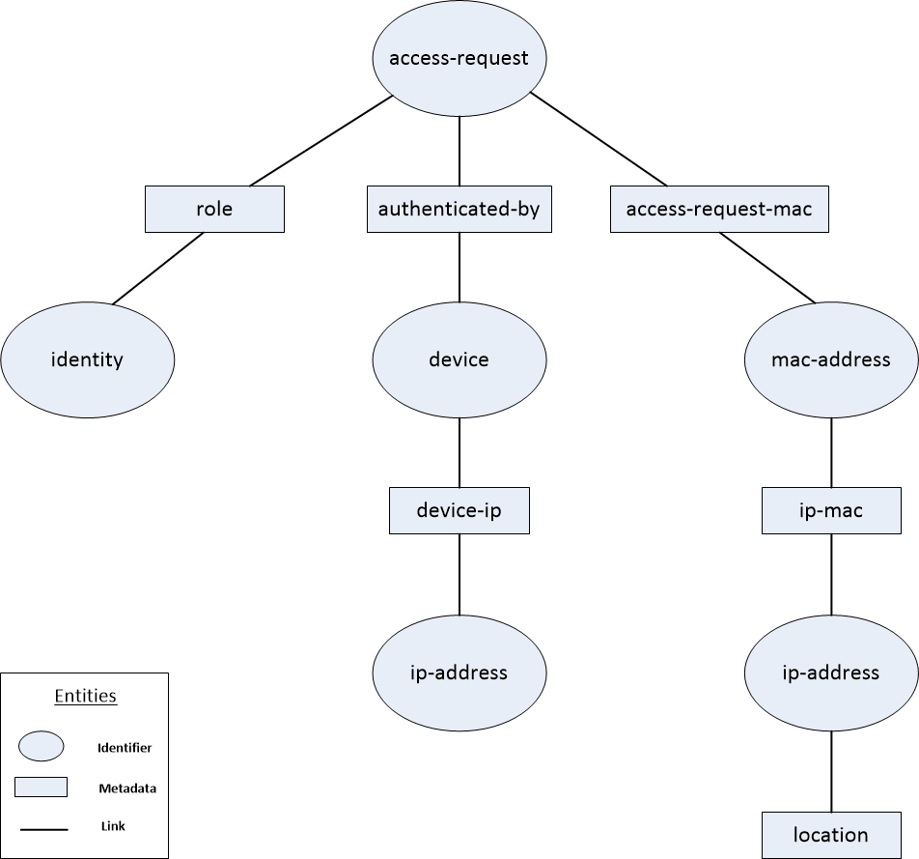
Figure 2: Example labeled graph representation of an IF-MAP data model

Glossary
Administrative-Domain
A string value defined by an organization as an optional qualifier to prevent name conflicts and can be used to group identifiers.
Content Selector
A MAP server resource attribute filter that controls which parts of a metadata item or identifier are used as XACML request attributes.
Extended Identifier
One of two classes of identifier that is defined in an external schema, which allow vendors and other standards to extend the identifier space for new applications and use cases for IF-MAP.
IF-MAP
The Interface for Metadata Access Points (IF-MAP) is an element of the TNC architecture that specifies a standard interface between a MAP and other elements of the TNC architecture.
Identifier
An identifier is an XML element, in which the IF-MAP interface specification defines a set of identifiers, or namespace that can be used to reference metadata items and represents a globally unique label of a node within the undirected, labeled graph representation of the IF-MAP data model.
Link
Within the undirected, labeled graph representation of the IF-MAP data model, links represent the graph’s edges and contains information about the relationship between two identifiers.
MAP
Metadata Access Point (MAP) is a server that provides device, user, and network flow state information to IF-MAP clients.
Metadata Item
A metadata item is an XML element which is the basic unit of content that can be attached to identifiers or links within the undirected, labeled graph representation of the IF-MAP data model.
NAC
Network Access Control. A unified set of network technologies and protocols to provide policy based network access controls.
Original Identifier
One of two classes of identifier for network-oriented elements. The 5 original identifier types are: access-request, device, identity, ip-address, and mac-address.
purgePublisher
A purgePublisher request is sent by a MAP client and is typically used to remove its own published data from the MAP server.
publisher-id
A publisher-id is an attribute of a metadata item that indicates which IF-MAP client published the metadata to the MAP server.
Publish Request Subtype
Each publish request is a sequence of operations. Each operation has a publish subtype update, notify or delete.
Self-Identifier
A MAP client’s identity identifier with the administrative-domain “ifmap:client”.
TCG
Trusted Computing Group is a standards organization that defines and promotes open, vendor-neutral standards for trusted computing platforms.
TNC
Trusted Network Connect is a working group of TCG that defines open architecture protocol specifications for network endpoint integrity and security.
Top-level attribute
An XML attribute of the root element of an XML document. Metadata items and extended identifiers are expressed in XML documents.

Terminology
The key words “MUST”, “MUST NOT”, “REQUIRED”, “SHALL”, “SHALL NOT”, “SHOULD”, “SHOULD NOT”, “RECOMMENDED”, “MAY”, and “OPTIONAL” in this document are to be interpreted as described in [RFC2119].

Normative References
[RFC2119] S. Bradner, Key words for use in RFCs to Indicate Requirement Levels, http://www.ietf.org/rfc/rfc2119.txt, IETF RFC 2119, March 1997.

[TNC-IF-MAP] TNC IF-MAP Binding for SOAP, version 2.1
http://www.trustedcomputinggroup.org/resources/tnc_ifmap_binding_for_soap_specification

[TNC-MAP-Authz] MAP Content Authorization, version 1.0
http://www.trustedcomputinggroup.org/resources/tnc_map_content_authorization

[XACML3] OASIS Standard, "eXtensible Access Control Markup Language (XACML) Version 3.0", January 2013. http://docs.oasis-open.org/xacml/3.0/xacml-3.0-core-spec-en.doc

[XACML2] OASIS Standard, "eXtensible Access Control Markup Language (XACML) Version 2.0", February 2005. http://docs.oasis-open.org/xacml/2.0/access_control-xacml-2.0-core-spec-os.pdf

[XACML1] OASIS Standard, "eXtensible Access Control Markup Language (XACML) Version 1.0", February 2003. http://www.oasis-open.org/committees/download.php/2406/oasis-xacml-1.0.pdf

Non-Normative References
[XACMLIntro] OASIS XACML TC, A Brief Introduction to XACML, 14 March 2003, http://www.oasis-open.org/committees/download.php/2713/Brief_Introduction_to_XACML.html

Profile

Subject Attributes

Role
The IF-MAP client role values shall be designated with the following attribute identifier:
urn:oasis:names:tc:xacml:3.0:if-map:content:subject:role
The DataType of this attribute is http://www.w3.org/2001/XMLSchema#string.
This attribute shall denote the role assigned to the MAP client’s session and MUST be omitted if the session has no roles. Role names beginning with “ifmap:” or “tcg:” are reserved and MUST only be used in accordance to the TCG specifications. Please see the TCG MAP Content Authorization specification for a list of pre-defined roles, as well as roles derived from metadata, LDAP groups or certificates. It is RECOMMENDED to use URNs when defining roles to avoid role conflicts.

The following is an example of a role attribute in which the IF-MAP client is a TNC Flow Controller, such as a firewall, in a target match:
<Match MatchId="urn:oasis:names:tc:xacml:1.0:function:string-equal">
<AttributeValue DataType="http://www.w3.org/2001/XMLSchema#string"
>tcg:flow-controller</AttributeValue>
<AttributeDesignator
MustBePresent="false"
Category="urn:oasis:names:tc:xacml:1.0:subject-category:access-subject"
AttributeId="urn:oasis:names:tc:xacml:3.0:if-map:content:subject:role"
DataType="http://www.w3.org/2001/XMLSchema#string"/>
</Match>

Task
The IF-MAP client task values shall be designated with the following attribute identifier:
urn:oasis:names:tc:xacml:3.0:if-map:content:subject:task:RELATIONSHIP:IDENTIFIER-TYPE
The DataType of this attribute is http://www.w3.org/2001/XMLSchema#string.
This attribute shall denote the task assigned to the MAP client. Both RELATIONSHIP and IDENTIFIER-TYPE MUST be URL-encoded.

The following is an example of an attribute identifier:
urn:oasis:names:tc:xacml:3.0:if-map:content:subject:task:member-of:http%3A//www.trustedcomputinggroup.org/2010/IFMAP-ICS-METADATA/1#overlay-network-group

Resource Attributes
For an IF-MAP publish request, each metadata item in the publish request is treated as a resource. Each attribute defined in this section refers to a metadata item or identifier found in the MAP database.
When a MAP Server retrieves data for a MAP Client, in response to a search or subscribe request, each metadata item in the MAP database is treated as a resource. In that context, each attribute defined in this section refers to a metadata item or identifier within the MAP database. For an IF-MAP purgePublisher request, the decision request MUST NOT include attributes defined in this section.

Metadata-Type
The Metadata-Type value shall be designated with the following attribute identifier:
urn:oasis:names:tc:xacml:3.0:if-map:content:resource:metadata-type
The DataType of this attribute is http://www.w3.org/2001/XMLSchema#string. This attribute denotes the type of the metadata item. The value of this attribute must be of the form NAMESPACE#TYPE, in which NAMESPACE represents the URI of the meta namespace and TYPE represents the top-level XML element name to the right of the prefix. This attribute MUST be a singleton and MUST be present if the IF-MAP client request is not purgePublisher.

The following is an example of a metadata-type attribute in a target match:
<Match MatchId="urn:oasis:names:tc:xacml:1.0:function:string-equal">
<AttributeValue DataType="http://www.w3.org/2001/XMLSchema#string"
>http://www.trustedcomputinggroup.org/2010/IFMAP-METADATA/2#device-ip</AttributeValue>
<AttributeDesignator
MustBePresent="false"
Category="urn:oasis:names:tc:xacml:3.0:attribute-category:resource"
AttributeId="urn:oasis:names:tc:xacml:3.0:if-map:content:resource:metadata-type"
DataType="http://www.w3.org/2001/XMLSchema#string"/>
</Match>

Identifier-Type
The Identifier-Type value shall be designated with the following attribute identifier:
urn:oasis:names:tc:xacml:3.0:if-map:content:resource:identifier-type
The DataType of this attribute is http://www.w3.org/2001/XMLSchema#string.

The following applies to these IF-MAP identifier types:
- Extended identifier types MUST be of the form NAMESPACE#ELEMENT-NAME, in which NAMESPACE represents the URI of the extended identifier’s XML schema and ELEMENT-NAME represents the XML element name within the schema. This attribute MUST be present in a decision request if the IF-MAP client request is not purgePublisher.

- Original identifier types MUST denote the type of identifier. Example values are access-request, identity, device, ip-address, and mac-address.

The following applies to decision requests associated with:
- An identifier. Then the identifier-type attribute SHALL denote the type of identifier. Example values are access-request, identity, device, ip-address, and mac-address.

- A link. Then the attribute identifier-type attribute SHALL have two values denoting the types of the two identifiers, with the exception of a link between two identifiers of the same identifier type, in which case the identifier-type attribute SHALL have one value.

The following is an example of an identity-type attribute in a target match:
<Match MatchId="urn:oasis:names:tc:xacml:1.0:function:string-equal">
<AttributeValue DataType="http://www.w3.org/2001/XMLSchema#string"
>ip-address</AttributeValue>
<AttributeDesignator
MustBePresent="false"
Category="urn:oasis:names:tc:xacml:3.0:attribute-category:resource"
AttributeId="urn:oasis:names:tc:xacml:3.0:if-map:content:resource:identifier-type"
DataType="http://www.w3.org/2001/XMLSchema#string"/>
</Match>

Is-Map-Client-Identifier
The Is-Map-Client-Identifier value shall be designated with the following attribute identifier:
urn:oasis:names:tc:xacml:3.0:if-map:content:resource:is-map-client-identifier
The DataType of this attribute is http://www.w3.org/2001/XMLSchema#boolean. This attribute indicates a MAP client identifier if and only if one or both identifiers in the request has the form of a MAP Client identifier in which case the value must be set to true if all of the following are true, otherwise the value must be set to false or omit the attribute altogether:
- The identifier is not extended.
- Its identifier-type is “identity”.
- Its administrative-domain is ifmap:client.

This attribute MUST be present if the IF-MAP client request is not purgePublisher.

The following is an example of an is-map-client-identifier attribute in a target match:
<Match MatchId="urn:oasis:names:tc:xacml:1.0:function:boolean-equal">
<AttributeValue DataType="http://www.w3.org/2001/XMLSchema#boolean"
>true</AttributeValue>
<AttributeDesignator
MustBePresent="true"
Category="urn:oasis:names:tc:xacml:3.0:attribute-category:resource"
AttributeId="urn:oasis:names:tc:xacml:3.0:if-map:content:resource:is-map-client-identifier"
DataType="http://www.w3.org/2001/XMLSchema#boolean"/>
</Match>

Is-Self-Identifier
The Is-Self-Identifier value shall be designated with the following attribute identifier:
urn:oasis:names:tc:xacml:3.0:if-map:content:resource:is-self-identifier
The DataType of this attribute is http://www.w3.org/2001/XMLSchema#boolean. This attribute indicates whether the identifier of the resource is the self-identifier of the subject MAP Client and it MUST be true if and only if one or both identifiers in the request are the subject MAP Client., otherwise it MUST be set to false or omitted altogether. This attribute MUST be present if the IF-MAP client request is not purgePublisher.

The following is an example of the is-self-identifier attribute in a target match in which one identifier must be the subjects MAP Clients self-identifier:
<Match MatchId="urn:oasis:names:tc:xacml:1.0:function:boolean-equal">
<AttributeValue DataType="http://www.w3.org/2001/XMLSchema#boolean"
>true</AttributeValue>
<AttributeDesignator
MustBePresent="false"
Category="urn:oasis:names:tc:xacml:3.0:attribute-category:resource"
AttributeId="urn:oasis:names:tc:xacml:3.0:if-map:content:resource:is-self-identifier"
DataType="http://www.w3.org/2001/XMLSchema#boolean"/>
</Match>

On-Link
The On-Link value shall be designated with the following attribute identifier:
urn:oasis:names:tc:xacml:3.0:if-map:content:resource:on-link
The DataType of this attribute is http://www.w3.org/2001/XMLSchema#boolean. This attribute indicates that the metadata item is or will be attached to a link, if set to true. If false, this attribute indicates that the metadata item is attached to an identifier. This attribute MUST be present if the IF-MAP client request is not purgePublisher.

The following is an example of the on-link attribute in a target match. The attribute value of true indicates that the metadata item is or will be attached to a link:
<Match MatchId="urn:oasis:names:tc:xacml:1.0:function:boolean-equal">
<AttributeValue DataType="http://www.w3.org/2001/XMLSchema#boolean"
>true</AttributeValue>
<AttributeDesignator
MustBePresent="false"
Category="urn:oasis:names:tc:xacml:3.0:attribute-category:resource"
AttributeId="urn:oasis:names:tc:xacml:3.0:if-map:content:resource:on-link"
DataType="http://www.w3.org/2001/XMLSchema#boolean"/>
</Match>

Metadata-Attribute
The family of Metadata-Attribute values shall be designated with the following attribute identifier:
urn:oasis:names:tc:xacml:3.0:if-map:content:resource:metadata-attribute
The DataType of this attribute is http://www.w3.org/2001/XMLSchema#string. This attribute denotes the name of a top-level attribute and MUST be extended to have the form:
urn:oasis:names:tc:xacml:3.0:if-map:content:resource:metadata-attribute:ATTR
In which ATTR is replaced by the name of a top-level attribute of the metadata item. Example URN values in the attribute family are:
urn:oasis:names:tc:xacml:3.0:if-map:content:resource:metadata-attribute:name
urn:oasis:names:tc:xacml:3.0:if-map:content:resource:metadata-attribute:administrative-domain

The following conditions apply:
- The value of the XACML attribute MUST be the value of the top-level attribute of the metadata item.
- If the IF-MAP metadata item does not have a top-level attribute named ATTR, then the XACML attribute corresponding to ATTR MUST NOT be present.
- The attribute MUST be included if the MAP Content Selector chooses it, otherwise it MAY be included.

The following is an example of a VariableDefinition in which the metadata-attribute name attribute needs to match the name of an Overlay Network that the IF-MAP Client is a member of:
<VariableDefinition VariableId="metadata-name-matches-subject- backhaul-interface">
<Apply FunctionId="urn:oasis:names:tc:xacml:1.0:function:string-is-in">
<Apply FunctionId="urn:oasis:names:tc:xacml:1.0:function:string-one-and-only">
<AttributeDesignator
MustBePresent="true"
Category="urn:oasis:names:tc:xacml:3.0:attribute-category:resource"
AttributeId="urn:oasis:names:tc:xacml:3.0:if-map:content:resource:metadata-attribute:name"
DataType="http://www.w3.org/2001/XMLSchema#string"/>
</Apply>

<AttributeDesignator
MustBePresent="false"
Category="urn:oasis:names:tc:xacml:1.0:subject-category:access-subject"
AttributeId="urn:oasis:names:tc:xacml:3.0:if-map:content:subject:member-of:http%3A//www.trustedcomputinggroup.org/2010/IFMAP-ICS-METADATA/1#overlay-network-group"
DataType="http://www.w3.org/2001/XMLSchema#string"/>
</Apply>
</VariableDefinition>>

Identifier Attribute
The family of identifier-attribute values shall be prefixed with the following attribute identifier:
urn:oasis:names:tc:xacml:3.0:if-map:content:resource:identifier-attribute
This attribute denotes the top-level attribute of the IF-MAP identifier and MUST be extended to have the form:
urn:oasis:names:tc:xacml:3.0:if-map:content:resource:identifier-attribute:IDENTIFIER-TYPE:ATTR
In which IDENTIFIER-TYPE is the type string of an identifier in a decision request and ATTR is replaced by the top-level attribute of the identifier. The value of the XACML attribute MUST be the value of the top-level attribute of the metadata item. Both IDENTIFIER-TYPE and ATTR MUST be URL encoded.
The following conditions apply to a link between two identifiers of the same type in which both identifiers have the attribute ATTR:
- The decision request attribute SHALL have two values if the values for ATTR are not equal.
- The decision request attribute SHALL have one value if the values for ATTR are equal.

The DataType of this attribute MUST be http://www.w3.org/2001/XMLSchema#string except for the following cases:

- The DataType of this attribute is urn:oasis:names:tc:xacml:2.0:data-type:ipAddress if both of the following are true:
  - The identifier’s type is ip-address.
  - The ATTR extension is value.

- The DataType of this attribute is urn:oasis:names:tc:xacml:1.0:data-type:x500Name if all of the following are true:
  - The identifier’s type is identity.
  - The identity subtype is x500Name.
  - The ATTR extension is name.

- The DataType of this attribute is urn:oasis:names:tc:xacml:2.0:data-type:dnsName if all of the following is true:
  - The identifier’s type is identity.
  - The identity subtype is dns-name
  - The ATTR extension is name.

This attribute MUST NOT be present in the decision request unless the identifier has a top-level attribute named ATTR, or ATTR is administrative-domain. If ATTR is administrative-domain and the identifier has no administrative-domain attribute, then the attribute value MUST be an empty string.

The following is an example of a target match in which the identity (IDENTIFIER-TYPE) type (ATTR) must match the identity type hip-hit, which is the Host Identity Protocol (HIP), Host Identity Tag (HIT) :
<Match MatchId="urn:oasis:names:tc:xacml:1.0:function:string-equal">
<AttributeValue DataType="http://www.w3.org/2001/XMLSchema#string"
>hip-hit</AttributeValue>
<AttributeDesignator
MustBePresent="true"
Category="urn:oasis:names:tc:xacml:3.0:attribute-category:resource"
AttributeId="urn:oasis:names:tc:xacml:3.0:if-map:content:resource: identifier-attribute:identity:type"
DataType="http://www.w3.org/2001/XMLSchema#string"/>
</Match>>

Action Attributes

Action-Id
The Action-Id value shall be designated with the following attribute identifier:
urn:oasis:names:tc:xacml:1.0:action:action-id
The DataType of this attribute is http://www.w3.org/2001/XMLSchema#string. This attribute indicates that the IF-MAP client is requesting to read or write metadata in the MAP database and MUST be present in the decision request. If the IF-MAP client request type to the MAP server is either search or subscribe then this attribute’s value MUST be read, otherwise it MUST be write.

The following is an example of a target match in which the IF-MAP Client is allowed to read metadata in the MAP database:
<Match MatchId="urn:oasis:names:tc:xacml:1.0:function:string-equal">
<AttributeValue DataType="http://www.w3.org/2001/XMLSchema#string"
>read</AttributeValue>
<AttributeDesignator
MustBePresent="false"
Category="urn:oasis:names:tc:xacml:3.0:attribute-category:action"
AttributeId="urn:oasis:names:tc:xacml:1.0:action:action-id"
DataType="http://www.w3.org/2001/XMLSchema#string"/>
</Match>

Request-Type
The Request-Type value shall be designated with the following attribute identifier:
urn:oasis:names:tc:xacml:3.0:if-map:content:action:request-type
The DataType of this attribute is http://www.w3.org/2001/XMLSchema#string. This attribute denotes the IF-MAP request type that is sent to the MAP server and MUST have one of the following values: publish, subscribe, search, or purgePublisher

The following is an example of a target match in which the request type is purgePublisher:
<Match MatchId="urn:oasis:names:tc:xacml:1.0:function:string-equal">
<AttributeValue DataType="http://www.w3.org/2001/XMLSchema#string"
>purgePublisher</AttributeValue>
<AttributeDesignator
MustBePresent="false"
Category="urn:oasis:names:tc:xacml:3.0:attribute-category:action"
AttributeId="urn:oasis:names:tc:xacml:3.0:if-map:content:action:request-type"
DataType="http://www.w3.org/2001/XMLSchema#string"/>
</Match>

Purge-Own-Metadata
The Purge-Own-Metadatavalue shall be designated with the following attribute identifier:
urn:oasis:names:tc:xacml:3.0:if-map:content:action:purge-own-metadata
The DataType of this attribute is http://www.w3.org/2001/XMLSchema#boolean. This attribute denotes whether the IF-MAP client is attempting to purge its own metadata items or metadata items published by another IF-MAP client. This attribute value is true if purging its own metadata; otherwise the value is false:

The following is an example of a target match in which a MAP Client may purge its own metadata:
<Match MatchId="urn:oasis:names:tc:xacml:1.0:function:boolean-equal">
<AttributeValue DataType="http://www.w3.org/2001/XMLSchema#boolean"
>true</AttributeValue>
<AttributeDesignator
MustBePresent="false"
Category="urn:oasis:names:tc:xacml:3.0:attribute-category:action"
AttributeId="urn:oasis:names:tc:xacml:3.0:if-map:content:action:purge-own-metadata"
DataType="http://www.w3.org/2001/XMLSchema#boolean"/>
</Match>

Publish-Request-Subtype
The Publish-Request-Subtype value shall be designated with the following attribute identifier:
urn:oasis:names:tc:xacml:3.0:if-map:content:action:publish-request-subtype
The DataType of this attribute is http://www.w3.org/2001/XMLSchema#string. This attribute denotes the type of an operation within an IF-MAP publish request and MUST have one of the following values: update, notify, or delete. This attribute must be present in the decision request if, and only if, the IF-MAP request type is publish.

The following is an example of a target match in which the IF-MAP publish request operation is notify:
<Match MatchId="urn:oasis:names:tc:xacml:1.0:function:string-equal">
<AttributeValue DataType="http://www.w3.org/2001/XMLSchema#string"
>notify</AttributeValue>
<AttributeDesignator
MustBePresent="false"
Category="urn:oasis:names:tc:xacml:3.0:attribute-category:action"
AttributeId=" urn:oasis:names:tc:xacml:3.0:if-map:content:action:publish-request-subtype"
DataType="http://www.w3.org/2001/XMLSchema#string"/>
</Match>

Environment Attributes

Dry-Run
The Dry-Run value shall be designated with the following attribute identifier:
urn:oasis:names:tc:xacml:3.0:if-map:content:environment:dry-run
The DataType of this attribute is http://www.w3.org/2001/XMLSchema#boolean. This attribute MUST be a singleton (bag of one) and MUST be present. A dry-run PolicySet allows MAP administrators to test new PolicySets before they are used in a production environment. A second use of dry-run policies is to allow for monitoring of certain activities. The value of true indicates the use of a dry-run PolicySet. The value of false indicates that a dry-run PolicySet will not be used.

The following is an example of a target match that checks for a dry run:
<Match MatchId="urn:oasis:names:tc:xacml:1.0:function:boolean-equal">
<AttributeValue DataType="http://www.w3.org/2001/XMLSchema#boolean"
>true</AttributeValue>
<AttributeDesignator
MustBePresent="false"
Category="urn:oasis:names:tc:xacml:3.0:attribute-category:environment"
AttributeId="urn:oasis:names:tc:xacml:3.0:if-map:content:environment:dry-run"
DataType="http://www.w3.org/2001/XMLSchema#boolean"/>
</Match>

Obligation Caching
The <Obligation> element will be used in the XACML response to notify the requestor that an additional processing requirement is needed if the obligation’s FulfillOn attribute is Permit. This profile defines an obligation that indicates when a MAP server is required to cache an XACML decision for no more than a specified period of time. Each caching obligation must contain exactly one maximum-policy-lag attribute. In the case where the XACML response contains two or more caching obligations, then the caching obligation with the shortest maximum-policy-lag attribute value must be used.
The Caching Obligation shall be designated with the following identifier:
urn:oasis:names:tc:xacml:3.0:if-map:content:obligation:caching

Maximum-Policy-Lag
The maximum-policy-lag value shall be designated with the following identifier:
urn:oasis:names:tc:xacml:3.0:if-map:content:obligation:maximum-policy-lag
The maximum-policy-lag attribute indicates the maximum length of time, in seconds, that a MAP server can cache an XACML decision before new XACML request will need to be made. The DataType of this attribute is http://www.w3.org/2001/XMLSchema#integer, in which its value must be a nonnegative integer.

The following is an example of a caching obligation:
<ObligationExpressions>
<ObligationExpression
ObligationId="urn:oasis:names:tc:xacml:3.0:if-map:content:obligation:caching"
FulfillOn="Permit">
<AttributeAssignmentExpression
AttributeId="urn:oasis:names:tc:xacml:3.0:if-map:content:obligation:maximum-policy-lag">
<AttributeValue
DataType="http://www.w3.org/2001/XMLSchema#integer"
>60</AttributeValue>
</AttributeAssignmentExpression>
</ObligationExpression>
</ObligationExpressions>

Identifiers
This profile defines the following URN identifiers.

Profile Identifier
The following identifier SHALL be used as the identifier for this profile when an identifier in the form of a URI is required.
urn:oasis:names:tc:xacml:3.0:if-map:content

Conformance
Conformance to this profile is defined for policies and requests generated and transmitted within and between XACML systems.

Attribute Identifiers
Conformant XACML policies and requests SHALL use the attribute identifiers defined in Section 2 for their specified purpose and SHALL NOT use any other identifiers for the purposes defined by attributes in this profile. The following table lists the attributes that must be supported.
Note: “M” is mandatory “O” is optional.

Identifiers
urn:oasis:names:tc:xacml:3.0:if-map:content:subject:role | M
urn:oasis:names:tc:xacml:3.0:if-map:content:subject:task: RELATIONSHIP:IDENTIFIER-TYPE | M
urn:oasis:names:tc:xacml:3.0:if-map:content:resource:metadata-type | M
urn:oasis:names:tc:xacml:3.0:if-map:content:resource:identifier-type | M
urn:oasis:names:tc:xacml:3.0:if-map:content:resource:is-map-client-identifier | M
urn:oasis:names:tc:xacml:3.0:if-map:content:resource:is-self-identifier | M
urn:oasis:names:tc:xacml:3.0:if-map:content:resource:on-link | M
urn:oasis:names:tc:xacml:3.0:if-map:content:resource:metadata-attribute:ATTR | M
urn:oasis:names:tc:xacml:3.0:if-map:content:resource:identifier-attribute:IDENTIFIER-TYPE:ATTR | M
urn:oasis:names:tc:xacml:3.0:if-map:content:action:request-type | M
urn:oasis:names:tc:xacml:3.0:if-map:content:action:purge-own-metadata | M
urn:oasis:names:tc:xacml:3.0:if-map:content:action:publish-request-subtype | M
urn:oasis:names:tc:xacml:3.0:if-map:content:environment:dry-run | M
urn:oasis:names:tc:xacml:3.0:if-map:content:obligation:caching | M
urn:oasis:names:tc:xacml:3.0:if-map:content:obligation:maximum-policy-lag | M

Attribute Values
Conformant XACML policies and requests SHALL use attribute values in the specified range or patterns as defined for each attribute in Section 2 (when a range or pattern is specified).
NOTE: In order to process conformant XACML policies and requests correctly, PIP and PEP modules may have to translate native data values into the datatypes and formats specified in this profile.
- Acknowledgements
The following individuals have participated in the creation of this specification and are gratefully acknowledged:
Participants:
Richard Hill, The Boeing Company
John Tolbert, The Boeing Company
Steve Venema, The Boeing Company
Stephen Hatch, The Boeing Company
Nancy Cam-Winget, Cisco Systems
Arne Welzel, FHH
Josef von Helden, FHH
James Tan, Infoblox
David Vigier, Infoblox
Stu Bailey, Infoblox
Navin Boddu, Infoblox
Steve Hanna, Juniper
Clifford Kahn, Juniper
Lisa Lorenzin, Juniper
Venkata Srikar Damaraju, Juniper
Atul Shah, Microsoft
Trevor Freeman, Microsoft
Charles Schmidt, The Mitre Corporation
Steven Legg, ViewDS

Committee members during profile development:
Person | Organization | Role
David Brossard | Axiomatics | Member
Gerry Gebel | Axiomatics | Member
Srijith Nair | Axiomatics | Member
Erik Rissanen | Axiomatics | Member
Richard Skedd | BAE SYSTEMS plc | Member
Abbie Barbir | Bank of America | Member
Radu Marian | Bank of America | Member
Rakesh Radhakrishnan | Bank of America | Member
Ronald Jacobson | CA Technologies | Member
Masum Hasan | Cisco Systems | Member
Anil Tappetla | Cisco Systems | Member
Robert van Herk | Connectis | Member
Danny Thorpe | Dell | Voting Member
Gareth Richards | EMC | Member
Remon Sinnema | EMC | Voting Member
Matt Crooke | First Point Global Pty Ltd. | Member
Allan Foster | Forgerock Inc. | Member
Michiharu Kudo | IBM | Member
Sridhar Muppidi | IBM | Member
Vernon Murdoch | IBM | Member
Nataraj Nagaratnam | IBM | Member
Gregory Neven | IBM | Member
Franz-Stefan Preiss | IBM | Member
Ron Williams | IBM | Member
David Chadwick | Individual | Member
David Choy | Individual | Member
Bill Parducci* | Individual | Chair
Mike Schmidt | Individual | Member
David Laurance | JPMorgan Chase Bank, N.A. | Member
Eliot Solomon | JPMorgan Chase Bank, N.A. | Member
Thomas Hardjono | M.I.T. | Member
Anthony Nadalin | Microsoft | Member
Vishwesh Bavadekar | NextLabs, Inc. | Member
Andy Han | NextLabs, Inc. | Member
Naomaru Itoi | NextLabs, Inc. | Member
Arun Shah | OpenIAM, LLC | Member
Kamalendu Biswas | Oracle | Member
Willem de Pater | Oracle | Member
Rich Levinson | Oracle | Secretary
Hal Lockhart | Oracle | Chair
Prateek Mishra | Oracle | Member
Sid Mishra | Oracle | Member
Roger Wigenstam | Oracle | Member
YanJiong WANG | Primeton Technologies, Inc. | Member
Kenneth Peeples | Red Hat | Member
Anil Saldhana | Red Hat | Member
Darran Rolls | SailPoint Technologies | Member
Jan Herrmann | Siemens AG | Member
Crystal Hayes | The Boeing Company | Voting Member
Richard Hill | The Boeing Company | Voting Member
Greg Smith | The Boeing Company | Member
John Tolbert | The Boeing Company | Voting Member
Bernard Butler | TSSG | Member
Steven Davy | TSSG | Member
Martin Smith | US Department of Homeland Security | Member
John Davis | Veterans Health Administration | Member
Duane DeCouteau | Veterans Health Administration | Member
Mohammad Jafari | Veterans Health Administration | Voting Member
David Staggs | Veterans Health Administration | Member
Gil Kirkpatrick | ViewDS | Member
Steven Legg | ViewDS | Voting Member
Johann Nallathamby | WSO2 | Member
Asela Pathberiya | WSO2 | Member
Prabath Siriwardena | WSO2 | Member

- Revision History

Revision | Date | Editor | Changes Made
WD 1 | 5/2/2013 | Richard Hill, John Tolbert, | Initial committee draft.
WD 2 | 7/15/2013 | Richard Hill, John Tolbert | Updated to reflect changes in the TNC MAP Content Authorization v31 specification.  Added figure 2  Added definitions to Glossary,  Added Non-Normative Reference  Added subject task attribute  Added attribute examples  Removed delete-metadata-by-other-client attribute  Added purge-own-metadata attribute
WD 3 | 10/28/2013 | Richard Hill, John Tolbert, Steven Legg | Addressed comments from WD 2 review.  Updated to reflect changes in the TNC MAP Content Authorization v33 specification.  Added Caching Obligation  Updated Appendix A. Acknowledgements
WD 4 | 11/12/2013 | Richard Hill, John Tolbert, Steven Legg | Addressed comments from WD 3 review.

