
TOSCA Simple Profile for Network Functions Virtualization (NFV) Version 1.0
Committee Specification Draft 03
17 March 2016
Specification URIs
This version:
http://docs.oasis-open.org/tosca/tosca-nfv/v1.0/csd03/tosca-nfv-v1.0-csd03.pdf (Authoritative)
http://docs.oasis-open.org/tosca/tosca-nfv/v1.0/csd03/tosca-nfv-v1.0-csd03.html
http://docs.oasis-open.org/tosca/tosca-nfv/v1.0/csd03/tosca-nfv-v1.0-csd03.doc
Previous version:
http://docs.oasis-open.org/tosca/tosca-nfv/v1.0/csd02/tosca-nfv-v1.0-csd02.pdf (Authoritative)
http://docs.oasis-open.org/tosca/tosca-nfv/v1.0/csd02/tosca-nfv-v1.0-csd02.html
http://docs.oasis-open.org/tosca/tosca-nfv/v1.0/csd02/tosca-nfv-v1.0-csd02.doc
Latest version:
http://docs.oasis-open.org/tosca/tosca-nfv/v1.0/tosca-nfv-v1.0.pdf (Authoritative)
http://docs.oasis-open.org/tosca/tosca-nfv/v1.0/tosca-nfv-v1.0.html
http://docs.oasis-open.org/tosca/tosca-nfv/v1.0/tosca-nfv-v1.0.doc
Technical Committee:
OASIS Topology and Orchestration Specification for Cloud Applications (TOSCA) TC
Chairs:
Paul Lipton (paul.lipton@ca.com), CA Technologies
Simon Moser (smoser@de.ibm.com), IBM
Editor:
Shitao Li (lishitao@huawei.com), Huawei Technologies Co., Ltd.
Related work:
This specification is related to:
- Topology and Orchestration Specification for Cloud Applications Version 1.0. Edited by Derek Palma and Thomas Spatzier. 25 November 2013. OASIS Standard. Latest version: http://docs.oasis-open.org/tosca/TOSCA/v1.0/TOSCA-v1.0.html.
Declared XML namespaces:
- http://docs.oasis-open.org/tosca/ns/simple/yaml/1.0/nfv/1.0/
Abstract:
The TOSCA NFV profile specifies a Network Functions Virtualisation (NFV) specific data model using TOSCA language.
Status:
This document was last revised or approved by the OASIS Topology and Orchestration Specification for Cloud Applications (TOSCA) TC on the above date. The level of approval is also listed above. Check the “Latest version” location noted above for possible later revisions of this document. Any other numbered Versions and other technical work produced by the Technical Committee (TC) are listed at https://www.oasis-open.org/committees/tc_home.php?wg_abbrev=tosca#technical.
TC members should send comments on this specification to the TC’s email list. Others should send comments to the TC’s public comment list, after subscribing to it by following the instructions at the “Send A Comment” button on the TC’s web page at https://www.oasis-open.org/committees/tosca/.
For information on whether any patents have been disclosed that may be essential to implementing this specification, and any offers of patent licensing terms, please refer to the Intellectual Property Rights section of the TC’s web page (https://www.oasis-open.org/committees/tosca/ipr.php).
Citation format:
When referencing this specification the following citation format should be used:
[TOSCA-Simple-Profile-NFV-v1.0]
TOSCA Simple Profile for Network Functions Virtualization (NFV) Version 1.0. Edited by Shitao Li. 17 March 2016. OASIS Committee Specification Draft 03. http://docs.oasis-open.org/tosca/tosca-nfv/v1.0/csd03/tosca-nfv-v1.0-csd03.html. Latest version: http://docs.oasis-open.org/tosca/tosca-nfv/v1.0/tosca-nfv-v1.0.html.

Notices
Copyright © OASIS Open 2016. All Rights Reserved.
All capitalized terms in the following text have the meanings assigned to them in the OASIS Intellectual Property Rights Policy (the "OASIS IPR Policy"). The full Policy may be found at the OASIS website.
This document and translations of it may be copied and furnished to others, and derivative works that comment on or otherwise explain it or assist in its implementation may be prepared, copied, published, and distributed, in whole or in part, without restriction of any kind, provided that the above copyright notice and this section are included on all such copies and derivative works. However, this document itself may not be modified in any way, including by removing the copyright notice or references to OASIS, except as needed for the purpose of developing any document or deliverable produced by an OASIS Technical Committee (in which case the rules applicable to copyrights, as set forth in the OASIS IPR Policy, must be followed) or as required to translate it into languages other than English.
The limited permissions granted above are perpetual and will not be revoked by OASIS or its successors or assigns.
This document and the information contained herein is provided on an "AS IS" basis and OASIS DISCLAIMS ALL WARRANTIES, EXPRESS OR IMPLIED, INCLUDING BUT NOT LIMITED TO ANY WARRANTY THAT THE USE OF THE INFORMATION HEREIN WILL NOT INFRINGE ANY OWNERSHIP RIGHTS OR ANY IMPLIED WARRANTIES OF MERCHANTABILITY OR FITNESS FOR A PARTICULAR PURPOSE.
OASIS requests that any OASIS Party or any other party that believes it has patent claims that would necessarily be infringed by implementations of this OASIS Committee Specification or OASIS Standard, to notify OASIS TC Administrator and provide an indication of its willingness to grant patent licenses to such patent claims in a manner consistent with the IPR Mode of the OASIS Technical Committee that produced this specification.
OASIS invites any party to contact the OASIS TC Administrator if it is aware of a claim of ownership of any patent claims that would necessarily be infringed by implementations of this specification by a patent holder that is not willing to provide a license to such patent claims in a manner consistent with the IPR Mode of the OASIS Technical Committee that produced this specification. OASIS may include such claims on its website, but disclaims any obligation to do so.
OASIS takes no position regarding the validity or scope of any intellectual property or other rights that might be claimed to pertain to the implementation or use of the technology described in this document or the extent to which any license under such rights might or might not be available; neither does it represent that it has made any effort to identify any such rights. Information on OASIS' procedures with respect to rights in any document or deliverable produced by an OASIS Technical Committee can be found on the OASIS website. Copies of claims of rights made available for publication and any assurances of licenses to be made available, or the result of an attempt made to obtain a general license or permission for the use of such proprietary rights by implementers or users of this OASIS Committee Specification or OASIS Standard, can be obtained from the OASIS TC Administrator. OASIS makes no representation that any information or list of intellectual property rights will at any time be complete, or that any claims in such list are, in fact, Essential Claims.
The name "OASIS" is a trademark of OASIS, the owner and developer of this specification, and should be used only to refer to the organization and its official outputs. OASIS welcomes reference to, and implementation and use of, specifications, while reserving the right to enforce its marks against misleading uses. Please see https://www.oasis-open.org/policies-guidelines/trademark for above guidance.
Table of Contents
1 Introduction 6
1.1 Terminology 6
1.2 Normative References 6
2 Summary of key TOSCA concepts 7
3 NFV Overview 8
3.1 Network Services 8
3.2 Network Connectivity Topology 8
4 Deployment Template in NFV 10
5 General Mapping between TOSCA and NFV Deployment Template 11
6 TOSCA Data Model for a network service 12
6.1 Namespace and Alias 13
7 TOSCA Data Model for a VNF 14
8 TOSCA template for VNFD 15
8.1 Node Template Substitution Mapping for a VNF 15
8.2 Capability Types 18
8.2.1 tosca.capabilities.Compute.Container.Architecture 18
8.2.2 tosca.capabilites.nfv.VirtualBindable 19
8.2.3 tosca.capabilities.nfv.Metric 19
8.3 Data Types 20
8.3.1 tosca.datatypes.compute.Container.Architecture.CPUAllocation 20
8.3.2 tosca.datatypes.compute.Container.Architecture.NUMA 20
8.4 Relationship Types 21
8.4.1 tosca.relationships.nfv.VirtualBindsTo 21
8.4.2 tosca.relationships.nfv.Monitor 21
8.5 Node Types 22
8.5.1 tosca.nodes.nfv.VNF 22
8.5.2 tosca.nodes.nfv.VDU 22
8.5.3 file: vdu1.image tosca.nodes.nfv.CP 24
9 TOSCA template for VLD 26
9.1 tosca.nodes.nfv.VL 26
9.1.1 Properties 26
9.1.2 Attributes 26
9.1.3 Definition 26
9.1.4 Additional Requirement 26
9.2 tosca.nodes.nfv.VL.ELine 26
9.3 tosca.nodes.nfv.VL.ELAN 27
9.4 tosca.nodes.nfv.VL.ETree 27
10 TOSCA template for VNFFGD 28
10.1 Semantics of VNFFG 28
10.2 Semantics of Network forwarding path 28
10.3 Capability Types 29
10.3.1 tosca.capabilites.nfv.Forwarder 29
10.4 Relationship Types 29
10.4.1 tosca.relationships.nfv.ForwardsTo 29
10.5 Node Types 30
10.5.1 tosca.nodes.nfv.FP 30
10.5.2 Properties 30
10.5.3 Attributes 30
10.5.4 Definition 30
10.6 Group types 31
10.6.1 tosca.groups.nfv.VNFFG 31
10.6.2 Properties 31
10.6.3 Attributes 31
10.6.4 Definition 31
11 TOSCA template for NSD 33
11.1 Metadata keynames 33
11.2 Using service template for a NFV network service 33
11.3 Capability types 38
11.3.1 tosca.capabilities.nfv.VirtualLinkable 38
11.4 Relationship Types 38
11.4.1 tosca.relationships.nfv.VirtualLinksTo 38
12 Examples 39
12.1 Simple Virtual Router VNFD Template 39
12.2 Virtual Router VNFD Template with Efficient CPU placement properties 41
12.3 Multi-VDU Virtual Router VNFD Template 43
Appendix A. Acknowledgments 48
Appendix B. Revision History 49

Introduction
The TOSCA NFV profile specifies a NFV specific data model using TOSCA language. Network Functions Virtualisation aims to transform the way that network operators architect networks by evolving standard IT virtualisation technology to consolidate many network equipment types onto industry standard high volume servers, switches and storage, which could be located in Datacentres, Network Nodes and in the end user premises.
The deployment and operational behavior requirements of each Network Service in NFV is captured in a deployment template, and stored during the Network Service on-boarding process in a catalogue, for future selection for instantiation. This profile using TOSCA as the deployment template in NFV, and defines the NFV specific types to fulfill the NFV requirements. This profile also gives the general rules when TOSCA used as the deployment template in NFV.

Terminology
The key words “MUST”, “MUST NOT”, “REQUIRED”, “SHALL”, “SHALL NOT”, “SHOULD”, “SHOULD NOT”, “RECOMMENDED”, “MAY”, and “OPTIONAL” in this document are to be interpreted as described in [RFC2119].

Normative References
[RFC2119] Bradner, S., “Key words for use in RFCs to Indicate Requirement Levels”, BCP 14, RFC 2119, March 1997. http://www.ietf.org/rfc/rfc2119.txt.
[ETSI GS NFV-MAN 001 v1.1.1] Network Functions Virtualisation (NFV); Management and Orchestration
[TOSCA-1.0] Topology and Orchestration Topology and Orchestration Specification for Cloud Applications (TOSCA) Version 1.0, an OASIS Standard, 25 November 2013, http://docs.oasis-open.org/tosca/TOSCA/v1.0/os/TOSCA-v1.0-os.pdf
[TOSCA-Simple-Profile-YAML] TOSCA Simple Profile in YAML Version 1.0

Summary of key TOSCA concepts
The TOSCA metamodel uses the concept of service templates to describe cloud workloads as a topology template, which is a graph of node templates modeling the components a workload is made up of and as relationship templates modeling the relations between those components. TOSCA further provides a type system of node types to describe the possible building blocks for constructing a service template, as well as relationship type to describe possible kinds of relations. Both node and relationship types may define lifecycle operations to implement the behavior an orchestration engine can invoke when instantiating a service template. For example, a node type for some software product might provide a ‘create’ operation to handle the creation of an instance of a component at runtime, or a ‘start’ or ‘stop’ operation to handle a start or stop event triggered by an orchestration engine. Those lifecycle operations are backed by implementation artifacts such as scripts or Chef recipes that implement the actual behavior.
An orchestration engine processing a TOSCA service template uses the mentioned lifecycle operations to instantiate single components at runtime, and it uses the relationship between components to derive the order of component instantiation. For example, during the instantiation of a two-tier application that includes a web application that depends on a database, an orchestration engine would first invoke the ‘create’ operation on the database component to install and configure the database, and it would then invoke the ‘create’ operation of the web application to install and configure the application (which includes configuration of the database connection).
The TOSCA simple profile assumes a number of base types (node types and relationship types) to be supported by each compliant environment such as a ‘Compute’ node type, a ‘Network’ node type or a generic ‘Database’ node type. Furthermore, it is envisioned that a large number of additional types for use in service templates will be defined by a community over time. Therefore, template authors in many cases will not have to define types themselves but can simply start writing service templates that use existing types. In addition, the simple profile will provide means for easily customizing existing types, for example by providing a customized ‘create’ script for some software.

NFV Overview
Network Functions Virtualization (NFV) leverages standard IT virtualization technology to enable rapid service innovation for Network Operators and Service Providers. Most current networks are comprised of diverse network appliances that are connected—or chained--in a specific way to achieve the desired network service functionality. NFV aims to replace these network appliances with virtualized network functions that can be consolidated onto industry-standard high volume servers, switches and storage, which could be located in data centers, network nodes, or in the end-user premises. These virtual network functions can then be combined using dynamic methods—rather than just static ones—to create and manage network services in an agile fashion.
Deploying and operationalizing end-to-end services in NFV requires software-based tools for Management and Orchestration of virtualized network functions on independently deployed and operated NFV infrastructure platforms. These tools use Network Service Descriptors (NSDs) that capture deployment and operational behavior requirements of each network service. This section describes how NFV models network services using NSDs.

Network Services
A network service is a composition of Network Functions that defines an end-to-end functional and behavioral specification. Consequently, a network service can be viewed architecturally as a forwarding graph of Network Functions (NFs) interconnected by supporting network infrastructure.
A major change brought by NFV is that virtualization enables dynamic methods rather than just static ones to control how network functions are interconnected and how traffic is routed across those connections between the various network functions.
To enable dynamic composition of network services, NFV introduces Network Service Descriptors (NSDs) that specify the network service to be created. Aside from general information about the service, these Network Service Descriptors typically include two types of graphs:
- A Network Connectivity Topology (NCT) Graph that specifies the Virtual Network Functions that make up the service and the logical connections between virtual network functions. NFV models these logical connections as Virtual Links that need to be created dynamically on top of the physical infrastructure.
- One or more Forwarding Graphs that specify how packets are forwarded between VNFs across the Network Connectivity Topology graph in order to accomplish the desired network service behavior.
A network connectivity topology is only concerned with how the different VNFs are connected, and how data flows across those connections, regardless of the location and placement of the underlying physical network elements. In contrast, the network forwarding graph defines the sequence of VNFs to be traversed by a set of packets matching certain criteria. The network forwarding graph must include the criteria that specify which packets to route through the graph. A simple example of this could be filtering based on a ToS or DSCP value, or routing based on source addresses, or a number of other different applications. Different forwarding graphs could be constructed on the same network connectivity topology based on different matching criteria.

Network Connectivity Topology
A VNF Network Connectivity Topology (NCT) graph describes how one or more VNFs in a network service are connected to one another, regardless of the location and placement of the underlying physical network elements. A VNF NCT thus defines a logical network-level topology of the VNFs in a graph. Note that the (logical) topology represented by a VNF-NCT may change as a function of changing user requirements, business policies, and/or network context.
In NFV, the properties, relationships, and other metadata of the connections are specified in Virtual Link abstractions. To model how virtual links connect to virtual network functions, NFV introduces uses Connection Points (CPs) that represent the virtual and/or physical interfaces of the VNFs and their associated properties and other metadata.
The following figure shows a network service example given by the NFV MANO specification [ETSI GS NFV-MAN 001 v1.1.1]. In this example, the network service includes three VNFs. Each VNF exposes different number of connection points.
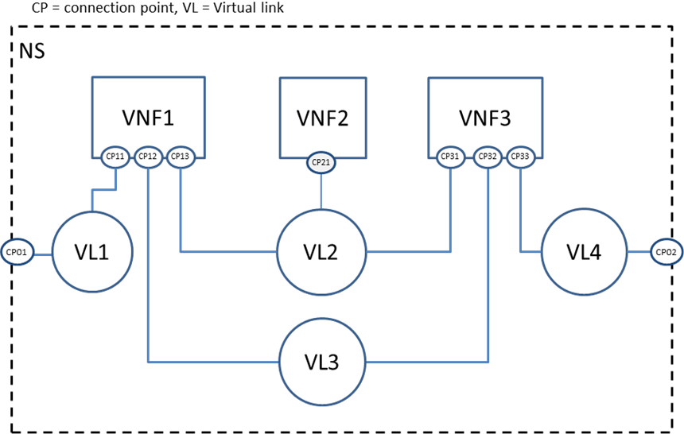
- Example network connectivity topology graph
Each Virtual link (VL) describes the basic topology of the connectivity as well as other required parameters (e.g. bandwidth and QoS class). Examples of virtual link types in VNF-NCTs include:
- E-Line, E-LAN, and E-TREE (defined by the Metro Ethernet Forum in MEF Technical Specification MEF 6.1: Ethernet Services Definitions - Phase 2", April, 2008).
- VPLS and VPWS Services (e.g. defined by IETF RFC 4761).
- Different types of Virtual LANs or Private Virtual LANs (e.g. IETF RFC 3069).
- Different types of Layer 2 Virtual Private Networks (e.g. IETF RFC 4464).
- Different types of Layer 3 Virtual Private Networks (e.g. IETF RFC 3809).
- Different types of Multi-Protocol Label Switching Networks (e.g. IETF RFC 3031).
- Other types of layer 2 services, such as Pseudo Wire Switching for providing multiple Virtual Leased Line Services (e.g. IETF RFC 4385).

Deployment Template in NFV
The deployment template in NFV fully describes the attributes and requirements necessary to realize such a Network Service. Network Service Orchestration coordinates the lifecycle of VNFs that jointly realize a Network Service. This includes (not limited to) managing the associations between different VNFs, the topology of the Network Service, and the VNFFGs associated with the Network Service.
The deployment template for a network service in NFV is called a network service descriptor (NSD), it describes a relationship between VNFs and possibly PNFs that it contains and the links needed to connect VNFs.
There are four information elements defined apart from the top level Network Service (NS) information element:
- Virtualized Network Function (VNF) information element
- Physical Network Function (PNF) information element
- Virtual Link (VL) information element
- VNF Forwarding Graph (VNFFG) information element
A VNF Descriptor (VNFD) is a deployment template which describes a VNF in terms of its deployment and operational behavior requirements.
A VNF Forwarding Graph Descriptor (VNFFGD) is a deployment template which describes a topology of the Network Service or a portion of the Network Service, by referencing VNFs and PNFs and Virtual Links that connect them.
A Virtual Link Descriptor (VLD) is a deployment template which describes the resource requirements that are needed for a link between VNFs, PNFs and endpoints of the Network Service, which could be met by various link options that are available in the NFVI.
A Physical Network Function Descriptor (PNFD) describes the connectivity, Interface and KPIs requirements of Virtual Links to an attached Physical Network Function.
The NFVO receives all descriptors and on-boards to the catalogues, NSD, VNFFGD, and VLD are “on-boarded” into a NS Catalogue; VNFD is on-boarded in a VNF Catalogue, as part of a VNF Package. At the instantiation procedure, the sender (operator) sends an instantiation request which contains instantiation input parameters that are used to customize a specific instantiation of a network service or VNF. Instantiation input parameters contain information that identifies a deployment flavor to be used and those parameters used for the specific instance.

General Mapping between TOSCA and NFV Deployment Template
At the top level of TOSCA data model is a service template, within a service template, it includes several node templates with different types. In NFV, NSD is at the top level, under NSD, it includes VNFD, VNFFGD, VLD and PNFD. The mapping between TOSCA and NFV takes the following approach.
- NSD is described by using a service template,
- VNFD, VNFFGD, VLD and PNFD is considered as node templates with appropriate node types.
- VNFD can be further described by using another service template with substitutable node type.
The mapping relationship between TOSCA and NFV is showing in Figure 3.

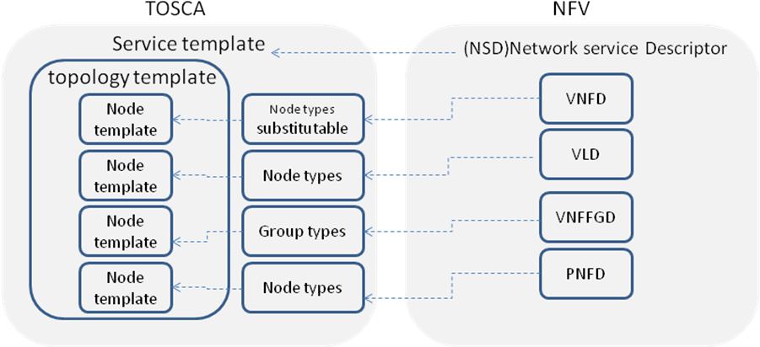
- General mapping between TOSCA and NFV

TOSCA Data Model for a network service
As described in NFV, NSD describes the attributes and requirements necessary to realize a Network Service. Figure 2 is a network service example given by NFV MANO specification [ETSI GS NFV-MAN 001 v1.1.1]. In this example, the network service includes three VNFs. Each VNF exposes different number of connection points, which represent the virtual and/or physical interface of VNFs. Virtual link (VL) describes the basic topology of the connectivity (e.g. ELAN, ELINE, ETREE) between one or more VNFs connected to this VL and other required parameters (e.g. bandwidth and QoS class).
- Network service example for NFV
For simplicity, the VNF and its connection point can be considered as a subsystem of the network service. And a new relationship type is needed to connect VNF and virtual link. Figure 3 shows how the TOSCA node, capability and relationship types enable modeling the NFV application using virtualLinkTo relationship between VNF and virtual link.
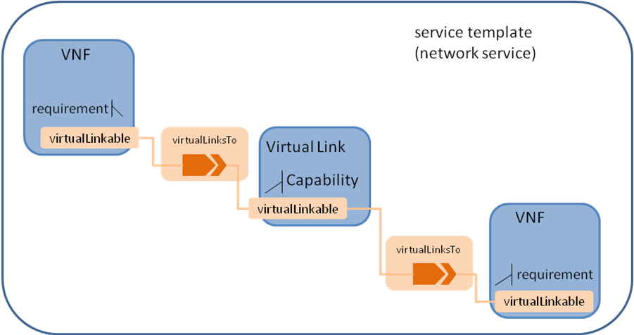
- TOSCA node, capability and relationship types used in NFV application
The virtualLinkable requirement of VNF is exposed by the connection point of that VNF who act as an endpoint.

Namespace and Alias
The following table defines the namespace alias and (target) namespace values that SHALL be used when referencing the TOSCA simple Profile for NFV version 1.0 specification.
Alias | Target Namespace | Specification Description
tosca_simple_profile_for_nfv_1_0 | http://docs.oasis-open.org/tosca/ns/simple/yaml/1.0/nfv/1.0/ | The TOSCA Simple Profile for NFV v1.0 target namespace and namespace alias.

TOSCA Data Model for a VNF
A VNF can be considered as a subsystem in a network service, it can include:
- VDU, which is a subset of a VNF. A VDU can be mapped to a single VM;
- Connection point, some of connection points are only used to connect internal virtual link, while others are exposed to connect outside virtual link. A connection point has to bind with a VDU.
- Internal virtual link, the main functionalities are the same with the virtual link defined in the network service level, but it is only used within VNF to provide connectivity between VDUs.
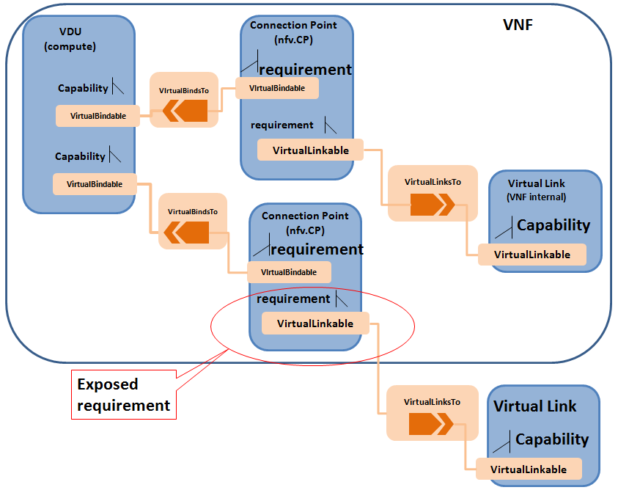
- TOSCA node, capability and relationship types used in VNF application

TOSCA template for VNFD

Node Template Substitution Mapping for a VNF
The substitution mapping feature as defined in [TOSCA-Simple-Profile-YAML], is used to define a new node type, which its characteristics can be mapped to internal elements of a service template.
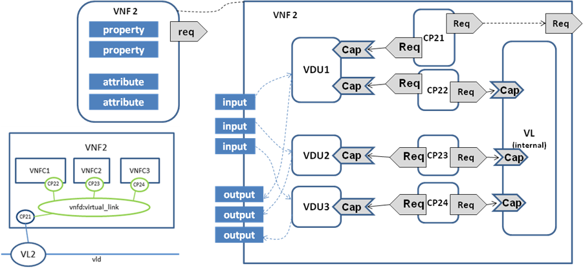
- Substitution mapping for a VNF node type to a service template
Figure 8 shows an example of the internal structure of a VNF. In this example, VNF2 comprises 3 VDUs which connect to an internal Virtual Link. The first VDU has two Connection Points: one (CP21) used to connect the external Virtual Link, another one used (CP22) to connect the internal Virtual Link. VDU provides the capability Bindable to bind Connection Point. Connection point has two requirements, bindable and virtualLinkable. The connection point that has the requirement to the external virtual link exposes the virtualLinkable requirement of the VNF. The external connection point also has Forwarder capability, used to form the network forwarding path. In the example as shown in Figure 8, CP21 is the external connection point of VNF2.

tosca_definitions _version: tosca_simple_profile_for_nfv_1_0

description: example for VNF2
metadata:
ID: # ID of this Network Service Descriptor
vendor: # Provider or vendor of the Network Service
version: # Version of the Network Service Descriptor
topology_template:

inputs:

subsititution_mappings:
node_type: tosca.nodes.nfv.VNF.VNF2
requirements:
virtualLink1: [CP21, virtualLink]
capabilities:
forwarder1: [CP21, Forwarder]

node_templates:
VDU1:
type: tosca.nodes.nfv.VDU
properties:
# omitted here for brivity
requirements:
- host:
node_filter:
capabilities:
# Constraints for selecting “host” (Container Capability)
- host
properties:
- num_cpus: { in_range: [ 1, 4 ] }
- mem_size: { greater_or_equal: 2 GB }

-
artifacts:
VM_image:vdu1.image #the VM image of VDU1
Interface:
Standard:
create:vdu1_install.sh
configure:
implementation: vdu1_configure.sh

VDU2:
type: tosca.nodes.nfv.VDU
properties:
# omitted here for brivity

VDU3:
type: tosca.nodes.nfv.VDU
properties:
# omitted here for brivity

CP21: #endpoints of VNF2
type: tosca.nodes.nfv.CP
properties:
type:
requirements:
virtualbinding: VDU1
capabilities:
Forwarder

CP22:
type: tosca.nodes.nfv.CP
properties:
type:
requirements:
virtualbinding: VDU1
virtualLink: internal_VL

CP23
type: tosca.nodes.nfv.CP
properties:
type:
requirements:
virtualbinding: VDU2
virtualLink: internal_VL

CP24
type: tosca.nodes.nfv.CP
properties:
type:
requirements:
virtualbinding: VDU3
virtualLink: internal_VL

internal_VL
type: tosca.nodes.nfv.VL.ELAN
properties:
# omitted here for brivity
capabilities:
-virtual_linkable
occurrences: 5
In the example above, ID, vender and version are defined service_properties for VNFD specific usage. The topology_template defines the internal structure of VNF2. In the subsititution_mappings element, it defines the node type as tosca.nodes.nfv.vnf2 which is the substitutable node type as defined by this service template. The virtualLinkable requirement is exposed by the virtualLinkable requirement of CP21.
VDU as a compute component in VNF, has requirement for compute and memory, it may also include VM image, which can be described as artifact. CP21 as the endpoint of VNF2, has binding requirement for VDU1, and virtualLinkable requirement for external virtual link. CP22, CP23 and CP24 are internal connection point of VNF2, which all connect to the internal_VL.

Capability Types

tosca.capabilities.Compute.Container.Architecture
Enhance compute architecture capability that needs to be typically use for performance sensitive NFV workloads.

Shorthand Name | Compute.Container.Architecture
Type Qualified Name | tosca:Compute.Contrainer.Architecture
Type URI | tosca.capabilities.Compute.Container.Architecture

Properties
Name | Required | Type | Constraints | Description
mem_page_size | No | string | One of:  - small  - large  - any  - custom mem in MB  Default: any | Describe page size of the VM  small page size is typically 4KB  large page size is typically 2MB  any page size maps to system default  custom MB value: sets TLB size to this specific value
cpu_allocation | no | CPUAllocation |  | Describes CPU allocation requirements like dedicated CPUs (cpu pinning), socket count, thread count, etc.
numa_node_count | no | Integer |  | Specifies the symmetric count of NUMA nodes to expose to the VM. vCPU and Memory equally split across this number of NUMA.  NOTE: the map of numa_nodes should not be specified.
numa_nodes | no | map of NUMA |  | Asymmetric allocation of vCPU and Memory across the specific NUMA nodes (CPU sockets and memory banks).  NOTE: symmetric numa_node_count should not be specified

Definition
tosca.capabilities.Compute.Container.Architecture:
derived_from: tosca.capabilities.Container
properties:
mem_page_size:
type: scalar-unit.size
required: false
constraints:
- [normal, huge]
cpu_allocation:
type: tosca.datatypes.compute.Container.Architecture.CPUAllocation
required: false
numa_nodes:
type: map
entry_schema:
tosca.datatypes.compute.Container.Architecture.NUMA

tosca.capabilites.nfv.VirtualBindable
A node type that includes the VirtualBindable capability indicates that it can be pointed by tosca.relationships.nfv.VirtualBindsTo relationship type.
Shorthand Name | VirtualBindable
Type Qualified Name | tosca: VirtualBindable
Type URI | tosca.capabilities.nfv.VirtualBindable

Properties
Name | Required | Type | Constraints | Description
N/A | N/A | N/A | N/A | N/A

Definition
tosca.capabilities.nfv.VirtualBindable:
derived_from: tosca.capabilities.Node

tosca.capabilities.nfv.Metric
A node type that includes the Metric capability indicates that it can be monitored using an nfv.relationships.Monitor relationship type.
Shorthand Name | Metric
Type Qualified Name | tosca:Metric
Type URI | tosca.capabilities.nfv.Metric

Properties
Name | Required | Type | Constraints | Description
N/A | N/A | N/A | N/A | N/A

Definition
tosca.capabilities.nfv.Metric:
derived_from: tosca.capabilities.Endpoint

Data Types

tosca.datatypes.compute.Container.Architecture.CPUAllocation
Granular CPU allocation requirements for NFV workloads.
Shorthand Name | CPUAllocation
Type Qualified Name | tosca:CPUAllocation
Type URI | tosca.datatypes.compute.Container.Architecture.CPUAllocation

Properties
Name | Type | Constraints | Description
cpu_affinity | String | One of:  - shared  - dedicated | Describes whether vCPU need to be pinned to dedicated CPU core or shared dynamically
thread_allocation | String | One of:  - avoid  - separate  - isolate  - prefer | Describe thread allocation requirement
socket_count | Integer | None | Number of CPU sockets
core_count | Integer | None | Number of cores per socket
thread_count | Integer | None | Number of threads per core

Definition
TBD

Examples
TBD

tosca.datatypes.compute.Container.Architecture.NUMA
Granular Non-Uniform Memory Access (NUMA) topology requirements for NFV workloads

Shorthand Name | NUMA
Type Qualified Name | tosca:NUMA
Type URI | tosca.datatypes.compute.Container.Architecture.NUMA

Properties
Name | Type | Constraints | Description
id | integer | greater_or_eq: 0 | CPU socket identifier
vcpus | map of integers | none | List of specific host cpu numbers within a NUMA socket complex  TODO: need a new base type, with non-overlapping, positive value validation (exclusivity)
mem_size | scalar-unit.size | greater_or_equal: 0MB | Size of memory allocated from this NUMA memory bank

Definition
TBD

Examples
TBD

Relationship Types

tosca.relationships.nfv.VirtualBindsTo
This relationship type represents an association relationship between VDU and CP node types.
Shorthand Name | VirtualBindsTo
Type Qualified Name | tosca: VirtualBindsTo
Type URI | tosca.relationships.nfv. VirtualBindsTo

Definition
tosca.relationships.nfv.VirtualBindsTo:
derived_from: tosca.relationships.DependsOn
valid_target_types: [ tosca.capabilities.nfv.VirtualBindable]

tosca.relationships.nfv.Monitor
This relationship type represents an association relationship to the Metric capability of VDU node types.
Shorthand Name | Monitor
Type Qualified Name | tosca:Monitor
Type URI | tosca.relationships.nfv.Monitor

Definition
tosca.relationships.nfv.Monitor:
derived_from: tosca.relationships.ConnectsTo
valid_target_types: [ tosca.capabilities.nfv.Metric]

Node Types

tosca.nodes.nfv.VNF
The NFV VNF Node Type represents a Virtual Network Function as defined by [ETSI GS NFV-MAN 001 v1.1.1]. It is the default type that all other VNF Node Types derive from. This allows for all VNF nodes to have a consistent set of features for modeling and management (e.g., consistent definitions for requirements, capabilities and lifecycle interfaces).
tosca.nodes.nfv.VNF:
derived_from: tosca.nodes.Root # Or should this be its own top-level type?
properties:
id:
type: string
description: ID of this VNF
vendor:
type: string
description: name of the vendor who generate this VNF
version:
type: version
description: version of the software for this VNF
requirements:
- virtualLink:
capability: tosca.capabilities.nfv.VirtualLinkable
relationship: tosca.relationships.nfv.VirtualLinksTo

tosca.nodes.nfv.VDU
The NFV vdu node type represents a logical vdu entity as defined by [ETSI GS NFV-MAN 001 v1.1.1].
Shorthand Name | VDU
Type Qualified Name | tosca:VDU
Type URI | tosca.nodes.nfv.VDU

Capabilities
Name | Type | Constraints | Description
monitoring_parameter | nvf.Metric | None | Monitoring parameter, which can be tracked for a VNFC based on this VDU  Examples include: memory-consumption, CPU-utilisation, bandwidth-consumption, VNFC downtime, etc.
virtualbinding | tosca.Bindable |  | Defines ability of VirtualBindable

Definition
tosca.nodes.nfv.VDU:
derived_from: tosca.nodes.Root

capabilities:

nfv_compute:
type: tosca.capabilities.Compute.Container.Architecture
virtualbinding:
type: tosca.capabilities.nfv.VirtualBindable
monitoring_parameter:
type: tosca.capabilities.nfv.Metric requirements:
-

VDU Artifact
The NFV profile maps VDU to a Virtual Machine. When creating a VDU node, apart from creating a VM with properties specified in nfv_compute, a VM image is needed. To specify the image the recommended way is to use artifact type. Here is an example,
node_templates:
VDU1:
type: tosca.nodes.nfv.VDU
capabilities:
…
artifacts:
VDU1Image:
type: tosca.artifacts.Deployment.Image.VM

file: vdu1.image tosca.nodes.nfv.CP
The NFV CP node represents a logical connection point entity as defined by [ETSI GS NFV-MAN 001 v1.1.1]. A connection point may be, for example, a virtual port, a virtual NIC address, a physical port, a physical NIC address or the endpoint of an IP VPN enabling network connectivity. It is assumed that each type of connection point will be modeled using subtypes of the CP type.

Shorthand Name | CP
Type Qualified Name | tosca:CP
Type URI | tosca.nodes.nfv.CP

Properties
Name | Required | Type | Constraints | Description
type | yes | string | None | This may be, for example, a virtual port, a virtual NIC address, a SR-IOV port, a physical port, a physical NIC address or the endpoint of an IP VPN enabling network connectivity.
anti_spoof_protection | no | boolean | None | Indicates of whether anti-spoofing rule need to be enabled for this vNIC. This is applicable only when CP type is virtual NIC (vPort)

Attributes
Name | Required | Type | Constraints | Description
address | no | string | None | The actual virtual NIC address that is been assigned when instantiating the connection point

Definition
tosca.nodes.nfv.CP:
derived_from: tosca.nodes.network.Port
properties:
type:
type: string
required: false
anti_spoof_protection:
type: boolean
required: false
requirements:
- virtualLink:
capability: tosca.capabilities.nfv.VirtualLinkable
relationship: tosca.relationships.nfv.VirtualLinksTo
- virtualbinding:
capability: tosca.capabilities.nfv.VirtualBindable
relationship: tosca.relationships.nfv.VirtualBindsTo
attributes:
address:
type: string

Additional Requirement

TOSCA template for VLD

tosca.nodes.nfv.VL
The NFV VL node type represents a logical virtual link entity as defined by [ETSI GS NFV-MAN 001 v1.1.1]. It is the default type from which all other virtual link types derive.
Shorthand Name | VL
Type Qualified Name | tosca:VL
Type URI | tosca.nodes.nfv.VL

Properties
Name | Required | Type | Constraints | Description
vendor | yes | string | None | Vendor generating this VLD

Attributes

Definition
tosca.nodes.nfv.VL:
derived_from: tosca.nodes.network.Network
properties:
vendor:
type: string
required: true
description: name of the vendor who generate this VL
capabilities:
virtual_linkable:
type: tosca.capabilities.nfv.VirtualLinkable

Additional Requirement

tosca.nodes.nfv.VL.ELine
The NFV VL.ELine node represents an E-Line virtual link entity.

tosca.nodes.nfv.VL.ELine:
derived_from: tosca.nodes.nfv.VL
capabilities:
virtual_linkable:
occurrences: 2

tosca.nodes.nfv.VL.ELAN
The NFV VL.ELan node represents an E-LAN virtual link entity.

tosca.nodes.nfv.VL.ELAN:
derived_from: tosca.nodes.network.Network

tosca.nodes.nfv.VL.ETree
The NFV VL.ETree node represents an E-Tree virtual link entity.

tosca.nodes.nfv.VL.ETree:
derived_from: tosca.nodes.nfv.VL

TOSCA template for VNFFGD
A VNF forwarding graph is specified by a Network Service Provider to define how traffic matching certain criteria is intended to flow through one or more network functions in a Network Connectivity Topology in order to accomplish the desired network service functionality. The NFV specification describes network forwarding graphs using one or more Network Forwarding Paths. A Network Forwarding Path is an ordered lists of Connection Points that form a chain of VNFs. The order of network functions applied is application-dependent, and may be a simple sequential set of functions, or a more complex graph with alternative paths (e.g. the service may fork, and even later combine), depending on the nature of the traffic, the context of the network, and other factors.
The following figure shows an example of two VNF Forwarding Graphs established on top of the Network Connectivity Topology described earlier. VNFFG1 has two Network Forwarding Paths (VNFFG1:NFP1 and VNFFG1:NFP2) whereas VNFFG2 only has a single NFP (VNFFG2:NFP1).
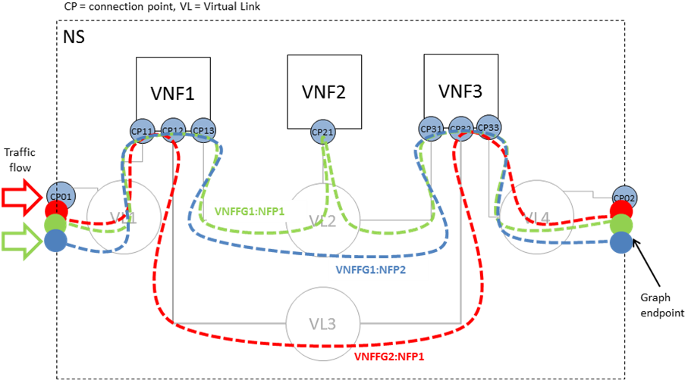
- Multiple forwarding graphs using the same network connectivity graph

Semantics of VNFFG
As described by [ETSI GS NFV-MAN 001 v1.1.1], VNFFG is a deployment template which describes a topology of the network service or a portion of the network service. When TOSCA metamodel is used, the group concept as defined in TOSCA shall be used to described the VNFFGD,
- the referenced VNFs, PNFs, virtual links and connection points shall be defined as the properties in the VNFFG group, and
- the network forwarding paths element shall be defined as the targets in the VNFFG group

Semantics of Network forwarding path
Network forwarding path as defined by [ETSI GS NFV-MAN 001 v1.1.1] is an order list of connection points forming a chain of network functions (VNFs or PNFs). A new “Forwarder” requirement is defined in this specification to model the network forwarding path by using ordered list of multiple “Forwarder” requirements. Each “Forwarder” requirement points to a single connection point. The following diagram gives an example to show how to use “Forwarder” requirements to describe a forwarding path. 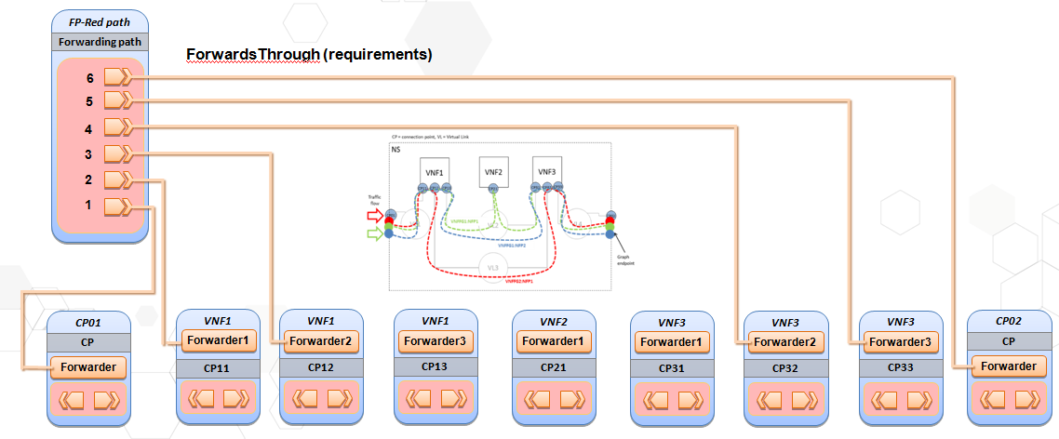

Capability Types

tosca.capabilites.nfv.Forwarder
A node type that includes the Forwarder capability indicates that it can be pointed by tosca.relationships.nfv.FowardsTo relationship type.
Shorthand Name | Forwarder
Type Qualified Name | tosca: Forwarder
Type URI | tosca.capabilities.nfv.Forwarder

Properties
Name | Required | Type | Constraints | Description
N/A | N/A | N/A | N/A | N/A

Definition
tosca.capabilities.nfv.Forwarder:
derived_from: tosca.capabilities.Root

Relationship Types

tosca.relationships.nfv.ForwardsTo
This relationship type represents a traffic flow between two connection point node types.
Shorthand Name | ForwardsTo
Type Qualified Name | tosca: ForwardsTo
Type URI | tosca.relationships.nfv. ForwardsTo

Definition
tosca.relationships.nfv.ForwardsTo:
derived_from: tosca.relationships.Root
valid_target_types: [ tosca.capabilities.nfv.Forwarder]

Node Types

tosca.nodes.nfv.FP
The NFV FP node type represents a logical network forwarding path entity as defined by [ETSI GS NFV-MAN 001 v1.1.1].
Shorthand Name | VL
Type Qualified Name | tosca:FP
Type URI | tosca.nodes.nfv.FP

Properties
Name | Required | Type | Constraints | Description
policy | no | string | None | A policy or rule to apply to the NFP

Attributes

Definition
tosca.nodes.nfv.FP:
derived_from: tosca.nodes.Root
properties:
policy:
type: string
required: false
description: name of the vendor who generate this VL
requirements:
- forwarder:
capability: tosca.capabilities.nfv.Forwarder

Group types

tosca.groups.nfv.VNFFG
The NFV VNFFG group type represents a logical VNF forwarding graph entity as defined by [ETSI GS NFV-MAN 001 v1.1.1].
Shorthand Name | VL
Type Qualified Name | tosca:VNFFG
Type URI | tosca.groups.nfv.VNFFG

Properties
Name | Required | Type | Constraints | Description
vendor | yes | string | None | Specify the vendor generating this VNFFG.
Version | yes | version | None | Specify the identifier (e.g. name), version, and description of service this VNFFG is describing.
number_of_endpoints | yes | integer | None | Count of the external endpoints included in this VNFFG, to form an index
dependent_virtual_  link | yes | string[] | None | Reference to a list of VLD used in this Forwarding Graph
connection_point | yes | string[] |  | Reference to Connection Points forming the VNFFG
constituent_vnfs | yes | string[] |  | Reference to a list of VNFD used in this VNF Forwarding Graph

Attributes

Definition
tosca.groups.nfv.VNFFG:
derived_from: tosca.groups.Root
properties:
vendor:
type: string
required: true
description: name of the vendor who generate this VNFFG
version:
type: string
required: true
description: version of this VNFFG
number_of_endpoints:
type: integer
required: true
description: count of the external endpoints included in this VNFFG
dependent_virtual_link:
type: list
entry_schema:
type: string
required: true
description: Reference to a VLD used in this Forwarding Graph
connection_point:
type: list
entry_schema: string
required: true
description: Reference to Connection Points forming the VNFFG
constituent_vnfs:
type: list
entry_schema:
type: string
required: true
description: Reference to a list of VNFD used in this VNF Forwarding Graph
targets: [ tosca.nodes.nfv.FP ]

TOSCA template for NSD

Metadata keynames
The following is the list of recognized metadata keynames for a TOSCA Service Template for NFV definition:
Keyname | Required | Type | Description
ID | yes | string | ID of this Network Service Descriptor
vendor | yes | string | Provider or vendor of the Network Service
version | yes | string | Version of the Network Service Descriptor

Using service template for a NFV network service
The use case of a network service is shown in Figure 6. This section uses a TOSCA service template to describe the network service as shown in Figure 4.
tosca_definitions_version: tosca_simple_profile_for_nfv_1_0
tosca_default_namespace: # Optional. default namespace (schema, types version)
description: example for a NSD.
metadata:
ID: # ID of this Network Service Descriptor
vendor: # Provider or vendor of the Network Service
version: # Version of the Network Service Descriptor
imports:
- tosca_base_type_definition.yaml
# list of import statements for importing other definitions files
topology_template:
inputs:
flavor ID:
VNF1:
type: tosca.nodes.nfv.VNF.VNF1
properties:
Scaling_methodology:
Flavour_ID:
Threshold:
Auto-scale policy value:
Constraints:
requirements:
virtualLink1: VL1 # the subsititution mappings in VNF1 has virtualLink1: [CP11, virtualLink]
virtualLink2: VL2 # the subsititution mappings in VNF1 has virtualLink2: [CP12, virtualLink]
virtualLink3: VL3 # the subsititution mappings in VNF1 has virtualLink3: [CP13, virtualLink]
capabilities:
forwarder1 # the subsititution mappings in VNF1 has forwarder1: [CP11, forwarder]
forwarder2 # the subsititution mappings in VNF1 has forwarder2: [CP12, forwarder]
forwarder3 # the subsititution mappings in VNF1 has forwarder3: [CP13, forwarder]

VNF2:
type: tosca.nodes.nfv.VNF.VNF2
properties:
Scaling_methodology:
Flavour_ID:
Threshold:
Auto-scale policy value:
Constraints:
requirements:
virtualLink1: VL2 # the subsititution mappings in VNF2 has virtualLink1: [CP21, virtualLink]
capabilities:
forwarder1 # the subsititution mappings in VNF1 has forwarder1: [CP21, forwarder]

VNF3:
type: tosca.nodes.nfv.VNF.VNF3
properties:
Scaling_methodology:
Flavour_ID:
Threshold:
Auto-scale policy value:
Constraints:
requirements:
virtualLink1: VL2 # the subsititution mappings in VNF3 has virtualLink1: [CP31, virtualLink]
virtualLink2: VL3 # the subsititution mappings in VNF3 has virtualLink2: [CP32, virtualLink]
virtualLink3: VL4 # the subsititution mappings in VNF3 has virtualLink3: [CP33, virtualLink]
capabilities:
forwarder1 # the subsititution mappings in VNF1 has forwarder1: [CP31, forwarder]
forwarder2 # the subsititution mappings in VNF1 has forwarder2: [CP32, forwarder]
forwarder3 # the subsititution mappings in VNF1 has forwarder3: [CP33, forwarder]

CP01 #endpoints of NS
type: tosca.nodes.nfv.CP
properties:
type:
requirements:
virtualLink: VL1

CP02 #endpoints of NS
type: tosca.nodes.nfv.CP
properties:
type:
requirements:
virtualLink: VL4

VL1
type: tosca.nodes.nfv.VL.Eline
properties:
# omitted here for brevity
capabilities:
-virtual_linkable
occurrences: 2

VL2
type: tosca.nodes.nfv.VL.ELAN
properties:
# omitted here for brevity
capabilities:
-virtual_linkable
occurrences: 5
VL3
type: tosca.nodes.nfv.VL.Eline
properties:
# omitted here for brevity
capabilities:
-virtual_linkable
occurrences: 2
VL4
type: tosca.nodes.nfv.VL.Eline
properties:
# omitted here for brevity
capabilities:
-virtual_linkable
occurrences: 2

Forwarding path1:
type: tosca.nodes.nfv.FP
description: the path (CP01→CP11→CP13→CP21→CP31→CP33→CP02)
properties:
policy:
requirements:
-forwarder: CP01
-forwarder: VNF1
capability: forwarder1 #CP11
-forwarder: VNF1
capability: forwarder3 #CP13
-forwarder: VNF2
capability: forwarder1 #CP21
-forwarder: VNF3
capability: forwarder1 #CP31
-forwarder: VNF3
capability: forwarder3 #CP33
-forwarder: CP02

Forwarding path2:
type: tosca.nodes.nfv.FP
description: the path (CP01→CP11→CP13→CP31→CP33→CP02)
properties:
policy:
requirements:
-forwarder: CP01
-forwarder: VNF1
capability: forwarder1 #CP11
-forwarder: VNF1
capability: forwarder3 #CP13
-forwarder: VNF3
capability: forwarder1 #CP31
-forwarder: VNF3
capability: forwarder3 #CP33
-forwarder: CP02

Forwarding path3:
type: tosca.nodes.nfv.FP
description: the path (CP01→CP11→CP12→CP32→CP33→CP02)
properties:
policy:
requirements:
-forwarder: CP01
-forwarder: VNF1
capability: forwarder1 #CP11
-forwarder: VNF1
capability: forwarder2 #CP12
-forwarder: VNF3
capability: forwarder2 #CP32
-forwarder: VNF3
capability: forwarder3 #CP33
-forwarder: CP02

Groups:
VNFFG1:
type: tosca.groups.nfv.vnffg
description: forwarding graph 1
properties:
vendor:
version:
vl: [VL1,VL2,VL4]
vnf: [VNF1,VNF2,VNF3]
targets: [Forwarding path1, Forwarding path2]

VNFFG2:
type: tosca.groups.nfv.vnffg
description: forwarding graph 2
properties:
vendor:
version:
vl: [VL1,VL3,VL4]
vnf: [VNF1,VNF2]
targets: [Forwarding path3]

In the example above, metadata element is used to define the service specific properties, as used in NFV, those NFV specific properties are ID, vender, version. Each VNF is described as a node template, which type is substituted by a different service template. As defined in VNF1, it has three requirements, each for a different virtual link, VL1, VL2 and VL3. VNF2 only has virtualLinkable requirement to VL2. VNF3 has three virtualLinkable requirements to VL2, VL3, VL4 respectively. CP01 and CP02 are acting as the endpoints of the network service. CP01 has virtualLinkable requirement to VL1, and CP02 has virtualLinkable requirement to VL4. VL1, VL2, VL3 and VL4 are described as node templates with tosca.nodes.nfv.virtualLink node type.

Capability types

tosca.capabilities.nfv.VirtualLinkable
A node type that includes the VirtualLinkable capability indicates that it can be pointed by tosca.relationships.nfv.VirtualLinksTo relationship type.
Shorthand Name | VirtualLinkable
Type Qualified Name | tosca:VirtualLinkable
Type URI | tosca.capabilities.nfv.VirtualLinkable

Properties
Name | Required | Type | Constraints | Description
N/A | N/A | N/A | N/A | N/A

Definition
tosca.capabilities.nfv.VirtualLinkable:
derived_from: tosca.capabilities.Node

Relationship Types

tosca.relationships.nfv.VirtualLinksTo
This relationship type represents an association relationship between VNFs and VL node types.
Shorthand Name | VirtualLinksTo
Type Qualified Name | tosca:VirtualLinksTo
Type URI | tosca.relationships.nfv.VirtualLinksTo

Definition
tosca.relationships.nfv.VirtualLinksTo:
derived_from: tosca.relationships.DependsOn
valid_target_types: [ tosca.capabilities.nfv.VirtualLinkable ]

Examples

Simple Virtual Router VNFD Template

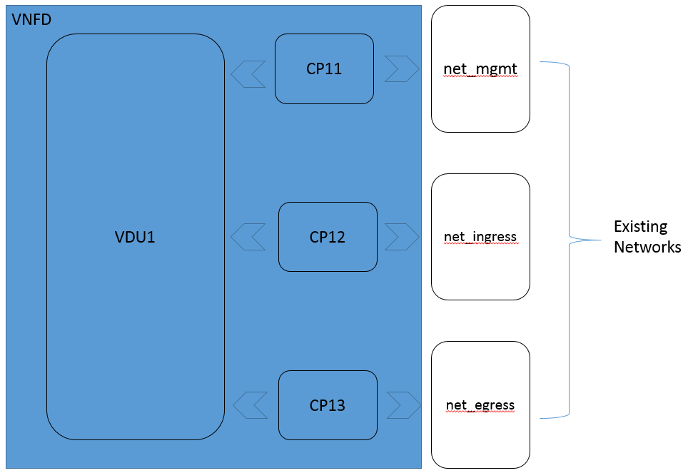

tosca_definitions_version: tosca_simple_profile_for_nfv_1_0

description: Simple Virtual Router with one VDU

metadata:
ID: vRouter-1-0-0
vendor: Acme
version: 1.0

node_types:
vRouterVNF:
derived_from: tosca.nodes.nfv.VNF
capabilities:
forwarder_ingres:
type: tosca.capabilities.nfv.Forwarder
forwarder_egres:
type: tosca.capabilities.nfv.Forwarder

topology_template:

# inputs:

substitution_mappings:
node_type: vRouterVNF
requirements:
virtualLink: [CP12, virtualLink]
virtualLink: [CP13, virtualLink]
capabilities:
forwarder_ingres: [CP12, forwarder]
forwarder_egres: [CP13, forwarder]

node_templates:

VDU1:
type: tosca.nodes.nfv.VDU
capabilities:
nfv_compute:
properties:
num_cpus: 4
mem_size: 4096 MB
disk_size: 8 GB
artifacts:
vRouterImage:
type: tosca.artifacts.Deployment.Image.VM
file: vdu1.image #the VM image of VDU1
interfaces:
Standard:
configure:
implementation: vdu1_configure.sh

CP11:
type: tosca.nodes.nfv.CP
requirements:
- virtualbinding: VDU1
- virtualLink: net_mgmt

CP12:
type: tosca.nodes.nfv.CP
properties:
anti_spoof_protection: false
requirements:
- virtualbinding: VDU1
- virtualLink: net_ingress

CP13:
type: tosca.nodes.nfv.CP
properties:
anti_spoof_protection: false

requirements:
- virtualbinding: VDU1
- virtualLink: net_egress

net_mgmt:
type: tosca.nodes.nfv.VL.ELAN

net_ingress:
type: tosca.nodes.nfv.VL.ELAN

net_egress:
type: tosca.nodes.nfv.VL.ELAN

Virtual Router VNFD Template with Efficient CPU placement properties

tosca_definitions_version: tosca_simple_for_nfv_1_0

description: Sample Virtual Router with one VDU with efficient CPU and Memory properties

metadata:
ID: vRouter-1-0-0
vendor: Acme
version: 1.0

node_types:

vRouterVNF:
derived_from: tosca.nodes.nfv.VNF
capabilities:
forwarder_ingres:
type: tosca.capabilities.nfv.Forwarder
forwarder_egres:
type: tosca.capabilities.nfv.Forwarder

topology_template:

# inputs:

substitution_mappings:
node_type: vRouterVNF
requirements:
virtualLink: [CP12, virtualLink]
virtualLink: [CP13, virtualLink]
capabilities:
forwarder_ingres: [CP12, forwarder]
forwarder_egres: [CP13, forwarder]

node_templates:

VDU1:
type: tosca.nodes.nfv.VDU
capabilities:
nfv_compute:
properties:
num_cpus: 8
mem_size: 4096 MB
disk_size: 8 GB
mem_page_size: large
cpu_allocation:
cpu_affinity: dedicated
thread_allocation: isolate
socket_count: 2
core_count: 2
thread_count: 4
numa_nodes:
node0: [ id: 0, vcpus: [ 2, 3 ], mem_size: 2 GB]
node1: [ id: 1, vcpus: [ 4, 5, 6, 7, 8, 9], mem_size: 6 GB]

artifacts:
VM_image:
type: tosca.artifacts.Deployment.Image.VM
file: vdu1.image #the VM image of VDU1

interfaces:
Standard:
create: vdu1_install.sh
configure:
implementation: vdu1_configure.sh

CP11:
type: tosca.nodes.nfv.CP
requirements:
- virtualbinding: VDU1
- virtualLink: net_mgmt

CP12:
type: tosca.nodes.nfv.CP
properties:
anti_spoof_protection: false
requirements:
- virtualbinding: VDU1
- virtualLink: net_ingress

CP13:
type: tosca.nodes.nfv.CP
properties:
anti_spoof_protection: false
requirements:
- virtualbinding: VDU1
- virtualLink: net_egress

net_mgmt:
type: tosca.nodes.nfv.VL.ELAN

net_ingress:
type: tosca.nodes.nfv.VL.ELAN

net_egress:
type: tosca.nodes.nfv.VL.ELAN

Multi-VDU Virtual Router VNFD Template

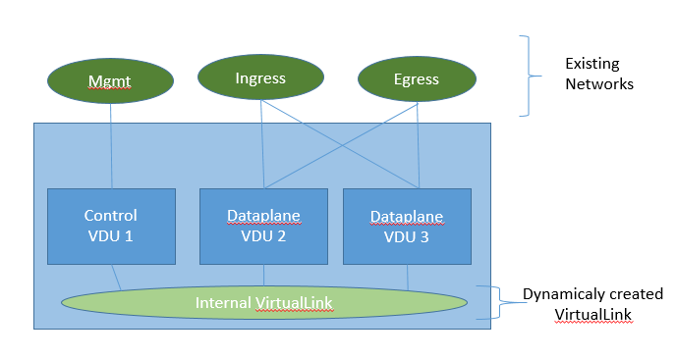

tosca_definitions_version: tosca_simple_profile_for_nfv_1_0

description: Sample Virtual Router with multiple VDUs and internal VirtualLink

metadata:
ID: vRouter-1-0-0
vendor: Acme
version: 1.0

node_types:
vRouterVNF:
derived_from: tosca.nodes.nfv.VNF
capabilities:
forwarder_ingres:
type: tosca.capabilities.nfv.Forwarder
forwarder_egres:
type: tosca.capabilities.nfv.Forwarder

topology_template:

substitution_mappings:
node_type: vRouterVNF
requirements:
virtualLink: [CP12, virtualLink]
virtualLink: [CP13, virtualLink]
capabilities:
forwarder_ingres: [CP12, forwarder]
forwarder_egres: [CP13, forwarder]

topology_template:
node_templates:
VDU1:
type: tosca.nodes.nfv.VDU
capabilities:
nfv_compute:
properties:
num_cpus: 2
mem_size: 2048 MB
disk_size: 8 GB

artifacts:
vRouterVNFImage:
type: tosca.artifacts.Deployment.Image.VM.QCOW2
file: http://filer/vnf/vRouterVNF_ControlPlane.qcow2

VDU2:
type: tosca.nodes.nfv.VDU
capabilities:
nfv_compute:
properties:
num_cpus: 6
mem_size: 4096
disk_size: 8

artifacts:
vRouterVNFImage:
type: tosca.artifacts.Deployment.Image.VM.QCOW2
file: http://filer/vnf/vRouterVNF_DataPlane.qcow2

VDU3:
type: tosca.nodes.nfv.VDU
capabilities:
nfv_compute:
properties:
num_cpus: 6
mem_size: 4096
disk_size: 8

artifacts:
vRouterVNFImage:
type: tosca.artifacts.Deployment.Image.VM.QCOW2
file: http://filer/vnf/vRouterVNF_DataPlane.qcow2

CP11:
type: tosca.nodes.nfv.CP
properties:
type: vPort
requirements:
- virtualLink: ManagementNetwork
- virtualBinding: VDU1

CP12:
type: tosca.nodes.nfv.CP
properties:
type: vPort
anti_spoofing_protection: false
requirements:
- virtualLink: InternalNetwork
- virtualBinding: VDU1

CP21:
type: tosca.nodes.nfv.CP
properties:
type: vPort
anti_spoofing_protection: false
requirements:
- virtualLink: InternalNetwork
- virtualBinding: VDU2

CP22:
type: tosca.nodes.nfv.CP
properties:
type: vPort
anti_spoofing_protection: false
requirements:
- virtualLink: IngressNetwork
- virtualBinding: VDU2

CP23:
type: tosca.nodes.nfv.CP
properties:
type: vPort
anti_spoofing_protection: false
requirements:
- virtualLink: EgressNetwork
- virtualBinding: VDU2

CP31:
type: tosca.nodes.nfv.CP
properties:
type: vPort
anti_spoofing_protection: false
requirements:
- virtualLink: InternalNetwork
- virtualBinding: VDU3

CP32:
type: tosca.nodes.nfv.CP
properties:
type: vPort
anti_spoofing_protection: false
requirements:
- virtualLink: IngressNetwork
- virtualBinding: VDU3

CP33:
type: tosca.nodes.nfv.CP
properties:
type: vPort
anti_spoofing_protection: false
requirements:
- virtualLink: EgressNetwork
- virtualBinding: VDU3

InternalNetwork:
type: tosca.nodes.nfv.VL.ELAN
properties:
# Hint to create new virtual network
vendor: ACME Networks
cidr: 10.1.10.0/24
gateway_ip: 10.1.10.1
network_type: vlan
physical_network: phynet1
segmentation_id: 1000

DataplaneNetwork:
type: tosca.nodes.nfv.VL.ELAN
properties:
# Existing dataplane network
name: neutron_net_dp0

ManagementNetwork:
type: tosca.nodes.nfv.VL.ELAN
properties:
# Existing virtual network
name: neutron_net_mgmt

IngressNetwork:
type: tosca.nodes.nfv.VL.ELAN
properties:
# Existing virtual network
name: neutron_net_ingress

EgressNetwork:
type: tosca.nodes.nfv.VL.ELAN
properties:
# Existing virtual network
name: neutron_net_egress

- Acknowledgments
The following individuals have participated in the creation of this specification and are gratefully acknowledged:
Participants:
Chris Lauwers (lauwers@ubicity.com), Ubicity
Derek Palma (dpalma@vnomic.com), Vnomic
Matt Rutkowski (mrutkows@us.ibm.com), IBM
Shitao li (lishitao@huawei.com), Huawei
Lawrence Lamers (ljlamers@vmware.com), VMware
Sridhar Ramaswamy (sramasw@Brocade.com), Brocade

- Revision History
Revision | Date | Editor | Changes Made
WD01, Rev01 | 2015-2-26 | Shitao li, Huawei | - Adding clause 1, the introduction about this profile  - Adding clause 2, summary of key TOSCA concepts  - Adding clause 3, deployment template in NFV  - Adding clause 4, general mapping between TOSCA and NFV deployment template  - Adding clause 5, describes the main idea about using a service template for NFV NSD
WD01, Rev02 | 2015-4-15 | Shitao li, Huawei | - Changing the NSD example used in clause 5  - Changing the TOSCA model for NSD in figure 3 in clause 5, consider a VNF and its connection point as a subsystem of a NS  - Adding the TOSCA template example for NSD in clause 5.1  - Adding NFV specific service properties for NSD in clause 5.2, the main properties are id ,vender and version  - Adding new capability tosca.capabilities.nfv.VirtualLinkable in clause 5.3  - Adding new relationship type tosca.relationships.nfv.VirtualLinkTo in clause 5.4, which used between connection point and virtual link node types.  - Adding clause 6, TOSCA data model for VNFD  - Adding clause 6.1, node template substitution mapping for a VNF  - Adding NFV specific service properties for VNFD in clause 6.2, the main properties are id ,vender and version  - Adding new node type tosca.nodes.nfv.vdu in clause 6.3  - Adding new node type tosca.nodes.nfv.CP in clause 6.4  - Adding clause 7, TOSCA template for VLD (virtual link descriptor)  - Adding new node type tosca.nodes.nfv.VL in clause 7.1
WD01, Rev03 | 2015-5-5 | Shitao li, Huawei  Chris Lauwers | - Adding clause 3 for NFV overview  - Adding namespace for tosca-nfv- profile in clause 5.1  - Deleting the NFV specific service properties for NSD and VNFD  - Adding capability type definitions for VNF in clause 7.2(VirtualBindable, HA, HA.ActiveActive, HA.ActivePassive, Metric)  - Adding relationship type definitions for VNF in clause 7.3(VirtualBindsTo, nfv.HA, nfv.Monitor)  - Adding default VNF node type definition in clause 7.4.1  - Changing the VDU node type definition in clause 7.4.2(treat HA and monitor parameters as capabilities)  - Adding new node types definition for VL.Eline, VL.ELAN and VL.ETree in clause 8.2, 8.3 and 8.4.
WD01, Rev04 | 2015-5-13 | Chris Lauwers | - Formatting changes
WD02,Rev01 | 2015-7-2 | Shitao li, Huawei | - 6.1, changing the version number from 1.0.0 to 1.0  - 6.2, adding NFV usage specific metadata keynames  - 6.3, using metadata element instead of service_properties  - 7.1, using metadata element instead of service_properties
WD02,Rev02 | 2015-8-26 | Shitao li, Huawei | - 6: change title to “TOSCA Data model for a network service”, and move the NSD example as well as NSD related definition to clause 11.  - 7: change title to “TOSCA Data model for a VNF”  - 8.1: in the text and the VNFD example, adding Forwarder capability to exteral connection point for supporting NFP description  - 10: moving VNFFG description text from clause 3.3 to clause 10.  - 10.1,10.2,10.3,10.4,10.5,10.6: adding TOSCA model for VNFFG, using group type for VNFFG and node type for NFP  - 11: moving TOSCA template for NSD from clause 7 to clause 11.  - 11.2: adding VNFFG and NFP in the NSD example
WD02, Rew03 | 2015-9-28 | Matt Rutkowski, IBM | - 11.2: changing NSD example for NFP, adding “-” in front of every requirement.
WD02, Rew04 | 2015-10-15 | Chris Lauwers | - Formatting changes
WD02, Rew05 | 2016-1-22 | Sridhar Ramaswamy, Brocade  Shitao li, Huawei | - 12, adding new VNFD example for the single vRouter use case.
WD02, Rev07 | 2016-2-18 | Sridhar Ramaswamy, Brocade  Matt Rutkowski, IBM | - 13. Enhance VDU with CPU Architecture properties like CPU pinning, Huge-pages, NUMA topology, etc.  - 13.2 Change, VirtualLink, ConnectionPoint to derive from / use appropriate Simple YAML Profile node_types and datatypes.
WD02, Rev08 | 2016-2-25 | Sridhar Ramaswamy, Brocade | - Add anti-spoof protection flag to ConnectionPoint  - Update the samples based on new CPU Architecture Schema  - Add NFV Profile sample with efficient CPU and Memory allocation  - Add NFV profile sample with multiple VDUs
WD02, Rev09 | 2016-2-29 | Sridhar Ramaswamy,  Brocade | - Move Compute Architecture capability and related datatypes to Sec 8.  - Add diagram for multi-vdu VNFD template example  - Add a note on artifacts for VDU

