

Test Assertions Part 1 - Test Assertions Model Version 1.0
Committee Specification 01
29 November 2010
Specification URIs:
This Version:
http://docs.oasis-open.org/tag/model/v1.0/cs01/testassertionsmodel-1.0-cs-01.html
http://docs.oasis-open.org/tag/model/v1.0/cs01/testassertionsmodel-1.0-cs-01.odt
http://docs.oasis-open.org/tag/model/v1.0/cs01/testassertionsmodel-1.0-cs-01.pdf (Authoritative)
Previous Version:
http://docs.oasis-open.org/tag/model/v1.0/cd02/testassertionsmodel-1.0-cd-02.html
http://docs.oasis-open.org/tag/model/v1.0/cd02/testassertionsmodel-1.0-cd-02.odt
http://docs.oasis-open.org/tag/model/v1.0/cd02/testassertionsmodel-1.0-cd-02.pdf (Authoritative)
Latest Version:
http://docs.oasis-open.org/tag/model/v1.0/testassertionsmodel-1.0.html
http://docs.oasis-open.org/tag/model/v1.0/testassertionsmodel-1.0.odt
http://docs.oasis-open.org/tag/model/v1.0/testassertionsmodel-1.0.pdf (Authoritative)
Technical Committee:
OASIS Test Assertions Guidelines (TAG)
Chair(s):
Patrick Curran
Jacques Durand
Editor(s):
Stephen D. Green
Related Work:
This specification is related to:
OASIS TAG TC - Test Assertions Guidelines - Version 1.0
OASIS TAG TC - Test Assertions Markup Language - Version 1.0
Declared XML Namespace(s):
N/A
Abstract:
This document specifies mandatory and optional components of a test assertion model.
Status:
This document was last revised or approved by the Test Assertions Guidelines TC on the above date. The level of approval is also listed above. Check the "Latest Version" location noted above for possible later revisions of this document.
Technical Committee members should send comments on this specification to the Technical Committee’s email list. Others should send comments to the Technical Committee by using the “Send A Comment” button on the Technical Committee’s web page at http://www.oasis-open.org/committees/tag/.
For information on whether any patents have been disclosed that may be essential to implementing this specification, and any offers of patent licensing terms, please refer to the Intellectual Property Rights section of the Technical Committee web page (http://www.oasis-open.org/committees/tag/ipr.php).
The non-normative errata page for this specification is located at http://www.oasis-open.org/committees/tag/.

Notices
Copyright © OASIS® 2008-2010. All Rights Reserved.
All capitalized terms in the following text have the meanings assigned to them in the OASIS Intellectual Property Rights Policy (the "OASIS IPR Policy"). The full Policy may be found at the OASIS website.
This document and translations of it may be copied and furnished to others, and derivative works that comment on or otherwise explain it or assist in its implementation may be prepared, copied, published, and distributed, in whole or in part, without restriction of any kind, provided that the above copyright notice and this section are included on all such copies and derivative works. However, this document itself may not be modified in any way, including by removing the copyright notice or references to OASIS, except as needed for the purpose of developing any document or deliverable produced by an OASIS Technical Committee (in which case the rules applicable to copyrights, as set forth in the OASIS IPR Policy, must be followed) or as required to translate it into languages other than English.
The limited permissions granted above are perpetual and will not be revoked by OASIS or its successors or assigns.
This document and the information contained herein is provided on an "AS IS" basis and OASIS DISCLAIMS ALL WARRANTIES, EXPRESS OR IMPLIED, INCLUDING BUT NOT LIMITED TO ANY WARRANTY THAT THE USE OF THE INFORMATION HEREIN WILL NOT INFRINGE ANY OWNERSHIP RIGHTS OR ANY IMPLIED WARRANTIES OF MERCHANTABILITY OR FITNESS FOR A PARTICULAR PURPOSE.
OASIS requests that any OASIS Party or any other party that believes it has patent claims that would necessarily be infringed by implementations of this OASIS Committee Specification or OASIS Standard, to notify OASIS TC Administrator and provide an indication of its willingness to grant patent licenses to such patent claims in a manner consistent with the IPR Mode of the OASIS Technical Committee that produced this specification.
OASIS invites any party to contact the OASIS TC Administrator if it is aware of a claim of ownership of any patent claims that would necessarily be infringed by implementations of this specification by a patent holder that is not willing to provide a license to such patent claims in a manner consistent with the IPR Mode of the OASIS Technical Committee that produced this specification. OASIS may include such claims on its website, but disclaims any obligation to do so.
OASIS takes no position regarding the validity or scope of any intellectual property or other rights that might be claimed to pertain to the implementation or use of the technology described in this document or the extent to which any license under such rights might or might not be available; neither does it represent that it has made any effort to identify any such rights. Information on OASIS' procedures with respect to rights in any document or deliverable produced by an OASIS Technical Committee can be found on the OASIS website. Copies of claims of rights made available for publication and any assurances of licenses to be made available, or the result of an attempt made to obtain a general license or permission for the use of such proprietary rights by implementers or users of this OASIS Committee Specification or OASIS Standard, can be obtained from the OASIS TC Administrator. OASIS makes no representation that any information or list of intellectual property rights will at any time be complete, or that any claims in such list are, in fact, Essential Claims.
The names "OASIS" and “OASIS Test Assertions Model” are trademarks of OASIS, the owner and developer of this specification, and should be used only to refer to the organization and its official outputs. OASIS welcomes reference to, and implementation and use of, specifications, while reserving the right to enforce its marks against misleading uses. Please see http://www.oasis-open.org/who/trademark.php for above guidance.

Table of Contents
1 Introduction 6
1.1 Terminology 6
Data Model Formal Definition Terminology 6
Domain terminology 6
1.2 Normative References 7
1.3 Non-Normative References 7
2 Definitions and Rationale 8
2.1 Test Assertion 8
2.2 Test Assertion Set and Test Assertion Document 8
2.3 Benefits of Test Assertions 9
3 Test Assertion 10
3.1 Test Assertion Overview and Terminology 10
Core Test Assertion Parts 10
Optional Test Assertion Parts 10
Implicit Test Assertion Parts 11
Informal Notation 11
3.2 Test Assertion Model 12
Convention Used for Formally Defining the Model 12
Mapping Test Assertion Terminology to the Formal Notation 13
General Structure of a Test Assertion 14
testAssertion 14
normativeSource 17
target 21
prerequisite 21
predicate 22
prescription 23
description 24
tag 24
Reserved Tag Names 25
variable 25
3.3 Outcome of a Test Assertion 26
4 Test Assertion Set 27
4.1 Core Elements 27
testAssertionSet 27
testAssertionSelection 28
shared 29
normativeSourceShared 33
targetShared 33
prerequisiteShared 33
predicateShared 33
prescriptionShared 34
descriptionShared 34
tagShared 34
variableShared 34
4.2 Test Assertion References 35
testAssertionRef 35
testAssertionResource 36
testAssertionDocumentHeader 37
common 37
5 Conformance 39
Appendix A.Acknowledgments 40
Appendix B.Revision History 41

Introduction

Terminology
Within this specification, the key words "shall", "shall not", "should", "should not" and "may" are to be interpreted as described in Annex H of [ISO/IEC Directives] if they appear in bold letters.

Data Model Formal Definition Terminology
The means of formally defining the model in this specification involves the use of terms “class”, “attribute”, “datatype” and “association”. These are terms familiar in an object oriented paradigm but shall not be strictly interpreted as object oriented terms. The terms are used as a means of formally defining the data structures in the model and do not specify or imply how that data is to be accessed or used. The use of the object oriented terminology shall not be taken to mean that the implementation is to be object oriented.
Class
The term “class” is used when the structure so modeled is a complex grouping of more than one entity (either “attributes” or “associations” or both).
Datatype
The term “datatype” is primarily used of a simple, primitive type such as a string or integer. An implementation may implement a datatype with another datatype such as a more restricted datatype based on the datatype specified in the model. (For example an entity specified with datatype “string” may be implemented as a URI.)
Attribute
The term “attribute” is used to specify an entity that is an instance of a primitive or simple datatype such as a string or an integer.
Association
The term “association” is used of an entity which is an instance of a class (i.e. its structure is defined by a class) and which appears as an element inside another class.

Domain terminology
Conformance
The fulfillment of specified requirements by a product, document, process, or service.
Conformance Clause
A statement in the Conformance section of a specification that provides a high-level description of what is required for an artifact to conform. The conformance clause may, in turn, refer to other parts of the specification for details. A conformance clause must reference one or more normative statements, directly or indirectly, and may refer to another conformance clause.
Implementation
A product, document, process, or service that is the realization of a specification or part of a specification.
Normative Statement, Normative Requirement
A statement made in the body of a specification that defines prescriptive requirements on a conformance target.
Test Case
A set of a test tools, software or files (data, programs, scripts, or instructions for manual operations) that verifies the adherence of a test assertion target to one or more normative statements in the specification. Typically a test case is derived from one or more test assertions. Each test case includes: (1) a description of the test purpose (what is being tested - the conditions / requirements / capabilities which are to be addressed by a particular test), (2) the pass/fail criteria, (3) traceability information to the verified normative statements, either as a reference to a test assertion, or as a direct reference to the normative statement. They are normally grouped in a test suite.
Test Metadata
Metadata that is included in test cases to facilitate automation and other processing.

Normative References
[ISO/IEC Directives] ISO/IEC Directives, Part 2 Rules for the structure and drafting of International Standards, International Organization for Standardization, 2004
[RFC 2119] S. Bradner. Key words for use in RFCs to Indicate Requirement Levels. IETF RFC 2119, March 1997. http://www.ietf.org/rfc/rfc2119.txt.

Non-Normative References
[CONFCLAUSE] OASIS, "Guidelines to Writing Conformance Clauses ", September 2007
http://docs.oasis-open.org/templates/TCHandbook/ConformanceGuidelines.html

[CONF1] OASIS, "Conformance requirements for Specifications" , March 2002,
http://www.oasis-open.org/committees/download.php/305/conformance_requirements-v1.pdf

[CONF2] OASIS, "Conformance testing and Certification Framework" , Conformance TC, June 2001,
http://www.oasis-open.org/committees/download.php/309/testing_and_certification_framework.pdf

[VAR] W3C, "Variability in Specifications", WG note,2005,
http://www.w3.org/TR/2005/NOTE-spec-variability-20050831/

Definitions and Rationale

Test Assertion
A test assertion is a testable or measurable expression for evaluating the adherence of an implementation (or part of it) to a normative statement in a specification. It describes the expected output or behavior for the test assertion target within specific operation conditions, in a way that can be measured or tested.
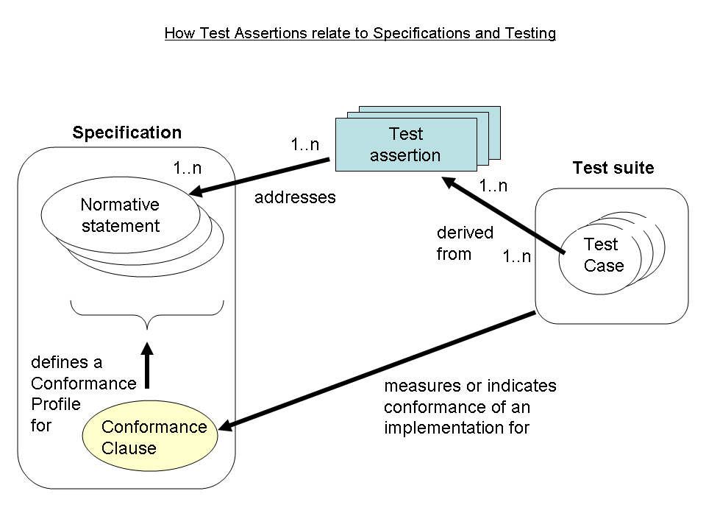
A Test Assertion should not be confused with a Conformance Clause, nor with a Test Case. The specification will often have one or more conformance clauses CONFCLAUSE [[CONF1]][[CONF2]] which define (one or more) conformance profiles or levels [[VAR]] . A set of test assertions may be associated with a conformance clause in order to define more precisely what conformance entails. Test assertions lie between the specification and any suite of tests to be conducted to determine conformance. Such a test suite is typically comprised of a set of test cases. These test cases may be derived from test assertions which address the normative statements of the specification.

Test Assertion Set and Test Assertion Document
A container may be produced for a complete set of test assertions; often those related to all or part of a specification or conformance profile. In some cases the container is the specification itself with test assertions included within it. Test assertions can be added to the document, removed or changed using a change and version management procedure. For other cases, a separate container structure is defined in this model that accommodates various ways test assertions can be referenced or packaged when creating a test assertions set.

Benefits of Test Assertions
Improving the Specification
When defined at an early stage, test assertions may help provide a tighter specification. Any ambiguities, contradictions and statements which require excessive resources for testing can be noted as they become apparent during test assertion creation. If there is still an opportunity to correct or improve the specification, these notes can be the basis of comments to the specification authors. If not developed by the specification authors, test assertions should be reviewed and approved by them which will improve both the quality and time-to-deployment of the specification. Therefore, best results are achieved when assertions are developed in parallel with the specification. An alternative is to have the leader of the team that is writing test suites write the test assertions as well and to provide feedback to the specification authors.
Facilitating Testing
Test assertions provide a starting point for writing a conformance test suite or an interoperability test suite for a specification that can be used during implementation. They simplify the distribution of the test development effort between different organizations while maintaining consistent test quality. By tying test output to specification statements, test assertions improve confidence in the resulting test and provide a basis for coverage analysis (estimating the extent to which the specification is tested).

Test Assertion

Test Assertion Overview and Terminology

Core Test Assertion Parts
The following are defined as the "core" parts of a test assertion:
Identifier
A unique identifier for the test assertion.. It is recommended that the identifier be made universally unique.
Normative Sources
These refer to the precise specification requirements or normative statements that the test assertion addresses.
Target
A test assertion target is the implementation or part of an implementation that is the main object of the test assertion , and of its Normative Sources. It categorizes an implementation or a part of an implementation of the referred specification.
Predicate
A predicate asserts, in the form of an expression, the feature (a behavior or a property) described in the specification statement(s) referred by the Normative Sources. If the predicate is an expression which evaluates to “true” over a Target instance, this means that the test assertion target exhibits this feature. “False” means the target does not exhibit this feature.

Optional Test Assertion Parts
The following are defined as the "optional" parts of a test assertion:
Prescription Level
The prescription level is a keyword that indicates how imperative it is that the Normative Statement referred to in the Normative Source, be met. The test assertion defines a normative statement which may be mandatory (MUST / REQUIRED / SHALL), permitted (MAY / CAN) or preferred (SHOULD / RECOMMENDED). This property can be termed the test assertion’s prescription level. NOTE: in the case of the normative source including keywords 'MUST NOT' the prescription level 'mandatory' is used and the 'NOT' included in the predicate. There are differences between various conventions of normative language [ISO/IEC Directives] [RFC 2119]and the above terms may be extended with more specialized terms for a particular convention and its distinct shades of meaning.
Prerequisite
A test assertion Prerequisite is a logical expression (similar to a Predicate) which further qualifies the Target for undergoing the core test (expressed by the Predicate) that addresses the Normative Statement. It may include references to the outcome of other test assertions. If the Prerequisite evaluates to "false" then the Target instance is not qualified for evaluation by the Predicate.
Tag
Test assertions may be assigned 'tags' or 'keywords', which may in turn be given values. These tags provide an opportunity to categorize the test assertions. They enable the grouping of the test assertions, for example based on the type of test they assume or based on their target properties.
Variable
Test assertions may also include variables for convenience in storing values for reuse and shared use. Another use of a variable is as parameter or attribute employed by the writer of a test assertion to refer to a value that is not known at the time the test assertion is written, but which will be determined at some later stage, possibly as late as the middle of running a set of tests.
Description
An informal definition of the role of the test assertion, with some optional details on some of its parts. This description must not alter the general meaning of the test assertion and its parts as described in this model. This description may be used to annotate the test assertion with any information useful to its understanding. It does not need to be an exhaustive description of it.

Implicit Test Assertion Parts
In an actual test assertion definition, the previously mentioned parts are often explicitly represented as elements of the test assertion.
A concrete representation of a test assertion may omit elements (core or optional) provided they are implicit, meaning that the context in which the test assertion is defined, allows for unambiguous determination of the non-explicit element, e.g. via some rule or inference. A common case of implicit test assertion components is the implicit target: When several test assertions relate to the same target, the latter may be described just once as part of the context where the test assertions are defined, so that it does not need to be repeated. This calls for further structural components than those described so far. The more complex structure may include a test assertion set whose model caters for sharing of test assertion parts among a group of test assertions.

Informal Notation
The following notation will be used for a plain English representation of a test assertion. In bold, are the test assertion part names as defined in the above terminology section :

TA id: (here state the Identifier of the test assertion)
Normative Source: (here state the Normative Source reference or copy)
Target: (here state the Target identifier)
Prerequisite: (here an assertion stating the Prerequisite with possible reference to the Target . Notational convention: the reference to the Target is within square brackets.
Predicate: (here an assertion stating the Predicate and referring to the Target. Notational convention: the reference to the Target is within square brackets.)
Prescription Level: (here state the Prescription Level of the test assertion, which is a keyword among {mandatory, preferred, permitted})
Tag: (here a name / value pair expressing a particular Tag. This test assertion part can be repeated. Notational convention: use the operator '=' between name and value.)
Variable: (here an identifier, along with its definition and/or value, representing a Variable that is reused in some other part of the test assertion. This test assertion part can be repeated. Notational convention: use the operator '=' between name and value, and put the definition in parenthesis just after the name, if any.)
Description: (here state the Description of the test assertion)
This informal notation will be used for describing examples of test assertions.

Example of informal Test Assertion:

TA id: gizmo-TA300
Normative Source: specification requirement 317
Target: electrical-gizmo
Prerequisite: [The gizmo] has a low-battery indicator.
Predicate: The low-battery indicator of [the gizmo] is a red LED that is flashing below CRITICAL-CHARGE battery voltage.
Prescription Level: mandatory
Tag: conformanceclass = "international"
Variable: CRITICAL-CHARGE (the critical voltage limit in a battery).

Test Assertion Model

Convention Used for Formally Defining the Model
The means of formally defining the model in this specification involves the use of terms “class”, “attribute”, “datatype” and “association”. These are terms familiar in an object oriented paradigm but shall not be strictly interpreted as object oriented terms. The terms are used as a means of formally defining the data structures in the model and do not specify or imply how that data is to be accessed or used. The use of the object oriented terminology shall not be taken to mean that the implementation is to be object oriented. See section 1.2 for meanings of these terms.
Example Formal Definition:
example {

content : string (1..1)
id : string (1..1)
Child : child (1..*)
Sibling : sibling (0..*)

}
With the exception of the example above, all of the textual representations in this specification shall be taken as normative and authoritative. However, some classes in this specification may be extended either by adding further attributes or by adding further associations or both. This is indicated in the prose immediately following the representation of the class.
The class name, here called 'example', is shown before the opening curly bracket.
The attributes combine the name of the attribute in lower camel case separated by a colon from the name of the datatype on which the type of the attribute is based.
The associations combine the name of the association in upper camel case separated by a colon from the name of the class which is associated and which represents the type of the association.
The cardinalities are specified using the notation “(x..y)” where “x” represents the lower bound and “y” the upper bound of the cardinality. The symbol “*” represents a limitless upper bound. There are the following cardinalities in the model:
(0..1) specifies an optional, singular entity (lower bound 0, upper bound 1)
(0..*) specifies an optional, multiple entity (lower bound 0, upper bound unlimited)
(1..1) specifies a mandatory, singular entity (lower bound 1, upper bound 1)
(1..*) specifies a mandatory, multiple entity (lower bound 1, upper unlimited)
(x..y) specifies an entity lower bound x, upper y where x and y are positive integers, for example (1..2)
In the example representation above there is a class called “example” (not a real class, just an example to illustrate the representation convention used in this specification). The class has a mandatory attribute, shown with “(1..1)” to signify that it is mandatory, called “id” whose content is type “string”. The class called “example” has another attribute named “content” which is shown to be optional by the notation (0..1). The “example” class has associations to other classes called “child” and “sibling”. These are similar to attributes whose types are complex and represented in this model as classes. The (0..*) notation signifies that the entity named “sibling” has multiple cardinality and is optional. The (1..*) after the association called “child” signifies that this association is mandatory and multiple.
Any graphic images such as class diagrams included in this specification are non-normative. It is the text which shall be taken as normative. Any diagrams are to be interpreted loosely as illustrative material and in the case of any discrepancy with the text it is the text which is to be taken as authoritative.

Mapping Test Assertion Terminology to the Formal Notation

Table 1. Mapping Section 3.1 test assertion parts (as defined in the previous terminology section) to the formal Test Assertions Model
Test Assertion Parts | Corresponding Entities in Test Assertions Model
Test Assertion | Class: testAssertion
Core Parts
Identifier | attribute: testAssertion.id  ('id' attribute of testAssertion class)
Normative Source | Class: normativeSource
Target | Class: target
Predicate | Class: predicate
Optional Parts
Prescription Level | attribute: prescription.level  ('level' attribute of prescription class)
Prerequisite | Class: prerequisite
Tag | Class: tag
Variable | Class: var
Description | Class: description

General Structure of a Test Assertion
A test assertion shall include, implicitly or explicitly the following parts:
- Identifier
- Normative Source
- Target
- Predicate
In addition, a test assertion may optionally include the following parts:
- Prescription Level
- Prerequisite
- Tag (possibly many)
- Variable (possibly many)
- Description

testAssertion
An instance of testAssertion is a testable or measurable expression for evaluating the adherence of part of an
implementation to a normative statement in a specification.

Formal Definition of 'testAssertion':
testAssertion {

id : string (1..1)
language : string (0..1)
NormativeSource : normativeSource (1..1)
Target : target (1..1)
Prerequisite : prerequisite (0..1)
Predicate : predicate (1..1)
Prescription : prescription (0..1)
Description : description (0..1)
Tag : tag (0..*)
Variable : variable (0..*)

}

Semantics:

- The <id> attribute (corresponding to the Identifier terminology definition) is uniquely identifying the test assertion.

- The <language> attribute specifies the language used in the other parts of the test assertion.

- The <NormativeSource> association (corresponding to the Normative Source terminology definition) is identifying the normative statement in the specification that describes the feature or behavior that needs to be verified over a <Target> instance.

- The <Target> association (corresponding to the Target terminology definition) is identifying (or categorizing) the specification implementation(s) or parts of, subject to testing.

- The <Prerequisite> association (corresponding to the Prerequisite terminology definition) expresses a pre-condition to be satisfied by the <Target> in order to qualify for the test expressed by the <Predicate>. It is a boolean expression: if evaluates to "true", the <Predicate> can be evaluated over the <Target>. If evaluates to "false", the <Target> is not qualified for this test assertion.

- The <Predicate> association (corresponding to the Predicate terminology definition) expresses the feature or behavior expected from the <Target> as stated in <NormativeSource>. It is a boolean expression: if evaluates to "true", the <Target> instance exhibits the expected feature. If "false", the <Target> does not.

- The <Prescription> association (corresponding to the Prescription Level terminology definition) expresses how imperative is the statement referred by <NormativeSource>: usually one level among {"permitted", "preferred", "mandatory" }(corresponds to optional/recommended/required)

- The <Description> association (corresponding to the Description terminology definition) gives an informal definition of this particular test assertion.

- The <Tag> association (s) (corresponding to the Tag terminology definition) add some annotation mechanism in the form of (name, value) pair(s), or just a (name) property.

- The <Variable> association (s) (corresponding to the Variable terminology definition) provide some way to parameterize the expressions used in other elements of the test assertion, or to abstract some of its values. It is in the form of a (name, value) pair or just a (name). An additional definition statement may be added to the name.

Other attributes and associations may be added to the testAssertion class.
The test assertion and most other classes in the Test Assertions Model have an optional attribute named 'language' which is used to specify the language used in the test assertion. The string datatype for this attribute may be further constrained using a language codelist.

The NormativeSource, target and Predicate elements, although mandatory, may be implicit and also may be declared in a test assertion set (specified later). An instance of the testAssertion class may have any of its parts defined implicitly, i.e. their actual representation can be inferred, either from a container structure like a “test assertion set” or from other rules.

The Prerequisite and Predicate elements are of same nature. They are logical statement evaluating to true or false, which may in turn be composed of sub-expressions or sub-statements. These sub-expressions may be captured by Variables.

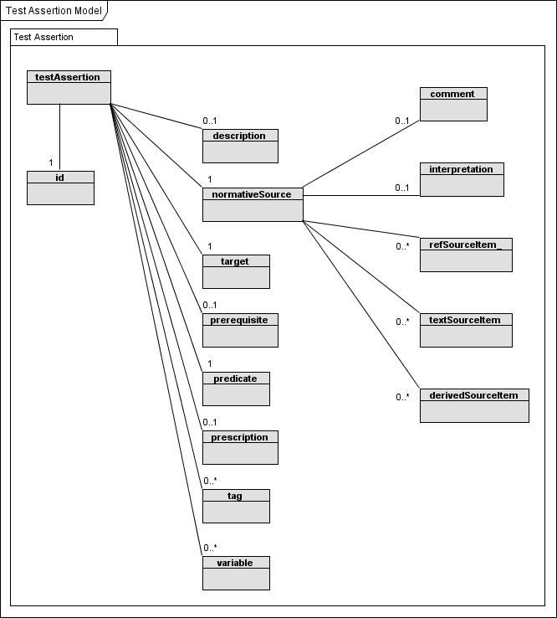
Test Assertion (Non-Normative UML-Style Class Diagram)
NOTE: the "language" attribute is not represented in the above diagram, unlike the "id" attribute which corresponds to a formal test assertion part.

normativeSource
An instance of 'normativeSource' identifies the normative statement in the specification that describes the feature or behavior that needs to be verified over a 'target' instance.
Formal Definition of 'normativeSource':
normativeSource {

content : string (0..1)
Comment : comment (0..1)
Interpretation : interpretation (0..1)
RefSourceItem : refSourceItem (0..*)
TextSourceItem : textSourceItem (0..*)
DerivedSourceItem : derivedSourceItem (0..*)

}

Semantics:

- The <content> attribute allows for quoting the entire normative source inside the test assertion (e.g. a copy of the original normative statement as it appears in a specification), when it is a single statement.

- The <Comment> association allows to add comments about the normative source.

- The <Interpretation> association may be used to add an alternative description in prose of any kind to a normative source e.g. to clarify its meaning or facilitate human understanding. It may provide further information clarifying how the predicate (or prerequisite) relates to the normative source.

- The <RefSourceItem> association references the original normative source statement, when externally defined.

- The <TextSourceItem> association quotes verbatim the source item.

- The <DerivedSourceItem> association derives a form of words equivalent in meaning to the source item. This is useful when the source consists of tables, diagrams, graphs or text spread over several parts of the specification.

Other attributes may be added to the normativeSource class.
The normative source of a test assertion may be provided as a reference using the refSourceItem class.
Formal Definition of 'refSourceItem':
refSourceItem {

name : string (0..1)
language : string (0..1)
uri : string (0..1)
documentId : string (0..1)
versionId : string (0..1)
revisionId : string (0..1)

resourceProvenanceId : string (0..1)

}

Semantics:

- The <content> attribute ...

- The <name> attribute is the name of the referred document containing the normative statement.

- The <language> attribute identifies the language used in the referred document containing the normative statement.

- The <uri> attribute contains a URI that locates the resource.

- The <documentId> attribute identifies the referred document containing the normative statement.

- The <versionId> attribute identifies the version of the referred document.

- The <revisionId> attribute identifies the revision of the referred document.

- The <resourceProvenanceId> attribute contains additional source information associated with the referred document (such as authorship identifiers to certify its authenticity).

Other attributes may be added to the refSourceItem class.

An alternative to using a reference to point to the normative source in a specification is to actually quote verbatim the source item so the normative source includes an association with a class named textSourceItem which allows a direct, verbatim quote of the specification text.
Formal Definition of 'textSourceItem':
textSourceItem {

content : string (0..1)
name : string (0..1)
language : string (0..1)

}

Semantics:

- The <content> attribute is quoting the normative source item.

- The <name> attribute is an informal qualifier of the statement.

- The <language> attribute identifies the language used in the normative statement.

Other attributes may be added to the textSourceItem class.
An alternative again to quoting verbatim the source item is to derive a form of words equivalent in meaning to the source item and for this the normative source includes an association to a class named derivedSourceItem. This is particularly useful when the source consists of tables, diagrams, graphs or text spread over several parts of the specification.
Formal Definition of 'derivedSourceItem':
derivedSourceItem {

content : string (0..1)
name : string (0..1)
language : string (0..1)
uri : string (0..1)
documentId : string (0..1)
versionId : string (0..1)
revisionId : string (0..1)
dateString : string (0..1)
resourceProvenanceId : string (0..1)

}
Semantics:

- The <content> attribute is expressing the normative statement as it has been interpreted from the (possibly non-textual) referred source material.

- other elements have same semantics as in refSourceItem class.

Other attributes may be added to the derivedSourceItem class.

Formal Definition of 'comment':
comment {

content : string (0..1)
language : string (0..1)

}
Other attributes may be added to the comment class.
The comment class may be used to simply add comments of any kind (or as further specified in a conformance profile for this markup or a customization thereof) to a normative source test assertion part.
Formal Definition of 'interpretation':
interpretation {

language : string (0..1)
content : string (0..1)

}
Other attributes may be added to the interpretation class.
The interpretation class may be used to simply add an alternative description in prose of any kind (or as further specified in a conformance profile for this markup or a customization thereof) to a normative source test assertion part. This allows a prose expression to be added to improve human understanding of its logic. It provides further information about how the predicate (or prerequisite) relates to the normative source.

target
An instance of 'target' identifies (or categorizes) the specification implementation(s) or parts of, subject to testing.
Formal Definition of 'target':
target {

content : string (0..1)
type : string (0..1)
idScheme : string (0..1)
language : string (0..1)

}

Semantics:

- The <content> attribute is identifying the target or the set of targets subject to the test assertion. A target can either be a specific item or a category of items.

- The <type> attribute specifies the target category. Its values may belong to a controlled vocabulary, ontology or other classification or taxonomy system.

- The <idScheme> attribute specifies the identity scheme used for identifying target instances, e.g. in test reports. It allows for generating the identifier of a target instance.

- The <language> attribute identifies the language used in the normative statement.

Other attributes may be added to the target class.
The 'type' attribute should be used to specify the target category, and this may be implemented using a controlled vocabulary, ontology or other classification or taxonomy system.
Where the scheme for listing or categorizing these types is defined in a document, the identifier, URL or URI for this document may be associated with the target using the attribute named 'schemeRef'. A target 'schemeRef' attribute or, for a set of test assertions, a shared target 'schemeRef' attribute may be used in cases where the target type scheme is defined using an expression or prose definition within the test assertion or set of test assertions.
The target content is a string. This may be an expression in a specialized formal expression language which may be specified using the 'language' attribute or using a complete conformance profile for that particular use of the markup.

prerequisite
An instance of 'prerequisite' expresses a pre-condition to be satisfied by the related 'target' instance in order to qualify for the test expressed by the 'predicate'. It is a boolean expression: if evaluates to "true", the 'predicate' can be evaluated over the 'target'. If evaluates to "false", the 'target' is not qualified for this test assertion.
Formal Definition of 'prerequisite':
prerequisite {

content : string (1..1)
language : string (0..1)

}

Semantics:

- The <content> attribute is stating the condition that must be met by the target and/or some collateral artifact, in order for the target to qualify for this test assertion.

- The <language> attribute identifies the expression language used for stating the prerequisite condition (content).

Other attributes may be added to the prerequisite class.
The prerequisite may be expressed using a specialized formal expression language which may be specified using the 'language' attribute or using a complete conformance profile for that particular use of an implementation of the model.
The content of the prerequisite class shall contain an expression which evaluates to true or false.

predicate
An instance of 'predicate' expresses the feature or behavior expected from the 'target' as stated by the 'normativeSource'. It is a boolean expression: if evaluates to "true", the related 'target' instance exhibits the expected feature. If "false", the 'target' instance does not.
Formal Definition of 'predicate':
predicate {

content : string (1..1)
language : string (0..1)

}

Semantics:

- The <content> attribute is stating the condition that must be met by the target and possibly some additional collateral artifact, in order for the target to fulfill the normative statement or its interpretation addressed by this test assertions.

- The <language> attribute identifies the expression language used for stating the predicate condition (content), if applicable.

Other attributes may be added to the predicate class.
A test assertion predicate shall be worded as an assertion, not as a requirement. Any 'MUST' or 'shall' keyword shall be absent from the predicate but reflected in the prescription level. The predicate has a clear Boolean value: Either the statement is true, or it is false for a particular target.

prescription
An instance of 'prescription' expresses how imperative is the statement referred by 'normativeSource' when applying to a 'target'. It is usually one level among {"permitted", "preferred", "mandatory"}.
Formal Definition of 'prescription':
prescription {

content : string (0..1)
level : string (0..1) (allowed values = mandatory|preferred|permitted)

}

Semantics:

- The <content> attribute is stating prescription information or annotation associated with the normative statement or its interpretation addressed by this test assertions.

- The <level> attribute identifies formally the prescription level, typically using a predefined keyword. The content attribute may add further information about this prescription level.

Other attributes may be added to the prerequisite class.
The allowable values for the attribute 'level' of the class prescription must contain the set of predefined values of mandatory, preferred and permitted. . Its values may be extended beyond this minimal set.
The prescription values correspond to the terms used in a specification to denote conformance requirements, or to a more nuanced expression:
- [RFC 2119] terms conveying mandatory nature of a statement such as 'MUST' and 'MUST NOT' and in Annex H of [ISO/IEC Directives] terms 'shall', etc shall correspond to the prescription level value 'mandatory'.
- RFC2119 terms conveying optionality with preference such as 'SHOULD' and 'SHOULD NOT', 'RECOMMENDED', etc and ISO/IEC Directive terms 'should', etc shall correspond to the prescription level value 'preferred'.
- RFC2119 terms conveying optionality without preference 'MAY' and ISO/IEC Directive terms 'may', etc shall correspond to the prescription level value 'permitted'.
The RFC2119 terms for preference do not permit non-conformance without a reason and usually the same 'preferred' prescription level is acceptable but in some cases implementers may wish to make a distinction by making use of the extension facility and specify further enumeration values.
The prescription shall not affect the outcome semantics of the test assertion but may determine how this outcome is to be used, e.g. how the outcome affects conformance or otherwise of the implementation to a conformance profile or to the conformance clause of the specification.
Besides the use of the 'level' attribute, the content (string) may be used to express further information regarding the prescription level using prose or as a logical expression.

description
An instance of 'description' gives an informal definition of a test assertion.
Formal Definition of 'description':
description {

content : string (0..1)
language : string (0..1)

}

Semantics:

- The <content> attribute is stating a general plain text description of this test assertion or of its intent.

- The <language> attribute identifies the language used by the description.

Other attributes may be added to the description class.
Notes:
The description class may be used to add a description in prose of any kind (or as further specified in a conformance profile for this markup or a customization thereof) to a test assertion or set of test assertions. This may be especially useful when a test assertion is otherwise expressed purely in a specialized, formal, logical language which might not be intended for legibility to human readers;

tag
An instance of 'tag' provides some annotation mechanism in the form of (name, value) pair, or just a (name) property. They may help the grouping or categorize test assertions - e.g. all test assertions related to a particular conformance profile "CP-1" may use a tag "conformance_profile" and be tagged with: conformance_profile = "CP-1"
Formal Definition of 'tag':
tag {

content : string (0..1)
name : string (0..1)
language : string (0..1)

}

Semantics:

- The <content> attribute is the value given to this tag.

- The <name> attribute is the name of the tag.

- The <language> attribute identifies the language used by the value.

When the 'content' attribute is used and set to a non-empty value, then the "name" attribute shall be used with a non-empty value. Other attributes may be added to the tag class.

Notes:
Special examples of tags are to indicate to which versions of a specification the test assertion or set of test assertions applies and to specify that a test assertion or set of test assertions exist to define a particular normative property or a conformance level. The tag class may be used to attach such data to a test assertion or test assertion set.

Reserved Tag Names
DefinesNormativeProperty and NormativeProperty
A test assertion may be tagged to show that it is a property test assertion using two reserved word tag names DefinesNormativeProperty and NormativeProperty .
A test assertion having a reserved word property tag DefinesNormativeProperty or NormativeProperty may have an absence of the prescription element.

VersionAdd and VersionDrop
tag: VersionAdd: the lowest numerical version to which the test assertion applies.
tag: VersionDrop: the lowest numerical version number to which the test assertion does NOT apply.
Both VersionAdd and VersionDrop are optional tags. The absence of both tags shall mean that the test assertion is valid in all specification versions. If only a VersionAdd tag exists and its value is X, the test assertion will be valid in version X of the specification and all subsequent versions. If only a VersionDrop tag exists and its value is Y, the test assertion shall be valid in all versions of the specification prior to version Y. If both VersionAdd and VersionDrop tags exist, the test assertion shall be valid in version X and all subsequent versions up to but not including version Y. Based on these rules, you can easily generate the set of test assertions that apply to a specific version of the specification.

variable
An instance of 'variable' allows for abstracting and naming some value used by one or more parts of a test assertion, or across several test assertions of a set.. The value of a variable may be determined at a later time, allowing the test assertion to be parameterized.
Formal Definition of 'variable':
variable {

content : string (0..1)
name : string (0..1)
language : string (0..1)

}

Semantics:

- The <content> attribute is the value given to this variable.

- The <name> attribute is the name of the variable.

- The <language> attribute identifies the language used by the value.

When the 'content' attribute is used and set to a non-empty value, then the "name" attribute shall be used with a non-empty value. Other attributes may be added to the variable class.
Notes:
The variable value may be an expression, the evaluation of which may vary depending on the target instance. It may also be a sub-expression of the predicate or of the prerequisite, The notation used for these variables in the content of predicates, prerequisite, etc. is left to implementations of this model.
As for a 'tag', an instance of 'variable' may state a (name, value) pair or just a (name).

Outcome of a Test Assertion
As a test assertion has parts that can be evaluated over a target instance (i.e. the prerequisite, the predicate, and possibly any variables containing expressions), the following semantics shall apply to a test assertion when determining its outcome:
With regard to a target instance, the following outcomes may occur:
- "Target not qualified": if the Prerequisite (if any) evaluates to "false" over a Target instance.
- "Normative statement fulfilled [by the Target]": if the Prerequisite (if any) evaluates to "true" over a Target instance, and the Predicate evaluates to "true".
- "Normative statement not fulfilled [by the Target]": if the Prerequisite (if any) evaluates to "true" over a Target instance, and the Predicate evaluates to "false".

Test Assertion Set
The testAssertionSet class may be used to group together test assertions either by inclusion of the test assertion within the test assertion set of by references to their Ids. It is expected that test assertions will be represented in very diverse media, e.g. embedded in specification documents or separately defined, using various representation modes ranging from informal description to formal languages. Also, specifications reuse each other, combine with each other and evolve through versioning. For these reasons it is expected that test assertion sets will be created from very diverse sources, and often defined while referring to test assertions as still belonging to their original source or medium. The following model for test assertion sets allows for diversity in sources and referential modes.

Core Elements

testAssertionSet
Formal Definition of 'testAssertionSet':
testAssertionSet {

id : string (0..1)
language : string (0..1)

TestAssertionDocumentHeader : testAssertionDocumentHeader (0..1)
Shared : shared (0..1)
TestAssertion : testAssertion (0..*)
TestAssertionRef : testAssertionRef (0..*)
TestAssertionSet : testAssertionSet (0..*)
TestAssertionSelection : testAssertionSelection (0..*)

}

Semantics:

- The <id> attribute is an identifier for the set of test assertions.

- The <language> attribute specifies the language used by default in every test assertion of the set.

- The <TestAssertionDocumentHeader> association refers to a header block containing metadata about this set. In case the test assertions set is embedded in a document the testAssertionDocumentHeader may be used once within the document either on its own or as a direct child of the root testAssertionSet element. See section on testAssertionDocumentHeader.

- The <Shared> association refers to test assertion material that is shared (by default) by all test assertions of this set: test assertion parts and their values, common variables. (See the section on the 'shared' class.)

- The <TestAssertion> association directly refers to test assertions included in this set.

- The <TestAssertionRef> association indirectly refers to some test assertions included in this set, by reference.

- The <TestAssertionSet> association indirectly refers to some test assertions included in this set, by referencing other test assertion sets that contain them.

- The <TestAssertionSelection> association refers to a set of test assertions that is defined by applying a test assertion filter (selection condition) over one or more existing sets of test assertions, resulting in a subset of the referred test assertions.

Other attributes and associations may be added to the testAssertionSet class.

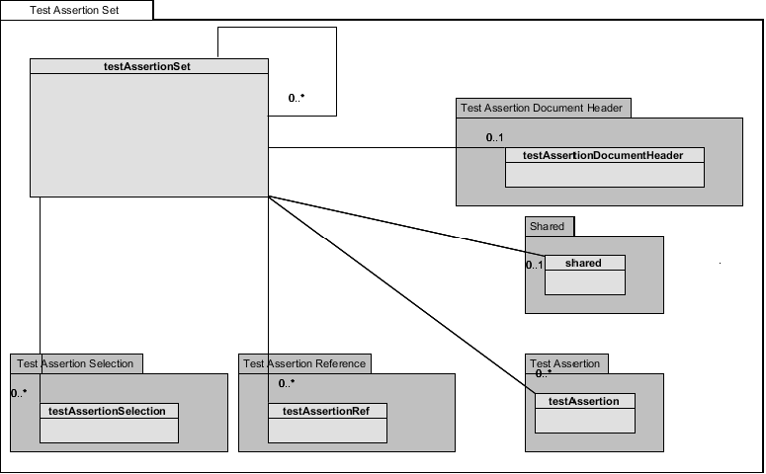
Test Assertion Set (Non-Normative UML-Style Class Diagram)

testAssertionSelection
Formal Definition of 'testAssertionSelection':
testAssertionSelection {

content : string (0..1)
language : string (0..1)
TestAssertionSet : testAssertionSet (0..*)
TestAssertionId : string (0..*)

}

Semantics:

- The <content> attribute is a logical condition that a test assertion from TestAssertionSet must satisfy in order to be part of this selection.

- The <language> attribute specifies the language used by the selection condition.

- The <TestAssertionSet> association refers to some test assertions to be subject to this selection.

- The <TestAssertionId> association provides one or more test assertion Ids that must be matched by test assertions from TestAssertionSet in order to be selected as part of this selection. In case content is present the test assertion must in addition satisfy its condition.

Other attributes may be added to the testAssertionSelection class.

shared
Formal Definition of 'shared':
shared {

NormativeSource : normativeSourceShared (0..1)
Target : targetShared (0..1)
Prerequisite : prerequisiteShared (0..1)
Predicate : predicateShared (0..1)
Prescription : prescriptionShared (0..1)
Description : descriptionShared (0..1)
Tag : tagShared (0..*)
Variable : variableShared (0..*)

}

Semantics:

- Each element (association) of the 'shared' class corresponds to the element of same name in the testAssertion class. The general semantics is that these shared parts will apply to all test assertions in the set, and sometimes will override or be overridden by the corresponding value of these parts in individual test assertions, in case there is a conflict.

- The class name of these elements is different because extended with an additional element ('conflict' attribute) described later.

The semantics of these elements w/r to the test assertion set that includes this 'shared' element is as follows:

- NormativeSource when present indicates a common normative source for all test assertions of the set, unless there is a conflict with a similar part in a test assertion. In that case its semantics depends on the value of its 'conflict' attribute:
o if 'conflict' = 'conjunction' or 'overriding': indicates a shared normative source respectively added to the particular TA normative source, or overriding the particular TA normative source.
o if 'conflict' = 'overridden' : indicates a default normative source for each test assertions, overridden by individual TA NormativeSource part if present.

- Target when present indicates a common Target for all test assertions of the set, unless there is a conflict with a similar part in a test assertion. In that case its semantics depends on the value of its 'conflict' attribute:
o if 'conflict' = 'overriding': indicates a shared target common to all test assertions in this set.
o if 'conflict' = 'overridden' : indicates a default target for each test assertion, overridden by individual TA target part if present.
o if 'conflict' = 'disjunction' : indicates a category of targets that is to be composed as a union with the target category specified for an individual test assertion.
o if 'conflict' = 'conjunction' : indicates a category of targets that is to be composed as an intersection with the target category specified for an individual test assertion.

- Prerequisite when present indicates a common Prerequisite for all test assertions of the set, unless there is a conflict with a similar part in a test assertion. In that case its semantics depends on the value of its 'conflict' attribute:
o if 'conflict' = 'overriding': indicates that the shared prerequisite overrides a similar part in a test assertion.
o if 'conflict' = 'conjunction': indicates that the shared prerequisite composes by a logical AND with a similar part in a test assertion.
o if 'conflict' = 'overridden': indicates that the shared prerequisite is replaced by a similar part in a test assertion.
o if 'conflict' = 'disjunction': indicates that the shared prerequisite composes by a logical OR with a similar part in a test assertion.

- Predicate when present indicates a common Predicate for all test assertions of the set, unless there is a conflict with a similar part in a test assertion. In that case its resolution is similar as for Prerequisite.

- Description when present indicates a common Description for all test assertions of the set, unless there is a conflict with a similar part in a test assertion. In that case its semantics depends on the value of its 'conflict' attribute:
o if 'conflict' = 'conjunction' or 'overriding': indicates a shared description respectively added to the particular TA description, or overriding the particular TA description.
o if 'conflict' = 'overridden' : indicates a default description for each test assertions, overridden by individual TA description part if present.

- Prescription when present indicates a common Prescription for all test assertions of the set, unless there is a conflict with a similar part in a test assertion. In that case its semantics depends on the value of its 'conflict' attribute:
o if 'conflict' = 'overriding': indicates a shared prescription common to all test assertions in this set.
o if 'conflict' = 'overridden' : indicates a default prescription for each test assertion, overridden by individual TA prescription part if present.

- Tag when present indicates a common Tag for all test assertions of the set, unless there is a conflict with a tag of same name in a test assertion. In that case its semantics depends on the value of its 'conflict' attribute:
o if 'conflict' = 'overriding': indicates a shared Tag value common to all test assertions in this set.
o if 'conflict' = 'overridden' : indicates a default tag value for each test assertion, overridden by individual TA tag value if present.
o if 'conflict' = 'conjunction' : indicates for a multi-valued tag (containing an enumeration) that the actual tag value for the test assertion results from the intersection of both enumerations.
o if 'conflict' = 'disjunction' : indicates for a multi-valued tag (containing an enumeration) that the actual tag value for the test assertion results from the union of both enumerations.

- Variable when present indicates a common variable for all test assertions of the set, unless there is a conflict with a variable of same name in a test assertion. In that case its semantics depends on the value of its 'conflict' attribute:
o if 'conflict' = 'overriding': indicates a shared variable value common to all test assertions in this set.
o if 'conflict' = 'overridden' : indicates a default variable value for each test assertion, overridden by individual TA variable value if present.
o if 'conflict' = 'conjunction' : indicates for a multi-valued variable (containing an enumeration) that the actual variable value for the test assertion results from the intersection of both enumerations.
o if 'conflict' = 'disjunction' : indicates for a multi-valued variable (containing an enumeration) that the actual variable value for the test assertion results from the union of both enumerations.

Other associations may be added to the shared class.

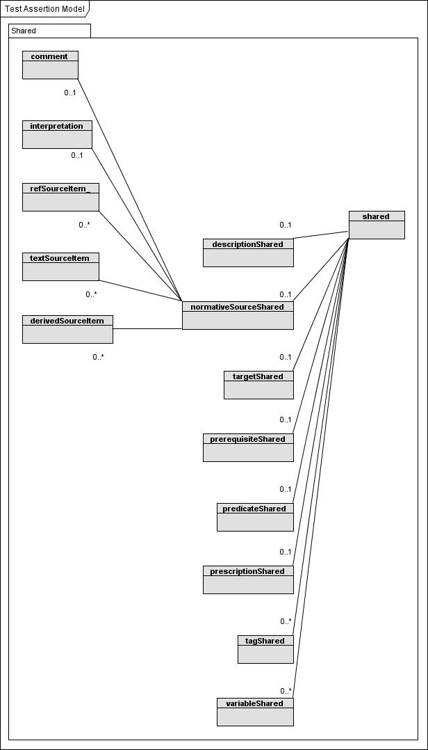
Shared (Non-Normative UML-Style Class Diagram)

normativeSourceShared
The formal Definition of 'normativeSourceShared' is similar as for 'normativeSource', except for an additional 'conflict' attribute:
normativeSourceShared {

content : string (0..1)
conflict : string (0..1) (allowed values = conjunction|disjunction|overriding|overridden)
Comment : comment (0..1)
Interpretation : interpretation (0..1)
RefSourceItem : refSourceItem (0..*)
TextSourceItem : textSourceItem (0..*)
DerivedSourceItem : derivedSourceItem (0..*)

}
Other attributes may be added to the normativeSourceShared class.

targetShared
The formal Definition of 'targetShared' is similar as for 'target', except for an additional 'conflict' attribute
targetShared {

content : string (0..1)
type : string (0..1)
schemeRef : string (0..1)
language : string (0..1)
conflict : string (0..1) (allowed values = disjunction|conjunction |overriding|overridden)

}
Other attributes may be added to the targetShared class.

prerequisiteShared
The formal Definition of 'prerequisiteShared' is similar as for 'prerequisite', except for an additional 'conflict' attribute
prerequisiteShared {

content : string (1..1)
language : string (0..1)
conflict : string (0..1) (allowed values = conjunction|disjunction)

}
Other attributes may be added to the prerequisiteShared class.

predicateShared
The formal Definition of 'predicateShared' is similar as for 'predicate', except for an additional 'conflict' attribute
predicateShared {
content : string (1..1)
language : string (0..1)
conflict : string (0..1) (allowed values = conjunction|disjunction|overriding|overridden)

}
Other attributes may be added to the predicateShared class.

prescriptionShared
The formal Definition of 'prescriptionShared' is similar as for 'prescription', except for an additional 'conflict' attribute
prescriptionShared {

content : string (0..1)
level : string (0..1) (allowed values = mandatory|preferred|permitted)
conflict : string (0..1) (allowed values = overriding|overridden)

}
Other attributes may be added to the prescriptionShared class.

descriptionShared
The formal Definition of 'descriptionShared' is similar as for 'description', except for an additional 'conflict' attribute
descriptionShared {

content : string (0..1)
language : string (0..1)
conflict : string (0..1) (allowed values = conjunction|disjunction|overriding|overridden)

}
Other attributes may be added to the descriptionShared class.

tagShared
The formal Definition of 'tagShared' is similar as for 'tag', except for an additional 'conflict' attribute
tagShared {

content : string (0..1)
name : string (0..1)
language : string (0..1)
conflict : string (0..1) (allowed values = conjunction|disjunction|overriding|overridden)

}
Other attributes may be added to the tagShared class.

variableShared
The formal Definition of 'variableShared' is similar as for 'variable', except for an additional 'conflict' attribute
variableShared {

content : string (0..1)
name : string (0..1)
language : string (0..1)
conflict : string (0..1) (allowed values = conjunction|disjunction|overriding|overridden)

}
Other attributes may be added to the variableShared class.
Whether these test assertion parts compose, with conjunction or disjunction (that is, combine using a logical 'AND' or 'OR' respectively), or override or are overridden by any corresponding test assertion parts of the same kind (and, in the case of 'tag' and 'variable', with the same 'name' attribute value) within the test assertion set shall depend on the corresponding values of the 'conflict' attribute.
Note that the part classes can each have different sets of allowed values for the 'conflict' attribute.
The values of the 'conflict' attribute may be extended. Custom values may be ignored by an implementation.

Test Assertion References
A test assertion set may refer to one or more test assertions by their test assertion identifiers rather than include the test assertions literally within the set.

testAssertionRef
Formal Definition of 'testAssertionRef':
testAssertionRef {

name : string (0..1)
TestAssertionResource : testAssertionResource (0..*)
TestAssertionSetId : string (0..*)
TestAssertionId : string (0..*)

}

Semantics:

- The <name> attribute identifies this referential element.

- The <TestAssertionResource> association refers to some container document that itself contains test assertions.

- The <TestAssertionSetId> association refers to some test assertion set by its Id.

- The <TestAssertionId> association refers to a test assertion by its Id.

Other attributes and associations may be added to the testAssertionRef class.
A test assertion set in which references are made to other test assertions outside of the set (whether in the same document or other documents) shall use the testAssertionRef class to do so. The structure of this class allows for the possibility that test assertions may be contained in another document in another location by inclusion of an association to class testAssertionResource. Other associations testAssertionSetId and testAssertionId allow for the possibilities that the test assertion may be within one or more layers of test assertion sets and might only be uniquely identifiable by keeping trace of the test assertion identifier (s). The testAssertionRef may be used to refer to a test assertion set as a whole, rather than a reference to each test assertion individually.

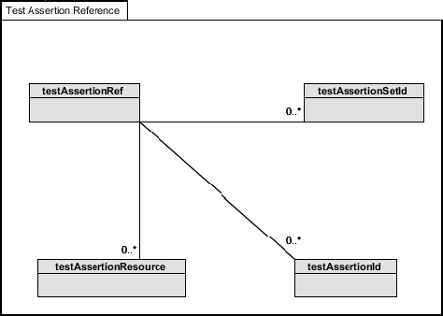
Test Assertion Reference (Non-Normative UML-Style Class Diagram)

testAssertionResource
A test assertion resource is used when test assertions are contained in another external document.
Formal Definition of 'testAssertionResource':
testAssertionResource {

language : string (0..1)
description : string (0..1)
uri : string (0..1)
documentId : string (0..1)

Semantics:

- The <language> attribute identifies the primary language used in the resource.

- The <description> attribute provides additional information on the resource and its properties, e.g. provenance (such as authorship identifiers to certify its authenticity) and version, etc . It may also describes the document identification scheme used.

- The <uri> attribute identifies the resource by its URI or IRI.

- The <documentId> identifies the resource using a document identification scheme, which may be specified in the language attribute.

Other attributes may be added to the testAssertionResource class.
The uri attribute may contain data to help locate the resource but the expected implementation is one where an identifier or URI is used to point to a repository of some kind which is a more appropriate container for the specific information needed to make the external test assertions available. .

testAssertionDocumentHeader
Formal Definition of 'testAssertionDocumentHeader':
testAssertionDocumentHeader {

Common : common (1..1)

}
Other associations may be added to the testAssertionDocumentHeader class.
The testAssertionDocumentHeader may be used to provide metadata (author, location, etc) about the specification to which test assertions are associated when such test assertions are interspersed within a document. The testAssertionDocumentHeader element may, alternatively, provide a container for metadata about the specification in the outermost testAssertionSet of a test assertion document or where an implementation only allows one test assertion set for each document.
An instance may have this as the top level class. There shall be no more than one testAssertionDocumentHeader used in any given document implementing this model.

common
Formal Definition of 'common':
common {

SourceDocument : sourceDocument (0..1)
Authors : authors (0..1)
Location : location (0..1)

}

Semantics:

- The <SourceDocument> association identifies the document containing normative statements and requirements that are addressed by this test assertions set. The definition of the related class (sourceDocument) is open: this model does not impose a particular definition.

- The <Authors> association provides a list of authors to this test assertions set. The definition of the related class (authors) is open: this model does not impose a particular definition.

- The <Location> association provides a way to locate this set of test assertions. The definition of the related class (location) is open: this model does not impose a particular definition.

Other attributes may be added to the common class.

Conformance
Implementations subject to conformance are of three kinds:
(1) languages or notations that represent the test assertion model described in Section 3 and Section 4. (For example, a mark-up language.)
(2) actual instances of test assertions, that follow the modeling principles and semantics described in Section 3.
(3) actual sets of test assertions, that follow the modeling principles and semantics described in Section 4.

In order to conform to this model, implementations of class (1):
(1) shall represent all test assertion parts (core and optional) defined in Section 3
(2) may represent any test assertion constructs defined in Section 4
(3) shall use names for these parts that are identical or can be unambiguously mapped to the definitions used in Section 3 and implemented parts of Section 4
(4) shall implement the normative statements for the test assertion model and its semantics in this specification.

In order to conform to this model, implementations of class (2):
(a) shall be represented using a notation or language that maps unambiguously to the TA model defined in Section 3,
(b) shall include the test assertion parts mandated by the TA model (Core TA parts)
(c) shall define values for its parts in a way that is consistent with the test assertion semantics stated in the TA model .
(d) The evaluation of the test assertion shall conform to the semantics of the outcome of the test assertion specified in Section 3.3.

In order to conform to this model, implementations of class (3):
(a) shall contain only conforming test assertion instances.
(b) in case some set-level constructs for grouping test assertions are used that define elements or values that are common to the set of test assertions as allowed by the model construct "shared" (Section 4), or that use some referential scheme e.g. to refer to external TAs or subsets of TAs (fulfilling the same function as modeling constructs TestAssertionRef, TestAssertionSet or TestAssertionSelection), then these constructs shall map unambiguously to their counterparts in the TA model and their semantics.

Mandatory statements are designated by the keyword 'shall' and 'shall not' in bold type, as described in Annex H of [ISO/IEC Directives] .
- Acknowledgments
The following individuals have participated in the creation of this specification and are gratefully acknowledged
Participants:

- Dennis Hamilton, Individual
- Dmitry Kostovarov, Oracle Corporation
- Dong-Hoon Lim, KIEC
- Hyunbo Cho, Pohang University
- Jacques Durand, Fujitsu
- Kevin Looney, Oracle Corporation
- Kyoung-Rog Yi, KIEC
- Lynne Rosenthal, NIST
- Patrick Curran, Oracle Corporation
- Paul Rank, Oracle Corporation
- Serm Kulvatunyou, NIST
- Stephen D. Green, Document Engineering Services
- Tim Boland, NIST
- Victor Rudometov, Oracle Corporation
- Youngkon Lee, KIEC

- Revision History

Rev | Date | By Whom | What
CD 1 | 12/15/09 | Stephen Green | CD 1 candidate
CD 2 | 08/10/10 | Jacques Durand | CD 2 draft for PR

One way to do this is to designate a universally unique name for a set of test assertions and to include this name along with the identifier when referencing the test assertion from outside of this set.

