
Integrated Collaboration Object Model (ICOM) for Interoperable Collaboration Services Version 1.0
Committee Specification Draft 03 /
Public Review Draft 03
28 March 2012
Specification URIs
This version:
http://docs.oasis-open.org/icom/icom-ics/v1.0/csprd03/icom-ics-v1.0-csprd03.doc (Authoritative)
http://docs.oasis-open.org/icom/icom-ics/v1.0/csprd03/icom-ics-v1.0-csprd03.html
http://docs.oasis-open.org/icom/icom-ics/v1.0/csprd03/icom-ics-v1.0-csprd03.pdf
Previous version:
http://www.oasis-open.org/committees/download.php/44405/icom-ics-v1.0-csprd02.zip
Latest version:
http://docs.oasis-open.org/icom/icom-ics/v1.0/icom-ics-v1.0.doc (Authoritative)
http://docs.oasis-open.org/icom/icom-ics/v1.0/icom-ics-v1.0.html
http://docs.oasis-open.org/icom/icom-ics/v1.0/icom-ics-v1.0.pdf
Technical Committee:
OASIS Integrated Collaboration Object Model for Interoperable Collaboration Services
(ICOM) TC
Chair:
Eric S. Chan (eric.s.chan@oracle.com), Oracle
Editors:
Eric S. Chan (eric.s.chan@oracle.com), Oracle
Patrick Durusau, (patrick@durusau.net), Individual
Additional artifacts:
This prose specification is one component of a Work Product which also includes:
- XML schemas: http://docs.oasis-open.org/icom/icom-ics/v1.0/csprd03/schemas/
Declared XML namespaces:
http://docs.oasis-open.org/ns/icom/core/201008
http://docs.oasis-open.org/ns/icom/accesscontrol/201008
http://docs.oasis-open.org/ns/icom/metadata/201008
http://docs.oasis-open.org/ns/icom/content/201008
http://docs.oasis-open.org/ns/icom/document/201008
http://docs.oasis-open.org/ns/icom/message/201008
http://docs.oasis-open.org/ns/icom/presence/201008
http://docs.oasis-open.org/ns/icom/contact/201008
http://docs.oasis-open.org/ns/icom/calendar/201008
http://docs.oasis-open.org/ns/icom/task/201008
http://docs.oasis-open.org/ns/icom/forum/201008
http://docs.oasis-open.org/ns/icom/conference/201008
Abstract:
The Integrated Collaboration Object Model (ICOM) for Interoperable Collaboration Services defines a framework for integrating a broad range of domain models for collaboration activities in an integrated and interoperable collaboration environment.
The framework is not intended to prescribe how applications or services conforming to its model implement, store, or transport the data for objects. It is intended as a basis for integrating a broad range of collaboration objects to enable seamless transitions across collaboration activities. This enables applications to maintain a complete thread of conversations across multiple collaboration activities.
The model integrates a broad range of collaboration activities, by encompassing and improving on a range of models which are part of existing standards and technologies. The model is modular to allow extensibility. The core concepts, metadata concepts, and their relations are included in the Core, while the specific concepts and relations for each area of collaboration activities are defined in separate extension modules.
Status:
This document was last revised or approved by the OASIS Integrated Collaboration Object Model for Interoperable Collaboration Services (ICOM) TC on the above date. The level of approval is also listed above. Check the “Latest version” location noted above for possible later revisions of this document.
Technical Committee members should send comments on this specification to the Technical Committee’s email list. Others should send comments to the Technical Committee by using “Send A Comment” button on the Technical Committee’s web page at http://www.oasis-open.org/committees/icom/.
For information on whether any patents have been disclosed that may be essential to implementing this specification, and any offers of patent licensing terms, please refer to the Intellectual Property Rights section of the Technical Committee web page (http://www.oasis-open.org/committees/icom/ipr.php).
Citation format:
When referencing this specification the following citation format should be used:
[ICOM-ics-v1.0]
Integrated Collaboration Object Model (ICOM) for Interoperable Collaboration Services Version 1.0. 28 March 2012. OASIS Committee Specification Draft 03 / Public Review Draft 03. http://docs.oasis-open.org/icom/icom-ics/v1.0/csprd03/icom-ics-v1.0-csprd03.html.

Notices
Copyright © OASIS Open 2012. All Rights Reserved.
All capitalized terms in the following text have the meanings assigned to them in the OASIS Intellectual Property Rights Policy (the "OASIS IPR Policy"). The full Policy may be found at the OASIS website.
This document and translations of it may be copied and furnished to others, and derivative works that comment on or otherwise explain it or assist in its implementation may be prepared, copied, published, and distributed, in whole or in part, without restriction of any kind, provided that the above copyright notice and this section are included on all such copies and derivative works. However, this document itself may not be modified in any way, including by removing the copyright notice or references to OASIS, except as needed for the purpose of developing any document or deliverable produced by an OASIS Technical Committee (in which case the rules applicable to copyrights, as set forth in the OASIS IPR Policy, must be followed) or as required to translate it into languages other than English.
The limited permissions granted above are perpetual and will not be revoked by OASIS or its successors or assigns.
This document and the information contained herein is provided on an "AS IS" basis and OASIS DISCLAIMS ALL WARRANTIES, EXPRESS OR IMPLIED, INCLUDING BUT NOT LIMITED TO ANY WARRANTY THAT THE USE OF THE INFORMATION HEREIN WILL NOT INFRINGE ANY OWNERSHIP RIGHTS OR ANY IMPLIED WARRANTIES OF MERCHANTABILITY OR FITNESS FOR A PARTICULAR PURPOSE.
OASIS requests that any OASIS Party or any other party that believes it has patent claims that would necessarily be infringed by implementations of this OASIS Committee Specification or OASIS Standard, to notify OASIS TC Administrator and provide an indication of its willingness to grant patent licenses to such patent claims in a manner consistent with the IPR Mode of the OASIS Technical Committee that produced this specification.
OASIS invites any party to contact the OASIS TC Administrator if it is aware of a claim of ownership of any patent claims that would necessarily be infringed by implementations of this specification by a patent holder that is not willing to provide a license to such patent claims in a manner consistent with the IPR Mode of the OASIS Technical Committee that produced this specification. OASIS may include such claims on its website, but disclaims any obligation to do so.
OASIS takes no position regarding the validity or scope of any intellectual property or other rights that might be claimed to pertain to the implementation or use of the technology described in this document or the extent to which any license under such rights might or might not be available; neither does it represent that it has made any effort to identify any such rights. Information on OASIS' procedures with respect to rights in any document or deliverable produced by an OASIS Technical Committee can be found on the OASIS website. Copies of claims of rights made available for publication and any assurances of licenses to be made available, or the result of an attempt made to obtain a general license or permission for the use of such proprietary rights by implementers or users of this OASIS Committee Specification or OASIS Standard, can be obtained from the OASIS TC Administrator. OASIS makes no representation that any information or list of intellectual property rights will at any time be complete, or that any claims in such list are, in fact, Essential Claims.
The name "OASIS" is a trademark of OASIS, the owner and developer of this specification, and should be used only to refer to the organization and its official outputs. OASIS welcomes reference to, and implementation and use of, specifications, while reserving the right to enforce its marks against misleading uses. Please see http://www.oasis-open.org/who/trademark.php for above guidance.

Table of Contents
1 Introduction 11
1.1 Terminology 12
1.2 Normative References 12
1.3 Non-Normative References 12
2 Modeling Language 14
2.1 Introduction 14
2.2 Class Definition Grammar 14
2.3 Property Definition Grammar 16
2.4 Namespaces 19
3 Core Model 20
3.1 Main Branch 20
3.1.1 Entity and Top-Level Subclasses 20
3.1.2 Identifiable 20
3.1.3 Parental 21
3.1.4 Extent 22
3.1.5 Entity 23
3.1.6 EntityDefinition 27
3.1.7 Overview of Scope, Subject, and Artifact Branches 28
3.2 Scope Branch 29
3.2.1 Scope and Top-Level Subclasses 29
3.2.2 Scope 30
3.2.3 Community 32
3.2.4 Space 34
3.3 Subject Branch 36
3.3.1 Subject and Top-Level Subclasses 36
3.3.2 Subject 36
3.3.3 Group 38
3.3.4 Actor 40
3.3.5 Person 42
3.3.6 Resource 46
3.3.7 ResourceType 48
3.3.8 ResourceTypeEnum 49
3.3.9 ResourceBookingRule 50
3.3.10 ResourceBookingRuleEnum 51
3.4 Artifact Branch 52
3.4.1 Artifact and Top-Level Subclasses 52
3.4.2 Item 52
3.4.3 SpaceItem 54
3.4.4 Container 54
3.4.5 FolderContainer 55
3.4.6 Artifact 56
3.4.7 Folder 59
3.4.8 HeterogeneousFolder 60
3.5 Access Control Model 61
3.5.1 Accessor 61
3.5.2 Owner 62
3.5.3 RoleDefinition 63
3.5.4 Role 64
3.5.5 Privilege 65
3.5.6 PrivilegeEnum 66
3.5.7 AccessControlList 67
3.5.8 AccessControlEntry 68
3.5.9 AccessType 69
3.5.10 AccessTypeEnum 70
3.6 Metadata Model 72
3.6.1 PropertyDefinition 72
3.6.2 Property 74
3.6.3 PropertyChoiceType 76
3.6.4 PropertyType 77
3.6.5 PropertyTypeEnum 78
3.6.6 Cardinality 79
3.6.7 CardinalityEnum 80
3.6.8 Marker and Subclasses 81
3.6.9 Marker 81
3.6.10 Category 82
3.6.11 CategoryApplication 84
3.6.12 Tag 85
3.6.13 TagApplication 87
3.6.14 RelationshipBondable 88
3.6.15 RelationshipDefinition 89
3.6.16 Relationship 91
3.7 Common Concepts 93
3.7.1 Addressable 93
3.7.2 EntityAddress 94
3.7.3 Participant 95
3.7.4 Priority 97
3.7.5 PriorityEnum 97
3.7.6 DateTimeResolution 98
3.7.7 DateTimeResolutionEnum 99
3.7.8 TimeZone 100
3.7.9 Location 101
3.7.10 GeoCoordinates 102
4 Extension Modules 105
4.1 Overview of Extension Modules 105
4.2 Content Module 107
4.2.1 MimeConvertible 107
4.2.2 Content 107
4.2.3 MultiContent 109
4.2.4 SimpleContent 110
4.2.5 OnlineContent 112
4.2.6 ContentDispositionType 113
4.2.7 ContentDispositionTypeEnum 114
4.2.8 Attachment 115
4.3 Document Module 116
4.3.1 Versionable 116
4.3.2 VersionControlMetadata 118
4.3.3 VersionSeries 119
4.3.4 Version 122
4.3.5 VersionType 124
4.3.6 VersionTypeEnum 124
4.3.7 Document 125
4.3.8 WikiPage 127
4.4 Message Module 129
4.4.1 Message 129
4.4.2 UnifiedMessage 130
4.4.3 UnifiedMessageParticipant 134
4.4.4 UnifiedMessageFlag 136
4.4.5 UnifiedMessageFlagEnum 136
4.4.6 UnifiedMessageDeliveryStatusNotificationRequest 137
4.4.7 UnifiedMessageDeliveryStatusNotificationRequestEnum 138
4.4.8 UnifiedMessageChannel 139
4.4.9 UnifiedMessageChannelEnum 140
4.4.10 UnifiedMessageEditMode 140
4.4.11 UnifiedMessageEditModeEnum 141
4.4.12 InstantMessage 142
4.4.13 InstantMessageType 145
4.4.14 InstantMessageTypeEnum 146
4.4.15 InstantMessageChatStatus 147
4.4.16 InstantMessageChatStatusEnum 147
4.4.17 InstantMessageFeed 148
4.4.18 InstantMessageConnection 150
4.5 Presence Module 153
4.5.1 Presence 153
4.5.2 PresenceEditMode 155
4.5.3 PresenceEditModeEnum 156
4.5.4 ContactMethod 157
4.5.5 ContactReachabilityStatus 159
4.5.6 ContactReachabilityStatusEnum 159
4.5.7 Activity 162
4.5.8 ActivityType 163
4.5.9 ActivityTypeEnum 164
4.6 Address Book Module 165
4.6.1 AddressBook 165
4.6.2 PersonContact 166
4.7 Calendar Module 171
4.7.1 Calendar 171
4.7.2 OccurrenceSeries 172
4.7.3 Occurrence 177
4.7.4 OccurrenceStatus 183
4.7.5 OccurrenceStatusEnum 183
4.7.6 OccurrenceType 184
4.7.7 OccurrenceTypeEnum 185
4.7.8 OccurrenceParticipant 186
4.7.9 OccurrenceParticipantStatus 187
4.7.10 OccurrenceParticipantStatusEnum 187
4.7.11 OccurrenceParticipantTransparency 188
4.7.12 OccurrenceParticipantTransparencyEnum 189
4.7.13 OccurrenceEditMode 190
4.7.14 OccurrenceEditModeEnum 191
4.8 Free Busy Module 191
4.8.1 FreeBusy 191
4.8.2 FreeBusyInterval 193
4.8.3 FreeBusyType 195
4.8.4 FreeBusyTypeEnum 196
4.9 Task List Module 197
4.9.1 TaskList 197
4.9.2 Task 198
4.9.3 TaskStatus 203
4.9.4 TaskStatusEnum 203
4.9.5 TaskParticipantStatus 204
4.9.6 TaskParticipantStatusEnum 205
4.9.7 TaskEditMode 206
4.9.8 TaskEditModeEnum 206
4.10 Forum Module 207
4.10.1 Discussion 207
4.10.2 DiscussionContainer 208
4.10.3 DiscussionMessage 209
4.10.4 TopicContainer 210
4.10.5 Forum 212
4.10.6 Topic 214
4.10.7 Announcement 215
4.10.8 AnnouncementStatus 217
4.10.9 AnnouncementStatusEnum 217
4.11 Conference Module 218
4.11.1 Conference 218
4.11.2 ConferenceType 221
4.11.3 ConferenceTypeEnum 222
4.11.4 ConferenceStatus 223
4.11.5 ConferenceStatusEnum 224
4.11.6 ConferenceSession 224
4.11.7 ConferenceSessionEndingReason 226
4.11.8 ConferenceSessionEndingReasonEnum 227
4.11.9 ConferenceSetting 228
4.11.10 ConferenceParticipantRole 229
5 Conformance 232
Appendix A. Acknowledgements 234
Appendix B. Revision History 235

Table of Figures
Figure 1: Entity and Top-Level Abstract Classes. 20
Figure 2: Entity Class Diagram. 27
Figure 3: Scope, Subject, and Artifact Branches. 29
Figure 4: Scope Branch. 29
Figure 5: Scope Class Diagram. 32
Figure 6: Community Class Diagram. 34
Figure 7: Space Class Diagram. 35
Figure 8: Subject Branch. 36
Figure 9: Subject Class Diagram. 38
Figure 10: Group and Actor Class Diagram. 40
Figure 11: Person Class Diagram. 46
Figure 12: Resource Class Diagram. 48
Figure 13: Artifact Branch. 52
Figure 14: Artifact Class Diagram. 58
Figure 15: Heterogeneous Folder Class Diagram. 61
Figure 16: Role Definition and Role Class Diagram. 65
Figure 17: Access Control List Class Diagram. 71
Figure 18: Property Definition and Property Class Diagram. 76
Figure 19: Marker Branch. 81
Figure 20: Marker Class Diagram. 82
Figure 21: Category and Category Application Class Diagram. 84
Figure 22: Tag and Tag Application Class Diagram. 87
Figure 23: Relationship Class Diagram. 93
Figure 24: Containers of Collaboration Activities. 105
Figure 25: Composite Content Class Diagram. 109
Figure 26: Document, Version Series, and Version Class Diagram. 127
Figure 27: Wiki Page Class Diagram. 128
Figure 28: Unified Message Class Diagram. 142
Figure 29: Instant Message Class Diagram. 145
Figure 30: Instant Message Feed and Connection Class Diagram. 150
Figure 31: Presence Class Diagram. 155
Figure 32: Presence Contact Method and Instant Message Connection Class Diagram. 161
Figure 33: Address Book Class Diagram. 166
Figure 34: Person Contact Class Diagram. 170
Figure 35: Calendar Class Diagram. 172
Figure 36: Occurrence Series Class Diagram. 177
Figure 37: Occurrence Class Diagram. 182
Figure 38: Free Busy Class Diagram. 195
Figure 39: Task List Class Diagram. 198
Figure 40: Task Class Diagram. 202
Figure 41: Forum Class Diagram. 212
Figure 42: Conference Class Diagram. 221

Introduction
The Integrated Collaboration Object Model (ICOM) for Interoperable Collaboration Services specification defines a framework for integrating a broad range of domain model for collaboration activities in an interoperable collaboration environment. The standard promotes an integrated user experience with seamless transitions across collaboration activities. It enables applications to support continuity of conversations across diverse collaboration activities. For example, applications can aggregate conversation threads in email with other conversations on the same topic in instant message, over the phone or via real-time conferencing, by discussion threads in community forum, weblog or micro blog, and activity stream of participants from all channels.
The specification defines a core model and a set of extension modules. The core model (Section 3) defines the classes (Section 3.1 Main Branch) that bring together the model of directory (Section 3.2 Scope Branch), identity management (Section 3.3 Subject Branch), and content management (Section 3.4 Artifact Branch) in a framework with a common access control model (Section 3.5) and metadata model (Section 3.6). The extension modules in Section 4 extend the artifact and folder model of Artifact Branch (Section 3.4) to define the specialized model for different collaboration activities. The range of collaboration model includes content sharing and co-creation, asynchronous communication, instant communication, presence awareness, moderated group discussion, time management, coordination, real-time interaction, etc.
The Subject and Artifact branches support separation of concerns for user administration and content management. Subject branch includes the model of actors, groups of actors, and role assignment of actors. Actors, groups, and roles typically appear as the subject in the (subject, privilege, object) triples of an access control model. The Artifact branch includes the model of content and metadata produced by actors. The Scope branch includes the model of communities and spaces that contain subjects and artifacts. Communities and spaces join the subjects and artifacts in a role-based access control model where a role is assigned to an actor in a specific scope. Thus Scope, Subject, and Artifact form a framework for applications to integrate and interoperate with directory, identity management, content management, and collaboration services.
The model specified in ICOM is part of existing standards and technologies, several of which are referenced in Section 1.3 Non-Normative References. The model is modular and extensible, with common concepts, metadata concepts, and their relations provided in the Core, while the specific concepts and relations for each area of collaboration activities defined in separate extension modules. ICOM core model encompasses LDAP Directory Information Models [RFC4512]. The extension modules integrate models from Content Management Interoperability Services [CMIS], Java Content Repository API [JCR 2.0], Web Distributed Authoring and Versioning (WebDAV) [RFC4918], Internet Message Access Protocol (IMAP) [RFC2119], Simple Mail Transfer Protocol (SMTP) [RFC5321], Extensible Messaging and Presence Protocol (XMPP) [RFC3920], XMPP Instant Messaging and Presence [RFC3921], vCard MIME Directory Profile [RFC2426], Internet Calendaring and Scheduling Core Object Specification (iCalendar) [RFC5545], and Calendaring Extensions to WebDAV (CalDAV) [RFC4791].
ICOM is open for extensions with additional domain models to enable seamless integration with business processes and social networks: for example in process integration domain which includes Business Process Model and Notation [BPMN], Web Services Business Process Execution Language [WS-BPEL], WS-BPEL Extension for People [BPEL4People], and Web Services for Human Task [WS-HumanTask]; in social networking domain, which includes Friend of a Friend [FOAF], Semantically-Interlinked Online Communities [SIOC], Open Social [OpenSocial], and Facebook Platform Open Graph [OpenGraph]. The OASIS ICOM TC Wiki [ICOM Wiki] provides Non-Normative supplemental information, including overview, primer, extensions, use cases, and mappings to various standard and proprietary data models.
The integrated model can be the foundation for defining the application programming interfaces (API) for application developers to develop integrated collaboration applications to interoperate with collaboration services. A service provider interface (SPI) can be specified to support interchangeable and interoperable services that conform to the ICOM application framework. ICOM does not prescribe how applications or services conforming to its model implement, store, or transport the data for objects.

Terminology
The key words “MUST”, “MUST NOT”, “REQUIRED”, “SHALL”, “SHALL NOT”, “SHOULD”, “SHOULD NOT”, “RECOMMENDED”, “MAY”, and “OPTIONAL” in this document are to be interpreted as described in [RFC2119].

Normative References
[CMIS] OASIS Standard, Content Management Interoperability Services (CMIS) Version 1.0, May 2010. (http://docs.oasis-open.org/cmis/CMIS/v1.0/os/cmis-spec-v1.0.doc)
[RFC2119] Bradner, S., "Key words for use in RFCs to Indicate Requirement Levels", BCP 14, RFC 2119, March 1997. (http://www.ietf.org/rfc/rfc2119.txt)
[RFC3986] Berners-Lee, T., Fielding, R., and Masinter, L., "Uniform Resource Identifier (URI): Generic Syntax", STD 66, RFC 3986, January 2005. (http://www.ietf.org/rfc/rfc3986.txt)
[RFC3987] Duerst, M. and Suignard, M., "Internationalized Resource Identifiers (IRIs)", RFC 3987, January 2005. (http://www.ietf.org/rfc/rfc3987.txt)
[XML SCHEMA] Biron, P.V. and Malhotra. A., "XML Schema Part 2: Datatypes Second Edition", W3C Recommendation, 28 October 2004. (http://www.w3.org/TR/xmlschema-2/)

Non-Normative References
[BPEL4People] OASIS Committee Specification, WS-BPEL Extension for People (BPEL4People) Specification Version 1.1, August 2010. http://docs.oasis-open.org/bpel4people/bpel4people-1.1.html
[BPMN] OMG, “Business Process Model and Notation (BPMN) Version 2.0”, January 2011. (http://www.omg.org/spec/BPMN/2.0/PDF)
[FOAF] Brickley, D. and Miller, L., “FOAF Vocabulary Specification”, August 2009. (http://xmlns.com/foaf/spec/)
[ICOM Wiki] OASIS ICOM TC Wiki, (http://wiki.oasis-open.org/icom)
[JCR 2.0] Java Specification Request (JSR) 283, Content Repository for Java™ Technology API 2.0 Specification, August 2009. (http://jcp.org/en/jsr/detail?id=283)
[OpenGraph] Facebook Platform Open Graph Core Concepts, (http://developers.facebook.com/docs/coreconcepts/)
[OpenSocial] OpenSocial and Gadgets Specification Group, “Social Data Specification”, November 2010. (http://opensocial-resources.googlecode.com/svn/spec/2.0/Social-Data.xml)
[RFC2119] Crispin, M., "Internet Message Access Protocol – Version 4rev1", RFC 2060, December 1996. (http://tools.ietf.org/html/rfc2060)
[RFC2426] Dawson, F. and Howes, T., "vCard MIME Directory Profile", RFC 2426, September 1998. (http://tools.ietf.org/html/rfc2426)
[RFC3920] Saint-Andre, P., "Extensible Messaging and Presence Protocol (XMPP): Core", RFC 3920, October 2004. (http://tools.ietf.org/html/rfc3920)
[RFC3921] Saint-Andre, P., " Extensible Messaging and Presence Protocol (XMPP): Instant Messaging and Presence", RFC 3921, October 2004. (http://tools.ietf.org/html/rfc3921)
[RFC4512] Zeilenga, K., "Lightweight Directory Access Protocol (LDAP): Directory Information Models", RFC 4512, June 2006. (http://tools.ietf.org/html/rfc4512)
[RFC4791] Daboo, C. and Desruisseaux, B., "Calendaring Extensions to WebDAV (CalDAV)", RFC 4791, March 2007. (http://tools.ietf.org/html/rfc4791)
[RFC4918] Dusseault, L., "HTTP Extensions for Web Distributed Authoring and Versioning (WebDAV)", RFC 4918, June 2007. (http://tools.ietf.org/html/rfc4918)
[RFC5321] Klensin, J., "Simple Mail Transfer Protocol, Draft Standard” RFC 5321, October 2008. (http://tools.ietf.org/html/rfc5321)
[RFC5545] Desruisseaux, B., "Internet Calendaring and Scheduling Core Object Specification (iCalendar)", RFC 5545, September 2009. (http://tools.ietf.org/html/rfc5545)
[SIOC] W3C Member Submission, “SIOC Core Ontology Specification”, June 2007. (http://www.w3.org/Submission/2007/SUBM-sioc-spec-20070612/)
[WS-BPEL] OASIS Standard, Web Services Business Process Execution Language Version 2.0, April 2007. http://docs.oasis-open.org/wsbpel/2.0/wsbpel-v2.0.html
[WS-HumanTask] OASIS Committee Specification, Web Services – Human Task (WS-HumanTask) Specification Version 1.1, CS-01, August 2010. http://docs.oasis-open.org/bpel4people/ws-humantask-1.1-spec-cs-01.html

Modeling Language

Introduction
ICOM specifies a set of objects in a collaboration environment, in terms of class definitions and property definitions of the classes. Objects comprise the information structures in a common application framework. An ICOM information structure MAY be composed of information from multiple repositories or collaboration services.
Note: To offer closer interoperability with OASIS Content Management Interoperability Services, ICOM specification follows the class and property definitions grammar of CMIS specification [CMIS], which is a normative reference for ICOM specification. ICOM specification adapts the CMIS class and property definitions grammar to introduce mixed-in types, enumeration types, and other base types which are not part of the domain model of CMIS Version 1 specification.
Note: One objective of ICOM standard is to offer seamless interoperability among identity management, content management, and collaboration services. Scope and Subject classes, defined respectively in Section 3.2 Scope Branch and Section 3.3 Subject Branch, can represent objects in Identity Management domain (such as LDAP). Artifact classes defined in Section 3.4 Artifact Branch can represent the extensions of CMIS Folder and Document base types. The extension modules in Section 4 define specialized subclasses of artifact and folder in Artifact Branch to support collaboration activities.
Note: ICOM extends the CMIS base types in several ways. ICOM Relationship class defined in Section 3.6.16 can represent n-nary relationships whereas CMIS Relationship base type represents binary relationships. ICOM version control model defined in Section 4.3.1 adopts the CMIS version control model and extends it with the concept of representative copy.
ICOM application framework includes a core model and a set of extension modules. All objects in the framework must be instances of at least one class.
Each class is defined in the class definition grammar, which specifies a namespace attribute, a localName attribute, a description attribute, an extendsFrom attribute representing a set of zero or more super classes, a stereotype attribute indicating whether a class is primary or mixin, an isAbstract attribute indicating whether a primary class is abstract, an isEnumeration attribute indicating whether instances of a primary class are enumerated, and a propertyDefinition attribute defining a set of zero or more properties of objects of the class. The properties are defined in the property definition grammar.
Note: The class and property definitions grammar corresponds to the UML meta-model, which is an OMG Meta Object Facility (MOF) M2-model. Each of the classes and properties thus defined are faithfully depicted by UML 2.0 diagrams in this specification.
A fully expanded class name, namespace/localName, MUST be unique within a domain.
Note: A namespace IRI reference qualifies a local name by associating the local name with the IRI reference to derive an expanded name.

Class Definition Grammar
A class-definition MUST contain the following attributes:
namespace String
The namespace attribute specifies an IRI.

localName String
The localName attribute specifies a local name portion of an expanded name or qualified name.

description String (optional)
The description attribute describes the nature and intended use of a class.

extendsFrom IRI (multi-valued)
The extendsFrom attribute specifies a set of zero or more super classes.

stereotype Enum
The stereotype attribute specifies whether a class is a primary or mixin class.
The values of stereotype attribute are:
- Primary: A primary class is part of a single inheritance class hierarchy;
- Mixin: A mixin class is part of multiple inheritance class hierarchy.
A particular class is either a primary class or a mixin class, i.e. it cannot be both.
Inheritance is constrained by:
- a primary class MUST extend from one and only one primary class;
- a primary or mixin class MAY extend from zero or more mixin classes;
- a mixin class MUST NOT extend from a primary class.
An object MUST be an instance of one and only one primary class.
Note: When there is more than one super class in a class definition, at most one of the super classes is a primary class and the rest of the super classes are mixin classes. For example, Scope extends from Entity, RelationshipBondable, and Extent. Scope is a primary class. Among its super classes, only Entity is a primary class while RelationshipBondable and Extent are mixin classes.

isAbstract Boolean
The isAbstract attribute specifies whether a primary class is an abstract class. It is applicable only when the value of stereotype attribute is Primary.
The values of isAbstract attribute are:
- TRUE if the primary class is an abstract class;
- FALSE if the primary class is not an abstract class.
The default value is FALSE.
Note: An abstract class typically does not provide a complete declaration and cannot be instantiated. An abstract class is intended to be extended by other primary classes.
An abstract primary class MUST NOT extend from any non-abstract primary class.

isEnumeration Boolean
The isEnumeration attribute specifies whether instances of a primary class are enumerated in a class definition. It is applicable only when the value of stereotype attribute is Primary.
The values of isEnumeration attribute are:
- TRUE if the instances of a primary class are enumerated in a class definition;
- FALSE if the instances of a primary class are not enumerated in a class definition.
The default value is FALSE.
Note: A primary class which is an enumeration of instances is also known as an enum class.

instances
The instances attribute enumerates instances of an enum class. It is applicable only when the value of stereotype attribute is Primary and the value of isEnumeration attribute is TRUE.

propertyDefinition property-definition (multi-valued)
The propertyDefinition attribute defines a set of zero or more property definitions for a class.
Property definitions of a class are a union of inherited property definitions from super classes and property definitions explicitly defined on a class.
The order of property definitions within a class is not significant.
Property definitions MUST be uniquely named to avoid conflicts from multiple inheritances.
Note: It is possible for the same property definition to be inherited through different paths in a super class hierarchy. Duplicate property definitions are eliminated from the set of property definitions of a class.

Property Definition Grammar
A property-definition MUST contain the following attributes:
namespace String
The namespace attribute specifies an IRI.

localName String
The localName attribute specifies the local name portion of an expanded name or qualified name.

description String (optional)
The description attribute specifies a description of a property

propertyType Enum
The propertyType attribute specifies a property-type for property values.
The value of propertyType attribute is one of the property-type names. The property-type names include names for the following data type defined by XML Schema Part 2 [XML SCHEMA]:
- string (xsd:string)
- boolean (xsd:boolean)
- decimal (xsd:decimal)
- integer (xsd:integer)
- datetime (xsd:dateTime)
- duration (xsd:duration)
- iri (xsd:anyURI)
In addition, the following data type names are also specified by ICOM:
- id (an opaque string representing an object id of an identifiable object)
- html (a document or fragment of Hypertext Markup Language)

cardinality Enum
The cardinality attribute specifies a cardinality of property values.
The values of cardinality attribute are:
- Single: Property can have zero or one value (if property is not required), or exactly one value (if property is required)
- Multi: Property can have zero or more values (if property is not required), or one or more values (if property is required).

updatability Enum
The updatability attribute specifies under what circumstances the value of this property MAY be updated.
The values of updatability attribute are:
- ReadOnly: The value of this property MUST NOT be set directly by application. It is a property that is either maintained or computed by a service provider.
- WriteOnly: The value of this property can be set by application. It is a property whose value MAY be propagated into another ReadOnly property by a service provider.
- ReadWrite: The property value can be modified.
- OnCreate: The property value MUST only be update-able during the creation (a create operation) of an object.

inherited Boolean
The inherited attribute specifies whether a property definition is inherited from a super class.
The values of inherited attribute are:
- TRUE if a property definition is inherited from a super class;
- FALSE if a property definition is explicitly defined for a class.

required Boolean
The required attribute is only applicable to read-write and on-create properties, i.e. properties whose value is provided by application.
The values of required attribute are:
- TRUE if the value of a property MUST never be set to the “not set” state when an object of this type is created or updated. If a value is not provided during a create or update operation, a service provider MUST provide a value for the property. If a value is not provided, then a default value defined for the property MUST be set. If no default value is defined, a service provider MUST throw an exception.
- FALSE if the value of a property MAY be set to the “not set” state when an object of this type is created or updated.
This attribute is not applicable when the value updatability attribute is ReadOnly. In that case, required attribute SHOULD be set to FALSE.
Note: The value of a read-only property (such as icom_core:objectId, icom_core:createdBy) is set by a service provider. Hence, the value of the required attribute SHOULD be FALSE because it is read only for applications.

choices property-choice-type (multi-valued)
The choices attribute specifies a set of single values allowed for this property.
Each value of choices attribute is an instance of property-choice-type that specifies a display name and a value to be stored in a property when selected.
If the value of cardinatity attribute is Single and the value of openChoice attribute is FALSE, then a property value MUST be at most one of the values listed in choices attribute.
If the value of cardinatity attribute is Single and the value of openChoice attribute is TRUE, then a property value MAY be one of the values listed in choices attribute.
If the value of cardinatity attribute is Multi and the value of openChoice attribute is FALSE, then a property value MUST be zero, one, or more than one of the values listed in choices attribute.
If the value of cardinatity attribute is Multi and the value of openChoice attribute is TRUE, then a property value MAY be zero, one, or more than one of the values listed in choices attribute.
If choices attribute is “not set”, then a property value MAY be an instance of the property-type specified by the propertyType attribute of a property definition.

openChoice Boolean
The openChoice attribute specifies whether the value of a property must be listed in choices attribute. It is applicable only when choices attribute is set.
The values of openChoice attribute are:
- TRUE if a value of a property MAY be other than those listed in choices attribute;
- FALSE if a value of a property MUST be among those listed in choices attribute.

defaultValue property-type
The defaultValue attribute specifies a value that a service provider MUST set for a property if a value is not provided by application when an object is created.
If no default value is specified and application creates an object of this class without setting a value for a property of this property definition, a service provider MUST attempt to store a “not set” state for the property value. If this occurs for a property that is defined to be required, then a service provider MUST throw an exception.
The value of the defaultValue attribute is an instance of the property-type specified by the propertyType attribute of a property definition.

minValue Integer | Decimal
The minimum value allowed for a property. It is applicable only when the propertyType attribute of a property definition specifies the property types Integer or Decimal.

maxValue Integer | Decimal
The maximum value allowed for a property. It is applicable only when the propertyType attribute of a property definition specifies the property types Integer or Decimal.

A property-choice-type MUST contain the following attributes:
displayName String
The displayName attribute specifies a string for presentation by application.

value property-type
The value attribute specifies a value compatible with the property-type specified by the propertyType attribute of a property definition.

Namespaces
Qualified names are subject to namespace interpretation depending on the namespace prefixes.
A class definition includes the two attributes: namespace and localName. The namespace specifies one of the namespace prefixes in Table 1. The localName specifies an unprefixed name of a class. Syntactically, the namespace qualifies the local name.

Table 1 Namespace prefixes and IRI references.
icom_core = http://docs.oasis-open.org/ns/icom/core/201008
icom_ac = http://docs.oasis-open.org/ns/icom/accesscontrol/201008
icom_meta = http://docs.oasis-open.org/ns/icom/metadata/201008
icom_content = http://docs.oasis-open.org/ns/icom/content/201008
icom_doc = http://docs.oasis-open.org/ns/icom/document/201008
icom_msg = http://docs.oasis-open.org/ns/icom/message/201008
icom_card = http://docs.oasis-open.org/ns/icom/contact/201008
icom_presence = http://docs.oasis-open.org/ns/icom/presence/201008
icom_cal = http://docs.oasis-open.org/ns/icom/calendar/201008
icom_task = http://docs.oasis-open.org/ns/icom/task/201008
icom_forum = http://docs.oasis-open.org/ns/icom/forum/201008
icom_conf = http://docs.oasis-open.org/ns/icom/conference/201008

Note: The namespace prefix icom_core represents the IRI reference http://docs.oasis-open.org/ns/icom/core/201008 for ICOM core namespace. Both the unprefixed name Entity and prefixed name icom_core:Entity are qualified names that SHALL be interpreted by the expanded name http://docs.oasis-open.org/ns/icom/core/201008#Entity.

Core Model

Main Branch

Entity and Top-Level Subclasses
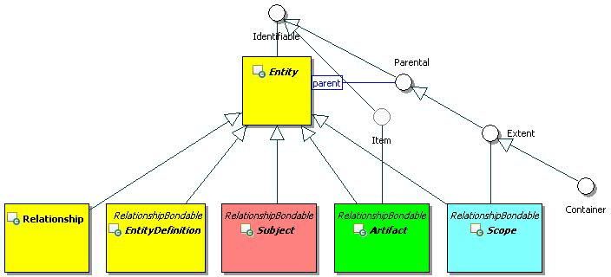
Figure 1: Entity and Top-Level Abstract Classes.
Figure 1 depicts Entity and top-level abstract classes forming the main branch of the ICOM class hierarchy. It depicts the Scope, Subject, and Artifact classes that represent the roots of the three major sub-branches of ICOM class hierarchy.

Identifiable

Description
An identifiable object has objectId and changeToken properties. The assignment of an objectId is implementation-dependent. The objectId is read only (immutable) once it is assigned.

Class Definition
The Identifiable class is a mixin class which defines the characteristics of entities and non-entities that enables unique identification.
The Identifiable class has attribute values:

localNamespace
Value: icom_core

localName
Value: Identifiable

extendsFrom
Value:

stereotype
Value: mixin

description
Value: Identifiable is a mixin class which defines the characteristics of all entities and some non-entities that enables unique identification.

propertyDefinitions
The values for this attribute are defined in Section 3.1.2.3.

Property Definitions
The Identifiable class MUST have the property definitions:

icom_core:objectId
Description: A persistent identifier of an object.
Required: False
Inherited: False
Property Type: String
Cardinality: Single
Updatability: Read Only

icom_core:changeToken
Description: An opaque token used for optimistic locking & concurrency checking.
Required: False
Inherited: False
Property Type: String
Cardinality: Single
Updatability: Read Only

The Identifiable class MAY include additional property definitions which are implementation-defined.

Parental

Description
A parental object may be a parent of other objects.

Class Definition
The Parental class is a mixin class which defines the characteristics of entities that may be parents of other entities or identifiable objects.
The Parental class has attribute values:

localNamespace
Value: icom_core

localName
Value: Parental

extendsFrom
Value: icom_core:Identifiable

stereotype
Value: mixin

description
Value: Parental is a mixin class which defines the characteristics of the entities that can be parents of other entities or identifiable objects.

propertyDefinitions
The values for this attribute are defined in Section 3.1.3.3.

Property Definitions
The Parental class inherits property definitions from super classes.
The Parental class MUST have the property definition:

icom_core:parent
Description: Parent of an object.
Required: False
Inherited: False
Property Type: icom_core:Parental
Cardinality: Single
Updatability: Read Only

The Parental class MAY include additional property definitions which are implementation-defined.

Extent

Description
An extent object is a parental object which may contain other entities.

Class Definition
The Extent class is a mixin class which defines characteristics of entities that may contain other entities.
The Extent class has attribute values:

localNamespace
Value: icom_core

localName
Value: Extent

extendsFrom
Value: icom_core:Parental

stereotype
Value: mixin

description
Value: Extent is a mixin class which defines the characteristics of entities that may contain other entities.

propertyDefinitions
The values for this attribute are defined in Section 3.1.4.3.

Property Definitions
The Extent class inherits property definitions from super classes.
The Extent class MUST have the property definition:

icom_core:parent
Description: Parent of an extent.
Required: False
Inherited: True
Property Type: icom_core:Extent
Cardinality: Single
Updatability: Read Only

The Extent class MAY include additional property definitions which are implementation-defined.

Entity

Description
An entity is an identifiable object that can be persisted and that has an access control list.
Each entity is assigned an internationalized resource identifier (IRI) composed from its objectId. The form of the IRI is implementation-dependent.

Class Definition
The Entity class has attribute values:

localNamespace
Value: icom_core

localName
Value: Entity

extendsFrom
Value: icom_core:Identifiable

stereotype
Value: primary

isAbstract
Value: TRUE

description
Value: An entity is an object with an immutable id and individual access control.

propertyDefinitions
The values for this attribute are defined in Section 3.1.5.3.

Property Definitions
The Entity class inherits property definitions from super classes.
The Entity class MUST have the property definitions:

icom_core:name
Description: Name of an entity.
Required: False
Inherited: False
Property Type: String
Cardinality: Single
Updatability: Read Write

icom_core:createdBy
Description: An actor who created an entity.
Required: False
Inherited: False
Property Type: icom_core:Actor
Cardinality: Single
Updatability: Read Only

icom_core:creationDate
Description: Date and time when an entity is created. It is immutable.
Required: False
Inherited: False
Property Type: DateTime
Cardinality: Single
Updatability: Read Only

icom_core:lastModifiedBy
Description: An actor who last modified an entity.
Required: False
Inherited: False
Property Type: icom_core:Actor
Cardinality: Single
Updatability: Read Only

icom_core:lastModificationDate
Description: Date and time of last modification.
Required: False
Inherited: False
Property Type: DateTime
Cardinality: Single
Updatability: Read Only

icom_core:parent
Description: A parental entity which contains an entity.
Required: False
Inherited: False
Property Type: icom_core:Parental
Cardinality: Single
Updatability: Read Only

icom_ac:owner
Description: A subject who owns an entity.
Required: True
Inherited: False
Property Type: icom_ac:Owner
Cardinality: Single
Updatability: Read Write

icom_ac:accessControlList
Description: Access control list on an entity.
Required: False
Inherited: False
Property Type: icom_ac:AccessControlList
Cardinality: Single
Updatability: Read Write

icom_meta:attachedMarker
Description: Zero or more markers applied on an entity.
Required: False
Inherited: False
Property Type: icom_meta:Marker
Cardinality: Multi
Updatability: Read Only

icom_meta:categoryApplication
Description: Zero or more category applications on an entity.
Required: False
Inherited: False
Property Type: icom_meta:CategoryApplication
Cardinality: Multi
Updatability: Read Only

icom_meta:tagApplication
Description: Zero or more tag applications on an entity.
Required: False
Inherited: False
Property Type: icom_meta:TagApplication
Cardinality: Multi
Updatability: Read Only

The Entity class MAY include additional property definitions which are implementation-defined.

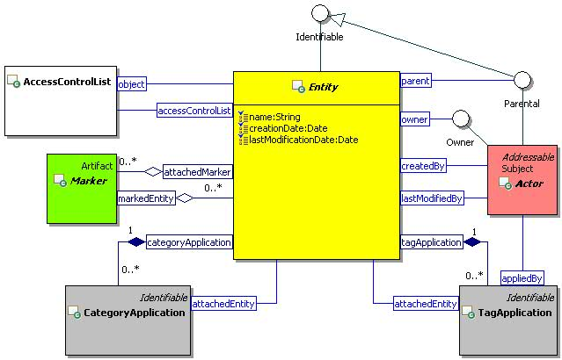
Figure 2: Entity Class Diagram.

EntityDefinition

Description
An entity definition is an entity that defines a type of entities.

Class Definition
The EntityDefinition class has attribute values:

localNamespace
Value: icom_core

localName
Value: EntityDefinition

extendsFrom
Value: icom_core:Entity, icom_meta:RelationshipBondable

stereotype
Value: primary

isAbstract
Value: TRUE

description
Value: An entity definition defines a type of entities.

propertyDefinitions
The values for this attribute are defined in Section 3.1.6.3.

Property Definitions
The EntityDefinition class inherits property definitions from super classes.
The EntityDefinition class MUST have the property definition:

icom_core:description
Description: A description of an entity definition.
Required: False
Inherited: False
Property Type: String
Cardinality: Single
Updatability: Read Write

The EntityDefinition class MAY include additional property definitions which are implementation-defined.

Overview of Scope, Subject, and Artifact Branches
The UML diagram in Figure 3 depicts the core classes in the Scope, Subject, and Artifact branches of ICOM class hierarchy. Scope branch includes the model of communities and spaces which are containers of subjects and artifacts. Subject branch includes the model of actors, groups, and roles. Artifact branch includes the model of content and metadata produced by actors.
Note: The Subject and Artifact branches support the separation of concerns of user administration and content management. Typically subjects and artifacts are joined in the (subject, privilege, artifact) triples of access control model. Some of the (subject, privilege, artifact) triples are derived from the scopes of the role assignments and the artifacts contained by the scopes. The communities and spaces contain subjects and artifacts; however, membership of subjects in a space is administered separately from management of artifacts in the space.
Scope, Subject, and Artifact are defined in Section 3.2, 3.3, and 3.4, respectively.

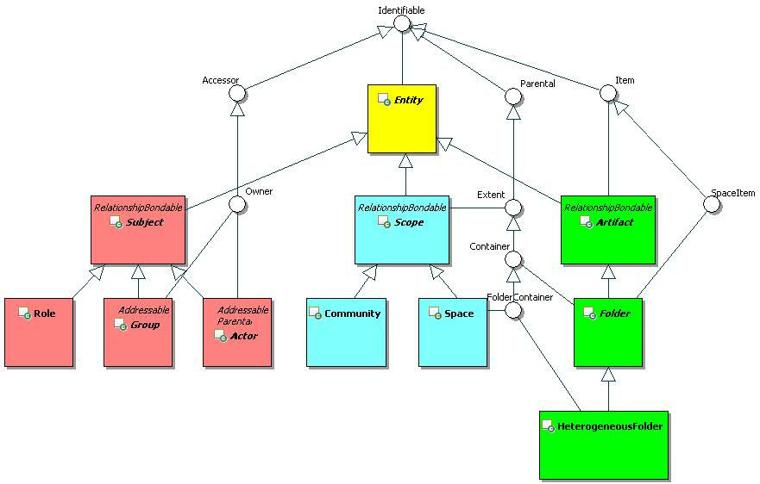
Figure 3: Scope, Subject, and Artifact Branches.

Scope Branch

Scope and Top-Level Subclasses
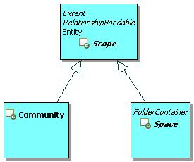
Figure 4: Scope Branch.
Figure 4 depicts the top-level classes of Scope Branch, which includes Scope, Community, and Space.

Scope

Description
A scope is an extent of an administrative policy.

Class Definition
The Scope class has attribute values:

localNamespace
Value: icom_core

localName
Value: Scope

extendsFrom
Value: icom_core:Entity, icom_core:Extent, icom_meta:RelationshipBondable

stereotype
Value: primary

isAbstract
Value: TRUE

description
Value: A scope is an extent of an administrative realm.

propertyDefinitions
The values for this attribute are defined in Section 3.2.2.3.

Property Definitions
The Scope class inherits property definitions from super classes.
The Scope class MUST have the property definitions:

icom_core:description
Description: A description of a scope.
Required: False
Inherited: False
Property Type: String
Cardinality: Single
Updatability: Read Write

icom_core:parent
Description: A community which contains a scope.
Required: False
Inherited: True
Property Type: icom_core:Community
Cardinality: Single
Updatability: Read Only

icom_core:group
Description: Zero or more groups defined in a scope.
Required: False
Inherited: False
Property Type: icom_core:Group
Cardinality: Multi
Updatability: Read Only

icom_core:memberGroup
Description: Member groups of a scope, i.e. groups whose assigned scopes include this scope.
Required: False
Inherited: False
Property Type: icom_core:Group
Cardinality: Multi
Updatability: Read Only

icom_ac:roleDefinition
Description: Zero or more role definitions defined in a scope.
Required: False
Inherited: False
Property Type: icom_ac:RoleDefinition
Cardinality: Multi
Updatability: Read Only

icom_ac:role
Description: Zero or more roles defined in a scope.
Required: False
Inherited: False
Property Type: icom_ac:Role
Cardinality: Multi
Updatability: Read Only

icom_meta:relationship
Description: Zero or more relationships associated with a scope.
Required: False
Inherited: False
Property Type: icom_meta:Relationship
Cardinality: Multi
Updatability: Read Only

The Scope class MAY include additional property definitions which are implementation-defined.

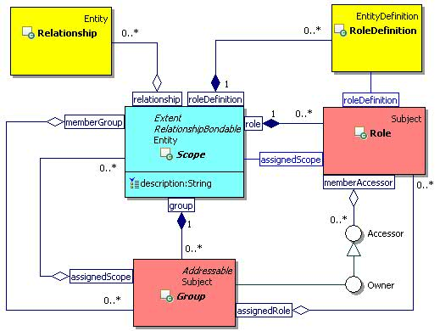
Figure 5: Scope Class Diagram.

Community

Description
A community is a scope that has a set of actors as members who can participate in a set of spaces.
It is implementation-dependent whether or not a space in a community can include participating actors who are not members of a parent community or ancestor communities.

Class Definition
The Community class has attribute values:

localNamespace
Value: icom_core

localName
Value: Community

extendsFrom
Value: icom_core:Scope

stereotype
Value: primary

description
Value: A community is a scope that has a set of actors as members who can participate in a set of spaces.

propertyDefinitions
The values for this attribute are defined in Section 3.2.3.3.

Property Definitions
The Community class inherits property definitions from super classes.
The Community class MUST have the property definitions:

icom_core:community
Description: Sub-communities of a community.
Required: False
Inherited: False
Property Type: icom_core:Community
Cardinality: Multi
Updatability: Read Only

icom_core:space
Description: Spaces of a community.
Required: False
Inherited: False
Property Type: icom_core:Space
Cardinality: Multi
Updatability: Read Only

icom_core:actor
Description: Managed actors of a community, i.e. actors whose parent community is this community.
Required: False
Inherited: False
Property Type: icom_core:Actor
Cardinality: Multi
Updatability: Read Only

icom_core:memberActor
Description: Member actors of a community, i.e. actors whose assigned communities include this community.
Required: False
Inherited: False
Property Type: icom_core:Actor
Cardinality: Multi
Updatability: Read Only

The Community class MAY include additional property definitions which are implementation-defined.

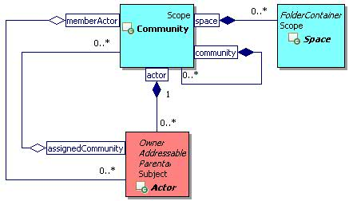
Figure 6: Community Class Diagram.

Space

Description
A space is a scope that defines a durable context and place for actors to work or collaborate.

Class Definition
The Space class has attribute values:

localNamespace
Value: icom_core

localName
Value: Space

extendsFrom
Value: icom_core:Scope, icom_core:FolderContainer

stereotype
Value: primary

description
Value: A space is a scope that defines a durable context and place for actors to work or collaborate.

propertyDefinitions
The values for this attribute are defined in Section 3.2.4.3.

Property Definitions
The Space class inherits property definitions from super classes.
The Space class MUST have the property definition:

icom_core:element
Description: Elements of a space.
Required: False
Inherited: True
Property Type: icom_core:SpaceItem
Cardinality: Multi
Updatability: Read Only

The Space class MAY include additional property definitions which are implementation-defined.

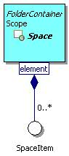
Figure 7: Space Class Diagram.

Subject Branch

Subject and Top-Level Subclasses
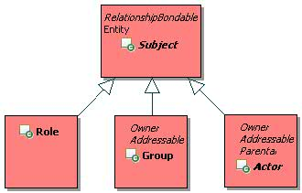
Figure 8: Subject Branch.
Figure 8 depicts the top-level classes of Subject Branch, which includes Subject, Role, Group, and Actor.

Subject

Description
A subject is an entity that can have rights to perform actions.

Class Definition
The Subject class has attribute values:

localNamespace
Value: icom_core

localName
Value: Subject

extendsFrom
Value: icom_core:Entity, icom_meta:RelationshipBondable

stereotype
Value: primary

isAbstract
Value: TRUE

description
Value: A subject is an entity that can have rights to perform actions.

propertyDefinitions
The values for this attribute are defined in Section 3.3.2.3.

Property Definitions
The Subject class inherits property definitions from super classes.
The Subject class MUST have the property definitions:

icom_core:description
Description: A description of a subject.
Required: False
Inherited: False
Property Type: String
Cardinality: Single
Updatability: Read Write

icom_core:parent
Description: A scope which contains a subject.
Required: False
Inherited: True
Property Type: icom_core:Scope
Cardinality: Single
Updatability: Read Only

icom_meta:relationship
Description: Zero or more relationships associated with a subject.
Required: False
Inherited: False
Property Type: icom_meta:Relationship
Cardinality: Multi
Updatability: Read Only

icom_meta:property
Description: Zero or more extended properties of a subject.
Required: False
Inherited: False
Property Type: icom_meta:Property
Cardinality: Multi
Updatability: Read Write

The Subject class MAY include additional property definitions which are implementation-defined.

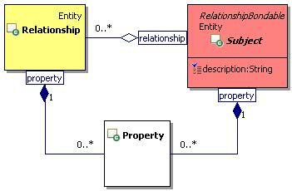
Figure 9: Subject Class Diagram.

Group

Description
A group is a subject representing a set of actors and sub-groups.
A group can be part of one or more super-groups.
It can be an owner of one or more entities.

Class Definition
The Group class has attribute values:

localNamespace
Value: icom_core

localName
Value: Group

extendsFrom
Value: icom_core:Subject, icom_core:Addressable, icom_ac:Accessor
Optional Value: icom_ac:Owner

stereotype
Value: primary

description
Value: A group is a subject representing a set of actors and sub-groups. A group can be part of one or more super-groups. It can be an owner of one or more entities.

propertyDefinitions
The values for this attribute are defined in Section 3.3.3.3.

Property Definitions
The Group class inherits property definitions from super classes.
The Group class MUST have the property definitions:

icom_core:assignedGroup
Description: A group’s super-groups.
Required: False
Inherited: False
Property Type: icom_core:Group
Cardinality: Multi
Updatability: Read Write

icom_core:assignedScope
Description: A group’s scopes.
Required: False
Inherited: False
Property Type: icom_core:Scope
Cardinality: Multi
Updatability: Read Write

icom_core:memberGroup
Description: Sub-groups of a group.
Required: False
Inherited: False
Property Type: icom_core:Group
Cardinality: Multi
Updatability: Read Only

icom_core:memberActor
Description: Actors in a group.
Required: False
Inherited: False
Property Type: icom_core:Actor
Cardinality: Multi
Updatability: Read Only

icom_ac:assignedRole
Description: A group’s roles.
Required: False
Inherited: False
Property Type: icom_ac:Role
Cardinality: Multi
Updatability: Read Write

The Group class MAY include additional property definitions which are implementation-defined.

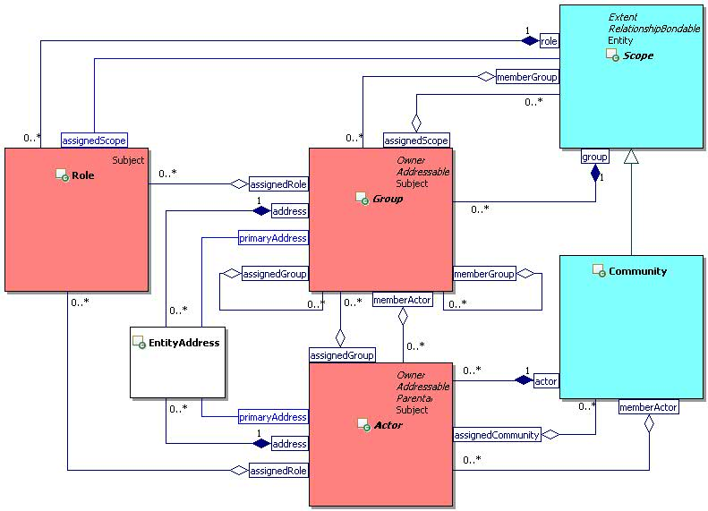
Figure 10: Group and Actor Class Diagram.

Actor

Description
An actor is a subject that can perform actions on objects.
It can be an owner of entities.

Class Definition
The Actor class has attribute values:

localNamespace
Value: icom_core

localName
Value: Actor

extendsFrom
Value: icom_core:Subject, icom_core:Addressable, icom_ac:Owner

stereotype
Value: primary

isAbstract
Value: TRUE

description
Value: An actor is a subject that can perform actions on objects.

propertyDefinitions
The values for this attribute are defined in Section 3.3.4.3.

Property Definitions
The Actor class inherits property definitions from super classes.
The Actor class MUST have the property definitions:

icom_core:parent
Description: A community which contains an actor.
Required: False
Inherited: True
Property Type: icom_core:Community
Cardinality: Single
Updatability: Read Only

icom_core:assignedGroup
Description: An actor’s groups.
Required: False
Inherited: False
Property Type: icom_core:Group
Cardinality: Multi
Updatability: Read Write

icom_core:assignedCommunity
Description: An actor’s communities.
Required: False
Inherited: False
Property Type: icom_core:Community
Cardinality: Multi
Updatability: Read Write

icom_ac:assignedRole
Description: An actor’s roles.
Required: False
Inherited: False
Property Type: icom_ac:Role
Cardinality: Multi
Updatability: Read Write

The Actor class MAY include additional property definitions which are implementation-defined.

Person

Description
A person is an individual human who may be an actor.
A person has a personal space.

Class Definition
The Person class has attribute values:

localNamespace
Value: icom_core

localName
Value: Person

extendsFrom
Value: icom_core:Actor

stereotype
Value: primary

description
Value: A person is an individual human who may be an actor.

propertyDefinitions
The values for this attribute are defined in Section 3.3.5.3.

Property Definitions
The Person class inherits property definitions from super classes.
The Person class MUST have the property definitions:

icom_core:givenName
Description: Given name of a person.
Required: False
Inherited: False
Property Type: String
Cardinality: Single
Updatability: Read Write

icom_core:middleName
Description: Middle name of a person. Can include multiple names concatenated.
Required: False
Inherited: False
Property Type: String
Cardinality: Single
Updatability: Read Write

icom_core:familyName
Description: Family name of a person.
Required: False
Inherited: False
Property Type: String
Cardinality: Single
Updatability: Read Write

icom_core:prefix
Description: Prefix of a person’s name.
Required: False
Inherited: False
Property Type: String
Cardinality: Single
Updatability: Read Write

icom_core:suffix
Description: Suffix of a person’s name.
Required: False
Inherited: False
Property Type: String
Cardinality: Single
Updatability: Read Write

icom_core:nickname
Description: Nickname of a person.
Required: False
Inherited: False
Property Type: String
Cardinality: Multi
Updatability: Read Write

icom_core:jobTitle
Description: Job title of a person.
Required: False
Inherited: False
Property Type: String
Cardinality: Single
Updatability: Read Write

icom_core:department
Description: A person’s affiliated department.
Required: False
Inherited: False
Property Type: String
Cardinality: Single
Updatability: Read Write

icom_core:officeLocation
Description: Location of a person’s department.
Required: False
Inherited: False
Property Type: String
Cardinality: Single
Updatability: Read Write

icom_core:company
Description: A person’s affiliated company.
Required: False
Inherited: False
Property Type: String
Cardinality: Single
Updatability: Read Write

icom_core:profession
Description: A person’s profession.
Required: False
Inherited: False
Property Type: String
Cardinality: Single
Updatability: Read Write

icom_core:personalSpace
Description: Personal space of a person.
Required: False
Inherited: False
Property Type: icom_core:Space
Cardinality: Single
Updatability: Read Only

icom_presence:presence
Description: Presence of a person.
Required: False
Inherited: False
Property Type: icom_presence:Presence
Cardinality: Single
Updatability: Read Only

icom_msg:instantMessageFeed
Description: Instant message feed for a person.
Required: False
Inherited: False
Property Type: icom_msg:InstantMessageFeed
Cardinality: Single
Updatability: Read Only

The Person class MAY include additional property definitions which are implementation-defined.

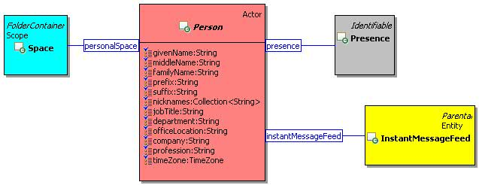
Figure 11: Person Class Diagram.

Resource

Description
A resource is an actor representing a bookable resource, such as a conference room, equipment, or on-line conference.
A resource is associated with a resource space that contains a resource scheduling calendar and on-line conference.

Class Definition
The Resource class has attribute values:

localNamespace
Value: icom_core

localName
Value: Resource

extendsFrom
Value: icom_core:Actor

stereotype
Value: primary

description
Value: A resource actor is an actor representing a bookable resource, such as a conference room, equipment, or on-line conference.

propertyDefinitions
The values for this attribute are defined in Section 3.3.6.3.

Property Definitions
The Resource class inherits property definitions from super classes.
The Resource class MUST have the property definitions:

icom_core:resourceSpace
Description: Administrative space of a resource actor.
Required: False
Inherited: False
Property Type: icom_core:Space
Cardinality: Single
Updatability: Read Only

icom_core:location
Description: Location of a resource.
Required: False
Inherited: False
Property Type: icom_core:Location
Cardinality: Single
Updatability: Read Write

icom_core:capacity
Description: Capacity of a resource.
Required: False
Inherited: False
Property Type: Integer
Cardinality: Single
Updatability: Read Write

icom_core:resourceType
Description: Type of a resource.
Required: False
Inherited: False
Property Type: icom_core:ResourceType
Cardinality: Single
Updatability: Read Write

icom_core:bookingRule
Description: Resource booking rule.
Required: False
Inherited: False
Property Type: icom_core:ResourceBookingRule
Cardinality: Single
Updatability: Read Write

icom_core:bookingApprover
Description: One or more persons who approve the booking of a resource.
Required: False
Inherited: False
Property Type: icom_core:Person
Cardinality: Multi
Updatability: Read Write

The Resource class MAY include additional property definitions which are implementation-defined.

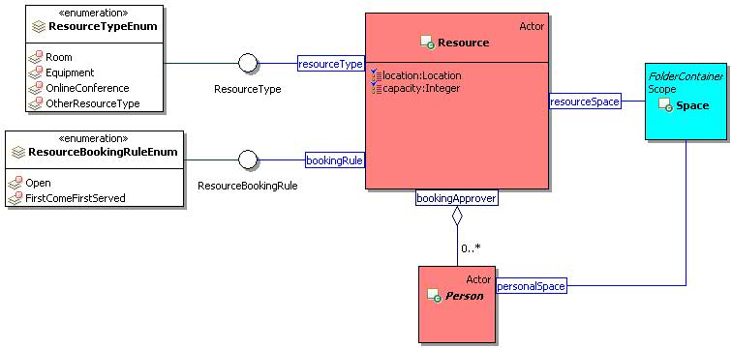
Figure 12: Resource Class Diagram.

ResourceType

Description
A resource type is a category of resources.

Class Definition
The ResourceType class is a mixin class which defines a resource type.
The ResourceType class has attribute values:

localNamespace
Value: icom_core

localName
Value: ResourceType

extendsFrom
Value:

stereotype
Value: mixin

description
Value: ResourceType is a mixin class which defines a type of resources.

propertyDefinitions
The values for this attribute are defined in Section 3.3.7.3.

Property Definitions
The ResourceType class MAY include additional property definitions which are implementation-defined.

ResourceTypeEnum
The ResourceTypeEnum class is an enum class that enumerates the instances each of which expresses a type of resources.
The ResourceTypeEnum class has attribute values:

localNamespace
Value: icom_core

localName
Value: ResourceTypeEnum

extendsFrom
Value: ResourceType

stereotype
Value: primary

isEnumeration
Value: TRUE

description
Value: A type of resources.

instances
Value: <icom_core:Room, icom_core:Equipment, icom_core:OnlineConference, icom_core:OtherResourceType>

ICOM defines four resource types:
- icom_core:Room a resource represents a room.
- icom_core:Equipment a resource represents an equipment.
- icom_core:OnlineConference a resource represents an online conference.
- icom_core:OtherResourceType a resource represents other things.

ResourceBookingRule

Description
A resource booking rule is a strategy for allocating resources for calendar scheduling.

Class Definition
The ResourceBookingRule class is a mixin class which defines a resource booking rule.
The ResourceBookingRule class has attribute values:

localNamespace
Value: icom_core

localName
Value: ResourceBookingRule

extendsFrom
Value:

stereotype
Value: mixin

description
Value: ResourceBookingRule is a mixin class which defines a rule for allocating resources for calendar scheduling.

propertyDefinitions
The values for this attribute are defined in Section 3.3.9.3.

Property Definitions
The ResourceBookingRule class MAY include additional property definitions which are implementation-defined.

ResourceBookingRuleEnum
The ResourceBookingRuleEnum class is an enum class that enumerates the instances each of which expresses a booking rule.
The ResourceBookingRuleEnum class has attribute values:

localNamespace
Value: icom_core

localName
Value: ResourceBookingRuleEnum

extendsFrom
Value: ResourceBookingRule

stereotype
Value: primary

isEnumeration
Value: TRUE

description
Value: A resource booking rule for allocating resources for calendar scheduling.

instances
Value: <icom_core:Open, icom_core:FirstComeFirstServed>

ICOM defines two resource booking rules:
- icom_core:Open a resource is open for booking.
- icom_core:FirstComeFirstServed a resource is first come first served.

Artifact Branch

Artifact and Top-Level Subclasses
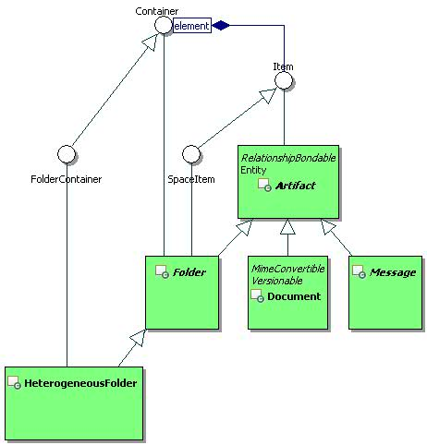
Figure 13: Artifact Branch.
Figure 13 depicts the top-level classes of Artifact Branch, which includes Artifact, Folder, HeterogeneousFolder, Document, and Message.

Item

Description
An item is an element of a container.
The parent of an item MUST be a container.

Class Definition
The Item class is a mixin class which defines the characteristics of entities that can be elements of a Container.
The Item class has attribute values:

localNamespace
Value: icom_core

localName
Value: Item

extendsFrom
Value: icom_core:Identifiable

stereotype
Value: mixin

description
Value: Item is a mixin class which defines the characteristics of entities that can be placed in a Container.

propertyDefinitions
The values for this attribute are defined in Section 3.4.2.3.

Property Definitions
The Item class inherits property definitions from super classes.
The Item class MUST have the property definition:

icom_core:parent
Description: A parent container of an item.
Required: False
Inherited: True
Property Type: icom_core:Container
Cardinality: Single
Updatability: Read Only

The Item class MAY have the optional property definition:

icom_core:container
Description: Zero, one, or more containers of an item, including the parent container.
Required: False
Inherited: False
Property Type: icom_core:Container
Cardinality: Multi
Updatability: Read Write

The Item class MAY include additional property definitions which are implementation-defined.

SpaceItem

Description
A space item is an item that can be an element of a space.

Class Definition
The SpaceItem class is a mixin class which defines the characteristics of items that can be elements of a Space.
The SpaceItem class has attribute values:

localNamespace
Value: icom_core

localName
Value: SpaceItem

extendsFrom
Value: icom_core:Item

stereotype
Value: mixin

description
Value: SpaceItem is a mixin class which defines the characteristics of entities that can be elements of a Space.

propertyDefinitions
The values for this attribute are defined in Section 3.4.3.3.

Property Definitions
The SpaceItem class inherits property definitions from super classes.
The SpaceItem class MAY include additional property definitions which are implementation-defined.

Container

Description
A container is an extent that contains items.

Class Definition
The Container class is a mixin class which defines the characteristics of extents that contain items.
The Container class has attribute values:

localNamespace
Value: icom_core

localName
Value: Container

extendsFrom
Value: icom_core:Extent

stereotype
Value: mixin

description
Value: A container is an extent that contains items.

propertyDefinitions
The values for this attribute are defined in Section 3.4.4.3.

Property Definitions
The Container class inherits property definitions from super classes.
The Container class MUST have the property definition:

icom_core:element
Description: Elements of a container, i.e. items whose parent container is the container or whose containers include the container.
Required: False
Inherited: False
Property Type: icom_core:Item
Cardinality: Multi
Updatability: Read Only

The Container class MAY include additional property definitions which are implementation-defined.

FolderContainer

Description
A folder container is a container which may contain folders. Space and heterogeneous folder are folder containers.

Class Definition
The FolderContainer class is a mixin class that defines the characteristics of containers that may contain folders.
The FolderContainer class has attribute values:

localNamespace
Value: icom_core

localName
Value: FolderContainer

extendsFrom
Value: icom_core:Container

stereotype
Value: mixin

description
Value: A folder container is a container which may contain folders.

propertyDefinitions
The values for this attribute are defined in Section 3.4.5.3.

Property Definitions
The FolderContainer class inherits property definitions from super classes.
The FolderContainer class MAY include additional property definitions which are implementation-defined.

Artifact

Description
An artifact is a result of a communication, cooperation, content creation, or collaboration activity.
Note: Document versioning is an example of content creation activity resulting in an artifact (a version of a document).

Class Definition
The Artifact class has attribute values:

localNamespace
Value: icom_core

localName
Value: Artifact

extendsFrom
Value: icom_core:Entity, icom_core:Item, icom_meta:RelationshipBondable
Optional Value: icom_core:SpaceItem

stereotype
Value: primary

isAbstract
Value: TRUE

description
Value: An artifact is a result of a communication, cooperation, content creation, or collaboration activity.

propertyDefinitions
The values for this attribute are defined in Section 3.4.6.3.

Property Definitions
The Artifact class inherits property definitions from super classes.
The Artifact class MUST have the property definitions:

icom_core:description
Description: A description of an artifact.
Required: False
Inherited: False
Property Type: String
Cardinality: Single
Updatability: Read Write

icom_core:userCreationDate
Description: Date and time when an artifact was created.
Required: False
Inherited: False
Property Type: DateTime
Cardinality: Single
Updatability: Read Write

icom_core:userLastModificationDate
Description: Date and time when an artifact was last modified.
Required: False
Inherited: False
Property Type: DateTime
Cardinality: Single
Updatability: Read Write

icom_meta:property
Description: Zero or more extended properties of an artifact.
Required: False
Inherited: False
Property Type: icom_meta:Property
Cardinality: Multi
Updatability: Read Write

icom_meta:viewerProperty
Description: Zero or more extended properties of an artifact visible to a viewer.
Required: False
Inherited: False
Property Type: icom_meta:Property
Cardinality: Multi
Updatability: Read Write

icom_meta:relationship
Description: Zero or more relationships associated with an artifact.
Required: False
Inherited: False
Property Type: icom_meta:Relationship
Cardinality: Multi
Updatability: Read Only

The Artifact class MAY include additional property definitions which are implementation-defined.

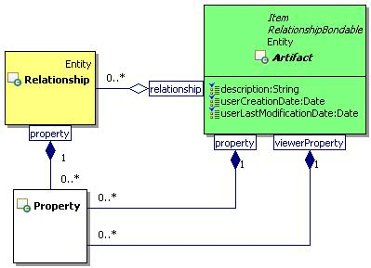
Figure 14: Artifact Class Diagram.

Folder

Description
A folder is an artifact that may contain other artifacts.
Note: Every folder except root folders has at least one parent folder. The parent of a root folder is a space. Subclasses of Folder class should enforce their own semantics on elements.

Class Definition
The Folder class has attribute values:

localNamespace
Value: icom_core

localName
Value: Folder

extendsFrom
Value: icom_core:Artifact, icom_core:Container, icom_core:SpaceItem

stereotype
Value: primary

isAbstract
Value: TRUE

description
Value: A folder is an artifact that may contain other artifacts.

propertyDefinitions
The values for this attribute are defined in Section 3.4.7.3.

Property Definitions
The Folder class inherits property definitions from super classes.
The Folder class MUST have the property definition:

icom_core:parent
Description: A parent container of a folder.
Required: False
Inherited: True
Property Type: icom_core:FolderContainer
Cardinality: Single
Updatability: Read Only

The Folder class MAY include additional property definitions which are implementation-defined.

HeterogeneousFolder

Description
A heterogeneous folder is an unconstrained folder to contain any type of artifacts.
Note: It is typically used for document folders, inbox, outbox, and trash folder of a space.

Class Definition
The HeterogeneousFolder class has attribute values:

localNamespace
Value: icom_core

localName
Value: HeterogeneousFolder

extendsFrom
Value: icom_core:Folder, icom_core:FolderContainer

stereotype
Value: primary

description
Value: A heterogeneous folder is an unconstrained folder to contain any type of artifacts.

propertyDefinitions
The values for this attribute are defined in Section 3.4.8.3.

Property Definitions
The HeterogeneousFolder class inherits property definitions from super classes.
The HeterogeneousFolder class MUST have the property definition:

icom_core:element
Description: Elements of a heterogeneous folder.
Required: False
Inherited: True
Property Type: icom_core:Artifact
Cardinality: Multi
Updatability: Read Only

The HeterogeneousFolder class MAY include additional property definitions which are implementation-defined.

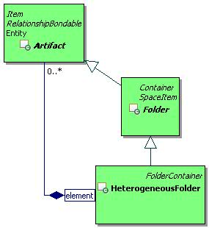
Figure 15: Heterogeneous Folder Class Diagram.

Access Control Model

Accessor

Description
An accessor can be granted or denied access rights to objects.

Class Definition
The Accessor class is a mixin class which defines the characteristics of subjects such as groups and actors that can be granted or denied access types in access control lists and privileges in role assignments.
The Accessor class has attribute values:

localNamespace
Value: icom_ac

localName
Value: Accessor

extendsFrom
Value: icom_core:Identifiable

stereotype
Value: mixin

description
Value: Accessor is a mixin class which defines the characteristics of subjects such as groups and actors that can be granted or denied access types in access control lists and granted privileges in role assignments.

propertyDefinitions
The values for this attribute are defined in Section 3.5.1.3.

Property Definitions
The Accessor class inherits property definitions from super classes.
The Accessor class MAY include additional property definitions which are implementation-defined.

Owner

Description
An owner is a subject that can be the owner of entities.
An owner of an entity MAY always have rights to update the access control list for the entity.

Class Definition
The Owner class is a mixin class which defines the characteristics of subjects such as groups and actors that can own entities.
The Owner class has attribute values:

localNamespace
Value: icom_ac

localName
Value: Owner

extendsFrom
Value: icom_ac:Accessor

stereotype
Value: mixin

description
Value: Owner is a mixin class which defines the characteristics of subjects such as groups and actors that can own entities.

propertyDefinitions
The values for this attribute are defined in Section 3.5.2.3.

Property Definitions
The Owner class inherits property definitions from super classes.
The Owner class MAY include additional property definitions which are implementation-defined.

RoleDefinition

Description
A role definition is a named set of privileges.

Class Definition
The RoleDefinition class has attribute values:

localNamespace
Value: icom_ac

localName
Value: RoleDefinition

extendsFrom
Value: icom_core:EntityDefinition

stereotype
Value: primary

description
Value: A role definition is a named set of privileges.

propertyDefinitions
The values for this attribute are defined in Section 3.5.3.3.

Property Definitions
The RoleDefinition class inherits property definitions from super classes.
The RoleDefinition class MUST have the property definition:

icom_ac:privilege
Description: A set of privileges.
Required: True
Inherited: False
Property Type: icom_ac:Privilege
Cardinality: Multi
Updatability: Read Write

The RoleDefinition class MAY include additional property definitions which are implementation-defined.

Role

Description
A role assigns a named set of privileges to a set of accessors for operations within an assigned scope.

Class Definition
The Role class has attribute values:

localNamespace
Value: icom_ac

localName
Value: Role

extendsFrom
Value: icom_core:Subject

stereotype
Value: primary

description
Value: A role assigns a named set of rights to a set of accessors for operations within an assigned scope.

propertyDefinitions
The values for this attribute are defined in Section 3.5.4.3.

Property Definitions
The Role class inherits property definitions from super classes.
The Role class MUST have the property definitions:

icom_ac:roleDefinition
Description: A role definition containing a set of privileges.
Required: True
Inherited: False
Property Type: icom_ac:RoleDefinition
Cardinality: Single
Updatability: On Create

icom_ac:assignedScope
Description: A scope in which a role is assigned.
Required: True
Inherited: False
Property Type: icom_core:Scope
Cardinality: Single
Updatability: Read Write

icom_ac:memberAccessor
Description: Accessors (actors and groups) assigned to a role.
Required: False
Inherited: False
Property Type: icom_ac:Accessor
Cardinality: Multi
Updatability: Read Write

The Role class MAY include additional property definitions which are implementation-defined.

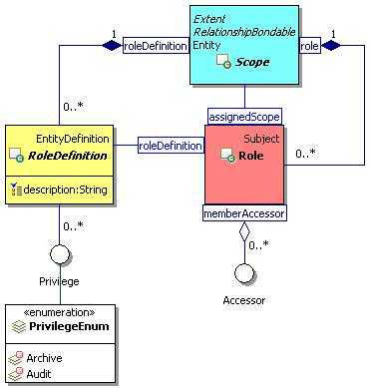
Figure 16: Role Definition and Role Class Diagram.

Privilege

Description
A privilege is an access right granted through roles.

Class Definition
The Privilege class is a mixin class which defines access rights that can be included in role definitions.
The Privilege class has attribute values:

localNamespace
Value: icom_ac

localName
Value: Privilege

extendsFrom
Value:

stereotype
Value: mixin

description
Value: Privilege is a mixin class which defines access rights that can be included in role definitions.

propertyDefinitions
The values for this attribute are defined in Section 3.5.5.3.

Property Definitions
The Privilege class MAY include additional property definitions which are implementation-defined.

PrivilegeEnum
The PrivilegeEnum class is an enum class that enumerates the instances each of which expresses a privilege that can be assigned to a role.
The PrivilegeEnum class has attribute values:

localNamespace
Value: icom_ac

localName
Value: PrivilegeEnum

extendsFrom
Value: icom_ac:Privilege

stereotype
Value: primary

isEnumeration
Value: TRUE

description
Value: Privilege that can be assigned to a role.

instances
Value: <icom_ac:Archive, icom_ac:Audit>

ICOM defines two privileges:
- icom_ac:Archive a right to archive contents in a scope.
- icom_ac:Audit a right to audit activities in a scope.

AccessControlList

Description
An access control list (ACL) is an object attached to an entity to specify a list of permissions to access the entity.

Class Definition
The AccessControlList class has attribute values:

localNamespace
Value: icom_ac

localName
Value: AccessControlList

extendsFrom
Value:

stereotype
Value: primary

description
Value: An access control list (ACL) is an object attached to an entity to specify a list of permissions to access the entity.

propertyDefinitions
The values for this attribute are defined in Section 3.5.7.3.

Property Definitions
The AccessControlList class MUST have the property definitions:

icom_ac:object
Description: Associated object.
Required: True
Inherited: False
Property Type: icom_core:Entity
Cardinality: Single
Updatability: On Create

icom_ac:accessControlEntry
Description: One or more access control entries.
Required: True
Inherited: False
Property Type: icom_ac:AccessControlEntry
Cardinality: Multi
Updatability: Read Write

AccessControlList class MAY include additional property definitions which are implementation-defined.

AccessControlEntry

Description
An access control entry specifies access types granted to or denied for an accessor.

Class Definition
The AccessControlEntry class has attribute values:

localNamespace
Value: icom_ac

localName
Value: AccessControlEntry

extendsFrom
Value:

stereotype
Value: primary

description
Value: An access control entry is associated with an accessor and contains a list of access types (permissions) granted to or denied from the accessor.

propertyDefinitions
The values for this attribute are defined in Section 3.5.8.3.

Property Definitions
The AccessControlEntry class MUST have the property definitions:

icom_ac:subject
Description: Associated subject.
Required: True
Inherited: False
Property Type: icom_ac:Accessor
Cardinality: Single
Updatability: On Create

icom_ac:grant
Description: One or more access types granted to a subject.
Required: False
Inherited: False
Property Type: icom_ac:AccessType
Cardinality: Multi
Updatability: Read Write

icom_ac:deny
Description: One or more access type denied for a subject.
Required: False
Inherited: False
Property Type: icom_ac:AccessType
Cardinality: Multi
Updatability: Read Write

The AccessControlEntry class MAY include additional property definitions which are implementation-defined.

AccessType
An AccessType is an access right granted through an access control entry.

Class Definition
The AccessType class is a mixin class which defines access rights that can be granted or denied in an access control entry.
The AccessType class has attribute values:

localNamespace
Value: icom_ac

localName
Value: AccessType

extendsFrom
Value:

stereotype
Value: mixin

description
Value: AccessType is a mixin class which defines access rights that can be granted or denied in an access control entry.

propertyDefinitions
The values for this attribute are defined in Section 3.5.9.2.

Property Definitions
The AccessType class inherits property definitions from super classes.
The AccessType class MAY include additional property definitions which are implementation-defined.

AccessTypeEnum
The AccessTypeEnum class is an enum class that enumerates the instances each of which expresses an access type that can be granted or denied in an access control entry.
The AccessTypeEnum class has attribute values:

localNamespace
Value: icom_ac

localName
Value: AccessTypeEnum

extendsFrom
Value: icom_ac:AccessType

stereotype
Value: primary

isEnumeration
Value: TRUE

description
Value: Access type that can be granted or denied in an access control entry.

instances
Value: <icom_ac:Read, icom_ac:Write, icom_ac:Delete>

ICOM defines three access types:
- icom_ac:Read a right to retrieve an entity.
- icom_ac:Write a right to update an entity.
- icom_ac:Delete a right to delete an entity.

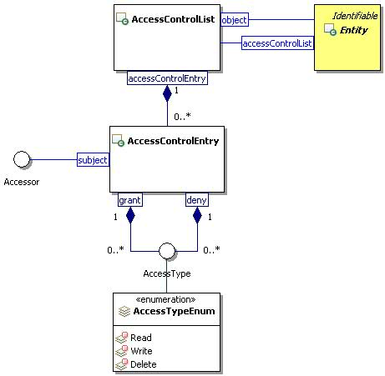
Figure 17: Access Control List Class Diagram.

Metadata Model

PropertyDefinition

Description
A property definition specifies the name, type, choice, and cardinality of values for properties.

Class Definition
The PropertyDefinition class has attribute values:

localNamespace
Value: icom_meta

localName
Value: PropertyDefinition

extendsFrom
Value: icom_core:Identifiable

stereotype
Value: primary

description
Value: A property definition specifies the name, type, choice, and cardinality of values for properties.

propertyDefinitions
The values for this attribute are defined in Section 3.6.1.3.

Property Definitions
The PropertyDefinition class inherits property definitions from super classes.
The PropertyDefinition class MUST have the property definitions:

icom_core:namespace
Description: Namespace for a property name.
Required: False
Inherited: False
Property Type: String
Cardinality: Single
Updatability: Read Write

icom_core:name
Description: Name for a property.
Required: True
Inherited: False
Property Type: String
Cardinality: Single
Updatability: Read Write

icom_core:description
Description: A description of a property definition.
Required: False
Inherited: False
Property Type: String
Cardinality: Single
Updatability: Read Write

icom_meta:propertyType
Description: Type of a property.
Required: True
Inherited: False
Property Type: icom_meta:PropertyType
Cardinality: Single
Updatability: On Create
Choices: {PropertyChoiceType}
Open Choice: False

Note: The notation {PropertyChoiceType} represents a set of PropertyChoiceType.

icom_meta:defaultValue
Description: A default value for a property.
Required: False
Inherited: False
Property Type: property-type
Cardinality: Single
Updatability: Read Write

icom_meta:choice
Description: An allowed value for a property.
Required: False
Inherited: False
Property Type: icom_meta:PropertyChoiceType
Cardinality: Multi
Updatability: Read Write

icom_meta:cardinality
Description: Cardinality of a property specifying whether the property can have “zero or one” or “zero or more” values.
Required: True
Inherited: False
Property Type: icom_meta:Cardinaility
Cardinality: Single
Updatability: On Create

icom_meta:minValue
Description: Minimum value for an integer or decimal property.
Required: False
Inherited: False
Property Type: Integer | Decimal
Cardinality: Single
Updatability: Read Write

icom_meta:maxValue
Description: Maximum value for an integer or decimal property.
Required: False
Inherited: False
Property Type: Integer | Decimal
Cardinality: Single
Updatability: Read Write

The PropertyDefinition class MAY include additional property definitions which are implementation-defined.

Property

Description
The property holds a property value.

Class Definition
The Property class has attribute values:

localNamespace
Value: icom_meta

localName
Value: Property

extendsFrom
Value:

stereotype
Value: primary

description
Value: A property value.

propertyDefinitions
The values for this attribute are defined in Section 3.6.2.3.

Property Definitions
The Property class MUST have the property definitions:

icom_meta:propertyDefinition
Description: A property definition that specifies the name, type, and cardinality of a property.
Required: True
Inherited: False
Property Type: icom_meta:PropertyDefinition
Cardinality: Single
Updatability: On Create

icom_meta:value
Description: A value of a property.
Required: True
Inherited: False
Property Type: property-type
Cardinality: Single
Updatability: Read Write

The Property class MAY include additional property definitions which are implementation-defined.

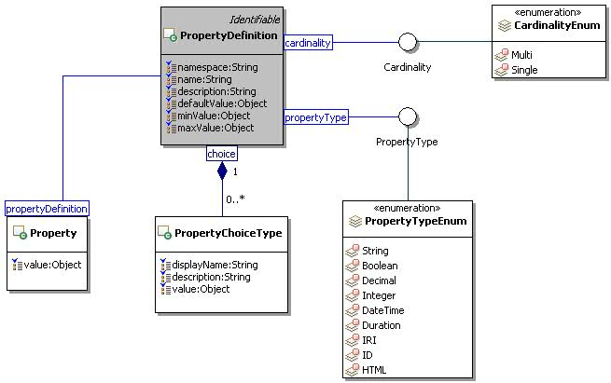
Figure 18: Property Definition and Property Class Diagram.

PropertyChoiceType

Description
The property choice type represents a value choice for a property. Each choice includes a display name to be used for presentation purpose and a value to be stored in a property when a choice is selected.

Class Definition
The PropertyChoiceType class has attribute values:
localNamespace
Value: icom_meta

localName
Value: PropertyChoiceType

extendsFrom
Value:

stereotype
Value: primary

description
Value: A choice for a property value.

propertyDefinitions
The values for this attribute are defined Section 3.6.3.3.

Property Definitions
The PropertyChoiceType class MUST have the property definitions:

icom_core:description
Description: A description of a property choice.
Required: False
Inherited: False
Property Type: String
Cardinality: Single
Updatability: Read Write

icom_meta:displayName
Description: Display name of a property choice.
Required: True
Inherited: False
Property Type: String
Cardinality: Single
Updatability: Read Write

icom_meta:value
Description: A value of a property choice.
Required: True
Inherited: False
Property Type: property-type
Cardinality: Single
Updatability: Read Write

The PropertyChoiceType class MAY include additional property definitions which are implementation-defined.

PropertyType
A PropertyType expresses a name of a property-type.

Class Definition
The PropertyType class is a mixin class which expresses a name of a property-type.
The PropertyType class has attribute values:

localNamespace
Value: icom_meta

localName
Value: PropertyType

extendsFrom
Value:

stereotype
Value: mixin

description
Value: PropertyType is a mixin class which expresses a name of a property-type.

propertyDefinitions
The values for this attribute are defined in Section 3.6.4.2.

Property Definitions
The PropertyType class MAY include additional property definitions which are implementation-defined.

PropertyTypeEnum
The PropertyTypeEnum class is an enum class that enumerates the instances each of which expresses the name of a property-type.
The PropertyTypeEnum class has attribute values:

localNamespace
Value: icom_meta

localName
Value: PropertyTypeEnum

extendsFrom
Value: PropertyType

stereotype
Value: primary

isEnumeration
Value: TRUE

description
Value: Name of a basic data type.

instances
Value: <icom_meta:String, icom_meta:Boolean, icom_meta:Decimal, icom_meta:Integer, icom_meta:Datetime, icom_meta:Duration, icom_meta:IRI, icom_meta:ID, icom_meta:HTML>

ICOM defines nine data types:
- icom_meta:String is equivalent to XML schema type xsd:string.
- icom_meta:Boolean is equivalent to XML schema type xsd:boolean.
- icom_meta:Decimal is equivalent to XML schema type xsd:decimal.
- icom_meta:Integer is equivalent to XML schema type xsd:integer.
- icom_meta:Datetime is equivalent to XML schema type xsd:dateTime.
- icom_meta:Duration is equivalent to XML schema type xsd:duration.
- icom_meta:IRI is equivalent to XML schema type xsd:anyURI.
- icom_meta:ID opaque object identifiers.
- icom_meta:HTML documents or fragments of Hypertext Markup Language (HTML) content

Note: ICOM uses basic data types defined by “XML Schema Part 2: Datatypes Second Edition” (W3C Recommendation, 28 October 2004, http://www.w3.org/TR/xmlschema-2/).

Cardinality

Description
Cardinality specifies whether a property is single or multi valued.

Class Definition
The Cardinality class is a mixin class which defines whether a property is single or multi valued.
The Cardinality class has attribute values:

localNamespace
Value: icom_meta

localName
Value: Cardinality

extendsFrom
Value:

stereotype
Value: mixin

description
Value: Cardinality is a mixin class which defines whether a property is single or multi valued.

propertyDefinitions
The values for this attribute are defined in Section 3.6.6.3.

Property Definitions
The Cardinality class MAY include additional property definitions which are implementation-defined.

CardinalityEnum
The CardinalityEnum class is an enum class that enumerates instances each of which expresses the cardinality of a property.
The CardinalityEnum has attribute values:

localNamespace
Value: icom_meta

localName
Value: CardinalityEnum

extendsFrom
Value: Cardinality

stereotype
Value: primary

isEnumeration
Value: TRUE

description
Value: Cardinality of a property.

instances
Value: <icom_meta:Single, icom_meta:Multi>

ICOM defines two cardinality types:
- icom_meta:Single a property can have zero or one value (if property is not required), or exactly one value (if property is required).
- icom_meta:Multi a property can have zero or more values (if property is not required), or one or more values (if property is required).

Marker and Subclasses
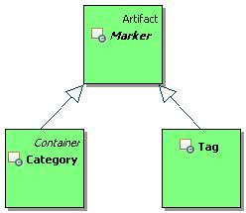
Figure 19: Marker Branch.
Figure 19 depicts the main classes of Marker Branch, which includes Marker, Category, and Tag.

Marker

Description
A marker is an artifact that groups together entities by a criterion. Markers can be flat or hierarchical. Flat markers are modeled by tag and hierarchical markers are modeled by category.
Note: In some cases when a user applies a marker to an entity, the marker application should be private such that only the user who applies the marker can browse or locate the entity through the marker. This is especially the case when markers are created by a user and visible only to the user who created them.

Class Definition
The Marker class has attribute values:

localNamespace
Value: icom-meta

localName
Value: Marker

extendsFrom
Value: icom_core:Artifact

stereotype
Value: primary

isAbstract
Value: TRUE

description
Value: A marker is an artifact that groups together entities by a criterion.

propertyDefinitions
The values for this attribute are defined in Section 3.6.9.3.

Property Definitions
The Marker class inherits property definitions from super classes.
The Marker class MUST have the property definition:

icom_meta:markedEntity
Description: A marked entity.
Required: False
Inherited: False
Property Type: icom_core:Entity
Cardinality: Multi
Updatability: Read Only

The Marker class MAY include additional property definitions which are implementation-defined.

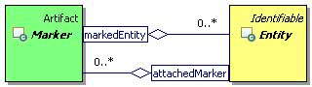
Figure 20: Marker Class Diagram.

Category

Description
A category is a marker that classifies entities.

Class Definition
The Category class has attribute values:

localNamespace
Value: icom_meta

localName
Value: Category

extendsFrom
Value: icom_meta:Marker, icom_core:Container

stereotype
Value: primary

description
Value: A category is a marker that classifies entities.

propertyDefinitions
The values for this attribute are defined in Section 3.6.10.3.

Property Definitions
The Category class inherits property definitions from super classes.
The Category class MUST have the property definitions:

icom_meta:superCategory
Description: A super category.
Required: False
Inherited: False
Property Type: icom_meta:Category
Cardinality: Single
Updatability: Read Only

icom_meta:subcategory
Description: Zero or more sub categories.
Required: False
Inherited: False
Property Type: icom_meta:Category
Cardinality: Multi
Updatability: Read Only

icom_meta:abstract
Description: Indicates whether a category is abstract or concrete.
Required: False
Inherited: False
Property Type: Boolean
Cardinality: Single
Updatability: Read Write

icom_meta:propertyDefinition
Description: Optional or mandatory properties for a category application.
Required: False
Inherited: False
Property Type: icom_meta:PropertyDefinition
Cardinality: Multi
Updatability: Read Write

The Category class MAY include additional property definitions which are implementation-defined.

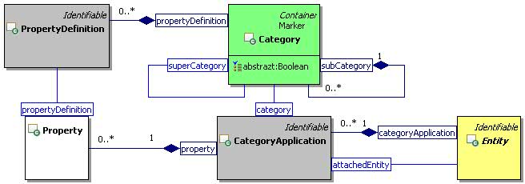
Figure 21: Category and Category Application Class Diagram.

CategoryApplication

Description
A category application is an instance of association between a category and a specific entity.

Class Definition
The CategoryApplication class has attribute values:

localNamespace
Value: icom_meta

localName
Value: CategoryApplication

extendsFrom
Value: icom_core:Identifiable

stereotype
Value: primary

description
Value: A category application is an instance of association between a category and a specific entity.

propertyDefinitions
The values for this attribute are defined in Section 3.6.11.3.

Property Definitions
The CategoryApplication class inherits property definitions from super classes.
The CategoryApplication class MUST have the property definitions:

icom_meta:attachedEntity
Description: An entity to which a category is applied.
Required: True
Inherited: False
Property Type: icom_core:Entity
Cardinality: Single
Updatability: On Create

icom_meta:category
Description: A category which is applied on an entity.
Required: True
Inherited: False
Property Type: icom_meta:Category
Cardinality: Single
Updatability: On Create

icom_meta:property
Description: Zero or more properties.
Required: False
Inherited: False
Property Type: icom_meta:Property
Cardinality: Multi
Updatability: Read Write

The CategoryApplication class MAY include additional property definitions which are implementation-defined.

Tag

Description
A tag is a marker that labels entities by a keyword.

Class Definition
The Tag class has attribute values:

localNamespace
Value: icom_meta

localName
Value: Tag

extendsFrom
Value: icom_meta:Marker

stereotype
Value: primary

description
Value: A tag is a marker that labels entities by a keyword.

propertyDefinitions
The values for this attribute are defined in Section 3.6.12.3.

Property Definitions
The Tag class inherits property definitions from super classes.
The Tag class MUST have the property definition:

icom_meta:applicationCount
Description: An estimate of the number of times a tag is applied on entities.
Required: False
Inherited: False
Property Type: Integer
Cardinality: Single
Updatability: Read Only

The Tag class MAY include additional property definitions which are implementation-defined.

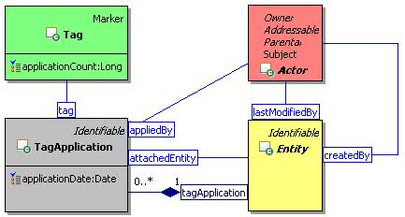
Figure 22: Tag and Tag Application Class Diagram.

TagApplication

Description
A tag application is an instance of association between a tag and a specific entity.

Class Definition
The TagApplication class has attribute values:

localNamespace
Value: icom_meta

localName
Value: TagApplication

extendsFrom
Value: icom_core:Identifiable

stereotype
Value: primary

description
Value: A tag application is an instance of association between a tag and a specific entity.

propertyDefinitions
The values for this attribute are defined in Section 3.6.13.3.

Property Definitions
The TagApplication class inherits property definitions from super classes.
The TagApplication class MUST have the property definitions:

icom_meta:attachedEntity
Description: An entity on which a tag is applied.
Required: True
Inherited: False
Property Type: icom_core:Entity
Cardinality: Single
Updatability: On Create

icom_meta:tag
Description: A tag which is applied to an entity.
Required: True
Inherited: False
Property Type: icom_meta:Tag
Cardinality: Single
Updatability: On Create

icom_meta:appliedBy
Description: A user who applies a tag to an entity.
Required: False
Inherited: False
Property Type: icom_core:Actor
Cardinality: Single
Updatability: Read Only

icom_meta:applicationDate
Description: A date and time when a tag is applied to an entity.
Required: False
Inherited: False
Property Type: DateTime
Cardinality: Single
Updatability: Read Write

The TagApplication class MAY include additional property definitions which are implementation-defined.

RelationshipBondable

Description
A relationship bondable entity is an entity which may be related to other entities by a relationship.
Note: A relationship can exist among entities that are not relationships.

Class Definition
The RelationshipBondable class is a mixin class which defines the characteristics of entities that may be relationship bonded. It includes almost every subclass of Entity except Relationship.
The RelationshipBondable class has attribute values:

localNamespace
Value: icom_meta

localName
Value: RelationshipBondable

extendsFrom
Value: icom_core:Identifiable

stereotype
Value: mixin

description
Value: RelationshipBondable is a mixin class which defines the characteristics of entities that can be relationship bonded.

propertyDefinitions
The values for this attribute are defined in Section 3.6.14.3.

Property Definitions
The RelationshipBondable class inherits property definitions from super classes.
The RelationshipBondable class MAY include additional property definitions which are implementation-defined.

RelationshipDefinition

Description
A relationship definition is an entity that defines a type of relationship, including a name and a description of the relationship type, types of source entity and target entities of a relationship, and definition of properties in a relationship.

Class Definition
The RelationshipDefinition class has attribute values:

localNamespace
Value: icom_meta

localName
Value: RelationshipDefinition

extendsFrom
Value: icom_core:EntityDefinition

stereotype
Value: primary

description
Value: A relationship definition is an entity that defines a type of relationship.

propertyDefinitions
The values for this attribute are defined in Section 3.6.15.3.

Property Definitions
The RelationshipDefinition class inherits property definitions from super classes.
The RelationshipDefinition class MUST have the property definitions:

icom_meta:propertyDefinition
Description: Optional or mandatory properties for a relationship.
Required: False
Inherited: False
Property Type: icom_meta:PropertyDefinition
Cardinality: Multi
Updatability: Read Write

icom_meta:allowedSourceType
Description: A list of expanded names of relationship bondable classes, indicating that the source entity of a relationship MUST be an instance of a class in the list.
Required: False
Inherited: False
Property Type: IRI
Cardinality: Multi
Updatability: Read Write

icom_meta:allowedTargetType
Description: A list of expanded names of relationship bondable classes, indicating that the target entity of a relationship MUST be an instance of a class in the list.
Required: False
Inherited: False
Property Type: IRI
Cardinality: Multi
Updatability: Read Write

The RelationshipDefinition class MAY include additional property definitions which are implementation-defined.

Relationship

Description
A relationship is an entity that relates a set of entities by a predicate.

Class Definition
The Relationship class has attribute values:

localNamespace
Value: icom_meta

localName
Value: Relationship

extendsFrom
Value: icom_core:Entity

stereotype
Value: primary

description
Value: A relationship is an entity that relates a set of entities by a predicate.

propertyDefinitions
The values for this attribute are defined in Section 3.6.16.3.

Property Definitions
The Relationship class inherits property definitions from super classes.
The Relationship class MUST have the property definitions:

icom_meta:relationshipDefinition
Description: A definition of relationships.
Required: True
Inherited: False
Property Type: icom_meta:RelationshipDefinition
Cardinality: Single
Updatability: On Create

icom_meta:sourceEntity
Description: A source entity of a relationship.
Required: True
Inherited: False
Property Type: icom_meta:RelationshipBondable
Cardinality: Single
Updatability: On Create

icom_meta:targetEntity
Description: One or more target entities of a relationship.
Required: True
Inherited: False
Property Type: icom_meta:RelationshipBondable
Cardinality: Multi
Updatability: Read Write

icom_meta:property
Description: Zero or more properties.
Required: False
Inherited: False
Property Type: icom_meta:Property
Cardinality: Multi
Updatability: Read Write

The Relationship class MAY include additional property definitions which are implementation-defined.

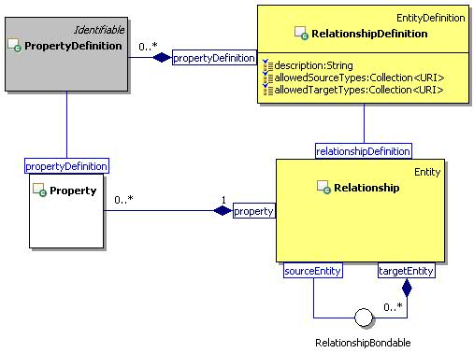
Figure 23: Relationship Class Diagram.

Common Concepts

Addressable

Description
An addressable object is an identifiable object that has one or more addresses.

Class Definition
The Addressable class is a mixin class which defines the characteristics of entities that has one or more addresses.
The Addressable class has attribute values:

localNamespace
Value: icom_core

localName
Value: Addressable

extendsFrom
Value: icom_core:Identifiable

stereotype
Value: mixin

description
Value: Addressable is a mixin class which defines the characteristics of entities that has one or more addresses.

propertyDefinitions
The values for this attribute are defined in Section 3.7.1.3.

Property Definitions
The Addressable class inherits property definitions from super classes.
The Addressable class MUST have the property definitions:

icom_core:address
Description: Zero or more addresses of an addressable object.
Required: False
Inherited: False
Property Type: icom_core:EntityAddress
Cardinality: Multi
Updatability: Read Write

icom_core:primaryAddress
Description: The primary address of an addressable object.
Required: False
Inherited: False
Property Type: icom_core:EntityAddress
Cardinality: Single
Updatability: Read Write

The Addressable class MAY include additional property definitions which are implementation-defined.

EntityAddress

Description
An entity address object represents an address which is defined by type and IRI.

Class Definition
The EntityAddress class has attribute values:

localNamespace
Value: icom_core

localName
Value: EntityAddress

extendsFrom
Value:

stereotype
Value: primary

description
Value: An entity address object represents an address which is defined by type and IRI.

propertyDefinitions
The values for this attribute are defined in Section 3.7.2.3.

Property Definitions
The EntityAddress class MUST have the property definitions:

icom_core:addressType
Description: Type of an address.
Required: False
Inherited: False
Property Type: String
Cardinality: Single
Updatability: Read Write

icom_core:address
Description: A IRI representing an address.
Required: False
Inherited: False
Property Type: IRI
Cardinality: Single
Updatability: Read Write

Participant

Description
A participant object represents the participation of any addressable entity in a collaboration activity such as an occurrence, task, conference, discussion, and message.
If an addressable entity is not specified, an address must be specified.

Class Definition
The Participant class has attribute values:

localNamespace
Value: icom_core

localName
Value: Participant

extendsFrom
Value:

stereotype
Value: primary

description
Value: A participant object represents the participation of any addressable entity in a collaboration activity such as an occurrence, task, conference, discussion, and message.

propertyDefinitions
The values for this attribute are defined in Section 3.7.3.3.

Property Definitions
The Participant class inherits property definitions from super classes.
The Participant class MUST have the property definitions:

icom_core:participant
Description: An addressable entity to participate in a collaboration activity.
Required: False
Inherited: False
Property Type: icom_core:Addressable
Cardinality: Single
Updatability: On Create

icom_core:address
Description: An address of a participant in a collaboration activity.
Required: False
Inherited: False
Property Type: IRI
Cardinality: Single
Updatability: On Create

icom_core:name
Description: Name of a participant in a collaboration activity.
Required: False
Inherited: False
Property Type: String
Cardinality: Single
Updatability: On Create

The Participant class MAY include additional property definitions which are implementation-defined.

Priority

Description
A priority level for delivery of information.

Class Definition
The Priority class is a mixin class which defines a priority level for delivery of information.
The Priority class has attribute values:

localNamespace
Value: icom_core

localName
Value: Priority

extendsFrom
Value:

stereotype
Value: mixin

description
Value: Priority is a mixin class which defines a priority level for delivery of information.

propertyDefinitions
The values for this attribute are defined in Section 3.7.4.3.

Property Definitions
The Priority class MAY include additional property definitions which are implementation-defined.

PriorityEnum
The PriorityEnum class is an enum class that enumerates the instances each of which defines a priority level for delivery of information.
The PriorityEnum has attribute values:

localNamespace
Value: icom_core

localName
Value: PriorityEnum

extendsFrom
Value: Priority

stereotype
Value: primary

isEnumeration
Value: TRUE

description
Value: Priority level for delivery of information.

instances
Value: <icom_core:Normal, icom_core:Low, icom_core:Medium, icom_core:High>

ICOM defines four priorities:
- icom_core:Normal a normal priority.
- icom_core:Low a low priority.
- icom_core:Medium a medium priority.
- icom_core:High a high priority.

DateTimeResolution

Description
A date time resolution is a resolution of date time value.

Class Definition
The DateTimeResolution class is a mixin class which defines a resolution of date time value.
The DateTimeResolution class has attribute values:

localNamespace
Value: icom_core

localName
Value: DateTimeResolution

extendsFrom
Value:

stereotype
Value: mixin

description
Value: DateTimeResolution is a mixin class which defines a resolution of date time value.

propertyDefinitions
The values for this attribute are defined in Section 3.7.6.3.

Property Definitions
The DateTimeResolution class MAY include additional property definitions which are implementation-defined.

DateTimeResolutionEnum
The DateTimeResolutionEnum class is an enum class that enumerates the instances each of which expresses a resolution of a date time value.
The DateTimeResolutionEnum has attribute values:

localNamespace
Value: icom_core

localName
Value: DateTimeResolutionEnum

extendsFrom
Value: DateTimeResolution

stereotype
Value: primary

isEnumeration
Value: TRUE

description
Value: Resolution of a date time value.

instances
Value: <icom_core:Year, icom_core:Date, icom_core:Time>

ICOM defines three date time resolutions:
- icom_core:Year date time resolution is in years.
- icom_core:Date date time resolution is in years and days.
- icom_core:Time date time resolution is in years, days, and time of day.

TimeZone

Description
A time zone is a region that has a uniform standard time.

Class Definition
The TimeZone class has attribute values:

localNamespace
Value: icom_core

localName
Value: TimeZone

extendsFrom
Value:

stereotype
Value: primary

description
Value: A time zone is a region that has a uniform standard time.

propertyDefinitions
The values for this attribute are defined in Section 3.7.8.3.

Property Definitions
The TimeZone class inherits property definitions from super classes.
The TimeZone class MUST have the property definitions:

icom_core:ID
Description: Identifier of a time zone.
Required: False
Inherited: False
Property Type: String
Cardinality: Single
Updatability: On Create

icom_core:rawOffset
Description: An offset to add to Universal Coordinated Time (UTC) to get local time. If Daylight Saving Time is in effect at the specified date, the offset value is adjusted with the amount of daylight saving.
Required: False
Inherited: False
Property Type: Integer
Cardinality: Single
Updatability: On Create

The TimeZone class MAY include additional property definitions which are implementation-defined.

Location

Description
A location object represents a physical location which is defined by name, description, and geo coordinates.
Note: The name of a location may remain unchanged while a physical location may be changing. For example, a location name might be “On an airplane” while a physical location might be the geo coordinates of a flight path or current coordinates of a plane.

Class Definition
The Location class has attribute values:

localNamespace
Value: icom_core

localName
Value: Location

extendsFrom
Value:

stereotype
Value: primary

description
Value: A location object represents a physical location which is defined by name, description, or geo coordinates.

propertyDefinitions
The values for this attribute are defined in Section 3.7.9.3.

Property Definitions
The Location class MUST have the property definitions:

icom_core:name
Description: Name of a location.
Required: False
Inherited: False
Property Type: String
Cardinality: Single
Updatability: Read Write

icom_core:description
Description: A description of a location.
Required: False
Inherited: False
Property Type: String
Cardinality: Single
Updatability: Read Write

icom_core:timeZone
Description: Time zone of a location.
Required: False
Inherited: False
Property Type: icom_core:TimeZone
Cardinality: Single
Updatability: Read Write

icom_core:coordinates
Description: A list of geo coordinates marking a point, path, or area of a physical location.
Required: False
Inherited: False
Property Type: icom_core:GeoCoordinates
Cardinality: Multi
Updatability: Read Write

The Location class MAY include additional property definitions which are implementation-defined.

GeoCoordinates

Description
A geo coordinates object specifies the latitude, longitude, and altitude of a physical location.

Class Definition
The GeoCoordinates class has attribute values:

localNamespace
Value: icom_core

localName
Value: GeoCoordinates

extendsFrom
Value:

stereotype
Value: primary

description
Value: A geo coordinates object specifies the latitude, longitude, and altitude of a physical location.

propertyDefinitions
The values for this attribute are defined in Section 3.7.10.3.

Property Definitions
The GeoCoordinates class MUST have the property definitions:

icom_core:latitude
Description: Latitude of a location.
Required: False
Inherited: False
Property Type: Float
Cardinality: Single
Updatability: Read Write

icom_core:longitude
Description: Longitude of a location.
Required: False
Inherited: False
Property Type: Float
Cardinality: Single
Updatability: Read Write

icom_core:altitude
Description: Altitude of a location.
Required: False
Inherited: False
Property Type: Float
Cardinality: Single
Updatability: Read Write

The GeoCoordinates class MAY include additional property definitions which are implementation-defined.

Extension Modules

Overview of Extension Modules
Each extension module defines a model of a collaboration activity. Different models of collaboration activities in this specification include content creation, communication, coordination, discussion forum, and conference. Except for the Presence Module and Free Busy Module, the extension modules in this section introduce specialized subclasses of Artifact and Folder of Artifact Branch.
Note: ICOM Core Model (Section 3) establishes a framework to integrate specialized collaboration activities of the extension modules, which more or less represent technology or protocol channels. The framework is extensible with additional extension modules. For example, applications can adopt a model for CMIS Policy base type as a new extension module, which can be used to integrate with BPMN or BPEL processes outside the ICOM domain. An ICOM space can provide a durable context for continuity of conversations and activities related to a business process type or process instance. Some new extension modules may import the models from related standards. For example, social network model may be imported from [OpenGraph] or [OpenSocial].
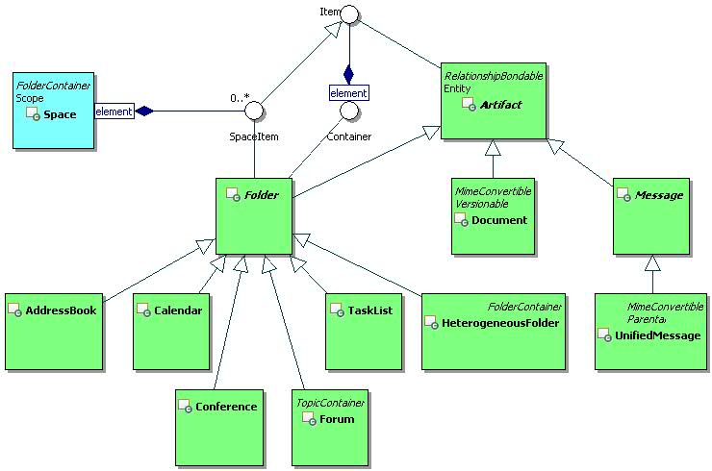
Figure 24: Containers of Collaboration Activities.
ICOM defines containers that provide contexts and structures for specific areas of collaborative activities. The UML class diagram in Figure 24 depicts a Space as a hub of containers, including HeterogeneousFolder, AddressBook, Calendar, TaskList, Forum, and Conference. These containers are briefly described as follows:
HeterogeneousFolder (defined in Core Model) is a general purpose container that can contain any type of artifacts, and therefore, can serve as
- a library of documents and wiki pages to support content sharing and co-creation,
- an inbox or outbox for communication, or
- a trash folder to archive all types of artifacts deleted from a space.
AddressBook is a specialized container to manage contact or personal information, such as addresses, phone numbers, birthdays, anniversaries, and other entries.
Calendar is a specialized container to support time management.
TaskList is a specialized container to support task coordination.
Forum is a specialized container to support
- Topic sub-containers for threaded discussions and
- Announcement sub-containers for time-sensitive communication.
Conference is a specialized container that provides a durable context for real-time interactions.

The following ten modules are specified as extension modules of ICOM:
- Content Module (in section 4.2) defines Content, MultiContent, and SimpleContent. A content represents a piece of data in a document or message. Content, multi-content, simple content, and online content form a composite design pattern.
- Document Module (in Section 4.3) defines Document, WikiPage, and version control model. A document can contain a composite content defined in section 4.2. Documents are typically contained by heterogeneous folders.
- Message Module (in Section 4.4) defines Message, UnifiedMessage, InstantMessage, and related classes. A message can contain a composite content defined in section 4.2. Unified messages are typically contained by heterogeneous folders.
- Presence Module (in Section 4.5) defines Presence, Activity, and Contact Method. Presence represents a watchable state of a presentity (which is usually a person). Presence state is derived using an actor's subscriptions.
Note: Since a Presence is derived using a viewer's subscriptions, a Presence should not be shared with other viewers. For this reason, Presence is not modeled as Entity and is not assigned an access control list.
- Address Book Module (in Section 4.6) defines AddressBook and PersonContact. A person contact can bookmark a reference to a person in an ICOM community as well as store addresses, phone numbers, and other entries about a person who may not be in any ICOM community.
- Calendar Module (in Section 4.7) defines Calendar, Occurrence, and OccurrenceSeries. Occurrence artifacts are used to resolve the free-busy times of participants for scheduling of meetings and booking of rooms and other resources.
- Free Busy Module (in Section 4.8) defines FreeBusy. FreeBusy is a view derived from occurrences in a calendar or a set of calendars using an actor's privileges to determine the free or busy states of calendar occurrences.
Note: Since a FreeBusy view is derived using a viewer's privileges, a FreeBusy should not be shared with other viewers. For this reason, FreeBusy is not modeled as Entity and is not assigned an access control list.
- Task List Module (in Section 4.9) defines TaskList and Task. Tasks are used to coordinate the assignment of tasks and to track the progress of task activities.
- Forum Module (in Section 4.10) defines Forum, Topic, Announcement, and DiscussionMessage. Topics, announcements, and discussions are used for treaded discussions. Moderators of a forum can prune, merge, or fork the discussion threads.
- Conference Module (in Section 4.11) defines Conference and related classes. A conference can contain visual, audio, and chat transcripts of the conference sessions. It also contains the current status, conference settings, past sessions, active session, and activity logs.

Content Module

MimeConvertible

Description
A MimeConvertible object represents an object that has Multipurpose Internet Mail Extensions (MIME) characteristics such as headers, content transfer encoding, and possible hierarchy of sub-contents.

Class Definition
The MimeConvertible class is a mixin class that defines the characteristics of objects that can be represented in MIME format.
The MimeConvertible class has attribute values:

localNamespace
Value: icom_content

localName
Value: MimeConvertible

extendsFrom
Value: icom_core:Identifiable

stereotype
Value: mixin

description
Value: MimeConvertible class is a mixin class that defines the characteristics of objects that can be represented in MIME format.

propertyDefinitions
The values for this attribute are defined in Section 4.2.1.3.

Property Definitions
The MimeConvertible class inherits property definitions from super classes.
The MimeConvertible class MAY include additional property definitions which are implementation-defined.

Content

Description
A content object represents a piece of data in a document or message. Content, multi-content, simple content, and online content form a composite design pattern.

Class Definition
The Content class has attribute values:

localNamespace
Value: icom_content

localName
Value: Content

extendsFrom
Value: icom_core:Identifiable, icom_content:MimeConvertible

stereotype
Value: primary

isAbstract
Value: TRUE

description
Value: Content represents a piece of data in a document or message.

propertyDefinitions
The values for this attribute are defined in Section 4.2.2.3.

Property Definitions
The Content class inherits property definitions from super classes.
The Content class MUST have the property definitions:

icom_content:contentId
Description: A content id is a unique identifier for a part of content in multi-part contents.
Required: False
Inherited: False
Property Type: String
Cardinality: Single
Updatability: Read Write

icom_content:mediaType
Description: Media type is a two-part identifier for Internet file formats.
Required: False
Inherited: False
Property Type: String
Cardinality: Single
Updatability: Read Write

icom_content:contentDisposition
Description: Content disposition specifies a presentation style.
Required: False
Inherited: False
Property Type: ContentDispositionType
Cardinality: Single
Updatability: Read Write

The Content class MAY include additional property definitions which are implementation-defined.

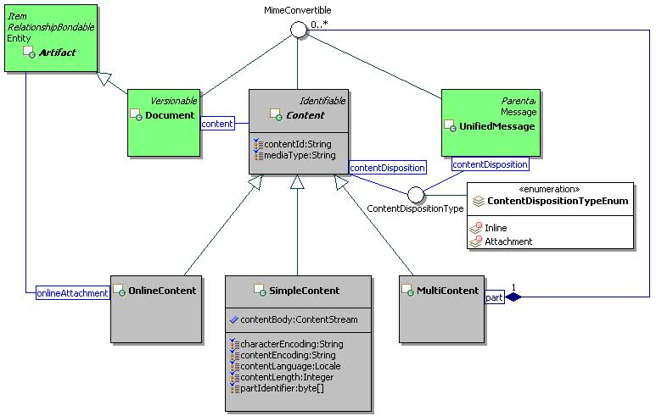
Figure 25: Composite Content Class Diagram.

MultiContent

Description
A multi-content object represents multiple parts of a message or document. It is a composite content that can contain a list of simple or composite contents.

Class Definition
The MultiContent class has attribute values:

localNamespace
Value: icom_content

localName
Value: MultiContent

extendsFrom
Value: icom_content:Content

stereotype
Value: primary

description
Value: A multi-content object represents the multiple parts of a message or document.

propertyDefinitions
The values for this attribute are defined in Section 4.2.3.3.

Property Definitions
The MultiContent class inherits property definitions from super classes.
The MultiContent class MUST have the property definitions:

icom_content:part
Description: Zero or more parts of a hierarchical composite content.
Required: False
Inherited: False
Property Type: icom_content:MimeConvertible
Cardinality: Multi
Updatability: Read Write

The MultiContent class MAY include additional property definitions which are implementation-defined.

SimpleContent

Description
A simple content holds a single piece of data.

Class Definition
The SimpleContent class has attribute values:

localNamespace
Value: icom_content

localName
Value: SimpleContent

extendsFrom
Value: icom_content:Content

stereotype
Value: primary

description
Value: A simple content holds a single piece of data.

propertyDefinitions
The values for this attribute are defined in Section 4.2.4.3.

Property Definitions
The SimpleContent class inherits property definitions from super classes.
The SimpleContent class MUST have the property definitions:

icom_content:characterEncoding
Description: Character encoding specifies character set of a content (a missing value means that a piece of content should be treated as binary or raw).
Required: False
Inherited: False
Property Type: String
Cardinality: Single
Updatability: Read Write

icom_content:contentEncoding
Description: Content encoding specifies encoding of a piece of content.
Required: False
Inherited: False
Property Type: String
Cardinality: Single
Updatability: Read Write

icom_content:contentLanguage
Description: Content language specifies language for a piece of content (a missing value means non-natural language content).
Required: False
Inherited: False
Property Type: Locale
Cardinality: Single
Updatability: Read Write

icom_content:contentLength
Description: Length of a piece of content.
Required: False
Inherited: False
Property Type: Integer
Cardinality: Single
Updatability: Read Write

icom_content:contentBody
Description: Body of a simple content.
Required: False
Inherited: False
Property Type: Object
Cardinality: Single
Updatability: Read Write

The SimpleContent class MAY include additional property definitions which are implementation-defined.

OnlineContent

Description
An online content holds an online artifact attached to a document, message, or invitation.
Note: An online artifact must be rendered as an IRI when a message or invitation is delivered to external recipients.

Class Definition
The OnlineContent class has attribute values:

localNamespace
Value: icom_content

localName
Value: OnlineContent

extendsFrom
Value: icom_content:Content

stereotype
Value: primary

description
Value: An online content holds an online artifact attached to a message or invitation.

propertyDefinitions
The values for this attribute are defined in Section 4.2.5.3.

Property Definitions
The OnlineContent class inherits property definitions from super classes.
The OnlineContent class MUST have the property definition:

icom_content:onlineAttachment
Description: An online artifact attached to a message.
Required: True
Inherited: False
Property Type: icom_core:Artifact
Cardinality: Single
Updatability: Read Write

The OnlineContent class MAY include additional property definitions which are implementation-defined.

ContentDispositionType

Description
A content disposition type is a presentation style of content.

Class Definition
The ContentDispositionType class is a mixin class which defines a presentation style of content.
The ContentDispositionType class has attribute values:

localNamespace
Value: icom_content

localName
Value: ContentDispositionType

extendsFrom
Value:

stereotype
Value: mixin

description
Value: ContentDispositionType is a mixin class which defines a presentation style of content.

propertyDefinitions
The values for this attribute are defined in Section 4.2.6.3.

Property Definitions
The ContentDispositionType class MAY include additional property definitions which are implementation-defined.

ContentDispositionTypeEnum
The ContentDispositionTypeEnum class is an enum class that enumerates the instances each of which expresses a presentation style of content.
The ContentDispositionTypeEnum class has attribute values:

localNamespace
Value: icom_content

localName
Value: ContentDispositionTypeEnum

extendsFrom
Value: ContentDispositionType

stereotype
Value: primary

isEnumeration
Value: TRUE

description
Value: A presentation style of content.

instances
Value: <icom_content:Inline, icom_content:Attachment>

ICOM defines two content disposition types:
- icom_content:Inline content is to be displayed automatically upon display of the main body of an artifact.
- icom_content:Attachment content is separate from the main body of an artifact, and that its display should not be automatic, but contingent upon some further action of a user.

Attachment

Description
An attachment holds a content for an occurrence, task, and contact artifact.

Class Definition
The Attachment class has attribute values:

localNamespace
Value: icom_content

localName
Value: Attachment

extendsFrom
Value:

stereotype
Value: primary

description
Value: An attachment holds a content for an occurrence, task, and contact artifact.

propertyDefinitions
The values for this attribute are defined in Section 4.2.8.3.

Property Definitions
The Attachment class MUST have the property definitions:

icom_core:name
Description: Name of a content attachment.
Required: True
Inherited: False
Property Type: String
Cardinality: Single
Updatability: Read Write

icom_content:content
Description: A content attached to an occurrence, task, or contact artifact.
Required: True
Inherited: False
Property Type: icom_content:Content
Cardinality: Single
Updatability: Read Write

The Attachment class MAY include additional property definitions which are implementation-defined.

Document Module

Versionable

Description
A versionable artifact is
- a non-version-controlled copy,
- a specific versioned copy,
- a private working copy, or
- a representative copy (optional)
of an artifact version series.
When a versionable artifact is not under version control, a non-version-controlled copy MUST be the only copy in a version series, i.e. there is only one copy and one objectId.
When a versionable artifact is under version control, a representative copy MAY provide a version-independent view of a versionable artifact.
When a non-version-controlled copy is placed under version control, a versioned copy MUST be created. Assignment of an object identifier to a versioned copy is implementation-dependent:
- if a versioned copy retains the object identifier of a non-version-controlled copy, the version type of a versionable artifact MUST change from NonVersionControlledCopy to VersionedCopy;
- if a versioned copy is assigned a new object identifier that is different from the object identifier of a non-version-controlled copy, a representative copy MAY retain the object identifier of the non-version-controlled copy;
- if both versioned copy and representative copy are assigned new object identifiers that are different from the object identifier of a non-version-controlled copy, the non-version-controlled copy SHALL be discarded.
When a private working copy is checked in, a versioned copy MUST be created. Assignment of an object identifier to a versioned copy is implementation-dependent:
- if a versioned copy retains the object identifier of a private working copy, the version type of a versionable artifact MUST change from PrivateWorkingCopy to VersionedCopy;
- if a versioned copy is assigned a new object identifier that is different from the object identifier of a private working copy, the private working copy SHALL be discarded.
It is optional for a service provider to provide a representative copy for a version series. If a representative copy is provided:
- a representative copy MUST have its own object identifier that is different from the object identifier of any versioned copy or private working copy;
- assignment of an object identifier to a representative copy is implementation-dependent:
  - a representative copy MAY retain the object identifier of a non-version-controlled copy; if so the version type of a versionable artifact MUST change from NonVersionControlledCopy to RepresentativeCopy;
  - a representative copy MAY be assigned a new object identifier that is different from the object identifier of a non-version-controlled copy;
- content and state of a representative copy is implementation-dependent:
  - a representative copy MAY be a copy of the content and state of the latest versioned copy or the latest major versioned copy in a version series;
  - a representative copy MAY be a copy of the content and state of a private working copy if the current user loading the representative copy is the same user who checks out a version series.
Note: Each versioned copy of a versionable artifact is itself a versionable artifact, i.e. it has its own objectId. A versioned copy has a version number, label, and check in comment.
Note: A private working copy is a versionable artifact created by an explicit checkout operation on a versionable artifact under version control. The properties for a private working copy are identical to the properties of a versioned copy on which a checkout operation was performed. Certain properties such as objectId and creationDate are different from a versioned copy. The content of a private working copy is identical to the content of a versioned copy. Its object identifier is different from that of the representative copy or any versioned copy.
A private working copy MAY be saved in a version series for sharing and co-editing, however, it needs not be visible to users who may only have permissions to view other versioned copies in a version series.
Note: Until it is checked in using an explicit check-in operation, a private working copy must not be considered the LatestMajorVersion in a version series.
A container of a versionable artifact CAN contain a representative copy so that it provides a version-independent view of a state of the version series.
Note: Starting from a representative copy in a container, an actor can traverse a version series to retrieve any versioned copy or private working copy.
ICOM version control model is based on the CMIS version control model specified in Section 2.1.9 of Content Management Interoperability Services Version 1.0 [CMIS].

Class Definition
The Versionable class is a mixin class that defines the characteristics of artifacts that can be versioned.
The Versionable class has attribute values:

localNamespace
Value: icom_doc

localName
Value: Versionable

extendsFrom
Value: icom_core:Identifiable

stereotype
Value: mixin

description
Value: Versionable class is a mixin class that defines the characteristics of artifacts that can be versioned.

propertyDefinitions
The values for this attribute are defined in Section 4.3.1.3.

Property Definitions
The Versionable class inherits property definitions from super classes.
The Versionable class MUST have the property definitions:

icom_doc:versionControlMetadata
Description: A version control metadata object attached to a versionable artifact.
Required: False
Inherited: False
Property Type: icom_doc:VersionControlMetadata
Cardinality: Single
Updatability: Read Only

icom_doc:versionType
Description: A type of version controlled copy of a versionable artifact.
Required: False
Inherited: False
Property Type: icom_doc:VersionType
Cardinality: Single
Updatability: Read Only

The Versionable class MAY include additional property definitions which are implementation-defined.

VersionControlMetadata

Description
A version control metadata is an object that contains version control information.
There are two classes of version control metadata: version series and version. A version control metadata of a versionable artifact is either a version series or a version depending on the version type.
- If the version type is icom_doc:NonVersionControlledCopy then metadata is optional; if metadata is present, it MUST be a version series object.
- If the version type is icom_doc:RepresentativeCopy, then metadata MUST be a version series object.
- If the version type is icom_doc:VersionedCopy or icom_doc:PrivateWorkingCopy, then metadata MUST be a version object.

Class Definition
The VersionControlMetadata class is a mixin class that defines the characteristics of version or version series metadata for version control.
The VersionControlMetadata class has attribute values:

localNamespace
Value: icom_doc

localName
Value: VersionControlMetadata

extendsFrom
Value: icom_core:Identifiable

stereotype
Value: mixin

description
Value: VersionControlMetadata is a mixin class that defines the characteristics of entities that serve as metadata for version control.

propertyDefinitions
The values for this attribute are defined in Section 4.3.2.3.

Property Definitions
The VersionControlMetadata class inherits property definitions from super classes.
The VersionControlMetadata class MUST have the property definition:

icom_doc:representativeCopy
Description: A representative copy of a versionable artifact.
Required: False
Inherited: False
Property Type: icom_doc:Versionable
Cardinality: Single
Updatability: Read Only

The VersionControlMetadata class MAY include additional property definitions which are implementation-defined.

VersionSeries

Description
A version series is a version control metadata that contains a version history and check in/out states of a versionable artifact.
A version series object is a version control metadata of a representative copy of a versionable artifact.

Class Definition
The VersionSeries class has attribute values:

localNamespace
Value: icom_doc

localName
Value: VersionSeries

extendsFrom
Value: icom_core:Entity, icom_doc:VersionControlMetadata, icom_meta:RelationshipBondable

stereotype
Value: primary

description
Value: A version series is version control metadata that contains a version history and check in/out states of a versionable artifact.

propertyDefinitions
The values for this attribute are defined in Section 4.3.3.3.

Property Definitions
The VersionSeries class inherits property definitions from super classes.
The VersionSeries class MUST have the property definitions:

icom_doc:versionHistory
Description: A history of version nodes of a versionable artifact.
Required: False
Inherited: False
Property Type: icom_doc:Version
Cardinality: Multi
Updatability: Read Only

icom_doc:versionableHistory
Description: A history of the versioned copies of a versionable artifact.
Required: False
Inherited: False
Property Type: icom_doc:Versionable
Cardinality: Multi
Updatability: Read Only

icom_doc:latestVersionedCopy
Description: Latest versioned copy of a versionable artifact.
Required: False
Inherited: False
Property Type: icom_doc:Versionable
Cardinality: Single
Updatability: Read Only

icom_doc:privateWorkingCopy
Description: A private working copy of a versionable artifact.
Required: False
Inherited: False
Property Type: icom_doc:Versionable
Cardinality: Single
Updatability: Read Only

icom_doc:versionSeriesCheckedOut
Description: Indicates whether a version series is checked out.
Required: False
Inherited: False
Property Type: Boolean
Cardinality: Single
Updatability: Read Only

icom_doc:versionSeriesCheckedOutBy
Description: An actor who checks out a version series.
Required: False
Inherited: False
Property Type: icom_core:Actor
Cardinality: Single
Updatability: Read Only

icom_doc:versionSeriesCheckedOutOn
Description: The time when a version series is checked out.
Required: False
Inherited: False
Property Type: DateTime
Cardinality: Single
Updatability: Read Only

icom_doc:versionSeriesCheckoutComment
Description: A check out comment of a version series.
Required: False
Inherited: False
Property Type: String
Cardinality: Single
Updatability: Read Only

icom_doc:totalSize
Description: Total size of all versioned copies of a versionable artifact in a version series.
Required: False
Inherited: False
Property Type: Integer
Cardinality: Single
Updatability: Read Only

The VersionSeries class MAY include additional property definitions which are implementation-defined.

Version

Description
A version is a version control metadata that contains a version number, label, and description.
A version object is a version control metadata of a versioned copy or a private working copy of a versionable artifact.

Class Definition
The Version class has attribute values:

localNamespace
Value: icom_doc

localName
Value: Version

extendsFrom
Value: icom_core:Entity, icom_doc:VersionControlMetadata, icom_meta:RelationshipBondable

stereotype
Value: primary

description
Value: A version is a version control metadata that contains a version number, label, and description.

propertyDefinitions
The values for this attribute are defined in Section 4.3.4.3.

Property Definitions
The Version class inherits property definitions from super classes.
The Version class MUST have the property definitions;

icom_doc:checkinComment
Description: A check in comment of a versioned copy.
Required: False
Inherited: False
Property Type: String
Cardinality: Single
Updatability: Read Write

icom_doc:versionNumber
Description: A version number of a versioned copy.
Required: True
Inherited: False
Property Type: Integer
Cardinality: Single
Updatability: Read Write

icom_doc:versionLabel
Description: A version label of a versioned copy.
Required: True
Inherited: False
Property Type: String
Cardinality: Single
Updatability: Read Write

icom_doc:majorVersion
Description: Indicates whether a versioned copy is a major version.
Required: True
Inherited: False
Property Type: Boolean
Cardinality: Single
Updatability: Read Write

icom_doc:versionedOrPrivateWorkingCopy
Description: A versioned copy or private working copy corresponding to a version of a versionable artifact.
Required: False
Inherited: False
Property Type: icom_doc:Versionable
Cardinality: Single
Updatability: Read Only

The Version class MAY include additional property definitions which are implementation-defined.

VersionType

Description
A version type is a version state of a copy of versionable document.

Class Definition
The VersionType class is a mixin class which defines a version state of a copy of versionable document.
The VersionType class has attribute values:

localNamespace
Value: icom_doc

localName
Value: VersionType

extendsFrom
Value:

stereotype
Value: mixin

description
Value: VersionType is a mixin class which defines a version state of a copy of versionable document.

propertyDefinitions
The values for this attribute are defined in Section 4.3.5.3.

Property Definitions
The VersionType class MAY include additional property definitions which are implementation-defined.

VersionTypeEnum
The VersionTypeEnum class is an enum class that enumerates the instances each of which expresses a version type.
The VersionTypeEnum class has attribute values:

localNamespace
Value: icom_doc

localName
Value: VersionTypeEnum

extendsFrom
Value: VersionType

stereotype
Value: primary

isEnumeration
Value: TRUE

description
Value: A version type of a copy of versionable document.

instances
Value: <icom_doc:NonVersionControlledCopy, icom_doc:VersionedCopy, icom_doc:PrivateWorkingCopy, icom_doc:RepresentativeCopy>

ICOM defines four version types:
- icom_doc:NonVersionControlledCopy a versionable artifact is not under version control.
- icom_doc:VersionedCopy a versionable artifact is a version of an artifact version series.
- icom_doc:PrivateWorkingCopy a versionable artifact is a private working copy of an artifact version series.
- icom_doc:RepresentativeCopy a versionable artifact is a version-independent representative copy of an artifact. This version type is optional and implementation-dependent.

Document

Description
A document is a versionable artifact that can contain a single content of a media type or composite contents of an assortment of media types.

Class Definition
The Document class has attribute values:

localNamespace
Value: icom_doc

localName
Value: Document

extendsFrom
Value: icom_core:Artifact, icom_doc:Versionable, icom_content:MimeConvertible

stereotype
Value: primary

description
Value: A document is a versionable artifact that may contain a single content of a media type or composite contents of an assortment of media types.

propertyDefinitions
The values for this attribute are defined in Section 4.3.7.3.

Property Definitions
The Document class inherits property definitions from super classes.
The Document class MUST have the property definitions:

icom_content:content
Description: Content of a document.
Required: False
Inherited: False
Property Type: icom_content:Content
Cardinality: Single
Updatability: Read Write

icom_doc:size
Description: The size of a copy of a document.
Required: False
Inherited: False
Property Type: Integer
Cardinality: Single
Updatability: Read Only

The Document class MAY include additional property definitions which are implementation-defined.

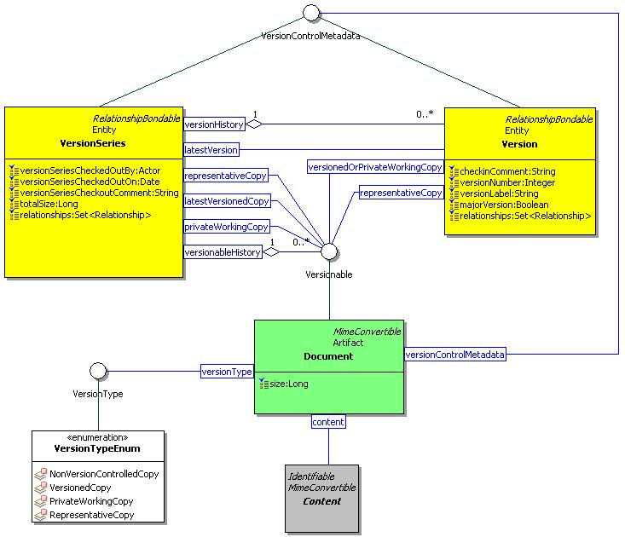
Figure 26: Document, Version Series, and Version Class Diagram.

WikiPage

Description
A wiki page is a document that contains a wiki content and that provides an html page generated from the wiki content.

Class Definition
The WikiPage class has attribute values:

localNamespace
Value: icom_doc

localName
Value: WikiPage

extendsFrom
Value: icom_doc:Document

stereotype
Value: primary

description
Value: A wiki page is a document that contains a wiki content and that provides an html page generated from the wiki content.

propertyDefinitions
The values for this attribute are defined in Section 4.3.8.3.

Property Definitions
The WikiPage class inherits property definitions from super classes.
The WikiPage class MUST have the property definitions:

icom_doc:renderedPage
Description: An html page generated from a wiki content.
Required: False
Inherited: False
Property Type: String
Cardinality: Single
Updatability: Read Only

The WikiPage class MAY include additional property definitions which are implementation-defined.

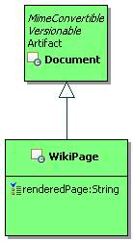
Figure 27: Wiki Page Class Diagram.

Message Module

Message

Description
A message is a unit of conversation. It holds a simple content or multipart message contents in a content property. It has a single sender.
Note: The delivered time is the time when a message is delivered to a given recipient. The user creation date and time property can be used as the sent date and time of a message. The name property can be used as the subject of a message.

Class Definition
The Message class has attribute values:

localNamespace
Value: icom_msg

localName
Value: Message

extendsFrom
Value: icom_core:Artifact

stereotype
Value: primary

isAbstract
Value: TRUE

description
Value: A message is a unit of conversation.

propertyDefinitions
The values for this attribute are defined in Section 4.4.1.3.

Property Definitions
The Message class inherits property definitions from super classes.
The Message class MUST have the property definitions:

icom_content:content
Description: Content of a message
Required: False
Inherited: False
Property Type: icom_content:Content
Cardinality: Single
Updatability: Read Write

icom_msg:sender
Description: Sender of a message.
Required: False
Inherited: False
Property Type: icom_core:Participant
Cardinality: Single
Updatability: Read Write

icom_msg:deliveredTime
Description: The date and time when a message is delivered to a given recipient.
Required: False
Inherited: False
Property Type: DateTime
Cardinality: Single
Updatability: Read Only

The Message class MAY include additional property definitions which are implementation-defined.

UnifiedMessage

Description
A unified message is a type of message delivered electronically over a computer, voice, fax, and other networks.
A unified message can be one of these types:
- Email is a message delivered electronically over a computer network.
- Voice is a message that contains a voice or audio stream.
- Fax is a message that contains an image transmitted via phone lines using the fax protocol.
- Notification is a type of message sent by applications.

Class Definition
The UnifiedMessage class has attribute values:

localNamespace
Value: icom_msg

localName
Value: UnifiedMessage

extendsFrom
Value: icom_msg:Message, icom_content:MimeConvertible

stereotype
Value: primary

description
Value: A unified message is a type of message delivered electronically over a computer, voice, fax, and other networks.

propertyDefinitions
The values for this attribute are defined in Section 4.4.2.3.

Property Definitions
The UnifiedMessage class inherits property definitions from super classes.
The UnifiedMessage class MUST have the property definitions:

icom_core:priority
Description: The priority of a message.
Required: False
Inherited: False
Property Type: icom_core:Priority
Cardinality: Single
Updatability: Read Write

icom_content:contentId
Description: Content id is a unique identifier for a message part in multi-part messages.
Required: False
Inherited: False
Property Type: String
Cardinality: Single
Updatability: Read Write

icom_content:mediaType
Description: Media type is a two-part identifier for Internet file formats.
Required: False
Inherited: False
Property Type: String
Cardinality: Single
Updatability: Read Write

icom_content:contentDisposition
Description: Content disposition specifies a presentation style.
Required: False
Inherited: False
Property Type: icom_content:ContentDispositionType
Cardinality: Single
Updatability: Read Write

icom_msg:envelopeSender
Description: An envelope sender is a participant to receive bounced message. It is also known as return path.
Required: False
Inherited: False
Property Type: icom_core:Participant
Cardinality: Single
Updatability: Read Write

icom_msg:toReceivers
Description: A list of participants to receive a message.
Required: False
Inherited: False
Property Type: icom_core:Participant
Cardinality: Multi
Updatability: Read Write

icom_msg:ccReceivers
Description: A list of participants to receive carbon-copies of a message.
Required: False
Inherited: False
Property Type: icom_core:Participant
Cardinality: Multi
Updatability: Read Write

icom_msg:bccReceivers
Description: A list of participants to receive blind-carbon-copies of a message.
Required: False
Inherited: False
Property Type: icom_core:Participant
Cardinality: Multi
Updatability: Read Write

icom_msg:replyTo
Description: A list of participants to receive a reply message.
Required: False
Inherited: False
Property Type: icom_core:Participant
Cardinality: Multi
Updatability: Read Write

icom_msg:flag
Description: Zero or more flags on a message.
Required: False
Inherited: False
Property Type: icom_msg:UnifiedMessageFlag
Cardinality: Multi
Updatability: Read Write

icom_msg:messageDispositionNotificationRequested
Description: A message disposition notification requested for a message.
Required: False
Inherited: False
Property Type: Boolean
Cardinality: Single
Updatability: Read Write

icom_msg:messageDeliveryStatusNotificationRequest
Description: Indicates the types of delivery status notifications requested for a message. Default is icom_msg:Failure.
Required: False
Inherited: False
Property Type: icom_msg:UnifiedMessageDeliveryStatusNotificationRequest
Cardinality: Multi
Updatability: Read Write

icom_msg:channel
Description: Indicates the delivery channel of a message.
Required: False
Inherited: False
Property Type: icom_msg:UnifiedMessageChannel
Cardinality: Single
Updatability: Read Write

icom_msg:editMode
Description: Indicates an editable mode (new, draft, or delivered) of a message.
Required: False
Inherited: False
Property Type: icom_msg:UnifiedMessageEditMode
Cardinality: Single
Updatability: Read Only

icom_msg:mimeHeader
Description: A list of headers. Each header is represented by a multi-valued property.
Required: False
Inherited: False
Property Type: icom_meta:Property
Cardinality: Multi
Updatability: Read Write

icom_msg:size
Description: The size of a unified message.
Required: False
Inherited: False
Property Type: Integer
Cardinality: Single
Updatability: Read Only

The UnifiedMessage class MAY include additional property definitions which are implementation-defined.

UnifiedMessageParticipant

Description
A unified message participant object represents the participation of an addressable entity in a unified message.

Class Definition
The UnifiedMessageParticipant class has attribute values:

localNamespace
Value: icom_msg

localName
Value: UnifiedMessageParticipant

extendsFrom
Value: icom_core:Participant

stereotype
Value: primary

description
Value: A unified message participant object represents the participation of an addressable entity in a unified message.

propertyDefinitions
The values for this attribute are defined in Section 4.4.3.3.

Property Definitions
The UnifiedMessageParticipant class inherits property definitions from super classes.
The UnifiedMessageParticipant class MUST have the property definitions:

icom_msg:fullAddress
Description: Full address of a participant.
Required: False
Inherited: False
Property Type: IRI
Cardinality: Single
Updatability: Read Write

icom_msg:localPart
Description: Local part of a full address.
Required: False
Inherited: False
Property Type: String
Cardinality: Single
Updatability: Read Write

icom_msg:domainPart
Description: Domain part of a full address.
Required: False
Inherited: False
Property Type: String
Cardinality: Single
Updatability: Read Write

The UnifiedMessageParticipant class MAY include additional property definitions which are implementation-defined.

UnifiedMessageFlag

Description
A unified message flag is a flag on a message.

Class Definition
The UnifiedMessageFlag class is a mixin class which defines a flag on a message.
The UnifiedMessageFlag class has attribute values:

localNamespace
Value: icom_msg

localName
Value: UnifiedMessageFlag

extendsFrom
Value:

stereotype
Value: mixin

description
Value: UnifiedMessageFlag is a mixin class which defines a flag on a message.

propertyDefinitions
The values for this attribute are defined in Section 4.4.4.3.

Property Definitions
The UnifiedMessageFlag class MAY include additional property definitions which are implementation-defined.

UnifiedMessageFlagEnum
The UnifiedMessageFlagEnum class is an enum class that enumerates the instances each of which expresses a flag on a message.
The UnifiedMessageFlagEnum class has attribute values:

localNamespace
Value: icom_msg

localName
Value: UnifiedMessageFlagEnum

extendsFrom
Value: UnifiedMessageFlag

stereotype
Value: primary

isEnumeration
Value: TRUE

description
Value: A flag on a message.

instances
Value: <icom_msg:Answered, icom_msg:Forwarded, icom_msg:Redirected, icom_msg:Hidden, icom_msg:MarkedForDelete, icom_msg:MarkedForFollowUp, icom_msg:MarkedForDraft, icom_msg:MessageDispositionNotificationProcessed>

ICOM defines eight flags:
- icom_msg:Answered a message is answered.
- icom_msg:Forwarded a message is forwarded.
- icom_msg:Redirected a message is redirected.
- icom_msg:Hidden a message is hidden.
- icom_msg:MarkedForDelete a message is marked for delete.
- icom_msg:MarkedForFollowUp a message is marked for follow up.
- icom_msg:MarkedForDraft a message is marked for draft.
- icom_msg:MessageDispositionNotificationProcessed a message disposition notification is processed.

UnifiedMessageDeliveryStatusNotificationRequest

Description
A unified message delivery status notification request is a directive for notifying a participant of delivery status of a message.

Class Definition
The UnifiedMessageDeliveryStatusNotificationRequest class is a mixin class which defines a directive for notifying a participant of delivery status of a message.
The UnifiedMessageDeliveryStatusNotificationRequest class has attribute values:

localNamespace
Value: icom_msg

localName
Value: UnifiedMessageDeliveryStatusNotificationRequest

extendsFrom
Value:

stereotype
Value: mixin

description
Value: UnifiedMessageDeliveryStatusNotificationRequest is a mixin class which defines a directive for notifying a participant of delivery status of a message.

propertyDefinitions
The values for this attribute are defined in Section 4.4.6.3.

Property Definitions
The UnifiedMessageDeliveryStatusNotificationRequest class MAY include additional property definitions which are implementation-defined.

UnifiedMessageDeliveryStatusNotificationRequestEnum
The UnifiedMessageDeliveryStatusNotificationRequestEnum class is an enum class that enumerates the instances each of which expresses a request for one of several types of delivery status notification.
The UnifiedMessageDeliveryStatusNotificationRequestEnum class has attribute values:

localNamespace
Value: icom_msg

localName
Value: UnifiedMessageDeliveryStatusNotificationRequestEnum

extendsFrom
Value: UnifiedMessageDeliveryStatusNotificationRequest

stereotype
Value: primary

isEnumeration
Value: TRUE

description
Value: A request for one of several types of delivery status notification.

instances
Value: <icom_msg:Never, icom_msg:Success, icom_msg:Failure, icom_msg:Delay>

ICOM defines four delivery status notification requests:
- icom_msg:Never a sender requests status notification not be returned to the sender under any condition.
- icom_msg:Success a sender requests a status notification for successful delivery of a message.
- icom_msg:Failure a sender requests a status notification for delivery failure of a message.
- icom_msg:Delay a sender requests a status notification when delivery of a message has been delayed for an unusual length of time.

UnifiedMessageChannel

Description
A message channel used to deliver a unified message.

Class Definition
The UnifiedMessageChannel class is a mixin class which defines a channel used to deliver a unified message.
The UnifiedMessageChannel class has attribute values:

localNamespace
Value: icom_msg

localName
Value: UnifiedMessageChannel

extendsFrom
Value:

stereotype
Value: mixin

description
Value: UnifiedMessageChannel is a mixin class which defines a channel used to deliver a unified message.

propertyDefinitions
The values for this attribute are defined in Section 4.4.8.3.

Property Definitions
The UnifiedMessageChannel class MAY include additional property definitions which are implementation-defined.

UnifiedMessageChannelEnum
The UnifiedMessageChannelEnum class is an enum class that enumerates the instances each of which expresses a type of delivery channel.
The UnifiedMessageChannelEnum class has attribute values:

localNamespace
Value: icom_msg

localName
Value: UnifiedMessageChannelEnum

extendsFrom
Value: UnifiedMessageChannel

stereotype
Value: primary

isEnumeration
Value: TRUE

description
Value: A delivery channel.

instances
Value: <icom_msg:Email, icom_msg:Voice, icom_msg:Fax, icom_msg:Notification>

ICOM defines four channel types:
- icom_msg:Email delivery channel is email.
- icom_msg:Voice delivery channel is voice.
- icom_msg:Fax delivery channel is fax.
- icom_msg:Notification delivery channel is notification.

UnifiedMessageEditMode

Description
A unified message edit mode is a mode that indicates whether a unified message is editable.

Class Definition
The UnifiedMessageEditMode class is a mixin class which defines a mode that indicates whether a unified message is editable.
The UnifiedMessageEditMode class has attribute values:

localNamespace
Value: icom_msg

localName
Value: UnifiedMessageEditMode

extendsFrom
Value:

stereotype
Value: mixin

description
Value: UnifiedMessageEditMode is a mixin class which defines a mode that indicates whether a unified message is editable.

propertyDefinitions
The values for this attribute are defined in Section 4.4.10.3.

Property Definitions
The UnifiedMessageEditMode class MAY include additional property definitions which are implementation-defined.

UnifiedMessageEditModeEnum
The UnifiedMessageEditModeEnum class is an enum class that enumerates the instances each of which expresses whether a message is a new copy, saved draft copy, or delivered copy.
The UnifiedMessageEditModeEnum class has attribute values:

localNamespace
Value: icom_msg

localName
Value: UnifiedMessageEditModeEnum

extendsFrom
Value: UnifiedMessageEditMode

stereotype
Value: primary

isEnumeration
Value: TRUE

description
Value: A message is a new copy, a saved draft copy, or a delivered copy. New or draft copies are usually editable while delivered copies are usually not editable.

instances
Value: <icom_msg:NewCopy, icom_msg:DraftCopy, icom_msg:DeliveredCopy>

ICOM defines three modes:
- icom_msg:NewCopy a message is a new message.
- icom_msg:DraftCopy a message is saved as a draft.
- icom_msg:DeliveredCopy a message is a sent or received message.

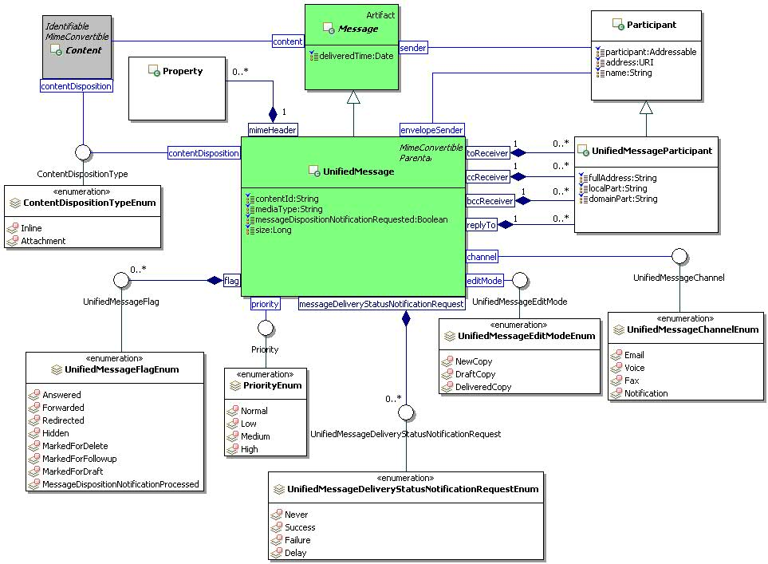
Figure 28: Unified Message Class Diagram.

InstantMessage

Description
An instant message is a type of message for synchronous, usually text based, conversation.

Class Definition
The InstantMessage class has attribute values:

localNamespace
Value: icom_msg

localName
Value: InstantMessage

extendsFrom
Value: icom_msg:Message

stereotype
Value: primary

isAbstract
Value: TRUE

description
Value: An instant message is a type of message for synchronous, usually text based, conversation.

propertyDefinitions
The values for this attribute are defined in Section 4.4.12.3.

Property Definitions
The InstantMessage class inherits property definitions from super classes.
The InstantMessage class MUST have the property definitions:

icom_msg:toReceivers
Description: A list of participants to receive a message.
Required: False
Inherited: False
Property Type: icom_core:Participant
Cardinality: Multi
Updatability: Read Write

icom_msg:conversationId
Description: An identifier of a conversation involving one or more instant messages.
Required: False
Inherited: False
Property Type: Integer
Cardinality: Single
Updatability: Read Write

icom_msg:clientSideId
Description: An identifier of a client.
Required: False
Inherited: False
Property Type: String
Cardinality: Single
Updatability: Read Write

icom_msg:formatingStyle
Description: A style for formatting a rich text message.
Required: False
Inherited: False
Property Type: String
Cardinality: Single
Updatability: Read Write

icom_msg:instantMessageType
Description: A type of instant message.
Required: False
Inherited: False
Property Type: icom_msg:InstantMessageType
Cardinality: Single
Updatability: Read Write

icom_msg:chatStatus
Description: A chat status of a user.
Required: False
Inherited: False
Property Type: icom_msg:InstantMessageChatStatus
Cardinality: Single
Updatability: Read Write

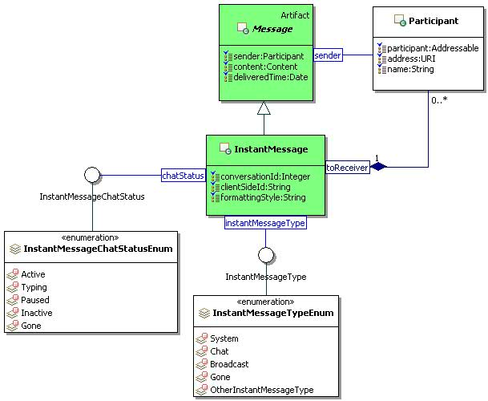
Figure 29: Instant Message Class Diagram.

InstantMessageType

Description
An instant message type.

Class Definition
The InstantMessageType class is a mixin class which defines a type of instant message.
The InstantMessageType class has attribute values:

localNamespace
Value: icom_msg

localName
Value: InstantMessageType

extendsFrom
Value:

stereotype
Value: mixin

description
Value: InstantMessageType is a mixin class which defines a type of instant message.

propertyDefinitions
The values for this attribute are defined in Section 4.4.13.3.

Property Definitions
The InstantMessageType class MAY include additional property definitions which are implementation-defined.

InstantMessageTypeEnum
The InstantMessageTypeEnum class is an enum class that enumerates the instances each of which expresses a type of instant message.
The InstantMessageTypeEnum class has attribute values:

localNamespace
Value: icom_msg

localName
Value: InstantMessageTypeEnum

extendsFrom
Value: InstantMessageType

stereotype
Value: primary

isEnumeration
Value: TRUE

description
Value: A type of instant message.

instances
Value: <icom_msg:System, icom_msg:Chat, icom_msg:Broadcast, icom_msg:Gone, icom_msg:OtherInstantMessageType>

ICOM defines five instant message types:
- icom_msg:System an instant message is a system message.
- icom_msg:Chat an instant message is a chat message.
- icom_msg:Broadcast an instant message is a broadcast message.
- icom_msg:Gone an instant message is a message indicating that a user is gone.
- icom_msg:OtherInstantMessageType an instant message is of other type.

InstantMessageChatStatus

Description
An instant message chat status defines a vocabulary of chat status.

Class Definition
The InstantMessageChatStatus class is a mixin class which defines a chat status.
The InstantMessageChatStatus class has attribute values:

localNamespace
Value: icom_msg

localName
Value: InstantMessageChatStatus

extendsFrom
Value:

stereotype
Value: mixin

description
Value: InstantMessageChatStatus is a mixin class which defines a chat status.

propertyDefinitions
The values for this attribute are defined in Section 4.4.15.3.

Property Definitions
The InstantMessageChatStatus class MAY include additional property definitions which are implementation-defined.

InstantMessageChatStatusEnum
The InstantMessageChatStatusEnum class is an enum class that enumerates the instances each of which expresses a chat status of a user.
The InstantMessageChatStatusEnum class has attribute values:

localNamespace
Value: icom_msg

localName
Value: InstantMessageChatStatusEnum

extendsFrom
Value: InstantMessageChatStatus

stereotype
Value: primary

isEnumeration
Value: TRUE

description
Value: A chat status of a user.

instances
Value: <icom_msg:Active, icom_msg:Typing, icom_msg:Paused, icom_msg:Inactive, icom_msg:Gone>

ICOM defines five chat status:
- icom_msg:Active a user is active.
- icom_msg:Typing a user is typing.
- icom_msg:Paused a user has paused.
- icom_msg:Inactive a user is inactive.
- icom_msg:Gone a user is gone.

InstantMessageFeed

Description
An instant message feed contains a set of instant message connections and a queue of outbound instant messages.

Class Definition
The InstantMessageFeed class has attribute values:

localNamespace
Value: icom_msg

localName
Value: InstantMessageFeed

extendsFrom
Value: icom_core:Entity

stereotype
Value: primary

description
Value: An instant message feed contains a set of instant message connections and a queue of outbound instant messages.

propertyDefinitions
The values for this attribute are defined in Section 4.4.17.3.

Property Definitions
The InstantMessageFeed class inherits property definitions from super classes.
The InstantMessageFeed class MUST have the property definitions:

icom_msg:connection
Description: One or more instant messaging connections.
Required: False
Inherited: False
Property Type: icom_msg:InstantMessageConnection
Cardinality: Multi
Updatability: Read Only

icom_msg:outboundInstantMessage
Description: Outbound instant messages.
Required: False
Inherited: False
Property Type: icom_msg:InstantMessage
Cardinality: Multi
Updatability: Write Only

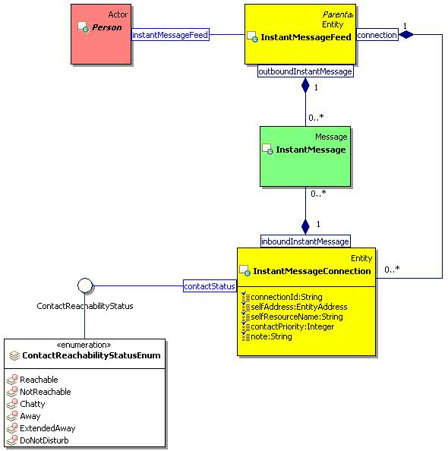
Figure 30: Instant Message Feed and Connection Class Diagram.

InstantMessageConnection

Description
An instant message connection contains queues for inbound instant messages.
A presentity can update the contact status, contact priority, and note for a contact method associated with a connection.

Class Definition
The InstantMessageConnection class has attribute values:

localNamespace
Value: icom_msg

localName
Value: InstantMessageConnection

extendsFrom
Value: icom_core:Entity

stereotype
Value: primary

description
Value: An instant message connection contains queues for inbound instant messages.

propertyDefinitions
The values for this attribute are defined in Section 4.4.18.3.

Property Definitions
The InstantMessageConnection class inherits property definitions from super classes.
The InstantMessageConnection class MUST have the property definitions:

icom_msg:connectionId
Description: An identifier of a connection.
Required: False
Inherited: False
Property Type: String
Cardinality: Single
Updatability: Read Only

icom_msg:selfAddress
Description: Address of a presentity who opens a connection.
Required: True
Inherited: False
Property Type: IRI
Cardinality: Single
Updatability: On Create

icom_msg:selfResourceName
Description: Resource name associated with a connection.
Required: True
Inherited: False
Property Type: String
Cardinality: Single
Updatability: On Create

icom_msg:inboundInstantMessage
Description: Inbound instant messages.
Required: False
Inherited: False
Property Type: icom_msg:InstantMessage
Cardinality: Multi
Updatability: Read Only

icom_presence:contactStatus
Description: Reachability status to be propagated to an associated contact method in presence.
Required: False
Inherited: False
Property Type: icom_presence:ContactReachabilityStatus
Cardinality: Single
Updatability: Write Only

icom_presence:contactPriority
Description: Priority to be propagated to an associated contact method in presence.
Required: False
Inherited: False
Property Type: Integer
Cardinality: Single
Updatability: Write Only

icom_presence:note
Description: Note to be propagated to an associated contact method in presence.
Required: False
Inherited: False
Property Type: String
Cardinality: Single
Updatability: Write Only

Presence Module

Presence

Description
A presence describes the contact methods and activities of a presentity.
It provides a list of contact methods describing how to contact a presentity. A viewer may choose any one of the contact methods based on circumstances.
It includes a list of activities describing what a presentity is doing.

Class Definition
The Presence class has attribute values:

localNamespace
Value: icom_presence

localName
Value: Presence

extendsFrom
Value: icom_core:Identifiable

stereotype
Value: primary

description
Value: A presence describes the contact methods and activities of a presentity.

propertyDefinitions
The values for this attribute are defined in Section 4.5.1.3.

Property Definitions
The Presence class inherits property definitions from super classes.
The Presence class MUST have the property definitions:

icom_core:lastModificationDate
Description: Last modification date and time of information in a presence.
Required: False
Inherited: False
Property Type: DateTime
Cardinality: Single
Updatability: Read Only

icom_core:location
Description: Location of a presentity.
Required: False
Inherited: False
Property Type: icom_core:Location
Cardinality: Single
Updatability: Read Only

icom_presence:editMode
Description: Indicates a mode which determines whether a presence is editable.
Required: False
Inherited: False
Property Type: icom_presence:PresenceEditMode
Cardinality: Single
Updatability: Read Only

icom_presence:contactMethod
Description: A collection of contact methods describing how to contact a presentity. A viewer may choose any one of the contact methods based on circumstances.
Required: False
Inherited: False
Property Type: icom_presence:ContactMethod
Cardinality: Multi
Updatability: Read Only

icom_presence:activity
Description: A collection of activities describing what a presentity is doing.
Required: False
Inherited: False
Property Type: icom_presence:Activity
Cardinality: Multi
Updatability: Read Only

The Presence class MAY include additional property definitions which are implementation-defined.

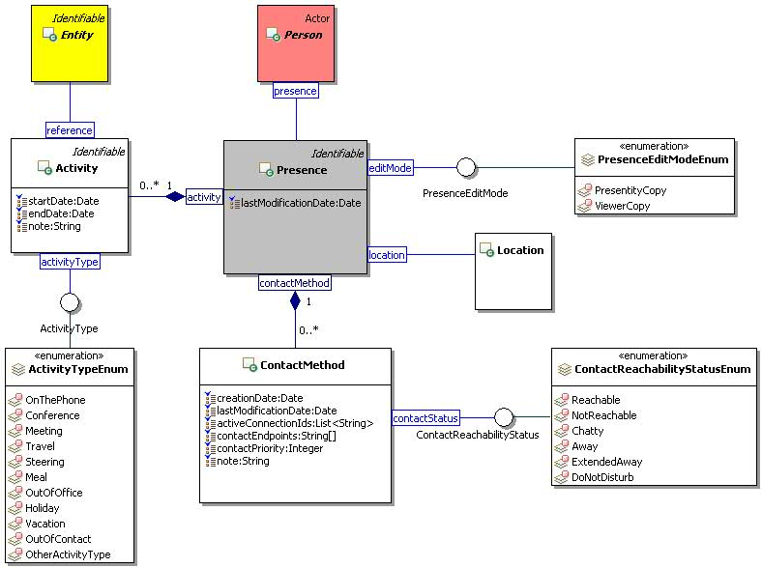
Figure 31: Presence Class Diagram.

PresenceEditMode

Description
A presence edit mode is a mode that indicates whether a presence is editable.

Class Definition
The PresenceEditMode class is a mixin class which defines a mode that indicates whether a presence is editable.
The PresenceEditMode class has attribute values:

localNamespace
Value: icom_presence

localName
Value: PresenceEditMode

extendsFrom
Value:

stereotype
Value: mixin

description
Value: PresenceEditMode is a mixin class which defines a mode that indicates whether a presence is editable.

propertyDefinitions
The values for this attribute are defined in Section 4.5.2.3.

Property Definitions
The PresenceEditMode class MAY include additional property definitions which are implementation-defined.

PresenceEditModeEnum
The PresenceEditModeEnum class is an enum class that enumerates the instances each of which expresses a mode that indicates whether a presence is editable.
The PresenceEditModeEnum class has attribute values:

localNamespace
Value: icom_presence

localName
Value: PresenceEditModeEnum

extendsFrom
Value: PresenceEditMode

stereotype
Value: primary

isEnumeration
Value: TRUE

description
Value: A mode that indicates whether a presence is editable.

instances
Value: <icom_presence:PresentityCopy, icom_presence:ViewerCopy>

ICOM defines two presence editable modes:
- icom_presence:PresentityCopy a presence is a copy belonging to a presentity who may update the properties such as activities.
- icom_presence:ViewerCopy a presence is a copy visible to a subscriber who may not update the properties.

ContactMethod

Description
A contact method object describes reachability circumstances of a presentity.

Class Definition
The ContactMethod class has attribute values:

localNamespace
Value: icom_presence

localName
Value: ContactMethod

extendsFrom
Value:

stereotype
Value: primary

description
Value: A contact method object describes reachability circumstances of a presentity.

propertyDefinitions
The values for this attribute are defined in Section 4.5.4.3

Property Definitions
The ContactMethod class MUST have the property definitions:

icom_core:creationDate
Description: Creation date and time of information in a contact method.
Required: False
Inherited: False
Property Type: DateTime
Cardinality: Single
Updatability: Read Only

icom_core:lastModificationDate
Description: Last modification date and time of information in a contact method.
Required: False
Inherited: False
Property Type: DateTime
Cardinality: Single
Updatability: Read Only

icom_presence:activeConnectionId
Description: A list of active connection ids of a presentity.
Required: False
Inherited: False
Property Type: String
Cardinality: Multi
Updatability: Read Only

icom_presence:contactEndpoint
Description: A list of endpoints or IRIs for contacting a presentity.
Required: False
Inherited: False
Property Type: String
Cardinality: Multi
Updatability: Read Only

icom_presence:contactPriority
Description: Priority of a contact method relative to other contact methods in a presence.
Required: False
Inherited: False
Property Type: Integer
Cardinality: Single
Updatability: Read Only

icom_presence:contactStatus
Description: Status of a contact method in a presence.
Required: False
Inherited: False
Property Type: icom_presence:ContactReachabilityStatus
Cardinality: Single
Updatability: Read Only

icom_presence:note
Description: A note about contacting a presentity.
Required: False
Inherited: False
Property Type: String
Cardinality: Single
Updatability: Read Only

ContactReachabilityStatus

Description
A contact reachability status is a status of a contact method.

Class Definition
The ContactReachabilityStatus class is a mixin class which defines a status of a contact method.
The ContactReachabilityStatus class has attribute values:

localNamespace
Value: icom_presence

localName
Value: ContactReachabilityStatus

extendsFrom
Value:

stereotype
Value: mixin

description
Value: ContactReachabilityStatus is a mixin class which defines a status of a contact method.

propertyDefinitions
The values for this attribute are defined in Section 4.5.5.3.

Property Definitions
The ContactReachabilityStatus class MAY include additional property definitions which are implementation-defined.

ContactReachabilityStatusEnum
The ContactReachabilityStatusEnum class is an enum class that enumerates the instances each of which expresses a reachability status of a contact method.
The ContactReachabilityStatusEnum class has attribute values:

localNamespace
Value: icom_presence

localName
Value: ContactReachabilityStatusEnum

extendsFrom
Value: ContactReachabilityStatus

stereotype
Value: primary

isEnumeration
Value: TRUE

description
Value: A reachability status of a contact method.

instances
Value: <icom_presence:Reachable, icom_presence:NotReachable, icom_presence:Chatty, icom_presence:Away, icom_presence:ExtendedAway, icom_presence:DoNotDisturb>

ICOM defines six reachability status:
- icom_presence:Reachable a presentity is reachable through a contact method.
- icom_presence:NotReachable a presentity is not reachable through a contact method.
- icom_presence:Chatty a presentity is chatty.
- icom_presence:Away a presentity is away.
- icom_presence:ExtendedAway a presentity is away for an extended period.
- icom_presence:DoNotDisturb a presentity prefers not to be disturbed.

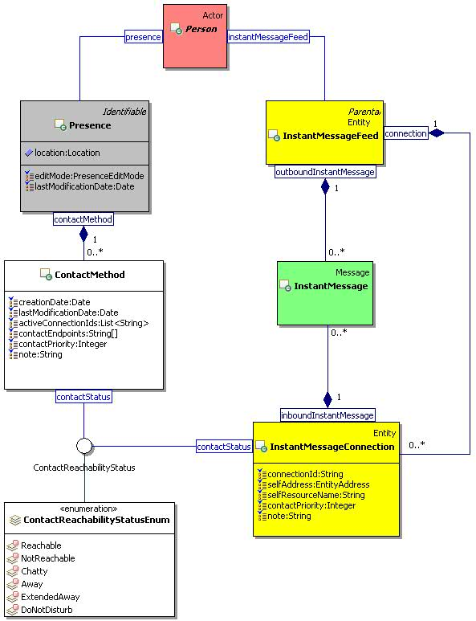
Figure 32: Presence Contact Method and Instant Message Connection Class Diagram.

Activity

Description
An activity object describes what a presentity is doing.

Class Definition
The Activity class has attribute values:

localNamespace
Value: icom_presence

localName
Value: Activity

extendsFrom
Value:

stereotype
Value: primary

description
Value: An activity object describes what a presentity is doing.

propertyDefinitions
The values for this attribute are defined in Section 4.5.7.3.

Property Definitions
The Activity class MUST have the property definitions:

icom_core:startDate
Description: Start date and time of an activity.
Required: True
Inherited: False
Property Type: DateTime
Cardinality: Single
Updatability: Read Write

icom_core:endDate
Description: End date and time of an activity.
Required: True
Inherited: False
Property Type: DateTime
Cardinality: Single
Updatability: Read Write

icom_presence:activityType
Description: Type of an activity.
Required: true
Inherited: False
Property Type: icom_presence:ActivityType
Cardinality: Single
Updatability: Read Write

icom_presence:note
Description: A note describing an activity.
Required: False
Inherited: False
Property Type: String
Cardinality: Single
Updatability: Read Write

icom_presence:reference
Description: An entity, such as occurrence, task, conference, etc., which is the source of or reference for an activity.
Required: False
Inherited: False
Property Type: icom_core:Entity
Cardinality: Single
Updatability: Read Write

ActivityType

Description
An activity type is a vocabulary of activities for rich presence information model.

Class Definition
The ActivityType class is a mixin class which defines an activity.
The ActivityType class has attribute values:

localNamespace
Value: icom_presence

localName
Value: ActivityType

extendsFrom
Value:

stereotype
Value: mixin

description
Value: ActivityType is a mixin class which defines a type of activity.

propertyDefinitions
The values for this attribute are defined in Section 4.5.8.3.

Property Definitions
The ActivityType class MAY include additional property definitions which are implementation-defined.

ActivityTypeEnum
The ActivityTypeEnum class is an enum class that enumerates the instances each of which expresses a type of activity.
The ActivityTypeEnum class has attribute values:

localNamespace
Value: icom_presence

localName
Value: ActivityTypeEnum

extendsFrom
Value: ActivityType

stereotype
Value: primary

isEnumeration
Value: TRUE

description
Value: A type of activity.

instances
Value: <icom_presence:OnThePhone, icom_presence:Conference, icom_presence:Meeting, icom_presence:Travel, icom_presence:Steering, icom_presence:Meal, icom_presence:OutOfOffice, icom_presence:Holiday, icom_presence:Vacation, icom_presence:OutOfContact, icom_presence:OtherActivityType>

ICOM defines eleven activity types:
- icom_presence:OnThePhone a presentity is on the phone.
- icom_presence:Conference a presentity is in a conference.
- icom_presence:Meeting a presentity is in a meeting.
- icom_presence:Travel a presentity is traveling.
- icom_presence:Steering a presentity is steering a vehicle.
- icom_presence:Meal a presentity is having a meal.
- icom_presence:OutOfOffice a presentity is out of office.
- icom_presence:Holiday a presentity is on holiday.
- icom_presence:Vacation a presentity is on vacation.
- icom_presence:OutOfContact a presentity is out of contact.
- icom_presence:OtherActivityType a presentity is involved in an unspecified activity.

Address Book Module

AddressBook

Description
An address book is a folder that contains sub-address books and addressable contacts.

Class Definition
The AddressBook class has attribute values:

localNamespace
Value: icom_card

localName
Value: AddressBook

extendsFrom
Value: icom_core:Folder

stereotype
Value: primary

description
Value: An address book is a folder that contains sub-address books and addressable contacts.

propertyDefinitions
The values for this attribute are defined in Section 4.6.1.3.

Property Definitions
The AddressBook class inherits property definitions from super classes.
The AddressBook class MUST have the property definitions:

icom_card:addressBook
Description: Sub-address books in an address book.
Required: False
Inherited: False
Property Type: icom_card:AddressBook
Cardinality: Multi
Updatability: Read Only

icom_card:contact
Description: Contacts in an address book.
Required: False
Inherited: False
Property Type: icom_card:PersonContact
Cardinality: Multi
Updatability: Read Only

The AddressBook class MAY include additional property definitions which are implementation-defined.

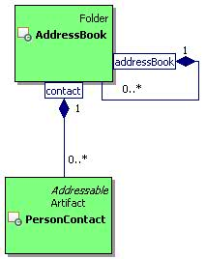
Figure 33: Address Book Class Diagram.

PersonContact

Description
A person contact is an artifact that contains address information about a person.

Class Definition
The PersonContact class has attribute values:

localNamespace
Value: icom_card

localName
Value: PersonContact

extendsFrom
Value: icom_core:Artifact, icom_core:Addressable

stereotype
Value: primary

description
Value: A person contact is an artifact that contains address information about a person.

propertyDefinitions
The values for this attribute are defined in Section 4.6.2.3.

Property Definitions
The PersonContact class inherits property definitions from super classes.
The PersonContact class MUST have the property definitions:

icom_core:timeZone
Description: Time zone of a person.
Required: False
Inherited: False
Property Type: icom_core:TimeZone
Cardinality: Single
Updatability: Read Write

icom_core:givenName
Description: Given name of a person.
Required: False
Inherited: False
Property Type: String
Cardinality: Single
Updatability: Read Write

icom_core:middleName
Description: Middle name of a person. Can include multiple names concatenated.
Required: False
Inherited: False
Property Type: String
Cardinality: Single
Updatability: Read Write

icom_core:familyName
Description: Family name of a person.
Required: False
Inherited: False
Property Type: String
Cardinality: Single
Updatability: Read Write

icom_core:prefix
Description: Prefix of a person’s name.
Required: False
Inherited: False
Property Type: String
Cardinality: Single
Updatability: Read Write

icom_core:suffix
Description: Suffix of a person’s name.
Required: False
Inherited: False
Property Type: String
Cardinality: Single
Updatability: Read Write

icom_core:nickname
Description: Nickname of a person.
Required: False
Inherited: False
Property Type: String
Cardinality: Multi
Updatability: Read Write

icom_core:jobTitle
Description: Job title of a person.
Required: False
Inherited: False
Property Type: String
Cardinality: Single
Updatability: Read Write

icom_core:department
Description: A person’s affiliated department.
Required: False
Inherited: False
Property Type: String
Cardinality: Single
Updatability: Read Write

icom_core:officeLocation
Description: Location of a person’s department.
Required: False
Inherited: False
Property Type: String
Cardinality: Single
Updatability: Read Write

icom_core:company
Description: A person’s affiliated company.
Required: False
Inherited: False
Property Type: String
Cardinality: Single
Updatability: Read Write

icom_core:profession
Description: A person’s profession.
Required: False
Inherited: False
Property Type: String
Cardinality: Single
Updatability: Read Write

icom_content:attachment
Description: One or more content attachments in a contact.
Required: False
Inherited: False
Property Type: icom_content:Attachment
Cardinality: Multi
Updatability: Read Write

icom_card:bookmark
Description: A person which is bookmarked by a contact.
Required: False
Inherited: False
Property Type: icom_core:Person
Cardinality: Single
Updatability: On Create

The PersonContact class MAY include additional property definitions which are implementation-defined.

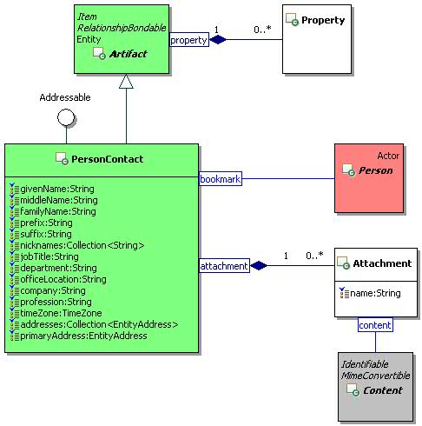
Figure 34: Person Contact Class Diagram.

Calendar Module

Calendar

Description
A calendar contains time management artifacts that include occurrences and occurrence series.

Class Definition
The Calendar class has attribute values:

localNamespace
Value: icom_cal

localName
Value: Calendar

extendsFrom
Value: icom_core:Folder

stereotype
Value: primary

description
Value: A calendar contains time management artifacts that include occurrences and occurrence series.

propertyDefinitions
The values for this attribute are defined in 4.7.1.3.

Property Definitions
The Calendar class inherits property definitions from super classes.
The Calendar class MUST have the property definitions:

icom_core:timeZone
Description: Time zone setting for a calendar.
Required: True
Inherited: False
Property Type: icom_core:TimeZone
Cardinality: Single
Updatability: Read Write

icom_core:element
Description: Elements of a calendar.
Required: False
Inherited: True
Property Type: icom_cal:Occurrence
Cardinality: Multi
Updatability: Read Only

icom_cal:recurrence
Description: Occurrence series of a calendar.
Required: False
Inherited: False
Property Type: icom_cal:OccurrenceSeries
Cardinality: Multi
Updatability: Read Only

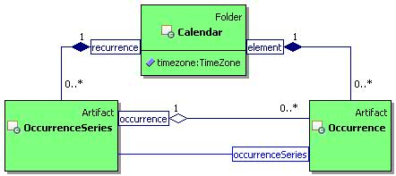
Figure 35: Calendar Class Diagram.

OccurrenceSeries

Description
An occurrence series represents a series of occurrences associated with the same calendar event.

Class Definition
The OccurrenceSeries class has attribute values:

localNamespace
Value: icom_cal

localName
Value: OccurrenceSeries

extendsFrom
Value: icom_core:Artifact

stereotype
Value: primary

description
Value: An occurrence series represents a series of occurrences associated with the same calendar event.

propertyDefinitions
The values for this attribute are defined in 4.7.2.3.

Property Definitions
The OccurrenceSeries class inherits property definitions from super classes.
The OccurrenceSeries class MUST have the property definitions:

icom_core:location
Description: Location of an occurrence series.
Required: False
Inherited: False
Property Type: icom_core:Location
Cardinality: Single
Updatability: Read Write

icom_core:organizer
Description: Organizer of an occurrence series.
Required: True
Inherited: False
Property Type: icom_core:Participant
Cardinality: Single
Updatability: On Create

icom_core:participant
Description: Participants in an occurrence series.
Required: False
Inherited: False
Property Type: icom_cal:OccurrenceParticipant
Cardinality: Multi
Updatability: Read Write

icom_core:priority
Description: Priority for an attendee of an occurrence series.
Required: False
Inherited: False
Property Type: icom_core:Priority
Cardinality: Single
Updatability: Read Write

icom_content:attachment
Description: One or more content attachments in an occurrence series.
Required: False
Inherited: False
Property Type: icom_content:Attachment
Cardinality: Multi
Updatability: Read Write

icom_cal:recurrenceStartDate
Description: Start date and time of an occurrence series.
Required: True
Inherited: False
Property Type: DateTime
Cardinality: Single
Updatability: On Create

icom_cal:recurrenceStartDateResolution
Description: Resolution of start date and time of an occurrence series.
Required: True
Inherited: False
Property Type: icom_core:DateTimeResolution
Cardinality: Single
Updatability: On Create

icom_cal:duration
Description: Duration of each occurrence in an occurrence series.
Required: True
Inherited: False
Property Type: Duration
Cardinality: Single
Updatability: On Create

icom_cal:recurrenceRule
Description: A recurrence rule of an occurrence series.
Required: True
Inherited: False
Property Type: String
Cardinality: Single
Updatability: On Create

icom_cal:occurrenceStatus
Description: Status of an occurrence series.
Required: True
Inherited: False
Property Type: icom_cal:OccurrenceStatus
Cardinality: Single
Updatability: Read Write

icom_cal:occurrenceType
Description: Type of an occurrence series.
Required: True
Inherited: False
Property Type: icom_cal:OccurrenceType
Cardinality: Single
Updatability: Read Write

icom_cal:editMode
Description: Indicates a mode which determines whether an occurrence series is editable.
Required: False
Inherited: False
Property Type: icom_cal:OccurrenceEditMode
Cardinality: Single
Updatability: Read Only

icom_cal:occurrence
Description: Occurrences in an occurrence series.
Required: False
Inherited: False
Property Type: icom_cal:Occurrence
Cardinality: Multi
Updatability: Read Only

icom_cal:attendee
Description: An attendee of an occurrence series.
Required: False
Inherited: False
Property Type: icom_core:Participant
Cardinality: Single
Updatability: Read Only

icom_cal:attendeeParticipantStatus
Description: Participation status for an attendee of an occurrence series.
Required: False
Inherited: False
Property Type: icom_cal:OccurrenceParticipantStatus
Cardinality: Single
Updatability: Read Write

icom_cal:transparency
Description: Participant transparency for an attendee of an occurrence series.
Required: False
Inherited: False
Property Type: icom_cal:OccurrenceParticipantTransparency
Cardinality: Single
Updatability: Read Write

icom_cal:attendeeProperty
Description: Extensible properties for an attendee of an occurrence series.
Required: False
Inherited: False
Property Type: icom_meta:Property
Cardinality: Multi
Updatability: Read Write

icom_conf:conference
Description: One or more conferences for an occurrence series.
Required: False
Inherited: False
Property Type: icom_conf:Conference
Cardinality: Multi
Updatability: Read Write

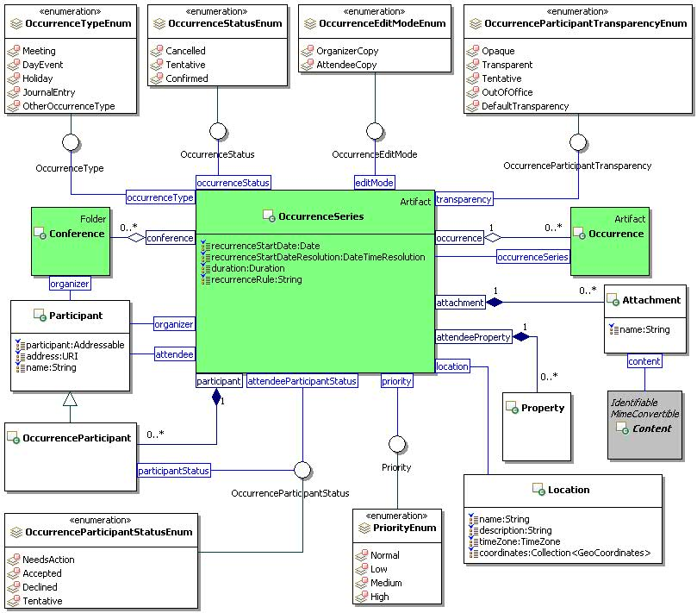
Figure 36: Occurrence Series Class Diagram.

Occurrence

Description
An occurrence represents an event in a calendar.

Class Definition
The Occurrence class has attribute values:

localNamespace
Value: icom_cal

localName
Value: Occurrence

extendsFrom
Value: icom_core:Artifact

stereotype
Value: primary

description
Value: An occurrence represents an event in a calendar.

propertyDefinitions
The values for this attribute are defined in 4.7.3.3.

Property Definitions
The Occurrence class inherits property definitions from super classes.
The Occurrence class MUST have the property definitions:

icom_core:location
Description: Location of an occurrence.
Required: False
Inherited: False
Property Type: icom_core:Location
Cardinality: Single
Updatability: Read Write

icom_core:organizer
Description: Organizer of an occurrence.
Required: True
Inherited: False
Property Type: icom_core:Participant
Cardinality: Single
Updatability: On Create

icom_core:participant
Description: Participants of an occurrence.
Required: False
Inherited: False
Property Type: icom_cal:OccurrenceParticipant
Cardinality: Multi
Updatability: Read Write

icom_core:priority
Description: Priority for an attendee of an occurrence.
Required: False
Inherited: False
Property Type: icom_core:Priority
Cardinality: Single
Updatability: Read Write

icom_core:startDate
Description: Start date and time of an occurrence.
Required: True
Inherited: False
Property Type: DateTime
Cardinality: Single
Updatability: On Create

icom_core:startDateResolution
Description: Resolution of start date and time of an occurrence.
Required: True
Inherited: False
Property Type: icom_core:DateTimeResolution
Cardinality: Single
Updatability: On Create

icom_core:endDate
Description: End date and time of an occurrence.
Required: True
Inherited: False
Property Type: DateTime
Cardinality: Single
Updatability: On Create

icom_core:endDateResolution
Description: Resolution of end date and time of an occurrence.
Required: True
Inherited: False
Property Type: icom_core:DateTimeResolution
Cardinality: Single
Updatability: On Create

icom_content:attachment
Description: One or more content attachments in an occurrence.
Required: False
Inherited: False
Property Type: icom_content:Attachment
Cardinality: Multi
Updatability: Read Write

icom_cal:occurrenceSeries
Description: An occurrence is part of this occurrence series.
Required: False
Inherited: False
Property Type: icom_cal:OccurrenceSeries
Cardinality: Single
Updatability: Read Only

icom_cal:fromRecurringOccurrenceSeries
Description: Occurrence is part of a recurring occurrence series.
Required: False
Inherited: False
Property Type: Boolean
Cardinality: Single
Updatability: Read Only

icom_cal:exceptionToOccurrenceSeries
Description: Occurrence is an exception to an occurrence series.
Required: False
Inherited: False
Property Type: Boolean
Cardinality: Single
Updatability: Read Only

icom_cal:occurrenceStatus
Description: Status of an occurrence.
Required: True
Inherited: False
Property Type: icom_cal:OccurrenceStatus
Cardinality: Single
Updatability: Read Write

icom_cal:occurrenceType
Description: Type of an occurrence.
Required: True
Inherited: False
Property Type: icom_cal:OccurrenceType
Cardinality: Single
Updatability: Read Write

icom_cal:editMode
Description: Indicates a mode which determines whether an occurrence is editable.
Required: False
Inherited: False
Property Type: icom_cal:OccurrenceEditMode
Cardinality: Single
Updatability: Read Only

icom_cal:attendee
Description: An attendee of an occurrence.
Required: False
Inherited: False
Property Type: icom_core:Participant
Cardinality: Single
Updatability: Read Only

icom_cal:attendeeParticipantStatus
Description: Status for an attendee of an occurrence.
Required: False
Inherited: False
Property Type: icom_cal:OccurrenceParticipantStatus
Cardinality: Single
Updatability: Read Write

icom_cal:transparency
Description: Transparency for an attendee of an occurrence.
Required: False
Inherited: False
Property Type: icom_cal:OccurrenceParticipantTransparency
Cardinality: Single
Updatability: Read Write

icom_cal:attendeeProperty
Description: Extensible properties for an attendee of an occurrence.
Required: False
Inherited: False
Property Type: icom_meta:Property
Cardinality: Multi
Updatability: Read Write

icom_conf:conference
Description: One or more conferences for an occurrence.
Required: False
Inherited: False
Property Type: icom_conf:Conference
Cardinality: Multi
Updatability: Read Write

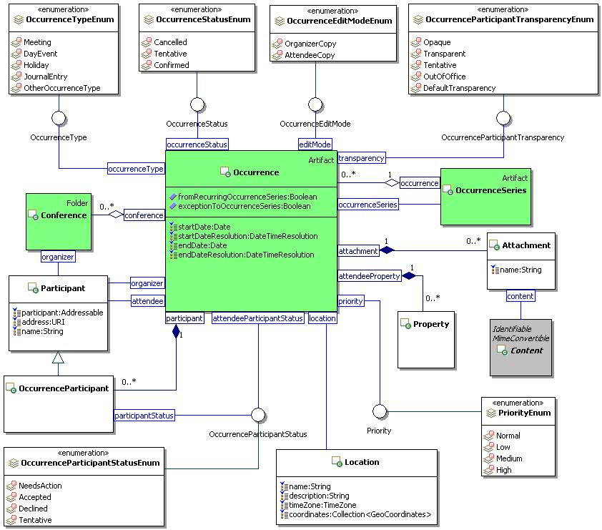
Figure 37: Occurrence Class Diagram.

OccurrenceStatus

Description
An occurrence status is a status of a calendar occurrence.

Class Definition
The OccurrenceStatus class is a mixin class which defines status of a calendar occurrence.
The OccurrenceStatus class has attribute values:

localNamespace
Value: icom_cal

localName
Value: OccurrenceStatus

extendsFrom
Value:

stereotype
Value: mixin

description
Value: OccurrenceStatus is a mixin class which defines status of a calendar occurrence.

propertyDefinitions
The values for this attribute are defined in Section 4.7.4.3.

Property Definitions
The OccurrenceStatus class MAY include additional property definitions which are implementation-defined.

OccurrenceStatusEnum
The OccurrenceStatusEnum class is an enum class that enumerates the instances each of which expresses a status of an occurrence or occurrence series.
The OccurrenceStatusEnum class has attribute values:

localNamespace
Value: icom_cal

localName
Value: OccurrenceStatusEnum

extendsFrom
Value: OccurrenceStatus

stereotype
Value: primary

isEnumeration
Value: TRUE

description
Value: Status of an occurrence or occurrence series.

instances
Value: <icom_cal:Cancelled, icom_cal:Tentative, icom_cal:Confirmed>

ICOM defines three occurrence status:
- icom_cal:Cancelled an occurrence or occurrence series is cancelled.
- icom_cal:Tentative an occurrence or occurrence series is tentative.
- icom_cal:Confirmed an occurrence or occurrence series is confirmed.

OccurrenceType

Description
An occurrence type is a category of calendar occurrences.

Class Definition
The OccurrenceType class is a mixin class which defines a type of occurrence.
The OccurrenceType class has attribute values:

localNamespace
Value: icom_cal

localName
Value: OccurrenceType

extendsFrom
Value:

stereotype
Value: mixin

description
Value: OccurrenceType is a mixin class which defines a type of occurrence.

propertyDefinitions
The values for this attribute are defined in Section 4.7.6.3.

Property Definitions
The OccurrenceType class MAY include additional property definitions which are implementation-defined.

OccurrenceTypeEnum
The OccurrenceTypeEnum class is an enum class that enumerates the instances each of which expresses a type of an occurrence or occurrence series.
The OccurrenceTypeEnum class has attribute values:

localNamespace
Value: icom_cal

localName
Value: OccurrenceTypeEnum

extendsFrom
Value: OccurrenceType

stereotype
Value: primary

isEnumeration
Value: TRUE

description
Value: Type of an occurrence or occurrence series.

instances
Value: <icom_cal:Meeting, icom_cal:DayEvent, icom_cal:Holiday, icom_cal:JournalEntry, icom_cal:OtherOccurrenceType>

ICOM defines five occurrence types:
- icom_cal:Meeting an occurrence or occurrence series is a meeting.
- icom_cal:DayEvent an occurrence or occurrence series is a day event.
- icom_cal:Holiday an occurrence or occurrence series is a holiday.
- icom_cal:JournalEntry an occurrence or occurrence series is a journal entry.
- icom_cal:OtherOccurrenceType an occurrence or occurrence series is of other type.

OccurrenceParticipant

Description
An occurrence participant object is a participant object that contains an occurrence participant status.

Class Definition
The OccurrenceParticipant class has attribute values:

localNamespace
Value: icom_cal

localName
Value: OccurrenceParticipant

extendsFrom
Value: icom_core:Participant

stereotype
Value: primary

description
Value: An occurrence participant object is a participant object that contains an occurrence participant status.

propertyDefinitions
The values for this attribute are defined in Section 4.7.8.3.

Property Definitions
The OccurrenceParticipant class inherits property definitions from super classes.
The OccurrenceParticipant class MUST have the property definition:

icom_cal:participantStatus
Description: Status of an occurrence participant.
Required: False
Inherited: False
Property Type: icom_cal:OccurrenceParticipantStatus
Cardinality: Single
Updatability: Read Write

OccurrenceParticipantStatus

Description
An occurrence participant status is a participant’s response status for an occurrence or occurrence series.

Class Definition
The OccurrenceParticipantStatus class is a mixin class which defines a participant’s response status for an occurrence or occurrence series.
The OccurrenceParticipantStatus class has attribute values:

localNamespace
Value: icom_cal

localName
Value: OccurrenceParticipantStatus

extendsFrom
Value:

stereotype
Value: mixin

description
Value: OccurrenceParticipantStatus is a mixin class which defines a participant’s response status for an occurrence or occurrence series.

propertyDefinitions
The values for this attribute are defined in Section 4.7.9.3.

Property Definitions
The OccurrenceParticipantStatus class MAY include additional property definitions which are implementation-defined.

OccurrenceParticipantStatusEnum
The OccurrenceParticipantStatusEnum class is an enum class that enumerates the instances each of which expresses a participant’s response status for an occurrence or occurrence series.
The OccurrenceParticipantStatusEnum class has attribute values:

localNamespace
Value: icom_cal

localName
Value: OccurrenceParticipantStatusEnum

extendsFrom
Value: OccurrenceParticipantStatus

stereotype
Value: primary

isEnumeration
Value: TRUE

description
Value: Participant’s response status for an occurrence or occurrence series.

instances
Value: <icom_cal:NeedsAction, icom_cal:Accepted, icom_cal:Declined, icom_cal:Tentative>

ICOM defines four occurrence participant’s status:
- icom_cal:NeedsAction an attendee needs to act on an occurrence or occurrence series.
- icom_cal:Accepted an attendee accepted an occurrence or occurrence series.
- icom_cal:Declined an attendee declined an occurrence or occurrence series.
- icom_cal:Tentative an attendee is tentative about attending an occurrence or occurrence series.

OccurrenceParticipantTransparency

Description
An occurrence participant transparency is visibility of an occurrence or occurrence series in a participant’s calendar or free busy.

Class Definition
The OccurrenceParticipantTransparency class is a mixin class which defines visibility of an occurrence or occurrence series in a participant’s calendar or free busy.
The OccurrenceParticipantTransparency class has attribute values:

localNamespace
Value: icom_cal

localName
Value: OccurrenceParticipantTransparency

extendsFrom
Value:

stereotype
Value: mixin

description
Value: OccurrenceParticipantTransparency is a mixin class which defines visibility of an occurrence or occurrence series in a participant’s calendar or free busy.

propertyDefinitions
The values for this attribute are defined in Section 4.7.11.3.

Property Definitions
The OccurrenceParticipantTransparency class MAY include additional property definitions which are implementation-defined.

OccurrenceParticipantTransparencyEnum
The OccurrenceParticipantTransparencyEnum class is an enum class that enumerates the instances each of which expresses an occurrence or occurrence series transparency in a participant’s calendar or free busy.
The OccurrenceParticipantTransparencyEnum class has attribute values:

localNamespace
Value: icom_cal

localName
Value: OccurrenceParticipantTransparencyEnum

extendsFrom
Value: OccurrenceParticipantTransparency

stereotype
Value: primary

isEnumeration
Value: TRUE

description
Value: Occurrence or occurrence series transparency in a participant’s calendar or free busy.

instances
Value: <icom_cal:Opaque, icom_cal:Transparent, icom_cal:Tentative, icom_cal:OutOfOffice, icom_cal:DefaultTransparency>

ICOM defines five participant transparencies:
- icom_cal:Opaque an occurrence or occurrence series is opaque in a participant’s calendar or free busy.
- icom_cal:Transparent an occurrence or occurrence series is transparent in a participant’s calendar or free busy.
- icom_cal:Tentative an occurrence or occurrence series has a tentative transparency in a participant’s calendar or free busy.
- icom_cal:OutOfOffice an occurrence or occurrence series has out of office transparency in a participant’s calendar or free busy.
- icom_cal:DefaultTransparency an occurrence or occurrence series has default transparency in a participant’s calendar or free busy.

OccurrenceEditMode

Description
An occurrence edit mode is a mode that indicates whether an occurrence or occurrence series is editable.

Class Definition
The OccurrenceEditMode class is a mixin class which defines a mode that indicates whether an occurrence or occurrence series is editable.
The OccurrenceEditMode class has attribute values:

localNamespace
Value: icom_cal

localName
Value: OccurrenceEditMode

extendsFrom
Value:

stereotype
Value: mixin

description
Value: OccurrenceEditMode is a mixin class which defines a mode that indicates whether an occurrence or occurrence series is editable.

propertyDefinitions
The values for this attribute are defined in Section 4.7.13.3.

Property Definitions
The OccurrenceEditMode class MAY include additional property definitions which are implementation-defined.

OccurrenceEditModeEnum
The OccurrenceEditModeEnum class is an enum class that enumerates the instances each of which expresses a mode that indicates whether an occurrence or occurrence series is editable.
The OccurrenceEditModeEnum class has attribute values:

localNamespace
Value: icom_cal

localName
Value: OccurrenceEditModeEnum

extendsFrom
Value: OccurrenceEditMode

stereotype
Value: primary

isEnumeration
Value: TRUE

description
Value: A mode that indicates whether an occurrence or occurrence series is editable.

instances
Value: <icom_cal:OrganizerCopy, icom_cal:AttendeeCopy>

ICOM defines two occurrence editable modes:
- icom_cal:OrganizerCopy an occurrence or occurrence series is a copy created by an organizer who may update the properties such as occurrence type, occurrence status, etc.
- icom_cal:AttendeeCopy an occurrence or occurrence series is a copy delivered to an attendee who may only update the attendee properties such as priority, transparency, etc .

Free Busy Module

FreeBusy

Description
A free busy object specifies the free time and busy time intervals of one or more participants.

Class Definition
The FreeBusy class has attribute values:

localNamespace
Value: icom_cal

localName
Value: FreeBusy

extendsFrom
Value:

stereotype
Value: primary

description
Value: A free busy object specifies the free time and busy time intervals of one or more participants.

propertyDefinitions
The values for this attribute are defined in Section 4.8.1.3.

Property Definitions
The FreeBusy class MUST have the property definitions:

icom_core:participant
Description: A list of participants whose free busy intervals are included.
Required: False
Inherited: False
Property Type: icom_core:Participant
Cardinality: Multi
Updatability: Read Only

icom_core:creationDate
Description: Creation date and time of a free busy object.
Required: False
Inherited: False
Property Type: DateTime
Cardinality: Single
Updatability: Read Only

icom_core:startDate
Description: Start date and time of a list of free busy intervals.
Required: False
Inherited: False
Property Type: DateTime
Cardinality: Single
Updatability: Read Only

icom_core:endDate
Description: End date and time of a list of free busy intervals.
Required: False
Inherited: False
Property Type: DateTime
Cardinality: Single
Updatability: Read Only

icom_cal:interval
Description: A list of free busy intervals.
Required: False
Inherited: False
Property Type: icom_cal:FreeBusyInterval
Cardinality: Multi
Updatability: Read Only

FreeBusyInterval

Description
A free busy interval specifies an interval of free or busy time.
If a free busy type is icom_cal:Free, then a time interval is free for scheduling.
If a free busy type is icom_cal:Busy, then a time interval is busy because one or more events have been scheduled for the interval.

Class Definition
The FreeBusyInterval class has attribute values:

localNamespace
Value: icom_cal

localName
Value: FreeBusyInterval

extendsFrom
Value:

stereotype
Value: primary

description
Value: A free busy interval object specifies an interval of free or busy time.

propertyDefinitions
The values for this attribute are defined in Section 4.8.2.3

Property Definitions
The FreeBusyInterval class MUST have the property definitions:

icom_core:startDate
Description: Start date and time of a free busy interval.
Required: False
Inherited: False
Property Type: DateTime
Cardinality: Single
Updatability: Read Only

icom_core:endDate
Description: End date and time of a free busy interval.
Required: False
Inherited: False
Property Type: DateTime
Cardinality: Single
Updatability: Read Only

icom_cal:freeBusyType
Description: A type of free busy interval.
Required: False
Inherited: False
Property Type: icom_cal:FreeBusyType
Cardinality: Single
Updatability: Read Only

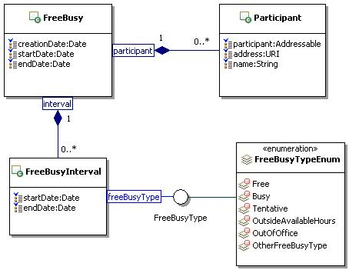
Figure 38: Free Busy Class Diagram.

FreeBusyType

Description
A free busy type classifies a time interval as free, busy, or other.

Class Definition
The FreeBusyType class is a mixin class which defines different types to classify a time interval.
The FreeBusyType class has attribute values:

localNamespace
Value: icom_cal

localName
Value: FreeBusyType

extendsFrom
Value:

stereotype
Value: mixin

description
Value: FreeBusyType is a mixin class which defines different types to classify a time interval.

propertyDefinitions
The values for this attribute are defined in Section 4.8.3.3.

Property Definitions
The FreeBusyType class MAY include additional property definitions which are implementation-defined.

FreeBusyTypeEnum
The FreeBusyTypeEnum class is an enum class that enumerates the instances each of which expresses a type of free busy interval.
The FreeBusyTypeEnum class has attribute values:

localNamespace
Value: icom_cal

localName
Value: FreeBusyTypeEnum

extendsFrom
Value: FreeBusyType

stereotype
Value: primary

isEnumeration
Value: TRUE

description
Value: A type of free busy interval.

instances
Value: <icom_cal:Free, icom_cal:Busy, icom_cal:Tentative, icom_cal:OutsideAvailableHours, icom_cal:OutOfOffice, icom_cal:OtherFreeBusyType>

ICOM defines six free busy types:
- icom_cal:Free a free busy interval is free.
- icom_cal:Busy a free busy interval is busy.
- icom_cal:Tentative a free busy interval is tentative.
- icom_cal:OutsideAvailableHours a free busy interval is outside available hours.
- icom_cal:OutOfOffice a free busy interval is within out of office hours.
- icom_cal:OtherFreeBusyType a free busy interval is of other type.

Task List Module

TaskList

Description
A task list contains task management artifacts.

Class Definition
The TaskList class has attribute values:

localNamespace
Value: icom_task

localName
Value: TaskList

extendsFrom
Value: icom_core:Folder

stereotype
Value: primary

description
Value: A task list contains task management artifacts.

propertyDefinitions
The values for this attribute are defined in 4.9.1.3.

Property Definitions
The TaskList class inherits property definitions from super classes.
The TaskList class MUST have the property definitions:

icom_core:timeZone
Description: Time zone of a task list.
Required: True
Inherited: False
Property Type: icom_core:TimeZone
Cardinality: Single
Updatability: Read Write

icom_core:element
Description: Elements of a task list.
Required: False
Inherited: True
Property Type: icom_task:Task
Cardinality: Multi
Updatability: Read Only

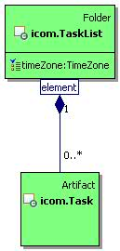
Figure 39: Task List Class Diagram.

Task

Description
A task is an artifact that represents a task to do or a task assignment in a task list.

Class Definition
The Task class has attribute values:

localNamespace
Value: icom_task

localName
Value: Task

extendsFrom
Value: icom_core:Artifact

stereotype
Value: primary

description
Value: A task is an artifact that represents a task to do or a task assignment in a task list.

propertyDefinitions
The values for this attribute are defined in 4.9.2.3.

Property Definitions
The Task class inherits property definitions from super classes.
The Task class MUST have the property definitions:

icom_core:location
Description: Location of a task.
Required: False
Inherited: False
Property Type: icom_core:Location
Cardinality: Single
Updatability: Read Write

icom_core:organizer
Description: Organizer of a task.
Required: True
Inherited: False
Property Type: icom_core:Participant
Cardinality: Single
Updatability: On Create

icom_core:priority
Description: Priority of a task.
Required: False
Inherited: False
Property Type: icom_core:Priority
Cardinality: Single
Updatability: Read Write

icom_core:startDate
Description: Start date and time of a task.
Required: True
Inherited: False
Property Type: DateTime
Cardinality: Single
Updatability: On Create

icom_core:startDateResolution
Description: Resolution of start date and time of a task.
Required: True
Inherited: False
Property Type: icom_core:DateTimeResolution
Cardinality: Single
Updatability: On Create

icom_content:attachment
Description: One or more content attachments in a task.
Required: False
Inherited: False
Property Type: icom_content:Attachment
Cardinality: Multi
Updatability: Read Write

icom_task:dueDate
Description: Due date and time of a task.
Required: True
Inherited: False
Property Type: DateTime
Cardinality: Single
Updatability: On Create

icom_task:dueDateResolution
Description: Resolution of due date and time of a task.
Required: True
Inherited: False
Property Type: icom_core:DateTimeResolution
Cardinality: Single
Updatability: On Create

icom_task:editMode
Description: Indicates a mode which determines whether a task is editable.
Required: False
Inherited: False
Property Type: icom_task:TaskEditMode
Cardinality: Single
Updatability: Read Only

icom_task:taskStatus
Description: Status of a task.
Required: True
Inherited: False
Property Type: icom_task:TaskStatus
Cardinality: Single
Updatability: Read Write

icom_task:assignee
Description: An assignee of a task.
Required: False
Inherited: False
Property Type: icom_core:Participant
Cardinality: Single
Updatability: Read Only

icom_task:participantStatus
Description: Participation status of a task.
Required: False
Inherited: False
Property Type: icom_task:TaskParticipantStatus
Cardinality: Single
Updatability: Read Write

icom_task:completionDate
Description: Completion date and time of a task.
Required: False
Inherited: False
Property Type: DateTime
Cardinality: Single
Updatability: Read Write

icom_task:completionDateResolution
Description: Resolution of completion date and time of a task.
Required: False
Inherited: False
Property Type: icom_core:DateTimeResolution
Cardinality: Single
Updatability: Read Write

icom_task:percentComplete
Description: Percentage of task completed.
Required: False
Inherited: False
Property Type: Integer
Cardinality: Single
Updatability: Read Write

icom_task:assigneeProperty
Description: Extensible properties for an assignee of a task.
Required: False
Inherited: False
Property Type: icom_meta:Property
Cardinality: Multi
Updatability: Read Write

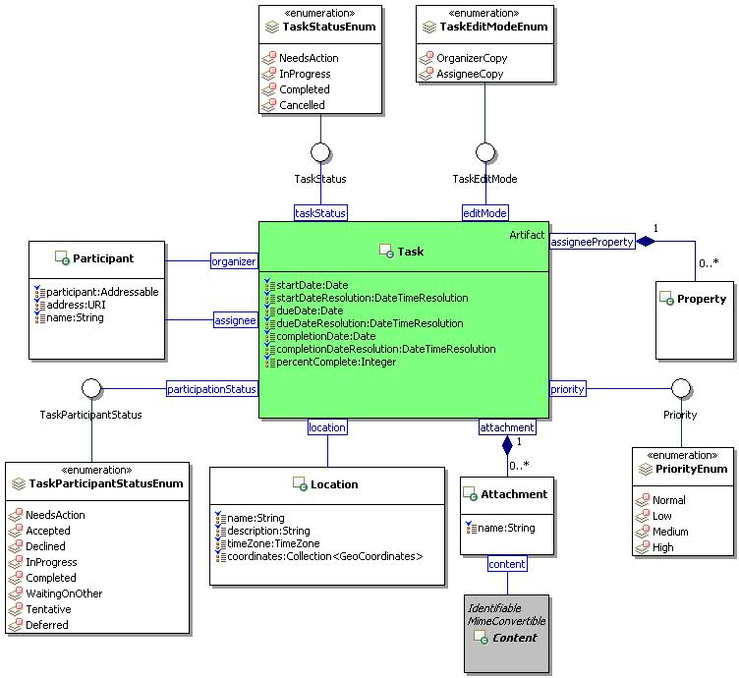
Figure 40: Task Class Diagram.

TaskStatus

Description
A task status is a status of a task.

Class Definition
The TaskStatus class is a mixin class which defines status of a task.
The TaskStatus class has attribute values:

localNamespace
Value: icom_task

localName
Value: TaskStatus

extendsFrom
Value:

stereotype
Value: mixin

description
Value: TaskStatus is a mixin class which defines status of a task.

propertyDefinitions
The values for this attribute are defined in Section 4.9.3.3.

Property Definitions
The TaskStatus class MAY include additional property definitions which are implementation-defined.

TaskStatusEnum
The TaskStatusEnum class is an enum class that enumerates the instances each of which expresses a status of task.
The TaskStatusEnum class has attribute values:

localNamespace
Value: icom_task

localName
Value: TaskStatusEnum

extendsFrom
Value: TaskStatus

stereotype
Value: primary

isEnumeration
Value: TRUE

description
Value: Status of a task.

instances
Value: <icom_task:NeedsAction, icom_task:InProgress, icom_task:Completed, icom_task:Cancelled>

ICOM defines four task status:
- icom_task:NeedsAction a task needs action.
- icom_task:InProgress a task is in progress.
- icom_task:Completed a task is completed.
- icom_task:Cancelled a task is cancelled.

TaskParticipantStatus

Description
A task participant status is a participant’s response status for a task assignment.

Class Definition
The TaskParticipantStatus class is a mixin class which defines a participant’s response status for a task assignment.
The TaskParticipantStatus class has attribute values:

localNamespace
Value: icom_task

localName
Value: TaskParticipantStatus

extendsFrom
Value:

stereotype
Value: mixin

description
Value: TaskParticipantStatus is a mixin class which defines a participant’s response status for a task assignment.

propertyDefinitions
The values for this attribute are defined in Section 4.9.5.3.

Property Definitions
The TaskParticipantStatus class MAY include additional property definitions which are implementation-defined.

TaskParticipantStatusEnum
The TaskParticipantStatusEnum class is an enum class that enumerates the instances each of which expresses a participant’s response status for a task.
The TaskParticipantStatusEnum class has attribute values:

localNamespace
Value: icom_task

localName
Value: TaskParticipantStatusEnum

extendsFrom
Value: TaskParticipantStatus

stereotype
Value: primary

isEnumeration
Value: TRUE

description
Value: Participant’s response status for a task.

instances
Value: <icom_task:NeedsAction, icom_task:Accepted, icom_task:Declined, icom_task:InProgress, icom_task:Completed, icom_task:WaitingOnOther, icom_task:Tentative, icom_task:Deferred>

ICOM defines eight task participant’s status:
- icom_task:NeedsAction an assignee needs to act on a task.
- icom_task:Accepted an assignee accepted a task.
- icom_task:Declined an assignee declined a task.
- icom_task:InProgress a task is in progress.
- icom_task:Completed a task is completed.
- icom_task:WaitingOnOther an assignee is waiting on other.
- icom_task:Tentative an assignee is tentative about a task.
- icom_task:Deferred an assignee deferred a task.

TaskEditMode

Description
A task edit mode is a mode that indicates whether a task is editable.

Class Definition
The TaskEditMode class is a mixin class which defines a mode that indicates whether a task is editable.
The TaskEditMode class has attribute values:

localNamespace
Value: icom_task

localName
Value: TaskEditMode

extendsFrom
Value:

stereotype
Value: mixin

description
Value: TaskEditMode is a mixin class which defines a mode that indicates whether task is editable.

propertyDefinitions
The values for this attribute are defined in Section 4.9.7.3.

Property Definitions
The TaskEditMode class MAY include additional property definitions which are implementation-defined.

TaskEditModeEnum
The TaskEditModeEnum class is an enum class that enumerates the instances each of which expresses an editable mode of a task.
The TaskEditModeEnum class has attribute values:

localNamespace
Value: icom_task

localName
Value: TaskEditModeEnum

extendsFrom
Value: TaskEditMode

stereotype
Value: primary

isEnumeration
Value: TRUE

description
Value: A mode that indicates whether a task is editable.

instances
Value: <icom_task:OrganizerCopy, icom_task:AssigneeCopy>

ICOM defines two task editable modes:
- icom_task:OrganizerCopy: a task is a copy created by an organizer who may update the properties such as start time, due time.
- icom_task:AssigneeCopy: a task is a copy delivered to an assignee who may only update the assignee properties such as completion time, participant status, percent completed.

Forum Module

Discussion

Description
A discussion is an item in a discussion container.

Class Definition
The Discussion class is a mixin class that defines the characteristics of artifacts that can be elements of discussion containers.
The Discussion class has attribute values:

localNamespace
Value: icom_forum

localName
Value: Discussion

extendsFrom
Value: icom_core:Item

stereotype
Value: mixin

description
Value: Discussion is a mixin class that defines the characteristics of artifacts that can be placed in a discussion container.

propertyDefinitions
The values for this attribute are defined in Section 4.10.1.3.

Property Definitions
The Discussion class inherits property definitions from super classes.
The Discussion class MUST have the property definition:

icom_forum:inReplyTo
Description: Another discussion object that a discussion object is replying to.
Required: False
Inherited: False
Property Type: icom_forum:Discussion
Cardinality: Single
Updatability: Read Write

The Discussion class MAY include additional property definitions which are implementation-defined.

DiscussionContainer

Description
A discussion container contains discussion items.

Class Definition
The DiscussionContainer class is a mixin class that defines the characteristics of folders that contain Discussion items.
The DiscussionContainer class has attribute values:

localNamespace
Value: icom_forum

localName
Value: DiscussionContainer

extendsFrom
Value: icom_core:Container

stereotype
Value: mixin

description
Value: DiscussionContainer is a mixin class that defines the characteristics of folders that contain Discussion items.

propertyDefinitions
The values for this attribute are defined in Section 4.10.2.3.

Property Definitions
The DiscussionContainer class inherits property definitions from super classes.
The DiscussionContainer class MUST have the property definition:

icom_core:element
Description: Elements of a discussion container.
Required: False
Inherited: True
Property Type: icom_forum:Discussion
Cardinality: Multi
Updatability: Read Only

The DiscussionContainer class MAY include additional property definitions which are implementation-defined.

DiscussionMessage

Description
A discussion message is a message in a forum discussion thread.

Class Definition
The DiscussionMessage class has attribute values:

localNamespace
Value: icom_forum

localName
Value: DiscussionMessage

extendsFrom
Value: icom_msg:Message, icom_forum:Discussion

stereotype
Value: primary

description
Value: Discussion message is a message in a forum discussion thread.

propertyDefinitions
The values for this attribute are defined in Section 4.10.3.3.

Property Definitions
The DiscussionMessage class inherits property definitions from super classes.
The DiscussionMessage class MUST have the property definition:

icom_forum:inReplyTo
Description: Another discussion message that a discussion message is replying to.
Required: False
Inherited: True
Property Type: icom_forum:DiscussionMessage
Cardinality: Single
Updatability: Read Write

The DiscussionMessage class MAY include additional property definitions which are implementation-defined.

TopicContainer

Description
A topic container contains topics.

Class Definition
The TopicContainer class is a mixin class which defines the characteristics of folders that contain Topics.
The TopicContainer class has attribute values:

localNamespace
Value: icom_forum

localName
Value: TopicContainer

extendsFrom
Value: icom_core:Container

stereotype
Value: mixin

description
Value: TopicContainer is a mixin class that defines the characteristics of folders that contain topics.

propertyDefinitions
The values for this attribute are defined in Section 4.10.4.3.

Property Definitions
The TopicContainer class inherits property definitions from super classes.
The TopicContainer class MUST have the property definitions:

icom_core:element
Description: Elements of a topic container.
Required: False
Inherited: True
Property Type: icom_forum:Topic
Cardinality: Multi
Updatability: Read Only

The TopicContainer class MAY include additional property definitions which are implementation-defined.

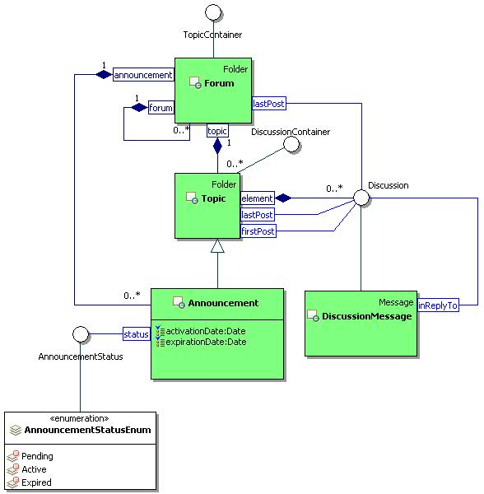
Figure 41: Forum Class Diagram.

Forum

Description
A forum contains sub-forums, topics, and announcements.

Class Definition
The Forum class has attribute values:

localNamespace
Value: icom_forum

localName
Value: Forum

extendsFrom
Value: icom_core:Folder, icom_forum:TopicContainer

stereotype
Value: primary

description
Value: A forum contains sub-forums, topics, and announcements.

propertyDefinitions
The values for this attribute are defined in Section 4.10.5.3.

Property Definitions
The Forum class inherits property definitions from super classes.
The Forum class MUST have the property definitions:

icom_forum:lastPost
Description: The last posted discussion in a forum.
Required: False
Inherited: False
Property Type: icom_forum:Discussion
Cardinality: Single
Updatability: Read Only

icom_forum:forum
Description: Sub-forums of a forum.
Required: False
Inherited: False
Property Type: icom_forum:Forum
Cardinality: Multi
Updatability: Read Only

icom_forum:topic
Description: Topics of a forum.
Required: False
Inherited: False
Property Type: icom_forum:Topic
Cardinality: Multi
Updatability: Read Only

icom_forum:announcement
Description: Announcements of a forum.
Required: False
Inherited: False
Property Type: icom_forum:Announcement
Cardinality: Multi
Updatability: Read Only

The Forum class MAY include additional property definitions which are implementation-defined.

Topic

Description
A topic contains conversations among forum participants. The discussions in a topic may be sorted in chronological order or threaded by reply.

Class Definition
The Topic class has attribute values:

localNamespace
Value: icom_forum

localName
Value: Topic

extendsFrom
Value: icom_core:Folder, icom_forum:DiscussionContainer

stereotype
Value: primary

description
Value: A topic contains discussion threads.

propertyDefinitions
The values for this attribute are defined in Section 4.10.6.3.

Property Definitions
The Topic class inherits property definitions from super classes.
The Topic class MUST have the property definitions:

icom_core:element
Description: Elements of a topic.
Required: False
Inherited: True
Property Type: icom_forum:Discussion
Cardinality: Multi
Updatability: Read Only

icom_forum:firstPost
Description: The first posted discussion in a topic.
Required: False
Inherited: False
Property Type: icom_forum:Discussion
Cardinality: Single
Updatability: Read Only

icom_forum:lastPost
Description: The last posted discussion in a topic.
Required: False
Inherited: False
Property Type: icom_forum:Discussion
Cardinality: Single
Updatability: Read Only

The Topic class MAY include additional property definitions which are implementation-defined.

Announcement

Description
An announcement contains time-sensitive discussion posts that are valid for a specified period of time, depending on activation and expiration times.

Class Definition
The Announcement class has attribute values:

localNamespace
Value: icom_forum

localName
Value: Announcement

extendsFrom
Value: icom_forum:Topic

stereotype
Value: primary

description
Value: An announcement contains discussion items that are valid for a specified period of time.

propertyDefinitions
The values for this attribute are defined in Section 4.10.7.3.

Property Definitions
The Announcement class inherits property definitions from super classes.
The Announcement class MUST have the property definitions:

icom_forum:activationDate
Description: Date and time when an announcement becomes active.
Required: False
Inherited: False
Property Type: DateTime
Cardinality: Single
Updatability: Read Write

icom_forum:expirationDate
Description: Date and time when an announcement expires.
Required: False
Inherited: False
Property Type: DateTime
Cardinality: Single
Updatability: Read Write

icom_forum:announcementStatus
Description: Status of an announcement.
Required: True
Inherited: False
Property Type: icom_forum:AnnouncementStatus
Cardinality: Single
Updatability: Read Write

The Announcement class MAY include additional property definitions which are implementation-defined.

AnnouncementStatus

Description
An announcement status is status of an announcement.

Class Definition
The AnnouncementStatus class is a mixin class which defines status of an announcement.
The AnnouncementStatus class has attribute values:

localNamespace
Value: icom_forum

localName
Value: AnnouncementStatus

extendsFrom
Value:

stereotype
Value: mixin

description
Value: AnnouncementStatus is a mixin class which defines status of an announcement.

propertyDefinitions
The values for this attribute are defined in Section 4.10.8.3.

Property Definitions
The AnnouncementStatus class MAY include additional property definitions which are implementation-defined.

AnnouncementStatusEnum
The AnnouncementStatusEnum class is an enum class that enumerates the instances each of which expresses a status of announcement.
The AnnouncementStatusEnum class has attribute values:

localNamespace
Value: icom_forum

localName
Value: AnnouncementStatusEnum

extendsFrom
Value: AnnouncementStatus

stereotype
Value: primary

isEnumeration
Value: TRUE

description
Value: Status of announcement.

instances
Value: <icom_forum:Pending, icom_forum:Active, icom_forum:Expired>

ICOM defines three announcement status:
- icom_forum:Pending an announcement is pending.
- icom_forum:Active an announcement is active.
- icom_forum:Expired an announcement is expired.

Conference Module

Conference

Description
A conference is a container that represents a durable context for conference sessions.
It contains conference metadata, settings, and transcripts.

Class Definition
The Conference class has attribute values:

localNamespace
Value: icom_conf

localName
Value: Conference

extendsFrom
Value: icom_core:Folder

stereotype
Value: primary

description
Value: A conference represents a durable context for online conference sessions.

propertyDefinitions
The values for this attribute are defined in Section 4.11.1.3.

Property Definitions
The Conference class inherits property definitions from super classes.
The Conference class MUST have the property definitions:

icom_core:organizer
Description: Organizer of a conference.
Required: False
Inherited: False
Property Type: icom_core:Participant
Cardinality: Single
Updatability: On Create

icom_conf:conferenceType
Description: Type of a conference.
Required: False
Inherited: False
Property Type: icom_conf:ConferenceType
Cardinality: Single
Updatability: Read Write

icom_conf:conferenceStatus
Description: Status of a conference.
Required: False
Inherited: False
Property Type: icom_conf:ConferenceStatus
Cardinality: Single
Updatability: Read Only

icom_conf:runningSession
Description: Current session of a conference.
Required: False
Inherited: False
Property Type: icom_conf:ConferenceSession
Cardinality: Single
Updatability: Read Only

icom_conf:conferenceSetting
Description: Configurable settings of a conference.
Required: False
Inherited: False
Property Type: icom_conf:ConferenceSetting
Cardinality: Single
Updatability: Read Only

icom_conf:transcript
Description: Transcripts from ended sessions of a conference.
Required: False
Inherited: False
Property Type: icom_doc:Document
Cardinality: Multi
Updatability: Read Write

icom_conf:scheduledStartDate
Description: Scheduled start date and time of a conference session.
Required: False
Inherited: False
Property Type: DateTime
Cardinality: Single
Updatability: Read Write

icom_conf:scheduledEndDate
Description: Scheduled end date and time of a conference session.
Required: False
Inherited: False
Property Type: DateTime
Cardinality: Single
Updatability: Read Write

The Conference class MAY include additional property definitions which are implementation-defined.

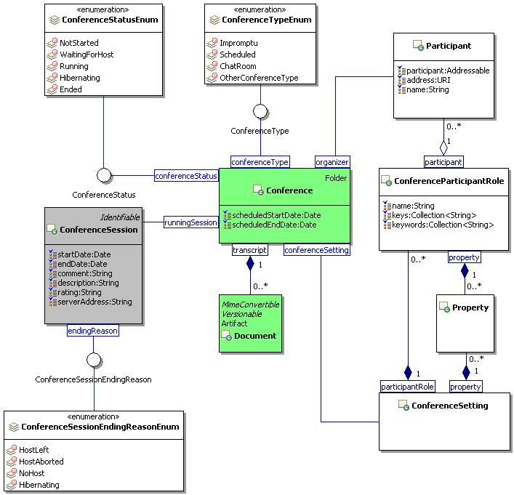
Figure 42: Conference Class Diagram.

ConferenceType

Description
A conference type represents a category of conferences.

Class Definition
The ConferenceType class is a mixin class which defines a type of conference.
The ConferenceType class has attribute values:

localNamespace
Value: icom_conf

localName
Value: ConferenceType

extendsFrom
Value:

stereotype
Value: mixin

description
Value: ConferenceType is a mixin class which defines type of conference.

propertyDefinitions
The values for this attribute are defined in Section 4.11.2.3.

Property Definitions
The ConferenceType class MAY include additional property definitions which are implementation-defined.

ConferenceTypeEnum
The ConferenceTypeEnum class is an enum class that enumerates the instances each of which expresses a type of a conference.
The ConferenceTypeEnum class has attribute values:

localNamespace
Value: icom_conf

localName
Value: ConferenceTypeEnum

extendsFrom
Value: ConferenceType

stereotype
Value: primary

isEnumeration
Value: TRUE

description
Value: A type of a conference.

instances
Value: <icom_conf:Impromptu, icom_conf:Scheduled, icom_conf:ChatRoom, icom_conf:OtherConferenceType>

ICOM defines four conference types:
- icom_conf:Impromptu a conference session is started impromptu.
- icom_conf:Scheduled a conference session is scheduled.
- icom_conf:ChatRoom a conference is used for a chat room.
- icom_conf:OtherConferenceType a conference is of other type.

ConferenceStatus

Description
A conference status is status of an online conference.

Class Definition
The ConferenceStatus class is a mixin class which defines status of an online conference.
The ConferenceStatus class has attribute values:

localNamespace
Value: icom_conf

localName
Value: ConferenceStatus

extendsFrom
Value:

stereotype
Value: mixin

description
Value: ConferenceStatus is a mixin class which defines status of an online conference.

propertyDefinitions
The values for this attribute are defined in Section 4.11.4.3.

Property Definitions
The ConferenceStatus class MAY include additional property definitions which are implementation-defined.

ConferenceStatusEnum
The ConferenceStatusEnum class is an enum class that enumerates the instances each of which expresses a status of a conference.
The ConferenceStateEnum class has attribute values:

localNamespace
Value: icom_conf

localName
Value: ConferenceStatusEnum

extendsFrom
Value: ConferenceStatus

stereotype
Value: primary

isEnumeration
Value: TRUE

description
Value: Status of a conference.

instances
Value: <icom_conf:NotStarted, icom_conf:WaitingForHost, icom_conf:Running, icom_conf:Hibernating, icom_conf:Ended>

ICOM defines five conference status:
- icom_conf:NotStarted a conference session is not started .
- icom_conf:WaitingForHost a conference session is waiting for a host.
- icom_conf:Running a conference session is running.
- icom_conf:Hibernating a conference session is hibernating.
- icom_conf:Ended a conference session is ended.

ConferenceSession

Description
A conference session represents the metadata for a session of a conference.

Class Definition
The ConferenceSession class has attribute values:

localNamespace
Value: icom_conf

localName
Value: ConferenceSession

extendsFrom
Value: icom_core:Identifiable

stereotype
Value: primary

description
Value: A conference session represents the metadata for a session of a conference.

propertyDefinitions
The values for this attribute are defined in Section 4.11.6.3.

Property Definitions
The ConferenceSession class inherits property definitions from super classes.
The ConferenceSession class MUST have the property definitions:

icom_core:startDate
Description: Start date and time of a conference session.
Required: False
Inherited: False
Property Type: DateTime
Cardinality: Single
Updatability: Read Only

icom_core:endDate
Description: End date and time of a conference session.
Required: False
Inherited: False
Property Type: DateTime
Cardinality: Single
Updatability: Read Only

icom_conf:comment
Description: Comment on a conference session.
Required: False
Inherited: False
Property Type: String
Cardinality: Single
Updatability: Read Write

icom_conf:description
Description: Description of a conference session.
Required: False
Inherited: False
Property Type: String
Cardinality: Single
Updatability: Read Write

icom_conf:rating
Description: Rating of a conference session.
Required: False
Inherited: False
Property Type: String
Cardinality: Single
Updatability: Read Write

icom_conf:serverAddress
Description: Address of a server that hosts a conference session.
Required: False
Inherited: False
Property Type: String
Cardinality: Single
Updatability: Read Only

icom_conf:endingReason
Description: Reason for ending a conference session.
Required: False
Inherited: False
Property Type: icom_conf:ConferenceSessionEndingReason
Cardinality: Single
Updatability: Read Only

The ConferenceSession class MAY include additional property definitions which are implementation-defined.

ConferenceSessionEndingReason

Description
A conference session ending reason is an indication of how a conference session ended.

Class Definition
The ConferenceSessionEndingReason class is a mixin class which defines an indication of how a conference session ended.
The ConferenceSessionEndingReason class has attribute values:

localNamespace
Value: icom_conf

localName
Value: ConferenceSessionEndingReason

extendsFrom
Value:

stereotype
Value: mixin

description
Value: ConferenceSessionEndingReason is a mixin class which defines an indication of how a conference session ended.

propertyDefinitions
The values for this attribute are defined in Section 4.11.7.3.

Property Definitions
The ConferenceSessionEndingReason class MAY include additional property definitions which are implementation-defined.

ConferenceSessionEndingReasonEnum
The ConferenceSessionEndingReasonEnum class is an enum class that enumerates the instances each of which expresses a reason for ending a conference session.
The ConferenceSessionEndingReasonEnum class has attribute values:

localNamespace
Value: icom_conf

localName
Value: ConferenceSessionEndingReasonEnum

extendsFrom
Value: ConferenceSessionEndingReason

stereotype
Value: primary

isEnumeration
Value: TRUE

description
Value: Reason for ending a conference session.

instances
Value: <icom_conf:HostLeft, icom_conf:HostAborted, icom_conf:NoHost, icom_conf:Hibernating>

ICOM defines four conference session states:
- icom_conf:HostLeft a conference session ended after the host left.
- icom_conf:HostAborted a conference session ended after the host aborted it.
- icom_conf:NoHost a conference session ended due to no one hosting.
- icom_conf:Hibernating a conference session is hibernating.

ConferenceSetting

Description
A conference setting represents configuration settings for sessions of a conference.

Class Definition
The ConferenceSetting class has attribute values:

localNamespace
Value: icom_conf

localName
Value: ConferenceSetting

extendsFrom
Value:

stereotype
Value: primary

description
Value: A conference setting represents configuration settings for sessions of a conference.

propertyDefinitions
The values for this attribute are defined in Section 4.11.9.3.

Property Definitions
The ConferenceSetting class inherits property definitions from super classes.
The ConferenceSetting class MUST have the property definitions:

icom_meta:property
Description: Configurable properties for a conference.
Required: False
Inherited: False
Property Type: icom_meta:property
Cardinality: Multi
Updatability: Read Write

icom_conf:participantRole
Description: Role settings for conference participants.
Required: False
Inherited: False
Property Type: icom_conf:ConferenceParticipantRole
Cardinality: Multi
Updatability: Read Write

The ConferenceSetting class MAY include additional property definitions which are implementation-defined.

ConferenceParticipantRole

Description
A conference participant role defines roles settings for a conference participant.

Class Definition
The ConferenceParticipantRole class has attribute values:

localNamespace
Value: icom_conf

localName
Value: ConferenceParticipantRole

extendsFrom
Value:

stereotype
Value: primary

description
Value: A conference participant role contains roles settings for a conference.

propertyDefinitions
The values for this attribute are defined in Section 4.11.10.3.

Property Definitions
The ConferenceParticipantRole class MUST have the property definitions:

icom_core:name
Description: Name of a role setting in a conference.
Required: False
Inherited: False
Property Type: String
Cardinality: Single
Updatability: Read Write

icom_core:participant
Description: One or more participants in a role setting.
Required: False
Inherited: False
Property Type: icom_core:Participant
Cardinality: Multi
Updatability: Read Write

icom_meta:property
Description: Configurable properties for a role setting.
Required: False
Inherited: False
Property Type: icom_meta:Property
Cardinality: Multi
Updatability: Read Write

icom_conf:key
Description: One or more sign on keys to activate a role setting.
Required: False
Inherited: False
Property Type: String
Cardinality: Multi
Updatability: Read Write

icom_conf:keyword
Description: One or more key words to activate a role setting.
Required: False
Inherited: False
Property Type: String
Cardinality: Multi
Updatability: Read Write

The ConferenceParticipantRole class MAY include additional property definitions which are implementation-defined.

5 Conformance
The ICOM specification does not presume a particular software architecture or framework for use of the ICOM model.

Conformance to the ICOM specification is defined using use case roles played by the following four stakeholders of a typical software architecture or framework:

- An ICOM platform provider supplies an environment for one or more ICOM service providers, producers, and consumers to exchange ICOM objects.
- An ICOM service provider manages objects produced by one or more ICOM producers for access by one or more ICOM consumers.
- An ICOM producer creates objects managed by an ICOM service provider.
- An ICOM consumer accepts objects managed by an ICOM service provider.

Fulfillment of ICOM use case roles and accompanying responsibilities is implementation dependent. An ICOM implementation may fulfill one or more of ICOM use case roles and accompanying responsibilities.

Conformance by platform provider:
- An ICOM platform provider:
  - SHALL conform to all mandatory statements and
  - MAY conform to optional statements
of the core ICOM model as defined in Section 3 of this standard
- An ICOM platform provider:
  - SHALL conform to all mandatory statements and
  - MAY conform to optional statements
as defined in Section 4 for each extension module.

Conformance by service provider:
- An ICOM service provider MAY support one or more extension modules as defined in Section 4 of this standard.
- An ICOM service provider that supports an extension module:
  - SHALL conform to all mandatory statements and
  - MAY conform to optional statements
as defined in Section 4 for that extension module.
- Depending on the classes extended by an extension module, an ICOM service provider:
  - SHALL conform to all mandatory statements and
  - MAY conform to optional statements
for inherited super classes and related classes defined in Section 3 of this standard.

Note: ICOM environment may include multiple service providers each of which provides different subsets of extension modules.

Conformance by ICOM producer:
- An ICOM producer that produces objects of a class:
  - SHALL conform to all mandatory statements and
  - MAY conform to optional statements
for the class and super classes thereof in Section 3 of this standard, for any object produced.
- An ICOM producer may support one or more extension modules as defined in Section 4 of this standard. ICOM producers that support an extension module:
  - SHALL conform to all mandatory statements and
  - MAY conform to optional statements
as defined in Section 4 for that extension module.

Conformance by ICOM consumer:
- An ICOM consumer that consumes objects of a class:
  - SHALL conform to all mandatory statements and
  - MAY conform to optional statements
for the class and super classes thereof in Section 3 of this standard, for any object consumed.
- An ICOM consumer may support one or more extension modules as defined in Section 4 of this standard. ICOM consumers that support an extension module:
  - SHALL conform to all mandatory statements and
  - MAY conform to optional statements
as defined in Section 4 for that extension module.
- Acknowledgements
The following individuals have participated in the creation of this specification and are gratefully acknowledged:
Participants:
Rafiul Ahad, Oracle Corporation
Eric S. Chan, Oracle Corporation
Martin Chapman, Oracle Corporation
Scott Conroy, Individual
Stefan Decker, Digital Enterprise Research Institute (DERI)
Laura Dragan, Digital Enterprise Research Institute (DERI)
Patrick Durusau, Individual
Siegfried Handschuh, Digital Enterprise Research Institute (DERI)
Deirdre Lee, Digital Enterprise Research Institute (DERI)
Marc Pallot, ESoCE-NET
Chancellor Pascale, Johns Hopkins University Applied Physics Laboratory
Vassilios Peristeras, Digital Enterprise Research Institute (DERI)
Peter Saint-Andre, Cisco Systems, Inc.
Ramesh Vasudevan, Oracle Corporation
Peter Yim, Individual

- Revision History

Revision | Date | Editor | Changes Made
CSPRD 01 | March 16, 2011 | Eric S. Chan  Patrick Durusau | Committee Specification Draft for Public Review
CSPRD 02 | November 8, 2011 | Eric S. Chan  Patrick Durusau | Changes in response to public review comments.
CSPRD 03 | March 20, 2012 | Eric S. Chan  Patrick Durusau  Laura Dragan | Changes in response to TC members review comments.

