

Functional Elements Specification

Committee Draft 2.0, 02-June-2006

Document identifier:

0000.doc

Location:
http://www.oasis-open.org/apps/org/workgroup/fwsi/documents.php

Editor:
Tan Puay Siew, Singapore Institute of Manufacturing Technology, SIMTech (pstan@simtech.a-star.edu.sg)

Contributor(s):
Andy Tan, Individual (andytan@intrinix.net)
Shawn Cheng Hua-Shan, XMLBoss (shawn@xmlboss.net)
Kenneth Lim, Crimson Logic Pte Ltd (kennethlim@crimsonlogic.com)
Viren Baraiya, Crimson Logic Pte Ltd (viren@crimsonlogic.com)
Jagdip Talla, Crimson Logic Pte Ltd (jagdip@crimsonlogic.com)
Roberto Pascual, Infocomm Development Authority (IDA) of Singapore (rbpascual@yahoo.com)
Lee Eng Wah, SIMTech (ewlee@simtech.a-star.edu.sg)
V.Ramasamy, SIMTech (rama@simtech.a-star.edu.sg)
Lee Siew Poh, SIMTech (splee@simtech.a-star.edu.sg)
Lee Ah Kim, SIMTech (aklee@simtech.a-star.edu.sg)

Abstract:
The ability to provide robust implementations is a very important aspect to create high quality Web Service-enabled applications and to accelerate the adoption of Web Services. The Framework for Web Services Implementation (FWSI) TC aims to enable robust implementations by defining a practical and extensible methodology consisting of implementation processes and common functional elements that practitioners can adopt to create high quality Web Services systems without reinventing them for each implementation.
This document specifies a set of Functional Elements for practitioners to instantiate into a technical architecture, and should be read in conjunction with the Functional Elements Requirements document. It is the purpose of this specification to define the right level of abstraction for these Functional Elements and to specify the purpose and scope of each Functional Element so as to facilitate efficient and effective implementation of Web Services.

Status:
This document is updated periodically on no particular schedule.
Committee members should send comments on this specification to the fwsi-fesc@lists.oasis-open.org list. Others should subscribe to and send comments to the fwsi-comment@lists.oasis-open.org list. To subscribe, send an email message to fwsi-comment-request@lists.oasis-open.org with the word "subscribe" as the body of the message.
For information on whether any patents have been disclosed that may be essential to implementing this specification, and any offers of patent licensing terms, please refer to the Intellectual Property Rights section of the FWSI TC web page (http://www.oasis-open.org/committees/fwsi/).

Table of Contents
1 Introduction 8
1.1 Document Outline 8
1.2 Motivation 9
1.3 Terminology 9
2 List of Functional Elements 10
2.1 Data Integrator Functional Element (new) 10
2.1.1 Motivation 10
2.1.2 Terms Used 10
2.1.3 Key Features 12
2.1.4 Interdependencies 12
2.1.5 Related Technologies and Standards 12
2.1.6 Model 13
2.1.7 Usage Scenarios 13
2.2 Error Management Functional Element (new) 26
2.2.1 Motivation 26
2.2.2 Terms Used 27
2.2.3 Key Features 28
2.2.4 Interdependencies 29
2.2.5 Related Technologies and Standards 29
2.2.6 Model 30
2.2.7 Usage Scenarios 30
2.3 Event Handler Functional Element 42
2.3.1 Motivation 42
2.3.2 Terms Used 42
2.3.3 Key Features 43
2.3.4 Interdependencies 45
2.3.5 Related Technologies and Standards 45
2.3.6 Model 46
2.3.7 Usage Scenarios 47
2.4 Group Management Functional Element 64
2.4.1 Motivation 64
2.4.2 Terms Used 64
2.4.3 Key Features 64
2.4.4 Interdependency 65
2.4.5 Related Technologies and Standards 65
2.4.6 Model 66
2.4.7 Usage Scenarios 66
2.5 Identity Management Functional Element 71
2.5.1 Motivation 71
2.5.2 Terms Used 71
2.5.3 Key Features 73
2.5.4 Interdependencies 73
2.5.5 Related Technologies and Standards 74
2.5.6 Model 75
2.5.7 Usage Scenarios 76
2.6 Information Catalogue Functional Element (new) 80
2.6.1 Motivation 80
2.6.2 Terms Used 80
2.6.3 Key Features 80
2.6.4 Interdependencies 81
2.6.5 Related Technologies and Standards 81
2.6.6 Model 82
2.6.7 Usage Scenario 82
2.7 Information Reporting Functional Element (new) 89
2.7.1 Motivation 89
2.7.2 Terms Used 89
2.7.3 Key Features 90
2.7.4 Interdependencies 90
2.7.5 Related Technologies and Standards 91
2.7.6 Model 91
2.7.7 Usage Scenario 91
2.8 Key Management Functional Element (new) 103
2.8.1 Motivation 103
2.8.2 Terms Used 103
2.8.3 Key Features 103
2.8.4 Interdependencies 104
2.8.5 Related Technologies and Standards 104
2.8.6 Model 105
2.8.7 Usage Scenarios 106
2.9 Log Utility Functional Element 112
2.9.1 Motivation 112
2.9.2 Terms Used 112
2.9.3 Key Features 112
2.9.4 Interdependencies 113
2.9.5 Related Technologies and Standards 113
2.9.6 Model 114
2.9.7 Usage Scenarios 114
2.10 Notification Functional Element 121
2.10.1 Motivation 121
2.10.2 Terms Used 121
2.10.3 Key Features 122
2.10.4 Interdependencies 122
2.10.5 Related Technologies and Standards 122
2.10.6 Model 123
2.10.7 Usage Scenarios 123
2.11 Phase and Lifecycle Management Functional Element 129
2.11.1 Motivation 129
2.11.2 Terms Used 129
2.11.3 Key Features 130
2.11.4 Interdependencies 130
2.11.5 Related Technologies and Standards 130
2.11.6 Model 130
2.11.7 Usage Scenarios 131
2.12 Policy Management Functional Element (new) 136
2.12.1 Motivation 136
2.12.2 Terms Used 136
2.12.3 Key Features 137
2.12.4 Interdependency 138
2.12.5 Related Technologies and Standards 138
2.12.6 Model 139
2.12.7 Usage Scenarios 139
2.13 Policy Enforcement Functional Element (new) 144
2.13.1 Motivation 144
2.13.2 Terms Used 144
2.13.3 Key Features 144
2.13.4 Interdependency 145
2.13.5 Related Technologies and Standards 145
2.13.6 Model 145
2.13.7 Usage Scenarios 146
2.14 Presentation Transformer Functional Element (Deprecated) 148
2.15 QoS Functional Element (new) 149
2.15.1 Motivation 149
2.15.2 Terms Used 150
2.15.3 Key Features 151
2.15.4 Interdependencies 151
2.15.5 Related Technologies and Standards 151
2.15.6 Model 152
2.15.7 Usage Scenarios 152
2.16 Role and Access Management Functional Element 163
2.16.1 Motivation 163
2.16.2 Terms Used 163
2.16.3 Key Features 164
2.16.4 Interdependencies 165
2.16.5 Related Technologies and Standards 165
2.16.6 Model 166
2.16.7 Usage Scenario 166
2.17 Search Functional Element 176
2.17.1 Motivation 176
2.17.2 Terms Used 176
2.17.3 Key Features 177
2.17.4 Interdependencies 177
2.17.5 Related Technologies and Standards 177
2.17.6 Model 178
2.17.7 Usage Scenario 178
2.18 Secure SOAP Management Functional Element 181
2.18.1 Motivation 181
2.18.2 Terms Used 181
2.18.3 Key Features 182
2.18.4 Interdependencies 182
2.18.5 Related Technologies and Standards 182
2.18.6 Model 183
2.18.7 Usage Scenarios 183
2.19 Sensory Functional Element 187
2.19.1 Motivation 187
2.19.2 Terms Used 187
2.19.3 Key Features 187
2.19.4 Interdependencies 188
2.19.5 Related Technologies and Standards 188
2.19.6 Model 188
2.19.7 Usage Scenarios 188
2.20 Service Level Management Functional Element (new) 191
2.20.1 Motivation 191
2.20.2 Terms Used 191
2.20.3 Key Features 191
2.20.4 Interdependencies 192
2.20.5 Related Technologies and Standards 192
2.20.6 Model 192
2.20.7 Usage Scenarios 193
2.21 Service Level Enforcement Functional Element (new) 199
2.21.1 Motivation 199
2.21.2 Terms Used 199
2.21.3 Key Features 199
2.21.4 Interdependencies 199
2.21.5 Related Technologies and Standards 200
2.21.6 Model 200
2.21.7 Usage Scenarios 200
2.22 Service Management Functional Element 205
2.22.1 Motivation 205
2.22.2 Terms Used 205
2.22.3 Key Features 205
2.22.4 Interdependencies 206
2.22.5 Related Technologies and Standards 206
2.22.6 Model 207
2.22.7 Usage Scenarios 207
2.23 Service Registry Functional Element 213
2.23.1 Motivation 213
2.23.2 Terms Used 213
2.23.3 Key Features 214
2.23.4 Interdependencies 214
2.23.5 Related Technologies and Standards 214
2.23.6 Model 215
2.23.7 Usage Scenario 215
2.24 Service Router Functional Element (new) 224
2.24.1 Motivation 224
2.24.2 Terms Used 224
2.24.3 Key Features 225
2.24.4 Interdependencies 226
2.24.5 Related Technologies and Standards 226
2.24.6 Model 227
2.24.7 Usage Scenarios 227
2.25 Service Tester Functional Element (Deprecated) 235
2.26 Transformer Functional Element (new) 236
2.26.1 Motivation 236
2.26.2 Terms Used 236
2.26.3 Key Features 237
2.26.4 Interdependencies 237
2.26.5 Related Technologies and Standards 238
2.26.6 Model 238
2.26.7 Usage Scenarios 238
2.27 User Management Functional Element 244
2.27.1 Motivation 244
2.27.2 Terms Used 244
2.27.3 Key Features 245
2.27.4 Interdependencies 246
2.27.5 Related Technologies and Standards 246
2.27.6 Model 246
2.27.7 Usage Scenarios 247
2.28 Web Service Aggregator Functional Element 254
2.28.1 Motivation 254
2.28.2 Terms Used 254
2.28.3 Key Features 255
2.28.4 Interdependencies 256
2.28.5 Related Technologies and Standards 256
2.28.6 Model 256
2.28.7 Usage Scenarios 257
3 Functional Elements Usage Scenarios 262
3.1 Service Monitoring 263
3.2 Securing SOAP Messages 264
3.3 Decoupled User Access Management 265
3.4 Single-Sign-On for Distributed Services (Applications) 266
4 References 267
Appendix A. Acknowledgments 269
Appendix B. Revision History 270
Appendix C. Notices 272

Introduction

The purpose of OASIS Framework for Web Services Implementation (FWSI) Technical Committee (TC) is to facilitate implementation of robust Web Services by defining a practical and extensible methodology consisting of implementation processes and common functional elements that practitioners can adopt to create high quality Web Services systems without re-inventing them for each implementation. It aims to solve the problem of the slow adoption of Web Services due to a lack of good Web Services methodologies for implementation, cum a lack of understanding and confidence in solutions that have the necessary components to reliably implement Web Service-enabled applications.

One of the FWSI TC’s deliverables is the Functional Elements Specification, which is detailed in this document. This Specification specifies a set of functional elements that practical implementation of Web Services-based systems will require. A Functional Element (FE) is defined as a building block representing common reusable functionalities for Web Service-enabled implementations, i.e. from an application Point-Of-View. These FEs are expected to be implemented as reusable components, with Web Services capabilities where appropriate, and to be the foundation for practitioners to instantiate into a technical architecture. The implementations of these FEs are further supported by another complementary work that is also from the FWSI TC, the Web Services Implementation Methodology (WSIM) []. As such, the TC hopes that through the implementations of these FEs, robust Web Service-enabled applications can be constructed quickly and deployed in a rapid manner.

The target audiences for this document are expected to be solution providers who intend to use the Functional Elements Specification to create building blocks that can be instantiated into the technical architecture of their solutions or software vendors and independent software vendors (ISVs) that are expected to build the functional elements specified into their products. Individuals and researchers who are interested in Web Services will also be able to benefit from this document. It is recommended that this document should be used in tandem with the Functional Elements Requirements document, to ensure that readers have a holistic view to the thought processes and knowledge that are encapsulated.

Document Outline

This document describes the Functional Elements in three main sections. In this section, explanation on the motivation for creating this Specification and the kind of impact that it will create for Web Service-enabled implementations and the terminology used in the normative part of this document are included.

Section 2 lists the identified Functional Elements arising from requirements documented in the Functional Elements Requirements document []. Under each of the ensuing FE, the following descriptions are provided:
- Motivation
A section for providing a short introduction explaining the motivation of including the FE from an application Point-Of-View, including cross-referencing of the requirements for the Functional Element
- Terms Used
A glossary of the terms used. An explanation or illustration of the runtime capabilities of the Functional Element are also provided where appropriate.
- Key Features
A list of key features to be implemented is provided here and is expressed in the normative form.
- Interdependencies
In this section, the interdependencies between Functional Elements are provided to clarify the linkages between FEs (if any).
- Related Technologies and Standards
Here, the reliance of the Functional Elements on related technologies and specifications (or standards) are provided

Section 3 provides the examples of how the Functional Elements can be assembled to accelerate web service-enabled applications. From these Functional Elements, a variety of solutions can be built.

Motivation

In a Service-Oriented Architecture (SOA) environment, new applications/services are created through the assembly of existing services. One of the key advantages of this loosely coupled model is that it allows the new application/service to leverage on 3rd party services. As a typical 3rd party’s implementation of the services is done via the software component approach, this specification further proliferate new applications/services by defining a framework for Web Services implementation consisting of Functional Elements. Through these Functional Elements, which are implementation neutral, this Specification hopes to influence future software development towards assembly of services rather than ‘pure built only’.

Terminology

Within this document the key words “MUST”, “MUST NOT”, “REQUIRED”, “SHALL”, “SHALL NOT”, “SHOULD”, “SHOULD NOT”, “RECOMMENDED”, “MAY”, and “OPTIONAL” in this document are to be interpreted as described in RFC2119 [].

Cross-references to the Functional Elements Requirements document [2] are designated throughout this specification to the requirement contained where the requirement number is enclosed in square brackets (e.g. [MANAGEMENT-005]).

List of Functional Elements

Data Integrator Functional Element (new)

Motivation
The Data Integrator Functional element is expected to be used for enabling easy and simple mechanisms to access disparate data sources by
:
- Providing unified data view of enterprise across various data sources
- Enabling the partitioned view of data for different groups/departments based on defined logical views, and
- Performing data processing or transformation before presenting the defined logical data view(s).

This Functional Element fulfills the following requirements from the Functional Elements Requirements Document 02 []:
- Primary Requirements
- PROCESS-220 to PROCESS-236.
- Secondary Requirements
- None

Terms Used
Terms | Description
Batch Retrieval Definition | Batch retrieval definition defines how batch data retrieval is performed. The definition of batch retrieval would include the XML schema for the XML format of retrieved data, the mapping of the data fields in the format to the data fields in the logical data view and the schedule of batch retrieval
Data Repository | Data repository is a form of persistent data storage used by Data Integrator to store information of logical data views information.
Data Source | Data source is physical data storage where data can be retrieved. It may include relational database, XML database, LDAP, text file, XML file, URL that pointing to a set of data in Internet.
Data Transformation Rule | Data transformation rule defines how raw data is transformed into the data format that is requested by final presentation. Data transformation rule has two types.  –The first type is the one that applies at the logical data view level and generates instances of data for the whole data view.  » An example of this type rule could be a name of the pre-defined function that gets data instances from various data sources and fills in the data view.  –The second type is the one that applies at the data field level of the logical data view and only generates the data for that particular data field.  » An examples of this type rule could be a formula like:  data field 1 in logical data view = data field 1 in data source 1 X data field 2 in data source 2  .
Logical Data View | Logical data view is a conceptual/semantic data model. It is defined by the name of logical data view, owner, created date, the data fields, the sources of data fields, the constraints of data view, and the transformation rule associated.

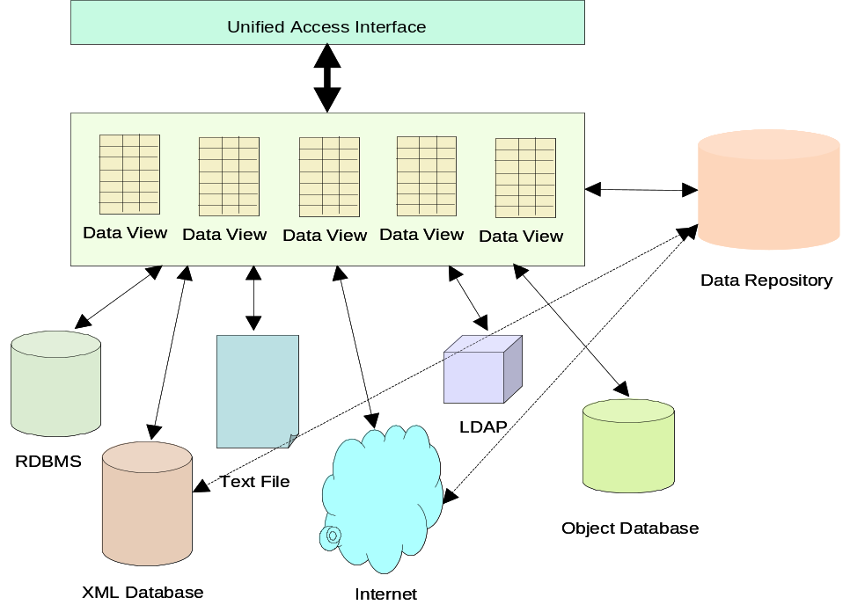
Figure 1: An Overview of the Data Integrator Functional Element

Figure 1 depicts the basic concepts of how the participating entities collaborate together in the Data Integrator Functional Element. Data can be physically scattered across various data sources, residing on the local area network (LAN) or over Wide Area Network (WAN). Examples include RDBMS, XML database, XML files, URLs that point to a set of data in the Internet, etc. Data Integrator enables the creation of different set of logical data views for various applications or systems. Users of Data Integrator manipulate the data according to the logical data view defined through a unified access interface. Logical data views could be physically stored in Data Repository for easy and fast access.

Key Features
Implementations of the Data Integrator Functional Element are expected to provide the following key features:
- The Functional Element MUST provide the capability to manage the available data sources. This includes capability to:
  - Add new data source to the pool of available data sources.
  - Remove data source from the pool of available data sources.
- The Functional Element MUST provide the capability to define a logical data view based on the pool of available data sources
- The Functional Element MUST provide capability to manage the updating and deletion of a logical data view
- The Functional Element MUST provide capability to manage the creation, updating and deletion of data transformation rules
- The Functional Element MUST provide capability to retrieve data based on the logical data view defined
- The Functional Element MUST provide a unified way to query data based on defined logical data views
- The Functional Element MUST provide a mechanism to extract data from various data sources and transform the data according to defined transformation rules for a logical data view

In addition, the following key features could be provided to enhance the Functional Element further:
- The Functional Element MAY provide capability to insert, update and delete data based on a logical data view (where applicable).
- The Functional Element MAY provide the capability to retrieve batch data based on logical data view according to a schedule and present the retrieved data in predefined XML formats.
- The Functional Element MAY provide the capability to manage the definition of batch data retrieval. This includes capability to:
3.1 Define a batch data retrieval
3.2 Disable the schedule of batch data retrieval
3.3 Enable the schedule of batch data retrieval
3.4 Remove the definition of batch data retrieval
- The Functional Element MAY implement data repository to host consolidated data. This data repository hosts the physical entity that stores the content of a logical data view.
- The Functional Element MAY provide a mechanism to synchronize data between data repository and data sources if data repository is provided.

Interdependencies
None

Related Technologies and Standards
RDBMS, LDAP, XML Database

Model

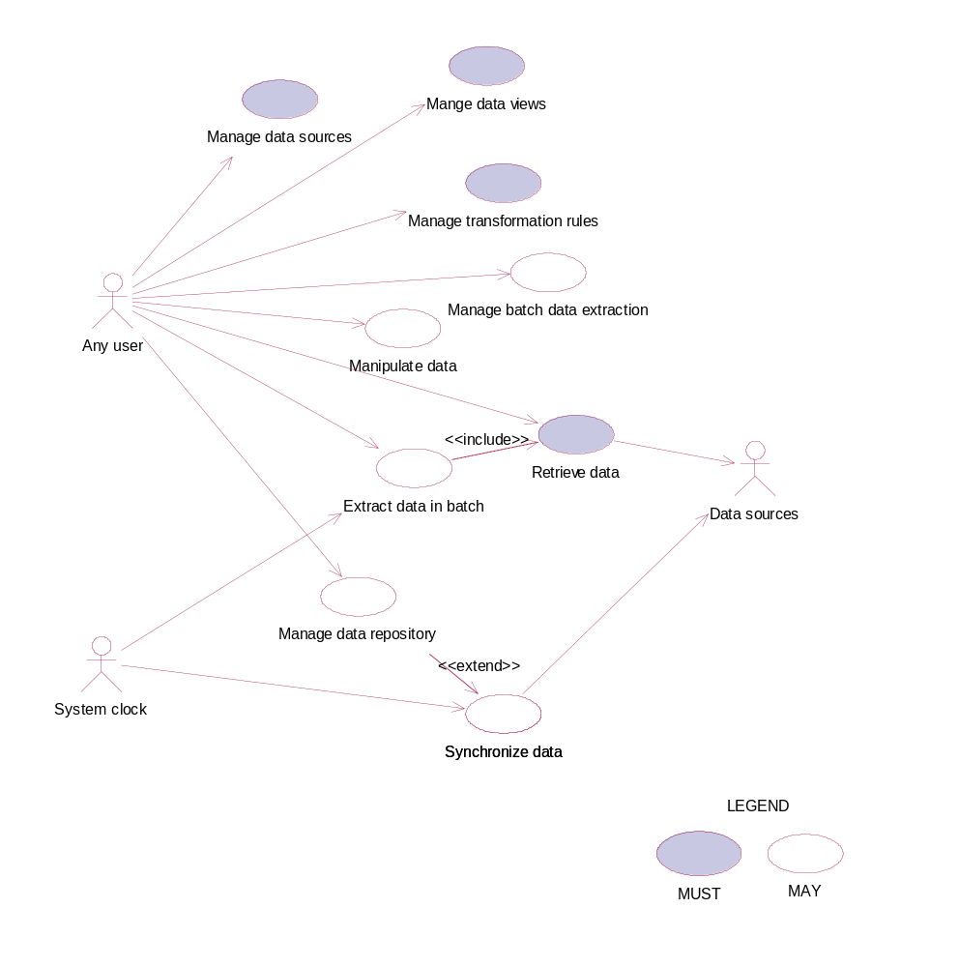
Figure 2: Model Of the Data Integrator Functional Element

Usage Scenarios

Manage data sources

Description
This use case allows the user to manage the available data sources on which logical data views are created.

Flow of Events

Basic Flow
The use case begins when the user of the Data Integrator wants to add in new data sources or remove existing data sources.
1: The user sends a request to Data Integrator together with data source profile and operation.
2: Based on the operation it specified, one of the following sub-flows is executed:
If the operation is ‘Add in data source’, then sub-flow 2.1 is executed.
If the operation is ‘Remove data source’, then sub-flow 2.2 is executed.
2.1: Add in data source.
2.1.1: The Functional Element gets the data source profile data, i.e. name, description, data source location for connection, login Id and password of the user who has privileges to manipulate data sources.
2.1.2: The Functional Element registers the data source as available data source.
2.2: Remove data source.
2.2.1: The Functional Element gets the name of data sources
2.2.2: The Functional Element checks whether the data source is valid data source.
2.2.3: The Functional Element removes the data source from the pool of available data source (with the assumption that the user has a valid login Id and password).
3: The Functional Element returns the results to indicate the success or failure of this operation to the user and the use case ends.

Alternative Flows
1: Data Source Already Registered.
1.1: If in the basic flow 2.1.2, the data source is already registered, Functional Element will return an error message to the user and the use case ends.
2: Data Source Not Exist.
2.1: If in the basic flow 2.2.2, the data source is not registered as available data source, Functional Element will return an error message to the user and the use case ends.
3: Persistency Mechanism Error.
3.1: If in the basic flow 2.1 and 2.2, the Functional Element cannot perform data persistency, Functional Element will return an error message to the user and the use case ends.

Special Requirements
None.

Pre-Conditions
None.

Post-Conditions
None.

Manage Data Views

Description
This use case allows the user to manage the logical data views.

Flow of Events

Basic Flow
The use case begins when the user wants to create/retrieve/update/delete a logical data view.
1: The user sends request to manage logical data view together with logical data view definition and operation.
2: Based on the operation it specifies, one of the following sub-flows is executed:
If the operation is ‘Create Data View’, the sub-flow 2.1 is executed.
If the operation is ‘Retrieve Data View’, the sub-flow 2.2 is executed.
If the operation is ‘Update Data View’, the sub-flow 2.3 is executed.
If the operation is ‘Delete Data View’, the sub-flow 2.4 is executed.
2.1: Create Data View.
2.1.1: The Functional Element gets logical data view definition, i.e. name, description, owner of data view, created date, data fields of data view, the source fields of data fields, and transformation rule.
2.1.2: The Functional Element checks whether the logical data view exists.
2.1.3: The Functional Element creates the logical data view exists.
2.2: Retrieve Data View.
2.2.1: The Functional Element gets name of the logical data view and retrieve condition.
2.2.2: The Functional Element retrieves the logical data view’s information according to the condition.
2.3: Update Data View.
2.3.1: The Functional Element gets name of the logical data view and its definition
2.3.2: The Functional Element checks whether the logical data view exists.
2.3.3: The Functional Element updates the logical data view definition
2.4: Delete Data View.
2.4.1: The Functional Element gets name of the logical data view.
2.4.2: The Functional Element checks whether the logical data view exists.
2.4.3: The Functional Element removes the logical data view.
3: The Functional Element returns the results of the operation to the user and the use case ends.

Alternative Flows
1: Data View Already Exists.
1.1: If in the basic flow 2.1.2, the data view is already defined, Functional Element returns an error message and the use case ends.
2: Data View Cannot Be Deleted.
2.1: If in the basic flow 2.4.3, the data of the logical data view is stored in Data Repository, Functional Element returns an error message and the use case ends.
3: Data View Not Found.
3.1: If in the basic flow 2.2.2, 2.3.2 and 2.4.2, the data view does not exist, Functional Element will return an error message and the use case ends.
4: Data View Cannot Be Updated.
4.1: If in the basic flow 2.4.3, the data of the logical data view is stored in Data Repository, Functional Element returns an error message and the use case ends.
5: Persistency Mechanism Error.
5.1: If in the basic flow 2.1.2, 2.1.3, 2.2, 2.3.2, 2.3.3, 2.4.2 and 2.4.3, the Functional Element cannot perform data persistency, Functional Element will return an error message to the user and the use case ends.

Special Requirements
None.

Pre-Conditions
None.

Post-Conditions
None.

Manage Transformation Rules

Description
This use case allows the user to manage the data transformation rules that are used by the Data Integrator to perform the data transformation before passing data back to users.

Flow of Events

Basic Flow
The use case begins when the user wants to create/retrieve/update/delete a data transformation rule.
1: The user sends request to manage data transformation rule together with the definition of transformation rule and operation.
2: Based on the operation it specifies, one of the following sub-flows is executed:
If the operation is ‘Define Data Transformation Rule’, the sub-flow 2.1 is executed.
If the operation is ‘Retrieve Data Transformation Rule’, the sub-flow 2.2 is executed.
If the operation is ‘Update Data Transformation Rule’, the sub-flow 2.3 is executed.
If the operation is ‘Delete Data Transformation Rule’, the sub-flow 2.4 is executed.
2.1: Create Data Transformation Rule.
2.1.1: The Functional Element gets the definition of the data transformation rule, i.e. name, description, rule type, function name, data view name, and applied data fields.
2.1.2: The Functional Element checks whether the data transformation rule exists.
2.1.3: The Functional Element creates the data transformation rule.
2.2: Retrieve Data Transformation Rule.
2.2.1: The Functional Element gets name of the data transformation rule and retrieve condition.
2.2.2: The Functional Element retrieves the data transformation rule’s information according to the condition.
2.3: Update Data Transformation Rule.
2.3.1: The Functional Element gets the name of data transformation rule.
2.3.2: The Functional Element checks whether data transformation rule exists.
2.3.3: The Functional Element updates the definition of the data transformation rule.
2.4: Delete Data Transformation Rule.
2.4.1: The Functional Element gets the name of data transformation rule.
2.4.2: The Functional Element checks whether the data transformation rule exists.
2.4.3: The Functional Element removes the data transformation rule from the Functional Element
3: The Functional Element returns the results of the operation to the user and the use case ends.

Alternative Flows
1: Data Transformation Rule Already Exists.
1.1: If in the basic flow 2.1.2, the data transformation rule is already defined, Functional Element returns an error message and the use case ends.
2: Data Transformation Rule Cannot Be Deleted.
2.1: If in the basic flow 2.4.3, the data of the logical data view, on which the data transformation rule is applied, is stored in Data Repository, Functional Element returns an error message and the use case ends.
3: Data Transformation Rule Not Found.
3.1: If in the basic flow 2.2.2, 2.3.2 and 2.4.2, the data transformation rule does not exist, Functional Element will return an error message and the use case ends
4: Data Transformation Rule Cannot Be Updated.
4.1: If in the basic flow 2.3.3, the data of the logical data view, on which the data transformation rule is applied, is stored in Data Repository, Functional Element returns an error message and the use case ends.
5: Logical Data View Not Exist.
4.1: If in the basic flow 2.1.3, the data of the logical data view, on which the data transformation rule is applied, dose not exist, Functional Element returns an error message and the use case ends.
6: Persistency Mechanism Error.
5.1: If in the basic flow 2.1.2, 2.1.3, 2.2, 2.3.2, 2.3.3, 2.4.2 and 2.4.3, the Functional Element cannot perform data persistency, Functional Element will return an error message to the user and the use case ends.

Special Requirements
None.

Pre-Conditions
None.

Post-Conditions
None.

Manage Batch Data Extraction

Description
This use case allows the user to define and disable the batch data extraction.

Flow of Events

Basic Flow
The use case begins when the user wants to define, remove, enable and disable a batch data extraction.
1: The user sends request to manage batch data extraction together with the definition of batch data extraction and operation.
2: Based on the operation it specifies, one of the following sub-flows is executed:
If the operation is ‘Define Batch Data Extraction’, the sub-flow 2.1 is executed.
If the operation is ‘Remove Batch Data Extraction Definition’, the sub-flow 2.1 is executed.
If the operation is ‘Enable Batch Data Extraction’, the sub-flow 2.2 is executed.
If the operation is ‘Disable Batch Data Extraction’, the sub-flow 2.3 is executed.
2.1: Define Batch Data Extraction.
2.1.1: The Functional Element gets batch data extraction definition, i.e. name, description, XML schema for the XML data format, the mapping of data fields from logical data view to XML data file, and extraction schedule.
2.1.2: The Functional Element checks whether the batch data extraction exists.
2.1.3: The Functional Element creates the batch data extraction.
2.2: Remove Batch Data Extraction Definition.
2.2.1: The Functional Element gets name of the batch data extraction.
2.2.2: The Functional Element checks whether the batch data extraction exists.
2.2.3: The Functional Element removes the batch data extraction from the Functional Element.
2.3: Enable Batch Data Extraction.
2.3.1: The Functional Element gets name of the batch data extraction.
2.3.2: The Functional Element checks whether the batch data extraction exists.
2.3.3: The Functional Element enables the batch data extraction.
2.4: Disable Batch Data Extraction.
2.4.1: The Functional Element gets name of the batch data extraction.
2.4.2: The Functional Element checks whether the batch data extraction exists.
2.4.3: The Functional Element disables the batch data extraction.
3: The Functional Element returns the results of the operation to the user and the use case ends.

Alternative Flows
1: Batch Data Extraction Exist.
1.1: If in the basic flow 2.1.2, the batch data extraction is already defined, Functional Element returns an error message and the use case ends.
2: Batch Data Extraction Not Found.
2.1: If in the basic flow 2.2.3, 2.3.3 and 2.4.3, the batch data extraction does not exist, Functional Element will return an error message and the use case ends
3: Persistency Mechanism Error.
3.1: If in the basic flow 2.1.2, 2.1.3, 2.2.2, 2.2.3, 2.3.2, 2.3.3, 2.4.2 and 2.4.3, the Functional Element cannot perform data persistency, Functional Element will return an error message to the user and the use case ends.

Special Requirements
None.

Pre-Conditions
None.

Post-Conditions
None.

Retrieve Data

Description
This use case allows the user to perform data retrieval based on the logical data view defined.

Flow of Events

Basic Flow
The use case begins when the user wants to perform data retrieval based on a logical data view.
1: The user sends request to retrieve data by providing the name of logical data view and SQL query statement.
2: The Functional Element checks whether the logical data view exists.
3: The Functional Element retrieves the definition of logical data view specified.
4: The Functional Element verifies the correctness of the SQL statement by checking the syntax of statement and the data fields used.
5: The Functional Element retrieves the definition of data transformation rule related with the data view.
6: The Functional Element performs the data retrieval from data sources
7: The Functional Element performs the data transformation to the data retrieved and fill up the data according to the definition of the logical data view.
8: The Functional Element returns the results of the operation to the user and the use case ends.

Alternative Flows
1: Query Statement Is Invalid.
1.1: If in the basic flow 4, the SQL statement is not valid, Functional Element returns an error message and the use case ends.
2: Data View Not Found.
2.1: If in the basic flow 3, the specified data view is not found, Functional Element returns an error message and the use case ends.
3: Data Source Not Available.
3.1: If in the basic flow 6, the data sources are not available for retrieving data, Functional Element returns an error message and the use case ends.
4: Data Transformation Rule Not Found.
4.1: If in the basic flow 5, the data transformation rule is not available, Functional Element returns an error message and the use case ends.
5: Data Repository Are Not Available.
5.1: If in the basic flow 6, the data of the logical data view is stored in Data Repository and the Data Repository is not available, Functional Element returns an error message and the use case ends.

Special Requirements
None.

Pre-Conditions
None.

Post-Conditions
None.

Manipulate Data

Description
This use case allows the user to insert, update, and delete data based on a logical data view defined.

Flow of Events

Basic Flow
The use case begins when the user wants to insert, update, and delete data based on a logical data view.
1: The user sends request to manipulate data by providing the name of the logical data view and SQL statement.
3: The Functional Element retrieves the definition of logical data view specified.
4: The Functional Element verifies the correctness of the SQL statement by checking the syntax of statement and the data fields used.
5: The Functional Element checks the violation of operations based on the definition of logical data view.
6: The Functional Element performs the operation specified in SQL statement.
7: The Functional Element returns the results of the operation to the user and the use case ends.

Alternative Flows
1: Manipulation Statement Is Invalid.
1.1: If in the basic flow 4, the SQL statement is not valid, Functional Element returns an error message and the use case ends.
2: Data View Not Found.
2.1: If in the basic flow 3, the specified data view is not found, Functional Element returns an error message and the use case ends.
3: Data Source Are Not Available.
3.1: If in the basic flow 6, the data sources are not available for retrieving data, Functional Element returns an error message and the use case ends.
4: SQL Error.
4.1: If in the basic flow 6, there is any error of SQL statement execution, Functional Element returns an error message and the use case ends.

Special Requirements
None.

Pre-Conditions
None.

Post-Conditions
None.

Extract Data in Batch

Description
This use case allows the user to perform batch data retrieval in a scheduled approach based on a logical data view defined.

Flow of Events

Basic Flow
The use case begins when the user wants to perform batch data retrieval or the time is up for scheduled batch data retrieval.
1: The user sends request to retrieve data by providing the name of the batch data retrieval or the Functional Element clock generates a trigger.
2: The Functional Element retrieves the definition of batch data retrieval according to the name.
3: The Functional Element prepares the parameters for invocation of Retrieve data use case
4: The Functional Element invokes the Data Retrieve use case
5: The Functional Element formats the data according to the format defined in the batch data retrieval definition
6: The Functional Element returns the results of the operation to the user and the use case ends.

Alternative Flows
1: Definition of Batch Data Retrieval Not Found.
1.1: If in the basic flow 2, the definition of batch data retrieval is not found, Functional Element returns an error message and the use case ends.
2: Error Returned From Data Retrieve Use Case.
2.1: If in the basic flow 4, the use case Retrieve data returns an error, Functional Element returns an error message and the use case ends.

Special Requirements
None.

Pre-Conditions
None.

Post-Conditions
None.

Manage Data Repository

Description
This use case allows the user to manage data repository.

Flow of Events

Basic Flow
The use case begins when the user wants to persistent a logical data view in the data repository, or the user wants to dispose the persistency of a data view from the data repository.
1: The user sends request to manage data repository by providing the name of the logical data view.
2: Based on the operation it specifies, one of the following sub-flows is executed:
If the operation is ‘Persistent Data View’, the sub-flow 2.1 is executed.
If the operation is ‘Dispose Data View’, the sub-flow 2.1 is executed.
2.1: Persistent Data View
2.1.1: The Functional Element retrieves the definition of the logical data view.
2.1.2: The Functional Element forms the SQL statement according to the definition of the logical data view.
2.1.3: The Functional Element performs the data retrieval from data sources.
2.1.4: The Functional Element performs the data transformation according to the transformation rule.
2.1.5: The Functional Element creates table in Data Repository and fill in the table with data generated in previous step.
2.2: Dispose Data View
2.1.1: The Functional Element forms the SQL statements of deleting the table
2.1.3: The Functional Element deletes the table in Data Repository.
3: The Functional Element returns the results of the operation to the user and the use case ends.

Alternative Flows
1: Data View Not Found
1.1: If in the basic flow 2.1.1, the definition of batch data retrieval is not found, Functional Element returns an error message and the use case ends.
2: Data Exist
2.1: If in the basic flow 2.1.3, there is data in the table, Functional Element returns an error message and the use case ends.
3: Data Repository Error
3.1: If in the basic flow 2.1.5 and 2.2.3, there is an error in Data Repository, Functional Element returns an error message and the use case ends.
4: Data Source Not Available
4.1: If in the basic flow 2.1.3, the data sources related is not available, Functional Element returns an error message and the use case ends

Special Requirements
None.

Pre-Conditions
None.

Post-Conditions
None.

Synchronize Data

Description
This use case allows the user to synchronize data in Data Repository with the data from data sources.

Flow of Events

Basic Flow
The use case begins when the user wants to synchronize data of a logical data view in data repository with the data in data sources, or the time is up for synchronization of data.
1: The user sends request to synchronize data repository or the Functional Element clock generates a trigger.
2: The Functional Element gets or finds those data views that are required to be synchronized with data sources.
3: The Functional Element retrieves data view definitions.
4: The Functional Element retrieves data from data sources according the definition of logical data view.
5: The Functional Element performs the data transformation on the data retrieved.
6: The Functional Element updates the table in Data Repository with the data generated in previous step.
7: The Functional Element returns the result of the operation and the use case ends.

Alternative Flows
1: Data View Definition Not Found
1.1: If in the basic flow 3, the definition of batch data retrieval is not found, Functional Element returns an error message and the use case ends.
2: Data Repository Error
2.1: If in the basic flow 6, there is an error in updating the Data repository, Functional Element returns an error message and the use case ends.
3: Data Source Not Available
3.1: If in the basic flow 4, the data sources related is not available, Functional Element returns an error message and the use case ends

Special Requirements
None.

Pre-Conditions
None.

Post-Conditions
None.

Error Management Functional Element (new)

Motivation
Error management is an important aspect in any software application development. In particular, it is important to know the cause of error in the Service Oriented Architecture (SOA) environment as an application can consume any service provided from any domain space spans across the Internet space. When an error occurs, it can be from within the same application domain or from different domain space. Hence, it is important to know the system state when the error occurred in the SOA environment. For example, when an error occurred, what services were used; which services’ interfaces were used; the passed in parameters and its associated values used for the interfaces, the time when the error occurred, API or SOAP invocation, etc are the important information for managing the application in the SOA environment.

The Error Management Functional Element is a framework designed to capture the system state at which the error occurred. The variables that governed the system state when an error occurred are defined as follows:
- The time at which the error occurred.
- The class/object name that the error occurred.
- The method name of the said class/object at which the error occurred.
- The input parameters, parameters types and its associated values of the said method at which the error occurred.
- The expected output type of the mentioned method name.
- The error category, error code and error severity assigned by the application.
- The name of the consumed service/component.
- The name of the interface used for the said service/component.
- The input parameters and types defined for the said interface.
- The values used for the mentioned input parameters.
- The Universal Resource Location (URL) of the consumed service endpoint.
- The SOAP Fault message <Fault> element returned from the consumed service.
- The type of invocation whether it is a Web Service call or Application Programming Interfaces (APIs) call.
- The domain controller information includes :
  - Name of the domain controller
  - Contact Information, .e. Email Id, Short Message Services (SMS), Telephone, Mobile phone, etc.
  - Means of Notification
The main motivation of the Functional Element is to provide a snapshot and capture all the system state information for an application when an error occurred. It assists system administrator to manage the system fault better for the necessary actions required for tracking the fault.

Figure 3 illustrates the perspective usage of Error Management Functional Element. When an error occurred in an application, the Functional Element will be used to capture the system state into a data store which can either be a database or a flat file.
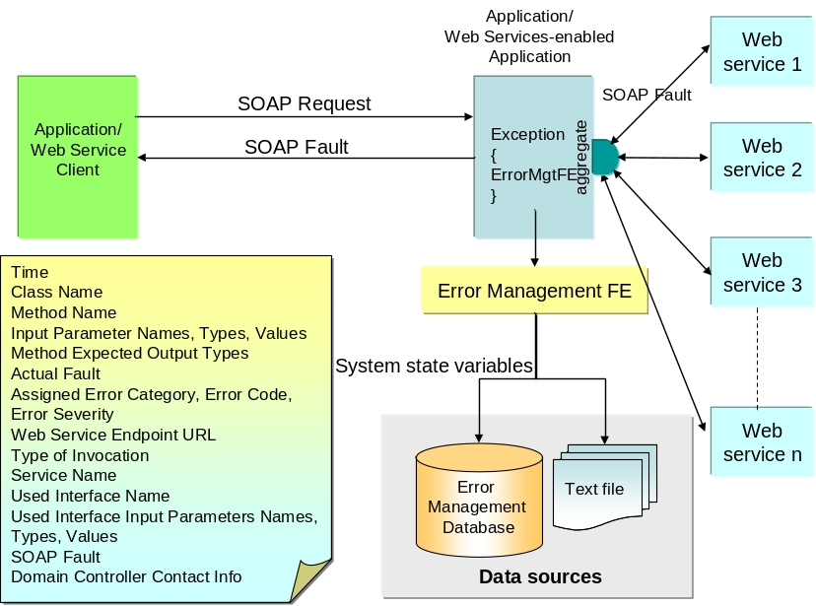

Figure 3: Error Management Functional Element Usage

This Functional Element fulfills the following requirements from the Functional Elements Requirements Document 02 [Error: Reference source not found]:
- Primary Requirements
- MANAGEMENT-340 to MANAGEMENT-346
- Secondary Requirements
- None

Terms Used
Terms | Description
Error Category | The Category or classification of error. For example, the category of error can be classified as:  Database error → DATABX,  Transaction error → TRANSX,  Authentication error → AUTHEX,  System error → SYSTEMX,  Application-specific error → APPLSX,  Third-party service error → THIRDPX,  etc.
Error Code | The Error Code defined for each Error Category. For example, 001, 002, 003, etc
Error Severity | The Error Severity defined for each Error Code. For example, the severity could be in the order of Critical, Major, Minor, Warning, For Information Only.
External Application Error | The External Application Error is defined as an error / fault / exception occurred by consuming external Web Services / Components providers. For example, customized exception, SOAPException and SOAP Fault resulted from APIs or SOAP invocation to external components or Web Services.
Internal Application Error | The Internal Application Error is defined as error / fault / exception raised resulted from an internal processing or run time error. For example, exceptions such as Null Pointer Exception, Class Type Casting, Array Out of Bound, etc. that occurred due to processing or run time error.

Figure 4 is an example illustrating the error hierarchy in terms of Error Category, Error Code and Error Severity.

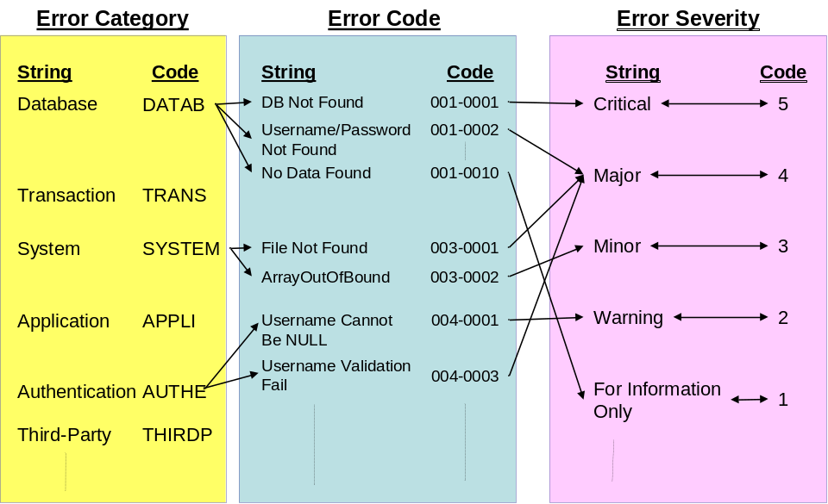
Figure 4: An Example of Error Hierarchy

For example, a database could give rise to a number of errors. For example, database not found, invalid username and password, no data found, null field, duplicate key etc are the common database errors. Each database error could have different severity. For example, database not found or invalid username and password are critical to business logic. An illustration of the resultant error code is defined as DATABX0001-CRITICAL.

Key Features
Implementations of the Error Management Functional Element are expected to provide the following key features:
- The Functional Element MUST provide the ability to create new Error Category.
- The Functional Element MUST provide the ability to modify and delete defined Error Category.
- The Functional Element MUST provide the ability to all the information stored in the Error Category. This includes the capability to:
  - Add new Error Code(s) and descriptions into a Error Category
  - Retrieve, modify and delete error code and descriptions
  - Support Error Code(s) in numeric, alpha-numeric or string format
- The Functional Element MUST provide a mechanism to capture the defined system state at which an error occurred.

In addition, the following key features could be provided to enhance the Functional Element further:
- The Functional Element MAY provide the ability to manage Error Severity by enabling the capability to:
  - Tag/Add to Error Code defined,
  - Retrieve, modify and delete Severity tag to Error Code, and
  - Retrieve information based on either Error Code or Severity.

Interdependencies
Direct Dependency
Log Utility Functional Element | The Log Utility Functional Element helps to log the audit trial.
Notification Functional Element | The Notification Element helps to notify the target user via email, or short messaging service.

Related Technologies and Standards
Specifications | Specific References
XML Version 1.0 | Extensible Markup Language (XML) 1.0 (Third Edition) W3C Recommendation 04 February 2004.
XML Schema | XML Schema Part 0: Primer Second Edition  W3C Recommendation 28 October 2004  XML Schema Part 1: Structures Second Edition  W3C Recommendation 28 October 2004  XML Schema Part 2: Datatypes Second Edition  W3C Recommendation 28 October 2004
WSDL Version 1.1 | Web Services Description Language (WSDL) 1.1 W3C Note 15 March 2001
SOAP Version 1.1 | Simple Object Access Protocol (SOAP) 1.1 W3C Note 08 May 2000
Functional Elements Specification | OASIS Functional Elements Specification  Committee Specifications 1.0, 16-Dec-2004

Model
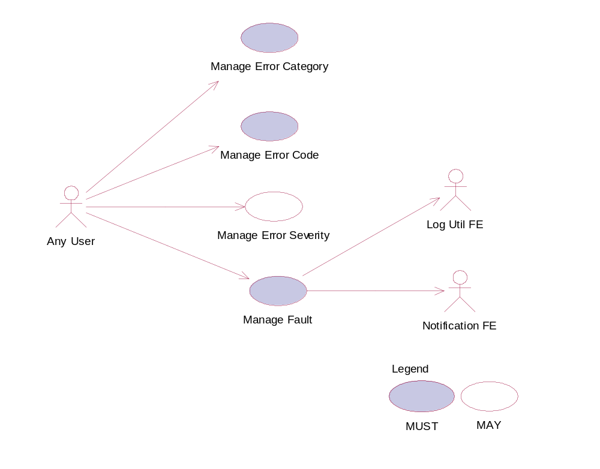
Figure 5: Model Of the Error Management Functional Element

Usage Scenarios

Manage Error Category

Description
This use case allows the error management administrator to manage Error Category.

Flow of Events

Basic Flow
The use case begins when the user wants to create/retrieve/update/delete an Error Category.
1: The user sends a request to manipulate an Error Category.
2: Based on the operation it specifies, one of the following sub-flows is executed:
If the operation is ‘Create Error Category’, the sub-flow 2.1 is executed.
If the operation is ‘Retrieve Error Category’, the sub-flow 2.2 is executed.
If the operation is ‘Update Error Category’, the sub-flow 2.3 is executed.
If the operation is ‘Delete Error Category’, the sub-flow 2.4 is executed.
2.1: Create Error Category.
2.1.1: The Functional Element gets category definition.
2.1.2: The Functional Element checks whether the category exists.
2.1.3: The Functional Element creates the category and save it in the error database.
2.2: Retrieve Error Category.
2.2.1: The Functional Element gets the Error Category name.
2.2.2: The Functional Element checks whether the category exists.
2.2.3: The Functional Element retrieves the Error Category’s information from the Error Management Data sources.
2.3: Update Error Category.
2.3.1: The Functional Element gets the Error Category name.
2.3.2: The Functional Element checks whether the Error Category exists.
2.3.3: The Functional Element updates the category definition and save it in the Error Management Data sources.
2.4: Delete Error Category.
2.4.1: The Functional Element gets the Error Category name.
2.4.2: The Functional Element checks whether the Error Category name exists.
2.4.3: The Functional Element checks whether the Error Code associated to the Error Category name exists.
- If Error Codes associated to the Error Category name exists, then basic sub-flow 2.4.4 is executed.
- If Error Codes associated to the Error Category name does not exist, then the basic sub-flow 2.4.7 is executed.
2.4.4: Error Codes associated to the Error Category name exists.
- If the Error Severity associated to the respective Error Codes exists, the basic sub-flow 2.4.5 is executed.
- If the Error Severity associated to the respective Error Code does not exist, then the basic sub-slow 2.4.6 is executed.
2.4.5: The Error Severity Exist.
2.4.5.1: The Functional Element removes the error severities associated to the respective Error Code from sub-flow 2.4.4.
2.4.6: The Error Severity Does Not Exist.
2.4.6.1 The Functional Element removes the respective Error Codes from sub-flow 2.4.3 from the Error Management Data sources.
2.4.7: The Error Codes Associated to the Error Category Name Does Not Exist.
2.4.7.1: The Functional Element removes the respective Error Codes associated to the Error Category name (from sub-flow 2.4.3) from the Error Management Data sources.
2.4.8: The Functional Element removes the Error Category name from the Error Management Data sources.
3: The Functional Element returns the results of the operation to the end user and the use case ends.

Alternative Flows
1: Error Category Already Exists.
1.1: If in the basic flow 2.1.2, the error category is already defined, the Functional Element writes the system state variables into the Error Management Data Sources using Log Utility Functional Element and notifies the system domain controller using the Notification Functional Element and the use case ends.
1.2: If in the basic flow 2.1.2, the error category is already defined, the Functional Element writes the system state variables into the Error Management Data Sources using Log Utility Functional Element and notifies the system domain controller using the Notification Functional Element and the use case ends.
2: Error Category Not Found.
2.1: If in the basic flow 2.2.2, 2.3.2 and 2.4.2, the error category does not exist, the Functional Element writes the system state variables into the Error Management Data Sources using Log Utility Functional Element and notifies the system domain controller using the Notification Functional Element and the use case ends.

Special Requirements
None.

Pre-Conditions
None.

Post-Conditions
Once the Error Category is deleted, all the associated Error Code and its Error Severity will be removed.

Manage Error Code

Description
This use case allows the user to manage Error Code.

Flow of Events

Basic Flow
The use case begins when the user wants to create/retrieve/update/delete an error code associated to an error category.
1: The user sends a request to manipulate an error code.
2: Based on the operation it specifies, one of the following sub-flows is executed:
If the operation is ‘Create Error Code’, the sub-flow 2.1 is executed.
If the operation is ‘Retrieve Error Code’, the sub-flow 2.2 is executed.
If the operation is ‘Update Error Code’, the sub-flow 2.3 is executed.
If the operation is ‘Delete Error Code’, the sub-flow 2.4 is executed.
2.1: Create Error Code.
2.1.1: The Functional Element gets the Error Category name
2.1.2. The Functional Element gets Error Code definition for the Error Category.
2.1.3: The Functional Element checks whether the Error Code exists.
2.1.4: The Functional Element creates the Error Code for the Error Category name and saves it into the Fault Management database.
2.2: Retrieve Error Code.
2.2.1: The Functional Element gets the Error Category name
2.2.2. The Functional Element gets the Error Code name.
2.2.3: The Functional Element checks whether the Error Code exists.
2.2.4. The Functional Element retrieves the Error Code’s information from the error database.
2.3: Update Error Code.
2.3.1: The Functional Element gets the Error Category name.
2.3.2. The Functional Element gets the Error Code name.
2.3.3: The Functional Element checks whether the Error Code exists.
2.3.4: The Functional Element updates the error code definition associated to the Error Category and save it in the Error Management Data sources.
2.4: Delete Error Code.
2.4.1: The Functional Element gets the Error Category name.
2.4.2. The Functional Element gets the Error Code name.
2.4.3: The Functional Element checks whether the Error Code exists.
2.4.4: The Functional Element checks whether the Error Severity associated to the Error Category and Error Code exists. Depending on whether the Error Severity exists, one of the following sub-flows will be executed.
  - If the Error Severity exists, then basic sub-flow 2.4.5 is executed.
  - If the Error Severity does not exist, the basic sub-flow 2.4.6 is executed.
2.4.5: Error Severity Exists.
2.4.5.1: The Functional Element removes the Error Severity associated to the Error Category and Error Code from the Error Management Data sources.
2.4.5.2: The Functional Element removes the Error Code associated to the Error Category name from the Error Management Data sources.
2.4.6: Error Severity Does Not Exist
2.4.6.1: The Functional Element removes the Error Code associated to the Error Category name from the Error Management Data sources.
3: The Functional Element returns the results of the operation to the end user and the use case ends.

Alternative Flows
1: Error Code Already Exists.
1.1: If in the basic flow 2.1.3, the Error Code associated to the Error Category name is already defined, the Functional Element writes the system state variables into the Error Management Data sources using the Log Utility Functional Element and notifies the system domain controller using the Notification Functional Element and the use case ends.
2: Error Code Not Found.
2.1: If in the basic flows 2.2.3, 2.3.3 and 2.4.3 the Error Code associated to the Error Category name does not exist, the Functional Element writes the system state variables into the Error Management Data sources using the Log Utility Functional Element and notifies the system domain controller using the Notification Functional Element and the use case ends.

Special Requirements
None.

Pre-Conditions
None.

Post-Conditions
None.

Manage Error Severity

Description
This use case allows the user to manage error severity.

Flow of Events

Basic Flow
The use case begins when the user wants to create/retrieve/update/delete an Error Severity associated to an Error Category and Error Code.
1: The user sends a request to manipulate an error severity.
2: Based on the operation it specifies, one of the following sub-flows is executed:
If the operation is ‘Create Error Severity’, the sub-flow 2.1 is executed.
If the operation is ‘Retrieve Error Severity, the sub-flow 2.2 is executed.
If the operation is ‘Update Error Severity’, the sub-flow 2.3 is executed.
If the operation is ‘Delete Error Severity’, the sub-flow 2.4 is executed
2.1: Create Error Severity.
2.1.1: The Functional Element gets Error Category name.
2.1.2: The Functional Element gets Error Code name.
2.1.3: The Functional Element gets Error Severity definition.
2.1.4: The Functional Element checks whether the Error Severity associated to the Error Category and error Code name exists.
2.1.5: The Functional Element creates the Error Severity associated to the Error Category name and Error Code name and saves it into the Error Management Data sources.
2.2 Retrieve Error Severity.
2.2.1: The Functional Element gets the Error Category name.
2.2.2: The Functional Element gets the Error Code name.
2.2.3. The Functional Element gets the Error Severity name.
2.2.4: The Functional Element checks whether the Error Severity exists associated to the Error Category and Error Code names.
2.2.5. The Functional Element retrieves the Error Severity’s information associated to the Error Category and Error Code names from the Error Management Data sources.
2.3: Update Error Severity.
2.3.1: The Functional Element gets the Error Category name.
2.3.2: The Functional Element gets the Error Code name.
2.3.3. The Functional Element gets the Error Severity name.
2.3.4: The Functional Element checks whether the Error Severity exists associated to the Error Category and Error Code names.
2.3.5: The Functional Element updates the Error Severity definition associated to the Error Category and Error Code names and saves it into the Error Management Data sources.
2.4: Delete Error Severity.
2.4.1: The Functional Element gets the Error Category name.
2.4.2: The Functional Element gets the Error Code name.
2.4.3. The Functional Element gets the Error Severity name.
2.4.4: The Functional Element checks whether the Error Severity exists associated to the Error Category and Error Code names.
2.4.5: The Functional Element removes the Error Severity associated to the Error Category and Error Code names from the Error Management Data sources.
3: The Functional Element returns the results of the operation to the end user and the use case ends.

Alternative Flows
1: Error Severity Already Exists.
1.1: If in the basic flow 2.1.4, the Error Severity associated to the Error Category and Error Code names is already defined, the Functional Element writes the system state variables into the Error Management Data sources using the Log Utility Functional Element and notifies the system domain controller using the Notification Functional Element and the use case ends.
2: Error Severity Not Found.
2.1: If in the basic flows 2.2.4, 2.3.4 and 2.4.4, the Error Severity associated to the Error Category and Error Code names does not exist, the Functional Element writes the system state variables into the Error Management Data sources using the Log Utility Functional Element and notifies the system domain controller using the Notification Functional Element and the use case ends.

Special Requirements
None

Pre-Conditions
None

Post-Conditions
None

Manage Fault

Description
This use case allows an application to manage error/fault depicted from a consumed service.

Flow of Events

Basic Flow
The use case begins when the user wants to manage an application’ fault arises.
If it is the ‘Internal Application Error, then basic flow 1 is executed.
If it is the ‘External Application Error, the basic flow 2 is executed.
1. Internal Application Error.
1.1. User sends the internal error detail information that needs to be tracked, together with Error Category, Error Code and Error Severity, which is an optional parameter, to the Functional Element. The internal error detailed information is described by Table 1.
1.2 The Functional Element logs the System State Information as defined in Table 1 using the Log Utility Functional Element into the Error Management Data sources.

S/N | Attributes of  System State | Description | Mandatory / Optional
1 | Time | The time where the fault occurred. | Mandatory
2 | Class Name | The name of class where the fault occurred | Mandatory
3 | Method Name | The name of the method where the fault occurred. | Mandatory
4 | Input Parameters Names | The list of input parameters names for the said method name. | Mandatory
5 | Input Parameters Types | The list of input parameter types associated to each of the input parameters names of the said method name. | Mandatory
6 | Input Parameters Values | The list of input parameters values associated to each of the input parameters names of the said method name. | Mandatory
7 | Expected Output Type | The expected output type of the said method name. | Optional
8 | Fault | The fault that causes the exception. | Mandatory
9 | Error Category | The Error Category assigned to the said Fault. | Mandatory
10 | Error Code | The Error Code assigned to the said Fault. | Mandatory
11 | Error Severity | The Error Severity assigned to the said Fault, if any. | Optional
12 | Domain Controller Contact | The contact information of the domain controller.  The contact information entails:  Name of domain controller  Email Id / Short Messaging Services (SMS) / Telephone / Mobile Phone  Means of Notification | Mandatory
Table 1 System State Information for Internal Application Error

2. External Application Error
2.1 User sends error information that needs to be tracked, as well as Error Category, Error Code and optional Error Severity to the Functional Element. The external error information includes System State Information for Internal Application Error defined in Table 1.
2.2 The Functional Element logs the System State Information as defined in Table 2 using the Log Utility Functional Element into the Error Management Data sources.

S/No. | Attributes of  System State | Description | Mandatory /  Optional
1 | Time | The time where the fault occurred. | Mandatory
2 | Class Name | The name of class where the fault occurred | Mandatory
3 | Method Name | The name of the method where the fault occurred. | Mandatory
4 | Input Parameters Names | The list of input parameters names for the said method name. | Mandatory
5 | Input Parameters Types | The list of input parameter types associated to each of the input parameters names of the said method name. | Mandatory
6 | Input Parameters Values | The list of input parameters values associated to each of the input parameters names of the said method name. | Mandatory
7 | Expected Output Type | The expected output type of the said method name. | Optional
8 | Fault | The fault that causes the exception. | Mandatory
9 | Error Category | The Error Category assigned to the said Fault. | Mandatory
10 | Error Code | The Error Code assigned to the said Fault. | Mandatory
11 | Error Severity | The Error Severity assigned to the said Fault, if any. | Optional
12 | Domain Controller Contact | The contact information of the domain controller.  The contact information entails:  Name of domain controller  Email Id / Short Messaging Services (SMS) / Telephone / Mobile Phone  Means of Notification | Mandatory
13* | Web Services Endpoint URL | The URL for the consumed web service. | Mandatory
14* | Invocation Type | The invocation type used for interface invocation, i.e. API or SOAP invocation. | Mandatory
15* | Consumed Web Service Name | The name of the consumed web service from within the application. | Mandatory
16* | Used Interface Name | The name of the interface used | Mandatory
17* | Used Interface Input Parameters Name | The list of input parameters names required for the said interface. | Mandatory
18* | Used Interface Input Parameters Types | The list of input parameters names types defined for the said interface. | Mandatory
19* | Used Interface Input Parameters Values | The list of input parameters values passed in for the said interface. | Mandatory
20* | SOAP Fault <Fault> Element | The content of the received SOAP Fault message <Fault> element. | Mandatory
Table 2. System State Information for External Application
Items indicated by the symbol “*” are the additional System State Information attributes which are applicable to External Application Error only.
3. The Functional Element returns the result of the operation to the user and the use case ends.

Alternative Flow
1: Error Category Does Not Exist
1.1: If in the basic flows 1.1 and 2.1, the Error Category Name is not defined, the Functional Element writes the system state variables into the Error Management Data sources using the Log Utility Functional Element and notifies the system domain controller and the use case ends.

2. Error Code Does Not Exist
2.1. If in the basic flows 1.1 and 2.1, the Error Code associated to the Error Category is not defined, the Element writes the system state variables into the Error Management Data sources using the Log Utility Functional Element and notifies the system domain controller using the Notification Functional Element and the use case ends.

3. Error Severity Does Not Exist
3.1. If in the basic flows 1.1 and 2.1, the Error Severity associated to the Error Category, and Error Code is not defined, the Functional Element writes the system state variables into the Error Management Data sources using the Log Utility Functional Element and notifies the system domain controller using the Notification Functional Element and the use case ends.

4. Log Utility Functional Element Not Available.
4.1. If in the basic flows 1.2 and 2.2, the Log Utility Functional Element writes the system state variables into the Error Management Data sources using the Log Utility Functional Element and notifies the system domain controller using the Notification Functional Element and the use case ends.

Special Requirements
None

Pre-Conditions
None

Post-Conditions
None

Event Handler Functional Element

Motivation
Information is in abundance in a service-oriented environment. However, not all information is applicable to a particular enterprise and there lies the need to control information flow in an organization. In a Web Service-enabled implementation, the Event Handler Functional Element can help to fulfill this need by:
- Managing the information flow through a subscription based mechanism,
- Streamlining information into meaningful categories so as to improve relevancy to a potential consumer of the information, and
- Refining information flow via a filtering mechanism

This Functional Element fulfills the following requirements from the Functional Elements Requirements Document 02 [Error: Reference source not found]:
- Primary Requirements
- MANAGEMENT-111,
- PROCESS-005, and
- PROCESS-100 to PROCESS-117.
- Secondary Requirements
- None

Terms Used
Terms | Description
Active Event Detection | Active Event Detection refers to the capability to periodically detect the occurrence of an external Event.
Channel | A Channel is a logical grouping of similar event types generated by the suppliers. When an Event is routed to a channel, all the Event Consumers who have subscribed to that Channel will be notified.
Event | An Event is an indication of an occurrence of an activity, such as the availability of a discounted air ticket. In such a case, it will trigger a follow-up action such as the URL where the ticket can be bought. Interested event consumer can then proceed with the purchase at the designated URL.
Event Consumer | An Event Consumer is a receiver of the events generated by an Event Supplier.
Event Supplier | An Event Supplier generates Event. It can be an application or a service, or even a person. Note that Event Suppliers are typically external to the Event Handler.
Filter | A Filter is a mechanism for defining Event that is of value to the Event Consumer.
Routing Rule | A Routing Rule defines how an Event is routed. An Event can be routed to a Channel or directly to an Event Consumer.

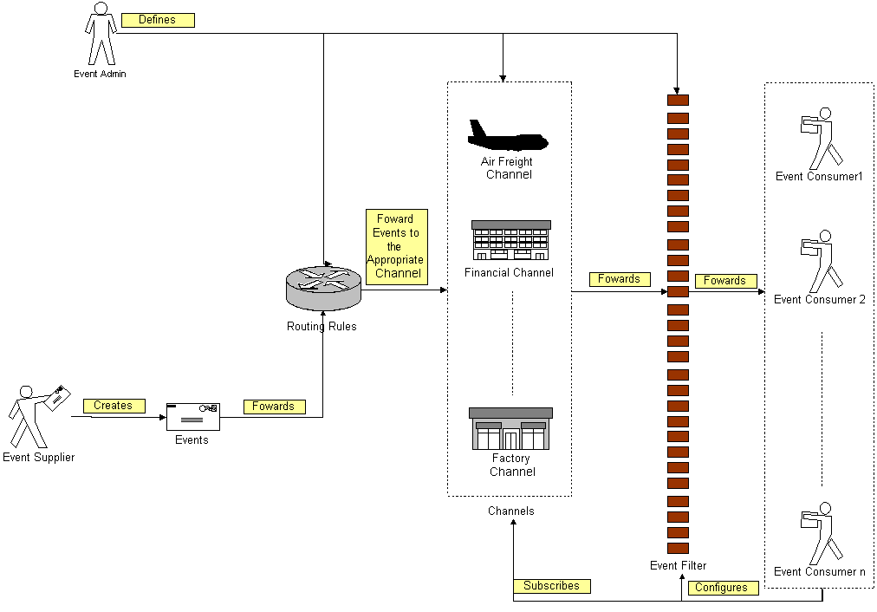
Figure 6: An Overview of the Event Handler Functional Element

Figure 3 depicts the basic concepts of how the participating entities collaborate together in the Event Handler Functional Element. Beginning with the event supplier who generates an event, the event is subsequently routed to the routing rules engine. Depending on the rules specified by the event administrator on the engine, the event could be routed to an appropriate channel, for example, the airfreight channel. In this case, a notification message will be sent to the subscribing event consumers. In between that, there is a filtering engine to determine if a particular event is meaningful to the intended recipients and this is configurable by the recipients themselves.

Key Features
Implementations of the Event Handler Functional Element are expected to provide the following key features:
- The Functional Element MUST provide the capability to manage the creation (or registration) and deletion of instances of the following concepts based on a pre-defined structure:
  - Event Supplier,
  - Event Consumer,
  - Event,
  - Filter,
  - Channel, and
  - Routing Rule.
- The Functional Element MUST provide the capability to manage all the information (attribute values) stored in such concepts. This includes the capability to retrieve and update attribute’s values belonging to the concepts mentioned in Key Feature (1).
- The Functional Element MUST provide the capability to enable Event Suppliers to trigger relevant Events.
- The Functional Element MUST provide a mechanism to associate/unassociate Routing Rules to an Event.
Example: As shown in Figure 1, where an event can be routed to Air Freight or Financial Channel or even to all channels based on the Routing Rules that are associated with the Event.
- As part of Key Feature (3), the Routing Rules must be able to route an event to all, specified Channels or individual Event Consumers.
- The Functional Element MUST enable Event Consumers to execute the following tasks to improve the relevancy of the incoming events”
  - Subscribe/Unsubscribe to relevant Channel(s), and
  - Apply a filter to the appropriate channel or event, which helps to refine the criteria of a useful event further.
- The Functional Element MUST provide the capability to notify relevant Event Consumers when an event occurs.
Examples of notification types include SMS, email and Web Services invocations.
- As part of Key Feature (6), the notification must be able to handle differing requirements arising from different notification formats.
Example: If the incoming event contains 2 important attributes, the order or position of these 2 attributes must be configurable to suit the convenience of the Event Consumer. This is extremely important in the case of Web Service Invocations.
- The Functional Element MUST provide a mechanism for managing the concepts specified across different application domains.
Example: Namespace control mechanism

In addition, the following key features could be provided to enhance the Functional Element further:
- The Functional Element MAY provide a mechanism to enable active event detection.
- If Key Feature (1) is implemented, then the Functional Element MUST provide the following capabilities also:
  - Non-intrusive detection
Example: The detection of a new event through periodic inspection of the audit log.
  - Configurable event detection schedule
Example: To inspect the audit log every 2 hours, where the duration between inspections is configurable.
  - Ability to retrieve relevant data from external source(s) for further event processing by Event Handler
Example: To retrieve Error Type and Message from audit log.
- The Functional Element MAY provide the capability to record event processing within the Event Handler. The logging of event processing includes the occurrences of event, sending of notifications, warning and error messages generated in the processing of events.
- The Functional Element MAY provide the capability scheduled-based event notification.

Interdependencies
Direct Dependency
Log Utility Functional Element | The Log Utility Functional Element helps to log the audit trial.

Interaction Dependency
Notification Functional Element | The Notification Functional Element helps to send SMS and email to the appropriate Event Consumer.

Related Technologies and Standards
None

Model
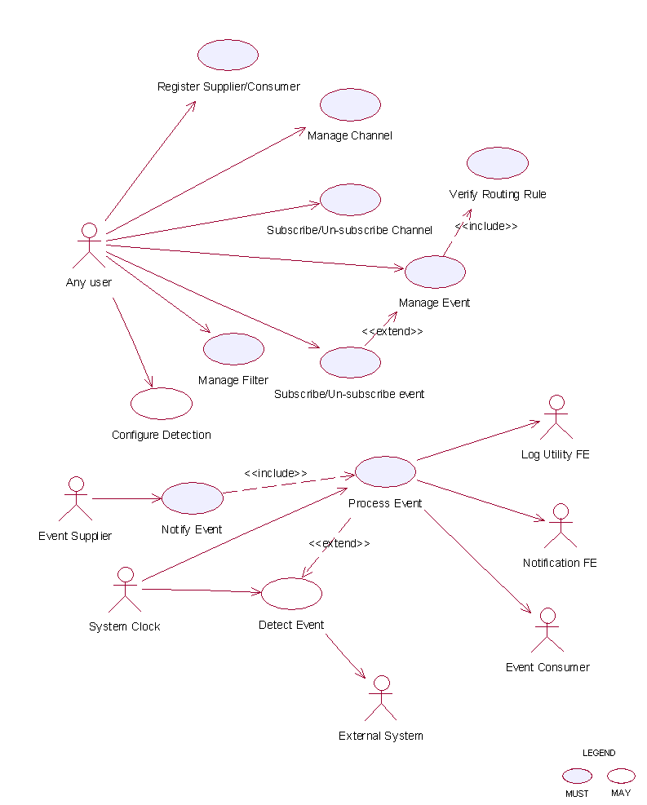
Figure 7: Model Of the Event Handler Functional Element []

Usage Scenarios

Register Supplier/Consumer

Description
This use case allows the user to register itself to the Event Handler Functional Element as an event supplier or an event consumer.

Flow of Events

Basic Flow
The use case begins when the user of the Event Handler wants to register an event supplier or event consumer with the Event Handler.
1: The user sends a request to Event Handler together with its profile data and operation.
2: Based on the operation it specified, one of the following sub-flows is executed:
If the operation is ‘Register as supplier’, then sub-flow 2.1 is executed.
If the operation is ‘Register as consumer’, then sub-flow 2.2 is executed.
If the operation is ‘Un-register as supplier’, then sub-flow 2.3 is executed.
If the operation is ‘Un-register as consumer’, then sub-flow 2.4 is executed.
If the operation is ‘Update supplier’, then sub-flow 2.5 is executed.
If the operation is ‘Update consumer’, then sub-flow 2.6 is executed.
If the operation is ‘Retrieve supplier’, then sub-flow 2.7 is executed.
If the operation is ‘Retrieve consumer’, then sub-flow 2.8 is executed.
2.1: Register as Supplier.
2.1.1: The Functional Element gets the user profile data, i.e. namespace, name, description and type.
2.1.2: The Functional Element registers the user as event supplier.
2.1.3: The Functional Element returns the Supplier Id to the user.
2.2: Register as Consumer.
2.2.1: The Functional Element gets the user profile data, i.e. namespace, name, description and type.
2.2.2: The Functional Element registers the user as event consumer.
2.2.3: The Functional Element returns the Consumer Id to the user.
2.3: Un-register as Supplier.
2.3.1: The Functional Element gets the user namespace and name or User Id.
2.3.2: The Functional Element checks whether the user is a supplier.
2.3.3: The Functional Element removes the user as supplier.
2.4: Un-register as Consumer.
2.4.1: The Functional Element gets the user namespace and name or User Id.
2.4.2: The Functional Element checks whether the user is a consumer.
2.4.3: The Functional Element removes the user as consumer.
2.5: Update Supplier.
2.5.1: The Functional Element gets the user namespace and name or User Id together with the user profile.
2.5.2: The Functional Element checks whether the user is a supplier.
2.5.2: The Functional Element updates the user profile.
2.6: Update Consumer.
2.6.1: The Functional Element gets the user namespace and name or User Id together with the user profile.
2.6.2: The Functional Element checks whether the user is a consumer.
2.6.3: The Functional Element updates the user profile.
2.7: Retrieve Supplier.
2.7.1: The Functional Element gets the user namespace and name or User Id.
2.7.2: The Functional Element checks whether the user is a supplier.
2.7.3: The Functional Element returns the user profile.
2.8: Retrieve Consumer.
2.8.1: The Functional Element gets the user namespace and name or User Id.
2.8.2: The Functional Element checks whether the user is a consumer.
2.8.3: The Functional Element returns the user profile.
3: The Functional Element returns the results to indicate the success or failure of this operation to the user and the use case ends.

Alternative Flows
1: Supplier Already Registered.
1.1: If in the basic flow 2.1.2, the user already registered as supplier, Functional Element will return an error message to the user and the use case ends.
2: Consumer Already Registered.
2.1: If in the basic flow 2.2.2, the user already registered as consumer, Functional Element will return an error message to the user and the use case ends.
3: Supplier or Consumer Not Registered.
3.1: If in the basic flow 2.3.2, 2.4.2, 2.5.2, 2.6.2, 2.7.2, and 2.8.2, the user specified is not registered, Functional Element will return an error message to the user and the use case ends.
4: Persistency Mechanism Error.
4.1: If in the basic flow 2.1, 2.2, 2.3, 2.4, 2.5, 2.6, 2,7 and 2.8, the Functional Element cannot perform data persistency, Functional Element will return an error message to the user and the use case ends.

Special Requirements
None.

Pre-Conditions
None.

Post-Conditions
None.

Manage Channel

Description
This use case allows the user to manage channels.

Flow of Events

Basic Flow
The use case begins when the user wants to create/retrieve/update/delete a channel
1: The user sends request to manipulate a channel.
2: Based on the operation it specifies, one of the following sub-flows is executed:
If the operation is ‘Create Channel’, the sub-flow 2.1 is executed.
If the operation is ‘Retrieve Channel’, the sub-flow 2.2 is executed.
If the operation is ‘Update Channel’, the sub-flow 2.3 is executed.
If the operation is ‘Delete Channel’, the sub-flow 2.4 is executed.
2.1: Create Channel.
2.1.1: The Functional Element gets channel definition, i.e. namespace, channel name and description.
2.1.2: The Functional Element checks whether the channel exists.
2.1.3: The Functional Element creates the channel.
2.2: Retrieve Channel.
2.2.1: The Functional Element gets namespace, channel name and retrieve condition.
2.2.2: The Functional Element retrieves the channel’s information according to the condition.
2.3: Update Channel.
2.3.1: The Functional Element gets namespace, channel name and description.
2.3.2: The Functional Element checks whether the channel exists.
2.3.3: The Functional Element updates the channel definition.
2.4: Delete Channel.
2.4.1: The Functional Element gets namespace and channel name.
2.4.2: The Functional Element checks whether the channel exists.
2.4.3: The Functional Element removes the channel from the Functional Element.
3: The Functional Element returns the results of the operation to the user and the use case ends.

Alternative Flows
1: Channel Already Exists.
1.1: If in the basic flow 2.1.2, the channel is already defined, Functional Element returns an error message and the use case ends.
2: Conditional Retrieving.
2.1: In the basic flow 2.2.2:
2.1 1: If the condition is the retrieval by channel name and the channel does not exist, then it will go to Alternative Flow 3.
2.1.2: If the condition is the retrieval of one channel definition, it returns the definition of that channel and the use case ends.
2.1.3: If the condition is the retrieval of all channels’ information, it returns all channels definition and the use case ends.
2.1.4: If the condition is the retrieval of channel through channel description, it will return all matched channels and the use case ends.
2.1.5: If the condition is the retrieval of registered consumers, it returns the list of consumer registered on the channel and the use case ends.
3: Channel Not Found.
3.1: If in the basic flow 2.2.2, 2.3.2 and 2.4.2, the channel does not exist, Functional Element will return an error message and the use case ends.
4: Consumer Not Found.
4.1: If in the basic flow 2.1.3, 2.5.3 and 2.6.3, the event consumer does not exist, Functional Element will return an error message and the use case ends.
5: Extension Point.
5.1: If in the basic flow 2.1.3, and 2.3.3, the event consumers that subscribed to the channel are provided, the use case Subscribe/un-subscribe channel will be extended.

Special Requirements
None.

Pre-Conditions
None.

Post-Conditions
None.

Subscribe/Un-subscribe To Channel

Description
This use case performs the subscription or un-subscription on a channel for an event consumer.

Flow of Events

Basic Flow
The use case begins when the user wants to subscribe or un-subscribe to a channel.
1: The user sends the request.
2: Based on the operation it specifies, one of the following sub-flows is executed:
If the operation is ‘Subscribe to Channel’, then sub-flow 2.1 is executed.
If the operation is ‘Un-Subscribe to Channel’, then sub-flow 2.2 is executed.
2.1: Subscribe To Channel.
2.1.1: The Functional Element gets event consumer Id, or consumer namespace and consumer name, together with channel namespace and channel name.
2.1.2: The Functional Element checks whether the channel exists.
2.1.3: The Functional Element adds the subscription of the consumer to the channel.
2.2: Un-Subscribe To Channel.
2.2.1: The Functional Element gets event consumer Id, or consumer namespace and consumer name, together with channel namespace and channel name.
2.2.2: The Functional Element checks whether the channel exists.
2.2.3: The Functional Element removes the subscription of the consumer to the channel.
3: The Functional Element returns the results of the operation to the user and the use case ends.

Alternative Flows
1: Channel Not Found.
1.1: If in the basic flow 2.1.2 and 2.2.2, the channel specified does not exist, Functional Element will return an error message to the user and the use case ends.
2: Event Consumer Not Found.
2.1: If in the basic flow 2.1.2 and 2.2.2, the event consumer related does not exist, Functional Element will return an error message to the user and the use case ends.

Special Requirements
None.

Pre-Conditions
None.

Post-Conditions
None.

Manage Event

Description
This use case describes the scenarios of managing events.

Flow of Events

Basic Flow
The use case begins when the user wants to manage events.
1: The user sends a request to the Functional Element.
2: Based on the operation it specifies, one of the following sub-flows is executed:
If the operation is ‘Create Event’, then sub-flow 2.1 is executed.
If the operation is ‘Retrieve Event Information’, then sub-flow 2.2 is executed.
If the operation is ‘Update Event Definition’, then sub-flow 2.3 is executed.
If the operation is ‘Delete Event’, then sub-flow 2.4 is executed.
If the operation is ‘Assign Flow’, then sub-flow 2.5 is executed.
If the operation is ‘Un-Assign Flow’, then sub-flow 2.6 is executed.
2.1: Create Event
2.1.1: The Functional Element gets event definition including namespace, event name, event description, event routing rule, and event attributes definition.
2.1.2: The Functional Element verifies the parameters.
2.1.3: The Functional Element verifies the routing rule through use case verify routing rule.
2.1.4: The Functional Element creates event definition by recording the definition of event.
2.2: Retrieve Event.
2.2.1: The Functional Element gets namespace, event name, and condition.
2.2.2: The Functional Element retrieves the event definition according to the condition.
2.3: Update Event Definition
2.3.1: The Functional Element gets event definition including namespace, event name, event description, event routing rule, and event attributes definition.
2.3.2: The Functional Element verifies the parameters.
2.3.3: The Functional Element verifies the routing rule through use case verify routing rule.
2.3.4: The Functional Element updates the event definition.
2.4: Delete Event.
2.4.1: The Functional Element gets namespace and event name.
2.4.2: The Functional Element checks whether the event exists.
2.4.3: The Functional Element deletes the event definition.
2.5: Assign Flow.
2.5.1: The Functional Element gets namespace, event name and flow name.
2.5.2: The Functional Element checks whether the event exists and flow defined.
2.5.3: The Functional Element assigns the flow to the event.
2.6: Un-assign Flow.
2.6.1: The Functional Element gets namespace, event name and flow name.
2.6.2: The Functional Element checks whether the event exists and flow defined.
2.6.3: The Functional Element un-assigns the flow to the event.
3: The Functional Element returns the results of the operation to the user and the use case ends.

Alternative Flows
1: Event Already Exist.
1.1: If in the basic flow 2.1.2, the event already exists, Functional Element will return an error message to the user and the use case ends.
2: Parameters Are Invalid.
2.1: If in the basic flow 2.1.2 and 2.3.2, the parameters provided are invalid, Functional Element will return an error message to the user and the use case ends.
3: Event Not Found.
3.1: If in the basic flow 2.2.2, 2.3.2 and 2.4.2, the event does not exist, Functional Element will return an error message to the user and the use case ends.
4: Flow Not Defined.
4.1: If in the basic flow 2.1.2 and 2.3.2, the flow does not exist, Functional Element will return an error message to the user and the use case ends.
5: Condition Retrieve.
5.1: In the basic flow 2.2.2:
5.1.1: If the retrieving condition is the retrieval of event definition based on event name, it returns event definition and the use case ends.
5.1.2: If the retrieving condition is the retrieval of all event definition, it returns all event definition and the use case ends.
5.1.3: If the retrieving condition is the retrieval of events assigned to specified channel, it returns the list of event definitions.
5.1.4: If the retrieving condition is the retrieval of channels associated with specified event, it returns the list of channel definition.
6: Extension Point.
6.1: If in the basic flow 2.1.4, and 2.3.4, the event consumers that subscribed to the event are provided, the use case Subscribe/Un-subscribe event will be extended.

Special Requirements
None.

Pre-Conditions
None.

Post-Conditions
None.

Subscribe/Un-subscribe To Event

Description
This use case performs the subscription or un-subscription on an event for an event consumer.

Flow of Events

Basic Flow
The use case begins when the user wants to subscribe or un-subscribe an event.
1: The user sends a request.
2: Based on the operation it specifies, one of the following sub-flows is executed:
If the operation is ‘Subscribe to Event’, then sub-flow 2.1 is executed.
If the operation is ‘Un-Subscribe to Event’, then sub-flow 2.2 is executed.
2.1: Subscribe To Event.
2.1.1: The Functional Element gets event consumer Id, or consumer namespace and consumer name, together with event namespace and event name.
2.1.2: The Functional Element checks whether the event exists.
2.1.3: The Functional Element adds the subscription of the consumer to the event.
2.2: Un-Subscribe To Event.
2.2.1: The Functional Element gets event consumer Id, or consumer namespace and consumer name, together with event namespace and event name.
2.2.2: The Functional Element checks whether the event exists.
2.2.3: The Functional Element removes the subscription of the consumer to the event.
3: The Functional Element returns the results of the operation to the user and the use case ends.

Alternative Flows
1: Event Not Found.
1.1: If in the basic flow 2.1.2 and 2.2.2, the event specified does not exist, Functional Element will return an error message to the user and the use case ends.
2: Event Consumer Not Found.
2.1: If in the basic flow 2.1.2 and 2.2.2, the event consumer related does not exist, Functional Element will return an error message to the user and the use case ends.

Special Requirements
None.

Pre-Conditions
None.

Post-Conditions
None.

Verify Routing Rule

Description
This use case verifies the syntax of routing rule.

Flow of Events

Basic Flow
The use case begins when the user wants to verify the correctness of a routing expression.
1: The user sends a request.
2: The Functional Element gets the routing expression.
3: The Functional Element checks the syntax of routing expression.
4: The Functional Element verifies the parameters.
5: The Functional Element returns the status of the operation to the user and the use case ends.

Alternative Flows
1: Routing Rule Expression Syntax Error.
1.1: If in the basic flow 3, there is a syntax error, Functional Element will return an error message to the user and the use case ends.
2: Event Consumer Not Found.
2.1: If in the basic flow 4, the event consumer related does not exist, Functional Element will return an error message to the user and the use case ends.

Special Requirements
None.

Pre-Conditions
None.

Post-Conditions
None.

Manage Filter

Description
A filter is used to filter out certain events to those event consumers even though they are the intended receivers according to the routing rules.

Flow of Events

Basic Flow
The use case begins when the user wants to create/retrieve/update/delete a filter.
1: The user sends a request to manage a filter.
2: Based on the operation it specifies, one of the following sub-flows is executed:
If the operation is ‘Create Filter’, then sub-flow 2.1 is executed.
If the operation is ‘Retrieve Filter’, then sub-flow 2.2 s executed.
If the operation is ‘Update Filter’, then sub-flow 2.3 is executed.
If the operation is ‘Delete Filter’, then sub-flow 2.4 is executed.
2.1: Create Filter.
2.1.1: The Functional Element gets filter definition, i.e. consumer namespace, consumer name, filter name, description, event name or channel name.
2.1.2: The Functional Element checks whether the event or channel exists.
2.1.3: The Functional Element saves the filter definition.
2.2: Retrieve Filter.
2.2.1: The Functional Element gets the filter name.
2.2.2: The Functional Element retrieves the filter information according to the name.
2.3: Update Filter.
2.3.1: The Functional Element gets filter definition, i.e. consumer namespace, name, filter name, description, event name or channel name.
2.3.2: The Functional Element checks the parameters.
2.3.3: The Functional Element updates the filter definition.
2.4: Delete Filter.
2.4.1: The Functional Element gets namespace and filter name.
2.4.2: The Functional Element checks whether the filter exists.
2.4.3: The Functional Element removes the filter from the Functional Element.
3: The Functional Element returns the results of the operation to the user and the use case ends.

Alternative Flows
1: Filter Already Exists.
1.1: If in the basic flow 2.1.2, the filter is already defined, Functional Element will return an error message and the use case ends.
2: Event Not Found.
2.1: If in the basic flow 2.1.2 and 2.3.2, the event used does not exist, Functional Element will return an error message and the use case ends.
3: Channel Not Found.
3.1: If in the basic flow 2.1.2 and 2.3.2, the channel used does not exist, Functional Element will return an error message and the use case ends.
4: Consumer Not Found.
4.1: If in the basic flow 2.1.3, 2.5.3, and 2.6.3, the event consumer does not exist, Functional Element will return an error message and the use case ends.

Special Requirements
None.

Pre-Conditions
None.

Post-Conditions
None.

Notify Event

Description
This use case allows the event supplier to notify an event to the Event Handler Functional Element. Once the Event Handler Functional Element receives the notification, it will process the event based on the processing logic defined.

Flow of Events

Basic Flow
The use case begins when the user wants to notify an event.
1: The user sends a notification.
2: The Functional Element receives the notification with parameters, i.e. event supplier id or event supplier namespace and name.
3: The Functional Element checks whether the event is defined and event supplier is registered.
4: Include use case Process Event to process the notification of event.
5: The Functional Element returns the status of the operation to the user and the use case ends.

Alternative Flows
1: User Is Not Registered.
1.1: If in the basic flow 3, the user is not registered, Functional Element will return an error message to the user and the use case ends.
2: Event Not Defined.
2.1: If in the basic flow 3, the event is not defined, Functional Element will return an error message to the user and the use case ends.
3: Error Returned.
3.1: If in the basic flow 4, an error is returned by use case Process event, Functional Element will return an error message to the user and the use case ends.

Special Requirements
None.

Pre-Conditions
None.

Post-Conditions
None.

Configure Monitoring

Description
This use case describes the capability of configuration on event monitoring. Based on the configuration, Event Handler will pro-actively check whether an event has happened.

Flow of Events

Basic Flow
The use case begins when the user wants to configure the event monitoring.
1: The user sends a request to manage a filter.
2: Based on the operation it specifies, one of the following sub-flows is executed:
If the operation is ‘Add Configuration’, then sub-flow 2.1 is executed.
If the operation is ‘Remove Configuration’, then sub-flow 2.2 is executed.
2.1: Add Configuration.
2.1.1: The Functional Element gets configuration definition, i.e. configuration name, namespace, event name, connection parameters, condition that signifies the events and schedule.
2.1.2: The Functional Element saves filter definition.
2.2: Remove Configuration.
2.2.1: The Functional Element gets configuration name.
2.2.2: The Functional Element removes the configuration.
3: The Functional Element returns the results of the operation to the user and the use case ends.

Alternative Flows
1: Configuration Exist.
1.1: If in the basic flow 2.1.2, the configuration already exists, Functional Element will return an error message and the use case ends.

Special Requirements
None.

Pre-Conditions
None.

Post-Conditions
None.

Detect Event

Description
This use case describes the event monitoring capability that Event Handler provides. Once Event Handler detects an event, it will trigger the pre-defined process for the event.

Flow of Events

Basic Flow
The use case begins when the Functional Element clock generates the trigger.
1: The Functional Element clock generates a trigger.
2: The Functional Element receives the trigger and checks the condition for pre-defined monitoring sources.
3: The Functional Element checks whether the event happens.
4: The Functional Element returns the results of the operation and the use case ends.

Alternative Flows
1: External Functional Element Not Available.
1.1: If in the basic flow 3, the external Functional Element is not available and the Event Handler cannot make a connection, Functional Element will return an error message and the use case ends.
2: Data Not Available.
2.1: If in the basic flow 3, the data that signifies the event cannot be accessed, Functional Element will return an error message and the use case ends.
3: Extension Point.
3.1: If in the basic flow 3, the event happens, Functional Element will extend to use case Process event.

Special Requirements
None.

Pre-Conditions
None.

Post-Conditions
None.

Process Event

Description
This use case describes the core functionality of Event Handler. It is the engine that processes the events. Actor can be the Functional Element clock that triggers the scheduled event notification, or any user who wants to notify the event.

Flow of Events

Basic Flow
The use case begins when there is a request to process the event.
1: The user sends a request to process an event.
2: Based on the actor of this use case, one of the sub-flows is executed.
If the initiator is the Functional Element clock, then sub-flow ‘Initiated By Functional Element Clock’ is executed.
If the initiator is other than Functional Element clock, then sub-flow ‘Initiated By Any User’ is executed.
2.1: Initiated By Functional Element Clock.
2.1.1: The Functional Element looks up scheduled events defined to find out time-due notification.
2.1.2: The Functional Element retrieves the routing rule for the event.
2.1.3: The Functional Element looks up the corresponding consumers based on the routing rule.
2.1.4: The Functional Element retrieves filters defined and find out the event receivers.
2.1.5: The Functional Element notifies or invokes the event consumers based on the routing rule defined.
2.2: Initiated By Any User.
2.2.1: The Functional Element retrieves the routing rule for the event.
2.2.2: The Functional Element looks up the corresponding consumers.
2.2.3: The Functional Element retrieves filters defined and find out the event receivers.
2.2.4: The Functional Element notifies or invokes the event consumers based on the routing rule defined.
3: The Functional Element logs the notification of event and the use case ends.

Alternative Flows
1: Notify Event.
In basic flow 2.1.4 and 2.2.4, based on the type of consumer, one of the sub-flows is execute.
If the consumer type is ‘SMTP’, then sub-flow Notify via SMTP is executed.
If the consumer type is ‘SMS Gateway’, then sub-flow Notify via SMS Gateway is executed.
If the consumer type is ‘Notify RPC-Web Service’, then sub-flow Notify RPC-Web Service is executed.
If the consumer type is ‘Notify Document Style Web Service’ then sub-flow Notify Document style Web Service is executed.
1.1: Notify via SMTP.
1.1.1: The Functional Element gets the pre-defined message for event and forms the parameters.
1.1.2: The Functional Element gets the parameters for SMTP server.
1.1.3: The Functional Element sends out the pre-defined message and the use case ends.
1.2: Notify via SMS Gateway.
1.2.1: The Functional Element gets the pre-defined message for event and forms the parameters.
1.2.2: The Functional Element gets the parameters for the SMS gateway.
1.2.3: The Functional Element sends out the pre-defined message and the use case ends.
1.3: Notify RPC-Web Service.
1.3.1: The Functional Element gets the operation parameter.
1.3.2: The Functional Element gets Web Services endpoint parameters.
1.3.3: The Functional Element dynamically invokes the Web Service and the use case ends.
1.4: Notify Document Style Web Service.
1.4.1: The Functional Element gets the operation parameter.
1.4.2: The Functional Element gets Web Services endpoint parameters.
1.4.3: The Functional Element dynamically generates the SOAP message and sends to the Web Services and the use case ends.
2: Flow Is Defined.
If in the basic flow 2.1.2 and 2.2.1, a flow is defined for the event, Functional Element will perform the following steps:
2.1: The Functional Element retrieves all the intended event consumers defined in the flow.
2.2: The Functional Element will go to basic flow 2.2.
2.3: The Functional Element will resume the execution from basic flow 2.1.2 or 2.2.1.
3: Log Utility Not Available.
3.1: If in the basic flow 3, the Log Utility Functional Element is not available, Functional Element will return an error message to the user and the use case ends.
4: SMS Gateway Not Available.
4.1: If in the Alternative Flow 1.2.3, the SMS Gateway is not available, Functional Element will return an error message to the user and the use case ends.
5: SMPT Server Not Available.
5.1: If in the Alternative Flow 1.1.3, the SMTP server is not available, Functional Element will return an error message to the user and the use case ends.
6: RPC Web Service Not Available.
6.1: If in the Alternative Flow 1.3.3, the Web Service is not available, Functional Element will return an error message to the user and the use case ends.
7: Document Style Web Service Not Available.
7.1: If in the Alternative Flow 1.4.3, document style Web Service is not available, Functional Element will return an error message to the user and the use case ends.

Special Requirements

Supportability
The application server used must have a JMS service provided.

Pre-Conditions
None.

Post-Conditions
None.

Group Management Functional Element

Motivation
The Group Management Functional Element is expected to be an integral part of the User Access Management (UAM) functionalities. In a Web Service-enabled implementation, this Functional Element helps to provide the mechanism to manage users in a collective manner. This is important as it provides the flexibility of adopting either coarse or fine-grain access controls, or both.

This Functional Element fulfills the following requirements from the Functional Elements Requirements Document 02 [Error: Reference source not found]:
- Primary Requirements
- MANAGEMENT-050 to MANAGEMENT-053, and
- MANAGEMENT-078
- Secondary Requirements
- None

Terms Used
Terms | Description
Group | A Group is a collection of individual users, and are typically grouped together as they have certain commonalities
Namespace | Namespace is use to segregate the instantiation of the application across different application domains. If a company has two separate standalone application, for example, an email application and an equipment booking application, then these two are considered as separate application domains.
User | A user is loosely defined to include both human and virtual users. Virtual users could include service users and application (or machine) users that are utilising other services in a SOA environment.
User Access Management / UAM | User Access Management or UAM refer to the concept of managing users in a holistic manner, considering all aspect which includes:  Defining a set of basic user information that should be stored in any enterprise application.  Providing a means to extend this basic set of user information when needed.  Simplifying management by grouping related users together through certain criteria.  Having the flexibility of adopting both coarse and fine grain access controls.

Key Features
Implementations of the Group Management Functional Element are expected to provide the following key features:
- The Functional Element MUST provide a basic Group structure with a set of pre-defined attributes.
- The Functional Element MUST provide the capability to extend on the basic Group structure dynamically.
- As part of Key Feature (2), this dynamic extension MUST be definable and configurable at runtime implementation of the Functional Element.
- The Functional Element MUST provide the capability to manage the creation and deletion of instances of Groups based on defined structure.
- The Functional Element MUST provide the capability to manage all the information (attribute values) stored in such Groups. This includes the capability to retrieve and update attribute’s values belonging to a Group.
- The Functional Element MUST provide a mechanism to manage the collection of users in a Group. This includes the capability to create, retrieve, update and delete users belonging to a Group.
- The Functional Element MUST provide a mechanism for managing Groups across different application domains.
Example: Namespace control mechanism

In addition, the following key features could be provided to enhance the Functional Element further:
- The Functional Element MAY provide a mechanism to enable different Groups to be related to one another.
- The Functional Element MAY also provide a mechanism to enable hierarchical relationships between Groups.
Example: Parent and Child Relationship.
- As an extension of Key Feature (2), the Functional Element MAY also provide the capability to enable Groups to be part of the collection of “users” of another Group.
Example: Adding of Group “Dept-A” to “Company-XYZ” – “Dept-A” is a Group, and also part of the collection of Group “Company-XYZ”.
- The Functional Element MAY provide validity checks when managing information stored in a Group.
Example: Adding of User “john” – A validity check could be imposed to ensure that a user “john” exists before adding to into the Group.

Interdependency
Direct Dependency
User Management Functional Element | The User Management Functional Element is used to manage the user’s attributes. The Group Management Functional Element in turn provides useful aggregation of the users. Together, they are able to achieve effective and efficient management of user information.

Related Technologies and Standards
None.

Model
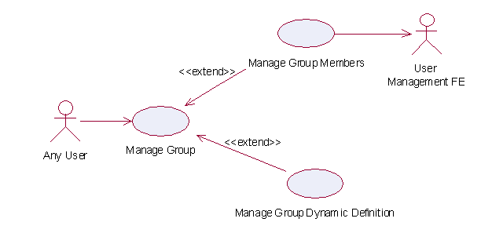
Figure 8: Model Of the Group Management Functional Element []

Usage Scenarios

Manage Group
This use case describes the management of a group, namely the creation, deletion, retrieval and update of the group.

Flow of Events

Basic Flow
This use case starts when the user wants to manage group.
If user wants to ‘Create Group’, then basic flow 1 is executed.
If user wants to ‘Retrieve Group’, then basic flow 2 is executed.
If user wants to ‘Update Group’, then basic flow 3 is executed.
If user wants to ‘Delete Group’, then basic flow 4 is executed.
1: Create Group.
1.1: User provides the basic information that is necessary for creating a group.
1.2: Functional Element creates the group and the use case ends.
2: Retrieve Group.
2.1: User provides the necessary information for retrieving the complete group’s attributes.
2.2: Functional Element returns the group’s information and the use case ends.
3: Update Group.
3.1: User provides the necessary information for updating the group’s attributes.
3.2: Functional Element updates the group and the use case ends.
4: Delete Group.
4.1: User provides the necessary information for deleting a particular group.
4.2: Functional Element deletes the group and the use case ends.

Alternative Flows
1: Group Exist.
1.1: In basic flow 1.2, Functional Element detects an identical group. Functional Element returns an error message and the use case ends.
2: Group Does Not Exist.
2.1: In basic flow 2.2, 3.2 and 4.2, Functional Element cannot find a group that matches the user’s criteria. Functional Element returns an error message and the use case ends.
3: Save Updated Information.
3.1: In basic flow 1.2, 2.2, 3.2 and 4.2, Functional Element fails to save the updated information. Functional Element returns an error message and the use case ends.

Special Requirements
None.

Pre-Conditions
None.

Post-Conditions
None.

Manage Group Members

Description
This use case is an extension of the manage group use case. Specifically, it describes the scenarios to manage members in the group.

Flow of Events

Basic Flow
This use case starts when the user wants to manage members in a group.
If user wants to ‘Create Members In A Group’, then basic flow 1 is executed.
If user wants to ‘Retrieve Members From A Group’, then basic flow 2 is executed.
If user wants to ‘Delete Members From A Group’, then basic flow 3 is executed.
1: Create Members In A Group.
1.1: User provides the necessary information for creating the group.
1.2: Functional Element adds members to the group and the use case ends.
2: Retrieve Members In A Group.
2.1: User provides the necessary information for retrieving the group.
2.2: Functional Element returns the members and the use case ends.
3: Delete Members From Group.
3.1: User provides the necessary information for deleting the group.
3.2: User provides the necessary information for deleting members in the group.
3.3: Functional Element deletes members from group and the use case ends.

Alternative Flows
1: Group Does Not Exist.
1.1: In basic flow 1.1, 2.1 and 3.1, Functional Element cannot find the group requested. Functional Element returns an error message and the use case ends.
2: Members Does Not Exist
2.1: In basic flow 3.3, the Functional Element attempts to delete a non-existence member. Functional Element returns an error message and the use case ends.

Special Requirements
None.

Pre-Conditions
None.

Post-Conditions
None.

Manage Group Dynamic Definition

Description
This use case describes scenario involved in managing the dynamic group definition.

Flow of Events

Basic Flow
This use case starts when the user wants to manage dynamic group definition. This includes create, retrieve, update and delete dynamic group definition.
If user wants to ‘Create Dynamic Definition For A Group’, then basic flow 1 is executed.
If user wants to ‘Retrieve Dynamic Definition For A Group’, then basic flow 2 is executed.
If user wants to ‘Delete Dynamic Definition For A Group’, then basic flow 3 is executed.
If user wants to ‘Update Dynamic Definition For A Group’, then basic flow 4 is executed.

1: Create Dynamic Definition For A Group.
1.1: User provides the additional definition for the group.
1.2: Functional Element creates the additional definition for the group and the use case ends.
2: Retrieve Dynamic Definition For A Group.
2.1: User provides the necessary information to retrieve a particular group.
2.2: Functional Element returns the additional definition for the group and the use case ends.
3: Delete Dynamic Definition For Group.
3.1: User provides the necessary information to delete a particular group.
3.2: Functional Element deletes the dynamic definition belonging to the group and the use case ends.
4: Update Dynamic Definition For Group.
4.1: User provides the necessary information to update a particular group.
4.2: User provides the necessary dynamic definition that needs to be updated.
4.3: Functional Element updates the dynamic definition and the use case ends.

Alternative Flows
1: Group Does Not Exist.
1.1: In basic flow 1.1, 2.1, 3.1 and 4.1, Functional Element cannot find the group specified. Functional Element returns an error message and the use case ends.
2: Dynamic Group Definition Already Exists.
2.1: In basic flow 1.2, Functional Element returns the error message and the use case ends.
3: Dynamic Group Definition Does Not Exist.
3.1: In basic flow 4.3, Functional Element cannot update the dynamic group definition. Functional Element returns an error message and the use case ends.

Special Requirements
None.

Pre-Conditions
None.

Post-Conditions
None.

Identity Management Functional Element

Motivation
As secured Web Services become rampant, with each having its own authentication and authorisation management, users are finding it difficult to keep track of their accounts and passwords. Through the use of Identity Management, users can now voluntarily establish links between their accounts so that they need not sign in multiple times to access enterprise-level Web Services. This mechanism is known as Single Sign-On (SSO). SSO can further be extended to access Web Services from across different business organisations that have prior agreements to trust and transact with each other (also known as a circle of trust). This mechanism, which involves federating and signing-in of identity’s accounts across different trusted organisations, is known as Federated Identity Single Sign-On.

Identity Management is about the management of information pertaining to an entity as well as the process of identification, authentication and authorization of resources to that entity.

Identity management generally covers the following aspects:
- Basic user accounts management facilities
- User authentication mechanism(s)
- User authorisation mechanism(s)
- Generation of audit trails for user activities

This Functional Element fulfills the following requirements from the Functional Elements Requirements Document 02 [Error: Reference source not found]:
- Primary Requirements
- SECURITY-001,
- SECURITY-003 (all),
- SECURITY -004 (all),
- SECURITY -040 and
- SECURITY -041.
- Secondary Requirements
- None

Terms Used
Terms | Description
Assertion | Assertion refers to a piece of data produced by an Assertion Authority regarding either an act of authentication performed on a subject, attribute information about a subject, or authorization permissions applying to the subject with respect to a specified resource.
Assertion Authority | An entity within a trusted circle that provides authentication assertions.
Access Policy | A logically defined, executable and testable set of rules or behavior for access control.
Entity | Entity can refer to a person, an organization, a resource or a service.
Federated Identity | An identity that has been associated, connected or binded with other accounts for a same given Principal.
Identity | Identity refers to a set of information that an entity can use to uniquely describe itself.
Identity Provider | An entity that creates, maintains, and manages identity information for Principals and provides Principal authentication to other service providers within a trusted circle.
Identity Repository | Identity Repository refers to the storage of the identity information. Common examples of identity repositories are relational databases, text files etc.
Principal | Principal refers to an entity whose identity can be authenticated. Also known as Subject.
Resource | A resource in an application is defined to encompass users, services, data / information, transaction and security
Security Markup Assertion Language | Security Markup Assertion Language refers to the set of specifications describing assertions that are encoded in XML, profiles for attaching the assertions to various protocols and frameworks, the request/response protocol used to obtain assertions, and bindings of this protocol to various transfer protocols (for example, SOAP and HTTP).
Single Sign-On (SSO) | The ability to use proof of an existing authentication session with an identity provider to create authenticated sessions with other service providers.
Subject | Subject – see Principal.

The following terms mentioned in this document are used in accordance with the terms defined in the Assertions and Protocol for the OASIS Security Assertion Markup Language (SAML) v1.1 specification:
- Assertion [section 2.3.2]
- AudienceRestrictionCondition [section 2.3.2.1.3]
- AuthenticationQuery [section 3.3.3]
- AuthenticationStatement [section 2.4.3]
- KeyInfo [section 5.4.5]
- Request [section 3.2.2]
- Response [section 3.4.2]
- Subject [section 2.4.2.1]

Key Features
Implementations of the Identity Management Functional Element are expected to provide the following key features:
- The Functional Element MUST be have the mechanism to access an Identity Repository.
- The Functional Element MUST provide the capability to manage the creation and deletion of instances of Identity in the said Identity Repository.
- The Functional Element MUST have the mechanisms to manage all the information (attribute values) stored in such Identities. This includes the capability to:
  - Retrieve and update attribute’s values belonging to a Identity,
  - Encrypt sensitive user information,
  - Authenticate a user, and
  - Assign/Unassign Access Policy (or Policies).
Example: Different levels of privileges to access protected resources.
- As part of Key Feature (3.3), the authentication of an Identity MUST be achieved at least through the use of a password.
- As part of Key Feature (3.3), the Functional Element MUST also provide the capability to use an Assertion Authority for Single Sign-On (SSO) authentication.
- As part of Key Feature (5), the SSO message exchange and protocol MUST use an approved standard. Recommendations are available in section 2.5.5.
- As part of Key Feature (3.4), a mechanism MUST be provided to verify the Identity’s Access Policy on protected Resources.
- The Functional Element MUST provide the capability to create audit trails.
Example: Timestamp of an Identity’s access to Resources.

In addition, the following key features could be provided to enhance the Functional Element further:
- The Functional Element MAY provide an Identity Repository.
- If Key Feature (1) is provided, the Functional Element MUST provide the capability to manage the creation and deletion of instances of Identities based on a pre-defined structure.
- The Functional Element MAY provide additional storage in the Identity Repository for an Identity to customise its preferences.
Example: Identity’s preferred subscription of notifications/alerts for news.
- The Functional Element MAY provide a capability to use an Identity Provider for Federated Identity SSO authentication.
- If Key Feature (4) is provided, the Federated Identity SSO message exchange and protocol MUST use an approved standard.

Interdependencies
Direct Dependencies
User Management Functional Element | The User Management Functional Element is being used for account management.
Role and Access Management Functional Element | The Role and Access Management Functional Element is being used for access control and authorization
Log Utility Functional Element | The Log Utility Functional Element is being used for logging and creation of audit trails.

Related Technologies and Standards
Specifications | Specific References
Web Services Security v1.0 [] | Web Services Security: SOAP Message Security 1.0 (WS-Security 2004) – OASIS Standard 2004, 01 March 2004
Security Assertion Markup Language (SAML) v1.1. [] | Assertions and Protocol for the OASIS Security Assertion Markup Language (SAML) V1.1 – OASIS Standard, 2 September 2003  Bindings and Profiles for the OASIS Security Assertion Markup Language (SAML) V1.1 – OASIS Standard, 2 September 2003, in particular the two schemas below:  - Assertion Schema  - Protocol Schema
Liberty Alliance Project Specifications | Liberty Alliance ID-FF 1.2 Specifications []  Liberty Alliance ID-WSF 1.0 Specifications []
WS-Federation [] | Web Services Federation Language (WS-Federation) - 08 July 2003
WS-Trust [ ] | Web Services Trust Language (WS-Trust) – OASIS Web Service Secure Exchange Standard, V1.3 Draft 01 09 May 2006

Model
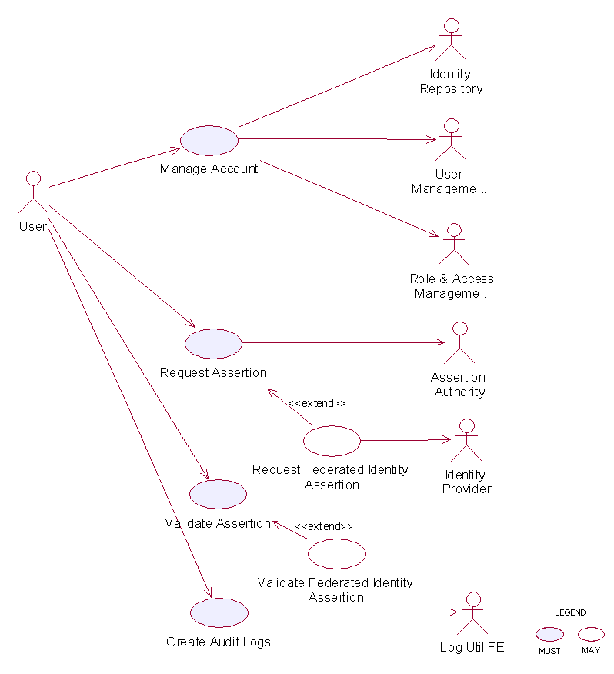
Figure 9: Model Of the Identity Management Functional Element []

Usage Scenarios

Manage Account

Description
This use case describes the creation/retrieval/update/deletion of an identity’s account. An identity’s account usually consists of two elements: i) the user information and ii) the associated access policy.
As Identity Management Functional Element leverages on the User Management Functional Elementand Role and Access Management Functional Element to provide for these functionalities, please refer to these Functional Elements’ use cases for details.

Request Assertion

Description
This use case describes the composition of either 1) an authentication query or 2) an authorisation decision query and sending it to the assertion authority.

Flow of Events

Basic Flow
This use case starts when the user wants to compose a query to the assertion authority.
If the user requests for an authentication query, then sub-flow 1 is executed.
If the user requests for an authorisation decision query, then sub-flow 2 is executed.
1: Request for Authentication Assertion
1.1: The user composes a valid SAML Request with an AuthenticationQuery and sends it to the assertion authority.
1.2: The user waits for an SAML Response from the assertion authority.
1.3: The user obtains the SAML Assertion from the SAML Response and use case ends.
2: Request for Authorisation Decision Assertion
2.1: The user composes a valid SAML Request with an AuthorizationDecisionQuery and sends it to the assertion authority.
2.2: The user waits for an SAML Response from the assertion authority.
2.3: The user obtains the SAML Assertion from the SAML Response and use case ends.

Alternative Flows
1: Invalid Request
1.1: If in basic flow 1.1 or 2.1, if any of the parameters passed into the request is invalid, the Functional Element flag an exception and use case ends.
2: Error message from assertion authority
2.1: If in basic flow 1.3 or 2.3, the assertion authority is unable to return an assertion (e.g. user has not logged on etc.), it returns an error code and an error message.
2.2: The Functional Element flag an error with the error message attached and use case ends.

Special Requirements
None.

Pre-Conditions
None.

Post-Conditions
None.

Validate Assertion

Description
This use case describes the validation of either 1) the Authentication Assertion or 2) the Authorisation Decision Assertion

Flow of Events

Basic Flow
This use case starts when the user wants to check if the assertion it is a valid assertion from the assertion authority.
1: The user passes the assertion to the Functional Element for validation.
2: The Functional Element checks if the assertion is signed by the assertion authority.
3: The Functional Element checks for an un-expired assertion.
4: The Functional Element checks if the assertion has an AudienceRestrictionCondition and verifies that the service provider using the Functional Element is in the audience list.
5: Based on the type of assertion, one of the sub-flows is executed.
- If the user wants to check for a valid authentication assertion, then sub-flow 5.1 is executed.
- If the user wants to check for a valid authorisation decision assertion, then sub-flow 5.2 is executed.
5.1: Validate Authentication Statement
5.1.1: The Functional Element checks if the assertion has indeed an AuthenticationStatement.
5.1.2: The Functional Element checks if the Subject in the AuthenticationStatement matches the userid of the principal.
5.1.3: The Functional Element verifies the Subject with its KeyInfo.
5.1.4: The Functional Element returns the status code to the user and use case ends.
5.2: Validate Authorisation Decision Statement
5.2.1: The Functional Element checks if the assertion has indeed an AuthorizationDecisionStatement.
5.2.2: The Functional Element checks if the Resource in the AuthorizationDecisionStatement matches the id of the requested resource.
5.2.3: The Functional Element determines if the decision is Permit.
5.2.4: The Functional Element returns the status code to the user and use case ends.

Alternative Flows
1: Signature Error
1.1: If in basic flow 2, the Functional Element is unable to verify that the signature is from the assertion authority, it returns an error and use case ends.
2: Expired Assertion
2.1: If in basic flow 3, the Functional Element finds that the assertion has already expired, it returns an error and use case ends.
3: Audience Error
3.1: If in basic flow 4, the service provider is not in the AudienceRestrictionCondition, the Functional Element returns an error and use case ends.
4: Invalid Authentication Assertion
4.1: If in basic flow 5.1.1, the Functional Element is unable to find an AuthenticationStatement, it returns an error and use case ends.
5: Mismatch Subject
5.1: If in basic flow 5.1.2, the Functional Element is unable to match the Subject in AuthenticationStatement, it returns an error and use case ends.
6: Subject Error
6.1: If in basic flow 5.1.3, the Functional Element is unable to verify the Subject with the KeyInfo, it returns an error and use case ends.
7: Invalid Authorisation Decision Assertion
7.1: If in basic flow 5.2.1, the Functional Element is unable to find an AuthorizationDecisionStatement, it returns an error and use case ends.
8: Mismatch Resource
8.1: If in basic flow 5.2.2, the Functional Element is unable to match the resource in AuthorizationDecisionStatement, it returns an error and use case ends.

Special Requirements
None.

Pre-Conditions
None.

Post-Conditions
None.

Create Audit Logs

Description
This use case describes logging all identity management activities for audit purposes.

Flow of Events

Basic Flow
This use case starts when any of other Functional Element use cases are triggered.
1: The Functional Element opens an audit log file.
2: The Functional Element writes a timestamp identity management activity message into the audit log file.
3: The Functional Element closes the audit log file and the use case ends.

Alternative Flows
1: Log File Not Created
1.1: If in the basic flow 1, the Functional Element cannot open the audit file, it creates a new audit file and use case continues.
2: Error Writing Log
2.1: If in the basic flow 2, the Functional Element has error writing to file, it will flag an exception and the use case ends.

Special Requirements
None.

Pre-Conditions
None.

Post-Conditions
None.

Information Catalogue Functional Element (new)

Motivation
There is a huge amount of information that is stored in the WWW that include product catalogues. Enable the capability to provide a generic facility to quickly and easily expose catalogues and/or orders as web services. E.g. Amazon.com Web Service, Google.com Web Service, etc.

Provide a framework that will enable the ability to harness and access huge amount of product-related information and present them as catalogue for:
- Quick and easy definition of product/information catalogues
- Customisation of catalogues for specific needs or marketing niche
- Easy maintenance of storefronts/catalogues over the network
- Outsourcing of catalogue management together with multilingual support

This Functional Element fulfills the following requirements from the Functional Elements Requirements Document 02 [Error: Reference source not found]:
- Primary Requirements
- PROCESS-200,
- PROCESS-201, and
- PROCESS-202.
- Secondary Requirements
- PROCESS-203,
- PROCESS-204,
- PROCESS-205, and
- PROCESS-206.

Terms Used
Terms | Description
Data source | Data source refers to any kind of information storage and retrieval databases like RDBMS, LDAP, ODBMS, XMLDB, XML Files, TEXT Files, etc.
Data source type | Data source type refers to the various kinds of data storage format or structure like XML, HTML, TEXT, Databases, Tables, Rows, Columns in RDBMS, Collections, Nodes, Files & Tags in XMLDB, that are used to store and retrieve information from different data sources

Key Features
Implementations of the Information Catalogue Functional Element are expected to provide the following key features:
- The Functional Element MUST provide the capability to define and maintain Catalogue Structures.
  - The capability to define the name for the catalogue structure
  - The capability to define the format of the catalogue information
  - The capability to choose the data source to store and retrieve the catalogue information
- The Functional Element MUST provide the capability to organize and manage all the information stored in the Catalogue Structures.
- The Functional Element MUST provide the capability to execute basic searches like categorical, names, keywords on the catalogue information.
- The Functional Element MUST provide the capability to return results formatted based on the Catalogue Structure.

In addition, the following key features could be provided to enhance the Information Catalogue Functional Element further:
- The Functional Element MAY provide the ability to enable secured access to catalogue structure as well as catalogue information.
- The Functional Element MAY provide the ability to present catalogue information in different languages, i.e. multi-lingual support.
- The Functional Element MAY provide the ability to import catalogue structure and information from different data sources.
- The Functional Element MAY provide the ability to export catalogue structure and information to different data sources.

Interdependencies
Direct Dependency
Search Functional Element | The Search Functional Element helps to perform basic search on the catalogue information.

Interaction Dependency
User Management Functional Element | The User Management Functional Element helps to provide user definition and management.
Role & Access Functional Element | The Role & Access Functional Element helps to provide role and access definition and management.
Transformer Functional Element | The Transformer Functional Element helps to provide the import and export catalogue information capabilities.

Related Technologies and Standards
None

Model
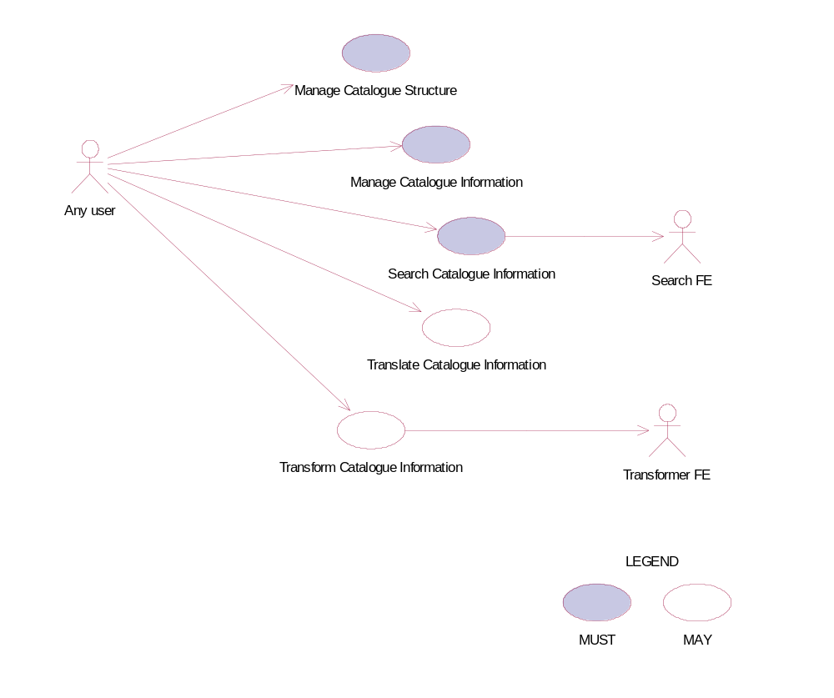
Figure 10: Model Of the Information Catalogue Functional Element

Usage Scenario

Manage Catalogue Structure

Description
This use case allows any users to configure and manage various data source(s), type(s) and structure(s) on which information is to be stored and retrieved.

Flow of Events

Basic Flow
This use case starts when users / other Functional Elements wishes to configure and manage various data source(s), type(s) and structure(s).
1. Users / Other Functional Elements initiates a request to configure data source, type and structure by providing name, format, and definition of the data source(s) to be added, removed or retrieved.
2. The Functional Element checks whether the data source configuration file exists.
3. Based on the operation it specified, one of the following sub-flows is executed:
If the operation is ‘Create Data Source, Type and Structure’, then sub-flow 3.1 is executed.
If the operation is ‘View Data Source, Type and Structure’, then sub-flow 3.2 is executed.
If the operation is ‘Remove Data Source, Type and Structure’, then sub-flow 3.3 is executed.
3.1. Create Data Source, Type and Structure.
3.1.1. The Functional Element checks whether the same data source, type, and structure has been created.
3.1.2. The Functional Element appends the new data source, type and structure in the data source configuration specified.
3.2. View Data Source, Type and Structure.
3.2.1. The Functional Element retrieves all the data source, type and structure information from the data source configuration file.
3.2.2. The Functional Element returns the data source(s), type(s) and structure(s).
3.3. Delete Data Source, Type and Structure.
3.3.1. The Functional Element checks whether the data source, type and structure exist in the data source configuration based on data source id from the data source configuration file.
3.3.2. The Functional Element removes the old data source, type and structure from the data source configuration file.
4. The Functional Element returns a success or failure flag indicating the status of the operation being performed and use case ends.

Alternative Flows
1. Data Source Configuration File Not Found.
1.1. If in Basic Flow 2, the data source configuration does not exist, Functional Element creates empty data source configuration.
2. Duplicate Data Source, Type and Structure.
2.1. If in Sub Flow 3.1.1, the same data source, type and structure have been defined already in data source configuration, Functional Element throws an exception with error code as ‘Duplicate Data Source, Type, and Structure’.
3. Data Source, Type, and Structure Do Not Exist.
3.1. If in Sub Flow 3.2.1 and 3.3.1, a particular data source, type and structure cannot be found in the specified data source configuration, Functional Element throws an exception with error code as ‘Data Source, Type, and Structure does not exist’.

Special Requirements
None.

Pre-Conditions
None.

Post-Conditions
None.

Manage Catalogue Information

Description
This use case describes the management of catalogue information, namely the creation, deletion, retrieval and update of the catalogue information.

Flow of Events

Basic Flow
The use case begins when the user wants to create/view/update/delete catalogue information.
1. The user sends request to manipulate catalogue information.
2. Based on the operation it specifies, one of the following sub-flows is executed:
If the operation is ‘Create Catalogue Information’, the sub-flow 2.1 is executed.
If the operation is ‘View Catalogue Information’, the sub-flow 2.2 is executed.
If the operation is ‘Update Catalogue Information’, the sub-flow 2.3 is executed.
If the operation is ‘Delete Catalogue Information’, the sub-flow 2.4 is executed.
2.1. Create Catalogue Information
2.1.1. User provides the basic information that is necessary for creating catalogue information.
2.1.2. The Functional Element checks whether the catalogue information exists.
2.1.3. The Functional Element creates the catalogue.
2.2. View Catalogue Information
2.2.1. User provides the necessary information for retrieving the complete catalogue’s attributes.
2.2.2. The Functional Element checks whether the catalogue information exists.
2.2.3. The Functional Element returns the catalogue’s information.
2.3. Update Catalogue Information
2.3.1. User provides the necessary information for updating the catalogue’s attributes.
2.3.2. The Functional Element checks whether the catalogue information exists.
2.3.3. The Functional Element updates the catalogue.
2.4. Delete Catalogue Information
2.4.1. User provides the necessary information for deleting particular catalogue information.
2.4.2. The Functional Element checks whether the catalogue information exists.
2.4.3. Functional Element deletes the catalogue information.

Alternative Flows
1. Catalogue Information Exist.
1.1. In Sub Flow 2.1.2, Function Element detects an identical catalogue information. Functional Element returns an error message and the use case ends.
2. Catalogue Information Does Not Exist.
2.1. In Sub Flow 2.2.2, 2.3.2, and 2.4.2, Functional Element cannot find the catalogue information that matches the user’s criteria. Functional Element returns an error message and the use case ends.
3. Save Updated Catalogue Information.
3.1. In Sub Flow 2.1.3, 2.2.3, 2.3.3, and 2.4.3, Functional Element fails to save the updated catalogue information. Functional Element returns an error message and the use case ends.

Special Requirements
None.

Pre-Conditions
None.

Post-Conditions
None.

Search Catalogue Information

Description
This use case allows any users to perform search on various types of disparate catalogues that are configured to be searched and returns the matching results.

Flow of Events

Basic Flow
This use case starts when users / other Functional Elements wishes to perform information search on any given catalogue.
1. Users / other Functional Elements initiates a request to perform information search on a given catalogue by providing information to be searched, the catalogue type(s) and the catalogue structure(s).
2. The Functional Element checks for the existence of the specified catalogue type(s) and structure(s).
3. The Functional Element validates the catalogue type(s) and structure(s) against the set of supported data type(s) and structure(s) configured within the Functional Element that are available for information search.
4. The Functional Element performs information search based on the search parameters given by the users or the other Functional Elements.
5. The Functional Element returns the result of the information search performed to the users or other Functional Elements and use case ends.

Alternative Flows
1. Catalogue(s) Are Not Available.
1.1. In Basic Flow 2, if the identified catalogue is not available, Functional Element displays an error message and exits the use case.
2. Invalid Catalogue Type and Structure.
2.1. In Basic Flow 3, if the catalogue type and structure are invalid, Functional Element displays catalogue type and structure failure message and prompts for the data source type and structure again and performs another search.
3. No Matching Result.
3.1. In Basic Flow 4, if the search results in no matching results, Functional Element displays a message “No search results found” and performs another search.

Special Requirements
None.

Pre-Conditions
None.

Post-Conditions
None.

Translate Catalogue Information

Description
This use case allows the user to translate a catalogue information file from one language to another language.

Flow of Events

Basic Flow
This use case starts when a user wants to translate a catalogue information file from one language to another language.
1. The user set the file name to be translated and the destination language.
2. The system checks whether the particular destination language as output can be translated within all the supported translation methods available.
4. Select the appropriate method based on the destination language.
5. Invoke the translate method and save the catalogue information which is translated in that particular destination language.
6: Return the results and the use case ends.

Alternative Flows
1. If in Basic Flow 2 there is no method to do the translation, the system return error message to the user and this use case ends.

Special Requirements
None.

Pre-Conditions
None.

Post-Conditions
None.

Transform Catalogue Information

Description
This use case allows the user to transform a catalogue information file from one format to another format.

Flow of Events

Basic Flow
This use case starts when a user wants to transform a catalogue information file from one format to another format.
1. The user sets the file name to be transformed and the destination format.
2. This use case calls the TRANSFORMER functional elements’ transform flow.
3. Return the results from the transformer functional elements’ transform flow and the use case ends.

Alternative Flows
1. If in Basic Flow 2 there is no method to do the transformation, the system return error message to the user and this use case ends.

Special Requirements
None.

Pre-Conditions
None.

Post-Conditions
None.

Information Reporting Functional Element (new)

Motivation
Information reporting is quite common in enterprise applications nowadays. In many scenarios, an enterprise does need to present its business information to, for example, business partners, sales representatives, and customers, in some form of information reporting. An information report is filled with the data that is retrieved from a data source using some type of queries. Such kind of information reporting is also used internally within an enterprise, or even within an individual department, to verify the business performance and other business scenarios.

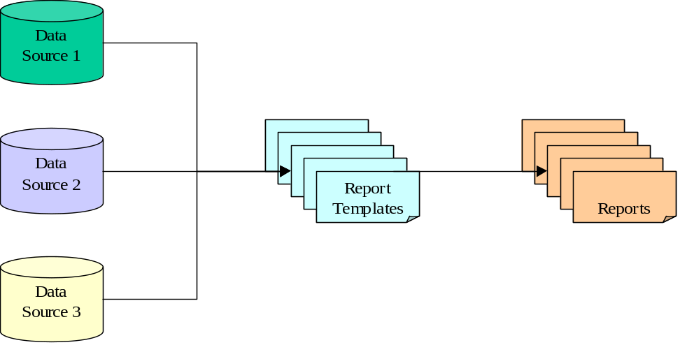

Figure 11: An Overview of the Information Reporting Functional Element

This Functional Element aims to provide the core features of information reporting solution to be used in general enterprise applications.

This Functional Element fulfills the following requirements from the Functional Elements Requirements Document 02 [Error: Reference source not found]:
- Primary Requirements:
- DELIVERY-100,
- DELIVERY-101,
- DELIVERY-102,
- DELIVERY-103, and
- DELIVERY-104.
- Secondary Requirements:
- DELIVERY-105, and
- DELIVERY-106.

Terms Used

Terms | Description
Data source | A Data Source refers to any kind of information storage and retrieval databases like RDBMS, LDAP, ODBMS, XMLDB, XML Files, TEXT Files, etc.
Query | A query refers to a predefined method to query a data source to retrieve information stored in that data source. An example is SQL SELECT statement, which is used to retrieve information from a relational database.
Report Template | A report template is a document (such as an XML file) that is used to describe or show the report format and related settings.

Key Features
Implementations of the Information Reporting Functional Element are expected to provide the following key features:
- The Functional Element MUST provide an approach to capture the report templates and provide the guidelines how to secure the report templates.
- The Functional Element MUST be able to generate reports in the format defined by report templates.
- The Functional Element MUST provide a way to specify data sources where information is retrieved to fill out the generated reports.
- The Functional Element MUST provide an approach to capture user-defined queries, and MUST be able to execute user-defined queries to retrieve information to fill out the generated reports.
- The Functional Element MUST be able to store and retrieve generated reports as stated in key feature #2.
- The Functional Element MUST provide a security approach to control report access. A considered approach is to use user, role, and access management.

In addition, the following key features could be provided to enhance the Information Reporting Functional Element further:
- The Functional Element MAY provide an approach, such as an IDE, to design report templates.
- The Functional Element MAY provide the capability to export reports to different electronic file formats.
- The Functional Element MAY provide the capability to log the activities of report access.
- The Functional Element MAY allow the users to subscribe to the reports they want to receive.

Interdependencies
Interaction Dependency
Transformer Functional Element | The Transformer Functional Element helps to provide the import and export report information capabilities.
Notification Functional Element | The Notification Functional Element helps to send SMS / email to the appropriate Report Subscriber.

Related Technologies and Standards
None.

Model
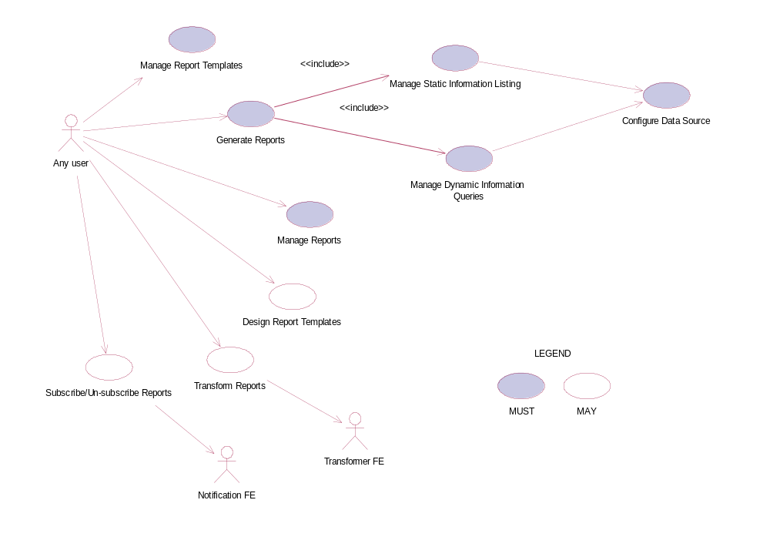
Figure 12: Model Of the Information Reporting Functional Element

Usage Scenario

Manage Report Templates

Description
This use case allows any users to create, update, remove and view reporting templates.

Flow of Events

Basic Flow
The use case begins when the user wants to create/view/update/delete reporting templates.
1: Any user initiates a request type to the Functional Element stating whether to create, view, update, or delete reporting templates.
2: The Functional Element checks whether the reporting template exists.
3: Based on the operation it specified, one of the following sub-flows is executed:
- If the operation is ‘Create Reporting Template’, then sub-flow 3.1 is executed.
- If the operation is ‘View Reporting Template’, then sub-flow 3.2 is executed.
- If the operation is ‘Update Reporting Template’, then sub-flow 3.3 is executed.
- If the operation is ‘Delete Reporting Template’, then sub-flow 3.4 is executed.
3.1: Create Reporting Template.
3.1.1: Any user provides reporting template information to be created.
3.1.2: The Functional Element checks for the duplicate reporting template information.
3.1.3: The Functional Element creates the reporting template information, if it does not exist and the use case ends.
3.2: View Reporting Template.
3.2.1: The Functional Element retrieves all the reporting templates.
3.2.2: The Functional Element returns the reporting template information to any user and the use case ends.
3.3: Update Reporting Template.
3.3.1: Any user provides reporting template information to be updated.
3.3.2: The Functional Element checks for the availability of reporting template information.
3.3.3: The Functional Element updates the reporting template information, if it exist and the use case ends.
3.4: Delete Reporting Template.
3.4.1: Any user provides reporting template information to be removed.
3.4.2: The Functional Element removes the reporting template information.
4: The Functional Element responses the status of the operation whether it is successful or failure to any user and the use case ends.

Alternative Flows
1: Reporting Template Information Not Found.
1.1: In the Sub Flow 3.2.1, 3.3.2, & 3.4.1, if the reporting template information cannot be found, Functional Element throws exception with error code as ‘Reporting Template does not exist’.
2: Duplicate Reporting Template Information.
2.1: In the Sub Flow 3.1.2, If the same reporting template information has been defined, Functional Element throws exception with error code as ‘Duplicate reporting template information’.

Special Requirements
None.

Pre-Conditions
None.

Post-Conditions
None.

Generate Reports
This use case allows any user to generate reports, which includes Static Information Listing and Dynamic Information Queries.

Flow of Events

Basic Flow
This use case starts when the user of the data source wishes to generate reports that include Static Information Listing and Dynamic Information Queries.
1: Any user initiates a request type to the Functional Element stating whether to generate reports that includes Static Information Listing or Dynamic Information Queries.
2: Based on the operation it specified, one of the following basic flows is executed:
- If the operation is ‘Manage Static Information Listing’, then Manage Static Information Listing Basic Flow is executed.
- If the operation is ‘Manage Dynamic Information Queries’, then Manage Dynamic Information Queries Basic Flow is executed.
3: Whenever a report is generated using a particular reporting template, the respective report subscribers are notified via email using NOTIFICATION Functional Element and the use case ends.

Manage Static Information Listing

Description
This use case allows any users to create, view, update, and delete Static Information Listing.

Flow of Events

Basic Flow
This use case starts when the users of the data source wishes to create, view, update, and delete Static Information Listing.
1: Any user initiates a request type to the Functional Element stating whether to create, view, update, or delete Static Information Listing.
2: The Functional Element checks whether the Static Information Listing exists.
3: Based on the operation it specified, one of the following sub-flows is executed:
- If the operation is ‘Create Static Information Listing’, then sub-flow 3.1 is executed.
- If the operation is ‘View Static Information Listing’, then sub-flow 3.2 is executed.
- If the operation is ‘Update Static Information Listing’, then sub-flow 3.3 is executed.
- If the operation is ‘Delete Static Information Listing’, then sub-flow 3.4 is executed.
3.1: Create Static Information Listing.
3.1.1: Any user provides Static Information Listing to be created.
3.1.2: The Functional Element checks for the duplicate Static Information Listing.
3.1.3: The Functional Element creates the Static Information Listing, if it does not exist and the use case ends.
3.2: View Static Information Listing.
3.2.1: The Functional Element retrieves all the Static Information Listing.
3.2.2: The Functional Element returns the Static Information Listing to any user and the use case ends.
3.3: Update Static Information Listing.
3.3.1: Any user provides Static Information Listing to be updated.
3.3.2: The Functional Element checks for the availability of Static Information Listing.
3.3.3: The Functional Element updates the Static Information Listing, if it exist and the use case ends.
3.4: Delete Static Information Listing.
3.4.1: Any user provides Static Information Listing to be removed.
3.4.2: The Functional Element removes the Static Information Listing.
4: The Functional Element responses the status of the operation whether it is successful or failure to any user and the use case ends.

Alternative Flows
1: Static Information Listing Not Found.
1.1: In the Sub Flow 3.2.1, 3.3.2, & 3.4.1, if the Static Information Listing cannot be found, Functional Element throws exception with error code as ‘Static Information Listing does not exist’.
2: Duplicate Static Information Listing.
2.1: In the Sub Flow 3.1.2, If the same Static Information Listing has been defined, Functional Element throws exception with error code as ‘Duplicate Static Information Listing’.

Special Requirements
This use case requires the following three elements:
- A data source
- A static information query
- A reporting template

Pre-Conditions
None.

Post-Conditions
None.

Manage Dynamic Information Queries

Description
This use case allows any users to create, view, update, and delete dynamic information queries.

Flow of Events
This use case starts when the users of the data source wishes to create, view, update, or delete dynamic information queries.
1: Any user initiates a request type to the Functional Element stating whether to create, view, update, or delete Dynamic Information Queries.
2: The Functional Element checks whether the Dynamic Information Query exists.
3: Based on the operation it specified, one of the following sub-flows is executed:
- If the operation is ‘Create Dynamic Information Query’, then sub-flow 3.1 is executed.
- If the operation is ‘View Dynamic Information Query’, then sub-flow 3.2 is executed.
- If the operation is ‘Update Dynamic Information Query’, then sub-flow 3.3 is executed.
- If the operation is ‘Delete Dynamic Information Query’, then sub-flow 3.4 is executed.
3.1: Create Dynamic Information Query.
3.1.1: Any user provides Dynamic Information Query to be created.
3.1.2: The Functional Element checks for the duplicate Dynamic Information Query.
3.1.3: The Functional Element creates the Dynamic Information Query, if it does not exist and the use case ends.
3.2: View Dynamic Information Query.
3.2.1: The Functional Element retrieves all the Dynamic Information Queries.
3.2.2: The Functional Element returns the Dynamic Information Query to any user and the use case ends.
3.3: Update Dynamic Information Query.
3.3.1: Any user provides Dynamic Information Query to be updated.
3.3.2: The Functional Element checks for the availability of Dynamic Information Query.
3.3.3: The Functional Element updates the Dynamic Information Query, if it exist and the use case ends.
3.4: Delete Dynamic Information Query.
3.4.1: Any user provides Dynamic Information Query to be removed.
3.4.2: The Functional Element removes the Dynamic Information Query.
4: The Functional Element responses the status of the operation whether it is successful or failure to any user and the use case ends.

Alternative Flows
1: Dynamic Information Query Not Found.
1.1: In the Sub Flow 3.2.1, 3.3.2, & 3.4.1, if the Dynamic Information Query cannot be found, Functional Element throws exception with error code as ‘Dynamic Information Query does not exist’.
2: Duplicate Dynamic Information Query.
2.1: In the Sub Flow 3.1.2, If the same Dynamic Information Query has been defined, Functional Element throws exception with error code as ‘Duplicate Dynamic Information Query’.

Special Requirements
This use case requires the following three elements:
- A data source
- A dynamic information query
- A reporting template

Pre-Conditions
None.

Post-Conditions
None.

Manage Reports

Description
This use case allows any users to view, update, and delete reports.

Flow of Events

Basic Flow
This use case starts when the users of the data source wishes to view, update, or delete reports.
1: Any user initiates a request type to the Functional Element stating whether to view, update, or delete reports.
2: The Functional Element checks whether the report exists.
3: Based on the operation it specified, one of the following sub-flows is executed:
- If the operation is ‘View Report’, then sub-flow 3.1 is executed.
- If the operation is ‘Update Report’, then sub-flow 3.2 is executed.
- If the operation is ‘Delete Report’, then sub-flow 3.3 is executed.
3.1: View Report.
3.1.1: The Functional Element retrieves all the reports.
3.1.2: The Functional Element returns the report information to any user and the use case ends.
3.2: Update Report.
3.2.1: Any user provides report information to be updated.
3.2.2: The Functional Element checks for the availability of report information.
3.2.3: The Functional Element updates the report information, if it exist and the use case ends.
3.3: Delete Report.
3.3.1: Any user provides report information to be removed.
3.3.2: The Functional Element removes the report information.
4: The Functional Element responses the status of the operation whether it is successful or failure to any user and the use case ends.

Alternative Flows
1: Report Information Not Found.
1.1: In the Sub Flow 3.1.1, 3.2.2, & 3.3.1, if the report information cannot be found, Functional Element throws exception with error code as ‘Report does not exist’.

Special Requirements
None.

Pre-Conditions
None.

Post-Conditions
None.

Configure Data Source

Description
This use case allows any users to create, view, update, and delete data source.

Flow of Events

Basic Flow
This use case starts when the users of the data source wishes to create, view, update, or delete data source.
1: Any user initiates a request type to the Functional Element stating whether to create, view, update, or delete source.
2: The Functional Element checks whether the data source exists.
3: Based on the operation it specified, one of the following sub-flows is executed:
- If the operation is ‘Create Data Source’, then sub-flow 3.1 is executed.
- If the operation is ‘View Data Source’, then sub-flow 3.2 is executed.
- If the operation is ‘Update Data Source’, then sub-flow 3.3 is executed.
- If the operation is ‘Delete Data Source’, then sub-flow 3.4 is executed.
3.1: Create Data Source.
3.1.1: Any user provides data source information to be created.
3.1.2: The Functional Element checks for the duplicate data source information.
3.1.3: The Functional Element creates the data source information, if it does not exist and the use case ends.
3.2: View Data Source.
3.2.1: The Functional Element retrieves all the data sources.
3.2.2: The Functional Element returns the data source information to any user and the use case ends.
3.3: Update Data Source.
3.3.1: Any user provides data source information to be updated.
3.3.2: The Functional Element checks for the availability of data source information.
3.3.3: The Functional Element updates the data source information, if it exist and the use case ends.
3.4: Delete Data Source.
3.4.1: Any user provides data source information to be removed.
3.4.2: The Functional Element removes the data source information.
4: The Functional Element responses the status of the operation whether it is successful or failure to any user and the use case ends.

Alternative Flows
1: Data Source Information Not Found.
1.1: In the Sub Flow 3.2.1, 3.3.2, & 3.4.1, if the data source information cannot be found, Functional Element throws exception with error code as ‘Data source does not exist’.
2: Duplicate Data Source Information.
2.1: In the Sub Flow 3.1.2, If the same data source information has been defined, Functional Element throws exception with error code as ‘Duplicate data source information’.

Special Requirements
None.

Pre-Conditions
None.

Post-Conditions
None.

Design Report Templates

Description
This use case allows any users to design reporting templates.

Flow of Events

Basic Flow
The use case begins when the user wants to design reporting templates.
1: Any user provides reporting template information to be designed.
2: The Functional Element checks for the duplicate reporting template information designed.
3: The Functional Element designs and saves the reporting template information, if it does not exist and the use case ends.

Alternative Flows
1: Duplicate Reporting Template Design Information.
1.1: In the Basic Flow 2, if the same reporting template information has been designed, Functional Element throws exception with error code as ‘Duplicate reporting template design information’.

Special Requirements
None.

Pre-Conditions
None.

Post-Conditions
None.

Transform Reports

Description
This use case allows the user to transform a report information file from one format to another format.

Flow of Events

Basic Flow
This use case starts when a user wants to transform a report information file from one format to another format.
1: The user set the file name to be transformed and the destination format.
2: This use case calls the TRANSFORMER functional elements’ transform flow.
3: Return the results from the transformer functional elements’ transform flow and the use case ends.

Alternative Flows
1: If in Basic Flow 2 there is no method to do the transformation, the system return error message to the user and this use case ends.

Special Requirements
None.

Pre-Conditions
None.

Post-Conditions
None.

Subscribe/Un-subscribe Reports

Description
This use case performs the subscription or un-subscription on desired reports for any user.

Flow of Events

Basic Flow
The use case begins when the user wants to subscribe or un-subscribe those desired reports.
1: The user sends a request.
2: Based on the operation it specifies, one of the following sub-flows is executed:
- If the operation is ‘Subscribe to Report’, then sub-flow 2.1 is executed.
- If the operation is ‘Un-Subscribe to Report’, then sub-flow 2.2 is executed.
2.1: Subscribe To Report.
2.1.1: The Functional Element gets user id, together with those desired report name.
2.1.2: The Functional Element checks whether the report exists.
2.1.3: The Functional Element adds the subscription of the user to the report.
2.2: Un-Subscribe To Report.
2.2.1: The Functional Element gets user id, together with those desired report name.
2.2.2: The Functional Element checks whether the report exists.
2.2.3: The Functional Element removes the subscription of the user to the report.
3: The Functional Element returns the results of the operation to the user and the use case ends.

Alternative Flows
1: Report Not Found.
1.1: If in the basic flow 2.1.2 and 2.2.2, the report specified does not exist, Functional Element will return an error message to the user and the use case ends.
2: User Not Found.
2.1: If in the basic flow 2.1.2 and 2.2.2, the user related does not exist, Functional Element will return an error message to the user and the use case ends.

Special Requirements
None.

Pre-Conditions
None.

Post-Conditions
None.

Key Management Functional Element (new)

Motivation
The Key Management Functional Element is expected to be related Web Services security. To enable Web Services security, cryptographic keys are used for digital signatures and encryption. XKMS defines a Web services interface to a public key infrastructure. With development of XKMS standard, more and more PKI providers adopt XKMS to remove its complexity without sacrificing its benefits. Application developers will only ever need to worry about implementing XKMS clients for key management. As such it will cover aspects that include.

This Functional Element fulfills the following requirements from the Functional Elements Requirements Document 02 [Error: Reference source not found]:
- Primary Requirements
- SECURITY-010.
- Secondary Requirements
- None

Terms Used
Terms | Description
PKI | PKI is a system of digital certificates, Certificate Authorities, and other registration authorities that verify and authenticate the validity of each party involved in an Internet transaction.
XML Key Management Specification (XKMS) | This specification addresses protocols for distributing and registering public keys, suitable for use in conjunction with the standards for XML Signature, XML Encryption and WS-Security.
the XML Key Information Service Specification (X-KISS) | The X-KISS is a specification that defines a protocol for a XKMS-compliant service that resolves public key information. It allows a client of such a service to delegate part or all of the tasks required to process <ds:KeyInfo>.
X-KRSS | XML Key Registration Service Specification defines a protocol for a web service that accepts registration of public key information.
Proof of Possession (POP) | Performing an action with a private key to demonstrate possession of it. An example is to create a signature using a registered private signing key to prove possession of it.

Key Features
Implementations of the Key Management Functional Element are expected to provide the following key features:
- The Functional Element MUST provide the capability to register a key or a key pair with an XKMS-compliant service.
- The Functional Element MUST provide the capability to revoke a registered key or key pair with an XKMS-compliant service.
- The Functional Element MUST provide the capability to recover a registered key or key pair with an XKMS-compliant service.
- The Functional Element MUST provide the capability to retrieve a public key registered with an XKMS-compliant service. The public can in turn be used to encrypt a document or verify a signature.
- The Functional Element MUST provide the capability to ensure that a public key registered with an XKMS-compliant service is valid and has not expired or been revoked.

In addition, the following key features could be provided to enhance the Functional Element further:
- The Functional Element MAY provide the capability to generate key pairs.

Interdependencies
Interaction Dependencies
SecureSOAP Management | The SecureSOAP Management Functional Element may make use key management facilities provided by this functional element to do security related operations.
Identity Management | The Identity Management Functional Element may make use of key management facility to obtain KeyInfo.

Related Technologies and Standards
Standards / Specifications | Specific References
Public Key Infrastructure (PKI) | PKI is a system of digital certificates, Certificate Authorities, and other registration authorities that verify and authenticate the validity of each party involved in an Internet transaction  In this Functional Element, the private key and public key are generated for the Functional Element to sign and encrypt SOAP messages. The Functional Element uses the session key to encrypt the SOAP message. The digital certificate is attached to the SOAP message after the Functional Element has signed the SOAP message.
XML-Signature Syntax and Processing, W3C Recommendation 12th Feb 2002 | This specification addresses authentication, non-repudiation and data-integrity issues. In addition, it also specifies the XML syntax and processing rules for creating and representing digital signatures.  In this Functional Element, both the digital signature on the SOAP message and validation of the signed SOAP message is done based on this specification.
XML-Encryption Syntax and Processing, W3C Recommendation 10th Dec 2002 | This specification addresses data privacy by defining a process for encrypting data and representing the result in XML document.  In this Functional Element, the encryption and decryption of SOAP messages are done based on this specification.
XML Key Management Specification (XKMS) | This specification addresses protocols for distributing and registering public keys, suitable for use in conjunction with the standards for XML Signature, XML Encryption and WS-Security. It comprises two parts – the XML Key Information Service Specification (X-KISS) and the XML Key Registration Service Specification (X-KRSS).

Model

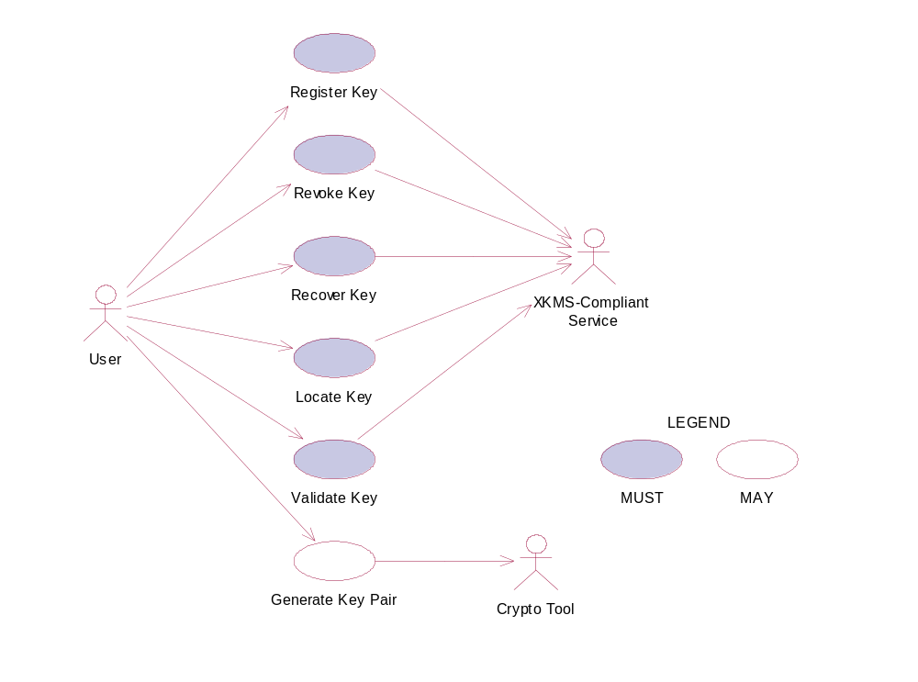
Figure 13: Model of the Key Management Functional Element.

Usage Scenarios

Register Key

Description
This use case allows any user to register a key or key pair with a XKMS-compliant service.

Flow of Events

Basic Flow
This use case starts when any user wants to register a key or key pair with a XKMS-compliant service. The register request is used to assert a binding of information to a public key pair. Generation of the public key pair MAY be performed by either the client or the XKMS-compliant service.
1: The user sends request to register a key or key pair by providing necessary registering information, which include key information, a prototype of the requested assertion, optional additional information to authenticate the user. If the public key pair to be registered is generated by the user, the user may provide Proof of Possession of the private key.
2: On receipt of a registering request from the user, the functional element transforms the request to X-KRSS request format and sends to targeted XKMS-compliant service.
3: The XKMS-compliant service verifies the authentication and Proof of Possession information provided if any. If the service accepts the request, an assertion is registered. The service returns part or all of the registered assertion in format of X-KRSS to the functional element.
4: The Functional Element passes the response from the service to the user and the use case ends.

Alternative Flows
1: Information Not Enough.
1.1: If in the basic flow 2, Functional Element detects the information provided by the user is not enough to form a X-KRSS request, Functional Element returns general error message and ends the use case.
2: POP Needed.
2.1: If in the basic flow 2, Functional Element checks that key pair is generated but the POP is not provided by the user in the request message, the Functional Element returns an error and ends the use case.

Special Requirements

Pre-Conditions
None.

Post-Conditions
None.

Revoke Key

Description
The use case allows any user to revoke previously issued assertions.

Flow of Events

Basic Flow
This use case starts when any user wants to revoke previous issued assertions.
1: The user sends request to revoke a key or key pair by providing information, which include key information, a prototype of the requested assertion, optional additional information to authenticate the user. If the public key pair to be registered is generated by the user, the user may provide Proof of Possession of the private key.
2: On receipt of a revoking request from the user, the Functional Element transforms the request to X-KRSS request format and sends to targeted XKMS-compliant service.
3: The XKMS-compliant service verifies the authentication and Proof of Possession information provided if any. If the service accepts the request, an assertion is revoked. The service returns response in X-KRSS to indicate that the assertion is revoked.
4: The Functional Element passes the response from the service to the user and the use case ends.

Alternative Flows
1: Information Not Enough.
1.1: If in the basic flow 2, Functional Element detects the information provided by the user is not enough to form an X-KRSS request, Functional Element returns general error message and ends the use case.
2: POP Needed.
2.1: If in the basic flow 2, Functional Element checks that key pair is generated but the POP is not provided by the user in the request message, the Functional Element returns an error and ends the use case.

Special Requirements
None.

Pre-Conditions
None.

Post-Conditions
If the use case was successful, the assertion issued previously would be revoked.

Recover Key
This use case allows any user to recover previously issued assertions.

Flow of Events

Basic Flow
This use case starts when any user wants to recover previous issued assertions.
1: The user sends request to recover a key or key pair by providing information, which include key information, a prototype of the requested assertion, optional additional information to authenticate the user. If the public key pair to be registered is generated by the user, the user may provide Proof of Possession of the private key.
2: On receipt of a recover request from the user, the Functional Element transforms the request to X-KRSS request format and sends to targeted XKMS-compliant service.
3: The XKMS-compliant service verifies the authentication and Proof of Possession information provided if any. If the service accepts the request, an assertion is recovered. The service returns response in X-KRSS to indicate that the assertion is recovered.
4: The Functional Element passes the response from the service to the user and the use case ends.

Alternative Flows
1: Information Not Enough.
1.1: If in the basic flow 2, Functional Element detects the information provided by the user is not enough to form an X-KRSS request, Functional Element returns general error message and ends the use case.
2: POP Needed.
2.1: If in the basic flow 2, Functional Element checks that key pair is generated but the POP is not provided by the user in the request message, the Functional Element returns an error and ends the use case.

Special Requirements
None.

Pre-Conditions
None.

Post-Conditions
If the use case successes, the registered assertion is recovered in the XKMS-compliant service.

Locate Key

Description
This use case allows users to retrieve a public key registered with an XKMS-compliant service. The public key can be in turn be used to encrypt a document or verify a signature.

Basic Flow
This use case starts when any user wants to retrieve a public key registered with an XKMS-compliant service.
1: The user sends request to retrieve a public key registered with an XKMS-compliant service by providing related information.
2: On receipt of a recover request from the user, the Functional Element transforms the request to X-KISS request format and sends to targeted XKMS-compliant service.
3: The XKMS-compliant service may obtain an X509V3 certificate. The certificate is parsed to obtain the public key value that is return to the Functional Element in the format of X-KISS.
4: The Functional Element checks the response message is issued by the target XKMS-compliant service; ensures that the response message has not been modified; and confirms that the response message corresponds to the request that made by the user.
5: The Functional Element passes the response from the service to the user and the use case ends.

Alternative Flows
1: Information Not Enough.
1.1: If in the basic flow 2, Functional Element detects the information provided by the user is not enough to form an X-KISS request, Functional Element returns general error message and ends the use case.
2: Fault Response.
2.1: If in basic flow 4, Functional Element detects the response message has problem in authenticity, integrity and does not correspond to the request, Functional Element returns general error message and ends the use case.

Special Requirements
None.

Pre-Conditions
None.

Post-Conditions
None.

Validate Key
This use case enables the user to obtain an assertion specifying the status of the binding between the public key and other data, for example a name or a set of extended attributes.

Flow of Events

Basic Flow
This use case starts when the user wants to obtain the status of the binding of a public key with an assertion.
1: The user sends request to validate a key or key pair by providing necessary validating information defined in X-KISS, which include key information, a prototype of the requested assertion, optional additional information to authenticate the user. If the public key pair to be registered is generated by the user, the user may provide Proof of Possession of the private key.
2: On receipt of a registering request from the user, the Functional Element transforms the request to XKRSS request format and sends to targeted XKMS-compliant service.
3: The XKMS-compliant service verifies the authentication and Proof of Possession information provided if any. If the service accepts the request, an assertion is registered. The service returns part or all of the registered assertion in format of XKRSS to the functional element.
4: The Functional Element checks the response message is issued by the target XKMS-compliant service; ensures that the response message has not been modified; and confirms that the response message corresponds to the request that made by the user.
5: The Functional Element passes the response from the service to the user and the use case ends.

Alternative Flows
1: Information Not Enough.
1.1: If in the basic flow 2, Functional Element detects the information provided by the user is not enough to form an X-KISS request, Functional Element returns general error message and ends the use case.
2: Fault Response.
2.1: If in basic flow 4, Functional Element detects the response message has problem in authenticity, integrity and does not correspond to the request, Functional Element returns general error message and ends the use case.

Special Requirements
None.

Pre-Conditions
None.

Post-Conditions
None.

Generate Key Pair
This use case enables the user to generate key pair using the desired cryptographic tool.

Flow of Events

Basic Flow
This use case starts when the user wants to obtain generate key pair using the desired cryptographic tool.
1: The user sends request to generate key pair by specifying related information.
2: On receipt of request from the user, the functional element validates the provided information and dispatch the request to Crypto Tool to generate key pair.
3: The Crypto Tool generates key pair and returns them to the Functional Element according to the request.
4: The Functional Element checks and dispatches the message to the user and the use case ends.

Alternative Flows
1: Invalid Input Parameter.
1.1: If in the basic flow 2, Functional Element detects the information provided by the user is not valid to generate key pair, Functional Element returns general error message and ends the use case.

Special Requirements
None.

Pre-Conditions
None.

Post-Conditions
If the use case successes, a key pair is generated and stored in the key store specified by the user.

Log Utility Functional Element

Motivation
In a Web Service-enabled implementation, the Log Utility Functional Element can help to organise the diagnostic output that may be generated by the implementation. In order to achieve that, the following capabilities should be provided. They include:
- Logging information into different data sources,
- Allowing user defined log format to be used,
- Capability for storing log information, and
- Providing the capability to analyse the information log.

This Functional Element fulfills the following requirements from the Functional Elements Requirements Document 02 [Error: Reference source not found]:
- Primary Requirements
- MANAGEMENT-007,
- MANAGEMENT-110,
- MANAGEMENT-112 to MANAGEMENT-114, and
- PROCESS-009.
- Secondary Requirements
- MANAGEMENT-006,
- MANAGEMENT-095,
- MANAGEMENT-111,
- PROCESS-008,
- PROCESS-115, and
- PROCESS-118.

Terms Used
Terms | Description
Log Category | A Log Category holds information about a log structure. This information includes the name of the log, the data source the log is to be stored and the format of the log.

Key Features
Implementations of the Log Utility Functional Element are expected to provide the following key features:
- The Functional Element MUST provide the capability to define a Log Category and manage it. This includes:
  - The capability to define the format of the log information,
  - The capability to choose the data source to logged to, and
  - The capability to define the name of the log category.
- The Functional Element MUST provide the capability to manage logging of events/records. This includes:
  - The capability to insert a new record into the log,
Examples of a log record could include events, transactions status, usages status or users’ activities.
  - The capability to search and return result sets of search on log records, and
  - The capability to archive or delete obsolete log records.

In addition, the following key features could be provided to enhance the Functional Element further:
- The Functional Element MAY also provide the capability to perform conditional search or viewing of log records.
- The Functional Element MAY provide the capability to perform basic statistical analysis on log records. Basic statistical analysis capabilities include:
  - Minimum and maximum value calculations on numerical values,
  - Mean values calculations on numerical values, and
  - Standard deviation calculations on numerical values.

Interdependencies
None

Related Technologies and Standards
None

Model
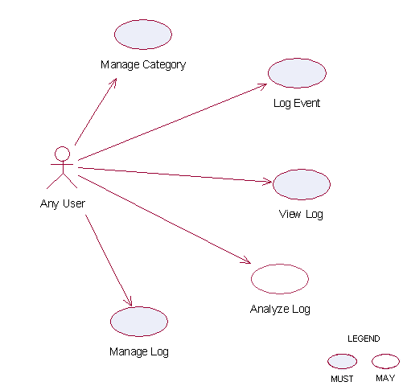
Figure 14: Model Of the Log Utility Functional Element []

Usage Scenarios

Manage Category

Description
This use case allows any user to manage log category. Log category defines the data fields that the user wants to log.

Flow of Events

Basic Flow
This use case starts when users wants to manage the log category.
1: The users send the request to the Functional Element. The request contains the operations the users want to perform.
2: The Functional Element receives the request. Based on the operation specified, one of the following sub-flows is executed.
If the operation is ‘Create Log Category’, then sub-flow 2.1 is executed.
If the operation is ‘Retrieve Log Category Information’, then sub-flow 2.2 is executed.
If the operation is ‘Delete Log Category’, then sub-flow 2.3 is executed.
2.1: Create Log Category.
2.1.1: The Functional Element gets the following data from the users.
- Category name
- The definition of category
- The data source where the log is located
2.1.2: The Functional Element checks the uniqueness of the category name.
2.1.3: The Functional Element connects to the data source according to the specified data source.
2.1.4: The Functional Element creates the empty log in the data source.
2.1.5: The Functional Element writes the category name and its definition in its own category definition record and the use case end.
2.2: Retrieve Log Category Information.
2.2.1: The Functional Element gets the category name.
2.2.2: The Functional Element checks the existence of this category.
2.2.3: The Functional Element retrieves the definition of this category.
2.2.4: The Functional Element returns the definition of this category to the user and the use case ends.
2.3: Delete Log Category.
2.3.1: The Functional Element gets the category name.
2.3.2: The Functional Element checks the existence of this category.
2.3.3: The Functional Element deletes its own records of category definition and the use case ends.

Alternative Flows
1: Category Already Exists.
1.1: In sub-flow 2.1.2, if the category name is already used by others, the Functional Element returns an error message and the use case ends.
2: Data Source Not Available.
2.1: In sub-flow 2.1.3, if the data source is not available, the Functional Element returns an error message and the use case ends.
3: Create Log Error.
3.1: In sub-flow 2.1.4, if the log cannot be created on the specified data source, the Functional Element returns an error message and the use case ends.
4: Category Does Not Exist.
4.1: In sub-flow 2.2.1 and 2.3.1, the category cannot be found in Functional Element category definition; the Functional Element returns an error message and the use case ends.
5: Delete Category Error.
5.1: In sub-flow 2.3.3, the log category cannot be deleted, the Functional Element returns an error message and the use case ends.

Special Requirements
None

Pre-Conditions
None.

Post-Conditions
If the use case was successful, the category definition is saved to the Functional Element and an empty log is created in the specified data source. Otherwise, the Functional Element’s state is unchanged.

Log Event

Description
The use case allows any user to log any event.

Flow of Events

Basic Flow
This use case starts when users want to write to a log.
1: The users provide the event data, category name he/she wants to log to the Functional Element.
2: The Functional Element gets the definition of the category.
3: The Functional Element connects the log data source.
4: The Functional Element writes the log record into the end of the log file and the use case ends.

Alternative Flows
1: Category Does Not Exist.
1.1: If in basic flow 2, the category that the users want to write does not exist, the Functional Element returns an error message and the use case ends.
2: Data Source Not Available.
2.1: If in basic flow 3, the data source is not available, the Functional Element returns an error message and the use case ends.
3: Data Not Match.
3.1: If in basic flow 4, the data provided by the users for logging does not match with the category definition in the Functional Element, the Functional Element returns an error message and the use case ends.

Special Requirements
None.

Pre-Conditions
None.

Post-Conditions
If the use case was successful, the log record is saved to the Functional Element. Otherwise, the Functional Element’s state is unchanged.

View Log

Description
The use case allows users to retrieve the log content.

Flow of Events

Basic Flow
This use case starts when users want to view a log.
1: The users specify the category name and the search criteria, such as searching by event type or searching by time period (starting time and end time).
2: The Functional Element connects to the data storage where the log records are stored.
3: The Functional Element retrieves the log content and returns to the service users and the use case ends.

Alternative Flows
1: Search Criteria Not Valid.
1.1: If in basic flow 1 and 3, the search criteria specified by the users is invalid for Search Service, the Functional Element returns an error message and the use case ends.

Special Requirements
None.

Pre-Conditions
None.

Post-Conditions
None.

Analyze Log Data

Description
The use case allows users to analyze the log data, i.e., to get statistics of certain event. The service users may get statistical results on the log data, such as the cumulative events and mean of two numerical values.

Flow of Events

Basic Flow
This use case starts when users want to analyze the log data.
1: The users specify the items to analyze, i.e. field name and category name.
2: The users specify the analysis method, option among max, min and mean.
3: The Functional Element retrieves the definition of the category and validates the parameters provided by the users.
4: The Functional Element connects to the data source and retrieves the log data.
5: The Functional Element analyses the log data and does statistics on the data with respect to what is specified in Step 1 and 2.
6: The Functional Element returns the analyzed result and the use case ends.

Alternative Flows
1: Invalid Item Specified.
1.1: If in basic flow 1, the analyze items specified by the users are invalid, i.e. invalid field and invalid data source, the Functional Element returns an error message and the use case ends.
2: Category Does Not Exist.
2.1: If in basic flow 3, the category that the users want to write to does not exist, the Functional Element returns an error message and the use case ends.
3: Data Source Not Available.
3.1: If in basic flow 4, the data source is not available, the Functional Element returns an error message and the use case ends.

Special Requirements

Supportability
Only basic statistic methods of numerical value are supported.

Pre-Conditions
None.

Post-Conditions
None.

Manage Log

Description
The use case allows users to drop log and backup log.

Flow of Events

Basic Flow
The use case starts when the users want to drop and backup a log of a specific data source.
1: The users specify the function name to the Functional Element.
2: Based on the operation specified, one of the following sub-flows is executed.
If the operation is ‘Delete Log’, then sub-flow 2.1 is executed.
If the operation is ‘Backup Log’, then sub-flow 2.2 is executed.
2.1: Delete Log
2.1.1: The Functional Element gets category name from the users.
2.1.2: The Functional Element retrieves the definition of the category.
2.1.3: The Functional Element connects to the corresponding data source.
2.1.4: The Functional Element deletes the log from the data source.
2.2: Backup Log
2.2.1: The Functional Element gets the category name and the destination file name from the users.
2.2.2: The Functional Element retrieves the definition of the category.
2.2.3: The Functional Element connects to the corresponding data source.
2.2.4: The Functional Element read the original log and writes it to the destination file.

Alternative Flows
1: Category Does Not Exist.
1.1: If in basic flow 2.1.2 and 2.2.2 the category that the users want to write does not exist, the Functional Element returns an error message and the use case ends.
2: Data Source Not Available.
2.1: If in basic flow 2.1.4 and 2.2.4, the data source is not available, the Functional Element returns an error message and the use case ends.

Special Requirements
None.

Pre-Conditions
None.

Post-Conditions
None.

Notification Functional Element

Motivation
In a Web Service-enabled implementation, timely information is crucial for the management of resources that it encompasses. Other uses of this Functional Element include broadcasting of information to other services and this could span across both the wired and wireless medium. In order to fulfill these needs, this Functional Element will cover the following aspects which include:
- Providing the capability to configure and link with the various gateways so as to enable messages dissemination, and
- Providing the capability to send instantaneous or scheduled messages to the intended audiences.

This Functional Element fulfills the following requirements from the Functional Elements Requirements Document 02 [Error: Reference source not found]:
- Primary Requirements
- DELIVERY-003, and
- PROCESS-118.
- Secondary Requirements
- MANAGEMENT-205,
- PROCESS-005,
- PROCESS-102,
- PROCESS-107, and
- PROCESS-110.

Terms Used
Terms | Description
Default Notification Channel | Default Notification Channel refers to the particular channel setting or value that is assigned automatically by the Functional Element and remains in effect unless canceled or overridden.
Device Type | Device Type refers to devices such as Mobile Phone, Numeric Pager, Alphanumeric Numeric Pager and Desktop etc.
Notification Channel | Notification Channel refers to the various messaging channels such as SMS (Short Message Service), Numeric Message, Alpha-numeric Message and E-mail Message etc.
Schedule Type | Schedule Type refers to the various types of Scheduling format such as ONCE, DAILY, WEEKLY, and MONTHLY.
SMS | Short Message Service
SMS Gateway | A device that enable sending of numeric, alpha-numeric and SMS messages.
SMTP | Simple Mail Transfer Protocol
SMTP Server | SMTP server supports email notifications.

Key Features
Implementations of the Notification Functional Element are expected to provide the following key features:
- The Functional Element MUST support notifications using both the SMS and SMTP protocols.
- The Functional Element MUST provide the capability to configure supported SMS gateway(s) and the SMTP servers where applicable.
Example: The capability to configure the username and password for SMTP server’s authentication.
- The Functional Element MUST provide the capability to send notifications to single and multiple recipients.
- The Functional Element MUST provide the capability to structure a notification based on the selected protocol(s).

In addition, the following key features could be provided to enhance the Functional Element further:
- The Functional Element MAY provide the capability to send notifications either instantly or based on a pre-defined schedule.
- If Key Feature (1) is provided, the Functional Element MAY also provide the capability to send scheduled messages in the following manner:
  - Hourly,
  - Daily,
  - Weekly, and
  - Monthly (based on a particular date or particular day of the week).

Interdependencies
None

Related Technologies and Standards
Technologies | Description
Short Message Service (SMS) | Short Message Service is a feature available with some wireless phones that allow users to send and/or receive short alphanumeric messages. This Functional Element is heavily reliance on this for transmission of messages to a pager and hand phone.
Simple Mail Transfer Protocol (SMTP) | A protocol used to send e-mail on the Internet. SMTP is a set of rules regarding the interaction between a program sending e-mail and a program receiving e-mail. This Functional Element is heavily reliance on this for transmission of messages to the designated email account.

Model
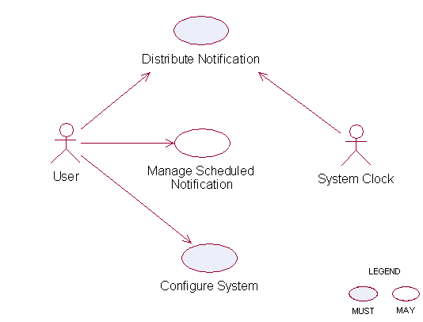
Figure 15: Model Of the Notification Functional Element []

Usage Scenarios

Distribute Notification

Description
This use case allows the Functional Element to distribute messages to intended recipients.

Flow of Events

Basic Flow
This use case starts when the service user or system clock wishes to send message to recipient.
1: The Functional Element decides to send messages to recipients. Based on the operation specified, one of the following sub-flows is executed.
If the request is ‘Initiated By The User’, then sub-flow 1.1 is executed.
If the request is ‘Initiated By The System Clock’ then sub-flow 1.2 is executed.
1.1: Initiated By The User
1.1.1: The Functional Element receives the request from the service user.
1.1.2: The Functional Element validates passed parameters such as message type, recipient address, and message key and message length.
1.1.3: The Functional Element checks the availability of the connection.
1.1.4: The Functional Element sends message to recipient(s) and the use case end
1.2: Initiated By The System Clock
1.2.1: The Functional Element checks scheduled message(s) and end date for scheduled message.
1.2.2: Once the Functional Element detects scheduled messages, one of the sub-flows is executed.
  - If the Functional Element detects the scheduled notification is once, the ‘Activate Once Notification’ sub-flow 1.2.2.1 is executed.
  - If the Functional Element detects the scheduled notification is daily, the ‘Activate Daily Notification’ sub-flow 1.2.2.2 is executed.
  - If the Functional Element detects the scheduled notification is weekly, the ‘Activate Weekly Notification’ sub-flow 1.2.2.3 is executed.
  - If the Functional Element detects the scheduled notification is Monthly, the ‘Activate Monthly Notification’ sub-flow 1.2.2.4 is executed.
1.2.2.1: Activate Once Notification.
1.2.2.1.1: The Functional Element compares the system time with the scheduled message’s time and gets notification details if both times are match.
1.2.2.2: Activate Daily Notification.
1.2.2.2.1: The Functional Element compares the system time with the scheduled message’s time and gets notification details if both times are match.
1.2.2.3: Activate Weekly Notification.
1.2.2.3.1: The Functional Element compares the system date and time with the scheduled message’s date and time and gets notification details if both date & time are match.
1.2.2.4: Activate Monthly Notification.
1.2.2.4.1: The Functional Element compares the system date and time with the scheduled message’s date and time and gets notification ID if both date & time are match.
1.2.3: The Functional Element extracts the list of recipient(s) and message(s).
1.2.4: The Functional Element checks the availability of connection.
1.2.5: The Functional Element sends message to recipient(s) and the use case ends.

Alternative Flows
1: Unsupported Message Type/Recipient Address/Message.
1.1: If in basic flow 1.1.2, Functional Element detects unsupported message type, recipient address or message, the Functional Element returns an error message and the use case ends.
2: Connection Fail.
2.1: If in basic flow 1.1.3 and 1.2.4, the Functional Element is unable to detect connection type, the Functional Element returns an error message and the use case ends
3: Delete Scheduled Message.
3.1: If in basic flow 1.2.1, if the Functional Element detects that the scheduled message has expired, the Functional Element will proceed to delete those messages.

Special Requirements

Supportability
None

Pre-Conditions
None.

Post-Conditions
None.

Manage Scheduled Notification

Description
This use case allows the service user to maintain the notification information. This includes adding, changing and deleting notification information from the Functional Element.

Flow of Events

Basic Flow
This use case starts when the service user wishes to schedule notification message(s).
1: The Functional Element requests the service user to specify the function he/she would like to perform (such as create, update and delete notification message).
2: Once the Functional Element user provides the requested information, one of the sub-flows is executed.
If the service user provides ‘Create Notification’, then sub-flow 2.1 is executed.
If the service user provides ‘Delete Notification’, then sub-flow 2.2 is executed.
2.1 Create Notification
2.1.1: The Functional Element receives the request from the service user.
2.1.2: The Functional Element validates passed parameters such as schedule type, message type, recipient address, message key and the message length.
2.1.3: The Functional Element generates and assigns a unique Notification ID and adds the notification information to the Functional Element and ends use case.
2.2: Delete Notification
2.2.1: The Functional Element requests the service user to provide the Notification information.
2.2.2: The Functional Element retrieves the existing Notification information.
2.2.3: The Functional Element deletes the Notification record and use case ends.

Alternative Flows
1: Invalid Parameters.
1.1: If in basic flow 2.1.2, if the Functional Element detects invalid parameters such as schedule type, date & time, recipient address, message key and message, the Functional Element returns an error message and the use case ends.

Special Requirements
None.

Pre-Conditions
None.

Post-Conditions
If the use case was successful, the schedule message information is added to Functional Element. Otherwise, the Functional Element’s state is unchanged.

Configure System

Description
This use case allows the service user to maintain the notification Functional Element behaviors. This includes configuration of supported Notification Channel, Default Notification Channel, Schedule Types, and SMS and SMTP Gateway.

Flow of Events

Basic Flow
1: The Functional Element requests the service user to specify or configure the function he/she would like to perform (such as create, update and delete configuration parameters).
2: Once the Functional Element user provides the requested information, one of the sub-flows is executed.
If user wishes to configure ‘Notification Channel’, then sub-flow 2.1 is executed.
If user wishes to configure ‘Default Notification Channel’, then sub-flow 2.2 is executed.
If user wishes to configure ‘Schedule Types’, then sub-flow 2.3 is executed.
If user wishes to configure ‘SMTP server and SMS Gateway’, then sub-flow 2.4 is executed.
2.1 Notification Channel.
2.1.1: The Functional Element receives the request from the service user.
2.1.2: The Functional Element validates passed parameters such as Notification Channel information.
2.1.3: The Functional Element generates and assigns a unique Notification Channel ID and adds the notification information to the Functional Element and the use case ends.
2.2: Default Notification Channel.
2.2.1: The Functional Element requests the service user to provide the Default Notification information.
2.2.2: The Functional Element validates passed parameters such as Default Notification Channel information.
2.2.3: The Functional Element updates existing Default Notification or creates new Default Notification information and the use case ends.
2.3 Schedule Types.
2.3.1: The Functional Element receives the request from the service user.
2.3.2: The Functional Element validates passed parameters such as Schedule Type.
2.3.3: The Functional Element generates and assigns a unique Schedule Type ID and adds the Schedule Type information to the Functional Element and the use case ends.
2.4: SMTP server and SMS Gateway.
2.4.1: The Functional Element requests the service user to provide the SMTP server and SMS Gateway information.
2.4.2: The Functional Element validates passed parameters such as SMTP server and SMS Gateway information.
2.4.3: The Functional Element updates existing SMTP server and SMS Gateway or creates new SMTP server and SMS Gateway information and the use case ends.

Alternative Flows
1: Invalid Parameters.
1.1: If in sub-flow 2.1.2, 2.2.2, 2.3.2 and 2.4.2, if the Functional Element detects invalid parameters such as Notification Channel, Default Notification Channel, and SMTP server, Schedule Types and SMS Gateway information, the Functional Element returns an error message and the use case ends

Special Requirements
None.

Pre-Conditions
None.

Post-Conditions
None.

Phase and Lifecycle Management Functional Element

Motivation
The Phase and Lifecycle Management Functional Element is expected to be an integral part of the User Access Management (UAM) functionalities that is expected to be needed by a Web Service-enabled implementation. This FE is expected to fulfill the needs arising out of managing the dynamic status of user information across the whole lifecycle. As such it will cover aspects that include:
- Basic lifecycle management facilities,
- Basic phase management facilities, and
- Management of user information in phases across the whole lifecycle.

This Functional Element fulfills the following requirements from the Functional Elements Requirements Document 02 [Error: Reference source not found]:
- Primary Requirements
- MANAGEMENT-070 to MANAGEMENT-078
- Secondary Requirements
- None

Terms Used
Terms | Description
Group | A Group is a collection of individual users, and are typically grouped together as they have certain commonalities
Namespace | Namespace is use to segregate the instantiation of the application across different application domains. If a company has two separate standalone application, for example, an email application and an equipment booking application, then these two are considered as separate application domains
Phase/lifecycle | Phase/lifecycle refers to the phases a project goes through between when it is conceived and when it is completed. As an example, a construction related project could have the following phases:  - Project Initiation  - Design  - Construction  - Maintenance.
User | A user is loosely defined to include both human and virtual users. Virtual users could include service users and application (or machine) users that are utilising other services in a SOA environment.
User Access Management (UAM) | User Access Management or UAM refer to the concept of managing users in a holistic manner, considering all aspect which includes:  Defining a set of basic user information that should be stored in any enterprise application.  Providing a means to extend this basic set of user information when needed.  Simplifying management by grouping related users together through certain criteria.  Having the flexibility of adopting both coarse/fine grain access control.

Key Features
Implementations of the Phase and Lifecycle Management Functional Element are expected to provide the following key features:
- The Functional Element MUST provide basic structures based on a set of pre-defined attributes for Lifecycle and Phase.
- The Functional Element MUST provide the capability to manage the creation and deletion of instances of Lifecycle and Phase based on the pre-defined structures.
- The Functional Element MUST provide a means to manage the lifecycles and phases contained within. This includes:
  - The capability to retrieve and update a lifecycle or phase
  - The capability to add/remove phases from a lifecycle
- The Functional Element MUST provide a mechanism to manage the collection of users in a Phase. This includes:
  - The capability to assign and un-assign users belonging to a Phase.
  - The users could be individual Users or Groups.
- The Functional Element MUST provide a mechanism for managing Groups across different application domains.
Example: Namespace control mechanism

Interdependencies
Direct Dependency
Group Management Functional Element | The Group Management Functional Element is used to achieve effective and efficient management of user’s information in each of the different phases..

Related Technologies and Standards
None.

Model

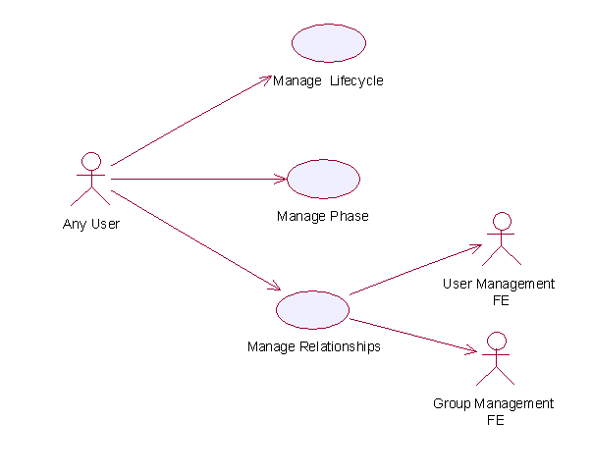
Figure 16: Model Of the Phase and Lifecycle Functional Element []

Usage Scenarios

Manage Lifecycle

Description
This use case is used to create, update, retrieve and delete the lifecycle.

Flow of Events

Basic Flow
This use case starts when the user wants to manage phase in lifecycle.
If user wants to ‘Create Lifecycle’, then basic flow 1 is executed.
If user wants to ‘Retrieve Lifecycle’, then basic flow 2 is executed.
If user wants to ‘Update Lifecycle’, then basic flow 3 is executed.
If user wants to ‘Delete Lifecycle’, then basic flow 4 is executed.
1: Create Lifecycle.
1.1: User provides information to create lifecycle.
1.2: Functional Element creates lifecycle and the use case ends.
2: Retrieve Lifecycle
2.1: User provides the lifecycle name, lifecycle namespace.
2.2: Functional Element returns the lifecycle information and the use case ends.
3: Update Lifecycle.
3.1: User provides the lifecycle information.
3.2: Functional Element updates the lifecycle-phase and the use case ends.
4: Delete Lifecycle.
4.1: User provides lifecycle name and lifecycle namespace.
4.2: Functional Element deletes the lifecycle and the use case ends.

Alternative Flows
1: Lifecycle Does Not Exist.
1.1: In basic flow 2.1, 3.1 and 4.1, if lifecycle can not be found based on lifecycle name and lifecycle namespace provided by user, Functional Element returns an error message and the use case ends.
2: Creation Of Lifecycle Fails.
2.1: In basic flow 1.2, if lifecycle cannot be created, the Functional Element returns an error message and the use case ends

Special Requirements
None.

Pre-Conditions
None.

Post-Conditions
None.

Manage Phase

Description
This use case describes the management of different phases in a project.

Flow of Events

Basic Flow
This use case starts when the user wants to manage phase.
If user wants to ‘Create Phase’, then basic flow 1 is executed.
If user wants to ‘Retrieve Phase’, then basic flow 2 is executed.
If user wants to ‘Update Phase’, then basic flow 3 is executed.
If user wants to ‘Delete Phase’, then basic flow 4 is executed.
1: Create Phase.
1.1: User provides information to create phase.
1.2: Functional Element creates phase and the use case ends.
2: Retrieve Phase.
2.1: User provides phase name, lifecycle name and lifecycle namespace.
2.2: Functional Element returns the phase information and the use case ends.
3: Update Phase.
3.1: User provides the phase information.
3.2: Functional Element updates the phase and the use case ends.
4: Delete Phase.
4.1: User provides phase name, lifecycle name and lifecycle namespace
4.2: Functional Element deletes phase and the use case ends.

Alternative Flows
1: Phase Does Not Exist.
1.1: In basic flow 2.1, 3.1 and 4.1 if phase cannot be found based on phase name, lifecycle name and lifecycle namespace provided by user, Functional Element returns an error message and the use case ends.
2: Creation of phase fails.
2.1: In basic flow 1.2, if phase cannot be created, the Functional Element returns an error message and the use case ends

Special Requirements
None.

Pre-Conditions
None.

Post-Conditions
None.

Manage Relationship

Description
This use case describes the management of the relationship between user/group and phase in a lifecycle.

Flow of Events

Basic Flow
This use case starts when the user wants to manage the relationship between the user/group and phase.
If user refers to ‘Create Relationship’, basic flow 1 is executed.
If user refers to ‘Update Relationship’, basic flow 2 is executed.
If user wants to ‘Retrieve Relationship’, basic flow 3 is executed.
If user refers to ‘Delete Relationship’, basic flow 4 is executed.
1: Create Relationship.
1.1: User provides user/group, phase and phase information.
1.2: Functional Element creates relationship and the use case ends.
2: Update Relationship.
2.1: User provides user/group name and user/group namespace.
2.2: Functional Element updates the relationship and the use case ends.
3: Retrieve Relationship.
3.1: User provides user/group name and user/group namespace.
3.2: Functional Element returns the relationship and the use case ends.
4: Delete Relationship.
4.1: User provides user/group name and user/group namespace.
4.2: Functional Element deletes relationship between phases and users/groups and the use case ends.

Alternative Flows
1: Phase Does Not Exist.
1.1: In basic flow 1,2, 2.2, 3.2 and 4.2, if the phase does not exist, the Functional Element returns an error message and the use case ends.
2: User/Group Does Not Exist.
1.1: In basic flow 1,2, 2.2, 3.2 and 4.2, if the user/group does not exist, the Functional Element returns an error message and the use case ends.

Special Requirements
None.

Pre-Conditions
None.

Post-Conditions
None.

Policy Management Functional Element (new)

Motivation

The Policy Management Functional Element helps enterprise to meet new challenges for IT security as the enterprise applications are now accessible from both the external partners and the customer applications. This Functional Element also helps to build consolidated view of the security configuration across all applications to ensure consistent application of a security policy across all Web Services. It also provides the mechanism for security policy management, establishment, selection and viewing for enterprises to dynamically configure the relevant policy required to protect their interests.

This Functional Element fulfills the following requirements from the Functional Elements Requirements Document 02 [Error: Reference source not found]:
- Primary Requirements
- SECURITY-110 to SECURITY-119.
- Secondary Requirements
- None

Terms Used
Terms | Description
XACML | eXtensible Access Control Markup Language. It is an XML-based language for access control that has been standardized in OASIS

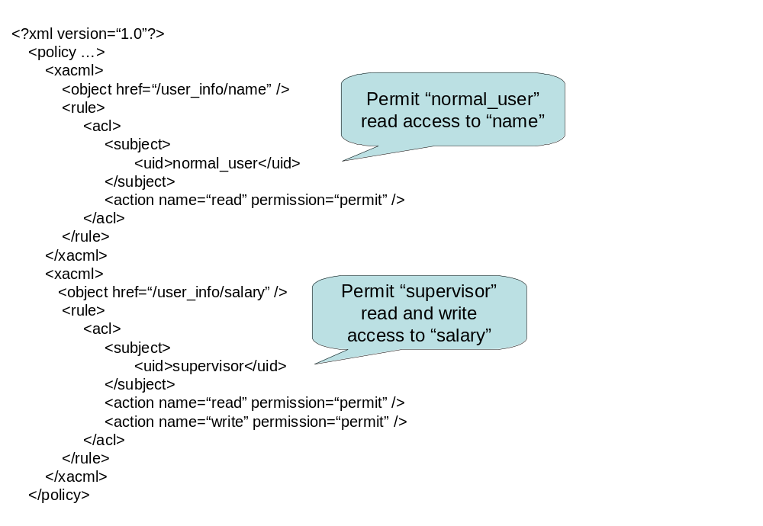
Figure 17: An example of an security policy in XACML format

Figure 17 shows an example of a security policy used in Policy Management Functional Element. The security policy is in XACML format.

Key Features
Implementations of the Policy Management Functional Element are expected to provide the following key features:
- The Functional Element MUST provide the capability to define and manage Policy Categories.
- The Functional Element MUST provide the capability to define and manage Policies.
- The Functional Element MUST provide version control capability to defined Policies.
- The Functional Element MUST provide the ability to manage Policies within a Policy Category; including insertion, update, retrieval and removal of attached Policies.
- The Functional Element MUST provide the ability to retrieve Policies that are attached to a Policy Category.

In addition, the following key feature could be provided to enhance the Functional Element further:
- The Functional Element MAY provide the ability to translate Policy into multi-lingual.

Interdependency
Direct Dependency
Policy Enforcement Functional Element | The Policy Enforcement Functional Element provides the mechanism to enforce the policy associated to a service. The enforcement is based on a pre-identified access structure. The access structure could be provided by the Role & Access Management Functional Element.
User Management Functional Element | The User Management Functional Element is used to manage the user’s attributes. The Group Management Functional Element in turn provides useful aggregation of the users. Together, they are able to achieve effective and efficient management of user information.
Role & Access Management Functional Element | The Role and Access Management Functional Element may be used to manage the user’s access rights by virtue of it’s association with a group, phase or even the complete lifecycle of the project.

Related Technologies and Standards
XACML.

Model
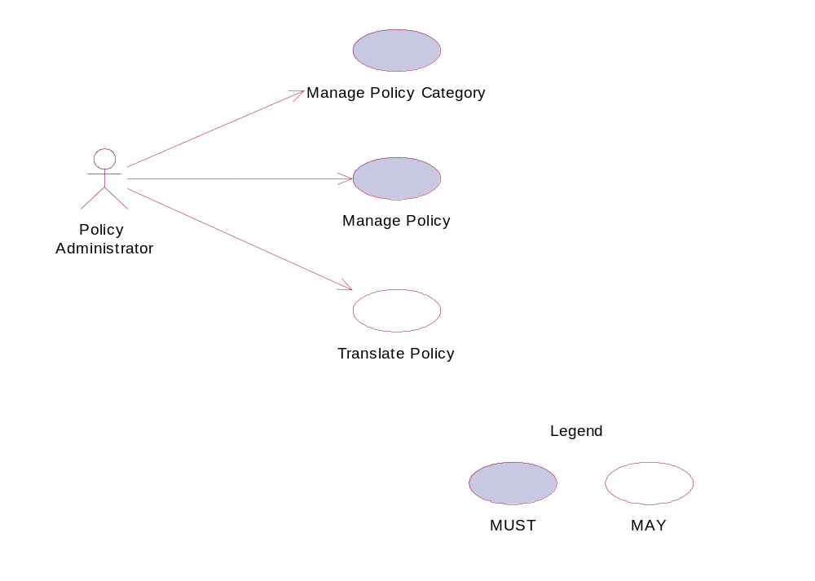
Figure 18: Model Of the Policy Management Functional Element

Usage Scenarios

Manage Policy Category

Description
This use case allows the policy administrator to manage policy category.

Flow of Events

Basic Flow
The use case begins when the policy administrator wants to create/retrieve/update/delete a policy category.
1: The policy administrator sends a request to manipulate a policy category.
2: Based on the operation it specifies, one of the following sub-flows is executed:
If the operation is ‘Create Policy Category’, the sub-flow 2.1 is executed.
If the operation is ‘Retrieve Policy Category’, the sub-flow 2.2 is executed.
If the operation is ‘Update Policy Category’, the sub-flow 2.3 is executed.
If the operation is ‘Delete Policy Category’, the sub-flow 2.4 is executed.
2.1: Create Policy Category.
2.1.1: The Functional Element gets the category name and definition.
2.1.2: The Functional Element checks whether the category exists.
2.1.3: The Functional Element creates the category.
2.2: Retrieve Policy Category.
2.2.1: The Functional Element gets the category name.
2.2.2: The Functional Element checks whether the category exists.
2.2.3: The Functional Element retrieves the category’s information.
2.3: Update Policy Category.
2.3.1: The Functional Element gets the category name and definition.
2.3.2: The Functional Element checks whether the category exists.
2.3.3: The Functional Element updates the category’s information.
2.4: Delete Policy Category.
2.4.1: The Functional Element gets the category name.
2.4.2: The Functional Element checks whether the category exists.
2.4.3: The Functional Element removes the category.
3: The Functional Element returns the results of the operation to the policy administrator and the use case ends.

Alternative Flows
1: Category Already Exists.
1.1: If in the basic flow 2.1.2, the category is already defined, Functional Element returns an error message and the use case ends.
2: Category Not Found.
2.1: If in the basic flow 2.2.2, 2.3.2 and 2.4.2, the category does not exist, Functional Element returns an error message and the use case ends.

Special Requirements
None.

Pre-Conditions
None.

Post-Conditions
None.

Manage Policy

Description
This use case allows the policy administrator to manage policy.

Flow of Events

Basic Flow
The use case begins when the policy administrator wants to create/retrieve/update/delete a policy.
1: The policy administrator sends a request to manipulate a policy.
2: Based on the operation it specifies, one of the following sub-flows is executed:
If the operation is ‘Create Policy’, the sub-flow 2.1 is executed.
If the operation is ‘Retrieve Policy’, the sub-flow 2.2 is executed.
If the operation is ‘Update Policy’, the sub-flow 2.3 is executed.
If the operation is ‘Delete Policy’, the sub-flow 2.4 is executed.
2.1: Create Policy.
2.1.1: The Functional Element gets the policy name, content and the Policy Category where the policy is to be created.
2.1.2: The Functional Element checks whether the policy exists.
2.1.3: The Functional Element creates the policy.
2.2: Retrieve Policy.
2.2.1: The Functional Element gets the policy name and the Policy Category.
2.2.2: The Functional Element checks whether the policy exists.
2.2.3: The Functional Element retrieves the policy’s information.
2.3: Update Policy.
2.3.1: The Functional Element gets the policy name, information and the Policy Category.
2.3.2: The Functional Element checks whether the policy exists.
2.3.3: The Functional Element updates the policy.
2.4: Delete Policy.
2.4.1: The Functional Element gets the policy name and the Policy Category.
2.4.2: The Functional Element checks whether the policy exists.
2.4.3: The Functional Element removes the policy from the Policy Category.
3: The Functional Element returns the results of the operation to the policy administrator and the use case ends.

Alternative Flows
1: Policy Already Exists.
1.1: If in the basic flow 2.1.2, the policy is already created, Functional Element returns an error message and the use case ends.
2: Policy Not Found.
2.1: If in the basic flow 2.2.2, 2.3.2 and 2.4.2, the policy does not exist, Functional Element returns an error message and the use case ends.

Special Requirements
None.

Pre-Conditions
None.

Post-Conditions
None.

Translate Policy

Description
This use case allows the policy administrator to translate policy into desired languages.

Flow of Events

Basic Flow
The use case begins when the policy administrator wants to translate a policy.
1: The policy administrator sends a request to translate a policy.
2: The Functional Element gets the policy name and the language desired.
3: The Functional Element checks whether the policy exists.
4: The Functional Element retrieves the policy for translation.
5: The Functional Element returns the results of the operation to the policy administrator and the use case ends.

Alternative Flows
1: Policy Not Found.
1.1: If in the basic flow 3, the policy does not exist, Functional Element returns an error message and the use case ends.

Special Requirements
None.

Pre-Conditions
None.

Post-Conditions
None.

Policy Enforcement Functional Element (new)

Motivation
The Policy Enforcement Functional Element helps enterprise to enforce policy for both the external partners and the customer applications that are authorized to access the enterprise applications. This Functional Element helps to ensure that the enterprise’s interests and its confidential information are protected.

This Functional Element fulfills the following requirements from the Functional Elements Requirements Document 02 [Error: Reference source not found]:
- Primary Requirements
- SECURITY-140 to SECURITY-144
- Secondary Requirements
- None

Terms Used
Terms | Description
XACML | eXtensible Access Control Markup Language. It is an XML-based language for access control that has been standardized in OASIS

Key Features
Implementations of the Policy Enforcement Functional Element are expected to provide the following key features:
- The Functional Element MUST provide the ability to identify Policy Categories and/or Policies that are to be enforced.
- The Functional Element MUST provide the ability to access enforced Policies for accepting/rejecting the policy.
- The Functional Element MUST provide the ability to associate a policy to a service.
- The Functional Element MUST provide the capability to associate a policy to its service’s access privileges through a pre-identified Access structure.
- The Functional Element MUST provide a mechanism to enforce policy upon acceptance of the policy.
- The Functional Element MUST provide the ability to enforce policies either based on individual or groups of services.
- The Functional Element MUST provide the capability to reject access.

Interdependency
Direct Dependency
Policy Management Functional Element | The Policy Management Functional Element provides the mechanism for security policy management, establishment, selection and viewing for enterprises to dynamically configure the relevant policy required to protect their interests.
Role & Access Management Functional Element | The Role & Access Management Functional Element may be used to manage the user’s access rights by virtue of its association with a group, phase or even the complete lifecycle of the project.

Related Technologies and Standards
XACML.

Model
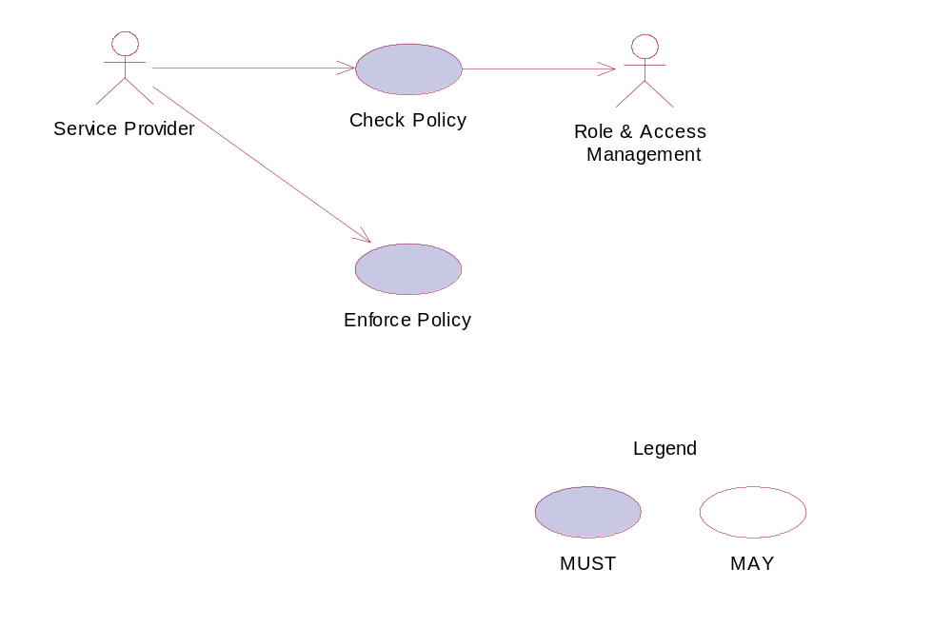
Figure 19: Model Of the Policy Enforcement Functional Element

Usage Scenarios

Check Policy

Description
This use case allows the service provider to check policy.

Flow of Events

Basic Flow
The use case begins when the service provider wants to check a policy.
1: The service provider sends a request to check a policy.
2: The Functional Element gets the policy and the requested service names.
3: The Functional Element checks whether the policy and the requested service exist.
4: The Functional Element evaluates the policy.
5: The Functional Element resolves any policy conflict.
6: The Functional Element returns the outcome to the service provider and the use case ends.

Alternative Flows
1: Policy Not Found.
1.1: If in the basic flow 3, the policy does not exist, Functional Element returns an error message and the use case ends.
2: Requested Service Not Found.
2.1: If in the basic flow 3, the requested service does not exist, Functional Element returns an error message and the use case ends.
3: Cannot Evaluate Policy.
3.1: If in the basic flow 4, the policy cannot be evaluated, Functional Element returns an error message and the use case ends.
4: Cannot Resolve Policy Conflict.
4.1: If in the basic flow 5, the policy conflict cannot be resolved, Functional Element returns an error message and the use case ends.

Special Requirements
None.

Pre-Conditions
None.

Post-Conditions
None.

Enforce Policy

Description
This use case allows the service provider to enforce policy based on the pre-identified access structure.

Flow of Events

Basic Flow
The use case begins when the service provider wants to enforce policy on a specific service.
1: The service provider sends a request to enforce a policy.
2: The Functional Element gets the policy name and the service activated.
3: The Functional Element checks whether the policy and the service exist.
4: The Functional Element gets the decision outcome.
5: The Functional Element enforces the policy to the service and the use case ends.

Alternative Flows
1: Policy Not Found.
1.1: If in the basic flow 3, the policy does not exist, Functional Element returns an error message and the use case ends.
2: Service Not Found.
2.1: If in the basic flow 3, the service does not exist, Functional Element returns an error message and the use case ends.
3: Cannot Make Decision.
3.1: If in the basic flow 4, decision cannot be made based on the information provided, Functional Element returns an error message and the use case ends.

Special Requirements
None.

Pre-Conditions
None.

Post-Conditions
None.

Presentation Transformer Functional Element (Deprecated)

This Functional Element has been deprecated in this version. Please refer to its replacement, 2.26 Transformer Functional Element (new) for further details.

QoS Functional Element (new)

Motivation
With the widespread of Web Services, Quality of Service (QoS) becomes a significant factor in distinguishing the success of service providers. On the other hand, poor QoS translates into frustrated customers, which can lead to lost of business opportunities. QoS determines the service usability and utility, both of which influence the popularity of the service.

This Functional Element fulfills the following requirements from the Functional Elements Requirements Document 02 [Error: Reference source not found]:
- Primary Requirements
- MANAGEMENT-320,
- MANAGEMENT-321,
- MANAGEMENT-323,
- MANAGEMENT-324,
- [MANAGEMENT-325 and
- MANAGEMENT-312.
- Secondary Requirements
- MANAGEMENT-311 and
- MANAGEMENT-310.

QoS FE has been re-designed with the conceptual model from WSQM Specs version xx dated xx taken into considerations. [The exact version is pending confirmation from WSQM.]
The mapping between FESC-QoS Functional Elements and WSQM-Service Level Measurement is depicted in the table below.

Mapping between FESC-QoS Functional Elements and WSQM-Service Level Measurement
FES-QoS Functional Elements | WSQM-Service Level Measurement
Availability | System Availability
Latency | Response Time
Throughput | Maximum Throughput
Reliability | Successability
Accessibility | Accessibility

Terms Used
Terms | Description
Availability | Availability refers to the quality aspect of whether the Web Service is present or ready for immediate use.
Performance | Performance refers to the quality aspect of Web service. It is measured in terms of throughput and latency. Higher throughput and lower latency values represent good performance of a Web Service.
Reliability | Reliability refers to the quality aspect of a Web Service that represents the degree of being capable of maintaining the service and service quality. For Reliability, the measurement is taken in the SOAP response level.
Accessibility | Accessibility refers to the quality aspect of a service that represents the degree it is capable of serving a Web service request. It denotes the success rate or chance of a successful service instantiation at a point in time. For accessibility, measurement is taken in the message carrier level like HTTP
Security | Security is the quality aspect of the Web service of providing confidentiality and non-repudiation by authenticating the parties involved, encrypting messages, and providing access control

Figure 20 depicts the basic concepts of 2 steps approach of QoS Functional Element. Step 1 begins when the user (service requester) requests to measure QOS of a known web service. The Function Element then returns a Reference ID once it receives that request. It also takes necessary measurements and logs them. Step 2 begins when the user requests for the result of measurement. The user provides the Functional Element a Reference ID. With this Reference ID, the Functional Element calculates and returns the result to the user. The measurements used in this Functional Element are designed with the requirements from WSQM Specs (working draft) Version 2.0, dated September 2005 taken into considerations.

Request to Measure
Q

O

S
Reference number returned
Request for result
Result return


known web service2
known web service1
known web service3

Figure 20: An Overview on the Expected Usage of Instantiated QoS Functional Element

Key Features
Implementations of the QoS Functional Element are expected to provide the following key features:
- The Functional Element MUST provide the capability to measure Availability.
- The Functional Element MUST provide the capability to measure Performance.
- The Functional Element MUST provide the capability to measure Reliability.
- The Functional Element MUST provide the capability to measure Accessibility.

In addition, the following key features could be provided to enhance the Functional Element further:
1. The Functional Element MAY provide confidentiality and non-repudiation by authenticating the parties involved, encrypting messages and providing access control as in the Security aspect.

Interdependencies
Direct Dependency
Log Utility Functional Element | The Log Utility Functional Element is used to record the data.

Interaction Dependency
Secure SOAP Management Functional Element | The Secure SOAP Management Functional Element is used to provide authentication to the user, encrypting messages and providing access control

Related Technologies and Standards
Specifications | Description
WSDL 1.1 | The ability to parse the WSDL document and generate a client is heavily dependent on it being a conforming WSDL document.

Model
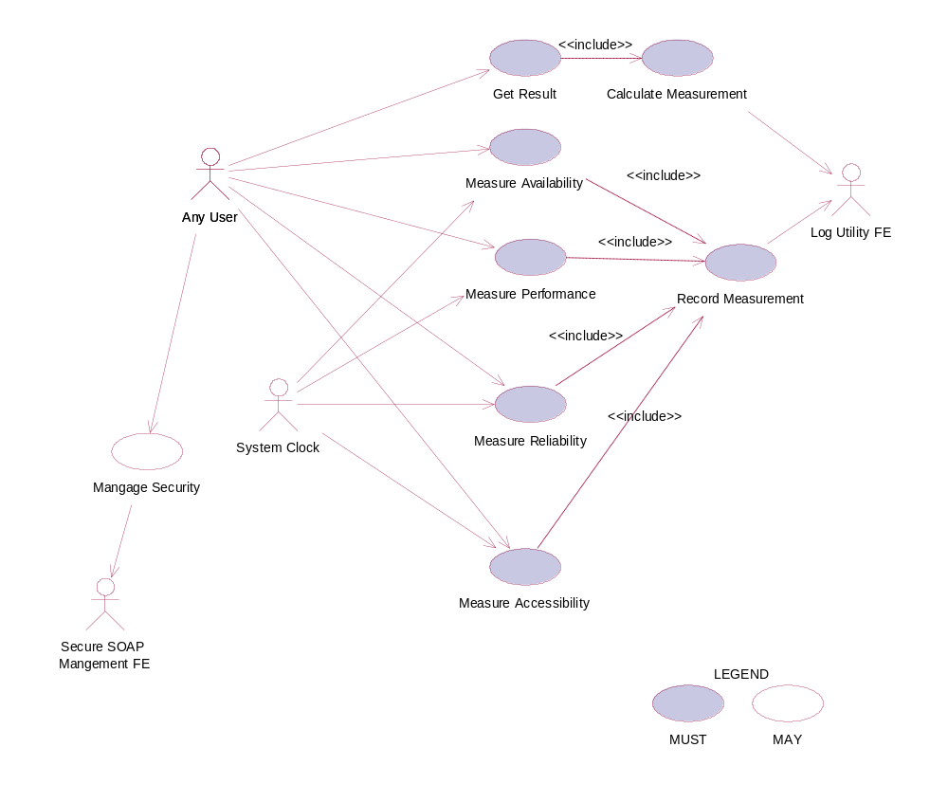
Figure 21: Model Of the QoS Functional Element

Usage Scenarios

Measure Availability

Description
Generally, the definition of Availability is based on percentage of ‘up time’ over unit time as given by Eq 1.
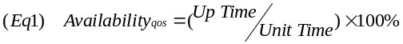
Based on the above equation, this use case allows the user to measure the availability of a known Web Service based on the concepts of successful invocation of Web Service with respect to an interval as well as the period of measurement set. The following shows the derivation of the above stated concepts.

Availability | = | Number of successful invocation X Interval)/period of measurement) X 100%
 |  | ((Number of successful invocations X Interval) / (Total invocations X Interval)) X 100%
 |  | (Number of successful invocations/Total invocations) X 100%

In WS-QM Service Level Measurement (Refer to Table A), the definition of Availability is defined in Eq 2. ,

The availability defined in FESC-QoS Functional Elements is mapped into system availability in WSQM-Service Level Measurement. Although the terminology used is in both specifications is different but the basis of the concept is the same.

Flow of Events

Basic Flow
This use case starts when the user wants to measure the availability of a Web Service.
1. User sets a period of measurement.
2. User determines the acceptable invocation interval.
3 User submits the WSDL of a known web service.
4. Functional Element parses the URL of the WSDL document and extracts the necessary information.
5. Functional Element generates client base on the extracted information.
6. Functional Element invokes the known web service using the generated client
7. Functional Element generates a Reference ID.
8. Functional Element returns Reference ID to the user.
9. Functional Element logs the Reference ID to the Record Measurement Use Case.
10. Functional Element logs the Measurement Type to the Record Measurement Use Case.
11. Functional Element logs each invocation at every interval to the Record Measurement Use Case.
12. Functional Element logs successful invocation at every interval to the Record Measurement Use Case.
13. Functional Element continues to invoke the known web service at every interval until the period of measurement is reached and the use case ends.

Alternative Flows
1. If the structure of the WSDL does not comply with the standard, the Functional Element returns an error message and the use case ends.
2. If the Functional Element fails to generate the client, the Functional Element returns an error message and the use case ends.
3. If the Functional Element fails to find the known web service, the Functional Element returns an error message and the use case ends.
4. If the Functional Element fails to invoke the known web service, the Functional Element returns an error message and the use case ends.
5. If the Functional Element fails to return a reference ID, the Functional Element returns an error message and the use case ends.
6. If the Functional Element gets a wrong a reference ID, the Functional Element returns an error message and the use case ends.

Special Requirements
None.

Pre-Conditions
None

Post-Conditions
None.

Measure Performance

Description
This use case allows the user to measure the performance of a Web Service. In Performance both Latency and Throughput are measured. For throughput, user sets a period of measurement. Throughput is derived as the total number of invocations for the given period of measurement. For Latency, user logs the request time and response time of invocation. Latency is derived by the response time minus the request time of the invocation, as indicated below:
invoke
Request

Response

Latency

The throughput defined in FESC-QoS Functional Elements is mapped into the maximum throughput as per defined in WSQM-Service Level Measurement (Refer to Table A). The terminology used is different; however the concept is the same.

The latency defined in FESC-QoS Functional Elements is mapped into the Response Time in WSQM-Service Level Measurement (Refer to Table A). The terminology used is totally different but the concept is the same. FESC-QoS Latency is defined as a round-trip time between sending a request & receiving a response. In WSQM, the Response Time measured is also the time between sending a request and receiving a response. The basis of measurement for both terms is the same except the naming of the terms.

Flow of Events

Basic Flow
This use case starts when a user wants to measure the Performance of a Web Service.
1. Based on the operation it specified, one of the following sub-flows is expected
- If the operation is ‘Measure Throughput’, then sub-flow 1.1 is executed.
- If the operation is ‘Measure Latency’, then sub-flow 1.2 is executed.
1.1. Measure Throughput
This use case starts when a user wants to measure the Throughput of a Web Service.
1.1.1. User sets a period of measurement.
1.1.2. User submits the WSDL of a known web service.
1.1.3. Functional Element parses the URL of the WSDL document and extracts the necessary information.
1.1.4. Functional Element generates a Reference ID.
1.1.5. Functional Element returns a Reference ID to user.
1.1.6. Functional Element logs the Reference ID to the Record Measurement Use Case.
1.1.7.Functional Element logs the measurement type to the Record Measurement Use Case.
1.1.8. Functional Element waits and logs any invocation to this WSDL until the period of measurement is reached and the use case ends.
1.2. Measure Latency
1.2.1. User submits the WSDL of a known web service.
1.2.2. Functional Element parses URL of the WSDL document and extracts the necessary information.
1.2.3. Functional Element invokes the known web service.
1.2.4. Functional Element generates a Reference ID.
1.2.5. Functional Element returns a Reference ID to user.
1.2.6. Functional Element logs the Reference ID to the Record Measurement Use Case.
1.2.7. Functional Element logs the measurement type to the Record Measurement Use Case.
1.2.8. Functional Element logs the request time to the Record Measurement Use Case.
1.2.9 Functional Element logs the response time to the Record Measurement Use Case and the use case ends.

Alternative Flows
1. If the structure of the WSDL does not comply with the standard, the Functional Element returns an error message and the use case ends.
2. If the Functional Element fails to generate the client, the Functional Element returns an error message and the use case ends.
3. If the Functional Element fails to find the known web service, the Functional Element returns an error message and the use case ends.
4. If the Functional Element fails to invoke the known web service, the Functional Element returns an error message and the use case ends.
5. If the Functional Element fails to return a reference ID, the Functional Element returns an error message and the use case ends.
6. If the Functional Element gets a wrong a reference ID, the Functional Element returns an error message and the use case ends.

Special Requirements
None.

Pre-Conditions
None.

Post-Conditions
None.

Measure Reliability

Description
This use case allows the user to measure the reliability of a known Web Service. User sends a number of requests to the service and records the total number of responses the service returns. The number of successful response messages over the number of request messages is the measure of Reliability.

Reliability = (Number of Successful Response Messages / Number of Request Messages) X 100%

The Reliability defined in FESC-QoS Functional Elements is mapped into Successability in WSQM-Service Level Measurement (Refer to Table A). The terminology used is totally different. The term used by FESC QoS FE will remain as it is but will adopt the concept and formula used by WSQM.

Flow of Events

Basic Flow
1. User sets a period of measurement.
2. User submits the WSDL of a known web service.
3. Functional Element parses the URL of the WSDL document and extracts the necessary information.
4. Functional Element generates a Reference ID.
5. Functional Element returns a Reference ID to user.
6. Functional Element logs the Reference ID to the Record Measurement Use Case.
7. Functional Element logs measurement type to the Record Measurement Use Case.
8. Functional Element sends a number of messages across to the known web service
9. Functional Element logs the number of messages sent to the web service and the number of messages the web service responses until the period defined by the user is reached and the use case ends.

Alternative Flows
1. If the structure of the WSDL does not comply with the standard, the Functional Element returns an error message and the use case ends.
2. If the Functional Element fails to generate the client, the Functional Element returns an error message and the use case ends.
3. If the Functional Element fails to find the known web service, the Functional Element returns an error message and the use case ends.
4. If the Functional Element fails to invoke the known web service, the Functional Element returns an error message and the use case ends.
5. If the Functional Element fails to return a reference ID, the Functional Element returns an error message and the use case ends.
6. If the Functional Element gets a wrong a reference ID, the Functional Element returns an error message and the use case ends.

Special Requirements
None.

Pre-Conditions
None.

Post-Conditions
None.

Measure Accessibility

Description
This use case allows the user to measure the accessibility of a known Web Service. It is a measure denoting the success rate or chance of a successful service instantiation at a point of time. User sends a number of requests to the service and records number of acknowledgments of the requests that are received. The number of acknowledgements received over number of request messages sent is the measure of Accessibility.

Accessibility = (Number of Acknowledgement / Number of request message) X 100%

The Accessibility defined in FESC-QoS Functional Elements is mapped into Accessibility in WSQM-Service Level Measurement (Refer to Table A). The terminology used is the same. FESC QoS FE will adopt the concept and the formula used by WSQM.

Flow of Events

Basic Flow
1. User sets a period of measurement.
2. User submits the WSDL of a known web service.
3. Functional Element parses the URL of the WSDL document and extracts the necessary information.
4. Functional Element generates a Reference ID.
5. Functional Element returns a Reference ID to user.
6. Functional Element logs the Reference ID to the Record Measurement Use Case.
7. Functional Element logs measurement type to the Record Measurement Use Case.
8. Functional Element sends a number of messages across to the known Web Service
9. Functional Element logs the number of messages sent to the Web Service and the number of messages Web Service acknowledged (the messages that reach the web service) until the period defined by the user is reached and the use case ends.

Alternative Flows
1. If the structure of the WSDL does not comply with the standard, the Functional Element returns an error message and the use case ends.
2. If the Functional Element fails to generate the client, the Functional Element returns an error message and the use case ends.
3. If the Functional Element fails to find the known web service, the Functional Element returns an error message and the use case ends.
4. If the Functional Element fails to invoke the known web service, the Functional Element returns an error message and the use case ends.
5. If the Functional Element fails to return a reference ID, the Functional Element returns an error message and the use case ends.
6. If the Functional Element gets a wrong a reference ID, the Functional Element returns an error message and the use case ends.

Special Requirements
None.

Pre-Conditions
None.

Post-Conditions
None.

Record Measurement

Description
This use case records the Measurement taken. It records type of Measurement, Reference ID, and the invocation data (invocation status (Successful or Unsuccessful), request time and response time)

Flow of Events

Basic Flow
This use case starts when the user record the Measurement.
1. The Functional Element logs Reference ID into a log file using Log Utility FE.
2. The Functional Element logs Measurement type into a log file using Log Utility FE.
3. The Functional Element logs the invocation data into a log file using Log Utility FE.

Alternate Flow
1. Log file not available, the Functional Element returns an error and the user case ends.
2. If the Functional Element fails to get a reference ID, the Functional Element returns an error message and the use case ends.

Special Requirements
None.

Pre-Conditions
None.

Post-Conditions
None.

Calculate Measurement

Description
This use case calculates the Measurement.

Flow of Events

Basic Flow
This use case starts when user wants to calculate Measurement.
1. The Functional Element gets the Reference ID.
2. The Functional Element opens up the log file.
3. The Functional Element reads the data in the log file base on Reference ID given.
4. The Functional Element calculates the measurement using the data read from the log file.
5. The Functional Element sends the calculated result to the user.

Alternative Flows
1. Log file not available, the Functional Element returns an error and the user case ends.
2. If the Functional Element fails to get a reference ID, the Functional Element returns an error message and the use case ends.

Special Requirements
None.

Pre-Conditions
None.

Post-Conditions
None.

Get Result

Description
This use case calculates the Measurement logged.

Flow of Events

Basic Flow
This use case starts when user wanted to get result base on the Reference ID.
1. The Functional Element gets the Reference ID from user
2. The Functional Element passes the Reference ID to Calculate Measurement Use Case.
3. The Functional Element gets calculated result.
4. The Functional Element returns the result to the user.

Alternative Flows
1. Log file not available, the Functional Element returns an error and the user case ends.
2. If the Functional Element fails to get a reference ID, the Functional Element returns an error message and the use case ends.

Special Requirements
None.

Pre-Conditions
None.

Post-Conditions
None.

Manage Security

Description
This use case allows user to check that the known web service is securely managed.

Flow of Events

Basic Flow
1. The service provider sends a request to check security of the known web service.
2. User submits the WSDL of a known web service.
3. Functional Element parses the URL of the WSDL document and extracts the necessary information.
4. Functional Element generates client base on the extracted information.
5. Functional Element invokes the known web service with a username.
6. User sends a message to the known web service.
7. The Functional Element checks whether username is authenticated.
8. The Functional Element checks whether message is encrypted.
9. The Functional Element checks whether the whole process is access controlled.
10. The Functional Element returns the outcome to the user and the use case ends.

Alternative Flows
1. If the structure of the WSDL does not comply with the standard, the Functional Element returns an error message and the use case ends.
2 If the Functional Element fails to generate the client, the Functional Element returns an error message and the use case ends.
3. If the Functional Element fails to find the known web service, the Functional Element returns an error message and the use case ends.
4. If the Functional Element fails to invoke the known web service, the Functional Element returns an error message and the use case ends.
5. If the web service fails to return result, the Functional Element returns an error message and the use case ends.

Special Requirements
None.

Pre-Conditions
None.

Post-Conditions
None.

Role and Access Management Functional Element

Motivation
The Role and Access Management Functional Element is expected to be an integral part of the User Access Management (UAM) functionalities that is expected to be needed by a Web Service-enabled implementation. This Functional Element is expected to fulfill the needs arising out of managing access to resources within an application, based on role-based access control mechanism. As such it will cover aspects that include:
- Management of roles and access privileges, and
- Assignment of roles to entities that will be accessing the resources that is being managed.

This Functional Element fulfills the following requirements from the Functional Elements Requirements Document 02 [Error: Reference source not found]:
- Primary Requirements
- MANAGEMENT-030 to MANAGEMENT-034, and
- MANAGEMENT-200 to MANAGEMENT-205.
- Secondary Requirements
- SECURITY-040 to SECURITY-041.

Terms Used
Terms | Description
Access Control | Access Control refers to the process of ensuring that only an authorized user can access the resources within a computer system.
Lifecycle | A lifecycle refers to the sequence of phases in the lifetime of a resource.
Phase | A phase refers to the different stages that a resource may be in when viewed from a lifecycle perspective
Resource | A resource in an application is defined to encompass data/information in a system. Examples of this information include users information, transaction information and security information.
Role | A role is typically assigned to a user to define or indicate the job or responsibility of the said user in a particular context.
Role Based Access Control | Role Based Access Control is a model of access management mechanism. In this model, the access control is enabled in the following manner:  Determine who (user) is requesting access.  Determine the role(s) of the user  Determine the type of access that is allowed based on the role(s) of the user  It is the task of the access control mechanism to ensure that only processes, which are explicitly authorized, perform the operation by these objects.
User | A user is loosely defined to include both human and virtual users. Virtual users could include service users and application (or machine) users that are utilising other services in a SOA environment.
User Access Management (UAM) | User Access Management or UAM refer to the concept of managing users in a holistic manner, considering all aspect which includes:  Defining a set of basic user information that should be stored in any enterprise application.  Providing a means to extend this basic set of user information when needed.  Simplifying management by grouping related users together through certain criteria.  Having the flexibility of adopting both coarse/fine grain access controls.

Key Features
Implementations of the Role and Access Management Functional Element are expected to provide the following key features:
- The Functional Element MUST provide the capability to manage the creation and deletion of instances of the following concepts based on a pre-defined structure:
  - Role,
  - Access, and
  - Resource
- The Functional Element MUST provide the capability to manage all the information (attribute values) stored in such concepts. This includes the capability to retrieve and update attribute’s values belonging to a concept like Role, Access or Resource.
- The Functional Element MUST provide the capability to associate a Role to its access privileges through the Access structure.
- The Functional Element MUST provide the capability to determine a Role’s accessibility to Resources based on the access privileges that have been assigned.
- The Functional Element MUST provide the ability to manage the association of users to Roles via assignments of Roles to users. This will include:
  - Assignment/Un-assignment of Roles to individual Users, and
  - Assignment/Un-assignment of Roles to Groups.
This will provide an indirect linkage between the accessibility of specific Users to Resources through the concept of Role and Access.
- The Functional Element MUST provide a mechanism for managing the concepts of Role, Access and Resource across different application domains.
Example: Namespace control mechanism

In addition, the following key features could be provided to enhance the Functional Element further:
- The Functional Element MAY provide a mechanism to enable different Access instances to be related to one another.
- The Functional Element MAY also provide a mechanism to enable hierarchical relationships between Access instances.
Example: Parent and Child Relationship
- The Functional Element MAY provide the ability for Roles to be temporal sensitive.
Example: A Role is assigned to a particular Phase in a Lifecycle.

Interdependencies
Direct Dependencies
Phase and Lifecycle Management Functional Element | The key abstraction, phases and lifecycle, in the Phase and Lifecycle Management Functional Element is used as a target for the assignment of roles and access privileges.
User Management Functional Element | The key abstraction, user, in the User Management Functional Element is used as a target for the assignment of roles and access privileges.
Group Management Functional Element | The key abstraction, group, in the Group Management Functional Element is used as a target for the assignment of roles and access privileges.

Related Technologies and Standards
None

Model
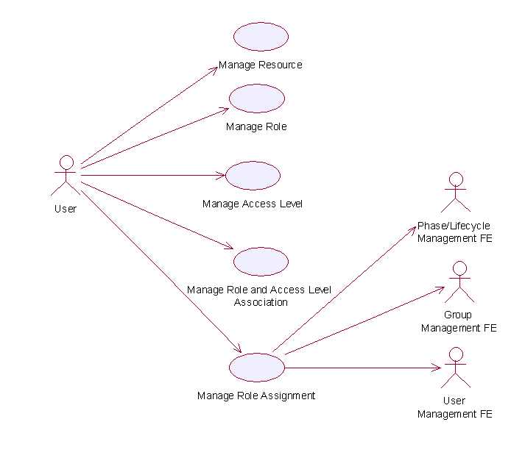
Figure 22: Model Of the Role and Access Management Functional Element []

Usage Scenario

Manage Role

Description
This use case allows the service user to manipulate the role information such as adding, changing and deleting role information in the Functional Element.

Flow of Events

Basic Flow
This use case starts when any user wants to create, change or delete a role.
1: Service user specifies the function it would like to perform (either create a role, update a role or delete a role).
2: Once the service user provides the requested information, one of the sub-flows is executed.
If the service user provides ‘Create a Role’, then sub-flow 2.1 is executed.
If the service user provides ‘Retrieve a Role’, then sub-flow 2.2 is executed.
If the service user provides ‘Update a Role’, then sub-flow 2.3 is executed.
If the service user provides ‘Delete a Role’, then sub-flow 2.4 is executed.
2.1: Create a Role.
2.1.1: The service user specifies role information such as the role name and description.
2.1.2: The Functional Element connects to the data storage.
2.1.3: The Functional Element checks whether the role exists in the Functional Element or not, saves the role information in the data storage and the use case ends.
2.2: Retrieve a Role.
2.2.1: The service user specifies the role name for retrieval.
2.2.2: The Functional Element connects to the data storage.
2.2.3: The Functional Element retrieves the role information in the data storage and the use case ends.
2.3: Update a Role.
2.3.1: The service user specifies the role name to update.
2.3.2: The service user specifies the target field name and value of the role.
2.3.3: The Functional Element connects to the data storage.
2.3.4: The Functional Element updates the role information in the data storage and the use case ends.
2.4: Delete a Role.
2.4.1: The service user specifies the role name to delete.
2.4.2: The Functional Element connects to the data storage.
2.4.3: The Functional Element removes the record of the role in the data storage and the use case ends.

Alternative Flows
1: Data Storage Not Available.
1.1: If in basic flow 2.1.2, 2.2.2, 2.3.3 and 2.4.2, the data storage of the role information is not available, an error message is returned and the use case ends.
2: Role Already Exists.
2.1: If in basic flow 2.1.3, the Functional Element checks that the role already exists in the data storage, an error message is returned and the use case ends.
3: Role Does Not Exist.
3.1: If in basic flow 2.2.3, 2.3.4 and 2.4.3, the Functional Element checks that the role does not exist in the data storage, an error message is returned and the use case ends.
4: Role Cannot Be Deleted.
4.1: If in basic flow 2.4.3, the other information associated with the role, such as any access level assigned, still exists, the role information may not be removed. An error message is returned and the use case ends.

Special Requirements
None

Pre-Conditions
None.

Post-Conditions
If the use case was successful, the role is saved/updated/removed in the Functional Element. Otherwise, the Functional Element state is unchanged.

Manage Resource

Description
This use case allows the service user to manipulate the resource information such as adding, changing and deleting resource information in the Functional Element.

Flow of Events

Basic Flow
This use case starts when any user wants to create, change or delete a resource.
1: The user specifies the function it would like to perform.
2: The user provides the requested information; one of the sub-flows is executed.
If the user provides ‘Create a Resource’, then sub-flow 2.1 is executed.
If the user provides ‘Retrieve a Resource’, then sub-flow 2.2 is executed.
If the user provides ‘Update a Resource’, then sub-flow 2.3 is executed.
If the user provides ‘Delete a Resource’, then sub-flow 2.4 is executed.
2.1: Create a Resource.
2.1.1: The user specifies resource information such as the resource name and description.
2.1.2: The Functional Element connects to the data storage.
2.1.3: The Functional Element checks whether the resource exists in the Functional Element, save the resource information in the data storage and the use case ends.
2.2: Retrieve a Resource.
2.2.1: The service user specifies the resource name for retrieval.
2.2.2: The Functional Element connects to the data storage.
2.2.3: The Functional Element retrieves the resource information in the data storage and the use case ends.
2.3: Update a Resource.
2.3.1: The service user specifies the resource name to update.
2.3.2: The Functional Element connects to the data storage.
2.3.3: The Functional Element updates the resource information in the data storage and the use case ends.
2.4: Delete a Resource.
2.4.1: The service user specifies the resource name to delete.
2.4.2: The Functional Element connects to the data storage.
2.4.3: The Functional Element removes the record of the resource in the data storage and the use case ends.

Alternative Flows
1: Data Storage Not Available.
1.1: If in basic flow 2.1.2, 2.2.2, 2.3.2 and 2.4.2, the data storage of the resource information is not available, an error message is returned and the use case ends.
2: Resource Already Exists.
2.1: If in basic flow 2.1.3, the Functional Element checks that the resource already exists in the data storage, an error message is returned and the use case ends.
3: Resource Does Not Exist.
3.1: If in basic flow 2.2.3, 2.3.3 and 2.4.3, the Functional Element checks that the resource does not exist in the data storage, an error message is returned and the use case ends.

Special Requirements
None

Pre-Conditions
None.

Post-Conditions
None

Manage Access Level

Description
This use case allows service user to manage the creation/retrieval/modification/deletion of access level.

Flow of Events

Basic Flow
This use case starts when service user wants to manage the access levels.
1: The service user specifies the function it would like to perform (add, update or delete an access level).
2: Once the service user provides the requested information, one of the sub-flows is executed.
If the service user provides ‘Add an Access Level’, then sub-flow 2.1 is executed.
If the service user provides ‘Retrieve an Access Level’, then sub-flow 2.2 is activated.
If the service user provides ‘Update an Access Level’, then sub-flow 2.3 is activated.
If the service user provides ‘Delete an Access Level’, then sub-flow 2.4 is executed.
2.1: Add an Access Level.
2.1.1: The service user specifies the access level information, which includes: name, description, name of parent access level and group of resources that the access level is associated with.
2.1.2: The Functional Element connects to the data storage.
2.1.3: The Functional Element check whether the access level and its parent access level exist in the Functional Element, saves the access level information in the data storage and the use case ends.
2.2: Retrieve an Access Level.
2.2.1: The service user specifies the access level name to retrieve.
2.2.2: The Functional Element connects to the data storage.
2.2.3: The Functional Element gets access level information from the data storage and returns to the service user and the use case ends.
2.3: Update an Access Level.
2.3.1: The service user specifies the access level name.
2.3.2: The service user specifies the field(s) and new value(s) to update.
2.3.3: The Functional Element connects to the data storage.
2.3.4: The Functional Element updates the access level information in the data storage with the value specified in 2.3.2 and the use case ends.
2.4: Delete an Access Level.
2.4.1: The service user specifies the access level name to delete.
2.4.2: The Functional Element connects to the data storage.
2.4.3: The Functional Element removes the record of the access level in the data storage and the use case ends.

Alternative Flows
1: Data Storage Not Available.
1.1: If in basic flow 2.1.2, 2.2.2, 2.3.3 and 2.4.2, the data storage of the access level information is not available, an error message is returned and the use case ends.
2: Access Level Already Exists.
2.1: If in basic flow 2.1.3, the Functional Element checks that the access level already exists in the data storage, an error message is returned and the use case ends.
3: Access Level Cannot Be Deleted.
3.1: If in basic flow 2.4.3, the other information associated with the Access Level, such as roles to which the access level is assigned and the parent access level still exists, the access level information may not be removed. An error message is returned and the use case ends.
4: Parent Access Level Not Exist.
4.1: If in basic flow 2.1.3, the parent access level does not exist, an error message is returned and the use case ends.

Special Requirements
None

Pre-Conditions
None.

Post-Conditions
None

Manage Role and Access Level Association

Description
This use case allows service user to assign, update and remove the access level assigned to role.

Flow of Events

Basic Flow
This use case starts when service user wants to manage the relationship between access level and role.
1: The service user specifies a role and the function he/she would like to perform on the role (either assign an access level to role, update role access level, or delete role access level).
2: Once the service user provides the requested information, one of the sub-flows is executed.
If the user provides ‘Assign an Access Level to Role’, then sub-flow 2.1 is executed.
If the user provides ‘Update Access Level for Role’, then sub-flow 2.2 is executed.
If the user provides ‘Delete Access Level for Role’, then sub-flow 2.3 is executed.
If the user provides ‘Retrieve Access Level for Role’, then sub-flow 2.4 is executed.
If the service user provides ‘Retrieve Role for Access Level’, then sub-flow 2.5 is executed.
2.1: Assign an Access Level to Role.
2.1.1: The service user specifies access level that will be assigned to the role.
2.1.2: The Functional Element connects to the data storage.
2.1.3: The Functional Element checks whether the access level has been assigned to the role. Functional Element saves the access level reference in the role record in the data storage and the use case ends.
2.2: Update Access Level for Role.
2.2.1: The service user specifies the access level to update and the new access level information.
2.2.2: The Functional Element connects to the data storage.
2.2.3: The Functional Element updates the access level reference in the role record in the data storage and the use case ends.
2.3: Delete Access Level to Role.
2.3.1: The service user specifies the access level to delete.
2.3.2: The Functional Element connects to the data storage.
2.3.3: The Functional Element removes the access level reference from the record of the role in the data storage and the use case ends.
2.4: Retrieve Access Level for Role.
2.4.1: The service user specifies the role to retrieve the access levels associated with it.
2.4.2: The Functional Element connects to the data storage.
2.4.3: The Functional Element retrieves the access level assigned to the role in the data storage and the use case ends.
2.5: Retrieve Role for Access Level.
2.5.1: The service user specifies the access level to retrieve roles associated to it.
2.5.2: The Functional Element connects to the data storage.
2.5.3: The Functional Element retrieves roles associated to the access level in the data storage and the use case ends.

Alternative Flows
1: Data Storage Not Available.
1.1: If in basic flow 2.1.2, 2.2.2 and 2.3.2, the data storage of the access level information is not available, an error message is returned and the use case ends.
2: Access Level Assignment Already Exists.
2.1: If in basic flow 2.1.3, the Functional Element checks that the access level already exists in the role record in the data storage, an error message is returned and the use case ends.
3: Access Level Assignment Not Exist.
3.1: If in basic flow 2.3.3, the access level assignment does not exist, an error message is returned and the use case ends.
4: Access Level Not Exist.
4.1: If in basic flow 2.1.3, 2.2.3, 2.3.3, 2.4.3 and 2.5.3, the access level does not exist, an error message is returned and the use case ends.
5: Role Not Exist.
5.1: If in basic flow 2.1.3, 2.2.3, 2.3.3, 2.4.3 and 2.5.3, the role does not exist, an error message is returned and the use case ends.

Special Requirements
None.

Pre-Conditions
None.

Post-Conditions
None.

Manage Role Assignment

Description
The use case allows service user to assign a role to a user, a group, a phase in a lifecycle, to change or to delete such assignment.

Flow of Events

Basic Flow
This use case starts when the service user wants to manage the assignment of a role. This role can be assigned to a user, group, phase and lifecycle.
1: Service user specifies a role and an operation to perform on the role.
2: Once the service user provides the requested information, one of the sub-flows is executed.
If the user provides ‘Assign Role’, then sub-flow 2.1 is executed.
If the user provides ‘Retrieve Role’, then sub-flow 2.2 is executed.
If the user provides ‘Un-assign Role’, then user sub-flow 2.3 is executed.
2.1: Assign Role.
2.1.1: The service user specifies a user/group/phase/lifecycle to which the role will be assigned.
2.1.2: Depending of target of the assignment, the Functional Element will check for the presence of one of the following Functional Elements.
User Management Functional Element
Group Management Functional Element
Phase and Lifecycle Management Functional Element
2.1.3: The Functional Element checks whether the role has been assigned to the intended target
2.1.4: The Functional Element saves the relationship between the role and the target and the use case ends.
2.2: Retrieve Role.
2.2.1: The service user specifies a user/group/phase/lifecycle to retrieve all roles assigned
2.2.2: Depending of target of the assignment, the Functional Element will check for the presence of one of the following Functional Elements.
User Management Functional Element
Group Management Functional Element
Phase and Lifecycle Management Functional Element
2.2.3: The Functional Element gets the roles that are assigned to the target.
2.2.4: The Functional Element returns the results to the service user and the use case ends.
2.3: Un-assign Role.
2.3.1: The service user specifies a user/group/phase/lifecycle and the role that is to be un-assigned.
2.3.2: Depending of target of this un-assignment, the Functional Element will check for the presence of one of the following Functional Elements.
User Management Functional Element
Group Management Functional Element
Phase and Lifecycle Management Functional Element
2.3.3: The Functional Element checks if the roles have been assigned to the target in the first place.
2.3.4: The Functional Element removes the role assigned and the use case ends.

Alternative Flows
1: Dependent Functional Element not available.
1.1: If in basic flow 2.1.2, 2.2.2 and 2.3.2, the dependent Functional Elements are not available, an error message is returned and the use case ends.
2: Invalid User/Group/Phase/Lifecycle Account.
2.1: If in basic flow 2.1.2, 2.2.2 and 2.3.2, the dependent Functional Elements are available but an invalid account is provided, an error message is returned and the use case ends.
3: Data Storage Not Available.
3.1: If in basic flow 2.1.2, 2.2.2 and 2.3.2, the Functional Element is unable to access the data storage, an error message is provided and the use case ends.

Special Requirements
None.

Pre-Conditions
None.

Post-Conditions
None.

Search Functional Element

Motivation
In a Web Service-enabled implementation, information is distributed across different sites and this makes searching and collating information difficult. Against this backdrop, this Functional Element is expected to fulfill the needs identified within an application by covering the following aspects.
- Providing the capability for configuration of different types of data sources for information search,
- Providing the facility to provide a concrete definition of data source classification for information search
- Providing the ability to define different search scopes for various data source classification
- Performing information search on those pre-configured different types of data sources and
- Providing the provision to consolidate the return result arising from the search operation.

This Functional Element fulfills the following requirements from the Functional Elements Requirements Document 02 [Error: Reference source not found]:
- Primary Requirements
- MANAGEMENT-009,
- PROCESS-030 to PROCESS-031, and
- PROCESS-034.
- Secondary Requirements
- None

Terms Used
Terms | Description
Data source | Data source refers to any kind of information storage and retrieval databases like RDBMS, LDAP, ODBMS, XMLDB, XML Files, TEXT Files, etc.
Search Category | A Search Category refers to some logical grouping of the data sources on the basis of purpose of various data source purpose like NEWS, EMAIL, USERS, GROUPS, TRANSACTIONS, etc.
Data Source Type | Data Source Type refers to the various kinds of data storage format or structure like XML, HTML, TEXT, Databases, Tables, Rows, Columns in RDBMS, Collections, Nodes, Files & Tags in XMLDB, that are used to store and retrieve information from different data sources
RDBMS | Relational Database Management Systems
XMLDB | eXtensible Markup Language (XML) Database
LDAP | Lightweight Directory Access Protocol
XML | eXtensible Markup Language
HTML | HyperText Markup Language

Key Features
Implementations of the Search Functional Element are expected to provide the following key features:
- The Functional Element MUST provide a mechanism to define and manage Search Categories.
- The Functional Element MUST provide the capability to configure and store information about targeted data sources for a particular Search Category.
Example: Some of the stored information would include Location, Type, Name, Data Fields (of interest to the search) and access control (typically username and password) of the targeted data source.
- As part of Key Feature (2), the Functional Element MUST also provide the ability to configure the scope of search and returned results.
- The Functional Element MUST also provide a mechanism to link the Search Categories to configured target data sources.
- The Functional Element MUST provide the ability to search multiple data sources for a defined Search Category.
Example: Some of the common data sources would include RDBMS, XML DB, LDAP servers and flat files like XML files, text files and HTML files
- The Functional Element MUST provide the ability to perform searches based on a given set of keyword(s).

In addition, the following key features could be provided to enhance the Functional Element further:
- The Functional Element MAY also provide the ability to perform conditional and parametric searches.
- The Functional Element MAY also provide the ability to restrict the scope of a search.
Example: By providing a particular Search Category or types of data sources for the search.

Interdependencies
None

Related Technologies and Standards
None

Model
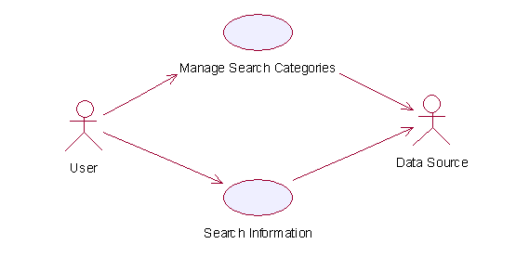
Figure 23: Model Of the Search Functional Element []

Usage Scenario

Manage Search Categories

Description
This use case allows the users to manage the different search categories.

Flow of Events

Basic Flow
This use case starts when the user wishes to manage the different data sources for search to be performed on it.
1: The users initiates a request to configure data source(s) and type(s) by providing the data source information and type to be added, removed or retrieved.
2: The Functional Element checks whether the data source configuration file exists.
3: The Functional Element checks the request. Based on the type of request, one of the sub-flows is executed.
If the request is to ‘Create Data Source And Type’, then sub-flow 3.1 is executed.
If the request is to ‘View Data Sources And Types’, then sub-flow 3.2 is executed.
If the request is to ‘Delete Data Source And Type’, then sub-flow 3.3 is executed.
3.1: Create Data Source and Type.
3.1.1: The Functional Element checks whether the same data source and type has been created.
3.1.2: The Functional Element appends the new data source and type in the data source configuration file specified.
3.2: View Data Source and Type.
3.2.1: The Functional Element retrieves all the data source and type information from the data source configuration file.
3.2.2: The Functional Element returns the data source(s) and type(s).
3.3: Delete Data Source and Type.
3.3.1: The Functional Element checks whether the data source and type exist in the data source configuration based on data source id from the data source configuration file.
3.3.2: The Functional Element removes the old data source and type from the data source configuration file.
4: The Functional Element returns a success or failure flag indicating the status of the operation being performed and use case ends.

Alternative Flows
1: Data Source Configuration File Not Found.
1.1: If in basic flow 2, the data source configuration file does not exist, the Functional Element creates an empty data source configuration file.
2: Duplicate Data Source and Type.
2.1: If in basic flow 3.1.1, the same data source and type have been configured, the Functional Element returns an error message and the use case end.
3: Data Source and Type Do Not Exist.
3.1: If in basic flow 3.2.1 and 3.3.1, a particular data source and type cannot be found in the specified data source configuration file, the Functional Element returns an error message and the use case end.

Special Requirements
None.

Pre-Conditions
None.

Post-Conditions
None.

Search Information

Description
This use case allows any users to perform search on various disparate data sources and types configured to be searched and returns the matching results.

Flow of Events

Basic Flow
This use case starts when the user wishes to perform information search on a data source.
1: Users initiates a request to perform information search on a given data source by providing information to be searched, location of the data source(s) and the data source type(s).
2: The Functional Element checks for the existence of the specified data source(s).
3: The Functional Element validates the data source type(s) against the set of supported data type(s) configured within the Functional Element that are available for information search.
4: The Functional Element performs information search based on the search parameters given by the users or the other Functional Elements.
5: The Functional Element returns the result of the information search performed to the users or other Functional Elements and use case ends.

Alternative Flows
1: Data Source(s) Are Not Available.
1.1: In basic flow 2, if the identified data source is not available, the Functional Element returns an error message and the use case ends.
2: Invalid Configuration Instructions
2.1: In basic flow 2, if the input inform by the user is incomplete, the Functional Element returns an error message and the use case ends.
3: Invalid Data Source Type.
3.1: In basic flow 3, if the data source type is invalid, the Functional Element returns an error message and the use case ends.
4: No Matching Result.
4.1: In basic flow 4, if the search results in no matching results, the Functional Element returns an error message and the use case ends..

Special Requirements
None

Pre-Conditions
None.

Post-Conditions
None.

Secure SOAP Management Functional Element

Motivation
In a Web Services implementation, it is envisage that confidential information is being exchanged all the time. Against this backdrop, it is imperative that an application in such an environment is equipped with the capability to guard sensitive information from prying eyes. Secure SOAP Management fulfills this need by covering the following areas.
- The facility of digitally signing SOAP message,
- The facility of encrypting SOAP message, and
- The capability to generate the original SOAP message after signing or encrypting the message.

This Functional Element fulfills the following requirements from the Functional Elements Requirements Document 02 [Error: Reference source not found]:
- Primary Requirements
- SECURITY-003 (SECURITY-003-3 only),
- SECURITY-020 (all), and
- SECURITY-022, and
- SECURITY-026.
- Secondary Requirements
- None

Terms Used
Terms | Description
Digital Signature | An electronic signature that can be used to authenticate the identity of the sender of a message, or of the signer of a document. It can also be used to ensure that the original content of the message or document that has been conveyed is unchanged
Encryption | A method of scrambling or encoding data to prevent unauthorized users from reading or tampering with the data. Only individuals with access to a password or key can decrypt and use the data.
PKCS#11 | The cryptographic token interface standards. Defines a technology independent programming interface for cryptographic devices such as smart cards.
Public Key Cryptography Specification (  PKCS) #12 | The personal information exchange syntax standard. Defines a potable format for storage and transportation of user private keys, certificates etc.

Key Features
Implementations of the Secure SOAP Functional Element are expected to provide the following key features:
- The Functional Element MUST provide the capability to digitally sign SOAP messages completely or partially using XML-Signature Syntax and Processing, W3C Recommendation 12 February 2002.
- The Functional Element MUST provide the capability to validate a signed SOAP message.
- The Functional Element MUST provide the capability to encrypt SOAP messages completely or partially using XML-Encryption Syntax and Processing, W3C Recommendation 10 December 2002.
- The Functional Element MUST provide the capability to decrypt encrypted SOAP messages.
- The Functional Element MUST support PKCS12 compatible digital certificates.
- The Functional Element MUST be able to verify the validity and authenticity of digital certificates used.

In addition, the following key features could be provided to enhance the Functional Element further:
- The Functional Element MAY also support PKCS11 compatible tokens.
- The Functional Element MAY also provide log support as part of the audit trails for its transaction records.

Interdependencies
Direct Dependency
Log Utility Functional Element | The Log Utility Functional Element is being used for logging and creation of audit trails.

Related Technologies and Standards
Standards / Specifications | Specific References
Public Key Infrastructure (PKI) | PKI is a system of digital certificates, Certificate Authorities, and other registration authorities that verify and authenticate the validity of each party involved in an Internet transaction  In this Functional Element, the private key and public key are generated for the Functional Element to sign and encrypt SOAP messages. The Functional Element uses the session key to encrypt the SOAP message. The digital certificate is attached to the SOAP message after the Functional Element has signed the SOAP message.
XML-Signature Syntax and Processing, W3C Recommendation 12th Feb 2002 [] | This specification addresses authentication, non-repudiation and data-integrity issues. In addition, it also specifies the XML syntax and processing rules for creating and representing digital signatures.  In this Functional Element, both the digital signature on the SOAP message and validation of the signed SOAP message is done based on this specification.
XML-Encryption Syntax and Processing, W3C Recommendation 10th Dec 2002  [] | This specification addresses data privacy by defining a process for encrypting data and representing the result in XML document.  In this Functional Element, the encryption and decryption of SOAP messages are done based on this specification.

Model
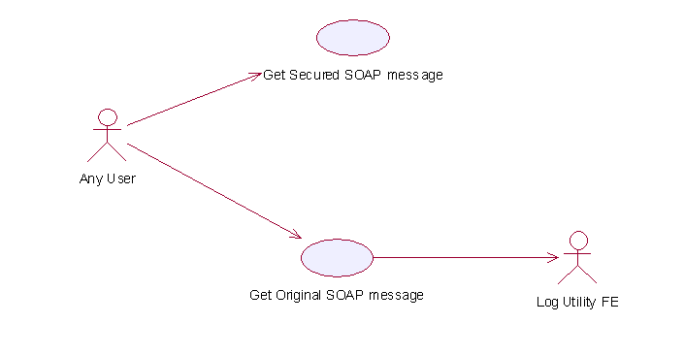
Figure 24: Model Of the Secure SOAP Management Functional Element []

Usage Scenarios

Get Secured SOAP message

Description
This Functional Element describes the process to generate secured SOAP message.

Flow of Events

Basic Flow
This use case starts when the user wants to secure the SOAP message.
If user wants to ‘Sign SOAP message’, then basic flow 1 is executed.
If user wants to ‘Encrypt and Sign the SOAP message’, then basic flow 2 is executed.
1: Sign SOAP Message.
1.1: User sends the SOAP message, digital certificate and specifies the element name that needs to be signed.
1.2: Functional Element gets the key information from the digital certificate.
Note: The private key will be used to sign the SOAP message and the public key will be added to the SOAP message after the signing.
1.3: Functional Element signs the element.
Note: The digital signature format is expected to be based on XML-Digital Signature Syntax mentioned in section 3.10.5.
1.4: Functional Element parses the secure SOAP message and regenerates the SOAP message.
1.5: Functional Element returns the secured SOAP message to user and the use case ends.
2: Encrypt And Sign SOAP Message.
2.1: User sends the SOAP message, digital certificate and specify the element name that needs to be encrypted.
2.2: User sends the receiver’s public key information to Functional Element.
Note: Receiver’s public key will be used to encrypt the session key, which was then used to encrypt the content of the element in the SOAP message.
2.3: Functional Element gets key information from the user’s digital certificate.
Note: Private Key is used to sign the SOAP message and public key is used to add into the SOAP message after the signing.
2.4: Functional Element generates the session key.
Note: Session key is used to encrypt the content of the element.
2.5: Functional Element encrypts the content of element with the session key.
2.6: Functional Element encrypts session key with the receiver’s public key.
2.7: Functional Element signs the SOAP message after encryption.
2.8: Functional Element regenerates the SOAP message.
Note: Functional Element adds the encrypted content of the element, encrypted session key information, the receiver’s public key information and the signature to the SOAP message.
2.9: Functional Element returns the SOAP message and the use case ends.

Alternative Flows
1: Cannot Get Key.
1.1: In basic flow 1.2 and 2.3, Functional Element cannot get the key information from the digital certificate. The Functional Element returns an error message and the use case ends.
2: Cannot Sign
2.1: In basic flow 1.3, Functional Element cannot sign the SOAP message. The Functional Element returns an error message and the use case ends.
3: Cannot Encrypt
3.1: In basic flow 2.5, Functional Element cannot encrypt the SOAP message. The Functional Element returns an error message and the use case ends.

Special Requirements
None.

Pre-Conditions
None.

Post-Conditions
None.

Get Original SOAP Message

Description
This use case allows users to get original SOAP message.

Flow of Events

Basic Flow
This use case starts when the user wants to get the original SOAP message.
If the user wants to ‘Verify the SOAP message’, then basic flow 1 is executed.
If the user wants to ‘Decrypt and Verify the SOAP message’, then basic flow 2 is executed.
1: Verify SOAP Message.
1.1: User sends the SOAP message and sender’s digital certificate.
1.2: Functional Element verifies the SOAP message.
Note: The sender’s certificate information will be used to verify the signature.
1.3: Functional Element gets the original SOAP message, returns to user and the use case ends.
2: Decrypt And Verify The SOAP Message.
2.1: User sends the SOAP message, user’s digital certificate and sender’s certificate.
2.2: Functional Element verifies the SOAP message.
Note: The sender’s certificate information will be used to verify the signature.
2.3: Functional Element gets the user’s key information from the user’s digital certificate.
Note: The user’s private key will be used to decrypt the session key.
2.4: Functional Element decrypts the session key.
2.5: Functional Element decrypts the content of the element with the session key.
2.6: Functional Element regenerates the SOAP message.
Note: Functional Element removes the session key information and the digital signature information from the SOAP message and gets the original one.
2.7: Functional Element returns the original SOAP message to user and the use case ends.

Alternative Flows
1: Verification Fails.
1.1: In basic flow 1.3 and 2.3, if verification fails, the Functional Element returns an error message and the use case ends.
2: Decryption of Content Fails.
2.1: In basic flow 2.5, the Functional Element cannot decrypt the content of the element. The Functional Element returns an error message and the use case ends.

Special Requirements
None

Pre-Conditions
None.

Post-Conditions
None.

Sensory Functional Element

Motivation
In a Web Service implementation where the presentation capabilities of clients differ, there is a need to determine the exact ability of the end devices so that the appropriate contents may be forwarded. The Sensory Functional Element can help to play this role by covering the following aspects within an application:
- Determining the presentation capabilities by inspecting incoming headers, and
- Determining the presentation capabilities by extracting MIME information from the relevant headers.

This Functional Element fulfills the following requirements from the Functional Elements Requirements Document 02 [Error: Reference source not found]:
- Primary Requirements
- DELIVERY-001,
- DELIVERY-005 to DELIVERY-006, and
- DELIVERY-009.
- Secondary Requirements
- MANAGEMENT-011, and
- MANAGEMENT-096.

Terms Used
Terms | Description
HTTP | Hyper Text Transport Protocol [HTTP] refers to the protocol for moving hypertext files across the Internet. Requires a HTTP client program on one end, and an HTTP server program on the other end. HTTP is the most important protocol used in the World Wide Web (WWW).
MIME | Multipurpose Internet Mail Extensions (MIME) refers to a standard that allows the embedding of arbitrary documents and other binary data of known types (images, sound, video, and so on) into e-mail handled by ordinary Internet electronic mail interchange protocols
Location Based Services (LBS) | Location-based services (LBS) refer to the services that provides users of mobile devices personalized services tailored to their current location.

Key Features
Implementations of the Sensory Functional Element are expected to provide the following key features:
- The Functional Element MUST intercept HTTP requests from client and determines existing supportability of the request’s MIME type.
- The Functional Element MUST provide the mechanism to manage MIME types, including the ability to add, delete and retrieve supported MIME types.

In addition, the following key features could be provided to enhance the Functional Element further:
- The Functional Element MAY provide a mechanism to enable Location Based Services (LBS).

Interdependencies
Interaction Dependency
Presentation Transformer Functional Element | The Presentation Transformer Functional Element may be used to generate the appropriate output for the targeted devices.

Related Technologies and Standards
None.

Model
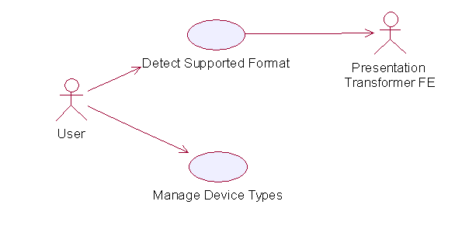
Figure 25: Model Of the Sensory Functional Element []

Usage Scenarios

Detect Supported Format

Description
This use case allows the service user (user/other service) to make request and based on that request it detects service user’s device capabilities.

Flow of Events

Basic Flow
This use case starts when the service user wishes to use any service provided by the service provider.
1: The Functional Element receives the request from the service user.
2: The Functional Element extracts MIME name and MIME type from the service user’s HTTP request (even from SOAP request).
3: The Functional Element uses MIME name and MIME TYPE to check with the pre-registered MIME type.
4: The Functional Element sends device capabilities to service user and ends the use case.

Alternative Flows
1: Unsupported Device.
1.1 If in the basic flow 2, the Functional Element is unable to detect the service user’ device capability, the Functional Element returns a error message and the use case ends.

Special Requirements
None

Supportability
The edge devices must be able to support the HTTP request.

Pre-Conditions
None.

Post-Conditions
None.

Manage Device Types

Description
This use case allows the service user to maintain the device (MIME Type information). This includes adding, changing and deleting device information from the Functional Element.

Flow of Events

Basic Flow
This use case starts when the service user wishes to add or delete either device or service information from the Functional Element.
1: The Functional Element requests that the service user specify the function to perform (either add, update or delete device or service).
2: Once the service user provides the requested information, one of the sub-flows is executed.
If the service user provides ‘Register Device Types’, then sub-flow 2.1 is executed.
If the service user provides ‘Delete Device Types’, then sub-flow 2.2 is executed.
2.1: Register Device Type.
2.1.1: The Functional Element requests that the service user provide the device information. This includes: MIME Name, MIME Description, Supported MIME type.
2.1.2: Once the service user provides the requested information, the Functional Element generates and assigns a unique MIME Id number to the device.
2.2: Delete Device Type.
2.2.1: The Functional Element requests that the service user provide the Device ID.
2.2.2: The Functional Element retrieves the existing device information based on the Device ID.
2.2.3: The service user provides the delete device information and the Functional Element deletes the device record from the Functional Element.
3: The use case ends when the service user provides the requested information or decided to end use case.

Alternative Flows
1: Invalid Device Information.
1.1: If in the sub-flow 2.1.2, the requested information provided by the user is invalid, the Functional Element returns an error message and the use case ends
2: Device Not Found.
2.1 If in the basic flows 2.2.2, the device information with the specified device is not found or does not exist, the Functional Element returns an error message and the use case ends.

Special Requirements

Supportability
Manage Device Types supports the most widespread MIME types used today.

Pre-Conditions
None.

Post-Conditions
If the use case was successful, the device information is added, updated or deleted from the Functional Element. Otherwise, the Functional Element’s state is unchanged.

Service Level Management Functional Element (new)

Motivation
The Service Level Management Functional Element enables the management of Service Level Agreements (SLAs), each of which represents a joint agreement between the service customer and provider based on a set of service offerings. The service offerings typically expressed as SLA templates, but still can be customized to cater to various services and customers. The Service Level Management Functional Element also manages the lifecycle of a SLA which could be broadly classified into: SLA creation; SLA deployment and provisioning; SLA enforcement and SLA termination.

This Functional Element fulfills the following requirements from the Functional Elements Requirements Document 02 [Error: Reference source not found]:
- Primary Requirement
  - MANAGEMENT-300.
- Secondary Requirements
- None

Terms Used
Terms | Description
SLA | Service Level Agreement is a joint agreement between service provider and service customer to define a set of service offerings.

Key Features
Implementations of the Service Level Management Functional Element are expected to provide the following key features:
- The Functional Element MUST provide the ability to create Service Offering and associated service levels.
- The Functional Element MUST provide the ability to manage defined Service Offerings, including the ability to retrieve, modify and delete.
- The Functional Element MUST provide the ability to create of a SLA via customer subscription based on defined Service Offerings.
- The Functional Element MUST provide the ability to generate billing & service level reports based on defined SLAs.
- The Functional Element MUST provide the ability to notify subscribers of SLA termination.
- The Functional Element MUST provide the ability to delete SLAs upon termination.

In addition, the following key features could be provided to enhance the Functional Element further:
- The Functional Element MAY provide the ability to customize SLAs. This includes the capability to:
  - Alter service offerings parameters.
  - Add and delete different service offerings into a SLA.

Interdependencies
Interaction Dependencies
QoS Management | The Service Level Management Functional Element may make use of the metrics and metering results to model SLAs.
Notification | The Service Level Management Functional Element may make use of the Notification Functional Element to notify subscribers of certain SLAs the happening on the SLAs.

Related Technologies and Standards
Standards / Specifications | Specific References
Web Service Level Agreement Project | – Under IBM Emerging Technology Toolkit. Latest update was in 2003. No news on its standardization.

Model

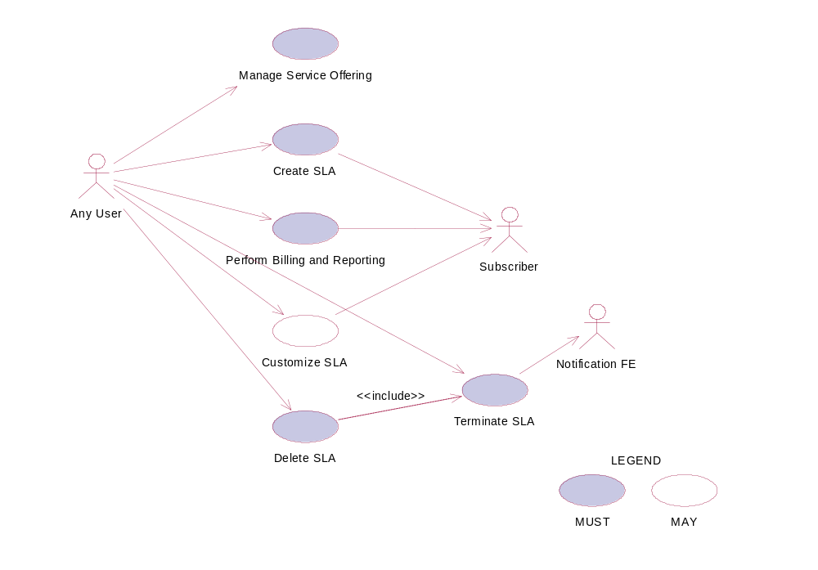
Figure 26: Model of the Service Level Management Functional Element.

Usage Scenarios

Manage Service Offering

Description
This use case allows any user to manage service offering, which enables any user to create, retrieve, update and delete a service offering.

Flow of Events

Basic Flow
This use case starts when any user wants to manage service offerings.
1: The user sends Manage Service Offering request to the system together with the specified operation.
2: On receipt of the request from the user, the functional element will execute one of the sub-flows. If the service user provides “Create Service Offering”, the Create Service Offering sub-flow (2.1) is executed. If the service user provides “Update Service Offering”, the Update Service Offering sub-flow (2.2) is activated. If the service user provides “Retrieve Service Offering”, the Retrieve Service Offering sub-flow (2.3) is activated. If the service user provides “Delete Service Offering”, the Delete Service Offering sub-flow (2.4) is executed.

2.1: Create Service Offering.
2.1.1: The service user specifies details of a service offering.
2.1.2: The system checks the existing service offering.
2.1.3: The system generates service offering information and adds to the system and the use case ends.
2.2: Update Service Offering.
2.2.1: The service user specifies the service offering to update.
2.2.2: The system retrieves the existing service offering information.
2.2.3: The service user provides the update service offering information.
2.2.4: The system updates the service offering with the updated information and ends use case.
2.3: Retrieve Service Offering.
2.3.1: The service user specifies the service offering to retrieve.
2.3.2: The system retrieves the existing service offering information and ends the use case.
2.4: Delete Service Offering.
2.4.1: The service user specifies the service offering to delete.
2.4.2: The system retrieves the existing service offering information.
2.4.3: The system deletes the service offering from the system and the use case ends.

Alternative Flows
1: Invalid Service Offering.
1.1: If in the Basic Flow 2.1.1, system detects any invalid description, system returns general error message and ends the use case.

2: Service Offering Already Exists.
2.1: If in the Basic Flow 2.1.2, the system checks the existing service offering and finds the service offering already exists. The system returns an error and ends the use case.

3: Service Offering Not Exist.
3.1: If in the Basic Flow 2.2.2, 2.3.2, 2.4.2, the system checks the existing service offering and finds the service offering doesn’t exist. The system returns an error and ends the use case.

Special Requirements

Pre-Conditions
None.

Post-Conditions
None.

Create SLA

Description
This use case allows any user to create Service Level Agreement.

Flow of Events

Basic Flow
This use case starts when any user wants to create SLA.
1: The user sends a request to create SLA to the Functional Element which includes the arrangement of the defined service offerings.
2: The Functional Element will dispatch the SLA information to the subscribers.
3: The subscribers accept the SLA arrangement and the use case ends.

Alternative Flows
1: Service Offering Not Available.
1.1: If in the Basic Flow 1, Functional Element detects the service offering provided by the user is not available, the Functional Element returns general error message and ends the use case.
2: Subscriber Not Available.
2.1: If in the Basic Flow 2, the Functional Element checks that the subscriber is not available, the Functional Element returns an error and ends the use case.
3: Subscriber Don’t Agree.
3.1: If in the Basic Flow 3, the subscriber does not agree with the arrangement defined in SLA, the Functional Element returns an error and ends the use case.

Special Requirements
None.

Pre-Conditions
None.

Post-Conditions
If the use case is successful, a SLA is added into the Functional Element.

Perform Billing and Reporting
This use case allows any user to do billing and reporting of the information related to SLA.

Flow of Events

Basic Flow
This use case starts when any user wants to do SLA related billing and report.
1: The user sends a request to conduct billing and reporting by providing information, which enables to identify the SLA and its service offering and associated subscribers.
2: On receipt of request of performing billing and reporting from the user, the Functional Element retrieves the billing and report information according to the definition of SLA and internally recorded information.
3: The Functional Element passes the generated information to the subscribers.
4: The Functional Element passes the response to the user and the use case ends.

Alternative Flows
1: Information Not Enough.
1.1: If in the Basic Flow 1, Functional Element detects the information provided by the user is not enough to form identify the SLA and its associated service offerings and subscribers, Functional Element returns general error message and ends the use case.
2: No Data Available.
2.1: If in the Basic Flow 2, the Functional Element retrieves the recorded information and finds it is unavailable or incomplete, the Functional Element returns an error and ends the use case.
3: Subscriber Not Available.
3.1: If in the Basic Flow 3, the subscriber is not available, the Functional Element returns an error and ends the use case.

Special Requirements
None.

Pre-Conditions
None.

Post-Conditions
None.

Customize SLA

Description
This use case allows users to customize a SLA.

Basic Flow
This use case starts when any user wants to customize a SLA.
1: The user sends request to customize a SLA by providing the information what will be customized in a SLA. There are two ways to customize a SLA, to modify the parameters of service offerings in a SLA and to add or delete service offerings in a SLA.
2: On receipt of a customizing SLA request from the user, the Functional Element checks the validity of the customized SLA.
3: The Functional Element passes the customized SLA to the subscribers.
4: The subscribers accept the customized SLA.
5: The Functional Element passes the response from the service to the user and the use case ends.

Alternative Flows
1: SLA Not Available.
1.1: If in the Basic Flow 1, the SLA that the user wants to customize does not exist, Functional Element returns general error message and ends the use case.
2: Information Not Valid.
2.1: If in the Basic Flow 2, Functional Element detects the information provided by the user is not valid to form a SLA, Functional Element returns general error message and ends the use case.
3: Subscriber Not Available.
3.1: If in the Basic Flow 3, the subscriber is not available, Functional Element returns general error message and ends the use case.
4: Subscriber Does Not Accept.
4.1: If in the Basic Flow 4, the subscriber does not accept the customized SLA, Functional Element returns general error message and ends the use case.

Special Requirements
None.

Pre-Conditions
None.

Post-Conditions
If the use case is successful, a customized SLA is added into the functional element.

Terminate SLA
This use case enables the user to terminate a SLA.

Flow of Events

Basic Flow
This use case starts when the user wants to terminate a SLA.
1: The user sends a request to terminate a SLA to the Functional Element by providing related information.
2: On receipt of a terminating SLA request from the user, the Functional Element terminates the operations related to the SLA.
3: The Functional Element notifies the subscribers about the termination of the SLA through Notification Functional Element.
4: The Functional Element passes the response from the service to the user and the use case ends.

Alternative Flows
1: SLA Not Exist.
1.1: If in the Basic Flow 2, Functional Element detects the SLA that the user wants to terminate does not exist, Functional Element returns general error message and ends the use case.
2: Notification FE Not Available.
2.1: If in Basic Flow 3, Functional Element detects the Notification Functional Element is not available, Functional Element returns general error message and ends the use case.

Special Requirements
None.

Pre-Conditions
None.

Post-Conditions
If the use case is successful, the Functional Element stops all the operations related to the SLA.

Delete SLA
This use case enables the user to remove a SLA from the Functional Element.

Flow of Events

Basic Flow
This use case starts when the user wants to delete a SLA from the Functional Element.
1: The user sends a request to delete a SLA providing related information.
2: On receipt of request of deleting SLA from the user, the Functional Element validates the provided information and invokes the use case Terminate SLA.
3: The Functional Element deletes the SLA.
4: The Functional Element passes the response from the service to the user and the use case ends.

Alternative Flows
1: SLA Does Not Exist.
1.1: If in the Basic Flow 2, Functional Element detects the SLA that the user wants to delete does not exist, Functional Element returns general error message and ends the use case.
2: Terminate SLA Error.
2.1: If in the Basic Flow 2, use case Terminate SLA returns error, Functional Element returns general error message and ends the use case.

Special Requirements
None.

Pre-Conditions
None.

Post-Conditions
If the use case is successful, a SLA is deleted from the Functional Element.

Service Level Enforcement Functional Element (new)

Motivation
The Service Level Enforcement Functional Element enables monitoring the compliance of SLA and enforcing SLA through load management.

This Functional Element fulfills the following requirements from the Functional Elements Requirements Document 02 [Error: Reference source not found]:
- Primary Requirements
  - MANAGEMENT-301 and
  - MANAGEMENT-302.
  - Secondary Requirements
  - None

Terms Used
Terms | Description
SLA | Service Level Agreement is a joint agreement between service provider and service customer to define a set of service offerings.

Key Features
Implementations of the Service Level Enforcement Functional Element are expected to provide the following key features:
- The Functional Element MUST provide the ability to monitor SLA compliance based on measured data.
- The Functional Element MUST provide the ability to detect any violation of SLA.
- The Functional Element MUST provide the ability to enforce a SLA via through load management.

In addition, the following key features could be provided to enhance the Functional Element further:
- The Functional Element MAY provide the ability to manage load. This include the capability to:
  - Control admission of service.
  - Prioritize requests.

Interdependencies
Interaction Dependencies
QoS Management | The Service Level Enforcement Functional Element may make use the metrics and metering results to monitor compliance of SLA.

Related Technologies and Standards
Standards / Specifications | Specific References
Web Service Level Agreement Project | – Under IBM Emerging Technology Toolkit. Latest update was in 2003. No news on its standardization.

Model

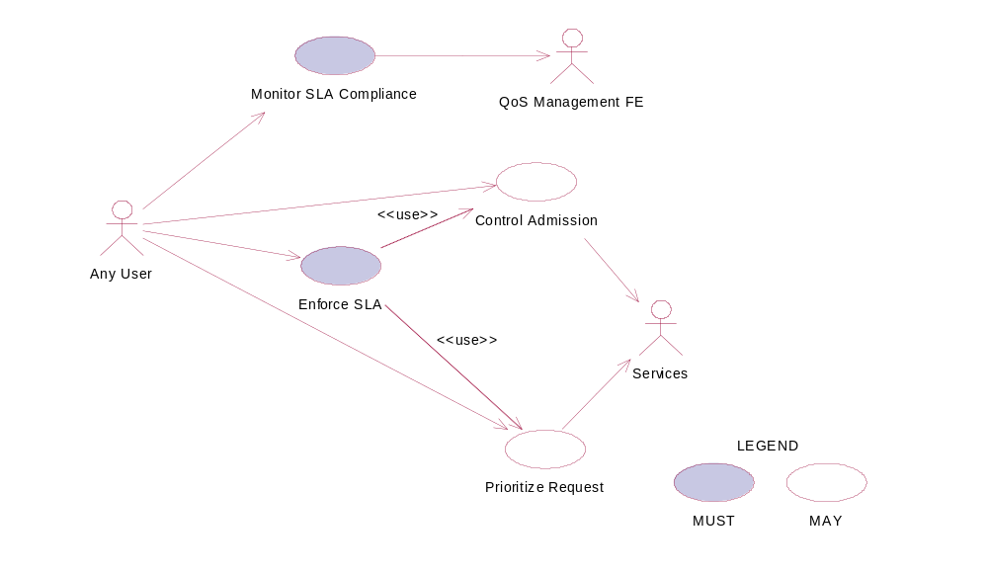
Figure 27: Model of the Service Level Enforcement Functional Element.

Usage Scenarios

Monitor SLA Compliance

Description
This use case allows any user to monitor and check the SLA is compliant or not at the run time.

Flow of Events

Basic Flow
This use case starts when any user wants to monitor the SLA compliance.
1: The user sends Monitor SLA Compliance request to the Functional Element together with the specified SLA information.
2: On receipt of the request from the user, the Functional Element will retrieve the SLA information.

3: The Functional Element extracts the measured data through QoS Management Functional Element.
4: The Functional Element checks the compliance of SLA.
5: The Functional Element returns response to the user and the use case ends.

Alternative Flows
1: SLA Not Exist.
1.1: If in the Basic Flow 2, the Functional Element detects that the SLA to monitor does not exists, system returns general error message and ends the use case.
2: Measured Data Not Available.
2.1: If in the Basic Flow 3, the Functional Element retrieves measured data through QoS Management Functional Element and the latter is not ready, the Functional Element returns an error and ends the use case.
3: SLA Not Compliant.
3.1: If in the Basic Flow 4, the Functional Element checks the measured data against SLA and the violation exists, the Functional Element returns an error and ends the use case.

Special Requirements

Pre-Conditions
None

Post-Conditions
None

Control Admission

Description
As a means of manage load to enforce SLA, the use case allows any user to control admission toward services.

Flow of Events

Basic Flow
This use case starts when any user wants to control admission toward services.
1: The user sends request to control admission to certain services to the Functional Element which includes the option of admission and the targeted services.
2: The Functional Element will manage the control of admission to the services at run time.
3: The Functional Element returns response to the user and the use case ends.

Alternative Flows
1: Service Not Available.
1.1: If in the Basic Flow 1, Functional Element detects the targeted service provided by the user is not available, Functional Element returns general error message and ends the use case.
2: Control Admission Failed.
2.1: If in the Basic Flow 2, the Functional Element fails to control admission to the services at run time, Functional Element returns an error and ends the use case.

Special Requirements
None.

Pre-Conditions
The services are manageable to the user.

Post-Conditions
If the use case is successful, the load of the monitored services is changed thus the SLA is enforced through load management.

Prioritize Request
As a means of load management to enable SLA enforcement, the use case allows any user to prioritize request to the targeted services according to the requirements of SLA.

Flow of Events

Basic Flow
This use case starts when any user wants to prioritize various requests to targeted services.
1: The user sends request to prioritize request to the Functional Element, which include information of the targeted services, the priority of the request and so on.
2: On receipt of the request from the user, the Functional Element controls the processing of the request according to the priority given at the run time.
3: The Functional Element passes the response to the user and the use case ends.

Alternative Flows
1: Services Not Exist.
1.1: If in the Basic Flow 1, Functional Element detects the targeted service provided by the user does not exist, Functional Element returns general error message and ends the use case.
2: Prioritize Request Fails.
2.1: If in the Basic Flow 2, the Functional Element fails to control the requests of the services according to the priority given the user, the Functional Element returns an error and ends the use case.

Special Requirements
None.

Pre-Conditions
The services are manageable to the user.

Post-Conditions
If the use case is successful, the load of the monitored services is changed thus the SLA is enforced through load management.

Enforce SLA

Description
This use case allows users to enforce a SLA in a run time environment.

Basic Flow
This use case starts when any user wants to enforce a SLA in the run time environment.
1: The user sends a request to enforce a SLA to the Functional Element by providing the SLA and its associated services and the option of the means of enforcement through load management.
2: On receipt of the request from the user, the Functional Element checks the SLA and decides the means of enforcement, i.e. by taking advantage of load management.
3: The Functional Element dispatches its request of load management and invokes use case Control Admission or use case Prioritize Request.
4: The Functional Element returns the response to the user and the use case ends.

Alternative Flows
1: SLA Not Available.
1.1: If in the Basic Flow 1, the SLA that the user wants to enforce does not exist, Functional Element returns general error message and ends the use case.
2: Services Not Exist.
2.1: If in the Basic Flow 1, Functional Element detects the services that the user wants to enforce SLA do not exist, Functional Element returns general error message and ends the use case.
3: Control Admission Not Working.
3.1: If in the Basic Flow 3, Functional Element fails to invoke use case control admission, Functional Element returns general error message and ends the use case.
4: Prioritize Request Not Working.
4.1: If in the Basic Flow 3, Functional Element fails to invoke use case Prioritize Request, Functional Element returns general error message and ends the use case.

Special Requirements
None.

Pre-Conditions
The services targeted are manageable.

Post-Conditions
None.

Service Management Functional Element

Motivation
The ability to monitor Web Services invocation is crucial towards the adoption of this technology from the security and performance standpoints. A security framework should incorporate an authentication and authorisation mechanism together with an audit trail. These twin considerations will serve to discourage resource misuse and in addition, will help to promote the “pay-as-you-use” concept. Service throughput on the server end is another important parameter that must be monitored. Administrators of services, which are sluggish, should be notified immediately via any electronic means.

This Functional Element fulfills the following requirements from the Functional Elements Requirements Document 02 [Error: Reference source not found]:
- Primary Requirements
- MANAGEMENT-090, and
- MANAGEMENT-093 to MANAGEMENT-096.
- Secondary Requirements
- None

Terms Used
Terms | Description
Management Domain | Management Domain refers to the set of servers that needs to be monitored. This domain is typically under the control of one agency and administered by a known administrator.
Performance Parameters | Performance Parameters refers to the set of attributes that should be track for the purpose of evaluating the performance of the Web Services.
Monitoring | Monitoring refers to the logging and tracking of the Web Service’s

Key Features
Implementations of the Service Management Functional Element are expected to provide the following key features:
- The Functional Element MUST provide the capability to configure the Management Domain.
Example: | All Servers that falls under a certain IP range (192.168.20.3 to 192.168.20.22)

- The Functional Element MUST provide the capability to discover services that are under the Management Domain.
- The Functional Element MUST provide the capability to configure Performance Parameters that are of interest for Monitoring purposes.
Example: | The following are some of the Performance Parameter that may be of interest:  The time at which a Web Service request came.  The time at which the corresponding response was sent.  The name of the Web Service that was invoked.
- The Functional Element MUST provide a means to log Performance Parameters.

In addition, the following key feature could be provided to enhance the Functional Element further:
- The Functional Element MAY provide the capability to configure additional attributes that is tagged along with a particular Web Service.
Example: | The access permission for invoking the service.
- The Functional Element MAY provide verification services to block unauthorized Web Service’s usage.
Example: | The header information that accompanies the request may be extracted for relevant client’s credential. This could then be compared to the access permission for the service.

Interdependencies
Direct Dependency
Log Utility Functional Element | The Log Utility Functional Element helps to log the Performance Parameter into the appropriate data sources

Interaction Dependencies
Role and Access Management Functional Element | In the event when authentication is required before invocation of a particular service is allowed, the Service Management Functional Element may extract authentication information from the header of the incoming request and use the Role and Access Management Functional Element to extract the relevant role information before deciding if a user has the privilege to access a particular Web Service.

Related Technologies and Standards
None

Model
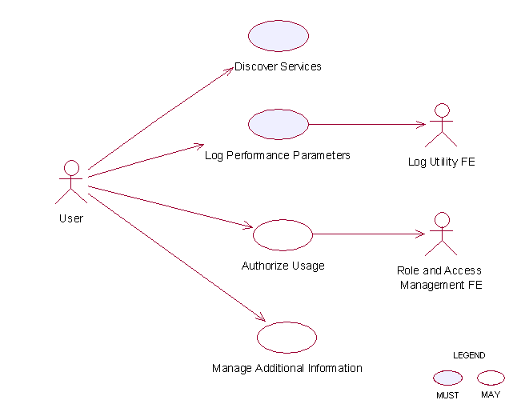
Figure 28: Model Of the Service Management Functional Element []

Usage Scenarios

Discover Services

Description
This use case describes the scenario surrounding the automatic discovery of services hosted in the Management Domain.

Flow of Events

Basic Flow
The use case begins when the user wants to retrieve a list of services URLs from the Management Domain.
1: The user sends a request to retrieve the list of services URLs from the Management Domain.
2: The Functional Element reads from a configuration file to so as to determine the exact boundaries of the Management Domain.
3: The Functional Element retrieves from each of the servers as stated in the configuration file a list of service URLs that it is hosting
4: The Functional Element returns the list of service URLs back to the user and the use case ends.

Alternative Flows
1: Configuration File Does Not Exist
1.1: In basic flow 2, the Functional Element fails to read boundaries from the configuration file. The Functional Element in turn returns an error message and the use case end.
2: Fail To Communicate With the Server
2.1: In basic flow 3, the Functional Element fails to communicate with the servers hosting the services. The Functional Element in turn returns an error message and the use case end.

Special Requirements
The protocol of communicating with a server hosting the services is not standardized. Each server may offer different mechanism for retrieving the list of services hosted and as such, the extensibility this approach is severely limited.

Pre-Conditions
None.

Post-Conditions
None

Log Performance Parameters

Description
This use case allows the user to log the performance parameters of all the Web Services that is being hosted by an application that contains the Service Management Functional Element.

Flow of Events

Basic Flow
The use case begins when the user wants to log the performance parameters of all the Web Services that is being hosted by an application that contains the Service Management Functional Element.
1: The user sends a request to log the performance parameters of all the Web Services hosted.
2: The Functional Element reads from a configuration file the performance parameter to be logged.
3: The Functional Element extracts the performance parameters for the incoming message and stores them into the data store
4: The Functional Element next extracts the performance parameters for the outgoing message and stores them into the data store
5: The Functional Element stores the necessary information into the data store.

Alternative Flows
1: No Performance Parameter Found.
1.1: In basic flow 2, the Functional Element discovers that the performance parameter to be logged is not configured. The Functional Element returns an error message and the use case ends.
2: Data Store Not Available.
2.1: In basic flow 5, the Functional Element detects that the data store is not available. The Functional Element returns an error message and the use case ends.

Special Requirements
None.

Pre-Conditions
None.

Post-Conditions
None.

Authorize Usage

Description
This use case describes the authentication process for invoking a Web Service that is being hosted by an application that contains the Service Management Functional Element.

Flow of Events

Basic Flow
The use case starts when a user accesses a service.
1: The user sends a request to invoke a particular Web Service.
2: The Functional Element extracts the following information from the incoming message
2.1: The username attribute that resides in the header of the incoming message
3: The Functional Element extracts the access privilege associated with the service from the data store
4: The Functional Element uses the Role and Access Management Functional Element to retrieve the role of the user.
5: The Functional Element looks up the data store to determine if the user is authorized to access the service
6: The Functional Element allows the request to be process and the use case ends.

Alternative Flow
1: Username header not found.
1.1: In basic flow 2, the username attribute is not found in the header.
1.2: The Functional Element denies access to the requested Web Service and returns an error message.
2: Web Service access privilege not set.
2.1: In basic flow 3, the Functional Element could not find the access privilege for the Web Service.
2.2: The Functional Element denies access to the requested Web Service and returns an error message.
3: Role and Access Management Functional Element not available
3.1: In basic flow 4, the Functional Element could not find the Role and Access Management Functional Element.
3.2: The Functional Element denies access to the requested Web Service and returns an error message.
4: User not authorize
41: In basic flow 5, the Functional Element looks up the data source and determines that the user does not have the required privilege to access the service.
4.2: The Functional Element denies access to the requested Web Service and returns an error message.

Special Requirements
None.

Pre-Conditions
None.

Post-Conditions
None.

Manage Additional Information

Description
This use case helps to maintain the following attributes of a Web Service that is useful in determining if a particular user has the privilege to invoke it.
Service Name. This is the name of the service to monitor
Access level. This refers to the access level of the Web Services hosted
Role Names. If a user’s role matches any of the roles contained here, then he/she has the privilege to access the Web Service.

Flow of Events

Basic Flow
This use case starts when user wants to manage services.
1: The user specifies the additional information that he wants to create/update/delete/retrieve.
2: Once the user provides the requested information, one of the sub-flows is executed.
If the user provides ‘Create Service Parameter’, then sub-flow 2.1 is executed.
If the user provides ‘Update Service Parameter’’, then sub-flow 2.2 is executed.
If the user provides ‘Delete Service Parameter’’, then sub-flow 2.3 is executed.
If the user provides ‘Retrieve Service Parameter’’, then sub-flow 2.4 is executed.
2.1: Create Service Parameter.
2.1.1: The user specifies the service to create with the appropriate additional information.
2.1.2: The Functional Element connects to the data store.
2.1.3: The Functional Element saves the new service in the data store and the use case ends.
2.2: Update Service Parameter.
2.2.1: The user specifies the service to update with the appropriate additional information.
2.2.2: The Functional Element connects to the data store.
2.2.3: The Functional Element updates the service in the data store and the use case ends.
2.3: Delete Service Parameter.
2.3.1: The user specifies the service to delete.
2.3.2: The Functional Element connects to the data store.
2.3.3: The Functional Element deletes the service in the data store and the use case ends.
2.4: Retrieve Service Parameter.
2.4.1: The user specifies the service to retrieve.
2.4.2: The Functional Element connects to the data store.
2.4.3: The Functional Element retrieves the service from the data store and the use case ends.

Alternative Flows
1: Data Store Not Available.
1.1: If in basic flow 2.1.2, 2.2.2, 2.3.2 and 2.4.2, the data store is not available, an error message is returned and the use case ends.

Special Requirements
None.

Pre-Conditions
None.

Post-Conditions
None.

Service Registry Functional Element

Motivation
In a Web Service-enabled implementation, there exist the needs to maintain a central repository of all the services that are available. This facilitates service lookups as well as management of Web Services within the application that contains the Functional Element. In order to achieve these expectations, the Functional Element will cover the following aspects.
- Simplify management of information in a XML registry server like UDDI and ebXML, and
- Simplify information publish and query from a XML registry server like UDDI and ebXML.

This Functional Element fulfills the following requirements from the Functional Elements Requirements Document 02 [Error: Reference source not found]:
- Primary Requirements
- PROCESS-031 to PROCESS-032,
- PROCESS-035, and
- MANAGEMENT-097 to MANAGEMENT-100
- Secondary Requirements
- PROCESS-014.

Terms Used
Terms | Description
Classification / Taxonomy | Classification / Taxonomy refers to a taxonomy that may be used to classify or categorize any registry object instances like Organizations, Web Services, Service Bindings, etc.
Concept / tModel | Concept / tModel are used to represent taxonomy elements and their structural relationship with each other in order to describe an internal taxonomy.
Organization | Organization provides information on organizations such as a Submitting Organization. Each Organization may have a reference to a parent Organization. In addition it may have a contact attribute defining the primary contact within the organization. An Organization also has an address attribute.
Registry Server | Registry Server refers to a registry that offers a mechanism for users or software applications to advertise and discover Web Services. An XML registry is an infrastructure that enables the building, deployment, and discovery of Web Services.
Service Binding | Service Binding represent technical information on a specific way to access a specific interface offered by a service.
UUID | Universally Unique Identifier

Key Features
Implementations of the Service Registry Functional Element are expected to provide the following key features:
- The Functional Element MUST provide the capability to facilitate the management of the following information in a UDDI or an ebXML compliant registry server.
  - Organisation
  - Classification / Taxonomy
  - Web Service
  - tModel
  - Service Binding
The management of this information includes registering, updating, deleting and searching.
- As part of Key Feature (1), the Functional Element MUST provide the ability to perform the operations specified across multiple registry servers.
- The Functional Element MUST provide a mechanism to enable single step publishing of services into registry servers

Interdependencies
None

Related Technologies and Standards
Specifications | Description
UDDI Data Structure and API Specification v2.0 | UDDI Data Structure Specification v2.0 describes in detail the data structure models of organizations, web services, service categories, service bindings, and tModels. []  UDDI API Specification v2.0 describes in detail the publishing, deleting, and querying API(s) to manipulate the information stored in XML registry server like UDDI. []
ebXML Registry Information Model (RIM) Specification v2.0 [] | ebXML Registry Information Model Specification v2.0 describes in detail the data structure models of organizations, web services, service categories, service bindings, and tModels.
ebXML Registry Services (RS) Specification v2.0 [] | ebXML Registry Services Specification v2.0 describes in detail the publishing, deleting, and querying API(s) to manipulate the information stored in XML registry server like UDDI.

Model
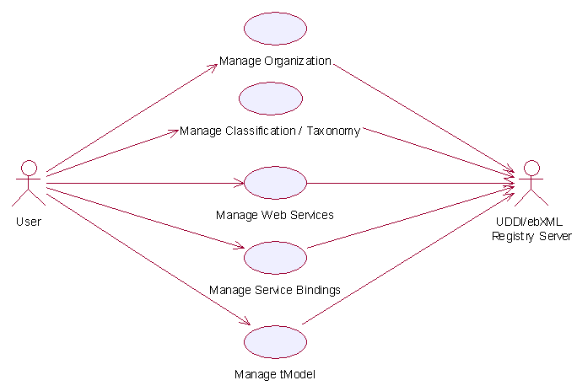
Figure 29: Model Of the Service Registry Functional Element []

Usage Scenario

Manage Classification / Taxonomy

Description
This use case allows any users to create, remove and view classification/taxonomy in the registry.

Flow of Events

Basic Flow
This use case starts when the users of registry server wishes to create, remove or view the classification/taxonomy in the registry server.

1: User initiates a request type to the Functional Element stating whether to create, remove or view classification/taxonomy.
2: The Functional Element checks whether the registry server exists.
3: The Functional Element checks the request. Based on the type of request, one of the sub-flows is executed.
If the request is to ‘Create Classification/Taxonomy’, then sub-flow 3.1 is executed.
If the request is to ‘View Classification/Taxonomy’, then sub-flow 3.2 is executed.
If the request is to ‘Remove Classification/Taxonomy’, then sub-flow 3.3 is executed.
3.1: Create Classification/Taxonomy.
3.1.1: Other Functional Element provides username, password and registry server URL to the Functional Element for authentication.
3.1.2: The Functional Element checks for the user validity in the identified registry server.
3.1.3: Other Functional Element provides classification/taxonomy information to be created in the registry server.
3.1.4: The Functional Element checks for the duplicate classification/taxonomy name.
3.1.5: The Functional Element creates the classification/taxonomy information in the private (default) or the public UDDI registry server according to the URL provided by other Functional Element, if it does not exist.
3.2: View Classification/Taxonomy.
3.2.1: The Functional Element retrieves all the classification/taxonomy from the identified registry server, which may be private (default) or public.
3.2.2: The Functional Element returns the classification/taxonomy information from the identified registry server to other Functional Element.
3.3: Remove Classification/Taxonomy.
3.3.1: Other Functional Element provides username, password and registry server URL to the Functional Element for authentication.
3.3.2: The Functional Element checks for the user validity in the identified registry server.
3.3.3: Other Functional Element provides classification/taxonomy key (i.e. UUID) to be removed from the identified registry server.
3.3.4: The Functional Element removes the classification/taxonomy information from the private (default) or the public UDDI registry server according to the URL provided by the user.
4: The Functional Element returns the status of the operation and the use case ends.

Alternative Flows
1: Registry Server Down.
1.1: In the basic flow 2, if the identified registry server is down, the Functional Element returns an error message and the use case ends.
2: Invalid Username And Password.
2.1: In the basic flow 3.1.2 and 3.3.2, if the username or password is invalid, the Functional Element returns an error message and the use case ends.
3: Classification/Taxonomy Key Not Found.
3.1: In the basic flow 3.3.3, if the classification/taxonomy key cannot be found in the specified registry server, the Functional Element returns an error message and the use case ends.
4: Duplicate Classification/Taxonomy.
4.1: In the basic flow 3.1.4, If the same classification/taxonomy name has been defined in the registry server, the Functional Element returns an error message and the use case ends.

Special Requirements
None

Pre-Conditions
In order to manage the classification/taxonomy in the registry server, users must be registered with the registry server. Username and password will be given when a user registers with a registry server.

Post-Conditions
None.

Manage Web Services

Description
This use case allows any users to register, remove and view Web Services in the private (default) as well as the public UDDI Registry Server.

Flow of Events

Basic Flow
This use case starts when the users of registry server wishes to create, remove and view Web Services.
1: User initiates a request type to the Functional Element stating whether to create, remove or view Web Services in the identified private or public registry server.
2: The Functional Element checks whether the registry server exists.
3: The Functional Element checks the request. Based on the type of request, one of the sub-flows is executed.
If the request is to ‘Create Web Service’, then sub-flow 3.1 is executed.
If the request is to ‘View Web Services’, then sub-flow 3.2 is executed.
If the request is to ‘Remove Web Service’, then sub-flow 3.3 is executed.
3.1: Create Web Service.
3.1.1: User provides username, password and registry server URL to the Functional Element for authentication.
3.1.2: The Functional Element checks for the user validity in the identified registry server.
3.1.3: Other Functional Element provides Web Service information to be created in the registry server.
3.1.4: The Functional Element creates the Web Service information in the private (default) or the public UDDI registry server according to the URL provided by other Functional Element.
3.2: View Web Services.
3.2.1: The Functional Element retrieves all the Web Services from the identified registry server for specific stated conditions like service name search, business name search, etc.
3.2.2: The Functional Element displays the Web Services information search results from the identified registry server to other Functional Element.
3.3: Remove Web Service
3.3.1 User provides username, password and registry server URL to the Functional Element for authentication.
3.3.2: The Functional Element checks for the user validity in the identified registry server.
3.3.3: Other Functional Element provides Web Service key (i.e. UUID) to be removed from the identified registry server.
3.3.4: The Functional Element removes the Web Service information from the private (default) or the public UDDI registry server according to the URL provided by other Functional Element.
4: The Functional Element returns the results of the operation and the use case ends.

Alternative Flows
1: Registry Server Down.
1.1: In the basic flow 2, if the identified registry server is down, the Functional Element returns an error message and the use case ends.
2: Invalid Username And Password.
2.1: In the basic flow 3.1.2 and 3.3.2, if the username or password is invalid, the Functional Element returns an error message and the use case ends.
3: Web Service Key Not Found.
3.1: In the basic flow 3.3.3, if the Web Service key cannot be found in the specified registry server, the Functional Element returns an error message and the use case ends.

Special Requirements

Pre-Conditions
In order to manage Web Services in the registry server, the users must be registered with the registry server. Username and password will be given when a user registers with a registry server.

Post-Conditions
None.

Manage Organization

Description
This use case allows any users to create, remove and view organization in the registry.

Flow of Events

Basic Flow
This use case starts when the users of registry server wishes to create, remove or view Organization.
1: User initiates a request type to the Functional Element stating whether to create, remove or view Organization.
2: The Functional Element checks whether the registry server exists.
3: The Functional Element checks the request. Based on the type of request, one of the sub-flows is executed.
If the request is to ‘Create Organization’, then sub-flow 3.1 is executed.
If the request is to ‘View Organizations’, then sub-flow 3.2 is executed.
If the request is to ‘Remove Organization’, then sub-flow 3.3 is executed.
3.1: Create Organization.
3.1.1: Other Functional Element provides username, password and registry server URL to the Functional Element for authentication.
3.1.2: The Functional Element checks for the user validity in the identified registry server.
3.1.3: Other Functional Element provides organization information to be created in the registry server.
3.1.4: The Functional Element checks for the duplicate organization name.
3.1.5: The Functional Element creates the organization information in the private (default) or the public UDDI registry server according to the URL provided by other Functional Element, if it does not exist.
3.2: View Organizations.
3.2.1: The Functional Element retrieves all the organizations from the identified registry server for specific stated conditions like organization name, key, etc.
3.2.2: The Functional Element returns the organization information from the identified registry server to other Functional Element.
3.3: Remove Organization.
3.3.1: Other Functional Element provides username, password and registry server URL to the Functional Element for authentication.
3.3.2: The Functional Element checks for the user validity in the identified registry server.
3.3.3: Other Functional Element provides Organization key (i.e. UUID) to be removed from the identified registry server.
3.3.4: The Functional Element removes the Organization information from the private (default) or the public UDDI registry server according to the URL provided by the user.
4: The Functional Element returns the status of the operation and the use case ends.

Alternative Flows
1: Registry Server Down.
1.1: In the basic flow 2, if the identified registry server is down, the Functional Element returns an error message and the use case ends.
2: Invalid Username And Password.
2.1: In the basic flow 3.1.2 and 3.3.2, if the username or password is invalid, the Functional Element returns an error message and the use case ends.
3: Organization Key Not Found.
3.1: In the basic flow 3.3.3, if the Organization key cannot be found in the specified registry server, the Functional Element returns an error message and the use case ends.
4: Duplicate Organization.
4.1: In the basic flow 3.1.4, if the same Organization name has been defined in the registry server the Functional Element returns an error message and the use case ends.

Special Requirements
None

Pre-Conditions
In order to manage Organization in the registry server, users must be registered with the registry server. Username and password will be given when a user registers with a registry server.

Post-Conditions
None.

Manage Service Binding

Description
This use case allows any users to register, remove and view Service Binding in the private (default) as well as the public UDDI Registry Server.

Flow of Events

Basic Flow
This use case starts when the users of registry server wishes to create, remove and view Service Binding.
1: User initiates a request type to the Functional Element stating whether to create, remove or view Service Binding in the identified private or public registry server.
2: The Functional Element checks whether the registry server exists.
3: The Functional Element checks the request. Based on the type of request, one of the sub-flows is executed.
If the request is to ‘Create Service Binding’, then sub-flow 3.1 is executed.
If the request is to ‘View Service Bindings’, then sub-flow 3.2 is executed.
If the request is to ‘Remove Service Binding’, then sub-flow 3.3 is executed.
3.1: Create Service Binding.
3.1.1: User provides username, password and registry server URL to the Functional Element for authentication.
3.1.2: The Functional Element checks for the user validity in the identified registry server.
3.1.3: Other Functional Element provides Service Binding information to be created in the registry server.
3.1.4: The Functional Element creates the Service Binding information in the private (default) or the public UDDI registry server according to the URL provided by other Functional Element.
3.2: View Service Bindings.
3.2.1: The Functional Element retrieves all the Service Bindings from the identified registry server for specific stated conditions like service binding key search, etc.
3.2.2: The Functional Element displays the Service Bindings information search results from the identified registry server to other Functional Element.
3.3: Remove Service Binding
3.3.1 User provides username, password and registry server URL to the Functional Element for authentication.
3.3.2: The Functional Element checks for the user validity in the identified registry server.
3.3.3: Other Functional Element provides Service Binding key (i.e. UUID) to be removed from the identified registry server.
3.3.4: The Functional Element removes the Service Binding information from the private (default) or the public UDDI registry server according to the URL provided by other Functional Element.
4: The Functional Element returns the results of the operation and the use case ends.

Alternative Flows
1: Registry Server Down.
1.1: In the basic flow 2, if the identified registry server is down, the Functional Element returns an error message and the use case ends.
2: Invalid Username And Password.
2.1: In the basic flow 3.1.2 and 3.3.2, if the username or password is invalid, the Functional Element returns an error message and the use case ends.
3: Service Binding Key Not Found.
3.1: In the basic flow 3.3.3, if the Service Binding key cannot be found in the specified registry server, the Functional Element returns an error message and the use case ends.

Special Requirements

Pre-Conditions
In order to manage Service Binding in the registry server, the users must be registered with the registry server. Username and password will be given when a user registers with a registry server.

Post-Conditions
None.

Manage tModel

Description
This use case allows any users to register, remove and view tModel in the private (default) as well as the public UDDI Registry Server.

Flow of Events

Basic Flow
This use case starts when the users of registry server wishes to create, remove and view tModel.
1: User initiates a request type to the Functional Element stating whether to create, remove or view tModel in the identified private or public registry server.
2: The Functional Element checks whether the registry server exists.
3: The Functional Element checks the request. Based on the type of request, one of the sub-flows is executed.
If the request is to ‘Create tModel’, then sub-flow 3.1 is executed.
If the request is to ‘View tModels’, then sub-flow 3.2 is executed.
If the request is to ‘Remove tModel’, then sub-flow 3.3 is executed.
3.1: Create tModel.
3.1.1: User provides username, password and registry server URL to the Functional Element for authentication.
3.1.2: The Functional Element checks for the user validity in the identified registry server.
3.1.3: Other Functional Element provides tModel information to be created in the registry server.
3.1.4: The Functional Element creates the tModel information in the private (default) or the public UDDI registry server according to the URL provided by other Functional Element.
3.2: View tModels.
3.2.1: The Functional Element retrieves all the tModels from the identified registry server for specific stated conditions like tModel name search, tModel key search, etc.
3.2.2: The Functional Element displays the tModel information search results from the identified registry server to other Functional Element.
3.3: Remove tModel.
3.3.1 User provides username, password and registry server URL to the Functional Element for authentication.
3.3.2: The Functional Element checks for the user validity in the identified registry server.
3.3.3: Other Functional Element provides tModel key (i.e. UUID) to be removed from the identified registry server.
3.3.4: The Functional Element removes the tModel information from the private (default) or the public UDDI registry server according to the URL provided by other Functional Element.
4: The Functional Element returns the results of the operation and the use case ends.

Alternative Flows
1: Registry Server Down.
1.1: In the basic flow 2, if the identified registry server is down, the Functional Element returns an error message and the use case ends.
2: Invalid Username And Password.
2.1: In the basic flow 3.1.2 and 3.3.2, if the username or password is invalid, the Functional Element returns an error message and the use case ends.
3: tModel Key Not Found.
3.1: In the basic flow 3.3.3, if the tModel key cannot be found in the specified registry server, the Functional Element returns an error message and the use case ends.

Special Requirements

Pre-Conditions
In order to manage tModel in the registry server, the users must be registered with the registry server. Username and password will be given when a user registers with a registry server.

Post-Conditions
None.

Service Router Functional Element (new)

Motivation

Enable capability for easy and simple mechanisms for invoking web services by:

- Providing a façade to service requesters for services location transparency, services reliability.
- Performing pre- and post- processing before and after web services invocation.

This Functional Element fulfills the following requirements from the Functional Elements Requirements Document 02 [Error: Reference source not found]:
- Primary Requirements
- PROCESS-250 to PROCESS-260.
- Secondary Requirements
- None

Terms Used
Terms | Description
Façade | Façade is exterior face or interface of a system, which hides the implementation details of the system.
Functional handler | Functional handler is a software component that performs certain business processing on the parameters passed.

Figure 30 depicts the basic concepts of how the participating entities collaborate together in the Service Router Functional Element. All the invocations from service client come to the Service router which servers as façade. The Service Router routes the invocation the actual web services. Functional handlers could be incorporated in the Functional Element or other Functional Elements. The functional handlers can be invoked before or after the actual web services are invoked.

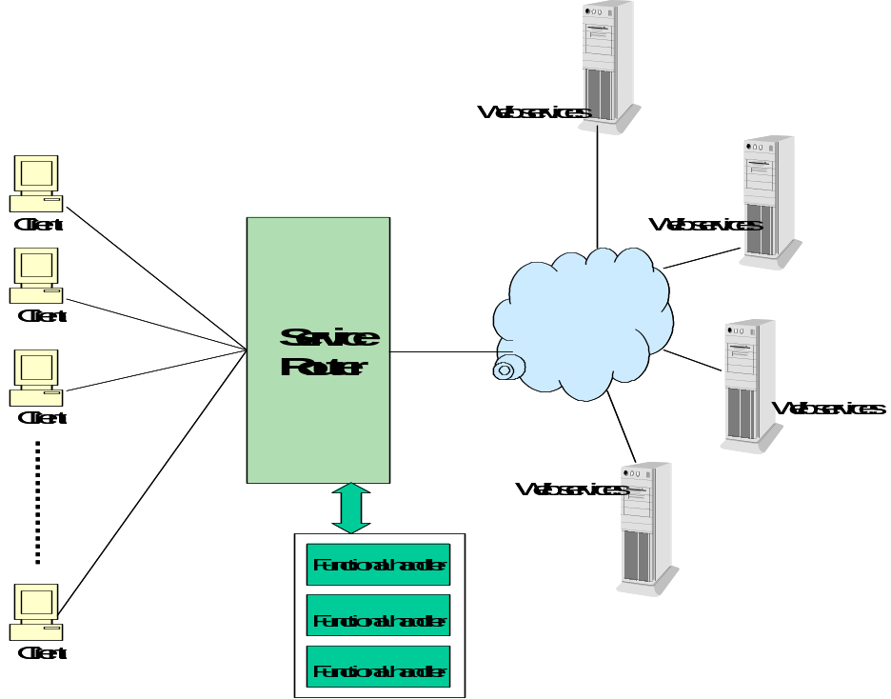
Figure 30: An Overview of the Service Router Functional Element

Key Features
Implementations of the Service Router Functional Element are expected to provide the following key features:
- The Functional Element MUST provide mechanism as façade for web services invocations. This mechanism has the following capabilities:
  - Provide a single access point for web service invocation.
  - Provide the location transparency of actual web services.
- The Functional Element MUST provide capability to route web services invocation on behalf of service requesters to the specified actual web services.
- The Functional Element MUST provide capability to manage web services invocation in the aspects of invocation time-out, transaction management.
- The Functional Element MUST provide capability to manage the registration of web services that are going to be invoked.
- The Functional Element MUST provide capability to deploy registered web services automatically into the façade.
- The Functional Element MUST provide mechanism to incorporate functional handlers.
- The Functional Element MUST provide capability to perform processing by invoking functional handlers defined for a web services invocation before the web services is really invoked.
- The Functional Element MUST provide capability to perform processing by invoking functional handlers for a web services invocation after the web services is invoked.
- The Functional Element MUST provide capability to manage functional handlers.
- The Functional Element MUST provide capability to manage the parameter mappings between two adjacent functional handlers and parameter mapping between functional handler and web services.

In addition, the following key features could be provided to enhance the Functional Element further:
- The Functional Element MAY provide capability to invoke the alternative web services if the actual web services that is targeted to invoke is not available.

- The Functional Element MAY provide the capability to define a sequence of functional handlers for a web services for a web services invocation.
- The Functional Element MAY provide capability to enable the invocation of functional handlers in pre-defined sequence for a web for a web services invocation.

Interdependencies
None.

Related Technologies and Standards
None.

Model
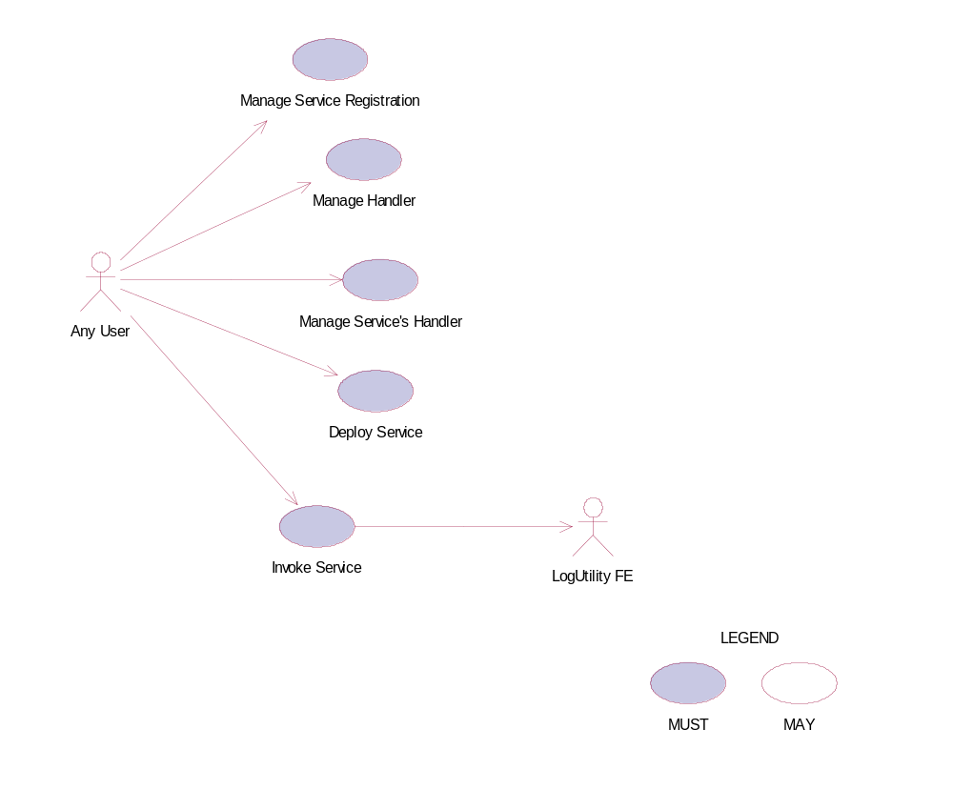
Figure 31: Model Of the Service Router Functional Element []

Usage Scenarios

Manage Service Registration

Description
This use case allows the user to register, remove and view web services from or to the service router.
- Register Web Service
Web services details are registered to the service router.
- Delete Web Service
Web services are removed from the service router.
- View Web Service
View the registration information of a web service.

Flow of Events

Basic Flow
This use case starts when the user of service router wishes to register, remove and view web services registration.
1: The user initiates a request type to the Functional Element stating whether to register, remove or view web services registration in the service router.
2: The Functional Element checks the request. Based on the type of request, one of the sub-flows is executed. If the request is to register a new web service in the service router, system executes ‘Register Web Service’. If the request is to view web services from the service router, system executes ‘View Web Services’. If the request is to remove a web service from the service router, system executes ‘Remove Web Service’.
2.1: Register Web Service.
2.1.1: The user provides the WSDL of a web service.
2.1.2: The user provides other web service information to be kept in the service router.
2.1.3: The Functional Element retrieves web service information from the WSDL and keeps them into the registry.
2.2: View Web Services.
2.2.1: The Functional Element retrieves the service from the registry with the specific service name.
2.2.2: The Functional Element returns the web services information results to the user.
2.3: Remove Web Service
2.3.1: The user provides web service name to be removed from the identified registry server.
2.3.2: The Functional Element removes the web service information from the registry.
3: The Functional Element responses the status of the operation whether it is successful or failure to the user and the use case ends.

Alternative Flows
1: WSDL error.
1.1: In the Basic Flow 2.1.1, if the WSDL could not be retrieved, “WSDL error” will be sent back.
2: Service does not exist
2.1: In the Basic Flow 2.2.1 and 2.3.1, if the service name does not exist, “Service does not exist” error will be sent back.

Special Requirements
None.

Pre-Conditions
None.

Post-Conditions
None.

Manage Handler

Description
This use case allows any user to add, remove and view handler to the service router.

Flow of Events

Basic Flow
This use case starts when the user of registry server wishes to add, remove or view web service handlers.
1: The user initiates a request type to the Functional Element stating whether to add, remove or view web service handlers.
2: The Functional Element checks the request. Based on the type of request, one of the sub-flows is executed. If the request is to add a new web service handler to the router, system executes ‘Add Service Handler’. If the request is to view web service handlers, system executes ‘View Service Handlers’. If the request is to remove a handler from the router, system executes ‘Remove Service Handler’.
2.1: Add Service Handler.
2.1.1: The user provides handler name and location to The Functional Element.
2.1.2: The service adds the information to the registry.
2.2: View Service Handlers.
2.2.1: The Functional Element receives a handler name from the user.
2.2.2: The Functional Element returns the information of the handler to the user.
2.3: Remove Service Handler.
2.3.1: The user provides handler name to be removed from the service router.
2.3.2: The Functional Element removes the service handler from the registry.
3: The Functional Element responses the status of the operation whether it is successful or failure to the user and the use case ends.

Alternative Flows
1: Handler name error.
1.1: In the Basic Flow 2.2.1 and 2.3.1, if the handler name does not exist, system displays an error message and exits the use case.

Special Requirements
None.

Pre-Conditions
None.

Post-Conditions
None.

Manage Service’s Handler

Description
This use case allows the user to add, remove and view handlers to the services registered in the service router.
- Add a handler to a service
New handler is added to a registered service.
- Remove a handler to a service
Existing handler is removed from a registered service.
- View service’s handler
Existing handlers of a service could be viewed by the user.

Flow of Events

Basic Flow
This use case starts when the user of service router wishes to add, remove or view handlers to a service.
1: The user initiates a request type to the Functional Element stating whether to add, remove or view handlers to a service.
2: The Functional Element checks the request. Based on the type of request, one of the sub-flows is executed. If the request is to add a new web service handler to a registered web service, system executes ‘Add Service Handler’. If the request is to view web service handlers, system executes ‘View Service Handlers’. If the request is to remove a handler from a service, system executes ‘Remove Service Handler’.
2.1: Add Service Handler.
2.1.1: The user provides handler name, service name and parameter mappings to The Functional Element.
2.1.2: The service adds the information to the registry.
2.2: View Service Handlers.
2.2.1: The Functional Element receives the service name from the user.
2.2.2: The Functional Element retrieves all the handlers and return to the user.
2.3: Remove Service Handler.
2.3.1: The user provides handler name and service name to be removed from the service router.
2.3.2: The Functional Element removes the service handler from the registry.
3: The Functional Element responses the status of the operation whether it is successful or failure to the user and the use case ends.

Alternative Flows
1: Handler name or service name does not exist.
1.1: In the Basic Flow 2.1.1, 2.2.1 and 2.3.1, if the service name or the handler name does not exist, system displays an error message and exits the use case.

Special Requirements
None.

Pre-Conditions
None.

Post-Conditions
None.

Deploy Service

Description
This use case allows the user to deploy registered services to an application server.
- Add server information to The Functional Element
New server is added to a registered service.
- Remove server information to The Functional Element
Existing server is removed from a registered service.
- View server information
Existing server information could be viewed by the user.
- Deploy service
Deploy a registered service to a server.
.

Flow of Events

Basic Flow
This use case starts when the user of service router wishes to add, remove, view server information or deploy a web service to a server.
1: The user initiates a request type to the Functional Element stating whether to add, remove or view server’s information or deploy service.
2: The Functional Element checks the request. Based on the type of request, one of the sub-flows is executed. If the request is to add a server to the router, system executes ‘Add Server’. If the request is to view server information, system executes ‘View Server’. If the request is to remove a server from the router, system executes ‘Remove Server’. If the request is to deploy a service to a server, system executes ‘Deploy Service’.
2.1: Add Server.
2.1.1: The user provides server name and location of the server.
2.1.2: The service adds the information to the registry.
2.2: View Server.
2.2.1: The Functional Element receives the server name from the user.
2.2.2: The Functional Element retrieves the information and return to the user.
2.3: Remove Server.
2.3.1: The user provides the server name from the service router.
2.3.2: The Functional Element removes the server from the registry.
2.4: Deploy Service.
2.4.1: The user provides the server name and service name from the service router.
2.4.2: The Functional Element generate code package the service and deploy it to the server.
3: The Functional Element responses the status of the operation whether it is successful or failure to the user and the use case ends.

Alternative Flows
1: Service name or server name does not exist.
1.1: In the Basic Flow 2.2.1, 2.3.1 and 2.4.1, if the service name or the server name does not exist, system displays an error message and exits the use case.

Special Requirements
None.

Pre-Conditions
None.

Post-Conditions
None.

Invoke Service

Description
This use case allows the user to invoke registered services through the Service Router. It is expected to utilize the Notification FE and Log Util FE in the implementation of this use case.

Flow of Events

Basic Flow
This use case starts when the user of service router wishes to invoke a deployed or registered service.
1: The user initiates a request to the Service Router.
2: The Functional Element checks the request, and determines if the invoked service has any pre-invocation Functional Handlers. If so, the handlers are invoked.
3: The Functional Element then routes the request to the actual service based on registration information captured.
4: When the result from the actual service is returned, the Functional Element checks if there is any post-invocation Functional Handlers. If so, the handlers are invoked.
5: The Functional Element returns the result of invocation to the user and the use case ends.

Alternative Flows
1: Functional Handlers are not available.
1.1: In the Basic Flow 2 and 4, if the Functional Handlers are not available, an error message will be returned, and the use case ends.
2: Invoked Service is not available.
2.1: In the Basic Flow 3, if the invoked Service is not available, an error message will be returned, and the use case ends.

Special Requirements
None.

Pre-Conditions
None.

Post-Conditions
None.

Service Tester Functional Element (Deprecated)

This Functional Element has been deprecated in this version. Please refer to its replacement, 2.15 QoS Functional Element (new) for further details.

Transformer Functional Element (new)

Motivation
Different applications support different format of files or message. Sometimes same information needs to be represented in different format in different use cases. This element tries to provide a framework to facilitate transformation between files or messages.

This Functional Element fulfills the following requirements from the Functional Elements Requirements Document 02 [Error: Reference source not found]:
- Primary Requirements
- DELIVERY-150,
- DELIVERY-151,
- DELIVERY-152,
- DELIVERY-153,
- DELIVERY-155, and
- DELIVERY-157.
- Secondary Requirements
- None

Terms Used
Terms | Description
API Handlers | Binary components which are deployed at the same location as the element. This component provides a set of APIs for the element to invoke to transform files or messages.
Web Services Handler | A web service which are used by the element to invoke to transform files or messages.
WSDL | Web Services Description Language
XSLT | Extensible Stylesheet Language Transformation

Figure 32 depicts the basic concepts of 2 steps approach of Transformer Functional Element. Step 1 begins when the user (service requester) requests to define supported message, file types, XSLT templates and process handlers. The Function Element persists these definitions the return the results. Step 2 begins when the user requests for file or message transformation. The user provides messages or files to be transformed. The Functional Element will do the transformation and returns the result to the user.

Handlers Definition
XSLT templates
File formats definition
Msg formats definition
Definition Manager
API handlers
Web service handlers
Transformer Manager
Request for transformation
Transformation Results
Definition Request
Definition Results
Figure 32: An Overview of Transformer Functional Element

Key Features
Implementations of the Transformer Functional Element are expected to provide the following key features:
- The Functional Element MUST provide the capability to manage supported files and messages.
- The Functional Element MUST provide the capability to manage XSLT templates.
- The Functional Element MUST provide the capability to manage handlers for transformation.
- The Functional Element MUST provide the handler to transform SOAP, WSDL messages.

In addition, the following key features could be provided to enhance the Functional Element further:
- The Functional Element MAY provide the capability to chain handlers.
- The Functional Element MAY provide the capability to measure the performance of handlers.
- The Functional Element MAY provide the capability to select the efficient handlers to do the transformation.

Interdependencies
Direct Dependency
Log Utility Functional Element | The Log Utility Functional Element is used to record the data.

Related Technologies and Standards
Specifications | Description
SOAP 1.2 | The ability to parse the SOAP message.
WSDL 1.1 | The ability to parse the WSDL.

Model

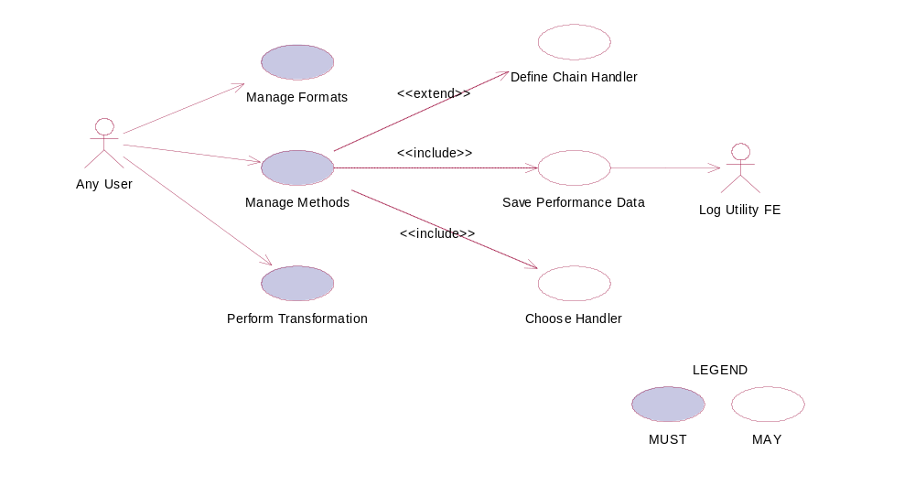
Figure 33: Model Of the Transformer Functional Element

Usage Scenarios

Manage Formats

Description
This use case allows the user to manage file or message formats supported by this element.

Flow of Events

Basic Flow
This use case starts when the user wants to manage file or message formats.
1: The user provides the management operation to the functional element.
2: Based on the operation one of the following sub-flow is executed. If the operation is “add- format” sub-flow 2.1 is executed. If the operation is “delete-format” sub-flow 2.2 is executed. If the operation is “query-format” sub-flow 2.3 is executed.
2.1: Add format
2.1.1: The system gets the format name, file extension name.
2.1.2: The system save this information.
2.2: Delete format
2.2.1: The system gets the format name.
2.2.2: The system deletes format information.
2.3: Query format:
2.3.1: The system gets the format name.
3: The Functional Element responses the status of the operation whether it is successful or failure to the user and the use case ends.

Alternative Flows
1: Format Name Already Registered.
1.1 In Basic Flow 2.1.2, if the format name already registered, the system will assign error message to the result message.
2: Format Name Does Not Exist
2.1 In Basic Flow 2.2.2, if the format name does not exist, the system will assign error message to the result message.

Special Requirements
None.

Pre-Conditions
None.

Post-Conditions
None.

Manage Methods

Description
This use case allows the user to manage the methods that are used to do the transformation.

Flow of Events

Basic Flow
This use case starts when a user wants to manage the methods that are used to do the transformation.
1. The user provides the management operation and data.
2. Based on the operation it specified, one of the following sub-flows is expected. If the operation is ‘Add Method’, then sub-flow 2.1 is executed. If the operation is ‘Delete Method’, then sub-flow 2.2 is executed. If the operation is “Query Method”, then sub-flow 2.3 is executed.
2.1: Add Method.
2.1.1: The user sets the file method name, type (API or Web Service), Input file format location and Output file format location, or user submits the WDSL of a known web service.
2.1.2: The system save this information.
2.2: Delete Method.
2.2.1: The user sets the method name.
2.2.2: The system deletes this information
2.3: Query Method.
2.3.1: The user sets the method name, or input format, or output format.
3: The Functional Element responses the status of the operation whether it is successful or failure to the user and the use case ends.

Alternative Flows
1: Method Name Already Registered.
1.1 In Basic Flow 2.1.2, if the format name already registered, the system will assign error message to the result message.
2: Method Name Does Not Exist.
2.1 In Basic Flow 2.2.2, if the format name does not exist, the system will assign error message to the result message.

Special Requirements
None.

Pre-Conditions
None.

Post-Conditions
None.

Perform Transformation

Description
This use case allows the user to transform a file from one format to another format.

Flow of Events

Basic Flow
This use case starts when a user wants to transform a file from one format to another format.
1: The user set the file name to be transformed and the destination format.
2: The system checks all the methods which use this file as input.
3: The system checks all the methods which use the destination format as output.
4: Select one method based on the performance data recorded before.
5: Invoke the methods and save the performance data.
6: Return the results and the use case ends.

Alternative Flows
1: If in Basic Flow 4 there is there is no method to do the transformation, the system return error message to the user and this use case ends.

Special Requirements
None.

Pre-Conditions
None.

Post-Conditions
None.

Define Chain Handler

Description
This use case allows the user to create new handler based on the existing handler if a transformation could be done directly but could be done indirectly through a chain of existing handler.

Flow of Events

Basic Flow
1: User sets the chain handler name and the handlers involved in this chain.
2: The system gets the input format name of the first handler and the output format name of the last handler.
3: The system save this information.
4: Return the results to the user and end the use case.

Alternative Flows
1: If the handler name could not be found in Basic Flow 2, system returns the results to the user and the use case ends.

Special Requirements
None.

Pre-Conditions
None.

Post-Conditions
None.

Choose Handler

Description
This use case allows the system to choose a handler for transformation.

Flow of Events

Basic Flow
This use case starts when the transform use case needs a handler to do the transformation.
1. The system checks the handlers that match the input and out put format.
2: The system returns the name of the handler to the transform use case and ends this use case.

Alternate Flow
1: In Basic Flow 1, if there are more handlers available and performance data are available, then the system select the handler with the best performance data. Otherwise select any one.
2: In Basic Flow 1, if the handler is a XSLT template, return the template name to the transform.

Special Requirements
None.

Pre-Conditions
None.

Post-Conditions
None.

Save Performance Data

Description
This use case saves performance data of each handler.

Flow of Events

Basic Flow
This use case starts when user wants to measure the performance of the handlers.
1: It starts time counting.
2: Collection CPU information, DISK access information and Network traffic information.
3: Waiting for the termination of the handler.
4: Save this information and end the use case.

Alternative Flows
1: In Basic Flow 3, If the log file is not available, the Functional Element returns an error and the user case ends.

Special Requirements
None.

Pre-Conditions
None.

Post-Conditions
None.

User Management Functional Element

Motivation
The User Management Functional Element is expected to be an integral part of the user access management (UAM) functionalities that is expected to be needed by a Web Service-enabled implementation. This FE is expected to fulfill the needs arising out of managing resources within an application, with a user-centric viewpoint. As such it will cover aspects that include:
- Basic user accounts management facilities,
- Ability to extend dynamically from the basic set of account information,
- Capability for configurable policies governing account management,
- Providing log trails for user activities, and
- Management of user authentication means, either directly or indirectly.

This Functional Element fulfills the following requirements from the Functional Elements Requirements Document 02 [Error: Reference source not found]:
- Primary Requirements
- MANAGEMENT-001 to MANAGEMENT-003,
- MANAGEMENT-005,
- MANAGEMENT-008,
- MANAGEMENT-012, and
- SECURITY-002 (all).
- Secondary Requirements
- SECURITY-001.

Terms Used
Terms | Description
Namespace | Namespace is use to segregate the instantiation of the application across different application domains. If a company has two separate standalone application, for example, an email application and an equipment booking application, then these two are considered as separate application domains.
User | A user is loosely defined to include both human and virtual users. Virtual users could include service users and application (or machine) users that are utilising other services in a SOA environment.
User Access Management / UAM | User Access Management or UAM refer to the concept of managing users in a holistic manner, considering all aspect which includes:  Defining a set of basic user information that should be stored in any enterprise application.  Providing a means to extend this basic set of user information when needed.  Simplifying management by grouping related users together through certain criteria.  Having the flexibility of adopting both coarse/fine grain access controls.
User Repository | User Repository is where the user information is stored. It can be a database or a flat file.

Key Features
Implementations of the User Management Functional Element are expected to provide the following key features:
- The Functional Element MUST provide a User Repository.
- The Functional Element MUST be able to control access to such a User Repository.
- The Functional Element MUST provide a basic User structure with a set of pre-defined attributes.
- The Functional Element MUST provide the capability to extend on the basic User structure dynamically.
- As part of Key Feature (4), this dynamic extension MUST be definable and configurable at runtime implementation of the Functional Element.
- The Functional Element MUST provide the capability to manage the creation and deletion of instances of Users based on defined structure.
- The Functional Element MUST provide the capability to manage all the information (attribute values) stored in such Users. This includes the capability to:
  - Retrieve and update attribute’s values belonging to a User,
  - Generate a random password,
  - Encrypt sensitive user information, and
  - Authenticate a user.
- As part of Key Feature (7.4), the authentication of a User MUST be achieved at least through the use of a password.
- The Functional Element MUST provide a mechanism for managing Users across different application domains.
Example: Namespace control mechanism

In addition, the following key features could be provided to enhance the Functional Element further:
- The Functional Element MAY provide a mechanism to control the username format.
Example: Usernames must be at least 8 characters long.
- The Functional Element MAY provide additional security mechanisms to enhance the security of sensitive information like user passwords.
Example: Passwords are stored in security tokens, or a more secure encryption algorithms for passwords.
- If Key Feature (2) is provided, the Functional Element MAY also provide a selection of selectable encryption algorithms.
- The Functional Element MAY provide additional security policies to ensure that systems are not compromised.
Example: Passwords must be changed every 30 days.
- If Key Feature (4) is provided, the Functional Element MAY also provide a facility to notify users before the password expires.

Interdependencies
Interaction Dependencies
Group Management Functional Element | The Group Management Functional Element may be used to provide useful aggregation of the users.
Phase and Lifecycle Management Functional Element | The Phase and Lifecycle Management Functional Element may be used to maintain the relationships between various phases of a project lifecycle and the group who is working on it.
Role and Access Management Functional Element | The Role and Access Management Functional Element may be used to manage the user’s access rights by virtue of it’s association with a group, phase or even the complete lifecycle of the project.

Related Technologies and Standards
None

Model

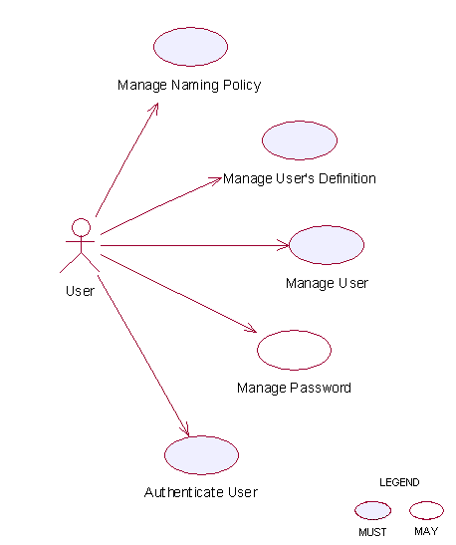
Figure 34: Model Of the User Management Functional Element []

Usage Scenarios

Manage Naming Policy

Description
This use case allows any user to manage naming policy when creating/updating user accounts. The service user may create, update, retrieve and delete a naming policy.

Flow of Events

Basic Flow
This use case starts when any user wants to manage naming policy for creating/updating user account.
1: The user sends Manage Naming Policy request to the Functional Element together with the specified operation.
2: Functional Element gets the operation. Based on the operation, one of the sub-flows is executed.
If the service user provides ‘Create Naming Policy’, then sub-flow 2.1 is executed.
If the service user provides ‘Update Naming Policy’, then sub-flow 2.2 is executed.
If the service user provides ‘Delete Naming Policy’, then sub-flow 2.3 is executed.
2.1: Create Naming Policy.
2.1.1: The service user specifies namespace, name and description of the policy to create, for example, the policy name may be name length, the policy description may be “=7”.
2.1.2: The Functional Element checks the existing naming policy.
2.1.3: The Functional Element generates naming policy information and adds to the Functional Element and the use case ends.
2.2: Update Naming Policy.
2.2.1: The service user specifies the policy to update.
2.2.2: The Functional Element retrieves the existing naming policy information.
2.2.3: The service user provides the update naming policy information according to the policy name used in creating a naming policy.
2.2.4: The Functional Element updates the naming policy with the updated information and ends use case.
2.3: Retrieve Naming Policy.
2.3.1: The service user specifies the policy to retrieve.
2.3.2: The Functional Element retrieves the existing naming policy information and ends the use case.
2.4: Delete Naming Policy.
2.4.1: The service user specifies the policy to delete.
2.4.2: The Functional Element retrieves the existing naming policy information.
2.4.3: The Functional Element deletes the naming policy from the Functional Element and the use case ends.

Alternative Flows
1: Invalid Policy.
1.1: If in the basic flow 2.1.1, Functional Element detects any invalid description, Functional Element returns general error message and ends the use case.
2: Naming Policy already exists.
2.1: If in the basic flow 2.1.2, the Functional Element checks the existing naming policy and finds the naming policy already exists. The Functional Element returns an error and ends the use case.

Special Requirements

Pre-Conditions
None.

Post-Conditions
If the use case was successful, the naming policy information is added to the Functional Element. To do any creating and updating of User information after the naming policy is added must satisfy the naming policies defined. If unsuccessful, the Functional Element’s state is unchanged.

Manage User Definition

Description
The use case allows any user to manage user definition when more basic user definition can not satisfied in creating/updating user accounts. The service user may create, update, retrieve and delete a user definition.

Flow of Events

Basic Flow
This use case starts when any user wants to manage user definition for creating/updating user account.
1: The user sends Manage User Definition request to the Functional Element together with the specified operation.
2: Functional Element gets the operation. Based on the operation, one of the sub-flows is executed.
If the service user provides ‘Create User Definition’, then sub-flow 2.1 is executed.
If the service user provides ‘Update User Definition’, then sub-flow 2.2 is executed.
If the service user provides ‘Delete User Definition’, then sub-flow 2.3 is executed.
2.1: Create User Definition.
2.1.1: The service user specifies namespace, name and description of the user definition fields to create.
2.1.2: The Functional Element checks the existing user definition fields (including basic ones).
2.1.3: The Functional Element generates user definition information and adds to the Functional Element and the use case ends.
2.2: Update User Definition.
2.2.1: The service user specifies the user definition field to update.
2.2.2: The Functional Element retrieves the existing user definition information.
2.2.3: The service user provides the update user definition information.
2.2.4: The Functional Element updates the user definition with the updated information and ends use case.
2.3: Retrieve User Definition.
2.3.1: The service user specifies the user definition to retrieve.
2.3.2: The Functional Element retrieves the existing user definition information and ends the use case.
2.4: Delete User Definition.
2.4.1: The service user specifies the user definition to delete.
2.4.2: The Functional Element retrieves the existing user definition information.
2.4.3: The Functional Element deletes the user definition from the Functional Element and the use case ends.

Alternative Flows
1: Invalid User Definition.
1.1: If in basic flow 2.1.1, Functional Element detects any invalid description, Functional Element returns general error message and ends the use case.
2: User Definition already exists.
2.1: If in basic flow 2.1.2, the Functional Element checks the existing user definition and finds the user definition already exists. The Functional Element returns an error and ends the use case.
3: User Definition not exists.
3.1: If in basic flow 2.2.2, 2.3.2 and 2.4.2, the Functional Element checks the existing user definition and finds the user definition does not exist. The Functional Element returns an error and ends the use case.

Special Requirements
None

Pre-Conditions
None.

Post-Conditions
If the use case was successful, the user definition information is added to the Functional Element. Thereafter, when creating and updating User, the User information must satisfy the user definition defined earlier. If the use case fails, the Functional Element’s state is unchanged.

Manage User
This use case describes the management of a user, namely the creation, deletion, retrieval and update of the user.

Flow of Events

Basic Flow
This use case starts when the user wants to manage a user.
If user wants to ‘Create User, then basic flow 1 is executed.
If user wants to ‘Retrieve User, then basic flow 2 is executed.
If user wants to ‘Update User, then basic flow 3 is executed.
If user wants to ‘Delete User, then basic flow 4 is executed.
1: Create User.
1.1: User provides the information that is necessary for creating a user.
1.2: The Functional Element validates the user information provided against the naming policy.
1.3: The Functional Element validates the user information provided against the user’s definition.
1.4: Functional Element creates the user and the use case ends.
2: Retrieve User.
2.1: User provides the necessary information for retrieving the complete user’s attributes.
2.2: The Functional Element returns the user’s information and the use case ends.
3: Update User.
3.1: User provides the necessary information for updating the group’s attributes.
3.2: The Functional Element validates the user’s information provided against the naming policy.
3.3: The Functional Element validates the user information provided against the user’s definition.
3.4: The Functional Element updates the user and the use case ends.
4: Delete User.
4.1: User provides the necessary information for deleting a user group.
4.2: Functional Element deletes the user and the use case ends.

Alternative Flows
1: User Exist.
1.1: In basic flow 1.4, if the Functional Element detects an identical user, the Functional Element returns an error message and the use case ends.
2: User Does Not Exist.
1.1: In basic flow 2.2, 3.4 and 4.2, if the Functional Element cannot find a user that matches the user’s criteria, the Functional Element returns an error message and the use case ends.

Special Requirements
None.

Pre-Conditions
None.

Post-Conditions
None.

Authenticate User

Description
This use case allows users to authenticate a user.

Flow of Events

Basic Flow
This use case starts when users wish to authenticate a user.
1: Users provide user name and password to Functional Element.
2: The Functional Element checks the user name and password.
3: The Functional Element returns the result to users and the use case ends.

Alternative Flows
None.

Special Requirements
None.

Pre-Conditions
None.

Post-Conditions
None.

Manage Password
This use case describes the management of password in this Functional Element.

Flow of Events

Basic Flow
This use case starts when the user wants to obtain an encrypted password. This can be achieved via one of the following basic flow.
If user wants to ‘Generate Password’, then basic flow 1 is executed.
If user wants to ‘Encrypt Password’, then basic flow 2 is executed.
1: Generate Password
1.1: The user specifies the option of format of password among available options in the Functional Element.
1.2: The Functional Element generates clear text password based on the format specified by the service user.
1.3: The Functional Element includes “Encrypt Password’ use case to encrypt the clear text password.
1.4: The Functional Element returns the clear text password and encrypted password to user and the use case ends.
2: Encrypt Password
1.1: The user provides clear text password to Functional Element.
1.2: The user specifies the encryption algorithm to be used.
1.3: The Functional Element encrypts the clear text password.
1.4: The Functional Element returns the encrypted password to user and the use case ends.

Alternative Flows
None.

Special Requirements
None.

Pre-Conditions
None.

Post-Conditions
None.

Web Service Aggregator Functional Element

Motivation
In any Web Service-enabled application, it is expected that complex business functions have to be realized via aggregation of multiple Web Services. This Functional Element is expected to fulfill the needs arising out of Web Services composition. As such it will cover aspects that include:
- Facilitating the composition of Web Services, and
- Testing of aggregated Web Services.

This Functional Element fulfills the following requirements from the Functional Elements Requirements Document 02 [Error: Reference source not found]:
- Primary Requirements
- PROCESS-010 to PROCESS-014.
- Secondary Requirements
- PROCESS-131

Terms Used
Terms | Description
Aggregated Web Service | Aggregated Web Service is single Web Services that invoke multiple Web Services to realize its functionality.
Composition Rule | A Composition Rule is an expression specifying how individual Web Services are invoked to form aggregated Web Services. It includes the name of Web Services that are included in aggregation, specification of aggregation sequence, data dependency among the individual Web Services.

The following diagram shows the meaning of the terms in the context of Web Services aggregation.

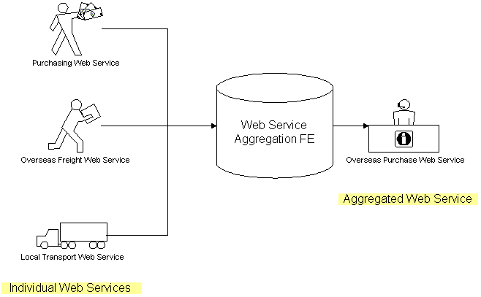
Figure 35: An Overview of the Web Service Aggregator Functional Element

Key Features
Implementations of the Web Service Aggregator Functional Element are expected to provide the following key features:
- The Functional Element MUST provide a mechanism for composing any number of Web Services into single Web Service according to specified Composition Rule(s).
- Individual web services can reside at any location, but it is expected to be accessible.
- As part of Key Feature (1), the WSDL of a web service used for composition MUST be available.
- The Functional Element MUST support the definition, modification and removal of Composition Rules.
- The Functional Element MUST encapsulate the composition logic used into an interpretable XML-based script based on a particular standard*.
Example: BPEL or WSCI. The TC will have to decide on which standard to use

In addition, the following key features could be provided to enhance the Functional Element further:
- The Functional Element MAY provide the capability to transform the interpretable XML-based script into an executable program.
- If Key Feature (1) is provided, then the Functional Element MAY also have the following capabilities:
  - The ability to test the functionality of the aggregated Web Service,
  - A WSDL to describe the aggregated Web Service, and
  - The capability to publish the aggregated Web Service into an UDDI-compliant registry

Interdependencies
Interaction Dependencies
Services Tester Functional Element | The Services Tester Functional Element may be used to test the performance of the aggregated web services
Service Registry Functional Element | The Services Registry Functional Element may be used to publish the aggregated web services

Related Technologies and Standards
Specifications | Specific References
Business Process Execution Language for Web Services version 2.0 [] | Web Services Business Process Execution Language Version 2.0, Committee Draft, 01 September 2005

Model
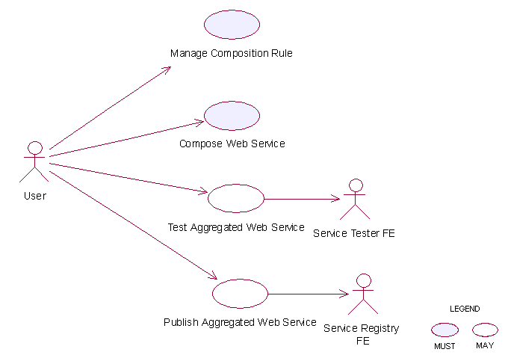
Figure 36: Model Of the Web Service Aggregation Functional Element []

Usage Scenarios

Manage composition rule

Description
This use case allows the user to manage the composition rule used for Web Services aggregation.

Flow of Events

Basic Flow
The use case begins when the user wants to manage a composition rule.
1: The user sends a request to the Functional Element together with the composition rule and operation.
2: Based on the operation it specified, one of the following sub-flows is executed:
If the operation is ‘Define a rule’, then sub-flow 2.1 is executed.
If the operation is ‘Update a rule’, then sub-flow 2.2 is executed.
If the operation is ‘Retrieve a rule’, then sub-flow 2.3 is executed.
If the operation is ‘Remove a rule’, then sub-flow 2.4 is executed.
2.1: Define Rule.
2.1.1: The Functional Element gets the composition rule, i.e. names of all Web Service, the sequence specification, parameters mapping between Web Services.
2.1.2: The Functional Element verifies the correctness of composition rule.
2.1.3: The Functional Element saves the composition rule to persistent mechanism.
2.2: Update Rule.
2.2.1: The Functional Element gets the name of composition rule.
2.2.2: The Functional Element retrieves the composition rule definition from persistent mechanism.
2.2.3: The Functional Element verifies the correctness of composition rule.
2.2.4: The Functional Element updates the composition rule.
2.3: Retrieve Rule.
2.3.1: The Functional Element gets the name of composition rule.
2.3.2: The Functional Element retrieves the definition of composition rule.
2.3.3: The Functional Element returns the definition of rule.
2.4: Remove Rule.
2.4.1: The Functional Element gets the name of composition rule.
2.4.2: The Functional Element checks whether the rule exists.
2.4.3: The Functional Element removes the rule.
3: The Functional Element returns the results to indicate the success or failure of this operation to the user and the use case ends.

Alternative Flows
1: Composition Rule Already Created.
1.1: If in the basic flow 2.1.2, the same rule already created, Functional Element will return an error message to the user and the use case ends.
2: Composition Rule Not Exist.
2.1: If in the basic flow 2.2, 2.3, and 2.4 the specified rule does not exist, Functional Element will return an error message to the user and the use case ends.
3: Persistency Mechanism Error.
3.1: If in the basic flow 2.1, 2.2, 2.3, and 2.4, the Functional Element cannot perform data persistency, Functional Element will return an error message to the user and the use case ends.

Special Requirements
None.

Pre-Conditions
None.

Post-Conditions
None.

Compose Web Services

Description
This use case will allow users to aggregate several simpler services into a higher-level service.

Flow of Events

Basic Flow
This use case begins when any user wants to compose a Web Service.
1: The user passes in a list of parameters for composition, including URLs of the WSDL, composition rules.
2: Functional Element checks the signature of the Web Services to be composed via accessing WSDL.
3: Functional Element generates interpretable XML-based script to encapsulate the composition logic.
4: Functional Element returns the generated script and the use case ends.

Alternative Flows
1: Functional Element generates executable program and WSDL.
1.1: At basic flow 3, Functional Element may transform the interpretable XML-based script into an executable program, if the user requested.
1.2: At basic flow 3, Functional Element may generate WSDL for the executable program, if the user requested.
1.3: Functional Element returns the code of executable program and WSDL file
2: Functional Element detects ambiguity in Web Services signature.
2.1: At basic flow 2, Functional Element encounters an ambiguity in the Web Services signature which it cannot resolve.
2.2: Functional Element returns an error message that there is a composition error.
3: Functional Element detects error in Web Services composition.
3.1: At basic flow 3, Functional Element encounters an error in the Web Services composition.
3.2: Functional Element returns an error message that there is a composition error.

Special Requirements
None.

Pre-Conditions
The composition rule for this Web Services aggregation must be pre-defined.

Post-Conditions
The generated program is ready for deployment in any Web Services container.

Test Aggregated Web Services

Description
This use case will allow users to test the functionality of aggregate web service.

Flow of Events

Basic Flow
This use case begins when any user wants to test aggregated web service.
1: The user passes in a list of parameters for testing, including URLs of the WSDL, values of parameters for invocation.
2: Functional Element invokes the aggregated web service with parameters.
3: Functional Element compares the returned parameter with the expected values.
4: Functional Element returns the result of comparison and the use case ends.

Alternative Flows
1: Functional Element cannot invoke the aggregated web service.
1.1: At basic flow 2, Functional Element encounters problems of invoking the aggregated web services.
1.2: Functional Element returns an error message that indicates the invocation error.

Special Requirements
None.

Pre-Conditions
The executable program must be generated and deployed in web services hosting environment and ready for invocation.

Post-Conditions
None.

Publish Aggregated Web Services

Description
This use case will allow users to publish the aggregated web services into UDDI registry.

Flow of Events

Basic Flow
This use case begins when any user wants to publish the aggregated web services into UDDI registry.
1: The user passes in a list of parameters for publishing, including URLs of the WSDL of aggregated web services, URL of UDDI and parameters of business and services description.
2: Functional Element checks the availability of UDDI.
3: Functional Element publishes services description of aggregated web services into UUDI.
4: Functional Element returns the publish result and the use case ends.

Alternative Flows
1: UDDI registry server is not available
1.1: At basic flow 2, Functional Element cannot connect to UDDI registry if UDDI registry server is not available.
1.2: Functional Element returns the error message that UDDI connection cannot be built.
2: Functional Element detects error in Web Services publishing.
2.1: At basic flow 3, Functional Element encounters an error in the publishing Web Services.
2.2: Functional Element returns an error message that there is a publishing error.

Special Requirements
None.

Pre-Conditions
The WSDL of the aggregated web services must exist.

Post-Conditions
None

Functional Elements Usage Scenarios
The Functional Elements are designed to be building blocks that can be assembled to accelerate web service-enabled applications. From these Functional Elements, a variety of solutions can be built. In this section, the following solutions are provided as examples:
- A service monitoring solution for the management of services in a SOA model 
- Enabling security through the Secure SOAP Functional Element
- Decoupled User Access Management with support for multi-domain capabilities in a web service environment
- Single-Sign On for Distributed Services (Applications)

Service Monitoring
In a SOA environment, management of services includes the capability to monitor services within the management domain. These includes:
Monitoring the performance of services invoked
Generating audit trails of services invoked
Monitoring and testing the availability of services on the remote machine (server)
A basic solution can be realised through the aggregation of two Functional Element, namely Service Management and Service Tester, as shown in Figure 19. This solution can be improved with notification capabilities, using the Notification Engine, be it to a remote client, a system administrator or an end user of a particular service. Further enhancement can be added with a Rule Engine that will have the cognitive ability to make decisions. An example of this enhancement would be the ability to decide when should notifications or alerts be sent and in what form.
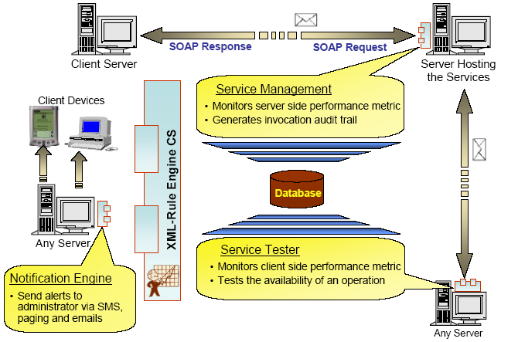
Figure 37: Service Monitoring Solution Through Aggregation of Functional Element

Securing SOAP Messages
SOAP in its pure form does not have any built in security as it is meant to be a simple and lightweight protocol. As such, where security is needed, additional capabilities must be provided. Presently, standards like XML Encryption and XML Signature are available. Making use of these standards, the Secure Soap Functional Element, when deployed on both the sending and receiving parties, will be able to provide encryption and signing of messages as illustrated in Figure 20.

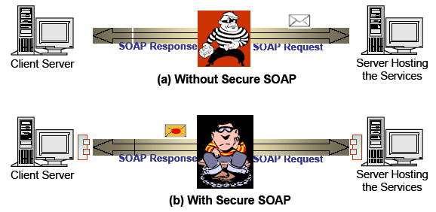

Figure 38: Securing SOAP Messages Using Secure SOAP Functional Element

Decoupled User Access Management
User Access Management (UAM) has been implemented in many forms and in a wide variety of ways, from the most basic to the most complex. At the most simple form, the functionality would include username and password support. On the end of the scale, it would include functionalities like distributed access management, replication capabilities and fine-grain controls just to name a few.
In this specification, the goal is to provide a set of Functional Element that can be used as building blocks for UAM, and can be extended when the need arises. It is provided as a decoupled building blocks consisting of four Functional Elements, namely User Management, Group Management, Role & Access Management and Phase & Lifecycle Management, as illustrated in Figure 21. These Functional Elements can be used in a variety of combinatorial forms, and some of these examples include:
- User Management only, or
- User Management and Group Management, or
- User Management and Role & Access Management, or
- User Management, Group Management and Role & Access Management, or
- All the four Functional Elements in tandem
On the same token, any of the Functional Elements can be replaced with similar functionality third party web services. As these services are designed to be in a web service environment, each of them also supports the concept of namespace. This namespace provision enables each of the Functional Elements to be used as web services that can be accessed by multiple organisations or to cater for users from different domains. With this, access control for example, can be defined for multiple domains without corruption or interferences problems.

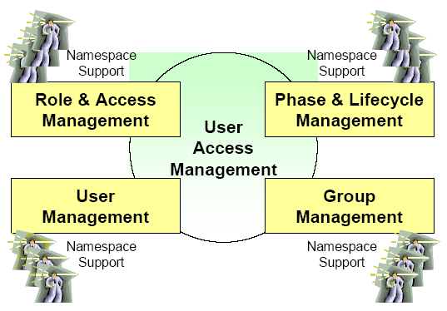
Figure 39: User Access Management via Functional Element

Single-Sign-On for Distributed Services (Applications)
In a SOA world, it is very likely that services for a composite application can be potentially made up of multiple 3rd party services from different application domains. It is also very likely that each of these domains will require authentication of the user separately. However, it is not user friendly to enforce re-authentication as the user moves from one domain to another. Using the Identity Management Functional Element, with the potential combination of Secure SOAP Functional Element and other user access management Functional Elements like User Management, a solution for such an environment can be put together to enable Single-Sign-On. In this scenario of use, a Circle of Trust between different application domains can be established using the Identity Management Functional Element, and the exchanges between these domains can be secured using the Secure SOAP Functional Element. Access and authentication to individual domains remain the purview of the distributed applications, and can potentially also leveraged on the Decoupled User Access Management scenario detailed in section 3.3.

Figure 40: User Access Management via Functional Element

References
- Acknowledgments
Special thanks to the following individuals who contributed significantly towards this specification:
- Chan Lai Peng
- Cheng Yushi
- Dilip Kumar Limbu
- V. Ramasamy
- Wu Yingzi
- Xu Xingjian, and
- Yin Zunliang.
The committee would also like to express its appreciation for the encouragement and guidance provided by Jamie Clark throughout the course of the TC work.

The committee would also like to record its heartfelt appreciation to IBM Rational (Singapore) Pte. Ltd. for kindly agreeing to allow the use of the Rational Tools towards the creation of the Use Case Model used in this document.

- Revision History
The following revision of this document represents the major milestones achieved.

Rev | Date | By Whom | What
FWSI-FESC-specifications-01.doc | 01-Jul-2004 | Huang Kheng Cheng  Puay Siew Tan | First Draft
FWSI-FESC-specifications-02.doc | 18-Oct-2004 | Huang Kheng Cheng  Puay Siew Tan | Second Draft
fwsi-fe-1.0-guidelines-spec-wd-03.doc | 25-Nov- 2004 | Huang Kheng Cheng | Second Draft (Voted version)
fwsi-fe-1.0-guidelines-spec-cs-01.doc | 04-Mar-2005 | Puay Siew Tan | Update the document to reflect its change of status to a Committee Specs (as of 16 Dec 2004)
fwsi-fe-1.0-guidelines-spec-cs-02.doc | 27-May-2005 | Puay Siew Tan | Update the document on syntactical errors. Features are not changed.
fwsi-fe-2.0-guidelines-spec-wd-01.doc | 28-Oct-2005 | Puay Siew Tan | New working draft for Version 2.0 of the FE Specs:  - Deprecated 2 FEs, namely Presentation Transformer and Service Tester  - Replaced the deprecated FEs with Transformer and Quality of Service (QoS) FEs respectively  - Added 10 new FEs identified for version 2.0  - Minor changes to the following FEs:  - Phase & Lifecycle Management  - Secure SOAP Management  - Sensory  - Service Management  - Service Registry  - Web Service Aggregator  - Usage Scenarios (added 1 more usage scenario for SSO)
fwsi-fe-2.0-guidelines-spec-wd-02.doc | 20-Dec-2005 | Puay Siew Tan | Revision of working draft for Version 2.0 of the FE Specs. This is based on feedback/comments received todate:  - Added the “Deprecated” phrase in the title of Presentation Transformer and Service Tester. Easier for readers to see.  - Added the checking of permission sets for Data Integrator  - Added Invoke Service Use Case in Service Router  - Corrected some minor syntax and grammar errors
fwsi-fe-2.0-guidelines-spec-cd-01a.doc | 05-Jan-2006 | Puay Siew Tan | Revision of working draft for Version 2.0 of the FE Specs. This is based on the feedback/comments received todate:  - WSQM TC from Korea.  - Public Comment
fwsi-fe-2.0-guidelines-spec-cd-02.doc | 01-Jun-2006 | Siew Poh Lee  Puay Siew Tan | Revision of working draft for Version 2.0 of the FE Specs. This is based on the feedback/comments received todate:  - After meeting with WSQM TC from Korea.  - Public Comment to include WS-Trust standard for Identity Management.  - Remove footnote related to patent filed.  - Modify reference to requirements doc to 02 instead of 01a

- Notices
OASIS takes no position regarding the validity or scope of any intellectual property or other rights that might be claimed to pertain to the implementation or use of the technology described in this document or the extent to which any license under such rights might or might not be available; neither does it represent that it has made any effort to identify any such rights. Information on OASIS's procedures with respect to rights in OASIS specifications can be found at the OASIS website. Copies of claims of rights made available for publication and any assurances of licenses to be made available, or the result of an attempt made to obtain a general license or permission for the use of such proprietary rights by implementors or users of this specification, can be obtained from the OASIS Executive Director.
OASIS invites any interested party to bring to its attention any copyrights, patents or patent applications, or other proprietary rights which may cover technology that may be required to implement this specification. Please address the information to the OASIS Executive Director.
Copyright © OASIS Open 2004. All Rights Reserved.
This document and translations of it may be copied and furnished to others, and derivative works that comment on or otherwise explain it or assist in its implementation may be prepared, copied, published and distributed, in whole or in part, without restriction of any kind, provided that the above copyright notice and this paragraph are included on all such copies and derivative works. However, this document itself does not be modified in any way, such as by removing the copyright notice or references to OASIS, except as needed for the purpose of developing OASIS specifications, in which case the procedures for copyrights defined in the OASIS Intellectual Property Rights document must be followed, or as required to translate it into languages other than English.
The limited permissions granted above are perpetual and will not be revoked by OASIS or its successors or assigns.
This document and the information contained herein is provided on an “AS IS” basis and OASIS DISCLAIMS ALL WARRANTIES, EXPRESS OR IMPLIED, INCLUDING BUT NOT LIMITED TO ANY WARRANTY THAT THE USE OF THE INFORMATION HEREIN WILL NOT INFRINGE ANY RIGHTS OR ANY IMPLIED WARRANTIES OF MERCHANTABILITY OR FITNESS FOR A PARTICULAR PURPOSE.

. FWSI TC, OASIS, Web Service Implementation Methodology Working Draft 0.1, http://www.oasis-open.org/apps/org/workgroup/fwsi/documents.php, September 2004.
. FWSI TC, OASIS, Functional Elements Requirements Approved Document 02, http://www.oasis-open.org/apps/org/workgroup/fwsi/documents.php, October 2005.
. S. Bradner, Key words for use in RFCs to Indicate Requirement Levels, 809, http://www.ietf.org/rfc/rfc2119.txt, IETF RFC 2119, March 1997.
. FWSI TC, OASIS, Functional Elements Requirements, Working Draft 02, http://www.oasis-open.org/apps/org/workgroup/fwsi/documents.php, August 2005.
. Cheng, Y.S., WSRA Use Case Specifications - Event Handler, version 1.0, JSSL of Singapore Institute of Manufacturing Technology, November 2003.
. Wu, Y.Z., WSRA Use Case Specifications – Group Management, version 1.4, JSSL of Singapore Institute of Manufacturing Technology, September 2003.
. OASIS Web Services Security TC, Web Services Security: SOAP Message Security 1.0 (WS-Security 2004), http://docs.oasis-open.org/wss/2004/01/oasis-200401-wss-soap-message-security-1.0.pdf, March 2004
. OASIS, Security Assertion Markup Language (SAML) v1.0, http://www.oasis-open.org/committees/download.php/2290/oasis-sstc-saml-1.0.zip, September 2002.
. Liberty Alliance, ID-FF 1.2 Specifications, version 1.2, http://www.projectliberty.org/specs/index.html#ID-FF_Specs.
. Liberty Alliance, ID-WSF 1.0 Specifications, version 1.0, http://www.projectliberty.org/specs/index.html#ID-WSF_Specs.
. Web Services Federation Language (WS-Federation), http://www-106.ibm.com/developerworks/webservices/library/ws-fed/, July 2003.
Web Services Trust Language http://www-128.ibm.com/developerworks/library/specification/ws-trust/
. Chan, L.P., WSRA Use Case Specifications – Identity Management, version 0.3, JSSL of Singapore Institute of Manufacturing Technology, December 2003.
. Yin, Z.L., WSRA Use Case Specifications – Log Utility, version 1.2, JSSL of Singapore Institute of Manufacturing Technology, December 2002.
. Limbu, D.K., WSRA Use Case Specifications - Notification Engine, version 1.2, JSSL of Singapore Institute of Manufacturing Technology, December 2002.
. Wu, Y.Z., WSRA Use Case Specifications - Phase & LC Management, version 1.3, JSSL of Singapore Institute of Manufacturing Technology, October 2003.
. Xu, X.J., WSRA Use Case Specifications - Role & Access Management, version 1.3, JSSL of Singapore Institute of Manufacturing Technology, September 2003.
. Ramasamy, V., WSRA Use Case Specifications - Search, version 1.3, JSSL of Singapore Institute of Manufacturing Technology, June 2004.
. W3C, XML-Signature Syntax and Processing, W3C Recommendation, http://www.w3.org/TR/xmldsig-core/, February 2002.
. W3C, XML-Encryption Syntax and Processing, W3C Recommendation, http://www.w3.org/TR/xmlenc-core, August 2002.
. Wu, Y.Z., WSRA Use Case Specifications - Secure SOAP Management Private, version 1.2, JSSL of Singapore Institute of Manufacturing Technology, December 2002
. Limbu, D.K., WSRA Use Case Specifications - Sensory Engine, version 1.2, JSSL of Singapore Institute of Manufacturing Technology, December 2002.
. Cheng, H.K., WSRA Use Case Specifications - Service Management, version 1.2, JSSL of Singapore Institute of Manufacturing Technology, December 2002.
. OASIS UDDI Specification TC, Universal Description, Discovery And Integration (UDDI) Data Structure, OASIS Standard, version 2.03, http://uddi.org/pubs/DataStructure-V2.03-Published-20020719.pdf, July 2002.
. OASIS UDDI Specification TC, Universal Description, Discovery And Integration (UDDI) API Specifications, OASIS Standard, version 2.04, http://uddi.org/pubs/ProgrammersAPI-V2.04-Published-20020719.pdf, July 2002.
. OASIS ebXML Registry TC, ebXML Registry Information Model Specification, version 2.0, OASIS Standard, http://www.oasis-open.org/committees/regrep/documents/2.0/specs/ebrim.pdf, April 2002.
. OASIS ebXML Registry TC, ebXML Registry Services Specification, version 2.0, http://www.oasis-open.org/committees/regrep/documents/2.0/specs/ebrs.pdf, April 2002.
. Ramasamy, V., WSRA Use Case Specifications - Service Registry, version 1.2, JSSL of Singapore Institute of Manufacturing Technology, December 2002.
. Yin Z.L., WSRA Use Case Specifications – Service Router, version 1.0, Web Services Programme of Singapore Institute of Manufacturing Technology, October 2004.
. Xu, X.J., WSRA Use Case Specifications – User Management, version 1.2, JSSL of Singapore Institute of Manufacturing Technology, December 2002.
. OASIS Web Services Business Process Execution Language TC, Web Services Business Process Execution Language Specification, Version 2.0, Committee Draft, http://www.oasis-open.org/apps/org/workgroup/wsbpel/documents.php, September 2002.
. Cheng, H.K., WSRA Use Case Specifications – Web Service Aggregator, version 1.2, JSSL of Singapore Institute of Manufacturing Technology, December 2002.

