
Electronic Trial Master File (eTMF) Specification Version 1.0
Committee Specification Draft 01 /
Public Review Draft 01
20 June 2014
Specification URIs
This version:
http://docs.oasis-open.org/etmf/etmf/v1.0/csprd01/etmf-v1.0-csprd01.pdf (Authoritative)
http://docs.oasis-open.org/etmf/etmf/v1.0/csprd01/etmf-v1.0-csprd01.html
http://docs.oasis-open.org/etmf/etmf/v1.0/csprd01/etmf-v1.0-csprd01.doc
Previous version:
N/A
Latest version:
http://docs.oasis-open.org/etmf/etmf/v1.0/etmf-v1.0.pdf (Authoritative)
http://docs.oasis-open.org/etmf/etmf/v1.0/etmf-v1.0.html
http://docs.oasis-open.org/etmf/etmf/v1.0/etmf-v1.0.doc
Technical Committee:
OASIS Electronic Trial Master File (eTMF) Standard TC
Chairs:
Zack Schmidt (zs@sureclinical.net), SureClinical
Jennifer Alpert Palchak (jalpert@carelex.org), CareLex
Editors:
Aliaa Badr (abadr@carelex.org), CareLex
Jennifer Alpert Palchak (jalpert@carelex.org), CareLex
Rich Lustig (rich.lustig@oracle.com), Oracle
Zack Schmidt (zs@sureclinical.net), SureClinical
Airat Sadreev (airat@sureclinical.net), SureClinical
Additional artifacts:
This prose specification is one component of a Work Product that also includes:
- OWL RDF/XML: http://docs.oasis-open.org/etmf/etmf/v1.0/csprd01/owl/etmf.owl
- Metadata vocabulary: http://docs.oasis-open.org/etmf/etmf/v1.0/csprd01/vocabulary/Oasis-eTMF-Metadata-Vocabulary-Spreadsheet-201406-R01.xls
Abstract:
In order to enable clinical trial stakeholders to rapidly achieve the benefits of interoperable electronic trial master file (eTMF) systems and technologies in life sciences, the OASIS eTMF Standard Technical Committee has developed a DRAFT eTMF system specification using an open architecture and technology neutral approach. As a proposed standard built upon standards, the OASIS eTMF Model specification includes the following components:
- Prose specification,
- Metadata Vocabulary based on a controlled vocabulary from the National Cancer Institute,
- Machine readable code using RDF/XML.
We welcome industry feedback and participation in the refinement of this proposed standard.
Status:
This document was last revised or approved by the OASIS Electronic Trial Master File (eTMF) Standard TC on the above date. The level of approval is also listed above. Check the “Latest version” location noted above for possible later revisions of this document.
Technical Committee members should send comments on this specification to the Technical Committee’s email list. Others should send comments to the Technical Committee by using the “Send A Comment” button on the Technical Committee’s web page at https://www.oasis-open.org/committees/etmf/.
For information on whether any patents have been disclosed that may be essential to implementing this specification, and any offers of patent licensing terms, please refer to the Intellectual Property Rights section of the Technical Committee web page (https://www.oasis-open.org/committees/etmf/ipr.php).
Citation format:
When referencing this specification the following citation format should be used:
[eTMF-v1.0]
Electronic Trial Master File (eTMF) Specification Version 1.0. Edited by Aliaa Badr, Jennifer Alpert Palchak, Rich Lustig, Zack Schmidt, and Airat Sadreev. 20 June 2014. OASIS Committee Specification Draft 01 / Public Review Draft 01. http://docs.oasis-open.org/etmf/etmf/v1.0/csprd01/etmf-v1.0-csprd01.html. Latest version: http://docs.oasis-open.org/etmf/etmf/v1.0/etmf-v1.0.html.

Notices
Copyright © OASIS Open 2014. All Rights Reserved.
All capitalized terms in the following text have the meanings assigned to them in the OASIS Intellectual Property Rights Policy (the "OASIS IPR Policy"). The full Policy may be found at the OASIS website.
This document and translations of it may be copied and furnished to others, and derivative works that comment on or otherwise explain it or assist in its implementation may be prepared, copied, published, and distributed, in whole or in part, without restriction of any kind, provided that the above copyright notice and this section are included on all such copies and derivative works. However, this document itself may not be modified in any way, including by removing the copyright notice or references to OASIS, except as needed for the purpose of developing any document or deliverable produced by an OASIS Technical Committee (in which case the rules applicable to copyrights, as set forth in the OASIS IPR Policy, must be followed) or as required to translate it into languages other than English.
The limited permissions granted above are perpetual and will not be revoked by OASIS or its successors or assigns.
This document and the information contained herein is provided on an "AS IS" basis and OASIS DISCLAIMS ALL WARRANTIES, EXPRESS OR IMPLIED, INCLUDING BUT NOT LIMITED TO ANY WARRANTY THAT THE USE OF THE INFORMATION HEREIN WILL NOT INFRINGE ANY OWNERSHIP RIGHTS OR ANY IMPLIED WARRANTIES OF MERCHANTABILITY OR FITNESS FOR A PARTICULAR PURPOSE.
OASIS requests that any OASIS Party or any other party that believes it has patent claims that would necessarily be infringed by implementations of this OASIS Committee Specification or OASIS Standard, to notify OASIS TC Administrator and provide an indication of its willingness to grant patent licenses to such patent claims in a manner consistent with the IPR Mode of the OASIS Technical Committee that produced this specification.
OASIS invites any party to contact the OASIS TC Administrator if it is aware of a claim of ownership of any patent claims that would necessarily be infringed by implementations of this specification by a patent holder that is not willing to provide a license to such patent claims in a manner consistent with the IPR Mode of the OASIS Technical Committee that produced this specification. OASIS may include such claims on its website, but disclaims any obligation to do so.
OASIS takes no position regarding the validity or scope of any intellectual property or other rights that might be claimed to pertain to the implementation or use of the technology described in this document or the extent to which any license under such rights might or might not be available; neither does it represent that it has made any effort to identify any such rights. Information on OASIS' procedures with respect to rights in any document or deliverable produced by an OASIS Technical Committee can be found on the OASIS website. Copies of claims of rights made available for publication and any assurances of licenses to be made available, or the result of an attempt made to obtain a general license or permission for the use of such proprietary rights by implementers or users of this OASIS Committee Specification or OASIS Standard, can be obtained from the OASIS TC Administrator. OASIS makes no representation that any information or list of intellectual property rights will at any time be complete, or that any claims in such list are, in fact, Essential Claims.
The name "OASIS" is a trademark of OASIS, the owner and developer of this specification, and should be used only to refer to the organization and its official outputs. OASIS welcomes reference to, and implementation and use of, specifications, while reserving the right to enforce its marks against misleading uses. Please see https://www.oasis-open.org/policies-guidelines/trademark for above guidance.

Table of Contents
1 Introduction 6
1.1 Terminology 6
1.2 Normative References 6
1.3 Non-Normative References 6
2 Problem Definition 7
2.1 Background 7
3 Objective 8
3.1 OASIS eTMF Standard Benefits 8
4 Core Technology Architecture 9
4.1 Description of the Architecture 9
5 Content Classification System 11
5.1 Classification Categorization 11
5.1.1 Content Entities, Hierarchy, and Numbering System 12
5.1.1.1 Classification Categories Design 12
5.1.1.2 Classification Categories Naming Scheme 13
5.1.1.3 Classification Categories Numbering Example 14
5.1.1.4 Rules to Modify/Create Classification Categories Entities 14
5.2 Metadata Definitions 16
5.2.1 Metadata Properties 16
5.2.1.1 Rules to Modify/Create Metadata Terms 18
5.2.2 Annotation Properties 19
5.2.2.1 Rules to Modify/Create Annotation Properties 20
5.3 Content Model 20
5.3.1 Content Model Format 21
5.3.2 Content Model Exchange 23
5.3.3 Content Model Versioning 23
6 Web Standard Technology Core 25
6.1 OASIS eTMF Data Model 25
6.1.1 OASIS eTMF Data Model Exchange Format 25
6.1.2 OASIS eTMF Exchange Package 26
6.2 Electronic and Digital Signatures 26
6.3 Business Process Model 27
7 Conformance 29
Appendix A. Acknowledgments 30
Appendix B. OASIS eTMF Terms 31
B.1 OASIS eTMF Classification Terms 31
B.2 OASIS eTMF Model Metadata Properties 31
B.2.1 Core Metadata 32
B.2.2 Domain based Metadata (eTMF Domain Example) 34
B.2.3 General Metadata 35
B.3 Annotation Properties 35
B.4 Document Version Numbering Policies 38
Appendix C. Glossary 39
Appendix D. Revision History 40

Introduction
[All text is normative unless otherwise labeled]
A specification for content classification and content interoperability in the clinical trial domain.

Terminology
The key words “MUST”, “MUST NOT”, “REQUIRED”, “SHALL”, “SHALL NOT”, “SHOULD”, “SHOULD NOT”, “RECOMMENDED”, “MAY”, and “OPTIONAL” in this document are to be interpreted as described in [RFC2119].

Normative References
[RFC2119] Bradner, S., “Key words for use in RFCs to Indicate Requirement Levels”, BCP 14, RFC 2119, March 1997. http://www.ietf.org/rfc/rfc2119.txt.
[1] Media Types. IANA. [Online] http://www.iana.org/assignments/media-types/media-types.xhtml
[2] OWL 2 Web Ontology Language, Structural Specification and Functional Style Syntax, W3C Recommendation. W3C OWL Specifications. [Online] October 27, 2009.
http://www.w3.org/TR/owl2-syntax/#Data_Properties
http://www.w3.org/TR/owl2-syntax/#Annotation_Properties

Non-Normative References
[3] NCI EVS. National Cancer Institute. [Online] http://evs.nci.nih.gov/.
[4] Dublin Core Metadata. [Online] http://dublincore.org/.
[5] Enabling Tailored Therapeutics with Linked Data. Anja Jentzsch, Oktie Hassan Zadeh, Christian Bizer, Bo Andersson, and Susie Stephens. s.l. : In Proceedings of the WWW2009 Workshop on Lined Data on the Web, 2009.
[6] Clement Jonquet, Paea LePendu, Sean Falconer, Adrien Coulet, Natalya Noy, Mark Musen, and Nigam Shah. Ontology-based Search and Mining of Biomedical Resources. Semantic Web Challenge 2010 Submission. [Online] 2010. http://www.cs.vu.nl/~pmika/swc/submissions/swc2010_submission_4.pdf, 2010..
[7] The Protégé Ontology Editor and Knowledge Acquisition System, Protégé ontology editing tools and open source community. [Online] Stanford Center for Biomedical Informatics Research(BMIR), Stanford University. [Cited: February http://protege.stanford.edu, 2012.]
[8] Object Management Group, Business Process Model and Notation (BPMN) Version 2.0, OMG. [Online] January 3, 2011. http://www.omg.org/spec/BPMN/2.0/.
[9] A Comparison of Semantic Markup Languages. Varun Ratnakar, Yolanda Gil. Pensacola, Florida : In proceedings of the 15th International FLAIRS Conference, Special Track on Semantic Web, 2002.
[10] Semantic Infrastructure to Enable Collaboration in Ontology Development. P.R.Alexander, C.I.Nyulas, T.Tudorache, T.Whetzel, N.F.Noy, and M.A.Musen. Philadelphia : In Proceedings of The International Workshop on Semantic Technologies for Information-Integrated Collaboration (STIIC 2011), 2011.
[11] NCBO and BioOntology BioPortal. [Online] National Center for Biomedical Ontology (NCBO), February 2012. http://www.bioontology.org/.
[12] NCI Thesaurus Online Vocabulary. [Online] National Cancer Institute (NCI), February 2012. http://ncit.nci.nih.gov/
[13] CarLex Content Models for Health Science. NCBO BioPortal. [Online] http://bioportal.bioontology.org/ontologies/3008/?p=terms
- Problem Definition
Many organizations in the health sciences industry – BioPharma and Healthcare – use Enterprise Document Management Systems (EDMS) to manage and archive clinical trial documents and records. Although many organizations coordinate and share the same documents, organizations lack a standards-based metadata vocabulary and method to classify and share electronic clinical trial documents, electronic medical images and related records. Additionally, it is difficult to efficiently search, report, and audit sets of clinical trial documents and their associated records due to a lack of a common metadata vocabulary. For example, if an organization wishes to search for a set of documents from the country ‘France’, unless each document is tagged with the metadata term ‘Country’, it would be very difficult to find such documents among distributed sets of clinical trial data. Information is often difficult to locate, unless it is indexed with a common published set of metadata vocabulary terms. This lack of interoperability among digital content repository resources, due to vocabulary and schema differences, makes rapid secure information discovery, retrieval, exchange, and sharing difficult for organizations.
Central to our vision is the belief that organizations that create document repositories should have the flexibility to classify, name, and organize documents in a way that meets their business needs and yet have interoperability, i.e., the ability to rapidly search and share repository resource information with other organizations in a standard format that is based on open systems standards.

Background
As clinical trial stakeholder organizations seek to move from paper-based record-keeping to electronic approaches, information interoperability, information standards and agency compliance are key factors in accelerating the safe delivery of therapies to patients.
In order to move clinical trial content from paper-based approaches to automated electronic Document Management Systems in the cloud, on-premises (in network) or offline, a standardized machine readable content classification system, with a web standards-based controlled metadata vocabulary, is needed. For those with access to Electronic Document Management Systems (EDMSs), a method to exchange content between systems is needed. For those without access to EDMSs, a method to exchange, view, and navigate content offline is needed. Ideally anyone with a web browser and proper permissions should be able to view the records and documents exported from an EDMS.
In the clinical trial domain, documents, medical images, and other electronic content are typically stored in an electronic archive known as the electronic Trial Master File (eTMF). The eTMF serves as a central repository to store and manage essential clinical trial documents and content as well as preparing content for regulatory submissions. Today, there is no standard that defines how eTMF documents and records should be formatted for electronic export and exchange between systems. To maximize interoperability, it is important to adopt an open systems approach that is standards-based, operating system independent, software application independent, and computer language independent.

Finally, any eTMF system must support government agency requirements for exported electronic records. The use of a standards-based, agency supported electronic document export formats will help raise the effectiveness, efficiency and safety of clinical trials and will help organizations share higher quality information more efficiently.

Objective
The purpose of the OASIS eTMF Standard Specification is to define machine readable formats for clinical trial electronic Trial Master File (eTMF) content interoperability and data exchange, a metadata vocabulary, and a classification system that has a set of defined policies and rules. This goal is achieved by specifying:
- An eTMF content classification model, which is comprised of a standards-based metadata vocabulary and a content classification ontology;
- A set of eTMF content classification rules and policies;
- An eTMF Data Model.
Features supported in the OASIS eTMF Standard Specification are divided into the following categories:
    - Core Technology Architecture
    - Content Classification System
    - Core Metadata and Content Type Term Sources
    - Content Model
    - Data Model
    - eTMF Metadata Vocabulary for Content Classification
    - eTMF Metadata Vocabulary for Content Tagging
Each of these categories is discussed in a separate section.

OASIS eTMF Standard Benefits
The benefits of implementing interoperable systems that enable data sharing among clinical trial stakeholders are obvious and evident. Everyone who has used the internet experiences the benefits of interoperability – the ability to open and view a web page in a browser is premised on interoperability capabilities and web standards. Regardless of who authored or who hosted the content, users are able to view the content in a web browser.
The high level benefits of a standard for interoperable clinical trial information exchange that is based on web standards are summarized below:
- Accelerate clinical trial development timelines with interoperable data exchange
- Streamline agency compliance with standards-based exports and eSubmissions
- Enable sharing between clinical trial stakeholders with language independent taxonomies
- Enhance clinical trial safety and efficacy with serious adverse event data exchange

Core Technology Architecture

Description of the Architecture
The key OASIS eTMF foundational layers, as illustrated in Figure 1, include a Content Classification System (CCS) layer to automate content classification; a Vocabulary for Content Management Layer to describe classifications and documents through published vocabulary; and a Web Standard Technology Core Layer, which includes W3C standards for information discovery and exchange in addition to support for electronic and digital signatures and business process models that reduce paper handling processes.
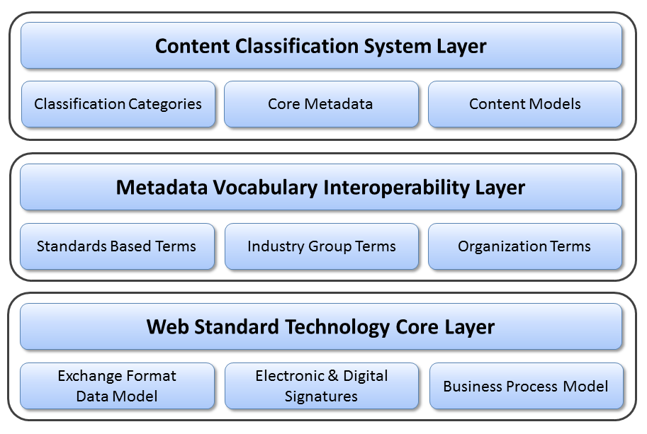
Figure 1: eTMF Foundational Layers

The first layer is the Content Classification System (CCS) layer, which includes three components: Classification Categories Component, Core Metadata component, and Content Model (Taxonomy) component. Details of this layer are discussed in Section 5, “Content Classification System” on page 11.
The second layer is the Metadata Vocabulary Interoperability Layer. The OASIS eTMF model utilizes a controlled vocabulary for content management that is based on terms curated by the National Cancer Institute’s NCI Thesaurus Enterprise Vocabulary Services (NCI EVS) [3]. NCI EVS’ term database is used globally, and contains terms used by healthcare and life sciences standards organizations such as HL7, CDISC, FDA, NIH and others. As part of its term curation effort, NCI manages the semantic relationships between terms and publishes its term database in a machine readable format known as RDF/XML; a web standard that enables interoperable data exchange between systems. Just as the internet uses the HTML to exchange data on websites, the OASIS eTMF Standard’s metadata vocabulary layer is based on the RDF/XML web standard so that any language or term names can be used in the presentation layer. Data interoperability is maintained through the use of RDF/XML in the metadata vocabulary layer, and is separate from the term label that end users see.
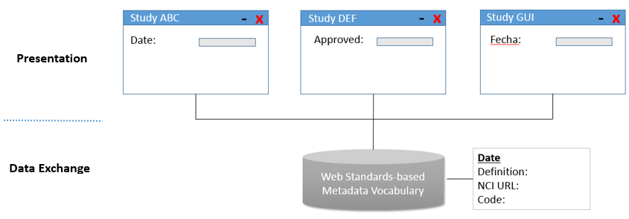
Figure 2: Presentation flexibility and data exchange interoperability with web standards-based metadata vocabulary
In addition to providing organizations with the ability to localize and customize any term label through the use of the Display Name metadata attribute, the metadata vocabulary layer provides organizations with the ability to create cross-referenced taxonomies that have a common interoperable data. As an example, a sponsor and a CRO organization might use a different term to represent the same content in an eTMF. The use of display names enables these organizations to share data seamlessly regardless of the names or even language used to display the terms.
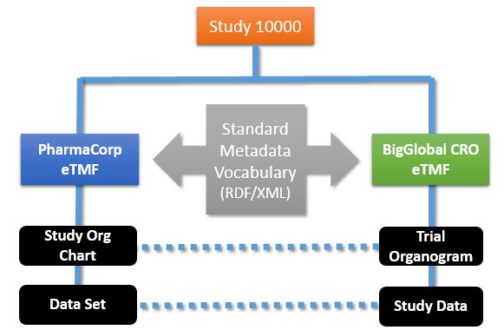
Figure 3: Multiple study taxonomies can be used with different names yet the same data.
The metadata vocabulary layer is flexible and can be extended using a set of metadata vocabulary policies. The metadata vocabulary layer contains standards-based terms, terms sourced from industry groups, and organization-specific internal terms. The OASIS eTMF model metadata vocabulary layer defines a standard set of metadata vocabulary terms that are present in all OASIS eTMF Standard content models, enabling interoperable exchange of taxonomies between sponsors, contract research organizations, investigators and other stakeholders in the clinical trial ecosystem. Support for the DIA TMF Reference Model (TMF RM) is provided in the OASIS eTMF Model through a cross-reference mapping of terms. The DIA TMF RM provides a set of terms for the industry through its published spreadsheet. The OASIS eTMF Model provides a cross-reference mapping of the NCI-based OASIS metadata vocabulary terms to DIA TMF RM terms, providing a path forward to a global ISO standard under the OASIS eTMF Standards effort.
The third layer is the Web Standard Technology Core layer. This layer is based upon the W3C RDF/XML, which represents resources through the web, can be easily searchable, widely used, and allows sharing electronic information through the cloud.

Content Classification System
The CCS Layer includes Classification Categorization (through a classification hierarchy or Taxonomy), a Metadata component, which characterizes content, and a Content Model component, which includes a published set of classification metadata for a specific domain (e.g., eTMF). These components are described in the following sub-sections.

Classification Categorization
Similar to how the Dewey Decimal system is used to classify books by category in a library, the OASIS eTMF model classification categories component utilizes Categories and Content Types with a decimal numbering format to classify documents or content items. The classification categories component format is based on the Universal Decimal Classification System (UDC), which is widely adopted and used by libraries in over 170 countries worldwide. This component is designed for both human and machine readability. It allows for automated sorting of content classifications and documents and has a flexible and infinitely expandable hierarchical system that can use any vocabulary or text-based terms.
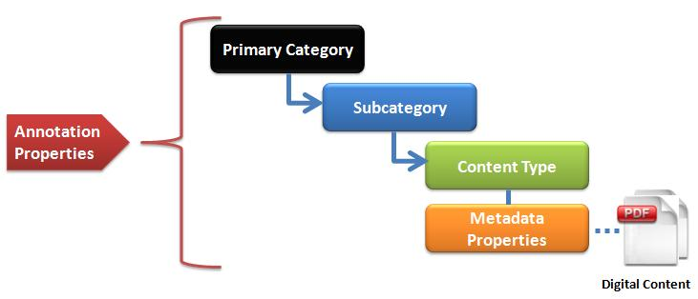
Figure Figure 4, where a document or digital content is classified in Categories. Each digital Content Item is classified by a Primary Category, linked to a Sub-Category, with a link to a single specific Content Type. Annotation Properties (1) provide annotations for Categories, Sub-Categories, and Content Types. As an example, the Annotation Property ‘Definition’ describes briefly the meaning of the title assigned to a Category, a Sub-Category, or a Content Type. The W3C OWL2 specification provides a general description of Annotation Properties. Further details about Annotation Properties are provided in the Appendix.
The Primary Categories in the eTMF domain are numbered from 100 – 199, providing 100 primary category divisions. Use of the three digit primary category yet provides additional categories for future growth in other health science domain areas such as legal, administrative, research and development or other domain areas, from 200-999. An example of how content might be classified, named, and numbered using the OASIS eTMF content classification model is shown below.
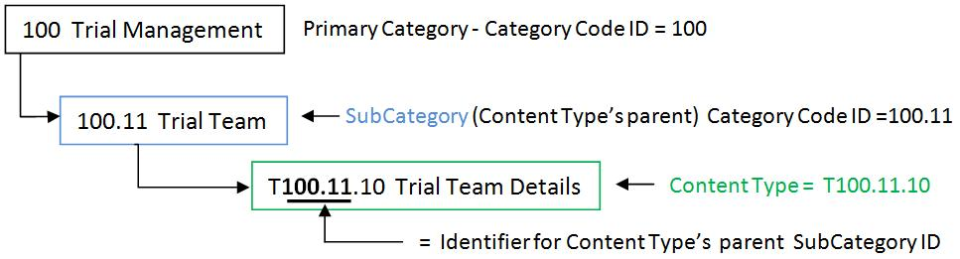
Figure 4: OASIS eTMF Classification Category Code Numbering
Classification categories terms are uniquely numbered using a hierarchical numbering scheme with a digital dot notation. The classification category numbers, known as Category Codes, allow content to be automatically classified in the content tree hierarchy, as shown in Figure 4. Each classification number forms a unique identifier that describes the position of the content in the hierarchy, making documents or content items easily sorted and searched. Design and naming of classification categories in addition to rules related to Category creation and modification are all discussed in the following section.

Content Entities, Hierarchy, and Numbering System
Every Category, Sub-Category, and Content Type contains Annotation Properties. Content Types have both annotation properties and metadata assigned to them, as illustrated in Figure 5. Each Classification entity contains at least the following annotation properties: Category Name, Category Code, and Term Type. Further details about Annotation Properties are provided in the Appendix.

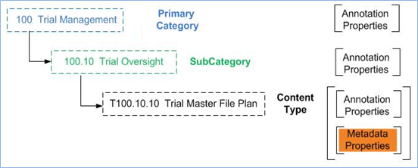
Figure 5: Classification Hierarchy Relationships, Annotation Properties, and Metadata

Classification Categories Design
Primary Categories and Sub-Categories are assigned unique decimal numbers for identification and classification called Category Code numbers. They correspond to one and only one Category Name. Content Types are linked to a parent Category and are used to link related documents or content items. Additionally, the Category Code for any Content Type has a unique numeric code prefixed by the letter “T” for identification and classification. The Category Code for a Content Type is known as Content Type ID. A Content Type ID always contains its parent Sub-Category’s Category Code number in the numeric prefix of the Content Type ID, as illustrated in Figure 6.
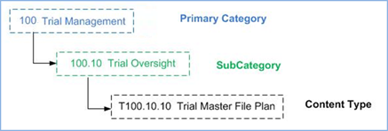
Figure 6: Classification hierarchy example showing categories and classification hierarchy names

Classification Categories Naming Scheme
The Classification System follows a naming scheme that combines the classification hierarchy name (i.e., Category Code, which is designed to automate document classification and locate the category in the content model hierarchy) and the simple text-based name (i.e., Category Name, which is used in the OASIS eTMF model for compliance with other standards). An example is the name “100.10 Trial Management” assigned to a Primary Category, where the first part “100.10” reflects the Category Code, while the second part “Trial Management” represents the Category Name.
Generally, all text-based names, or Category Names, should be unique and should not start with a number or a special character to be compatible with XML naming standards. In the following, we summarize the scheme used in generating the classification hierarchy name:
- Primary Categories: Have a 3-digit numbers starting from 100: 100, 101, 102, etc. up to 999. The maximum number of Primary Categories is 900. Primary Categories act as headings, which include Sub-Categories. Primary Categories may have zero or more Sub-Categories as their children.
- Sub-Category: The Sub-Category classification hierarchy number is based on the number assigned to the Sub-Category’s parent category. It is a sequence number delimited with a period, to indicate the Sub-Category division. Numbers for sub-categories start from 10: 10, 11, 12, etc., up to 99. The maximum number of nested sub-category items per parent category is 90. Examples are: 100.10, 100.11, 100.12, and 142.23.67. The maximum number of Sub-Category divisions is 5 excluding the 3-digits for the Primary Category (i.e., aaa.bb.cc.dd.ee.ff). Every Sub-Category must have one and only one Primary Category or Sub-Category as its parent. Sub-Categories may have zero or more Content Types as their children.
- Content Type: This is a two digit number sequenced from 10-99. It is based on the Content Type’s parent Sub-Category and a sequence number delimited with a period to indicate the Content Type ID, as illustrated in Figure 7. The Content Type ID is always prefixed with the letter “T” to indicate that it is a Content Type entity. Content Types have one and only one Sub-Category as their parent. Typically, a Content Type ID number includes its hierarchical position in the Content Classification hierarchy.
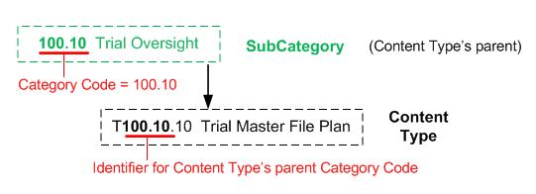
Figure 7: Content Type ID Structure

Classification Categories Numbering Example
An implementation example for a content repository is shown in Figure 8. Within a repository, a single archive would typically contain a collection of related content, such as those relevant to a specific clinical trial study. This figure shows the archive of a clinical study labeled “Study 102880.” Examples for Category numbering (e.g., “100 Trial Management Category”), Sub-Category numbering (e.g., “100.10 Trial Oversight Subcategory”), and Content Type numbering (e.g., “T100.10.10 Trial Master File Plan”) are illustrated in the figure in different colors.
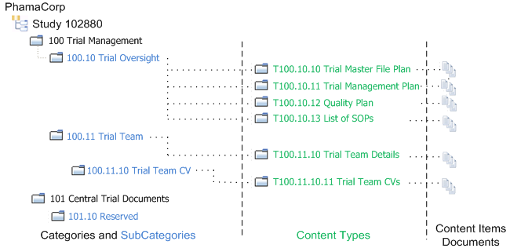
Figure 8: Content Classification Scheme for a Clinical Trial Example

Rules to Modify/Create Classification Categories Entities
Often organizations use abbreviated names, organization specific names, or localized language names for some or all of the Classification Entities. The eTMF model allows applications to use an abbreviation as the Classification Entity Name and use an optional internal label. For interoperability, when using an abbreviation or internal name with any Entity, make sure to retain the original Code for Categories and Content Types.
In an OASIS eTMF model implementation, a new Category, Sub-Category, or Content Type could be added to the classification hierarchy, as long as the classification numbering format is followed and the new entity does not conflict with any existing item. Addition of Categories and Content Types has two possibilities: the new Category or Content Type can either be Organization-specific or Domain-specific.
In the first case, the details of the Organization-specific Category or Content Type are entered by the user and a Category Code and a machine-readable unique Term Code are generated locally in a way that ensures the classification numbering format is followed and no conflicts exist in the classification hierarchy. Category Codes and Term Codes for internal use can be generated following the published Category Code format. These codes should have the ‘Z’ prefix as illustrated in Table 1. Note that, Organization-specific Classification Categories and Content Types could also be imported to a content model (e.g., one organization publishes its own Classification Categories and Content Types for public use and another organization uses them). However, the importing party must check for conflicts, as Organization-specific Classification Categories and Content Types are not interoperable.
In the second case, the Domain-specific Category or Content Type is imported (through looking up the term) from a published Content Model. In this case, the Category Code could be modified to enable placing the new Category in the classification hierarchy. However, the assigned Code should not be changed under any circumstances, so as not to violate interoperability. Generally, new Categories, Sub-Categories, and Content Types could only be imported from existing Content Model Categories, Sub-Categories, and Content Types, respectively ( i.e., no mixing is allowed, such as importing an existing Content Model’s Content Type as a new Sub-Category).
Restrictions apply to which Annotation Properties can be modified for different types of Classification Categories and Content Types. Except for annotation properties of Organization-specific classification Categories and Content Types, only Display Name, Definition, Abbreviation, and Requirement Annotation Properties can be modified. Table 1 illustrates rules for modifying/creating annotation properties for different types of Classification Categories and Content Types. Please refer to the Appendix for detailed information regarding Annotation Properties. It is worth mentioning that domain specific classifications are considered to be the core for the content model instance in use. Additionally, a content model could use more than one domain.
Table 1: Rules for Creating and Editing Annotation Properties of Categories and Content Types
Type of Category or Content Type Term/ Create or Edit Annotation Property | Display Name | Preferred Name | Requirement | Definition | ValueSet | Abbreviation | Data Type | Term Source URL
Domain-specific | Yes | No | Yes | Yes | No | Yes | No | Yes
Organization-specific | Yes | Yes (1) | Yes | Yes | Yes | Yes | Yes | No (2)
- Preferred Name can be created but not edited.
- Organization-specific term has no Term Source URL.
Domain-specific Classification Categories and Content Types cannot be deleted from the content model. Instead of deleting a classification item that is unused, the item’s name is marked as ‘Reserved’, to denote that the item is not used in the content model. This marking enables interoperability and the future use of the item, if needed. However, Organization-specific Categories and Content Types can be deleted from the Content Model. Table 2 provides a summary of the OASIS eTMF modification rules discussed in this section.
(Continued)

Table 2: Rules for Addition, Modification, and Delete of Classification Categories and Content Types
Type of Classification Category or Content Type/Action | Import Term | Generate Code | Add / Modify Term | Delete/Reserve Term
Domain-specific | Yes | No | Yes/Yes | Reserve/UnReserve
Organization-specific | Yes | Yes | Yes/Yes | Delete

Metadata Definitions
Metadata is used to give additional information about digital content items and classification categories. The OASIS eTMF model includes two types of metadata (illustrated in Figure 9):
- Metadata Properties: Describes the Content Type, e.g., Study ID, Site ID, Org, etc. It is also called Data Properties.
- Annotation Properties: Describes attributes of Content Classifications and attributes of Metadata Properties.
Each of these metadata types are discussed in detail in the following sections.

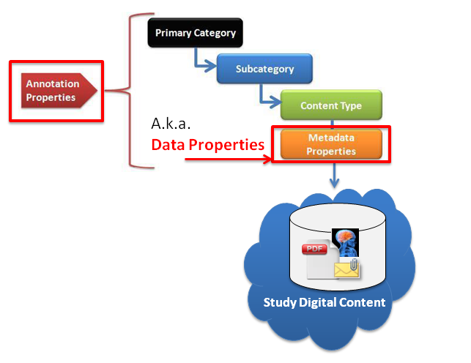
Figure 9: OASIS eTMF Metadata Definitions

Metadata Properties
What is metadata and why is it needed? Metadata, or information about data, is used to tag or index digital content items such as documents. In the context of a Content Management System (CMS), metadata is used to help organizations automate the classification and search, report, and exchange of digital content items. Every digital document has some basic core metadata. For example, every computer file contains metadata such as the ‘file type.’ That metadata facilitates file exchange and enables applications to automatically process files. Figure 10 shows an example for file metadata, displayed upon right-clicking on it.
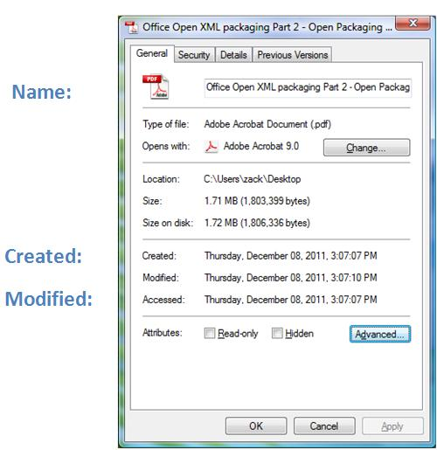
Figure 10: File Metadata Example

If every organization uses different metadata terms (as shown in Figure 11), it is impossible to enable efficient global search, reporting, and classification of documents within and outside of an organization.
As illustrated in the figure, the use of dissimilar metadata terms inhibits efficient search and decreases productivity, while the use of similar terms enhances search efficiency and business productivity.
The OASIS eTMF model metadata is divided into four types: Core Metadata, Domain Specific Metadata, General Metadata, and Organization Specific Metadata.
- Core Metadata is associated with every document or Content Item, such as the basic audit information ‘Created by’ and ‘Modified by’, which are widely used in EDMSs.
- Domain-based Metadata are those used in specific domain areas, such as the metadata used in the Clinical Trials electronic Trial Master File (eTMF) domain. General Metadata is a set of Metadata Properties obtained from public terminology resources and metadata vocabularies (in support of interoperable solutions), such as Dublin Core Metadata [4].
- Finally, in order to allow for a flexible model that organizations can easily adapt to existing business terms and business processes, Organization Specific metadata can be used with any content type. In general, Organization specific metadata terms, unless widely published, may not be interoperable with content models in use by other organizations or entities. Due to its lack of interoperability, Organization specific metadata is not published in the OASIS eTMF model. Domain-specific, Organization-specific, and General Metadata Properties could be added to a Content Model according to an organization’s needs. Please refer to the Appendix for further details.

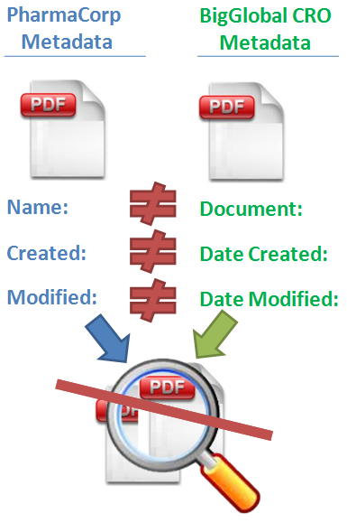
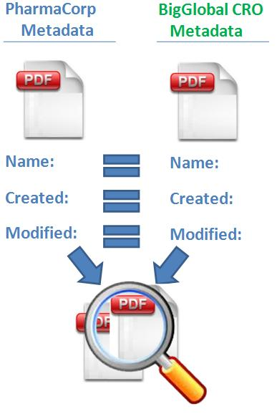

Figure 11: Similar vs. Dissimilar Metadata or Terms
The OASIS eTMF model metadata is also known as Data Properties (both names are used interchangeably throughout this document). Data Properties are similar to XML attributes. They define the attributes of Content Types. For example, ‘Country’ is a Data Property, which describes the country for a Content Item. Data properties are associated with each Content Type instance. Data Properties are simple Content Item tags without explicit relationships defined within the model. For a general description of a Data Property, see the W3C OWL2 specification [2]. Data properties have a number of annotation properties that provide additional information.

Rules to Modify/Create Metadata Terms
To ensure interoperability in the OASIS eTMF model, a number of rules must be followed when adding, modifying, or deleting metadata terms, as summarized in Table 3 and Table 4 . Adding Domain-specific Metadata terms, General Metadata terms, and Organization-specific Metadata terms is allowed. Metadata terms could be added to the content model through looking up (i.e., importing) or enabling the user to enter its details, as shown in Table 3. The former case applies to General and Domain-specific Metadata terms (as their details are already available in other published content models or in resources for public vocabularies), while the second case applies to Organization-specific Metadata terms. Core Metadata terms is part of the published content model and cannot be added.
Generally, interoperability is satisfied through the Code annotation property included with every entity term. This annotation property provides a unique number assigned to every entity term, including Category, Sub-Category, Content Type, and Metadata terms. To ensure interoperability, this unique code value cannot be modified once created.
In case of Organization-specific metadata terms, the details of these terms (i.e., values of annotation properties) are user-defined with exception to Code annotation property, which is generated locally. Domain-specific and General Metadata terms could be imported through looking up existing sources, such as the NCI Thesaurus and Dublin core, respectively. When importing metadata terms, the Code annotation property should be retained unmodified. Note that, some General Metadata properties may not include the Code annotation property. To ensure interoperability, these codes should be generated locally whenever required. The local generation of Codes should ensure the uniqueness of the generated code such that no conflicts exist with any other codes in the content model. Rules for Code generation and the import of different types of metadata terms are summarized in Table 3. This table also presents rules for addition and modification of metadata terms (in the content model) according to their types.

Metadata Type/Action | Import Term | Generate Code | Add / Modify Term | Delete/Reserve Term
Core | No | No | No/Yes | No/No
Organization-specific | No | Yes | Yes/Yes | Delete
Domain-specific | Yes | No | Yes/Yes | Delete
General | Yes | Yes(1) | Yes/Yes | Delete
- Only generate Code if a code is not available from the term source (e.g., Dublin Core metadata)
Table 3: Rules for Addition, Modification, Import, and Delete of Metadata Properties
Modification of metadata terms is allowed; however, not all annotation properties could be modified. Table 4 illustrates annotation properties that could be modified per metadata type.
Metadata Type/ Create or Edit | Display Name | Preferred Name | Requirement | Definition | ValueSet | Abbreviation | Data Type | Term Source URL
Core | Yes | No | No | Yes | No | Yes | No | No
Organization Specific | Yes | Yes (1) | Yes | Yes | Yes | Yes | Yes | Yes
Domain Specific | Yes | No | Yes | Yes | No | Yes | No | No
General | Yes | No | Yes | Yes | No | Yes | No | Yes (3)
- Preferred Name can be created but not edited.
- Only allow editing of a URL if there is no URL available from the term source.
Table 4: Rules to Edit/Create Metadata Annotation Properties
Finally, when a published content model is used, some metadata terms cannot be deleted; they are labeled ‘reserved’ in the content model, as shown in Table 3. Whenever these terms are used in the future, they would be labeled as ‘unreserved’ metadata terms. Domain-specific Metadata, Organization-specific Metadata, and General Metadata can be deleted from the content model if they are not referenced in any content item. Core Metadata terms are not allowed to be reserved or deleted, as they provide basic information in any content model.

Annotation Properties
Annotation properties provide additional information about different entities in the OASIS eTMF model, including classification categories (i.e., Categories and Sub-Categories), Content Types, and Metadata Properties. An example for annotation properties is Code, which uniquely identifies different terms in a content model. The OASIS eTMF model includes two types of annotation properties: Core and Organization-specific. The former are part of the published content model, while the latter are added to the content model according to an organization’s specific needs.

Rules to Modify/Create Annotation Properties
As with Classification Categories, Content Types, and Metadata Properties, Annotation Properties also have rules for modification, addition, and deletion. Table 5 summarizes rules for addition, deletion, modification, and import of annotation properties. Generally, Core annotation properties are part of the published content model and they can be neither added nor deleted. Both core and organization specific annotation properties cannot be imported (i.e., looked up in public resources). Additionally, when an organization-specific annotation property is added, a unique code is generated locally. This code should not conflict with any other existing code.
Annotation Properties Type/Action | Import Term | Generate Code | Add / Modify Term | Delete/Reserve Term
Core | No | No | No/Yes | No delete or reserve
Organization-specific | No | Yes | Yes/Yes | Delete
Table 5: Rules for Addition, Modification, Import, and Delete of Annotation Properties
Annotation properties also have additional annotation properties that provide details about them. In case of modifying details of annotation properties, only a subset of the annotation properties of annotation properties could be modified for the Core type, while more annotation properties could be modified for the Organization-specific type. Annotation properties that can be created or modified are illustrated in Table 6.
Annotation Properties Type/ Create or Edit | Display Name | Preferred Name | Requirement | Definition | ValueSet | Abbreviation | Data Type | Term Source URL
Core | Yes | No | Yes | Yes | No | Yes | No | No
Organization-specific | Yes | Yes (1) | Yes | Yes | Yes | Yes | Yes | Yes
- Preferred Name can be created but not edited.
Table 6: Rules to Edit/Create Annotation Properties of Annotation Properties
Finally, the details of the OASIS eTMF model annotation properties are presented in the Appendix.

Content Model
Content models represent content classifications, relationships, and metadata in a semantic web taxonomy or ‘Ontology’. Content models are technology agnostic; there is no particular software, computer operating system, or application required in order to use them. They are published using a Web standard format known as ‘OWL’. This format allows browser-based discovery of information. To illustrate how the OASIS eTMF content model can be used in an organization to manage content items, consider the technology that nearly everyone has used - management and organization of music MP3 files.
All MP3 files today contain standard tags or metadata, such as Artist, Title, Album, and Genre that are embedded in the MP3 file to enable rapid electronic classification and search. These tags describe the music or album. A user typically classifies the MP3 files by Genre or category, such as ‘Rock’, ‘Jazz’, etc. Because of standard MP3 tags/terms and the MP3 genres or classifications, it is possible to easily search for MP3 songs on the internet or in a file system. Additionally, many software applications can read an MP3 library collection, import it, and automatically classify and sort MP3s based on the metadata tags. Similarly, by using both a standardized set of metadata terms for tagging and a set of published content classification categories, health science content items (such as documents, images, photos, and other digital media) can be tagged, organized, and more efficiently searched.
As in the MP3 content classification example, the OASIS eTMF content model uses a published set of content classification categories in a hierarchy, as shown in Figure 12. Each content classification primary category contains Sub-Categories and Content Types. A Content Type is linked to a reusable collection of metadata for a category of items or documents. Content Data Properties, or Metadata, describe the document or content item’s attributes.
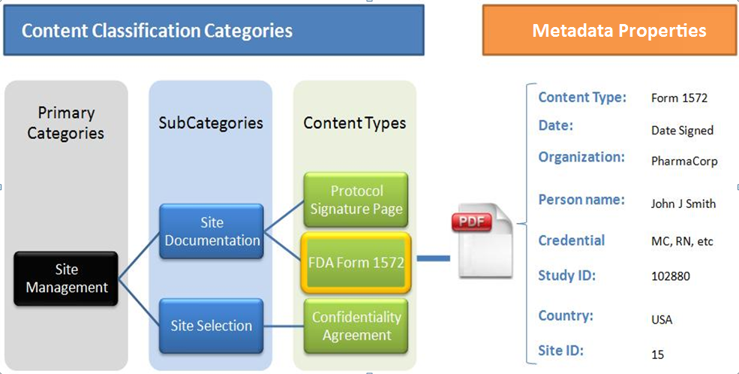
Figure 12: OASIS standard eTMF Content Model Example

While the OASIS eTMF content model hierarchy is flexible and interoperable, it is also useful for organizations that want to save time and resources and share content models with others.

Content Model Format
The OASIS eTMF content models are created and published as ontologies based on the W3C’s OWL 2.0 syntax and RDF/XML. Semantic web allows seamless sharing, linking, and search of data across domains. Additionally, the W3C’s OWL format is used in describing the content model in order to retain compatibility with the technology that NCI, WHO, and other leading health science vocabulary standards groups are using to model information relationships (3) and (4) . The OWL format can be used to represent hierarchies, complex relationships, data properties, and values. It also allows search engine discovery and presentation in a web browser. Furthermore, many Organizations are moving towards a semantic web model, which enables interoperability between content models. For example, the CTMS model follows BRIDG semantic web model; hence, the OASIS eTMF content model can be more readily integrated with the CTMS for interoperability given they are both based upon the semantic web model.
The best way to view, understand, and edit the OASIS eTMF content model hierarchy is to open the content model in the Protégé OWL editing application. Using the NCBO BioPortal/OASIS sites, download the OASIS eTMF content model OWL file and open it in Protégé. In Protégé, users can add new Categories, Content Type, and Data Properties, and perform editing operations to change labels or other minor changes.
Protégé is a very sophisticated application. However, the OASIS eTMF content model only uses a subset of the features of the OWL syntax and Protégé. Users should focus primarily on the tabs ‘Classes’, ‘Individuals’, and ‘Data Properties’. shows a screenshot of the Protégé editor. In this example, we use the Stanford University’s Protégé application, freely available for download at the following:
URL: http://protege.stanford.edu [7].
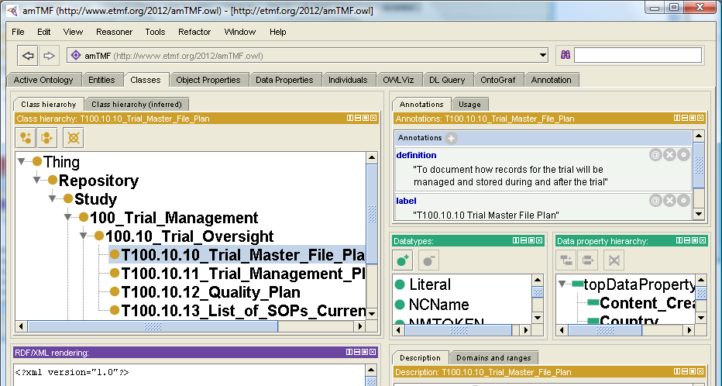
Figure 13: Using Protégé OWL Editor to Modify OASIS eTMF content Models

An example for a W3C RDF/XML file is illustrated in Figure 14. The W3C RDF/XML is used as the syntax for content model representation and exchange. The file contains RDF and OWL in XML. Additionally, it includes reference to content model Profile for the eTMF. Furthermore, the RDF/XML file contains the content model instance for a study.

The .owl filename extension is used for the RDF/XML files. Filenames for content model exchange shall be similar to IETF URL naming as follows: Alphanumeric characters and the hyphen ‘-’ (special character) can be used to ensure future compatibility.
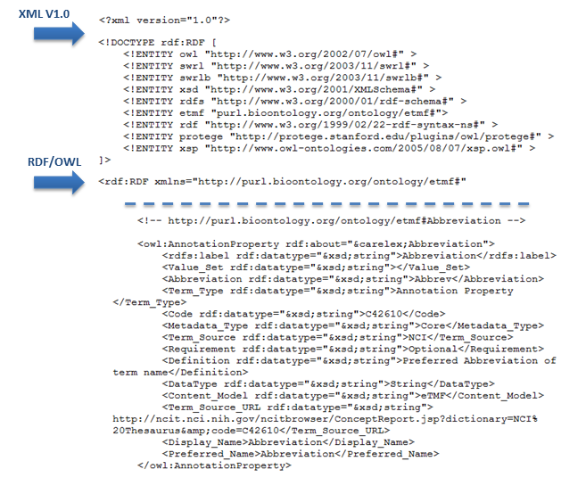
Figure 14: Example W3C RDF/XML File Snippet

Content Model Exchange
The OASIS eTMF content model profile is represented as W3C OWL2 classes. In this way, content models can be easily edited and shared by anyone. Content Model instances are expressed as W3C RDF/XML (e.g., eTMF specific study).
Generally, RDF/XML is used as the syntax for content model exchange. Content models can be exchanged using Serialized RDF/XML or RDF/XML as a file with .owl extension (e.g., etmf.owl). No specific exchange protocol is specified by RDF/XML nor is one required for the content model exchange (the protocol is application/implementation specific). Any protocol which supports exchange of RDF/XML files or serialized data can be used (e.g., W3C http/s, REST, SOAP, RPS, CMIS, etc.).

Content Model Versioning
Versioning of content models is supported through the W3C OWL Versioning Policies . The W3C OWL supports granular level of versioning. However, version management is considered to be an application-specific task. Being a W3C standard, an OWL file includes an element for content model versioning; the owl:versionInfo, which provides a hook suitable for use by version management systems.
The OASIS content model version numbering text follows the Major.Minor numbering format, where the Major part reflects the content model profile version number. The Minor part should reflect an Organization-specific version of the content model (as illustrated in Figure 15). This Minor numbering may be enhanced with Organization-specific and application-specific numbering within the W3C OWL versioning policies. The element owl:versionInfo in RDF/XML should be used for Categories, Content Types, Annotation Properties, and Metadata Propertiers. Finally, the first version of the OASIS eTMF content model would be published as Version 1.0.
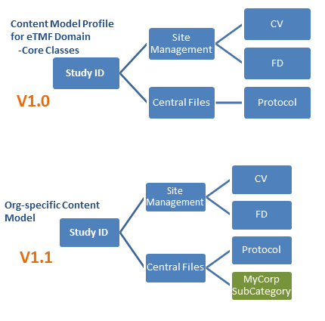
Figure 15: Content Model Versioning Example

Web Standard Technology Core
The Web Standard Technology Core Layer has three components: the Data Model, the Electronic and Digital Signatures technologies, and Business Process Model support.

OASIS eTMF Data Model
The OASIS eTMF data model represents a single instance of an eTMF content model for a single clinical trial. An eTMF data model instance contains data values for metadata properties and content items for this clinical trial study. It also includes the core and organization specific content model categories and content types. The OASIS eTMF data model enables organizations to package, archive, and share clinical trial records with other systems or with regulatory agencies. For FDA part 11 compliance, the eTMF electronic archives can be exported using common file formats of XML and PDF. These electronic eTMF archives have the ability to be viewed in a simple web browser or exchanged using simple files and folders that are operating system and application independent. The information in all data models should contain the content model instance, content item URIs and metadata values, and should follow content classification rules and policies.
The OASIS eTMF content classification system uses W3C OWL2 RDF/XML to represent content models. Starting with standards based content model ontology; it is possible to create an organization specific instance of the content model that represents the clinical trial taxonomy, metadata values, and content items in a clinical trial. As well as exporting records as regulatory agency compliant archives, the OASIS eTMF clinical trial data model can be exported to other systems that can be viewed in any web browser, Exported OASIS eTMF data model content items can be stored in the cloud, simple file folders, or other physical media such as network file shares or connected storage with a URI.

OASIS eTMF Data Model Exchange Format
The OASIS eTMF data model primary exchange file format is the RDF/XML. The file includes core and organization specific Categories and Content Types (reserved and in use), annotation properties, metadata properties, and links to instance resource content items offline and online (linked data). Content item name is unspecified and the content item file format is any supported IANA media type format [1]. To allow exporting content items that use the electronic Common Technical Document (eCTD) compatible file formats (for FDA Part 11 compliance), a metadata term called eCTD Item tags eCTD docs/records (tag value is true or false).
This format enables the interoperable exchange of content models, content items from cloud or physical media, metadata terms, and metadata values for clinical trial study instances between systems and applications. Exported records are in XML format and no specific format for content items is specified.
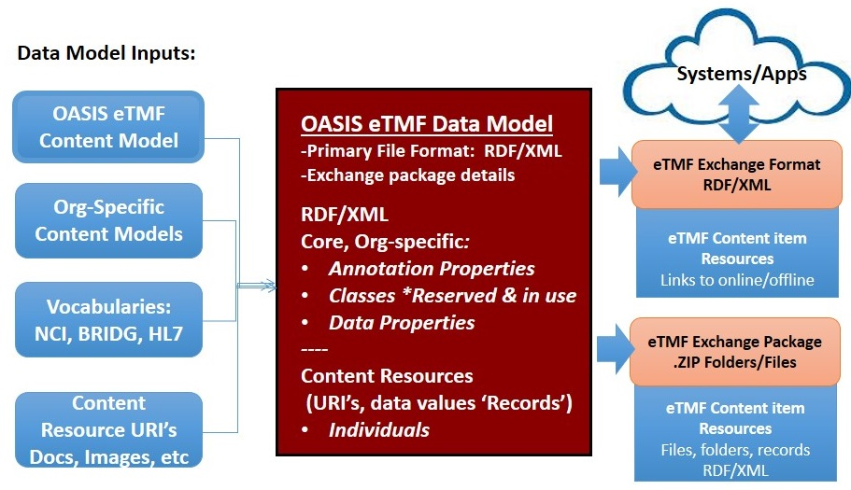
Figure 16: Data Model inputs, file format; eTMF Exchange format and package

OASIS eTMF Exchange Package
All OASIS eTMF content can be exchanged as collection of folders following the folder taxonomy and includes content items and records in RDF/XML format. Folders and resources are packaged in a standard .ZIP file, with or without encryption. Additionally, the OASIS eTMF standard supports an Alternate Taxonomy; alternate names for classification categories and content types for the exchange format. The Alternate Taxonomy is supported through the use of Display Name metadata property. This metadata property allows the use of any language and names for the exported taxonomy. It can be used for any category and content type for exchange. Interoperability is enforced with RDF/XML. Figure 17 shows an example for the Alternate Taxonomy for the eTMF Exchange Package folder names.
The eTMF exchange file format has a default structure and naming and supports any IANA media type; thus, enabling broad flexibility. The eTMF exchange file format will be an RDF/XML file with records and URI pointers to linked content online or offline.
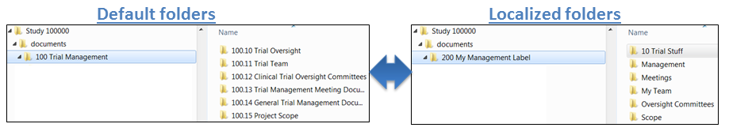
Figure 17: Alternative Taxonomy Example

Electronic and Digital Signatures
Electronic and digital signatures enable the removal of wet signatures on paper. An electronic signature (i.e., point of sale signature) is a digital mark accepted by many agencies. They are accepted by both EMA and FDA. However, the signing party cannot be easily verified.
Digital signatures use a digital certificate issued to the signing party and incorporate standards based technology (x.509 PKI). A digital certificate is a cryptographic artifact. It contains a cryptographic key using RSA or Elliptic Curve technologies, where the private key is not discernable by knowing one’s public key. The subscriber gets a public key and a private key.
The digital certificate technology is known as the Public Key Infrastructure (PKI). Currently, the FDA requires a digital signature for eSubmissions and a trusted digital certificate on the documents themselves. There are multiple types of digital certificates that are trustworthy. An electronic document, such as a PDF, that is digitally signed using a digital certificate from a recognized certificate authority is more reliable than a wet signature on a paper. As of September 2013, the EMA moved to require only digital certificates from recognized certificate authorities for three types of submissions: orphan medicines, pediatric submissions, and scientific advice.
Digital certificates are issued to individuals, groups, and devices. In the context of the OASIS eTMF standard content model, digital certificates are issued to individuals to sign electronic documents. Digital certificates must satisfy the EU qualified certificate policy and the EU advanced electronic signature directive. As of the date of this document, there is a complete overlap between these EU requirements and the FDA PKI policy.
Digital signatures enable validation of the signing party through digital certificate technologies using a third party certificate authority validation website. Contrary to electronic signatures, digital signers are validated every time they sign. Additionally, digital signing should use the two factor authentication, as per FDA CFR 21 Part 11.
The OASIS eTMF standard supports two types of electronic signatures; electronic signatures (under Part 11 and EMA) and digital signatures. The standard recognizes images with signatures, which can be supported in the OASIS eTMF standard through metadata to indicate documents that contain a scanned signature.
Generally, electronic signatures should comply with FDA and EU regulations. Additionally, any file format approved by FDA and EU is supported for e-signing. Digital signatures should use x.509 PKI certificates, should comply with FDA and EU regulations, and should support any file format approved by FDA and EU for e-signing. While not the purview of version 1.0 of this draft standard, V2.0 of the OASIS eTMF standard should support EU compliant Digital Signatures per emerging EU regulations.

Business Process Model
Many organizations use automated business processes or workflows for specific operations, such as electronic document approvals. The Business Process Model component provides a mechanism to capture basic business process model task completion information found in metadata linked to documents. The Business Process Model is based on the Business Process Model and Notation (BPMN) V2.0 specification, which is maintained by the Object Management Group [7]. BPMN is a standard for business process modeling, i.e., the representation of processes in an enterprise, with an objective to support business process management. The BPMN V2.0 includes two elements: Business Process and Task. A Business Process is a collection of related tasks that produce a specific output, e.g., a service or a product. A Task is a unit of work that cannot be broken down into a further level of business process details. An example is provided in Figure 18 to illustrate Business Processes and Tasks. In this figure, the Business Process “Sign and Review” is split into three Tasks: Send email request for Signature, Sign Document, and Review Complete.
The aforementioned BPMN elements are supported in the OASIS eTMF Business Process Model component. They are mapped to their equivalent OASIS eTMF model Business Process Metadata (BPM) terms. For example, whenever a process, or a specific task in the process, is completed for a particular content item, a date/time stamped entry is captured in the OASIS eTMF model BPM, forming an auditable document history log (see Figure 19 for an example). The OASIS eTMF model Business Process component utilizes XML to capture the details of BPMN processes and tasks. No specific software, system, or language is required to implement it.

The OASIS eTMF model BPM enables capturing details about business processes and tasks associated with a specific document. It also allows organization and person entities to be associated with processes and tasks. The OASIS eTMF model BPM includes Process Name, Task Name, Content Type, Organization, Person, Source, Digital Signature, and Date. The OASIS eTMF model BPM can be captured for any Content Type.

When used in conjunction with digital signatures, the OASIS eTMF model Business Process Component offers automation of paper-based document approval and signing processes. Figure 18 shows an example of a BPMN V2.0 process for an automated signature approval on a confidentiality agreement. Figure 19 illustrates how the BPMN signature process example in Figure 18 is mapped into BPM, with a date/time stamp captured to indicate completion of each task. By capturing the date/time stamp in the BPM for each completed process and task, each document resource has its own auditable workflow metadata history; this enables detailed auditing and reporting in applications. For each Content Type that uses BPM, a new entry is made in the BPM history log for each task in a process. For example, one of the tasks is Send email request for signature, which is associated with the Content Type ‘Confidentiality Agreement’. This information is captured in the OASIS eTMF model BPM history log as shown in the figure.
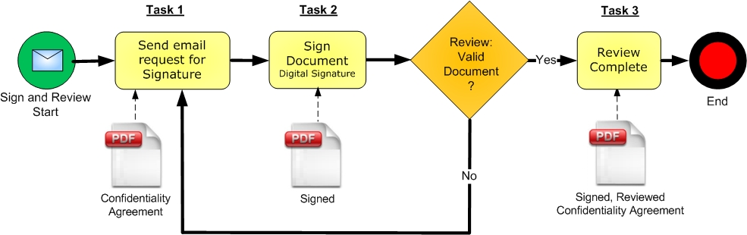
Figure 18: Business Process Management “Sign and Review Process” Example Using the BPMN Notation
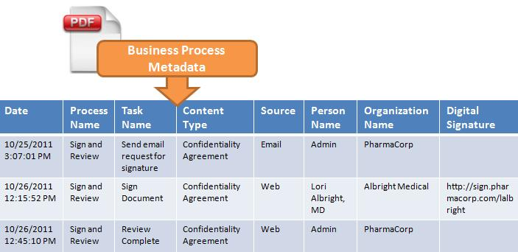
Figure 19: The OASIS eTMF BPM Audit Trail Log Captured for Tasks in Figure 18

Conformance
An implementation is a conforming eTMF Content Classification System if the implementation meets the conditions in section 1.1:

  - Conformance as an eTMF Content Classification System

An implementation is a conforming eTMF Content Classification System if the implementation meets the conditions:
- Conforms to specifications detailed in the OASIS eTMF Content Classification System (CCS) Layer, with support for the Content Classification System, the RDF/XML based Content Model and includes support for the Core Metadata.
  - Conforms to CCS specifications for naming, numbering and organizing content classifications
  - Conforms to CCS specifications and policy rules for modifying and editing content classification entities.
  - Includes Core Metadata as property tags for all content classified in the system.

- Conforms to specifications detailed in the OASIS eTMF Metadata Vocabulary Interoperability Layer, and sources core classification terms from the published OASIS eTMF Standard Ontology, based on terms published at the National Cancer Institute’s NCI Thesaurus term repository.
  - Supports the Metadata Vocabulary Interoperability Layer requirement that classification entity terms must have a user-modifiable display label to enable localized terms to end-users.

- Conforms to specifications detailed in the OASIS eTMF Web Standard Core Layer.
  - Supports content exchange through the RDF/XML based data model component.
  - Supports FDA and EMA acceptable electronic and digital signatures as detailed in the electronic and digital signature component.

- If the eTMF Content Classification System is used for any application where ‘individually identifiable health information’ is captured, stored or transmitted, US Department of Health and Human Services HIPAA privacy regulations and compliance policies for electronic records and patient protected health information (PHI) security must be implemented in the eTMF System. For example, investigator site data may contain individually identifiable patient protected health information. System protections and data management policies for the protection of this information must be implemented to be in compliance with US HIPAA privacy regulations.

- If the eTMF Content Classification System is used for clinical trials subject to FDA regulation and electronic records and / or electronic signatures are used, the system must adhere to applicable FDA regulations such as 21 CFR Part 11 or other related agency regulations.

- Acknowledgments
The following individuals have participated in the creation of this specification and are gratefully acknowledged:
Participant: | Organization:
Sharon Ames | NextDocs
Michael Agard | Paragon Solutions
Jennifer Alpert Palchak | CareLex
Peter Alterman, PhD | SAFE-BioPharma Association
Aliaa Badr | CareLex
Lou Chappuie | SureClinical
Sharon Elcombe | Mayo Clinic
Chet Ensign | OASIS
Robert Gehrke | Mayo Clinic
Troy Jacobson | Forte Research Systems, Inc.
Rich Lustig | Oracle
Christopher McSpiritt | Paragon Solutions
Jamie O'Keefe | Paragon Solutions
Oleksiy (Alex) Palinkash | CareLex
Fran Ross | Paragon Solutions
Catherine Schmidt | SterlingBio
Zack Schmidt | SureClinical
Mead Walker | Health Level Seven, Inc.
Trish Whetzel, PhD | SureClinical

The Technical Committee thanks the following for their work:

For its work on the eTMF controlled vocabulary, we acknowledge the National Cancer Institute, Enterprise Vocabulary Services. In particular, we acknowledge the work of:
Margaret W. Haber, Program Manager, Enterprise Vocabulary Services, National Cancer Institute

Theresa Quinn, Biomedical/Clinical Research Information Specialist (C) Enterprise Vocabulary Services, National Cancer Institute

Jordan Li, PhD, Biomedical/Clinical Research Information Specialist (C) Enterprise Vocabulary Services, National Cancer Institute

Erin Muhlbradt, PhD, Biomedical/Clinical Research Information Specialist (C) Enterprise Vocabulary Services, National Cancer Institute

For its work in reviewing the specification, we acknowledge the PhUSE/FDA project. In particular, we acknowledge the work of Kerstin L. Forsberg
- OASIS eTMF Terms
  - OASIS eTMF Classification Terms
Classification Category terms, used in the OASIS eTMF Content Model, are sourced from NCI (1) using the CareLex Preferred Term, as approved by the eTMF Technical Committee. Classification terms are published online and curated by NCI.
  - OASIS eTMF Model Metadata Properties
The OASIS model Metadata is linked to each Content Type. Similar to how MP3 files are tagged with metadata like artist, song, etc., the purpose of the OASIS model Metadata is to tag content items for use in classification, navigation, searching, and reporting. The OASIS model Metadata is split into Core Metadata, General Metadata, Domain-specific, and Organization-specific Metadata. The OASIS Metadata types and their uses are illustrated in Table 7. In the following, Core Metadata is defined in Table 8, eTMF Metadata (i.e., domain-specific metadata) is represented in Table 9, and General Metadata is illustrated in Table 10.
Table 7: OASIS Model Metadata Types and Usage
Metadata Type | Description | How Used
Core | Core metadata are split into four main areas as follows:  - File Properties: The metadata present in most digital files, such as Created, Modified, Filename, Format, and URI (i.e., path).  - Basic audit trail: Indicates username for the user who created and modified a content item. Fields are Created by and Modified by. These are widely used fields in popular CMS’s data properties.  - Classification: Terms used in classification, e.g., Category and Sub-Category. These are annotation properties. When used with a content model, it enables automated content classification and metadata assignment for an item’s Annotation Properties.  - Business Processes: A set of metadata properties that enables capturing tasks in business or workflow processes for a Content Type. For example, after a task (like submittal of an approval or a signature) is completed for a content item, an entry is made in the business process metadata history log to record the task’s occurrence. Additionally, each task includes a date stamp and the name of the organization and/or person to whom the task is linked. For example, in a digital signing business process, a single business process metadata history log entry can be completed using the following attributes:  - Date: Date of signing event.  - Task: The task associated with the document, such as Signed, Approved, Declined, etc.  - Source: The source of the content item, such as Import Scan, Fax, E-mail, System, and Other.  - Organization Name: The name of the organization which performed the business process task or to whom the item or document is linked. Note that Organization name should be captured for each document.  - Person Name: The name of the person who performed the business process task to whom the document is linked.  - Digital Signature: The optional URI to digital certificate information for the document.  Each document must contain at least a Date and Organization Name to which the item is linked. Additionally, each event creates a workflow history entry, in the workflow history table, which is captured for each content item. | Use differs according to the area:  - File Properties: Same as in digital files. It enables minimal metadata mapping for operations, such as drag and drop of files.  - Basic audit trail: Same as the popular EDMSs’ basic audit information for an item. They enable minimal metadata mapping for operations, such as drag and drop of files.  - Classification: Used in automated content classification.  - Business Process: Used in the following:  - Content Item business process or workflow history.  - Content item enhanced audit trail.  - Content Item digital signing process.
Domain-specific | Metadata used in specific domain areas, such as the metadata used in the Clinical Trials electronic Trial Master File (eTMF) of the health science domain. This type of metadata varies according to the domain area. | It provides domain specific information for content items, e.g., Clinical Study Report metadata (used in the eTMF content model in the health science domain) describes final or interim results of a trial.
General | The set of metadata properties obtained from public terminology resources and metadata vocabularies (in support of interoperable solutions), such as Dublin Core Metadata. This type of metadata properties can be applied to a content type at discretion of the implementer. | It provides metadata that can be used in any Content Model. As an example, the Dublin Core resource provides “Description” metadata, which supplies an account for the content item.
Organization-specific | User defined metadata that enables organizations to define their own metadata to fulfill their needs.
    - Core Metadata
The following Table illustrates Core Metadata found in all content models irrespective of domain area.
Table 8: Core Metadata
Term |  | Definition |  | Code
File Properties
Created |  | The date and time at which the resource is created. For a digital file, this need not match a file-system creation time. For a freshly created resource, it should be close to that time. Later file transfer, copying, etc., may make the file-system time arbitrarily different. |  | C69199
Modified |  | The date and time the resource was last modified. |  | C25446
Content Identifier |  | The unique identifier for a content item, such as a document, image, or other media in a specified context. (Document name.) |  | C99023
URI |  | The unique uniform resource Identifier or path (URI) for a content item such as a document, image, or other media in a specified context. |  | C42778
Format |  | Content Item File Format, e.g., PDF, JPG, GIF, XLS, DOC, DOCX, XLSX, PPT, PPTX. It uses a filename extension as the format value. |  | C42761
Document Version |  | A representation of a particular edition or snapshot of a document as it exists at a particular point in time. Please refer to the Appendix for details regarding the document versioning policies. |  | C93484
Country Code |  | Name of country using ISO 3166-1 alpha-3 country codes- Example: USA. |  | C20108
Basic Audit Trail
Created By |  | Indicates the username of the person who brought the item into existence. |  | C42628
Modified By |  | Indicates the username of the person who changed an item. |  | C42629
Classification
Content Type Name |  | The name of the Content Type such as 'CV.' A Content Type is a reusable collection of metadata, workflow, behavior, and other settings for a category of items in electronic content material. |  | C115999
Business Process
Date | Date of task or event, or date in the context of document or Content Type. Date can be different from date created. |  | C25164
Process | A sequence or flow of activities in an organization with the objective of carrying out work. Source: BPMN V2.0 Spec (4). Tasks are atomic activities. They are included within a Process. |  | C29862
Task | A single activity that has occurred within a business process. Generally, an end-user, an application, or both will perform the Task. Concept derives from BPMN V2.0. Example task values are: Submitted, Approved, Reviewed, Signed, etc., indicating that a task has been completed. Each task is date stamped and captured in a single record of the business process metadata history log. |  | C101129
Source | Where the content item is from or its origin. Example values: Import, Scan, Fax, email, system, and other. |  | C25683
Person Name | The full name of the person who performed the workflow action (e.g., approved or submitted a document) or the person to whom this document is linked. |  | C25191
Person Role | The role of the person who is responsible for or linked to a content item, such as Principal Investigator, Sub-Investigator, Study Coordinator, Sponsor Project Manager, CRO Project Manager, or Data Manager. |  | C113644
Subject Identifier | Subject Identifier is a unique sequence of characters used to identify, name, or characterize the study subject individual in a clinical trial study. |  | C83083
Organization Name | The full name of the Organization linked to the resource. |  | C93874
Organization Role | Denotes the role of the organization, which is responsible for or linked to the Content Item. Values include Sponsor, Site, CRO, and Vendor. |  | C114551
Username | The account name used by a person to access a computer system (used for system generated tasks). |  | C42694
Digital Signature | Extra data embedded in a document or metadata linked to a document. It identifies and authenticates the signer of a document using public-key encryption. May be a URI or path to digital signature resource or certificate. |  | C80447
Digital Signature Status | Specifies whether a document or content item has been digitally signed. If no signature is required, status = null. Values: Signed, Not Signed, Null |  | C114552
    - Domain based Metadata (eTMF Domain Example)
Note that the OASIS eTMF model can support other domains in life sciences or healthcare such as research and development, finance, administration, or others.
Table 9: Metadata Used in the eTMF Domain Area (Content Model = eTMF)

Term | Definition | Code
Study ID | A sequence of characters used to identify, name, or characterize the study. | C83082
Site ID | A unique symbol that establishes the identity of the study site. | C83081
Credential | Professional credential of Person for study - MD, RN, PhD or other for Person linked to a content item / document; EX: MD, RN, PhD, MS, MA, BA, MBA | C73925
Visit Number | The numerical identifier of the visit. | C83101
Clinical Study Sponsor | An entity that is responsible for the initiation, management, and/or financing of a clinical study | C70793
eCTD Item | An electronic content item and its associated electronic record that is targeted for inclusion in an Electronic Common Technical Document. Valid values are Yes/No.. | X90010
    - General Metadata
This section discusses General Metadata (obtained from public terminology resources and metadata vocabularies) that can be used in OASIS eTMF ontologies. Terms presented in Table 10 are from the Dublin Core Project [4].
Table 10: General Metadata in Dublin Core
Term | Definition | Code
Description | An account of the resource or content item. | X90005
Location | A spatial region or named place. | X90006
Title | A name given to the resource or content item. | X90007
Type | The nature or genre of the resource or content item. | X90008
  - Annotation Properties
Table 11: Annotation Properties
Term | Definition | Code
Abbreviation | Preferred Abbreviation of term name. | C42610
Annotation Property | Annotation Properties are used to provide annotations for a content model entity or term. For more, refer to general description at: http://www.w3.org/TR/owl2-syntax/#Annotation_Properties | C114458
Archive | A single collection of related digital content items within a digital repository, for example a collection of clinical trial documents for a single clinical trial Study. File based or database. Child entities are Categories, Organization, Person, Data Property, and Annotation Property. | C114463
Category | A hierarchical classification of Content Items within an Archive, with child Sub-Categories and Content Types. Child entities = Sub-Category, Data Property assignments, Data Property values, Annotation Property assignments, and Annotation Property values. | C25372
Category Code | A coded value specifying a Category or Content Type classification using the OASIS eTMF Standard Classification numbering scheme. Required for every Category and Content Type, e.g., 100.11. | C93524
Category Name | The word or phrase used by preference to refer to an entity or a term, including Category, Content Type, Data Property, Annotation Property, Organization, and Person. | C42614
Category Type | Represents the type of the classification Category, which could either be Core (i.e., part of the published Content Model), Domain-specific (i.e., added to the Content Model from another model), or Organization-specific (i.e., user defined). Possible values are core, domain, and org. | C115618
Code | Unique Code assigned to each term, including Category, Content Type, Data Property, or Annotation Property. NCI Thesaurus codes begin with ‘C’; CareLex term codes begin with X; Codes which are pending review by CareLex begin with ‘Y’, while Organization-specific codes and codes for terms used as General metadata (those with no previously assigned Code) begin with ‘Z’. All codes are 1 alpha char (a-z) and 5 numeric characters 0-9. | C115478
Content Item | A single digital file, which may include digital documents, images, multimedia, or other digital content. It has one and only one Content Type parent. Child entities = Data Property assignments and Data Property values. | C99095
Content Model | Specifies the content model that the term belongs to. A content model defines how content can be classified for a specific business domain. It is similar to an electronic filing system folder structure, where content or documents are classified and assigned properties. A content model is structured as ontology comprised of a hierarchical taxonomy of content categories, content or document types, and data properties or metadata. The relationships between content types and data properties are described in a machine readable computer language known as RDF/XML. | C114459
Content Type | A content type is a reusable collection of metadata, business processes, behavior, and other settings for a category of items or documents in electronic content material. | C114466
Creator | Specifies the name of a person or entity that enters a term in the content model ontology. | C42628
Cross Reference | Optional Code indicating mapping of term to an external term in another place (if more than one, each code separated by semi-colon). | C43621
Data Property | Data Properties are similar to XML attributes. They are used to define the attributes of Content Types. For more information, refer to the general description at: http://www.w3.org/TR/owl2-syntax/#Data_Properties | C114468
Data Type | A data type is a classification identifying one of various types of data, such as string, date, integer, or Boolean. It determines the possible values for that type of value. | C42645
Definition | A concise explanation of the meaning of the Data Property. | C42777
Display Name | Provides an alternative Preferred Name. For use by software or systems to provide a localized display name. By default, Display Name is the same as Preferred Name. | C70896
Label | Used only in OWL RDF/XML file. An identifying marker attached to a Category, Content Type, Data Property or Annotation Property. Label is always the same as Preferred Name and cannot be changed. | C45561
Metadata | Used in Ontology to indicate which metadata or data property attributes are assigned to a given content type. Metadata attributes are assigned to Content Types in RDF/XML separated by semi-colons. | C52095
Metadata Type | Metadata terms are organized by type. Types of metadata are: Core metadata, Business Process Metadata, Domain Specific metadata, General Metadata, Organization Specific. | C114465
Preferred Name | The word or phrase used by preference to refer to an entity or a term, including Category, Content Type, Data Property, Annotation Property, Organization, and Person. | C43707
Regulation | Specifies agency regulatory Code Section that corresponds to a Content Type requirement for example, FDA CFR 21 part 11, ICH 5.1.1. Multiple Code sections are separated by semi-colon characters. | C68821
Repository | A digital library in which collections, or archives, of content items are stored in digital format. File based or database. Child entities = Archive. | C114457
Requirement | For a Content Type, specifies whether the Content Type is required by a regulatory agency or to satisfy organization requirements. Does not apply where content type = category. Valid values: Required, Optional, Required if Applicable | C115762
Sub-Category | A classification of content within a parent Category. It may have zero or more Content Types as children. Additionally, it has zero or more Sub-Categories. It is the child of Category. | C25692
Synonym | Synonyms for the Category, Content Type, Data Property or Annotation Property | C52469
Term Source | An indicator of the particular group or agency that supplied a specific term. | C43822
Term Source URL | Indicates URL where term is defined and maintained. Organization specific terms do not require Term Source URL. | C114456
Term Type | The type of term. Valid values are Primary Category, Sub-Category, Content Type, Data Property, Annotation Property, and Entity. | C114455
Value Set | A value set is a fixed set of data values that can be selected for a given data property attribute. The value set helps ensure data entry accuracy for a given data property field. For example, the data property Organization Role may have a value set of: sponsor, investigator, CRO. The data property attribute could be assigned one of these value set values. | C113497
  - Document Version Numbering Policies
In the OASIS eTMF Standard, the document version text values follow the same formatting that is familiar and commonly implemented in software and in other health science standards: Major Version.Minor Version. Version numbering text is an integer value separated by a period, without leading zeros. There can be a new Major version every time the document/content item changes. There can be a new Minor version every time the metadata changes.
Within the OASIS eTMF archives, content item version management shall be application specific to provide application flexibility. However, for consistent content item exchange, version number text formatting should be implemented using the OASIS eTMF document version numbering policies (based on NCI/CDISC/FDA/BRIDG definition: C93816):
- Each document Major version number is an integer starting at '1' and is incremented by 1. The first instance, or the original content item, should always be valued as '1'. The version number value must be incremented by one when a document is replaced, but can also be incremented more often to meet application specific requirements.
- Different versions of the same document belong to the same Content Type group.
- The document Minor version number would be an integer starting at ‘0' and incrementing by 1. The first instance of an original document with no minor version should always be valued as ‘1.0’, where ‘0‘indicates that no minor version exists.
- Documents with a change to the metadata values would require a minor version. The first minor version for a 1.0 document would be indicated as 1.1. Successive changes to any of the document’s metadata would increment the Minor version by 1. For example 1.2 indicates major version 1 and minor version 2. The Minor version number value must be incremented by one when a document’s metadata is changed, but can also be incremented more often to meet the application specific requirements.

- Glossary
Term | Definition | Reference
EDMS | Electronic Document Management System: a collection of technologies that work together to provide a comprehensive solution for managing the creation, capture, indexing, storage, retrieval, and disposition of records and information assets of the organization. | http://www.nd.gov/itd/services/enterprise-document-management-system-edms
eTMF | Electronic Trial Master File: is a formalized means of organizing and storing documents, images, and other digital content for pharmaceutical clinical trials that may be required for compliance with government regulatory agencies. | http://en.wikipedia.org/wiki/Electronic_trial_master_file
eCTD | Electronic Common Technical Document: is CDER/CBER’s standard format for FDA approved electronic regulatory submissions. | http://www.fda.gov/Drugs/DevelopmentApprovalProcess/FormsSubmissionRequirements/ElectronicSubmissions/ucm330116.htm
NCI | National Cancer Institute: is part of the National Institute of Health (NIH) and coordinates the U.S national Cancer program and conducts and supports research, training, health information dissemination, and other activities related to the causes, prevention, diagnosis, and treatment of Cancer. | http://en.wikipedia.org/wiki/National_Cancer_Institute
NCI EVS | NCI Enterprise Vocabulary Service: provides terminology content, tools, and services to code, analyze, and share cancer and biomedical research, clinical, and public health information. | http://evs.nci.nih.gov/

- Revision History
Revision | Date | Editor | Changes Made
R01 | April 18 2014 | Aliaa Badr | Working draft – first version
R02 | May 24 2014 | Aliaa Badr | Working draft – apply edits by Jennifer, Rich, and Airat.
R03 | June 7 2014 | Aliaa Badr | Updated graphics (Figure 6 and 7) to reflect correct classification terms. Added sub-section in the Appendix for OASIS Classification Terms
201406-R01 | June 13, 2014 | Zack Schmidt | Renamed document and version for public review as committee specification draft

