
Energy Market Information Exchange (EMIX) Version 1.0
Committee Specification Draft 04 /
Public Review 04
08 September 2011
Specification URIs
This version:
http://docs.oasis-open.org/emix/emix/v1.0/csprd04/emix-v1.0-csprd04.pdf (Authoritative)
http://docs.oasis-open.org/emix/emix/v1.0/csprd04/emix-v1.0-csprd04.html
http://docs.oasis-open.org/emix/emix/v1.0/csprd04/emix-v1.0-csprd04.doc
Previous version:
http://docs.oasis-open.org/emix/emix/v1.0/csprd03/emix-v1.0-csprd03.pdf (Authoritative)
http://docs.oasis-open.org/emix/emix/v1.0/csprd03/emix-v1.0-csprd03.html
http://docs.oasis-open.org/emix/emix/v1.0/csprd03/emix-v1.0-csprd03.doc
Latest version:
http://docs.oasis-open.org/emix/emix/v1.0/emix-v1.0.pdf (Authoritative)
http://docs.oasis-open.org/emix/emix/v1.0/emix-v1.0.html
http://docs.oasis-open.org/emix/emix/v1.0/emix-v1.0.doc
Technical Committee:
OASIS Energy Market Information Exchange (eMIX) TC
Chairs:
William Cox (wtcox@coxsoftwarearchitects.com), Individual
Edward Cazalet (ed@cazalet.com), Individual
Editor:
Toby Considine (Toby.Considine@unc.edu), University of North Carolina at Chapel Hill
Additional artifacts:
This prose specification is one component of a Work Product that also includes:
- XML schemas: http://docs.oasis-open.org/emix/emix/v1.0/csprd04/xsd/
Related work:
This specification is related to:
- WS-Calendar Version 1.0. Latest version.
http://docs.oasis-open.org/ws-calendar/ws-calendar/v1.0/ws-calendar-1.0-spec.html
- Energy Interoperation Version 1.0. Latest version.
http://docs.oasis-open.org/energyinterop/ei/v1.0/energyinterop-v1.0.html
Declared XML namespaces:
http://docs.oasis-open.org/ns/emix/2011/06
http://docs.oasis-open.org/ns/emix/2011/06/siscale
http://docs.oasis-open.org/ns/emix/2011/06/power
http://docs.oasis-open.org/ns/emix/2011/06/power/resource
Abstract:
This specification defines an information model and XML vocabulary for the interoperable and standard exchange of prices and product definitions in transactive energy markets:
- Price information
- Bid information
- Time for use or availability
- Units and quantity to be traded
- Characteristics of what is traded
Status:
This document was last revised or approved by the OASIS Energy Market Information Exchange (eMIX) TC on the above date. The level of approval is also listed above. Check the “Latest version” location noted above for possible later revisions of this document.
Technical Committee members should send comments on this specification to the Technical Committee’s email list. Others should send comments to the Technical Committee by using the “Send A Comment” button on the Technical Committee’s web page at http://www.oasis-open.org/committees/emix/.
For information on whether any patents have been disclosed that may be essential to implementing this specification, and any offers of patent licensing terms, please refer to the Intellectual Property Rights section of the Technical Committee web page (http://www.oasis-open.org/committees/emix/ipr.php).
Citation format:
When referencing this specification the following citation format should be used:
[EMIX]
Energy Market Information Exchange (EMIX) Version 1.0. 08 September 2011. OASIS Committee Specification Draft 04 / Public Review Draft 04. http://docs.oasis-open.org/emix/emix/v1.0/csprd04/emix-v1.0-csprd04.html.

Notices
Copyright © OASIS Open 2011. All Rights Reserved.
All capitalized terms in the following text have the meanings assigned to them in the OASIS Intellectual Property Rights Policy (the "OASIS IPR Policy"). The full Policy may be found at the OASIS website.
This document and translations of it may be copied and furnished to others, and derivative works that comment on or otherwise explain it or assist in its implementation may be prepared, copied, published, and distributed, in whole or in part, without restriction of any kind, provided that the above copyright notice and this section are included on all such copies and derivative works. However, this document itself may not be modified in any way, including by removing the copyright notice or references to OASIS, except as needed for the purpose of developing any document or deliverable produced by an OASIS Technical Committee (in which case the rules applicable to copyrights, as set forth in the OASIS IPR Policy, must be followed) or as required to translate it into languages other than English.
The limited permissions granted above are perpetual and will not be revoked by OASIS or its successors or assigns.
This document and the information contained herein is provided on an "AS IS" basis and OASIS DISCLAIMS ALL WARRANTIES, EXPRESS OR IMPLIED, INCLUDING BUT NOT LIMITED TO ANY WARRANTY THAT THE USE OF THE INFORMATION HEREIN WILL NOT INFRINGE ANY OWNERSHIP RIGHTS OR ANY IMPLIED WARRANTIES OF MERCHANTABILITY OR FITNESS FOR A PARTICULAR PURPOSE.
OASIS requests that any OASIS Party or any other party that believes it has patent claims that would necessarily be infringed by implementations of this OASIS Committee Specification or OASIS Standard, to notify OASIS TC Administrator and provide an indication of its willingness to grant patent licenses to such patent claims in a manner consistent with the IPR Mode of the OASIS Technical Committee that produced this specification.
OASIS invites any party to contact the OASIS TC Administrator if it is aware of a claim of ownership of any patent claims that would necessarily be infringed by implementations of this specification by a patent holder that is not willing to provide a license to such patent claims in a manner consistent with the IPR Mode of the OASIS Technical Committee that produced this specification. OASIS may include such claims on its website, but disclaims any obligation to do so.
OASIS takes no position regarding the validity or scope of any intellectual property or other rights that might be claimed to pertain to the implementation or use of the technology described in this document or the extent to which any license under such rights might or might not be available; neither does it represent that it has made any effort to identify any such rights. Information on OASIS' procedures with respect to rights in any document or deliverable produced by an OASIS Technical Committee can be found on the OASIS website. Copies of claims of rights made available for publication and any assurances of licenses to be made available, or the result of an attempt made to obtain a general license or permission for the use of such proprietary rights by implementers or users of this OASIS Committee Specification or OASIS Standard, can be obtained from the OASIS TC Administrator. OASIS makes no representation that any information or list of intellectual property rights will at any time be complete, or that any claims in such list are, in fact, Essential Claims.
The name "OASIS" is a trademark of OASIS, the owner and developer of this specification, and should be used only to refer to the organization and its official outputs. OASIS welcomes reference to, and implementation and use of, specifications, while reserving the right to enforce its marks against misleading uses. Please see http://www.oasis-open.org/who/trademark.php for above guidance.

Table of Contents
1 Introduction 9
1.1 Terminology 9
1.2 Process 9
1.3 Normative References 9
1.4 Non-Normative References 10
1.5 Namespace 12
1.6 Naming Conventions 12
1.7 Editing Conventions 12
1.8 Security Approaches 13
2 Overview 14
2.1 Introduction 14
2.1.1 Product Terminology 14
2.2 Approach 15
2.3 Time Semantics 16
2.4 Information Structure 16
2.5 Tenders and Transactions for Power Products and Resource Capabilities 17
2.6 Transport 17
2.7 Verification of Response 17
3 Guide to the Schema Structures 18
3.1 Use of Core Type Extension to define EMIX 18
3.1.1 Core Abstract Types 18
3.1.2 Price Base and its extensions 19
3.1.3 The EMIX Interface 20
3.1.4 The Item Base 21
3.1.5 The Envelope Contents 21
3.2 WS-Calendar Terms and Descriptions (Non-Normative) 22
3.3 Simple Semantic Elements of EMIX 24
3.4 Extensibility of EMIX Framework 24
4 Envelopes: EMIX Base and its Derivatives 25
4.1 UML Summary of the EMIX Base and Extensions 25
4.2 The EMIX Base 26
4.3 The EMIX Product 26
4.4 The EMIX Option 28
4.5 EMIX Delivery 29
5 EMIX Terms 30
5.1 EMIX Performance Oriented Terms 30
5.2 EMIX Schedule Oriented Terms 30
5.3 Market Requirements 31
5.4 Extensibility of Terms 31
6 Schedules in EMIX: Intervals, Gluons, and WS-Calendar 33
6.1 Intervals, Gluons, and Sequences 33
6.2 Availability (Vavailability) and Temporal Granularity 33
6.3 Temporal Granularity 34
6.4 Illustration of WS-Calendar and EMIX 34
7 Standardizing Terms for Market Context 35
7.1 Overview of Standard Terms 35
8 Extending EMIX for Electrical Power 37
8.1 EMIX Interfaces for Power 37
8.2 Power Items derived from Item Base 38
8.2.1 Power Items 38
8.3 Energy Items derived from Item Base 39
8.3.1 Energy Items 39
8.3.2 Illustrative Diagram of Energy Items 40
8.4 Other Item-derived types 40
9 EMIX Power Product Descriptions 41
9.1 Power Product Descriptions 41
9.2 Resource Offer Descriptions 41
9.3 Transport Product Descriptions 41
10 Power Product Descriptions 42
10.1 Overview of Power Product Descriptions 42
10.1.1 Enumerated Power Contract Types 43
10.1.2 Power Product Charges 44
10.2 The Power Product Description 45
10.3 Full Requirements Power 45
10.4 Block Power Full Requirements 46
10.5 TeMIX Power Product 46
11 Power Transport Product Description 48
11.1 Power Transport Elements 48
11.2 UML Summary of Transport Charges 49
12 Profile for Transactive Energy (TeMIX) 50
12.1 TeMIX Overview 50
12.2 TeMIX Products 51
12.3 Conformance Rules for TeMIX 52
12.3.1 Valid TeMIX Product Types 52
12.3.2 Transactive States for TeMIX 52
13 Energy Resources 53
13.1 Resource Capabilities 53
13.2 Resource Capability Description 54
13.3 Contrasting Operation and Capability Descriptions 55
13.4 Resource Description Semantics 55
13.5 UML Summary of Resource Descriptions 57
13.6 Generic Power Resource 57
13.6.1 Power Ramp Segments 57
13.6.2 Offer Curves 58
13.7 Voltage Regulation Resources 58
14 Ancillary Services Products 60
15 EMIX Warrants 62
15.1 Warrants Described 62
16 Power Quality 64
16.1 Power Quality Warrant 64
16.2 UML Summary of Power Quality Indicators 67
17 Conformance and Rules for EMIX and Referencing Specifications 68
17.1 EMIX Conformance with [WS-Calendar] 68
17.1.1 Inheritance in EMIX Base 68
17.1.2 Specific Attribute Inheritance within EMIX Envelopes 69
17.2 Time Zone Specification 69
17.3 Inheritance from Standard Terms 69
17.4 Specific Rules for Optimizing Inheritance 69
A. Acknowledgements 71
B. Extensibility and EMIX 72
B.1 Extensibility in Enumerated values 72
B.2 Extension of Structured Information Collective Items 73
C. Electrical Power and Energy 75
D. Mapping NAESB Definitions to Terminology of Energy Interoperation 76
E. Revision History 80

Index to Figures
Figure 2-1: Attributes of a Product 15
Figure 3-1: The Abstract Product Description Base Type 19
Figure 3-2: Price Base and Extensions 20
Figure 3-3: Summary of EMIX Interfaces including both Emix and Power 21
Figure 3-4: Envelope Contents 22
Figure 4-1: UML of EMIX Base and its Extensions 25
Figure 4-2: EMIX Base Type 26
Figure 4-3: EMIX Product 27
Figure 4-4: EMIX Option Type 28
Figure 4-5: Delivery 29
Figure 5-1: Summary of EMIX Terms 32
Figure 6-1: EMIX Schedule and Building a Product 34
Figure 7-1: Standard Terms 36
Figure 8-1: UML Summary of Power Items 39
Figure 8-2: UML summary of Energy Item Types 40
Figure 10-1: UML Summary of Power Product Descriptions 42
Figure 10-2: UML Summary of Power Product Charges 45
Figure 10-3: Block Power Full Requirements 46
Figure 11-1: UML Summary of Transport Charges 49
Figure 13-1:Operational Profile of a Generic Resource 53
Figure 13-2: Equivalence of Load Shed and Generation 54
Figure 13-3: Combining Resource Operational Responses 54
Figure 13-4: Ramp Rate Curve—CIM Style 55
Figure 13-5: Resource Description base 56
Figure 13-6: UML Summary of Resource Descriptions 57
Figure 14-1: UML Ancillary Services Product 60
Figure 15-1: UML Summary of Warrants 62
Figure 16-1: UML of Power Quality Warrant 64
Figure 16-2: UML Summary of Power Quality Indicators 67

Index to Tables
Table 1-1: XML Namespaces in this standard 12
Table 3-1: EMIX Core Abstract Types 18
Table 3-2: Elements derived from Price Base 20
Table 3-3: The EMIX Interface. 20
Table 3-4: WS-Calendar defined Terms used in EMIX 22
Table 3-5: Simple Semantic Elements of EMIX 24
Table 4-1: Elements of the EMIX Base. 26
Table 4-2: Elements of the EMIX Product 27
Table 4-3: EMIX Option Elements – another "Face of the Envelope" 28
Table 4-4: Elements of the EMIX Delivery 29
Table 5-1: Performance-Oriented Terms 30
Table 5-2: Schedule-Oriented Terms 30
Table 5-3: Market Requirements for EMIX Products 31
Table 7-1: Elements of the Standard Term Set 35
Table 7-2: Elements of Standard Terms 35
Table 8-1: Elemental types of EMIX Interfaces defined in POWER 37
Table 8-2: EMIX Interfaces defined in POWER 37
Table 8-3: Elements of the Power Item 38
Table 8-4: Defined Power Items 38
Table 8-5: Elements of the Energy Item 39
Table 8-6: Defined Energy Items 39
Table 8-7: Voltage as an Item 40
Table 10-1: Summary of Power Product Description Types 42
Table 10-2: Power Contract Types 43
Table 10-3: Power Product Charges 44
Table 10-4: Elements of Demand Charges 44
Table 10-5: Base Power Product Description 45
Table 10-6: Full Requirements Power Product Description 45
Table 10-7: Block Power Full Requirements 46
Table 10-8: TeMIX Power Product Description 47
Table 11-1: Transport Description 48
Table 11-2: Transport Product Charges 48
Table 12-1: TeMIX Product Description 51
Table 12-2: TeMIX Power Option Product Description 51
Table 13-1: Resource Description Elements 56
Table 13-2: Terms unique to Power Resources 56
Table 13-3: Generic Power Response Resource 57
Table 13-4: Power Ramp 58
Table 13-5: Resource Offer Segment 58
Table 13-6: Semantics for Voltage Regulation Services 58
Table 15-1: Warrant Types 62
Table 16-1: Elements of the Power Quality Warrant 65
Table 16-2: Named Power Quality Protocols 65
Table 16-3: Power Quality Indicators 65

Introduction
This specification defines an information model to exchange Price and Product information for power and energy markets. Product definition includes quantity and quality of supply as well as attributes of interest to consumers distinguishing between power and energy sources. It is anticipated to be used for information exchange in a variety of market-oriented interactions.
The EMIX Technical Committee (TC) is developing this specification in support of the US Department of Commerce National Institute of Standards and Technology (NIST) Framework and Roadmap for Smart Grid Interoperability Standards [NIST Roadmap] and in support of the US Department of Energy (DOE) as described in the Energy Independence and Security Act of 2007 (EISA 2007) [EISA].
Key to reading this document:
- BOLD terms are the names of referenced standards
- Italic phrases are quotes from external material.
- [bracketed] are references to the standards listed in listed in the normative or non-normative references sections.
- All examples and all Appendices are non-normative.

Terminology
The key words “MUST”, “MUST NOT”, “REQUIRED”, “SHALL”, “SHALL NOT”, “SHOULD”, “SHOULD NOT”, “RECOMMENDED”, “MAY”, and “OPTIONAL” in this document are to be interpreted as described in [RFC2119].

Process
This information model was developed primarily by integrating requirements and use cases for Price and Product definition developed by the North American Energy Standards Board (NAESB) as part of its response to NIST Priority Action Plan 03 (PAP03), “Develop Common Specification for Price and Product Definition” [NIST PAP03], which was driven by NIST, Federal Energy Regulatory Commission (FERC), and DOE priority items.
Where appropriate, semantic elements from the International Electrotechnical Commission (IEC) Technical Committee (TC) 57 Power Systems Management and Associated Information Exchange Common Information Model (CIM) are used [IEC TC57]. Business and market information was borrowed from the financial instruments Common Information Models as described in International Standards Organization (ISO) [ISO20022] standard and in the financial trading protocol, [FIX] (Financial Information eXchange).
Both the supply and the use of energy, and therefore the market value, are time dependent, so precise communication of time of delivery is a significant component of product definition. EMIX incorporates schedule and interval communication interfaces from Web Services Calendar ([WS-Calendar]) to communicate schedule-related information. Practitioners should read the [WS-Calendar] specification or the [WS-Calendar Note].
Additional guidance was drawn from subject matter experts familiar with the design and implementation of enterprise and other systems that may interact with smart grids.

Normative References
RFC2119 S. Bradner, Key words for use in RFCs to Indicate Requirement Levels, http://www.ietf.org/rfc/rfc2119.txt, IETF RFC 2119, March 1997.
ISO42173 United Nations Centre for Trade Facilitation and Electronic Business, Currency codes, ISO 42173A - Code List Schema Module http://www.unece.org/uncefact/codelist/standard/ISO_ISO3AlphaCurrencyCode_20100407.xsd
GML L van den Brink, C Portele, P. Vretanos Geography Markup Language (GML) simple features profile, OpenGIS® Implementation Standard, GML 3.2 Profile, Version 2.0, October 2010, http://schemas.opengis.net/gml/3.2.1/gml.xsd
SI Units Bureau International des Poids et Mesures (BIPM), The International System of Units, 8th Edition, May 2006. http://www.bipm.org/en/si/si_brochure/general.html
SOA-RM OASIS Standard, OASIS Reference Model for Service Oriented Architecture 1.0, October 2006 http://docs.oasis-open.org/soa-rm/v1.0/
URI T. Berners-Lee, R. Fielding, L. Masinter, Uniform Resource Identifier (URI): Generic Syntax, http://www.ietf.org/rfc/rfc3986.txt, January 2005
WS-Calendar OASIS Committee Specification 1.0, WS-Calendar, July 2011, http://docs.oasis-open.org/ws-calendar/ws-calendar-spec/v1.0/cs01/ws-calendar-spec-v1.0-cs01.pdf
XML Schema H. Thompson, D Beech, M Maloney, N Mendelsohn, XML Schema Part 1: Structures Second Edition, http://www.w3.org/TR/xmlschema-1/ October 2004
PV Biron, A Malhotra, XML Schema Part 2: Datatypes Second Edition, http://www.w3.org/TR/xmlschema-2/ October 2004.

Non-Normative References
Budeanu C.I. Budeanu, The different options and conceptions regarding active power in nonsinusoidal systems. Rumanian National Institute, 1927
Caramia P Caramia, G. Carpinelli, P Verde, Power Quality Indices in Liberalized Markets, Wiley 2009
EISA Energy Independence and Security Act (EISA 2007) http://www.gpo.gov/fdsys/pkg/PLAW-110publ140/content-detail.html
EN50160 EN50160-2000 (2003) Electromagnetic Compatibility (EMC) – Part 4-30: Testing and Measurement Techniques – Power Quality Measurement Methods, Edition 2, June.
FIX Financial Information eXchange (FIX) Protocol, http://www.fixprotocol.org/specifications/FIX.5.0SP2
IEC TC57 IEC TC 57 Power Systems Management and Associated Information Exchange, IEC 61968-9 Application integration at electric utilities - System interfaces for distribution management - Part 9: Interfaces for meter reading and control http://webstore.iec.ch/preview/info_iec61968-9%7Bed1.0%7Den.pdf
IEC 61970-301, Energy management system application program interface (EMS-API) - Part 301: Common information model (CIM) base http://webstore.iec.ch/Webstore/webstore.nsf/Artnum_PK/42807
IEC61000-4-30 IEC 61000-4-30–2003, Electromagnetic compatibility (EMC) – Part 4-30: Testing and measurement techniques – Power quality measurement methods
IEEE1519 IEEE1159-2009, IEEE Recommended Practice for Monitoring Electric Power Quality, ieee.org
IEEE1547 IEEE 1547, Standard for Interconnecting Distributed Resources with Electric Power Systems, ieee.org
IEEEv15#3 Pretorius, van Wyk, Swart. An Evaluation of Some Alternative Methods of Power Resolution in a Large Industrial Plant, 1990 IEEE Transactions on Power Delivery, VOL. 15, NO. 3, JULY 2000.
ISO 20022 ISO Standards, Financial Services - Universal financial industry message scheme, http://www.iso20022.org/UNIFI_ISO20022_standard.page
Kingham Brian Kingham, Quality of Supply Standards: Is EN 50160 the Answer?, 17th Conference of Electrical Power Supply Industry, Macau, 2008; also EPRI Power Quality Conference, 2008; Also available at http://www.oasis-open.org/committees/download.php/37248/Power%20Quality%20White%20Paper%20from%20Schneider.pdf
NAESB PAP03 Requirements Specification for Common Electricity Product and Pricing Definition, North American Energy Standards Board [NAESB], March, 2010 NAESB Wholesale Electrical Quadrant Business Practice http://www.naesb.org/member_login_check.asp?doc=fa_2010_weq_api_6_a_ii.doc
NAESB Retail Electrical Quadrant Business Practice, http://www.naesb.org/member_login_check.asp?doc=fa_2010_retail_api_9_a.doc
NAESB MDL Wholesale Electrical Quadrant Business Practice Master Data Element List, http://www.naesb.org/member_login_check.asp?doc=fa_2010_weq_api_6_a-c.doc
Retail Electrical Quadrant Business Practice Master Data Element List, http://www.naesb.org/member_login_check.asp?doc=fa_2010_retail_api_9_a-c.doc
NAESB PAP10 NAESB Wholesale Electrical Quadrant Business Practice Standard PAP10 http://www.naesb.org/member_login_check.asp?doc=fa_weq_2010_ap_6d.doc
NAESB Retail Electrical Quadrant Business Practice Standard PAP10
http://www.naesb.org/member_login_check.asp?doc=fa_req_2010_retail_ap_9d.doc
Energy Usage Model (freely available): http://www.naesb.org/pdf4/naesb_energy_usage_information_model.pdf
NAESB M&V Measurement and Verification Standards
Wholesale Electrical Quadrant Business Practice Standard: http://www.naesb.org/member_login_check.asp?doc=fa_2010_weq_api_4a_4b.doc
Retail Electrical Quadrant Business Practice Standard:
http://www.naesb.org/member_login_check.asp?doc=fa_2010_retail_api_3_c.doc
NIEM NIEM Technical Architecture Committee (NTAC), National Information Exchange Model Naming and Design Rules v1.3, October 2008, http://www.niem.gov/pdf/NIEM-NDR-1-3.pdf
OpenADR Mary Ann Piette, Girish Ghatikar, Sila Kiliccote, Ed Koch, Dan Hennage, Peter Palensky, and Charles McParland. 2009. Open Automated Demand Response Communications Specification (Version 1.0). California Energy Commission, PIER Program. CEC-500-2009-063. http://openadr.lbl.gov/pdf/cec-500-2009-063.pdf
TeMIX Transactive Energy Market Information Exchange [TeMIX] an approved Note of the EMIX TC. Ed Cazalet et al. http://www.oasis-open.org/committees/download.php/37954/TeMIX-20100523.pdf
NIST Roadmap NIST Framework and Roadmap for Smart Grid Interoperability Standards, Release 1.0, http://www.nist.gov/public_affairs/releases/upload/smartgrid_interoperability_final.pdf
NIST PAP03 Details of PAP03 can be found at http://collaborate.nist.gov/twiki-sggrid/bin/view/SmartGrid/PAP03PriceProduct
RFC5545 B. Desruisseaux Internet Calendaring and Scheduling Core Object Specification (iCalendar), http://www.ietf.org/rfc/rfc5545.txt, IETF RFC 5545, September 2009.
RDDL J Borden, T Bray, Resource Directory Description Language (RDDL) Version 2.0, October, 2002, http://www.rddl.org/RDDL2
UML Unified Modeling Language (UML), Version 2.2, Object Management Group, February, 2009, http://www.omg.org/spec/UML/2.2/
WS-Calendar Note OASIS Committee Note Public Review Draft, WS-Calendar Conceptual Overview, http://docs.oasis-open.org/ws-calendar/ws-calendar/v1.0/CD01/WS-Calendar-Conceptual-Overview-CD01.pdf

Namespace
XML namespaces and prefixes used in this specification are shown in Table 1-1.
Table 1-1: XML Namespaces in this standard
Prefix | Namespace
emix | http://docs.oasis-open.org/ns/emix/2011/06
scale | http://docs.oasis-open.org/ns/emix/2011/06/siscale
power | http://docs.oasis-open.org/ns/emix/2011/06/power
resource | http://docs.oasis-open.org/ns/emix/2011/06/power/resource
xs | http://www.w3.org/2001/XMLSchema
gml | http://www.opengis.net/gml/3.2
xcal | urn:ietf:params:xml:ns:icalendar-2.0
All OASIS Schemas are permanently accessible through directory structures that include major and minor version numbers. They are also accessible through RDDL files that describe these structures and version in directories below http://docs.oasis-open.org/emix/emix.
The schema document at that URI may however change in the future, in order to remain compatible with the latest version of EMIX Specification. In other words, if the schemas namespaces change, the version of this document at http://docs.oasis-open.org/ns/emix/2011/ will change accordingly.
In keeping with OASIS standard policy, a RDDL document locating the schemas defined in this specification will persist in http://docs.oasis-open.org/ns/emix.
The EMIX schema versioning policy is that namespaces reflect the year and month in which they were released. For this version, this rule results namespaces as indicated in the first four namespaces listed in Table 1-1.
Namespace maintenance as described above also addresses the need for schema versioning; such information is already contained in the directory structures found at http://docs.oasis-open.org/emix/emix/. Versioning beyond that which is required by the namespace maintenance policy is not specified.

Naming Conventions
The names of EMIX XSD Elements and Attributes follow Lower Camel Case convention.
Example:
<element name="componentService" type="emix:ComponentServiceType"/>
The names of EMIX Types follow Upper Camel Case convention and Type names are postfixed with “Type“.
Example:
<complexType name="ComponentServiceType">

Editing Conventions
For readability, Element names in tables appear as separate words. In the Schemas, they follow the rules as described in Section 1.6.
Terms defined in this specification or used from specific cited references are capitalized; the same term not capitalized has its normal English meaning.
All sections explicitly noted as examples are informational and SHALL NOT be considered normative.
All UML and figures are illustrative and SHALL NOT be considered normative.

Security Approaches
EMIX will normally be conveyed in messages as part of business processes. Each business process will have its own security needs, including different consequences for failure of security. EMIX relies on the business processes using the standard to ensure secure exchange of Price and Product information in energy market transactions.

Overview

Introduction
Energy markets have been characterized by tariffs and embedded knowledge that makes decision automation difficult. Different market segments use conflicting terms for similar attributes. Smart grids introduce rapidly changing products and product availability, with associated dynamic prices. A lack of a widely understood model conveying market information has been a barrier to development and deployment of technology to respond to changing market conditions.
Price and Product Descriptions are actionable information. When presented with standard messages conveying price and product information, automated systems can make decisions to optimize energy and economic results. In regulated electricity markets, price and products often are defined by complex tariffs, derived through not strictly economic processes. These tariffs convey the price and product information to make buying and selling decisions easier. The same information can be derived from market operations in non-tariffed markets. EMIX defines an information model to convey this actionable information.
An essential distinction between energy and other markets is that price is strongly influenced by time of delivery. Energy for sale at 2:00 AM, when energy use is low, may not have the same value as energy for sale at the same location at 2:00 PM, during the working day. EMIX conveys time and Interval by incorporating WS-Calendar into tenders, transactions, and delivery. Not all market information is available in real time. Present day markets, particularly wholesale markets, may have deferred charges (e.g. balancing charges) that cannot be determined at point of sale. Other markets may require additional purchases to allow the use of the energy purchased (e.g. same-time transmission rights or pipeline fees when accepting delivery on a forward contract). EMIX is useful for representing available price and product information.

Product Terminology
This specification uses a definition of Product that is inclusive of attributes including schedule, location, and source. Some markets define products in a more restricted or general manner. We combine the various attributes of a thing bought or sold, shown graphically in FIGURE 2-1. In this specification we define a product to include both the type of product (e.g., Energy), the response time (e.g. fast enough to qualify as Regulation), and the delivery time as shown by the black arrow. Others (e.g., ISO Wholesale markets) define products at a higher level (e.g. Energy) which is considered the same product regardless of delivery time, as indicated by the gray arrow.
Figure 2-1is illustrative, not normative; the order of significance is not defined in this specification. Moreover, there are attributes such as Source or Power Quality that do not easily fit in a single dimension—and a renewable source typically makes a different Product with different value.
Fortunately, this is often a distinction without moment, as the information needed for a transaction involves the more detailed characteristics as indicated by the black arrow, and the specific definition of a Product is part of the Market Context.
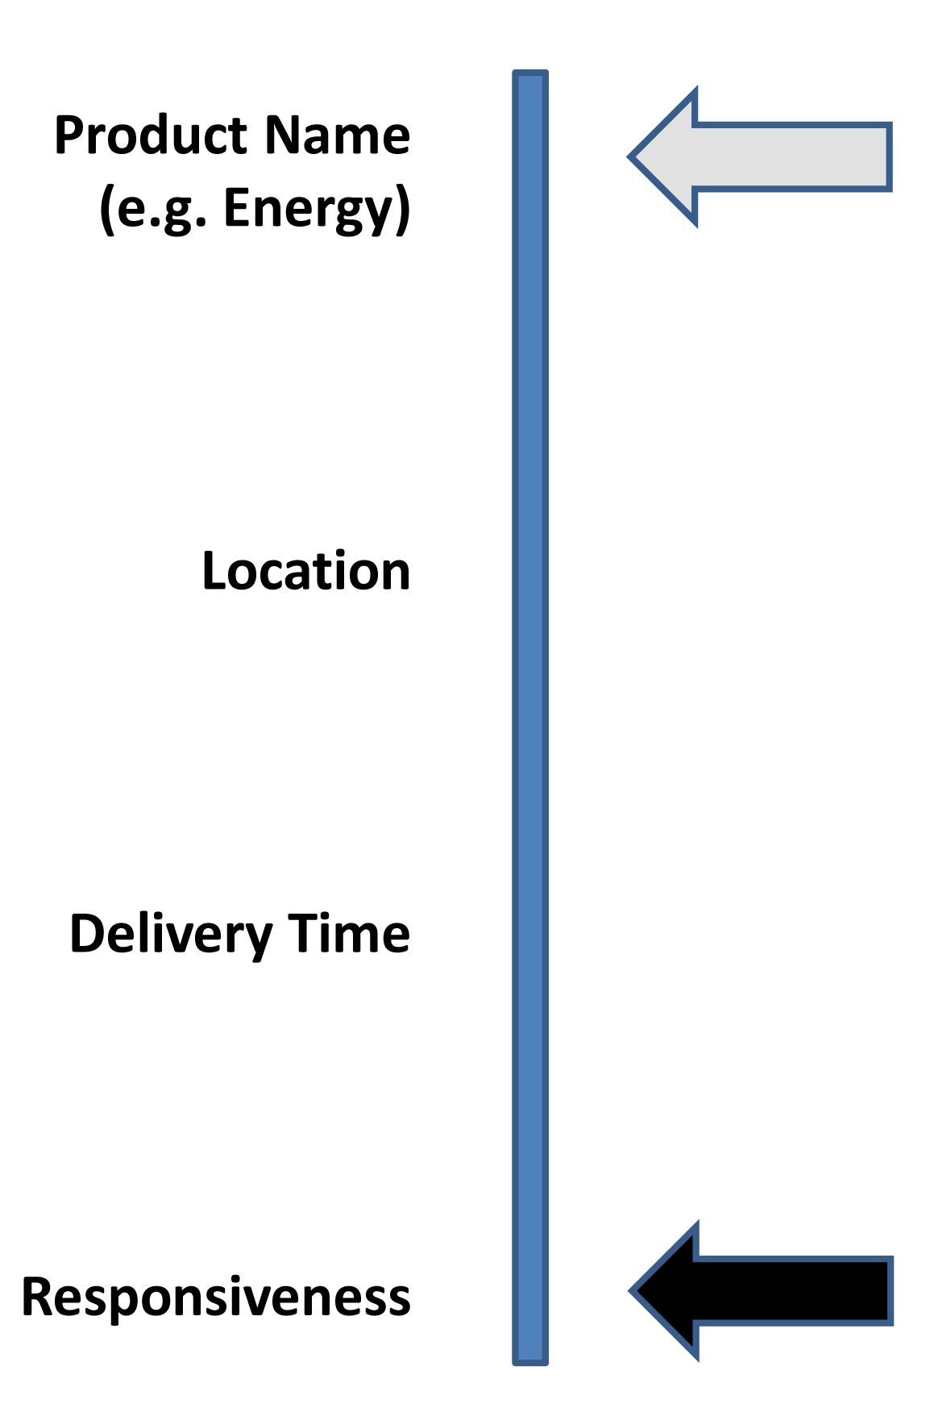
Figure 2-1: Attributes of a Product

Approach
The approach of the TC strives to support price and product communication among current operating models of wholesale market operators, utilities, exchanges, Demand Response providers, bilateral markets, and open retail and wholesale markets as well as new market models that may evolve.
Markets use a range of terminology. For interoperation, EMIX uses the terminology of market "transactions" and "tenders" to characterize the communication of price and product across markets. Some markets may call a transaction an "award" or a "contract". Some markets may call a tender a "bid", "offer" or "rate". EMIX uses the transaction and tender terminology that can be translated to the terminology of various markets.
System Operator Markets such as those operated by Independent System Operators (ISO) and Regional Transmission Operators (RTO) use specific information models for communication of resource offers (tenders) for Energy and Ancillary Services products. Retail service providers use specialized terminology to characterize retail full requirements and other tariffs. Bilateral wholesale markets and exchanges may use a "bid/ask" terminology and various contract types. Each of the markets may use specialized market clearing methods or the price may be the result of a cost-based tariff calculation. Market mechanisms and tariff calculations are out of scope for EMIX.
The EMIX information model is intended to support interoperation among markets that may use different information models.
Power is a commodity good whose market value may be different based upon how it is produced or generated. After production, though, the commodity is commingled with production from other sources with which it is fully fungible. Even so, some energy purchasers distinguish between sources of this product even as they consume the commingled commodity. EMIX assumes this product differentiation and defines multiple products based on the underlying good.
Throughout this work, the specification refers to the intrinsic and extrinsic properties of an energy product. An intrinsic property is one “belonging to a thing by its very nature.” An extrinsic property is one “not forming an essential part of a thing or arising or originating from the outside.” In EMIX, the term intrinsic properties refers to those that can be measured and / or verified at the point of delivery, such as electric power and price. The term extrinsic properties refers to those that can only be known with prior knowledge, such as the carbon cost, the energy source, or the sulfate load from generation.
EMIX Artifacts can communicate both intrinsic and extrinsic properties. EMIX is designed to support arrange of markets from those in which extrinsic properties must clear just as do intrinsic properties, to markets may not be concerned with the extrinsic properties.
EMIX is an information model that assumes conveyance within a service-based environment, as defined in the OASIS Reference Model for Service Oriented Architecture 1.0 [SOA-RM].

Time Semantics
Time semantics are critical to EMIX. Consider two sellers that offer the same product. For the first, one must start planning an hour or more in advance. The second may be able to deliver the product within five minutes of a request. The service start time is the time when product delivery begins. Because this service start time and service period are all that matters to product delivery, different providers using quite different technologies can provide equivalent product as specified in EMIX if each is given adequate notice. For other products, timeliness of notice is of the essence, and the first may not be able to provide the service.
EMIX uses semantics from [WS-Calendar] to describe Time, Duration, and Schedule. An overview of [WS-Calendar] semantics is provided in Appendix E.

Information Structure
As a conceptual aid, consider the information structure using the metaphor of an envelope containing Warrants. The intrinsic properties and the price are on the face of the envelope, easy to read by all. The contents of the envelope are the supporting information and various Warrants about the extrinsic qualities.
On the face of the envelope, EMIX lists the intrinsic qualities of the energy product. In the simplest model, the intrinsic qualities are limited to the price and the information a meter can provide. In a market of homogenous energy sources and commodity energy, only the intrinsic qualities are actionable. In postal handling, information on the face of the envelope is meant for high-speed automated processing. The simplest devices, including the proverbial smart toaster, may understand only the intrinsic qualities. The phrase “prices to devices” is used in energy policy discussions to describe a market model in which energy use decisions are distributed to each device that uses energy. Under this model, decisions about whether to use energy immediately or delay energy use until a later time are best made where the value is received for that energy use, that is, at the end device. The smart toaster is shorthand for the smallest, least capable end device that can receive such a message. It is anticipated that the information on the face of the envelope will be sufficient for many, if not most, energy decisions.
The envelope contents are the supporting documents that explain and support the price for the intrinsic qualities on the face of the envelope. These extrinsic qualities are separable from the intrinsic transaction and perhaps can be traded in secondary markets. The contents can include Warrants about the source and the environmental attributes which provide information about the energy, but they are not the energy. The extrinsic qualities enable traceability and auditing, increasing public trust in energy markets and on energy differentiation. The simplest gateways and devices may ignore the Warrants; that is, they can forward or process messages without opening the envelope.
The extrinsic information within the envelope may contain information that supports the price among the Extrinsic information conveyed within the envelope. For example, a purchaser may opt to buy energy from a particular supplier with advertised rates. Transport loss may reduce the quantity delivered. Markets may add congestion charges along the way.
Such supporting information can explain why the delivered cost, on the face of the envelope, is different than the purchase cost.

Tenders and Transactions for Power Products and Resource Capabilities
The focus of EMIX is on a Price and Product information model for communication in support of commercial transactions. The messaging and interaction patterns for commercial transactions are out of scope for EMIX but worth a brief discussion here to provide context.
EMIX is intended for commercial transactions in all types of markets including ISO/RTO markets, exchange markets, regulated markets, regulated retail tariffs, open markets, and wholesale and retail bilateral markets. (ISO refers to Independent System Operators. ISOs provide non-discriminatory access to transmission, operate spot markets and maintain grid reliability. RTO refers to Regional Transmission Organizations. RTOs perform the ISO functions on a regional basis.) The commercial practices that determine prices vary in these markets but all markets can benefit from interoperable communication of Price and Product information.
Transactions in most markets begin with tenders (offers to buy or sell) by one party to another party. Once an agreement among parties is reached, the parties agree to a transaction (contract or award). The parties to the transaction then must perform on the transaction by arranging for supply, transport, consumption, settlement and payment. At every stage in this process, clear communication of the terms (price, quantity, delivery schedule and other attributes) of the tender or transaction is essential. Section 4, “Envelopes: EMIX Base and its Derivatives” describes EMIX Base Type, the core of EMIX information models.
In many electricity markets, Operators are offered electrical products based on specific resources such as generators, load curtailment, and other energy resources. EMIX uses EMIX Resource Descriptions to describe the responsiveness, capacity, and other aspects of these Resources. EMIX Resource Offers combine an EMIX Resource Description with a multi-part offer. A Party can use EMIX Resource Offers to tender to an Operator one or more EMIX Products. Similarly, an EMIX Load Curtailment Offer combines a Load Curtailment Resource Description with a multi-part offer.

Transport
Product transport from a point of injection to a grid to a point of takeout to a grid is also described by the EMIX information model. Product transport can be characterized by (1) the quantity transported and price, or (2) the quantity transported and cost detail.
Transport costs come in two general forms. Congestion charges apply to each unit of product that passes through a particular point in the distribution system. Congestion charges increase the cost of the Product delivered in a particular Interval. Loss reduces the product delivered as it passes from the purchase point to the delivery point. Loss may reduce the amount of product received or a loss charge may be applied to purchase replacement energy for the energy loss.
If the Product is priced for delivery to the consumer, transport charges may not apply. Product descriptions for transport services are discussed in Section 11, “Power Transport Product Description”.

Verification of Response
Many products, e.g. those transacted for Demand Response, have detailed verification methods. In today’s markets, verification can be quite complex.
Verification is out of scope for this specification. Measurement and Verification is fully specified by NAESB Business Practices for Measurement and Verification [NAESB M&V]. This specification does not define verification.

Guide to the Schema Structures
The EMIX 1.0 Specification consists of four schemas:
- The EMIX schema defines the framework and extensibility as well as agreement types common to many markets. The EMIX schema consists of three files—emix.xsd, emix-terms.xsd, and emix-warrants.xsd
- The SI Scale schema, defines a code list enumerating the characters indicating the decadic scale for measurements defined by the System International (SI).
- The Power schema defines the specific information exchanges, based on the EMIX framework, needed for markets in power and energy. The Power schema consists of three files—power.xsd, power-product.xsd, and power-quality.xsd.
- The Resource schema describes specific capabilities of devices and systems, irrespective of the underlying technologies that affect power and energy markets.
Note that EMIX and Power schemas are broken into multiple files for convenience of human readers and editors.
The Power and Resource schemas are, in effect, the first extensions to the EMIX Schema. The Power schema extends the EMIX schema to define products for Power markets. The Resource schema extends the Power schema to provide information on the capabilities and the responsiveness of devices and systems in support of decisions regarding tenders and transactions for products that can be provided by or consumed by Resources.

Use of Core Type Extension to define EMIX
The core elements of EMIX are abstract types. The concrete types used in exchangeable information models are built by extending those abstract types to create the information exchanges for energy markets. Product Descriptions are built out of lower-level Items. Schedules are populated with Product Descriptions. Top level models, derived from EMIX Base, incorporate Schedules. Top level models can be exchanged at an Interface between systems or owners.

Core Abstract Types
The abstract EMIX Base Type defines a Product Description conveyed by a Schedule. That Schedule may be as simple as a single 5 minute interval on a particular day, or as complex and repeating as you can find in your own personal calendar. Any type derived from the EMIX Base Type contains a Sequence that can contain any Product Description. Information elements derived from the EMIX Base include Products, Options, TeMIX, and Delivery (Metered Information). The definitions in Table 3-2 assume that the reader is familiar with terms defined in [WS-Calendar]; as a convenience to the reader, these are summarized in section 3.2.
Table 3-2: EMIX Core Abstract Types
Type | Description
Item Base | Abstract base type for units for EMIX Products. Item Base does not include Quantity or Price, because a single Product may have multiple quantities or prices associated with each Interval.
Schedule | EMIX Products are delivered for a Duration, at a particular time. EMIX relies on the Interval and the Gluon as defined in [WS-Calendar] to communicate Schedules. The Schedule names a collection, but is not itself a type.
Product Description | Product Description is derived from an abstract Artifact type that resides within [WS-Calendar] Components, and all Product Description-derived types can therefore reside within those Components as well. The Product Description is placed in Components of the Schedule.
EMIX Base | The EMIX Base conveys a Schedule populated with Product Descriptions and is extended to express additional market information sufficient to define Products. All EMIX Products are derived from EMIX Base, but not all derived types are Products. Along with the Schedule, EMIX Base includes an optional Envelope (see 3.1.5).
Conforming specifications can extend the EMIX specification for use in their own domain by extending the core types of EMIX. Within this specification, Electrical Power is a specific extension of EMIX for power markets. Specifications to support energy markets can be created through extension in an analogous manner.
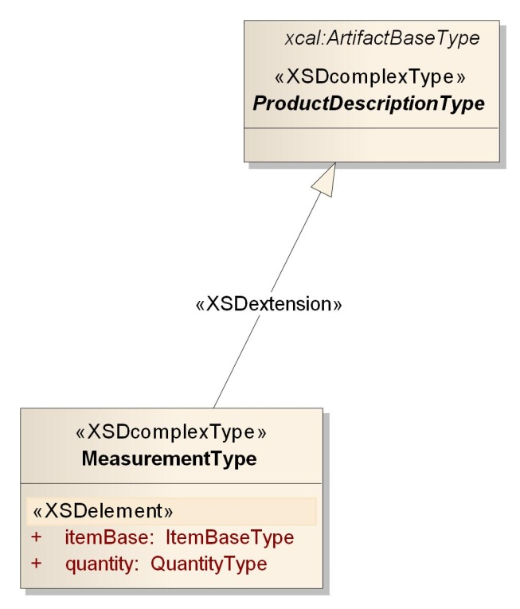
Figure 3-2: The Abstract Product Description Base Type

Price Base and its extensions
Prices in today’s power markets may be communicated other than as a simple price. The Price Base is a low level abstract type which is an element in many other types. Price Base is an extensible type whose extensions include not only a simple or absolute price, but other types that rely on foreknowledge and computation. Unless otherwise specified (as it is in TeMIX which is restricted to only the simple price), wherever an information model requires a Price Base, any type derived from Price Base is supported.
Table 3-3: Elements derived from Price Base
Element | Description
Price | This is the number that quantifies the actual price per unit of the product.
Price Multiplier | A Price Multiplier applied to a reference price produces the actual price. Optionally includes a Market Context for the reference price.
Price Relative | A Price Relative is added to a reference price to compute the actual price. Price Relative may be positive or negative. Optionally includes a Market Context for the reference price.
For extension purposes, a conforming specification can define a new price type that can be used in any EMIX type by extending the abstract Price Base.
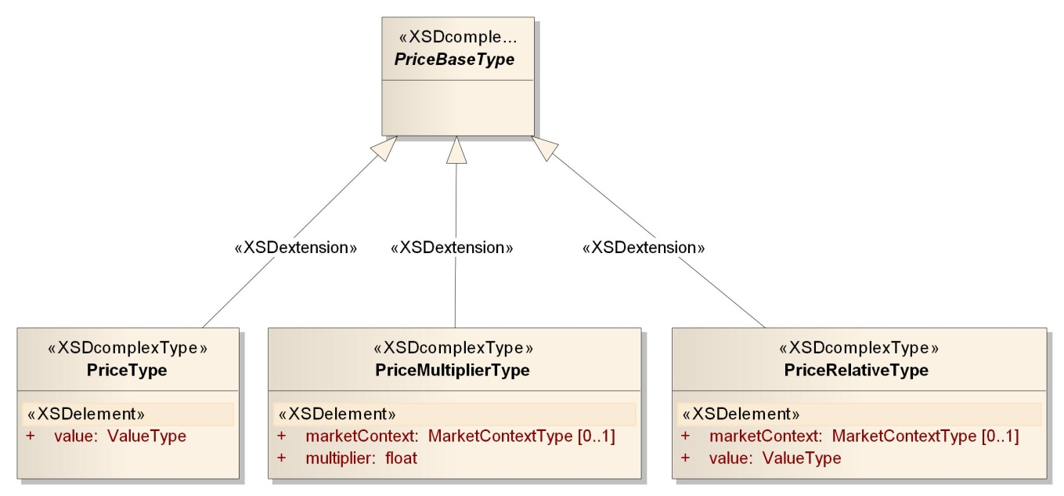
Figure 3-3: Price Base and Extensions

The EMIX Interface
EMIX describes Products whose value is tied to an exchange of ownership or control at a particular location at a particular time. EMIX expresses this locality using the EMIX Interface.
The EMIX Interface is where something transfers ownership. In power, this may be a node or meter, an aggregation of nodes or meters, a pair of nodes, or a geographic area. Other specifications can derive from the base type to support their own needs.
The EMIX Interface is an abstract type. The EMIX Interface can represent a meter or a computation; the EMIX Interface can be real or virtual, the EMIX Interface can be a collection or a singlet.
Table 3-4: The EMIX Interface.
Type | Description
EMIX Interface | Abstract base class for the interfaces for EMIX Product delivery, measurement, and/or pricing
Service Area | The Service Area is the only Interface defined for all derived schemas. The Service Area expresses locations or geographic regions relevant to price communication. For example, a change in price for a power product could apply to all customers in an urban area. Service Areas are defined using [GML] in its simplest profile, i.e., level 0.
EMIX interfaces for specific products have product-specific requirements or have characteristics already defined in specific markets. Within this specification, the EMIX Interface has specific extensions for Power markets defined in Section 8.1 “EMIX Interfaces for Power”. Other markets can extend the EMIX Interface to support their specific needs.
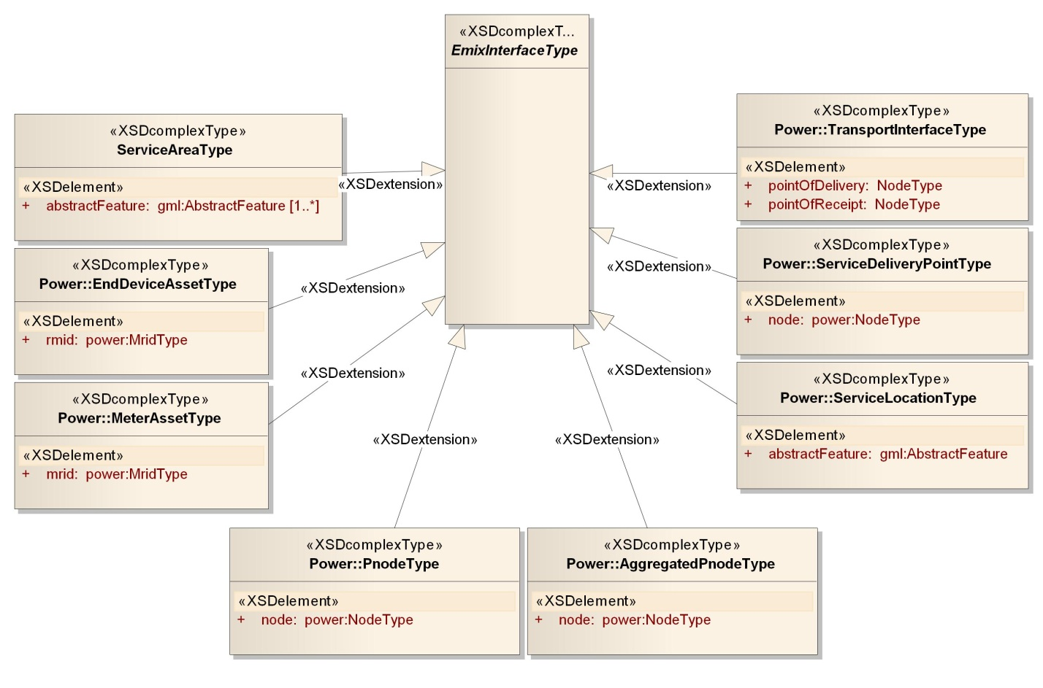
Figure 3-4: Summary of EMIX Interfaces including both Emix and Power

The Item Base
The Item Base is the basis for the lowest level description of each Product and its aspects. The term Item is in common business use for that thing on a line of a purchase order, or of a receipt, or on a bill of lading. Item Base derived types have at least a name, a unit of measure, and a scale factor. The power schema (see See Figure 3-4: Summary of EMIX Interfaces including both Emix and Power for all Interfaces defined in this specification.) defines three power types derived from the Item Base Type.
Items, i.e., types derived from Item Base, reference the International System of Units (SI) to specify a set of alphabetic prefixes known as SI prefixes or metric prefixes. An SI prefix is a name that precedes a basic unit of measure to indicate a decadic multiple or fraction of the unit [SI Units].
EMIX requires that conforming specifications use the SI Scale to indicate the size of the unit of measure. The SI Scale is in the external code list siscale.xsd.

The Envelope Contents
While energy markets actually deliver a blended commodity, the customer may value the product differently based upon extrinsic characteristics of the commodity. This distinction may be based, for example, upon the origin of the product or upon its means of production. The product may come with attached credits that may have re-sale value. The buyer may contract for, and the supplier may need to report specific quality of product delivery. In other circumstances, it may be necessary to deliver supporting detail to explain the prices delivered.
In EMIX, the assertions that distinguish the commodity product are called EMIX Warrants. A common definition of a warrant is a written assurance that some product or service will be provided or will meet certain specifications. Sellers may use EMIX Warrants to provide information about the source of the energy or about its environmental characteristics. Buyers may use EMIX Warrants to indicate what they wish to purchase. It seems a fundamental market rule that a middleman cannot sell more wind power than he has bought. Such rules are beyond the scope of EMIX, but EMIX information models, including EMIX Warrants, can support such market rules.
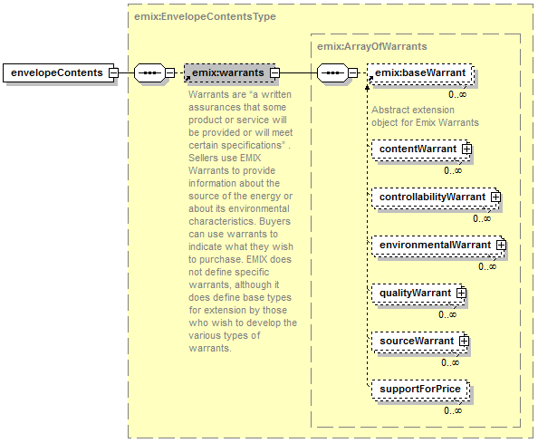
Figure 3-5: Envelope Contents
EMIX Warrants are described in section 15. For now, it is sufficient to know that EMIX Warrants are delivered as Envelope Contents.

WS-Calendar Terms and Descriptions (Non-Normative)
The communication of a commonly understood Schedule is essential to EMIX. EMIX is conformant with the [WS-Calendar] specification for communicating duration and time to define a Schedule. [WS-Calendar] itself extends the well-known semantics [RFC5545].
Without an understanding of certain terms defined in [WS-Calendar], the reader may have difficulty achieving complete understanding of their use in this standard. The table below provides summary descriptions of certain key terms from that specification. EMIX does not redefine these terms; they are here solely as a convenience to the reader.
Table 3-5: WS-Calendar defined Terms used in EMIX
WS-Calendar Term | Description
Component | In [iCalendar], the primary information structure is a Component, also known as “vcomponent.” A Component is refined by Parameters and can itself contain Components. Several RFCs have extended iCalendar by defining new components using the common semantics defined in that specification. In the list below, Interval, Gluon, and Availability (Vavailability) are Components. Duration, Link, and Relationship are Parameters. A Sequence is set of Components, primarily Intervals and Gluons, but is not itself a Type.
Duration | Duration is the length of an event scheduled using iCalendar or any of its derivatives. The [XCAL] duration is a data type using the string representation defined in the iCalendar ([RFC5545]) Duration.
Interval | The Interval is a single Duration derived from the common calendar Components as defined in iCalendar ([RFC5545]). An Interval is part of a Sequence.
Sequence | A set of Intervals with defined temporal relationships. Sequences may have gaps between Intervals, or even simultaneous activities. A Sequence is re-locatable, i.e., it does not have a specific date and time. A Sequence may consist of a single Interval, and can be scheduled by scheduling that single Interval in that sequence.
Gluon | A Gluon influences the serialization of Intervals in a Sequence, through inheritance and through schedule setting. The Gluon is similar to the Interval, but has no service or schedule effects until applied to an Interval or Sequence.
Artifact | The thing that occurs during an Interval. [WS-Calendar] uses the Artifact as a placeholder. EMIX Product Descriptions populate Schedules as Artifacts inside Intervals.
Link | A reference to an internal object within the same calendar, or an external object in a remote system. The Link is used by one [WS-Calendar] Component to reference another.
Relationship | Links between Components.
Availability | Availability in this specification refers to the Vavailability Component, itself a collection of recurring Availability parameters each of which expresses set of Availability Windows. In this specification, these Windows may indicate when an Interval or Sequence can be Scheduled, or when a partner can be notified, or even when it is cannot be Scheduled.
Inheritance | A pattern by which information in Sequence is completed or modified by information in a Gluon.
Normative descriptions of the terms in the table above are in [WS-Calendar].
Using the relation between Gluon and Sequence in WS-Calendar, external information can be applied to an existing Sequence. For example, a resource representing a responsive load may state that 15 minutes lead time is required between notification and load reduction. This characteristic may hold true whether the response requested is for a run-time of 10 minutes or for one of 10 hours. EMIX specifies invariant characteristics as part of a product description or resource, while offering the variable run-time to the market.
A Sequence populated with product descriptions is referred to as a Schedule. Because Schedules embody the same calendaring standards used by most business and personal calendaring systems, there is a base of compatibility between EMIX communications and business and personal systems. For example, the Power Product (see section 10 Power Product Descriptions), an EMIX Base-derived type, may convey a Product Description for a constant rate of delivery power product over a single Interval comprises a (1) start time, (2) duration, (3) rate of delivery, (4) price and (5) location. If the rate of delivery (kW) and price ($/kWh) have been exchanged in advance, the information exchanged to deliver the product is simply “start (reference [URI] to product) at 3:00 AM for 0.75 hours.”

Simple Semantic Elements of EMIX
A number of simple semantic types appear throughout this specification. These are defined here.
Table 3-6: Simple Semantic Elements of EMIX
Element | Definition
Market Context | A URI uniquely identifying a source for market terms, market rules, market prices, etc. The URI may or may not resolve.
Transactive State | An indicator included in an EMIX Base derived types to aid in processing. The enumerated Transactive States are: Indication Of Interest, Tender, Transaction, Exercise, Delivery, Transport Commitment, and Publication.
Currency | Market expressions of price are in the context of a particular currency. Currency is always expressed as the [ISO 42173] Alpha Currency Code.
Side | An indicator of the interest of the party originating the artifact. Possible enumerations are Buy and Sell.
Integral Only | An indication that the element described is [tendered] as an all or nothing product. It may apply to an (amount, response, ramp) that is all (true) or nothing (false).
Autonomous | An indicator that the tendering party is able to detect a need and self-dispatch to meet or correct that need.
Envelope | A generic name for all of the EMIX-Base derived types.
Normative descriptions of the terms in the table above are in [WS-Calendar].

Extensibility of EMIX Framework
EMIX is modular by design. EMIX can be extended in conforming standards. Information models from EMIX-conforming standards can be exchanged in any interaction designed to exchange EMIX information models.
New efforts can specify novel Product Descriptions by extending the EMIX Product Description Type. For example, district energy systems distribute and transact thermal energy products. A district energy group could define an EMIX-compliant product definition. These definitions could be used to populate the Schedule of an EMIX Product or EMIX Option without re-considering any aspects of the EMIX specification itself. A specification used to exchange EMIX information could exchange these new information models without change.
Warrants can evolve in a similar way. Some postulate that water costs of energy sources may be of more future interest than the Warrants anticipated in this specification. A water Warrant can be defined that extends the Base Warrant type. This water Warrant can accompany EMIX information models inside the envelope without any change to the underlying specification.
The Power and Resource schemas are, in effect, the first extensions to the EMIX Schema.
Extensibility mechanisms supported in EMIX are discussed in Appendix B.

Envelopes: EMIX Base and its Derivatives
EMIX describes the market communications of tenders and transactions for products whose market value varies with time. An energy product is delivered over time at a specific location. Five kW at 2:00 AM does not have the same value as five kW at 2:00 PM due to differences in its composition and potential usage by individual consumers. EMIX describes the terms of tenders and transactions for which time and location are essential characteristics. For example, the price and quantity (rate of delivery) of energy in each time Interval of a Sequence of Intervals may vary for energy transactions made in a Sequence of Intervals.
A Product Description included in each Interval in a Sequence could describe similar elements repeatedly. Only a few elements, perhaps only price, or quantity, may change per Interval. EMIX uses the WS-Calendar Sequence to specify product elements once, and then specifies which elements may vary by the time Intervals of a Sequence. A Sequence populated with product descriptions is referred to as a Schedule.

UML Summary of the EMIX Base and Extensions
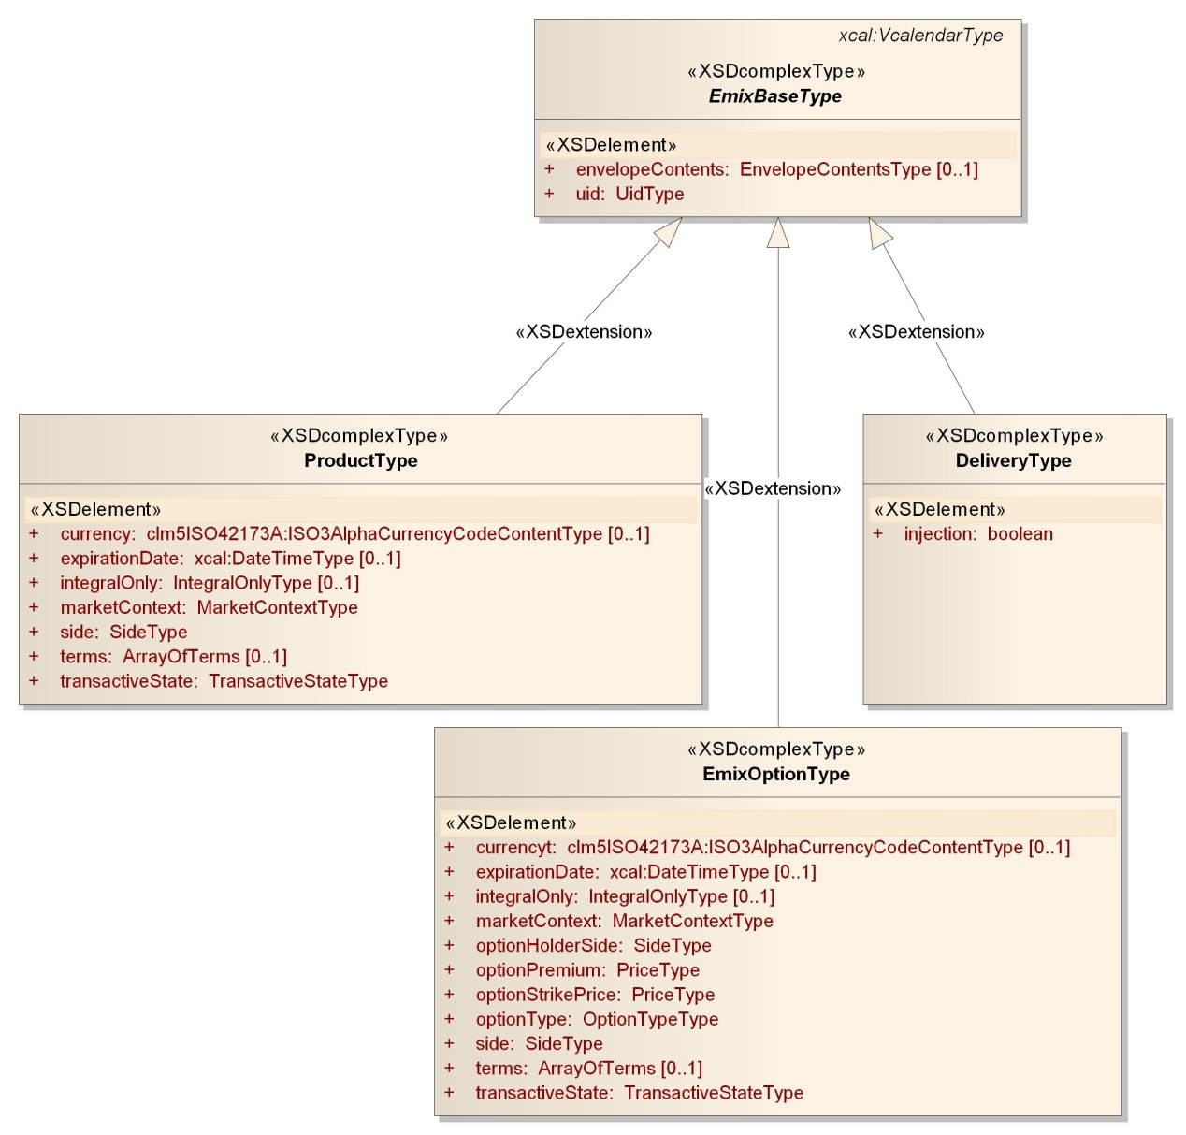
Figure 4-6: UML of EMIX Base and its Extensions

The EMIX Base
The EMIX Base, as defined in Table 3-2: EMIX Core Abstract Types and shown in Figure 4-6: UML of EMIX Base and its Extensions is the foundation for the Envelopes. The EMIX Base conveys a [WS-Calendar] Sequence populated with Product Descriptions. This populated Sequence, sometimes referred to as the Schedule, provides a flexible information model for describing any energy tender or transaction.
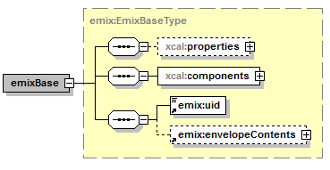
Figure 4-7: EMIX Base Type
There are three types of Envelopes defined in EMIX: the Product, the Option, and the Delivery. Sections 4.3-4.5 define the information on the “face of the envelope”, also referred to as the Intrinsic Information. The Envelope Contents, also referred to as the Extrinsic Information, are discussed in Section 15.
Table 4-7: Elements of the EMIX Base.
Element | Definition
UID | A unique identifier for an EMIX element. Note: different markets and specifications that use EMIX may have their own rules for specifying a UID.
Schedule | A [WS-Calendar] Sequence populated with a Product Description. See Table 3-1.
Envelope Contents | The extrinsic information that may distinguish the product from being a pure commodity. See Section 3.1.5.
New or specialized products can be offered and transacted without changing the EMIX standard. A new Type can be derived from the Product Description, be applied to a Schedule, and conveyed with EMIX Envelope.

The EMIX Product
The EMIX Product is derived from the EMIX Base type and conveys a Schedule as described in Section 4.2. Section 2.1.1 discusses terminology and characteristics of a Product as defined in this specification.
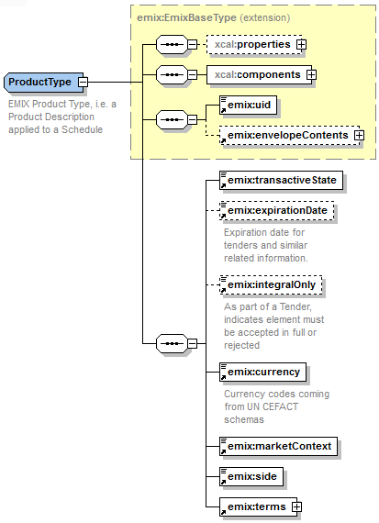
Figure 4-8: EMIX Product
The EMIX Product is the most common of the envelopes. It is used for simple tenders and agreements. It describes specific product delivery.
Table 4-8: Elements of the EMIX Product
Product Element | Description
EMIX Base | Incorporated EMIX Base Type. See Table 4-7: Elements of the EMIX Base.
Transactive State | As defined in Table 3-6: Simple Semantic Elements of EMIX.
Tender Expiration Date | The date and time when a Tender expires. Meaningful only when the value of Transactive State is Tender.
Integral Only | Indicates that Schedule is accepted entirely or not at all. Meaningful only when the value of Transactive State is Tender.
Market Context | As defined in Table 3-6: Simple Semantic Elements of EMIX.
Side | Buyer or Seller.
Currency | Currency denominating product, Table 3-6: Simple Semantic Elements of EMIX.
Terms | A collection of business and performance rules that define the product offering. See Section 5, “EMIX Terms”.

The EMIX Option
The EMIX Option is an elaboration of the EMIX Product described above. An option is an instrument that gives the buyer the right, but not the obligation, to buy or sell a product at a set price during given time windows. Many typical energy agreements, including demand response and reserves, include elements that would give them the name option in any other market.
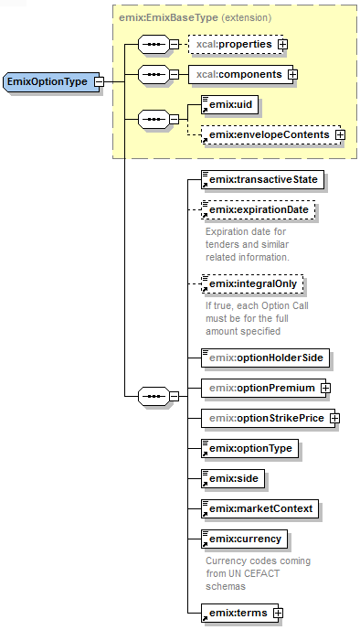
Figure 4-9: EMIX Option Type
The EMIX Option also conveys specific availability and performance. The “face of the Envelope” contains additional information to support these requirements.
Table 4-9: EMIX Option Elements – another "Face of the Envelope"
Option Element | Description
EMIX Base | Incorporated EMIX Base Type. See Table 4-7: Elements of the EMIX Base.
Transactive State | As defined in Table 3-6: Simple Semantic Elements of EMIX.
Tender Expiration Date | The date and time when a Tender expires. Meaningful only when the value of Transactive State is Tender.
Market Context | As defined in Table 3-6: Simple Semantic Elements of EMIX.
Currency | Currency denominating product, Table 3-6: Simple Semantic Elements of EMIX.
Terms | A collection of business and performance rules that define the product offering. See Section 5, “EMIX Terms”.
Integral Only | Indicates that a Schedule is accepted entirely or not at all. Meaningful only when the value of Transactive State is Tender.
Option Exercise Schedule | The schedule of time windows for the option expressed using the “Availability Schedule” in Terms. See Section 5.2.
Option Holder Side | The side which enjoys the benefit of choosing whether to exercise the terms specified in the option.
Option Premium | The Price paid by the Option Holder Side for the rights involved.
Option Strike Price | The Price that the Option Holder Side pays to exercise the option.
Exercise Lead Time | The minimum Duration in advance of a proposed response that a notification will be accepted for the exercise of the option. Expressed using the “Minimum Notification Duration” in Terms. See Section 5.1.
Side | Identifies whether information originator is on the Buy or Sell side.
Option Type | An enumerated list of Option types.

EMIX Delivery
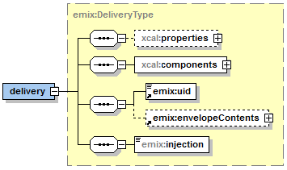
Figure 4-10: Delivery
In any market, order must be matched to delivery. EMIX Delivery reports the historical delivery of product over time.
Table 4-10: Elements of the EMIX Delivery
Delivery Element | Description
EMIX Base | Incorporated EMIX Base Type. See Table 4-7: Elements of the EMIX Base.
Injection | True means positive Delivery is injection into the grid. False means positive Delivery is extraction from Grid

EMIX Terms
EMIX Products can be subject to a number of Terms and Market Requirements. These Terms can apply at each transactive state. Terms are extensible, so additional schemas, specifications, and standards can extend the list while remaining in conformance.
Terms are extrinsic to the product delivery but affect how a partner may request performance of a service. Terms may originate in the basic mechanical needs of the Resource or in the business needs of the source. These Terms can affect the market value of the resource or the repeated invocation of a resource. It is possible for a given underlying resource to be offered to the market with different terms and therefore different values.

EMIX Performance Oriented Terms
Some terms indicate the ability of a side to perform. As many market interactions may have a penalty for non-performance or for performance that is not timely, it is essential for parties using EMIX information to negotiate services to be able to define performance.
Table 5-11: Performance-Oriented Terms
Term | Description
Minimum Response Duration | The shortest Duration for which a request will be accepted.
Maximum Response Duration | The longest Duration for which a request will be accepted.
Minimum Recovery Duration | The minimum Duration after completion of a response before a new response can be begun.
Minimum Duration Between Invocations | The minimum Duration between successive responses that will be accepted.
Minimum Notification Duration | The minimum Duration in advance of a proposed response that a notification will be accepted.
Maximum Notification Duration | The maximum Duration in advance of a proposed response that a notification will be accepted.
Response Time | Duration required from receipt of a request to supplying the full requested level of response; i.e., notification time plus response time.
Maximum Invocations Per Duration | Maximum number of requests for response that will be accepted during a Duration.
Maximum Consecutive Durations | Maximum consecutive Durations in which a notification will be accepted; e.g., it will not accept requests on more than three consecutive days.
Maximum Run Duration | Maximum acceptable Duration for a proposed response
Minimum Run Duration | Minimum acceptable Duration for a proposed response

EMIX Schedule Oriented Terms
Schedule related terms indicate schedules when a product may be available or when an interaction may occur. A product may only be available on weekends, or a party may not be able to respond outside of normal office hours.
Table 5-12: Schedule-Oriented Terms
Term | Description
Availability Schedule | A schedule of time windows during which a response may be scheduled. A scheduled Duration must be entirely within a single instance of an availability window.
Unavailability Schedule | A schedule of time windows for which no request for response will be accepted. No part of a requested Duration must coincide with an unavailability window.
Notification Schedule | A schedule of time windows during which requests can be made.

Market Requirements
Market Requirements are terms tied to the economic expectations expressed in certain market tenders. Market Requirements are the market portion of Terms, i.e., they are used to state the offeror's expectations about a tender. It is possible for a given underlying resource to be offered to the market with different Requirements and therefore different values.
Table 5-13: Market Requirements for EMIX Products
Market Requirement | Description
Market Granularity | The size of a market “bundle”. For example, a Market with a granularity of 10 MW, will only accept tenders, process transactions, and pay for delivery of Power in multiples of 10MW.
Minimum Economic Requirement | Minimum net remuneration for any single response
Required Startup Remuneration | Minimum remuneration required for initiating a response.
Minimum Starts Per Duration | The fewest requests that the resource will accept during any Duration.
Minimum Remuneration Rate | Minimum remuneration acceptable per stated Duration of response. For example, a minimum remuneration of $100 per hour.

Extensibility of Terms
The EMIX Terms above are not tied to any particular kind of Product or Resource. All are based on the abstract Base Term type. Specifications that require additional terms can create them by extending the Base Term Type to create new terms.
Specific Terms for use with Power Products created by extending the Base Term Type are found in Table 13-36: Terms unique to Power Resources.
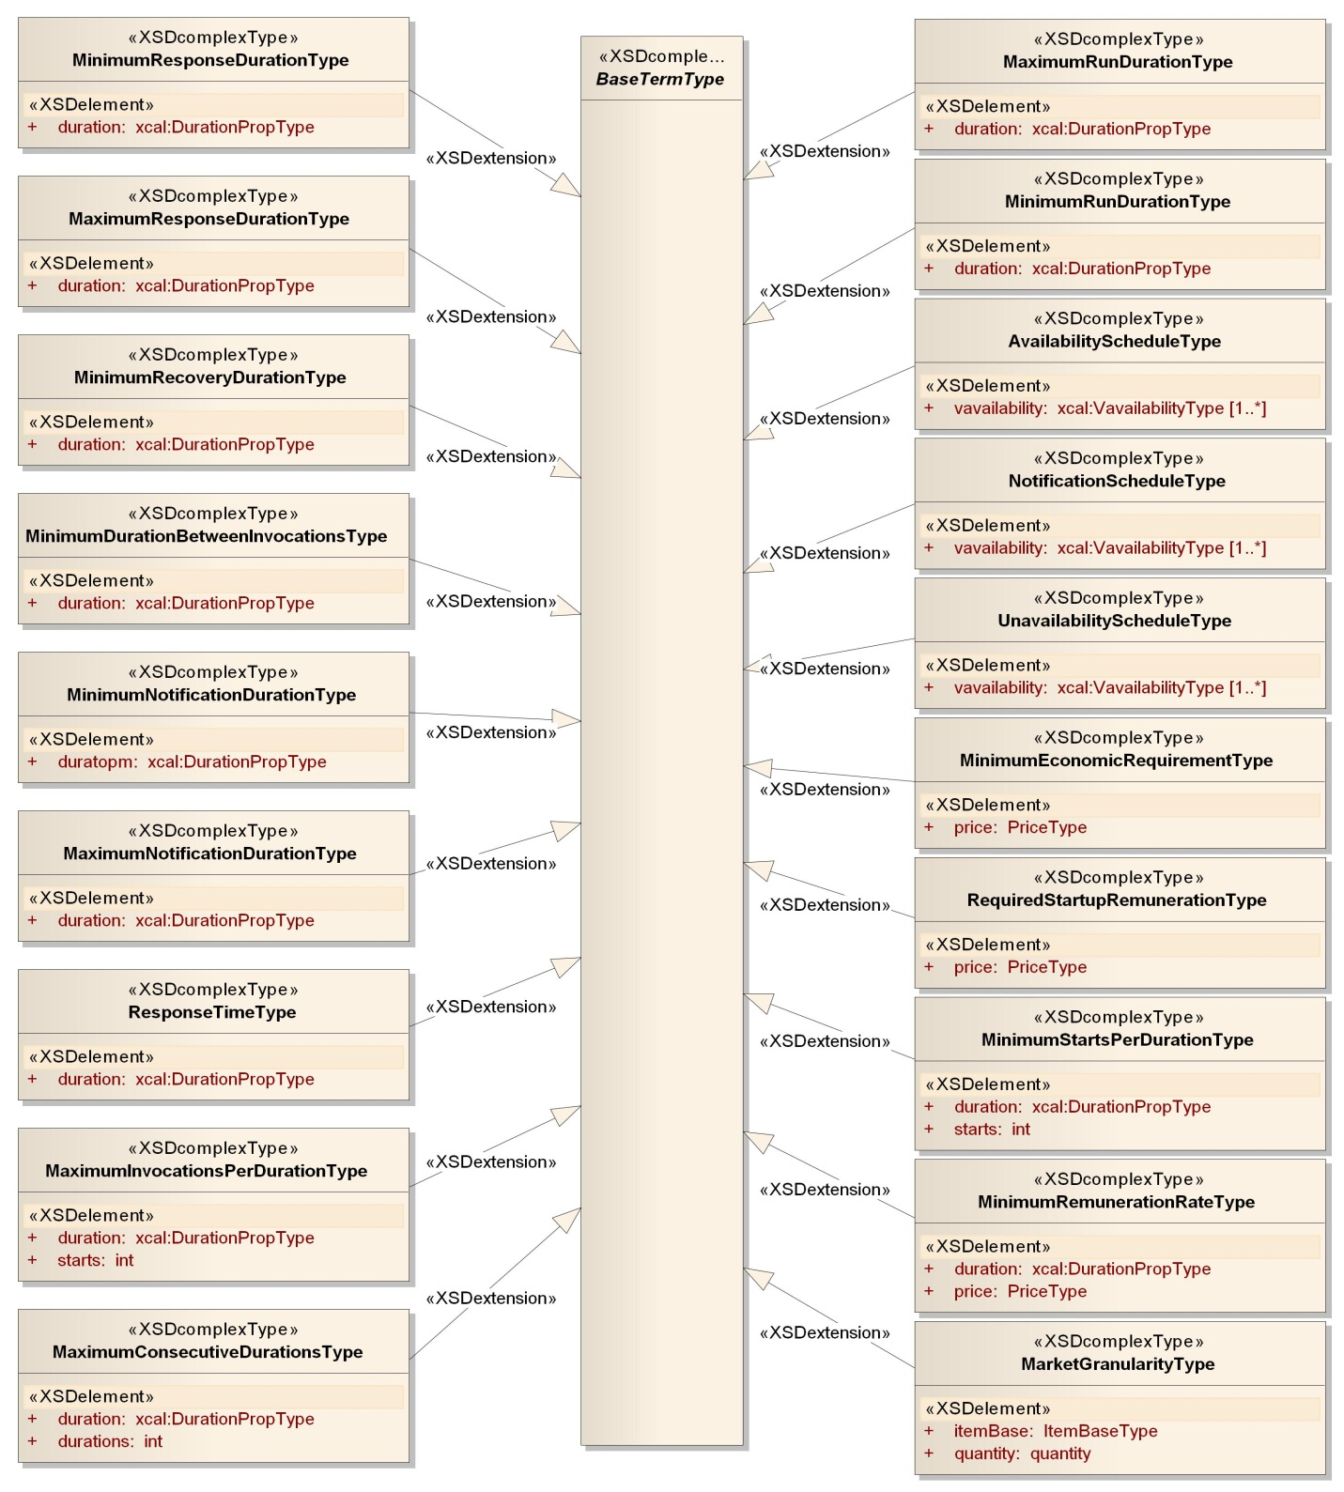
Figure 5-11: Summary of EMIX Terms

Schedules in EMIX: Intervals, Gluons, and WS-Calendar
This section discusses how EMIX uses [WS-Calendar] to create Schedules. EMIX does not “schedule”. EMIX includes information to communicate Schedules. Algorithms and methods are completely outside the scope of EMIX. EMIX uses [WS-Calendar] to create information models that describe schedules and that are populated with Product Descriptions. The Semantics drawn from [WS-Calendar] are summarized in Table 3-5: WS-Calendar defined Terms used in EMIX. This section describes how EMIX uses the recombination and conformance rules from [WS-Calendar] to create Schedules.

Intervals, Gluons, and Sequences
Types derived from the abstract EMIX Base contain a Schedule created by populating a Sequence with Product Descriptions. The terms Duration, Interval, Sequence, and Gluon are defined in [WS-Calendar]. [WS-Calendar] defines a model for inheritance wherein a fixed description of a product is refined with additional information as it becomes actionable. The Intervals in a Sequence can inherit information from a Gluon related to that Sequence.
The iCalendar standard, with which [WS-Calendar] conforms, is an information model of a “bag of Components”. Each Component can include an attachment for passing some kind of information. Intervals and Gluons are two of the [WS-Calendar] Components. The schema type for Product Descriptions is derived from the attachment so Product Description-derived types are valid contents of these Components.
In [WS-Calendar], a Gluon relates to a Sequence by relating to a specific Designated Interval within that sequence. All other Intervals have defined temporal relationships, directly or indirectly, to the Designated Interval. If a Gluon contains a start date and time, that start date and time is inherited only by the Designated Interval; the start dates and times for all other Intervals in the Sequence can be computed from that single date and time. In this way, a set of Intervals containing EMIX Product Descriptions can define what is in effect a schedule sub-routine, invoked by starting the Designated Interval.
In EMIX, when a Gluon contains a Product Description, it can then be inherited by each of the Intervals. If an Interval already contains a Product Description, then it refuses the Inheritance from the Gluon. This model of inheritance mimics that defined in [WS-Calendar] for inheriting Duration.
Duration, Product Description, Price, and Quantity for each Interval in a Sequence can each be inherited from a Gluon in EMIX. The Start Date and Time can be inherited only by the Designated Interval. This follows and extends the rules of inheritance defined in [WS-Calendar].
There is no requirement for the Designated Interval to be the “first” interval. If a Sequence describes a ramp-up, peak operation (of whatever service), and ramp down, it may be more useful to designate the Interval containing peak operation. In this scenario, the Durations of all Intervals other than the Designated Interval may be fixed, that is encoded in each interval. A communication to “start” the Sequence, then, could contain the start date and time and the run Duration.
The rules of inheritance are described in Section 17.1 EMIX Conformance with [WS-Calendar. Inheritance in [WS-Calendar] is described in that specification.

Availability (Vavailability) and Temporal Granularity
[WS-Calendar] defines the expression of the Vavailability information model for repeating instances of time (Availability Windows) within a period that may or may not have an end date. Vavailability is a Component of iCalendar. EMIX uses Vavailability primarily in Terms.
One party MAY use Vavailability to indicate to another party when a service can be requested. This may be a contracted part of an EMIX Option or it may define the Demand Response window (afternoons during summer months) of a regulated tariff. EMIX does not define the interactions or negotiations that lead to either of those circumstances.
Availability communicates acceptable schedule times for Sequences. The semantics of scheduling a Sequence to comply with previously stated Availability in [WS-Calendar] is that the Designated Interval must be inside one of the Availability Windows. While it is possible that not all information regarding Intervals in a Sequence may be exposed in interactions, a party requesting an EMIX product does know the Duration and Start Date and Time of the Designated Interval.
WS-Calendar EMIX are information models, and do not create market rules or define interactions. The specification makes no statement about how a market, or even how a market participant handles receipt of a Schedule which does not comply with a stated availability. Such an Availability and Schedule are likely in separate communications, each containing valid informational artifacts. The word “comply” in the previous paragraph describes the meaning of the information exchanged, and not any behavior or market rule.
Again, see [WS-Calendar] for a complete description.

Temporal Granularity
[WS-Calendar] defines temporal Granularity which is expressed as a Duration. When Granularity is applied to a Vavailability object, then:
- The valid start times are offsets from the start of the availability window that are integral multiples of that duration. For an Availability of 14:00 to 16:00, with a granularity of fifteen minutes “PT15M”, there are 8 valid starting times (14:00, 14:15, 14:30, 14:45, 15:00, 15:15, 15:30, 15:45).
- If duration is specified by the requestor, it must be an integral multiple of the Granularity. In the example above, “PT15M”, “PT30M”, “PT45M”, “PT1H”, PT1H15M”, etc. are valid Durations.
- The Start Date and Time plus the Duration must complete no later than the end of the Availability window.

Illustration of WS-Calendar and EMIX
The illustration below provides a model demonstrating a sequence of three Intervals, and the successive application of Gluons to bring them to market.

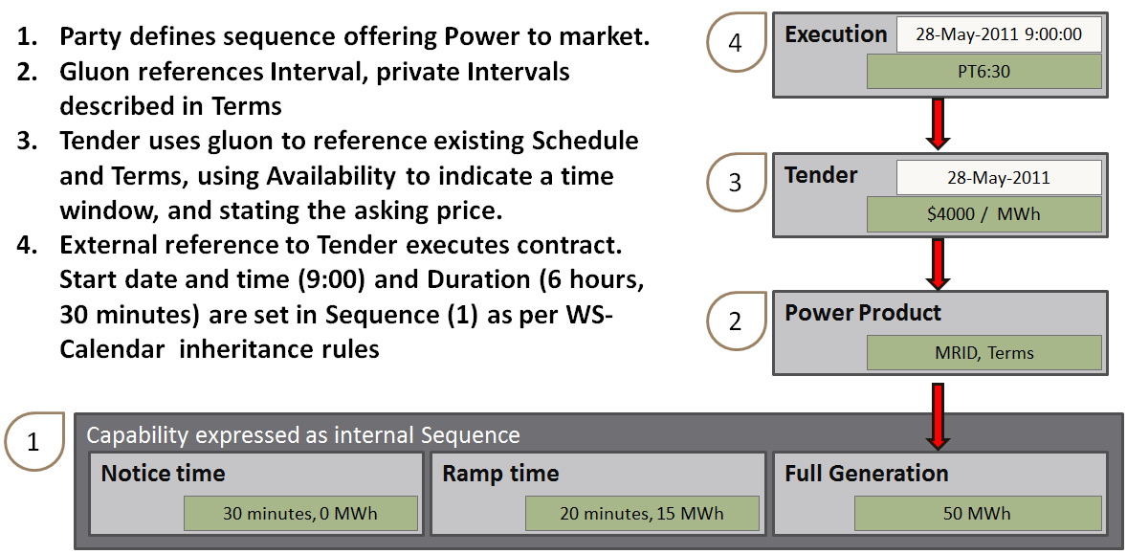
Figure 6-12: EMIX Schedule and Building a Product

Standardizing Terms for Market Context
In any market context, there are standing terms and expectations about product offerings. If these standing terms and expectations are not known, many exchanges need to occur of products that do not meet those expectations. If those expectations are only known by local knowledge, then then national and international products need to be re-configured for each local market that they enter. If all market information is transmitted in every information exchange, messages based on EMIX would be repetitious.
As defined in Table 3-6: Simple Semantic Elements of EMIX, a Market Context is no more than a URI uniquely identifying a source for market terms, market rules, market prices, etc. This section defines an information model for the common rules and expectations for all interactions within a single Market Context.

Overview of Standard Terms
Standard Terms defines an information model for exchanging these common expectations outside of any single product-related artifact. The TC acknowledges that these can be only a small portion the total market rules.
The basis of Standard Terms is the Standard Terms Set shown in the following table.
Table 7-14: Elements of the Standard Term Set
Component | Description
Terms | A collection of Terms as defined in Section 5: EMIX Terms.
Availability | [WS-Calendar] Vavailability (see Table 3-5: WS-Calendar defined Terms used in EMIX) indicating when this Market Term Set is valid, i.e., weekdays from 11:00 AM to 6:00 PM.. If absent, the Market Term Set is valid at all times.
Non-Standard Terms Handling | A string enumeration indicating how to handle terms received that are different than those in the Market Term Set. Permissible values are: Reject (the information artifact), Ignore (the terms), Must Understand, Must Accept.
Side | “Buy” or “Sell”. Note: Some Terms can have different interpretations based on who is offering them. A Buyer may indicate "meet or exceed" while a seller expressing the same term may indicate "no worse than".
Standard Terms Sets can be assembled with other information to create the Standard Terms shown in the following table.
Table 7-15: Elements of Standard Terms
Element | Description
Market Context | URI uniquely identifying context, per Table 3-6: Simple Semantic Elements of EMIX.
Standard Terms Set | Zero (0) to many. As defined in Table 1-1
Product Description | As defined in Table 10-23: Summary of Power Product Description Types. If present, this is the only Product Description in this market context. If Product Quantity is included, it SHALL be ignored.
Temporal Granularity | As defined in [WS-Calendar]. For example, this may be the temporal granularity of market; i.e., a 5-minute market operates in 5-minute chunks, with a fixed offset from the beginning of the Availability time window.
Time Zone | TZID as defined in [WS-Calendar]. Time Zone for communications in this market. Note: this applies to "floating" time, that is expressions of time that are not in UTC or do not have a Time Zone indicated.
Currency | Currency for all information models. If present, becomes the default for all information models. As defined in Table 3-6: Simple Semantic Elements of EMIX.
Non-Standard Terms Handling | As defined in Table 7-14: Elements of the Standard Term Set
Specifications that claim conformance with EMIX MAY define inheritance patterns by which EMIX compliant information models inherit certain information from the Standard Terms.
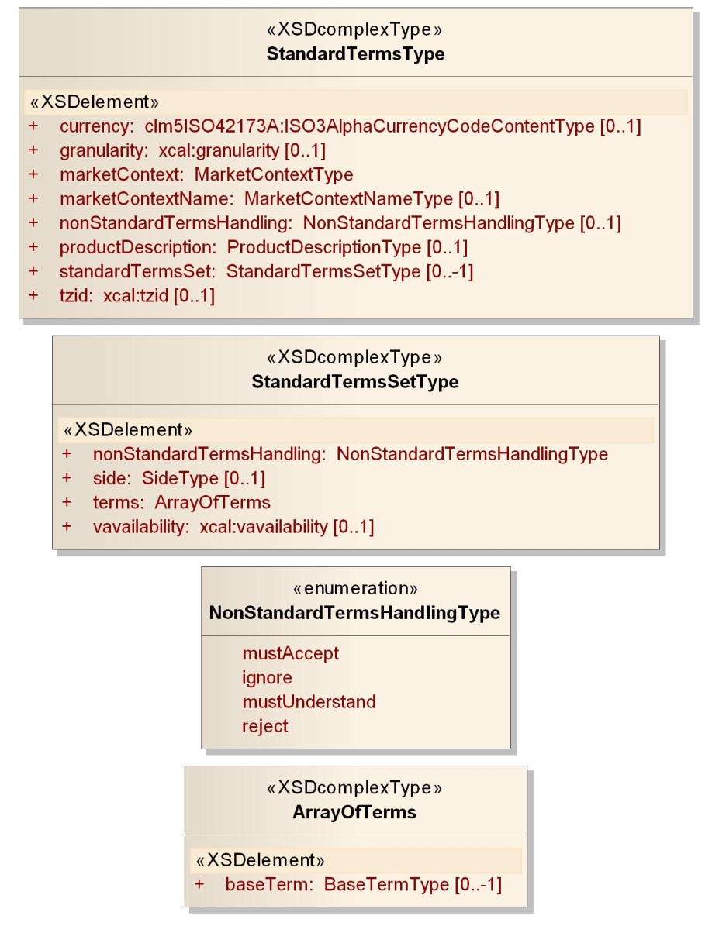
Figure 7-13: Standard Terms

Extending EMIX for Electrical Power
EMIX provides an abstract information model that can be extended to convey Price and Product information for commodities whose value varies with the time and location of delivery.
The EMIX Power schema (POWER.XSD) can be viewed as the first extension of EMIX into a particular domain. The schema extends the Base EMIX Product Descriptions to define a variety of power products, in particular extending the Item Base to create Items for Real Power, Apparent Power, and Reactive Power among others. The schema derives new Product Descriptions products with ways to describe levels and tiers.
Electrical power markets have their own definitions for where the transaction occurs. The EMIX Power schema (POWER.XSD) extends the EMIX Interface to accommodate these definitions.
The resulting extensions can populate a Schedule and define EMIX Products, Options, and Delivery.

EMIX Interfaces for Power
Every market transaction occurs at an interface, where beneficial rights to or use of a product are transferred between buyer and seller. This is often the point at which the flow of product is measured although it may not be.
In power markets, described in the sections below, the Interface can be a node or meter, an aggregation of nodes or meters, a pair of nodes, or a geographic area. The Service area defined in the underlying EMIX.XSD schema is also available for use by power-based products.
Table 8-16: Elemental types of EMIX Interfaces defined in POWER
Elemental Type | Description
MRID | As defined in the [IEC TC57], can identify a physical device that may be a Customer Meter or other types of End Devices."
Node | As defined in the [IEC TC57], a place where something changes (often ownership) or connects on the grid. Many nodes are associated with meters, but not all are.
Power Interfaces are, for the most part, named instances of one of the elements above included in the EMIX Interface.
Table 8-17: EMIX Interfaces defined in POWER
Power Interface | Description
EMIX Interface | Each of the interfaces below derives from the abstract class as defined in .
Service Area | Inherited from EMIX schema. See .
End Device Asset | Physical device or devices, which could be meters or other types of devices that may be of interest. Examples of End Device Assets include a Meter Asset that can perform metering, load management, connect/disconnect, accounting functions, etc. Some End Device Assets may be connected to a Meter Asset.
Meter Asset | Physical device or devices that perform the role of the meter.
Pricing Node (PNode) | Pricing location for which market participants submit their bids, offers, buy/sell CRRs, and settle. Note: a pricing node is directly associated with a connectivity node.
Aggregated Pricing Node | Specialized type of Pricing Node used to model items such as system zone, default price zone, custom price zone, control area, aggregated generation, aggregated participating load, aggregated non-participating load, trading hub, or DCA zone.
Service Location | A location on the network where the ownership of the service changes hands, expressed as a [GML] Abstract Feature. Note: it potentially has many Service Delivery Points, delivering service in accordance with a Customer Agreement. Each Service Location may have zero to many Meter Assets.
Service Delivery Point | Logical point on the network where the ownership of the service changes hands. There is only one Service Location for each Service Delivery Point, delivering service in accordance with a Customer Agreement. Used at the place where a meter may be installed. Each Service Delivery Point may have zero to many Meter Assets.
Transport Interface | Delineates the edges at either end of a transport segment. Note: unique among Interfaces in that it names two Nodes rather than one: point of receipt and point of delivery.
See Figure 3-4: Summary of EMIX Interfaces including both Emix and Power for all Interfaces defined in this specification.

Power Items derived from Item Base
Types derived from the abstract Item Base type are used not only to quantify the items, but potential attributes of items as well.

Power Items
The POWER.XSD schema defines a number of items to define the exchange of POWER. These Power Items are derived from the abstract Power Item, itself derived from Item Base.
Table 8-18: Elements of the Power Item
Power Element | Description
Item Base | Abstract Item as defined in Table 4-7: Elements of the EMIX Base.
Item Description | Name of the Power Item.
Item Units | String representation of Units.
Scale Code | Alphabetic representations of Scale from the SI Scale code list; e.g., M for Mega, K for Kilo, etc.
Power Attributes | Gross attributes of Power: AC/DC, Hertz, nominal Voltage.
The named Items derived from the Power Item type are shown in the table below.
Table 8-19: Defined Power Items
Item Name | Units | Description
Real Power | W or J/s | Real power, expressed in Watts (W) or Joules/second (J/s).
Reactive Power | VAR | Reactive power, expressed in volt-amperes reactive (VAR).
Apparent Power | VA | Apparent power, expressed in volt-amperes (VA).

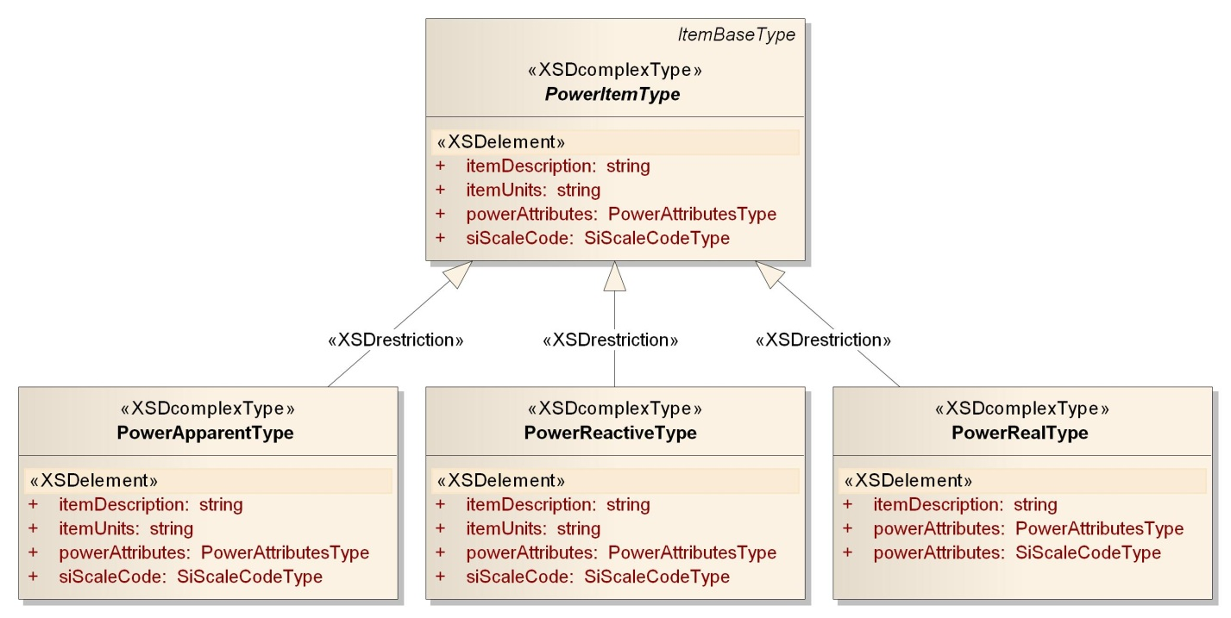
Figure 8-14: UML Summary of Power Items

Energy Items derived from Item Base
Types derived from the abstract Item Base type are used not only to quantify the items, but potential attributes of Energy as well.

Energy Items
The POWER.XSD schema defines a number of items to define the exchange of electrical energy. These Energy Items are derived from the abstract Energy Item, itself derived from Item Base. The following table enumerates the Energy Elements.
Table 8-20: Elements of the Energy Item
Energy Element | Description
Item Base | Abstract Item as defined in Table 4-7: Elements of the EMIX Base.
Item Description | Name of the Energy Item.
Item Units | String representation of Units.
Scale Code | Alphabetic representations of Scale from the SI Scale code list; e.g., M for Mega, K for Kilo, etc.
The named Items derived from the Energy Item type are shown in the following table.
Table 8-21: Defined Energy Items
Item Name | Units | Description
Real Energy | Wh or J | Real energy, expressed in Watt Hours (Wh) or Joules (J).
Reactive Energy | VARh | Reactive energy, expressed in volt-amperes reactive hours (VARh).
Apparent Energy | VAh | Apparent energy, expressed in volt-ampere hours (VAh).

Illustrative Diagram of Energy Items
Many types in POWER.XSD derive from the Item Base. Figure 8-15 shows the Energy Item Type, from which Real Energy, Apparent Energy, and Reactive Energy are derived.
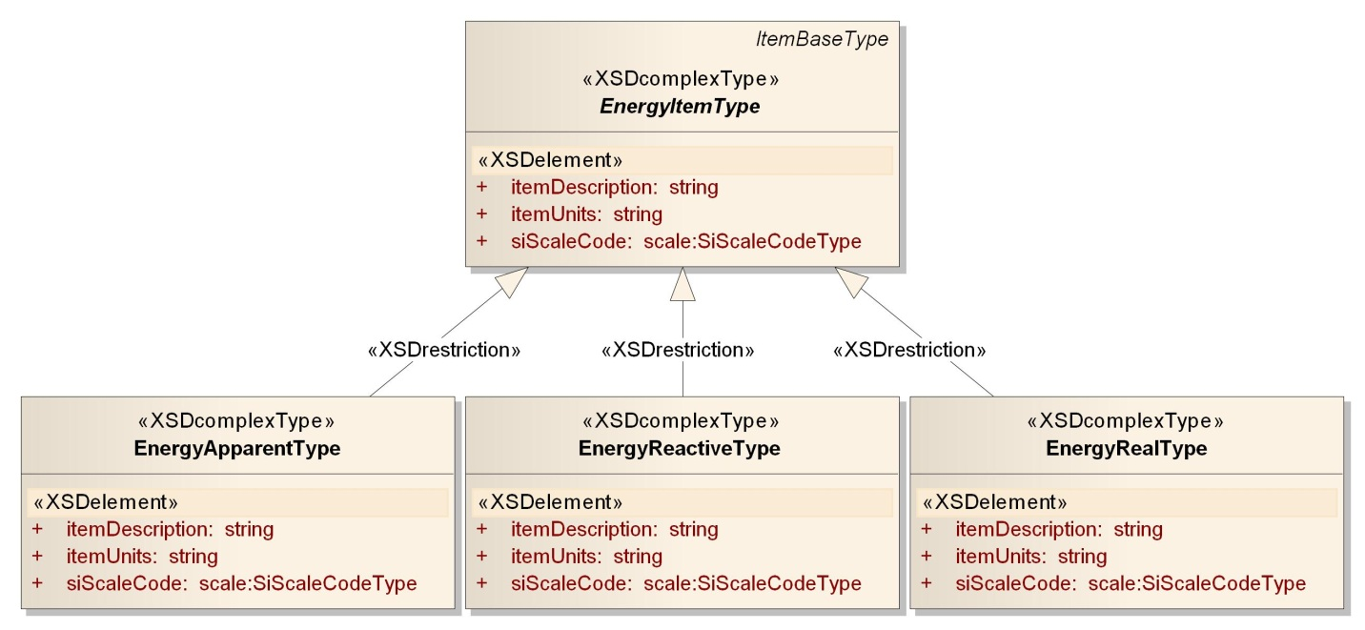
Figure 8-15: UML summary of Energy Item Types

Other Item-derived types
Voltage is another type in POWER.XSD derived directly from the underlying Item Base. The Elements of Voltage are shown in the table below.
Table 8-22: Voltage as an Item
Voltage Element | Description
Item Base | Abstract Item as defined in Table 4-7: Elements of the EMIX Base.
Item Description | Voltage
Item Units | V
Scale Code | Alphabetic representations of Scale from the SI Scale code list; e.g., M for Mega, K for Kilo, etc.

EMIX Power Product Descriptions
This section provides a guide to the rest of the Specification.
Electrical power and energy must be described precisely as it comes to market. Different products can provide total power, real power, or reactive power. Products delivering the same Power at a different voltage, or in DC rather than AC, may be valued differently. For the convenience of the readers, terms associated with electrical power and energy, and the relationships between them, are reviewed in Appendix E.
EMIX provides an information model for exchanging Price and Product information for power and energy markets, where the value of the Products is tied closely to the time of delivery. EMIX Power defines specific EMIX Products for Power delivery. EMIX Resources define capabilities that could be brought to market and the performance characteristics those resources will have, and thus enable a buyer to determine with which resources to seek agreements.
EMIX Products consist of Product Descriptions applied to the EMIX Base Product. There are three classes of Product Description defined as:
1) Power Product Descriptions
2) Resource Offer Descriptions
3) Transport Product Descriptions
EMIX Power Products are defined using standard attribute definitions from [IEC TC57], where the canonical definitions also reside.

Power Product Descriptions
Power can be bought under terms that specify the energy and its rate of delivery (power), or made available for use up to the maximum amount deliverable by the in-place infrastructure (also known as “Full Requirements Power”). While the underlying commodity good is identical, the Product is differentiated based on how it is purchased. Common distinctions include:
- Specify the rate of delivery over a Duration.
- Specify the amount of energy over an Interval with no restrictions on the rate of delivery at any instant within the Interval.
- Made available as Full Requirements Power, the same as b, except that the amount of energy transacted is measured after delivery.
Product Descriptions for transacting Power are found in Section 10 “Power Product Descriptions”

Resource Offer Descriptions
Resources include generators that can produce power and other services, storage devices that can consume, store and then produce power, and loads that produce power through load curtailment.
A Resource Offer describes both the characteristics of the resource and the prices and quantities of products and services offered as described in Section 13: Energy Resources.

Transport Product Descriptions
Product Transport provides for the transport of a product from one Interface location to another generally using transmission and distribution facilities. Transport prices may cover recovery of investment and energy loses incurred during transport as well as congestion prices. A single price may characterize a Transport Product or a set of charges. Product descriptions for Transport are discussed in Section 11 Power Transport Product Description.

Power Product Descriptions
The information model in this section is described in POWER-PRODUCTS.XSD
Almost all Power Products are based on core abstract class, the Power Product Description. The Power Products also share core semantic elements, used throughout the Descriptions and their associated charges. Several of these were described in Section 8: Extending EMIX for Electrical Power.
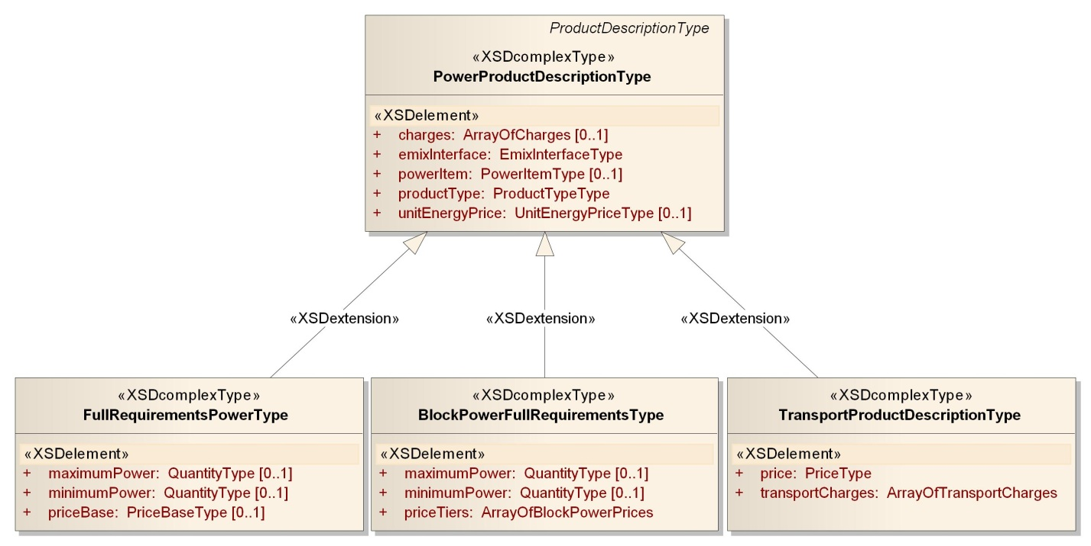
Figure 10-16: UML Summary of Power Product Descriptions

Overview of Power Product Descriptions
The following sections define the Power Product Descriptions. A summary of those descriptions is provided in the following table..
Table 10-23: Summary of Power Product Description Types
Name | Description
Product Description | All Power Product Descriptions are derived from the EMIX base Product Description type See Table 3-2: EMIX Core Abstract Types.
Power Product Description | Used for simple power transactions; also used as template for other Power Product Description Types. After a specified duration, energy has been delivered at a price per unit of energy.
Full Requirements Power | Used to provide for full requirements of buyer. Simple price, will supply all used. Demand Charges optional. Often used in retail residential rates.
Block Power Full Requirements | Used to provide for full requirements of buyer in "blocks". Price is constant within a block, but changes as each block is used during a period. Demand Charges MAY be included. Often used in retail residential rates.
Transport Product | Used for charges and revenue related to Transport Services for a Power Product; i.e., the movement of Power through Transmission and Distribution. The Interface used matches a segment of the transport infrastructure, usually identified by an injection node and a delivery node. Transport Products are discussed in Section 11.
TeMIX Power | Used for a specific sized block of Power at a constant rate of delivery. Derived directly from EMIX Product Description rather than Power Product Description because only Price and Quantity are required.

Enumerated Power Contract Types
Because different Power Product Descriptions use the same informational elements, and because different transaction states may not require all elements be present in every exchange, each Power Product Description includes a Power Contract Type. Different Power Contract Types MAY have different conformance requirements in different market contexts.
Table 10-24: Power Contract Types
Power Contract Type | Note
Energy | Block of Energy.
Transport | Block of Transport.
Energy Option | Option for Block of Energy.
Transport Option | Option for Block of Transport.
Full Requirements Power | Used for supplier to provide for full requirements of buyer. Simple price, will supply all used. Often used in retail residential rates.
Full Requirements Power with Demand Charge | Similar to Full Requirements except specific and perhaps recurring Demand Charges are incurred for exceeding set demand limit(s).
Full Requirements Power with Maximum and Minimum | Customer must draw power at no less than the minimum rate and no more than the maximum rate during any measurement Interval.
Hourly Day Ahead Pricing | Same as Full Requirements Power but prices potentially change each hour.
Ex-Ante Real Time Price | Used to report prices after the fact.
Time of Use Pricing | Strategy where the price may change based on time of day on a schedule set by the provider. The provider may define schedule and pricing differences depending upon day of week, holiday or not, month of year and season.
Transport Service | Used to acquire Transport including factors for congestion, loss, charges, fees, etc.
Congestion Revenue Rights | Used to hedge against future Transport / Congestion costs.
Regulation Up | Instructed Injection of Energy to Grid.
Regulation Down | Instructed Decrease of Energy to Grid.
Spinning Reserve | Synchronized Reserve Product
Non Spinning Reserve | Non Synchronized Reserve Product
The Power Contract Type MAY be extended per the extensibility rules. See Appendix B-1 for a discussion of extending string enumerations.

Power Product Charges
Power Products are often encumbered with a number of special charges. Some charges may be intrinsic to the product, and specifically incorporated into the Power Product Descriptions below. Others arise from specific market conditions and can be applied through a generic charges collection.
Each of the products from Table 10-24, with the exception of TeMIX, can be subject to one or more Power Charges. All Charges are based on the Base Charge abstract type, meaning markets that require non-standard Charges have the means to define extensions to the set of Power Charges.
Table 10-25 summarizes the Power Product Charges.
Table 10-25: Power Product Charges
Charge Type | Description
Base Charge | Null abstract type from which all charges are derived.
Block Power Price | A Price and a Maximum Energy Quantity. When arranged in order by Maximum Energy Quantity, they represent a set or prices for different levels of Energy.
Demand Charge | Charges meant to offset infrastructure needed to support peak use. The structure that describes a Demand Charge is described in Section 10.1.2.1.

Demand Charges
The Demand Charge as defined above has a more complex structure than the other Charges. The Demand Charge is defined in Table 10-26: Elements of Demand Charges.
Table 10-26: Elements of Demand Charges
Demand Charge Element | Description
Consumption Units | Units of product consumed upon which Demand Charges will be computed.
Consumption Ceiling | Below this quantity, a Consumption Penalty is not applied.
Consumption Penalty | Incremental charge applied if Consumption Ceiling Floor is exceeded.
Measurement Interval | Duration over which average peak demand is measured (e.g., 15 minutes, 30 minutes...)
Collection Interval | Collection of Measurement Intervals. Consumption Penalty is based on single highest average peak demand taken from all the Measurement Intervals contained in the Collection Interval.
Penalty Period | Duration to which the Penalty applies, often a billing cycle.
Penalty Duration | Duration during which consecutive Consumption Penalties will continue to be applied after incurred.

Summary of Power Product Charges
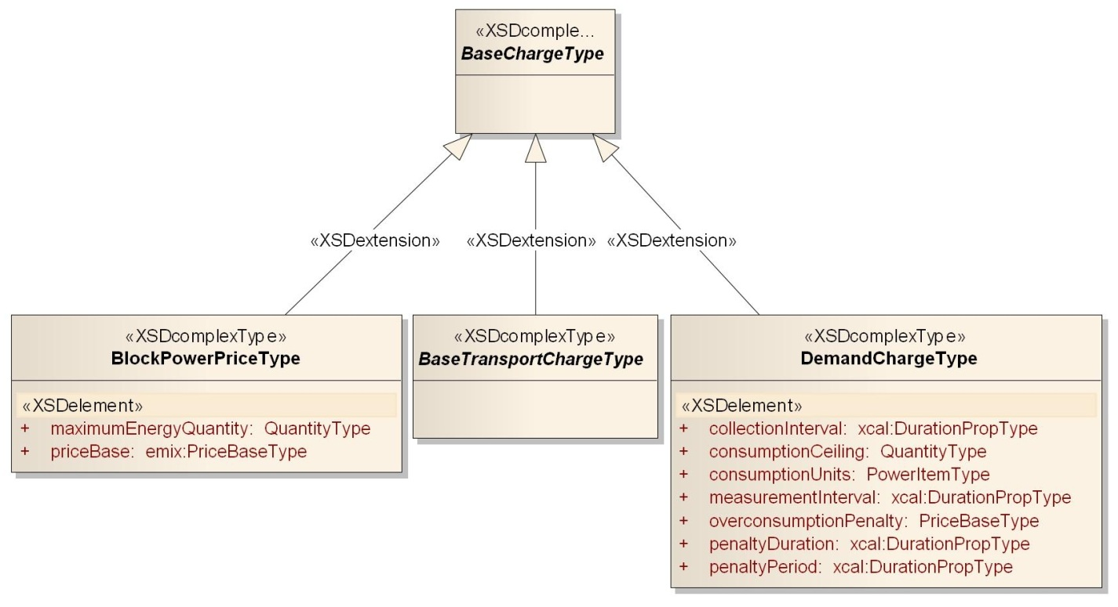
Figure 10-17: UML Summary of Power Product Charges

The Power Product Description
The Base Power Contract is the foundation for all the other Power Contracts. Each of them has the characteristics of the Base Power Contract plus their own additional elements:
Table 10-27: Base Power Product Description
Name | Description
Product Description | Base type for derivation. See Table 3-2: EMIX Core Abstract Types.
Power Product Type | Used to determine conformance and processing. See Table 10-24
EMIX Interface | See Table 8-17: EMIX Interfaces defined in POWER.
Unit Energy Price | Price Base, see Table 3-3: Elements derived from Price Base.
Power Item | See Table 8-19: Defined Power Items.
Charges | Any number of Charges as defined in Table 10-25: Power Product Charges
Each Power Product is applied to the EMIX Base Product before it is fully described. Because each element can be set for the whole Sequence, or applied to individual Intervals, each can vary over time.

Full Requirements Power
Full Requirements Power products are the traditional “all-you-can-eat” electrical contract. Maximum delivery is limited by the physical infrastructure. Demand Charges may apply. This type of product often appears in Residential markets.
As well as the attributes in the base Power Contract, the Full Requirements Product has the elements defined below.
Table 10-28: Full Requirements Power Product Description
Name | Description
Power Product Description | As described in Table 10-27: Base Power Product Description.
Maximum Power | The most power available for transacting during the period. Often determined by physical limits.
Minimum Power | The least power that must be transacted during the Interval. Buyer is responsible for making up the difference if the stated value is not consumed.

Block Power Full Requirements
Block Power Full Requirements products provide for full buyer requirement, but prices the power in “blocks”. Price is constant within a block, but each block may have a different price within a period. Demand Charges MAY be included. This type of Product is often used in retail residential rates.
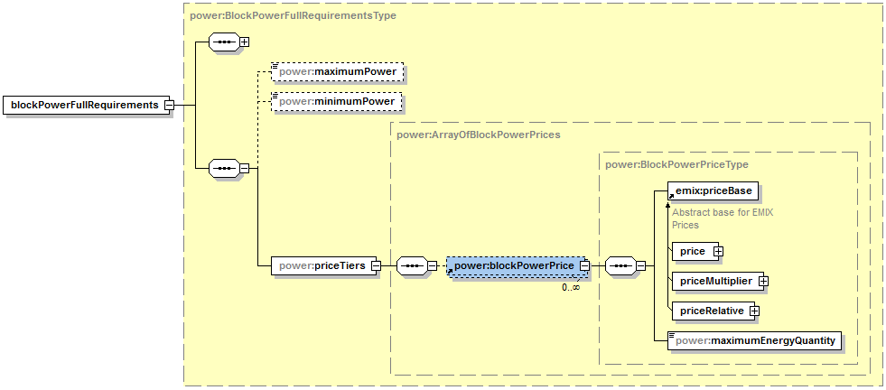
Figure 10-18: Block Power Full Requirements
As well as the attributes in the base Power Contract, the Block Power Full Requirements Product has these additional elements:
Table 10-29: Block Power Full Requirements
Block Power Element | Description
Power Product Description | As described in Table 10-27: Base Power Product Description.
Maximum Power | Denominates the most power available for transacting during the period.
Minimum Power | Denominates the least power that must be transacted during the Interval. Buyer is responsible for making up the difference if the stated value is not consumed.
Price Tiers | Any number of Block Power Prices as described in Table 10-25: Power Product Charges.

TeMIX Power Product
The TeMIX (Transactive Energy Market Information Exchange) is a model for balancing power markets with pure economic trading. It uses the simplest of the Power Product Descriptions.
The TeMIX profile allows only specific tenders and transactions for block power on defined Intervals of time. Tenders may be offered by any party to any other party, as market rules and regulations may allow. Any party can be a buyer, seller, or both. Transactions may include call and put options. TeMIX Options perform a similar function to demand response contracts or ancillary service contracts where an operator has dispatch control over the exercise of the option. TeMIX products also include transmission and distribution (transport) products.
TeMIX tenders and transactions can support dynamic tariffs by retail providers to retail customers. TeMIX is designed for interval metering where delivery can be accurately measured. The simplified information model and services of the TeMIX profile also support increased automation of transactions using the computer and communications technology of the smart grid.
TeMIX Products are specified by Power (rate of delivery of energy) over an Interval. TeMIX Products are obligations in that a TeMIX Product is a commitment by the seller to deliver and the buyer to take the Power (Energy) over the Interval. When the Interval includes more than one measurement or metering Interval, the TeMIX product is defined as a constant rate over each of those metering Intervals. An example is the sale of 1 MW tomorrow between 3 and 5 PM that may be measured every 15 minutes (The energy is 1 MWh). The power in each 15 minute Interval is 2 MW and the Energy in each 15 minute Interval is 0.25 MWh. A position in a TeMIX product may be sold or added to. Depending on local market rules, differences between the Power purchased and the actual delivery may be delivered from or to spot markets at spot market prices.
TeMIX is derived directly from the base Product Description because TeMIX is simpler and with less optionality than other Power Product Descriptions.
Table 10-30: TeMIX Power Product Description
TeMIX Element | Description
Product Description | Base type for derivation. See Table 3-2: EMIX Core Abstract Types.
Power Product Type | Used to determine conformance and processing. See Table 10-24
EMIX Interface | An EMIX Interface is any of a number of market exchange points including a point, an aggregate point, or a geographic area at which a product exchanges ownership
Price | Price per Unit of Energy. For TeMIX, this is always the actual price and not an offset.
Energy Item | Total Energy being transacted. Energy Type (Real, Apparent, or Reactive) must match Energy Type of Power Item.
Power Item | Rate of Delivery of Energy. Power Type (Real, Apparent, or Reactive) must match type of Energy Item.
TeMIX Product-based information exchanges are a little different from those for other products; they are discussed by themselves in Section 12 Profile for Transactive Energy (TeMIX).

Power Transport Product Description
The information model in this section is described in POWER-PRODUCTS.XSD
Transport costs affect the delivery of energy in all markets. Today’s electrical power markets use different terms in transmission and delivery, but the underlying elements are the same. Future markets, including those for microgrids and virtual service providers, may not make the same distinctions between transmission and distribution as have been made in the past. Distributed Energy Resources (DER) may create new business models for use of the existing distribution networks.

Power Transport Elements
The information model below merges the charges and approaches used in the respective transmission and distribution networks today. It anticipates that potential source selection markets may result in passage through multiple networks. The resulting Schedule can either stand-alone in transport products, or be conveyed inside the Envelope as price support information, in support of Locational Marginal Pricing (LMP).
Table 11-31: Transport Description
Transport Product Element | Description
Point of Receipt | Where power enters a network or changes ownership.
Point of Delivery | Where power exits a network or changes ownership.
Price | As defined in Table 3-3: Elements derived from Price Base.
Transport Charges | An array of Transport Charges, as defined in ..
There MAY be multiple instances of the above Artifacts in a single Price instance. For example, in a given transaction, power may pass through multiple distribution nodes and congestion points.
The items listed in the table above are each derived from the base charge type. All other charges, previously described, are available for inclusion within a Transport Product.
Table 11-32: Transport Product Charges
Charge Type | Description
Base Transport Charge | A sub-set of Charges for Transport-related Charges. Derived from Base Charge.
Congestion Revenue Rights | A financial hedge for congestion; i.e., a forward contract for congestion revenues potentially to offset congestion charges. Also known as financial transmission rights. (Transport Charge)
Congestion Charge | The cost of purchasing the right to transfer power over a given segment of the grid. (Transport Charge)
Transport Access Fee | A simple charge (not dependent on congestion) to access transport system. (Transport Charge)
Transport Congestion Fee | Assessment per unit of energy for energy flowing from receipt to delivery point. Can be a positive or negative price. (Transport Charge)
Marginal Loss Fee | A Marginal Loss Fee is assessed per unit of energy to pay to replace Power lost during transport. (Transport Charge)
Transport Loss Factor | A multiplier applied to a transacted quantity of energy to reduce delivery quantity due to loss during transport. (Transport Charge)
Conversion Loss Factor | A multiplier applied to a transacted quantity of energy to reduce delivery quantity due to loss as product voltage is changed or as converted from AC to DC or DC to AC. (Transport Charge)

UML Summary of Transport Charges
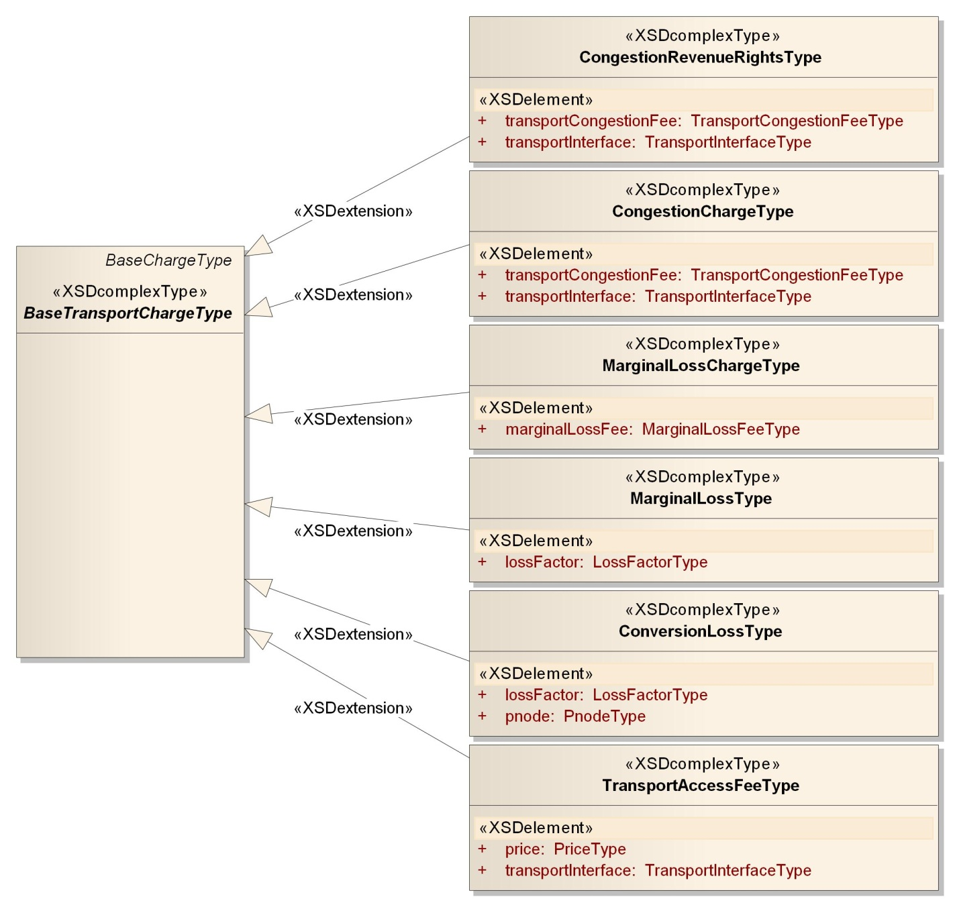
Figure 11-19: UML Summary of Transport Charges

Profile for Transactive Energy (TeMIX)
TeMIX is a profile of the EMIX Power Products. This section describes the TeMIX profile. The EMIX TC has prepared a Committee Note [TeMIX] that provides a context for the TeMIX profile.
The TeMIX model is based on blocks of Power with a constant rate of delivery (subscription) over a single Interval. All TeMIX Products are transactions for Power delivered over the course of a single Interval. Each transaction imposes an obligation on the buyer to purchase and the seller to deliver a TeMIX Power Product. This simplicity reduces the number of products and interactions.
There are only four types of TeMIX Products:
- TeMIX Power Product
- TeMIX Transport Product
- TeMIX Option Power Product
- TeMIX Option Transport Product
The Transactive States for a TeMIX Product are:
- Indication of Interest
- Tender
- Transaction
- Delivery
- Price Publishing
A TeMIX Delivery Interval is specified by a Duration and Start Time. When a TeMIX Product specifies a set of Delivery Intervals, then the elements that do not vary by Delivery Interval may be specified in a Gluon or the Standard Terms. Each TeMIX Delivery Interval is transacted independently of the others.

TeMIX Overview
The rate of delivery of a TeMIX Power Product is constant over all measured (metered) Intervals within a TeMIX Delivery Interval. For example the transaction could be for 1 hour, but the meter reads every 5 minutes. These market rules are outside the scope of this specification/
For example, 1 MW of power transacted for delivery tomorrow for two hours between 3 and 5 PM provides 1 MWh of energy over each hour and 2 MWh over the two hours. If delivery is measured every 15-minutes, then the power transacted in each 15 minute Interval is 1 MW. The energy transacted in each 15-minute Interval is 0.25 MWh. If the energy delivered in each 15-minute Interval is greater or less than 0.25 MWh then the balance (positive or negative) will be sold or purchased in a subsequent balancing transaction.
The Price of a TeMIX Product is expressed in energy units. For the example above, when the price is $80 per MWh of energy, the extended price (cost) of 1 MW of Power for two hours between 3 and 5 PM is $160; the extended price for 1 MW of Power in each 15-minute Interval of the two hours is $20.
A TeMIX Transport Product is a subscription for Transport (transmission or distribution) to transport a TeMIX Power Product from one EMIX Interface to another. A TeMIX Transport Product is a subscription for power transport at a constant power over the interval.
A TeMIX Option Product provides the Option Holder the right to instruct the option writer to deliver (call) or take (put) a TeMIX Power or Transport Product up to the transacted quantity (rate of delivery) of the Option at a Strike Price.
TeMIX Options are either Call or Put Options on TeMIX Power and Transport Products. A TeMIX Option can be exercised during the Delivery Interval of the Option for any sub-Interval not smaller than the Option Interval Granularity.
For example, a TeMIX Option for 10 MW for a Day and an Option Interval Granularly of 1-hour and an Option Lead Time of 30 minutes would allow the Holder to exercise the option for any or all hours of the Day at the Strike Price by giving notice 30 minutes before each hour.

TeMIX Products
The elements of a TeMIX Power and Transport Product are shown in Table 11-31: Transport Description. When the Product Description (from the Section Power Product Descriptions) is applied to the EMIX Base types, the TeMIX elements are as shown in that table.
Table 12-33: TeMIX Product Description
TeMIX Element | Description
Power Product Type | Enumerated type of Power Product. Used to determine conformance requirements.
EMIX Interface | The Interface where the transaction occurs. Generally, the Interface for a Power Product has one node and the Interface for a Transport Product has two nodes.
Start Date and Time | When the Interval begins.
Duration | The extent of time of the Interval.
Price | The Unit Energy Price for the Interval. TeMIX does not allow Relative Prices or Price Multipliers.
Energy Item | Total Energy (Power * Time), Real, Apparent, or Reactive, delivered over the Interval.
Power Item | Units for the Rate of Delivery of Energy for the Delivery Interval. Includes Power Attributes.
Power Quantity | Rate of Delivery of Energy for the Delivery Interval.
Transactive State | TeMIX Transactive state is conformed to Indication of Interest, Tender, Transaction, Delivery or Publish.
Currency | Currency for the exchange.
Side | Indicates which side of the agreement the information originator is on. Buy or Sell.
Expires Date | Date and Time Tender expires. Not present if the Transactive State is anything other than Tender.
Envelope | As defined in Section 3.1.5: The Envelope Contents.
The TeMIX Option extends the TeMIX Product by adding these additional elements:
Table 12-34: TeMIX Power Option Product Description
TeMIX Element | Description
Option Holder Side | The side (buy or sell side of the option) which enjoys the benefit of choosing whether or not to exercise the option. The other side is the option writer.
Option Strike Price | The price at which the Option Holder can require option writer to deliver.
Exercise Lead Time | (Term) The Minimum Notification Duration expressed as an EMIX Term.
Option Exercise Schedule | (Term) The Availability Schedule expressed as an EMIX Term.
Temporal Granularity | If present, expresses the temporal granularity of requests as a Duration. For example, if the Duration is 15 Minutes, the option can be called at 10:00, 10:15, 10:30, or 10:45. Granularity is a Property of the Option Schedule.
In TeMIX, very few terms are used, and they are homogenous for the entire market. See 7 Standardizing Terms for Market Context for a discussion of exchanging market-wide information.

Conformance Rules for TeMIX
The following comprise the conformance rules for TeMIX:
- All allowed TeMIX Product Elements are named in Tables 7-1, 7-2, 12-1 and 12-2.
- For a given Market Context, all Product Elements MUST be Defined in Standard Terms EXCEPT FOR
- Starting Date and Time
- Quantity
- Price
- Side
- Tender Expiration Date and Time
- All TeMIX Product Elements MUST BE UNDERSTOOD
- All Elements NOT in the TeMIX Product Elements MUST BE IGNORED
- All TeMIX Intervals are transacted separately MUST NOT have Links to other Intervals.
- TeMIX MUST conform to all EMIX Conformance Requirements

Valid TeMIX Product Types
The allowed TeMIX Products are:
- TeMIX Power Product
- TeMIX Transport Product
- TeMIX Option Power Product
- TeMIX Option Transport Product

Transactive States for TeMIX
The Transactive States for a TeMIX are:
- Indication of Interest (IOI)
- Tender
- Transaction
- Delivery
- Publish

Energy Resources
The information model in this section is described in RESOURCE.XSD
The Resource information model describes information that MAY be used to offer product(s) in a market. The Resource model describes a range of potential operational responses. The model allows parties to describe a wide range operations, both generation and curtailment. Resource descriptions are used tenders either to buy or tenders to sell Energy or Power products.
When making a tender for products and services, it is useful to describe the operational characteristics of a resource so the counter party can determine if a resource can meet the requirements. A notice of interest MAY specify performance expectations. A Resource MAY compare its own capabilities to those requirements before submitting a bid.
Parties can potentially exchange these models, until they come to an agreement. The rules for exchanging these models are outside the scope of this specification. Resource tenders are less specific than a single transactive request, and one Resource tender may be able offer the Resource to more than one market.
Resources may represent a generator or a load responses or aggregations. In interactions involving Resources it may be useful to describe either (1) the proposed or actual operation of a Resources, or (2) the range of capability of a Resource.

Resource Capabilities
The following curve characterizes the a schedule for operation of a generic Resource
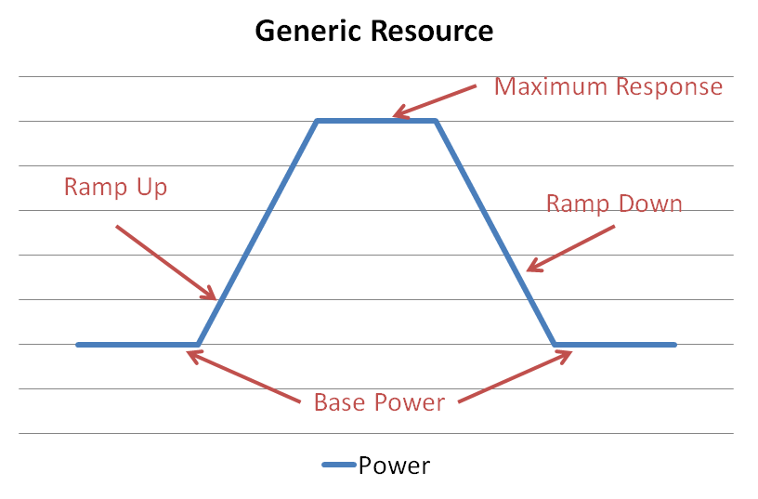
Figure 13-20:Operational Profile of a Generic Resource
In the Resource illustration above, there is some base level of power, a status quo ante. When invoked, the resource takes a period of time to change to a different level. If the response is binary, then it can only go up to the maximum response, and that ramp rate takes a fixed time. If a resource is able to provide several layers of response, then the ramp time also varies. The ramp time can be computed from the ramp rate and the difference between the base power and the maximum response.
As electricity is fungible, a critical key element of the information model in Power Resources is that generation, that is the production of power, and load shedding, the reduction of power use are similar products.
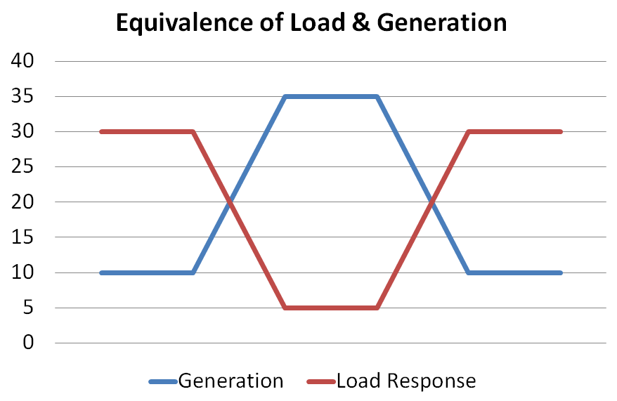
Figure 13-21: Equivalence of Load Shed and Generation
As shown in the example above, generation and load response are similar and can be described using the same information model.
Many Resources have capabilities that change over the range of response. A generator may have one ramp rate until it gets up to half speed, and then another as it goes to full speed. Load response can have similar characteristics. Such resources can be described by combining simple response characteristics.
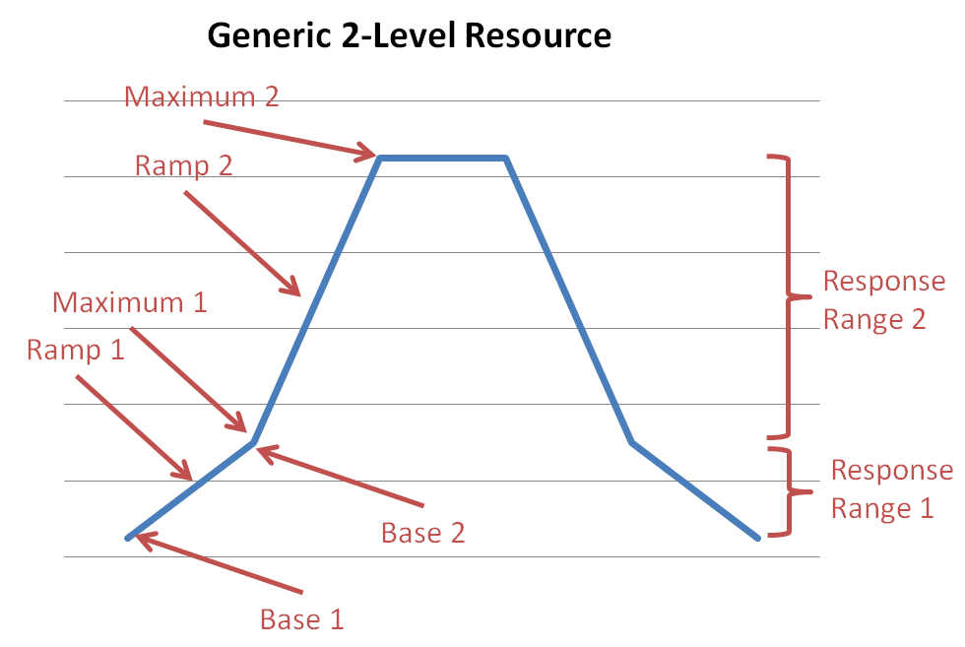
Figure 13-22: Combining Resource Operational Responses

Resource Capability Description
Resource capability descriptions describe what could be done, as distinguished from a transaction in which specific performance is requested or agreed to.
Resources capabilities may be communicated as an array of ramp up rates, a maximum power offered, and an array of ramp down rates. Between the Base 1 and Maximum 1, expressed in MW, the resource ramps up at Ramp 1 expressed in MW/minute. Between the Base 2 and Maximum 2, expressed in MW, the resource can ramp up at Ramp 2 expressed in MW/minute.
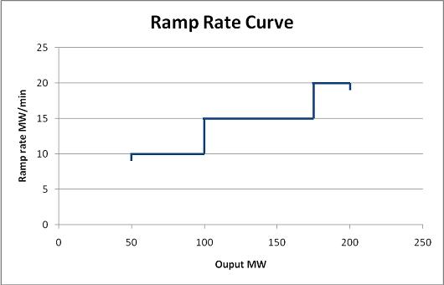
Figure 13-23: Ramp Rate Curve—CIM Style
As described in [IEC 62325-301], a given resource may publish multiple ramp rate curves for different circumstances. This resource capability description may be preferred to the resource operation description in some interactions.

Contrasting Operation and Capability Descriptions
Assume the Resource is operated at the ramp rates as in Figure 13-23 then an operation as described in Figure 13-20. A capability description is generally used to guide resource dispatch. Once the dispatch is computed, an operational description can be used to tender or transact the power that is the result of the dispatch from the market.
This specification describes market interactions, i.e., the operational profiles. Only the description in Section 13.1 is in this specification. When a single resource offers different ramp rates for different circumstances, this specification considers the resulting operational profiles to be distinct products.
The description in Section 13.2 may be considered at a later date by the committee.

Resource Description Semantics
EMIX Resource Descriptions are an extension of the EMIX Product Description. As an extension of the Product Description, resources can be applied inside any EMIX schedule.
The only aspects of a Resource that matter to the energy market are the effects it can provide, the likelihood it will be able adequately to provide what it promises, and the financial incentives required to acquire them. The technology and process control details are many, and new ones may be required for each new power technology. Unless the market for the Resource requires direct control, such details are irrelevant.
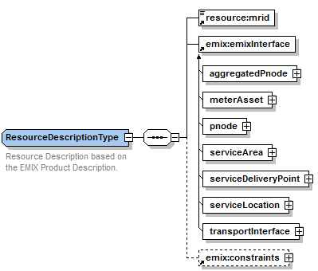
Figure 13-24: Resource Description base
The EMIX Resource Description base consists of the elements shown in the table below.
Table 13-35: Resource Description Elements
Resource Description Element | Note
MRID | The Master Resource ID as defined in the [IEC TC57] IEC 61970-301.
EMIX Interface | The Interface is where the Resource injects or extracts power. Note: for many transactions, reduced extraction is equivalent to injection.
Terms | In addition to the Terms listed for Product performance, Resources have additional Terms, listed in Table 10-2.
Power Resources descriptions can use any of the Terms or requirements defined in EMIX. Power Resource descriptions can also use additional Terms that are specific to Power:
Table 13-36: Terms unique to Power Resources
Power Term | Note
Minimum Load | Minimum Load that a Resource can maintain.
Maximum Power | Maximum Power available from a resource.
Maximum Energy | Maximum Energy available from a resource.
Minimum Load Reduction | Minimum Load Reduction resource can make.

UML Summary of Resource Descriptions
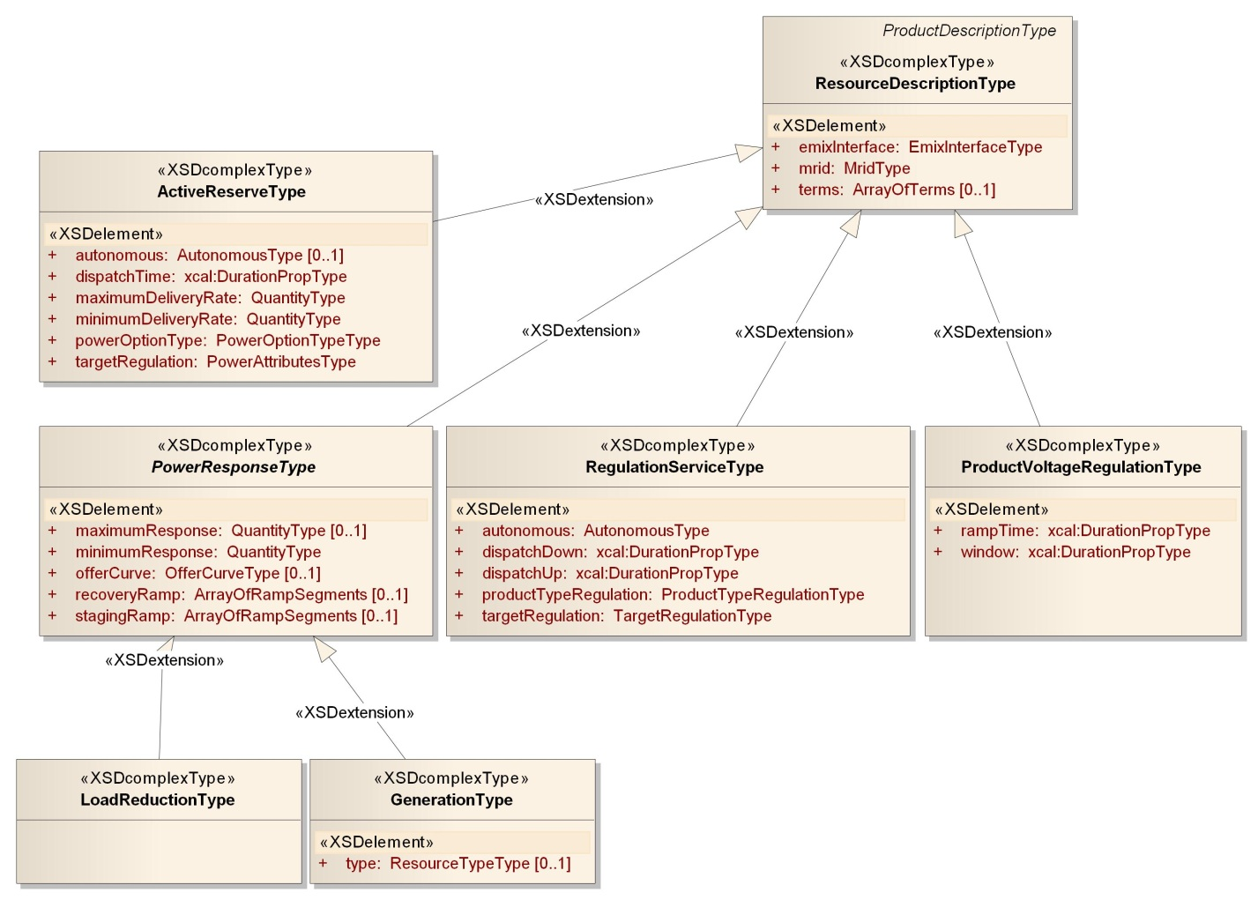
Figure 13-25: UML Summary of Resource Descriptions

Generic Power Resource
The Generic Power Resource description is used both for generation and for load Resources. The common Resource model is shown in the following table.
Table 13-37: Generic Power Response Resource
Generic Resource Element | Note
Staging Ramp | An array of Power Ramp Segments describing a Resource’s ability to change level at the initiation of a Response.
Minimum Response | The least Response for which this resource will accept a request.
Maximum Response | The greatest Response for which this resource will accept a request.
Recovery Ramp | An array Power Ramp Segments describing how a Resource’s returns to its original state following a response.
A Power Response Description MAY be accompanied by an Offer Curve (described in section 13.6.2 Offer Curves). Each Ramp consists of zero to many Power Ramp Segments (see Figure 13-22: Combining Resource Operational Responses).

Power Ramp Segments
Power Ramp Segments consist of the following elements shown in the table below.
Table 13-38: Power Ramp
Power Ramp Element | Note
Rate | Power Units for the Ramp.
Begin Ramp Quantiy | Power Quantity at the beginning of the Segment.
End Ramp Quantity | Power Quantity at the end of the Segment.
Duration | The time between the begin ramp and the end ramp.
Integral Only | If true, one can’t stop between the begin and end rates.
While Power Ramps are generic, specific instances within derived Resource Descriptions are subject to different conformance rules.
For a Generation Resource, Staging Ramps are processed in order of increasing End Power. The quantity of End Power MUST be greater than the quantity of the Begin Power for each Ramp in the Staging Ramp. Recovery Ramps are processed in order of decreasing End Power. The quantity of End Power MUST be less than the quantity of Begin Power for each Ramp in the Recovery Ramp.
For a Load Resource, Staging Ramps are processed in order of decreasing End Power. The quantity of End Power MUST be less than the quantity of Begin Power for each Ramp in the Staging Ramp. Recovery Ramps are processed in order of increasing End Power. The quantity of End Power MUST be greater than the quantity of the Begin Power for each Ramp in the Recovery Ramp.
Load Resources and Power Resources are conformed instances of the Generic Power Resource.

Offer Curves
When the capability of Power Resource tendered, it may be accompanied by an Offer Curve. An Offer Curve is comprised of a number of Offer Segments. An Offer Segment defines the offer price (as expressed in EMIX Requirements) for the quantity offered in each segment. A sequence number indicates the order of the segments. Each segment may be offered in any partial amount or all-or-none.
Table 13-39: Resource Offer Segment
Resource Offer Element | Note
Price | Energy Price for this Segment.
Quantity | Power Quantity for this Segment.
Duration | Duration of the Segments.
Units | Power Units in which Segment is denominated.
Units | Energy Units in which Segment is denominated.
Integral Only | If true, offer is all or none; no partial acceptance of this segment.

Voltage Regulation Resources
Voltage regulation services have their own particular semantics as described in the following table.
Table 13-40: Semantics for Voltage Regulation Services
Voltage Regulation Element | Note
VMin | VMin is the minimum voltage level of 88% of nominal voltage where the photovoltaic (PV) inverter must disconnect, as defined in [IEE1547].
VMax | VMax is maximum voltage level of 110% of nominal voltage where the photovoltaic (PV) inverter must disconnect, as defined in [IEE1547].
QMax | QMax is the inverter’s present reactive power (VAR) capability and may be positive (capacitive) or negative (inductive). It can also be considered as the apparent power (VA) capability left after supporting the real power (W) demand. See [Budeanu] and [IEEEv15#3].

Ancillary Services Products
Ancillary Services are defined in the schema POWER-PRODUCTS.XSD
Ancillary Services are typically products provided by a Resource contracted to stand by for a request to deliver changes in power to balance the grid on short notice. Ancillary services include Regulation, Spinning Reserve, Non-Spinning Reserve and Volt/Var support (Reactive Power). Resources providing Ancillary services may be paid for availability, whether or not they are dispatched. Of course, if dispatched, they are obligated to perform. Demand side Resources, when qualified, may provide Ancillary Services
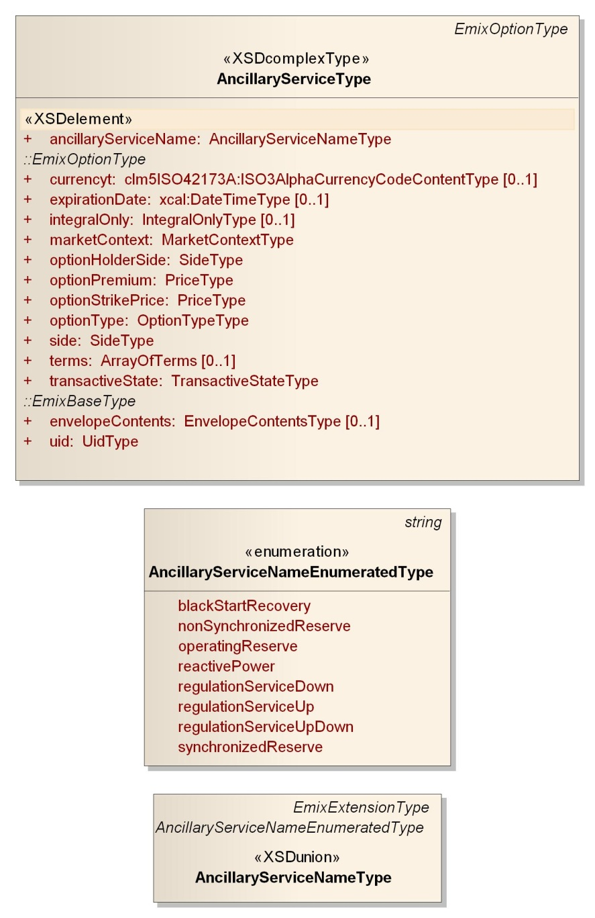
Figure 14-26: UML Ancillary Services Product
The Ancillary Services Type is derived from the abstract Emix Option base type. Ancillary Services are described using the market semantics of Options within the EMIX Option type. Performance expectations are expressed using Terms. Strike prices and the penalty for non-performance are part of the option agreement.
Because it is useful to have a short-hand to refer to these services, they are enumerated in the Power Option Type enumeration which is incorporated into the Power Product Types. The enumerated Power Option Types are:
- Operating Reserve
- Regulation Service Up
- Regulation Service Down
- Regulation Service Up/Down
- Synchronized Reserve
- Non-Synchronized Reserve
- Black Start Recovery
- Reactive Power
The enumerated list is extensible as described in Appendix B.1: “Extensibility in Enumerated Values”. Because the exact definitions vary from market to market, and will continue to vary over time, EMIX does not define these terms. All definitions and performance requirements SHALL be expressed through the Terms.

EMIX Warrants
The information model in this section is described in EMIX-WARRANTS.XSD
Warrants are specific assertions about the extrinsic characteristics of EMIX Products that may affect market pricing. Warrants are "a written assurances that some product or service will be provided or will meet certain specifications."
Parties may use warrants to exchange information about the source of the energy or about its environmental characteristics. Sellers may use EMIX Warrants to provide information about the source of the energy or about its environmental characteristics. Buyers may use warrants to indicate what they wish to purchase. EMIX does not define specific warrants, although it does define base types for extension by those who wish to develop the various types of warrants.
The general form of a warrant is similar to that of an EMIX Product. It can vary by time, using schedules as in WS-Calendar. The Intervals in a Warrant may differ from those of the Product on the outside of the envelope. There may be zero Intervals in a Product if the unchanged product description applies to all.
Some Warrants may be separable from the underlying energy. For example, a Warrant that energy is generated by a source that is certified as "green" by an authority, may be issued a "green certificate". In some markets, such a certificate can be traded separately.
Today, the information conveyed in warrants is local, and not ready for standardization. For example, in 2011 energy warranted as renewable in the Pacific Northwest can include hydropower. Energy markets in California exclude hydropower from their definition of renewable power. Credits or mandates for renewable energy in California are not met by Products warranted as renewable in the Pacific Northwest.
The Technical Committee has chosen to define a general semantic mechanism to convey warrants, without standardizing warrants in v1.0. The Technical Committee defined broad classes of warrants, any of which may be the subject of a future standardization effort.
Parties that need additional types of warrants can extend the abstract Warrant Type to create a new base type for Warrants not defined in this specification.
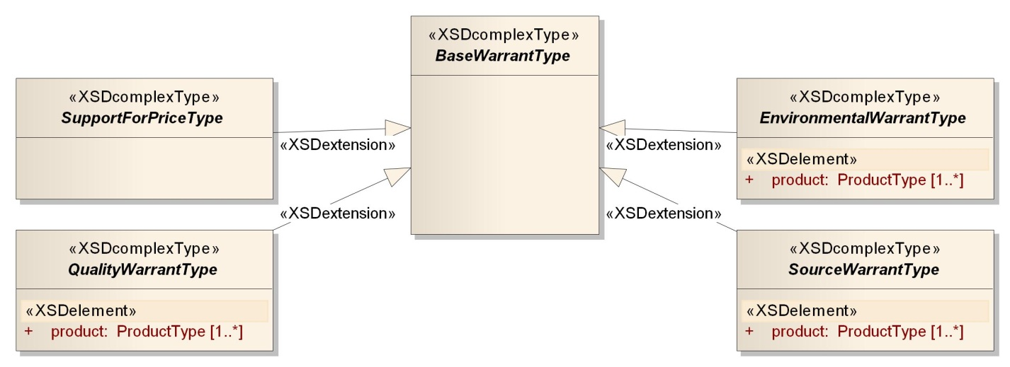
Figure 15-27: UML Summary of Warrants

Warrants Described
Warrant Types are abstract types defined in this specification for extension and definition elsewhere. Conforming information exchanges can include schema types derived from these types.
Table 15-41: Warrant Types
Warrant Type | Descriptions
Product Quality | A Quality Warrant asserts or requires that the product be of a certain quality or better. A quality warrant includes an array of Quality Measures. The Quality Measure type is extensible to support the definition of additional quality measures.
Environmental Warrant | An Environmental Warrant is used to assert what environmental effects of the product. These may include emission of a chemical, or use of a scarce resource. No environmental warrants are defined in the EMIX v1.0. Parties wishing to exchange Environmental Warrants may extend this type to create the environmental assertions that they require.
Source Warrant | A Source Warrant consists of assertions the sources (often meaning the technologies) of the commodity included in this product. Source often has specific regulated meaning in different jurisdictions, so no definition of Source is included in this specification. Parties that require Source information may extend this type to create the source assertions that they require.
Support for Price | Support for Price conveys additional information to support the price on the outside of the envelope. It was originally conceived of as a potential array of products with their own prices. An example is the wholesale purchase of a product, along with transport products to establish a base cost to support a contracted price. Without further definition, support for price is not restricted in this way as of v1.0, and Parties that wish to exchange price support may extend this type to meet their needs.

Power Quality
The information model in this section is described in POWER-QUALITY.XSD.
Higher quality power can obtain a market premium. A buyer willing to accept lower quality power may be able to obtain it at lower expense. Power qualities must be measurable, discrete, and allow buyers and sellers to make choices. They must also be auditable and measurable by a specific defined protocol, so performance can be compared to promise.
Figure 16-28: UML of Power Quality Warrant
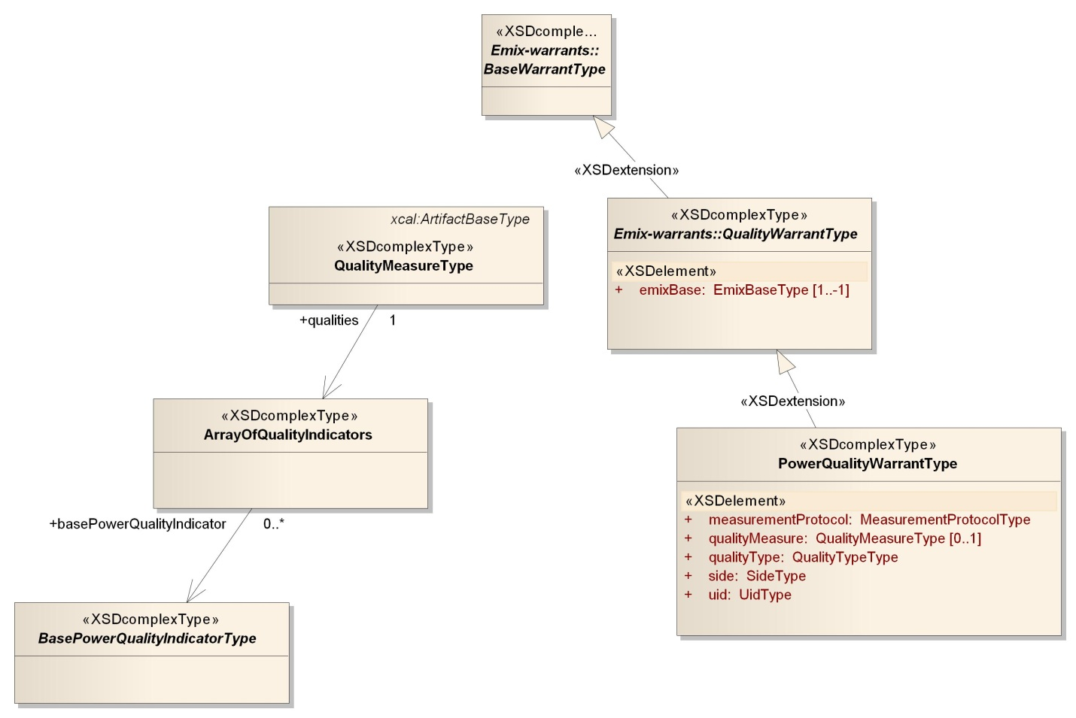

Power Quality Warrant
There are numerous protocols for determining power quantity, and often more than one name for the same quality. Assertions about Power Quality must be qualified with what protocol is being used, and must be able to specify the period or periods to which they refer.
The Power Quality Warrant is similar to the EMIX Base. As an extension to the EMIX Base, it holds a schedule, which can be populated with Quality Assertions. A Quality Assertion is a collection of Quality Statements that apply for an Interval.
Table 16-42: Elements of the Power Quality Warrant
Product Element | Description
Quality Warrant | See Table 15-41: Warrant Types
Power Quality Type | An enumerated string that about the origins of the Warrant. Defined enumerations are Guaranteed, Measured, Projected, Average.
Measurement Protocol | A string containing an identification of the standard or other protocol used to measure power quality.
Schedule | Sequence populated by a Quality Measure (Table 16-44)
Side | Buy or Sell, as defined in Table 3-6: Simple Semantic Elements of EMIX. Side can be used to determine whether this warrant is a requirement or a promise.
Quality Measure | Quality Measure is a collection of Power Quality Indicators (Table 16-44) Note: Quality Measure can be applied EITHER in the intervals of the schedule in emixBase inherited from the emix:QualityWarrant OR in external to the Intervals, but not both.
The Schedule is populated by Quality Measures. A Quality Measure is a collection of Power Quality Indicators. The Power Quality indicators MUST be recorded as per the requirements and definitions in the Measurement Protocol. The defined Power Quality indicators are in Table 16-44: Power Quality Indicators.
The terminology for characteristics is largely that of [IEC61000-4-30] and the generally similar [Caramia]. Table 16-2 defines strings for Measurement Protocol in Table 15-3; others may be added by prefixing “x-“ as described in Appendix B “Extensibility in EMIX”.
Table 16-43: Named Power Quality Protocols
Protocol | Reference
EN 50160 | As described in [EN50160]
IEEE 1519-2008 | As described in [IEEE1519
IEC 61000-2003 | A described in [IEC61000-2003]
The power quality indicators are described in Table 16-44. Other Quality Indicators can be defined by deriving from the base Quality Indicator type.
Table 16-44: Power Quality Indicators
Name | Description
Measurement Protocol | A string containing an identification of the standard or other protocol used to measure power quality.
Power Frequency | A floating point number describing the measured Power Frequency. Note: users who wish to describe how the frequency varies over time will need to derive their own measure from the base Power Quality type.
Supply Voltage Variations | An unsigned integer count of Supply Voltage Variations during the period.
Rapid Voltage Changes | An unsigned integer count of Rapid Voltage Change events during the period.
Flicker ST | A measurement of Short Term Rapid Voltage Change. The actual periods for measurement are defined in the measurement protocol documents.
Flicker LT | A measurement of Long Term Rapid Voltage Change. The actual periods for measurement are defined in the measurement protocol documents..
Supply Voltage Dips | An unsigned integer count of Supply Voltage Dip events (called Sags in some protocols) during the period.
Short Interruptions | An unsigned integer count of Short Interruption events during the period.
Long Interruptions | An unsigned integer count of Long Interruption events during the period.
Temp Overvoltage | An unsigned integer count of Temporary Overvoltage events during the period.
Supply Voltage Imbalance | An unsigned integer count of Supply Voltage Imbalance events during the period. Not meaningful for DC.
Harmonic Voltage | A floating point number for the Harmonic Voltage during the period. For DC, distortion is with respect to a signal of zero (0) Hz.
Mains Voltage | A floating point number indicating Mains Voltage.
Mains Signaling Voltage | A floating point number indicating Mains Signaling Voltage, relating generally to power line communications systems.

UML Summary of Power Quality Indicators
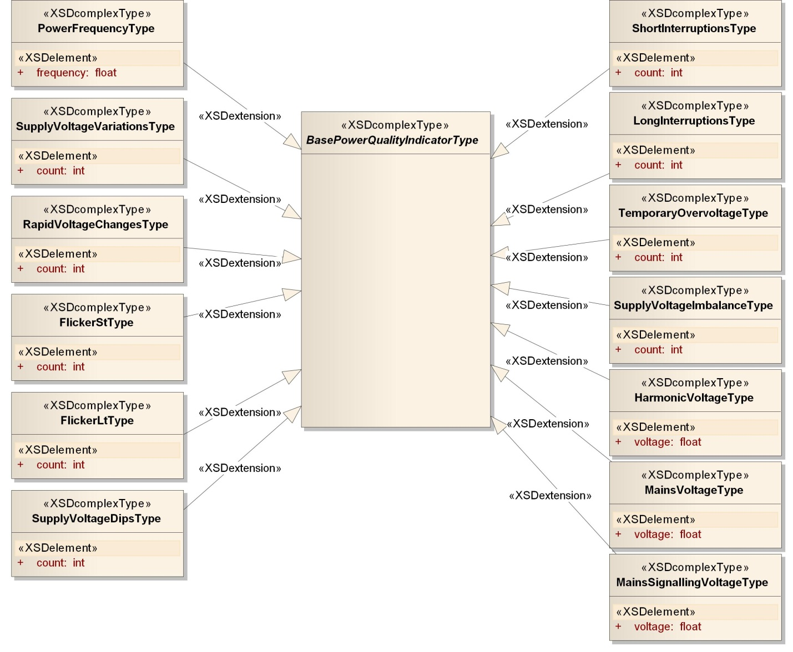
Figure 16-29: UML Summary of Power Quality Indicators

Conformance and Rules for EMIX and Referencing Specifications
This section specifies conformance related to the semantic model of EMIX. EMIX is heavily dependent upon [WS-Calendar], and repeatedly incorporates [WS-Calendar]-based information models.
EMIX Artifacts can be exchanged at any of several stages of a transaction. Necessarily, a tender must be able to accept an incomplete information model while a call for execution must fully define the performance expected. Specifications referencing EMIX SHALL define conformance rules by transaction type and market context.
EMIX conformance necessarily occurs in two stages. EMIX uses [WS-Calendar] to communicate similar Intervals that occur over time, each containing an EMIX Artifact. Portions of that Artifact may be expressed within the Lineage of the sequence. Applications MUST apply [WS-Calendar] Inheritance and then EMIX Inheritance to Compose the information exchange for each Interval. Only after Composition, can the EMIX Artifact within each Interval of the Sequence be evaluated for conformance and completeness.

EMIX Conformance with [WS-Calendar]
EMIX Base are EMIX Products and Resources instantiated through the schedule model of [WS-Calendar]. As such, EMIX Base SHALL follow [WS-Calendar] Conformance rules. These rules include the following conformance types:
- Conformance to the inheritance rules in [WS-Calendar], including the direction of inheritance
- Specific attributes for each type that MUST or MUST NOT be inherited.
- Conformance rules that Referencing Specifications MUST follow
- Description of Covarying attributes with respect to the Reference Specification
- Semantic Conformance for the information within the Artifacts exchanged.
EMIX Products and Resources also extend the Inheritance patterns of [WS-Calendar] to include the EMIX information model. We address each of these in the following sections.

Inheritance in EMIX Base
The rules that define inheritance, including direction in [WS-Calendar], are recapitulated.
I1: Proximity Rule Within a given lineage, inheritance is evaluated though each Parent to the Child before what the Child bequeaths is evaluated.
I2: Direction Rule Intervals MAY inherit attributes from the nearest Gluon subject to the Proximity Rule and Override Rule, provided those attributes are defined as Inheritable.
I3: Override Rule If and only if there is no value for a given attribute of a Gluon or Interval, that Gluon or Interval SHALL inherit the value for that attribute from its nearest Ancestor in conformance to the Proximity Rule.
I4: Comparison Rule Two Sequences are equivalent if a comparison of the respective Intervals succeeds as if each Sequence were fully Bound and redundant Gluons are removed.
I5: Designated Interval Inheritance [To facilitate composition of Sequences] the Designated Interval in the ultimate Ancestor of a Gluon is the Designated Interval of the composed Sequence. Special conformance rules for Designated Intervals apply only to the Interval linked from the Designator Gluon.
I6: Start Time Inheritance When a start time is specified through inheritance, that start time is inherited only by the Designated Interval; the start time of all other Intervals are computed through the durations and temporal; relationships within the Sequence. The designated Interval is the Interval whose parent is at the end of the lineage.

Specific Attribute Inheritance within EMIX Envelopes
This section refers to EMIX Products, agreements, and Resources as Artifacts. In general, an Artifact of a particular type blocks inheritance of a complete Artifact of that type down the lineage.
The root node of parent and the child must match for blended inheritance to occur, that is, the roots must be of the same type. The exception is if there are no roots in the child’s Artifact, then the root and all its branches are inherited by the child.
If matching roots for the model are found in both the parent and in the child, then each tree should be navigated to determine blended inheritance. The child’s artifact may be mostly unpopulated. Within any branch in the child, the first node that is populated blocks all further inheritance on that branch. All nodes deeper into the Artifact than that populated node are determined by the child. When a branch is inherited from the child, it blocks the inheritance of any deeper nodes within that branch.
Specific artifacts may declare rules that break this inheritance pattern. As of now, the exceptions are:
- There are no exceptions.
Inheritance creates a virtual artifact at each level of processing. That virtual Artifact is the basis for inheritance for any child Artifact.
In EMIX the following attributes MUST NOT be inherited
- UID (Gluons and Intervals)
- Temporal Relationships
Some elements of EMIX are may be covariant, meaning that they change together. Such elements are treated as a single element for inheritance, they either are inherited together or the child keeps its current values intact. This becomes important if one or more of a covariant set have default values. In that case, if any are present, then inheritance should deem they are all present, albeit some perhaps in their default values.

Time Zone Specification
The time zone MUST be explicitly expressed in any conforming EMIX Artifact.
This may be accomplished in two ways:
- The time, date, or date and time MUST be specified using [ISO8601] utc-time (also called zulu time)
- The [WS-Calendar] Time Zone Identifier, TZID, MUST be in the Lineage of the artifact, as extended by the Standard Terms. See 17.3 below.
If neither expression is included, the Artifact does not conform to this specification and its attempted use in information exchanges MUST result in an error condition.

Inheritance from Standard Terms
If an Artifact exists within the context of Standard Terms, the artifact inherits from the Standard Terms. Elements that can be inherited from Standard Terms include Product Type, TZID, Currency, and Measurement Units.
Inheritance MUST be determined in the manner of Section 17.1.1. Rules I1, I2, and I3, that is, that the attribute definition be determined by going to the nearest Gluon in the Lineage containing that attribute, with the addition that if no such Gluon is present then the search continues in the associated Standard Terms.

Specific Rules for Optimizing Inheritance
- If the Designated Interval in a Series has a Price only, all Intervals in the Sequence have a Price only and there is no Price in the Product.
- If the Designated Interval in a Series has a Quantity only, all Intervals in the Sequence have a Quantity only and there is no quantity in the Product.
- If the Designated Interval in a Series has a Price & Quantity, all Intervals in the Sequence MUST have a Price and Quantity and there is neither Price not Quantity in the Product.
- Acknowledgements
The following individuals have participated in the creation of this specification and are gratefully acknowledged:
Participants:
Bruce Bartell, Southern California Edison
Timothy Bennett, Drummond Group Inc.
Carl Besaw, Southern California Edison (SCE)
Edward Cazalet, Individual
Toby Considine, University of North Carolina at Chapel Hill*
William Cox, Individual
Sean Crimmins, California Independent System Operator
Phil Davis, Schneider Electric
Sharon Dinges, Trane
Pim van der Eijk, Sonnenglanz Consulting
Girish Ghatikar, Lawrence Berkeley National Laboratory
Todd Graves, Microsoft Corporation
Anne Hendry, Individual
David Holmberg, NIST*
Gale Horst, Electric Power Research Institute (EPRI)
Ali Ipakchi, Open Access Technology International Inc. (OATi)
Perry Krol, TIBCO Software Inc.
Derek Lasalle, JPMorganChase
Jeremy Laundergan, Southern California Edison (SCE)
Alex Levinson, Lockheed Martin*
Dirk Mahling, CPower
Scott Neumann, Utility Integration Solutions Inc.
Robert Old, Siemens AG
John Petze, Individual
Joshua Phillips, ISO/RTO Council (IRC)
Donna Pratt, ISO/RTO Council (IRC)
Ruchi Rajasekhar, Midwest Independent Transmission System Operator, Inc.
Carl Reed, Open Geospatial Consortium, Inc. (OGC)*
Jeremy Roberts, LonMark International*
Anno Scholten, Individual
Aaron F. Snyder, Enernex
Pornsak Songkakul, Siemens AG
Bill Stocker, ISI/RTO Council (IRC)
David Sun, Alstom Power Inc.
Jake Thompson, EnerNOC
Matt Wakefield, Electric Power Research Institute (EPRI)
David Webber, Individual
Leighton Wolffe, Individual
Brian Zink, New York Independent System Operator (NYISO)
- Extensibility and EMIX
Extensibility was a critical design constraint for EMIX. Extensibility allows the EMIX specification to be used in markets and in interactions that were not represented on the Technical Committee. Formal extensibility rules also create a set of complaint extensions for incorporation into later versions that are already compliant.
  - Extensibility in Enumerated values
EMIX defines a number of enumerations. Some of these, such as measurements of power, are predictably stable. Others, such as market contracts or energy sources, may well have new elements added. In general, these accept any string beginning with “x-“ as a legal extension. In particular, these are defined using the following mechanism in the formal schemas (XSD’s).
In emix.xsd, the extensibility pattern is:
<xs:simpleType name="EMIXExtensionType">
<xs:annotation>
<xs:documentation>Pattern used for extending string enumeration, where allowed</xs:documentation>
</xs:annotation>
<xs:restriction base="xs:string">
<xs:pattern value="x-\S.*"/>
</xs:restriction>
</xs:simpleType>
An example of non-extensible enumerated types is:
<xs:simpleType name="PowerOptionTypeEnumeratedType">
<xs:annotation>
<xs:documentation>Power Reserve Options</xs:documentation>
</xs:annotation>
<xs:restriction base="xs:string">
<xs:enumeration value="SpinningReserve"/>
<xs:enumeration value="NonSpinningReserve"/>
<xs:enumeration value="OperatingReserve"/>
<xs:enumeration value="DemandResponse"/>
</xs:restriction>
</xs:simpleType>
The enumerations used in the specification follow this pattern:.
<xs:element name="powerOptionType" type="power:PowerOptionTypeType"/>
<xs:simpleType name="PowerOptionTypeType">
<xs:union memberTypes="power:PowerOptionTypeEnumeratedType emix:EmixExtensionType"/>
</xs:simpleType>
This pattern has been followed throughout EMIX, allowing any string beginning “x-“ to be a legal extension enumeration for EMIX enumerated strings.
Some extensible enumerated types assume they will be used for extension. For example, the means of measurements for power quality enumerate specific testing protocols. As of this writing, there are only two testing protocols in the specification.
<xs:simpleType name="MeasurementProtocolEnumeratedType">
<xs:restriction base="xs:string">
<xs:enumeration value="EN 50160"/>
<xs:enumeration value="IEEE 1549-2009"/>
</xs:restriction>
</xs:simpleType>
It is anticipated that other protocols will be used. In this case the suffix "EnumeratedType"is used to allow for the possibility of other Measurement Protocols that are not enumerated. Actual compliance, though, is based upon the type:
<xs:simpleType name="MeasurementProtocolType">
<xs:union memberTypes="power:MeasurementProtocolEnumeratedType emix:EMIXExtensionType"/>
</xs:simpleType>
That is, valid values for the measurement protocol are the enumerated values, and any that match the extension pattern “x-*”
EMIX defines extensibility for the following values:
- [Quality] Measurement Protocol
- Contract Type
- Option Type
- Power Option Type
- Resource Type
  - Extension of Structured Information Collective Items
EMIX anticipates adding some information structures that are more complex than simple strings that can also be extended. A challenge for these items is that they are more complicated and so require formal definition. Formal definitions, expressed as additions to schema, could require changes to the specification. Without formal definition, it is difficult for trading partners to agree on valid information exchanges.
EMIX uses abstract classes for many information exchanges. For example, trading partners could agree on the exchange of larger or smaller lists of quality measures. Many measures of power quality are defined in power-quality.xsd. Quality consists of an array of elements that are derived from the abstract base quality element.
<xs:complexType name="PowerQualityType">
<xs:annotation>
<xs:documentation>Power Quality consists of a number of measures, based on contract, negotiation, and local regulation. Extend Power Quality to incorporate new elements by creating additional elements based on PowerQualityBaseType</xs:documentation>
</xs:annotation>
<xs:sequence>
<xs:element name="measurementProtocol" type="power:MeasurementProtocolType"/>
<xs:element name="constraints" type="power:ArrayOfPowerQualities"/>
</xs:sequence>
</xs:complexType>
A practitioner who wanted to add an additional quality type would need to develop a description and instantiation of that type based on the abstract base, similar to that used below. The implementation refers to the substitution group:
<xs:element name="supplyVoltageVariations" type="power:SupplyVoltageVariationsType" substitutionGroup="power:basePowerQualityMeasurement"/>
and the type extends the abstract base class BasePowerQualityMeaurementType:
<xs:complexType name="SupplyVoltageVariationsType" mixed="false">
<xs:complexContent mixed="false">
<xs:extension base="power:BasePowerQualityMeasurementType">
<xs:sequence>
<xs:element name="count" type="xs:int"/>
</xs:sequence>
</xs:extension>
</xs:complexContent>
</xs:complexType>
The resulting schema, which references the approved EMIX schemas, but does not change them, can then be distributed to business partners to validate the resulting information exchanges. The core EMIX types, which are used throughout the specifications herein, can be extended this way, including:
- EMIX Base Type: iCalendar-derived object to host EMIX Product Descriptions
- Product Description Type: In EMIX, the Product Description is the basis for all Resources and Product Descriptions.
- Item Base: Abstract base class for units for EMIX Product delivery, measurement, and Warrants. Item does not include Quantity or Price, because a single product description or transaction may have multiple quantities or prices associated with a single item.
- EMIX Interface: Abstract base class for the interfaces for EMIX Product delivery, measurement, and/or pricing.
The following additional abstract types are among those designed with extension by practitioners in mind:
- BasePowerQualityMeaurementType: the basis for exchanging measurements of power quality
- BaseTermType: used to express Terms on the performance of equipment exposed to the market as Resources
- BaseRequirementType: used to express the market or business requirements of a trading partner.
- BaseWarrantType: the root for all Warrants delivered with the energy product.
- Electrical Power and Energy
Each type of Electrical Power and Energy Product has its own definitions and its own descriptive parameters. These Artifacts are the specific descriptions relevant to defining the potential utility of the power and energy Product. The Power and Energy Artifacts describe the intrinsic information. There may be cases when an Artifact is held in the envelope contents, perhaps as informational support for the intrinsic prices.
To put the terms "Power" and "Energy" into the proper context for this specification, the following definitions will be used:
- Apparent Energy: the production or consumption of Apparent Power over time; unit: volt-ampere hours; abbreviation: VAh
- Apparent Power (S): mathematical product of root-mean-square voltage and root-mean-square current, vector sum of Real Power and Reactive Power, square root of sum of squares of Real Power and Reactive Power; unit: volt-ampere; abbreviation: VA
- Current: flow of electric charge, or rate of flow of electric charge; unit: ampere; abbreviation: A
- Energy: the production or consumption of Power over time.
- Power Factor: ratio of Real Power to Complex Power, cosine of the phase angle between Current and Voltage, expressed as a number between 0 and 1, expressed as a percentage (i.e., 50% = 0.5); unit: dimensionless; abbreviation: p.f.
- Power Triangle: the mathematic relationship between the Apparent Power (S), the Real Power (P) and the Reactive Power (Q) where S = sqrt(P*P + Q*Q).
- Reactive Energy: the production or consumption of Reactive Power over time; unit: volt-ampere-reactive hours; abbreviations: VARh, VArh, VA-rh, varh
- Reactive Power (Q): mathematical product of the root-mean-square voltage and root-mean-square current multiplied by the sine of the angle between the voltage and current; unit: volt-amperes reactive; abbreviations: VAR, VAr, VA-r, var
- Real Energy: the production or consumption of Real Power over time; unit: Watt-hour; abbreviation: Wh
- Real Power (P): rate at which electricity is produced or consumed, mathematical product of Voltage and Current; unit: Watt; abbreviation: W
- Voltage: difference in electric potential between two points; unit: volt, abbreviation: V
Generically, the use of the term "Power" refers to "Real Power" and is expressed in Watts. Otherwise, one talks of Apparent Power in VA, or Reactive Power in VARs. Generically, the use of the term "Energy" refers to "Real Energy" and is expressed in Watt-hours. Otherwise, one talks of Apparent Energy in VArh, or Reactive Energy in VArh.
- Mapping NAESB Definitions to Terminology of Energy Interoperation

Energy Interoperation can be used in today’s markets and business interactions. Generally accepted business terms for these markets were defined for both the retail and wholesale electrical quadrants in the [NAESB PAP03].
Because Energy Interoperation describes a general-purpose mechanism that can be used by parties for today’s market interactions at several levels of today’s markets as well as for new and extended future interactions, the terms do not determinatively map to the NAESB semantics. Symmetric use of the interfaces in this specification can make some mappings ambiguous.
There are several kinds of definitions used in Energy Interoperation and in EMIX.
- Abstraction over a class of similar information (for example, the EMIX Interface, the EmixInterfaceType abstract type, addresses all locational information including geospatial, P-Node, AP-Node, and more.)
- Simplification (for example, Party addresses all Business Entities as the focus is on the service interaction; a Business Entity presents and assumes various roles and interfaces)
- Algebraic combination (for example, a Resource summarizes characteristics from both curtailment and generation/battery draw-down as equivalent, though the market values and markets may vary)
Some terms are outside the scope of Energy Interoperation, hence neither used nor defined (for example, Asset, Resource Object, Regulator).
With these caveats, most of the terms defined by NAESB can be mapped to those in this specification.
NOTE: Market Participant is not defined explicitly; Party is the generalization of business entities. A Party enrolls and some of the “things enrolled and is qualified in” are roles such as LSE, MA, etc…so the answer for those is “Party enrolled as …”

NAESB Term | Definition from NAESB | Energy Interoperation Term
Asset | A logical entity with measurable and reportable consumption, e.g. an Asset may be a physical device with its own meter, or the main meter at the Service Delivery Point of a Service Location. | Not used in 1.0
Asset Group | A logical entity that has a reportable interval level consumption, e.g. an Asset Group may be a physical entity with its own meter, a neighborhood of homes that has a net meter, or an estimate of consumption of an aggregation of retail customers. | Not used in 1.0
Business Entity | The wholesale or retail entity that interacts with other entities in its market. | Party
Communication Method | The method by which an object communicates with another object to instruct, measure, report or control. | Out of scope. Energy Interoperation defines SOA Web Services
Control | The role associated with the control of an end device. | Out of scope
Designated Dispatch Entity (DDE) | A role which carries the responsibility of receiving and processing demand resource dispatch instructions or market information and (optionally) providing response information. | Party enrolled as DDE
Distributed Energy Resources (DER) | DERs are small, modular, energy generation and storage technologies that provide electric capacity or energy where it is needed. Definition of DER provided by the Department of Energy, http://www1.eere.energy.gov/femp/pdfs/31570.pdf | Resource
Environmental Authority (EA) | A regulatory authority responsible for the development, reporting and enforcement of environmental activities. | Out of scope
Federal Regulator (FR) | A federal regulatory authority. | Out of scope
Load-Serving Entity (LSE) | The responsible entity that secures energy and Transmission Service (and related Interconnected Operations Services) to serve the electrical demand and energy requirements of its end-use customers. | Party enrolled as LSE
Local Authority (LA) | A regulatory authority responsible for the oversight and administration of utility service-related functions within its jurisdiction. | Out of scope
Market Enrollment | The collection of enrollment or tariff data for a Resource Object to provide a specific market product or service. | Enrollment of a Resource combined with Market Standard Terms
Market Participant (MP) | An organization registered with the System Operator that may take on roles such as SP, LSE, TDSP, DDE, SE, and/or MA in accordance with the SO’s market rules. | Party enrolled as an MP
Measurement | The role associated with the device or algorithm that measures the consumption or supply of an end device. | Measurement
Meter Authority (MA) | A role which carries the responsibility of providing data necessary to determine the performance of a Resource. | Party enrolled as an MA
P-Node | The price location of the Premise in the transmission and/or distribution network. | EMIX Interface is superclass
Participant | The entity that represents resources to a market or distribution operator. | Party
Regulator | A rule-making and enforcement entity. | Out of scope
Resource | A market-dependent group of Response Method Aggregations that represents a dispatchable entity. | EMIX Resource
Resource Object | Physical and logical types of demand response resource objects. | Out of scope
Scheduling Entity(SE) | A role which carries the responsibility of submitting bids/offers and receives schedules and awards. | Party enrolled an SE
Service Delivery Point | The identifier of the location where electric service is delivered to the Service Location. | EMIX Interface is superclass
Service Location | The physical location at which connection to the transmission or distribution system is made. | EMIX Interface is superclass
Service Provider (SP) | A role which carries the responsibility of coordinating resources to deliver electricity products and services to a market or distribution operator. | Party enrolled as an SP. All roles offer services.
State Regulator (SR) | A regulatory authority responsible for the oversight and administration of electric utilities. | Out of scope
Supporting Objects | Objects that support the interaction of Business Entities and Resource Objects. | Out of scope
Transmission/Distribution Service Provider (TDSP) | A role which carries the responsibility of operating a local electricity transmission and/or distribution system. | Party enrolled as a TDSP
Utility Customer (UC) | An end-use customer of the Utility Distribution Operator that takes on roles such as Premise or Resource. | Not defined explicitly. Party may take role
Utility Distribution Operator (UDO) | An entity which carries the responsibility of operating an electricity distribution system. | Not defined explicitly. Party that provides transport products
Zone | A physical or electrical region. | EMIX Interface is the superclass

- Revision History
Revision | Date | Editor | Changes Made
WD01 | 2009-12-08 | Toby Considine | Initial Draft from templates and outline
WD02 | 2010-01-12 | William Cox | Inserted information model details from TC discussions
WD03 | 2010-03-10 | William Cox | Change to envelope and certificate metaphor. Changes in mandatory and optional definitions.
WD04 | 2010-03-24 | William Cox | Updates based on TC comments and corrections. Additional open issues in TC agenda.
WD05 | 2010-05-18 | Toby Considine | Aligned elements with current draft if WS-Calendar, cleaned up some language to align with the last two months of conversation. Extended envelop and intrinsic/extrinsic language
WD06 | 2010-05-21 | Toby Considine | Began incorporating TeMIX language. Changed Certificates to Warrants. Fleshed out Energy Artifacts
WD07 | 2010-07-07 | Toby Considine | Incorporated Aaron Snyder’s extensive re-write into Power & Energy section
WD08 | 2010-08-10 | Toby Considine | Extensive re-write for narrative quality, responded to first 52 comments, Updated to include WS-Calendar WD08 language, added tables of table, examples
WD09 | 2010-08-18 | Toby Considine | Incorporated recent WS-Calendar changes to update Products. Added explanation of WS-Calendar. Cleaned up double entry of Partitions.
WD10 | 2010-08-30 | Toby Considine | Reduced argumentation in intro, excluded WS-Calendar re-writes, pointed to WS-Calendar appendices. Merged AC and DC
WD11 | 2010-09-05 | Toby Considine | Distinguished between Intrinsic elements and Generic Product, incorporated inheritance language into GP, Re-created T&D as a much smaller Transport Artifact, changed envelope language to face and contents.
WD12 | 2010-10-26 | Toby Considine | Responded to many Jira comments. Re-created T&D as a much smaller Transport Artifact, changed envelope language to face and contents. Responded to many Jira comments. Descriptions now based on WD12 Schema.
WD13 | 2010-11-01 | Toby Considine  Ed Cazalet  Dave Holmberg | Removed repetitive discussion of WS-Calendar objects. Reflect new use of WS-Calendar Sequence in Schema. Recast Options to describe reserves.
WD14 | 2010-11-09 | Toby Considine  Ed Cazalet | Changes to resources, block power, misc. tightening of document
WD15 | 2010-11-14 | Toby Considine  Ed Cazalet  Sean Crimmins | EMIX Sequence changed to EMIX Base. General tightening. Addition of Load and Power Offers, including 3-part bids for each.
CSD01 | 2010-11-15 | Toby Considine | Minor changes as per comments
WD16 | 2011-01-15 | Toby Considine | 46 Minor issues from PR01  Adopted new WD format  Moved namespaces into section 1  Adjusted duplicate table names  Fixed section numbering anomalies
WD17 | 2011-02-08 | Toby Considine | Issue Resolution. See Release Notes from Jira
WD18 | 2011-03-07 | Toby Considine | Numerous Jira Issues, (see release notes), Significant Schema work: Resources as discussed, General EMIX constraints and requirements now in Core EMIX namespace, but isolated in requirements.xsd. Added schedule constraints as optional constraint
WD19 | 2011-03-17 | Toby Considine | Tightened language, some egregious errors and references not found removed
WD20 | 2011-03022 | Toby Considine | Simplified Tables, Added NAESB appendix, updated schemas in appendix
WD21 | 2011-0323 | Toby Considine | Quick Pass for show-stoppers, Purged last 16 uses of EMIX Terms for EMIX Base,
WD22 | 2011-0329 | Toby Considine | Minor edits and comments from Jira. Made explicit relations between Base, Product Description, Items, Interfaces, and all derived extensions
WD23 | 2011-0411 | Toby Considine | Extensive review and re-write to consolidate changes as logged in Jira
WD24 | 2011-05-29 | Anne Hendry | Reorganization, underbrush of PR02
WD25 | 2011-05-31 | Toby Considine | Paul Knight comments, related
WD26 | 2011-06-01 | Toby Considine | Most Aclara comments, Gerry Gray comments, Cox comments, others from Jira
WD27 | 2011-06-05 | Anne Hendry  Dave Holmberg  Ed Cazalet  Toby Considine | Tightened spec, formalized many definitions earlier, incorporated many suggestions for improving definitions, moved base class, non-normative ref to WS-Calendar to Section 2, Changes made up only though Section 5 (6 and 7 may require complete re-write)
WD28 | 2011-06-07 | Toby Considine | Completed run though from WD27  Added Market Rules section
WD29 | 2011-06-14 | Toby Considine | Jira issues from PR02  Added Plenty-O-UML  Propagated Envelope language  Removed top level TEMIX Base type  Moved Temix toward Profile
WD30 | 2011-06-15 | Toby Considine, Aaron Snyder | Too numerous to list here, almost 100% editorial.
WD31 | 2011-06019 | Toby Considine | Many Editorial issues, Updates to Resource Introduction, TeMIX, Offer Curves
WD32 | 20110620 | Toby Considine | Editorial final pass, esp Offer Segments
WD33 | 2011-06-21 | Toby Considine | More editorial, moves some references to non-normative *Integral Only* in Product and Option
WD34 | 2011-06-22 | Toby Considine | Minor changes (Josh Phillips in Jira) in intro material in sections 2, 4, 13
WD35 | 2011-06025 | Toby Considine | Minor changes made in meeting – not separately logged
WD36 | 2011-0905 | Ed Cazalet  Aaron Snyder  Toby Considine | Changes as per separate document on Changes to WD36. Responsive to comments following public review
WD37 | 2011-0906 | Toby Considine | Updated NAESB Appendix (Cox).  Updated Ancillary Services Section  Cleaner language on Warrants  Misc speeling & math errors  Updated UML throughout document

This presumably is a DDE earlier in the table, as Dispatch Entity is not defined here.

