
Emergency Data Exchange Language Resource Messaging (EDXL-RM) 1.0
Public Review Draft 03
27 May 2008
Specification URIs:

This Version:
http://docs.oasis-open.org/emergency/edxl-rm/v1.0/pr03/EDXL-RM-v1.0-PR03.doc (Authoritative)
http://docs.oasis-open.org/emergency/edxl-rm/v1.0/pr03/EDXL-RM-v1.0-PR03.pdf
http://docs.oasis-open.org/emergency/edxl-rm/v1.0/pr03/EDXL-RM-v1.0-PR03.html
Previous Version:
http://docs.oasis-open.org/emergency/edxl-rm/v1.0/pr02/EDXL-RM-SPEC-V1.0.doc
http://docs.oasis-open.org/emergency/edxl-rm/v1.0/pr02/EDXL-RM-SPEC-V1.0.pdf
http://docs.oasis-open.org/emergency/edxl-rm/v1.0/pr02/EDXL-RM-SPEC-V1.0.html
Latest Version:
http://docs.oasis-open.org/emergency/edxl-rm/v1.0/EDXL-RM-SPEC-V1.0.doc
http://docs.oasis-open.org/emergency/edxl-rm/v1.0/EDXL-RM-SPEC-V1.0.pdf
http://docs.oasis-open.org/emergency/edxl-rm/v1.0/EDXL-RM-SPEC-V1.0.html
Technical Committee:
Emergency Management
Chair(s):
Elysa Jones, Warning Systems, Inc.
Editor(s):
Dr. Patti Aymond, Individual
Rex Brooks, Individual
Tim Grapes, DHS Disaster Management Interoperability Service
Gary Ham, Individual
Dr. Renato Iannella, National ICT Australia (NICTA)
Dr. Karen Robinson, National ICT Australia (NICTA)
Werner Joerg, IEM, Inc
Alessandro Triglia, OSS Nokalva, Inc
Related work:
This specification is related to:
- Emergency Data Exchange Language (EDXL) Distribution Element, v. 1.0

Declared XML Namespace(s):
urn:oasis:names:tc:emergency:EDXL:RM:1.0
urn:oasis:names:tc:emergency:EDXL:RM:1.0:Reference
urn:oasis:names:tc:emergency:EDXL:RM:1.0:RequestResource
urn:oasis:names:tc:emergency:EDXL:RM:1.0:ResponseToRequestResource
urn:oasis:names:tc:emergency:EDXL:RM:1.0:RequisitionResource
urn:oasis:names:tc:emergency:EDXL:RM:1.0:CommitResource
urn:oasis:names:tc:emergency:EDXL:RM:1.0:RequestInformation
urn:oasis:names:tc:emergency:EDXL:RM:1.0:ResponseToRequestInformation
urn:oasis:names:tc:emergency:EDXL:RM:1.0:OfferUnsolicitedResource
urn:oasis:names:tc:emergency:EDXL:RM:1.0:ReleaseResource urn:oasis:names:tc:emergency:EDXL:RM:1.0:RequestReturn
urn:oasis:names:tc:emergency:EDXL:RM:1.0:ResponseToRequestReturn
urn:oasis:names:tc:emergency:EDXL:RM:1.0:RequestQuote
urn:oasis:names:tc:emergency:EDXL:RM:1.0:ResponseToRequestQuote
urn:oasis:names:tc:emergency:EDXL:RM:1.0:RequestResourceDeploymentStatus
urn:oasis:names:tc:emergency:EDXL:RM:1.0:ReportResourceDeploymentStatus
urn:oasis:names:tc:emergency:EDXL:RM:1.0:RequestExtendedDeploymentDuration
urn:oasis:names:tc:emergency:EDXL:RM:1.0:ResponseToRequestExtendedDeploymentDuration

Abstract:
This XML-based Emergency Data Exchange Language (EDXL) Resource Messaging specification describes a suite of standard messages for data sharing among emergency and other information systems that deal in requesting and providing emergency equipment, supplies, people and teams. This format may be used over any data transmission system, including but not limited to the SOAP HTTP binding.
Status:
This document was last revised or approved by the Emergency Management Technical Committee on the above date. The level of approval is also listed above. Check the current location noted above for possible later revisions of this document.
Technical Committee members should send comments on this specification to the Technical Committee’s email list. Others should send comments to the Technical Committee by using the “Send A Comment” button on the Emergency Management TC web page at http://www.oasis-open.org/committees/emergency/.
For information on whether any patents have been disclosed that may be essential to implementing this specification, and any offers of patent licensing terms, please refer to the Intellectual Property Rights section of the Technical Committee web page at http://www.oasis-open.org/committees/emergency/ipr.php
The non-normative errata page for this specification is located at http://www.oasis-open.org/committees/emergency/.

Notices
Copyright © OASIS® 1993–2007.
All capitalized terms in the following text have the meanings assigned to them in the OASIS Intellectual Property Rights Policy (the "OASIS IPR Policy"). The full Policy may be found at the OASIS website.
This document and translations of it may be copied and furnished to others, and derivative works that comment on or otherwise explain it or assist in its implementation may be prepared, copied, published, and distributed, in whole or in part, without restriction of any kind, provided that the above copyright notice and this section are included on all such copies and derivative works. However, this document itself may not be modified in any way, including by removing the copyright notice or references to OASIS, except as needed for the purpose of developing any document or deliverable produced by an OASIS Technical Committee (in which case the rules applicable to copyrights, as set forth in the OASIS IPR Policy, must be followed) or as required to translate it into languages other than English.
The limited permissions granted above are perpetual and will not be revoked by OASIS or its successors or assigns.
This document and the information contained herein is provided on an "AS IS" basis and OASIS DISCLAIMS ALL WARRANTIES, EXPRESS OR IMPLIED, INCLUDING BUT NOT LIMITED TO ANY WARRANTY THAT THE USE OF THE INFORMATION HEREIN WILL NOT INFRINGE ANY OWNERSHIP RIGHTS OR ANY IMPLIED WARRANTIES OF MERCHANTABILITY OR FITNESS FOR A PARTICULAR PURPOSE.
OASIS requests that any OASIS Party or any other Party that believes it has patent claims that would necessarily be infringed by implementations of this OASIS Committee Specification or OASIS Standard, to notify OASIS TC Administrator and provide an indication of its willingness to grant patent licenses to such patent claims in a manner consistent with the IPR Mode of the OASIS Technical Committee that produced this specification.
OASIS invites any Party to contact the OASIS TC Administrator if it is aware of a claim of ownership of any patent claims that would necessarily be infringed by implementations of this specification by a patent holder that is not willing to provide a license to such patent claims in a manner consistent with the IPR Mode of the OASIS Technical Committee that produced this specification. OASIS may include such claims on its website, but disclaims any obligation to do so.
OASIS takes no position regarding the validity or scope of any intellectual property or other rights that might be claimed to pertain to the implementation or use of the technology described in this document or the extent to which any license under such rights might or might not be available; neither does it represent that it has made any effort to identify any such rights. Information on OASIS' procedures with respect to rights in any document or deliverable produced by an OASIS Technical Committee can be found on the OASIS website. Copies of claims of rights made available for publication and any assurances of licenses to be made available, or the result of an attempt made to obtain a general license or permission for the use of such proprietary rights by implementers or users of this OASIS Committee Specification or OASIS Standard, can be obtained from the OASIS TC Administrator. OASIS makes no representation that any information or list of intellectual property rights will at any time be complete, or that any claims in such list are, in fact, Essential Claims.
The names "OASIS", “Emergency Data Exchange Language,” “Emergency Data Exchange Language Distribution Element,” “Emergency Data Exchange Language Hospital Availability Exchange,” “Emergency Data Exchange Language Resource Messaging,” “EDXL,” “EDXL-DE,” “EDXL-HAVE” and “EDXL-RM” are trademarks of OASIS, the owner and developer of this specification, and should be used only to refer to the organization and its official outputs. OASIS welcomes reference to, and implementation and use of, specifications, while reserving the right to enforce its marks against misleading uses. Please see http://www.oasis-open.org/who/trademark.php for above guidance.
Table of Contents
1 Introduction 8
1.1 Purpose 8
1.2 History 8
1.3 Structure of the EDXL Resource Message 9
1.4 Terminology 10
1.5 Normative References 10
1.6 Non-Normative References 11
2 Design Principles and Concepts (non-normative) 12
2.1 Requirements for Design 12
2.2 Distribution of EDXL-RM 13
2.2.1 EDXL DISTRIBUTION ELEMENT (EDXL-DE) 13
2.2.2 EDXL RESOURCE MESSAGING (EDXL-RM) DISTRIBUTION 13
2.3 Example Usage Scenarios 13
2.3.1 Safecom Explosion 14
2.3.2 Cedar Fire Incident 14
2.3.3 Hurricane 15
2.3.4 Pandemic Influenza 15
3 EDXL Resource Messaging Model (Normative unless otherwise stated) 16
3.1 Abstract Reference Model (Non-Normative) 16
3.2 Element Reference Model 18
3.3 Resource Message Types 20
3.4 RequestResource Message 27
3.4.1 Overview 27
3.4.2 Element Reference Model 27
3.4.3 RequestResource Message Rules 30
3.4.4 Message Flow 30
3.4.5 Message Example 30
3.5 ResponseToRequestResource Message 34
3.5.1 Overview 34
3.5.2 Element Reference Model 34
3.5.3 ResponseToRequestResource Message Rules 37
3.5.4 Message Flow 38
3.5.5 Message Example 38
3.6 RequisitionResource Message 41
3.6.1 Overview 41
3.6.2 Element Reference Model 41
3.6.3 RequisitionResource Message Rules 44
3.6.4 Message Flow 45
3.6.5 Message Example 45
3.7 CommitResource Message 48
3.7.1 Overview 48
3.7.2 Element Reference Model 48
3.7.3 CommitResource Message Rules 51
3.7.4 Message Flow 52
3.7.5 Message Example 52
3.8 RequestInformation Message 55
3.8.1 Overview 55
3.8.2 Element Reference Model 55
3.8.3 RequestInformation Message rules 58
3.8.4 Message Flow 58
3.8.5 Message Example 59
3.9 ResponseToRequestInformation Message 61
3.9.1 Overview 61
3.9.2 Element Reference Model 61
3.9.3 ResponseToRequestInformation Message Rules 64
3.9.4 Message Flow 65
3.9.5 Message Example 66
3.10 OfferUnsolicitedResource Message 69
3.10.1 Overview 69
3.10.2 Element Reference Model 69
3.10.3 OfferUnsolicitedResource Message Rules 72
3.10.4 Message Flow 73
3.10.5 Message Example 73
3.11 ReleaseResource Message 76
3.11.1 Overview 76
3.11.2 Element Reference Model 76
3.11.3 ReleaseResource Message Rules 79
3.11.4 Message Flow 80
3.11.5 Message Example 80
3.12 RequestReturn Message 83
3.12.1 Overview 83
3.12.2 Element Reference Model 83
3.12.3 RequestReturn Message Rules 86
3.12.4 Message Flow 87
3.12.5 Message Example 87
3.13 ResponseToRequestReturn Message 89
3.13.1 Overview 89
3.13.2 Element Reference Model 89
3.13.3 ResponseToRequestReturn Message Rules 92
3.13.4 Message Flow 93
3.13.5 Message Example 93
3.14 RequestQuote Message 95
3.14.1 Overview 95
3.14.2 Element Reference Model 95
3.14.3 RequestQuote Message Rules 98
3.14.4 Message Flow 99
3.14.5 Message Example 99
3.15 ResponseToRequestQuote Message 102
3.15.1 Overview 102
3.15.2 Element Reference Model 102
3.15.3 ResponseToRequestQuote Message Rules 105
3.15.4 Message Flow 106
3.15.5 Message Example 106
3.16 RequestResourceDeploymentStatus Message 109
3.16.1 Overview 109
3.16.2 Element Reference Model 109
3.16.3 RequestResourceDeploymentStatus Message Rules 112
3.16.4 Message Flow 113
3.16.5 Message Example 113
3.17 ReportResourceDeploymentStatus Message 115
3.17.1 Overview 115
3.17.2 Element Reference Model 115
3.17.3 ReportResourceDeploymentStatus Message Rules 118
3.17.4 Message Flow 119
3.17.5 Message Example 119
3.18 RequestExtendedDeploymentDuration 122
3.18.1 Overview 122
3.18.2 Element Reference Model 122
3.18.3 RequestExtendedDeploymentDuration Message Rules 125
3.18.4 Message Flow 126
3.18.5 Message Example 126
3.19 ResponseToRequestExtendedDeploymentDuration Message 128
3.19.1 Overview 128
3.19.2 Element Reference Model 128
3.19.3 ResponseToRequestExtendedDeploymentDuration Message Rules 131
3.19.4 Message Flow 132
3.19.5 Message Example 132
4 Data Dictionary (NORMATIVE) 135
4.1.1 EDXLResourceMessage ElementReferenceType Type 135
4.1.2 IncidentInformation Element 138
4.1.3 MessageRecall Element 139
4.1.4 Funding Element 140
4.1.5 ResourceInformation Element 141
4.1.6 ResponseInformation Element 141
4.1.7 Resource Element 142
4.1.8 OwnershipInformation Element 146
4.1.9 ResourceStatus Element 148
4.1.10 AssignmentInformation Element 151
4.1.11 AssignmentInstructions Element 154
4.1.12 ScheduleInformation Element 156
4.1.13 Supporting Element Types 158
4.1.13.1 ContactInformationType 158
4.1.13.1.1 Radio Element 161
4.1.13.2 LocationType 161
4.1.13.2.1 Imported Type Definitions 162
4.1.13.3 ValueListType 165
5 Conformance 167
5.1 Conformance Targets 167
5.2 Conformance Levels 167
5.3 Conformance as an EDXL-RM Message 168
5.3.1 Level-1 EDXL-RM Message 168
5.3.2 Level-2 EDXL-RM Message 168
5.4 Conformance as an EDXL-RM Message Producer 169
5.4.1 Level-1 EDXL-RM Message Producer 169
5.4.2 Level-2 EDXL-RM Message Producer 169
A. XML Schema for the EDXL Resource Messaging (NORMATIVE) 170
A.1 Resource Messaging Common Types 170
A.2 Resource Messaging Reference Schema 174
A.3 RequestResource Message Schema 176
A.4 ResponseToRequestResource Message Schema 178
A.5 RequisitionResource Message Schema 180
A.6 CommitResource Message Schema 181
A.7 RequestInformation Message Schema 183
A.8 ResponseToRequestInformation Message Schema 185
A.9 OfferUnsolicitedResource Message Schema 187
A.10 ReleaseResource Message Schema 189
A.11 RequestReturn Message Schema 191
A.12 ResponseToRequestReturn Message Schema 193
A.13 RequestQuote Message Schema 195
A.14 ResponseToRequestQuote Message Schema 196
A.15 RequestResourceDeploymentStatus Message Schema 198
A.16 ReportResourceDeploymentStatus Message Schema 200
A.17 Request Extended Deployment Duration Message Schema 203
A.18 ResponseToRequestExtendedDeploymentDuration Message Schema 205
A.19 Acknowledgements 207
B. Revision History 208

Introduction

Purpose
As detailed in the EDXL-DE Specification, the goal of the EDXL project is to facilitate emergency information sharing and data exchange across the local, state, tribal, national and non-governmental organizations of different professions that provide emergency response and management services. EDXL will accomplish this goal by focusing on the standardization of specific messages (messaging interfaces) to facilitate emergency communication and coordination particularly when more than one profession or governmental jurisdiction is involved.
The primary purpose of the Emergency Data Exchange Language Resource Messaging (EDXL-RM) Specification is to provide a set of standard formats for XML emergency response messages. These Resource Messages are specifically designed as payloads of Emergency Data Exchange Language Distribution Element- (EDXL-DE)-routed messages. Together EDXL-DE and EDXL-RM are intended to expedite all activities associated with resources needed to respond and adapt to emergency incidents. The Distribution Element may be thought of as a "container". It provides the information to route "payload" message sets (such as Alerts or Resource Messages), by including key routing information such as distribution type, geography, incident, and sender/recipient IDs.

The Resource Message is constrained to the set of Resource Message Types contained in this specification. The Resource Message is intended to be the payload or one of the payloads of the Distribution Element which contains it.

History
Disaster Management (DM) is a communications program in the Department of Homeland Security’s (DHS) Office for Interoperability and Compatibility (OIC) and managed by the Science and Technology (S&T) Directorate. The program was initiated as one of the President’s e-government initiatives. DM’s mission is to serve as the program within the Federal Government to help local, tribal, state, and federal public safety and emergency response agencies improve public safety response through more effective and efficient interoperable data sharing. The DHS DM program sponsors a Practitioner Steering Group (PSG).

The DM Practitioner Steering Group (PSG) governance was formalized following publication of the EDXL Distribution Element. It plays a key role in the direction, prioritization, definition, and execution of the DHS-DM program. The group is comprised of representatives of major emergency response associations, setting priorities and providing recommendations regarding messaging standards development as well as the other facets of the DM program.

The PSG specified messaging standards-based systems interoperability as the top priority for the DHS Disaster Management program. The EDXL Resource Messaging Specification effort was identified as the top priority standard by this group following the EDXL-DE. The requirements and specification effort was initiated by this group in partnership with industry members of the Emergency Interoperability Consortium (EIC) in a Standards Working Group (SWG). That group developed a draft specification which was submitted to the OASIS Emergency Management Technical Committee to begin work on this EDXL-RM specification.

The process remained the same as with the EDXL-DE specification with the exception that the Technical Committee requested that the initial candidate specification submitted by the expert group be recast as a formal Requirements Document according to a template that the Technical Committee provided to the expert group. The candidate specification was then resubmitted along with this requested requirements document.

Structure of the EDXL Resource Message
As stated in Section 1.1, the EDXL Resource Message specification defines 16 separate and specific message types supporting the major communication requirements for allocation of resources across the emergency incident life-cycle. This includes preparedness, pre-staging of resources, initial and ongoing response, recovery and demobilization / release of resources.
The EDXL Resource Message structure is defined using successively more detailed or constrained artifacts in the form of diagrams, figures and tables. The overall structure of the EDXL Resource Message is first represented in a reference model referred to as the Element Reference Model (ERM). This overall model is the foundation from which individual constraint schemas (individual resource message types) are defined. The ERM (Section 3.2) with the Data Dictionary (Section 4) defines the overall structure of Resource Messages including message structure (element cardinality), message element definitions and cardinality which must be adhered to. An overall XML schema is also provided for the ERM.

Following overall Resource Message definition, each individual EDXL Resource Message type is defined. Table 2 provides a matrix defining required, optional and conditional message elements for each EDXL Resource Message. A section is then provided for each individual EDXL Resource Message (each message constrains the overall ERM or reference model), providing the normative ERM, element cardinality and optionality, business rules and message flow that defines each individual message type. Message XML and example XML is also provided for each message.
The following descriptions of these artifacts are here only as preparation to better understand how to use these diagrams, figures and tables
The non-normative Abstract Reference Model diagram in Figure 1 shows the abstract structural relationships of the main components or elements. The normative ERM diagram in Figure 2 shows the structural relationships of the main Resource Messaging elements. Elements are logical groupings of message elements for purposes of defining message structure
- The EDXLResourceMessage element itself is the top level element of this specification as a whole, and contains the message elements that identify and describe the message with information such as ID, DateTime, ContactInformation, MessageDescription and previous message references;
- An IncidentInformation element identifies and describes the incident with which the message is concerned;
- A MessageRecall element is needed when a message updates or cancels a previous message;
- A Funding element specifies applicable codes and specific funding information;
- A ResourceInformation element specifies the resource information or resource requirement. The ResourceInformation element contains:
  - A Resource element to identify and describe the specific resource or resources with which the message is concerned, such as ID, Name, Type and Description. The Resource element contains the following additional elements:
    - An OwnershipInformation element; and,
    - A ResourceStatus element.
  - A ResponseInformation element that identifies the Resource to which it applies, specifies the ResponseType such as Accept or Decline, a ResponseCode and ResponseReason;
  - An AssignmentInformation element to specify information such as Quantity, PriceQuote and OrderID. The AssignmentInformation element includes:
    - An AssignmentInstructions element for specifying ModeOfTransportation, NavigationInstructions and ReportingInstructions; and,
  - A ScheduleInformation element to specify a ScheduleType, such as RequestedArrival, RequestedDeparture, ActualArrival and Actual Departure, as well as DateTime and Location;
- A ContactInformation element is organized separately to be reused in Resource Message Elements as needed, and it reuses the OASIS Customer Information Quality Specifications;
- A LocationType element is organized separately to be used in Resource Message elements as needed, using the geo-oasis:WhereType;
- A ValueListType element is organized and specified separately to be used in Resource Message elements as needed.
Table 1 provides a Resource Message Type Summary of the 16 specific types of Resource Message. This is useful for getting a quick overview of the message types contained in the specification.
Figure 3 illustrates the three primary types of behavior which Resource Messages enable:
- Discovery;
- Ordering; and
- Deployment.
Table 2 provides a Resource Message Type – Element Matrix where each row represents a specific message element grouped by element group and each column represents a specific message type. Using this matrix, one can determine whether any combination of message element and message type is Required, Conditional, or Optional.
Finally, each specific message type is fully defined in Sections 3.4 through 3.19.

Terminology
The key words “MUST”, “MUST NOT”, “REQUIRED”, “SHALL”, “SHALL NOT”, “SHOULD”, “SHOULD NOT”, “RECOMMENDED”, “MAY”, and “OPTIONAL” in this document are to be interpreted as described in [RFC2119].
The term “Conditional” as used in this specification is to be interpreted that a message element MUST be used, according to specified rules, within a particular message type (elements MUST be one of “Required,” “Optional” or “Conditional”).
The term “Provisional” as used in this specification is to be interpreted that the Request, Requisition or Commit is accepted on a tentative; constrained or probationary basis; or that a Release is made on a tentative, constrained or probationary basis.

Normative References
[RFC2046] N. Freed, Multipurpose Internet Mail Extensions (MIME) Part Two: Media Types, http://www.ietf.org/rfc/rfc2046.txt, IETF RFC 2046, November 1996.
[RFC2119] S. Bradner, Key words for use in RFCs to Indicate Requirement Levels, http://www.ietf.org/rfc/rfc2119.txt, IETF RFC 2119, March 1997.
[RFC3066] H. Alvestrand, Tags for the Identification of Languages, http://www.ietf.org/rfc/rfc3066.txt, IETF RFC 3066, January 2001.
[WGS 84] National Geospatial Intelligence Agency, Department of Defense World Geodetic System 1984, http://earth-info.nga.mil/GandG/tr8350_2.html, NGA Technical Report TR8350.2, January 2000.
[XML 1.0] T. Bray, Extensible Markup Language (XML) 1.0 (Third Edition), http://www.w3.org/TR/REC-xml/, W3C REC-XML-20040204, February 2004.
[namespaces] T. Bray, Namespaces in XML, http://www.w3.org/TR/REC-xml-names/, W3C REC-xml-names-19990114, January 1999.
[dateTime] N. Freed, XML Schema Part 2: Datatypes Second Edition, http://www.w3.org/TR/xmlschema-2/#dateTime, W3C REC-xmlschema-2, October 2004.
[EDXL-HAVE] Emergency Data Exchange Language Hospital AVailablity Exchange http://www.oasis-open.org/apps/org/workgroup/emergency/download.php/25719/emergency_edxl_have-1.0-spec-pr03.pdf
[OGC 03-105r1] OpenGIS Geography Markup Language (GML) Implementation Specification, http://portal.opengeospatial.org/files/?artifact_id=4700, Version 3.1.1, 2003
[OGC CRS] Open Geospatial Consortium, Topic 2 - Spatial Referencing by Coordinates (Topic 2) (CRS Abstract Specification), https://portal.opengeospatial.org/files/?artifact_id=6716, Version 3, 2004.
[OGC 04-092r4] Open Geospatial Consortium, GML 3.1.1 schemas, http://schemas.opengis.net/gml/3.1.1/, 2004
OASIS CIQ OASIS, Customer Information Quality (CIQ) Specifications Version 3.0, Name (xNL), Address (xAL), and Party (xPIL), http://docs.oasis-open.org/ciq/v3.0/specs/, 15 June 2007

Non-Normative References
[EDXL GFR] EDXL General Functional Requirements, http://www.oasis-open.org/committees/download.php/10031/EDXL%20General%20Functional%20Requirements.doc, November 2004
[EDXL-DE IG] EDXL Distribution Element Implementer's Guide, http://www.oasis-open.org/committees/download.php/14120/EDXL_Implementer%27sGuide.doc, August 2005
[EDXL-RM SRS] EDXL Resource Messaging Standard Requirements Supplement, workgroup http://www.oasis-open.org/committees/download.php/14981/EDXLRqmtsSupplement101905.doc, October 19, 2005
[EDXL-RM SF] EDXL Resource Messaging Standard Format for Resource Messaging (candidate specification) http://www.oasis-open.org/committees/download.php/13690/EDXL_ResourceDraft07152005.doc, July 15, 2005
[ISO 4217] ISO 4217:2001, Codes for the representation of currencies and funds
[ISO 4217 codes] ISO 4217 currency names and code elements, http://www.iso.org/iso/support/faqs/faqs_widely_used_standards/widely_used_standards_other/currency_codes/currency_codes_list-1.htm
[UCUM] Gunther Schadow, Clement J. McDonald, The Unified Code for Units of Measure,Version 1.6, http://aurora.regenstrief.org/UCUM/ucum.html, Regenstrief Institute for Health Care, 2005

Design Principles and Concepts (non-normative)
Below are some of the guiding principles behind the development of EDXL-RM:
- Provide a standard message format for the Resource Message
- Provide separate specific formats for the distinct Resource Message Types
- Enable dissemination of messages based on geographic delivery area
- Use and reuse of data content and models developed by other initiatives
- Business process-driven specific messaging needs across emergency professions
- Supporting everyday events and incident preparedness, as well as disasters
- Facilitate emergency information sharing and data exchange across the local, state, tribal, national and non-governmental organizations of different professions that provide emergency response and management services

Requirements for Design
The initial requirements submitted to the Technical Committee by the EDXL Standards Working Group described in Section 1.2 can be reviewed:

EDXL Resource Messaging Standard Requirements Supplement, workgroup
http://www.oasisopen.org/committees/download.php/14981/EDXLRqmtsSupplement101905.doc, October 19, 2005

In summary, the EDXL Resource Messaging specification should
- Define a detailed message structure for the following specific EDXL Resource Message Types: (Note that requirements that are self-evident from Message Type names are not separately listed)
  - RequestResource
  - ResponseToRequestResource
  - RequisitionResource
  - CommitResource
  - RequestInformation
  - ResponseToRequestInformation
  - OfferUnsolicitedResource
  - ReleaseResource
  - RequestReturn
  - ResponseToRequestReturn
  - RequestQuote
  - ResponseToRequestQuote
  - RequestResourceDeploymentStatus
  - ReportResourceDeploymentStatus
  - RequestExtendedDeploymentDuration
  - ResponseToRequestExtendedDeploymentDuration
- Explicitly specify use of EDXL-DE as the routing mechanism for the EDXL Resource Message
- Provide the ability to specify a desired geographic Resource delivery area, provide for notice of Resource demobilization and the ability to communicate information to provide for returning Resource
- Provide ability to accept or decline in a ResponseToRequestResource that indicates availability of the requested Resource or to accept or decline to an OfferUnsolicitedResource
- Provide the ability to cancel any Resource Message (actual method is MessageRecall)
- Provide the ability to reference specific incidents in Resource Message
- Provide unique identifier for each message as well as the ability to reference previous messages, including but not limited to originating message in a given sequence
- Provide the ability to specify Date and Time of Resource Message, referenced messages, scheduling information, assignment information and specific instructions
- Provide the ability to report Disposition of referenced Resource Message(s)
- Provide the ability to specify contact information of individuals responsible for Resource Message(s) and/or Resource(s)
- Provide the ability to specify funding information for Resources
- Provide the ability to reference external lists for Resource Message content
- Provide the ability to fully describe Resource(s)
- Provide the ability to specify Special Requirements such as protective equipment or specific skill credentials, e.g. certifications, licenses
- Provide the ability to specify Resource Information for purposes beyond identification and qualification such as scheduling and assignment.

Distribution of EDXL-RM
The primary purpose of the Emergency Data Exchange Language Resource Messaging (EDXL-RM) Specification is to provide a set of standard formats for XML emergency messages. These Resource Messages are specifically designed as payloads of the EDXL-DE. Together EDXL-DE and EDXL-RM are intended to expedite activities associated with managing resources during all phases of Emergency Management. Routing and distribution information is found only in the EDXL-DE and not in the EDXL-RM.

EDXL DISTRIBUTION ELEMENT (EDXL-DE)
EDXL Distribution Element (EDXL-DE) V 1.0 was approved as an OASIS standard in April 2006. The EDXL-DE provides a flexible message-distribution framework for data sharing among emergency information systems using XML. The EDXL-DE may be used over any data transmission system, including, but not limited to, the SOAP HTTP binding.

The primary purpose of the Distribution Element is to facilitate the routing of emergency messages to recipients. The Distribution Element may be thought of as a "container". It provides the information to route "payload" message sets by including key routing information such as distribution type, geography, incident, and sender/recipient IDs. Messages may be distributed to specific recipients, to a geographic area, or based on codes such as agency type (police, fire, etc.).

EDXL RESOURCE MESSAGING (EDXL-RM) DISTRIBUTION
The EDXL-DE is designed to carry one or more payloads called Content Objects. Each Content Object may be well-formed XMLContent, or NonXMLContent. The EDXL-RM is designed to be well-formed XMLContent for routing using the EDXL-DE. The EDXL-DE supports both context sensitive routing via metadata (i.e. information about the Content Objects) and directed distribution (i.e. the sender specifies specific recipients).

While the EDXL-RM is designed to be an EDXL-DE payload, other routing mechanisms may be used to distribute EDXL-RM content if the message metadata is provided in the same form or if the sender specifies specific recipients of the payload.

Example Usage Scenarios
Note: The following examples of usage scenarios were used as a basis for design and review of the EDXL Resource Messaging Specification. These scenarios are non-normative and not intended to be exhaustive or to reflect actual practices.

SAFECOM Explosion
This scenario follows the detection of a noxious aerosol substance leak at a chemical plant that produces toxic materials. This scenario involves evacuations, requests for hazmat teams and the evolution of the incident into an explosion that destroys the leak site and an adjacent building with casualties requiring emergency healthcare teams, full incident command establishment, responses of various kinds and cleanup.
Full use case available: http://www.oasis-open.org/committees/download.php/26805/EDXL_use_example_SafecomExplosion%20060805.doc
Explosion scenarios from the following source document provided scenario content for this use case:
“SAFECOM Statement of Requirements for Public Safety Wireless Communications and Interoperability”
The SAFECOM Program
Department of Homeland Security
Version 1.0
March 10, 2004

Cedar Fire Incident
This is an actual use case that follows the events of the “Cedar” fire incident in late October and November 2003 in San Diego County, California. Operation Center (EOC) has been activated, and requests the agencies to be on alert. This scenario represents a large scale incident involving activation of the state Emergency Operation Center (EOC). This use example is based upon four official source documents which provide a detailed description of the incident and response, and provides independent evaluations of overall response. The use example chronicles a lack of radio interoperability coupled with poor coordination of mutual aid in the area, due to several concurrent fires back to back with other recent fires in this geographical region.
Full use case available: http://www.oasis-open.org/committees/download.php/26803/EDXL_use_example_Fire061005.doc
The following source documents provided scenario content for this use case:

    - Final Draft_ 2003 SD Co Fire Safety Review-no pics.pdf http://www.oasis-open.org/committees/download.php/26809/Final%20Draft_%202003%20SD%20Co%20Fire%20Safety%20Review-no%20pics.pdf
    - Cedar Fire SDFD.pdf http://www.oasis-open.org/committees/download.php/26808/Cedar%20Fire%20SDFD.pdf
    - City of SD City Mgr Rpt Fire 2003.pdf http://www.oasis-open.org/committees/download.php/26810/City%20of%20SD%20City%20Mgr%20Rpt%20Fire%202003.pdf
Firestorm 2003 Case Study – Final.pdf http://www.oasis-open.org/committees/download.php/26807/Firestorm%202003%20Case%20Study%20-%20Final.pdf

Hurricane
This scenario modeled a category 5 hurricane several months prior to the start of the 2005 hurricane season in earnest, and follows many different kinds of resource requests and evolving situations as a widespread incident with mass casualties and damage occurs.
Full use case available: http://www.oasis-open.org/committees/download.php/26804/EDXL_use_example_Hurricane061005.doc
The following source document provided scenario content for this use case: “Planning Scenarios, Executive Summaries, Created for use in National, Federal, State and Local
Homeland Security Preparedness Activities” – Version 2.0 – The Homeland Security Council, David Howe, Senior Director for Response and Planning – July 2004”
“Scenario 10: Natural Disaster – Major Hurricane http://www.altheim.com/lit/planning_scenarios_exec_summary.html#p36

Pandemic Influenza
This scenario models an Influenza Pandemic outbreak at Phase 6 (Increased and pre-sustained transmission in general population) as determined by the State Health Agency/Public Health Department. It includes such activities as requesting medical facilities to take stock and determine what resources are readily available and on hand (inventory of available supplies). It includes a wide range of resource messages such as requests for vaccines and antivirals.

Full use case available: http://www.oasis-open.org/committees/download.php/26806/EDXL_use_example_Influenza_06152005%20LaniGrahmRev.doc

EDXL Resource Messaging Model (Normative unless otherwise stated)
Section 3 of this Standard is normative unless otherwise stated. If any differences are found between any XML schema and its associated model, diagram, table or other artifact or text, then the XML schema shall always take precedence and the other artifact(s) must be changed to match the XML schema.
NOTE: Please report any such errors to OASIS

Abstract Reference Model (Non-Normative)
Figure 1 below shows the Resource Messaging Abstract Reference Model (RM-ARM). The purpose of the RM-ARM is to highlight the high-level structure of the RM framework and the relationships between the main entities.
The Resource Message contains one of two major message categories: a Request or a Response message; or a minor message category type, or a Report message. These two major and one minor message categories form the underlying framework for all messages. The Resource Message also contains information on the Party or Parties (person or organization) that plays a significant Role in the message transaction. Funding information can also be specified.

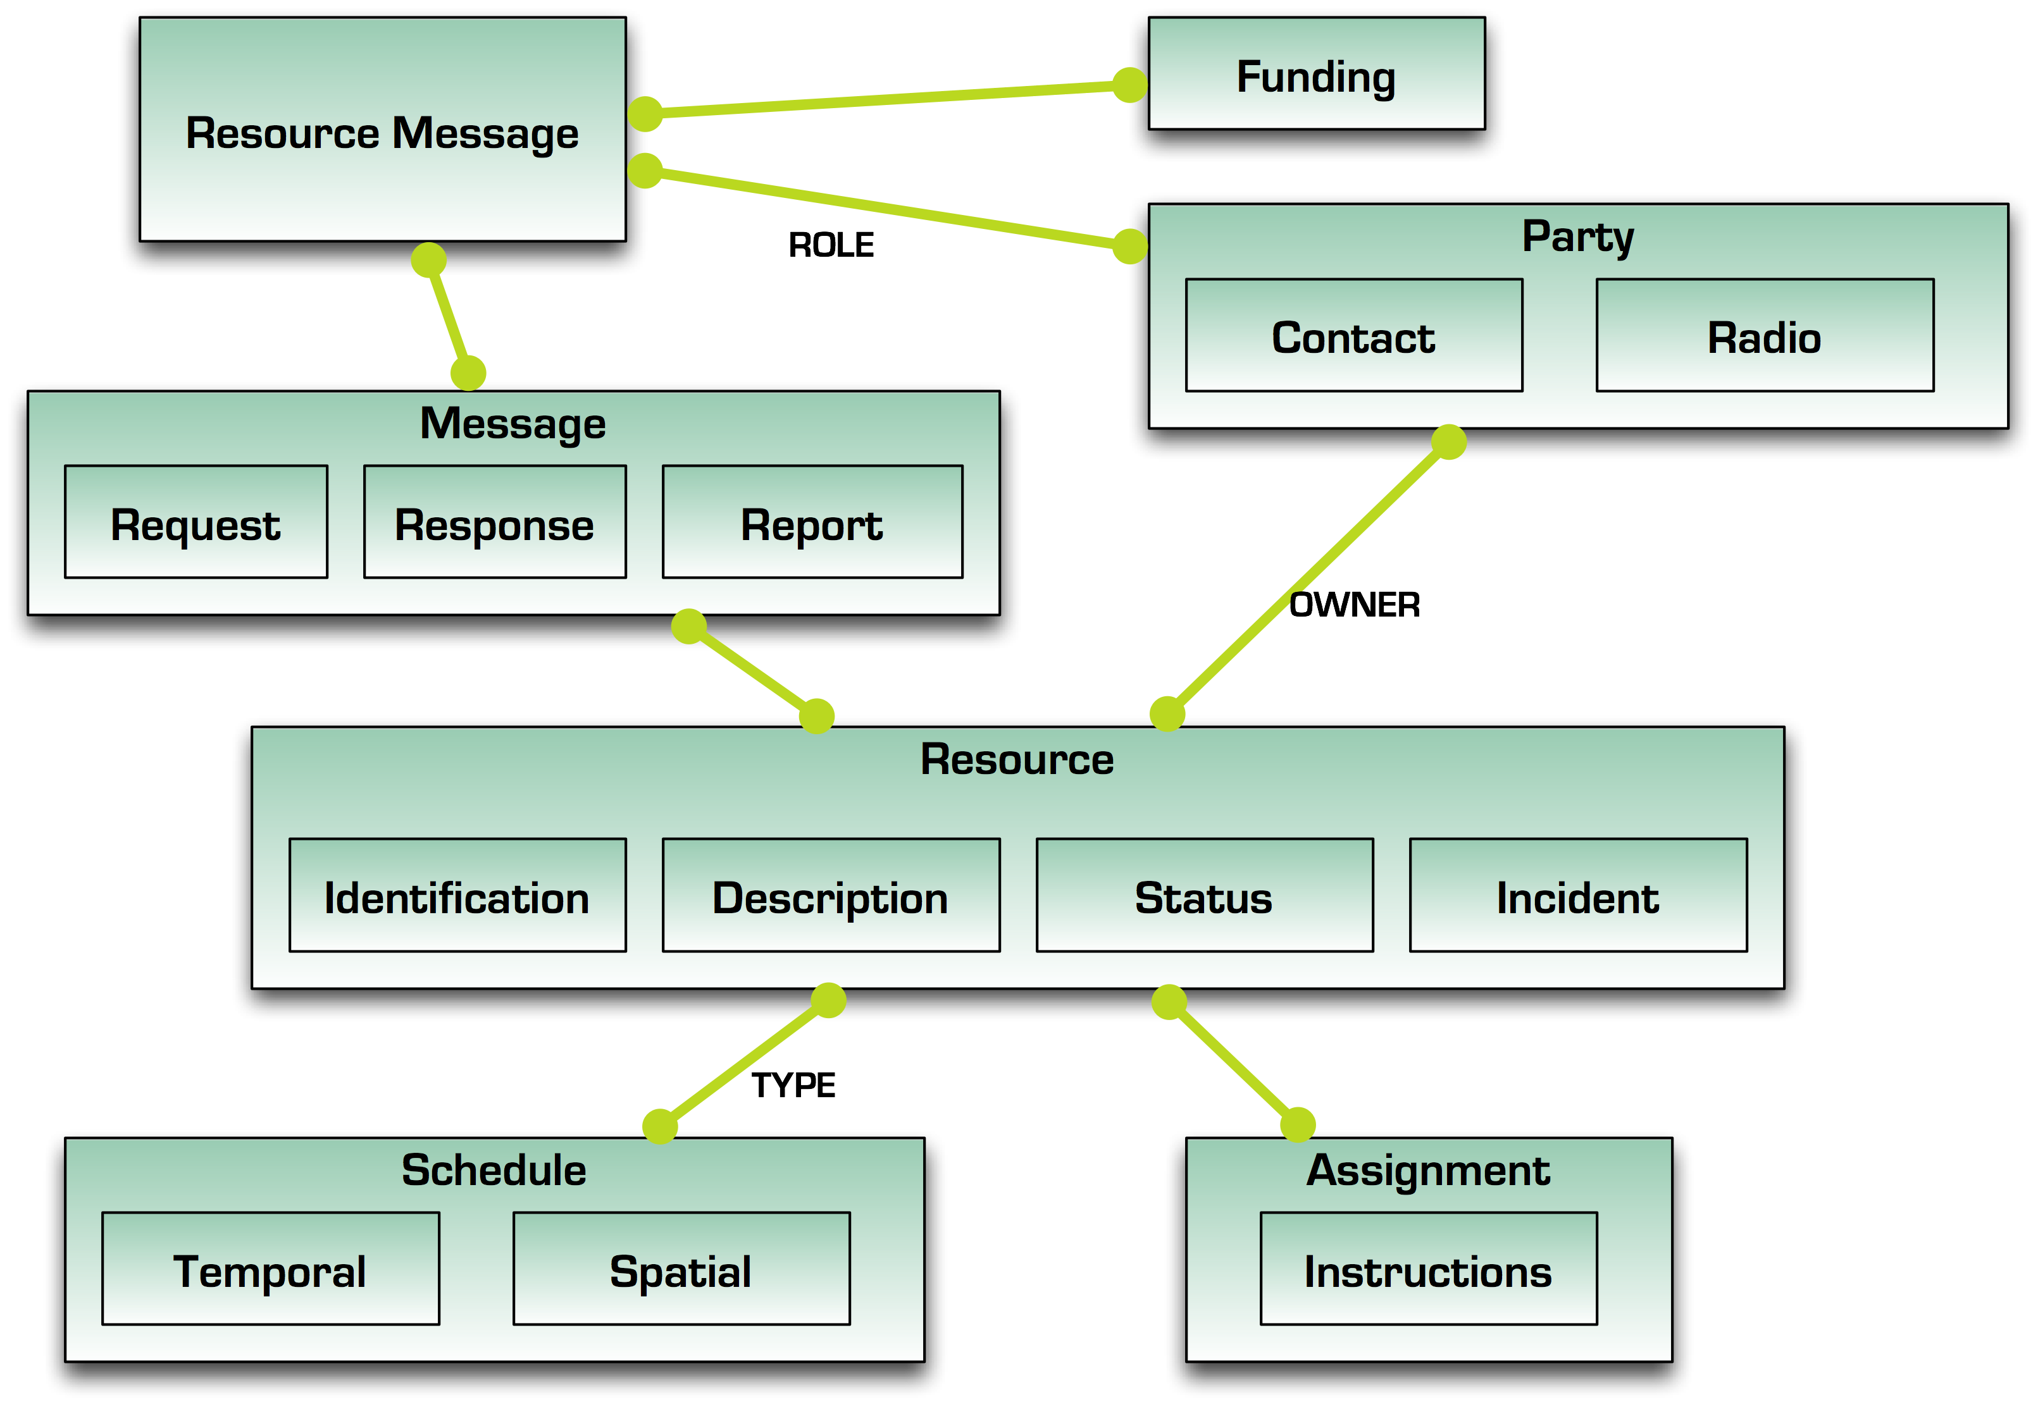
Figure 1: Resource Messaging – Abstract Reference Model

The core of any message is the Resource or Resources with which it is concerned. A Resource contains information about its Identity, Description and Status. A Resource owner can also be identified.
A Resource may also have a schedule which includes Temporal and Spatial details. For example, the expected arrival time and place for a specific resource. There are a number of types for Schedules.
A Resource may also have information about its Assignment including the identified Incident and Instructions related to the incident assignment.

Element Reference Model
Figure 2 below shows the EDXL–RM Element Reference Model (ERM). The purpose of the ERM is to highlight the low-level structure of the RM framework and the relationships between the main entities and their elements.
It is important to note that the ERM should not be used as an implementation model as the exact semantics and structure are captured in the subsequent sections on the Resource Message Types.

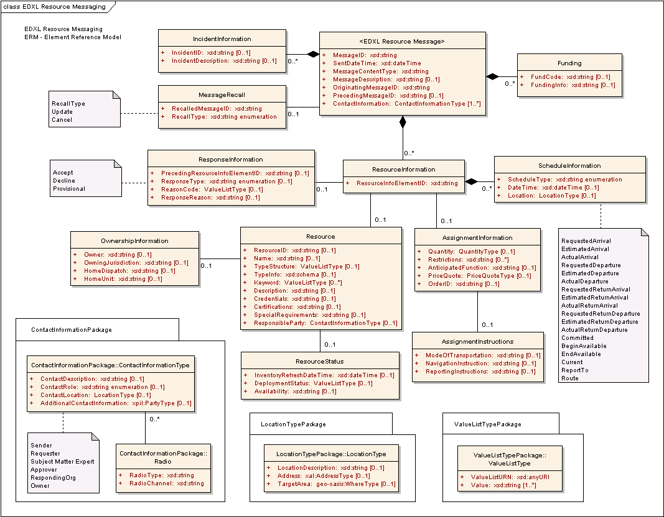
Figure 2: Resource Messaging – Element Reference Model
The RM-ERM shows the element-level details for the main entities in the RM. The semantics for each of the elements is defined in Section 3.3.

Resource Message Types
The general RM framework is based on a Request/Response model. Most of the Request messages expect a Response, and in some cases, messages are used to notify others of changes or offers of resources.
An RM message MUST be carried as the payload of the EDXL-DE or a distribution mechanism with the distribution type values of Report, Update, Cancel, Request, Response, Dispatch, Ack and Error, as defined in EDXL-DE. For example, the acknowledgement of an RM message is handled by the distribution mechanism.
When a message recipient receives an RM message, it uses the EDXL-DE DistributionType value of Ack as an acknowledgement. An acknowledgement is intended to inform the sender that the RM message has been received.
The EDXL-RM provides the mechanism to recall or update a previously sent resource message through the EDXL MessageRecall element. The MessageRecall element, when present, contains the RecalledMessageID and the RecallType. The RecalledMessageID contains the MessageID of the message previously sent that is being either canceled or updated. If the RecallType element contains the value “Cancel”, then the entire message specified in RecalledMessageID is to be canceled. If the RecallType element contains the value “Update”, then the entire message specified in RecalledMessageID is replaced by the new message.
This two-way communication is characterized by two classes of primary actors. The Resource Consumer is an actor that needs or requires resources to undertake response to an incident. The Resource Supplier is an owner, or distributor, or manager of resources that can meet the needs of Resource Consumers. There may be more than one actor of each class for a given sequence of message exchanges, and there may also be other classes of actors besides these two primary types.
There are 16 resource messages defined in this specification, which are summarized in Table 1 below.
Table 1: Resource Message Type Summary
Message Type | Description | Message  Sender
RequestResource | Message used to request needed resources from one or many recipients, possibly spawning multiple responses. | Resource Consumer
ResponseToRequestResource | Message used as the response to a “RequestResource”. Allows sender to list resource(s) which they feel represent suitable match with a resource request. | Resource Supplier
RequisitionResource | Message used to “order” specific resource, or to confirm specific resource to be “ordered” relating to one or more responses to a “RequestResource”. | Resource Consumer
CommitResource | Message used to agree or commit specific resource in response to a RequestResoure or RequisitionResource,”. | Resource Supplier
RequestInformation | Message used to ask resource questions or provide general description of situation and general resources needs. | Resource Consumer,  Resource Supplier
ResponseToRequestInformation | Message used as the response to a RequestInformation message providing general information or to list resource that may meet the specified need. | Resource Supplier, Resource Consumer
OfferUnsolicitedResource | Message used to offer available resources (that have not been requested) to assist with an emergency response. | Resource Supplier
ReleaseResource | Message used at the incident to “release” (demobilize) resource back to its original Supplier. | Resource Consumer
RequestReturn | Message used to request release (demobilize) of resources back to its original point of assignment or to another location / assignment ("I want my stuff back"). | Resource Supplier
ResponseToRequestReturn | Message used as the response to a "RequestReturn" indicating whether the resource may be released, with relevant time-line information. | Resource Consumer
RequestQuote | Message used to request a price quote from a seller or supplier. | Resource Consumer
ResponseToRequestQuote | Message used as the response to a “RequestQuote”. Allows sender to list resource(s) which they feel represent suitable match with the request, with pricing information. | Resource Supplier
RequestResourceDeploymentStatus | Message used to request current “status” of resource. | Resource Consumer,  Resource Supplier
ReportResourceDeploymentStatus | Message used to report on the current “status” of any resource. | Resource Consumer,  Resource Supplier
RequestExtendedDeploymentDuration | A request initiated by the requester / receiver of resource, “I want to extend how long I need to keep this resource” | Resource Consumer
ResponseToRequestExtendedDeployment Duration | Message used as the response to “RequestExtendedDeploymentDuration”. | Resource Supplier
Table 1 above and Figure 3 below are informative only. They are included to show how the resource messages might flow between the Resource Consumer and Resource Supplier during resource management. Note, however, that this specification does not prescribe the sequence of message exchanges, except for some dependencies between messages which are described in Section3.3.
The Resource Messages can be used in three phases of resource management:
- Discovery,
- Ordering, and
- Deployment, as shown in Figure 3.
The Discovery phase enables Resource Consumers to find out about available resources, including their costs, and offers of resources from Resource Suppliers.
The Ordering phase enables Resource Consumers to explicitly requisition Resources from Resource Suppliers.
The Deployment phase enables both actors to find about the current status of resources in the field, request extensions and returns.
It is important to note that this specification does not mandate an exact order and workflow of Resource Messages. For example, the Ordering phase may actually only require the CommitResource message for some actors.
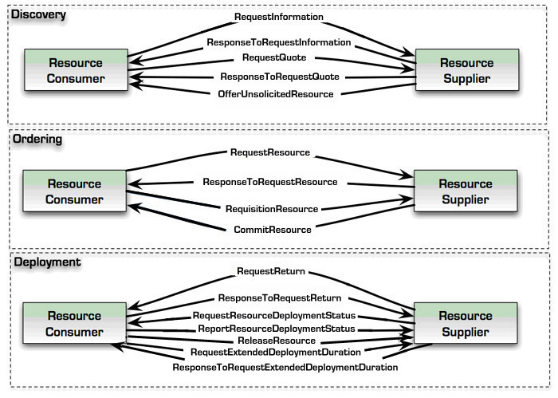
Figure 3: Resource Message Phases

Table 2 (below) summarizes all the Message Types and their element contents. The specific details on each of the Message Types are outlined in the following sections.

Table 2: Resource Message Type – Element Matrix (Key: R = Required, C = Conditional, O = Optional) N/A – Not Applicable to the message type)

Schema Element | Message Element | Request Resource | ResponseTo Request Resource | Requisition Resource | Commit Resource | Request Information | ResponseTo Request Information | Offer Unsolicited Resource | Release Resource | Request Return | ResponseTo Request Return | Request Quote | ResponseTo Request Quote | Request Resource Deployment Status | Report Resource Deployment Status | Request Extended Deployment Duration | ResponseTo Request Extended Deployment Duration
Resource  Message | MessageID | R | R | R | R | R | R | R | R | R | R | R | R | R | R | R | R
Resource  Message | SentDateTime | R | R | R | R | R | R | R | R | R | R | R | R | R | R | R | R
Resource  Message | MessageContentType | R | R | R | R | R | R | R | R | R | R | R | R | R | R | R | R
Resource  Message | MessageDescription | O | O | O | O | R | O | O | O | O | O | O | O | O | O | O | O
Resource  Message | OriginatingMessageID | R | R | R | R | R | R | R | R | R | R | R | R | R | R | R | R
Resource  Message | PrecedingMessageID | N/A | R | O | R | O | R | N/A | O | O | R | O | R | O | O | O | R
Resource  Message | Incident Information | O | O | O | O | O | O | O | O | O | O | O | O | O | O | O | O
Resource  Message | MessageRecall | O | O | O | O | O | O | O | O | O | O | O | O | O | O | O | O
Resource  Message | Funding | O | O | R | O | O | O | N/A | O | O | O | O | O | O | O | O | O
Resource  Message | ContactInformation | R | R | R | R | R | R | R | R | R | R | R | R | R | R | R | R
Resource  Message | Resource Information | R | R | R | R | O | O | R | R | R | R | R | R | R | R | R | R
Incident Information | IncidentID | C | C | C | C | C | C | C | C | C | C | C | C | C | C | C | C
Incident Information | IncidentDescription | C | C | C | C | C | C | C | C | C | C | C | C | C | C | C | C
Message Recall | RecalledMessageID | R | R | R | R | R | R | R | R | R | R | R | R | R | R | R | R
Message Recall | RecallType | R | R | R | R | R | R | R | R | R | R | R | R | R | R | R | R
Funding | FundCode | C | C | C | C | C | C | N/A | C | C | C | C | C | C | C | C | C
Funding | FundingInfo | C | C | C | C | C | C | N/A | C | C | C | C | C | C | C | C | C
Resource Information | ResourceInfoElementID | R | R | R | R | R | R | R | R | R | R | R | R | R | R | R | R
Resource Information | Response Information | N/A | R | N/A | R | N/A | O | N/A | O | N/A | R | O | R | N/A | O | N/A | R
Resource Information | Resource | R | O | R | C | O | O | R | R | R | O | R | C | R | O | R | C
Resource Information | AssignmentInformation | O | O | R | C | O | O | O | O | O | O | O | O | O | O | O | O
Resource Information | Schedule Information | O | O | O | C | O | O | O | O | O | O | O | O | O | O | O | O
Response Information | PrecedingResourceInfoElementID | N/A | R | N/A | R | N/A | R | N/A | R | N/A | R | R | R | N/A | R | N/A | R
Response Information | ResponseType | N/A | R | N/A | R | N/A | R | N/A | R | N/A | R | R | R | N/A | R | N/A | R
Response Information | ReasonCode | N/A | C | N/A | C | N/A | C | N/A | C | N/A | C | C | C | N/A | C | N/A | C
Response Information | ResponseReason | N/A | C | N/A | C | N/A | C | N/A | C | N/A | C | C | C | N/A | C | N/A | C
Resource | ResourceID | C | C | C | C | C | C | C | C | C | C | C | C | C | C | C | C
Resource | Name | C | C | C | C | C | C | C | C | C | C | C | C | C | C | C | C
Resource | TypeStructure | C | C | C | C | C | C | C | C | C | C | C | C | C | C | C | C
Resource | TypeInfo | O | O | O | O | O | O | O | O | O | O | O | O | O | O | O | O
Resource | Keyword | O | O | O | O | O | O | O | O | O | O | O | O | O | O | O | O
Resource | Description | O | O | O | O | O | O | O | O | O | O | O | O | O | O | O | O
Resource | Credentials | O | O | O | O | O | O | O | O | O | O | O | O | O | O | O | O
Resource | Certifications | O | O | O | O | O | O | O | O | O | O | O | O | O | O | O | O
Resource | SpecialRequirements | O | O | O | O | O | O | O | O | O | O | O | O | O | O | O | O
Resource | ResponsibleParty | N/A | O | O | O | O | O | O | O | O | O | O | O | O | O | O | O
Resource | OwnershipInformation | N/A | O | O | O | O | O | O | O | O | O | O | O | O | O | O | O
Resource | Resource Status | N/A | O | N/A | O | O | O | O | O | O | R | N/A | O | NA | O | O | O
Ownership Information | Owner | N/A | C | C | C | C | C | C | C | C | C | C | C | C | C | C | C
Ownership Information | OwningJurisdiction | N/A | C | C | C | C | C | C | C | C | C | C | C | C | C | C | C
Ownership Information | HomeDispatch | N/A | O | O | O | O | O | O | O | O | O | O | O | O | O | O | O
Ownership Information | HomeUnit | N/A | O | O | O | O | O | O | O | O | O | O | O | O | O | O | O
Resource Status | InventoryRefreshDateTime | N/A | O | N/A | O | O | O | O | N/A | N/A | N/A | N/A | O | N/A | O | N/A | N/A
Resource Status | DeploymentStatus | N/A | O | N/A | O | O | O | O | O | O | R | N/A | O | N/A | O | O | O
Resource Status | Availability | N/A | O | N/A | N/A | O | O | O | O | O | R | N/A | O | N/A | O | O | O
Assignment Information | Quantity | O | C | R | R | O | O | O | R | O | O | O | O | O | O | O | O
Assignment Information | Restrictions | O | O | O | O | O | O | O | O | O | O | O | O | O | O | O | O
Assignment Information | AnticipatedFunction | O | O | O | O | O | O | O | O | O | O | O | O | O | O | O | O
Assignment Information | PriceQuote | N/A | O | O | O | O | O | O | O | O | O | N/A | R | O | O | O | O
Assignment Information | OrderID | N/A | N/A | N/A | O | O | O | N/A | O | O | O | N/A | N/A | O | O | O | O
Assignment Information | Assignment Instructions | N/A | O | O | O | O | O | O | O | O | O | O | O | O | O | N/A | O
Assignment Instructions | ModeOfTransportation | N/A | O | O | O | O | O | O | O | O | O | O | O | O | O | N/A | O
Assignment Instructions | NavigationInstructions | N/A | O | O | O | O | O | O | O | O | O | O | O | O | O | N/A | O
Assignment Instructions | ReportingInstructions | N/A | O | O | O | O | O | O | O | O | O | O | O | O | O | N/A | O
Schedule Information | ScheduleType | R | R | R | R | R | R | R | R | R | R | R | R | R | R | R | R
Schedule Information | DateTime | O | O | O | O | O | O | O | O | O | O | O | O | O | O | O | O
Schedule Information | Location | O | O | O | O | O | O | O | O | O | O | O | O | O | O | O | O

Table 3: ScheduleTypes – Message Matrix
 | RequestResource | ResponseToRequestResource | RequisitionResource | CommitResource | RequestInformation | ResponseToRequestInformation | OfferUnsolicitedResource | ReleaseResource | RequestReturn | ResponseToRequestReturn | RequestQuote | ResponseToRequestQuote | RequestResourceDeploymentStatus | ReportResourceDeploymentStatus | RequestExtendedDeploymentDuration | ResponseToRequestExtendedDeploymentDuration
RequestedArrival | x | x | x | x | x | x |  | x | x | x | x | x | x | x | x | x
EstimatedArrival |  | x | x | x | x | x | x | x | x | x |  | x | x | x | x | x
ActualArrival |  |  |  |  | x | x |  | x | x | x |  |  | x | x | x | x
RequestedDeparture | x | x | x | x | x | x |  | x | x | x | x | x | x | x | x | x
EstimatedDeparture |  | x | x | x | x | x | x | x | x | x |  | x | x | x | x | x
ActualDeparture |  |  |  | x | x | x |  | x | x | x |  |  | x | x | x | x
RequestedReturnArrival |  | x | x | x | x | x | x | x | x | x |  | x | x | x | x | x
EstimatedReturnArrival | x | x | x | x | x | x |  | x |  | x | x | x | x | x | x | x
ActualReturnArrival |  |  |  |  | x | x |  |  |  |  |  |  | x | x
RequestedReturnDeparture |  | x | x | x | x | x | x | x | x | x |  | x | x | x | x | x
EstimatedReturnDeparture | x | x | x | x | x | x |  | x |  | x | x | x | x | x | x | x
ActualReturnDeparture |  |  |  |  | x | x |  | x |  | x |  |  | x | x
Committed |  |  |  | x | x | x |  | x | x | x |  |  | x | x | x | x
BeginAvailable |  | x | x | x | x | x | x | x | x | x |  | x | x | x
EndAvailable |  | x | x | x | x | x | x | x | x | x |  | x | x | x |  | x
Current |  |  |  | x | x | x |  | x | x | x |  | x | x | x | x | x
ReportTo | x | x | x | x | x | x |  | x | x | x | x | x | x | x | x | x
Route | x | x | x | x | x | x | x | x | x | x | x | x | x | x | x | x

RequestResource Message

Overview
The “RequestResource” message is used as an announcement to a broad audience of potential suppliers as well as potential suppliers in the local geographic area of interest. It is intended to be used by Emergency Managers, Incident Commanders and other First Responders to request information on availability of needed resources.

Element Reference Model
Figure 4 below shows the EDXL–RM Element Reference Model (ERM) tailored for the RequestResource Message. The ERM shows the element-level details for the main entities in the RM.

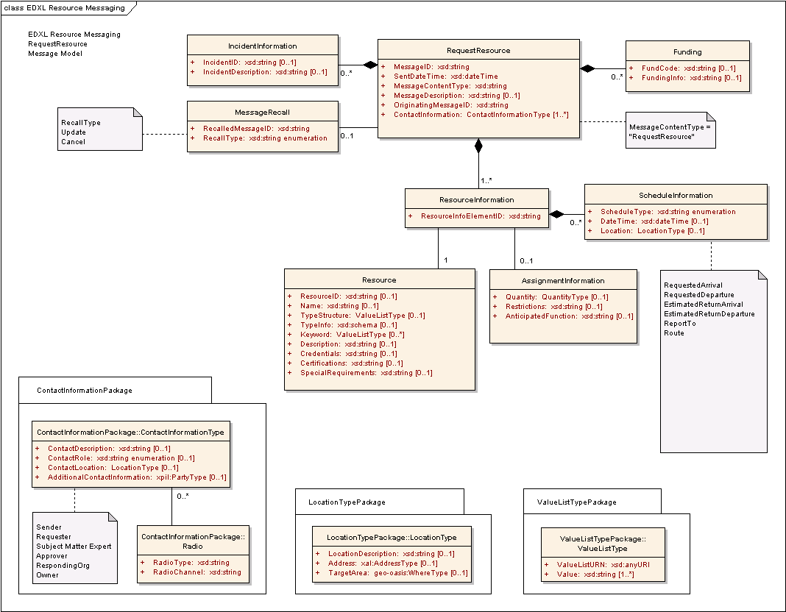
Figure 4: EDXL-RM ERM for RequestResource Message
The following table outlines the element cardinalities for this message type, as follows:
- bold indicates an element that is required
- italics indicate an element that is conditional (the applicable rules for these elements appear below the table)
- an asterisk (*) indicates that an element can appear multiple times
- a caret symbol (^) indicates that the values of an element are constrained, as per the rules shown below the table.
All elements that are not shown in bold or italics are optional.

Table 4: RequestResource Message Elements
Parent Element | Sub-Elements
RequestResource | MessageID, SentDateTime, MessageContentType^, MessageDescription, OriginatingMessageID, IncidentInformation*, MessageRecall, Funding*, ContactInformation*, ResourceInformation*
IncidentInformation | IncidentID, IncidentDescription
MessageRecall | RecalledMessageID, RecallType
Funding | FundCode, FundingInfo
ResourceInformation | ResourceInfoElementID, Resource, AssignmentInformation, ScheduleInformation*
Resource | ResourceID, Name, TypeStructure, TypeInfo, Keyword*, Description, Credentials, Certifications, SpecialRequirements
AssignmentInformation | Quantity, Restrictions, AnticipatedFunction
ScheduleInformation | ScheduleType^, DateTime, Location

RequestResource Message Rules
The following rules apply to the above elements: The following notation is used throughout this document: a colon is used as a separator between the name of an element and the name of a child of that element.
- The RequestResource:MessageID, RequestResource:SentDateTime, RequestResource:MessageContentType, RequestResource:OriginatingMessageID, RequestResource:ContactInformation, and RequestResource:ResourceInformation elements MUST be present.
- The value of RequestResource:MessageContentType MUST be “RequestResource”.
- If a RequestResource:IncidentInformation element is present, then at least one of IncidentInformation:IncidentID and/or IncidentInformation:IncidentDescription MUST be present.
- If the RequestResource:MessageRecall element is present, then the MessageRecall:RecalledMessageID and MessageRecall:RecallType elements MUST be present.
- If a RequestResource:Funding element is present, then at least one of Funding:FundCode and/or Funding:FundingInfo MUST be present.
- The ResourceInformation:ResourceInfoElementID and ResourceInformation:Resource elements MUST be present.
- At least one of Resource:ResourceID, Resource:Name and/or Resource:TypeStructure MUST be present.
- If the ResourceInformation:ScheduleInformation element is present, then the ScheduleInformation:ScheduleType MUST be present and contain one of the following values:
- “RequestedArrival”, “RequestedDeparture”, “EstimatedReturnDeparture”, “EstimatedReturnArrival”, “ReportTo”, or “Route”.

The schema for a RequestResource message can be found in Appendix A.3.

Message Flow
The RequestResource message is an initial message created and sent by the Resource Consumer to any number of Resource Suppliers.
The potential responses to this message include:
- ResponseToRequestResource (See Section 3.5)
- Response may include Accept, Decline, and Provisional responses.
The message may be canceled or updated through the RequestResource:MessageRecall element.

Message Example
Below is an example of a RequestResource Message, in which three resource requests are shown:
- Small Animal Sheltering Team (ResourceInfoElementID=001)
- Patrol and Surveillance Helicopters (ResourceInfoElementID =002)
- Electrical Power Restoration Team (ResourceInfoElementID =003).

[Note: The XML example shown in this section is informative only.]
<?xml version="1.0" encoding="UTF-8"?>
<RequestResource xmlns:xsi="http://www.w3.org/2001/XMLSchema-instance"
xsi:schemaLocation="urn:oasis:names:tc:emergency:EDXL:RM:1.0:msg
EDXL-RMRequestResource.xsd"
xmlns="urn:oasis:names:tc:emergency:EDXL:RM:1.0:msg"
xmlns:rm="urn:oasis:names:tc:emergency:EDXL:RM:1.0"
xmlns:xpil="urn:oasis:names:tc:ciq:xpil:3"
xmlns:xnl="urn:oasis:names:tc:ciq:xnl:3" xmlns:xal="urn:oasis:names:tc:ciq:xal:3"
xmlns:geo-oasis="urn:oasis:names:tc:emergency:EDXL:HAVE:1.0:geo-oasis"
xmlns:gml="http://www.opengis.net/gml">
<MessageID>urn:au-qld-eoc:12332</MessageID>
<SentDateTime>2006-03-21T11:58:00+10:00</SentDateTime>
<MessageContentType>RequestResource</MessageContentType>
<OriginatingMessageID>urn:au-qld-eoc:12332</OriginatingMessageID>
<IncidentInformation>
<rm:IncidentDescription>Cyclone Larry</rm:IncidentDescription>
</IncidentInformation>
<ContactInformation>
<rm:ContactRole>Sender</rm:ContactRole>
<rm:AdditionalContactInformation>
<xpil:PartyName>
<xnl:PersonName>
<xnl:NameElement xnl:ElementType="FirstName">Alex</xnl:NameElement>
<xnl:NameElement xnl:ElementType="LastName">Jones</xnl:NameElement>
</xnl:PersonName>
<xnl:OrganisationName>
<xnl:NameElement>Dept of Emergency Services</xnl:NameElement>
</xnl:OrganisationName>
</xpil:PartyName>
<xpil:ContactNumbers>
<xpil:ContactNumber xpil:CommunicationMediaType="Telephone"
xpil:ContactHours="9:00AM - 5:00PM">
<xpil:ContactNumberElement
xpil:Type="CountryCode">61</xpil:ContactNumberElement>
<xpil:ContactNumberElement xpil:Type="AreaCode">7</xpil:ContactNumberElement>
<xpil:ContactNumberElement xpil:Type="LocalNumber">
3000
1234
</xpil:ContactNumberElement>
</xpil:ContactNumber>
</xpil:ContactNumbers>
<xpil:ElectronicAddressIdentifiers>
<xpil:ElectronicAddressIdentifier>alexj@emergencyservices.gov.au
</xpil:ElectronicAddressIdentifier>
</xpil:ElectronicAddressIdentifiers>
</rm:AdditionalContactInformation>
</ContactInformation>
<ResourceInformation>
<ResourceInfoElementID>001</ResourceInfoElementID>
<Resource>
<TypeStructure>
<rm:ValueListURN>urn:x-hazard:vocab:resourceTypes</rm:ValueListURN>
<rm:Value>Small Animal Sheltering Team</rm:Value>
</TypeStructure>
<Description>
5-person response team to advise and support local efforts to set up a
small animal shelter
</Description>
<SpecialRequirements>A qualified veterinary surgeon</SpecialRequirements>
</Resource>
<AssignmentInformation>
<Quantity>
<rm:MeasuredQuantity>
<rm:Amount>1</rm:Amount>
</rm:MeasuredQuantity>
</Quantity>
</AssignmentInformation>
<ScheduleInformation>
<ScheduleType>RequestedArrival</ScheduleType>
<DateTime>2006-03-24T09:00:00+10:00</DateTime>
<Location>
<rm:LocationDescription>Innisfail Animal Refuge</rm:LocationDescription>
<rm:Address>
<xal:Country>
<xal:NameElement>Australia</xal:NameElement>
</xal:Country>
<xal:AdministrativeArea>
<xal:NameElement>QLD</xal:NameElement>
</xal:AdministrativeArea>
<xal:Locality>
<xal:NameElement>Innisfail</xal:NameElement>
</xal:Locality>
<xal:Thoroughfare>
<xal:NameElement>Downing St</xal:NameElement>
<xal:Number>27</xal:Number>
</xal:Thoroughfare>
<xal:PostCode>
<xal:Identifier>4860</xal:Identifier>
</xal:PostCode>
</rm:Address>
</Location>
</ScheduleInformation>
<ScheduleInformation>
<ScheduleType>EstimatedReturnDeparture</ScheduleType>
<DateTime>2006-03-30T17:00:00+10:00</DateTime>
</ScheduleInformation>
</ResourceInformation>
<ResourceInformation>
<ResourceInfoElementID>002</ResourceInfoElementID>
<Resource>
<TypeStructure>
<rm:ValueListURN>urn:x-hazard:vocab:resourceTypes</rm:ValueListURN>
<rm:Value>Patrol and Surveillance Helicopters</rm:Value>
</TypeStructure>
</Resource>
<AssignmentInformation>
<Quantity>
<rm:MeasuredQuantity>
<rm:Amount>3</rm:Amount>
</rm:MeasuredQuantity>
</Quantity>
<AnticipatedFunction>
Aerial surveillance to determine extent of
flooding
</AnticipatedFunction>
</AssignmentInformation>
<ScheduleInformation>
<ScheduleType>RequestedArrival</ScheduleType>
<DateTime>2006-03-22T09:00:00+10:00</DateTime>
<Location>
<rm:LocationDescription>Innisfail airport</rm:LocationDescription>
</Location>
</ScheduleInformation>
</ResourceInformation>
<ResourceInformation>
<ResourceInfoElementID>003</ResourceInfoElementID>
<Resource>
<TypeStructure>
<rm:ValueListURN>urn:x-hazard:vocab:resourceTypes</rm:ValueListURN>
<rm:Value>Electrical Power Restoration Team</rm:Value>
</TypeStructure>
</Resource>
<AssignmentInformation>
<Quantity>
<rm:MeasuredQuantity>
<rm:Amount>2</rm:Amount>
</rm:MeasuredQuantity>
</Quantity>
<AnticipatedFunction>
Restore power to critical infrastructure in and around the
Innisfail area
</AnticipatedFunction>
</AssignmentInformation>
<ScheduleInformation>
<ScheduleType>RequestedArrival</ScheduleType>
<DateTime>2006-03-22T08:00:00+10:00</DateTime>
<Location>
<rm:TargetArea>
<gml:Point>
<gml:pos> 146.03 -17.53 </gml:pos>
</gml:Point>
</rm:TargetArea>
</Location>
</ScheduleInformation>
</ResourceInformation>
</RequestResource>

ResponseToRequestResource Message

Overview
The “ResponseToRequestResource” message is used by potential resource suppliers (e.g. mutual aid partners, equipment suppliers, etc.) to respond to RequestResource messages from Emergency Managers, Incident Commanders and First Responders or others with logistics responsibilities. The response may identify availability, limitations and other pertinent information related to resources in the original request.

Element Reference Model
Figure 5 below shows the EDXL–RM Element Reference Model (ERM) tailored for the ResponseToRequestResource Message. The ERM shows the element-level details for the main entities in the RM.
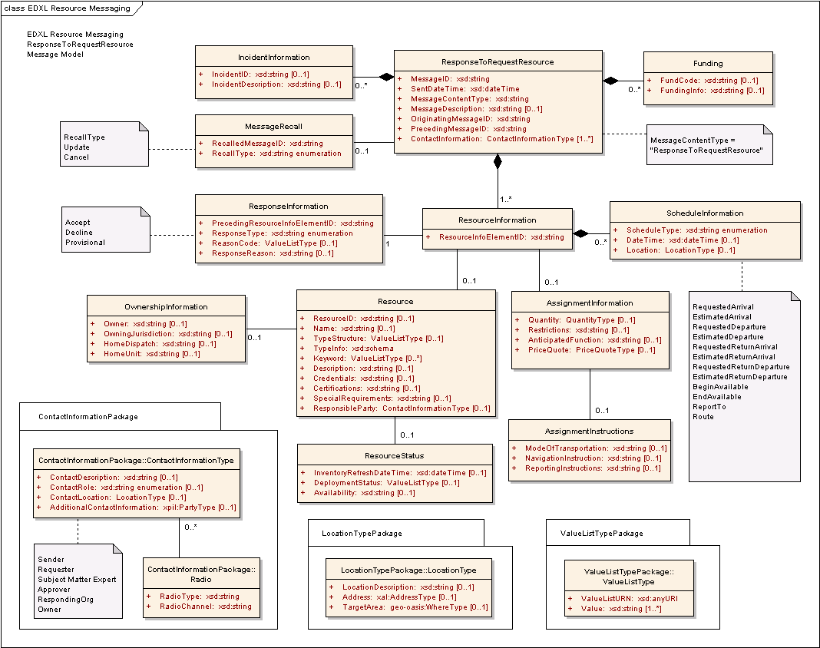
Figure 5: EDXL-RM ERM for ResponseToRequestResource Message

The following table outlines the element cardinalities for this message type.

Table 4: ResponseToRequestResource Message Elements
Parent Element | Sub-Elements
ResponseToRequestResource | MessageID, SentDateTime, MessageContentType^, MessageDescription, OriginatingMessageID, PrecedingMessageID, IncidentInformation*, MessageRecall, Funding*, ContactInformation*, ResourceInformation*
IncidentInformation | IncidentID, IncidentDescription
MessageRecall | RecalledMessageID, RecallType
Funding | FundCode, FundingInfo
ResourceInformation | ResourceInfoElementID, ResponseInformation, Resource, AssignmentInformation, ScheduleInformation*
ResponseInformation | PrecedingResourceInfoElementID, ResponseType, ReasonCode, ResponseReason
Resource | ResourceID, Name, TypeStructure, TypeInfo, Keyword*, Description, Credentials, Certifications, SpecialRequirements, ResponsibleParty, OwnershipInformation, ResourceStatus
OwnershipInformation | Owner, OwningJurisdiction, HomeDispatch, HomeUnit
ResourceStatus | InventoryRefreshDateTime, DeploymentStatus, Availability
AssignmentInformation | Quantity, Restrictions, AnticipatedFunction, PriceQuote, AssignmentInstructions
AssignmentInstructions | ModeOfTransportation, NavigationInstructions, ReportingInstructions
ScheduleInformation | ScheduleType^, DateTime, Location

ResponseToRequestResource Message Rules
The following rules apply to the above elements:
- The ResponseToRequestResource:MessageID, ResponseToRequestResource:SentDateTime, ResponseToRequestResource:MessageContentType, ResponseToRequestResource:OriginatingMessageID, ResponseToRequestResource:PrecedingMessageID, ResponseToRequestResource:ContactInformation, and ResponseToRequestResource:ResourceInformation elements MUST be present.
- The value of ResponseToRequestResource:MessageContentType MUST be “ResponseToRequestResource”.
- If a ResponseToRequestResource:IncidentInformation element is present, then at least one of IncidentInformation:IncidentID and/or IncidentInformation:IncidentDescription MUST be present.
- If the ResponseToRequestResource:MessageRecall element is present, then the MessageRecall:RecalledMessageID and MessageRecall:RecallType elements MUST be present.
- If a ResponseToRequestResource:Funding element is present, then at least one of Funding:FundCode and/or Funding:FundingInfo elements MUST be present.
- The ResourceInformation:ResourceInfoElementID and ResourceInformation:ResponseInformation elements MUST be present.
- The ResponseInformation:PrecedingResourceInfoElementID and ResponseInformation:ResponseType elements MUST be present.
- At least one of Resource:ResourceID, Resource:Name, and/or Resource:TypeStructure elements MUST be present.
- If a ResourceInformation:Resource element is present, then at least one of Resource:ResourceID, Resource:Name, and/or Resource:TypeStructure element MUST be present.
- If Resource:OwnershipInformation element is present, then at least one of OwnershipInformation:Owner and/or OwnershipInformation:OwningJurisdiction element MUST be present.
- If the ResourceInformation:AssignmentInformation element is present and the ResponseInformation:ResponseType contains a value of “Accept” or “Provisional”, then the AssignmentInformation:Quantity element MUST be present.
- If ResourceInformation:ScheduleInformation is present then ScheduleInformation:ScheduleType MUST be present and contain one of the following values:
- “EstimatedArrival”, “EstimatedDeparture”, “RequestedReturnDeparture”, “RequestedReturnArrival”, “BeginAvailable”, “EndAvailable”, “RequestedArrival”, “RequestedDeparture”, “EstimatedReturnArrival”, “ReportTo” or “Route”.

The schema for a ResponseToRequestResource message can be found in Appendix A.4.

Message Flow
The ResponseToRequestResource message is sent by a Resource Supplier in response to an original RequestResource message.
The potential responses to this message include:
- RequisitionResource (See Section 3.6).
The message may be canceled or updated through the ResponseToRequestResource:MessageRecall element.

Message Example
Below is an example of a ResponseToRequestResource Message. This is an example response to the original request shown in Section 3.4.5 . In this example, the three requests have different responses:
- The “Small Animal Sheltering Team” (ResourceInfoElementID=001) has Conditional changes to the request. In this case the Schedule information is different from that requested.
- The “Patrol and Surveillance Helicopters” (ResourceInfoElementID=002) is Declined.
- The “Electrical Power Restoration Team” (ResourceInfoElementID=003) is Accepted.

[Note: The XML example shown in this section is informative only.]
<?xml version="1.0" encoding="UTF-8"?>
<ResponseToRequestResource xmlns:xsi="http://www.w3.org/2001/XMLSchema-instance"
xsi:schemaLocation="urn:oasis:names:tc:emergency:EDXL:RM:1.0:msg
EDXL-RMResponseToRequestResource.xsd"
xmlns="urn:oasis:names:tc:emergency:EDXL:RM:1.0:msg"
xmlns:rm="urn:oasis:names:tc:emergency:EDXL:RM:1.0"
xmlns:xpil="urn:oasis:names:tc:ciq:xpil:3"
xmlns:xnl="urn:oasis:names:tc:ciq:xnl:3" xmlns:xal="urn:oasis:names:tc:ciq:xal:3"
xmlns:geo-oasis="urn:oasis:names:tc:emergency:EDXL:HAVE:1.0:geo-oasis"
xmlns:gml="http://www.opengis.net/gml">
<MessageID>urn:au-qld-eoc:12334</MessageID>
<SentDateTime>2006-03-21T12:34:00+10:00</SentDateTime>
<MessageContentType>ResponseToRequestResource</MessageContentType>
<OriginatingMessageID>urn:au-qld-eoc:12332</OriginatingMessageID>
<PrecedingMessageID>urn:au-qld-eoc:12332</PrecedingMessageID>
<IncidentInformation>
<rm:IncidentDescription>Cyclone Larry</rm:IncidentDescription>
</IncidentInformation>
<ContactInformation>
<rm:ContactRole>Sender</rm:ContactRole>
<rm:AdditionalContactInformation>
<xpil:PartyName>
<xnl:PersonName>
<xnl:NameElement xnl:ElementType="FirstName">Charlotte</xnl:NameElement>
<xnl:NameElement xnl:ElementType="LastName">Ryan</xnl:NameElement>
</xnl:PersonName>
<xnl:OrganisationName>
<xnl:NameElement>EMA</xnl:NameElement>
</xnl:OrganisationName>
</xpil:PartyName>
<xpil:ContactNumbers>
<xpil:ContactNumber xpil:CommunicationMediaType="Telephone">
<xpil:ContactNumberElement
xpil:Type="CountryCode">61</xpil:ContactNumberElement>
<xpil:ContactNumberElement xpil:Type="AreaCode">2</xpil:ContactNumberElement>
<xpil:ContactNumberElement xpil:Type="LocalNumber">
9864
4321
</xpil:ContactNumberElement>
</xpil:ContactNumber>
</xpil:ContactNumbers>
</rm:AdditionalContactInformation>
</ContactInformation>
<ResourceInformation>
<ResourceInfoElementID>001</ResourceInfoElementID>
<ResponseInformation>
<rm:PrecedingResourceInfoElementID>001</rm:PrecedingResourceInfoElementID>
<rm:ResponseType>Provisional</rm:ResponseType>
<rm:ResponseReason>Earliest arrival date is 2006-03-25</rm:ResponseReason>
</ResponseInformation>
<ScheduleInformation>
<ScheduleType>EstimatedDeparture</ScheduleType>
<DateTime>2006-03-25T08:10:00</DateTime>
<Location>
<rm:LocationDescription>Cairns Airport</rm:LocationDescription>
</Location>
</ScheduleInformation>
<ScheduleInformation>
<ScheduleType>EstimatedArrival</ScheduleType>
<DateTime>2006-03-25T09:00:00+10:00</DateTime>
<Location>
<rm:LocationDescription>Innisfail Airport</rm:LocationDescription>
</Location>
</ScheduleInformation>
<ScheduleInformation>
<ScheduleType>EstimatedArrival</ScheduleType>
<DateTime>2006-03-25T09:30:00+10:00</DateTime>
<Location>
<rm:LocationDescription>Innisfail Animal Refuge</rm:LocationDescription>
<rm:Address>
<xal:Country>
<xal:NameElement>Australia</xal:NameElement>
</xal:Country>
<xal:AdministrativeArea>
<xal:NameElement>QLD</xal:NameElement>
</xal:AdministrativeArea>
<xal:Locality>
<xal:NameElement>Innisfail</xal:NameElement>
</xal:Locality>
<xal:Thoroughfare>
<xal:NameElement>Downing St</xal:NameElement>
<xal:NameElement>27</xal:NameElement>
</xal:Thoroughfare>
<xal:PostCode>
<xal:Identifier>4860</xal:Identifier>
</xal:PostCode>
</rm:Address>
</Location>
</ScheduleInformation>
</ResourceInformation>
<ResourceInformation>
<ResourceInfoElementID>002</ResourceInfoElementID>
<ResponseInformation>
<rm:PrecedingResourceInfoElementID>002</rm:PrecedingResourceInfoElementID>
<rm:ResponseType>Accept</rm:ResponseType>
</ResponseInformation>
</ResourceInformation>
<ResourceInformation>
<ResourceInfoElementID>003</ResourceInfoElementID>
<ResponseInformation>
<rm:PrecedingResourceInfoElementID>003</rm:PrecedingResourceInfoElementID>
<rm:ResponseType>Decline</rm:ResponseType>
</ResponseInformation>
</ResourceInformation>
</ResponseToRequestResource>

RequisitionResource Message

Overview
The “RequisitionResource” message is used by Resource Consumers to order resources from Resource Suppliers. These may relate to one or more responses to a previous Request Resource message.

Element Reference Model
Figure 6 below shows the EDXL–RM Element Reference Model (ERM) tailored for the RequisitionResource Message. The ERM shows the element-level details for the main entities in the RM.
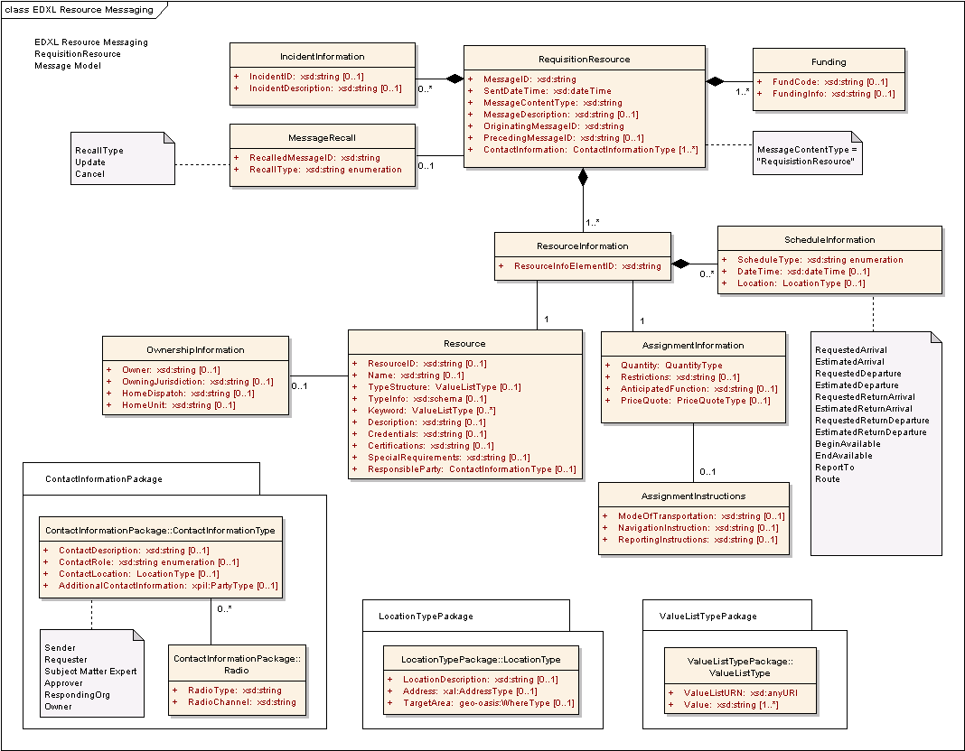
Figure 6: EDXL-RM ERM for RequisitionResource Message

The following table outlines the element cardinalities for this message type.

Table 5: RequisitionResource Message Elements
Parent Element | Sub-Elements
RequisitionResource | MessageID, SentDateTime, MessageContentType^, MessageDescription, OriginatingMessageID, PrecedingMessageID, IncidentInformation*, MessageRecall, Funding*, ContactInformation*, ResourceInformation*
IncidentInformation | IncidentID, IncidentDescription
MessageRecall | RecalledMessageID, RecallType
Funding | FundCode, FundingInfo
ResourceInformation | ResourceInfoElementID, Resource, AssignmentInformation, ScheduleInformation*
Resource | ResourceID, Name, TypeStructure, TypeInfo, Keyword*, Description, Credentials, Certifications, SpecialRequirements, ResponsibleParty, OwnershipInformation
OwnershipInformation | Owner, OwningJurisdiction, HomeDispatch, HomeUnit
AssignmentInformation | Quantity, Restrictions, AnticipatedFunction, PriceQuote, AssignmentInstructions
AssignmentInstructions | ModeOfTransportation, NavigationInstructions, ReportingInstructions
ScheduleInformation | ScheduleType^, DateTime, Location

RequisitionResource Message Rules
The following rules apply to the above elements:
- The RequisitionResource:MessageID, RequisitionResource:SentDateTime, RequisitionResource:MessageContentType, RequisitionResource:OriginatingMessageID, RequisitionResource:Funding, RequisitionResource:ContactInformation, and RequisitionResource:ResourceInformation elements MUST be present.
- The value of RequisitionResource:MessageContentType MUST be “RequisitionResource”.
- If a RequisitionResource:IncidentInformation element is present, then at least one of IncidentInformation:IncidentID and/or IncidentInformation:IncidentDescription elements MUST be present.
- If the RequisitionResource:MessageRecall element is present, then the MessageRecall:RecalledMessageID and MessageRecall:RecallType elements MUST be present.
- If a RequisitionResource:Funding element is present, then at least one of Funding:FundCode and/or Funding:FundingInfo elements MUST be present.
- The ResourceInformation:ResourceInfoElementID, ResourceInformation:Resource and ResourceInformation:AssignmentInformation elements MUST be present.
- At least one of Resource:ResourceID, Resource:Name, and/or Resource:TypeStructure elements MUST be present.
- If a Resource:OwnershipInformation element is present, then at least one of OwnershipInformation:Owner and/or OwnershipInformation:OwningJurisdiction elements MUST be present.
- The AssignmentInformation:Quantity element MUST be present.
- If ResourceInformation:ScheduleInformation is present, then the ScheduleInformation:ScheduleType element MUST be present and contain one of the following values:
- “RequestedArrival”, “RequestedDeparture”, “EstimatedArrival”, “EstimatedDeparture”, “RequestedReturnArrival”, “EstimatedReturnArrival”, “RequestedReturnDeparture”, “EstimatedReturnDeparture”, “BeginAvailable”, “EndAvailable”, “ReportTo”, or “Route”

The schema for a RequisitionResource message can be found in Appendix A.5.

Message Flow
The RequisitionResource message is a message created and sent by the Resource Consumer to any number of Resource Suppliers.
The potential responses to this message include:
- CommitResource (See Section 3.7)
- This includes Accept, Decline and Provisional responses.
The message may be canceled or updated through the RequisitionResource:MessageRecall element.

Message Example
Below is an example of a RequisitionResource Message, in which two resource requisitions are shown:
- Small Animal Sheltering Team (ResourceInfoElementID=001)
- Patrol and Surveillance Helicopters (ResourceInfoElementID=002).

[Note: The XML example shown in this section is informative only.]
<?xml version="1.0" encoding="UTF-8"?>
<RequisitionResource xmlns:xsi="http://www.w3.org/2001/XMLSchema-instance"
xsi:schemaLocation="urn:oasis:names:tc:emergency:EDXL:RM:1.0:msg
EDXL-RMRequisitionResource.xsd"
xmlns="urn:oasis:names:tc:emergency:EDXL:RM:1.0:msg"
xmlns:rm="urn:oasis:names:tc:emergency:EDXL:RM:1.0"
xmlns:xpil="urn:oasis:names:tc:ciq:xpil:3"
xmlns:xnl="urn:oasis:names:tc:ciq:xnl:3" xmlns:xal="urn:oasis:names:tc:ciq:xal:3"
xmlns:geo-oasis="urn:oasis:names:tc:emergency:EDXL:HAVE:1.0:geo-oasis"
xmlns:gml="http://www.opengis.net/gml">
<MessageID>urn:au-qld-eoc:987654</MessageID>
<SentDateTime>2006-03-21T12:39:00+10:00</SentDateTime>
<MessageContentType>RequisitionResource</MessageContentType>
<OriginatingMessageID>urn:au-qld-eoc:12332</OriginatingMessageID>
<IncidentInformation>
<rm:IncidentDescription>Cyclone Larry</rm:IncidentDescription>
</IncidentInformation>
<Funding>
<rm:FundCode>HP4347</rm:FundCode>
</Funding>
<ContactInformation>
<rm:ContactRole>Requester</rm:ContactRole>
<rm:AdditionalContactInformation>
<xpil:PartyName>
<xnl:PersonName>
<xnl:NameElement xnl:ElementType="FirstName">Alex</xnl:NameElement>
<xnl:NameElement xnl:ElementType="LastName">Jones</xnl:NameElement>
</xnl:PersonName>
<xnl:OrganisationName>
<xnl:NameElement>Dept of Emergency Services</xnl:NameElement>
</xnl:OrganisationName>
</xpil:PartyName>
<xpil:ContactNumbers>
<xpil:ContactNumber xpil:CommunicationMediaType="Telephone"
xpil:ContactHours="9:00AM - 5:00PM">
<xpil:ContactNumberElement
xpil:Type="CountryCode">61</xpil:ContactNumberElement>
<xpil:ContactNumberElement xpil:Type="AreaCode">7</xpil:ContactNumberElement>
<xpil:ContactNumberElement xpil:Type="LocalNumber">
3000
1234
</xpil:ContactNumberElement>
</xpil:ContactNumber>
</xpil:ContactNumbers>
<xpil:ElectronicAddressIdentifiers>
<xpil:ElectronicAddressIdentifier>alexj@emergencyservices.gov.au
</xpil:ElectronicAddressIdentifier>
</xpil:ElectronicAddressIdentifiers>
</rm:AdditionalContactInformation>
</ContactInformation>
<ContactInformation>
<rm:ContactRole>Approver</rm:ContactRole>
<rm:AdditionalContactInformation>
<xpil:PartyName>
<xnl:PersonName>
<xnl:NameElement xnl:ElementType="FirstName">Michelle</xnl:NameElement>
<xnl:NameElement xnl:ElementType="LastName">Yates</xnl:NameElement>
</xnl:PersonName>
<xnl:OrganisationName>
<xnl:NameElement>QLD Police</xnl:NameElement>
</xnl:OrganisationName>
</xpil:PartyName>
<xpil:ContactNumbers>
<xpil:ContactNumber xpil:CommunicationMediaType="Cellphone">
<xpil:ContactNumberElement xpil:Type="NationalNumber">
0422 877
665
</xpil:ContactNumberElement>
</xpil:ContactNumber>
</xpil:ContactNumbers>
<xpil:Occupations>
<xpil:Occupation>
<xpil:OccupationElement xpil:Type="Role">
District Disaster
Coordinator
</xpil:OccupationElement>
</xpil:Occupation>
</xpil:Occupations>
</rm:AdditionalContactInformation>
</ContactInformation>
<ResourceInformation>
<ResourceInfoElementID>001</ResourceInfoElementID>
<Resource>
<TypeStructure>
<rm:ValueListURN>urn:x-hazard:vocab:resourceTypes</rm:ValueListURN>
<rm:Value>Small Animal Sheltering Team</rm:Value>
</TypeStructure>
<Description>
5-person response team to advise and support local efforts to set up a
small animal shelter
</Description>
<SpecialRequirements>A qualified veterinary surgeon</SpecialRequirements>
</Resource>
<AssignmentInformation>
<Quantity>
<rm:MeasuredQuantity>
<rm:Amount>1</rm:Amount>
</rm:MeasuredQuantity>
</Quantity>
<AssignmentInstructions>
<rm:ReportingInstructions>
Report to Mark Darcy, Innisfail Animal
Refuge
</rm:ReportingInstructions>
</AssignmentInstructions>
</AssignmentInformation>
<ScheduleInformation>
<ScheduleType>EstimatedArrival</ScheduleType>
<DateTime>2006-03-25T09:30:00+10:00</DateTime>
<Location>
<rm:LocationDescription>Innisfail Animal Refuge</rm:LocationDescription>
</Location>
</ScheduleInformation>
<ScheduleInformation>
<ScheduleType>EstimatedReturnDeparture</ScheduleType>
<DateTime>2006-03-30T17:00:00+10:00</DateTime>
</ScheduleInformation>
</ResourceInformation>
<ResourceInformation>
<ResourceInfoElementID>002</ResourceInfoElementID>
<Resource>
<TypeStructure>
<rm:ValueListURN>urn:x-hazard:vocab:resourceTypes</rm:ValueListURN>
<rm:Value>Patrol and Surveillance Helicopters</rm:Value>
</TypeStructure>
</Resource>
<AssignmentInformation>
<Quantity>
<rm:MeasuredQuantity>
<rm:Amount>3</rm:Amount>
</rm:MeasuredQuantity>
</Quantity>
<AnticipatedFunction>
Aerial surveillance to determine extent of
flooding
</AnticipatedFunction>
</AssignmentInformation>
<ScheduleInformation>
<ScheduleType>RequestedArrival</ScheduleType>
<DateTime>2006-03-22T09:00:00+10:00</DateTime>
<Location>
<rm:LocationDescription>Innisfail airport</rm:LocationDescription>
</Location>
</ScheduleInformation>
</ResourceInformation>
</RequisitionResource>

CommitResource Message

Overview
The “CommitResource” message is used by a Resource Supplier to confirm that resources have been committed to a Resource Consumer request. Usually, the CommitResource is in response to a RequisitionResource, or even a RequestResource. The CommitResource is the only message used to indicate the resources have been allocated to an assignment/incident.

Element Reference Model
Figure 7 below shows the EDXL–RM Element Reference Model (ERM) tailored for the CommitResource Message. The ERM shows the element-level details for the main entities in the RM.
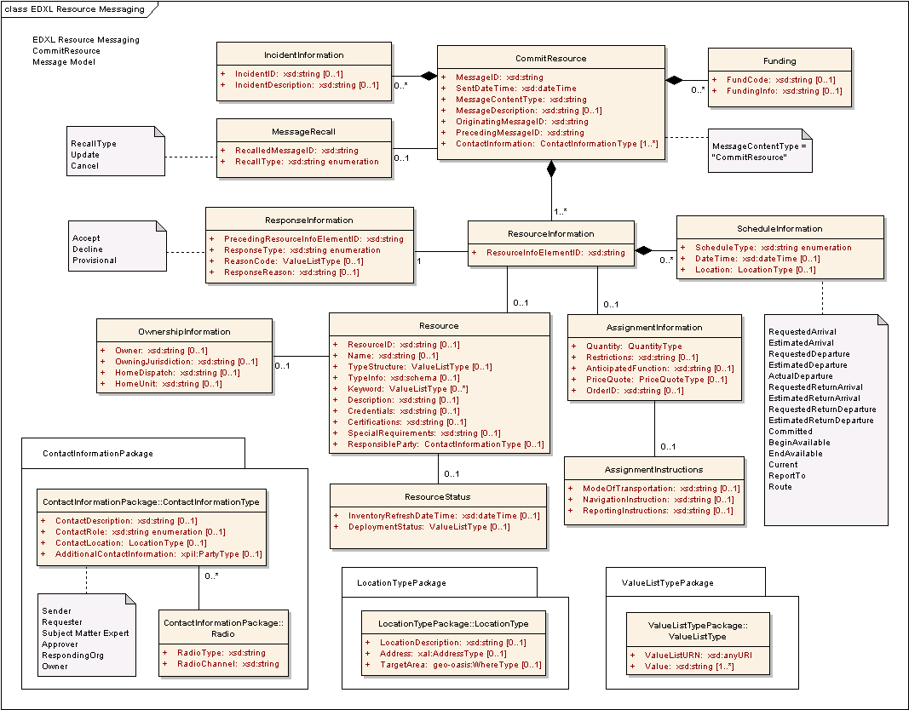
Figure 7: EDXL-RM ERM for CommitResource Message

The following table outlines the element cardinalities for this message type.

Table 6: CommitResource Message Elements
Parent Element | Sub-Elements
CommitResource | MessageID, SentDateTime, MessageContentType^, MessageDescription, OriginatingMessageID, PrecedingMessageID, IncidentInformation*, MessageRecall, Funding*, ContactInformation*, ResourceInformation*
IncidentInformation | IncidentID, IncidentDescription
MessageRecall | RecalledMessageID, RecallType
Funding | FundCode, FundingInfo
ResourceInformation | ResourceInfoElementID, ResponseInformation, Resource, AssignmentInformation, ScheduleInformation*
ResponseInformation | PrecedingResourceInfoElementID, ResponseType, ReasonCode, ResponseReason
Resource | ResourceID, Name, TypeStructure, TypeInfo, Keyword*, Description, Credentials, Certifications, SpecialRequirements, ResponsibleParty, OwnershipInformation, ResourceStatus
OwnershipInformation | Owner, OwningJurisdiction, HomeDispatch, HomeUnit
ResourceStatus | InventoryRefreshDateTime, DeploymentStatus
AssignmentInformation | Quantity, Restrictions, AnticipatedFunction, PriceQuote, OrderID, AssignmentInstructions
AssignmentInstructions | ModeOfTransportation, NavigationInstructions, ReportingInstructions
ScheduleInformation | ScheduleType^, DateTime, Location

CommitResource Message Rules
The following rules apply to the above elements:
- The CommitResource:MessageID, CommitResource:SentDateTime, CommitResource:MessageContentType, CommitResource:OriginatingMessageID, CommitResource:PrecedingMessageID, CommitResource:ContactInformation, and CommitResource:ResourceInformation elements MUST be present.
- The value of CommitResource:MessageContentType MUST be “CommitResource”.
- If a CommitResource:IncidentInformation element is present, then at least one of IncidentInformation:IncidentID and/or IncidentInformation:IncidentDescription elements MUST be present.
- If the CommitResource:MessageRecall element is present, then the MessageRecall:RecalledMessageID and MessageRecall:RecallType elements MUST be present.
- If a CommitResource:Funding element is present, then at least one of Funding:FundCode and/or Funding:FundingInfo elements MUST be present.
- The ResourceInformation:ResourceInfoElementID and ResourceInformation:ResponseInformation elements MUST be present.
- If ResponseInformation:ResponseType has a value of “Accept” or “Provisional”, then the ResourceInformation:Resource element MUST be present.
- If ResponseInformation:ResponseType has a value of “Accept” or “Provisional”, then the ResourceInformation:AssignmentInformation element MUST be present. If ResponseInformation:ResponseType has a value of “Decline”, then the ResourceInformation:AssignmentInformation is not applicable.
- If ResponseInformation:ResponseType has a value of “Accept” or “Provisional”, then the ResourceInformation:ScheduleInformation element MUST be present. If ResponseInformation:ResponseType has a value of “Decline”, then the ResourceInformation:ScheduleInformation is not applicable.
- The ResponseInformation:PrecedingResourceInfoElementID and ResponseInformation:ResponseType elements MUST be present.
- If ResponseInformation:ResponseType has a value of “Provisional”, then at least one of ResponseInformation:ReasonCode and/or ResponseInformation:ResponseReason elements MUST be present.
- If a ResourceInformation:Resource element is present, then at least one of Resource:ResourceID, Resource:Name, and/or Resource:TypeStructure elements MUST be present.
- If a Resource:OwnershipInformation is present, then at least one of OwnershipInformation:Owner and/or OwnershipInformation:OwningJurisdiction elements MUST be present.
- If a ResourceInformation:AssignmentInformation element is present, then the AssignmentInformation:Quantity element MUST be present.
- If the ResourceInformation:ScheduleInformation element is present, then the ScheduleInformation:ScheduleType element MUST be present and contain one of the following values:
- “RequestedArrival”, “EstimatedArrival “, “EstimatedDeparture”, “RequestedDeparture”, “ActualDeparture”, “RequestedReturnArrival”, “EstimatedReturnArrival“, “RequestedReturnDeparture”, ”EstimatedReturnDeparture”, “Committed”, “BeginAvailable”, “EndAvailable”, “Current”, “ReportTo” or “Route”.

The schema for a CommitResource message can be found in Appendix A.6.

Message Flow
The CommitResource message is sent by a Resource Supplier in response to either a RequestResource or RequisitionResource message sent by the Resource Consumer.
The message may be canceled or updated through the CommitResource:MessageRecall element.

Message Example
Below is an example of a CommitResource Message. This is an example Response to the original RequisitionResource shown in Section 3.6.5. In this example, the two requests have different responses:
- The “Small Animal Sheltering Team” (ResourceInfoElementID=001) is Accepted. In this case the Schedule information is updated with Committed date.
- The “Patrol and Surveillance Helicopters” (ResourceInfoElementID=002) is Declined.

[Note: The XML example shown in this section is informative only.]
<?xml version="1.0" encoding="UTF-8"?>
<CommitResource xmlns:xsi="http://www.w3.org/2001/XMLSchema-instance"
xsi:schemaLocation="urn:oasis:names:tc:emergency:EDXL:RM:1.0:msg
EDXL-RMCommitResource.xsd"
xmlns="urn:oasis:names:tc:emergency:EDXL:RM:1.0:msg"
xmlns:rm="urn:oasis:names:tc:emergency:EDXL:RM:1.0"
xmlns:xpil="urn:oasis:names:tc:ciq:xpil:3"
xmlns:xnl="urn:oasis:names:tc:ciq:xnl:3" xmlns:xal="urn:oasis:names:tc:ciq:xal:3"
xmlns:geo-oasis="urn:oasis:names:tc:emergency:EDXL:HAVE:1.0:geo-oasis"
xmlns:gml="http://www.opengis.net/gml">
<MessageID>urn:au-qld-eoc:997754</MessageID>
<SentDateTime>2006-03-21T12:46:00+10:00</SentDateTime>
<MessageContentType>CommitResource</MessageContentType>
<OriginatingMessageID>urn:au-qld-eoc:12332</OriginatingMessageID>
<PrecedingMessageID>urn:au-qld-eoc:987654</PrecedingMessageID>
<IncidentInformation>
<rm:IncidentDescription>Cyclone Larry</rm:IncidentDescription>
</IncidentInformation>
<Funding>
<rm:FundCode>HP4347</rm:FundCode>
</Funding>
<ContactInformation>
<rm:ContactRole>Sender</rm:ContactRole>
<rm:AdditionalContactInformation>
<xpil:PartyName>
<xnl:PersonName>
<xnl:NameElement xnl:ElementType="FirstName">Charlotte</xnl:NameElement>
<xnl:NameElement xnl:ElementType="LastName">Ryan</xnl:NameElement>
</xnl:PersonName>
<xnl:OrganisationName>
<xnl:NameElement>EMA</xnl:NameElement>
</xnl:OrganisationName>
</xpil:PartyName>
</rm:AdditionalContactInformation>
</ContactInformation>
<ResourceInformation>
<ResourceInfoElementID>001</ResourceInfoElementID>
<ResponseInformation>
<rm:PrecedingResourceInfoElementID>001</rm:PrecedingResourceInfoElementID>
<rm:ResponseType>Accept</rm:ResponseType>
</ResponseInformation>
<Resource>
<TypeStructure>
<rm:ValueListURN>urn:x-hazard:vocab:resourceTypes</rm:ValueListURN>
<rm:Value>Small Animal Sheltering Team</rm:Value>
</TypeStructure>
<Description>
5-person response team to advise and support local efforts to set up a
small animal shelter
</Description>
<SpecialRequirements>A qualified veterinary surgeon</SpecialRequirements>
</Resource>
<AssignmentInformation>
<Quantity>
<rm:MeasuredQuantity>
<rm:Amount>1</rm:Amount>
</rm:MeasuredQuantity>
</Quantity>
</AssignmentInformation>
<ScheduleInformation>
<ScheduleType>Committed</ScheduleType>
<DateTime>2006-03-21T12:46:00+10:00</DateTime>
</ScheduleInformation>
</ResourceInformation>
<ResourceInformation>
<ResourceInfoElementID>002</ResourceInfoElementID>
<ResponseInformation>
<rm:PrecedingResourceInfoElementID>002</rm:PrecedingResourceInfoElementID>
<rm:ResponseType>Decline</rm:ResponseType>
</ResponseInformation>
</ResourceInformation>
</CommitResource>

RequestInformation Message

Overview
One use of the “RequestInformation” message is to ask questions about specific resources. In this case, the message can be the initial message sent from the Resource Consumer to the Resource Suppliers, or it can be a follow up message seeking further information after the Resource Consumer has sent a RequestResource or other resource messages. A RequestInformation can be used in this manner even after a resource has been committed and/or deployed; however, if the request is related to the status of a deployed resource, the RequestResourceDeploymentStatus message MUST be used instead.
A second use of this message type is to provide a general description of the sender’s situation and needs, with the expectation of receiving responses suggesting suitable resources. This is useful when the Resource Consumer is not able to issue a specific RequestResource message because of a lack of knowledge about the resources that would be most appropriate for the situation.

Element Reference Model
Figure 8 below shows the EDXL–RM Element Reference Model (ERM) tailored for the RequestInformation Message. The ERM shows the element-level details for the main entities in the RM.
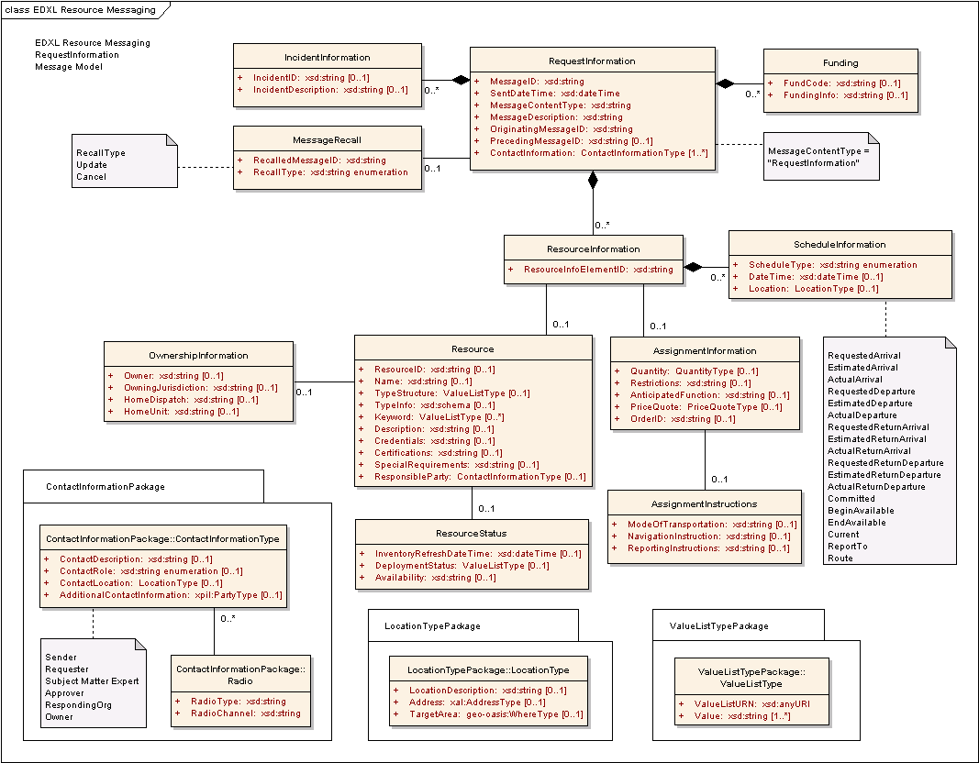
Figure 8: EDXL-RM ERM for RequestInformation Message

The following table outlines the element cardinalities for this message type.

Table 7: RequestInformation Message Elements
Parent Element | Sub-Elements
RequestInformation | MessageID, SentDateTime, MessageContentType^, MessageDescription, OriginatingMessageID, PrecedingMessageID, IncidentInformation*, MessageRecall, Funding*, ContactInformation*, ResourceInformation*
IncidentInformation | IncidentID, IncidentDescription
MessageRecall | RecalledMessageID, RecallType
Funding | FundCode, FundingInfo
ResourceInformation | ResourceInfoElementID, Resource, AssignmentInformation, ScheduleInformation*
Resource | ResourceID, Name, TypeStructure, TypeInfo, Keyword*, Description, Credentials, Certifications, SpecialRequirements, ResponsibleParty, OwnershipInformation, ResourceStatus
OwnershipInformation | Owner, OwningJurisdiction, HomeDispatch, HomeUnit
ResourceStatus | InventoryRefreshDateTime, DeploymentStatus, Availability
AssignmentInformation | Quantity, Restrictions, AnticipatedFunction, PriceQuote, OrderID, AssignmentInstructions
AssignmentInstructions | ModeOfTransportation, NavigationInstructions, ReportingInstructions
ScheduleInformation | ScheduleType^, DateTime, Location

RequestInformation Message rules
The following rules apply to the above elements:
- The RequestInformation:MessageID, ResourceMessage:SentDateTime ResourceMessage:MessageContentType, ResourceMessage:MessageDescription, ResourceMessage:OriginatingMessageID, and ResourceMessage:ContactInformation elements MUST be present.
- The value of RequestInformation:MessageContentType MUST be “RequestInformation”.
- If a RequestInformation:IncidentInformation element is present, then at least one of IncidentInformation:IncidentID and/or IncidentInformation:IncidentDescription elements MUST be present.
- If the ResourceMessage:MessageRecall element is present, then the MessageRecall:RecalledMessageID and MessageRecall:RecallType elements MUST be present.
- If a RequestInformation:Funding element is present, then at least one of Funding:FundCode and/or Funding:FundingInfo elements MUST be present.
- If a RequestInformation:ResourceInformation element is present, then the ResourceInformation:ResourceInfoElementID element MUST be present.
- If a ResourceInformation:Resource element is present, then at least one of Resource:ResourceID, Resource:Name, and/or Resource:TypeStructure elements MUST be present.
- If a Resource:OwnershipInformation is present, then at least one of OwnershipInformation:Owner and/or OwnershipInformation:OwningJurisdiction elements MUST be present.
- If the ResourceInformation:ScheduleInformation element is present, then the ScheduleInformation:ScheduleType element MUST be present and contain one of the following values:
- “RequestedArrival”, “EstimatedArrival”, “ActualArrival”, “RequestedDeparture”, “EstimatedDeparture”, “ActualDeparture”, “RequestedReturnDeparture”, “EstimatedReturnDeparture”, “ActualReturnDeparture”, “RequestedReturnArrival”, “EstimatedReturnArrival”, “ActualReturnArrival”, “BeginAvailable”, “EndAvailable”, “Committed”, “Current”, “ReportTo” or “Route”.

The schema for a RequestInformation message can be found in Appendix A.7.

Message Flow
The RequestInformation message may be sent by the Resource Consumer to any number of Resource Suppliers, or may it may be sent vice versa. The RequestInformation message may follow earlier resource messages.
The potential responses to this message include:
- ResponseToRequestInformation (See Section 3.9)
- ReportResourceDeploymentStatus
- This includes Accept, Decline, and Provisional responses.
The message may be canceled or updated through the RequestInformation:MessageRecall element.

Message Example
Below is an example RequestInformation messages. The first is intended as a follow up message to the RequestResource and ResponseToRequestResource messages shown in Sections 3.4.5 and 3.5.5, requesting further information about the third resource that was requested (two electrical power restoration teams).

[Note: The XML examples shown in this section are informative only.]
<?xml version="1.0" encoding="UTF-8"?>
<RequestInformation xmlns:xsi="http://www.w3.org/2001/XMLSchema-instance"
xsi:schemaLocation="urn:oasis:names:tc:emergency:EDXL:RM:1.0:msg
EDXL-RMRequestInformation.xsd"
xmlns="urn:oasis:names:tc:emergency:EDXL:RM:1.0:msg"
xmlns:rm="urn:oasis:names:tc:emergency:EDXL:RM:1.0"
xmlns:xpil="urn:oasis:names:tc:ciq:xpil:3"
xmlns:xnl="urn:oasis:names:tc:ciq:xnl:3" xmlns:xal="urn:oasis:names:tc:ciq:xal:3"
xmlns:geo-oasis="http://www.oasis-open.org/oasis/10"
xmlns:gml="http://www.opengis.net/gml">
<MessageID>urn:au-qld-eoc:12338</MessageID>
<SentDateTime>2006-03-21T12:35:00+10:00</SentDateTime>
<MessageContentType>RequestInformation</MessageContentType>
<MessageDescription>
Could you please advise the size (personnel and equipment) of each power
restoration team?
</MessageDescription>
<OriginatingMessageID>urn:au-qld-eoc:12332</OriginatingMessageID>
<PrecedingMessageID>urn:au-qld-eoc:12332</PrecedingMessageID>
<IncidentInformation>
<rm:IncidentDescription>Cyclone Larry</rm:IncidentDescription>
</IncidentInformation>
<ContactInformation>
<rm:ContactRole>Sender</rm:ContactRole>
<rm:AdditionalContactInformation>
<xpil:PartyName>
<xnl:PersonName>
<xnl:NameElement xnl:ElementType="FirstName">Charlotte</xnl:NameElement>
<xnl:NameElement xnl:ElementType="LastName">Ryan</xnl:NameElement>
</xnl:PersonName>
<xnl:OrganisationName>
<xnl:NameElement>EMA</xnl:NameElement>
</xnl:OrganisationName>
</xpil:PartyName>
</rm:AdditionalContactInformation>
</ContactInformation>
<ResourceInformation>
<ResourceInfoElementID>001</ResourceInfoElementID>
<Resource>
<TypeStructure>
<rm:ValueListURN>urn:x-hazard:vocab:resourceTypes</rm:ValueListURN>
<rm:Value>Electrical Power Restoration Team</rm:Value>
</TypeStructure>
</Resource>
<AssignmentInformation>
<Quantity>
<rm:MeasuredQuantity>
<rm:Amount>1</rm:Amount>
</rm:MeasuredQuantity>
</Quantity>
<AnticipatedFunction>
Restore power to critical infrastructure in and around the
Innisfail area
</AnticipatedFunction>
</AssignmentInformation>
</ResourceInformation>
</RequestInformation>

ResponseToRequestInformation Message

Overview
The “ResponseToRequestInformation” message is used by Resource Suppliers to respond to a RequestInformation message from Resource Consumers. If the RequestInformation message contained one or more ResourceInformation elements, the response MUST Accept or Decline for each ResourceInformation element with a separate ResponseInformation element. However, accepting here only entails agreeing to supply the requested information, not agreeing to supply resources. If the RequestInformation message did not contain any ResourceInformation elements, one or more ResponseInformation elements MAY be included in the response message.

Element Reference Model
Figure 9 below shows the EDXL–RM Element Reference Model (ERM) tailored for the ResponseToRequestInformation Message. The ERM shows the element-level details for the main entities in the RM.
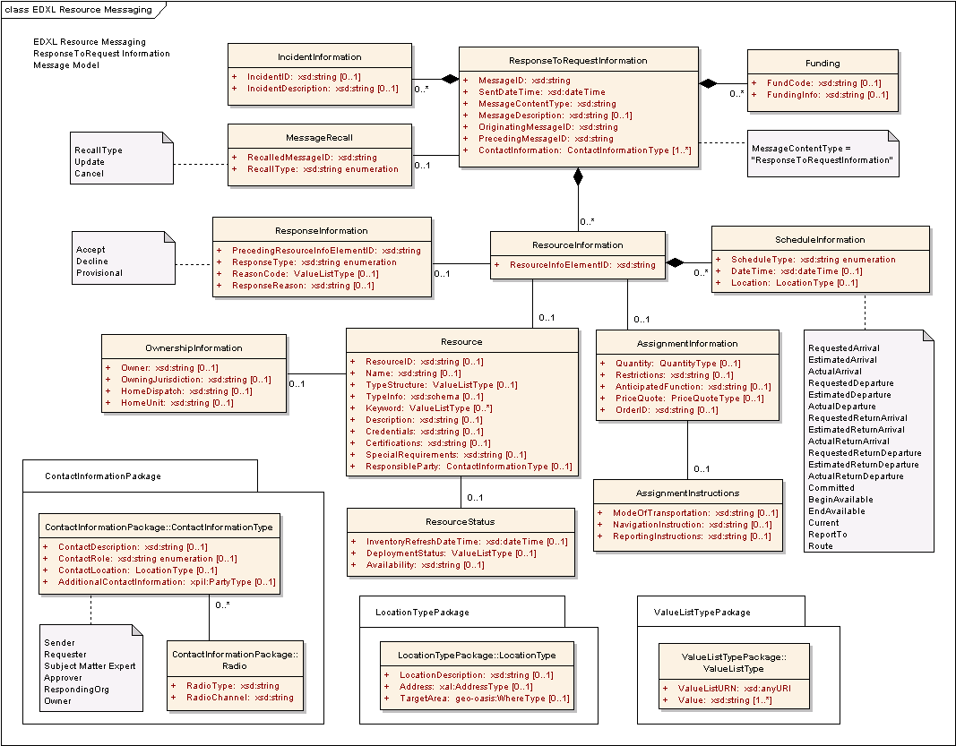
Figure 9: EDXL-RM ERM for ResponseToRequestInformation Message

The following table outlines the element cardinalities for this message type.

Table 8: ResponseToRequestInformation Message Elements
Parent Element | Sub-Elements
ResponseToRequestInformation | MessageID, SentDateTime, MessageContentType^, MessageDescription, OriginatingMessageID, PrecedingMessageID, IncidentInformation*, MessageRecall, Funding*, ContactInformation*, ResourceInformation*
IncidentInformation | IncidentID, IncidentDescription
MessageRecall | RecalledMessageID, RecallType
Funding | FundCode, FundingInfo
ResourceInformation | ResourceInfoElementID, ResponseInformation, Resource, AssignmentInformation, ScheduleInformation*
ResponseInformation | PrecedingResourceInfoElementID, ResponseType, ReasonCode, ResponseReason
Resource | ResourceID, Name, TypeStructure, TypeInfo, Keyword*, Description, Credentials, Certifications, SpecialRequirements, ResponsibleParty, OwnershipInformation, ResourceStatus
OwnershipInformation | Owner, OwningJurisdiction, HomeDispatch, HomeUnit
ResourceStatus | InventoryRefreshDateTime, DeploymentStatus, Availability
AssignmentInformation | Quantity, Restrictions, AnticipatedFunction, PriceQuote, OrderID, AssignmentInstructions
AssignmentInstructions | ModeOfTransportation, NavigationInstructions, ReportingInstructions
ScheduleInformation | ScheduleType, DateTime, Location

ResponseToRequestInformation Message Rules
The following rules apply to the above elements:
- The ResponseToRequestInformation:MessageID, ResponseToRequestInformation:SentDateTime ResponseToRequestInformation:MessageContentType, ResponseToRequestInformation:OriginatingMessageID, ResponseToRequestInformation:PrecedingMessageID, and ResponseToRequestInformation:ContactInformation elements MUST be present.
- The value of ResponseToRequestInformation:MessageContentType MUST be “ResponseToRequestInformation”.
- If a ResponseToRequestInformation:IncidentInformation element is present, then at least one of IncidentInformation:IncidentID and/or IncidentInformation:IncidentDescription elements MUST be present.
- If the ResponseToRequestInformation:MessageRecall element is present, then the MessageRecall:RecalledMessageID and MessageRecall:RecallType elements MUST be present.
- If a ResponseToRequestInformation:Funding element is present, then at least one of Funding:FundCode and/or Funding:FundingInfo elements MUST be present.
- If a ResponseToRequestInformation:ResourceInformation element is present, then the ResourceInformation:ResourceInfoElementID element MUST be present.
- If the ResourceInformation:ResponseInformation element is present, then the ResponseInformation:PrecedingResourceInfoElementID and ResponseInformation:ResponseType elements MUST be present.
- If the ResourceInformation:ResponseInformation element is present and the ResponseInformation:ResponseType element has a value of “Provisional”, then at least one of ResponseInformation:ReasonCode and/or ResponseInformation:ResponseReason elements MUST be present.
- If a ResourceInformation:Resource element is present, then at least one of Resource:ResourceID, Resource:Name, and/or Resource:TypeStructure elements MUST be present.
- If a Resource:OwnershipInformation element is present, then at least one of OwnershipInformation:Owner and/or OwnershipInformation:OwningJurisdiction elements MUST be present.
- If the ResourceInformation:ScheduleInformation element is present, then the ScheduleInformation:ScheduleType element MUST be present and contain one of the following values:
- “RequestedArrival”, “EstimatedArrival”, “ActualArrival”, “RequestedDeparture”, “EstimatedDeparture”, “ActualDeparture”, “RequestedReturnDeparture”, “EstimatedReturnDeparture”, “ActualReturnDeparture”, “RequestedReturnArrival”, “EstimatedReturnArrival”, “ActualReturnArrival”, “BeginAvailable”, “EndAvailable”, “Committed”, “Current”, “ReportTo” or “Route”.

The schema for a ResponseToRequestInformation message can be found in Appendix A.8.

Message Flow
The ResponseToRequestInformation message is sent by a Resource Supplier or Resource Consumer in response to an original RequestInformation message.
The potential responses to this message include:
- RequisitionResource message from the Resource Consumer. (See Section 3.6)
The message may be canceled or updated through the ResponseToRequestInformation:MessageRecall element.

Message Example
Below are two example ResponseToRequestInformation messages. These are example responses to the RequestInformation messages shown in Section 3.8.5.

[Note: The XML examples shown in this section are informative only.]
<?xml version="1.0" encoding="UTF-8"?>
<ResponseToRequestInformation xmlns:xsi="http://www.w3.org/2001/XMLSchema-instance"
xsi:schemaLocation="urn:oasis:names:tc:emergency:EDXL:RM:1.0:msg
EDXL-RMResponseToRequestInformation.xsd"
xmlns="urn:oasis:names:tc:emergency:EDXL:RM:1.0:msg"
xmlns:rm="urn:oasis:names:tc:emergency:EDXL:RM:1.0"
xmlns:xpil="urn:oasis:names:tc:ciq:xpil:3"
xmlns:xnl="urn:oasis:names:tc:ciq:xnl:3" xmlns:xal="urn:oasis:names:tc:ciq:xal:3"
xmlns:geo-oasis="urn:oasis:names:tc:emergency:EDXL:HAVE:1.0:geo-oasis"
xmlns:gml="http://www.opengis.net/gml">
<MessageID>urn:au-qld-eoc:12346</MessageID>
<SentDateTime>2006-03-21T12:37:00+10:00</SentDateTime>
<MessageContentType>ResponseToRequestInformation</MessageContentType>
<MessageDescription>
Team consists of 5 overhead (2 person) crews with material handlers; 1
overhead (2 person) crew; 2 designers; 1 team leader; 1 safety specialist and fleet
services support. Each team is additionally equipped with digger derrick/pole
trailer and auxiliary (material handler or 36' bucket).
</MessageDescription>
<OriginatingMessageID>urn:au-qld-eoc:12332</OriginatingMessageID>
<PrecedingMessageID>urn:au-qld-eoc:12338</PrecedingMessageID>
<IncidentInformation>
<rm:IncidentDescription>Cyclone Larry</rm:IncidentDescription>
</IncidentInformation>
<ContactInformation>
<rm:ContactRole>Sender</rm:ContactRole>
<rm:AdditionalContactInformation>
<xpil:PartyName>
<xnl:PersonName>
<xnl:NameElement xnl:ElementType="FirstName">Alex</xnl:NameElement>
<xnl:NameElement xnl:ElementType="LastName">Jones</xnl:NameElement>
</xnl:PersonName>
<xnl:OrganisationName>
<xnl:NameElement>Dept of Emergency Services</xnl:NameElement>
</xnl:OrganisationName>
</xpil:PartyName>
<xpil:ContactNumbers>
<xpil:ContactNumber xpil:CommunicationMediaType="Telephone"
xpil:ContactHours="9:00AM - 5:00PM">
<xpil:ContactNumberElement
xpil:Type="CountryCode">61</xpil:ContactNumberElement>
<xpil:ContactNumberElement xpil:Type="AreaCode">7</xpil:ContactNumberElement>
<xpil:ContactNumberElement xpil:Type="LocalNumber">
3000
1234
</xpil:ContactNumberElement>
</xpil:ContactNumber>
</xpil:ContactNumbers>
<xpil:ElectronicAddressIdentifiers>
<xpil:ElectronicAddressIdentifier>alexj@emergencyservices.gov.au
</xpil:ElectronicAddressIdentifier>
</xpil:ElectronicAddressIdentifiers>
</rm:AdditionalContactInformation>
</ContactInformation>
</ResponseToRequestInformation>
<?xml version="1.0" encoding="UTF-8"?>
<ResponseToRequestInformation xmlns:xsi="http://www.w3.org/2001/XMLSchema-instance"
xsi:schemaLocation="urn:oasis:names:tc:emergency:EDXL:RM:1.0:msg
EDXL-RMResponseToRequestInformation.xsd"
xmlns="urn:oasis:names:tc:emergency:EDXL:RM:1.0:msg"
xmlns:rm="urn:oasis:names:tc:emergency:EDXL:RM:1.0"
xmlns:xpil="urn:oasis:names:tc:ciq:xpil:3"
xmlns:xnl="urn:oasis:names:tc:ciq:xnl:3" xmlns:xal="urn:oasis:names:tc:ciq:xal:3"
xmlns:geo-oasis="urn:oasis:names:tc:emergency:EDXL:HAVE:1.0:geo-oasis"
xmlns:gml="http://www.opengis.net/gml">
<MessageID>urn:au-qld-eoc:77397</MessageID>
<SentDateTime>2006-03-22T08:22:00+10:00</SentDateTime>
<MessageContentType>ResponseToRequestInformation</MessageContentType>
<MessageDescription>
QBuild can send a damage assessment team from Cairns this afternoon.
</MessageDescription>
<OriginatingMessageID>urn:au-qld-eoc:77388</OriginatingMessageID>
<PrecedingMessageID>urn:au-qld-eoc:77388</PrecedingMessageID>
<IncidentInformation>
<rm:IncidentDescription>Cyclone Larry</rm:IncidentDescription>
</IncidentInformation>
<ContactInformation>
<rm:ContactRole>Sender</rm:ContactRole>
<rm:AdditionalContactInformation>
<xpil:PartyName>
<xnl:PersonName>
<xnl:NameElement xnl:ElementType="FirstName">Barnaby</xnl:NameElement>
<xnl:NameElement xnl:ElementType="LastName">James</xnl:NameElement>
</xnl:PersonName>
<xnl:OrganisationName>
<xnl:NameElement>EMA</xnl:NameElement>
</xnl:OrganisationName>
</xpil:PartyName>
<xpil:ContactNumbers>
<xpil:ContactNumber xpil:CommunicationMediaType="Telephone">
<xpil:ContactNumberElement
xpil:Type="CountryCode">61</xpil:ContactNumberElement>
<xpil:ContactNumberElement xpil:Type="AreaCode">2</xpil:ContactNumberElement>
<xpil:ContactNumberElement xpil:Type="LocalNumber">
9864
4329
</xpil:ContactNumberElement>
</xpil:ContactNumber>
</xpil:ContactNumbers>
</rm:AdditionalContactInformation>
</ContactInformation>
<ContactInformation>
<rm:ContactRole>Requester</rm:ContactRole>
<rm:AdditionalContactInformation>
<xpil:PartyName>
<xnl:PersonName>
<xnl:NameElement xnl:ElementType="FirstName">Alex</xnl:NameElement>
<xnl:NameElement xnl:ElementType="LastName">Jones</xnl:NameElement>
</xnl:PersonName>
<xnl:OrganisationName>
<xnl:NameElement>Dept of Emergency Services</xnl:NameElement>
</xnl:OrganisationName>
</xpil:PartyName>
</rm:AdditionalContactInformation>
</ContactInformation>
<ResourceInformation>
<ResourceInfoElementID>001</ResourceInfoElementID>
<Resource>
<TypeStructure>
<rm:ValueListURN>urn:x-hazard:vocab:resourceTypes</rm:ValueListURN>
<rm:Value>Engineering Services: Damage Assessment Team</rm:Value>
</TypeStructure>
</Resource>
<AssignmentInformation>
<Quantity>
<rm:MeasuredQuantity>
<rm:Amount>1</rm:Amount>
</rm:MeasuredQuantity>
</Quantity>
<AnticipatedFunction>
Preliminary assessment of cracks in Centenary Bridge,
Innisfail.
</AnticipatedFunction>
</AssignmentInformation>
<ScheduleInformation>
<ScheduleType>EstimatedDeparture</ScheduleType>
<DateTime>2006-03-22T15:00:00</DateTime>
<Location>
<rm:LocationDescription>Cairns Airport</rm:LocationDescription>
</Location>
</ScheduleInformation>
<ScheduleInformation>
<ScheduleType>EstimatedArrival</ScheduleType>
<DateTime>2006-03-25T16:00:00+10:00</DateTime>
<Location>
<rm:LocationDescription>Innisfail Airport</rm:LocationDescription>
</Location>
</ScheduleInformation>
</ResourceInformation>
</ResponseToRequestInformation>

OfferUnsolicitedResource Message

Overview
The “OfferUnsolicitedResource” message is used to offer available resources (that have not been requested) to assist with an emergency response.

Element Reference Model
Figure 10 below shows the EDXL–RM Element Reference Model (ERM) tailored for the OfferUnsolicitedResource Message. The ERM shows the element-level details for the main entities in the RM.
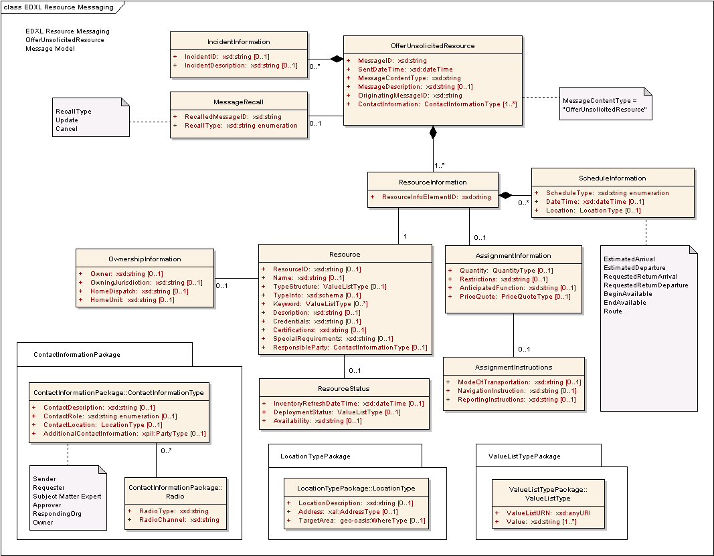
Figure 10: EDXL-RM ERM for OfferUnsolicitedResource Message

The following table outlines the element cardinalities for this message type.

Table 9: OfferUnsolicitedResource Message Elements
Parent Element | Sub-Elements
OfferUnsolicitedResource | MessageID, SentDateTime, MessageContentType^, MessageDescription, OriginatingMessageID, IncidentInformation*, MessageRecall, ContactInformation*, ResourceInformation*
IncidentInformation | IncidentID, IncidentDescription
MessageRecall | RecalledMessageID, RecallType
ResourceInformation | ResourceInfoElementID, Resource, AssignmentInformation, ScheduleInformation*
Resource | ResourceID, Name, TypeStructure, TypeInfo, Keyword*, Description, Credentials, Certifications, SpecialRequirements, ResponsibleParty, OwnershipInformation, ResourceStatus
OwnershipInformation | Owner, OwningJurisdiction, HomeDispatch, HomeUnit
ResourceStatus | InventoryRefreshDateTime, DeploymentStatus, Availability
AssignmentInformation | Quantity, Restrictions, AnticipatedFunction, PriceQuote, AssignmentInstructions
AssignmentInstructions | ModeOfTransportation, NavigationInstructions, ReportingInstructions
ScheduleInformation | ScheduleType^, DateTime, Location

OfferUnsolicitedResource Message Rules
The following rules apply to the above elements:
- The OfferUnsolicitedResource:MessageID, OfferUnsolicitedResource:SentDateTime OfferUnsolicitedResource:MessageContentType, OfferUnsolicitedResource:OriginatingMessageID, OfferUnsolicitedResource:ContactInformation, and OfferUnsolicitedResource:ResourceInformation elements MUST be present.
- The value of OfferUnsolicitedResource:MessageContentType MUST be “OfferUnsolicitedResource”.
- If an OfferUnsolicitedResource:IncidentInformation element is present, then at least one of IncidentInformation:IncidentID and/or IncidentInformation:IncidentDescription elements MUST be present.
- If the OfferUnsolicitedResource:MessageRecall element is present, then the MessageRecall:RecalledMessageID and MessageRecall:RecallType elements MUST be present.
- For each OfferUnsolicitedResource:ResourceInformation element, the ResourceInformation:ResourceInfoElementID and ResourceInformation:Resource elements MUST be present.
- At least one of Resource:ResourceID, Resource:Name, and/or Resource:TypeStructure elements MUST be present.
- If a Resource:OwnershipInformation element is present, then at least one of OwnershipInformation:Owner and/or OwnershipInformation:OwningJurisdiction elements MUST be present.
- If the ResourceInformation:ScheduleInformation element is present, then the ScheduleInformation:ScheduleType element MUST be present and contain one of the following values:
- “EstimatedArrival”, “EstimatedDeparture”, “RequestedReturnDeparture”, “RequestedReturnArrival”, “BeginAvailable”, “EndAvailable”, or “Route”.

The schema for an OfferUnsolicitedResource message can be found in Appendix A.9.

Message Flow
The OfferUnsolicitedResource message is an initial message created and sent by the Resource Supplier to any number of Resource Consumers.
The potential responses to this message include:
- RequestInformation (See Section 3.8)
- RequisitionResource (See Section 3.6)
The message may be canceled or updated through the OfferUnsolicitedResource:MessageRecall element.

Message Example
Below is an example OfferUnsolicitedResource message. This message offers a donation of 100 large and 100 small tarpaulins.

[Note: The XML example shown in this section is informative only.]
<?xml version="1.0" encoding="UTF-8"?>
<OfferUnsolicitedResource xmlns:xsi="http://www.w3.org/2001/XMLSchema-instance"
xsi:schemaLocation="urn:oasis:names:tc:emergency:EDXL:RM:1.0:msg
EDXL-RMOfferUnsolicitedResource.xsd"
xmlns="urn:oasis:names:tc:emergency:EDXL:RM:1.0:msg"
xmlns:rm="urn:oasis:names:tc:emergency:EDXL:RM:1.0"
xmlns:xpil="urn:oasis:names:tc:ciq:xpil:3"
xmlns:xnl="urn:oasis:names:tc:ciq:xnl:3" xmlns:xal="urn:oasis:names:tc:ciq:xal:3">
<MessageID>urn:au-qld-eoc:84313</MessageID>
<SentDateTime>2006-03-22T10:34:00+10:00</SentDateTime>
<MessageContentType>OfferUnsolicitedResource</MessageContentType>
<MessageDescription>
We would like to donate 100 small and 100 large tarps for use by residents
whose homes have been damaged by the cyclone.
</MessageDescription>
<OriginatingMessageID>urn:au-qld-eoc:84313</OriginatingMessageID>
<IncidentInformation>
<rm:IncidentDescription>Cyclone Larry</rm:IncidentDescription>
</IncidentInformation>
<ContactInformation>
<rm:ContactRole>Owner</rm:ContactRole>
<rm:AdditionalContactInformation>
<xpil:PartyName>
<xnl:PersonName>
<xnl:NameElement xnl:ElementType="FirstName">Joe</xnl:NameElement>
<xnl:NameElement xnl:ElementType="LastName">Williams</xnl:NameElement>
</xnl:PersonName>
<xnl:OrganisationName>
<xnl:NameElement>Hardware Megastore Cairns</xnl:NameElement>
</xnl:OrganisationName>
</xpil:PartyName>
<xpil:Addresses>
<xpil:Address>
<xal:Country>
<xal:NameElement>Australia</xal:NameElement>
</xal:Country>
<xal:AdministrativeArea>
<xal:NameElement>QLD</xal:NameElement>
</xal:AdministrativeArea>
<xal:Locality>
<xal:NameElement>Cairns</xal:NameElement>
</xal:Locality>
<xal:Thoroughfare>
<xal:NameElement>Spence St</xal:NameElement>
</xal:Thoroughfare>
<xal:PostCode>
<xal:Identifier>4870</xal:Identifier>
</xal:PostCode>
</xpil:Address>
</xpil:Addresses>
<xpil:ContactNumbers>
<xpil:ContactNumber xpil:CommunicationMediaType="Telephone"
xpil:ContactHours="8:00AM - 6:00PM">
<xpil:ContactNumberElement
xpil:Type="CountryCode">61</xpil:ContactNumberElement>
<xpil:ContactNumberElement xpil:Type="AreaCode">7</xpil:ContactNumberElement>
<xpil:ContactNumberElement xpil:Type="LocalNumber">
4052
0378
</xpil:ContactNumberElement>
</xpil:ContactNumber>
</xpil:ContactNumbers>
</rm:AdditionalContactInformation>
</ContactInformation>
<ResourceInformation>
<ResourceInfoElementID>001</ResourceInfoElementID>
<Resource>
<TypeStructure>
<rm:ValueListURN>urn:x-hazard:vocab:resourceTypes</rm:ValueListURN>
<rm:Value>Large tarpaulin</rm:Value>
</TypeStructure>
<Description> 30 x 40 ft, 800 denier blue tarp </Description>
</Resource>
<AssignmentInformation>
<Quantity>
<rm:MeasuredQuantity>
<rm:Amount>100</rm:Amount>
</rm:MeasuredQuantity>
</Quantity>
<AssignmentInstructions>
<rm:ModeOfTransportation>
We have a truck available to deliver to Innisfail (or other
preferred location).
</rm:ModeOfTransportation>
</AssignmentInstructions>
</AssignmentInformation>
<ScheduleInformation>
<ScheduleType>BeginAvailable</ScheduleType>
<DateTime>2006-03-22T12:00:00+10:00</DateTime>
<Location>
<rm:LocationDescription>Hardware Megastore Cairns</rm:LocationDescription>
<rm:Address>
<xal:Country>
<xal:NameElement>Australia</xal:NameElement>
</xal:Country>
<xal:AdministrativeArea>
<xal:NameElement>QLD</xal:NameElement>
</xal:AdministrativeArea>
<xal:Locality>
<xal:NameElement>Cairns</xal:NameElement>
</xal:Locality>
<xal:Thoroughfare>
<xal:NameElement>Spence St</xal:NameElement>
</xal:Thoroughfare>
<xal:PostCode>
<xal:Identifier>4870</xal:Identifier>
</xal:PostCode>
</rm:Address>
</Location>
</ScheduleInformation>
</ResourceInformation>
<ResourceInformation>
<ResourceInfoElementID>002</ResourceInfoElementID>
<Resource>
<TypeStructure>
<rm:ValueListURN>urn:x-hazard:vocab:resourceTypes</rm:ValueListURN>
<rm:Value>Small tarpaulin</rm:Value>
</TypeStructure>
<Description> 8 x 10 ft, 800 denier blue tarp </Description>
</Resource>
<AssignmentInformation>
<Quantity>
<rm:MeasuredQuantity>
<rm:Amount>100</rm:Amount>
</rm:MeasuredQuantity>
</Quantity>
<AssignmentInstructions>
<rm:ModeOfTransportation>
We have a truck available to deliver to Innisfail (or other
preferred location).
</rm:ModeOfTransportation>
</AssignmentInstructions>
</AssignmentInformation>
<ScheduleInformation>
<ScheduleType>BeginAvailable</ScheduleType>
<DateTime>2006-03-22T12:00:00+10:00</DateTime>
<Location>
<rm:LocationDescription>Hardware Megastore Cairns</rm:LocationDescription>
<rm:Address>
<xal:Country>
<xal:NameElement>Australia</xal:NameElement>
</xal:Country>
<xal:AdministrativeArea>
<xal:NameElement>QLD</xal:NameElement>
</xal:AdministrativeArea>
<xal:Locality>
<xal:NameElement>Cairns</xal:NameElement>
</xal:Locality>
<xal:Thoroughfare>
<xal:NameElement>Spence St</xal:NameElement>
</xal:Thoroughfare>
<xal:PostCode>
<xal:Identifier>4870</xal:Identifier>
</xal:PostCode>
</rm:Address>
</Location>
</ScheduleInformation>
</ResourceInformation>
</OfferUnsolicitedResource>

ReleaseResource Message

Overview
The “ReleaseResource” message is used by authorities at the incident to “release” (demobilize) a resource back to its original point of assignment or to another location / assignment.

Element Reference Model
Figure 11 below shows the EDXL–RM Element Reference Model (ERM) tailored for the ReleaseResource Message. The ERM shows the element-level details for the main entities in the RM.

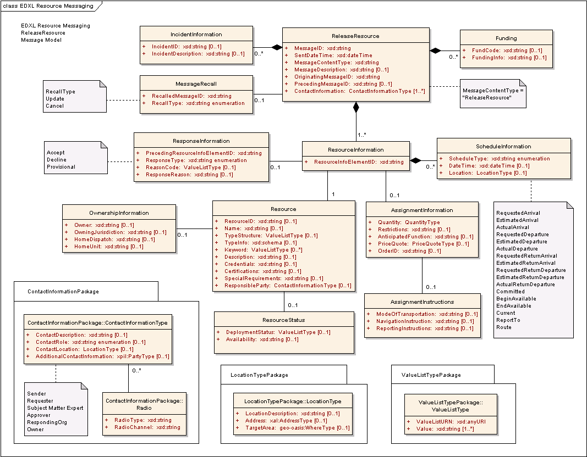
Figure 11: EDXL-RM ERM for ReleaseResource Message

The following table outlines the element cardinalities for this message type.

Table 11: ReleaseResource Message Elements
Parent Element | Sub-Elements
ReleaseResource | MessageID, SentDateTime, MessageContentType^, MessageDescription, OriginatingMessageID, PrecedingMessageID, IncidentInformation*, MessageRecall, Funding*, ContactInformation*, ResourceInformation*
IncidentInformation | IncidentID, IncidentDescription
MessageRecall | RecalledMessageID, RecallType
Funding | FundCode, FundingInfo
ResourceInformation | ResourceInfoElementID, ResponseInformation, Resource, AssignmentInformation, ScheduleInformation*
ResponseInformation | PrecedingResourceInfoElementID, ResponseType, ReasonCode, ResponseReason
Resource | ResourceID, Name, TypeStructure, TypeInfo, Keyword*, Description, Credentials, Certifications, SpecialRequirements, ResponsibleParty, OwnershipInformation, ResourceStatus
OwnershipInformation | Owner, OwningJurisdiction, HomeDispatch, HomeUnit
ResourceStatus | DeploymentStatus, Availability
AssignmentInformation | Quantity, Restrictions, AnticipatedFunction, PriceQuote, OrderID, AssignmentInstructions
AssignmentInstructions | ModeOfTransportation, NavigationInstructions, ReportingInstructions
ScheduleInformation | ScheduleType, DateTime, Location

ReleaseResource Message Rules
The following rules apply to the above elements:
- The ReleaseResource:MessageID, ReleaseResource:SentDateTime, ReleaseResource Message:MessageContentType, ReleaseResource:OriginatingMessageID, ReleaseResource:ContactInformation, and ReleaseResource:ResourceInformation elements MUST be present.
- The value of ReleaseResource:MessageContentType MUST be “ReleaseResource”.
- If a ReleaseResource:IncidentInformation element is present, then at least one of IncidentInformation:IncidentID and/or IncidentInformation:IncidentDescription elements MUST be present.
- If the ReleaseResource:MessageRecall element is present, then the MessageRecall:RecalledMessageID and MessageRecall:RecallType elements MUST be present.
- If a ReleaseResource:Funding element is present, then at least one of Funding:FundCode and/or Funding:FundingInfo elements MUST be present.
- For each ReleaseResource:ResourceInformation element, the ResourceInformation:ResourceInfoElementID and ResourceInformation:Resource elements MUST be present.
- If a ResourceInformation:ResponseInformation element is present, then the ResponseInformation:PrecedingResourceInfoElementID and ResponseInformation:ResponseType elements MUST be present.
- If a ResourceInformation:ResponseInformation element is present and the ResponseInformation:ResponseType has a value of “Provisional”, then at least one of ResponseInformation:ReasonCode and/or ResponseInformation:ResponseReason elements MUST be present.
- At least one of Resource:ResourceID, Resource:Name, and/or Resource:TypeStructure elements MUST be present.
- If a Resource:OwnershipInformation element is present, then at least one of OwnershipInformation:Owner and/or OwnershipInformation:OwningJurisdiction elements MUST be present.
- If the ResourceInformation:AssignmentInformation element is present, then the AssignmentInformation:Quantity element MUST be present.
- If the ResourceInformation:ScheduleInformation element is present, then the ScheduleInformation:ScheduleType element MUST must be present and contain one of the following values:
- “RequestedArrival”, “EstimatedArrival”, “ActualArrival”, “RequestedDeparture” , “EstimatedDeparture”, “ActualDeparture”, “RequestedReturnDeparture”, “EstimatedReturnDeparture”, “ActualReturnDeparture” “RequestedReturnArrival”, “EstimatedReturnArrival”, “BeginAvailable”, “EndAvailable”, “Committed”, “ReportTo”, “Current” or “Route”.

The schema for a ReleaseResource message can be found in Appendix A.10.

Message Flow
The ReleaseResource message is sent by the Resource Consumer to the Resource Supplier, and typically follows an earlier sequence of messages (e.g., RequisitionResource and CommitResource messages).
The potential responses to this message include:
- RequestInformation (See Section 3.8)
- RequisitionResource (See Section 3.6)
- Consumers waiting on the release of resources may send to a RequisitionResource Message after receipt of a ReleaseResource Message.
The message may be canceled or updated through the ReleaseResource:MessageRecall element.

Message Example
Below is an example ReleaseResource message. This message releases the Small Animal Sheltering Team committed in the example in Section 3.7.5.

[Note: The XML example shown in this section is informative only.]
<?xml version="1.0" encoding="UTF-8"?>
<ReleaseResource xmlns:xsi="http://www.w3.org/2001/XMLSchema-instance"
xsi:schemaLocation="urn:oasis:names:tc:emergency:EDXL:RM:1.0:msg
EDXL-RMReleaseResource.xsd"
xmlns="urn:oasis:names:tc:emergency:EDXL:RM:1.0:msg"
xmlns:rm="urn:oasis:names:tc:emergency:EDXL:RM:1.0"
xmlns:xpil="urn:oasis:names:tc:ciq:xpil:3"
xmlns:xnl="urn:oasis:names:tc:ciq:xnl:3" xmlns:xal="urn:oasis:names:tc:ciq:xal:3"
xmlns:geo-oasis="urn:oasis:names:tc:emergency:EDXL:HAVE:1.0:geo-oasis">
<MessageID>urn:au-qld-eoc:997985</MessageID>
<SentDateTime>2006-03-29T10:17:00+10:00</SentDateTime>
<MessageContentType>ReleaseResource</MessageContentType>
<MessageDescription>
Small Animal Sheltering Team will be flying back to Cairns this evening.
</MessageDescription>
<OriginatingMessageID>urn:au-qld-eoc:12332</OriginatingMessageID>
<IncidentInformation>
<rm:IncidentDescription>Cyclone Larry</rm:IncidentDescription>
</IncidentInformation>
<ContactInformation>
<rm:ContactRole>Sender</rm:ContactRole>
<rm:AdditionalContactInformation>
<xpil:PartyName>
<xnl:PersonName>
<xnl:NameElement xnl:ElementType="FirstName">Alex</xnl:NameElement>
<xnl:NameElement xnl:ElementType="LastName">Jones</xnl:NameElement>
</xnl:PersonName>
<xnl:OrganisationName>
<xnl:NameElement>Dept of Emergency Services</xnl:NameElement>
</xnl:OrganisationName>
</xpil:PartyName>
<xpil:ContactNumbers>
<xpil:ContactNumber xpil:CommunicationMediaType="Telephone"
xpil:ContactHours="9:00AM - 5:00PM">
<xpil:ContactNumberElement
xpil:Type="CountryCode">61</xpil:ContactNumberElement>
<xpil:ContactNumberElement xpil:Type="AreaCode">7</xpil:ContactNumberElement>
<xpil:ContactNumberElement xpil:Type="LocalNumber">
3000
1234
</xpil:ContactNumberElement>
</xpil:ContactNumber>
</xpil:ContactNumbers>
<xpil:ElectronicAddressIdentifiers>
<xpil:ElectronicAddressIdentifier>
alexj@emergencyservices.gov.au
</xpil:ElectronicAddressIdentifier>
</xpil:ElectronicAddressIdentifiers>
</rm:AdditionalContactInformation>
</ContactInformation>
<ResourceInformation>
<ResourceInfoElementID>001</ResourceInfoElementID>
<Resource>
<TypeStructure>
<rm:ValueListURN>urn:x-hazard:vocab:resourceTypes</rm:ValueListURN>
<rm:Value>Small Animal Sheltering Team</rm:Value>
</TypeStructure>
</Resource>
<AssignmentInformation>
<Quantity>
<rm:MeasuredQuantity>
<rm:Amount>1</rm:Amount>
</rm:MeasuredQuantity>
</Quantity>
</AssignmentInformation>
<ScheduleInformation>
<ScheduleType>Current</ScheduleType>
<Location>
<rm:LocationDescription>Innisfail Animal Refuge</rm:LocationDescription>
<rm:Address>
<xal:Country>
<xal:NameElement>Australia</xal:NameElement>
</xal:Country>
<xal:AdministrativeArea>
<xal:NameElement>QLD</xal:NameElement>
</xal:AdministrativeArea>
<xal:Locality>
<xal:NameElement>Innisfail</xal:NameElement>
</xal:Locality>
<xal:Thoroughfare>
<xal:NameElement>Downing St</xal:NameElement>
<xal:Number>27</xal:Number>
</xal:Thoroughfare>
<xal:PostCode>
<xal:Identifier>4860</xal:Identifier>
</xal:PostCode>
</rm:Address>
</Location>
</ScheduleInformation>
<ScheduleInformation>
<ScheduleType>EstimatedReturnDeparture</ScheduleType>
<DateTime>2006-03-29T19:05:00+10:00</DateTime>
<Location>
<rm:LocationDescription>Innisfail Airport</rm:LocationDescription>
</Location>
</ScheduleInformation>
<ScheduleInformation>
<ScheduleType>EstimatedReturnArrival</ScheduleType>
<DateTime>2006-03-29T19:55:00+10:00</DateTime>
<Location>
<rm:LocationDescription>Cairns Airport</rm:LocationDescription>
</Location>
</ScheduleInformation>
</ResourceInformation>
</ReleaseResource>

RequestReturn Message

Overview
The “RequestReturn” message is used to request release (demobilization) of resource(s) back to its original owning jurisdiction and location or to another location / assignment.

Element Reference Model
Figure 12 below shows the EDXL–RM Element Reference Model (ERM) tailored for the RequestReturn Message. The ERM shows the element-level details for the main entities in the RM.

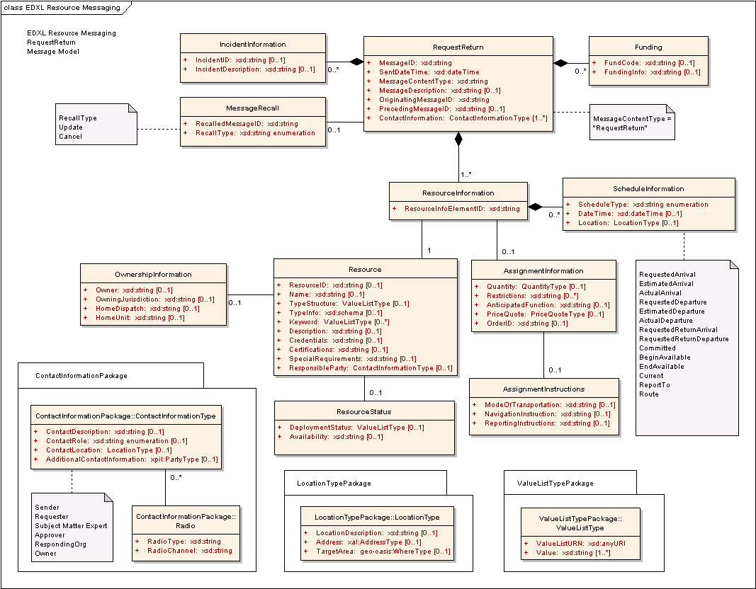
Figure 12: EDXL-RM ERM for RequestReturn Message

The following table outlines the element cardinalities for this message type.

Table 12: RequestReturn Message Elements
Parent Element | Sub-Elements
RequestReturn | MessageID, SentDateTime, MessageContentType^, MessageDescription, OriginatingMessageID, PrecedingMessageID, IncidentInformation*, MessageRecall, Funding*, ContactInformation*, ResourceInformation*
IncidentInformation | IncidentID, IncidentDescription
MessageRecall | RecalledMessageID, RecallType
Funding | FundCode, FundingInfo
ResourceInformation | ResourceInfoElementID, Resource, AssignmentInformation, ScheduleInformation*
Resource | ResourceID, Name, TypeStructure, TypeInfo, Keyword*, Description, Credentials, Certifications, SpecialRequirements, ResponsibleParty, OwnershipInformation, ResourceStatus
OwnershipInformation | Owner, OwningJurisdiction, HomeDispatch, HomeUnit
ResourceStatus | DeploymentStatus, Availability
AssignmentInformation | Quantity, Restrictions, AnticipatedFunction, PriceQuote, OrderID, AssignmentInstructions
AssignmentInstructions | ModeOfTransportation, NavigationInstructions, ReportingInstructions
ScheduleInformation | ScheduleType^, DateTime, Location

RequestReturn Message Rules
The following rules apply to the above elements:
- The RequestReturn:MessageID, ResourceMessage:SentDateTime, RequestReturn:MessageContentType, RequestReturn:OriginatingMessageID, RequestReturn:ContactInformation, and RequestReturn:ResourceInformation elements MUST be present.
- The value of RequestReturn:MessageContentType MUST be “RequestReturn”.
- If a RequestReturn:IncidentInformation element is present, then at least one of IncidentInformation:IncidentID and/or IncidentInformation:IncidentDescription elements MUST be present.
- If the RequestReturn:MessageRecall element is present, then the MessageRecall:RecalledMessageID and MessageRecall:RecallType elements MUST be present.
- If a RequestReturn:Funding element is present, then at least one of Funding:FundCode and/or Funding:FundingInfo elements MUST be present.
- The ResourceInformation:ResourceInfoElementID and ResourceInformation:Resource elements MUST be present.
- At least one of Resource:ResourceID, Resource:Name, and/or Resource:TypeStructure elements MUST be present for each ResourceInformation:Resource element present.
- If a Resource:OwnershipInformation element is present, then at least one of OwnershipInformation:Owner and/or OwnershipInformation:OwningJurisdiction elements MUST be present.
- If the ResourceInformation:ScheduleInformation element is present, then the ScheduleInformation:ScheduleType element MUST be present and contain one of the following values:
- “RequestedArrival”, “EstimatedArrival”, “ActualArrival”, “RequestedDeparture”, “EstimatedDeparture”, “ActualDeparture”, “RequestedReturnDeparture”, “RequestedReturnArrival”, “BeginAvailable”, “Committed”, “EndAvailable”, “Current”, “ReportTo” or “Route”.

The schema for a RequestReturn message can be found in Appendix A.11.

Message Flow
The RequestReturn message is sent by the Resource Supplier to the Resource Consumer, and typically follows an earlier sequence of messages (e.g., RequisitionResource and CommitResource messages).
The potential responses to this message include:
- ResponseToRequestReturn (See Section 3.13)
- ReleaseResource (See Section 3.11)
- This includes Accept, Decline, and Provisional responses.
The message may be canceled or updated through the RequestReturn:MessageRecall element.

Message Example
Below is an example of a RequestReturn Message, in which one request return is shown:
- Small Animal Sheltering Team (ResourceInfoElementID=001).

[Note: The XML example shown in this section is informative only.]
<?xml version="1.0" encoding="UTF-8"?>
<RequestReturn xmlns:xsi="http://www.w3.org/2001/XMLSchema-instance"
xsi:schemaLocation="urn:oasis:names:tc:emergency:EDXL:RM:1.0:msg
EDXL-RMRequestReturn.xsd"
xmlns="urn:oasis:names:tc:emergency:EDXL:RM:1.0:msg"
xmlns:rm="urn:oasis:names:tc:emergency:EDXL:RM:1.0"
xmlns:xpil="urn:oasis:names:tc:ciq:xpil:3"
xmlns:xnl="urn:oasis:names:tc:ciq:xnl:3" xmlns:xal="urn:oasis:names:tc:ciq:xal:3"
xmlns:geo-oasis="urn:oasis:names:tc:emergency:EDXL:HAVE:1.0:geo-oasis">
<MessageID>urn:au-qld-eoc:997821</MessageID>
<SentDateTime>2006-03-28T14:48:00+10:00</SentDateTime>
<MessageContentType>RequestReturn</MessageContentType>
<OriginatingMessageID>urn:au-qld-eoc:12332</OriginatingMessageID>
<IncidentInformation>
<rm:IncidentDescription>Cyclone Larry</rm:IncidentDescription>
</IncidentInformation>
<ContactInformation>
<rm:ContactRole>Sender</rm:ContactRole>
<rm:AdditionalContactInformation>
<xpil:PartyName>
<xnl:PersonName>
<xnl:NameElement xnl:ElementType="FirstName">Charlotte</xnl:NameElement>
<xnl:NameElement xnl:ElementType="LastName">Ryan</xnl:NameElement>
</xnl:PersonName>
<xnl:OrganisationName>
<xnl:NameElement>EMA</xnl:NameElement>
</xnl:OrganisationName>
</xpil:PartyName>
</rm:AdditionalContactInformation>
</ContactInformation>
<ResourceInformation>
<ResourceInfoElementID>001</ResourceInfoElementID>
<Resource>
<TypeStructure>
<rm:ValueListURN>urn:x-hazard:vocab:resourceTypes</rm:ValueListURN>
<rm:Value>Small Animal Sheltering Team</rm:Value>
</TypeStructure>
</Resource>
<AssignmentInformation>
<Quantity>
<rm:MeasuredQuantity>
<rm:Amount>1</rm:Amount>
</rm:MeasuredQuantity>
</Quantity>
</AssignmentInformation>
<ScheduleInformation>
<ScheduleType>RequestedReturnArrival</ScheduleType>
<DateTime>2006-03-29T20:00:00+10:00</DateTime>
<Location>
<rm:LocationDescription>Cairns Airport</rm:LocationDescription>
</Location>
</ScheduleInformation>
</ResourceInformation>
</RequestReturn>

ResponseToRequestReturn Message

Overview
The “ResponseToRequestReturn” message is used by Resource Consumers to respond to a RequestReturn message from Resource Suppliers. The response identifies the resources in the original request message and how the Resource Consumer has responded.

Element Reference Model
Figure 13 below shows the EDXL–RM Element Reference Model (ERM) tailored for the ResponseToRequestReturn Message. The ERM shows the element-level details for the main entities in the RM.
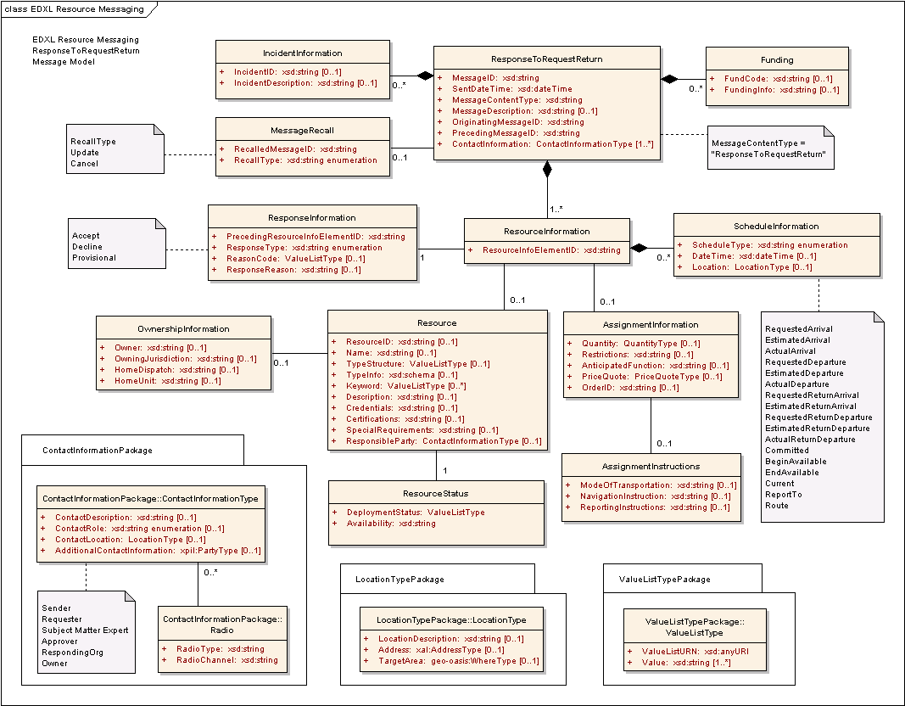
Figure 13: EDXL-RM ERM for ResponseToRequestReturn Message

The following table outlines the element cardinalities for this message type.

Table 13: ResponseToRequestReturn Message Elements
Parent Element | Sub-Elements
ResponseToRequestReturn | MessageID, SentDateTime, MessageContentType^, MessageDescription, OriginatingMessageID, PrecedingMessageID, IncidentInformation*, MessageRecall, Funding*, ContactInformation*, ResourceInformation*
IncidentInformation | IncidentID, IncidentDescription
MessageRecall | RecalledMessageID, RecallType
Funding | FundCode, FundingInfo
ResourceInformation | ResourceInfoElementID, ResponseInformation, Resource, AssignmentInformation, ScheduleInformation*
ResponseInformation | PrecedingResourceInfoElementID, ResponseType, ReasonCode, ResponseReason
Resource | ResourceID, Name, TypeStructure, TypeInfo, Keyword*, Description, Credentials, Certifications, SpecialRequirements, ResponsibleParty, OwnershipInformation, ResourceStatus
OwnershipInformation | Owner, OwningJurisdiction, HomeDispatch, HomeUnit
ResourceStatus | DeploymentStatus, Availability
AssignmentInformation | Quantity, Restrictions, AnticipatedFunction, PriceQuote, OrderID, AssignmentInstructions
AssignmentInstructions | ModeOfTransportation, NavigationInstructions, ReportingInstructions
ScheduleInformation | ScheduleType^, DateTime, Location

ResponseToRequestReturn Message Rules
The following rules apply to the above elements:
- The ResponseToRequestReturn:MessageID, ResponseToRequestReturn:SentDateTime, ResponseToRequestReturn:MessageContentType, ResponseToRequestReturn:OriginatingMessageID, ResponseToRequestReturn:PrecedingMessageID, ResponseToRequestReturn:ContactInformation, and ResponseToRequestReturn:ResourceInformation elements MUST be present.
- The value of ResponseToRequestReturn:MessageContentType MUST be “ResponseToRequestReturn”.
- If a ResponseToRequestReturn:IncidentInformation element is present, then at least one of IncidentInformation:IncidentID and/or IncidentInformation:IncidentDescription elements MUST be present.
- If the ResponseToRequestReturn:MessageRecall element is present, then the MessageRecall:RecalledMessageID and MessageRecall:RecallType elements MUST be present.
- If a ResponseToRequestReturn:Funding element is present, then at least one of Funding:FundCode and/or Funding:FundingInfo elements MUST be present.
- The ResourceInformation:ResourceInfoElementID and ResourceInformation:ResponseInformation elements MUST be present.
- The ResponseInformation:PrecedingResourceInfoElementID and ResponseInformation:ResponseType elements MUST be present.
- If the ResponseInformation:ResponseType element has a value of “Provisional”, then at least one of ResponseInformation:ReasonCode and/or ResponseInformation:ResponseReason elements MUST be present.
- At least one of Resource:ResourceID, Resource:Name, and/or Resource:TypeStructure elements MUST be present for each ResourceInformation:Resource element present.
- The Resource:ResourceStatus element MUST be present for each ResourceInformation:Resource element present.
- If a Resource:OwnershipInformation element is present, then at least one of OwnershipInformation:Owner and/or OwnershipInformation:OwningJurisdiction elements MUST be present.
- The ResourceStatus:DeploymentStatus and ResourceStatus:Availability elements MUST be present.
- If the ResourceInformation:ScheduleInformation element is present, then the ScheduleInformation:ScheduleType element MUST be present and contain one of the following values:
- “RequestedArrival”, “EstimatedArrival”, “ActualArrival”, “RequestedDeparture”, “EstimatedDeparture”, “ActualDeparture”, RequestedReturnArrival”, “EstimatedReturnArrival”,” “BeginAvailable”, “RequestedReturnDeparture”, “EstimatedReturnDeparture”, “ActualReturnDeparture”, “EndAvailable”, “Committed”, “Current”, “ReportTo” or “Route.”

The schema for a ResponseToRequestReturn message can be found in Appendix A.12.

Message Flow
The ResponseToRequestReturn message is sent by a Resource Consumer in response to an original RequestReturn message sent by the Resource Supplier.
The potential responses to this message include:
- RequestReturn (See Section 3.12)
- The Supplier may send this response when the Consumer has specified return conditions with which the Supplier is not in agreement.
The message will typically be followed by a ReleaseResource message (See Section 3.11) when the Resource Consumer is ready to return the resource to the Resource Supplier.
The message may be canceled or updated through the ResponseToRequestReturn:MessageRecall element.

Message Example
Below is an example of a ResponseToRequestReturn message. This is an example response to the RequestReturn message shown in Section.3.12.5 The sender of the message is the original resource requester (Resource Consumer). The response is an “Accept” (i.e., the Resource Consumer agrees to return the resource according to the specified schedule).

[Note: The XML example shown in this section is informative only.]
<?xml version="1.0" encoding="UTF-8"?>
<ResponseToRequestReturn xmlns:xsi="http://www.w3.org/2001/XMLSchema-instance"
xsi:schemaLocation="urn:oasis:names:tc:emergency:EDXL:RM:1.0:msg
EDXL-RMResponseToRequestReturn.xsd"
xmlns="urn:oasis:names:tc:emergency:EDXL:RM:1.0:msg"
xmlns:rm="urn:oasis:names:tc:emergency:EDXL:RM:1.0"
xmlns:xpil="urn:oasis:names:tc:ciq:xpil:3"
xmlns:xnl="urn:oasis:names:tc:ciq:xnl:3" xmlns:xal="urn:oasis:names:tc:ciq:xal:3"
xmlns:geo-oasis="urn:oasis:names:tc:emergency:EDXL:HAVE:1.0:geo-oasis">
<MessageID>urn:au-qld-eoc:997981</MessageID>
<SentDateTime>2006-03-28T16:17:00+10:00</SentDateTime>
<MessageContentType>ResponseToRequestReturn</MessageContentType>
<OriginatingMessageID>urn:au-qld-eoc:12332</OriginatingMessageID>
<PrecedingMessageID>urn:au-qld-eoc:997821</PrecedingMessageID>
<IncidentInformation>
<rm:IncidentDescription>Cyclone Larry</rm:IncidentDescription>
</IncidentInformation>
<ContactInformation>
<rm:ContactRole>Sender</rm:ContactRole>
<rm:AdditionalContactInformation>
<xpil:PartyName>
<xnl:PersonName>
<xnl:NameElement xnl:ElementType="FirstName">Alex</xnl:NameElement>
<xnl:NameElement xnl:ElementType="LastName">Jones</xnl:NameElement>
</xnl:PersonName>
<xnl:OrganisationName>
<xnl:NameElement>Dept of Emergency Services</xnl:NameElement>
</xnl:OrganisationName>
</xpil:PartyName>
</rm:AdditionalContactInformation>
</ContactInformation>
<ResourceInformation>
<ResourceInfoElementID>001</ResourceInfoElementID>
<ResponseInformation>
<rm:PrecedingResourceInfoElementID>001</rm:PrecedingResourceInfoElementID>
<rm:ResponseType>Accept</rm:ResponseType>
</ResponseInformation>
</ResourceInformation>
</ResponseToRequestReturn>

RequestQuote Message

Overview
The “RequestQuote” message is used by the Resource Consumer to request a price quote from the Resource Supplier.

Element Reference Model
Figure 14 below shows the EDXL–RM Element Reference Model (ERM) tailored for the RequestQuote Message. The ERM shows the element-level details for the main entities in the RM.
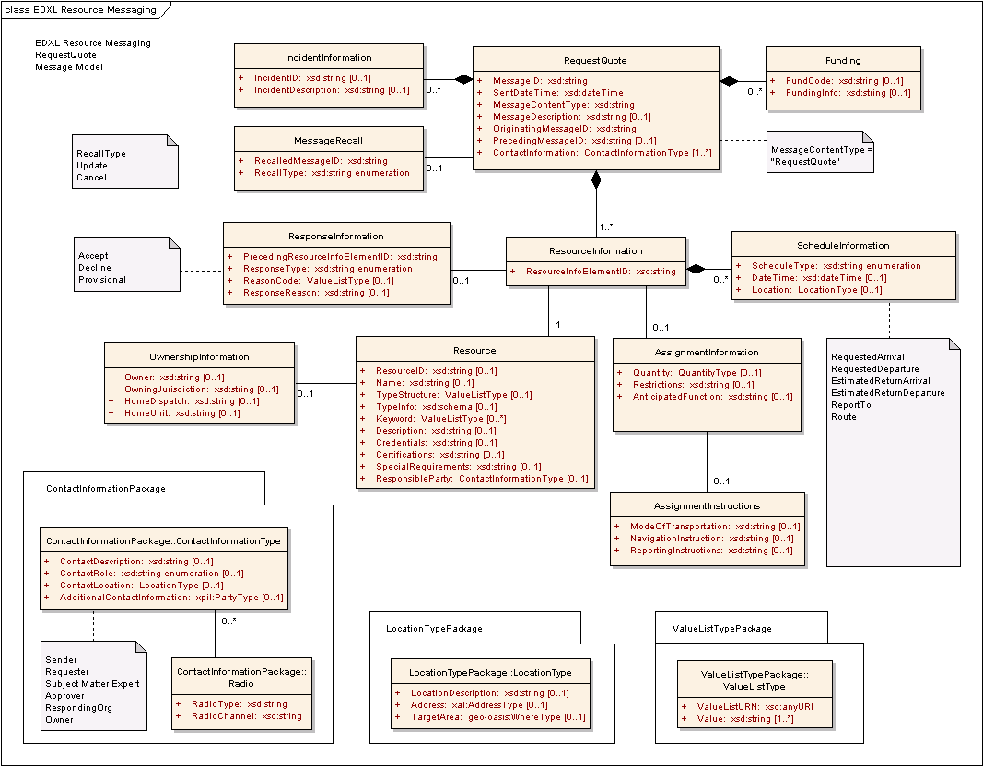
Figure 14: EDXL-RM ERM for RequestQuote Message

The following table outlines the element cardinalities for this message type.

Table 14: RequestQuote Message Elements
Parent Element | Sub-Elements
RequestQuote | MessageID, SentDateTime, MessageContentType^, MessageDescription, OriginatingMessageID, PrecedingMessageID, IncidentInformation*, MessageRecall, Funding*, ContactInformation*, ResourceInformation*
IncidentInformation | IncidentID, IncidentDescription
MessageRecall | RecalledMessageID, RecallType
Funding | FundCode, FundingInfo
ResourceInformation | ResourceInfoElementID, ResponseInformation, Resource, AssignmentInformation, ScheduleInformation*
ResponseInformation | PrecedingResourceInfoElementID, ResponseType, ReasonCode, ResponseReason
Resource | ResourceID, Name, TypeStructure, TypeInfo, Keyword*, Description, Credentials, Certifications, SpecialRequirements, ResponsibleParty, OwnershipInformation
OwnershipInformation | Owner, OwningJurisdiction, HomeDispatch, HomeUnit
AssignmentInformation | Quantity, Restrictions, AnticipatedFunction, AssignmentInstructions
AssignmentInstructions | ModeOfTransportation, NavigationInstructions, ReportingInstructions
ScheduleInformation | ScheduleType^, DateTime, Location

RequestQuote Message Rules
The following rules apply to the above elements:
- The RequestQuote:MessageID, RequestQuote:SentDateTime, RequestQuote:MessageContentType, RequestQuote:OriginatingMessageID, RequestQuote:ContactInformation, and RequestQuote:ResourceInformation elements MUST be present.
- The value of RequestQuote:MessageContentType MUST be “RequestQuote”.
- If a RequestQuote:IncidentInformation element is present, then at least one of IncidentInformation:IncidentID and/or IncidentInformation:IncidentDescription elements MUST be present.
- If the RequestQuote:MessageRecall element is present, then the MessageRecall:RecalledMessageID and MessageRecall:RecallType elements MUST be present.
- If a RequestQuote:Funding element is present, then at least one of Funding:FundCode and/or Funding:FundingInfo elements MUST be present.
- The ResourceInformation:ResourceInfoElementID and ResourceInformation:Resource elements MUST be present.
- If the ResourceInformation:ResponseInformation element is present, then the ResponseInformation:PrecedingResourceInfoElementID” and “ResponseInformation:ResponseType MUST be present.
- If ResponseInformation:ResponseType has a value of “Conditional”, then at least one of ResponseInformation:ReasonCode and/or ResponseInformation:ResponseReason elements MUST be present.
- At least one of Resource:ResourceID, Resource:Name, and/or Resource:TypeStructure elements MUST be present for each ResourceInformation:Resource element present.
- If a Resource:OwnershipInformation element is present, then at least one of OwnershipInformation:Owner and/or OwnershipInformation:OwningJurisdiction elements MUST be present.
- If the ResourceInformation:ScheduleInformation element is present, then the ScheduleInformation:ScheduleType element MUST be present and contain one of the following values:
- “RequestedArrival”, “RequestedDeparture”, “EstimatedReturnDeparture”, “EstimatedReturnArrival”, “ReportTo” or “Route”.

The schema for a RequestQuote message can be found in Appendix A.13.

Message Flow
The RequestQuote message is usually an initial message created and sent by the Resource Consumer to any number of Resource Suppliers.
The potential responses to this message include:
- ResponseToRequestQuote (See 3.15)
- This includes Accept, Decline, and Provisional responses.
The message may be canceled or updated through the RequestQuote:MessageRecall element.

Message Example
Below is an example RequestQuote message. This message requests quotes for a “Debris Management Team” (ResourceInfoElementID=001) and two “All Terrain Cranes” (ResourceInfoElementID=002).

[Note: The XML example shown in this section is informative only.]
<?xml version="1.0" encoding="UTF-8"?>
<RequestQuote xmlns:xsi="http://www.w3.org/2001/XMLSchema-instance"
xsi:schemaLocation="urn:oasis:names:tc:emergency:EDXL:RM:1.0:msg
EDXL-RMRequestQuote.xsd"
xmlns="urn:oasis:names:tc:emergency:EDXL:RM:1.0:msg"
xmlns:rm="urn:oasis:names:tc:emergency:EDXL:RM:1.0"
xmlns:xpil="urn:oasis:names:tc:ciq:xpil:3"
xmlns:xnl="urn:oasis:names:tc:ciq:xnl:3" xmlns:xal="urn:oasis:names:tc:ciq:xal:3"
xmlns:geo-oasis="urn:oasis:names:tc:emergency:EDXL:HAVE:1.0:geo-oasis">
<MessageID>urn:au-qld-eoc:77388</MessageID>
<SentDateTime>2006-03-30T10:45:00+10:00</SentDateTime>
<MessageContentType>RequestQuote</MessageContentType>
<OriginatingMessageID>urn:au-qld-eoc:77388</OriginatingMessageID>
<IncidentInformation>
<rm:IncidentDescription>Cyclone Larry</rm:IncidentDescription>
</IncidentInformation>
<ContactInformation>
<rm:ContactRole>Sender</rm:ContactRole>
<rm:AdditionalContactInformation>
<xpil:PartyName>
<xnl:PersonName>
<xnl:NameElement xnl:ElementType="FirstName">Alex</xnl:NameElement>
<xnl:NameElement xnl:ElementType="LastName">Jones</xnl:NameElement>
</xnl:PersonName>
<xnl:OrganisationName>
<xnl:NameElement>Dept of Emergency Services</xnl:NameElement>
</xnl:OrganisationName>
</xpil:PartyName>
<xpil:ContactNumbers>
<xpil:ContactNumber xpil:CommunicationMediaType="Telephone"
xpil:ContactHours="9:00AM - 5:00PM">
<xpil:ContactNumberElement
xpil:Type="CountryCode">61</xpil:ContactNumberElement>
<xpil:ContactNumberElement xpil:Type="AreaCode">7</xpil:ContactNumberElement>
<xpil:ContactNumberElement xpil:Type="LocalNumber">
3000
1234
</xpil:ContactNumberElement>
</xpil:ContactNumber>
</xpil:ContactNumbers>
<xpil:ElectronicAddressIdentifiers>
<xpil:ElectronicAddressIdentifier>alexj@emergencyservices.gov.au
</xpil:ElectronicAddressIdentifier>
</xpil:ElectronicAddressIdentifiers>
</rm:AdditionalContactInformation>
</ContactInformation>
<ResourceInformation>
<ResourceInfoElementID>001</ResourceInfoElementID>
<Resource>
<TypeStructure>
<rm:ValueListURN>urn:x-hazard:vocab:resourceTypes</rm:ValueListURN>
<rm:Value>Debris Management Team</rm:Value>
</TypeStructure>
<Description>
5 person team to clear roads of debris incl. fallen trees. </Description>
<SpecialRequirements>
Team to supply own equipment, such as trucks and chainsaws
</SpecialRequirements>
</Resource>
<AssignmentInformation>
<Quantity>
<rm:MeasuredQuantity>
<rm:Amount>1</rm:Amount>
</rm:MeasuredQuantity>
</Quantity>
<AssignmentInstructions>
<rm:ModeOfTransportation>Team's own trucks</rm:ModeOfTransportation>
</AssignmentInstructions>
</AssignmentInformation>
<ScheduleInformation>
<ScheduleType>ReportTo</ScheduleType>
<DateTime>2006-04-01T09:00:00+10:00</DateTime>
<Location>
<rm:LocationDescription>Johnstone Shire Council</rm:LocationDescription>
<rm:Address>
<xal:Country>
<xal:NameElement>Australia</xal:NameElement>
</xal:Country>
<xal:AdministrativeArea>
<xal:NameElement>QLD</xal:NameElement>
</xal:AdministrativeArea>
<xal:Locality>
<xal:NameElement>Innisfail</xal:NameElement>
</xal:Locality>
<xal:Thoroughfare>
<xal:NameElement>Rankin St</xal:NameElement>
<xal:Number>70</xal:Number>
</xal:Thoroughfare>
</rm:Address>
</Location>
</ScheduleInformation>
<ScheduleInformation>
<ScheduleType>EstimatedReturnDeparture</ScheduleType>
<DateTime>2006-04-21T09:00:00+10:00</DateTime>
</ScheduleInformation>
</ResourceInformation>
<ResourceInformation>
<ResourceInfoElementID>002</ResourceInfoElementID>
<Resource>
<TypeStructure>
<rm:ValueListURN>urn:x-hazard:vocab:resourceTypes</rm:ValueListURN>
<rm:Value>All Terrain Crane</rm:Value>
</TypeStructure>
<Description> Crane with minimum boom reach of 150 feet. </Description>
</Resource>
<AssignmentInformation>
<Quantity>
<rm:MeasuredQuantity>
<rm:Amount>2</rm:Amount>
</rm:MeasuredQuantity>
</Quantity>
</AssignmentInformation>
<ScheduleInformation>
<ScheduleType>ReportTo</ScheduleType>
<DateTime>2006-04-01T09:00:00+10:00</DateTime>
<Location>
<rm:LocationDescription>Johnstone Shire Council</rm:LocationDescription>
<rm:Address>
<xal:Country>
<xal:NameElement>Australia</xal:NameElement>
</xal:Country>
<xal:AdministrativeArea>
<xal:NameElement>QLD</xal:NameElement>
</xal:AdministrativeArea>
<xal:Locality>
<xal:NameElement>Innisfail</xal:NameElement>
</xal:Locality>
<xal:Thoroughfare>
<xal:NameElement>Rankin St</xal:NameElement>
<xal:Number>70</xal:Number>
</xal:Thoroughfare>
</rm:Address>
</Location>
</ScheduleInformation>
<ScheduleInformation>
<ScheduleType>EstimatedReturnDeparture</ScheduleType>
<DateTime>2006-04-21T09:00:00+10:00</DateTime>
</ScheduleInformation>
</ResourceInformation>
</RequestQuote>

ResponseToRequestQuote Message

Overview
The “ResponseToRequestQuote” message is used by the Resource Supplier to respond to a RequestQuote Message. The supplier may respond with pricing or decline to respond with pricing (i.e. a response that says that the Resource Supplier is unable to supply a requested quote). The Resource Supplier may provide quotes for several alternative resources that match a single resource request.

Element Reference Model
Figure 15 below shows the EDXL–RM Element Reference Model (ERM) tailored for the ResponseToRequestQuote Message. The ERM shows the element-level details for the main entities in the RM.
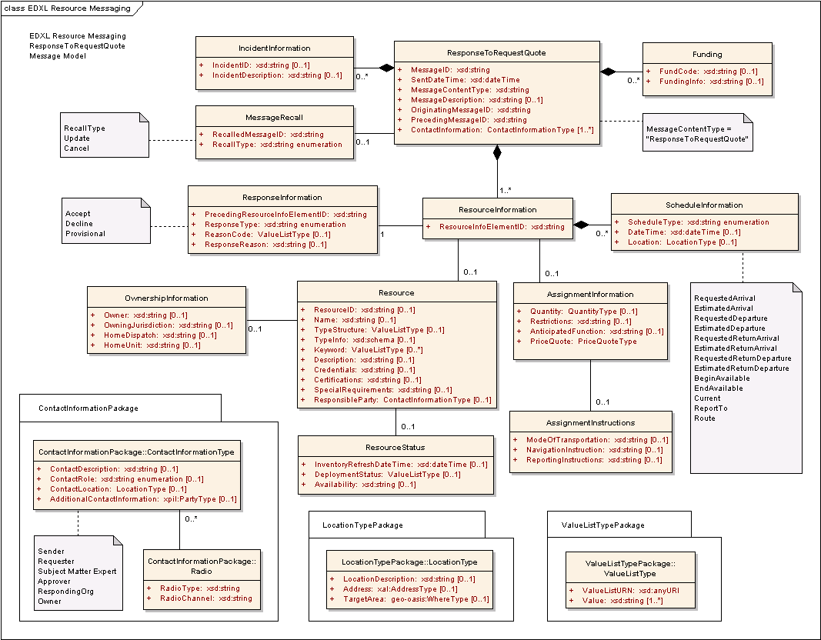
Figure 15: EDXL-RM ERM for ResponseToRequestQuote Message

The following table outlines the element cardinalities for this message type.

Table 15: ResponseToRequestQuote Message Elements
Parent Element | Sub-Elements
ResponseToRequestQuote | MessageID, SentDateTime, MessageContentType^, MessageDescription, OriginatingMessageID, PrecedingMessageID, IncidentInformation*, MessageRecall, Funding*, ContactInformation*, ResourceInformation*
IncidentInformation | IncidentID, IncidentDescription
MessageRecall | RecalledMessageID, RecallType
Funding | FundCode, FundingInfo
ResourceInformation | ResourceInfoElementID, ResponseInformation, Resource, AssignmentInformation, ScheduleInformation*
ResponseInformation | PrecedingResourceInfoElementID, ResponseType, ReasonCode, ResponseReason
Resource | ResourceID, Name, TypeStructure, TypeInfo, Keyword*, Description, Credentials, Certifications, SpecialRequirements, ResponsibleParty, OwnershipInformation, ResourceStatus
OwnershipInformation | Owner, OwningJurisdiction, HomeDispatch, HomeUnit
ResourceStatus | InventoryRefreshDateTime, DeploymentStatus, Availability
AssignmentInformation | Quantity, Restrictions, AnticipatedFunction, PriceQuote, AssignmentInstructions
AssignmentInstructions | ModeOfTransportation, NavigationInstructions, ReportingInstructions
ScheduleInformation | ScheduleType^, DateTime, Location

ResponseToRequestQuote Message Rules
The following rules apply to the above elements:
- The ResponseToRequestQuote:MessageID, ResponseToRequestQuote:SentDateTime, ResponseToRequestQuote:MessageContentType, ResponseToRequestQuote:OriginatingMessageID, ResponseToRequestQuote:PrecedingMessageID, ResponseToRequestQuote:ContactInformation, and ResponseToRequestQuote:ResourceInformation elements MUST be present.
- The value of ResponseToRequestQuote:MessageContentType MUST be “ResponseToRequest Quote”.
- If a ResponseToRequestQuote:IncidentInformation element is present, then at least one of IncidentInformation:IncidentID and/or IncidentInformation:IncidentDescription elements MUST be present.
- If the ResponseToRequestQuote:MessageRecall element is present, then the MessageRecall:RecalledMessageID and MessageRecall:RecallType elements MUST be present.
- If a ResponseToRequestQuote:Funding element is present, then at least one of Funding:FundCode and/or Funding:FundingInfo elements MUST be present.
- The ResourceInformation:ResourceInfoElementID and ResourceInformation:ResponseInformation elements MUST be present.
- If the ResponseInformation:ResponseType element has a value of “Accept” or “Provisional”, then the ResourceInformation:Resource element MUST be present.
- The ResponseInformation:PrecedingResourceInfoElementID and ResponseInformation:ResponseType elements MUST be present.
- If ResponseInformation:ResponseType has a value of “Provisional”, at least one of ResponseInformation:ReasonCode and/or ResponseInformation:ResponseReason elements MUST be present.
- At least one of Resource:ResourceID, Resource:Name, and/or Resource:TypeStructure elements MUST be present for each ResourceInformation:Resource element present.
- If a Resource:OwnershipInformation element is present, then at least one of OwnershipInformation:Owner and/or OwnershipInformation:OwningJurisdiction element MUST be present.
- If a ResourceInformation:AssignmentInformation element is present, then the AssignmentInformation:PriceQuote element MUST be present.
- If the ResourceInformation:ScheduleInformation element is present, then the ScheduleInformation:ScheduleType element MUST be present and contain one of the following values:
- “EstimatedArrival”, “RequestedArrival”, “RequestedDeparture”, “EstimatedDeparture”, “RequestedReturnDeparture”, “EstimatedReturnDeparture”, “RequestedReturnArrival”, “EstimatedReturnArrival”, “BeginAvailable”, EndAvailable”, “Current”, “ReportTo” or “Route”.

The schema for a ResponseToRequestQuote message can be found in Appendix A.14.

Message Flow
The ResponseToRequestQuote message is sent by the Resource Supplier to the Resource Consumer in response to a RequestQuote message.
The potential responses to this message include:
- Request Information (See Section 3.8)
- RequisitionResource (See Section 3.6).
The message may be canceled or updated through the ResponseToRequestQuote:MessageRecall element.

Message Example
Below is an example ResponseToRequestQuote message. The message is a possible response to the RequestQuote message shown in Section 3.14.5. The first quote request (“Debris Management Team”, ResourceInfoElementID=001) is accepted, while the second (“All Terrain Crane”, ResourceInfoElementID=002) is declined.

[Note: The XML example shown in this section is informative only.]
<?xml version="1.0" encoding="UTF-8"?>
<ResponseToRequestQuote xmlns:xsi="http://www.w3.org/2001/XMLSchema-instance"
xsi:schemaLocation="urn:oasis:names:tc:emergency:EDXL:RM:1.0:msg
EDXL-RMResponseToRequestQuote.xsd"
xmlns="urn:oasis:names:tc:emergency:EDXL:RM:1.0:msg"
xmlns:rm="urn:oasis:names:tc:emergency:EDXL:RM:1.0"
xmlns:xpil="urn:oasis:names:tc:ciq:xpil:3"
xmlns:xnl="urn:oasis:names:tc:ciq:xnl:3" xmlns:xal="urn:oasis:names:tc:ciq:xal:3"
xmlns:geo-oasis="urn:oasis:names:tc:emergency:EDXL:HAVE:1.0:geo-oasis">
<MessageID>urn:au-qld-eoc:77396</MessageID>
<SentDateTime>2006-03-28T14:48:00+10:00</SentDateTime>
<MessageContentType>ResponseToRequestQuote</MessageContentType>
<MessageDescription>
This message provides a quote for the services of a debris management team
for the requested period of 3 weeks. We do not have any all-terrain cranes, and
therefore unable to quote on this element of the request.
</MessageDescription>
<OriginatingMessageID>urn:au-qld-eoc:77388</OriginatingMessageID>
<PrecedingMessageID>urn:au-qld-eoc:77388</PrecedingMessageID>
<IncidentInformation>
<rm:IncidentDescription>Cyclone Larry</rm:IncidentDescription>
</IncidentInformation>
<ContactInformation>
<rm:ContactRole>Sender</rm:ContactRole>
<rm:AdditionalContactInformation>
<xpil:PartyName>
<xnl:PersonName>
<xnl:NameElement xnl:ElementType="FirstName">Alison</xnl:NameElement>
<xnl:NameElement xnl:ElementType="LastName">Smith</xnl:NameElement>
</xnl:PersonName>
<xnl:OrganisationName>
<xnl:NameElement>QBuild</xnl:NameElement>
</xnl:OrganisationName>
</xpil:PartyName>
</rm:AdditionalContactInformation>
</ContactInformation>
<ContactInformation>
<rm:ContactRole>Requester</rm:ContactRole>
<rm:AdditionalContactInformation>
<xpil:PartyName>
<xnl:PersonName>
<xnl:NameElement xnl:ElementType="FirstName">Alex</xnl:NameElement>
<xnl:NameElement xnl:ElementType="LastName">Jones</xnl:NameElement>
</xnl:PersonName>
<xnl:OrganisationName>
<xnl:NameElement>Dept of Emergency Services</xnl:NameElement>
</xnl:OrganisationName>
</xpil:PartyName>
</rm:AdditionalContactInformation>
</ContactInformation>
<ResourceInformation>
<ResourceInfoElementID>001</ResourceInfoElementID>
<ResponseInformation>
<rm:PrecedingResourceInfoElementID>001</rm:PrecedingResourceInfoElementID>
<rm:ResponseType>Accept</rm:ResponseType>
</ResponseInformation>
<Resource>
<TypeStructure>
<rm:ValueListURN>urn:x-hazard:vocab:resourceTypes</rm:ValueListURN>
<rm:Value>Debris Management Team</rm:Value>
</TypeStructure>
<Description>
5 person team to clear roads of debris incl. fallen trees. </Description>
<SpecialRequirements>
Team to supply own equipment, such as trucks and chainsaws
</SpecialRequirements>
</Resource>
<AssignmentInformation>
<Quantity>
<rm:MeasuredQuantity>
<rm:Amount>1</rm:Amount>
</rm:MeasuredQuantity>
</Quantity>
<PriceQuote>
<rm:QuantityText>Daily rate: $2100</rm:QuantityText>
<rm:QuantityText>Total before tax: $31500</rm:QuantityText>
<rm:QuantityText>Tax: $3150</rm:QuantityText>
<rm:QuantityText>Total including tax: $34650</rm:QuantityText>
<rm:QuantityText>
NOTES: Accommodation for the team will be organised and paid by us. Team will
work Mon-Fri for 3 weeks.Total including tax: $34650</rm:QuantityText>
</PriceQuote>
</AssignmentInformation>
<ScheduleInformation>
<ScheduleType>BeginAvailable</ScheduleType>
<DateTime>2006-03-31T15:00:00+10:00</DateTime>
</ScheduleInformation>
<ScheduleInformation>
<ScheduleType>ReportTo</ScheduleType>
<DateTime>2006-04-01T09:00:00+10:00</DateTime>
<Location>
<rm:LocationDescription>Johnstone Shire Council</rm:LocationDescription>
<rm:Address>
<xal:Country>
<xal:NameElement>Australia</xal:NameElement>
</xal:Country>
<xal:AdministrativeArea>
<xal:NameElement>QLD</xal:NameElement>
</xal:AdministrativeArea>
<xal:Locality>
<xal:NameElement>Innisfail</xal:NameElement>
</xal:Locality>
<xal:Thoroughfare>
<xal:NameElement>Rankin St</xal:NameElement>
<xal:Number>70</xal:Number>
</xal:Thoroughfare>
</rm:Address>
</Location>
</ScheduleInformation>
<ScheduleInformation>
<ScheduleType>EstimatedReturnDeparture</ScheduleType>
<DateTime>2006-04-21T09:00:00+10:00</DateTime>
</ScheduleInformation>
</ResourceInformation>
<ResourceInformation>
<ResourceInfoElementID>002</ResourceInfoElementID>
<ResponseInformation>
<rm:PrecedingResourceInfoElementID>002</rm:PrecedingResourceInfoElementID>
<rm:ResponseType>Decline</rm:ResponseType>
</ResponseInformation>
</ResourceInformation>
</ResponseToRequestQuote>

RequestResourceDeploymentStatus Message

Overview
The “RequestResourceDeploymentStatus” message is used to request the current status of one or more deployed resources. It can be sent by the Resource Supplier to the Resource Consumer (e.g., to check the status of the resource after a “ReleaseResource” message) or by the Resource Consumer to the Resource Supplier (e.g., to track the progress of a resource after a “RequisitionResource” message).

Element Reference Model
Figure 16 below shows the EDXL–RM Element Reference Model (ERM) tailored for the RequestResourceDeploymentStatus Message. The ERM shows the element-level details for the main entities in the RM.
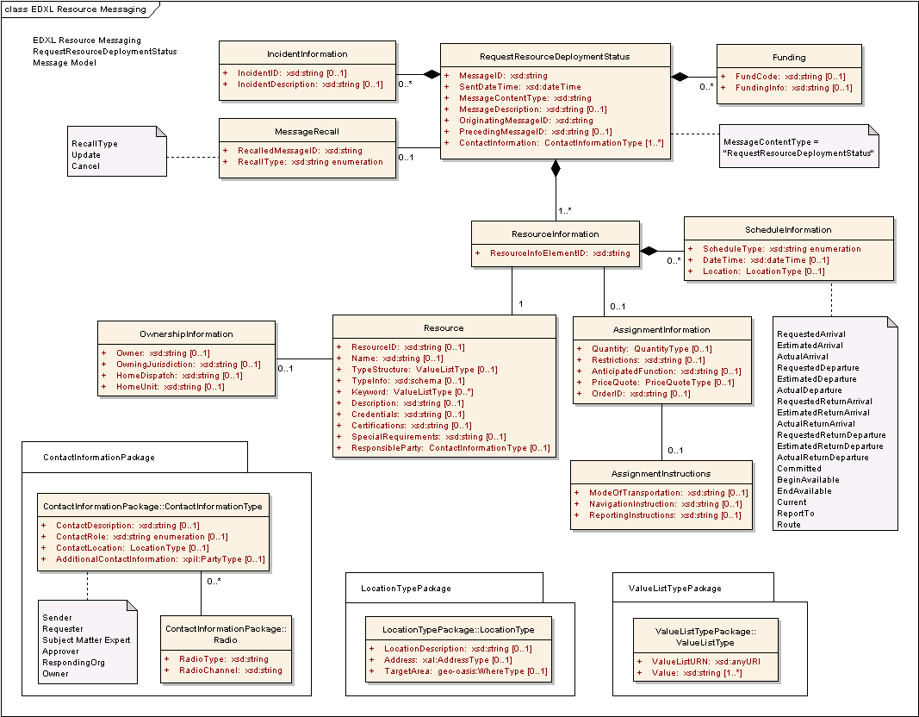
Figure 16: EDXL-RM ERM for RequestResourceDeploymentStatus Message

The following table outlines the element cardinalities for this message type.

Table 16: RequestResourceDeploymentStatus Message Elements
Parent Element | Sub-Elements
RequestResourceDeploymentStatus | MessageID, SentDateTime, MessageContentType^, MessageDescription, OriginatingMessageID, PrecedingMessageID, IncidentInformation*, MessageRecall, Funding*, ContactInformation*, ResourceInformation*
IncidentInformation | IncidentID, IncidentDescription
MessageRecall | RecalledMessageID, RecallType
Funding | FundCode, FundingInfo
ResourceInformation | ResourceInfoElementID, Resource, AssignmentInformation, ScheduleInformation*
Resource | ResourceID, Name, TypeStructure, TypeInfo, Keyword*, Description, Credentials, Certifications, SpecialRequirements, ResponsibleParty, OwnershipInformation
OwnershipInformation | Owner, OwningJurisdiction, HomeDispatch, HomeUnit
AssignmentInformation | Quantity, Restrictions, AnticipatedFunction, PriceQuote, OrderID, AssignmentInstructions
AssignmentInstructions | ModeOfTransportation, NavigationInstructions, ReportingInstructions
ScheduleInformation | ScheduleType^, DateTime, Location

RequestResourceDeploymentStatus Message Rules
The following rules apply to the above elements:
- The RequestResourceDeploymentStatus:MessageID, RequestResourceDeploymentStatus:SentDateTime, RequestResourceDeploymentStatus:MessageContentType, RequestResourceDeploymentStatus:OriginatingMessageID, RequestResourceDeploymentStatus:ContactInformation, and RequestResourceDeploymentStatus:ResourceInformation elements MUST be present.
- The value of RequestResourceDeploymentStatus:MessageContentType MUST be “RequestResourceDeploymentStatus”.
- If a RequestResourceDeploymentStatus:IncidentInformation element is present, then at least one of IncidentInformation:IncidentID and/or IncidentInformation:IncidentDescription elements MUST be present.
- If the RequestResourceDeploymentStatus:MessageRecall element is present, then the MessageRecall:RecalledMessageID and MessageRecall:RecallType elements MUST be present.
- If a RequestResourceDeploymentStatus:Funding element is present, then at least one of Funding:FundCode and/or Funding:FundingInfo elements MUST be present.
- The ResourceInformation:ResourceInfoElementID and ResourceInformation:Resource elements MUST be present.
- At least one of Resource:ResourceID, Resource:Name, and/or Resource:TypeStructure element MUST be present for each ResourceInformation:Resource element present.
- If a Resource:OwnershipInformation element is present, then at least one of OwnershipInformation:Owner and/or OwnershipInformation:OwningJurisdiction elements MUST be present.
- If the ResourceInformation:ScheduleInformation element is present, then the ScheduleInformation:ScheduleType element MUST be present and contain one of the following values:
- “RequestedArrival”, “EstimatedArrival”, “ActualArrival”, “RequestedDeparture”, “EstimatedDeparture”, “ActualDeparture”, “RequestedReturnDeparture”, “EstimatedReturnDeparture”, “ActualReturnDeparture”, “RequestedReturnArrival”, “EstimatedReturnArrival”, “ActualReturnArrival”, “BeginAvailable”, “EndAvailable”, “Committed”, “Current”, “ReportTo” or “Route”.

The schema for a RequestResourceDeploymentStatus message can be found in Appendix A.15.

Message Flow
The RequestResourceDeploymentStatus message can be sent from the Resource Supplier to the Resource Consumer, or from the Resource Consumer to the Resource Supplier, any time after a resource is requisitioned or committed.
The potential responses to this message include:
- ReportResourceDeploymentStatus (See Section 3.17)
- This may include Accept, Decline, and Provisional responses.
The message may be canceled or updated through the RequestResourceDeploymentStatus:MessageRecall element.

Message Example
Below is an example RequestResourceDeploymentStatus message. This message requests the deployment status of the “Small Animal Sheltering Team”; it follows on from the example CommitResource message in Section 3.7.5, and precedes the ReleaseResource message in Section 3.11.5 .

[Note: The XML example shown in this section is informative only.]
<?xml version="1.0" encoding="UTF-8"?>
<RequestResourceDeploymentStatus xmlns:xsi="http://www.w3.org/2001/XMLSchema-instance"
xsi:schemaLocation="urn:oasis:names:tc:emergency:EDXL:RM:1.0:msg
EDXL-RMRequestResourceDeploymentStatus.xsd"
xmlns="urn:oasis:names:tc:emergency:EDXL:RM:1.0:msg"
xmlns:rm="urn:oasis:names:tc:emergency:EDXL:RM:1.0"
xmlns:xpil="urn:oasis:names:tc:ciq:xpil:3"
xmlns:xnl="urn:oasis:names:tc:ciq:xnl:3" xmlns:xal="urn:oasis:names:tc:ciq:xal:3"
xmlns:geo-oasis="urn:oasis:names:tc:emergency:EDXL:HAVE:1.0:geo-oasis">
<MessageID>urn:au-qld-eoc:997958</MessageID>
<SentDateTime>2006-03-25T09:05:00+10:00</SentDateTime>
<MessageContentType>RequestResourceDeploymentStatus</MessageContentType>
<OriginatingMessageID>urn:au-qld-eoc:12332</OriginatingMessageID>
<IncidentInformation>
<rm:IncidentDescription>Cyclone Larry</rm:IncidentDescription>
</IncidentInformation>
<ContactInformation>
<rm:ContactRole>Sender</rm:ContactRole>
<rm:AdditionalContactInformation>
<xpil:PartyName>
<xnl:PersonName>
<xnl:NameElement xnl:ElementType="FirstName">Alex</xnl:NameElement>
<xnl:NameElement xnl:ElementType="LastName">Jones</xnl:NameElement>
</xnl:PersonName>
<xnl:OrganisationName>
<xnl:NameElement>Dept of Emergency Services</xnl:NameElement>
</xnl:OrganisationName>
</xpil:PartyName>
</rm:AdditionalContactInformation>
</ContactInformation>
<ResourceInformation>
<ResourceInfoElementID>001</ResourceInfoElementID>
<Resource>
<TypeStructure>
<rm:ValueListURN>urn:x-hazard:vocab:resourceTypes</rm:ValueListURN>
<rm:Value>Small Animal Sheltering Team</rm:Value>
</TypeStructure>
</Resource>
<AssignmentInformation>
<Quantity>
<rm:MeasuredQuantity>
<rm:Amount>1</rm:Amount>
</rm:MeasuredQuantity>
</Quantity>
</AssignmentInformation>
<ScheduleInformation>
<ScheduleType>EstimatedArrival</ScheduleType>
<DateTime>2006-03-25T09:30:00+10:00</DateTime>
<Location>
<rm:LocationDescription>Innisfail Animal Refuge</rm:LocationDescription>
</Location>
</ScheduleInformation>
<ScheduleInformation>
<ScheduleType>EstimatedReturnDeparture</ScheduleType>
<DateTime>2006-03-30T17:00:00+10:00</DateTime>
</ScheduleInformation>
<ScheduleInformation>
<ScheduleType>Committed</ScheduleType>
<DateTime>2006-03-21T12:46:00+10:00</DateTime>
</ScheduleInformation>
</ResourceInformation>
</RequestResourceDeploymentStatus>

ReportResourceDeploymentStatus Message

Overview
The “ReportResourceDeploymentStatus” message is used to report on the current status of any deployed resource. The message can be sent from the Resource Supplier to the Resource Consumer, or from the Resource Consumer to the Resource Supplier.

Element Reference Model
Figure 17 below shows the EDXL–RM Element Reference Model (ERM) tailored for the ReportResourceDeploymentStatus Message. The ERM shows the element-level details for the main entities in the RM.
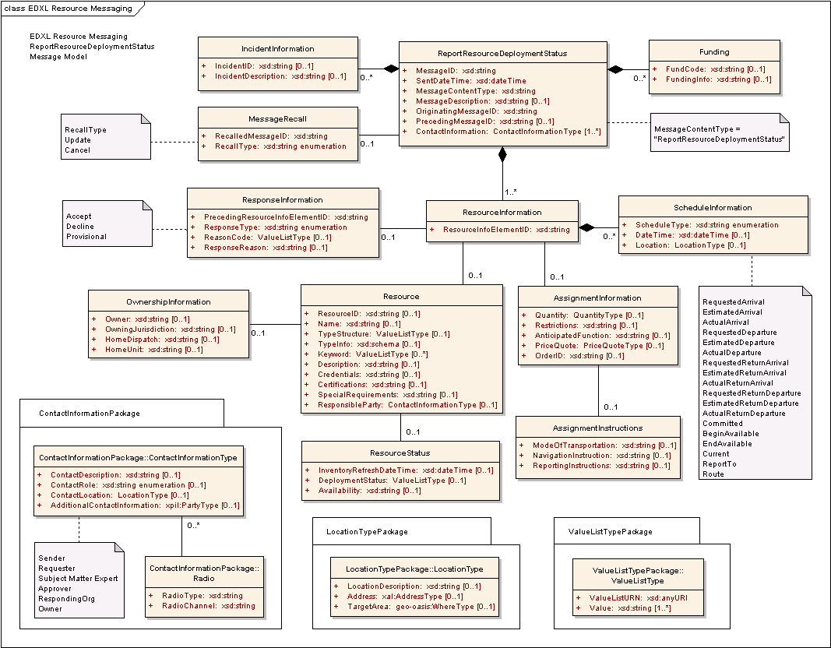
Figure 17: EDXL-RM ERM for ReportResourceDeploymentStatus Message

The following table outlines the element cardinalities for this message type.

Table 17: ReportResourceDeploymentStatus Message Elements
Parent Element | Sub-Elements
ReportResourceDeploymentStatus | MessageID, SentDateTime, MessageContentType^, MessageDescription, OriginatingMessageID, PrecedingMessageID, IncidentInformation*, MessageRecall, Funding*, ContactInformation*, ResourceInformation*
IncidentInformation | IncidentID, IncidentDescription
MessageRecall | RecalledMessageID, RecallType
Funding | FundCode, FundingInfo
ResourceInformation | ResourceInfoElementID, ResponseInformation, Resource, AssignmentInformation, ScheduleInformation*
ResponseInformation | PrecedingResourceInfoElementID, ResponseType, ReasonCode, ResponseReason
Resource | ResourceID, Name, TypeStructure, TypeInfo, Keyword*, Description, Credentials, Certifications, SpecialRequirements, ResponsibleParty, OwnershipInformation, ResourceStatus
OwnershipInformation | Owner, OwningJurisdiction, HomeDispatch, HomeUnit
ResourceStatus | InventoryRefreshDateTime, DeploymentStatus, Availability
AssignmentInformation | Quantity, Restrictions, AnticipatedFunction, PriceQuote, OrderID, AssignmentInstructions
AssignmentInstructions | ModeOfTransportation, NavigationInstructions, ReportingInstructions
ScheduleInformation | ScheduleType^, DateTime, Location

ReportResourceDeploymentStatus Message Rules
The following rules apply to the above elements:
- The ReportResourceDeploymentStatus:MessageID, ReportResourceDeploymentStatus:SentDateTime, ReportResourceDeploymentStatus:MessageContentType, ReportResourceDeploymentStatus:OriginatingMessageID, ReportResourceDeploymentStatus:ContactInformation, and ReportResourceDeploymentStatus:ResourceInformation elements MUST be present.
- The value of ReportResourceDeploymentStatus:MessageContentType MUST be “ReportResourceDeploymentStatus”.
- If a ReportResourceDeploymentStatus:IncidentInformation element is present, then at least one of IncidentInformation:IncidentID and/or IncidentInformation:IncidentDescription elements MUST be present.
- If the ReportResourceDeploymentStatus:MessageRecall element is present, then the MessageRecall:RecalledMessageID and MessageRecall:RecallType elements MUST be present.
- If a ReportResourceDeploymentStatus:Funding element is present, then at least one of Funding:FundCode and/or Funding:FundingInfo elements MUST be present.
- The ResourceInformation:ResourceInfoElementID and ResourceInformation:Resource elements MUST be present.
- If the ResourceInformation:ResponseInformation element is present, then the ResponseInformation:PrecedingResourceInfoElementID and ResponseInformation:ResponseType elements MUST be present.
- If the ResponseInformation:ResponseType element has a value of “Provisional”, at least one of ResponseInformation:ReasonCode and/or ResponseInformation:ResponseReason elements MUST be present.
- At least one of Resource:ResourceID, Resource:Name, and/or Resource:TypeStructure element MUST be present for each ResourceInformation:Resource element present.
- If a Resource:OwnershipInformation element is present, then at least one of OwnershipInformation:Owner and/or OwnershipInformation:OwningJurisdiction elements MUST be present.
- If the ResourceInformation:ScheduleInformation element is present, then the ScheduleInformation:ScheduleType element MUST be present and contain one of the following values:
- “RequestedArrival”, “EstimatedArrival”, “ActualArrival”, “RequestedDeparture”, “EstimatedDeparture”, “ActualDeparture”, “RequestedReturnDeparture”, “EstimatedReturnDeparture”, “ActualReturnDeparture”, “RequestedReturnArrival”, “EstimatedReturnArrival”, “ActualReturnArrival”, “BeginAvailable”, “EndAvailable”, “Committed”, “Current”, “ReportTo” or “Route”.

The schema for a ReportResourceDeploymentStatus message can be found in Appendix A.16.

Message Flow
The ReportResourceDeploymentStatus message can be sent from the Resource Supplier to the Resource Consumer, or from the Resource Consumer to the Resource Supplier, any time after a resource is requisitioned or committed. The message MAY be sent in response to an earlier RequestResourceDeploymentStatus message. (See Section 3.16)
The message may be canceled or updated through the EDXLResourceMessage:MessageRecall element.

Message Example
Below is an example ReportResourceDeploymentStatus message. This message shows a possible response to the RequestResourceDeploymentStatus message in Section 3.16.
[Note: The XML example shown in this section is informative only.]
<?xml version="1.0" encoding="UTF-8"?>
<ReportResourceDeploymentStatus xmlns:xsi="http://www.w3.org/2001/XMLSchema-instance"
xsi:schemaLocation="urn:oasis:names:tc:emergency:EDXL:RM:1.0:msg
EDXL-RMReportResourceDeploymentStatus.xsd"
xmlns="urn:oasis:names:tc:emergency:EDXL:RM:1.0:msg"
xmlns:rm="urn:oasis:names:tc:emergency:EDXL:RM:1.0"
xmlns:xpil="urn:oasis:names:tc:ciq:xpil:3"
xmlns:xnl="urn:oasis:names:tc:ciq:xnl:3" xmlns:xal="urn:oasis:names:tc:ciq:xal:3"
xmlns:geo-oasis="urn:oasis:names:tc:emergency:EDXL:HAVE:1.0:geo-oasis">
<MessageID>urn:au-qld-eoc:997967</MessageID>
<SentDateTime>2006-03-25T09:16:00+10:00</SentDateTime>
<MessageContentType>ReportResourceDeploymentStatus</MessageContentType>
<OriginatingMessageID>urn:au-qld-eoc:12332</OriginatingMessageID>
<PrecedingMessageID>urn:au-qld-eoc:997958</PrecedingMessageID>
<IncidentInformation>
<rm:IncidentDescription>Cyclone Larry</rm:IncidentDescription>
</IncidentInformation>
<ContactInformation>
<rm:ContactRole>Sender</rm:ContactRole>
<rm:AdditionalContactInformation>
<xpil:PartyName>
<xnl:PersonName>
<xnl:NameElement xnl:ElementType="FirstName">Charlotte</xnl:NameElement>
<xnl:NameElement xnl:ElementType="LastName">Ryan</xnl:NameElement>
</xnl:PersonName>
<xnl:OrganisationName>
<xnl:NameElement>EMA</xnl:NameElement>
</xnl:OrganisationName>
</xpil:PartyName>
</rm:AdditionalContactInformation>
</ContactInformation>
<ContactInformation>
<rm:ContactRole>Requester</rm:ContactRole>
<rm:AdditionalContactInformation>
<xpil:PartyName>
<xnl:PersonName>
<xnl:NameElement xnl:ElementType="FirstName">Alex</xnl:NameElement>
<xnl:NameElement xnl:ElementType="LastName">Jones</xnl:NameElement>
</xnl:PersonName>
<xnl:OrganisationName>
<xnl:NameElement>Dept of Emergency Services</xnl:NameElement>
</xnl:OrganisationName>
</xpil:PartyName>
</rm:AdditionalContactInformation>
</ContactInformation>
<ResourceInformation>
<ResourceInfoElementID>001</ResourceInfoElementID>
<ResponseInformation>
<rm:PrecedingResourceInfoElementID>001</rm:PrecedingResourceInfoElementID>
<rm:ResponseType>Accept</rm:ResponseType>
</ResponseInformation>
<Resource>
<TypeStructure>
<rm:ValueListURN>urn:x-hazard:vocab:resourceTypes</rm:ValueListURN>
<rm:Value>Small Animal Sheltering Team</rm:Value>
</TypeStructure>
<ResourceStatus>
<DeploymentStatus>
<rm:ValueListURN>urn:x-hazard:vocab:deploymentStatusTypes</rm:ValueListURN>
<rm:Value>In Transit</rm:Value>
</DeploymentStatus>
</ResourceStatus>
</Resource>
<AssignmentInformation>
<Quantity>
<rm:MeasuredQuantity>
<rm:Amount>1</rm:Amount>
</rm:MeasuredQuantity>
</Quantity>
</AssignmentInformation>
<ScheduleInformation>
<ScheduleType>ActualDeparture</ScheduleType>
<DateTime>2006-03-25T08:20:00+10:00</DateTime>
<Location>
<rm:LocationDescription>Cairns Airport</rm:LocationDescription>
</Location>
</ScheduleInformation>
<ScheduleInformation>
<ScheduleType>ActualArrival</ScheduleType>
<DateTime>2006-03-25T09:00:00+10:00</DateTime>
<Location>
<rm:LocationDescription>Innisfail Airport</rm:LocationDescription>
</Location>
</ScheduleInformation>
<ScheduleInformation>
<ScheduleType>EstimatedArrival</ScheduleType>
<DateTime>2006-03-25T09:40:00+10:00</DateTime>
<Location>
<rm:LocationDescription>Innisfail Animal Refuge</rm:LocationDescription>
</Location>
</ScheduleInformation>
</ResourceInformation>
</ReportResourceDeploymentStatus>

RequestExtendedDeploymentDuration

Overview
The “RequestExtendedDeploymentDuration” message is sent by the Resource Consumer to the Resource Supplier when the Consumer wishes to retain one or more resources longer than previously agreed (e.g., in the original RequisitionResource and CommitResource messages).

Element Reference Model
Figure 18 below shows the EDXL–RM Element Reference Model (ERM) tailored for the RequestExtendedDeploymentDuration Message. The ERM shows the element-level details for the main entities in the RM.
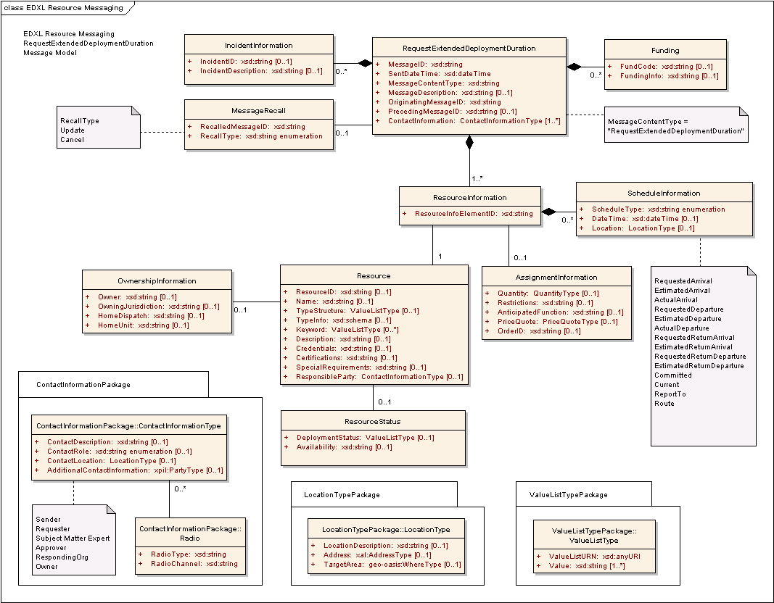
Figure 18: EDXL-RM ERM for RequestExtendedDeploymentDuration Message

The following table outlines the element cardinalities for this message type.

Table 18: RequestExtendedDeploymentDuration Message Elements
Parent Element | Sub-Elements
RequestExtendedDeploymentDuration | MessageID, SentDateTime, MessageContentType^, MessageDescription, OriginatingMessageID, PrecedingMessageID, IncidentInformation*, MessageRecall, Funding*, ContactInformation*, ResourceInformation*
IncidentInformation | IncidentID, IncidentDescription
MessageRecall | RecalledMessageID, RecallType
Funding | FundCode, FundingInfo
ResourceInformation | ResourceInfoElementID, Resource, AssignmentInformation, ScheduleInformation*
Resource | ResourceID, Name, TypeStructure, TypeInfo, Keyword*, Description, Credentials, Certifications, SpecialRequirements, ResponsibleParty, OwnershipInformation, ResourceStatus
OwnershipInformation | Owner, OwningJurisdiction, HomeDispatch, HomeUnit
ResourceStatus | DeploymentStatus, Availability
AssignmentInformation | Quantity, Restriction, AnticipatedFunction, PriceQuote, OrderID
ScheduleInformation | ScheduleType^, DateTime, Location

RequestExtendedDeploymentDuration Message Rules
The following rules apply to the above elements:
- The RequestExtendedDeploymentDuration:MessageID, RequestExtendedDeploymentDuration:SentDateTime, RequestExtendedDeploymentDuration:MessageContentType, RequestExtendedDeploymentDuration:OriginatingMessageID, RequestExtendedDeploymentDuration:ContactInformation, and RequestExtendedDeploymentDuration:ResourceInformation elements MUST be present.
- The value of RequestExtendedDeploymentDuration:MessageContentType MUST be “RequestExtendedDeploymentDuration”.
- If a RequestExtendedDeploymentDuration:IncidentInformation element is present, then at least one of IncidentInformation:IncidentID and/or IncidentInformation:IncidentDescription elements MUST be present.
- If the RequestExtendedDeploymentDuration:MessageRecall element is present, then the MessageRecall:RecalledMessageID and MessageRecall:RecallType elements MUST be present.
- If a RequestExtendedDeploymentDuration:Funding element is present, then at least one of Funding:FundCode and/or Funding:FundingInfo elements MUST be present.
- The ResourceInformation:ResourceInfoElementID and ResourceInformation:Resource elements MUST be present.
- At least one of Resource:ResourceID, Resource:Name, and/or Resource:TypeStructure element MUST be present for each ResourceInformation:Resource element present.
- If a Resource:OwnershipInformation element is present, then at least one of OwnershipInformation:Owner and/or OwnershipInformation:OwningJurisdiction elements MUST be present.
- If a ResourceInformation:ScheduleInformation element is present, then the ScheduleInformation:ScheduleType element MUST be present and contain one of the following values:
- “RequestedArrival”, “EstimatedArrival”, “ActualArrival”, “RequestedDeparture”, “EstimatedDeparture”, “ActualDeparture”, “RequestedReturnArrival”, “EstimatedReturnArrival”, “RequestedReturnDeparture”, “EstimatedReturnDeparture”, “Committed”, “Current”, “ReportTo”
or “Route”.

The schema for a RequestExtendedDeploymenDuration message can be found in Appendix A.17.

Message Flow
The RequestExtendedDeploymentDuration message is sent from the Resource Consumer to the Resource Supplier after the Commit Resource message and prior to the Release Resource message.
The potential responses to this message include:
- ResponseToRequestExtendedDeploymentDuration (See Section 3.19)
- This includes Accept, Decline and Provisional responses.
The message may be canceled or updated through the RequestExtendedDeploymentDuration:MessageRecall element.

Message Example
Below is an example RequestExtendedDeploymentDuration message. This message follows on from the CommitResource message in Section 3.7.5 and preceeds the RequestReturn and ReleaseResource messages in Sections 3.12.5 and 3.11.5 respectively.

[Note: The XML example shown in this section is informative only.]
<?xml version="1.0" encoding="UTF-8"?>
<RequestExtendedDeploymentDuration xmlns:xsi="http://www.w3.org/2001/XMLSchema-instance"
xsi:schemaLocation="urn:oasis:names:tc:emergency:EDXL:RM:1.0:msg
EDXL-RMRequestExtendedDeploymentDuration.xsd"
xmlns="urn:oasis:names:tc:emergency:EDXL:RM:1.0:msg"
xmlns:rm="urn:oasis:names:tc:emergency:EDXL:RM:1.0"
xmlns:xpil="urn:oasis:names:tc:ciq:xpil:3"
xmlns:xnl="urn:oasis:names:tc:ciq:xnl:3" xmlns:xal="urn:oasis:names:tc:ciq:xal:3"
xmlns:geo-oasis="urn:oasis:names:tc:emergency:EDXL:HAVE:1.0:geo-oasis">
<MessageID>urn:au-qld-eoc:997814</MessageID>
<SentDateTime>2006-03-22T16:38:00+10:00</SentDateTime>
<MessageContentType>RequestExtendedDeploymentDuration</MessageContentType>
<OriginatingMessageID>urn:au-qld-eoc:12332</OriginatingMessageID>
<IncidentInformation>
<rm:IncidentDescription>Cyclone Larry</rm:IncidentDescription>
</IncidentInformation>
<ContactInformation>
<rm:ContactRole>Sender</rm:ContactRole>
<rm:AdditionalContactInformation>
<xpil:PartyName>
<xnl:PersonName>
<xnl:NameElement xnl:ElementType="FirstName">Alex</xnl:NameElement>
<xnl:NameElement xnl:ElementType="LastName">Jones</xnl:NameElement>
</xnl:PersonName>
<xnl:OrganisationName>
<xnl:NameElement>Dept of Emergency Services</xnl:NameElement>
</xnl:OrganisationName>
</xpil:PartyName>
</rm:AdditionalContactInformation>
</ContactInformation>
<ResourceInformation>
<ResourceInfoElementID>001</ResourceInfoElementID>
<Resource>
<TypeStructure>
<rm:ValueListURN>urn:x-hazard:vocab:resourceTypes</rm:ValueListURN>
<rm:Value>Small Animal Sheltering Team</rm:Value>
</TypeStructure>
</Resource>
<AssignmentInformation>
<Quantity>
<rm:MeasuredQuantity>
<rm:Amount>1</rm:Amount>
</rm:MeasuredQuantity>
</Quantity>
</AssignmentInformation>
<ScheduleInformation>
<ScheduleType>RequestedReturnArrival</ScheduleType>
<DateTime>2006-04-07T17:00:00+10:00</DateTime>
<Location>
<rm:LocationDescription>Cairns Airport</rm:LocationDescription>
</Location>
</ScheduleInformation>
</ResourceInformation>
</RequestExtendedDeploymentDuration>

ResponseToRequestExtendedDeploymentDuration Message

Overview
The “ResponseToRequestExtendedDeploymentDuration” message is used as the response to a “RequestExtendedDeploymentDuration” message. It allows the sender to accept, decline, or offer conditions upon which deployment duration of resources may be extended.

Element Reference Model
Figure 19 below shows the EDXL–RM Element Reference Model (ERM) tailored for the ResponseToRequestExtendedDeploymentDuration message. The ERM shows the element-level details for the main entities in the RM.
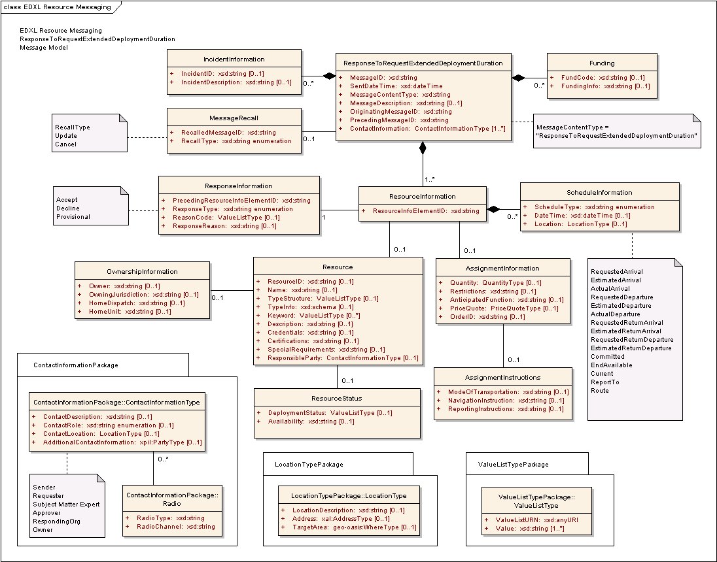
Figure 19: EDXL-RM ERM for ResponseToRequestExtendedDeploymentDuration Message

The following table outlines the element cardinalities for this message type.

Table 19: Response to RequestExtendedDeploymentDuration Message Elements
Parent Element | Sub-Elements
ResponseToRequestExtendedDeploymentDuration | MessageID, SentDateTime, MessageContentType^, MessageDescription, OriginatingMessageID, PrecedingMessageID, IncidentInformation*, MessageRecall, Funding*, ContactInformation*, ResourceInformation*
IncidentInformation | IncidentID, IncidentDescription
MessageRecall | RecalledMessageID, RecallType
Funding | FundCode, FundingInfo
ResourceInformation | ResourceInfoElementID, ResponseInformation, Resource, AssignmentInformation, ScheduleInformation*
ResponseInformation | PrecedingResourceInfoElementID, ResponseType, ReasonCode, ResponseReason
Resource | ResourceID, Name, TypeStructure, TypeInfo, Keyword*, Description, Credentials, Certifications, SpecialRequirements, ResponsibleParty, OwnershipInformation, ResourceStatus
OwnershipInformation | Owner, OwningJurisdiction, HomeDispatch, HomeUnit
ResourceStatus | DeploymentStatus, Availability
AssignmentInformation | Quantity, Restrictions, AnticipatedFunction, PriceQuote, OrderID, AssignmentInstructions
AssignmentInstructions | ModeOfTransportation, NavigationInstructions, ReportingInstructions
ScheduleInformation | ScheduleType^, DateTime, Location

ResponseToRequestExtendedDeploymentDuration Message Rules
The following rules apply to the above elements:
- The ResponseToRequestExtendedDeploymentDuration:MessageID, ResponseToRequestExtendedDeploymentDuration:SentDateTime, ResponseToRequestExtendedDeploymentDuration:MessageContentType, ResponseToRequestExtendedDeploymentDuration:OriginatingMessageID, ResponseToRequestExtendedDeploymentDuration:PrecedingMessageID, ResponseToRequestExtendedDeploymentDuration:ContactInformation, and ResponseToRequestExtendedDeploymentDuration:ResourceInformation elements MUST be present.
- The value of ResponseToRequestExtendedDeploymentDuration:MessageContentType MUST be “ResponseToRequestExtendedDeploymentDuration”.
- If a ResponseToRequestExtendedDeploymentDuration:IncidentInformation element is present, then at least one of IncidentInformation:IncidentID and/or IncidentInformation:IncidentDescription elements MUST be present.
- If the ResponseToRequestExtendedDeploymentDuration:MessageRecall element is present, then the MessageRecall:RecalledMessageID and MessageRecall:RecallType elements MUST be present.
- If a ResponseToRequestExtendedDeploymentDuration:Funding element is present, then at least one of Funding:FundCode and/or Funding:FundingInfo elements MUST be present.
- The ResourceInformation:ResourceInfoElementID and ResourceInformation:ResponseInformation elements MUST be present.
- The ResponseInformation:PrecedingResourceInfoElementID and ResponseInformation:ResponseType elements MUST be present.
- If the ResponseInformation:ResponseType element has a value of “Accept” or “Provisional”, then ResourceInformation:Resource element MUST be present. Otherwise, the ResourceInformation:Resource element is optional.
- If ResponseInformation:ResponseType has a value of “Provisional”, at least one of ResponseInformation:ReasonCode and/or ResponseInformation:ResponseReason elements MUST be present.
- If a ResourceInformation:Resource element is present, then at least one of Resource:ResourceID, Resource:Name, and/or Resource:TypeStructure elements MUST be present.
- If a Resource:OwnershipInformation element is present, then at least one of OwnershipInformation:Owner and/or OwnershipInformation:OwningJurisdiction elements MUST be present.
- If the ResourceInformation:ScheduleInformation element is present, then the ScheduleInformation:ScheduleType element MUST be present and contain one of the following values:
- “RequestedArrival”, “EstimatedArrival”, “ActualArrival”, “RequestedDeparture”, “EstimatedDeparture”, “ActualDeparture”, “RequestedReturnArrival”, “EstimatedReturnArrival”, “RequestedReturnDeparture”, “EstimatedReturnDeparture”, “Committed”, “EndAvailable”, “Current”, “ReportTo” or “Route”.

The schema for a ResponseToRequestExtendedDeploymentDuration message can be found in Appendix A.18.

Message Flow
The ResponseToRequestExtendedDeploymentDuration message is sent from the Resource Supplier to the Resource Consumer in response to a RequestExtendedDeploymentDuration message.
The message may be canceled or updated through the ResponseToRequestExtendedDeploymentDuration:MessageRecall element.

Message Example
Below is an example ResponseToRequestExtendedDeploymentDuration message. This message follows on from the example RequestExtendedDeploymentDuration message shown in Section 3.18.5 (declining the request).

[Note: The XML example shown in this section is informative only.]
<?xml version="1.0" encoding="UTF-8"?>
<ResponseToRequestExtendedDeploymentDuration xmlns:xsi="http://www.w3.org/2001/XMLSchema-instance"
xsi:schemaLocation="urn:oasis:names:tc:emergency:EDXL:RM:1.0:msg
EDXL-RMResponseToRequestExtendedDeploymentDuration.xsd"
xmlns="urn:oasis:names:tc:emergency:EDXL:RM:1.0:msg"
xmlns:rm="urn:oasis:names:tc:emergency:EDXL:RM:1.0"
xmlns:xpil="urn:oasis:names:tc:ciq:xpil:3"
xmlns:xnl="urn:oasis:names:tc:ciq:xnl:3" xmlns:xal="urn:oasis:names:tc:ciq:xal:3"
xmlns:geo-oasis="urn:oasis:names:tc:emergency:EDXL:HAVE:1.0:geo-oasis">
<MessageID>urn:au-qld-eoc:997816</MessageID>
<SentDateTime>2006-03-22T17:02:00+10:00</SentDateTime>
<MessageContentType>ResponseToRequestExtendedDeploymentDuration</MessageContentType>
<OriginatingMessageID>urn:au-qld-eoc:12332</OriginatingMessageID>
<PrecedingMessageID>urn:au-qld-eoc:997814</PrecedingMessageID>
<IncidentInformation>
<rm:IncidentDescription>Cyclone Larry</rm:IncidentDescription>
</IncidentInformation>
<ContactInformation>
<rm:ContactRole>Sender</rm:ContactRole>
<rm:AdditionalContactInformation>
<xpil:PartyName>
<xnl:PersonName>
<xnl:NameElement xnl:ElementType="FirstName">Charlotte</xnl:NameElement>
<xnl:NameElement xnl:ElementType="LastName">Ryan</xnl:NameElement>
</xnl:PersonName>
<xnl:OrganisationName>
<xnl:NameElement>EMA</xnl:NameElement>
</xnl:OrganisationName>
</xpil:PartyName>
</rm:AdditionalContactInformation>
</ContactInformation>
<ContactInformation>
<rm:ContactRole>Requester</rm:ContactRole>
<rm:AdditionalContactInformation>
<xpil:PartyName>
<xnl:PersonName>
<xnl:NameElement xnl:ElementType="FirstName">Alex</xnl:NameElement>
<xnl:NameElement xnl:ElementType="LastName">Jones</xnl:NameElement>
</xnl:PersonName>
<xnl:OrganisationName>
<xnl:NameElement>Dept of Emergency Services</xnl:NameElement>
</xnl:OrganisationName>
</xpil:PartyName>
</rm:AdditionalContactInformation>
</ContactInformation>
<ResourceInformation>
<ResourceInfoElementID>001</ResourceInfoElementID>
<ResponseInformation>
<rm:PrecedingResourceInfoElementID>001</rm:PrecedingResourceInfoElementID>
<rm:ResponseType>Decline</rm:ResponseType>
<rm:ResponseReason>
Team is already committed elsewhere for the period of 4 to April.
</rm:ResponseReason>
</ResponseInformation>
<Resource>
<TypeStructure>
<rm:ValueListURN>urn:x-hazard:vocab:resourceTypes</rm:ValueListURN>
<rm:Value>Small Animal Sheltering Team</rm:Value>
</TypeStructure>
</Resource>
<AssignmentInformation>
<Quantity>
<rm:MeasuredQuantity>
<rm:Amount>1</rm:Amount>
</rm:MeasuredQuantity>
</Quantity>
</AssignmentInformation>
<ScheduleInformation>
<ScheduleType>RequestedReturnArrival</ScheduleType>
<DateTime>2006-04-07T17:00:00+10:00</DateTime>
<Location>
<rm:LocationDescription>Cairns Airport</rm:LocationDescription>
</Location>
</ScheduleInformation>
</ResourceInformation>
</ResponseToRequestExtendedDeploymentDuration>

Data Dictionary (NORMATIVE)

EDXLResourceMessage ElementReferenceType Type
Element | MessageID
Type | MessageIDType [xsd:string]
Usage | REQUIRED, MUST be used once and only once
Definition | Each EDXL resource message contains an identifier that uniquely identifies the resource message.
Comments | - The EDXL Distribution Element contains the "Distribution ID", which identifies the "container" for the distribution message information.
Requirements  Supported | 20

Element | SentDateTime
Type | DateTimeType [xsd:dateTime]
Usage | REQUIRED, MUST be used once and only once
Definition | The system stamped date and time the resource message was sent. (1) The date and time is represented in [dateTime] format (e. g., "2002-05-24T16:49:00-07:00" for 24 May 2002 at 16: 49 PDT). (2) Alphabetic time zone designators such  as “Z” MUST NOT be used. The time zone for UTC MUST be represented as “-00:00”  or “+00:00.
Comments | - Original requirement = ICS "Request Date/Time"
Requirements  Supported | 21

Element | MessageContentType
Type | MessageContentTypeType [xsd:string]
Usage | REQUIRED, MUST be used once and only once
Definition | Specifies the purpose / type of resource content / payload being sent within the Resource Messaging – Element Reference Model
Constraints | - Value MUST be one of the following:  - RequestResource  - ResponseToRequestResource  - RequisitionResource  - CommitResource  - RequestInformation  - ResponseToRequestInformation  - OfferUnsolicitedResource  - ReleaseResource  - RequestReturn  - ResponseToRequestReturn  - RequestQuote  - ResponseToRequestQuote  - RequestResourceDeploymentStatus  - ReportResourceDeploymentStatus  - RequestExtendedDeploymentDuration  - ResponseToRequestExtendedDeploymentDuration
Requirements  Supported | 2,3,4,5,6,7,8,9,10,11,12,17

Element | MessageDescription
Type | MessageDescriptionType [xsd:string]
Usage | CONDITIONAL, MAY be used once and only once
Definition | Text field used to specify the information requested in a request for information and the response to a request for information. May also be used to include additional information in other message types.
Constraints | - Conditional Usage:  - Required:  - EDXLResourceMessage:MessageContentType = “RequestInformation”  - Optional:  - Otherwise
Requirements  Supported | 20

Element | OriginatingMessageID
Type | MessageIDType [xsd:string]
Usage | REQUIRED, MUST be used once and only once
Definition | Each EDXL resource message contains a MessageID that uniquely identifies the resource message. OriginatingMessageID identifies the MessageID of the first message in a message sequence to which the message belongs. If the message is itself the originating message in a new sequence, OriginatingMessageID will have the same value as the MessageID element. In some other cases, the OriginatingMessageID element will have the same value as the PrecedingMessageID element. The OriginatingMessageID value essentially forms a unique identifier for a group of related messages, linking them together so that the relationship between the messages is made explicit and unambiguous (and threads of messages can be tracked by resource management software).
Comments | - This MessageID is an EDXL-RM MessageID, not an EDXL-Distribution Element MessageID.
Requirements Supported | 20

Element | PrecedingMessageID
Type | MessageIDType [xsd:string]
Usage | CONDITIONAL, MAY be used once and only once
Definition | The PrecedingMessageID identifies the message that immediately preceded the current message in the message sequence. This MessageID is an EDXL-RM MessageID not and EDXL-Distribution Element MessageID.
Constraints | - Conditional Usage:  - Required:  - EDXLResourceMessage:MessageContentType = “ResponseToRequestResource”  - EDXLResourceMessage:MessageContentType = “CommitResource”  - EDXLResourceMessage:MessageContentType = “ResponseToRequestInformation”  - EDXLResourceMessage:MessageContentType = “ResponseToRequestReturn”  - EDXLResourceMessage:MessageContentType = “ResponseToRequestQuote”  - EDXLResourceMessage:MessageContentType = “ResponseToRequestExtendedDeploymentDuration”  - Optional:  - EDXLResourceMessage:MessageContentType = “RequisitionResource”  - EDXLResourceMessage:MessageContentType = “Request Information”  - EDXLResourceMessage:MessageContentType = “ReleaseResource”  - EDXLResourceMessage:MessageContentType = “RequestReturn”  - EDXLResourceMessage:MessageContentType = “RequestQuote”  - EDXLResourceMessage:MessageContentType = “RequestResourceDeploymentStatus”  - EDXLResourceMessage:MessageContentType = “ReportResourceDeploymentStatus”  - Not Applicable:  - Otherwise

Element | ContactInformation
Type | ContactInformationType [XML structure]
Usage | REQUIRED, MUST be used at least once
Definition | The contact associated with the resource message.
Comments | - Refer to Section 4.1.13.1 for ContactInformationType  - There may be more than one contact given – message sender, requester, subject matter expert, approver, owner, etc.

IncidentInformation Element
Element | IncidentID
Type | IncidentIDType [xsd:string]
Usage | CONDITIONAL, MAY be used once and only once.
Definition | The name or other identifier of the incident to which the current message refers.
Constraints | - If an IncidentInformation element is present, then at least one of IncidentInformation:IncidentID or IncidentInformation:IncidentDescription MUST be present
Requirements Supported | 19

Element | IncidentDescription
Type | IncidentDescriptionType [xsd:string]
Usage | CONDITIONAL, MAY be used once and only once.
Definition | A free form description of the incident to which the current message refers.
Constraints | - If an IncidentInformation element is present, then at least one of IncidentInformation:IncidentID or IncidentInformation:IncidentDescription MUST be present
Requirements Supported | 19

MessageRecall Element
Element | RecalledMessageID
Type | MessageIDType [xsd:string]
Usage | REQUIRED, MUST be used once and only once.
Definition | The identifier of the previously sent message that is to be recalled. MessageRecall is used to replace a previously sent message by updating or canceling it.
Comments | - The MessageRecall element is Optional.
Requirements Supported | 14, 15

Element | RecallType
Type | RecallTypeType [xsd:string]
Usage | REQUIRED, MUST be used once and only once.
Definition | Specifies the recall type as either an update or a cancel of the previously sent message. MessageRecall is used to replace a previously sent message which is then updated or cancelled.
Constraints | - Value MUST be one of the following:  - Update  - Cancel
Comments | - The MessageRecall element is Optional.
Requirements Supported | 14,15

Funding Element
Element | FundCode
Type | FundCodeType [xsd:string]
Usage | CONDITIONAL, MAY be used once and only once.
Definition | Identifies the funds that will pay for the resource
Constraints | - The Funding element MUST be present in a Requisition Resource message.  - If a Funding element is present, then at least one of Funding:FundCode or Funding:FundingInfo MUST be present
Comments | - Identified in support of NIMS Resource Management Guide NIC-GDL0004  - This field may be used as a comma separated list of fund codes (e.g. “HP4347,RT45S”
Requirements Supported | 18, 24

Element | FundingInfo
Type | FundingInfoType [xsd:string]
Usage | CONDITIONAL, MAY be used once and only once.
Definition | Provides additional information on the funds that will pay for the resource
Constraints | - A textual description of funding sources or distribution  - The Funding element MUST be present in a Requisition Resource message.  - If a Funding element is present, then at least one of Funding:FundCode or Funding:FundingInfo MUST be present
Requirements Supported | 18, 24

ResourceInformation Element
Element | ResourceInfoElementID
Type | ResourceInfoElementIDType[xsd:string]
Usage | REQUIRED, MUST be used once and only once.
Definition | This element identifies the instance of ResourceInformation within the message. It does not identify the Resource.
Comments | - The purpose of this element is to uniquely identify the ResourceInformation element in future messages that refer to this message.  - The Resource is identified by a combination of one or more of ResourceID, Name and/or ResourceTypeStructure.

ResponseInformation Element
Element | PrecedingResourceInfoElementID
Type | ResourceInfoElementIDType[xsd:string]
Usage | REQUIRED, MUST be used once and only once
Definition | This element identifies the instance of ResourceInformation within the message specified in the EDXLResourceMessage:PrecedingMessageID element.

Element | ResponseType
Type | ResponseTypeType [xsd:string enumeration]
Usage | REQUIRED, MUST be used once and only once
Definition | Used to accept, decline, or provisionally accept a Request or Unsolicited Offer.
Constraints | - Value MUST be one of the following:  - Accept  - Decline  - Provisional
Comments | - The “ResponseReason” element is associated with a “Provisional” or “Decline” value.
Requirements Supported | 6,29

Element | ReasonCode
Type | ValueListType[XML structure]
Usage | CONDITIONAL, MAY be used once and only once
Definition | Code from a managed list that offers an explanation for a declined or provisional response to a Request or Unsolicited Offer.
Constraints | - If the ResponseInformation:ResponseType element has a value of “Provisional”, then at least one of the ResponseInformation:ReasonCode and/or ResponseInformation:ResponseReason elements MUST be present.
Requirements Supported | 6,29

Element | ResponseReason
Type | ResponseReasonType [xsd:string]
Usage | CONDITIONAL, MAY be used once and only once
Definition | Explanation for a declined or provisional response to a Request, Response, Unsolicited Offer, or a Request Return.
Constraints | - If the ResponseInformation:ResponseType element has a value of “Provisional”, then at least one of the ResponseInformation:ReasonCode and/or ResponseInformation: ResponseReason elements MUST be present.
Requirements Supported | 6,29

Resource Element
Element | ResourceID
Type | ResourceIDType [xsd:string]
Usage | CONDITIONAL, MAY be used once and only once.
Definition | This identifier (if available) is used to identify and track a resource.
Constraints | - At least one of Resource:ResourceID, Resource:Name or Resource:TypeStructure MUST be present to identify a specific resource and the same element and value MUST be used consistently within a sequence from a common Originating Message.
Requirements Supported | 3,16,26

Element | Name
Type | ResourceNameType [xsd:string]
Usage | CONDITIONAL, MAY be used once and only once.
Definition | A name or title of the resource used for identification and tracking.
Constraints | - At least one of Resource:ResourceID, Resource:Name or Resource:TypeStructure MUST be present to identify a specific resource and the same element and value MUST be used consistently within a sequence from a common Originating Message.
Requirements Supported | 3,16,18,26

Element | TypeStructure
Type | ValueListType [XML structure]
Usage | CONDITIONAL, MAY be used once and only once.
Definition | Uniform Resource Name (URN) paired with a string “keyword” value such as  <TypeStructure>  <rm:ValueListURN>urn:x-hazard:vocab:resourceTypes</rm:ValueListURN>  <rm:Value>Debris Management Team</rm:Value>  </TypeStructure>  for a certified list of resources maintained by the Community of Interest (for the value referenced.)
Constraints | - At least one of Resource:ResourceID, Resource:Name or Resource:TypeStructure MUST be present to identify a specific resource and the same element and value MUST be used consistently within a sequence from a common Originating Message for each Resource element present.
Comments | - Refer to Section 4.1.13.3 for ValueListType
Requirements Supported | 3,16,25, 26

Element | TypeInfo
Type | TypeInfoType [sequence of xsd:any]
Usage | OPTIONAL, MAY be used once and only once
Definition | The resource type as defined by either a Keyword structure or a valid schema.
Comments | - This element contains one or more child elements whose names and types depend on the value of the TypeStructure element.
Requirements Supported | 3,16,25,26

Element | Keyword
Type | ValueListType [XML structure]
Usage | OPTIONAL, MAY be used one or more times
Definition | Any value from a discrete managed list, used to specify a keyword.
Comments | - Allows reference to a separate schema for enumerations. Example: ValueListURN= "http://www.dhs.gov/NiemEquipmentResources" and Value="Portable Radio",  or ValueListURN= "http://www.eic.org/Package" and Value="DMAT – burn"  - A Type Structure is assumed to have an enumerated, allowed list.  - A Keyword is not restricted to a particular enumeration, a Keyword can be any word or string.
Requirements Supported | 3,16,25,26

Element | Description
Type | DescriptionType [xsd:string]
Usage | OPTIONAL, MAY be used once and only once
Definition | Free Text description of resource or resource characteristics, situation requiring resource assistance, or statement of mission the resource satisfies.
Requirements Supported | 3,7,16,18,26

Element | Credentials
Type | CredentialsType [xsd:string]
Usage | OPTIONAL, MAY be used once and only once
Definition | Statements of resource qualifications showing that a person or role has a right to exercise official power
Comments | - Multiple credentials may be included as a comma-separated list.  Example 1: “Splinting, bandaging, oxygen administration” Example 2: “A practitioner credentialed by a State to function as an EMT by a State Emergency Medical Services (EMS) system.”

Element | Certifications
Type | CertificationsType [xsd:string]
Usage | OPTIONAL, MAY be used once and only once
Definition | Statements of recognition that a resource has met special requirements or qualifications within a field
Comments | - Multiple certifications may be included as a comma-separated list.  Example 1: “ALS; Advanced First Aid & CPR, BLS; Advanced First Aid & CPR”  Example 2: “Pilot – Commercial (instrument) or higher certificate and complete unit certification program”, “Pilot – Private Pilot (instrument) or higher certificate and complete unit certification program”  Example 3: “Trained to the HazMat First Responder Operational Level (NFPA 472); Comply with organization; Operations Level for support personnel as outlined in NFPA 1670”

Element | SpecialRequirements
Type | SpecialRequirementsType [xsd:string]
Usage | OPTIONAL, MAY be used once and only once
Definition | A description of any special needs related to the requested resource (e.g. must carry protective equipment)
Comments | - Not intended to carry certifications or capabilities.
Requirements Supported | 3,7,16,27

Element | ResponsibleParty
Type | ContactInformationType [XML Structure]
Usage | CONDITIONAL, MAY be used once and only once
Definition | Contact Info for person currently responsible for resource
Comments | - Conditional Usage:  - Not Applicable:  - EDXLResourceMessage:MessageContentType = “RequestResource”  - Optional, otherwise
Requirements Supported | 3,7,16,27

OwnershipInformation Element
Element | Owner
Type | OwnerType [xsd:string]
Usage | CONDITIONAL, MAY be used once and only once
Definition | The name of an agency or supplier that owns the resource (which may not be the home unit or dispatch). Also referred to as home agency.
Constraints | - At least one of OwnershipInformation:Owner or OwnershipInformation:OwningJurisdiction MUST be present for each OwnershipInformation element.
Requirements Supported | 3,16,18

Element | OwningJurisdiction
Type | OwningJurisdictionType [xsd:string]
Usage | CONDITIONAL, MAY be used once and only once
Definition | A geopolitical area in which an organization, person, or object has a specific range of authority for specified resources.
Constraints | - At least one of OwnershipInformation:Owner or OwnershipInformation:OwningJurisdiction MUST be present for each OwnershipInformation element.
Comments | - Can be a code
Requirements Supported | 3, 16, 18

Element | HomeDispatch
Type | HomeDispatchType [xsd:string]
Usage | CONDITIONAL, MAY be used once and only once
Definition | Resource home agency dispatch center name. This identifies the dispatch unit that has primary responsibility for maintaining information on the resource (e.g., Ft. Collins Dispatch Center, Rocky Mountain Area Coordination Center).
Comments | - Conditional Usage:  - Not Applicable:  - EDXLResourceMessage:MessageContentType = “RequestResource”  - Optional, otherwise
Requirements Supported | 18

Element | HomeUnit
Type | HomeUnitType [xsd:string]
Usage | CONDITIONAL, MAY be used once and only once
Definition | The unit (office, district, organization, etc.) from which the resource typically works or is used (e.g., Manti-LaSalle National Forest/Sanpete District). When released from an assignment, the location to which the resource is released will usually be determined by the home unit.
Comments | - Conditional Usage:  - Not Applicable:  - EDXLResourceMessage:MessageContentType = “RequestResource”  - Optional, otherwise
Requirements Supported | 18

ResourceStatus Element
Element | InventoryRefreshDateTime
Type | DateTimeType[xsd:dateTime]
Usage | CONDITIONAL, MAY be used once and only once
Definition | Date and time that resource inventory counts were last updated
Comments | - Conditional Usage:  - Optional:  - EDXLResourceMessage:MessageContentType = “ResponseToRequestResource”  - EDXLResourceMessage:MessageContentType = “CommitResource”  - EDXLResourceMessage:MessageContentType = “RequestInformation”  - EDXLResourceMessage:MessageContentType = “ResponseToRequestInformation”  - EDXLResourceMessage:MessageContentType = “OfferUnsolicitedResource”  - EDXLResourceMessage:MessageContentType = “ResponseToRequestQuote”  - EDXLResourceMessage:MessageContentType = “ReportResourceDeploymentStatus”  - Not Applicable, otherwise
Requirements Supported | 2,12

Element | DeploymentStatus
Type | ValueListType [XML structure]
Usage | CONDITIONAL, MAY be used once and only once
Definition | Any value from a discrete managed list, used to specify the general state of a resource if known.
Comments | - Conditional Usage:  - Required  - EDXLResourceMessage:MessageContentType = “ResponseToRequestReturn”  - Optional:  - EDXLResourceMessage:MessageContentType = “ResponseToRequestResource”  - EDXLResourceMessage:MessageContentType = “CommitResource”  - EDXLResourceMessage:MessageContentType = “RequestInformation”  - EDXLResourceMessage:MessageContentType = “ResponseToRequestInformation”  - EDXLResourceMessage:MessageContentType = “OfferUnsolicitedResource”  - EDXLResourceMessage:MessageContentType = “ReleaseResource”  - EDXLResourceMessage:MessageContentType = “RequestReturn”  - EDXLResourceMessage:MessageContentType = “ResponseToRequestQuote”  - EDXLResourceMessage:MessageContentType = “ReportResourceDeploymentStatus”  - EDXLResourceMessage:MessageContentType = “RequestExtendedDeploymentDuration”  - EDXLResourceMessage:MessageContentType = “ResponseToRequestExtendedDeploymentDuration”  - Not Applicable, otherwise  - Allows reference to a separate schema for enumerations. Example: ValueListURN= "http://www.dhs.gov/NIMSResourceStatus" and Value="Available”. Example values include:  - atBase-Available  - enroute-Unavailable  - on-scene-Unavailable  - returning-Unavailable  - Resource Maintenance  - Out of Service  - Depleted  - Available  - Committed  - In Transit  - At incident (ROSS)  - Assigned  - In Camp  - Reassignment  - Return Transit  - Returned  - Demobilized
Requirements Supported | 18

Element | Availability
Type | AvailabilityType [xsd:string]
Usage | CONDITIONAL, MAY be used once and only once
Definition | Text to describe availability and limitations on availability. Resource availability refers to resource that it is present or ready for immediate use, or otherwise accessible or obtainable, or is qualified or willing to do something or to assume a responsibility.
Comments | - Conditional Usage:  - Required  - EDXLResourceMessage:MessageContentType = “ResponseToRequestReturn”  - Optional:  - EDXLResourceMessage:MessageContentType = “ResponseToRequestResource”  - EDXLResourceMessage:MessageContentType = “RequestInformation”  - EDXLResourceMessage:MessageContentType = “ResponseToRequestInformation”  - EDXLResourceMessage:MessageContentType = “OfferUnsolicitedResource”  - EDXLResourceMessage:MessageContentType = “ReleaseResource”  - EDXLResourceMessage:MessageContentType = “RequestReturn”  - EDXLResourceMessage:MessageContentType = “ResponseToRequestQuote”  - EDXLResourceMessage:MessageContentType = “ReportResourceDeploymentStatus”  - EDXLResourceMessage:MessageContentType = “RequestExtendedDeploymentDuration”  - EDXLResourceMessage:MessageContentType = “ResponseToRequestExtendedDeploymentDuration”  - Not Applicable, otherwise
Requirements Supported | 3,16

AssignmentInformation Element
Element | Quantity
Type | QuantityType [XML structure]
Usage | CONDITIONAL, MAY be used once and only once
Definition | Description of amount of resource needed in both quantity and units of measure (if applicable).
Comments | - This element carries quantity information expressed in one of two ways:  - informally, as one or more lines of text (the QuantityText element); or  - formally, as an element (the MeasuredQuantity element) containing an amount (required) and a unit of measure (optional).  The unit of measure is expressed, in turn, as a uniform resource name (ValueListURN) identifying a managed code list of units of measure, paired with a code from that list (identifying a particular unit of measure).  The use of the first alternative (the QuantityText element) is not recommended when the second alternative (the MeasuredQuantity element) can be used. For example, in a RequestResource message requesting 10000 liters of water, the second alternative (the MeasuredQuantity element) is the preferred one.  A Community of Interest can either use an existing managed code list of units of measure, or define its own code list and use it.  One possibility is to use one of the two lists specified in the Unified Code for Units of Measure [UCUM]: case-sensitive codes (“c/s”) and case-insensitive codes (“c/i”). It is recommended that the two following URNs be used within EDXL-RM messages to identify those two code lists (respectively):  urn:oasis:names:tc:emergency:EDXL:RM:1.0:ucum:1.6:cs  urn:oasis:names:tc:emergency:EDXL:RM:1.0:ucum:1.6:ci
Constraints | - Value MUST be non-negative.  - Conditional Usage:  - Required  - EDXLResourceMessage:MessageContentType = “ResponseToRequestResource” and ResponseInformation:ResponseType = “Accept”  - EDXLResourceMessage:MessageContentType = “ResponseToRequestResource” and ResponseInformation:ResponseType = “Conditional”  - EDXLResourceMessage:MessageContentType = “RequisitionResource”  - EDXLResourceMessage:MessageContentType = “CommitResource”  - EDXLResourceMessage:MessageContentType = “ReleaseResource”  - Optional, otherwise.
Requirements Supported | 3,16,18,26

Element | Restrictions
Type | RestrictionsType [xsd:string]
Usage | OPTIONAL, MAY be used once and only once
Definition | Description of a condition governing the availability of resources. E.g. condition for number of beds available may be "if patients have insurance". This may be thought of as a term/condition or a restriction on availability.
Requirements Supported | 28

Element | AnticipatedFunction
Type | AnticipatedFunctionType [xsd:string]
Usage | OPTIONAL, MAY be used once and only once
Definition | Anticipated function, task, job, or role to be provided by the requested resource.
Requirements Supported | 18,28

Element | PriceQuote
Type | PriceQuoteType [XML structure]
Usage | CONDITIONAL, MAY be used once and only once
Definition | Description of quoted cost to acquire desired resource including currency, if the distinction is appropriate.
Comments | - This element carries price information expressed in one of two ways:  - informally, as one or more lines of text (element QuantityText); or  - formally, as an element (element MeasuredQuantity) containing an amount (required) and a unit of measure (optional).  The unit of measure is expressed, in turn, as a uniform resource name (ValueListURN) identifying a managed code list of units of measure, paired with a code from that list (identifying a particular unit of measure–usually a currency).  The use of the first alternative (the QuantityText element) is not recommended when the second alternative (the MeasuredQuantity element) can be used.  A Community of Interest can either use an existing managed code list of units of measure, or define its own code list and use it.  Usually, the unit of measure is a currency and the code list consists of the alphabetic currency codes specified in [ISO 4217] and summarized in [ISO 4217 codes]. It is recommended that the following URN be used within EDXL-RM messages to identify the alphabetic currency code list specified in [ISO 4217]:  urn:oasis:names:tc:emergency:EDXL:RM:1.0:iso4217:a  - Completed in response to a “RequestQuote”  - Conditional Usage:  - Required  - EDXLResourceMessage:MessageContentType = “ResponseToRequestQuote”  - May be indeterminate, i.e. “current market value.”  - Not Applicable  - EDXLResourceMessage:MessageContentType = “RequestResource”  - EDXLResourceMessage:MessageContentType = “RequestQuote”  - Optional, otherwise
Requirements Supported | 10,30

Element | OrderID
Type | OrderIDType [xsd:string]
Usage | CONDITIONAL, MAY be used once and only once
Definition | Reference to the external system number or ID assigned by the ordering system or personnel meeting the request for resources that has been made.
Comments | - There is no assurance of uniqueness between various external systems.  - Conditional Usage:  - Optional  - EDXLResourceMessage:MessageContentType = “CommitResource”  - EDXLResourceMessage:MessageContentType = “RequestInformation”  - EDXLResourceMessage:MessageContentType = “ResponseToRequestInformation”  - EDXLResourceMessage:MessageContentType = “ReleaseResource”  - EDXLResourceMessage:MessageContentType = “RequestReturn”  - EDXLResourceMessage:MessageContentType = “ResponseToRequestReturn”  - EDXLResourceMessage:MessageContentType = “RequestResourceDeploymentStatus”  - EDXLResourceMessage:MessageContentType = “ReportResourceDeploymentStatus”  - EDXLResourceMessage:MessageContentType = “RequestExtendedDeploymentDuration”  - EDXLResourceMessage:MessageContentType = “ResponseToRequestExtendedDeploymentDuration”  - Not Applicable, otherwise
Requirements Supported | 18,30

AssignmentInstructions Element
Element | ModeOfTransportation
Type | ModeOfTransportationType [xsd:string]
Usage | CONDITIONAL, MAY be used once and only once
Definition | Method or mode used to transport the resource to or from the incident.
Comments | - Conditional Usage:  - Not Applicable  - EDXLResourceMessage:MessageContentType = “RequestResource”  - EDXLResourceMessage:MessageContentType = “RequestExtendedDeploymentDuration”  - Optional, otherwise
Requirements Supported | 18,30

Element | NavigationInstructions
Type | NavigationInstructionsType [xsd:string]
Usage | CONDITIONAL, MAY be used once and only once
Definition | Instructions that define how to get to the “ReportTo” location.
Comments | - Conditional Usage:  - Not Applicable  - EDXLResourceMessage:MessageContentType = “RequestResource”  - EDXLResourceMessage:MessageContentType = “RequestExtendedDeploymentDuration”  - Optional, otherwise
Requirements Supported | 28

Element | ReportingInstructions
Type | ReportingInstructionsType [xsd:string]
Usage | CONDITIONAL, MAY be used once and only once
Definition | A text description which explains to whom or where the resource should report upon arrival. This could include a name for a person, place or functional role.
Comments | - Conditional Usage:  - Not Applicable  - EDXLResourceMessage:MessageContentType = “RequestResource”  - EDXLResourceMessage:MessageContentType = “RequestExtendedDeploymentDuration”  - Optional, otherwise
Requirements Supported | 30

ScheduleInformation Element
Element | ScheduleType
Type | ScheduleTypeType [xsd:string]
Usage | REQUIRED, MUST be used once and only once
Definition | A scheduled event that occurs at a particular time and/or at a particular location.
Constraints | - Value MUST be one of the following:  - RequestedArrival  - When the resource is needed. Completed for Resource requests, returns, etc.  - ICS uses the term "delivery" vs. "arrival". “Arrival" is used here because this applies to Human Resources also  - EstimatedArrival  - Date and time the resource is expected to arrive at its “ReportTo” location.  - ActualArrival  - Date and time when the resource arrives at its “ReportTo” location.  - RequestedDeparture  - Date and time when the resource is requested to Depart from its current location for transit to a “ReportTo” location.  - EstimatedDeparture  - Date and time when the resource is estimated to Depart from its current location for transit to a “ReportTo” location.  - ActualDeparture  - Date and time when the resource Departs from its current location for transit to a “ReportTo” location.  - RequestedReturnArrival  - Date and time the resource is requested to arrive from its deployment at its “OwningJurisdiction”.  - EstimatedReturnArrival  - Date and time the resource is expected to arrive from its deployment at its “OwningJurisdiction”.  - ActualReturnArrival  - Date and time the resource arrives from its deployment at its “OwningJurisdiction”.  - RequestedReturnDeparture  - Date and time the resource is requested to Depart from its deployment for transit to its “OwningJurisdiction”.  - EstimatedReturnDeparture  - Date and time the resource is expected to Depart from its deployment for transit to its “OwningJurisdiction”.  - ActualReturnDeparture  - Date and time the resource Departs from its deployment for transit to its “OwningJurisdiction”.  - Committed  - Confirmation from Resource Supplier that resource has been allocated to Resource Consumer, usually in response to a “RequisitionResource” message.  - May be part of an “OriginatingMessage”.  - BeginAvailable  - Date and time the resource will become available for allocation.  - EndAvailable  - Date and time the resource will cease to be available for deployment.  - Current  - Location of resource at date and time of message.  - ReportTo  - Location of place where resource is to be delivered.  - May include a text description which explains to whom or where the resource should report upon arrival. This could include a name for a person, place or functional role.  - Route  - Information specifying the course of transit of resource from.Resource Supplier to Resource Consumer.
Requirements Supported | 2, 11, 12, 28, 30

Element | DateTime
Type | DateTimeType [xsd:dateTime]
Usage | OPTIONAL, MAY be used once and only once
Definition | The date and time that a scheduled event takes place.
Requirements Supported | 2, 11, 12, 28, 30

Element | Location
Type | LocationType [XML structure]
Usage | OPTIONAL, MAY be used once and only once
Definition | The location in which a scheduled event takes place.
Comments | Information on the structure of LocationType can be found in Section 4.1.13.2.

Supporting Element Types

ContactInformationType
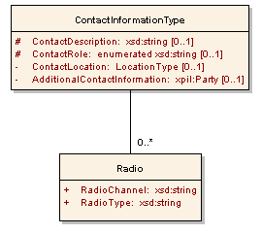
Figure 20: ContactInformationType Structure

Element | ContactDescription
Type | ContactDescriptionType [xsd:string]
Usage | CONDITIONAL, MAY be used once and only once.
Definition | Identifying information associated with a contact role related to the resource message.
Constraints | - If a ContactInformation element is present, then at least one of ContactInformation:ContactDescription or ContactInformation:ContactRole MUST be present.
Comments | - The ContactDescription element is free text information identifying a contact that acts as an alternative to the ContactRole element for roles that are not covered by the ContactRole enumeration. The identifying information should be as specific as possible but can be suitably flexible (e.g. “Accounts Payable Clerk”).  - The element contains information associated with the contact role that is easily understood by humans but that is not necessarily usable by automation systems.
Requirements Supported | 18,23,24

Element | ContactRole
Type | ContactRoleType [xsd:string enumeration] ]
Usage | CONDITIONAL, MAY be used once and only once.
Definition | Role of the contact associated with the resource message.
Constraints | - If a ContactInformation element is present, then at least one of ContactInformation:ContactDescription or ContactInformation:ContactRole MUST be present  - Value MUST be one of the following:  - "Sender" (who sent the message)  - ”Requester" (authorization for the message / request)  - "SubjectMatterExpert" (answer questions or provide details)  - "Approver"  - "RespondingOrg" (who responded to the message)  - “Owner”
Requirements Supported | 18,23,24

Element | ContactLocation
Type | LocationType [XML Structure]
Usage | OPTIONAL, MAY be used once and only once.
Definition | The geophysical location of the contact.
Constraints | - If a PostalAddress needs to be included, an AdditionalContactInformation element MUST be included, and MUST be placed in the xAL:Address element within the AdditionalContactInformation element.
Comments | - Information on the structure of LocationType can be found in Section 4.1.13.2.
Requirements Supported | 18,23,24

Element | AdditionalContactInformation
Type | AdditionalContactInformationType [xpil:PartyType]
Usage | OPTIONAL, MAY be used once and only once.
Definition | Any other contact information including name and other Party information.
Comments | - The AdditionalContactInformation element is an xpil:PartyType structure that includes an xal:AddressType.  - If the optional AdditionalContactInformation element is included, the physical postal address should be included in the AdditionalContactInformation xal:Address element. Otherwise, it may be included in the ContactLocation element.  - The CIQ xpil:PartyType can specify person name, Organization name, contact phone numbers, email addresses, street addresses, etc. suitable for use in any country. This is the element that should be used to capture most of the contact information.  - Example:  <rm:AdditionalContactInformation>  <xnl:PartyName>  <xnl:PersonName>  <xnl:NameElement xnl:ElementType="FirstName">Joe  </xnl:NameElement>  <xnl:NameElement xnl:ElementType="LastName">Williams  </xnl:NameElement>  </xnl:PersonName>  <xnl:OrganizationName>  <xnl:NameElement>Hardware Megastore Cairns  </xnl:NameElement>  </xnl:OrganizationName>  </xnl:PartyName>  <xpil:Addresses>  <xal:Address>  <xal:Country>  <xal:Name>Australia</xal:Name>  </xal:Country>  <xal:AdministrativeArea>  <xal:Name>QLD</xal:Name>  </xal:AdministrativeArea>  <xal:Locality>  <xal:Name>Cairns</xal:Name>  </xal:Locality>  <xal:Thoroughfare>  <xal:NameElement>Spence St</xal:NameElement>  </xal:Thoroughfare>  <xal:PostCode>  <xal:Identifier>4870</xal:Identifier>  </xal:PostCode>  </xal:Address>  </xpil:Addresses>  <xpil:ContactNumbers>  <xpil:ContactNumber xpil:MediaType="Telephone"  xpil:ContactHours="8:00AM - 6:00PM">  <xpil:ContactNumberElement  xpil:ElementType="CountryCode">61  </xpil:ContactNumberElement>  <xpil:ContactNumberElement xpil:ElementType="AreaCode">7  </xpil:ContactNumberElement>  <xpil:ContactNumberElement  xpil:ElementType="LocalNumber">4052 0378  </xpil:ContactNumberElement>  </xpil:ContactNumber>  </xpil:ContactNumbers>  </rm:AdditionalContactInformation>
Requirements Supported | 18,23,24

Radio Element
Element | RadioType
Type | RadioTypeType [xsd:string]
Usage | REQUIRED, MUST be used once and only once
Definition | Contact radio type of the person or organization referred to in ContactRole
Requirements Supported | 18,23

Element | RadioChannel
Type | RadioChannelType [xsd:string] ]
Usage | REQUIRED, MUST be used once and only once
Definition | Contact radio channel of the person or organization referred to in ContactRole
Comments | - “Channel” and “Frequency” are synonyms for purposes of this standard
Requirements Supported | 18,23

LocationType
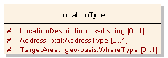
Figure 21: LocationType Structure
Element | LocationDescription
Type | LocationDescriptionType [xsd:string]
Usage | CONDITIONAL, MAY be used once and only once.
Definition | A free-form textual description of a location.
Constraints | - At least one of the LocationDescription, Address or TargetArea elements MUST be present.

Element | Address
Type | xal:AddressType
Usage | CONDITIONAL, MAY be used once and only once.
Definition | A CIQ structure containing address details in an internationally-applicable format (See Section 1.5)
Constraints | - At least one of the Description, Address or TargetArea elements MUST be present.  - An example of a CIQ AddressType can be found in section 3.10.5

Element | TargetArea
Type | geo-oasis:WhereType
Usage | CONDITIONAL, MAY be used once and only once.
Definition | The container element for GML-based geospatial information. This element uses the EDXL-HAVE geo-oasis schema. It allows the target Area to be defined by a choice that includes:
Constraints | - At least one of the LocationDescription, Address or TargetArea elements MUST be present.
Comments | - More detailed definitions for geo-oasis:WhereType and its components can be found in the geo-oasis schema. Specific usage of those types for EDXL-RM are found in section 4.1.13.2.1.

Imported Type Definitions
Type | geo-oasis:WhereType
Usage | Used for as the type value for TargetArea elements
Definition | WhereType provides a mechanism for defining location. This element uses the EDXL-HAVE geo-oasis schema. It allows the target Area to be defined as a choice of one of the following:  - gml:Point – WGS84 latitude and longitude  - gml:LineString – a series of points  - gml:CircleByCenterPoint – a point and radius  - gml:Polygon – a set of connected non-crossing lines  - gml:Envelope – two points used to define a bounding rectangle  It also allows the use of a set of attributes (geo-oasis:whereAttrGroup) defined for “WhereType.” More detailed definitions for geo-oasis:WhereType can be found in the geo-oasis schema
Comments | - EDXL-RM uses the geo-oasis schema that is specified as an element of EDXL-HAVE, Both EDXL-RM and EDXL-HAVE require the use of the WGS84 coordinate reference system.

Type | geo-oasis:WhereType using gml:Point
Usage | Where TargetAreaType is best represented as a WGS84 point.
Definition | The use of gml:Point within TargetArea provides location using a specific WGS84 point value that is compatible with GML compliant geospatial information systems. The following example applies:  <gml:Point>  <gml:pos>45.256 -71.92</gml:pos>  </gml:Point>  More detailed definitions for geo-oasis:WhereType can be found in the geo-oasis schema.
Constraints | - WGS84 MUST be used for EDXL-RM.
Requirements Supported

Type | geo-oasis:WhereType using gml:LineString
Usage | Where TargetAreaType is best represented as a route along a series of WGS84 points.
Definition | The use of gml:LineString within TargetArea provides location along a line represented by a specific list of WGS84 point values that is compatible with GML compliant geospatial information systems. The following example applies:  <gml:LineString>  <gml:posList>  45.256 -110.45  46.46 -109.48  43.84 -109.86  </gml:posList>  </gml:LineString>  More detailed definitions for geo-oasis:WhereType can be found in the geo-oasis schema.
Constraints | - WGS84 MUST be used for EDXL-RM.
Requirements Supported

Type | geo-oasis:WhereType using gml:CircleByCenterPoint
Usage | Where TargetAreaType is best represented circular area of a given radius in kilometers around a center point represented in WGS84.
Definition | The use of gml:CircleByCenterPoint within TargetArea provides location as a circle centered on a WGS84 referenced point with a radius defined in kilometers. The following example applies:  <gml:CircleByCenterPoint>  <gml:pos> 45.256 -110.45 </gml:pos>  <gml:radius> 10 </gml:radius>  <gml:CircleByCenterPoint>  More detailed definitions for geo-oasis:WhereType can be found in the geo-oasis schema.
Constraints | - WGS84 MUST be used for EDXL-RM.  - For EDXL-RM the unit of measure MUST be kilometers.

Type | geo-oasis:WhereType using gml:Polygon
Usage | Where TargetAreaType is best represented as a connected group of WGS84 points representing an actual area of concern.
Definition | The use of gml:Polygon within TargetArea provides a ring of points (first and last point are the same) represented by a specific list of WGS84 point values that is compatible with GML compliant geospatial information systems. The following example applies:  <gml:Polygon>  <gml:exterior>  <gml:LinearRing>  <gml:posList>  45.256 -110.45  46.46 -109.48  43.84 -109.86  45.256 -110.45  </gml:posList>  </gml:LinearRing>  </gml:exterior>  </gml:Polygon>  More detailed definitions for geo-oasis:WhereType can be found in the geo-oasis schema.
Constraints | - WGS84 MUST be used for EDXL-RM.  - For EDXL-RM gml:posList layout MUST be used.
Requirements Supported

Type | geo-oasis:WhereType using gml:Envelope
Usage | Where TargetAreaType is best represented as a rectangular area of interest often known as a “bounding box” of WGS84 points representing an actual area of concern.
Definition | The use of gml:Envelope within TargetArea provides two WGS 84 point representations, the first representing a lower corner of the box and the second representing an upper corner. The following example applies:  <gml:Envelope>  <gml:lowerCorner>42.943 -71.032</gml:lowerCorner>  <gml:upperCorner>43.039 -69.856</gml:upperCorner>  </gml:Envelope>  More detailed definitions for geo-oasis:WhereType can be found in the geo-oasis schema.
Constraints | - WGS84 MUST be used for EDXL-RM.

ValueListType
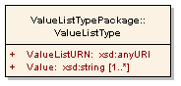
Figure 22: ValueListType Structure
Element | ValueListURN
Type | ValueListURNType[xsd:anyURI]
sage | REQUIRED, MUST be used once and only once
Definition | The name of the certified list maintained by the Community of Interest for the value referenced.
Requirements Supported | 25,26

Element | Value
Type | ValueType [xsd:string]
Usage | REQUIRED, MUST be used one to many
Definition | A value from the certified list maintained by the Community of Interest.

Conformance

Conformance Targets
The two following conformance targets are defined in order to support the specification of conformance to this standard:
- EDXL-RM Message; and

- EDXL-RM Message Producer.

An EDXL-RM Message is an XML 1.0 element whose syntax and semantics are specified in this standard. An EDXL-RM Message Producer is a software entity that produces EDXL-RM Messages.
NOTE There is no conformance target corresponding to the consumers of EDXL-RM messages. All the existing requirements for the consumption of an incoming EDXL-RM message are, in fact, requirements on the type and content of the EDXL-RM message that is produced by the consumer in reply to that message (if any). Therefore, a conforming EDXL-RM Message Producer (as defined in Section 5.4) will necessarily meet all the existing requirements for the production as well as for the consumption of EDXL-RM messages.

Conformance Levels
The two following conformance levels are defined for EDXL-RM Messages:
- Level-1 EDXL-RM Message; and
- Level-2 EDXL-RM Message.
NOTE The conformance requirements for Level-1 and Level-2 EDXL-RM Messages are given in Section 5.3, and summarized here. A Level-1 EDXL-RM Message is either one of the 16 resource message elements specified in sections 3.4 to 3.19, or a different element (with a different namespace name and an arbitrary local name) whose type is the complex type “EDXLResourceMessageReferenceType” specified in Section 4.1.1. A Level-2 EDXL-RM Message is restricted to be one of the 16 resource message elements specified in sections 3.4 to 3.19. Every Level-2 EDXL-RM Message is also a conforming Level-1 EDXL-RM Message.
The two following conformance levels are defined for EDXL-RM Message Producers:
- Level-1 EDXL-RM Message Producer; and
- Level-2 EDXL-RM Message Producer.
NOTE The conformance requirements for Level-1 and Level-2 EDXL-RM Message Producers are given in Section 5.4, and summarized here. A Level-1 EDXL-RM Message Producer is a software entity that produces conforming (Level-1) EDXL-RM Messages whenever a (Level-1) EDXL-RM Message is expected. A Level-2 EDXL-RM Message Producer is a software entity that only produces Level-2 EDXL-RM Messages whenever a Level-2 EDXL-RM Message is expected. Every Level-2 EDXL-RM Message Producer is also a conforming Level-1 EDXL-RM Message Producer.

Conformance as an EDXL-RM Message

Level-1 EDXL-RM Message
An XML 1.0 element is a conforming Level-1 EDXL-RM Message if and only if:
- it meets the general requirements specified in Section 3.3;

- if its namespace name is "urn:oasis:names:tc:emergency:EDXL:RM:1.0:msg", then its local name is one of the 16 resource message type names specified in sections 3.4 to 3.19 (also listed in Table 1), and the element is valid according to the schema located at
http://docs.oasis-open.org/emergency/EDXL-RM/EDXL-RM.xsd, where validation is performed against the global element declaration with the same local name;

- if its namespace name is not "urn:oasis:names:tc:emergency:EDXL:RM:1.0:msg", then the element is valid according to the schema located at
http://docs.oasis-open.org/emergency/EDXL-RM/EDXL-RM.xsd, where validation is performed against the complex type definition “EDXLResourceMessageReferenceType”;

- if its namespace name is "urn:oasis:names:tc:emergency:EDXL:RM:1.0:msg", then its content (which includes the content of each of its descendants) meets all the additional mandatory requirements provided in the specific subsection of Section 3 (sections 3.4 to 3.19) corresponding to the element’s name, with the exception of the Message Flow; such requirements include:

- the content of the Element Reference Model;
- each of the Message Rules; and
- the normative parts (element name, usage, and constraints) of any dictionary data entries (in Section Error: Reference source not found) corresponding to the elements that actually occur in the content of the element;

- if its namespace name is not "urn:oasis:names:tc:emergency:EDXL:RM:1.0:msg", then its content (which includes the content of each of its descendants) meets all the additional mandatory requirements provided in the normative parts (element name, usage, and constraints) of all the dictionary data entries (in Section 4) corresponding to the elements that actually occur in the content of the element.
NOTE The Information Exchange Package Documentation (IEPD) process, specified within the United States National Information Exchange Model (available on www.niem.gov), can be used by a Community of Interest when specifying new types of resource messages conforming to Level 1.

Level-2 EDXL-RM Message
An XML 1.0 element is a conforming Level-2 EDXL-RM Message if and only if:
- it meets all the requirements for a Level-1 EDXL-RM Message specified in Section 5.3.1; and

- its namespace name is "urn:oasis:names:tc:emergency:EDXL:RM:1.0:msg"; and

- its content meets all the requirements provided in the specific subsection of Section 3 (sections Error: Reference source not found to Error: Reference source not found) corresponding to the element’s name (see also Section 5.3.1item (d)), including the Message Flow.
NOTE The conditions in (a) and (b) above imply that the local name of the element is one of the 16 resource message type names specified in sections 3.4 to 3.19 (see Section 5.3.1 item (b)).

Conformance as an EDXL-RM Message Producer

Level-1 EDXL-RM Message Producer
A software entity is a conforming Level-1 EDXL-RM Message Producer if and only if it is constructed in such a way that any XML 1.0 element produced by it and present in a place in which a conforming Level-1 EDXL-RM message is expected (based on contextual information) is indeed a conforming Level-1 EDXL-RM message according to this standard.
NOTE The condition above can be satisfied in many different ways. Here are some examples of possible scenarios:
- a standard distribution protocol (say, EDXL-DE) transfers EDXL-RM messages; a resource consumer has sent an EDXL-RM request message to a resource supplier which claims to be a conforming EDXL-RM Message Producer, and has received an EDXL-DE message which is therefore expected to carry a conforming EDXL-RM Message;
- a local test environment has been set up, and the application under test (which claims to be a conforming EDXL-RM Message Producer) has the ability to produce an EDXL-RM message and write it to a file in a directory in response to a request coming from the testing tool; the testing tool has sent many requests to the application under test and is now verifying all the files present in the directory, which is expected to contain only conforming EDXL-RM Messages.

Level-2 EDXL-RM Message Producer
A software entity is a conforming Level-2 EDXL-RM Message Producer if and only if:
- it meets all the requirements for a Level-1 EDXL-RM Producer Message specified in Section 5.4.1; and
b) it produces a conforming Level-2 EDXL-RM Message when such a message is expected.
NOTE There is no requirement for a Level-2 EDXL-RM Message Producer to be able to produce resource messages of all 16 resource message types specified in sections Error: Reference source not found to Error: Reference source not found.
- XML Schema for the EDXL Resource Messaging (NORMATIVE)
Schemas included in Appendix A are for reference only. The normative schemas can be found at http://docs.oasis-open.org/emergency/edxl-rm/v1.0/cd01/schemas/.
  - Resource Messaging Common Types
<xsd:schema xmlns:xsd="http://www.w3.org/2001/XMLSchema"
xmlns:xnal="urn:oasis:names:tc:ciq:xnal:3"
xmlns:xnl="urn:oasis:names:tc:ciq:xnl:3"
xmlns:xal="urn:oasis:names:tc:ciq:xal:3"
xmlns:xpil="urn:oasis:names:tc:ciq:xpil:3"
xmlns:geo-oasis="urn:oasis:names:tc:emergency:EDXL:HAVE:1.0:geo-oasis"
xmlns="urn:oasis:names:tc:emergency:EDXL:RM:1.0"
targetNamespace="urn:oasis:names:tc:emergency:EDXL:RM:1.0"
elementFormDefault="qualified"
attributeFormDefault="unqualified">

<!-- All elements that have unchanged internal content across the entire matrix of
RM messages are typed here.
Where internal content differs between messages, please see the appropriate
schemas. -->
<xsd:import namespace="urn:oasis:names:tc:ciq:xpil:3" schemaLocation="xpil.xsd"/>
<xsd:import namespace="urn:oasis:names:tc:ciq:xal:3" schemaLocation="xal.xsd"/>
<xsd:import namespace="urn:oasis:names:tc:ciq:xnl:3" schemaLocation="xnl.xsd"/>

<xsd:import namespace="urn:oasis:names:tc:emergency:EDXL:HAVE:1.0:geo-oasis"
schemaLocation="geo-oasis.xsd"/>
<xsd:simpleType name="MessageIDType">
<xsd:restriction base="xsd:string"/>
</xsd:simpleType>
<xsd:simpleType name="DateTimeType">
<xsd:restriction base="xsd:dateTime"/>
</xsd:simpleType>
<xsd:simpleType name="MessageContentTypeType">
<xsd:restriction base="xsd:string">
<xsd:annotation>
<xsd:documentation>
The following strings values for MessageContentType
are reserved for Level 2 Conformant Message types (New
level 1 conformant messagetypes should use other name strings):

RequestResource
ResponseToRequestResource
RequisitionResource
CommitResource
RequestInformation
ResponseToRequestInformation
OfferUnsolicitedResource
ReleaseResource
RequestReturn
ResponseToRequestReturn
RequestQuote
ResponseToRequestQuote
RequestResourceDeploymentStatus
ReportResourceDeploymentStatus
RequestExtendedDeploymentDuration
ResponseToRequestExtendedDeploymentDuration
</xsd:documentation>
</xsd:annotation>

</xsd:restriction>
</xsd:simpleType>
<xsd:simpleType name="MessageDescriptionType">
<xsd:restriction base="xsd:string"/>
</xsd:simpleType>
<xsd:complexType name="IncidentInformationType">
<!-- One(or both) of the IncidentID and IncidentDescription elements is required -->
<xsd:sequence>
<xsd:element name="IncidentID" type="IncidentIDType" minOccurs="0"/>
<xsd:element name="IncidentDescription" type="IncidentDescriptionType"
minOccurs="0"/>
</xsd:sequence>
</xsd:complexType>
<xsd:simpleType name="IncidentIDType">
<xsd:restriction base="xsd:string"/>
</xsd:simpleType>
<xsd:simpleType name="IncidentDescriptionType">
<xsd:restriction base="xsd:string"/>
</xsd:simpleType>
<xsd:complexType name="MessageRecallType">
<xsd:sequence>
<xsd:element name="RecallMessageID" type="MessageIDType"/>
<xsd:element name="RecallType" type="RecallTypeType"/>
</xsd:sequence>
</xsd:complexType>
<xsd:simpleType name="RecallTypeType">
<xsd:restriction base="xsd:string">
<xsd:enumeration value="Update"/>
<xsd:enumeration value="Cancel"/>
</xsd:restriction>
</xsd:simpleType>
<xsd:complexType name="FundingType">
<!-- One (or both) of the FundCode and FundingInfo elements is required -->
<xsd:sequence>
<xsd:element name="FundCode" type="FundCodeType" minOccurs="0" maxOccurs="1"/>
<xsd:element name="FundingInfo" type="FundingInfoType" minOccurs="0"
maxOccurs="1"/>
</xsd:sequence>
</xsd:complexType>
<xsd:simpleType name="FundCodeType">
<xsd:restriction base="xsd:string"/>
</xsd:simpleType>
<xsd:simpleType name="FundingInfoType">
<xsd:restriction base="xsd:string"/>
</xsd:simpleType>
<xsd:complexType name="ContactInformationType">
<xsd:sequence>
<!-- At least one of ContactDescription and ContextRole is required -->
<xsd:element name="ContactDescription" type="ContactDescriptionType" minOccurs="0"
maxOccurs="1"/>
<xsd:element name="ContactRole" type="ContactRoleType" minOccurs="0"
maxOccurs="1"/>
<xsd:element name="Radio" type="RadioInformationType" minOccurs="0"
maxOccurs="unbounded"/>
<xsd:element name="ContactLocation" type="LocationType" minOccurs="0"
maxOccurs="1"/>
<xsd:element name="AdditionalContactInformation" type="xpil:PartyType"
minOccurs="0" maxOccurs="1"/>
</xsd:sequence>
</xsd:complexType>
<xsd:simpleType name="ContactDescriptionType">
<xsd:restriction base="xsd:string"/>
</xsd:simpleType>
<xsd:simpleType name="ContactRoleType">
<xsd:restriction base="xsd:string">
<xsd:enumeration value="Sender"/>
<xsd:enumeration value="Requester"/>
<xsd:enumeration value="SubjectMatterExpert"/>
<xsd:enumeration value="Approver"/>
<xsd:enumeration value="RespondingOrg"/>
<xsd:enumeration value="Owner"/>
</xsd:restriction>
</xsd:simpleType>
<xsd:complexType name="RadioInformationType">
<xsd:sequence>
<xsd:element name="RadioType" type="ValueListType"/>
<xsd:element name="RadioChannel" type="RadioChannelType"/>
</xsd:sequence>
</xsd:complexType>
<xsd:simpleType name="RadioTypeType">
<xsd:restriction base="xsd:string"/>
</xsd:simpleType>
<xsd:simpleType name="RadioChannelType">
<xsd:restriction base="xsd:string"/>
</xsd:simpleType>
<xsd:complexType name="ResponseInformationType">
<xsd:sequence>
<xsd:element name="PrecedingResourceInfoElementID"
type="ResourceInfoElementIDType"/>
<xsd:element name="ResponseType" type="ResponseTypeType"/>
<!-- If the ResponseType element has the value "Provisional", one (or both) of
ReasonCode and ResponseReason must be present -->
<xsd:element name="ReasonCode" type="ValueListType" minOccurs="0" maxOccurs="1"/>
<xsd:element name="ResponseReason" type="ResponseReasonType" minOccurs="0"
maxOccurs="1"/>
</xsd:sequence>
</xsd:complexType>
<xsd:simpleType name="ResourceInfoElementIDType">
<xsd:restriction base="xsd:string"/>
</xsd:simpleType>
<xsd:simpleType name="ResponseTypeType">
<xsd:restriction base="xsd:string">
<xsd:enumeration value="Accept"/>
<xsd:enumeration value="Decline"/>
<xsd:enumeration value="Provisional"/>
</xsd:restriction>
</xsd:simpleType>
<xsd:simpleType name="ResponseReasonType">
<xsd:restriction base="xsd:string"/>
</xsd:simpleType>
<xsd:simpleType name="ResourceIDType">
<xsd:restriction base="xsd:string"/>
</xsd:simpleType>
<xsd:simpleType name="ResourceNameType">
<xsd:restriction base="xsd:string"/>
</xsd:simpleType>
<xsd:complexType name="TypeInfoType">
<xsd:sequence>
<xsd:any processContents="skip" maxOccurs="unbounded"/>
</xsd:sequence>
<xsd:anyAttribute/>
</xsd:complexType>
<xsd:simpleType name="DescriptionType">
<xsd:restriction base="xsd:string"/>
</xsd:simpleType>
<xsd:simpleType name="CredentialsType">
<xsd:restriction base="xsd:string"/>
</xsd:simpleType>
<xsd:simpleType name="CertificationsType">
<xsd:restriction base="xsd:string"/>
</xsd:simpleType>
<xsd:simpleType name="SpecialRequirementsType">
<xsd:restriction base="xsd:string"/>
</xsd:simpleType>
<xsd:complexType name="OwnershipInformationType">
<!-- One (or both) of the Owner and OwningJurisdiction elements is required -->
<xsd:sequence>
<xsd:element name="Owner" type="OwnerType" minOccurs="0" maxOccurs="1"/>
<xsd:element name="OwningJurisdiction" type="OwningJurisdictionType" minOccurs="0"
maxOccurs="1"/>
<xsd:element name="HomeDispatch" type="HomeDispatchType" minOccurs="0"
maxOccurs="1"/>
<xsd:element name="HomeUnit" type="HomeUnitType" minOccurs="0" maxOccurs="1"/>
</xsd:sequence>
</xsd:complexType>
<xsd:simpleType name="OwnerType">
<xsd:restriction base="xsd:string"/>
</xsd:simpleType>
<xsd:simpleType name="OwningJurisdictionType">
<xsd:restriction base="xsd:string"/>
</xsd:simpleType>
<xsd:simpleType name="HomeDispatchType">
<xsd:restriction base="xsd:string"/>
</xsd:simpleType>
<xsd:simpleType name="HomeUnitType">
<xsd:restriction base="xsd:string"/>
</xsd:simpleType>
<xsd:simpleType name="AvailabilityType">
<xsd:restriction base="xsd:string"/>
</xsd:simpleType>
<xsd:simpleType name="QuantityTypeOld">
<xsd:restriction base="xsd:string"/>
</xsd:simpleType>
<xsd:complexType name="QuantityType">
<xsd:choice>
<xsd:element name="QuantityText" type="xsd:string" maxOccurs="unbounded"/>
<xsd:element name="MeasuredQuantity">
<xsd:complexType>
<xsd:sequence>
<xsd:element name="Amount" type="xsd:double"/>
<xsd:element name="UnitOfMeasure" type="ValueListType" minOccurs="0"/>
</xsd:sequence>
</xsd:complexType>
</xsd:element>
</xsd:choice>
</xsd:complexType>
<xsd:simpleType name="RestrictionsType">
<xsd:restriction base="xsd:string"/>
</xsd:simpleType>
<xsd:simpleType name="AnticipatedFunctionType">
<xsd:restriction base="xsd:string"/>
</xsd:simpleType>
<xsd:complexType name="PriceQuoteType">
<xsd:complexContent>
<xsd:extension base="QuantityType"/>
</xsd:complexContent>
</xsd:complexType>
<xsd:simpleType name="OrderIDType">
<xsd:restriction base="xsd:string"/>
</xsd:simpleType>
<xsd:complexType name="AssignmentInstructionsType">
<xsd:sequence>
<xsd:element name="ModeOfTransportation" type="ModeOfTransportationType"
minOccurs="0"
maxOccurs="1"/>
<xsd:element name="NavigationInstructions" type="NavigationInstructionsType"
minOccurs="0" maxOccurs="1"/>
<xsd:element name="ReportingInstructions" type="ReportingInstructionsType"
minOccurs="0"
maxOccurs="1"/>
</xsd:sequence>
</xsd:complexType>
<xsd:simpleType name="ModeOfTransportationType">
<xsd:restriction base="xsd:string"/>
</xsd:simpleType>
<xsd:simpleType name="NavigationInstructionsType">
<xsd:restriction base="xsd:string"/>
</xsd:simpleType>
<xsd:simpleType name="ReportingInstructionsType">
<xsd:restriction base="xsd:string"/>
</xsd:simpleType>
<xsd:simpleType name="ScheduleTypeType">
<xsd:restriction base="xsd:string">
<xsd:enumeration value="RequestedArrival"/>
<xsd:enumeration value="EstimatedArrival"/>
<xsd:enumeration value="ActualArrival"/>
<xsd:enumeration value="RequestedDeparture"/>
<xsd:enumeration value="EstimatedDeparture"/>
<xsd:enumeration value="ActualDeparture"/>
<xsd:enumeration value="EstimatedReturnDeparture"/>
<xsd:enumeration value="EstimatedReturnArrival"/>
<xsd:enumeration value="ActualReturnArrival"/>
<xsd:enumeration value="RequestedReturnDeparture"/>
<xsd:enumeration value="RequestedReturnArrival"/>
<xsd:enumeration value="ActualReturnDeparture"/>
<xsd:enumeration value="BeginAvailable"/>
<xsd:enumeration value="EndAvailable"/>
<xsd:enumeration value="Committed"/>
<xsd:enumeration value="Current"/>
<xsd:enumeration value="ReportTo"/>
<xsd:enumeration value="Route"/>
</xsd:restriction>
</xsd:simpleType>
<xsd:complexType name="LocationType">
<xsd:sequence>
<!-- One (or more) of the LocationDescription, Address and TargetArea elements is
required -->
<xsd:element name="LocationDescription" type="LocationDescriptionType"
minOccurs="0"
maxOccurs="1"/>
<xsd:element name="Address" type="xal:AddressType" minOccurs="0" maxOccurs="1"/>
<xsd:element name="TargetArea" type="geo-oasis:WhereType" minOccurs="0"
maxOccurs="1"/>
</xsd:sequence>
</xsd:complexType>
<xsd:simpleType name="LocationDescriptionType">
<xsd:restriction base="xsd:string"/>
</xsd:simpleType>
<xsd:complexType name="ValueListType">
<xsd:sequence>
<xsd:element name="ValueListURN" type="ValueListURNType"/>
<xsd:element name="Value" type="ValueType" maxOccurs="unbounded"/>
</xsd:sequence>
</xsd:complexType>
<xsd:simpleType name="ValueListURNType">
<xsd:restriction base="xsd:anyURI"/>
</xsd:simpleType>
<xsd:simpleType name="ValueType">
<xsd:restriction base="xsd:string"/>
</xsd:simpleType>
</xsd:schema>

  - Resource Messaging Reference Schema
<schema xmlns="http://www.w3.org/2001/XMLSchema"
xmlns:rmsg="urn:oasis:names:tc:emergency:EDXL:RM:1.0:msg"
targetNamespace="urn:oasis:names:tc:emergency:EDXL:RM:1.0:msg"
xmlns:rm="urn:oasis:names:tc:emergency:EDXL:RM:1.0"
xmlns:xsd="http://www.w3.org/2001/XMLSchema"
elementFormDefault="qualified"
attributeFormDefault="unqualified">
<xsd:import namespace="urn:oasis:names:tc:emergency:EDXL:RM:1.0"
schemaLocation="EDXL-RMCommonTypes.xsd"/>
<!-- This schema is the base reference schema for all EDXL-RM messages.
All resource messages will conform to this schema and to the elementicular
sub-schema corresponding to the message type.-->
<complexType name="EDXLResourceMessageReferenceType">
<sequence>
<element name="MessageID" type="rm:MessageIDType"/>
<element name="SentDateTime" type="rm:DateTimeType"/>
<element name="MessageContentType" type="rm:MessageContentTypeType"/>
<element name="MessageDescription" type="rm:MessageDescriptionType"
minOccurs="0" maxOccurs="1"/>
<element name="OriginatingMessageID" type="rm:MessageIDType"/>
<element name="PrecedingMessageID" type="rm:MessageIDType"
minOccurs="0" maxOccurs="1"/>
<element name="IncidentInformation" type="rm:IncidentInformationType"
minOccurs="0" maxOccurs="unbounded"/>
<element name="MessageRecall" type="rm:MessageRecallType"
minOccurs="0" maxOccurs="1"/>
<element name="Funding" type="rm:FundingType" minOccurs="0"
maxOccurs="unbounded"/>
<element name="ContactInformation" type="rm:ContactInformationType"
minOccurs="1" maxOccurs="unbounded"/>
<element name="ResourceInformation" minOccurs="0" maxOccurs="unbounded">
<complexType>
<sequence>
<element name="ResourceInfoElementID"
type="rm:ResourceInfoElementIDType"/>
<element name="ResponseInformation" type="rm:ResponseInformationType"
minOccurs="0" maxOccurs="1"/>
<element name="Resource" minOccurs="0" maxOccurs="1">
<complexType>
<sequence>
<!-- One (or more) of first three elements is required -->
<element name="ResourceID" type="rm:ResourceIDType" minOccurs="0"
maxOccurs="1"/>
<element name="Name" type="rm:ResourceNameType" minOccurs="0"
maxOccurs="1"/>
<element name="TypeStructure" type="rm:ValueListType" minOccurs="0"
maxOccurs="1"/>
<element name="TypeInfo" type="rm:TypeInfoType" minOccurs="0"
maxOccurs="1"/>
<element name="Keyword" type="rm:ValueListType" minOccurs="0"
maxOccurs="unbounded"/>
<element name="Description" type="rm:DescriptionType" minOccurs="0"
maxOccurs="1"/>
<element name="Credentials" type="rm:CredentialsType" minOccurs="0"
maxOccurs="1"/>
<element name="Certifications" type="rm:CertificationsType"
minOccurs="0" maxOccurs="1"/>
<element name="SpecialRequirements"
type="rm:SpecialRequirementsType" minOccurs="0" maxOccurs="1"/>
<element name="ResponsibleParty" type="rm:ContactInformationType"
minOccurs="0" maxOccurs="1"/>
<element name="OwnershipInformation"
type="rm:OwnershipInformationType" minOccurs="0" maxOccurs="1"/>
<element name="ResourceStatus" minOccurs="0" maxOccurs="1">
<complexType>
<sequence>
<element name="InventoryRefreshDateTime"
type="rm:DateTimeType" minOccurs="0" maxOccurs="1"/>
<element name="DeploymentStatus" type="rm:ValueListType"
minOccurs="0" maxOccurs="1"/>
<element name="Availability" type="rm:AvailabilityType"
minOccurs="0" maxOccurs="1"/>
</sequence>
</complexType>
</element>
</sequence>
</complexType>
</element>
<element name="AssignmentInformation" minOccurs="0" maxOccurs="1">
<complexType>
<sequence>
<element name="Quantity" type="rm:QuantityType" minOccurs="0"
maxOccurs="1"/>
<element name="Restrictions" type="rm:RestrictionsType"
minOccurs="0" maxOccurs="1"/>
<element name="AnticipatedFunction"
type="rm:AnticipatedFunctionType" minOccurs="0" maxOccurs="1"/>
<element name="PriceQuote" type="rm:PriceQuoteType" minOccurs="0"
maxOccurs="1"/>
<element name="OrderID" type="rm:OrderIDType" minOccurs="0"
maxOccurs="1"/>
<element name="AssignmentInstructions"
type="rm:AssignmentInstructionsType" minOccurs="0" maxOccurs="1"/>
</sequence>
</complexType>
</element>
<element name="ScheduleInformation" minOccurs="0" maxOccurs="unbounded">
<complexType>
<sequence>
<element name="ScheduleType" type="rm:ScheduleTypeType"/>
<element name="DateTime" type="rm:DateTimeType" minOccurs="0"
maxOccurs="1"/>
<element name="Location" type="rm:LocationType" minOccurs="0"
maxOccurs="1"/>
</sequence>
</complexType>
</element>
</sequence>
</complexType>
</element>
</sequence>
</complexType>
</schema>
  - RequestResource Message Schema
<schema xmlns="http://www.w3.org/2001/XMLSchema"
xmlns:rmsg="urn:oasis:names:tc:emergency:EDXL:RM:1.0:msg"
targetNamespace="urn:oasis:names:tc:emergency:EDXL:RM:1.0:msg"
xmlns:rm="urn:oasis:names:tc:emergency:EDXL:RM:1.0"
xmlns:xsd="http://www.w3.org/2001/XMLSchema"
elementFormDefault="qualified" attributeFormDefault="unqualified">
<xsd:import namespace="urn:oasis:names:tc:emergency:EDXL:RM:1.0"
schemaLocation="EDXL-RMCommonTypes.xsd"/>
<!-- This schema describes the structure of
EDXL-RM "RequestResource" messages.-->
<element name="RequestResource">
<complexType>
<sequence>
<element name="MessageID" type="rm:MessageIDType"/>
<element name="SentDateTime" type="rm:DateTimeType"/>
<element name="MessageContentType">
<simpleType>
<restriction base="rm:MessageContentTypeType">
<enumeration value="RequestResource"/>
</restriction>
</simpleType>
</element>

<element name="MessageDescription" type="rm:MessageDescriptionType" minOccurs="0"
maxOccurs="1"/>
<element name="OriginatingMessageID" type="rm:MessageIDType"/>
<element name="IncidentInformation" type="rm:IncidentInformationType"
minOccurs="0" maxOccurs="unbounded"/>
<element name="MessageRecall" type="rm:MessageRecallType" minOccurs="0"
maxOccurs="1"/>
<element name="Funding" minOccurs="0" maxOccurs="unbounded">
<complexType>
<sequence>
<!-- One(or both) of the FundCode and FundingInfo elements is required -->
<element name="FundCode" type="rm:FundCodeType" minOccurs="0"
maxOccurs="1"/>
<element name="FundingInfo" type="rm:FundingInfoType" minOccurs="0"
maxOccurs="1"/>
</sequence>
</complexType>
</element>
<element name="ContactInformation" type="rm:ContactInformationType"
minOccurs="1" maxOccurs="unbounded"/>
<element name="ResourceInformation" minOccurs="1" maxOccurs="unbounded">
<complexType>
<sequence>
<element name="ResourceInfoElementID"
type="rm:ResourceInfoElementIDType"/>
<element name="Resource">
<complexType>
<sequence>
<!-- One (or more) of first three elements is required -->
<element name="ResourceID" type="rm:ResourceIDType"
minOccurs="0" maxOccurs="1"/>
<element name="Name" type="rm:ResourceNameType"
minOccurs="0" maxOccurs="1"/>
<element name="TypeStructure" type="rm:ValueListType"
minOccurs="0" maxOccurs="1"/>
<element name="TypeInfo" type="rm:TypeInfoType"
minOccurs="0" maxOccurs="1"/>
<element name="Keyword" type="rm:ValueListType"
minOccurs="0" maxOccurs="unbounded"/>
<element name="Description" type="rm:DescriptionType"
minOccurs="0" maxOccurs="1"/>
<element name="Credentials" type="rm:CredentialsType"
minOccurs="0" maxOccurs="1"/>
<element name="Certifications" type="rm:CertificationsType"
minOccurs="0" maxOccurs="1"/>
<element name="SpecialRequirements"
type="rm:SpecialRequirementsType" minOccurs="0"
maxOccurs="1"/>
</sequence>
</complexType>
</element>
<element name="AssignmentInformation" minOccurs="0" maxOccurs="1">
<complexType>
<sequence>
<element name="Quantity" type="rm:QuantityType"
minOccurs="0" maxOccurs="1"/>
<element name="Restrictions" type="rm:RestrictionsType"
minOccurs="0" maxOccurs="1"/>
<element name="AnticipatedFunction"
type="rm:AnticipatedFunctionType" minOccurs="0"
maxOccurs="1"/>
</sequence>
</complexType>
</element>
<element name="ScheduleInformation" minOccurs="0" maxOccurs="unbounded">
<complexType>
<sequence>
<element name="ScheduleType">
<simpleType>
<restriction base="rm:ScheduleTypeType">
<enumeration value="RequestedArrival"/>
<enumeration value="RequestedDeparture"/>
<enumeration value="EstimatedReturnDeparture"/>
<enumeration value="EstimatedReturnArrival"/>
<enumeration value="ReportTo"/>
<enumeration value="Route"/>
</restriction>
</simpleType>
</element>
<element name="DateTime" type="rm:DateTimeType"
minOccurs="0" maxOccurs="1"/>
<element name="Location" type="rm:LocationType"
minOccurs="0" maxOccurs="1"/>
</sequence>
</complexType>
</element>
</sequence>
</complexType>
</element>
</sequence>
</complexType>
</element>
</schema>
  - ResponseToRequestResource Message Schema
<schema xmlns="http://www.w3.org/2001/XMLSchema"
xmlns:rmsg="urn:oasis:names:tc:emergency:EDXL:RM:1.0:msg"
targetNamespace="urn:oasis:names:tc:emergency:EDXL:RM:1.0:msg"
xmlns:rm="urn:oasis:names:tc:emergency:EDXL:RM:1.0"
xmlns:xsd="http://www.w3.org/2001/XMLSchema"
elementFormDefault="qualified"
attributeFormDefault="unqualified">
<xsd:import namespace="urn:oasis:names:tc:emergency:EDXL:RM:1.0"
schemaLocation="EDXL-RMCommonTypes.xsd"/>
<!-- This schema describes the structure of
EDXL-RM "ResponseToRequestResource"
messages.-->
<element name="ResponseToRequestResource">
<complexType>
<sequence>
<element name="MessageID" type="rm:MessageIDType"/>
<element name="SentDateTime" type="rm:DateTimeType"/>
<element name="MessageContentType">
<simpleType>
<restriction base="rm:MessageContentTypeType">
<enumeration value="ResponseToRequestResource"/>
</restriction>
</simpleType>
</element>
<element name="MessageDescription" type="rm:MessageDescriptionType"
minOccurs="0" maxOccurs="1"/>
<element name="OriginatingMessageID" type="rm:MessageIDType"/>
<element name="PrecedingMessageID" type="rm:MessageIDType"/>
<element name="IncidentInformation" type="rm:IncidentInformationType"
minOccurs="0" maxOccurs="unbounded"/>
<element name="MessageRecall" type="rm:MessageRecallType" minOccurs="0"
maxOccurs="1"/>
<element name="Funding" type="rm:FundingType" minOccurs="0"
maxOccurs="unbounded"/>
<element name="ContactInformation" type="rm:ContactInformationType"
minOccurs="1" maxOccurs="unbounded"/>
<element name="ResourceInformation" minOccurs="1" maxOccurs="unbounded">
<complexType>
<sequence>
<element name="ResourceInfoElementID"
type="rm:ResourceInfoElementIDType"/>
<element name="ResponseInformation" type="rm:ResponseInformationType"/>
<element name="Resource" minOccurs="0" maxOccurs="1">
<complexType>
<sequence>
<!-- One (or more) of first three elements is required -->
<element name="ResourceID" type="rm:ResourceIDType" minOccurs="0"
maxOccurs="1"/>
<element name="Name" type="rm:ResourceNameType" minOccurs="0"
maxOccurs="1"/>
<element name="TypeStructure" type="rm:ValueListType" minOccurs="0"
maxOccurs="1"/>
<element name="TypeInfo" type="rm:TypeInfoType" minOccurs="0"
maxOccurs="1"/>
<element name="Keyword" type="rm:ValueListType" minOccurs="0"
maxOccurs="unbounded"/>
<element name="Description" type="rm:DescriptionType" minOccurs="0"
maxOccurs="1"/>
<element name="Credentials" type="rm:CredentialsType" minOccurs="0"
maxOccurs="1"/>
<element name="Certifications" type="rm:CertificationsType"
minOccurs="0" maxOccurs="1"/>
<element name="SpecialRequirements"
type="rm:SpecialRequirementsType" minOccurs="0" maxOccurs="1"/>
<element name="ResponsibleParty" type="rm:ContactInformationType"
minOccurs="0" maxOccurs="1"/>
<element name="OwnershipInformation"
type="rm:OwnershipInformationType" minOccurs="0" maxOccurs="1"/>
<element name="ResourceStatus" minOccurs="0" maxOccurs="1">
<complexType>
<sequence>
<element name="InventoryRefreshDateTime"
type="rm:DateTimeType" minOccurs="0" maxOccurs="1"/>
<element name="DeploymentStatus" type="rm:ValueListType"
minOccurs="0" maxOccurs="1"/>
<element name="Availability" type="rm:AvailabilityType"
minOccurs="0" maxOccurs="1"/>
</sequence>
</complexType>
</element>
</sequence>
</complexType>
</element>
<element name="AssignmentInformation" minOccurs="0" maxOccurs="1">
<complexType>
<sequence>
<element name="Quantity" type="rm:QuantityType" minOccurs="0"
maxOccurs="1"/>
<element name="Restrictions" type="rm:RestrictionsType"
minOccurs="0" maxOccurs="1"/>
<element name="AnticipatedFunction"
type="rm:AnticipatedFunctionType" minOccurs="0" maxOccurs="1"/>
<element name="PriceQuote" type="rm:PriceQuoteType" minOccurs="0"
maxOccurs="1"/>
<element name="AssignmentInstructions"
type="rm:AssignmentInstructionsType" minOccurs="0" maxOccurs="1"/>
</sequence>
</complexType>
</element>
<element name="ScheduleInformation" minOccurs="0" maxOccurs="unbounded">
<complexType>
<sequence>
<element name="ScheduleType">
<simpleType>
<restriction base="rm:ScheduleTypeType">
<enumeration value="EstimatedArrival"/>
<enumeration value="EstimatedDeparture"/>
<enumeration value="RequestedReturnDeparture"/>
<enumeration value="RequestedReturnArrival"/>
<enumeration value="BeginAvailable"/>
<enumeration value="EndAvailable"/>
<enumeration value="RequestedArrival"/>
<enumeration value="RequestedDeparture"/>
<enumeration value="EstimatedReturnDeparture"/>
<enumeration value="ReportTo"/>
<enumeration value="Route"/>
</restriction>
</simpleType>
</element>
<element name="DateTime" type="rm:DateTimeType" minOccurs="0"
maxOccurs="1"/>
<element name="Location" type="rm:LocationType" minOccurs="0"
maxOccurs="1"/>
</sequence>
</complexType>
</element>
</sequence>
</complexType>
</element>
</sequence>
</complexType>
</element>
</schema>
  - RequisitionResource Message Schema
<schema xmlns="http://www.w3.org/2001/XMLSchema"
xmlns:rmsg="urn:oasis:names:tc:emergency:EDXL:RM:1.0:msg"
targetNamespace="urn:oasis:names:tc:emergency:EDXL:RM:1.0:msg"
xmlns:rm="urn:oasis:names:tc:emergency:EDXL:RM:1.0"
xmlns:xsd="http://www.w3.org/2001/XMLSchema"
elementFormDefault="qualified"
attributeFormDefault="unqualified">
<xsd:import namespace="urn:oasis:names:tc:emergency:EDXL:RM:1.0"
schemaLocation="EDXL-RMCommonTypes.xsd"/>
<!-- This schema describes the structure of
EDXL-RM "RequisitionResource" messages.-->
<element name="RequisitionResource">
<complexType>
<sequence>
<element name="MessageID" type="rm:MessageIDType"/>
<element name="SentDateTime" type="rm:DateTimeType"/>
<element name="MessageContentType">
<simpleType>
<restriction base="rm:MessageContentTypeType">
<enumeration value="RequisitionResource"/>
</restriction>
</simpleType>
</element>
<element name="MessageDescription" type="rm:MessageDescriptionType"
minOccurs="0" maxOccurs="1"/>
<element name="OriginatingMessageID" type="rm:MessageIDType"/>
<element name="PrecedingMessageID" type="rm:MessageIDType" minOccurs="0"
maxOccurs="1"/>
<element name="IncidentInformation" type="rm:IncidentInformationType"
minOccurs="0" maxOccurs="unbounded"/>
<element name="MessageRecall" type="rm:MessageRecallType" minOccurs="0"
maxOccurs="1"/>
<element name="Funding" type="rm:FundingType" minOccurs="1"
maxOccurs="unbounded"/>
<element name="ContactInformation" type="rm:ContactInformationType"
minOccurs="1" maxOccurs="unbounded"/>
<element name="ResourceInformation" minOccurs="1" maxOccurs="unbounded">
<complexType>
<sequence>
<element name="ResourceInfoElementID"
type="rm:ResourceInfoElementIDType"/>
<element name="Resource">
<complexType>
<sequence>
<!-- One (or more) of first three elements is required -->
<element name="ResourceID" type="rm:ResourceIDType" minOccurs="0"
maxOccurs="1"/>
<element name="Name" type="rm:ResourceNameType" minOccurs="0"
maxOccurs="1"/>
<element name="TypeStructure" type="rm:ValueListType" minOccurs="0"
maxOccurs="1"/>
<element name="TypeInfo" type="rm:TypeInfoType" minOccurs="0"
maxOccurs="1"/>
<element name="Keyword" type="rm:ValueListType" minOccurs="0"
maxOccurs="unbounded"/>
<element name="Description" type="rm:DescriptionType" minOccurs="0"
maxOccurs="1"/>
<element name="Credentials" type="rm:CredentialsType" minOccurs="0"
maxOccurs="1"/>
<element name="Certifications" type="rm:CertificationsType"
minOccurs="0" maxOccurs="1"/>
<element name="SpecialRequirements"
type="rm:SpecialRequirementsType" minOccurs="0" maxOccurs="1"/>
<element name="ResponsibleParty" type="rm:ContactInformationType"
minOccurs="0" maxOccurs="1"/>
<element name="OwnershipInformation"
type="rm:OwnershipInformationType" minOccurs="0" maxOccurs="1"/>
</sequence>
</complexType>
</element>
<element name="AssignmentInformation">
<complexType>
<sequence>
<element name="Quantity" type="rm:QuantityType"/>
<element name="Restrictions" type="rm:RestrictionsType"
minOccurs="0" maxOccurs="1"/>
<element name="AnticipatedFunction"
type="rm:AnticipatedFunctionType" minOccurs="0" maxOccurs="1"/>
<element name="PriceQuote" type="rm:PriceQuoteType" minOccurs="0"
maxOccurs="1"/>
<element name="AssignmentInstructions"
type="rm:AssignmentInstructionsType" minOccurs="0" maxOccurs="1"/>
</sequence>
</complexType>
</element>
<element name="ScheduleInformation" minOccurs="0" maxOccurs="unbounded">
<complexType>
<sequence>
<element name="ScheduleType">
<simpleType>
<restriction base="rm:ScheduleTypeType">
<enumeration value="EstimatedArrival"/>
<enumeration value="EstimatedDeparture"/>
<enumeration value="EstimatedReturnDeparture"/>
<enumeration value="EstimatedReturnArrival"/>
<enumeration value="ReportTo"/>
<enumeration value="RequestedArrival"/>
<enumeration value="RequestedDeparture"/>
<enumeration value="Route"/>
</restriction>
</simpleType>
</element>
<element name="DateTime" type="rm:DateTimeType" minOccurs="0"
maxOccurs="1"/>
<element name="Location" type="rm:LocationType" minOccurs="0"
maxOccurs="1"/>
</sequence>
</complexType>
</element>
</sequence>
</complexType>
</element>
</sequence>
</complexType>
</element>
</schema>
  - CommitResource Message Schema
<schema xmlns="http://www.w3.org/2001/XMLSchema"
xmlns:rmsg="urn:oasis:names:tc:emergency:EDXL:RM:1.0:msg"
targetNamespace="urn:oasis:names:tc:emergency:EDXL:RM:1.0:msg"
xmlns:rm="urn:oasis:names:tc:emergency:EDXL:RM:1.0"
xmlns:xsd="http://www.w3.org/2001/XMLSchema"
elementFormDefault="qualified"
attributeFormDefault="unqualified">
<xsd:import namespace="urn:oasis:names:tc:emergency:EDXL:RM:1.0"
schemaLocation="EDXL-RMCommonTypes.xsd"/>
<!-- This schema describes the structure of
EDXL-RM "CommitResource" messages.-->
<element name="CommitResource">
<complexType>
<sequence>
<element name="MessageID" type="rm:MessageIDType"/>
<element name="SentDateTime" type="rm:DateTimeType"/>
<element name="MessageContentType">
<simpleType>
<restriction base="rm:MessageContentTypeType">
<enumeration value="CommitResource"/>
</restriction>
</simpleType>
</element>
<element name="MessageDescription" type="rm:MessageDescriptionType"
minOccurs="0" maxOccurs="1"/>
<element name="OriginatingMessageID" type="rm:MessageIDType"/>
<element name="PrecedingMessageID" type="rm:MessageIDType"/>
<element name="IncidentInformation" type="rm:IncidentInformationType"
minOccurs="0" maxOccurs="unbounded"/>
<element name="MessageRecall" type="rm:MessageRecallType" minOccurs="0"
maxOccurs="1"/>
<element name="Funding" type="rm:FundingType" minOccurs="0"
maxOccurs="unbounded"/>
<element name="ContactInformation" type="rm:ContactInformationType"
minOccurs="1" maxOccurs="unbounded"/>
<element name="ResourceInformation" minOccurs="1" maxOccurs="unbounded">
<complexType>
<sequence>
<element name="ResourceInfoElementID"
type="rm:ResourceInfoElementIDType"/>
<element name="ResponseInformation" type="rm:ResponseInformationType"/>
<element name="Resource" minOccurs="0" maxOccurs="1">
<complexType>
<sequence>
<!-- One (or more) of first three elements is required -->
<element name="ResourceID" type="rm:ResourceIDType" minOccurs="0"
maxOccurs="1"/>
<element name="Name" type="rm:ResourceNameType" minOccurs="0"
maxOccurs="1"/>
<element name="TypeStructure" type="rm:ValueListType" minOccurs="0"
maxOccurs="1"/>
<element name="TypeInfo" type="rm:TypeInfoType" minOccurs="0"
maxOccurs="1"/>
<element name="Keyword" type="rm:ValueListType" minOccurs="0"
maxOccurs="unbounded"/>
<element name="Description" type="rm:DescriptionType" minOccurs="0"
maxOccurs="1"/>
<element name="Credentials" type="rm:CredentialsType" minOccurs="0"
maxOccurs="1"/>
<element name="Certifications" type="rm:CertificationsType"
minOccurs="0" maxOccurs="1"/>
<element name="SpecialRequirements"
type="rm:SpecialRequirementsType" minOccurs="0" maxOccurs="1"/>
<element name="ResponsibleParty" type="rm:ContactInformationType"
minOccurs="0" maxOccurs="1"/>
<element name="OwnershipInformation"
type="rm:OwnershipInformationType" minOccurs="0" maxOccurs="1"/>
<element name="ResourceStatus" minOccurs="0" maxOccurs="1">
<complexType>
<sequence>
<element name="InventoryRefreshDateTime"
type="rm:DateTimeType" minOccurs="0" maxOccurs="1"/>
<element name="DeploymentStatus" type="rm:ValueListType"
minOccurs="0" maxOccurs="1"/>
</sequence>
</complexType>
</element>
</sequence>
</complexType>
</element>
<element name="AssignmentInformation" minOccurs="0" maxOccurs="1">
<complexType>
<sequence>
<element name="Quantity" type="rm:QuantityType"/>
<element name="Restrictions" type="rm:RestrictionsType"
minOccurs="0" maxOccurs="1"/>
<element name="AnticipatedFunction"
type="rm:AnticipatedFunctionType" minOccurs="0" maxOccurs="1"/>
<element name="PriceQuote" type="rm:PriceQuoteType" minOccurs="0"
maxOccurs="1"/>
<element name="OrderID" type="rm:OrderIDType" minOccurs="0"
maxOccurs="1"/>
<element name="AssignmentInstructions"
type="rm:AssignmentInstructionsType" minOccurs="0" maxOccurs="1"/>
</sequence>
</complexType>
</element>
<element name="ScheduleInformation" minOccurs="0" maxOccurs="unbounded">
<complexType>
<sequence>
<element name="ScheduleType">
<simpleType>
<restriction base="rm:ScheduleTypeType">
<enumeration value="ActualDeparture"/>
<enumeration value="Committed"/>
<enumeration value="RequestedArrival"/>
<enumeration value="RequestedDeparture"/>
<enumeration value="EstimatedReturnDeparture"/>
<enumeration value="RequestedReturnArrival"/>
<enumeration value="EstimatedReturnArrival"/>
<enumeration value="ReportTo"/>
<enumeration value="EstimatedArrival"/>
<enumeration value="EstimatedDeparture"/>
<enumeration value="RequestedReturnDeparture"/>
<enumeration value="BeginAvailable"/>
<enumeration value="EndAvailable"/>
<enumeration value="Current"/>
<enumeration value="Route"/>
</restriction>
</simpleType>
</element>
<element name="DateTime" type="rm:DateTimeType" minOccurs="0"
maxOccurs="1"/>
<element name="Location" type="rm:LocationType" minOccurs="0"
maxOccurs="1"/>
</sequence>
</complexType>
</element>
</sequence>
</complexType>
</element>
</sequence>
</complexType>
</element>
</schema>
  - RequestInformation Message Schema
<schema xmlns="http://www.w3.org/2001/XMLSchema"
xmlns:rmsg="urn:oasis:names:tc:emergency:EDXL:RM:1.0:msg"
targetNamespace="urn:oasis:names:tc:emergency:EDXL:RM:1.0:msg"
xmlns:rm="urn:oasis:names:tc:emergency:EDXL:RM:1.0"
xmlns:xsd="http://www.w3.org/2001/XMLSchema"
elementFormDefault="qualified"
attributeFormDefault="unqualified">
<xsd:import namespace="urn:oasis:names:tc:emergency:EDXL:RM:1.0"
schemaLocation="EDXL-RMCommonTypes.xsd"/>
<!-- This schema describes the structure of
EDXL-RM "RequestInformation" messages.-->
<element name="RequestInformation">
<complexType>
<sequence>
<element name="MessageID" type="rm:MessageIDType"/>
<element name="SentDateTime" type="rm:DateTimeType"/>
<element name="MessageContentType">
<simpleType>
<restriction base="rm:MessageContentTypeType">
<enumeration value="RequestInformation"/>
</restriction>
</simpleType>
</element>
<element name="MessageDescription" type="rm:MessageDescriptionType"/>
<element name="OriginatingMessageID" type="rm:MessageIDType"/>
<element name="PrecedingMessageID" type="rm:MessageIDType" minOccurs="0"
maxOccurs="1"/>
<element name="IncidentInformation" type="rm:IncidentInformationType"
minOccurs="0" maxOccurs="unbounded"/>
<element name="MessageRecall" type="rm:MessageRecallType" minOccurs="0"
maxOccurs="1"/>
<element name="Funding" type="rm:FundingType" minOccurs="0"
maxOccurs="unbounded"/>
<element name="ContactInformation" type="rm:ContactInformationType"
minOccurs="1" maxOccurs="unbounded"/>
<element name="ResourceInformation" minOccurs="0" maxOccurs="unbounded">
<complexType>
<sequence>
<element name="ResourceInfoElementID"
type="rm:ResourceInfoElementIDType"/>
<element name="Resource" minOccurs="0" maxOccurs="1">
<complexType>
<sequence>
<!-- One (or more) of first three elements is required -->
<element name="ResourceID" type="rm:ResourceIDType" minOccurs="0"
maxOccurs="1"/>
<element name="Name" type="rm:ResourceNameType" minOccurs="0"
maxOccurs="1"/>
<element name="TypeStructure" type="rm:ValueListType" minOccurs="0"
maxOccurs="1"/>
<element name="TypeInfo" type="rm:TypeInfoType" minOccurs="0"
maxOccurs="1"/>
<element name="Keyword" type="rm:ValueListType" minOccurs="0"
maxOccurs="unbounded"/>
<element name="Description" type="rm:DescriptionType" minOccurs="0"
maxOccurs="1"/>
<element name="Credentials" type="rm:CredentialsType" minOccurs="0"
maxOccurs="1"/>
<element name="Certifications" type="rm:CertificationsType"
minOccurs="0" maxOccurs="1"/>
<element name="SpecialRequirements"
type="rm:SpecialRequirementsType" minOccurs="0" maxOccurs="1"/>
<element name="ResponsibleParty" type="rm:ContactInformationType"
minOccurs="0" maxOccurs="1"/>
<element name="OwnershipInformation"
type="rm:OwnershipInformationType" minOccurs="0" maxOccurs="1"/>
<element name="ResourceStatus" minOccurs="0" maxOccurs="1">
<complexType>
<sequence>
<element name="InventoryRefreshDateTime"
type="rm:DateTimeType" minOccurs="0" maxOccurs="1"/>
<element name="DeploymentStatus" type="rm:ValueListType"
minOccurs="0" maxOccurs="1"/>
<element name="Availability" type="rm:AvailabilityType"
minOccurs="0" maxOccurs="1"/>
</sequence>
</complexType>
</element>
</sequence>
</complexType>
</element>
<element name="AssignmentInformation" minOccurs="0" maxOccurs="1">
<complexType>
<sequence>
<element name="Quantity" type="rm:QuantityType" minOccurs="0"
maxOccurs="1"/>
<element name="Restrictions" type="rm:RestrictionsType"
minOccurs="0" maxOccurs="1"/>
<element name="AnticipatedFunction"
type="rm:AnticipatedFunctionType" minOccurs="0" maxOccurs="1"/>
<element name="PriceQuote" type="rm:PriceQuoteType" minOccurs="0"
maxOccurs="1"/>
<element name="OrderID" type="rm:OrderIDType" minOccurs="0"
maxOccurs="1"/>
<element name="AssignmentInstructions"
type="rm:AssignmentInstructionsType" minOccurs="0" maxOccurs="1"/>
</sequence>
</complexType>
</element>
<element name="ScheduleInformation" minOccurs="0" maxOccurs="unbounded">
<complexType>
<sequence>
<element name="ScheduleType" type="rm:ScheduleTypeType"/>
<element name="DateTime" type="rm:DateTimeType" minOccurs="0"
maxOccurs="1"/>
<element name="Location" type="rm:LocationType" minOccurs="0"
maxOccurs="1"/>
</sequence>
</complexType>
</element>
</sequence>
</complexType>
</element>
</sequence>
</complexType>
</element>
</schema>
  - ResponseToRequestInformation Message Schema
<schema xmlns="http://www.w3.org/2001/XMLSchema"
xmlns:rmsg="urn:oasis:names:tc:emergency:EDXL:RM:1.0:msg"
targetNamespace="urn:oasis:names:tc:emergency:EDXL:RM:1.0:msg"
xmlns:rm="urn:oasis:names:tc:emergency:EDXL:RM:1.0"
xmlns:xsd="http://www.w3.org/2001/XMLSchema"
elementFormDefault="qualified"
attributeFormDefault="unqualified">
<xsd:import namespace="urn:oasis:names:tc:emergency:EDXL:RM:1.0"
schemaLocation="EDXL-RMCommonTypes.xsd"/>
<!-- This schema describes the structure of
EDXL-RM "ResponseToRequestInformation" messages.-->
<element name="ResponseToRequestInformation">
<complexType>
<sequence>
<element name="MessageID" type="rm:MessageIDType"/>
<element name="SentDateTime" type="rm:DateTimeType"/>
<element name="MessageContentType">
<simpleType>
<restriction base="rm:MessageContentTypeType">
<enumeration value="ResponseToRequestInformation"/>
</restriction>
</simpleType>
</element>
<element name="MessageDescription" type="rm:MessageDescriptionType"
minOccurs="0" maxOccurs="1"/>
<element name="OriginatingMessageID" type="rm:MessageIDType"/>
<element name="PrecedingMessageID" type="rm:MessageIDType"/>
<element name="IncidentInformation" type="rm:IncidentInformationType"
minOccurs="0" maxOccurs="unbounded"/>
<element name="MessageRecall" type="rm:MessageRecallType" minOccurs="0"
maxOccurs="1"/>
<element name="Funding" type="rm:FundingType" minOccurs="0"
maxOccurs="unbounded"/>
<element name="ContactInformation" type="rm:ContactInformationType"
minOccurs="1" maxOccurs="unbounded"/>
<element name="ResourceInformation" minOccurs="0" maxOccurs="unbounded">
<complexType>
<sequence>
<element name="ResourceInfoElementID"
type="rm:ResourceInfoElementIDType"/>
<element name="ResponseInformation" type="rm:ResponseInformationType"
minOccurs="0" maxOccurs="1"/>
<element name="Resource" minOccurs="0" maxOccurs="1">
<complexType>
<sequence>
<!-- One (or more) of first three elements is required -->
<element name="ResourceID" type="rm:ResourceIDType" minOccurs="0"
maxOccurs="1"/>
<element name="Name" type="rm:ResourceNameType" minOccurs="0"
maxOccurs="1"/>
<element name="TypeStructure" type="rm:ValueListType" minOccurs="0"
maxOccurs="1"/>
<element name="TypeInfo" type="rm:TypeInfoType" minOccurs="0"
maxOccurs="1"/>
<element name="Keyword" type="rm:ValueListType" minOccurs="0"
maxOccurs="unbounded"/>
<element name="Description" type="rm:DescriptionType" minOccurs="0"
maxOccurs="1"/>
<element name="Credentials" type="rm:CredentialsType" minOccurs="0"
maxOccurs="1"/>
<element name="Certifications" type="rm:CertificationsType"
minOccurs="0" maxOccurs="1"/>
<element name="SpecialRequirements"
type="rm:SpecialRequirementsType" minOccurs="0" maxOccurs="1"/>
<element name="ResponsibleParty" type="rm:ContactInformationType"
minOccurs="0" maxOccurs="1"/>
<element name="OwnershipInformation"
type="rm:OwnershipInformationType" minOccurs="0" maxOccurs="1"/>
<element name="ResourceStatus" minOccurs="0" maxOccurs="1">
<complexType>
<sequence>
<element name="InventoryRefreshDateTime"
type="rm:DateTimeType" minOccurs="0" maxOccurs="1"/>
<element name="DeploymentStatus" type="rm:ValueListType"
minOccurs="0" maxOccurs="1"/>
<element name="Availability" type="rm:AvailabilityType"
minOccurs="0" maxOccurs="1"/>
</sequence>
</complexType>
</element>
</sequence>
</complexType>
</element>
<element name="AssignmentInformation" minOccurs="0" maxOccurs="1">
<complexType>
<sequence>
<element name="Quantity" type="rm:QuantityType" minOccurs="0"
maxOccurs="1"/>
<element name="Restrictions" type="rm:RestrictionsType"
minOccurs="0" maxOccurs="1"/>
<element name="AnticipatedFunction"
type="rm:AnticipatedFunctionType" minOccurs="0" maxOccurs="1"/>
<element name="PriceQuote" type="rm:PriceQuoteType" minOccurs="0"
maxOccurs="1"/>
<element name="OrderID" type="rm:OrderIDType" minOccurs="0"
maxOccurs="1"/>
<element name="AssignmentInstructions"
type="rm:AssignmentInstructionsType" minOccurs="0" maxOccurs="1"/>
</sequence>
</complexType>
</element>
<element name="ScheduleInformation" minOccurs="0" maxOccurs="unbounded">
<complexType>
<sequence>
<element name="ScheduleType" type="rm:ScheduleTypeType"/>
<element name="DateTime" type="rm:DateTimeType" minOccurs="0"
maxOccurs="1"/>
<element name="Location" type="rm:LocationType" minOccurs="0"
maxOccurs="1"/>
</sequence>
</complexType>
</element>
</sequence>
</complexType>
</element>
</sequence>
</complexType>
</element>
</schema>
  - OfferUnsolicitedResource Message Schema
<schema xmlns="http://www.w3.org/2001/XMLSchema"
xmlns:rmsg="urn:oasis:names:tc:emergency:EDXL:RM:1.0:msg"
targetNamespace="urn:oasis:names:tc:emergency:EDXL:RM:1.0:msg"
xmlns:rm="urn:oasis:names:tc:emergency:EDXL:RM:1.0"
xmlns:xsd="http://www.w3.org/2001/XMLSchema"
elementFormDefault="qualified"
attributeFormDefault="unqualified">
<xsd:import namespace="urn:oasis:names:tc:emergency:EDXL:RM:1.0"
schemaLocation="EDXL-RMCommonTypes.xsd"/>
<!-- This schema describes the structure of
EDXL-RM "OfferUnsolicitedResource" messages.-->
<element name="OfferUnsolicitedResource">
<complexType>
<sequence>
<element name="MessageID" type="rm:MessageIDType"/>
<element name="SentDateTime" type="rm:DateTimeType"/>
<element name="MessageContentType">
<simpleType>
<restriction base="rm:MessageContentTypeType">
<enumeration value="OfferUnsolicitedResource"/>
</restriction>
</simpleType>
</element>
<element name="MessageDescription" type="rm:MessageDescriptionType"
minOccurs="0" maxOccurs="1"/>
<element name="OriginatingMessageID" type="rm:MessageIDType"/>
<element name="IncidentInformation" type="rm:IncidentInformationType"
minOccurs="0" maxOccurs="unbounded"/>
<element name="MessageRecall" type="rm:MessageRecallType" minOccurs="0"
maxOccurs="1"/>
<element name="ContactInformation" type="rm:ContactInformationType"
minOccurs="1" maxOccurs="unbounded"/>
<element name="ResourceInformation" minOccurs="1" maxOccurs="unbounded">
<complexType>
<sequence>
<element name="ResourceInfoElementID"
type="rm:ResourceInfoElementIDType"/>
<element name="Resource">
<complexType>
<sequence>
<!-- One (or more) of first three elements is required -->
<element name="ResourceID" type="rm:ResourceIDType" minOccurs="0"
maxOccurs="1"/>
<element name="Name" type="rm:ResourceNameType" minOccurs="0"
maxOccurs="1"/>
<element name="TypeStructure" type="rm:ValueListType" minOccurs="0"
maxOccurs="1"/>
<element name="TypeInfo" type="rm:TypeInfoType" minOccurs="0"
maxOccurs="1"/>
<element name="Keyword" type="rm:ValueListType" minOccurs="0"
maxOccurs="unbounded"/>
<element name="Description" type="rm:DescriptionType" minOccurs="0"
maxOccurs="1"/>
<element name="Credentials" type="rm:CredentialsType" minOccurs="0"
maxOccurs="1"/>
<element name="Certifications" type="rm:CertificationsType"
minOccurs="0" maxOccurs="1"/>
<element name="SpecialRequirements"
type="rm:SpecialRequirementsType" minOccurs="0" maxOccurs="1"/>
<element name="ResponsibleParty" type="rm:ContactInformationType"
minOccurs="0" maxOccurs="1"/>
<element name="OwnershipInformation"
type="rm:OwnershipInformationType" minOccurs="0" maxOccurs="1"/>
<element name="ResourceStatus" minOccurs="0" maxOccurs="1">
<complexType>
<sequence>
<element name="InventoryRefreshDateTime"
type="rm:DateTimeType" minOccurs="0" maxOccurs="1"/>
<element name="DeploymentStatus" type="rm:ValueListType"
minOccurs="0" maxOccurs="1"/>
<element name="Availability" type="rm:AvailabilityType"
minOccurs="0" maxOccurs="1"/>
</sequence>
</complexType>
</element>
</sequence>
</complexType>
</element>
<element name="AssignmentInformation" minOccurs="0" maxOccurs="1">
<complexType>
<sequence>
<element name="Quantity" type="rm:QuantityType" minOccurs="0"
maxOccurs="1"/>
<element name="Restrictions" type="rm:RestrictionsType"
minOccurs="0" maxOccurs="1"/>
<element name="AnticipatedFunction"
type="rm:AnticipatedFunctionType" minOccurs="0" maxOccurs="1"/>
<element name="PriceQuote" type="rm:PriceQuoteType" minOccurs="0"
maxOccurs="1"/>
<element name="AssignmentInstructions"
type="rm:AssignmentInstructionsType" minOccurs="0" maxOccurs="1"/>
</sequence>
</complexType>
</element>
<element name="ScheduleInformation" minOccurs="0" maxOccurs="unbounded">
<complexType>
<sequence>
<element name="ScheduleType">
<simpleType>
<restriction base="rm:ScheduleTypeType">
<enumeration value="EstimatedArrival"/>
<enumeration value="EstimatedDeparture"/>
<enumeration value="RequestedReturnDeparture"/>
<enumeration value="RequestedReturnArrival"/>
<enumeration value="BeginAvailable"/>
<enumeration value="EndAvailable"/>
<enumeration value="Route"/>
</restriction>
</simpleType>
</element>
<element name="DateTime" type="rm:DateTimeType" minOccurs="0"
maxOccurs="1"/>
<element name="Location" type="rm:LocationType" minOccurs="0"
maxOccurs="1"/>
</sequence>
</complexType>
</element>
</sequence>
</complexType>
</element>
</sequence>
</complexType>
</element>
</schema>
  - ReleaseResource Message Schema
<schema xmlns="http://www.w3.org/2001/XMLSchema"
xmlns:rmsg="urn:oasis:names:tc:emergency:EDXL:RM:1.0:msg"
targetNamespace="urn:oasis:names:tc:emergency:EDXL:RM:1.0:msg"
xmlns:rm="urn:oasis:names:tc:emergency:EDXL:RM:1.0"
xmlns:xsd="http://www.w3.org/2001/XMLSchema"
elementFormDefault="qualified"
attributeFormDefault="unqualified">
<xsd:import namespace="urn:oasis:names:tc:emergency:EDXL:RM:1.0"
schemaLocation="EDXL-RMCommonTypes.xsd"/>
<!-- This schema describes the structure of
EDXL-RM "ReleaseResource" messages.-->
<element name="ReleaseResource">
<complexType>
<sequence>
<element name="MessageID" type="rm:MessageIDType"/>
<element name="SentDateTime" type="rm:DateTimeType"/>
<element name="MessageContentType">
<simpleType>
<restriction base="rm:MessageContentTypeType">
<enumeration value="ReleaseResource"/>
</restriction>
</simpleType>
</element>
<element name="MessageDescription" type="rm:MessageDescriptionType"
minOccurs="0" maxOccurs="1"/>
<element name="OriginatingMessageID" type="rm:MessageIDType"/>
<element name="PrecedingMessageID" type="rm:MessageIDType" minOccurs="0"
maxOccurs="1"/>
<element name="IncidentInformation" type="rm:IncidentInformationType"
minOccurs="0" maxOccurs="unbounded"/>
<element name="MessageRecall" type="rm:MessageRecallType" minOccurs="0"
maxOccurs="1"/>
<element name="Funding" type="rm:FundingType" minOccurs="0"
maxOccurs="unbounded"/>
<element name="ContactInformation" type="rm:ContactInformationType"
minOccurs="1" maxOccurs="unbounded"/>
<element name="ResourceInformation" minOccurs="1" maxOccurs="unbounded">
<complexType>
<sequence>
<element name="ResourceInfoElementID"
type="rm:ResourceInfoElementIDType"/>
<element name="ResponseInformation" type="rm:ResponseInformationType"
minOccurs="0" maxOccurs="1"/>
<element name="Resource">
<complexType>
<sequence>
<!-- One (or more) of first three elements is required -->
<element name="ResourceID" type="rm:ResourceIDType" minOccurs="0"
maxOccurs="1"/>
<element name="Name" type="rm:ResourceNameType" minOccurs="0"
maxOccurs="1"/>
<element name="TypeStructure" type="rm:ValueListType" minOccurs="0"
maxOccurs="1"/>
<element name="TypeInfo" type="rm:TypeInfoType" minOccurs="0"
maxOccurs="1"/>
<element name="Keyword" type="rm:ValueListType" minOccurs="0"
maxOccurs="unbounded"/>
<element name="Description" type="rm:DescriptionType" minOccurs="0"
maxOccurs="1"/>
<element name="Credentials" type="rm:CredentialsType" minOccurs="0"
maxOccurs="1"/>
<element name="Certifications" type="rm:CertificationsType"
minOccurs="0" maxOccurs="1"/>
<element name="SpecialRequirements"
type="rm:SpecialRequirementsType" minOccurs="0" maxOccurs="1"/>
<element name="ResponsibleParty" type="rm:ContactInformationType"
minOccurs="0" maxOccurs="1"/>
<element name="OwnershipInformation"
type="rm:OwnershipInformationType" minOccurs="0" maxOccurs="1"/>
<element name="ResourceStatus" minOccurs="0" maxOccurs="1">
<complexType>
<sequence>
<element name="DeploymentStatus" type="rm:ValueListType"
minOccurs="0" maxOccurs="1"/>
<element name="Availability" type="rm:AvailabilityType"
minOccurs="0" maxOccurs="1"/>
</sequence>
</complexType>
</element>
</sequence>
</complexType>
</element>
<element name="AssignmentInformation" minOccurs="0" maxOccurs="1">
<complexType>
<sequence>
<element name="Quantity" type="rm:QuantityType"/>
<element name="Restrictions" type="rm:RestrictionsType"
minOccurs="0" maxOccurs="1"/>
<element name="AnticipatedFunction"
type="rm:AnticipatedFunctionType" minOccurs="0" maxOccurs="1"/>
<element name="PriceQuote" type="rm:PriceQuoteType" minOccurs="0"
maxOccurs="1"/>
<element name="OrderID" type="rm:OrderIDType" minOccurs="0"
maxOccurs="1"/>
<element name="AssignmentInstructions"
type="rm:AssignmentInstructionsType" minOccurs="0" maxOccurs="1"/>
</sequence>
</complexType>
</element>
<element name="ScheduleInformation" minOccurs="0" maxOccurs="unbounded">
<complexType>
<sequence>
<element name="ScheduleType">
<simpleType>
<restriction base="rm:ScheduleTypeType">
<enumeration value="ActualReturnDeparture"/>
<enumeration value="Current"/>
<enumeration value="RequestedArrival"/>
<enumeration value="EstimatedArrival"/>
<enumeration value="ActualArrival"/>
<enumeration value="RequestedDeparture"/>
<enumeration value="EstimatedDeparture"/>
<enumeration value="ActualDeparture"/>
<enumeration value="RequestedReturnDeparture"/>
<enumeration value="RequestedReturnArrival"/>
<enumeration value="BeginAvailable"/>
<enumeration value="EndAvailable"/>
<enumeration value="Committed"/>
<enumeration value="ReportTo"/>
<enumeration value="EstimatedReturnDeparture"/>
<enumeration value="EstimatedReturnArrival"/>
<enumeration value="Route"/>
</restriction>
</simpleType>
</element>
<element name="DateTime" type="rm:DateTimeType" minOccurs="0"
maxOccurs="1"/>
<element name="Location" type="rm:LocationType" minOccurs="0"
maxOccurs="1"/>
</sequence>
</complexType>
</element>
</sequence>
</complexType>
</element>
</sequence>
</complexType>
</element>
</schema>
  - RequestReturn Message Schema
<schema xmlns="http://www.w3.org/2001/XMLSchema"
xmlns:rmsg="urn:oasis:names:tc:emergency:EDXL:RM:1.0:msg"
targetNamespace="urn:oasis:names:tc:emergency:EDXL:RM:1.0:msg"
xmlns:rm="urn:oasis:names:tc:emergency:EDXL:RM:1.0"
xmlns:xsd="http://www.w3.org/2001/XMLSchema"
elementFormDefault="qualified"
attributeFormDefault="unqualified">
<xsd:import namespace="urn:oasis:names:tc:emergency:EDXL:RM:1.0"
schemaLocation="EDXL-RMCommonTypes.xsd"/>
<!-- This schema describes the structure of
EDXL-RM "RequestReturn" messages.-->
<element name="RequestReturn">
<complexType>
<sequence>
<element name="MessageID" type="rm:MessageIDType"/>
<element name="SentDateTime" type="rm:DateTimeType"/>
<element name="MessageContentType">
<simpleType>
<restriction base="rm:MessageContentTypeType">
<enumeration value="RequestReturn"/>
</restriction>
</simpleType>
</element>
<element name="MessageDescription" type="rm:MessageDescriptionType"
minOccurs="0" maxOccurs="1"/>
<element name="OriginatingMessageID" type="rm:MessageIDType"/>
<element name="PrecedingMessageID" type="rm:MessageIDType" minOccurs="0"
maxOccurs="1"/>
<element name="IncidentInformation" type="rm:IncidentInformationType"
minOccurs="0" maxOccurs="unbounded"/>
<element name="MessageRecall" type="rm:MessageRecallType" minOccurs="0"
maxOccurs="1"/>
<element name="Funding" type="rm:FundingType" minOccurs="0"
maxOccurs="unbounded"/>
<element name="ContactInformation" type="rm:ContactInformationType"
minOccurs="1" maxOccurs="unbounded"/>
<element name="ResourceInformation" minOccurs="1" maxOccurs="unbounded">
<complexType>
<sequence>
<element name="ResourceInfoElementID"
type="rm:ResourceInfoElementIDType"/>
<element name="Resource">
<complexType>
<sequence>
<!-- One (or more) of first three elements is required -->
<element name="ResourceID" type="rm:ResourceIDType" minOccurs="0"
maxOccurs="1"/>
<element name="Name" type="rm:ResourceNameType" minOccurs="0"
maxOccurs="1"/>
<element name="TypeStructure" type="rm:ValueListType" minOccurs="0"
maxOccurs="1"/>
<element name="TypeInfo" type="rm:TypeInfoType" minOccurs="0"
maxOccurs="1"/>
<element name="Keyword" type="rm:ValueListType" minOccurs="0"
maxOccurs="unbounded"/>
<element name="Description" type="rm:DescriptionType" minOccurs="0"
maxOccurs="1"/>
<element name="Credentials" type="rm:CredentialsType" minOccurs="0"
maxOccurs="1"/>
<element name="Certifications" type="rm:CertificationsType"
minOccurs="0" maxOccurs="1"/>
<element name="SpecialRequirements"
type="rm:SpecialRequirementsType" minOccurs="0" maxOccurs="1"/>
<element name="ResponsibleParty" type="rm:ContactInformationType"
minOccurs="0" maxOccurs="1"/>
<element name="OwnershipInformation"
type="rm:OwnershipInformationType" minOccurs="0" maxOccurs="1"/>
<element name="ResourceStatus" minOccurs="0" maxOccurs="1">
<complexType>
<sequence>
<element name="DeploymentStatus" type="rm:ValueListType"
minOccurs="0" maxOccurs="1"/>
<element name="Availability" type="rm:AvailabilityType"
minOccurs="0" maxOccurs="1"/>
</sequence>
</complexType>
</element>
</sequence>
</complexType>
</element>
<element name="AssignmentInformation" minOccurs="0" maxOccurs="1">
<complexType>
<sequence>
<element name="Quantity" type="rm:QuantityType" minOccurs="0"
maxOccurs="1"/>
<element name="Restrictions" type="rm:RestrictionsType"
minOccurs="0" maxOccurs="1"/>
<element name="AnticipatedFunction"
type="rm:AnticipatedFunctionType" minOccurs="0" maxOccurs="1"/>
<element name="PriceQuote" type="rm:PriceQuoteType" minOccurs="0"
maxOccurs="1"/>
<element name="OrderID" type="rm:OrderIDType" minOccurs="0"
maxOccurs="1"/>
<element name="AssignmentInstructions"
type="rm:AssignmentInstructionsType" minOccurs="0" maxOccurs="1"/>
</sequence>
</complexType>
</element>
<element name="ScheduleInformation" minOccurs="0" maxOccurs="unbounded">
<complexType>
<sequence>
<element name="ScheduleType">
<simpleType>
<restriction base="rm:ScheduleTypeType">
<enumeration value="RequestedArrival"/>
<enumeration value="EstimatedArrival"/>
<enumeration value="ActualArrival"/>
<enumeration value="RequestedDeparture"/>
<enumeration value="EstimatedDeparture"/>
<enumeration value="ActualDeparture"/>
<enumeration value="RequestedReturnDeparture"/>
<enumeration value="RequestedReturnArrival"/>
<enumeration value="BeginAvailable"/>
<enumeration value="EndAvailable"/>
<enumeration value="Committed"/>
<enumeration value="ReportTo"/>
<enumeration value="Route"/>
</restriction>
</simpleType>
</element>
<element name="DateTime" type="rm:DateTimeType" minOccurs="0"
maxOccurs="1"/>
<element name="Location" type="rm:LocationType" minOccurs="0"
maxOccurs="1"/>
</sequence>
</complexType>
</element>
</sequence>
</complexType>
</element>
</sequence>
</complexType>
</element>
</schema>
  - ResponseToRequestReturn Message Schema
<schema xmlns="http://www.w3.org/2001/XMLSchema"
xmlns:rmsg="urn:oasis:names:tc:emergency:EDXL:RM:1.0:msg"
targetNamespace="urn:oasis:names:tc:emergency:EDXL:RM:1.0:msg"
xmlns:rm="urn:oasis:names:tc:emergency:EDXL:RM:1.0"
xmlns:xsd="http://www.w3.org/2001/XMLSchema"
elementFormDefault="qualified"
attributeFormDefault="unqualified">
<xsd:import namespace="urn:oasis:names:tc:emergency:EDXL:RM:1.0"
schemaLocation="EDXL-RMCommonTypes.xsd"/>
<!-- This schema describes the structure of
EDXL-RM "ResponseToRequestReturn" messages.-->
<element name="ResponseToRequestReturn">
<complexType>
<sequence>
<element name="MessageID" type="rm:MessageIDType"/>
<element name="SentDateTime" type="rm:DateTimeType"/>
<element name="MessageContentType">
<simpleType>
<restriction base="rm:MessageContentTypeType">
<enumeration value="ResponseToRequestReturn"/>
</restriction>
</simpleType>
</element>
<element name="MessageDescription" type="rm:MessageDescriptionType"
minOccurs="0" maxOccurs="1"/>
<element name="OriginatingMessageID" type="rm:MessageIDType"/>
<element name="PrecedingMessageID" type="rm:MessageIDType"/>
<element name="IncidentInformation" type="rm:IncidentInformationType"
minOccurs="0" maxOccurs="unbounded"/>
<element name="MessageRecall" type="rm:MessageRecallType" minOccurs="0"
maxOccurs="1"/>
<element name="Funding" type="rm:FundingType" minOccurs="0"
maxOccurs="unbounded"/>
<element name="ContactInformation" type="rm:ContactInformationType"
minOccurs="1" maxOccurs="unbounded"/>
<element name="ResourceInformation" minOccurs="1" maxOccurs="unbounded">
<complexType>
<sequence>
<element name="ResourceInfoElementID"
type="rm:ResourceInfoElementIDType"/>
<element name="ResponseInformation" type="rm:ResponseInformationType"/>
<element name="Resource" minOccurs="0" maxOccurs="1">
<complexType>
<sequence>
<!-- One (or more) of first three elements is required -->
<element name="ResourceID" type="rm:ResourceIDType" minOccurs="0"
maxOccurs="1"/>
<element name="Name" type="rm:ResourceNameType" minOccurs="0"
maxOccurs="1"/>
<element name="TypeStructure" type="rm:ValueListType" minOccurs="0"
maxOccurs="1"/>
<element name="TypeInfo" type="rm:TypeInfoType" minOccurs="0"
maxOccurs="1"/>
<element name="Keyword" type="rm:ValueListType" minOccurs="0"
maxOccurs="unbounded"/>
<element name="Description" type="rm:DescriptionType" minOccurs="0"
maxOccurs="1"/>
<element name="Credentials" type="rm:CredentialsType" minOccurs="0"
maxOccurs="1"/>
<element name="Certifications" type="rm:CertificationsType"
minOccurs="0" maxOccurs="1"/>
<element name="SpecialRequirements"
type="rm:SpecialRequirementsType" minOccurs="0" maxOccurs="1"/>
<element name="ResponsibleParty" type="rm:ContactInformationType"
minOccurs="0" maxOccurs="1"/>
<element name="OwnershipInformation"
type="rm:OwnershipInformationType" minOccurs="0" maxOccurs="1"/>
<element name="ResourceStatus">
<complexType>
<sequence>
<element name="DeploymentStatus" type="rm:ValueListType"/>
<element name="Availability" type="rm:AvailabilityType"/>
</sequence>
</complexType>
</element>
</sequence>
</complexType>
</element>
<element name="AssignmentInformation" minOccurs="0" maxOccurs="1">
<complexType>
<sequence>
<element name="Quantity" type="rm:QuantityType" minOccurs="0"
maxOccurs="1"/>
<element name="Restrictions" type="rm:RestrictionsType"
minOccurs="0" maxOccurs="1"/>
<element name="AnticipatedFunction"
type="rm:AnticipatedFunctionType" minOccurs="0" maxOccurs="1"/>
<element name="PriceQuote" type="rm:PriceQuoteType" minOccurs="0"
maxOccurs="1"/>
<element name="OrderID" type="rm:OrderIDType" minOccurs="0"
maxOccurs="1"/>
<element name="AssignmentInstructions"
type="rm:AssignmentInstructionsType" minOccurs="0" maxOccurs="1"/>
</sequence>
</complexType>
</element>
<element name="ScheduleInformation" minOccurs="0" maxOccurs="unbounded">
<complexType>
<sequence>
<element name="ScheduleType">
<simpleType>
<restriction base="rm:ScheduleTypeType">
<enumeration value="ActualReturnDeparture"/>
<enumeration value="RequestedArrival"/>
<enumeration value="EstimatedArrival"/>
<enumeration value="ActualArrival"/>
<enumeration value="RequestedDeparture"/>
<enumeration value="EstimatedDeparture"/>
<enumeration value="ActualDeparture"/>
<enumeration value="RequestedReturnDeparture"/>
<enumeration value="RequestedReturnArrival"/>
<enumeration value="BeginAvailable"/>
<enumeration value="EndAvailable"/>
<enumeration value="Committed"/>
<enumeration value="ReportTo"/>
<enumeration value="EstimatedReturnDeparture"/>
<enumeration value="EstimatedReturnArrival"/>
<enumeration value="Route"/>
<enumeration value="Current"/>
</restriction>
</simpleType>
</element>
<element name="DateTime" type="rm:DateTimeType" minOccurs="0"
maxOccurs="1"/>
<element name="Location" type="rm:LocationType" minOccurs="0"
maxOccurs="1"/>
</sequence>
</complexType>
</element>
</sequence>
</complexType>
</element>
</sequence>
</complexType>
</element>
</schema>
  - RequestQuote Message Schema
<schema xmlns="http://www.w3.org/2001/XMLSchema"
xmlns:rmsg="urn:oasis:names:tc:emergency:EDXL:RM:1.0:msg"
targetNamespace="urn:oasis:names:tc:emergency:EDXL:RM:1.0:msg"
xmlns:rm="urn:oasis:names:tc:emergency:EDXL:RM:1.0"
xmlns:xsd="http://www.w3.org/2001/XMLSchema"
elementFormDefault="qualified"
attributeFormDefault="unqualified">
<xsd:import namespace="urn:oasis:names:tc:emergency:EDXL:RM:1.0"
schemaLocation="EDXL-RMCommonTypes.xsd"/>
<!-- This schema describes the structure of
EDXL-RM "RequestQuote" messages.-->
<element name="RequestQuote">
<complexType>
<sequence>
<element name="MessageID" type="rm:MessageIDType"/>
<element name="SentDateTime" type="rm:DateTimeType"/>
<element name="MessageContentType">
<simpleType>
<restriction base="rm:MessageContentTypeType">
<enumeration value="RequestQuote"/>
</restriction>
</simpleType>
</element>
<element name="MessageDescription" type="rm:MessageDescriptionType"
minOccurs="0" maxOccurs="1"/>
<element name="OriginatingMessageID" type="rm:MessageIDType"/>
<element name="PrecedingMessageID" type="rm:MessageIDType" minOccurs="0"
maxOccurs="1"/>
<element name="IncidentInformation" type="rm:IncidentInformationType"
minOccurs="0" maxOccurs="unbounded"/>
<element name="MessageRecall" type="rm:MessageRecallType" minOccurs="0"
maxOccurs="1"/>
<element name="Funding" type="rm:FundingType" minOccurs="0"
maxOccurs="unbounded"/>
<element name="ContactInformation" type="rm:ContactInformationType"
minOccurs="1" maxOccurs="unbounded"/>
<element name="ResourceInformation" minOccurs="1" maxOccurs="unbounded">
<complexType>
<sequence>
<element name="ResourceInfoElementID"
type="rm:ResourceInfoElementIDType"/>
<element name="ResponseInformation" type="rm:ResponseInformationType"
minOccurs="0" maxOccurs="1"/>
<element name="Resource">
<complexType>
<sequence>
<!-- One (or more) of first three elements is required -->
<element name="ResourceID" type="rm:ResourceIDType" minOccurs="0"
maxOccurs="1"/>
<element name="Name" type="rm:ResourceNameType" minOccurs="0" maxOccurs="1"/>
<element name="TypeStructure" type="rm:ValueListType" minOccurs="0"
maxOccurs="1"/>
<element name="TypeInfo" type="rm:TypeInfoType" minOccurs="0"
maxOccurs="1"/>
<element name="Keyword" type="rm:ValueListType" minOccurs="0"
maxOccurs="unbounded"/>
<element name="Description" type="rm:DescriptionType" minOccurs="0"
maxOccurs="1"/>
<element name="Credentials" type="rm:CredentialsType" minOccurs="0"
maxOccurs="1"/>
<element name="Certifications" type="rm:CertificationsType"
minOccurs="0" maxOccurs="1"/>
<element name="SpecialRequirements"
type="rm:SpecialRequirementsType" minOccurs="0" maxOccurs="1"/>
<element name="ResponsibleParty" type="rm:ContactInformationType"
minOccurs="0" maxOccurs="1"/>
<element name="OwnershipInformation"
type="rm:OwnershipInformationType" minOccurs="0" maxOccurs="1"/>
</sequence>
</complexType>
</element>
<element name="AssignmentInformation" minOccurs="0" maxOccurs="1">
<complexType>
<sequence>
<element name="Quantity" type="rm:QuantityType" minOccurs="0"
maxOccurs="1"/>
<element name="Restrictions" type="rm:RestrictionsType"
minOccurs="0" maxOccurs="1"/>
<element name="AnticipatedFunction"
type="rm:AnticipatedFunctionType" minOccurs="0" maxOccurs="1"/>
<element name="AssignmentInstructions"
type="rm:AssignmentInstructionsType" minOccurs="0" maxOccurs="1"/>
</sequence>
</complexType>
</element>
<element name="ScheduleInformation" minOccurs="0" maxOccurs="unbounded">
<complexType>
<sequence>
<element name="ScheduleType">
<simpleType>
<restriction base="rm:ScheduleTypeType">
<enumeration value="RequestedArrival"/>
<enumeration value="RequestedDeparture"/>
<enumeration value="EstimatedReturnDeparture"/>
<enumeration value="EstimatedReturnArrival"/>
<enumeration value="ReportTo"/>
<enumeration value="Route"/>
</restriction>
</simpleType>
</element>
<element name="DateTime" type="rm:DateTimeType" minOccurs="0"
maxOccurs="1"/>
<element name="Location" type="rm:LocationType" minOccurs="0"
maxOccurs="1"/>
</sequence>
</complexType>
</element>
</sequence>
</complexType>
</element>
</sequence>
</complexType>
</element>
</schema>
  - ResponseToRequestQuote Message Schema
<schema xmlns="http://www.w3.org/2001/XMLSchema"
xmlns:rmsg="urn:oasis:names:tc:emergency:EDXL:RM:1.0:msg"
targetNamespace="urn:oasis:names:tc:emergency:EDXL:RM:1.0:msg"
xmlns:rm="urn:oasis:names:tc:emergency:EDXL:RM:1.0"
xmlns:xsd="http://www.w3.org/2001/XMLSchema"
elementFormDefault="qualified"
attributeFormDefault="unqualified">
<xsd:import namespace="urn:oasis:names:tc:emergency:EDXL:RM:1.0"
schemaLocation="EDXL-RMCommonTypes.xsd"/>
<!-- This schema describes the structure of
EDXL-RM "ResponseToRequestQuote" messages.-->
<element name="ResponseToRequestQuote">
<complexType>
<sequence>
<element name="MessageID" type="rm:MessageIDType"/>
<element name="SentDateTime" type="rm:DateTimeType"/>
<element name="MessageContentType">
<simpleType>
<restriction base="rm:MessageContentTypeType">
<enumeration value="ResponseToRequestQuote"/>
</restriction>
</simpleType>
</element>
<element name="MessageDescription" type="rm:MessageDescriptionType"
minOccurs="0" maxOccurs="1"/>
<element name="OriginatingMessageID" type="rm:MessageIDType"/>
<element name="PrecedingMessageID" type="rm:MessageIDType"/>
<element name="IncidentInformation" type="rm:IncidentInformationType"
minOccurs="0" maxOccurs="unbounded"/>
<element name="MessageRecall" type="rm:MessageRecallType" minOccurs="0"
maxOccurs="1"/>
<element name="Funding" type="rm:FundingType" minOccurs="0"
maxOccurs="unbounded"/>
<element name="ContactInformation" type="rm:ContactInformationType"
minOccurs="1" maxOccurs="unbounded"/>
<element name="ResourceInformation" minOccurs="1" maxOccurs="unbounded">
<complexType>
<sequence>
<element name="ResourceInfoElementID"
type="rm:ResourceInfoElementIDType"/>
<element name="ResponseInformation" type="rm:ResponseInformationType"/>
<element name="Resource" minOccurs="0" maxOccurs="1">
<complexType>
<sequence>
<!-- One (or more) of first three elements is required -->
<element name="ResourceID" type="rm:ResourceIDType" minOccurs="0"
maxOccurs="1"/>
<element name="Name" type="rm:ResourceNameType" minOccurs="0"
maxOccurs="1"/>
<element name="TypeStructure" type="rm:ValueListType" minOccurs="0"
maxOccurs="1"/>
<element name="TypeInfo" type="rm:TypeInfoType" minOccurs="0"
maxOccurs="1"/>
<element name="Keyword" type="rm:ValueListType" minOccurs="0"
maxOccurs="unbounded"/>
<element name="Description" type="rm:DescriptionType" minOccurs="0"
maxOccurs="1"/>
<element name="Credentials" type="rm:CredentialsType" minOccurs="0"
maxOccurs="1"/>
<element name="Certifications" type="rm:CertificationsType"
minOccurs="0" maxOccurs="1"/>
<element name="SpecialRequirements"
type="rm:SpecialRequirementsType" minOccurs="0" maxOccurs="1"/>
<element name="ResponsibleParty" type="rm:ContactInformationType"
minOccurs="0" maxOccurs="1"/>
<element name="OwnershipInformation"
type="rm:OwnershipInformationType" minOccurs="0" maxOccurs="1"/>
<element name="ResourceStatus" minOccurs="0" maxOccurs="1">
<complexType>
<sequence>
<element name="InventoryRefreshDateTime"
type="rm:DateTimeType" minOccurs="0" maxOccurs="1"/>
<element name="DeploymentStatus" type="rm:ValueListType"
minOccurs="0" maxOccurs="1"/>
<element name="Availability" type="rm:AvailabilityType"
minOccurs="0" maxOccurs="1"/>
</sequence>
</complexType>
</element>
</sequence>
</complexType>
</element>
<element name="AssignmentInformation" minOccurs="0" maxOccurs="1">
<complexType>
<sequence>
<element name="Quantity" type="rm:QuantityType" minOccurs="0"
maxOccurs="1"/>
<element name="Restrictions" type="rm:RestrictionsType"
minOccurs="0" maxOccurs="1"/>
<element name="AnticipatedFunction"
type="rm:AnticipatedFunctionType" minOccurs="0" maxOccurs="1"/>
<element name="PriceQuote" type="rm:PriceQuoteType"/>
<element name="AssignmentInstructions"
type="rm:AssignmentInstructionsType" minOccurs="0" maxOccurs="1"/>
</sequence>
</complexType>
</element>
<element name="ScheduleInformation" minOccurs="0" maxOccurs="unbounded">
<complexType>
<sequence>
<element name="ScheduleType">
<simpleType>
<restriction base="rm:ScheduleTypeType">
<enumeration value="EstimatedArrival"/>
<enumeration value="EstimatedDeparture"/>
<enumeration value="RequestedReturnDeparture"/>
<enumeration value="RequestedReturnArrival"/>
<enumeration value="BeginAvailable"/>
<enumeration value="EndAvailable"/>
<enumeration value="RequestedArrival"/>
<enumeration value="RequestedDeparture"/>
<enumeration value="EstimatedReturnDeparture"/>
<enumeration value="EstimatedReturnArrival"/>
<enumeration value="ReportTo"/>
<enumeration value="Route"/>
</restriction>
</simpleType>
</element>
<element name="DateTime" type="rm:DateTimeType" minOccurs="0"
maxOccurs="1"/>
<element name="Location" type="rm:LocationType" minOccurs="0"
maxOccurs="1"/>
</sequence>
</complexType>
</element>
</sequence>
</complexType>
</element>
</sequence>
</complexType>
</element>
</schema>
  - RequestResourceDeploymentStatus Message Schema
<schema xmlns="http://www.w3.org/2001/XMLSchema"
xmlns:rmsg="urn:oasis:names:tc:emergency:EDXL:RM:1.0:msg"
targetNamespace="urn:oasis:names:tc:emergency:EDXL:RM:1.0:msg"
xmlns:rm="urn:oasis:names:tc:emergency:EDXL:RM:1.0"
xmlns:xsd="http://www.w3.org/2001/XMLSchema"
elementFormDefault="qualified"
attributeFormDefault="unqualified">
<xsd:import namespace="urn:oasis:names:tc:emergency:EDXL:RM:1.0"
schemaLocation="EDXL-RMCommonTypes.xsd"/>
<!-- This schema describes the structure of
EDXL-RM "RequestResourceDeploymentStatus" messages.-->
<element name="RequestResourceDeploymentStatus">
<complexType>
<sequence>
<element name="MessageID" type="rm:MessageIDType"/>
<element name="SentDateTime" type="rm:DateTimeType"/>
<element name="MessageContentType">
<simpleType>
<restriction base="rm:MessageContentTypeType">
<enumeration value="RequestResourceDeploymentStatus"/>
</restriction>
</simpleType>
</element>
<element name="MessageDescription" type="rm:MessageDescriptionType"
minOccurs="0" maxOccurs="1"/>
<element name="OriginatingMessageID" type="rm:MessageIDType"/>
<element name="PrecedingMessageID" type="rm:MessageIDType" minOccurs="0"
maxOccurs="1"/>
<element name="IncidentInformation" type="rm:IncidentInformationType"
minOccurs="0" maxOccurs="unbounded"/>
<element name="MessageRecall" type="rm:MessageRecallType" minOccurs="0"
maxOccurs="1"/>
<element name="Funding" type="rm:FundingType" minOccurs="0"
maxOccurs="unbounded"/>
<element name="ContactInformation" type="rm:ContactInformationType"
minOccurs="1" maxOccurs="unbounded"/>
<element name="ResourceInformation" minOccurs="1" maxOccurs="unbounded">
<complexType>
<sequence>
<element name="ResourceInfoElementID"
type="rm:ResourceInfoElementIDType"/>
<element name="Resource">
<complexType>
<sequence>
<!-- One (or more) of first three elements is required -->
<element name="ResourceID" type="rm:ResourceIDType" minOccurs="0"
maxOccurs="1"/>
<element name="Name" type="rm:ResourceNameType" minOccurs="0"
maxOccurs="1"/>
<element name="TypeStructure" type="rm:ValueListType" minOccurs="0"
maxOccurs="1"/>
<element name="TypeInfo" type="rm:TypeInfoType" minOccurs="0"
maxOccurs="1"/>
<element name="Keyword" type="rm:ValueListType" minOccurs="0"
maxOccurs="unbounded"/>
<element name="Description" type="rm:DescriptionType" minOccurs="0"
maxOccurs="1"/>
<element name="Credentials" type="rm:CredentialsType" minOccurs="0"
maxOccurs="1"/>
<element name="Certifications" type="rm:CertificationsType"
minOccurs="0" maxOccurs="1"/>
<element name="SpecialRequirements"
type="rm:SpecialRequirementsType" minOccurs="0" maxOccurs="1"/>
<element name="ResponsibleParty" type="rm:ContactInformationType"
minOccurs="0" maxOccurs="1"/>
<element name="OwnershipInformation"
type="rm:OwnershipInformationType" minOccurs="0" maxOccurs="1"/>
</sequence>
</complexType>
</element>
<element name="AssignmentInformation" minOccurs="0" maxOccurs="1">
<complexType>
<sequence>
<element name="Quantity" type="rm:QuantityType" minOccurs="0"
maxOccurs="1"/>
<element name="Restrictions" type="rm:RestrictionsType"
minOccurs="0" maxOccurs="1"/>
<element name="AnticipatedFunction"
type="rm:AnticipatedFunctionType" minOccurs="0" maxOccurs="1"/>
<element name="PriceQuote" type="rm:PriceQuoteType" minOccurs="0"
maxOccurs="1"/>
<element name="OrderID" type="rm:OrderIDType" minOccurs="0"
maxOccurs="1"/>
<element name="AssignmentInstructions"
type="rm:AssignmentInstructionsType" minOccurs="0" maxOccurs="1"/>
</sequence>
</complexType>
</element>
<element name="ScheduleInformation" minOccurs="0" maxOccurs="unbounded">
<complexType>
<sequence>
<element name="ScheduleType">
<simpleType>
<restriction base="rm:ScheduleTypeType">
<enumeration value="RequestedArrival"/>
<enumeration value="EstimatedArrival"/>
<enumeration value="ActualArrival"/>
<enumeration value="RequestedDeparture"/>
<enumeration value="EstimatedDeparture"/>
<enumeration value="ActualDeparture"/>
<enumeration value="RequestedReturnDeparture"/>
<enumeration value="EstimatedReturnDeparture"/>
<enumeration value="ActualReturnDeparture"/>
<enumeration value="RequestedReturnArrival"/>
<enumeration value="EstimatedReturnArrival"/>
<enumeration value="ActualReturnArrival"/>
<enumeration value="BeginAvailable"/>
<enumeration value="EndAvailable"/>
<enumeration value="Committed"/>
<enumeration value="ReportTo"/>
<enumeration value="Route"/>
</restriction>
</simpleType>
</element>
<element name="DateTime" type="rm:DateTimeType" minOccurs="0"
maxOccurs="1"/>
<element name="Location" type="rm:LocationType" minOccurs="0"
maxOccurs="1"/>
</sequence>
</complexType>
</element>
</sequence>
</complexType>
</element>
</sequence>
</complexType>
</element>
</schema>
  - ReportResourceDeploymentStatus Message Schema
<schema xmlns="http://www.w3.org/2001/XMLSchema"
xmlns:rmsg="urn:oasis:names:tc:emergency:EDXL:RM:1.0:msg"
targetNamespace="urn:oasis:names:tc:emergency:EDXL:RM:1.0:msg"
xmlns:rm="urn:oasis:names:tc:emergency:EDXL:RM:1.0"
xmlns:xsd="http://www.w3.org/2001/XMLSchema"
elementFormDefault="qualified"
attributeFormDefault="unqualified">
<xsd:import namespace="urn:oasis:names:tc:emergency:EDXL:RM:1.0"
schemaLocation="EDXL-RMCommonTypes.xsd"/>
<!-- This schema describes the structure of
EDXL-RM "ReportResourceDeploymentStatus" messages.-->
<element name="ReportResourceDeploymentStatus">
<complexType>
<sequence>
<element name="MessageID" type="rm:MessageIDType"/>
<element name="SentDateTime" type="rm:DateTimeType"/>
<element name="MessageContentType">
<simpleType>
<restriction base="rm:MessageContentTypeType">
<enumeration value="ReportResourceDeploymentStatus"/>
</restriction>
</simpleType>
</element>
<element name="MessageDescription" type="rm:MessageDescriptionType"
minOccurs="0" maxOccurs="1"/>
<element name="OriginatingMessageID" type="rm:MessageIDType"/>
<element name="PrecedingMessageID" type="rm:MessageIDType" minOccurs="0"
maxOccurs="1"/>
<element name="IncidentInformation" type="rm:IncidentInformationType"
minOccurs="0" maxOccurs="unbounded"/>
<element name="MessageRecall" type="rm:MessageRecallType" minOccurs="0"
maxOccurs="1"/>
<element name="Funding" type="rm:FundingType" minOccurs="0"
maxOccurs="unbounded"/>
<element name="ContactInformation" type="rm:ContactInformationType"
minOccurs="1" maxOccurs="unbounded"/>
<element name="ResourceInformation" minOccurs="1" maxOccurs="unbounded">
<complexType>
<sequence>
<element name="ResourceInfoElementID"
type="rm:ResourceInfoElementIDType"/>
<element name="ResponseInformation" type="rm:ResponseInformationType"
minOccurs="0" maxOccurs="1"/>
<element name="Resource" minOccurs="0" maxOccurs="1">
<complexType>
<sequence>
<!-- One (or more) of first three elements is required -->
<element name="ResourceID" type="rm:ResourceIDType" minOccurs="0"
maxOccurs="1"/>
<element name="Name" type="rm:ResourceNameType" minOccurs="0"
maxOccurs="1"/>
<element name="TypeStructure" type="rm:ValueListType" minOccurs="0"
maxOccurs="1"/>
<element name="TypeInfo" type="rm:TypeInfoType" minOccurs="0"
maxOccurs="1"/>
<element name="Keyword" type="rm:ValueListType" minOccurs="0"
maxOccurs="unbounded"/>
<element name="Description" type="rm:DescriptionType" minOccurs="0"
maxOccurs="1"/>
<element name="Credentials" type="rm:CredentialsType" minOccurs="0"
maxOccurs="1"/>
<element name="Certifications" type="rm:CertificationsType"
minOccurs="0" maxOccurs="1"/>
<element name="SpecialRequirements"
type="rm:SpecialRequirementsType" minOccurs="0" maxOccurs="1"/>
<element name="ResponsibleParty" type="rm:ContactInformationType"
minOccurs="0" maxOccurs="1"/>
<element name="OwnershipInformation"
type="rm:OwnershipInformationType" minOccurs="0" maxOccurs="1"/>
<element name="ResourceStatus" minOccurs="0" maxOccurs="1">
<complexType>
<sequence>
<element name="InventoryRefreshDateTime"
type="rm:DateTimeType" minOccurs="0" maxOccurs="1"/>
<element name="DeploymentStatus" type="rm:ValueListType"
minOccurs="0" maxOccurs="1"/>
<element name="Availability" type="rm:AvailabilityType"
minOccurs="0" maxOccurs="1"/>
</sequence>
</complexType>
</element>
</sequence>
</complexType>
</element>
<element name="AssignmentInformation" minOccurs="0" maxOccurs="1">
<complexType>
<sequence>
<element name="Quantity" type="rm:QuantityType" minOccurs="0"
maxOccurs="1"/>
<element name="Restrictions" type="rm:RestrictionsType"
minOccurs="0" maxOccurs="1"/>
<element name="AnticipatedFunction"
type="rm:AnticipatedFunctionType" minOccurs="0" maxOccurs="1"/>
<element name="PriceQuote" type="rm:PriceQuoteType" minOccurs="0"
maxOccurs="1"/>
<element name="OrderID" type="rm:OrderIDType" minOccurs="0"
maxOccurs="1"/>
<element name="AssignmentInstructions"
type="rm:AssignmentInstructionsType" minOccurs="0" maxOccurs="1"/>
</sequence>
</complexType>
</element>
<element name="ScheduleInformation" minOccurs="0" maxOccurs="unbounded">
<complexType>
<sequence>
<element name="ScheduleType">
<simpleType>
<restriction base="rm:ScheduleTypeType">
<enumeration value="RequestedArrival"/>
<enumeration value="EstimatedArrival"/>
<enumeration value="ActualArrival"/>
<enumeration value="RequestedDeparture"/>
<enumeration value="EstimatedDeparture"/>
<enumeration value="ActualDeparture"/>
<enumeration value="RequestedReturnDeparture"/>
<enumeration value="EstimatedReturnDeparture"/>
<enumeration value="ActualReturnDeparture"/>
<enumeration value="RequestedReturnArrival"/>
<enumeration value="EstimatedReturnArrival"/>
<enumeration value="ActualReturnArrival"/>
<enumeration value="BeginAvailable"/>
<enumeration value="EndAvailable"/>
<enumeration value="Committed"/>
<enumeration value="Current"/>
<enumeration value="ReportTo"/>
<enumeration value="Route"/>
</restriction>
</simpleType>
</element>
<element name="DateTime" type="rm:DateTimeType" minOccurs="0"
maxOccurs="1"/>
<element name="Location" type="rm:LocationType" minOccurs="0"
maxOccurs="1"/>
</sequence>
</complexType>
</element>
</sequence>
</complexType>
</element>
</sequence>
</complexType>
</element>
</schema>
  - Request Extended Deployment Duration Message Schema
<schema xmlns="http://www.w3.org/2001/XMLSchema"
xmlns:rmsg="urn:oasis:names:tc:emergency:EDXL:RM:1.0:msg"
targetNamespace="urn:oasis:names:tc:emergency:EDXL:RM:1.0:msg"
xmlns:rm="urn:oasis:names:tc:emergency:EDXL:RM:1.0"
xmlns:xsd="http://www.w3.org/2001/XMLSchema"
elementFormDefault="qualified"
attributeFormDefault="unqualified">
<xsd:import namespace="urn:oasis:names:tc:emergency:EDXL:RM:1.0"
schemaLocation="EDXL-RMCommonTypes.xsd"/>
<!-- This schema describes the structure of
EDXL-RM "RequestExtendedDeploymentDuration" messages.-->
<element name="RequestExtendedDeploymentDuration">
<complexType>
<sequence>
<element name="MessageID" type="rm:MessageIDType"/>
<element name="SentDateTime" type="rm:DateTimeType"/>
<element name="MessageContentType">
<simpleType>
<restriction base="rm:MessageContentTypeType">
<enumeration value="RequestExtendedDeploymentDuration"/>
</restriction>
</simpleType>
</element>
<element name="MessageDescription" type="rm:MessageDescriptionType"
minOccurs="0" maxOccurs="1"/>
<element name="OriginatingMessageID" type="rm:MessageIDType"/>
<element name="PrecedingMessageID" type="rm:MessageIDType" minOccurs="0"
maxOccurs="1"/>
<element name="IncidentInformation" type="rm:IncidentInformationType"
minOccurs="0" maxOccurs="unbounded"/>
<element name="MessageRecall" type="rm:MessageRecallType" minOccurs="0"
maxOccurs="1"/>
<element name="Funding" type="rm:FundingType" minOccurs="0"
maxOccurs="unbounded"/>
<element name="ContactInformation" type="rm:ContactInformationType"
minOccurs="1" maxOccurs="unbounded"/>
<element name="ResourceInformation" minOccurs="1" maxOccurs="unbounded">
<complexType>
<sequence>
<element name="ResourceInfoElementID"
type="rm:ResourceInfoElementIDType"/>
<element name="Resource">
<complexType>
<sequence>
<!-- One (or more) of first three elements is required -->
<element name="ResourceID" type="rm:ResourceIDType" minOccurs="0"
maxOccurs="1"/>
<element name="Name" type="rm:ResourceNameType" minOccurs="0"
maxOccurs="1"/>
<element name="TypeStructure" type="rm:ValueListType" minOccurs="0"
maxOccurs="1"/>
<element name="TypeInfo" type="rm:TypeInfoType" minOccurs="0"
maxOccurs="1"/>
<element name="Keyword" type="rm:ValueListType" minOccurs="0"
maxOccurs="unbounded"/>
<element name="Description" type="rm:DescriptionType" minOccurs="0"
maxOccurs="1"/>
<element name="Credentials" type="rm:CredentialsType" minOccurs="0"
maxOccurs="1"/>
<element name="Certifications" type="rm:CertificationsType"
minOccurs="0" maxOccurs="1"/>
<element name="SpecialRequirements"
type="rm:SpecialRequirementsType" minOccurs="0" maxOccurs="1"/>
<element name="ResponsibleParty" type="rm:ContactInformationType"
minOccurs="0" maxOccurs="1"/>
<element name="OwnershipInformation"
type="rm:OwnershipInformationType" minOccurs="0" maxOccurs="1"/>
<element name="ResourceStatus" minOccurs="0" maxOccurs="1">
<complexType>
<sequence>
<element name="DeploymentStatus" type="rm:ValueListType"
minOccurs="0" maxOccurs="1"/>
<element name="Availability" type="rm:AvailabilityType"
minOccurs="0" maxOccurs="1"/>
</sequence>
</complexType>
</element>
</sequence>
</complexType>
</element>
<element name="AssignmentInformation" minOccurs="0" maxOccurs="1">
<complexType>
<sequence>
<element name="Quantity" type="rm:QuantityType" minOccurs="0"
maxOccurs="1"/>
<element name="Restrictions" type="rm:RestrictionsType"
minOccurs="0" maxOccurs="1"/>
<element name="AnticipatedFunction"
type="rm:AnticipatedFunctionType" minOccurs="0" maxOccurs="1"/>
<element name="PriceQuote" type="rm:PriceQuoteType" minOccurs="0"
maxOccurs="1"/>
<element name="OrderID" type="rm:OrderIDType" minOccurs="0"
maxOccurs="1"/>
</sequence>
</complexType>
</element>
<element name="ScheduleInformation" minOccurs="0" maxOccurs="unbounded">
<complexType>
<sequence>
<element name="ScheduleType">
<simpleType>
<restriction base="rm:ScheduleTypeType">
<enumeration value="RequestedArrival"/>
<enumeration value="EstimatedArrival"/>
<enumeration value="ActualArrival"/>
<enumeration value="RequestedDeparture"/>
<enumeration value="EstimatedDeparture"/>
<enumeration value="ActualDeparture"/>
<enumeration value="RequestedReturnArrival"/>
<enumeration value="Committed"/>
<enumeration value="ReportTo"/>
<enumeration value="RequestedReturnDeparture"/>
<enumeration value="EstimatedReturnDeparture"/>
<enumeration value="EstimatedReturnArrival"/>
<enumeration value="Route"/>
</restriction>
</simpleType>
</element>
<element name="DateTime" type="rm:DateTimeType" minOccurs="0"
maxOccurs="1"/>
<element name="Location" type="rm:LocationType" minOccurs="0"
maxOccurs="1"/>
</sequence>
</complexType>
</element>
</sequence>
</complexType>
</element>
</sequence>
</complexType>
</element>
</schema>
  - ResponseToRequestExtendedDeploymentDuration Message Schema
<schema xmlns="http://www.w3.org/2001/XMLSchema"
xmlns:rmsg="urn:oasis:names:tc:emergency:EDXL:RM:1.0:msg"
targetNamespace="urn:oasis:names:tc:emergency:EDXL:RM:1.0:msg"
xmlns:rm="urn:oasis:names:tc:emergency:EDXL:RM:1.0"
xmlns:xsd="http://www.w3.org/2001/XMLSchema"
elementFormDefault="qualified"
attributeFormDefault="unqualified">
<xsd:import namespace="urn:oasis:names:tc:emergency:EDXL:RM:1.0"
schemaLocation="EDXL-RMCommonTypes.xsd"/>
<!-- This schema describes the structure of
EDXL-RM "ResponseToRequestExtendedDeploymentDuration" messages.-->
<element name="ResponseToRequestExtendedDeploymentDuration">
<complexType>
<sequence>
<element name="MessageID" type="rm:MessageIDType"/>
<element name="SentDateTime" type="rm:DateTimeType"/>
<element name="MessageContentType">
<simpleType>
<restriction base="rm:MessageContentTypeType">
<enumeration value="ResponseToRequestExtendedDeploymentDuration"/>
</restriction>
</simpleType>
</element>
<element name="MessageDescription" type="rm:MessageDescriptionType"
minOccurs="0" maxOccurs="1"/>
<element name="OriginatingMessageID" type="rm:MessageIDType"/>
<element name="PrecedingMessageID" type="rm:MessageIDType"/>
<element name="IncidentInformation" type="rm:IncidentInformationType"
minOccurs="0" maxOccurs="unbounded"/>
<element name="MessageRecall" type="rm:MessageRecallType" minOccurs="0"
maxOccurs="1"/>
<element name="Funding" type="rm:FundingType" minOccurs="0"
maxOccurs="unbounded"/>
<element name="ContactInformation" type="rm:ContactInformationType"
minOccurs="1" maxOccurs="unbounded"/>
<element name="ResourceInformation" minOccurs="1" maxOccurs="unbounded">
<complexType>
<sequence>
<element name="ResourceInfoElementID"
type="rm:ResourceInfoElementIDType"/>
<element name="ResponseInformation" type="rm:ResponseInformationType"/>
<element name="Resource" minOccurs="0" maxOccurs="1">
<complexType>
<sequence>
<!-- One (or more) of first three elements is required -->
<element name="ResourceID" type="rm:ResourceIDType" minOccurs="0"
maxOccurs="1"/>
<element name="Name" type="rm:ResourceNameType" minOccurs="0"
maxOccurs="1"/>
<element name="TypeStructure" type="rm:ValueListType" minOccurs="0"
maxOccurs="1"/>
<element name="TypeInfo" type="rm:TypeInfoType" minOccurs="0"
maxOccurs="1"/>
<element name="Keyword" type="rm:ValueListType" minOccurs="0"
maxOccurs="unbounded"/>
<element name="Description" type="rm:DescriptionType" minOccurs="0"
maxOccurs="1"/>
<element name="Credentials" type="rm:CredentialsType" minOccurs="0"
maxOccurs="1"/>
<element name="Certifications" type="rm:CertificationsType"
minOccurs="0" maxOccurs="1"/>
<element name="SpecialRequirements"
type="rm:SpecialRequirementsType" minOccurs="0" maxOccurs="1"/>
<element name="ResponsibleParty" type="rm:ContactInformationType"
minOccurs="0" maxOccurs="1"/>
<element name="OwnershipInformation"
type="rm:OwnershipInformationType" minOccurs="0" maxOccurs="1"/>
<element name="ResourceStatus" minOccurs="0" maxOccurs="1">
<complexType>
<sequence>
<element name="DeploymentStatus" type="rm:ValueListType"
minOccurs="0" maxOccurs="1"/>
<element name="Availability" type="rm:AvailabilityType"
minOccurs="0" maxOccurs="1"/>
</sequence>
</complexType>
</element>
</sequence>
</complexType>
</element>
<element name="AssignmentInformation" minOccurs="0" maxOccurs="1">
<complexType>
<sequence>
<element name="Quantity" type="rm:QuantityType" minOccurs="0"
maxOccurs="1"/>
<element name="Restrictions" type="rm:RestrictionsType"
minOccurs="0" maxOccurs="1"/>
<element name="AnticipatedFunction"
type="rm:AnticipatedFunctionType" minOccurs="0" maxOccurs="1"/>
<element name="PriceQuote" type="rm:PriceQuoteType" minOccurs="0"
maxOccurs="1"/>
<element name="OrderID" type="rm:OrderIDType" minOccurs="0"
maxOccurs="1"/>
<element name="AssignmentInstructions"
type="rm:AssignmentInstructionsType" minOccurs="0" maxOccurs="1"/>
</sequence>
</complexType>
</element>
<element name="ScheduleInformation" minOccurs="0" maxOccurs="unbounded">
<complexType>
<sequence>
<element name="ScheduleType">
<simpleType>
<restriction base="rm:ScheduleTypeType">
<enumeration value="EndAvailable"/>
<enumeration value="RequestedArrival"/>
<enumeration value="EstimatedArrival"/>
<enumeration value="ActualArrival"/>
<enumeration value="RequestedDeparture"/>
<enumeration value="EstimatedDeparture"/>
<enumeration value="ActualDeparture"/>
<enumeration value="RequestedReturnArrival"/>
<enumeration value="Committed"/>
<enumeration value="ReportTo"/>
<enumeration value="RequestedReturnDeparture"/>
<enumeration value="EstimatedReturnDeparture"/>
<enumeration value="EstimatedReturnArrival"/>
<enumeration value="Route"/>
</restriction>
</simpleType>
</element>
<element name="DateTime" type="rm:DateTimeType" minOccurs="0"
maxOccurs="1"/>
<element name="Location" type="rm:LocationType" minOccurs="0"
maxOccurs="1"/>
</sequence>
</complexType>
</element>
</sequence>
</complexType>
</element>
</sequence>
</complexType>
</element>
</schema>
  - Acknowledgements
The following individuals have participated in the creation of this specification and are gratefully acknowledged:
Participants:
Dr. Patti Aymond, Individual
Art Botterell, Individual
Rex Brooks, Individual
Kurt Buehler, Associate Member
Mr. Mark Carlson, Conneva, Inc.
Eliot Christian, US Department of the Interior
Mr. David Danko, ESRI
Mr. Sukumar Dwarkanath, Associate Member
David Ellis, Individual
Jack Fox, US Department of Homeland Security
Tim Grapes, Evolution Technologies Inc.
Gary Ham, Individual
Adam Hocek, Associate Member
Dr. Renato Iannella, NICTA
Mrs. Elysa Jones, Warning Systems, Inc.
Mr. David Kehrlein, ESRI
Mr. Jeff Kyser, Warning Systems, Inc.
Ron Lake, Galdos Systems Inc.
Mr. Tom Merkle, Lockheed Martin
Mr. Enoch Moses, ManTech Enterprise Integration Center (e-IC)
Michelle Raymond, Associate Member
Dr. Carl Reed, Open Geospatial Consortium, Inc. (OGC)
Ms. Julia Ridgely, Individual
Dr. Karen Robinson, NICTA
Mr. Anthony Sangha, Raining Data Corporation
Mr. Josh Shows, ESI Acquisition, Inc.
Aviv Siegel, Athoc, Inc.
Mr. Bryan Small, ESI Acquisition, Inc.
Dr. Aaron Temin, Individual
Lee Tincher, Evolution Technologies Inc.
Mr. Tom Wall, Evolution Technologies Inc.
Ms. Sylvia Webb, Individual

- Revision History
[optional; should not be included in OASIS Standards]

Revision | Date | Editor | Changes Made
[Rev number] | [Rev Date] | [Modified By] | [Summary of Changes]

Because this is a response to a request for information and the response may not be to a particular resource, the ResourceInformation:ResponseInformation element is not mandatory.

