STIX^{[TM]} Version 1.2.1. Part 4: Indicator
Committee Specification Draft 01
06 November 2015
Specification URIs
This version:
http://docs.oasis-open.org/cti/stix/v1.2.1/csd01/part4-indicator/stix-v1.2.1-csd01-part4-indicator.docx (Authoritative)
http://docs.oasis-open.org/cti/stix/v1.2.1/csd01/part4-indicator/stix-v1.2.1-csd01-part4-indicator.html
http://docs.oasis-open.org/cti/stix/v1.2.1/csd01/part4-indicator/stix-v1.2.1-csd01-part4-indicator.pdf
Previous version:
N/A
Latest version:
http://docs.oasis-open.org/cti/stix/v1.2.1/stix-v1.2.1-part4-indicator.docx (Authoritative)
http://docs.oasis-open.org/cti/stix/v1.2.1/stix-v1.2.1-part4-indicator.html
http://docs.oasis-open.org/cti/stix/v1.2.1/stix-v1.2.1-part4-indicator.pdf
Technical Committee:
OASIS Cyber Threat Intelligence (CTI) TC
Chairs
Richard Struse (Richard.Struse@HQ.DHS.GOV), DHS Office of Cybersecurity and Communications (CS&C)
Editors:
Sean Barnum (sbarnum@mitre.org), MITRE Corporation
Desiree Beck (dbeck@mitre.org), MITRE Corporation
Aharon Chernin (achernin@soltra.com), Soltra
Rich Piazza (rpiazza@mitre.org), MITRE Corporation
Additional artifacts:
This prose specification is one component of a Work Product that also includes:
- STIX Version 1.2.1. Part 1: Overview. http://docs.oasis-open.org/cti/stix/v1.2.1/csd01/part1-overview/stix-v1.2.1-csd01-part1-overview.html
- STIX Version 1.2.1. Part 2: Common. http://docs.oasis-open.org/cti/stix/v1.2.1/csd01/part2-common/stix-v1.2.1-csd01-part2-common.html
- STIX Version 1.2.1. Part 3: Core. http://docs.oasis-open.org/cti/stix/v1.2.1/csd01/part3-core/stix-v1.2.1-csd01-part3-core.html
- STIX Version 1.2.1. Part 4: Indicator (this document). http://docs.oasis-open.org/cti/stix/v1.2.1/csd01/part4-indicator/stix-v1.2.1-csd01-part4-indicator.html
- STIX Version 1.2.1. Part 5: TTP. http://docs.oasis-open.org/cti/stix/v1.2.1/csd01/part5-ttp/stix-v1.2.1-csd01-part5-ttp.html
- STIX Version 1.2.1. Part 6: Incident. http://docs.oasis-open.org/cti/stix/v1.2.1/csd01/part6-incident/stix-v1.2.1-csd01-part6-incident.html
- STIX Version 1.2.1. Part 7: Threat Actor. http://docs.oasis-open.org/cti/stix/v1.2.1/csd01/part7-threat-actor/stix-v1.2.1-csd01-part7-threat-actor.html
- STIX Version 1.2.1. Part 8: Campaign. http://docs.oasis-open.org/cti/stix/v1.2.1/csd01/part8-campaign/stix-v1.2.1-csd01-part8-campaign.html
- STIX Version 1.2.1. Part 9: Course of Action. http://docs.oasis-open.org/cti/stix/v1.2.1/csd01/part9-coa/stix-v1.2.1-csd01-part9-coa.html
- STIX Version 1.2.1. Part 10: Exploit Target. http://docs.oasis-open.org/cti/stix/v1.2.1/csd01/part10-exploit-target/stix-v1.2.1-csd01-part10-exploit-target.html
- STIX Version 1.2.1. Part 11: Report. http://docs.oasis-open.org/cti/stix/v1.2.1/csd01/part11-report/stix-v1.2.1-csd01-part11-report.html
- STIX Version 1.2.1. Part 12: Default Extensions. http://docs.oasis-open.org/cti/stix/v1.2.1/csd01/part12-extensions/stix-v1.2.1-csd01-part12-extensions.html
- STIX Version 1.2.1. Part 13: Data Marking. http://docs.oasis-open.org/cti/stix/v1.2.1/csd01/part13-data-marking/stix-v1.2.1-csd01-part13-data-marking.html
- STIX Version 1.2.1. Part 14: Vocabularies. http://docs.oasis-open.org/cti/stix/v1.2.1/csd01/part14-vocabularies/stix-v1.2.1-csd01-part14-vocabularies.html
- STIX Version 1.2.1. Part 15: UML Model. http://docs.oasis-open.org/cti/stix/v1.2.1/csd01/part15-uml-model/stix-v1.2.1-csd01-part15-uml-model.html
- UML Model Serialization: http://docs.oasis-open.org/cti/stix/v1.2.1/csd01/uml-model/
Related work:
This specification replaces or supersedes:
- STIXTM 1.2 Indicator Specification (v2.2). https://github.com/STIXProject/specifications/blob/version1.2/documents/pdf%20versions/STIX_Indicator_Draft.pdf
This specification is related to:
- CybOX^{[TM]} Version 2.1.1. Work in progress. https://www.oasis-open.org/committees/tc_home.php?wg_abbrev=cti-cybox
- CybOX^{[TM]} 2.1. https://cyboxproject.github.io/
Abstract:
The Structured Threat Information Expression (STIX) framework defines nine core constructs and the relationships between them for the purposes of modeling cyber threat information and enabling cyber threat information analysis and sharing. This specification document defines the Indicator construct, which conveys specific Observable patterns combined with contextual information intended to represent artifacts and/or behaviors of interest within a cyber security context.
Status:
This document was last revised or approved by the OASIS Cyber Threat Intelligence (CTI) TC on the above date. The level of approval is also listed above. Check the “Latest version” location noted above for possible later revisions of this document. Any other numbered Versions and other technical work produced by the Technical Committee (TC) are listed at https://www.oasis-open.org/committees/tc_home.php?wg_abbrev=cti#technical.
TC members should send comments on this specification to the TC’s email list. Others should send comments to the TC’s public comment list, after subscribing to it by following the instructions at the “Send A Comment” button on the TC’s web page at https://www.oasis-open.org/committees/cti/.
For information on whether any patents have been disclosed that may be essential to implementing this specification, and any offers of patent licensing terms, please refer to the Intellectual Property Rights section of the TC’s web page (https://www.oasis-open.org/committees/cti/ipr.php).
Citation format:
When referencing this specification the following citation format should be used:
[STIX-v1.2.1-Indicator]
STIX^{[TM]} Version 1.2.1. Part 4: Indicator. Edited by Sean Barnum, Desiree Beck, Aharon Chernin, and Rich Piazza. 06 November 2015. OASIS Committee Specification Draft 01. http://docs.oasis-open.org/cti/stix/v1.2.1/csd01/part4-indicator/stix-v1.2.1-csd01-part4-indicator.html. Latest version: http://docs.oasis-open.org/cti/stix/v1.2.1/stix-v1.2.1-part4-indicator.html.

Notices
Copyright © OASIS Open 2015. All Rights Reserved.
All capitalized terms in the following text have the meanings assigned to them in the OASIS Intellectual Property Rights Policy (the "OASIS IPR Policy"). The full Policy may be found at the OASIS website.
This document and translations of it may be copied and furnished to others, and derivative works that comment on or otherwise explain it or assist in its implementation may be prepared, copied, published, and distributed, in whole or in part, without restriction of any kind, provided that the above copyright notice and this section are included on all such copies and derivative works. However, this document itself may not be modified in any way, including by removing the copyright notice or references to OASIS, except as needed for the purpose of developing any document or deliverable produced by an OASIS Technical Committee (in which case the rules applicable to copyrights, as set forth in the OASIS IPR Policy, must be followed) or as required to translate it into languages other than English.
The limited permissions granted above are perpetual and will not be revoked by OASIS or its successors or assigns.
This document and the information contained herein is provided on an "AS IS" basis and OASIS DISCLAIMS ALL WARRANTIES, EXPRESS OR IMPLIED, INCLUDING BUT NOT LIMITED TO ANY WARRANTY THAT THE USE OF THE INFORMATION HEREIN WILL NOT INFRINGE ANY OWNERSHIP RIGHTS OR ANY IMPLIED WARRANTIES OF MERCHANTABILITY OR FITNESS FOR A PARTICULAR PURPOSE.
OASIS requests that any OASIS Party or any other party that believes it has patent claims that would necessarily be infringed by implementations of this OASIS Committee Specification or OASIS Standard, to notify OASIS TC Administrator and provide an indication of its willingness to grant patent licenses to such patent claims in a manner consistent with the IPR Mode of the OASIS Technical Committee that produced this specification.
OASIS invites any party to contact the OASIS TC Administrator if it is aware of a claim of ownership of any patent claims that would necessarily be infringed by implementations of this specification by a patent holder that is not willing to provide a license to such patent claims in a manner consistent with the IPR Mode of the OASIS Technical Committee that produced this specification. OASIS may include such claims on its website, but disclaims any obligation to do so.
OASIS takes no position regarding the validity or scope of any intellectual property or other rights that might be claimed to pertain to the implementation or use of the technology described in this document or the extent to which any license under such rights might or might not be available; neither does it represent that it has made any effort to identify any such rights. Information on OASIS' procedures with respect to rights in any document or deliverable produced by an OASIS Technical Committee can be found on the OASIS website. Copies of claims of rights made available for publication and any assurances of licenses to be made available, or the result of an attempt made to obtain a general license or permission for the use of such proprietary rights by implementers or users of this OASIS Committee Specification or OASIS Standard, can be obtained from the OASIS TC Administrator. OASIS makes no representation that any information or list of intellectual property rights will at any time be complete, or that any claims in such list are, in fact, Essential Claims.
The name "OASIS" is a trademark of OASIS, the owner and developer of this specification, and should be used only to refer to the organization and its official outputs. OASIS welcomes reference to, and implementation and use of, specifications, while reserving the right to enforce its marks against misleading uses. Please see https://www.oasis-open.org/policies-guidelines/trademark for above guidance.

Portions copyright © United States Government 2012-2015. All Rights Reserved.
STIX[™], TAXII[™], AND CybOX[™] (STANDARD OR STANDARDS) AND THEIR COMPONENT PARTS ARE PROVIDED “AS IS” WITHOUT ANY WARRANTY OF ANY KIND, EITHER EXPRESSED, IMPLIED, OR STATUTORY, INCLUDING, BUT NOT LIMITED TO, ANY WARRANTY THAT THESE STANDARDS OR ANY OF THEIR COMPONENT PARTS WILL CONFORM TO SPECIFICATIONS, ANY IMPLIED WARRANTIES OF MERCHANTABILITY, FITNESS FOR A PARTICULAR PURPOSE, OR FREEDOM FROM INFRINGEMENT, ANY WARRANTY THAT THE STANDARDS OR THEIR COMPONENT PARTS WILL BE ERROR FREE, OR ANY WARRANTY THAT THE DOCUMENTATION, IF PROVIDED, WILL CONFORM TO THE STANDARDS OR THEIR COMPONENT PARTS. IN NO EVENT SHALL THE UNITED STATES GOVERNMENT OR ITS CONTRACTORS OR SUBCONTRACTORS BE LIABLE FOR ANY DAMAGES, INCLUDING, BUT NOT LIMITED TO, DIRECT, INDIRECT, SPECIAL OR CONSEQUENTIAL DAMAGES, ARISING OUT OF, RESULTING FROM, OR IN ANY WAY CONNECTED WITH THESE STANDARDS OR THEIR COMPONENT PARTS OR ANY PROVIDED DOCUMENTATION, WHETHER OR NOT BASED UPON WARRANTY, CONTRACT, TORT, OR OTHERWISE, WHETHER OR NOT INJURY WAS SUSTAINED BY PERSONS OR PROPERTY OR OTHERWISE, AND WHETHER OR NOT LOSS WAS SUSTAINED FROM, OR AROSE OUT OF THE RESULTS OF, OR USE OF, THE STANDARDS, THEIR COMPONENT PARTS, AND ANY PROVIDED DOCUMENTATION. THE UNITED STATES GOVERNMENT DISCLAIMS ALL WARRANTIES AND LIABILITIES REGARDING THE STANDARDS OR THEIR COMPONENT PARTS ATTRIBUTABLE TO ANY THIRD PARTY, IF PRESENT IN THE STANDARDS OR THEIR COMPONENT PARTS AND DISTRIBUTES IT OR THEM “AS IS.”

Table of Contents
1 Introduction 7
1.1 STIX^{[TM]} Specification Documents 7
1.2 Document Conventions 8
1.2.1 Fonts 8
1.2.2 UML Package References 8
1.2.3 UML Diagrams 8
1.2.4 Property Table Notation 10
1.2.5 Property and Class Descriptions 10
1.3 Terminology 11
1.4 Normative References 11
2 Background Information 12
2.1 Indicator-Related Component Data Models 12
2.2 Indicator Patterns 13
2.2.1 CybOX^{[TM]} Observables 14
2.3 Simple and Composite Indicators 14
3 STIX^{[TM]} Indicator Data Model 15
3.1 IndicatorVersionType Enumeration 21
3.2 ValidTimeType Class 21
3.3 CompositeIndicatorExpressionType Class 22
3.3.1 OperatorTypeEnum Enumeration 23
3.4 TestMechanismsType Class 23
3.4.1 TestMechanismType Class 24
3.5 SuggestedCOAsType Class 27
3.6 SightingsType Class 28
3.6.1 SightingType Class 28
3.7 RelatedIndicatorsType Class 31
3.8 RelatedCampaignReferencesType Class 32
4 Conformance 34
Appendix A. Acknowledgments 35
Appendix B. Revision History 37

Introduction
[All text is normative unless otherwise labeled]
The Structured Threat Information Expression (STIX^{[TM]}) framework defines nine top-level component data models: Observable, Indicator, Incident, TTP, ExploitTarget, CourseOfAction, Campaign, ThreatActor, and Report. This document serves as the specification for the STIX Indicator data model.
As defined within the STIX language, an Indicator construct is inherently a mapping between a specific set of observable conditions (the “observable pattern”) and some sort of adversary modus operandi (TTP). More specifically, an Indicator consists of an observable pattern typically mapped to a related TTP context and potentially associated with other relevant metadata such as valid time windows, likely impact, related Campaigns, suggested Courses of Action, and source information.
In Section 1.1 we discuss additional specification documents, in Section 1.2 we provide document conventions, and in Section 1.3 we provide terminology. References are given in Section 1.4. In Section 2, we give background information to help the reader better understand the specification details that are provided later in the document. We present the Indicator data model specification details in Section 3 and conformance information in Section 4.

STIX^{[TM]} Specification Documents
The STIX specification consists of a formal UML model and a set of textual specification documents that explain the UML model. Specification documents have been written for each of the key individual data models that compose the full STIX UML model.
The STIX Version 1.2.1 Part 1: Overview document provides a comprehensive overview of the full set of STIX data models, which in addition to the nine top-level component data models mentioned in the Introduction, includes a core data model, a common data model, a cross-cutting data marking data model, various extension data models, and a set of default controlled vocabularies. STIX Version 1.2.1 Part 1: Overview also summarizes the relationship of STIX to other languages, and outlines general STIX data model conventions.
Figure 1-1 illustrates the set of specification documents that are available. The color black is used to indicate the specification overview document, altered shading differentiates the overarching Core and Common data models from the supporting data models (vocabularies, data marking, and default extensions), and the color white indicates the component data models. The solid grey color denotes the overall STIX Language UML model. This Indicator specification document is highlighted in its associated color (see Section 1.2.3.3). For a list of all STIX documents and related information sources, please seeSTIX Version 1.2.1 Part 1: Overview.
Figure 1-1. STIX^{[TM]} Language v1.2.1 specification documents

Document Conventions
The following conventions are used in this document.

Fonts
The following font and font style conventions are used in the document:
- Capitalization is used for STIX high level concepts, which are defined in STIX Version 1.2.1 Part 1: Overview.
Examples: Indicator, Course of Action, Threat Actor
- The Courier New font is used for writing UML objects.
Examples: RelatedIndicatorsType, stixCommon:StatementType
Note that all high level concepts have a corresponding UML object. For example, the Course of Action high level concept is associated with a UML class named, CourseOfActionType.
- The ‘italic’ font (with single quotes) is used for noting actual, explicit values for STIX Language properties. The italic font (without quotes) is used for noting example values.
Example: ‘PackageIntentVocab-1.0,’ high, medium, low

UML Package References
Each STIX data model is captured in a different UML package (e.g., Core package, Campaign package, etc.) where the packages together compose the full STIX UML model. To refer to a particular class of a specific package, we use the format package_prefix:class, where package_prefix corresponds to the appropriate UML package. STIX Version 1.2.1 Part 1: Overview contains a list of the packages used by the Indicator data model, along with the associated prefix notations, descriptions, examples.
Note that in this specification document, we do not explicitly specify the package prefix for any classes that originate from the Indicator data model.

UML Diagrams
This specification makes use of UML diagrams to visually depict relationships between STIX Language constructs. Note that the diagrams have been extracted directly from the full UML model for STIX; they have not been constructed purely for inclusion in the specification documents. Typically, diagrams are included for the primary class of a data model, and for any other class where the visualization of its relationships between other classes would be useful. This implies that there will be very few diagrams for classes whose only properties are either a data type or a class from the STIX Common data model. Other diagrams that are included correspond to classes that specialize a superclass and abstract or generalized classes that are extended by one or more subclasses.
In UML diagrams, classes are often presented with their attributes elided, to avoid clutter. The fully described class can usually be found in a related diagram. A class presented with an empty section at the bottom of the icon indicates that there are no attributes other than those that are visualized using associations.

Class Properties
Generally, a class property can be shown in a UML diagram as either an attribute or an association (i.e., the distinction between attributes and associations is somewhat subjective). In order to make the size of UML diagrams in the specifications manageable, we have chosen to capture most properties as attributes and to capture only higher level properties as associations, especially in the main top-level component diagrams. In particular, we will always capture properties of UML data types as attributes. For example, properties of a class that are identifiers, titles, and timestamps will be represented as attributes.

Diagram Icons and Arrow Types
Diagram icons are used in a UML diagram to indicate whether a shape is a class, enumeration or data type, and decorative icons are used to indicate whether an element is an attribute of a class or an enumeration literal. In addition, two different arrow styles indicate either a directed association relationship (regular arrowhead) or a generalization relationship (triangle-shaped arrowhead). The icons and arrow styles we use are shown and described in Table 1-1.
Table 1-1. UML diagram icons
Icon | Description
 | This diagram icon indicates a class. If the name is in italics, it is an abstract class.
 | This diagram icon indicates an enumeration.
 | This diagram icon indicates a data type.
 | This decorator icon indicates an attribute of a class. The green circle means its visibility is public. If the circle is red or yellow, it means its visibility is private or protected.
 | This decorator icon indicates an enumeration literal.
 | This arrow type indicates a directed association relationship.
 | This arrow type indicates a generalization relationship.

Color Coding
The shapes of the UML diagrams are color coded to indicate the data model associated with a class. The colors used in the Indicator specification are illustrated via exemplars in Figure 1-2.
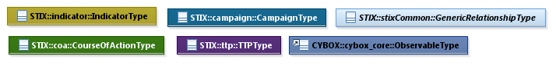
Figure 1-2. Data model color coding

Property Table Notation
Throughout Section 3, tables are used to describe the properties of each data model class. Each property table consists of a column of names to identify the property, a type column to reflect the datatype of the property, a multiplicity column to reflect the allowed number of occurrences of the property, and a description column that describes the property. Package prefixes are provided for classes outside of the Indicator data model (see Section 1.2.2).
Note that if a class is a specialization of a superclass, only the properties that constitute the specialization are shown in the property table (i.e., properties of the superclass will not be shown). However, details of the superclass may be shown in the UML diagram.

Property and Class Descriptions
Each class and property defined in STIX is described using the format, “The X property verb Y.” For example, in the specification for the STIX Indicator, we write, “The id property specifies a globally unique identifier for the kill chain instance.” In fact, the verb “specifies” could have been replaced by any number of alternatives: “defines,” “describes,” “contains,” “references,” etc.
However, we thought that using a wide variety of verb phrases might confuse a reader of a specification document because the meaning of each verb could be interpreted slightly differently. On the other hand, we didn’t want to use a single, generic verb, such as “describes,” because although the different verb choices may or may not be meaningful from an implementation standpoint, a distinction could be useful to those interested in the modeling aspect of STIX.
Consequently, we have chosen to use the three verbs, defined as follows, in class and property descriptions:
Verb | STIX Definition
captures | Used to record and preserve information without implying anything about the structure of a class or property. Often used for properties that encompass general content. This is the least precise of the three verbs.
Examples:
The Source property characterizes the source of the sighting information. Examples of details captured include identitifying characteristics, time-related attributes, and a list of the tools used to collect the information.
The Description property captures a textual description of the Indicator.
characterizes | Describes the distinctive nature or features of a class or property. Often used to describe classes and properties that themselves comprise one or more other properties.
Examples:
The Confidence property characterizes the level of confidence in the accuracy of the overall content captured in the Incident.
The ActivityType class characterizes basic information about an activity a defender might use in response to a Campaign.
specifies | Used to clearly and precisely identify particular instances or values associated with a property. Often used for properties that are defined by a controlled vocabulary or enumeration; typically used for properties that take on only a single value.
Example:
The version property specifies the version identifier of the STIX Campaign data model used to capture the information associated with the Campaign.

Terminology
The key words “MUST”, “MUST NOT”, “REQUIRED”, “SHALL”, “SHALL NOT”, “SHOULD”, “SHOULD NOT”, “RECOMMENDED”, “MAY”, and “OPTIONAL” in this document are to be interpreted as described in [RFC2119].

Normative References
[RFC2119] Bradner, S., “Key words for use in RFCs to Indicate Requirement Levels”, BCP 14, RFC 2119, March 1997. http://www.ietf.org/rfc/rfc2119.txt.

Background Information
In this section, we provide high level information about the Indicator data model that is necessary to fully understand the Indicator data model specification details given in Section 3.

Indicator-Related Component Data Models
As will be explicitly detailed in Section 3, a STIX Indicator leverages four other top-level STIX component constructs, namely Campaign, Course of Action, Observable (as defined with the CybOX Language; see Section 2.2.1), and TTP (as indicated by the outward-oriented arrows). Figure 2-1 illustrates the relationship between the Indicator and the other core constructs. As stated in Section 1.1, each of these components is defined in a separate specification document.
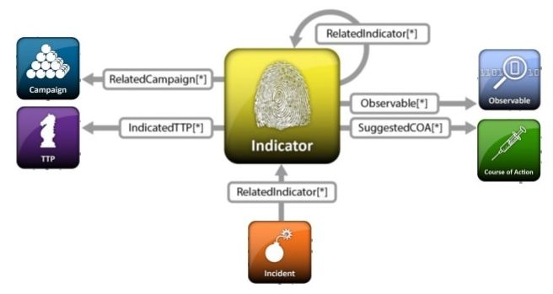
Figure 2-1. High level view of the Indicator data model
In this section, we give a high level summary of the relationship between the Indicator data model and the other components to which an Indicator may refer. We also make note of the fact that the Indicator data model can be self-referential. Other relationships shown in the diagram are defined in the specification of the component that they originate from.
- Campaign
A STIX Campaign represents a set of TTPs, Incidents, or Threat Actors that together express a common intent or desired effect. For example, an adversary using a particular set of TTPs (malware and tools) to target an industry sector with a specific intent may constitute a Campaign. In the STIX data model, a Campaign represents both that intent itself and, perhaps more importantly, acts as a meta-construct to capture the associated TTPs, incidents, and Threat Actors that are part of that Campaign. Please see STIX Version 1.2.1 Part 8: Campaign for details.
The Indicator data model references the Campaign data model as a means to identify Campaigns for which the Indicator may be relevant.
- Course of Action
A STIX Course of Action (COA) is used to convey information about courses of action that may be taken either in response to an attack or as a preventative measure prior to an attack. A Course of Action component captures a variety of information such as the Course of Action’s objective, likely impact, efficacy, and cost. Please see STIX Version 1.2.1 Part 9: Course of Action for details.
The Indicator data model references the Course of Action data model as a means to identify Courses of Action that may be appropriate for responding to the Indicator.
- Observable
A STIX Observable (as defined with the CybOX Language) represents stateful properties or measurable events pertinent to the operation of computers and networks. Implicit in this is a practical need for descriptive capability of two forms of observables: “observable instances” and “observable patterns.” Observable instances represent actual specific observations that took place in the cyber domain. The property details of this observation are specific and unambiguous. Observable patterns represent conditions for a potential observation that may occur in the future or may have already occurred and exists in a body of observable instances. These conditions may be anything from very specific concrete patterns that would match very specific observable instances to more abstract generalized patterns that have the potential to match against a broad range of potential observable instances.
The Indicator data model leverages the Observable data model to specify the observable pattern that forms the core of a STIX Indicator.
- Indicator
The Indicator data model is self-referential, enabling one Indicator to reference other Indicators that are asserted to be related. Self-referential relationships between Indicators may indicate general associativity or can be used to indicate relationships beween different versions of the same Indicator.
- Tactics, Techniques and Procedures (TTP)
A STIX Tactics, Techniques, and Procedures (TTP) is used to represent the behavior or modus operandi of cyber adversaries. Please see STIX Version 1.2.1 Part 5: TTP for details.
The Indicator data model references the TTP data model as a means to identify sets of specific TTPs that the presense of the Indicator observable pattern may indicate.

Indicator Patterns
Each STIX Indicator contains an observable pattern that can matched upon (“triggered”) where the pattern can be defined using the STIX Observable component (specified as a CybOX pattern, which corresponds to an Observable belonging to the CybOX ObservableType class; see Section 2.2.1) and/or through a provided extension point for other pattern definition formats (non-CybOX pattern, which corresponds to a test mechanism belonging to the STIX Indicator TestMechanismType class; see Section 3.4.1).
It is valid for an Indicator to include both a CybOX Observable-based pattern as well as one or more test mechanisms, which provide proprietary representations of the pattern (e.g., a YARA rule and/or an OVAL rule as an extension to the TestMechanismType class). In this case, the patterns defined by the test mechanism MUST semantically match the pattern defined by the Observable to the extent possible given the test mechanism language and the CybOX pattern language, however enforcement of such matching is outside the scope of STIX.

CybOX^{[TM]} Observables
We will not give specification information for the CybOX ObservableType class, and instead we refer the reader to the appropriate CybOX specification documents. However, for a full understanding of the STIX Indicator data model, it is necessary to explain the role of the CybOX Observable property, which is used to specify a relevant cyber observable pattern for an Indicator.
A CybOX Observable pattern can either be on a CybOX Object with type corresponding to the CybOX ObjectType class (e.g., a File with name X), on a CybOX Event with type corresponding to the CybOX EventType class (an Event is typically one or more actions taken against one or more Objects; e.g., “delete the File with name X”), or as an Observable Composition with type corresponding to the CybOX ObservableCompositionType class.
The ObservableCompositionType class enables a content creator to define a composite Observable pattern expression through the specification of a single Boolean operator (the operator of the expression) and a list of simple (non-composition) Observable patterns (the operands of the expression).
More complex Observable compositions (of the ObservableCompositionType class) can be created using multiple simple Observable patterns and/or other Observable compositions. For example, it may be desired to express the Observable Composition, OC_{X} = O_{A} AND (E_{A} OR E_{B}). The Observable (O_{A}) and each of the two Events (E_{A} and E_{B}) would be created individually, and then one Observable Composition would be defined as OC_{A} = E_{A} OR E_{B}. This permits OC_{X} to be rewritten as OC_{X} = O_{A} AND OC_{A}. Note that this example shows just one or several possible constructions that generate OC_{X}.
The evaluation of a CybOX observable pattern can be found in the CybOX specification documents.

Simple and Composite Indicators
Similarly to how CybOX defines simple and composite Observable patterns, the STIX Indicator data model defines both simple and composite Indicator expressions. More specifically, a “simple” Indicator is defined as an Indicator with a single observable pattern defined (either via the CybOX-based Observable structure or via the Test Mechanism extension structure) and a single set of contextual information, and a “composite” Indicator is defined as an aggregate pattern (with its own contextual information) logically composed of other Indicators expressions (each with its own contextual information) using Boolean logic.
As the following example illustrates, more complex Indicator compositions can be created using multiple simple and/or other composite Indicators. Say we want to express the composite Indicator, CI_{X} = [I_{A} AND (I_{B} OR I_{C})] OR (I_{D} AND I_{E} AND I_{F}). Each of the six Indicators (I_{A} through I_{F}) would be created individually (i.e., as simple Indicators), and then two composite Indicators could be created where CI₁ = (I_{B} OR I_{C}) and CI₂ = (I_{D} AND I_{E} AND I_{F}). This permits CI_{X} to be rewritten as CI_{X} = [I_{A} AND CI₁] OR CI₂, which can be captured using one additional composite indicator: CI₃ = I_{A} AND CI₁. Finally, CI_{X} = CI₃ OR CI₂. Note that this example shows just one or several possible constructions that generate in CI_{X}.
As illustrated in our example, an Indicator composition may be built directly to support a desired use case. Alternatively, an Indicator composition can be built using other preexisting Indicators, which were possibly created by different producers. The particular circumstances will likely dictate the depth and variety of other content that is captured in the individual Indicators.
The need for composite Indicators is motivated by the fact that a pattern associated with an Indicator is either matched or not matched; a single, composite observable pattern will not provide partial information. For example, assume that we have defined an Indicator that uses a CybOX Observable Composition that corresponds to “Filename = X AND Mutex = Y.” It is necessary for both conditions to be true for the Indicator to trigger; the Indicator will not reveal whether one or the other or neither of the conditions is true. However, if each of the two conditions is captured as a separate Indicator, and those Indicators are combined to create a composite Indicator, then each of the Indicators can trigger individually and finer-grained results are achieved.

STIX^{[TM]} Indicator Data Model
The primary class of the STIX Indicator package is the IndicatorType class, which characterizes a cyber threat indicator by capturing an asserted relationship between a pattern identifying certain observable conditions and a particular TTP likely in play if those observable conditions are seen, as well as contextual information about how and when it should be acted on and how it relates to other Indicators, Campaigns, and TTPs. Similar to the primary classes of all of the component data models in STIX, the IndicatorType class extends a base class defined in the STIX Common data model; more specifically, it extends the IndicatorBaseType base class, which provides the essential identifier (id) and identifier reference (idref) properties.
The relationship between the IndicatorType class and the IndicatorBaseType base class, as well as the properties of the IndicatorType class, are illustrated in the UML diagram given in Figure 3-1.
Note that while all properties of the IndicatorType class are optional, the observable pattern (Indicator_Expression property) and the Indicated_TTP property SHOULD be present except in very rare and odd circumstances when their absence is justifiable.

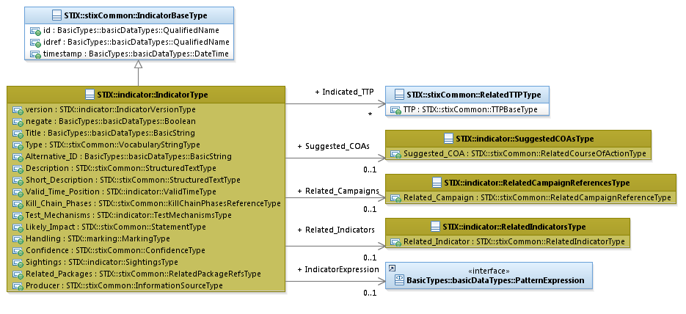
Figure 3-1. UML diagram of the IndicatorType class
The property table, which includes property descriptions and corresponds to the UML diagram above, is given in Table 3-1.
All classes defined in the Indicator data model are described in detail in Section 3.1 through Section 3.8. Details are not provided for classes defined in non-Indicator data models; instead, the reader is referred to the corresponding data model specification as indicated by the package prefix specified in the Type column of the table.
Table 3-1. Properties of the IndicatorType class
Name | Type | Multiplicity | Description
version | IndicatorVersionType | 0..1 | The version property specifies the version identifier of the STIX Indicator data model for STIX v1.2.1 used to capture the information associated with the Indicator.
negate | basicDataTypes:  Boolean | 0..1 | The negate property specifies whether the absence (true) or presence (false) of the pattern constitutes the Indicator. More explicitly, if the negate property is `false,’ then if the Indicator pattern is matched, the Indicator is true. However, if the negate property is `true,’ then if the Indicator pattern is not matched, the Indicator is true. Note that this property applies to the entire indicator, not to a specific part of the Indicator pattern. The default value is 'false.'
Title | basicDataTypes:  BasicString | 0..1 | The Title property captures a title for the Indicator and reflects what the content producer thinks the Indicator as a whole should be called. The Title property is typically used by humans to reference a particular Indicator; however, it is not suggested for correlation.
Type | stixCommon:  VocabularyStringType | 0..* | The Type property characterizes the type of the Indicator. Examples of potential values include malicious e-mail, URL watchlist, and malware artifacts (these specific values are only provided to help explain the Type property: they are neither recommended values nor necessarily part of any existing vocabulary). The content creator may choose any arbitrary value or may constrain the set of possible values by referencing an externally-defined vocabulary or leveraging a formally defined vocabulary extending from the stixCommon:ControlledVocabularyStringType class. The STIX default vocabulary class for use in the property is ‘IndicatorTypeVocab-1.1.’
Alternative_ID | basicDataTypes:  BasicString | 0..* | The Alternative_ID property specifies an alternative identifier or alias for the Indicator. The Alternative_ID property is not intended to capture a STIX identifier; instead, it should be used for capturing identifiers from external systems (e.g., an incident ID from an organization’s Remedy system or the rule ID of a Snort rule in the Snort community repository).
Description | stixCommon:  StructuredTextType | 0..* | The Description property captures a textual description of the Indicator. Any length is permitted. Optional formatting is supported via the structuring_format property of the StructuredTextType class.
Short_Description | stixCommon:  StructuredTextType | 0..* | The Short_Description property captures a short textual description of the Indicator. This property is secondary and should only be used if the Description property is already populated and another, shorter description is available.
Valid_Time_Position | ValidTimeType | 0..* | The Valid_Time_Position property specifies the time window for which this Indicator is valid.
IndicatorExpression | basicDataTypes:  PatternExpression | 0..1 | The IndicatorExpression property characterizes an observable pattern associated with the Indicator. The basicDataTypes:PatternExpression class is a UML interface, which can be realized using either the cybox:ObservableType class (see CybOX specification documents) or the CompositeIndicatorExpressionType class (see below for more details).
Indicated_TTP | stixCommon:RelatedTTPType | 0..* | The Indicated_TTP property specifies a TTP indicated by the presence of the observable pattern within this Indicator and characterizes the relationship between the TTP and the Indicator by capturing information such as the level of confidence that the observable pattern indicates the TTP, the source of the relationship information, and the type of relationship.
Kill_Chain_Phases | stixCommon:  KillChainPhasesReferenceType | 0..1 | The Kill_Chain_Phases property specifies a set of one or more kill chain phases (from one or more kill chains defined elsewere) relevant to the Indicator. The kill chain property is further defined in the STIX Common specification document. For more details on the cyber kill chain see STIX Version 1.2.1 Part 2: Common.
Test_Mechanisms | TestMechanismsType | 0..1 | The Test_Mechanisms property specifies a set of one or more test mechanisms effective at identifying the cyber Observable patterns characterized in the Indicator.
Likely_Impact | stixCommon:StatementType | 0..1 | The Likely_Impact property characterizes the probable impact if the TTP indicated by the presence of the indicator pattern were to occur, which includes a Value property that specifies the impact. Examples of potential impacts include none, minor, and moderate (these specific values are only provided to help explain the Value property: they are neither recommended impacts nor necessarily part of any existing vocabulary). The content creator may choose any arbitrary impact or may constrain the set of possible impacts by referencing an externally-defined vocabulary. The STIX default vocabulary class for use in the Value property is ‘ImpactRatingEnum-1.0.’
Suggested_COAs | SuggestedCOAsType | 0..1 | The Suggested_COA property specifies a Course of Action suggested for this Indicator and characterizes the relationship between the Course of Action and the Indicator by capturing information such as the level of confidence that the Course of Action and the Indicator are related, the source of the relationship information, and the type of relationship.
Handling | marking:MarkingType | 0..1 | The Handling property specifies data handling markings for the properties of this Indicator. The marking scope is limited to the Indicator and the content it contains. Note that data handling markings can also be specified at a higher level.
Confidence | stixCommon:ConfidenceType | 0..1 | The Confidence property characterizes the level of confidence that an observed instance of the defined observable pattern actually indicates the presence of the TTP. (Recall that an Indicator asserts a relationship between an observable pattern and a TTP.)
Sightings | SightingsType | 0..1 | The Sightings property characterizes sightings associated with the Indicator (observed instance). Information captured includes a sightings count and a set of zero or more sighting reports.
Related_Indicators | RelatedIndicatorsType | 0..1 | The Related_Indicators property specifies a set of one or more other Indicators related to this Indicator.
Related_Campaigns | RelatedCampaignReferencesType | 0..1 | The Related_Campaigns property specifies a set of one or more Campaigns for which the Indicator may be relevant.
Related_Packages | stixCommon:  RelatedPackagesRefsType | 0..1 | The Related_Packages property specifies a set of one or more Packages for which the Indicator may be relevant.
Producer | stixCommon:  InformationSourceType | 0..1 | The Producer property characterizes the source of the Indicator information. Examples of details captured include identitifying characteristics, time-related attributes, and a list of the tools used to collect the information.
As discussed in Section 3.3, the observable pattern associated with an Indicator can be expressed as a combination of other Indicators. This is characterized using the CompositeIndicatorExpressionType class, which models a compound Indicator expression through the specification of a single operator (the operator of the expression) and the capture of one or more Indicators (the operands of the expression). Eventually, these operands are simple observable patterns that can be represented using the cybox:ObservableType class. The content captured for the Observable pattern includes a cyber-relevant object, event, or observable composition, as well as a title, description, keywords, source information, and fidelity information. Please see the CybOX Core Specification document for details.
The modeling of Indicator pattern expressions is illustrated in the UML diagram in Figure 3-2.
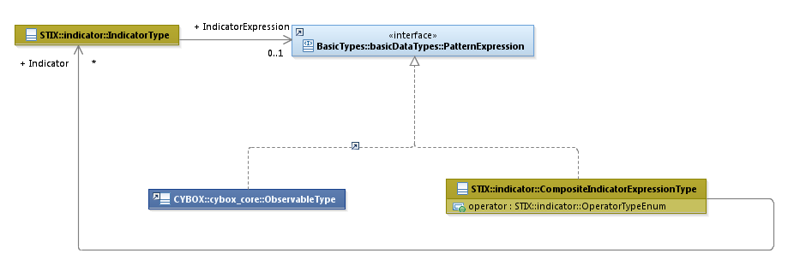
Figure 3-2. Modeling Indicator pattern expressions

IndicatorVersionType Enumeration
The IndicatorVersionType enumeration is an inventory of all versions of the Indicator data model for STIX Version 1.2.1. The enumeration literals are given in Table 3-2.
Table 3-2. Literals of the IndicatorVersionType enumeration
Enumeration Literal | Description
stix-1.2.1 | Indicator data model for STIX v1.2.1

ValidTimeType Class
The ValidTimeType class characterizes a temporal window during which the Indicator is able to accurately detect the TTP.
The properties of the ValidTimeType class are given in Table 3-3.
Table 3-3. Properties of the ValidTimeType class
Name | Type | Multiplicity | Description
Start_Time | stixCommon:  DateTimeWithPrecisionType | 0..1 | The Start_Time property specifies the beginning of the temporal window in which an Indicator is able to accurately detect the TTP. To avoid ambiguity, timestamps SHOULD include a specification of the time zone. In addition to capturing a date and time, the Start_Time property MAY also capture a precision property to specify the granularity with which the time should be considered, as specified by the DateTimePrecisionEnum enumeration (e.g., 'hour,' 'minute'). If the Start_Time property is not present, then there is no constraint on the earliest time for which the Indicator is able to accurately detect the TTP (i.e., the temporal window is only bounded by the End_Time property, if present).
End_Time | stixCommon:  DateTimeWithPrecisionType | 0..1 | The End_Time property specifies the end of the temporal window in which an Indicator is able to accurately detect the TTP. To avoid ambiguity, timestamps SHOULD include a specification of the time zone. In addition to capturing a date and time, the End_Time property MAY also capture a precision property to specify the granularity with which the time should be considered, as specified by the DateTimePrecisionEnum enumeration (e.g., 'hour,' 'minute'). If the End_Time property is not present, then there is no constraint on the latest time for which the Indicator is able to accurately detect the TTP (i.e., the temporal window is only bounded by the Start_Time property, if present).

CompositeIndicatorExpressionType Class
The CompositeIndicatorExpressionType class characterizes a composite Indicator expression through the specification of a single operator (the operator of the expression) and zero or more Indicators (the operands of the expression).
The properties of the CompositeIndiatorExpressionType class are given in Table 3-4.
It should be noted that each simple Indicator can “trigger” individually and independently of whether a related composite Indicator triggers. A composite Indicator will trigger only when the full specified logic on the set of individual Indicators that it comprises triggers.
Table 3-4. Properties of the CompositeIndicatorExpressionType class
Name | Type | Multiplicity | Description
operator | OperatorTypeEnum | 1 | The operator property specifies the logical composition operator for the composite Indicator expression. The enumeration that defines valid operators in the Indicator v2.2 data model contains the operators AND and OR.
Indicator | IndicatorType | 0..* | The Indicator property characterizes a cyber threat indicator by capturing an asserted relationship between a pattern identifying certain observable conditions and a particular TTP likely in play if those observable conditions are seen, as well as contextual information about how and when it should be acted on and how it relates to other Indicators, Campaigns, and TTPs.

OperatorTypeEnum Enumeration
The OperatorTypeEnum enumeration is an inventory of valid operators for the CompositeIndicatorExpressionType class, which is used to define a compound Indicator expression. The enumeration literals are given in Table 3-5.
Table 3-5. Literals of the OperatorTypeEnum enumeration
Enumeration Literals | Description
AND | Logical AND operator
OR | Logical OR operator

TestMechanismsType Class
A test mechanism is an alternative (non-CybOX) method of expressing an observable pattern; examples include Snort rules, Yara rules, and OVAL definitions. Test mechanisms may be provided by content producers to support consumers who rely on the relevant underlying tools and methods in their operations. An Indicator may contain both a CybOX-based Observable pattern (or a Composite Indicator Expression) and one or more semantically equivalent test mechanisms where equivalency means that the test mechanisms trigger on the same conditions as the Observable (note that this equivalency is not enforced by STIX). Just as an Indicator may contain an Observable or Composite Indicator without a test mechanism, it is also possible for an Indicator to contain one or more test mechanisms without containing an Observable or Composite Indicator Expression, in which case the Indicator relies solely on non-CybOX pattern matching. Please see Sections 2.2 and 2.3 for additional information.
The TestMechanismsType class specifies a set of one or more test mechanisms effective at identifying the cyber observable pattern characterized in the Indicator. The property of the TestMechanismsType class is shown in Table 3-6.
Table 3-6. Properties of the TestMechanismsType class
Name | Type | Multiplicity | Description
Test_Mechanism | TestMechanismType | 1..* | The Test_Mechanism property characterizes an alternative (non-CybOX) test mechanism representation for the desired observable pattern of the Indicator. Its underlying abstract class MUST be extended to enable the expression of a structured or unstructured test mechanism (e.g., Snort, OVAL).

TestMechanismType Class
The TestMechanismType class characterizes an alternative (non-CybOX) test mechanism effective for representing the desired observable pattern of the Indicator. It is an abstract class, so it MUST be extended via a subclass to enable the expression of any structured or unstructured test mechanism. STIX v1.2.1 provides five default subclasses; please refer to STIX Version 1.2.1 Part 12: Default Extensions.
The TestMechanismType class is illustrated in Figure 3-3 (note that qualified names are not provided for the five default subclasses due to space considerations).
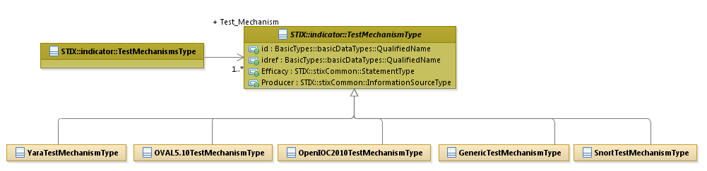Figure 3-3. UML diagram of the TestMechanismType class
Test mechanisms may be different for different use cases. For example, one consumer may routinely rely on Snort signatures while another uses Yara rules and OVAL definitions. As stated previously, individual test mechanisms are intended to test for the same conditions as the Observable (CybOX) patterns; however, STIX does not enforce equivalency.
As listed in Table 3-7, the five default subclasses and their descriptions are defined as possible extensions to the TestMechanismType class. Additional formats can be used by either specifying the test mechanism in the Specification property of the GenericTestMechanismType class or by defining a new subclass of the TestMechanismType class. Each of the extensions is further defined in STIXTM Version 1.2.1 Part 12: Default Extensions.
Table 3-7. Default subclass extensions of the TestMechanismType class
Subclasses | Description
GenericTestMechanismType | The Generic test mechanism allows for the specification of any generic test mechanism through the use of a raw data section (via the Specification property).
OpenIOC2010TestMechanismType | The OpenIOC test mechanism allows for the specification of an OpenIOC test by importing the OpenIOC schema.
Data model | OpenIOC (http://www.openioc.org/#schema)
OVAL5.10TestMechanismType | The OVAL test mechanism allows for the specification of an OVAL definition through importing the OVAL schemas.
Data model | OVAL (http://oval.mitre.org/language/version5.10.1/)
SnortTestMechanismType | The Snort test mechanism allows for the specification of a snort signature through the use of raw data sections.
Signatures | https://www.snort.org/downloads/#rule-downloads
YaraTestMechanismType | The YARA test mechanism allows for the specification of a YARA test through the use of a raw data section (via the Rule property).
Signatures | https://github.com/plusvic/yara/releases/tag/v3.1.0

The properties of the TestMechanismType class are given in Table 3-8.
Table 3-8. Properties of the TestMechanismType class
Name | Type | Multiplicity | Description
id | basicDataTypes:  QualifiedName | 0..1 | The id property specifies a globally unique identifier for the test mechanism instance.
idref | basicDataTypes:  QualifiedName | 0..1 | The idref property specifies an identifier reference to a test mechanism instance specified elsewhere. When the idref property is used, the id property MUST NOT also be specified and the other properties of the TestMechanismType class MUST NOT hold any content.
Efficacy | stixCommon:StatementType | 0..1 | The Efficacy property characterizes a measure of the likely effectiveness of a TestMechanismType instance to detect the targeted cyber observable pattern, which includes a Value property that specifies the level of effectiveness. Examples of potential levels include high, medium, and low (these specific values are only provided to help explain the Value property: they are neither recommended values nor necessarily part of any existing vocabulary). The content creator may choose any arbitrary value or may constrain the set of possible levels by referencing an externally-defined vocabulary. The STIX default vocabulary class for use in the Value property is ‘HighMediumLowVocab-1.0.’
Producer | stixCommon:  InformationSourceType | 0..1 | The Producer property chacterizes the source of the test mechanism information. Examples of details captured include identitifying characteristics, time-related attributes, and a list of the tools used to collect the information.

SuggestedCOAsType Class
The SuggestedCOAsType class specifies one or more suggested Courses of Action that could be taken if the Indicator is sighted. It extends the GenericRelationShipListType superclass defined in the STIX Common data model, which specifies the scope (whether the elements of the set are related individually or as a group).
The UML diagram corresponding to the SuggestedCOAsType class is shown in Figure 3-4.
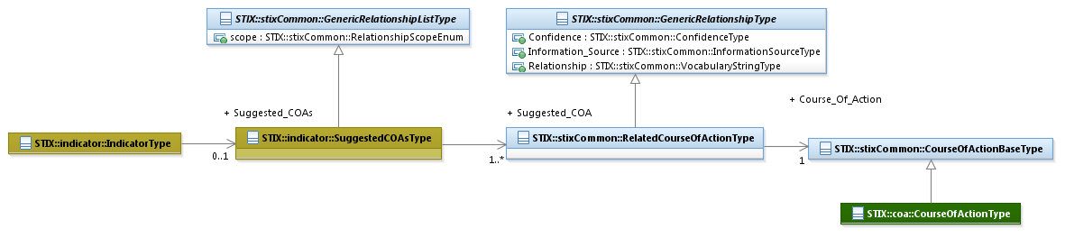
Figure 3-4. UML diagram of the SuggestedCOAsType class
The property table given in Table 3-9 corresponds to the UML diagram shown in Figure 3-4.
Table 3-9. Properties of the SuggestedCOAsType class
Name | Type | Multiplicity | Description
Suggested_COA | stixCommon:  RelatedCourseOfActionType | 1..* | The Suggested_COA property specifies a Course of Action suggested for this Indicator and characterizes the relationship between the Course of Action and the Indicator. The relationship between the Course of Action and the Indicator is characterized by capturing information such as the level of confidence that the Course of Action and the Indicator are related, the source of the relationship information, and the type of relationship.

SightingsType Class
The SightingsType class characterizes the sightings of the Indicator by capturing the number of sightings and a set of zero or more sighting reports (see Section 3.6.1 for details on what constitutes an Indicator sighting report). The properties of the SightingsType class are shown in Table 3-10, and the classes defining the associated property types are discussed in Sections 3.6.1 and 3.6.1.1.
Table 3-10. Properties of the SightingsType class
Name | Type | Multiplicity | Description
sightings_count | Integer | 0..1 | The sightings_count property specifies the total number of times the Indicator was sighted.
Sighting | SightingType | 0..* | The Sighting property characterizes a single sighting report for the Indicator. Note that this property can occur zero times because it’s possible to just count the sightings, not capture any.

SightingType Class
The SightingType class characterizes a single sighting report for an Indicator. An Indicator sighting report may capture a variety of information associated with an observable instance that matches the Indicator’s observable pattern including the time the sighting occurred, a textual description of the sighting, the set of Observables (instances) related to the sighting, the source of the sighting information (e.g., tool or an analyst name), and the level of confidence that the sighting information actually represents a sighting of that particular Indicator.
Properties of the class are given in Table 3-11. Please see Figure 3-5 in Section 3.6.1.1 for a diagram illustrating the role of the SightingType class.
Table 3-11. Properties of the SightingType class
Name | Type | Multiplicity | Description
timestamp | basicDataTypes:DateTime | 0..1 | The timestamp property specifies the date and time of the Indicator sighting. To avoid ambiguity, all timestamps SHOULD include a specification of the time zone.
timestamp_precision | stixCommon:  DateTimePrecisionEnum | 0..1 | The timestamp_precision property specifies the granularity with which the timestamp property should be considered, as specified by the DateTimePrecisionEnum enumeration (e.g., 'hour,' 'minute'). If omitted, the default precision is ‘second.’ Digits in a timestamp that are beyond the specified precision should be zeroed out.
Source | stixCommon:  InformationSourceType | 0..1 | The Source property characterizes the the organization or tool that is the source of the sighting of the sighting information. Examples of details captured include identitifying characteristics, time-related attributes, and a list of the tools used to collect the information.
Reference | basicDataTypes:URI | 0..1 | The Reference property specifies a formal reference to an external description of the sighting through the capture of a Uniform Resource Locator (URL).
Confidence | stixCommon:ConfidenceType | 0..1 | The Confidence property characterizes the level of confidence that the observed instance of the Sighting actually matches the Indicator pattern.
Description | stixCommon:StructuredTextType | 0..* | The Description property captures a textual description of the Indicator sighting. Any length is permitted. Optional formatting is supported via the structuring_format property of the StructuredTextType class.
Related_Observables | RelatedObservablesType | 0..1 | The Related_Observables property specifies a set of one or more Observable instances that represent the observations for this Indicator sighting.

RelatedObservablesType Class
The RelatedObservablesType class specifies one or more CybOX Observables (instances) representing the actual observations that are believed to be a match for the Indicator observable pattern. It extends the GenericRelationShipListType superclass defined in the STIX Common data model, which specifies the scope (whether the elements of the set are related individually or as a group).
The UML diagram corresponding to the RelatedObservablesType class is shown in Figure 3-5.
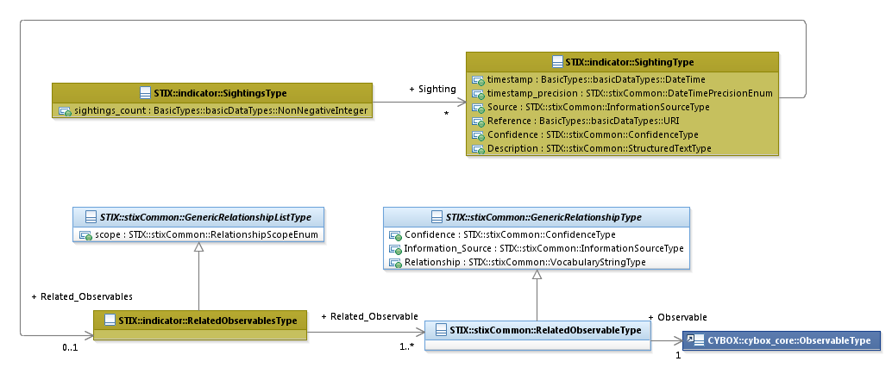
Figure 3-5. UML diagram of the RelatedObservablesType class
The property table given in Table 3-12 corresponds to the UML diagram shown in Figure 3-5.
Table 3-12. Properties of the RelatedObservablesType class
Name | Type | Multiplicity | Description
Related_Observable | stixCommon:  RelatedObservableType | 1..* | The Related_Observable property specifies an Observable instance that represents the observation for this Indicator sighting and characterizes the relationship between the Observable and the Indicator sighting by capturing information such as the level of confidence that the Observable accurately characterizes the observation for the Indicator sighting, the source of the relationship information, and the type of relationship.

RelatedIndicatorsType Class
The RelatedIndicatorsType class specifies a set of one or more other Indicators asserted to be related to this Indicator and therefore is a self-referential relationship. It extends the GenericRelationshipListType superclass defined in the STIX Common data model, which specifies the scope (whether the elements of the set are related individually or as a group).
The UML diagram corresponding to the RelatedIndicatorsType class is shown in Figure 3-6.
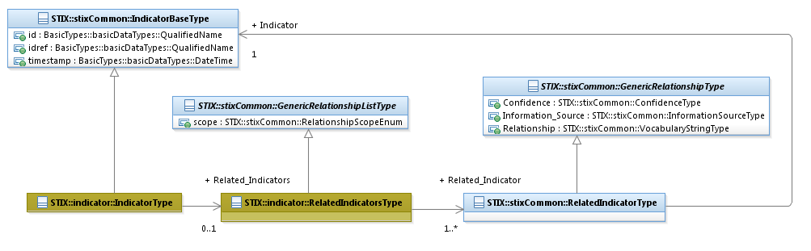
Figure 3-6. UML diagram of the RelatedIndicatorsType class
The property table given in Table 3-13 corresponds to the UML diagram given in Figure 3-6.
Table 3-13. Properties of the RelatedIndicatorsType class
Name | Type | Multiplicity | Description
Related_Indicator | stixCommon:RelatedIndicatorType | 1..* | The Related_Indicator property specifies another Indicator associated with this Indicator and characterizes the relationship between the Indicators by capturing information such as the level of confidence that the Indicators are related, the source of the relationship information, and type of the relationship. A relationship between Indicators may represent assertions of general associativity or different versions of the same Indicator.

RelatedCampaignReferencesType Class
The RelatedCampaignReferencesType class specifies a set of one or more Campaigns for which the Indicator may be relevant. It extends the GenericRelationShipListType superclass defined in the STIX Common data model, which specifies the scope (whether the elements of the set are related individually or as a group).
The ability to define a direct relationship between an Indicator and a Campaign is provided for ease of use and may not always be appropriate. The more formal and always appropriate method for capturing such a relationship is to first define a relationship between the Indicator and a TTP and then to define a relationship from the TTP to the Campaign (which uses the TTP).
The UML diagram corresponding to the RelatedCampaignReferencesType class is shown in Figure 3-7.
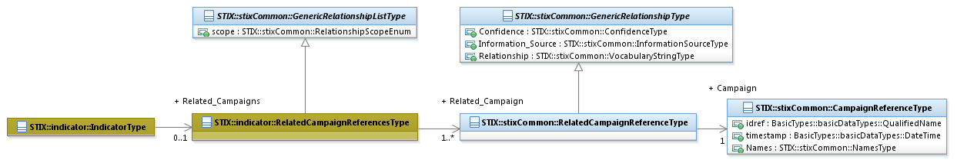
Figure 3-7. UML diagram of the RelatedCampaignReferencesType class
Note that the STIX Common RelatedCampaignReferencesType class is used instead of the STIX Common RelatedCampaignType class. As a result, an Indicator only references a Campaign by its Name property and/or its identifier; the Campaign is not directly embedded in the Indicator. (Compare this to how Related Indicators are captured; see Section 3.7.)
Table 3-14 shows the property of the RelatedCampaignReferencesType specialization and is associated with the UML diagram given in Figure 3-7.
Table 3-14. Properties of the RelatedCampaignReferencesType class
Name | Type | Multiplicity | Description
Related_Campaign | stixCommon:  RelatedCampaignReferenceType | 1..* | The Related_Campaign property specifies a Campaign for which the Indicator may be relevant. Unlike most other relationships that are defined in STIX, the underlying RelatedCampaignReferencesType class does not allow a Campaign to be embedded; an already-defined Campaign MUST be specified by its Name property and/or a reference to its identifier. The relationship between the Indicator and the Campaign is characterized by capturing information such as the level of confidence that the Indicator and the Campaign are related, the source of the relationship information, and the type of the relationship.

Conformance
Implementations have discretion over which parts (components, properties, extensions, controlled vocabularies, etc.) of STIX they implement (e.g., Indicator/Suggested_COAs).
[1] Conformant implementations must conform to all normative structural specifications of the UML model or additional normative statements within this document that apply to the portions of STIX they implement (e.g., Implementers of the entire TTP component must conform to all normative structural specifications of the UML model or additional normative statements within this document regarding the TTP component).
[2] Conformant implementations are free to ignore normative structural specifications of the UML model or additional normative statements within this document that do not apply to the portions of STIX they implement (e.g., Non-implementers of any particular properties of the TTP component are free to ignore all normative structural specifications of the UML model or additional normative statements within this document regarding those properties of the TTP component).
The conformance section of this document is intentionally broad and attempts to reiterate what already exists in this document. The STIX 1.2 Specifications, which this specification is based on, did not have a conformance section. Instead, the STIX 1.2 Specifications relied on normative statements and the non-mandatory implementation of STIX profiles. STIX 1.2.1 represents a minimal change from STIX 1.2, and in that spirit no requirements have been added, modified, or removed by this section.
- Acknowledgments
The following individuals have participated in the creation of this specification and are gratefully acknowledged:
Participants:
Dean Thompson, Australia and New Zealand Banking Group (ANZ Bank)
Bret Jordan, Blue Coat Systems, Inc.
Adnan Baykal, Center for Internet Security (CIS)
Jyoti Verma, Cisco Systems
Liron Schiff, Comilion (mobile) Ltd.
Jane Ginn, Cyber Threat Intelligence Network, Inc. (CTIN)
Richard Struse, DHS Office of Cybersecurity and Communications (CS&C)
Marlon Taylor, DHS Office of Cybersecurity and Communications (CS&C)
David Eilken, Financial Services Information Sharing and Analysis Center (FS-ISAC)
Sarah Brown, Fox-IT
Ryusuke Masuoka, Fujitsu Limited
Eric Burger, Georgetown University
Jason Keirstead, IBM
Paul Martini, iboss, Inc.
Jerome Athias, Individual
Terry MacDonald, Individual
Alex Pinto, Individual
Patrick Maroney, Integrated Networking Technologies, Inc.
Wouter Bolsterlee, Intelworks BV
Joep Gommers, Intelworks BV
Sergey Polzunov, Intelworks BV
Rutger Prins, Intelworks BV
Andrei Sîrghi, Intelworks BV
Raymon van der Velde, Intelworks BV
Jonathan Baker, MITRE Corporation
Sean Barnum, MITRE Corporation
Desiree Beck, MITRE Corporation
Mark Davidson, MITRE Corporation
Ivan Kirillov, MITRE Corporation
Jon Salwen, MITRE Corporation
John Wunder, MITRE Corporation
Mike Boyle, National Security Agency
Jessica Fitzgerald-McKay, National Security Agency
Takahiro Kakumaru, NEC Corporation
John-Mark Gurney, New Context Services, Inc.
Christian Hunt, New Context Services, Inc.
Daniel Riedel, New Context Services, Inc.
Andrew Storms, New Context Services, Inc.
John Tolbert, Queralt, Inc.
Igor Baikalov, Securonix
Bernd Grobauer, Siemens AG
Jonathan Bush, Soltra
Aharon Chernin, Soltra
Trey Darley, Soltra
Paul Dion, Soltra
Ali Khan, Soltra
Natalie Suarez, Soltra
Cedric LeRoux, Splunk Inc.
Brian Luger, Splunk Inc.
Crystal Hayes, The Boeing Company
Brad Butts, U.S. Bank
Mona Magathan, U.S. Bank
Adam Cooper, United Kingdom Cabinet Office
Mike McLellan, United Kingdom Cabinet Office
Chris O'Brien, United Kingdom Cabinet Office
Julian White, United Kingdom Cabinet Office
Anthony Rutkowski, Yaana Technologies, LLC

The authors would also like to thank the larger STIX Community for its input and help in reviewing this document.

- Revision History
Revision | Date | Editor | Changes Made
wd01 | 21 August 2015 | Sean Barnum Desiree Beck Aharon Chernin Rich Piazza | Initial transfer to OASIS template

The CybOX Observable data model is actually defined in the CybOX Language, not in STIX.

