
Customer Information Quality Specifications Version 3.0

Change Log Document
08 April 2008

Table of Contents
1 Changes to CIQ V3.0 Committee Specifications 3
1.1 Issue with xAL Version 3.0 XML Schema 3
1.1.1 NameType ComplexType as defined 3
1.1.2 How NameType ComplexType is reused and extended 4
1.1.3 Fix to xAL.xsd Version 3.0 4
1.1.4 Impact to existing implementations of xAL.xsd Version 3.0 5
1.1.5 Implementing the fix to CIQ V3.0 released in November 2007 5
1.2 Wrong Case for File Names imported by xNAL.xsd 5
1.2.1 Fix to xNAL.xsd 5
A. Acknowledgements 6
B. Revision History 7

Changes to CIQ V3.0 Committee Specifications
The following section lists all changes to OASIS CIQ V3.0 Committee Specifications that were released in November 2007.

Issue with xAL Version 3.0 XML Schema
Version 3.0 of extensible Address Language (xAL.xsd) was released as part of the OASIS Customer Information Quality Version 3.0 Committee Specifications in November 2007.
Implementation of the schema by one of the end user revealed that a minor issue exists with the XML schema. In the xAL schema, the issue was identified with the “AdministrativeArea”, “SubAdministrativeArea”, “Locality”, “SubLocality”, “Premises” and “Thoroughfare” elements. A “NameType” element has been defined as a Complex Type with Simple Content in the schema and this has been reused as a Complex Type with Complex Content by the above elements and this NameType element’s attributes are extended. Mixing of ComplexType with SimpleContent and ComplexContent is a grey area in the W3C Recommendation document. Therefore, the current CIQ schema does not violate any normative statements in the Recommendation. However, some tools complain about this mix up and mixing up the content types with complex types is not a god practice.

NameType ComplexType as defined

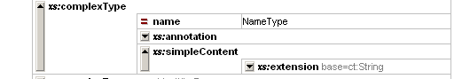

How NameType ComplexType is reused and extended
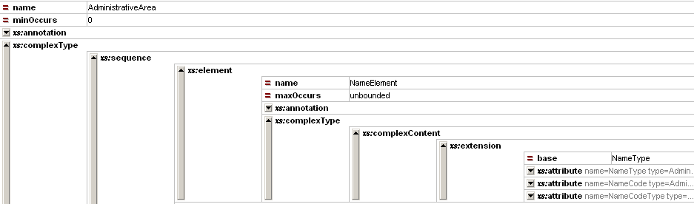

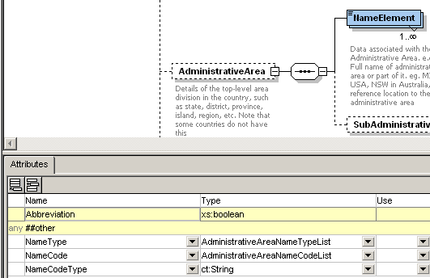
Extended
Re-used

Fix to xAL.xsd Version 3.0

In order to avoid this confusion of extending a "complex type definition with simple content" into a "complex type definition with complex content" (i.e., by adding particles) and given that xAL.xsd uses the
tag <simpleContent> in some places and the tag <complexContent> in other places, to define different extensions of the same type (which is a complex type with simple content), it was decided to clean this minor issue.
The “NameType” ComplexType element was removed from xAL.xsd. All elements that re-used (see the list below) the “NameType” ComplexType elements in “xAL.xsd” was removed and instead was defined individually for the following elements in “xAL.xsd”:
- Country->NameElement (ComplexType)
- AdministrativeArea->NameElement
- SubAdministratievArea->NameElement
- Locality->NameElement
- SubLocality->NameElement
- Thoroughfare->NameElement (Complex Type)
- Premises->NameElement (CompelxType)

Defined for each element listed above and not re-used
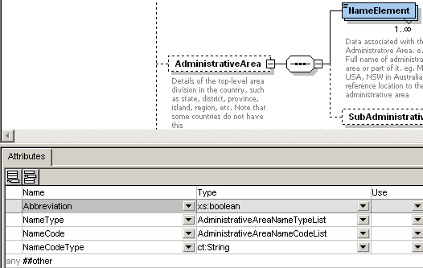
Defined for each element listed above and not re-used

Impact to existing implementations of xAL.xsd Version 3.0
Any code generated out of xAL.xsd version 3.0 requires re-generation of the code using the fixedxAL.xsd. This impact does not affect the XML documents generated/created in anyway.

Wrong Case for File Names imported by xNAL.xsd
V3.0 of xNAL.xsd imports two files namely, xNL.xsd and xAL.xsd. The import statement defined in xNAL.xsd is as follows:
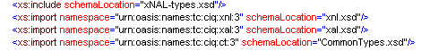
The actual physical file names are “xNL.xsd” and “xAL.xsd”.

Fix to xNAL.xsd
The fix to xNAL.xsd is as follows:
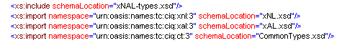

Implementing the fix to CIQ V3.0 Committee Specification Package released in November 2007
A new release of CIQ V3.0 (committee specification 02) includes these fixes. A document titled, “CIQ V3.0 – Installing fixes to CIQ V3.0 Committee Specifications” (File Name: “installing-fixes-to-ciqv3-cs”) available under “supp” directory of this package explains how to install the fixes as part of V3.0 of CIQ Specification package that was released in November 2007.

- Acknowledgements
Special thanks to members of the Emergency Management Technical Committee of OASIS (http://www.oasis-open.org/committees/emergency) for identifying this issue with xALv3.0 schema in January 2008.

- Revision History
Revision | Date | Editor | Changes Made
V3.0 Change Log Document v0.1 | 07 February 2008 | Ram Kumar | Initial Version
V3.0 Change Log Document v0.2 | 18 March 2008 | Ram Kumar | Released as part of CIQ V3.0 Committee Draft 02
V3.0 Change Log Document v0.3 | 08 April 2008 | Ram Kumar | Released as part of CIQ V3.0 Public Review Draft 03

