
Cloud Application Management for Platforms Version 1.2
Committee Specification Draft 01 /
Public Review Draft 01
12 May 2017
Specification URIs
This version:
http://docs.oasis-open.org/camp/camp-spec/v1.2/csprd01/camp-spec-v1.2-csprd01.pdf (Authoritative)
http://docs.oasis-open.org/camp/camp-spec/v1.2/csprd01/camp-spec-v1.2-csprd01.html
http://docs.oasis-open.org/camp/camp-spec/v1.2/csprd01/camp-spec-v1.2-csprd01.doc
Previous version:
N/A
Latest version:
http://docs.oasis-open.org/camp/camp-spec/v1.2/camp-spec-v1.2.pdf (Authoritative)
http://docs.oasis-open.org/camp/camp-spec/v1.2/camp-spec-v1.2.html
http://docs.oasis-open.org/camp/camp-spec/v1.2/camp-spec-v1.2.doc
Technical Committee:
OASIS Cloud Application Management for Platforms (CAMP) TC
Chair:
Anish Karmarkar (anish.karmarkar@oracle.com), Oracle
Editors:
Jacques Durand (jdurand@us.fujitsu.com), Fujitsu Limited
Adrian Otto (adrian.otto@rackspace.com), Rackspace Hosting, Inc.
Gilbert Pilz (gilbert.pilz@oracle.com), Oracle
Tom Rutt (trutt@us.fujitsu.com), Fujitsu Limited
Related work:
This specification replaces or supersedes:
- Cloud Application Management for Platforms Version 1.1. Edited by Jacques Durand, Adrian Otto, Gilbert Pilz, and Tom Rutt. Latest version: http://docs.oasis-open.org/camp/camp-spec/v1.1/camp-spec-v1.1.html.
Test assertions for the normative statements in this specification are located at:
- Cloud Application Management for Platforms (CAMP) Test Assertions Version 1.1. Edited by Jacques Durand, Gilbert Pilz, Adrian Otto, and Tom Rutt. Latest version: http://docs.oasis-open.org/camp/camp-ta/v1.1/camp-ta-v1.1.html.
Abstract:
This document defines the artifacts and APIs that need to be offered by a Platform as a Service (PaaS) cloud to manage the building, running, administration, monitoring and patching of applications in the cloud. Its purpose is to enable interoperability among self-service interfaces to PaaS clouds by defining artifacts and formats that can be used with any conforming cloud and enable independent vendors to create tools and services that interact with any conforming cloud using the defined interfaces. Cloud vendors can use these interfaces to develop new PaaS offerings that will interact with independently developed tools and components.
Status:
This document was last revised or approved by the OASIS Cloud Application Management for Platforms (CAMP) TC on the above date. The level of approval is also listed above. Check the “Latest version” location noted above for possible later revisions of this document. Any other numbered Versions and other technical work produced by the Technical Committee (TC) are listed at https://www.oasis-open.org/committees/tc_home.php?wg_abbrev=camp#technical.
TC members should send comments on this specification to the TC’s email list. Others should send comments to the TC’s public comment list, after subscribing to it by following the instructions at the “Send A Comment” button on the TC’s web page at https://www.oasis-open.org/committees/camp/.
This Committee Specification Public Review Draft is provided under the Non-Assertion Mode of the OASIS IPR Policy, the mode chosen when the Technical Committee was established. For information on whether any patents have been disclosed that may be essential to implementing this specification, and any offers of patent licensing terms, please refer to the Intellectual Property Rights section of the TC’s web page (https://www.oasis-open.org/committees/camp/ipr.php).
Note that any machine-readable content (Computer Language Definitions) declared Normative for this Work Product is provided in separate plain text files. In the event of a discrepancy between any such plain text file and display content in the Work Product's prose narrative document(s), the content in the separate plain text file prevails.
Citation format:
When referencing this specification the following citation format should be used:
[CAMP-v1.2]
Cloud Application Management for Platforms Version 1.2. Edited by Jacques Durand, Adrian Otto, Gilbert Pilz, and Tom Rutt. 12 May 2017. OASIS Committee Specification Draft 01 / Public Review Draft 01. http://docs.oasis-open.org/camp/camp-spec/v1.2/csprd01/camp-spec-v1.2-csprd01.html. Latest version: http://docs.oasis-open.org/camp/camp-spec/v1.2/camp-spec-v1.2.html.
Notices
Copyright © OASIS Open 2017. All Rights Reserved.
All capitalized terms in the following text have the meanings assigned to them in the OASIS Intellectual Property Rights Policy (the "OASIS IPR Policy"). The full Policy may be found at the OASIS website.
This document and translations of it may be copied and furnished to others, and derivative works that comment on or otherwise explain it or assist in its implementation may be prepared, copied, published, and distributed, in whole or in part, without restriction of any kind, provided that the above copyright notice and this section are included on all such copies and derivative works. However, this document itself may not be modified in any way, including by removing the copyright notice or references to OASIS, except as needed for the purpose of developing any document or deliverable produced by an OASIS Technical Committee (in which case the rules applicable to copyrights, as set forth in the OASIS IPR Policy, must be followed) or as required to translate it into languages other than English.
The limited permissions granted above are perpetual and will not be revoked by OASIS or its successors or assigns.
This document and the information contained herein is provided on an "AS IS" basis and OASIS DISCLAIMS ALL WARRANTIES, EXPRESS OR IMPLIED, INCLUDING BUT NOT LIMITED TO ANY WARRANTY THAT THE USE OF THE INFORMATION HEREIN WILL NOT INFRINGE ANY OWNERSHIP RIGHTS OR ANY IMPLIED WARRANTIES OF MERCHANTABILITY OR FITNESS FOR A PARTICULAR PURPOSE.
OASIS requests that any OASIS Party or any other party that believes it has patent claims that would necessarily be infringed by implementations of this OASIS Committee Specification or OASIS Standard, to notify OASIS TC Administrator and provide an indication of its willingness to grant patent licenses to such patent claims in a manner consistent with the IPR Mode of the OASIS Technical Committee that produced this specification.
OASIS invites any party to contact the OASIS TC Administrator if it is aware of a claim of ownership of any patent claims that would necessarily be infringed by implementations of this specification by a patent holder that is not willing to provide a license to such patent claims in a manner consistent with the IPR Mode of the OASIS Technical Committee that produced this specification. OASIS may include such claims on its website, but disclaims any obligation to do so.
OASIS takes no position regarding the validity or scope of any intellectual property or other rights that might be claimed to pertain to the implementation or use of the technology described in this document or the extent to which any license under such rights might or might not be available; neither does it represent that it has made any effort to identify any such rights. Information on OASIS' procedures with respect to rights in any document or deliverable produced by an OASIS Technical Committee can be found on the OASIS website. Copies of claims of rights made available for publication and any assurances of licenses to be made available, or the result of an attempt made to obtain a general license or permission for the use of such proprietary rights by implementers or users of this OASIS Committee Specification or OASIS Standard, can be obtained from the OASIS TC Administrator. OASIS makes no representation that any information or list of intellectual property rights will at any time be complete, or that any claims in such list are, in fact, Essential Claims.
The name "OASIS" is a trademark of OASIS, the owner and developer of this specification, and should be used only to refer to the organization and its official outputs. OASIS welcomes reference to, and implementation and use of, specifications, while reserving the right to enforce its marks against misleading uses. Please see https://www.oasis-open.org/policies-guidelines/trademark for above guidance.
Table of Contents
1 Introduction 10
1.0.1 IPR Policy 10
1.1 Overview 10
1.2 Purpose 10
1.3 Example (non-normative) 11
1.4 Non-Goals 12
1.5 Actors 12
1.6 Terminology 12
1.6.1 Term Definitions 12
1.6.1.1 CAMP Provider (Provider) 12
1.6.1.2 CAMP Consumer (Consumer) 12
1.6.2 Keywords, Conventions, and Normative Text 13
1.7 Notational Conventions 13
1.8 Specification Version 13
1.8.1 Backwards Compatibility 13
1.9 Normative References 13
1.10 Non-Normative References 14
2 Concepts and Types 16
2.1 Introduction 16
2.2 Resources 17
2.2.1 Platform 17
2.2.2 Assemblies 17
2.2.3 Components 18
2.2.4 Plans 18
2.2.5 Services 18
2.2.6 Collection and Factory Resources 18
2.2.7 Operations and Sensors 19
2.2.8 Resource Relationships 21
2.3 Deployment 21
2.4 Versions and Extensions 22
2.5 Parameters 24
2.6 CAMP Common Attribute Types 25
2.7 Representation Skew 26
2.8 External Management Resources 27
3 Application Management Lifecycle 28
3.1 Initial Platform Resources 28
3.2 Creating an Assembly from a PDP or Plan File 28
3.3 Creating an Assembly from a plan resource 29
3.4 Managing an Application Assembly 31
3.5 Removing Assemblies 31
4 Platform Deployment Package 32
4.1 PDP Package Structure 32
4.1.1 Supported Archive Formats 32
4.1.2 Validating Integrity 32
4.2 Plan Overview 32
4.2.1 Types 33
4.2.2 Requirement Specifications 33
4.2.3 Service Specifications 33
4.2.3.1 Shared Services 35
4.2.3.2 Service Frameworks 35
4.2.4 Names, Description, and Tags 36
4.3 Plan Schema 36
4.3.1 General Nodes 37
4.3.1.1 name 37
4.3.1.2 description 37
4.3.1.3 tags 37
4.3.2 Plan 37
4.3.2.1 camp_version 37
4.3.2.2 origin 37
4.3.2.3 artifacts 38
4.3.2.4 services 38
4.3.3 ArtifactSpecification 38
4.3.3.1 type 38
4.3.3.2 content 38
4.3.3.3 requirements 38
4.3.4 ContentSpecification 39
4.3.5 RequirementSpecification 39
4.3.5.1 type 40
4.3.5.2 fulfillment 40
4.3.6 ServiceSpecification 40
4.3.6.1 id 40
4.3.6.2 href 40
4.3.6.3 characteristics 41
4.3.7 CharacteristicSpecification 41
4.3.7.1 type 41
5 Resources 42
5.1 Required Attributes 42
5.2 Attribute Types 42
5.2.1 Boolean 42
5.2.2 String 42
5.2.3 Number 42
5.2.4 URI 42
5.2.5 Timestamp 42
5.3 CAMP Resource Type Inheritance 42
5.4 camp_resource Resource 43
5.4.1 uri 43
5.4.2 name 43
5.4.3 description 43
5.4.4 tags 43
5.4.5 representation_skew 43
5.4.6 external_management_resource 44
5.4.7 metadata 44
5.4.7.1 type_definition 44
5.4.7.2 mutable 44
5.4.7.3 consumer_mutable 45
5.5 HTTP Method Support 45
5.6 collection Resource 45
5.6.1 collection_type 46
5.6.2 total_items 46
5.6.3 items_per_page 46
5.6.4 start_index 46
5.6.5 items 47
5.7 platform_endpoints Collection 47
5.8 platform_endpoint Resource 47
5.8.1 platform 48
5.8.2 specification_version 48
5.8.3 backward_compatible_specification_versions 48
5.8.4 implementation_version 48
5.8.5 backward_compatible_implementation_versions 49
5.8.6 auth_scheme 49
5.9 platform Resource 49
5.9.1 supported_format_collection 50
5.9.2 extension_collection 50
5.9.3 type_definition_collection 50
5.9.4 platform_endpoints_collection 50
5.9.5 specification_version 51
5.9.6 implementation_version 51
5.9.7 assembly_factory 51
5.9.8 service_collection 51
5.9.9 plan_factory 51
5.10 assembly_factory Resource 51
5.10.1 parameter_definition_collection 52
5.11 assembly Resource 52
5.11.1 component_collection 53
5.11.2 plan 53
5.11.3 operation_collection 53
5.11.4 sensor_collection 53
5.12 component Resource 53
5.12.1 assembly_collection 54
5.12.2 artifact 54
5.12.3 service 54
5.12.4 status 54
5.12.5 related_component_collection 54
5.12.6 operation_collection 54
5.12.7 sensor_collection 55
5.13 service Resource 55
5.13.1 parameter_definition_collection 55
5.13.2 characteristics 55
5.14 plan_factory Resource 56
5.14.1 parameter_definition_collection 56
5.15 plan Resource 56
5.15.1 Advertising Support for the Plan Resource 58
5.16 format Resource 58
5.16.1 mime_type 58
5.16.2 version 59
5.16.3 documentation 59
5.16.4 Required JSON Format Resource 59
5.17 type_definition Resource 59
5.17.1 items 60
5.17.2 documentation 60
5.17.3 inherits_from_collection 60
5.18 attribute_definition Resource 60
5.18.1 documentation 60
5.18.2 attribute_type 61
5.18.3 required 61
5.19 parameter_definition Resource 61
5.19.1 parameter_type 61
5.19.2 required 61
5.19.3 default_value 62
5.19.4 parameter_extension 62
5.20 operation Resource 62
5.20.1 name 62
5.20.2 documentation 63
5.20.3 target_resource 63
5.20.4 parameter_definition_collection 63
5.21 sensor Resource 63
5.21.1 documentation 63
5.21.2 target_resource 64
5.21.3 sensor_type 64
5.21.4 value 64
5.21.5 units 64
5.21.6 timestamp 64
5.21.7 operation_collection 64
6 Protocol 65
6.1 Transfer Protocol 65
6.2 URI Space 65
6.3 Media Types 65
6.3.1 Required Formats 65
6.3.1.1 Duplicate Keys in JSON Objects 65
6.3.2 Supported Formats 65
6.4 Request Headers 66
6.5 Query String Parameters 66
6.6 POST Body Parameters 66
6.6.1 Parameter Handling 67
6.7 Response Headers 67
6.8 HTTP Status Codes 67
7 Operations 68
7.1 Deploying an Application 68
7.1.1 Deploying an Application by Reference 68
7.1.2 Deploying an Application by Value 69
7.1.2.1 Deploying an Application by Value Using MIME 69
7.1.2.2 Deploying an Application by Value Without MIME 70
7.2 Registering a Plan 70
7.2.1 Registering a Plan by Reference 70
7.2.2 Registering a Plan by Value 71
7.2.2.1 Registering a Plan by Value Using MIME 71
7.2.2.2 Registering a Plan by Value Without MIME 72
7.3 Retrieving Resources 72
7.3.1 Selecting Attributes on a GET 72
7.3.2 Selecting Attributes of the Resources in a Collection on a GET 72
7.3.2.1 Uniqueness of Resources in a Collection 73
7.3.3 Sorting Elements of a Collection 74
7.3.3.1 Sort Ordering 75
7.3.3.1.1 Boolean 75
7.3.3.1.2 String 75
7.3.3.1.3 Number 75
7.3.3.1.4 URI 75
7.3.3.1.5 Timestamp 75
7.3.4 Pagination of a Collection 75
7.3.5 Retrieving Index of an Item in a Collection 76
7.4 Updating Resources 76
7.4.1 Updating with PUT 76
7.4.1.1 Partial Updates with PUT 77
7.4.2 Updating with JSON Patch 77
7.4.3 Mutability of Resource Attributes 77
7.5 Stopping an Application Instance 77
8 Extensions 78
8.1 Unique Name Requirement 78
8.2 extension Resource 79
8.2.1 version 79
8.2.2 documentation 80
8.3 Extending Existing Resources 80
9 Conformance 81
9.1 CAMP Provider 81
9.2 CAMP Consumer 81
9.3 Platform Deployment Package 81
9.4 Plan 81
Appendix A. Acknowledgments 82
Appendix B. Glossary 83
Appendix C. Normative Statements 84
C.1 Mandatory Statements 84
C.2 Non-Mandatory Statements 91
Appendix D. Example Version Scheme 95
Appendix E. Revision History 96

Introduction

IPR Policy
This Committee Specification Public Review Draft is provided under the Non-Assertion Mode of the OASIS IPR Policy, the mode chosen when the Technical Committee was established.
For information on whether any patents have been disclosed that may be essential to implementing this specification, and any offers of patent licensing terms, please refer to the Intellectual Property Rights section of the TC’s web page (https://www.oasis-open.org/committees/camp/ipr.php).

Overview
Platform as a Service (PaaS) is a term that refers to a type of cloud computing in which the service provider offers customers/consumers access to one or more instances of a running application computing platform or application service stack. NIST defines PaaS [SP800-145] as a “service model” with the following characteristics:
The capability provided to the consumer is to deploy onto the cloud infrastructure consumer-created or acquired applications created using programming languages and tools supported by the provider. The consumer does not manage or control the underlying cloud infrastructure including network, servers, operating systems, or storage, but has control over the deployed applications and possibly application hosting environment configurations.
There are multiple commercial PaaS offerings in existence using languages such as Java, Python and Ruby and frameworks such as Spring, Django and Rails. Although these offerings differ in such aspects as programming languages, application frameworks, etc., there are inherent similarities in the way they manage the lifecycle of the applications that are targeted for, and deployed upon them. The core proposition of this specification is that these similarities can be leveraged to produce a generic application and platform management API that is language, framework, and platform neutral.
For PaaS consumers this management API would have the following benefits:
- “Portability between clouds” is emerging as one of the primary concerns of cloud computing. By standardizing the management API for the use cases around deploying, stopping, starting, and updating applications, this specification increases consumers’ ability to port their applications between PaaS offerings.
- It is likely that implementations of this specification will appear as plugins for application development environments (ADEs) and application management systems. Past experience has shown that, over time, such generic implementations are likely to receive more attention and be of higher quality than the implementations written for solitary, proprietary application management interfaces.
For PaaS providers this management API would have the following benefits:
- Because the strength and features of a PaaS offering’s application management API are unlikely to be perceived as key differentiators from other PaaS offerings, the existence of a consensus management API allows providers to leverage the experience and insight of the specification’s contributors and invest their design resources in other, more valuable areas.
- By increasing the portability of applications between PaaS offerings, this management API helps “grow the pie” of the PaaS marketplace by addressing one of the key pain points for PaaS consumers.

Purpose
This document defines the artifacts and APIs that need to be offered by a Platform as a Service (PaaS) cloud to manage the building, running, administration, monitoring and patching of applications in the cloud. Its purpose is to enable interoperability among self-service interfaces to PaaS clouds by defining artifacts and formats that can be used with any conforming cloud and enable independent vendors to create tools and services that interact with any conforming cloud using the defined interfaces. Cloud vendors can use these interfaces to develop new PaaS offerings that will interact with independently developed tools and components.
The following is a non-exhaustive list of the use cases which are supported by this specification.
- Building and packaging an application in a local Application Development Environment (ADE)
- Building an application in an ADE running in the cloud
- Importing a Platform Deployment Package into the cloud
- Uploading application artifacts into the cloud
- Run, stop, suspend, snapshot, and patch an application

Example (non-normative)
This example illustrates a scenario in which the application administrator wants to run and monitor an application.
The administrator does this by deploying the application, in the form of a Platform Deployment Package, to the platform. This is done by sending an HTTP POST request to the URL of the assembly_factory resource as shown below, where "/my_paas/assembly_factory" is this URL and "/my_paas/pkgs/1" is the location of the application package.
POST /my_paas/assembly_factory HTTP/1.1
Host: example.org
Content-Type: application/json
Content-Length: …
{
"pdp_uri": "/my_paas/pkgs/1"
}
On receiving such a request the platform unpacks the package, parses and validates the Plan file, resolves the service dependencies described by that Plan, and starts the application. On successful start the platform creates a new resource representing the running application and provides the URL of that resource "/my_paas/apps/1" in the response as shown below.
HTTP/1.1 201 Created
Location: http://example.org/my_paas/apps/1
Content-Type: …
Content-Length: …
…
The administrator can now monitor the running application by sending an HTTP GET request to the resource that represents the running application, which was obtained in the previous step ("/my_paas/apps/1").
GET /my_paas/apps/1 HTTP/1.1
Host: example.org
The response contains the JSON representation of the running application as shown below.
HTTP/1.1 200 OK
Content-Type: application/json
Content-Length: …
{
"uri": "http://example.org/my_paas/apps/1",
"name": "Hello Cloud App",
"description": "Hello Cloud Application Running in a PaaS Env",
"component_collection": http://example.org/collections/aad7,
"metadata": {
"type_definition": "http://example.org/my_paas/types/assembly",
"mutable": ["/name", "/description"],
"consumer_mutable": ["/description"]
}
}

Non-Goals
The interfaces exposed by the components and services in a PaaS system can be broadly split into two categories; functional interfaces and management interfaces. Functional interfaces are those that involve the specific utility provided by that component. For example, the interface used to submit a message to a message queuing service is as a functional interface. Management interfaces are those that deal with the administration of components. For example, the interface used to deploy and start an application on the platform is a management interface.
The specification of functional interfaces is out of scope for this document.

Actors
There are many actors for a PaaS environment. For the purposes of this specification we identify the following actors:
Application Developer: The person that builds and tests an application and presents the developed artifacts for deployment.
Application Administrator: The person that deploys applications and manages the application throughout its life-cycle.
Together these two actors make up the consumers of the management API described in this specification. This specification is intended mainly for Application Administrators, though it does constraint the artifacts that an Application Developer presents for deployment.
Platform Administrator: The person that manages the platform. This specification describes some of the functions of a Platform Administrator, though most of the functions of this actor are outside its scope.
Application End-User: A user of an application deployed on the platform. The interactions of the Application end-user and the application are outside the scope of this specification.
Extension Developer: The person who creates new Extensions for Platforms.

Terminology

Term Definitions

CAMP Provider (Provider)
A CAMP Provider (Provider) is an implementation of the service aspects of this specification.

CAMP Consumer (Consumer)
A CAMP Consumer (Consumer) is an implementation of the client aspects of this specification.

Keywords, Conventions, and Normative Text
The key words “MUST”, “MUST NOT”, “REQUIRED”, “SHALL”, “SHALL NOT”, “SHOULD”, “SHOULD NOT”, “RECOMMENDED”, “MAY”, and “OPTIONAL” in this document are to be interpreted as described in RFC 2119 [RFC2119].
Upper case versions of the RFC 2119 keywords are used in this document for emphasis. All text except examples, unless otherwise labeled, is normative. Normative statements that use these keywords have been highlighted as per this sentence. Each such statement has been given a unique tag in the following manner: [EX-00]. For convenience these statements have been tabulated and cross-indexed by their tags and appear in Appendix C. All examples, figures and notes in this document are informative. Unless marked otherwise text in this specification is normative.
See Section 9, “Conformance”, for details on Conformance to this specification.

Notational Conventions
The JSON and YAML descriptions that depict the representation of resources and the structure of Plans use a pseudo-schema notation with the following conventions:
- Characters are appended to items to indicate cardinality:
  - “?” (0 or 1)
  - “*” (0 or more)
  - “+” (1 or more)
Absent any indication of cardinality, the default cardinality of an element is “exactly 1”. The scope of these operators is the entire line on which they appear.
- Vertical bars, “|”, denote choice. For example, “a | b” means a choice between “a” and “b”.
- Parentheses, “(“ and “)”, are used to indicate the scope of the “|” operator.
- An expression in italics indicates a value whose type is indicated by the italicized expression. For example, “foo: String” indicates that the value of “foo” will be a String.
- Square brackets, “[]”, indicate an array of the type indicated by the expression preceding it. For example, “foo: String[]” indicates that the value of “foo” will be an array of Strings.
- An expression surrounded in angle brackets, “<” and “>”, indicates a value whose type is indicated either by some of field in the object or by other context information. For example, “foo: <sensor_type>” indicates that the type of the value of “foo” is provided by the value of the “sensor_type” attribute.
Note that the information presented in pseudo-schema is intended as a condensed guide and is subordinate to the textual descriptions of the nodes and objects that appear in those descriptions. In the event of a conflict (due to a typo or other editorial error) the text takes precedence over the pseudo-schema.

Specification Version
Each version of a CAMP specification is identified by a unique string termed the “Specification Version String”. The Specification Version String for this specification is “CAMP 1.2”.

Backwards Compatibility
This version of the CAMP specification is not backwards compatible with any previous version of the CAMP specification.

Normative References
[ISO 8601:2004] International Organization for Standardization, Geneva, Switzerland, “Data elements and interchange formats -- Information interchange - - Representation of dates and times”, March 2008. http://www.iso.org/iso/iso_catalogue/ catalogue_tc/catalogue_detail.htm?csnumber=40874
[OVF] DMTF DSP0243, “Open Virtualization Format Specification 2.0.1”, http://www.dmtf.org/sites/default/files/standards/documents/DSP0243_2.0.1.pdf
[RFC1952] Deutsch, P., "GZIP file format specification version 4.3", RFC 1952, May 1996. http://www.ietf.org/rfc/rfc1952.txt
[RFC2119] Bradner, S., “Key words for use in RFCs to Indicate Requirement Levels”, BCP 14, RFC 2119, March 1997. http://www.ietf.org/rfc/rfc2119.txt.
[RFC2616] Fielding, R., Gettys, J., Mogul, J., Frystyk, H., Masinter, L., Leach, P., and T. Berners-Lee, "Hypertext Transfer Protocol -- HTTP/1.1", RFC 2616, June 1999. http://www.ietf.org/rfc/rfc2616.txt
[RFC2818] E. Rescorla, “HTTP Over TLS”, RFC 2818, May 2000. http://www.ietf.org/rfc/rfc2818.txt
[RFC2388] Masinter, L., "Returning Values from Forms: multipart/form-data", RFC 2388, August 1998. http://www.ietf.org/rfc/rfc2388.txt
[RFC3986] Berners-Lee, T., Fielding, R., and L. Masinter, "Uniform Resource Identifier (URI): Generic Syntax", STD 66, RFC 3986, January 2005. http://www.ietf.org/rfc/rfc3986.txt
[RFC4346] Dierks, T. and E. Rescorla, "The Transport Layer Security (TLS) Protocol Version 1.1", RFC 4346, April 2006. http://www.ietf.org/rfc/rfc4346.txt
[RFC4627] Crockford, D., "The application/json Media Type for JavaScript Object Notation (JSON)", RFC 4627, July 2006. http://www.ietf.org/rfc/rfc4627.txt
[RFC5246] Dierks, T. and E. Rescorla, "The Transport Layer Security (TLS) Protocol Version 1.2", RFC 5246, August 2008. http://www.ietf.org/rfc/rfc5246.txt
[RFC5789] Dusseault, L. and J. Snell, "PATCH Method for HTTP", RFC 5789, March 2010. http://www.ietf.org/rfc/rfc5789.txt
[RFC6901] P. Bryan, K. Zyp, M. Nottingham, “JavaScript Object Notation (JSON) Pointer”, RFC 6901, April 2013. http://www.ietf.org/rfc/rfc6901.txt
[RFC6902] Bryan, P., Ed., and M. Nottingham, Ed., "JavaScript Object Notation (JSON) Patch", RFC 6902, April 2013. http://www.ietf.org/rfc/rfc6902.txt
[SHA256] FIPS PUB 180-4, Federal Information Processing Standards Publication, “Secure Hash Standard (SHS) (FIPS PUB 180-4)”, 6.2, SHA-256. http://csrc.nist.gov/publications/fips/fips180-4/fips-180-4.pdf
[TAR] IEEE Std 1003.1, 2004 Edition, Standard for Information Technology - Portable Operating System Interface (POSIX) http://ieeexplore.ieee.org/servlet/opac?punumber=9158
[YAML 1.1] Oren Ben-Kiki, Clark Evans, Brian Ingerson, “YAML Ain’t Markup Language (YAML) Version 1.1, 2005-01-18”. http://yaml.org/spec/1.1/. Also archived at http://xml.coverpages.org/yaml-spec-v1.1-archive-copy.html.
[ZIP] ZIP File Format Specification, http://www.pkware.com/documents/APPNOTE/APPNOTE-6.3.0.TXT

Non-Normative References
[Git] The Software Freedom Conservancy, “Git, the fast version control system”, March 2012. http://git-scm.com/
[Keystone] OpenStack Foundation, “OpenStack Identity Service API v2.0 Reference”, July 2013. http://docs.openstack.org/api/openstack-identity-service/2.0/content/
[RFC2617] Franks, J., Hallam-Baker, P., Hostetler, J., Lawrence, S., Leach, P., Luotonen, A., and L. Stewart, "HTTP Authentication: Basic and Digest Access Authentication", RFC 2617, June 1999. http://www.ietf.org/rfc/rfc2617.txt
[RFC6749] Hardt, D., Ed., "The OAuth 2.0 Authorization Framework", RFC 6749, October 2012. http://www.ietf.org/rfc/rfc6749.txt
[SP800-145] Peter Mell, Timothy Grance, “The NIST Definition of Cloud Computing”, Special Publication 800-145, September 2011. http://csrc.nist.gov/publications/nistpubs/800-145/SP800-145.pdf
[POM-Syntax] Tim O'Brien, Manfred Moser, John Casey, Brian Fox, Jason Van Zyl, Eric Redmond Larry Shatzer, “Maven: The Complete Reference”, 2008-2014, Section 3.3 POM Syntax. http://books.sonatype.com/mvnref-book/reference/

Concepts and Types
This section is informative.

Introduction
This specification defines the self-service management API that a Platform as a Service offering presents to the consumer of the platform. The API is the interface into a platform implementation layer that controls the deployment of applications and their use of the platform.
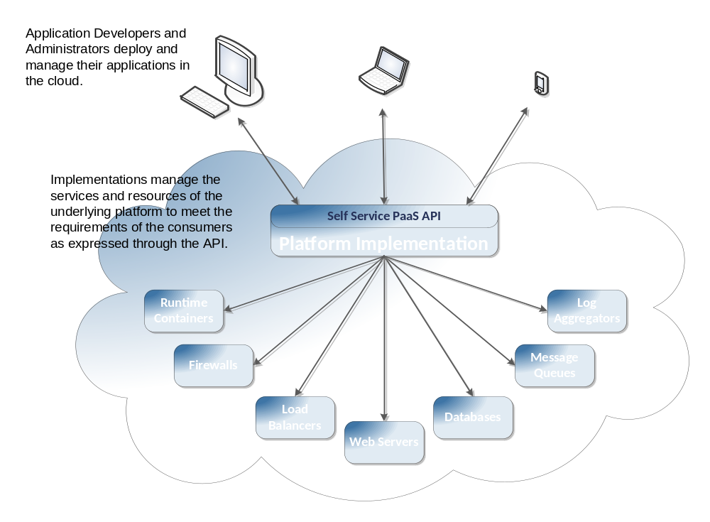
Figure 2-1: Typical PaaS Architecture
The figure above shows a typical architecture of a Platform as a Service cloud. The platform implementation is a management client of the underlying resources that transforms (through policies) the application requirements expressed by the Application Administrator into provisioning and other operations on those resources. The Platform Administrator manages the underlying hardware, storage, networks, and software services that make up the platform through existing administrative interfaces. Thus the Application Administrator is able to concentrate on their application and its deployment environment rather than having to be a systems administrator, database administrator and middleware administrator as well (as is the case with IaaS).
The goal of the management interface is to provide the PaaS consumer with a model that is as simple as possible, and yet still provides the essential elements that give them control over the deployment, execution, administration and metering of their application and its deployment environment.

Resources
The CAMP API is made up of resources in a REST protocol. The resources represent elements of the underlying system. The protocol enables interaction with the resources. The following are the main resources in the API:
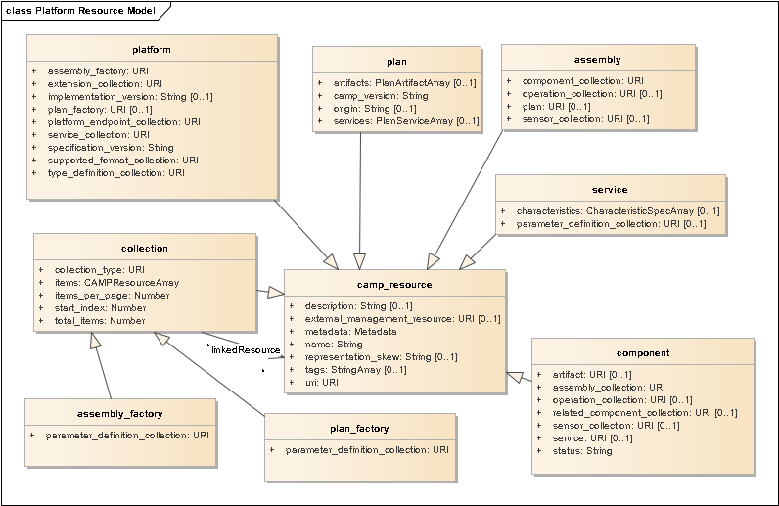
Figure 2-2: CAMP Resources as UML Classes
Figure 2-2 is a UML Class Diagram showing the CAMP resources as UML classes. All CAMP resources share a set of common attributes which they inherit from the camp_resource parent class.
Each attribute shown in these UML class diagrams has a CAMP common attribute type. The ‘+’ symbol before each attribute name in the boxes indicates that the attribute access is public (i.e. available through the API). Non-mandatory resource attributes are indicated using the [0..1] UML multiplicity tag.

Platform
The platform resource is the primary view of the platform and what is running on it. The platform resource references collections of resources that represent the services provided by the platform (as Services), the applications running on this platform (as assembly resources), as well as collections of metadata resources that describe the resources supported by the platform as well as any extensions that the Provider has implemented. The platform resource also determines the scope of access for sharing amongst multiple applications.

Assemblies
An assembly resource represents running applications. Operations on an assembly resource affect the components and elements of that application.

Components
An assembly resource is comprised of one or more component resources. A component resource represents a discrete and, in most cases, dynamic element of an application such as such as a deployed Ruby gem, a database instance, or a set of entries in a LDAP directory. A component resource can be related to other component resources through producer/consumer or other kinds of relationships.

Plans
A Plan is meta-data that provides a description of the artifacts that make up an application, the services that are required to execute or utilize those artifacts, and the relationship of the artifacts to those services. Plans can be expressed in two forms; either as a YAML file or, optionally, as a plan resource. The Artifacts described in a Plan represent discrete, static elements of an application such as a Ruby gem file, an SQL script, or a PKCS #12 file.

Services
A service resource represents a blueprint for creating component resources that utilize or embody a platform-provided service in some way. For example, a Service may represent the platform’s ability to create a message queue for use by an application.

Collection and Factory Resources
A resource may refer to a set of other resources through the use of a collection resource. For example, an assembly resource references the set of components that make up that Assembly through a reference to a collection of component resources. The type of the resources in a collection is homogenous. All of the resources in a collection are instances of a given type of resource, or instances of a sub-type of that type.
The assembly_factory and plan_factory resources are sub-types of the generic collection resource. In addition to acting as collections, these resources can be used to create new instances of the resources of which they are a collection (i.e. the assembly_factory resource can be used to create new assembly resources and the plan_factory resource can be used to create new plan resources).

Operations and Sensors
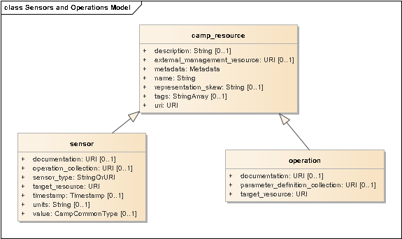
Figure 2-3: Operations and Sensors
Figure 2-3 is a UML class diagram showing the attributes of the operation resources and sensor resources.
Operations and Sensors provide a way of interacting with an application through the CAMP API. An operation resource represents actions that can be taken on a resource, and sensor resources represent dynamic data about resources, such as metrics or state. A sensor resource is useful for exposing data that changes rapidly, or that might need to be fetched from a secondary system. A sensor resource can also offer Operations to allow resetting metrics, or adjusting frequency collection settings.
Multiple operation resources and sensor resources can be exposed both on assembly resources and component resources. Operations are also known as effectors. The combination of Operations and Sensors enables ongoing management. This can include automation techniques such as using policies, event-condition-action paradigms, or autonomic control. A Consumer can use the REST API to perform such management. A Provider can also use them. For example, a component resource could be offered that allows for “autoscaling” capacity based on the volume of work an application performs.
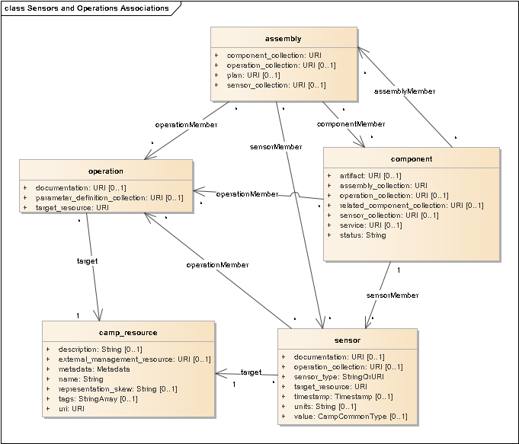
Figure 2-4: Operations and Sensors Associations
Figure 2-4 is a UML class diagram showing operation resources, sensor resources, and the other CAMP resources that they are associated with.
In Figure 2-4 the notation <resourceType>Member is used for association names to indicate that the associated resource type may be a member of a collection linked through a collection resource pointed at by a collection attribute in the "from" resource class ( i.e. the collection resource is not shown in the diagram).

Resource Relationships
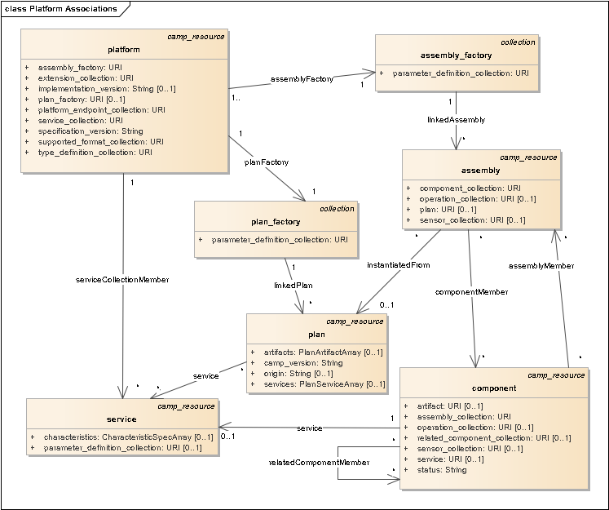
Figure 2-5: Platform and Resource Relationships
Figure 2-5 shows the relationships between Platform Resources using a UML class diagram.
Associations which are visible through pointer attributes in resources (i.e. URIs) are shown using UML named associations with navigation arrows.
The notation <resourceType>Member is used for association names to indicate that the associated resource type may be a member of a collection linked through a collection resource pointed at by a collection attribute URI in the "from" resource class ( i.e. the collection resource is not shown in the diagram).

Deployment
A Platform Deployment Package (PDP) is an archive containing a Plan file together with application content files such as web archives, database schemas, scripts, source code, localization bundles, and icons; and metadata files such as manifests, checksums, signatures, and certificates. It can be used to move an Application and its Components from Platform to Platform, or between an Application Development Environment and a Platform.
In the simplest case (an example of which is provided Section 1.3, “Example”), a PDP or a Plan file can be used to create an assembly resource by transmitting an HTTP POST request containing either the PDP or the Plan file to the assembly_factory resource.
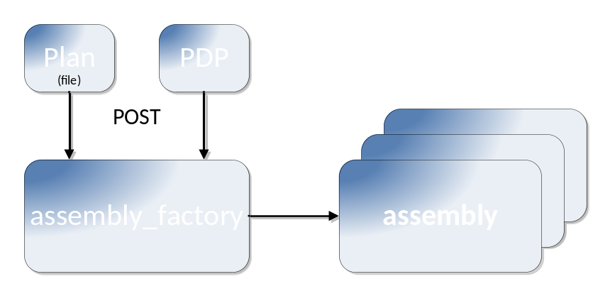
Figure 2-6: Deploying an Application
On platforms that choose to support Plans, a CAMP Consumer can create a plan resource by uploading either a PDP or a Plan file to the plan_factory resource using an HTTP POST request. An assembly resource can then be created from the plan resource by including a reference to the plan resource in an HTTP POST request to the assembly_factory resource.
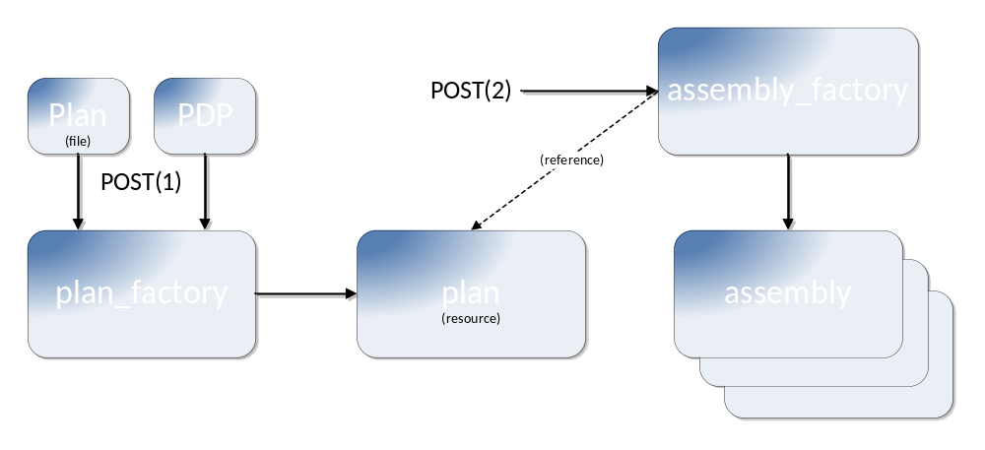
Figure 2-7: Instantiating an Application from a plan resource
In Figure 2-7 the POST(1) request creates a plan resource by uploading either a PDP or a Plan file to the plan_factory resource. The POST(2) request to the assembly_factory resource creates an assembly resource. Multiple assembly resources can be created from a single plan resource by submitting multiple HTTP POST requests.

Versions and Extensions
This specification supports multiple endpoints and versions, and extensions. All of these are represented in the resource model so they can be discovered by CAMP Consumers. The resources enabling discovery are shown in Figure 2-8, and their relationships are shown in Figure 2-9.
In these figures, the notation <resourceType>Member is used for association names to indicate that the associated resource type may be a member of a collection linked through a collection resource pointed at by a collection attribute URI in the "from" resource class ( i.e. the collection resource is not shown in the diagram).
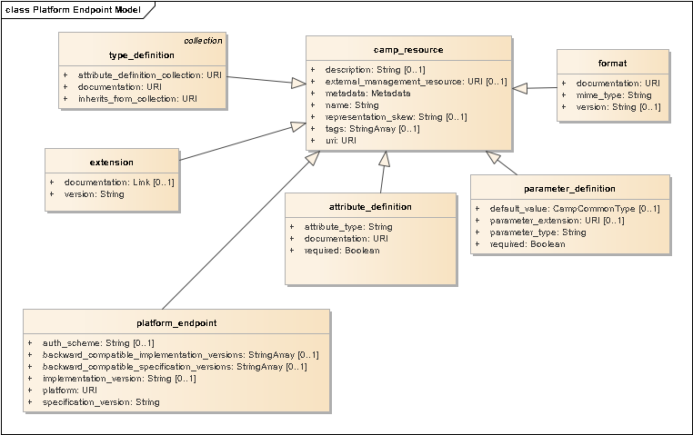
Figure 2-8: Platform Endpoint and Metadata Resources
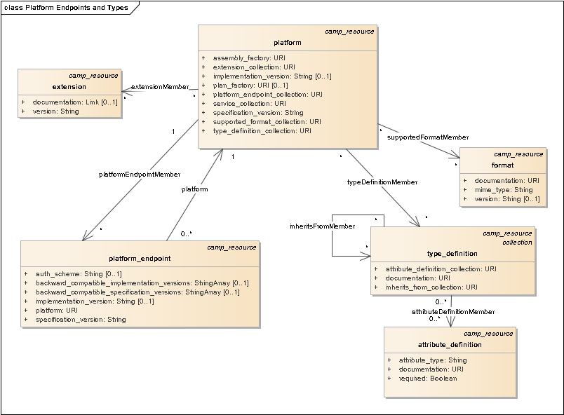
Figure 2-9: Platform Endpoint and Extension Resource Relationships

Parameters
Parameters can be defined on the assembly_factory resource, service resources, and, if supported, plan_factory resource. Parameters affect the resources that are generated from these resources. Figure 2-10 illustrates the relationships between these resources and the resources used to represent Parameters.
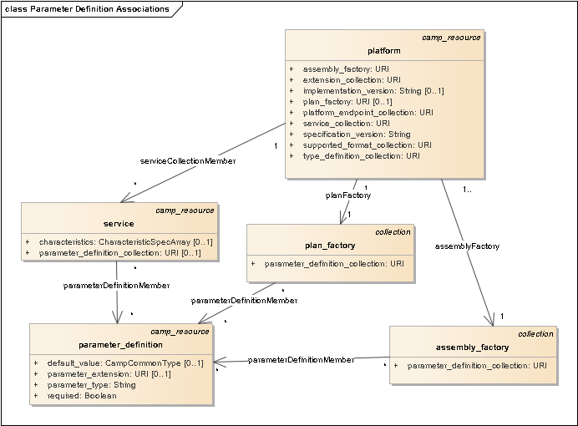
Figure 2-10: Parameter Definition Relationships

CAMP Common Attribute Types
Many of the attributes in the UML class diagrams have one of the CAMP common attribute types, specified in Section 5.2, “Attribute Types”. Figure 2-11 is a UML diagram showing the common data types as UML Data Types, which are used for the Types of these Resource Attribute definitions.
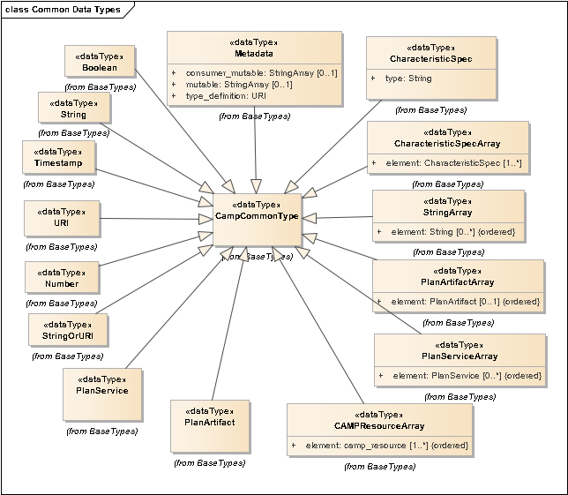
Figure 2-11: CAMP Common Base Types for Resource Attribute Definitions
Multi-valued member attributes are used to model the elements of the StringArray. This is done for modeling purposes only; the attribute name "element" does not appear in the JSON serialization for these common types.
The array types have their elements tagged as ordered.

Representation Skew
There can be situations in which the information in the resources provided by the CAMP API is not a complete or accurate representation of the state of the underlying implementation. For example, while generating a new instance of an application, a CAMP server might be asked to provide a representation of a Component that corresponds to a dataset that is in the process of being loaded onto a database. While the CAMP server might not be able to provide all of the information about this Component, it would be inaccurate to say that the Component does not exist; it exists but in an intermediate state. It is expected that these sorts of situations will be the exception and that, during the majority of its existence, a CAMP resource will be in synch with the state of its underlying platform implementation.
The significance of this skew is the manner in which it affects the Consumer’s interactions with, and expectations about, the resource. In the above example, while the Consumer cannot make any changes to the Component until it has reached a steady state, the Consumer can expect that the resource will reach this state in the near future. There are other situations in which, through some sort of error, the CAMP API cannot tell when or if the information in the resource will ever be synchronized with the underlying implementation.
Details on how this skew is exposed in the CAMP API are provided in Section 5.4.5, “representation_skew”.

External Management Resources
The information provided by the resources defined in the CAMP API is only one view of the implementation of the underlying platform. There are, of course, other ways of viewing and interacting with the entities that are modeled by CAMP’s resources. For example, CAMP may represent an instance of a database as a component resource. This database instance may also be viewed and managed through a database management application. To enable the integration of CAMP-based management tools with other management systems all CAMP resources have an optional URI attribute that references an external management resource. In the above example, the component resource that represented the database instance could have an external_management_resource attribute that, when de-referenced, would bring the Consumer to a database management system with that database instance already contextualized (i.e. “selected” in whatever manner the UI did such things).

Application Management Lifecycle
This section is informative. The figures in this section are UML object instance diagrams, which represent related Resources at various stages of Platform Resource lifecycle. For simplification, attributes for these resources are not shown. For a comprehensive list of attributes for resources see Section 5, “Resources”.
Instances in these diagrams are indicated by boxes, with an underlined “object-name: Class” label. Relationships visible through the API are shown using associations with navigation arrows. Implementation specific relationships are indicated using the association end notation, without navigation arrows.

Initial Platform Resources
The CAMP model includes the resources below when no assembly resources or plan resources have been created. Note that the support of the plan resource collection and plan resources is optional.
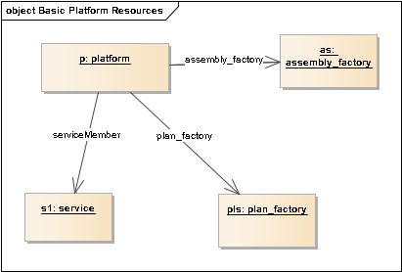
Figure 3-12: Initial Platform Resources
When the Application Administrator first accesses a new account a Platform will have a number of resources visible through the API. The platform resource is used to find the other resources in this diagram. The various service resources allow for discovery of all the platform services that are available along with value ranges for each service’s attributes.

Creating an Assembly from a PDP or Plan File
A CAMP Consumer can create a new assembly resource by uploading either a PDP or a Plan file to the assembly_factory resource using an HTTP POST request (see Section 2.3, “Deployment”). The loaded assembly model might then appear as follows (for simplification, the instantiated component resources are not shown in Figure 3-13):
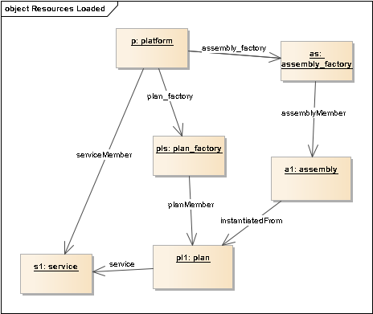
Figure 3-13: Loaded Assembly Resource
If any of its requirements are not resolved, a PDP or Plan file could require modification before it can be used to create assembly resources.

Creating an Assembly from a plan resource
If a Provider supports the plan resources, a CAMP Consumer can create a new plan resource without creating an assembly resource by supplying the contents of, or a reference to, either a PDP or a Plan file to the plan resource collection in an HTTP POST request (see Section 7.2, “Registering a Plan”). The loaded plan resource model might then appear as follows:
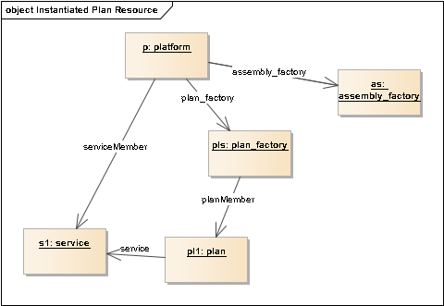
Figure 3-14: Loaded Plan Resource
A CAMP Consumer can create a new assembly resource from an existing plan resource by providing the reference to that plan resource to the assembly_factory resource in a HTTP POST request (see Section 7.1.1, “Deploying an Application by Reference”).
Using this two-step process, the loaded assembly resource model would appear the same as when using the one-step process, as shown in Figure 3-13.

Managing an Application Assembly
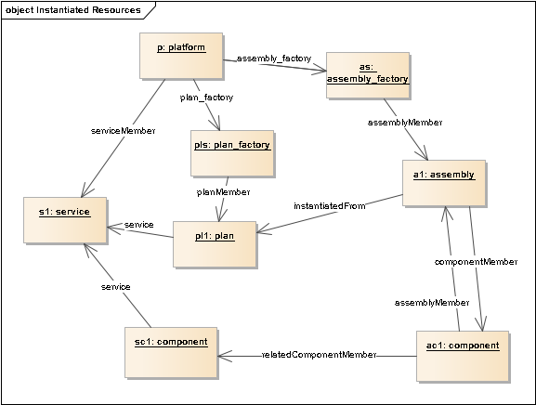
Figure 3-15: Instantiated Resources
To manage the operation of the application, the Application Administrator interacts with the assembly resource and the related component resources.
The traversal of the resources in the model can be accomplished by following the navigation arrows on the associations in these object instance diagrams, from each resource to the other resources it depends on.
The Application Administrator can observe real-time operational metrics through sensor resources on assembly resources and component resources. In response to these metrics, the Application Administrator — or an automated process such as a management system — can affect changes to those resources through the operation resources linked from those same resources.

Removing Assemblies
When finished working with an application, an Application Administrator can delete an assembly resource using a DELETE request. The CAMP platform will typically soon thereafter remove the assembly resource and all associated resources which are dedicated to that assembly. Where such a resource is not removed immediately, for example, when it is in the process of shutting down, it ought to present a representation skew of DESTROYING in the interim.
When the original plan resource is no longer needed, an Application Administrator can delete it using a DELETE request. Again, the CAMP platform will typically delete the plan resource and all associated resources which are dedicated to that plan resource. Where this deletion is accepted but not immediate, such as because an assembly resource is in use that references the plan resource, again the CAMP platform ought to present a representation skew of DESTROYING for the resources being deleted.

Platform Deployment Package
The Platform Deployment Package (PDP) ensures portability across platforms. It can be created by a platform to export to another platform, which then imports it. It can also be created by an Application Development Environment running locally or deployed as Software as a Service in the cloud. The PDP (and the Plan file, see Section 4.2, “Plan Overview”) defines the formats for on-boarding new applications onto a CAMP-enabled Provider.

PDP Package Structure
A PDP is an archive which contains a Plan file named camp.yaml at the root of the archive. A PDP archive MAY include other files related to the application including, but not limited to, language-specific bundles, resource files, application content files such as web archives, database schemas, scripts, source code, localization bundles, and icons; and metadata files such as manifests, checksums, signatures, and certificates. [PDP-01]

Supported Archive Formats
A Provider SHALL support the following archive formats for a PDP:
- A PDP as a ZIP archive [ZIP] [PDP-02]
- A PDP as a TAR archive [TAR] [PDP-03]
- A PDP as a GZIP [RFC1952] compressed TAR archive [PDP-04]
Providers MAY support additional archive formats for the PDP. [PDP-05]

Validating Integrity
A PDP MAY contain a manifest file, named camp.mf, at the root of the archive. [PDP-06] This file contains SHA256 [SHA256] digests of some or all files in the package. A Provider SHOULD reject a PDP if any digest listed in the manifest does not match the computed digest for that file in the package. [PDP-07]
A PDP MAY contain a certificate, named camp.cert, at the root of the archive. [PDP-08] This file contains a signed SHA256 digest for the manifest file and the corresponding X.509 certificate. A Provider SHOULD reject any PDP for which the signature verification fails. [PDP-09]
The format of the manifest file and the certificate file SHALL be as defined by the OVF specification [OVF]. [PDP-10]

Plan Overview
The Plan provides a description of the artifacts that make up an application, the services that are required to execute or utilize those artifacts, and the relationship of the artifacts to those services. As discussed previously, Plans can be represented in two ways, either as YAML files or as CAMP resources. The examples in this section show Plans as YAML files.
Example 1: Minimal Plan describing an application consisting of a single RPM file
00 camp_version: CAMP 1.2
01 artifacts:
02 -
03 type: org.rpm:RPM
04 content: { href: my-app.rpm }
The above example describes an application that consists of a single RPM (RPM Package Manager) package, named “my-app.rpm”, which exists at the root of the PDP archive.

Types
Plans can contain descriptions of artifacts, services and their relationships. However, it is outside the scope of this specification to provide detailed definitions of these entities. Instead Plans use ‘type’ nodes to identify these things. ‘Type’ nodes are Strings that describe entities that are managed by CAMP, but whose value and semantics are defined outside the CAMP specification. For example, a group of PaaS providers could agree to use the artifact type “org.rpm:RPM” to identify RPM packages. Line 03 in Example 1, above, is an example of the use of such a type.
To promote portability, both providers and consumers of the CAMP API are encouraged to namespace-qualify the types that they use. For example, if a PaaS provider supports a requirement type that expresses the relationship “deploy on a Spring container”, the value “com.paas-r-us.spring.DeployOn” is preferable to the value “DeployOn”, as the latter is likely to collide with similar types.
In addition to defining the labels for artifacts, services, and their relationships it is expected that those individuals and organizations that define such labels will also define additional attributes that qualify and constrain the entity that is referenced.
Note that this specification does not specify a normative mechanism for Providers to advertise their supported type nodes.

Requirement Specifications
Although Example 1 is a complete, CAMP-conformant Plan, it is somewhat abstract. It essentially says “this application is made up of the following RPM file”. It does not say anything about what a CAMP Provider is supposed to do with the RPM file. When presented with the Plan in Example 1, a Provider is free to do whatever it likes with the artifact. The obvious action is to install the RPM file (the fact that there is an obvious action is what makes Example 1 workable) but not all artifacts will necessarily have such obvious actions.
Requirement Specifications allow Application Developers to specify what the Provider should do with an artifact.
Example 2: Expanded Plan describing details of how to install the RPM
00 camp_version: CAMP 1.2
01 artifacts:
02 -
03 type: org.rpm:RPM
04 content: { my-app.rpm }
05 requirements:
06 -
07 type: org.rpm:Install
08 org.rpm.installopts.excludedocs: true
Example 2 adds a Requirement Specification (lines 07-08) to indicate (through the type value of “org.rpm:Install” on line 07) that target Providers are to install the RPM. Furthermore it indicates, on line 08, something about how the Provider should install the RPM (i.e. in a way that excludes documentation).
The correct processing of this requirement is predicated upon the Providers understanding of the structure and semantics of the “org.rpm:Install” type. The Provider has to know that this type indicates that the parent RPM artifact is to be installed on a Linux instance and that Requirement Specifications of this type may contain a org.rpm.installopts.excludedoc node whose value is a boolean that indicates whether files marked as documentation should be installed. It is assumed that the semantics associated with “org.rpm:Install” requirement type are documented, and that this documentation also describes the value space and semantics of the org.rpm.installopts.excludedocs node.

Service Specifications
Example 2 is more specific than Example 1, but it is still silent about what kind of Linux instance we want the RPM installed on. When presented with the Plan in Example 2, a Provider is free to install the RPM on any kind of Linux instance or even, hypothetically, a non-Linux operating system that supports RPM.
Service Specifications allow Application Developers to constrain or outline the services that can be used to support the requirements they have specified.
Example 3: Expanded Plan that includes a Service Specification
00 camp_version: CAMP 1.2
01 artifacts:
02 -
03 type: org.rpm:RPM
04 content: { my-app.rpm }
05 requirements:
06 -
07 type: org.rpm:Install
08 org.rpm.installopts.excludedocs: true
09 fulfillment:
10 characteristics:
11 -
12 type: com.example:Linux
13 com.example.linux.kernelVersion: [3.9.6]
14 org.iaas.bitsize: 64
Example 3 adds a Service Specification to the Requirement Specification from Example 2. This Service Specification indicates that, wherever the Provider decides to install the RPM, it has to be a 64-bit Linux instance running a kernel of version 3.9.6.
As in the case of our Requirement Specification, the correct processing of this Plan depends upon the Providers ability to understand Characteristic Specifications of the type “com.example:Linux”. The Provider needs to know that characteristics of this type can contain, among other possible nodes, the com.example.linux.kernelVersion and org.iaas.bitsize nodes as well as understand the allowed values and the semantics of these nodes.
Although Example 3 is fairly specific (“this application is made up of an RPM file which is to be installed, excluding documentation, on a 64-bit Linux instance running a kernel of version 3.9.6”), it is still somewhat abstract in that it does not reference the specific Linux instance that the RPM is to be installed on. If an Application Developer wishes to explicitly identify the exact Linux instance on which their RPM is to be installed, they can do so using the href node of a Service Specification.
Note: See Appendix D for suggested version range values to use when no prevailing scheme already exists for the type.
Example 4: Concrete Plan with service resource reference
00 camp_version: CAMP 1.2
01 artifacts:
02 -
03 type: org.rpm:RPM
04 content: { my-app.rpm }
05 requirements:
06 -
07 type: org.rpm:Install
08 org.rpm.installopts.excludedocs: true
09 fulfillment:
10 href: http://example.org/my_paas/services/8675309
Example 4 amends the Service Specification introduced in Example 3 to reference an instance of a service resource provided by the CAMP implementation at “example.org”. Since the Application Developer is calling for the use of a specific service, it is no longer necessary to indicate to the Provider the general characteristics of the services that are suitable for fulfilling the “org.rpm:Install” requirement. Therefore, the Characteristic Specification in Example 3 has been removed
Note that the specificity in Example 4 comes at the expense of portability. Due to the reference to a specific resource, it is doubtful that the Plan in Example 4 could be successfully deployed on any CAMP instance other than the one at “example.org” whereas the Plan in Example 3 can be deployed on any CAMP instance that supports the “org.rpm:RPM” artifact type, the “org.rpm:Install” requirement type, and the “com.example:Linux” characteristic type. This tradeoff between specificity and portability is a design feature of CAMP Plans. There are cases (e.g. when developing an application) in which it makes sense to target a Plan for a specific CAMP instance and there are cases (e.g. when moving an application to a different provider) when it makes sense to make the Plan as generic as possible. Plans are designed to allow the Application Developer to be as specific or generic as necessary to accomplish their particular task.

Shared Services
There are situations in which an application can have two or more artifacts that need to share the same runtime instance of a service.
Example 5: Plan with shared Service Specification
00 camp_version: CAMP 1.2
01 artifacts:
02 -
03 type: com.java:WAR
04 content: { href: vitaminder.war }
05 requirements:
06 -
07 type: com.java:HostOn
08 com.java.servlet.contextName: "/vitaM"
09 fulfillment:
10 …
11 -
12 type: com.java.jdbc:ConnectTo
13 fulfillment: id:db
14 -
15 type: org.sql:SqlScript
16 content: { href: vitaminder.sql }
17 requirements:
18 -
19 type: org.sql:ExecuteAt
20 fulfillment: id:db
21 services:
22 -
23 id: db
24 characteristics:
25 -
26 type: org.storage.db:RDBM
27 …
28 -
29 type: org.storage.db:Replication
30 …
31 -
32 type: org.iso.sql:SQL
The above example describes an application with two components, a WAR file and an SQL script. In the case of this particular application, the SQL script is used to initialize the database that will be used by the WAR file. The components created from the two artifacts need to share a common database instance or the application will not work. Lines 23-33 describe the shared target database service. Line 23 is an ‘id’ node with the value ‘db’. This node is used as the target for the ‘fulfillment’ nodes on lines 13 and 20. The common use of the “id:db” value in lines 13 and 20 indicates that, whatever service used to satisfy the Service Specification in lines 23-33, it will be shared by the components that are created by resolving the requirements on lines 12-13 and lines 19-20.

Service Frameworks
There are situations in which the artifacts of an application are dynamically added (e.g. via a git [Git] push operation) after the creation of a “service framework” on which these artifacts can be deployed. Such a framework can be specified via a Plan that contains Service Specifications but no Artifact Specifications.
Example 6: Plan with only Services Specifications
camp_version: CAMP 1.2
services:
-
name: Rails Runtime
characteristics:
-
type: org.ruby-lang:Ruby
…
-
type: org.rubyonrails:Rails
…
-
name: Database
characteristics:
-
type: org.storage.db:RDBM
…
-
name: Git Repo
characteristics:
-
type: com.git-scm:GIT
…
The above example specifies a set of services onto which the user can deploy Rails components by pushing them to the git repository that will be created as a result of deploying this Plan.

Names, Description, and Tags
Plans, artifacts and services can be decorated with names, descriptions, and tags. CAMP implementations can use this information when creating the resources that correspond to these entities. For example, the following Plan file:
Example 7: Plan with names, descriptions, and tags
name: Mike’s Drupal Instance
description: Drupal 6.28
tags: [ PHP, Drupal6, mikez ]
camp_version: CAMP 1.2
artifacts:
-
type: net.php:Module
content:
href: ftp://ftp.drupal.org/files/projects/drupal-6.28.tar.gz
…
when successfully registered, could result in the creation of the following plan resource:
{
"type": "plan",
"uri": "http://uswest.paas-r-us.com/camp/plan/101",
"name": "Mike’s Drupal Instance",
"description": "Drupal 6.28",
"tags": [ "PHP", "Drupal6", "mikez" ],
…
}

Plan Schema
A Platform Deployment Package (PDP) SHALL contain a single Plan file. [PDP-11] The Plan file SHALL be located at the root of the PDP archive. [PLAN-01] The Plan file SHALL be named “camp.yaml”. [PLAN-02] The Plan file SHALL conform to YAML 1.1 [YAML 1.1]. [PLAN-08] The Plan file SHALL conform to the description provided in this section. [PLAN-09]

General Nodes
Plans, Artifact Specifications, and Service Specifications can contain the following nodes:

name
Type: String
Required: false
This node expresses the human-readable name of the Plan or Specification. Providers MAY reflect the value of this attribute in the names of any resources that are created in the processing the Plan. [PDP-14]

description
Type: String
Required: false
This node expresses the human-readable description of the Plan or Specification. Providers MAY reflect the value of this attribute in the descriptions of the resources that are in the processing the Plan. [PDP-15]

tags
Type: String[]
Required: false
This node expresses an array of human-readable tags for the Plan or Specification. Providers MAY reflect the values of this attribute in the tags of the resources that are created in the processing of the Plan. [PDP-16]

Plan
A Plan defines the structure the elements in a Plan file or resource. A Plan file SHALL contain a single instance of a Plan. [PLAN-03] A Plan has the following, general representation:
name: String ?
description: String ?
tags: String[] ?
camp_version: String
origin: String ?
artifacts: ArtifactSpecification[] ?
services: ServiceSpecification[] ?
In addition to the general nodes, a Plan contains the following nodes:

camp_version
Type: String
Required: true
The value of this node expresses the version of the CAMP specification to which the Plan conforms. For Plans that conform to this document, the value of this node SHALL be as defined in Section 1.8 “Specification Version”. [PLAN-05]

origin
Type: String
Required: false
The value of this node specifies the origin of the Plan. For example, when exporting a plan resource into a PDP, a Provider might use the URL of its platform resource for this value. Alternatively, an Application Development Environment could use its name and version.

artifacts
Type: ArtifactSpecification[]
Required: false
This node lists the artifacts that comprise the application described by the Plan. For portability reasons, Providers are cautioned against regarding the order of the elements in this array as significant.

services
Type: ServiceSpecification[]
Required: false
This node describes the services that the application described by the Plan requires in order to function. For portability reasons, Providers are cautioned against regarding the order of the elements in this array as significant.

ArtifactSpecification
An ArtifactSpecification describes an artifact of the application. The artifact MAY be contained within the PDP or MAY exist in some other location. [PDP-22]
An ArtifactSpecification has the following, general representation:
name: String ?
description: String ?
tags: String[] ?
type: String
content: ContentSpecification
requirements: RequirementSpecification[] ?
In addition to the general nodes, an ArtifactSpecification contains the following nodes:

type
Type: String
Required: true
The value of a type node specifies the type of an artifact.
Note: Values for a type node are not defined by this specification. See Section 4.2.1, “Types”.

content
Type: ContentSpecification
Required: true
This node identifies the location of the content of the artifact described by this Artifact Specification. See Section 4.3.4, “ContentSpecification”, for details.

requirements
Type: RequirementSpecification[]
Required: false
This array specifies the ways in which the artifact described by this Artifact Specification engages with the services provided by the platform. See Section 4.3.5, “RequirementSpecification”, for details. For portability reasons, Providers are cautioned against regarding the order of the elements in this array as significant.

ContentSpecification
A ContentSpecification defines the content of a component. A ContentSpecification has one of two, mutually exclusive, nodes: href or data. It has the following, general representation:
href: URI
or
data: String
When href is used in a ContentSpecification its value is interpreted as follows:
- Providers SHALL support the “https” URI scheme as defined in RFC 2818 [RFC2818]. [PDP-27] A Provider MAY support additional URI schemes listed at http://www.iana.org/assignments/uri-schemes/uri-schemes.xhtml. [PDP-28]
- URL’s with the special scheme “pdp:” are interpreted as files contained in the PDP.
  - If the path segment (after the “pdp:”) begins with a “/” it is an absolute path.
  - If the path segment is “!” (i.e. the URL is “pdp:!”), the reference is to the PDP archive itself. This is useful in making an existing deployment package (such as a WAR) function as a PDP.
  - For any other path segment, the path is relative to the location of the file which contains the Content Specification, subject to the guidelines below.
  - Where the path segment contains the special character “!”, it is treated as a delimiter to look for the path to the right of “!” inside the archive at the path to the left of the “!". Providers SHALL understand this delimiter and SHALL NOT resolve any content if the archive format is unsupported. [PDP-29] Consumers SHALL follow the syntax and semantics described here when using URIs with a “pdp” scheme. [PLAN-07] For example “pdp:/certs.zip!/id_rsa.pub” refers to a file “id_rsa.pub” contained at the root of a “certs.zip” file located at the root of the PDP, and is valid only on platforms which support the ZIP format in conjunction with “!”. On other platforms the link will not be resolved.
- Where the value is not a URI, it is interpreted as a “pdp:” protocol link, as though it were preceded by “pdp:/”.
Example 8: A Plan describing an application consisting of the contents of the PDP
00 artifacts:
01 -
02 type: org.oasis-open.tosca:CSAR
03 content: { href: pdp:! }
04 requirements:
05 -
06 type: com.oasis-open.tosca:DeployOn
The above example illustrates the use of the “pdp:!” construct wherein the content being referenced (on line 03) is the PDP itself. In this case the PDP is also an OASIS TOSCA v1 Cloud Service Archive.

RequirementSpecification
A RequirementSpecification describes the relationship between an artifact and a platform. Providers are expected to use the information in a RequirementSpecification to determine what actions to perform on/with the artifact described in the containing Artifact Specification.
A RequirementSpecification has the following, general representation:
type: String
fulfillment: (String | ServiceSpecification) ?

type
Type: String
Required: true
The value of this node defines the relationship of the artifact that contains this RequirementSpecification to a service. For example, “com.java:HostOn”. See Section 4.2.1, “Types”, for a general description of the definition and treatment of these values.
It is expected that RequirementSpecifications will contain extension nodes that modify or provide additional information about the relationship that they describe. The value space and semantics of these extensions ought to be part of the definition of the value used in the “type” node. For example, the definition of the “com.java:HostOn” relationship might define a “com.java:contextPath” node whose value specifies the desired context path for the artifact when it is deployed on its selected service.

fulfillment
Type: String or ServiceSpecification
Required: false
The value of this node either describes, or references a description of, the other party in the relationship (i.e. the service) defined by this RequirementSpecification. In the case where this node references a description, the value is a String that corresponds to the id node of a ServiceSpecification (e.g. “id:db”). In the case where this node contains the description, the value is a ServiceSpecification. See Section4.3.6, “ServiceSpecification”, for details.

ServiceSpecification
A ServiceSpecification describes a service used by the application. This description is not intended to be a complete list of every detail of the service but, instead, an enumeration of those facets that, for whatever reason, are important to the application described by the Plan. Providers are expected to use the information in a ServiceSpecification to select an appropriate service for resolving the containing RequirementSpecification.
A ServiceSpecification has the following, general representation:
name: String ?
description: String ?
tags: String[] ?
id: String ?
href: URI ?
characteristics: CharacteristicSpecification[] ?
In addition to the general nodes, a ServiceSpecification contains the following nodes:

id
Type: String
Required: false
The value of this node serves as an anchor for intra-Plan references. See Section 4.3.5.2, “fulfillment”, for information on how this anchor is used. Plans SHALL use id values that are unique within the scope of the Plan. [PLAN-06]

href
Type: URI
Required: false
The value of this node is a reference to a service resource (see Section 5.13, “service Resource”) that resolves the service described by this ServiceSpecification. If a Consumer includes this node in a Plan, the value of this node SHALL reference a Consumer-visible resource within the target Platform. [RMR-01]

characteristics
Type: CharacteristicSpecification[]
Required: true
This array provides the characteristics of the service described by this ServiceSpecification. See Section 4.3.6, “CharacteristicSpecification”, for details. For portability reasons, Providers are cautioned against regarding the order of the elements in this array as significant.

CharacteristicSpecification
A CharacteristicSpecification describes a desired characteristic or capability of a service. It has the following, general representation.
type: String
<name>: <value> *
A CharacteristicSpecification is a node with a single, CAMP-defined key named type. A CharacteristicSpecifaction can have zero or more additional nodes whose values can be any valid YAML value.
The inclusion of a CharacteristicSpecification in a ServiceSpecification indicates that the characteristics being described are significant to the application, but the degree of this significance (e.g. “absolutely necessary” versus “would be nice to have”) is not indicated.

type
Type: String
Required: true
The value of this node defines the characteristic being described by this CharacteristicSpecification. For example, “com.java:ServletContainer”. See Section 4.2.1, “Types”, for a general description of the definition and treatment of these values.
It is expected that CharacteristicSpecifications will contain extension nodes that modify or provide additional information about the characteristic that they describe. The value space and semantics of these extensions ought to be part of the definition of the value used in the type node. For example, the definition of the “org.rubyonrails:Rails” characteristic might define a “org.rubyonrails:version” node whose value specifies the version of Rails provided by the service.
Note: See Appendix D for suggested version range values to use when no prevailing scheme already exists for the type.

Resources
The following sub-sections describe the resources defined by this specification.
When supporting such a Resource, a Provider SHALL implement it and serialize it as described in the corresponding sub-section. [RE-70]
A Consumer SHALL serialize Resource data in its requests based on the definition of this Resource as described in the corresponding sub-section. [RE-71]

Required Attributes
If the Required boolean constraint for an attribute of a resource type has a value of "true", then a resource of this type SHALL have the attribute present. [RE-06] If the value is "false" then the resource is valid with or without the attribute present.

Attribute Types
Resource attributes are defined using the following types:

Boolean
As defined by JSON [RFC4627], a token having a literal value of either true or false. The use of this type is indicated in metadata by an attribute_definition resource with an attribute_type value of “Boolean”.

String
A UNICODE string as defined by JSON [RFC4627]. The use of this type is indicated in metadata by an attribute_definition resource with an attribute_type value of “String”.

Number
As defined by Section 2.4 of JSON [RFC4627]. The use of this type is indicated in metadata by an attribute_definition resource with an attribute_type value of “Number”.

URI
A String (see above) that conforms to the syntax defined in RFC 3986 [RFC3986]. The use of this type is indicated in metadata by an attribute_definition resource with an attribute_type value of “URI”.

Timestamp
A String (see above) that conforms to the syntax defined in ISO 8601 [ISO 8601:2004]. Consumers and Providers SHALL express Timestamps in UTC (Coordinated Universal Time), with the special UTC designator ("Z"). [RE-65] The use of this type is indicated in metadata by an attribute_definition resource with an attribute_type value of “Timestamp”.

CAMP Resource Type Inheritance
Each CAMP resource has a resource type associated with it, indicated by the type_definition URI in the resource’s metadata section (see Section 5.4.7.1, “type_definition”). A resource’s type defines the attributes of that resource along with the constraints and semantics of those attributes. Resource types form an inheritance hierarchy with camp_resource (See Section 5.4, “camp_resource Resource”) at its root. When a resource type (sub-type) inherits from another resource type (super-type), the sub-type inherits, and therefore includes, all the super-type’s attributes along with its constraints and semantics. A sub-type can add additional attributes not present in its super-type(s). A sub-type MAY further restrict the constraints of an attribute inherited from its super-type(s). [MO-01] A sub-type SHALL NOT loosen the constraints of an attribute inherited from its super-type(s). [MO-02] As a consequence, a resource of a super-type can always be substituted with a resource of any of its sub-types. A resource type MAY inherit from more than one super-type. [MO-03] If there is an attribute name collision when a sub-type inherits from multiple super-types, the inherited attributes of the same name SHALL NOT contradict the constraints and semantics of the attributes defined in its super-types. [MO-04]

camp_resource Resource
All CAMP resources SHALL inherit directly or indirectly from this resource. [MO-05] This resource contains the following attributes:

uri
Type: URI
Required: true
This attribute expresses the URI of the resource.

name
Type: String
Required: true
This attribute expresses the human-readable name of the resource.

description
Type: String
Required: false
This attribute expresses the human-readable description of the resource.

tags
Type: String[]
Required: false
This attribute is an array of String values that may be assigned by the provider or the user. These values can be used for keywording and terms-of-interest.

representation_skew
Type: String
Required: false
The representation_skew attribute expresses the relationship between the information presented in the resource and the status of the platform implementation artifacts that are represented by that resource (see Section 2.7, “Representation Skew”). It is an optional, enumerated String. If present, representation_skew SHALL have one of the following values: [RE-11]
- “CREATING” – describes a resource that is in the process of being created. The client can expect that the resource will have a skew of “NONE” once this process has completed.
- “NONE” – is an assertion by the CAMP server that the information in the resource is an accurate representation of the underlying platform implementation. Absent some action by the client or some other event (e.g. platform shutdown), a resource with a skew of NONE can be expected to remain in synch with the platform implementation.
- “UNKNOWN” – indicates that the CAMP server cannot accurately depict the aspect of the platform implementation represented by this resource. Users can attempt to address the underlying issues(s) by manipulating this and/or other resources as specified by the API.
- “DESTROYING” – describes a resource that is in the process of being destroyed. The client can expect that the resource will cease to exist once this process has completed.
The absence of the representation_skew attribute is semantically equivalent to a value of “NONE”.
The value of the representation_skew attribute applies only to the resource of which it is part. The skew of any resources that are contained by another resource (e.g. in the manner in which the assembly resource contains component resources) is conveyed by the individual representation_skew of those sub-resources and not aggregated or “rolled up” into the containing resource.
The value of the representation_skew attribute affects the availability of the HTTP methods for that resource. For example, resources with a representation_skew value of CREATING might support the GET, HEAD and DELETE methods, but no other HTTP methods. The following table lists the methods that SHALL be supported for each representation_skew value. [RE-12]
representation_skew value | Methods Available
CREATING | GET, DELETE
NONE | All supported methods for that resource.
UNKNOWN | All supported methods for that resource.
DESTROYING | GET
Table 5-1: representation_skew Available Methods
For each representation_skew value, CAMP Providers MAY support HTTP methods in addition to those listed in the corresponding row of Table 5-1. [RE-13]

external_management_resource
Type: URI
Required: false
A URI to an external management interface to manage the entity represented by this resource (see Section 2.8 “External Management Resources”). The entity referred to by this attribute is platform dependent and requires external documentation to understand its meaning.

metadata
Type: object
Required: true
The value of this attribute specifies the metadata for the resource. Three attributes are defined for metadata: type_definition, mutable, and consumer_mutable. Metadata for a resource is extensible; a Platform Provider MAY provide additional metadata attributes. [RE-81]

type_definition
Type: URI
Required: true
The value of this attribute is a reference to the type_definition resource that describes this resource.

mutable
Type: array
Required: false
The value of this attribute is a list of the attributes of the resource that are mutable. If a particular attribute is not listed, it indicates that the value(s) of the attribute, once set, SHALL NOT change for the lifetime of the resource. [RE-07] If a particular attribute is listed, it indicates that the value of the attribute MAY change due to the actions or activity of either the Provider or the Consumer. [RE-08]
Elements of this array use JSON Pointer [RFC6901] syntax to identify the attribute that is mutable.

consumer_mutable
Type: array
Required: false
The value of this attribute is a list of attributes of the resource that are consumer-mutable. If a particular attribute is not listed, it indicates that the value(s) of the attribute SHALL NOT be changed by Consumers. [RE-09] If a particular attribute is listed, it indicates that Consumers MAY change the value of the attribute. [RE-10] Note that absence of an attribute in the list does not preclude the Provider from changing the value of the attribute.
The values in this list are only relevant for mutable attributes. A Provider SHALL NOT list an attribute in the consumer_mutable array if it is not present in the mutable array. [RE-82]
Elements of this array use JSON Pointer [RFC6901] syntax to identify the attribute that is consumer-mutable.

HTTP Method Support
As described in Section 6.1, “Transfer Protocol”, Consumers use HTTP [RFC2616] to interact with CAMP-defined resources. To foster interoperability it is necessary to define the HTTP methods supported by each resource. Note that a requirement on the Provider to support a particular HTTP method on a resource does not ensure that all requests to that resource using that method will succeed; it simply guarantees that the Provider will not fail such requests with a 405 (Method Not Allowed) error.
Providers SHALL support the HTTP GET method on all of the resources defined in this section. [RE-53] Providers SHALL support the HTTP PUT and PATCH methods on resources that have at least one consumer-mutable attribute. [RE-83] Note that Providers are required to provide metadata on the consumer mutability of all attributes. Requirements for the support of additional HTTP methods are outlined in the descriptions of each resource below. Providers MAY elect to support additional HTTP methods in addition to those described here. [RE-54]
There are interactions between various HTTP methods and the mutable and consumer-mutable attributes that warrant some explanation. Note that it is possible for a Consumer to cause the Provider to change the values of some mutable attributes in response to a POST operation. For example, a successful POST to an operation resource could cause the Provider to change the value of the status attribute of the target resource for that operation. However, this does not mean that the status attribute of that target resource is consumer-mutable. Consumer mutability refers to the ability of the Consumer to directly alter the value of one or more attributes via the PUT or PATCH methods (see Section 7.4, “Updating Resources”).

collection Resource
A collection resource is a representation of an improper subset of the resources in a collection. collection resources have the following general representation:
{
"uri": URI,
"name": String,
"description": String ?,
"tags": String[] ?,
"representation_skew": String ?,
"external_management_resource": URI ?,
"collection_type": URI,
"total_items": Number,
"items_per_page": Number,
"start_index": Number,
"items": camp_resource[],
"metadata": object
}
If a Provider chooses to return the ETag header in its responses, the value of this header SHALL refer to the entire collection. [RE-84] Sort order and page size does not affect the ETAG value.
collection resources have the following attributes in addition to those defined in camp_resource:

collection_type
Type: URI
Required: true
The value of this attribute is a reference to the type_definition resource that describes the type of the resources in this collection. All of the resources in this collection will either be of the type described by this type_definition resource or of a type that inherits, directly or indirectly, from that type. A Provider MUST only return representations of collection resources whose items array contains resources whose type is either that described by the type_definition resource referenced by the collection_type attribute or a type derived, directly or indirectly, from that type. [RE-80]

total_items
Type: Number
Required: true
The value of this attribute is the total number of resources in the collection, as seen by the Provider. This may be greater than the number of resources returned in the collection resource, for example if the GET request specified either of the start_index or max_page query string parameters to request pagination. See Section 7.3.4, “Pagination of a Collection”, for more details. The value of total_items attribute SHALL be a non-negative integer. [RE-85]

items_per_page
Type: Number
Required: true
The value of this attribute is the number of resources returned in the collection resource. This may be fewer than the total number of resources in the collection, for example if the GET request specified either of the start_index or max_page query string parameters to request pagination. See Section 7.3.4, “Pagination of a Collection”, for more details. The value of the items_per_page attribute SHALL be a non-negative integer. [RE-86]

start_index
Type: Number
Required: true
The value of this attribute is the zero-based, ordinal number of the first element returned from the collection, after sorting. If the start_index query parameter was used on the HTTP GET request, the value of this attribute SHALL equal the value of that query parameter. [RE-87] See Section 7.3.4, “Pagination of a Collection”, for more details. The value of the start_index attribute SHALL be a non-negative integer. [RE-88]

items
Type: camp_resource[]
Required: true
The value of this attribute is an array of objects that comprise the resources in the collection. The objects in the items array are independently accessible resources identified by the item's uri attribute.
The size of the array SHALL be equal to the value of the items_per_page attribute. [RE-89] If the collection is empty, the value of this attribute SHALL be an array with no elements (represented as “[]” in JSON). [RE-90]

platform_endpoints Collection
A Provider MAY concurrently offer multiple instances of the CAMP API. [RE-15] The primary example of why a provider might do this is to simultaneously support two or more incompatible versions/implementations of the CAMP API, but there are many reasons for a provider to offer multiple instances of the CAMP API.
Concurrent instances are supported through the use of multiple platform resources. A collection of platform_endpoint resources allows Consumers to discover all the instances of the CAMP API that are currently available.
A Provider MAY expose the platform_endpoints resource collection and corresponding platform_endpoint resources in a way that allows for version discovery before the client has authenticated. [RE-17]
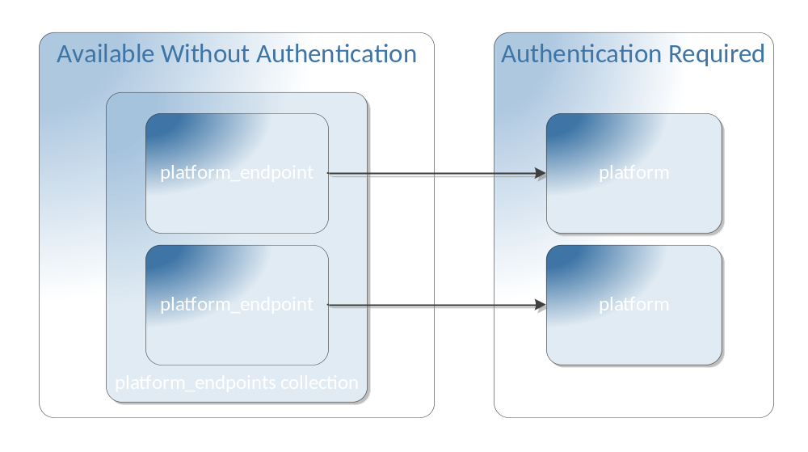
Figure 5-16: Example Implementation

platform_endpoint Resource
Each platform_endpoint resource SHALL refer to exactly one platform resource, and indicate the versions supported by the Platform. [RE-20] This specification is deliberately silent about any relationship between resources within different platform trees. Each platform resource could represent a different CAMP API “view” of the same applications and services. On the other hand, each platform could represent a completely independent system.
A platform_endpoint resource has the following general representation:
{
"uri": URI,
"name": String,
"description": String ?,
"tags": String[], ?
"representation_skew": String ?,
"external_management_resource": URI ?,
"platform": URI,
"specification_version": String,
"backward_compatible_specification_versions": String[] ?,
"implementation_version": String ?,
"backward_compatible_implementation_versions": String[] ?,
"auth_scheme": String ?,
"metadata": object
}
Note: Because of its unique function, future versions of the CAMP specification are cautioned against making non-backwards compatible changes to this resource.
Instances of the platform_endpoint resource contain the following attributes:

platform
Type: URI
Required: true
This attribute is the URI of the platform resource that this platform_endpoint resource describes.

specification_version
Type: String
Required: true
Each platform resource is the root of a tree of resources, the syntax and semantics of which conform to one or more versions of the CAMP specification. The value of this attribute is the Specification Version String of the CAMP specification that is supported by the resources rooted in the Platform referenced by the platform attribute of this resource.
For Platforms that implement this version of the CAMP specification, the value of this attribute SHALL be as defined in Section 1.8, “Specification Version”. [RE-22]

backward_compatible_specification_versions
Type: String[]
Required: false
The values in this array identify each version of the CAMP specification that is backwards compatible with the current specification_version of the Platform (referenced in the platform attribute of this resource). The values in this array SHALL be the Specification Version Strings of previous CAMP specification versions. [RE-23]
If this attribute is not present, the version of the CAMP specification implemented by the Platform (referenced in the platform attribute of this resource) is not backwards compatible with any previous version of the CAMP specification.
platform_endpoint resources that reference platform resources with a specification_version value of “CAMP 1.2” SHALL NOT include this attribute because no previous versions are compatible. [RE-24]

implementation_version
Type: String
Required: false
Multiple implementations of the same CAMP specification MAY be offered concurrently. [RE-25] For example, a Provider could offer an initial beta version of “CAMP 1.1” and, later, a production version; allowing a period of overlap for their customers to migrate from the beta to the production version. The value of this attribute is an arbitrary String that expresses the Provider-specific implementation version supported by the resources rooted in the Platform (referenced in the platform attribute of this resource).

backward_compatible_implementation_versions
Type: String[]
Required: false
The values in this array list the provider-specific implementation versions that are backwards compatible with the implementation version of the Platform (referenced in the platform attribute of this resource). The values in this array are arbitrary Strings that correspond to previous implementation_version Strings.
If this attribute is not present, the implementation version offered by the Platform (referenced in the platform attribute of this resource) is not backwards compatible with any previous implementation versions.

auth_scheme
Type: String
Required: false
The value of the auth_scheme attribute indicates the authentication scheme expected by the referenced Platform. For interoperability reasons, Providers are encouraged to offer at least one of the following three (case sensitive) values:
Value | Description
RFC2617 | HTTP Basic Authentication [RFC2617]
RFC6749 | OAuth2 [RFC6749]
KEYSTONE-2.0 | OpenStack Keystone Authentication. [Keystone]
NONE | No authentication required.
Table 5-2 - auth_scheme values
Providers are allowed to extend this list, and provide values of their own. Absence of this attribute means that no authentication scheme is advertised.
Note: Omitting the auth_scheme attribute is discouraged for interoperability reasons.
Note: If Providers wish to offer multiple authentication schemes, they may use multiple platform_endpoint resources each with a different auth_scheme value.

platform Resource
The platform resource represents the Consumer’s initial view of the accessible resources and deployed entities. This resource has the following, general representation:
{
"uri": URI,
"name": String,
"description": String ?,
"tags": String[] ?,
"type_definition": URI,
"representation_skew": String ?,
"external_management_resource": URI ?,
"supported_format_collection": URI,
"extension_collection": URI,
"type_definition_collection": URI,
"platform_endpoints_collection": URI,
"specification_version": String,
"implementation_version": String ?,
"assembly_factory": URI,
"service_collection": URI,
"plan_factory": URI ?,
"metadata": object
}
The platform resource contains the following attributes:

supported_format_collection
Type: URI
Required: false
This attribute is a URL reference to a collection of format resources that identify the Supported Formats for this Platform. See Section 5.16, “format Resource”, for details.
For every format that the Platform supports, there SHALL be a format resource that describes that format. [RE-40] A format resource that describes the required JSON format SHALL appear in the collection of format resources referenced by the platform resource. [RE-41]

extension_collection
Type: URI
Required: true
This attribute is a URL reference to the collection of extension resources that identify the Extensions supported by this Platform. See Section 8.2, “extension Resource”, for details.
For every available extension, the extension resource collection referenced by the platform resource SHALL contain an extension resource that represents the extension. [EX-08]

type_definition_collection
Type: URI
Required: true
This attribute is a reference to the collection of type_definition resources that provide information on the resource types supported by this Platform. See Section 5.17, “type_definition Resource”, for details.
For every resource type that the Platform supports, the type_definition resource collection SHALL contain a type_definition resource that represents that resource type. [RE-44]

platform_endpoints_collection
Type: URI
Required: true
This attribute is a URL reference to the collection of platform_endpoint resources that enumerate the currently available CAMP implementations. See Section 5.7 “platform_endpoints Collection”, for details.

specification_version
Type: String
Required: true
Each platform resource is the root of a tree of resources, the syntax and semantics of which conform to one or more versions of the CAMP specification. The value of this attribute is the Specification Version String of the CAMP specification that is supported by the resources rooted in this Platform.
For Platforms that implement this version of the CAMP specification, the value of this attribute SHALL be as defined in Section 1.8, “Specification Version”. [RE-26]
The value of this attribute SHALL exactly match the value of the specification_version attribute of any platform_endpoint resource that references this platform resource. [RE-27]

implementation_version
Type: String
Required: false
A Provider MAY choose to offer multiple implementations of the same CAMP specification. [RE-28] For example, a Provider could offer an initial beta version of “CAMP 1.1” and, later, a production version; allowing a period of overlap for their customers to migrate from the beta to the production version. The value of this attribute is an arbitrary String that expresses the Provider-specific implementation version supported by the resources rooted in this Platform.
The value of this attribute SHALL exactly match the value of the implementation_version attribute of any platform_endpoint resource that references this platform resource. [RE-29]

assembly_factory
Type: URI
Required: true
This attribute is a URL reference to the assembly_factory resource. The assembly_factory resource both enumerates the applications deployed on this platform and acts as a factory for instantiating new applications. See Section 5.10, “assembly_factory Resource“, for details.

service_collection
Type: URI
Required: true
This attribute is a URL reference to the collection of service resources that enumerate the services available to the Consumer on this platform. See Section 5.13, “service Resource“, for details.

plan_factory
Type: URI
Required: false
This attribute is a URL reference to the plan_factory resource. The (optional) plan_factory resource both enumerates the plans deployed on this platform and acts as a factory for creating new plans. See Section 5.14, “plan_factory Resource“, for details.

assembly_factory Resource
This collection resource acts as a factory for the assembly resources on this platform. This resource is a sub-type of the collection resource and has the following, general representation:
{
"uri": URI,
"name": String,
"description": String ?,
"tags": String[] ?,
"representation_skew": String ?,
"external_management_resource": URI ?,
"collection_type": URI,
"total_items": Number,
"items_per_page": Number,
"start_index": Number,
"items": assembly[],
"parameter_definition_collection": URI,
"metadata": object
}
In addition to the methods defined in Section 5.4.6, “HTTP Method Support”, Providers SHALL support the HTTP POST method on the assembly_factory resource as described in Section 7.1, “Deploying an Application”. [RMR-02]
The assembly_factory resource contains the following, additional attribute:

parameter_definition_collection
Type: URI
Required: true
The value of the parameter_definition_collection attribute references a collection of parameter_definition resources that describe the parameters accepted by this resource on an HTTP POST request. Each of the parameter_definition resources in this collection provides metadata for a parameter as described in Section 5.19, “parameter_definition Resource”. The assembly_factory resource accepts the pdp_uri, plan_uri, pdp_file, plan_file, name, description, and tags parameters to create a new assembly resource upon a POST. The assembly_factory resource SHALL reference a collection of parameter_definition resources that describe the pdp_uri, plan_uri, pdp_file, plan_file, name, description, and tags parameters. [RMR-03]

assembly Resource
An assembly resource represents an instantiated application at runtime. This resource has the following, general representation:
{
"uri": URI,
"name": String,
"description": String ?,
"tags": String[] ?,
"representation_skew": String ?,
"external_management_resource": URI ?,
"component_collection": URI,
"plan": URI ?,
"operation_collection": URI ?,
"sensor_collection": URI ?,
"metadata": object
}
In addition to the methods defined in Section 5.4.6, “HTTP Method Support”, Providers SHALL support the HTTP DELETE method on the assembly resource. [RE-61] On reception of a DELETE request a Provider SHALL remove the assembly resource from the system along with any component resources referenced by that assembly resource. (i.e. the tree of resources that was created when the application was instantiated). [RE-73] On reception of a DELETE request a Provider SHALL remove the assembly resource from the assembly_factory resource’s items array. [RE-74]
An assembly resource contains the following attributes:

component_collection
Type: URI
Required: true
The value of the component_collection attribute is a reference to the collection of component resources that make up this assembly resource. An assembly resource SHALL have at least one component resource. [RE-39]

plan
Type: URI
Required: false
The value of this optional attribute is a URL reference to the plan resource for this assembly resource. Providers that support Plans SHALL include this attribute in all assembly resources. [RMR-04]

operation_collection
Type: URI
Required: false
This attribute references a collection of operation resources. The operation resources in this collection represent the operations available for this application.

sensor_collection
Type: URI
Required: false
This attribute references a collection of sensor resources. The sensor resources in this collection represent the sensors available for this application.

component Resource
A component represents a component of a running application. This resource has the following, general representation:
{
"uri": URI,
"name": String,
"description": String ?,
"tags": String[] ?,
"representation_skew": String ?,
"external_management_resource": URI ?,
"assembly_collection": URI,
"artifact": URI ?,
"service": URI ?,
"status": String,
"related_component_collection": URI ?,
"operation_collection": URI ?,
"sensor_collection": URI ?,
"metadata": object
}
In addition to the methods defined in Section 5.4.6, “HTTP Method Support”, Providers SHALL support the HTTP DELETE method on the component resource. [RE-62] A successful DELETE request stops the underlying component, removes the component resource from the system, and removes it from the component collection of its containing assembly resource.
Each component resource contains the following attributes:

assembly_collection
Type: URI
Required: true
The value of the assembly_collection attribute is a reference to the collection of assembly resources for which this component resource is a member.

artifact
Type: URI
Required: false
The value of the artifact attribute is a URL reference to the artifact on which this component resource is based. This artifact is not a CAMP resource, but a representation of the actual artifact (e.g. WAR file, Ruby gem file, etc.)
The artifact attribute and the service attribute are mutually exclusive.

service
Type: URI
Required: false
The value of the service attribute is a URL reference to the service resource on which this component resource is based.
The service attribute and the artifact attribute are mutually exclusive.

status
Type: String
Required: true
The value of this attribute indicates the status of the component represented by the component resource. This attribute MAY have one of the following values:
- “RUNNING” – indicates that the component is functioning as expected.
- “ERROR” – indicates that the component has encountered some sort of error. [RE-68]
Providers MAY extend this list with additional values. [RE-69]
The value of this attribute can change in response to the invocation of an operation (see Section 5.20, “operation Resource”) or as a result of some change in the underlying system.
As with other attributes, the value of this attribute cannot be construed to accurately reflect the status of the underlying component if the representation_skew has a value other than “NONE”.

related_component_collection
Type: URI
Required: false
This attribute is a reference to a collection of the component resources to which this component is related.

operation_collection
Type: URI
Required: false
This attribute references a collection of operation resources. The operation resources in this collection represent the operations available for this component.

sensor_collection
Type: URI
Required: false
This attribute references a collection of sensor resources. The sensor resources in this collection represent the sensors available for this component.

service Resource
A service resource represents a particular configuration of a service available for use by one or more applications. This resource has the following, general representation:
{
"uri": URI,
"name": String,
"description": String ?,
"tags": String[] ?,
"representation_skew": String ?,
"external_management_resource": URI ?,
"parameter_definition_collection": URI ?
"characteristics": [
{
type: String,
String: String *
} +
] ?,
"metadata": object
}
The service resource contains the following attributes:

parameter_definition_collection
Type: URI
Required: false
Some service resources can act as factories for the independent creation of components. Sending an HTTP POST request to the URL of such a resource will create a new component. Often there is a need to parameterize such requests.
The value of this attribute references a collection of parameter_definition resources that describe the parameters accepted by this resource on an HTTP POST request. Each of the parameter_definition resources in this collection provides metadata for a parameter as described in Section 5.19, “parameter_definition Resource”.
The collection of parameter_definition resources referenced by this attribute SHALL define parameters to allow setting the ‘name’, ‘description’, and ‘tags’ attributes of any new resource created in the course of interacting with this resource. [RE-37]
If this attribute is present in the resource, Providers SHALL support the POST method on that resource in addition to the methods defined in Section 5.4.6, “HTTP Method Support”. [RE-38]

characteristics
Type: Array of CharacterisicSpecifications
Required: false
The optional characteristics attribute describes the capabilities of the service described by the service resource. The elements of this array have the same schema as the CharacteristicSpecification (described in Section 4.3.7, “CharacteristicSpecification”) of a Plan.
Note that this specification is deliberately silent about the process of matching the ServiceSpecifications in a Plan to the services described by service resources. Any correspondence between the information in a Plan’s ServiceSpecification and the information in the characteristics attribute does not necessarily constitute a contract to resolve the containing requirement with that service, though Providers are free to implement and advertise such contracts if they wish.

plan_factory Resource
This optional collection resource acts as a factory for the plan resources on this platform. This resource is a sub-type of the collection resource and has the following, general representation:
{
"uri": URI,
"name": String,
"description": String ?,
"tags": String[] ?,
"representation_skew": String ?,
"external_management_resource": URI ?,
"collection_type": URI,
"total_items": Number,
"items_per_page": Number,
"start_index": Number,
"items": plan[],
"parameter_definition_collection": URI,
"metadata": object
}
In addition to the methods defined in Section 5.4.6, “HTTP Method Support”, Providers SHALL support the HTTP POST method on the plan_factory resource as described in Section 7.2, “Registering a Plan”. [RMR-05]
The plan_factory resource contains the following, additional attribute:

parameter_definition_collection
Type: URI
Required: true
The value of the parameter_definition_collection attribute references a collection of parameter_definition resources that describe the parameters accepted by this resource on an HTTP POST request. Each of the parameter_definition resources in this collection provides metadata for a parameter as described in Section 5.19, “parameter_definition Resource”. The plan_factory resource accepts the pdp_uri, plan_uri, pdp_file, plan_file, name, description, and tags parameters to create a new plan resource upon a POST. The plan_factory resource SHALL reference a collection of parameter_definition resources that describe the pdp_uri, plan_uri, pdp_file, plan_file, name, description, and tags parameters. [RMR-06]

plan Resource
This optional resource stores the plan for an application. As discussed in Section 2.3, “Deployment”, this information is supplied to the platform as part of the operation of deploying an application. This resource has the following, general representation:
{
"uri": URI,
"name": String,
"description": String ?,
"tags": String[] ?,
"representation_skew": String ?,
"external_management_resource": URI ?,
"camp_version": String,
"origin": String ?,
"artifacts": [
{
"name": String ?,
"description": String ?,
"tags": String[] ?,
"type": String,
"content": { "href": URI },
"requirements": [
{
"type": String,
"fulfillment": {
"name": String ?,
"description": String ?,
"tags": String[] ?,
"id": String ?,
"href": URI ?,
"characteristics": [
{
"type": String,
String: String *
} +
] ?
} ?
} +
] ?,
} +
] ?,
"services": [
{
"name": String ?,
"description": String ?,
"tags": String[] ?,
"id": String ?,
"href": URI ?,
"characteristics": [
{
"type": String,
String: String *
} +
] ?,
} +
] ?,
"metadata": object
}
The schema of the plan resource returned from a CAMP Provider SHALL conform to the schema for Plans described in Section 4.3, “Plan Schema”, with the following additional requirements: [RMR-07]
- Representations of the plan resource SHALL be serialized as JSON, unless another format is negotiated. [RMR-08]
- Any href attributes of ServiceSpecifications SHOULD refer to a Service resource. [RMR-09]
- All href attributes in the plan resource SHOULD be set to a consumer accessible URL. If the original Plan file referred to a local file, the URL indicates where the Provider stored the content. [RMR-10]
- The plan resource inherits from the camp_resource defined in Section 5.4, “camp_resource Resource”, and therefore inherits all its attributes.
For example, if the consumer-supplied Plan file describes an artifact with an href pointing to a file contained in a PDP, the platform-supplied plan resource will point to a copy of that artifact, such as one hosted at the platform or in an object store.
Support for the plan resource is uniform across a CAMP implementation. Regardless of whether a Consumer attempts to create an assembly resource by POSTing to the assembly_factory resource or creates a plan resource by POSTing to the plan_factory resource, a Provider that supports plan resources and the plan_factory resource SHALL create a plan resource for every deployed application. [RMR-11]
In addition to the methods defined in Section 5.4.6, “HTTP Method Support”, Providers SHALL support the HTTP DELETE method on the plan resource. [RE-77] On reception of a DELETE request a Provider SHALL remove the plan resource from the system. [RE-78] On reception of a DELETE request a Provider SHALL remove the plan resource from the plan resource collection. [RE-79]

Advertising Support for the Plan Resource
As an aid to interoperability it is helpful if Consumers can easily discover if a particular Provider supports plan resources and the plan resource collection. Section 8.2, “extension Resource”, defines a mechanism for advertising extensions to the CAMP specification. This mechanism is used to advertise support for plan resources and the plan resource collection.
Providers that support plan resources and the plan resource collection SHALL advertise such support using the following extension resource: [RMR-12]
{
"uri": <as appropriate>,
"name": "CAMP Plans Extension",
"description": "indicates support for plan resources",
"version": "CAMP 1.2",
"documentation": "http://docs.oasis-open.org/camp/camp-spec/v1.2/camp-spec-v1.2.pdf",
"metadata": object
}

format Resource
A format resource represents exactly one supported data serialization format. This resource has the following, general representation:
{
"uri": URI,
"name": String,
"description": String ?,
"tags": String[] ?,
"representation_skew": String ?,
"external_management_resource": URI ?,
"mime_type": String,
"version": String ?,
"documentation": URI
}
Instances of the Format resource contain the following attributes:

mime_type
Type: String
Required: true
This attribute contains the mime-type to be used by the Platform in HTTP [RFC2616] compliant content negotiation for this Format. For example: “application/json”.

version
Type: String
Required: false
This attribute contains the version identifier of the data serialization format used.

documentation
Type: URI
Required: true
The value of the documentation attribute is a URI reference to a document that describes the format identified by this resource. See the following sub-section for an example.

Required JSON Format Resource
The required JSON format resource is defined as:
{
"uri": URI,
"name": "JSON",
"description": "JavaScript Object Notation",
"tags": String[] ?,
"mime_type": "application/json",
"version": "RFC4627",
"documentation": "http://www.ietf.org/rfc/rfc4627.txt",
"metadata": object
}
The name, mime_type, version, and documentation attribute values for the JSON format resource SHALL reflect the above values. [RE-42]

type_definition Resource
A type_definition resource describes a resource type supported by the Platform. This resource is a sub-type of the collection resource and has the following, general representation:
{
"uri": URI,
"name": String,
"description": String ?,
"tags": String[] ?,
"representation_skew": String ?,
"external_management_resource": URI ?,
"collection_type": URI,
"total_items": Number,
"items_per_page": Number,
"start_index": Number,
"items": attribute_definition[],
"documentation": URI,
"inherits_from_collection": URI,
"metadata": object
}
The type_definition resource contains the following attributes:

items
Type: attribute_definition[]
Required: true
The value of this attribute is an array of attribute_definition resources that enumerate the attributes of the type described by this resource.
For every attribute of the type that is not inherited from its super-types, the items array SHALL contain an attribute_definition resource that defines that attribute. [RE-45] In cases where a sub-type adds additional constraints to an attribute inherited from its super-types (e.g. makes an optional attribute required), Providers SHALL include an attribute_defintion resource for that attribute in the items array. [RE-76] For more information on the attribute_definition resource see the next section.

documentation
Type: URI
Required: true
This attribute contains a URI that points to the documentation for the resource type. For resource types that are defined in this specification, the URI can point to this specification.

inherits_from_collection
Type: URI
Required: false
This attribute references a collection of type_definition resources that enumerate the type(s) that the described type inherits from. Items in this collection SHALL NOT, either directly or transitively, refer to the described resource. [MO-06] If a type inherits only from the camp_resource type then this attribute MAY be absent. [MO-07]

attribute_definition Resource
An attribute_definition resource represents exactly one supported attribute of one or more resource types. This resource has the following, general representation:
{
"uri": URI,
"name": String,
"description": String ?,
"tags": String[] ?,
"representation_skew": String ?,
"external_management_resource": URI ?,
"documentation": URI,
"attribute_type": String
"required": Boolean,
"metadata": object
}
Instances of the attribute_definition resource contain the following attributes:

documentation
Type: URI
Required: true
The value of the documentation attribute is a URI that references the documentation for the attribute that this resource represents. For attributes that are defined in this specification, this URI references this specification.

attribute_type
Type: String
Required: true
Mutable: false
The value of the attribute_type attribute specifies the type of the attribute that is described by this resource. See Section 5.2, “Attribute Types”, for a list of the values defined by this specification.
The appearance of the square bracket symbols, “[]”, appended to the value of the attribute_type attribute indicates that the value of the attribute that is described by this resource is an array of the specified type. For example, an attribute_type value of “String[]” indicates that the value of the attribute being described by is an array of Strings.

required
Type: Boolean
Required: true
Mutable: false
The value of the required attribute determines if the attribute defined this attribute_definition resource is required for resources of the type defined by the containing type_definition resource. A value of “true” indicates that the referenced attribute will always be present in resources of the type defined by the containing type_definition resource.

parameter_definition Resource
A parameter_definition resource represents exactly one supported parameter of one or more resource types. This resource has the following, general representation:
{
"uri": URI,
"name": String,
"description": String ?,
"tags": String[] ?,
"representation_skew": String ?,
"external_management_resource": URI ?,
"parameter_type": String,
"required": Boolean,
"default_value": <parameter type> ?,
"parameter_extension": URI ?,
"metadata": object
}
parameter_definition resources contain the following attributes:

parameter_type
Type: String
Required: true
This attribute specifies the type of the attribute that this resource represents. For example, "String", "Timestamp".

required
Type: Boolean
Required: true
The value of the required attribute specifies whether the parameter defined by this parameter_definition resource is required for HTTP POST requests on the resource that references the collection that contains this parameter_definition resource. A value of “true” indicates that the referenced parameter is required for all POST requests.

default_value
Type: As defined by parameter_definition resource.
Required: false
The value of the default_value attribute, when present, specifies the default value for the parameter defined by this parameter_definition resource. If the Consumer does not supply a value for the parameter, the value of this attribute will be used. Note that the presence of the default_value attribute is mutually exclusive with a required value (see above) of “true”.

parameter_extension
Type: URI
Required: false
If this parameter is handled by an extension, this attribute refers to the extension resource that represents that Extension and documents how the parameter is handled.

operation Resource
An operation resource represents exactly one operation or action available on a target resource. This resource has the following, general representation:
{
"uri": URI,
"name": String,
"description": String ?,
"tags": String[] ?,
"representation_skew": String ?,
"external_management_resource": URI ?,
"documentation": URI ?,
"target_resource": URI,
"parameter_definition_collection": URI ?,
"metadata": object
}
In addition to the methods defined in Section 5.4.6, “HTTP Method Support”, Providers SHALL support the HTTP POST method on the operation resource. [RE-64]
A POST request on the operation resource invokes the Operation on the target resource. The Operation MAY require content in the body of the POST, such as parameters. [RE-47] The response to a POST request on an operation resource SHOULD indicate what changes were made on the target resource. [RE-48] For asynchronous operations, the response SHOULD indicate how to track the progress of the request operation. [RE-49]
NOTE: CAMP does not specify a mechanism for asynchronous operations. Consumers and Providers can use mechanisms available to them for asynchronous operations, for example, HTTP callbacks. Consumers can also poll the target resource and use the value of the representation_skew attribute (see Section 5.4.5, “representation_skew”) and/or other attributes as an indicator of any changes in that resource.
Instances of the operation resource contain the following attributes:

name
Type: String
Required: true
This attribute contains the name of the operation that this resource represents. For example, “deploy” or “resize”.

documentation
Type: URI
Required: false
If present, the value of this attribute is a URI that refers to the documentation for the operation represented by this resource.

target_resource
Type: URI
Required: true
This attribute indicates the CAMP resource on which the linked operation is invoked.

parameter_definition_collection
Type: URI
Required: false
The value of the parameter_definition_collection attribute references a collection of parameter_definition resources that describe the parameters accepted by this operation on an HTTP POST request. Each of the parameter_definition resources provides metadata for a parameter as described in Section 5.19, “parameter_definition Resource”.
This attribute can be omitted when the operation does not support parmeterization.

sensor Resource
A sensor resource represents exactly one supported sensor on one or more resources. A sensor resource represents dynamic data about resources, such as metrics or state. A sensor resources is useful for exposing data that changes rapidly, or that may need to be fetched from a secondary system. This resource has the following, general representation:
{
"uri": URI,
"name": String,
"description": String ?,
"tags": String[] ?,
"representation_skew": String ?,
"external_management_resource": URI ?,
"documentation": URI ?,
"target_resource": URI,
"sensor_type": String | URI,
"value": <sensor_type> ?,
"units": String ?,
"timestamp": Timestamp ?,
"operation_collection": URI ?,
"metadata": object
}
Instances of the sensor resource contain the following attributes:

documentation
Type: URI
Required: false
If present, the value of this attribute is a URI that refers to the documentation for the sensor represented by this resource.

target_resource
Type: URI
Required: true
This attribute indicates the CAMP resource for which this sensor resource supplies runtime data.

sensor_type
Type: String | URI
Required: true
This attribute specifies the type of the data that this sensor resource collects. If the value of the “value” attribute is a CAMP-defined scalar, the value of this attribute will be as defined in Section 5.2, “Attribute Types”; for example, "String", "Number", etc. If the value of the “value” attribute is an object, the value of this attribute will be a URI that references the type_definition resource that defines that object. See Section 5.17, “type_definition Resource”.

value
Type: As defined by sensor_type
Required: false
This attribute contains the current or most recent available value for this sensor. It can be omitted, for example, to indicate that no current value is available; either because no data has been collected or the collected data is stale.

units
Type: String
Required: false
The value of this optional attribute identifies the unit of measure associated with the value of the value attribute.

timestamp
Type: Timestamp
Required: false
This attribute contains the timestamp of the last collection or relevant activity of the sensor. When a “value” attribute is supplied, any timestamp provided in this attribute SHOULD correspond to when that value was observed. [RE-51]

operation_collection
Type: URI
Required: false
This attribute references a collection of operation resources. The operation resources in this collection represent the operations available for this sensor.
Extensions MAY be defined to govern common sensor management operations, such as enabling, disabling, adjusting collection frequency, specifying the history of values which should be remembered, or collecting immediately. [RE-52]

Protocol

Transfer Protocol
The CAMP API is based on the Hypertext Transfer Protocol, version 1.1 [RFC2616]. Requests sent from Consumers across unsecured networks SHOULD use the HTTPS protocol. [PR-40] TLS 1.1 [RFC4346] SHALL be implemented by the Provider. [PR-41] TLS 1.2 [RFC5246] is RECOMMENDED. [PR-42] When TLS is implemented, the following cipher suites are RECOMMENDED to ensure a minimum level of security and interoperability between implementations:
- TLS_RSA_WITH_AES_128_CBC_SHA (mandatory for TLS 1.1/1.2) [PR-43]
- TLS_RSA_WITH_AES_256_CBC_SHA256 (addresses 112-bit security strength requirements) [PR-44]
Note: For interoperability reasons, Providers are encouraged to support a common authentication scheme in order to simplify the implementation of client tools that are intended to work with multiple Providers. The platform_endpoint resource auth_scheme attribute (see Section 5.8.6, “auth_scheme”) makes available authentication schemes discoverable by unauthenticated clients.

URI Space
The resources in the system are identified by URIs. Dereferencing the URI will yield a representation of the resource containing resource attributes and links to associated resources.
Note: Consumers are cautioned against making assumptions about the layout of the URIs or the structure of the URIs of the resources.

Media Types

Required Formats
In this specification resource representations are encoded in JSON, as specified in [RFC4627]. The media-type associated with CAMP JSON resource representations is "application/json".
Providers SHALL provide representations of all available resources in JSON. [PR-01]

Duplicate Keys in JSON Objects
CAMP defined JSON objects do not contain duplicate keys. Consumers and Providers SHALL NOT transmit JSON objects that contain duplicate keys. [PR-02]
If a Consumer sends a Provider a request containing duplicate keys in a JSON object, the Provider SHOULD reject the request by sending back a ‘400 Bad Request’ status code. [PR-03] If a Provider sends a Consumer a response containing duplicate keys in a JSON object, the Consumer SHOULD raise an error to the user indicating the response from the server was malformed. [PR-04]
Note: Duplicate keys in JSON objects are allowed by JSON [RFC4627]. This specification prohibits duplicate keys for interoperability reasons.

Supported Formats
If Supported Formats besides JSON are defined in the format resource collection referenced by the supported_format_collection attribute of the platform resource, then the indicated resource representations are allowed in the Supported Formats.
For each Supported Format, Consumers MAY request any resource from the Provider in that format. [PR-45] Providers SHALL respond in the requested Supported Format. [PR-05]
A client can request any Supported Format using HTTP content negotiation.

Request Headers
All PUT requests that update a resource SHOULD contain the If-Match header field with a single entity tag value. [PR-06] If the If-Match header field value in the request does not match the one on the server-side, the Provider SHALL send back a '412 Precondition Failed' status code. [PR-07]

Query String Parameters
The CAMP API supports a set of request parameters that are conveyed in the query component of the URI. The following table lists the supported key values for these parameters.
Key | Description | Example
select_attr | Comma (“,”) separated attribute names of the resource to return. See Section 7.3.1, “Selecting Attributes on a GET”. | assembly132?select_attr=name%2Cdescription%2Ctags  Would access only “name”, “description”, “tags” attributes of assembly132.
select_collection_attr | Comma (“,”) separated list for the attribute names of the resources in the collection to return. See Section 7.3.2, “Selecting Attributes of the Resources in a Collection on a GET”. | If /paas/assembly/8675309/comps is the components resource URI of assembly/8675309, then GET /paas/assembly/8675309/comps?select_collection_attr =name%2Cdescription%2Ctags would access only “name”, “description”, “tags” attributes of the components of assembly/8675309.
sort | The value of this parameter is a sequence of attribute names separated by commas with each attribute prefixed by the symbol ‘+’ implying ascending, or ‘–‘ implying descending sort order.See Section 7.3.3, “Sorting Elements of a Collection” for details. | assembly_factory?sort=+name  Would sort the items array of the assembly factory resource by the name attribute of the elements in that array in ascending order.
start_index | Used to specify the first requested element in a collection resource. See Section 7.3.4 “Pagination of a Collection” for details. | assembly_factory?start_index=10  Would retrieve the elements of the assembly factory resource starting from the tenth element in the collection.
max_page | Used to page through the elements in a collection resource. See Section 7.3.4 “Pagination of a Collection” for details. | assembly_factory?max_page=10  Would retrieve the first 10 elements of the assembly factory resource.
index_in_collection | Used to get the index of a specified resource within a collection. See Section 7.3.5 “Retrieving Index of an Item in a Collection” for details. | assemblies?index_in_collection= http%3A%2F%2Fexample.org%2Fmy_paas%2Fapps%2F1  Would retrieve a collection with a single element (the one identified by “http://example.org/my_paas/apps/1”). The attributes of the collection resource indicate where in the collection the supplied element exists.
Table 6-3: Query String Parameters

POST Body Parameters
Parameters MAY be included when performing a POST request on any resource with a parameter_definition_collection attribute defined. [PR-14] Supported parameters are defined by the collection of parameter_definition resources referenced by the parameter_definition_collection attribute of the resource handling the POST request.
Example of a POST Parameter:
POST /<assembly-template-resource-url> HTTP/1.1
Host: example.org
Content-Type: application/json
Content-Length: ...
{ "EXAMPLE:someParameter": "bar" }
HTTP/1.1 201 Created
Location: http://example.org/paas/assembly/1
Content-Type: ...
Content-Length: ...

Parameter Handling
Parameters allow customizing resources upon creation. Parameters MAY have the same name as an attribute of the resource. [PR-15] In such cases the Provider SHOULD set the value of that attribute to the value of the parameter OR clearly document alternate behavior. [PR-16] The parameter_extension attribute MAY be used to reference the extension which documents how the parameter is handled. [PR-17]
If a POST request body does not contain a value for a required parameter, a “400 Bad Request” response SHALL be returned. [PR-18]
If a POST request body does not contain an acceptable value for a parameter, a “400 Bad Request” response SHALL be returned. [PR-19]

Response Headers
Responses returned by the Provider make standard use of HTTP headers. All HTTP responses that return representation of a resource SHOULD use a strong ETag response header field indicating the current value of the entity tag for the resource. [PR-20]

HTTP Status Codes
The API returns standard HTTP response codes.

Operations

Deploying an Application
Deploying an application uploads the artifacts and metadata that make up the application, allocates the necessary resources and services, and, in the successful case, creates a running application (represented by an assembly resource).
There are two ways to deploy an application using a PDP: by POSTing the entire PDP to the assembly_factory resource (by value) or by POSTing the URI of the PDP to the assembly_factory resource (by reference). Similarly, there are two ways to deploy an application using a Plan: by POSTing the entire Plan file to the assembly_factory resource (by value) or by POSTing the URI of the Plan file or plan resource to the assembly_factory resource (by reference). All of these methods are described below. Providers SHALL support PDPs that use either the ZIP [ZIP], TAR [TAR], or GZIP [RFC1952] compressed TAR formats. [RMR-13]

Deploying an Application by Reference
To deploy an application by reference, a Consumer sends a reference to either a PDP, Plan file, or plan resource in a POST request to the assembly_factory resource (see Section 5.10, “assembly_factory Resource”). Providers SHALL support the deployment of applications via HTTP POST requests on the assembly_factory resource as described in this section. [PR-49] The entity body of the request contains a URI that identifies the PDP, Plan file, or plan resource that is being deployed. If the URI that identifies the PDP, Plan file, or plan resource is a relative URI, its base URI is that of the platform resource. When deploying a PDP the JSON serialization of the HTTP request entity body is:
{"pdp_uri": "<uri-of-the-pdp>"}
When deploying a Plan file or plan_resource the JSON serialization of the HTTP request entity body is:
{"plan_uri": "<uri-of-the-plan>"}
Where, the value of pdp_uri is the URI of the PDP to be deployed and the value of plan_uri is the URI of the Plan to be deployed. To support the deployment of applications via a reference to either a PDP, Plan file, or plan resource, Providers SHALL accept the "application/json" media type. [PR-68] The JSON object MAY contain additional name-value pairs that are not defined in this specification. [PR-33]
Note that the value of plan_uri can refer to either a Plan file or a plan resource. A referenced plan resource can exist either on the same CAMP Platform as the target assembly_factory resource, or on some other CAMP Platform. In the case where the referenced plan resource exists within the same Platform as the target assembly_factory resource, Consumers are advised to use a relative URL for the plan resource reference to help Providers identify the plan resource as local.
An example HTTP request-response is as follows:
POST /paas/assemblies HTTP/1.1
Host: example.org
Content-Type: application/json
Content-Length: 46
…
{"pdp_uri": "/paas/pdp/1",
"description": "Mike’s other Drupal instance"}
HTTP/1.1 201 Created
Location: http://example.org/paas/assembly/11
…
Note the inclusion of description parameter/attribute in the body of the above POST request.
On successfully processing the request the Provider SHALL create an assembly resource and return a 201 Created status code in the HTTP response. [PR-50] The Provider SHALL include the Location header in the HTTP response and the value of this header SHALL reference the newly created assembly resource. [PR-51] The Provider SHALL update the items attribute of the assembly_factory resource to include the newly created assembly resource. [PR-52]

Deploying an Application by Value
To deploy an application by value, a Consumer transmits the contents of either a PDP or a Plan file in a POST request to the top-level assembly_factory resource (see Section 5.10, “assemblies_factory Resource”). The Consumer can do this in two ways, either by including the data as a part in a multipart MIME message or by simply including the data in the entity body of the HTTP request.
To support the deployment of applications using a PDP, Providers SHALL accept the media types associated with the various formats as follows:
- ZIP: "application/x-zip" [PR-29]
- TAR: "application/x-tar" [PR-30]
- GZIP compressed TAR: "application/x-tgz" [PR-31]
To support the deployment of applications using a Plan file, Providers SHALL accept the use of the "application/x-yaml" media type. [PR-32]
On successfully processing the request the Provider SHALL create an assembly resource and return a 201 Created status code in the HTTP response. [PR-53] The Provider SHALL include the Location header in the HTTP response and the value of this header SHALL reference the newly created assembly resource. [PR-54] The Provider SHALL update the items attribute of the assembly_factory resource to include the newly created assembly resource. [PR-55]
For large PDPs, the Consumer can use existing HTTP facilities like chunked transfer encoding.

Deploying an Application by Value Using MIME
Providers SHALL support the deployment of applications via HTTP POST requests on the assembly_factory resource as described in this section. [PR-74] The entity body of the request is a multipart MIME message that contains the PDP or the Plan file that is being deployed. The value of the HTTP Content-Type header is “multipart/form-data” [RFC2388]. The MIME part that contains the file data has the value of the name parameter of its Content-Disposition header set to “pdp_file”, if a PDP is being deployed, or “plan_file”, if a Plan file is being deployed. CAMP parameters can be included in the request as additional MIME parts using the value of the name parameter of the Content-Disposition header to indicate the CAMP parameter being included.
An example HTTP request-response is as follows:
POST /paas/assemblies HTTP/1.1
Host: example.org
Content-Length: 9768506
Content-Type: multipart/form-data; boundary=----WebKitFormBoundaryU6AnBoMx
…
------WebKitFormBoundaryU6AnBoMx
Content-Disposition: form-data; name="pdp_file"; filename="Mike_Drupal2.pdp"
Content-Type: application/x-zip
… binary octets …
------WebKitFormBoundaryU6AnBoMx
Content-Disposition: form-data; name="description"
Mike’s other Drupal instance
------WebKitFormBoundaryU6AnBoMx--
HTTP/1.1 201 Created
Location: http://example.org/paas/assembly/12
Content-Type: application/json
…
Note the inclusion of the description parameter as a separate MIME part.

Deploying an Application by Value Without MIME
Providers SHALL support the deployment of applications via HTTP POST requests on the assembly_factory resource in which the entity body of the request contains the PDP or the Plan file that is being deployed. [PR-60]
An example HTTP request-response is as follows:
POST /paas/assemblies HTTP/1.1
Host: example.org
Content-Length: 976361
Content-Type: application/x-zip
Content-Transfer-Encoding: binary
…
… binary PDP ZIP octets …
HTTP/1.1 201 Created
Location: http://example.org/paas/assembly/12
…
Note that it is not possible to include additional parameters when using this mechanism to deploy by an application.

Registering a Plan
As described in Section 2.3, “Deployment”, CAMP implementations can choose to support the expression of Plans as CAMP resources. This feature allows Consumers to register an application (upload the artifacts and metadata, validate the Plan, resolve dependencies, etc.) without creating a running instance of that application. Consumers can later instantiate an application from the plan resource.
Similarly to deploying an application, Plans can be registered using either a PDP or a Plan file. The PDP or Plan file can be supplied by value or by reference.
The archive formats available to the PDP are identical to those used to deploy an application.

Registering a Plan by Reference
To register a Plan by reference, a Consumer sends a reference to either a PDP or a Plan file in a POST request to the plan resource collection. Providers that support the plan resource and plan resource collection SHALL support the registration of Plans via an HTTP POST request on the plan resource collection as described in this section. [PR-56] The entity body of the request contains a URI that identifies the PDP or the Plan file that is being registered. If the URI that identifies the PDP or the Plan file is a relative URI, its base URI is that of the platform resource. When registering a PDP the JSON serialization of the HTTP request entity body is:
{"pdp_uri": "<uri-of-the-pdp>"}
When registering a Plan file the JSON serialization of the HTTP request entity body is:
{"plan_uri": "<uri-of-the-plan>"}
Where, the value of pdp_uri is the URI of the PDP to be registered and the value of plan_uri is the URI of the Plan to be registered. To support the registration of Plans via a reference to either a PDP or a Plan file, Providers SHALL accept the "application/json" media type. [PR-69] The JSON object MAY contain additional name-value pairs that are not defined in this specification. [PR-46]
An example HTTP request-response is as follows:
POST /paas/plans HTTP/1.1
Host: example.org
Content-Type: application/json
Content-Length: 46
…
{"pdp_uri": "/paas/pdp/1",
"description": "Mike’s other Drupal instance"}
HTTP/1.1 201 Created
Location: http://example.org/paas/plan/9
…
Note the inclusion of description parameter/attribute in the body of the above POST request.
On successfully processing the request the Provider SHALL create a plan resource and return a 201 Created status code in the HTTP response. [PR-57] The Provider SHALL include the Location header in the HTTP response and the value of this header SHALL reference the newly created plan resource. [PR-58] The Provider SHALL update the items attribute of the plan resource collection to include the newly created plan resource. [PR-59]

Registering a Plan by Value
To register a Plan by value, a Consumer transmits the contents of either a PDP or a Plan file in a POST request to the plan resource collection. The Consumer can do this in two ways, either by including the data as a part in a multipart MIME message or by simply including the data in the entity body of the HTTP request.
To support the registration of Plans using a PDP, Providers SHALL accept the media types associated with the various formats as follows:
- ZIP: "application/x-zip" [PR-70]
- TAR: "application/x-tar" [PR-71]
- GZIP compressed TAR: "application/x-tgz" [PR-72]
To support the registration of Plans using a Plan file, Providers SHALL accept the use of the "application/x-yaml" media type. [PR-73]
On successfully processing the request the Provider SHALL create a plan resource and return a 201 Created status code in the HTTP response. [PR-62] The Provider SHALL include the Location header in the HTTP response and the value of this header SHALL reference the newly created plan resource. [PR-63] The Provider SHALL update the items attribute of the plan resource collection to include the newly created plan resource. [PR-64]
For large PDPs, the Consumer can use existing HTTP facilities like chunked transfer encoding.

Registering a Plan by Value Using MIME
Providers that support plan resources and the plan resource collection SHALL support the registration of Plans via HTTP POST requests on the plan resource collection as described in this section. [PR-75] The entity body of the request is a multipart MIME message that contains the PDP or the Plan file that is being registered. The value of the HTTP Content-Type header is “multipart/form-data” [RFC2388]. The MIME part that contains the file data has the value of the name parameter of its Content-Disposition header set to “pdp_file”, if a PDP is being registered, or “plan_file”, if a Plan file is being registered. CAMP parameters can be included in the request as additional MIME parts using the value of the name parameter of the Content-Disposition header to indicate the CAMP parameter being included.
An example HTTP request-response is as follows:
POST /paas/plans HTTP/1.1
Host: example.org
Content-Length: 1685
Content-Type: multipart/form-data; boundary=----WebKitFormBoundaryE733b300
…
------WebKitFormBoundaryE733b300
Content-Disposition: form-data; name="plan_file"; filename="Mike_Drupal.yaml"
Content-Type: application/x-yaml
… unicode characters …
------WebKitFormBoundaryE733b300
Content-Disposition: form-data; name="description"
Mike’s other Drupal instance
------WebKitFormBoundaryE733b300--
HTTP/1.1 201 Created
Location: http://example.org/paas/plan/9
…
Note the inclusion of the description parameter as a separate MIME part.

Registering a Plan by Value Without MIME
Providers that support plan resources and the plan resource collection SHALL support the registration of Plans via HTTP POST requests on the plan resource collection in which the entity body of the request contains the PDP or the Plan file that is being registered. [PR-61]
An example HTTP request-response is as follows:
POST /paas/plans HTTP/1.1
Host: example.org
Content-Length: 1465
Content-Type: application/x-yaml
…
… unicode characters …
HTTP/1.1 201 Created
Location: http://example.org/paas/plan/9
…
Note that it is not possible to include additional parameters when using this mechanism to register a Plan.

Retrieving Resources

Selecting Attributes on a GET
To retrieve a subset of the attributes in a resource, the Consumer MAY use the ‘select_attr’ query parameter in conjunction with the HTTP GET method. [PR-08] A Provider SHALL return only those attributes of the queried resource whose name occurs in the list specified by the value of ‘select_attr’. [PR-47] If an attribute listed in the value of the ‘select_attr’ query parameter is not part of the resource, a “400 Bad Request” status code SHALL be returned. [PR-09] The “select_attr” query parameter MAY appear more than once (separated by an “&”). [PR-10]

Selecting Attributes of the Resources in a Collection on a GET
To retrieve a subset of the attributes of the resources in a collection, the Consumer MAY use the ‘select_collection_attr’ query parameter in conjunction with the HTTP GET method. [PR-77] A Provider SHALL return only those attributes of the resources in the collection whose name occurs in the list specified by the value of ‘select_collection_attr’. [PR-78] The absence of one or more attributes listed in ‘select_collection_attr’ in one or more items in the collection is not considered an error. If an attribute listed in the value of the ‘select_collection_attr’ query parameter is not part of the resource, it SHALL not appear in the returned resource. [PR-79] If a resource in the collection contains none of the attributes listed in the ‘select_collection_attr’ query parameter, then it SHALL be returned as an empty object. [PR-80] The ‘select_collection_attr’ query parameter MAY appear more than once (separated by an “&”), in which case the value of the query parameter is considered to be the union of the attribute sets specified by each individual query parameter. [PR-81]
If the ‘select_collection_attr’ query parameter is supplied for a URL that is not a collection resource, the provider SHALL return 400 Bad Request. [PR-82]

Uniqueness of Resources in a Collection
In the case where no ‘select_collection_attr’ parameter is specified, all the elements of a collection are unique by virtue of the value of their uri attribute. However, when the ‘select_collection_attr’ query parameter is applied to the attributes of these resources, elements of the resulting collection could contain duplicate attribute sets. Providers SHALL remove all duplicates from collection resources and return a unique collection of sets of attributes. [PR-83]. In cases where pagination is used in combination with ‘select_collection_attr’, the Provider SHALL apply pagination to the unique collection of sets of attributes. [PR-84]. Note that a corollary to the previous requirement is that the values for the total_items, items_per_page, and start_index attrbitues all are calculated with respect to the collection after any duplicate elements have been removed (i.e. the “unique collection”).
For example, consider the following collection of component resources:
{
"uri": "http://example.org/botsc/assembly/8675309/comps",
"name": "BOTS-Test-App-3 Components",
…
"total_items": 3,
"items_per_page": 3,
"start_index": 0,
"items" : [
{
"uri": "http://example.org/botsc/comp/7429",
"name": "MySQL5-med-20160821",
"description": "MySQL5.7 on medium VM",
"status": "RUNNING",
…
},
{
"uri": "http://example.org/botsc/comp/275831/comps",
"name": "Kafka9-20161003"
"description": "Shared Kafka 0.9.0.1",
"status": "PAUSED",
…
},
{
"uri": "http://example.org/botsc/comp/275831/comps",
"name": "Logstash-20170112"
"status": "RUNNING",
…
}
]
}
The following request
GET /botsc/assembly/8675309/comps?select_collection_attr=description HTTP/1.1
Host: example.org
…
will return the following resource. Note how the lack of a description attribute for the Logstash component resulted in an empty element in the items array.
{
"uri": "http://example.org/botsc/assembly/8675309/comps",
"name": "BOTS-Test-App-3 Components",
…
"total_items": 3,
"items_per_page": 3,
"start_index": 0,
"items" : [
{
"description": "MySQL5.7 on medium VM",
},
{
"description": "Shared Kafka 0.9.0.1",
},
{
}
]
}
The following request on the same resource
GET /botsc/assembly/8675309/comps?select_collection_attr=status HTTP/1.1
Host: example.org
…
will produce the following resource. Note how the total_items attribute represents the total number resources after duplicate elimination.
{
"uri": "http://example.org/botsc/assembly/8675309/comps",
"name": "BOTS-Test-App-3 Components",
…
"total_items": 2,
"items_per_page": 2,
"start_index": 0,
"items" : [
{
"status": "RUNNING",
},
{
"status": "PAUSED",
}
]
}

Sorting Elements of a Collection
The Consumer MAY specify the ‘sort’ query parameter when sending an HTTP GET request to a collection resource. [OP-01] The value of the ‘sort’ query parameter is a sequence of comma-separated attribute names, with each name prefixed by the ‘+’ or ‘-‘ characters. The prefix indicates the sort order for the attribute that it prefixes; the ‘+’ indicates ascending sort order and the ‘-‘ indicates descending sort order. If neither the ‘+’ nor the ‘-‘ prefix is present, then ‘+’ is assumed. The order of the attribute names within the sequence indicates their precedence in the sort operation. Names that appear earlier in the sequence have precedence over the names that appear later in the sequence.
For example, the results of a GET request on the component collection of an assembly resource can be sorted with the following query parameter:
GET /paas/assembly/8675309/comps?sort=-status,+name
This specifies that the items array of the returned collection resource should first be sorted in descending order by the value of the status attribute and then, within components which share the same status value, in ascending order by the value of the name attribute.
The Provider SHALL use the value of the ‘sort’ query parameter to order the elements of the items array in the returned collection resource. [OP-02] In cases where pagination is used in combination with sorting, the Provider SHALL perform the sort operation before applying pagination. [OP-03]

Sort Ordering
The sort operation is defined for attributes of the resources within the collection (i.e. the elements of the items array), not for the attributes of the collection resource itself. It applies only to the scalar CAMP types (see Section 5.2, “Attribute Types”). Note that it is possible that the sorted attribute(s) may not be present in all elements of the collection, in which case the non-existent attributes are treated as having the value null. For all scalar attribute types a value of null is considered to be the lowest value; appearing first when sorting in ascending order and last when sorting in descending order. A Provider SHALL respond to a request in which the value of the ‘sort’ query parameter specifies one or more non-scalar attributes (e.g. an attribute whose value is an array) with a “400 Bad Request” status code. [OP-04]

Boolean
false has a lower value than true.

String
Based on the binary comparison of the Unicode characters in the String.

Number
In the numeric order of the encoded number (as per JSON [RFC4627]).

URI
As per String.

Timestamp
In the chronological order of the date corresponding to the string (expressed as per ISO 8601 [ISO 8601:2004]).

Pagination of a Collection
Some collections may contain too many elements to be conveniently and/or efficiently handled by either the Consumer or the Provider. As described in Section 5.6, “collection Resource”, the elements returned in a representation of a collection resource are a subset (possibly equal to the entire set) of the collection. Consumers can deliberately select specific subsets of the collection through the use of the start_index and max_page query parameters
A Consumer MAY specify the ‘start_index’ and ‘max_page’ query parameters when sending an HTTP GET request to a collection resource. [OP-05] The start_index query parameter specifies the zero-based index of the first element in the subset of the collection that the Consumer wishes to retrieve. The max_page query parameter specifies the maximum number of elements the Consumer wishes to retrieve. The absence of the start_index query parameter is treated as a request with a start_index of 0. The absence of a max_page query parameter is treated as a request with a max_page of ∞. If provided, the value of the ‘start_index’ query parameter SHALL be a non-negative integer. [OP-06] If provided, the value of the ‘max_page’ query parameter SHALL be a positive integer. [OP-07]
For example, the following sequence of requests would page through elements in a collection resource at ten items per page:
GET /my_paas/assembly_factory?max_page=10 HTTP/1.1
GET /my_paas/assembly_factory?start_index=10&max_page=10 HTTP/1.1
GET /my_paas/assembly_factory?start_index=20&max_page=10 HTTP/1.1
Because pagination is not stateful, Consumers need to be prepared to handle inconsistent results. For example suppose that, between the second and third requests in the above example, a new assembly resource was created and inserted at index 17 in the assembly factory. This would cause the first element of the collection resource retrieved from the third request to be a repeat of the last element of the collection resource retrieved from the second request. There a number of strategies for detecting and dealing with these situations. If the Provider returns ETag headers, the Consumer can use the value of this header to detect when items have been added to or removed from the collection. Furthermore, because the elements of the items array are CAMP resources and all CAMP resources are uniquely identified by the value of their uri attribute, overlaps like the one discussed above can be detected by the appearance of one or more resources in two separate “pages” in a series of requests. The possibility of missing items (due to deletion of previously seen items in the collection, the opposite of the above example) can be mitigated (but not completely removed) by purposely overlapping pages and correcting for the overlap by comparing the values of the uri attributes of the elements in the items array.
A Provider MAY respond to an HTTP GET request on a collection resource with a representation whose items_per_page value is less than the number of items requested by the Consumer (whether explicitly via the ‘max_page’ query parameter or implicitly through the absence of this query parameter). [OP-08] A Provider SHALL NOT respond to an HTTP GET request on a collection resource with a representation whose items_per_page value is greater than the value of the ‘max_page’ query parameter. [OP-09] A Provider SHALL respond to a request in which the value of the ‘start_index’ query parameter is equal to or greater than the number of items in the collection with a “400 Bad Request” status code. [OP-10]

Retrieving Index of an Item in a Collection
In many user interface use cases it is useful to find the index of an item within a collection. To retrieve the index of an item within a collection, the Consumer MAY use the index_in_collection query parameter in conjunction with the HTTP GET method. [OP-11] The value of this query parameter is the URI of the resource of interest within the collection. If the specified resource is not present in the collection a “404 Not Found” status code SHALL be returned by the Provider. [OP-12]
If the specified resource is present in the collection the Provider will return a collection resource with the following constraints:
- The items_per_page attribute SHALL be 1. [OP-13]
- The items array SHALL contain the resource referenced by value of the query parameter. [OP-14]
The normal semantics of a collection resource provides the Consumer with enough information to determine where the item falls within the collection. The value of the total_items attribute is the total number of resources in the collection and the value of the start_index attribute is the index of the resource of interest.

Updating Resources
Attributes that are referenced by a value in the consumer_mutable array can be modified by Consumers in two ways. Consumers MAY use the HTTP PUT method to replace the representation of a resource, in its entirety, with a new representation that adds, omits or replaces the values for some of the attributes. [PR-23] Alternatively, Consumers MAY use the HTTP PATCH [HTTP PATCH] method and the “application/json-patch+json” media type [RFC6902] to add, delete, or replace specific attributes. [PR-24]
See Section 5.5, “HTTP Method Support”, for a discussion of the interaction of the POST, PUT, and PATCH methods with mutable and consumer-mutable attributes.

Updating with PUT
HTTP PUT requests are requests for complete replacement of the resource identified by the request URL.
On successfully processing an HTTP PUT request a Provider SHALL update all the consumer-mutable attributes of the target resource, and only these, with the values of the matching attributes in the request. [PR-48] If a resource attribute is present on a resource and if an HTTP PUT request omits that attribute, it SHOULD be treated by the Provider as a request to delete the attribute. [PR-25]

Partial Updates with PUT
Section 6.5, “Request Parameters”, describes the use of the ‘select_attr’ query parameter to circumscribe the GET method to a subset of a resource’s attributes. To allow an update of a subset of a resource’s attributes, Providers SHALL support the use of the ‘select_attr’ query parameter in conjunction with the HTTP PUT method. [PR-76] A Consumer SHALL NOT include attributes, whose name does not occur in the list specified by the value of the ‘select_attr’ query parameter, in the entity body of a PUT request. [PR-12] Upon receiving such a malformed request the Provider SHALL respond with a “400 Bad Request” status code. [PR-13]
One way to think about this is to regard the values listed in ‘select_attr’ as a mask on the base resource where HTTP requests are interpreted within the context of this mask. Another way to think about this is to consider a URL that includes the ‘select_attr’ query parameter as dynamically addressing a resource that contains only those attributes whose name occurs in the value of that query parameter.
For example, the following request should be considered as an attempt to delete the ‘tags’ attribute but, because they are not listed in the value of ‘select_attr’, not an attempt to delete any other attributes:
PUT /my_paas/assembly/273?select_attr=tags HTTP/1.1
Host: example.org
Content-Type: application/json
Content-Length: …
Note that the appearance of an attribute in the value of ‘select_attr’ that is not listed in the consumer_mutable array does not, in itself, constitute an erroneous request. As with the processing of a PUT request without ‘select_attr’, it is the value of the attribute in the message body that determines whether or not the Consumer is attempting to modify the resource’s attribute. A PUT request in which the value of ‘select_attr’ lists every attribute of a resource is semantically equivalent to a PUT request that does not use ‘select_attr’.

Updating with JSON Patch
JSON Patch [RFC6902] defines a JSON document structure for expressing a sequence of operations to apply to a JSON document, suitable for use with the HTTP PATCH method. The "application/json-patch+json" media type is used to identify such patch documents.
Providers SHALL support the HTTP PATCH method in conjunction with the “application/json-patch+json” media type with the following, additional provisions with respect to the operations defined in Section 4 of the JSON Patch specification: [PR-26]
- Providers SHALL support the ‘add’, ‘remove’, and ‘replace’ operations. [PR-27]
- Providers MAY support the ‘move’, ‘copy, and ‘test’ operations. [PR-28]

Mutability of Resource Attributes
Consumers SHALL NOT send a request that attempts to change the value of a resource attribute that is not referenced by an element in the consumer_mutable array of the target resource. [PR-21] On receiving such a request the Provider SHALL generate an HTTP response with 403 HTTP status code. [PR-22]

Stopping an Application Instance
One way of stopping an application instance is to send an HTTP DELETE request to the URL of the corresponding assembly resource.

Extensions
Features provided by this specification can be extended to provide additional information and functionality. Extensions MAY be added by registering the new functionality in the extension resource collection. [EX-02] Extensions SHALL NOT change or remove any features or functionality of this specification. [EX-03] Each extension SHALL satisfy all the criteria in Section 9, “Conformance”, and SHALL NOT contradict any normative statements in this document. [EX-04] The following extensions are allowed:
Category | Functionality | Description
API Extension | New HTTP Request Verbs | Support for additional HTTP Request Verbs that are not used by this specification, such as HEAD.
API Extension | HTTP Header Handlers | Processing of specific HTTP headers provided by clients. For example, an API Extension may require an authentication token header.
API Extension | New Resources | Addition of new resource types that MAY handle HTTP requests such as POST or PUT to create new resources of this type.
API Extension | New Resource Methods | Allow the creation of new methods or actions that may cause different sequences of state changes than happen by default.
PDP Extension | New Metadata in the PDP | Additional metadata provided in the PDP to allow for more sophisticated handling of the bundled data.
Resource Extension | New Resource Types | Addition of new resource types.
Resource Extension | New Resource Attributes | Addition of new attributes to existing resources.
Resource Extension | New States in any Application Lifecycle | Addition of new application states, such as an intermediate state between the states defined by the specification.
Table 8-4: Extension Categories and Functionality

Unique Name Requirement
Entities
- Resources
- Attributes
- Methods
- PDP Metadata Keys
Table 8-5: Entities
Entities are enumerated in Table 8-5. The Extension Developer SHALL use a unique name for new entities within an existing namespace. [EX-05] Entities added by an extension SHALL NOT interfere with names of existing entities, including any added by another extension. [EX-06]
NOTE: Each resource has its own namespace. It is acceptable to create a resource named example.org:Foo, and another resource named example.org:Bar, where both resources have an attribute named fooBar.
The use of your registered ICAAN Internet domain name followed by a colon (“:”) character as a prefix to all your entity names is RECOMMENDED to comply with these requirements. [EX-07]
Example: New Attribute “foo” added by Example Organization
example.org:foo
Example: New Attribute “foo” added by Example Inc.
EXAMPLE-INC:foo
Extension Category | New Entity | Exception
API Extension | Adding HTTP Request Verbs | Unique name not required for HTTP verbs
API Extension | Adding HTTP Header Handlers | Unique name not required for HTTP headers
Table 8-6: Unique Name Exceptions
A unique name is not required for entities listed in Table 7-3.
NOTE: RFC-3986 identifies Unreserved Characters that may be used in a URI without any encoding. Percent-Encoding allows any character to be represented in a URI. Special characters such as “:” and “.” have specific meanings in scripting languages such as JavaScript. Special characters must be properly escaped in order to use them as part of a name string. Your data serialization format may not escape all problematic characters, so you may need to add logic to your clients to escape special characters to enable interaction with an Extension.

extension Resource
An extension resource represents new functionality added to the Platform. This resource has the following, general representation:
{
"uri": URI,
"name": String,
"description": String ?,
"tags": String[] ?,
"representation_skew": String ?,
"external_management_resource": URI ?,
"version": String,
"documentation": URI ?,
"metadata": object
}
The extension resource contains the following attributes:

version
Type: String
Required: true
This attribute contains a string identifier of the version of this extension.

documentation
Type: URI
Required: false
This attribute is a URI that references a human readable document that describes the extension.

Extending Existing Resources
New attributes MAY be added to an existing resource using an extension resource if the Unique Name Requirement in 8.1 is met. [EX-10] A new resource type is not required in order to add new attributes.
Example of an extended extension resource:
{
"uri": URI,
"name": String,
"description": String,
"version": String,
"documentation": URI ?,
"acme.com:foo": String ?,
"metadata": object
}

Conformance
There are three conformance targets defined in this specification:
- CAMP Provider
- CAMP Consumer
- Platform Deployment Package
- Plan

CAMP Provider
An implementation claiming to conform to the requirements of a CAMP Provider defined in this specification SHALL comply with all of the CAMP Provider or Provider mandatory requirements listed in this specification, as summarized in Appendix C.1, “Mandatory Statements”.

CAMP Consumer
An implementation claiming to conform to the requirements of a CAMP Consumer defined in this specification SHALL comply with all of the CAMP Consumer or Consumer mandatory requirements listed in this specification, as summarized in Appendix C.1, “Mandatory Statements”.

Platform Deployment Package
For a document to be a valid PDP, it SHALL comply with all of the PDP mandatory requirements listed in this specification, as summarized in Appendix C.1, “Mandatory Statements”.

Plan
For a document to be a valid Plan, it SHALL comply with all of the Plan mandatory requirements listed in this specification, as summarized in Appendix C.1, “Mandatory Statements”.
- Acknowledgments
This appendix is non-normative. The following individuals have participated in the creation of this specification and are gratefully acknowledged:
Participants:
Roshan Agrawal Rackspace Hosting, Inc.
Michael Behrens US Department of Defense (DoD)
Bhaskar Reddy Byreddy Software AG, Inc.
Mark Carlson Oracle
Martin Chapman Oracle
Francesco D'Andria Cloud4SOA
Jacques Durand Fujitsu Limited
Panagiotis Gouvas Cloud4SOA
Keith Grange JumpSoft
Alex Heneveld Cloudsoft Corporation Limited
Gershon Janssen Individual Member
David Jilk Standing Cloud, Inc.
Duncan Johnston-Watt Cloudsoft Corporation Limited
Anish Karmarkar Oracle
Tobias Kunze Red Hat
Eugene Luster US Department of Defense (DoD)
Ashok Malhotra Oracle
Alex McDonald NetApp
Rich Miller Cloudsoft Corporation Limited
Jeff Mischkinsky Oracle
Adrian Otto Rackspace Hosting, Inc.
Derek Palma Vnomic
Gilbert Pilz Oracle
Krishna Raman Red Hat
Tom Rutt Fujitsu Limited
Zhexuan Song Huawei Technologies Co., Ltd.
Charles Tupitza JumpSoft
Jeffrey West Oracle
Prasad Yendluri Software AG, Inc.
- Glossary
Application – a set of components that act together to provide useful functions and are typically exposed as a service to Application end-users.
Artifact - a static element of an application that either provides a set of related services and functionality or contains a set of related information. Code examples include Ruby gems, Java libraries, and PHP modules. Examples of resources include data sets, identity sets (i.e. collections of user account and attribute information), and collections of graphical images.
Component – a dynamic element of an application that provides a set of related services and functionality. Examples include Ruby processes, Spring web applications, and database instances.
Application Development Environment (ADE) – a developer tool used to create an application (can be an offline tool installed locally or part of the platform offering itself).
Assembly – a management resource that represents a running application.
Deploy – the act of using a PDP or Plan to create a running application (represented by an assembly resource) on the platform
Extension - a systematic representation of additional features and functionality added by an Extension Developer.
Plan - packaging management meta-data that provides a description of the artifacts that make up an application, the services that are required to execute or utilize those artifacts, and the relationship of the artifacts to those services.
Platform – The collection of management resources that constitute the consumer visible view of the Platform as a Service offering. The platform resource is an aggregation and discovery point for all the Applications and their dependencies currently deployed and running.
Platform as a Service (PaaS) - A type of cloud computing in which the service provider offers customers/consumers access to one or more instances of a running application computing platform or application service stack.
Platform Deployment Package (PDP) - an archive of executable images, dependency descriptions and metadata (including a Plan file) that can be used to move an Application and its Components from Platform to Platform, or between an Application Development Environment and a Platform (e.g. a storefront application with component binaries, database images and all the configurations needed to install and run).
Register – the act of creating a Plan on the platform.
Supported Formats - one or more data serialization format for data representation. JSON format is required, but other data serialization formats are also allowed. The platform resource identifies all Supported Formats in the optional supported_formats_collection attribute. If the supported_formats_collection attribute is absent from the platform resource, then only JSON is supported.
- Normative Statements
  - Mandatory Statements
Tag | Statement
[PDP-02] | A Provider SHALL support the following archive formats for a PDP:  - A PDP as a ZIP archive [ZIP]
[PDP-03] | A Provider SHALL support the following archive formats for a PDP:  - A PDP as a TAR archive [TAR]
[PDP-04] | A Provider SHALL support the following archive formats for a PDP:  - A PDP as a GZIP [RFC1952] compressed TAR archive
[PDP-10] | The format of the manifest file and the certificate file SHALL be as defined by the OVF specification [OVF].
[PDP-11] | A Platform Deployment Package (PDP) SHALL contain a single Plan file.
[PDP-27] | Providers SHALL support the “https” URI scheme as defined in RFC 2818 [RFC2818].
[PDP-29] | Providers SHALL understand this delimiter and SHALL NOT resolve any content if the archive format is unsupported.
[PLAN-01] | The Plan file SHALL be located at the root of the PDP archive.
[PLAN-02] | The Plan file SHALL be named “camp.yaml”.
[PLAN-03] | A Plan file SHALL contain a single instance of a Plan.
[PLAN-05] | For Plans that conform to this document, the value of this node SHALL be as defined in Section 1.8 “Specification Version”.
[PLAN-06] | Plans SHALL use id values that are unique within the scope of the Plan.
[PLAN-07] | Consumers SHALL follow the syntax and semantics described here when using URIs with a “pdp” scheme.
[PLAN-08] | The Plan file SHALL conform to YAML 1.1 [YAML 1.1].
[PLAN-09] | The Plan file SHALL conform to the description provided in this section.
[RE-06] | If the Required boolean constraint for an attribute of a resource type has a value of "true", then a resource of this type SHALL have the attribute present.
[RE-07] | If a particular attribute is not listed, it indicates that the value(s) of the attribute, once set, SHALL NOT change for the lifetime of the resource.
[RE-09] | If a particular attribute is not listed, it indicates that the value(s) of the attribute SHALL NOT be changed by Consumers.
[RE-11] | If present, representation_skew SHALL have one of the following values:  - “CREATING” – describes a resource that is in the process of being created. The client can expect that the resource will have a skew of “NONE” once this process has completed.  - “NONE” – is an assertion by the CAMP server that the information in the resource is an accurate representation of the underlying platform implementation. Absent some action by the client or some other event (e.g. platform shutdown), a resource with a skew of NONE can be expected to remain in synch with the platform implementation.  - “UNKNOWN” – indicates that the CAMP server cannot accurately depict the aspect of the platform implementation represented by this resource. Users can attempt to address the underlying issues(s) by manipulating this and/or other resources as specified by the API.  - “DESTROYING” – describes a resource that is in the process of being destroyed. The client can expect that the resource will cease to exist once this process has completed.
[RE-12] | The following table lists the methods that SHALL be supported for each representation_skew value.
  representation_skew value | Methods Available
  CREATING | GET, DELETE
  NONE | All supported methods for that resource.
  UNKNOWN | All supported methods for that resource.
  DESTROYING | GET
[RE-20] | Each platform_endpoint resource SHALL refer to exactly one platform resource, and indicate the versions supported by the Platform.
[RE-22] | For Platforms that implement this version of the CAMP specification, the value of this attribute SHALL be as defined in Section 1.8, “Specification Version”.
[RE-23] | The values in this array SHALL be the Specification Version Strings of previous CAMP specification versions.
[RE-24] | platform_endpoint resources that reference platform resources with a specification_version value of “CAMP 1.2” SHALL NOT include this attribute because no previous versions are compatible.
[RE-26] | For Platforms that implement this version of the CAMP specification, the value of this attribute SHALL be as defined in Section 1.8, “Specification Version”.
[RE-27] | The value of this attribute SHALL exactly match the value of the specification_version attribute of any platform_endpoint resource that references this platform resource.
[RE-29] | The value of this attribute SHALL exactly match the value of the implementation_version attribute of any platform_endpoint resource that references this platform resource.
[RE-37] | The collection of parameter_definition resources referenced by this attribute SHALL define parameters to allow setting the ‘name’, ‘description’, and ‘tags’ attributes of any new resource created in the course of interacting with this resource.
[RE-38] | If this attribute is present in the resource, Providers SHALL support the POST method on that resource in addition to the methods defined in Section 5.4.6, “HTTP Method Support”.
[RE-39] | An assembly resource SHALL have at least one component resource.
[RE-40] | For every format that the Platform supports, there SHALL be a format resource that describes that format.
[RE-41] | A format resource that describes the required JSON format SHALL appear in the collection of format resources referenced by the platform resource.
[RE-42] | The name, mime_type, version, and documentation attribute values for the JSON format resource SHALL reflect the above values.
[RE-44] | For every resource type that the Platform supports, the type_definition resource collection SHALL contain a type_definition resource that represents that a resource type.
RE-45 | For every attribute of the type that is not inherited from its super-types, the items array SHALL contain an attribute_definition resource that defines that attribute.
[RE-53] | Providers SHALL support the HTTP GET method on all of the resources defined in this section.
[RE-61] | In addition to the methods defined in Section 5.4.6, “HTTP Method Support”, Providers SHALL support the HTTP DELETE method on the assembly resource.
[RE-62] | In addition to the methods defined in Section 5.4.6, “HTTP Method Support”, Providers SHALL support the HTTP DELETE method on the component resource.
[RE-64] | In addition to the methods defined in Section 5.4.6, “HTTP Method Support”, Providers SHALL support the HTTP POST method on the operation resource.
[RE-65] | Consumers and Providers SHALL express Timestamps in UTC (Coordinated Universal Time), with the special UTC designator ("Z").
[RE-70] | When supporting such a Resource, a Provider SHALL implement it and serialize it as described in the corresponding sub-section.
[RE-71] | A Consumer SHALL serialize Resource data in its requests based on the definition of this Resource as described in the corresponding sub-section.
[RE-73] | On reception of a DELETE request a Provider SHALL remove the assembly resource from the system along with any component resources referenced by that assembly resource. (i.e. the tree of resources that was created when the application was instantiated).
[RE-74] | On reception of a DELETE request a Provider SHALL remove the assembly resource from the assembly_factory resource’s items array.
RE-76 | In cases where a sub-type adds additional constraints to an attribute inherited from its super-types (e.g. makes an optional attribute required), Providers SHALL include an attribute_defintion resource for that attribute inthe items array.
[RE-77] | In addition to the methods defined in Section 5.4.6, “HTTP Method Support”, Providers SHALL support the HTTP DELETE method on the plan resource.
[RE-78] | On reception of a DELETE request a Provider SHALL remove the plan resource from the system.
[RE-79] | On reception of a DELETE request a Provider SHALL remove the plan resource from the plan resource collection.
[RE-82] | A Provider SHALL NOT list an attribute in the consumer_mutable array if it is not present in the mutable array.
[RE-83] | Providers SHALL support the HTTP PUT and PATCH methods on resources that have at least one consumer-mutable attribute.
[RE-84] | If a Provider chooses to return the ETag header in its responses, the value of this header SHALL refer to the entire collection.
[RE-85] | The value of total_items attribute SHALL be a non-negative integer.
[RE-86] | The value of the items_per_page attribute SHALL be a non-negative integer.
[RE-87] | If the start_index query parameter was used on the HTTP GET request, the value of this attribute SHALL equal the value of that query parameter.
[RE-88] | The value of the start_index attribute SHALL be a non-negative integer.
[RE-89] | The size of the array SHALL be equal to the value of the items_per_page attribute.
[RE-90] | If the collection is empty, the value of this attribute SHALL be an array with no elements (represented as “[]” in JSON).
[PR-01] | Providers SHALL provide representations of all available resources in JSON.
[PR-02] | Consumers and Providers SHALL NOT transmit JSON objects that contain duplicate keys.
[PR-05] | Providers SHALL respond in the requested Supported Format.
[PR-07] | If the If-Match header field value in the request does not match the one on the server-side, the Provider SHALL send back a '412 Precondition Failed' status code.
[PR-09] | If an attribute listed in the value of the ‘select_attr’ query parameter is not part of the resource, a “400 Bad Request” status code SHALL be returned.
[PR-12] | A Consumer SHALL NOT include attributes, whose name does not occur in the list specified by the value of the ‘select_attr’ query parameter, in the entity body of a PUT request.
[PR-13] | Upon receiving such a malformed request the Provider SHALL respond with a “400 Bad Request” status code.
[PR-18] | If a POST request body does not contain a value for a required parameter, a “400 Bad Request” response SHALL be returned.
[PR-19] | If a POST request body does not contain an acceptable value for a parameter, a “400 Bad Request” response SHALL be returned.
[PR-21] | Consumers SHALL NOT send a request that attempts to change the value of a resource attribute that is not referenced by an element in the consumer_mutable array of the target resource.
[PR-22] | On receiving such a request the Provider SHALL generate an HTTP response with 403 HTTP status code.
[PR-26] | Providers SHALL support the HTTP PATCH method in conjunction with the “application/json-patch+json” media type with the following, additional provisions with respect to the operations defined in Section 4 of the JSON Patch specification:
[PR-27] | Providers SHALL support the ‘add’, ‘remove’, and ‘replace’ operations.
[PR-29] | To support the deployment of applications using a PDP, Providers SHALL accept the media types associated with the various formats as follows:  - ZIP: "application/x-zip"
[PR-30] | To support the deployment of applications using a PDP, Providers SHALL accept the media types associated with the various formats as follows:  - TAR: "application/x-tar"
[PR-31] | To support the deployment of applications using a PDP, Providers SHALL accept the media types associated with the various formats as follows:  - GZIP compressed TAR: "application/x-tgz"
[PR-32] | To support the deployment of applications using a Plan file, Providers SHALL accept the use of the "application/x-yaml" media type.
[PR-41] | TLS 1.1 [RFC4346] SHALL be implemented by the Provider.
[PR-47] | A Provider SHALL return only those attributes of the queried resource whose name occurs in the list specified by the value of ‘select_attr’.
[PR-48] | On successfully processing an HTTP PUT request a Provider SHALL update all the consumer-mutable attributes of the target resource, and only these, with the values of the matching attributes in the request.
[PR-49] | Providers SHALL support the deployment of applications via HTTP POST requests on the assembly_factory resource as described in this section.
[PR-50] | On successfully processing the request the Provider SHALL create an assembly resource and return a 201 Created status code in the HTTP response.
[PR-51] | The Provider SHALL include the Location header in the HTTP response and the value of this header SHALL reference the newly created assembly resource.
[PR-52] | The Provider SHALL update the items attribute of the assembly_factory resource to include the newly created assembly resource.
[PR-53] | On successfully processing the request the Provider SHALL create an assembly resource and return a 201 Created status code in the HTTP response.
[PR-54] | The Provider SHALL include the Location header in the HTTP response and the value of this header SHALL reference the newly created assembly resource.
[PR-55] | The Provider SHALL update the items attribute of the assembly_factory resource to include the newly created assembly resource.
[PR-56] | Providers that support the plan resource and plan resource collection SHALL support the registration of Plans via an HTTP POST request on the plan resource collection as described in this section.
[PR-57] | On successfully processing the request the Provider SHALL create a plan resource and return a 201 Created status code in the HTTP response.
[PR-58] | The Provider SHALL include the Location header in the HTTP response and the value of this header SHALL reference the newly created plan resource.
[PR-59] | The Provider SHALL update the items attribute of the plan resource collection to include the newly created plan resource.
[PR-60] | Providers SHALL support the deployment of applications via HTTP POST requests on the assembly_factory resource in which the entity body of the request contains the PDP or Plan file that is being deployed.
[PR-61] | Providers that support plan resources and the plan resource collection SHALL support the registration of Plans via HTTP POST requests on the plan resource collection in which the entity body of the request contains the PDP or the Plan file that is being registered.
[PR-62] | On successfully processing the request the Provider SHALL create a plan resource and return a 201 Created status code in the HTTP response.
[PR-63] | The Provider SHALL include the Location header in the HTTP response and the value of this header SHALL reference the newly created plan resource.
[PR-64] | The Provider SHALL update the items attribute of the plan resource collection to include the newly created plan resource.
[PR-68] | To support the deployment of applications via a reference to either a PDP, Plan file, or plan resource, Providers SHALL accept the "application/json" media type.
[PR-69] | To support the registration of Plans via a reference to either a PDP or a Plan file, Providers SHALL accept the "application/json" media type.
[PR-70] | To support the registration of Plans using a PDP, Providers SHALL accept the media types associated with the various formats as follows:  - ZIP: "application/x-zip"
[PR-71] | To support the registration of Plans using a PDP, Providers SHALL accept the media types associated with the various formats as follows:  - TAR: "application/x-tar"
[PR-72] | To support the registration of Plans using a PDP, Providers SHALL accept the media types associated with the various formats as follows:  - GZIP compressed TAR: "application/x-tgz"
[PR-73] | To support the registration of Plans using a Plan file, Providers SHALL accept the use of the "application/x-yaml" media type.
[PR-74] | Providers SHALL support the deployment of applications via HTTP POST requests on the assembly_factory resource as described in this section.
[PR-75] | Providers that support plan resources and the plan resource collection SHALL support the registration of Plans via HTTP POST requests on the plan resource collection as described in this section.
[PR-76] | To allow an update of a subset of a resource’s attributes, Providers SHALL support the use of the ‘select_attr’ query parameter in conjunction with the HTTP PUT method.
[PR-78] | A Provider SHALL return only those attributes of the resources in the collection whose name occurs in the list specified by the value of ‘select_collection_attr’.
[PR-79] | If an attribute listed in the value of the ‘select_collection_attr’ query parameter is not part of the resource, it SHALL not appear in the returned resource.
[PR-80] | If a resource in the collection contains none of the attributes listed in the ‘select_collection_attr’ query parameter, then it SHALL be returned as an empty object.
[PR-82] | If the ‘select_collection_attr’ query parameter is supplied for a URL that is not a collection resource, the provider SHALL return 400 Bad Request.
[PR-83] | Providers SHALL remove all duplicates from collection resources and return a unique collection of sets of attributes.
[PR-84] | In cases where pagination is used in combination with ‘select_collection_attr’, the Provider SHALL apply pagination to the unique collection of sets of attributes.
[EX-03] | Extensions SHALL NOT change or remove any features or functionality of this specification.
[EX-04] | Each extension SHALL satisfy all the criteria in Section 9, “Conformance”, and SHALL NOT contradict any normative statements in this document.
[EX-05] | The Extension Developer SHALL use a unique name for new entities within an existing namespace.
[EX-06] | Entities added by an extension SHALL NOT interfere with names of existing entities, including any added by another extension.
[EX-08] | For every available extension, the extension resource collection referenced by the platform resource SHALL contain an extension resource that represents the extension.
[RMR-01] | If a Consumer includes this node in a Plan, the value of this node SHALL reference a Consumer-visible resource within the target Platform.
[RMR-02] | Providers SHALL support the HTTP POST method on the assembly_factory resource as described in Section 7.1, “Deploying an Application”.
[RMR-03] | The assembly_factory resource SHALL reference a collection of parameter_definition resources that describe the pdp_uri, plan_uri, pdp_file, plan_file, name, description, and tags parameters.
[RMR-04] | Providers that support Plans SHALL include this attribute in all assembly resources.
[RMR-05] | In addition to the methods defined in Section 5.4.6, “HTTP Method Support”, Providers SHALL support the HTTP POST method on the plan_factory resource as described in Section 7.2, “Registering a Plan”.
[RMR-06] | The plan_factory resource SHALL reference a collection of parameter_definition resources that describe the pdp_uri, plan_uri, pdp_file, plan_file, name, description, and tags parameters.
[RMR-07] | The schema of the plan resource returned from a CAMP Provider SHALL conform to the schema for Plans described in Section 4.3, “Plan Schema”, with the following additional requirements:
[RMR-08] | Representations of the plan resource SHALL be serialized as JSON, unless another format is negotiated.
[RMR-11] | Regardless of whether a Consumer attempts to create an assembly resource by POSTing to the assembly_factory resource or creates a plan resource by POSTing to the plan_factory resource, a Provider that supports the plan resources and the plan_factory resource SHALL create a plan resource for every deployed application.
[RMR-12] | Providers that support plan resources and the plan resource collection SHALL advertise such support using the following extension resource: [RMR-12]  {  "uri": <as appropriate>,  "name": "CAMP Plans Extension",  "type": "extension",  "description": "indicates support for plans and plan resources",  "version": "CAMP 1.2",  "documentation": "http://docs.oasis-open.org/camp/camp-spec/v1.2/camp-spec-v1.2.pdf"  }
[RMR-13] | Providers SHALL support PDPs that use either the ZIP [ZIP], TAR [TAR], or GZIP [RFC1952] compressed TAR formats.
[MO-02] | A sub-type SHALL NOT loosen the constraints of an attribute inherited from its super-type(s).
[MO-03] | A resource type MAY inherit from more than one super-type.
[MO-04] | If there is an attribute name collision when a sub-type inherits from multiple super-types, the inherited attributes of the same name SHALL NOT contradict the constraints and semantics of the attributes defined in its super-types.
[MO-05] | All CAMP resources SHALL inherit directly or indirectly from this resource.
[MO-06] | Items in this collection SHALL NOT, either directly or transitively, refer to the described resource.
[OP-02] | The Provider SHALL use the value of the ‘sort’ query parameter to order the elements of the items array in the returned collection resource.
[OP-03] | In cases where pagination is used in combination with sorting, the Provider SHALL perform the sort operation before applying pagination.
[OP-04] | A Provider SHALL respond to a request in which the value of the ‘sort’ query parameter specifies one or more non-scalar attributes (e.g. an attribute whose value is an array) with a “400 Bad Request” status code.
[OP-06] | If provided, the value of the ‘start_index’ query parameter SHALL be a non-negative integer.
[OP-07] | If provided, the value of the ‘max_page’ query parameter SHALL be a positive integer.
[OP-09] | A Provider SHALL NOT respond to an HTTP GET request on a collection resource with a representation whose items_per_page value is greater than the value of the ‘max_page’ query parameter.
[OP-10] | A Provider SHALL respond to a request in which the value of the ‘start_index’ query parameter is equal to or greater than the number of items in the collection with a “400 Bad Request” status code.
[OP-12] | If the specified resource is not present in the collection a “404 Not Found” status code SHALL be returned by the Provider.
[OP-13] | The items_per_page attribute SHALL be 1.
[OP-14] | The items array SHALL contain the resource referenced by value of the query parameter.
  - Non-Mandatory Statements
Tag | Statement
[PDP-01] | A PDP archive MAY include other files related to the application including, but not limited to, language-specific bundles, resource files, application content files such as web archives, database schemas, scripts, source code, localization bundles, and icons; and metadata files such as manifests, checksums, signatures, and certificates.
[PDP-05] | Providers MAY support additional archive formats for the PDP.
[PDP-06] | A PDP MAY contain a manifest file, named camp.mf, at the root of the archive.
[PDP-07] | A Provider SHOULD reject a PDP if any digest listed in the manifest does not match the computed digest for that file in the package.
[PDP-08] | A PDP MAY contain a certificate, named camp.cert, at the root of the archive.
[PDP-09] | A Provider SHOULD reject any PDP for which the signature verification fails.
[PDP-14] | Providers MAY reflect the value of this attribute in the names of any resources that are created in the processing the plan.
[PDP-15] | Providers MAY reflect the value of this attribute in the descriptions of the resources that are in the processing the plan.
[PDP-16] | Providers MAY reflect the values of this attribute in the tags of the resources that are created in the processing of the plan.
[PDP-22] | The artifact MAY be contained within the PDP or MAY exist in some other location.
[PDP-28] | A Provider MAY support additional URI schemes listed at http://www.iana.org/assignments/uri-schemes/uri-schemes.xhtml.
[RE-08] | If a particular attribute is listed, it indicates that the value of the attribute MAY change due to the actions or activity of either the Provider or the Consumer.
[RE-10] | If a particular attribute is listed, it indicates that Consumers MAY change the value of the attribute.
[RE-13] | For each representation_skew value, CAMP Providers MAY support HTTP methods in addition to those listed in the corresponding row of Table 5-1.
[RE-15] | A Provider MAY concurrently offer multiple instances of the CAMP API.
[RE-17] | A Provider MAY expose the platform_endpoints resource collection and corresponding platform_endpoint resources in a way that allows for version discovery before the client has authenticated.
[RE-25] | Multiple implementations of the same CAMP specification MAY be offered concurrently.
[RE-28] | A Provider MAY choose to offer multiple implementations of the same CAMP specification.
[RE-47] | The Operation MAY require content in the body of the POST, such as parameters.
[RE-48] | The response to a POST request on an operation resource SHOULD indicate what changes were made on the target resource.
[RE-49] | For asynchronous operations, the response SHOULD indicate how to track the progress of the request operation.
[RE-51] | When a “value” attribute is supplied, any timestamp provided in this attribute SHOULD correspond to when that value was observed.
[RE-52] | Extensions MAY be defined to govern common sensor management operations, such as enabling, disabling, adjusting collection frequency, specifying the history of values which should be remembered, or collecting immediately.
[RE-54] | Providers MAY elect to support additional HTTP methods in addition to those described here.
[RE-68] | This attribute MAY have one of the following values:  - “RUNNING” – indicates that the component is functioning as expected.  - “ERROR” – indicates that the component has encountered some sort of error.
[RE-69] | Providers MAY extend this list with additional values.
[RE-80] | A Provider MUST only return representations of collection resources whose items array contains resources whose type is either that described by the type_definition resource referenced by the collection_type attribute or a type derived, directly or indirectly, from that type.
[RE-81] | Metadata for a resource is extensible; a Platform Provider MAY provide additional metadata attributes.
[PR-03] | If a Consumer sends a Provider a request containing duplicate keys in a JSON object, the Provider SHOULD reject the request by sending back a ‘400 Bad Request’ status code.
[PR-04] | If a Provider sends a Consumer a response containing duplicate keys in a JSON object, the Consumer SHOULD raise an error to the user indicating the response from the server was malformed.
[PR-06] | All PUT requests that update a resource SHOULD contain the If-Match header field with a single entity tag value.
[PR-08] | To retrieve a subset of the attributes in a resource, the Consumer MAY use the ‘select_attr’ query parameter in conjunction with the HTTP GET method.
[PR-10] | The “select_attr” query parameter MAY appear more than once (separated by an “&”).
[PR-14] | Parameters MAY be included when performing a POST request on any resource with a parameter_definitions_collection attribute defined.
[PR-15] | Parameters MAY have the same name as an attribute of the resource.
[PR-16] | In such cases the Provider SHOULD set the value of that attribute to the value of the parameter OR clearly document alternate behavior.
[PR-17] | The parameter_extension attribute MAY be used to reference the extension which documents how the parameter is handled.
[PR-20] | All HTTP responses that return representation of a resource SHOULD use a strong ETag response header field indicating the current value of the entity tag for the resource.
[PR-23] | Consumers MAY use the HTTP PUT method to replace the representation of a resource, in its entirety, with a new representation that adds, omits or replaces the values for some of the attributes.
[PR-24] | Alternatively, Consumers MAY use the HTTP PATCH [HTTP PATCH] method and the “application/json-patch+json” media type [RFC6902] to add, delete, or replace specific attributes.
[PR-25] | If a resource attribute is present on a resource and if an HTTP PUT request omits that attribute, it SHOULD be treated by the Provider as a request to delete the attribute.
[PR-28] | Providers MAY support the ‘move’, ‘copy, and ‘test’ operations.
[PR-33] | The JSON object MAY contain additional name-value pairs that are not defined in this specification.
[PR-40] | Requests sent from Consumers across unsecured networks SHOULD use the HTTPS protocol.
[PR-42] | TLS 1.2 [RFC5246] is RECOMMENDED.
[PR-43] | When TLS is implemented, the following cipher suites are RECOMMENDED to ensure a minimum level of security and interoperability between implementations:  - TLS_RSA_WITH_AES_128_CBC_SHA (mandatory for TLS 1.1/1.2)
[PR-44] | When TLS is implemented, the following cipher suites are RECOMMENDED to ensure a minimum level of security and interoperability between implementations:  - TLS_RSA_WITH_AES_256_CBC_SHA256 (addresses 112-bit security strength requirements)
[PR-45] | For each Supported Format, Consumers MAY request any resource from the Provider in that format.
[PR-46] | The JSON object MAY contain additional name-value pairs that are not defined in this specification.
[PR-77] | To retrieve a subset of the attributes of the resources in a collection, the Consumer MAY use the ‘select_collection_attr’ query parameter in conjunction with the HTTP GET method.
[PR-81] | The ‘select_collection_attr’ query parameter MAY appear more than once (separated by an “&”), in which case the value of the query parameter is considered to be the union of the attribute sets specified by each individual query parameter.
[EX-02] | Extensions MAY be added by registering the new functionality in the extension resource collection.
[EX-07] | The use of your registered ICAAN Internet domain name followed by a colon (“:”) character as a prefix to all your entity names is RECOMMENDED to comply with these requirements.
[EX-10] | New attributes MAY be added to an existing resource using an Extension if the Unique Name Requirement in 8.1 is met.
[RMR-09] | Any href attributes of ServiceSpecifications SHOULD refer to a Service resource.
[RMR-10] | All href attributes in the plan resource SHOULD be set to a consumer accessible URL. If the original Plan file referred to a local file, the URL indicates where the Provider stored the content.
[MO-01] | A sub-type MAY further restrict the constraints of an attribute inherited from its super-type(s).
[MO-07] | If a type inherits only from the camp_resource type then this attribute MAY be absent.
[OP-01] | The Consumer MAY specify the ‘sort’ query parameter when sending an HTTP GET request to a collection resource.
[OP-05] | A Consumer MAY specify the ‘start_index’ and ‘max_page’ query parameters when sending an HTTP GET request to a collection resource.
[OP-08] | A Provider MAY respond to an HTTP GET request on a collection resource with a representation whose items_per_page value is less than the number of items requested by the Consumer (whether explicitly via the ‘max_page’ query parameter or implicitly through the absence of this query parameter).
[OP-11] | To retrieve the index of an item within a collection, the Consumer MAY use the index_in_collection query parameter in conjunction with the HTTP GET method.
- Example Version Scheme
This appendix is non-normative. The table below describes the version semantics from the Maven POM Syntax [POM-Syntax] for your consideration. In the absence of a prevailing version range scheme for your types, this approach is suggested. Range values can be used as version string values to convey matching semantics to the platform. This is useful when using a CharacteristicSpecification (see Section 4.3.7 “CharacteristicSpecification”) that can be satisfied by more than one potential match.
Range | Meaning
1.0 | x >= 1.0
(,1.0] | x <= 1.0
(,1.0) | x < 1.0
[1.0] | x == 1.0
[1.0,) | x >= 1.0
(1.0,) | x > 1.0
(1.0,2.0) | 1.0 < x < 2.0
[1.0,2.0] | 1.0 <= x <= 2.0
(,1.0],[1.2,) | x <= 1.0 or x >= 1.2. Multiple sets are comma-separated.
(,1.1),(1.1,) | x != 1.1
Table D-1: POM Version Semantics
In cases where a prevailing scheme is already popular for a given technology, use the prevailing scheme.
- Revision History
Revision | Date | Editor | Changes Made
50 | 2015-04-02 | Gilbert Pilz | Applied resolution to CAMP-176. Changed version number to “x.x” pending resolution of CAMP-182.
01 | 2015-04-08 | Gilbert Pilz | Changed version number to “1.2” to resolve CAMP-182. Restarting working draft numbering to coincide with this change. Resolved CAMP-178 by requiring Providers to support the HTTP DELETE method on plan resources. Miscellaneous editorial changes.
02 | 2015-04-22 | Gilbert Pilz | Resolved CAMP-179. Miscellaneous editorial changes.
03 | 2015-04-30 | Gilbert Pilz | Resolved CAMP-181.
04 | 2015-05-27 | Gilbert Pilz | Resolved CAMP-177; updated diagrams.
05 | 2015-07-08 | Gilbert Pilz, Tom Rutt | Resolved CAMP-192; updated diagrams. Miscellaneous editorial changes.
06 | 2015-08-05 | Gilbert Pilz | Resolved CAMP-188. Miscellaneous editorial changes.
07 | 2016-03-02 | Gilbert Pilz | Resolved CAMP-180 and CAMP-201. Miscellaneous editorial changes.
08 | 2016-03-31 | Gilbert Pilz | Resolved CAMP-202. Cleaned up some requirements and text that still used to the pre-07 style of defining mutability and consumer-mutability.
09 | 2016-05-05 | Gilbert Pilz | Resolved CAMP-205. Cleaned up some lingering references (including requirement RE-75) that referred to the now-defunct ‘type’ attribute.
10 | 2016-05-19 | Gilbert Pilz | Resolved CAMP-195. Miscellaneous editorial changes.
11 | 2016-05-26 | Gilbert Pilz | Resolved CAMP-210. Miscellaneous editorial changes.
12 | 2016-09-29 | Gilbert Pilz | Resolved CAMP-186 and CAMP-187. Miscellaneous editorial changes.
13 | 2016-11-16 | Gilbert Pilz | Resolved CAMP-193 and CAMP-204. Miscellaneous editorial changes.
14 | 2017-02-16 | Gilbert Pilz | Resolved CAMP-212, CAMP-215, CAMP-216, and CAMP-219. Miscellaneous editorial changes.
15 | 2017-03-01 | Gilbert Pilz | Resolve CAMP-198. Miscellaneous editorial changes.
16 | 2017-03-10 | Gilbert Pilz | Fix Figure 5-1 to reflect the fact that platform_endpoints is a collection resource. Miscellaneous editorial changes and cleanups.
17 | 2017-05-05 | Gilbert Pilz | Resolved CAMP-221. Updated UML diagrams to reflect changes to the resource model from CAMP 1.1. Miscellaneous editorial changes and cleanups.

